Drying kinetics and efficiency of vacuum-assisted drying of phyllanthus emblica (amla) slices at moderate temperature
Keerthana R¹, Karthiayani A¹, Nithyalakshmi V¹, Mathanghi S K²
Corresponding Author Mail id: keerthanainiya62@gmail.com
¹Department of Food Process Engineering, College of Food and Dairy Technology, Tamil Nadu Veterinary and Animal Sciences University, Chennai, Tamil Nadu, India | ²Department of Food Processing Technology, College of Food and Dairy Technology, Tamil Nadu Veterinary and Animal Sciences University, Chennai, Tamil Nadu, India.
Abstract
This study investigated the drying behaviour and efficiency of vacuum-assisted drying of Phyllanthus emblica (amla) slices under controlled pressure and temperature conditions. Fresh amla slices (1-2 mm thick) were pre-dried at 60 °C for 90 min and subsequently vacuum-dried at − 600 mm Hg and temperatures of 60, 65, 70, and 75 °C. The effects of temperature on moisture reduction, drying rate, moisture ratio, and energy efficiency were evaluated. Drying curves exhibited a continuous decline typical of the falling rate period without a constant rate period, confirming that internal diffusion dominated moisture migration. Increasing the drying temperature significantly reduced total drying time from 5.5 h at 60 °C to 4 h at 75 °C, achieving final moisture contents of 11.47-12.41 % (d.b.). The drying rate peaked within the first 0.5 h (0.530 - 0.926 g g⁻¹ h⁻¹) and decreased progressively with declining moisture content. Moisture ratio curves demonstrate a faster approach to equilibrium at higher temperatures, demonstrating enhanced diffusivity under vacuum. Drying efficiency improved from 13.97 % at 60 °C to 19.63 % at 75 °C, indicating better utilisation of thermal energy at elevated temperatures. Among packaging materials, polypropylene exhibited superior moisture barrier properties compared with low density polyethylene during storage. Overall, vacuum assisted drying proved to be producing shelf stable amla slices with minimal thermal degradation, offering strong potential for development of high quality functional and nutraceutical food products.
Keywords: Phyllanthus emblica, vacuum drying, drying kinetics, moisture ratio, drying efficiency, food preservation

1. Introduction
Drying is one of the oldest and most effective techniques for preserving fruits and vegetables by reducing moisture content to safe levels, thereby preventing microbial growth. When performed under controlled temperature and humidity conditions, drying not only extends shelf life but also helps preserve the product’s nutritional and sensory attributes (Sehrawat et al., 2016). The growing consumer demand for natural, minimally processed, and health-oriented foods has driven research towards developing drying methods that retain nutritional quality, colour, and texture.
Traditional dehydration methods, including sun and hot-air drying, are cost-effective but often result in undesirable changes in flavour, texture, and colour due to prolonged exposure to high temperatures and oxygen. In contrast, advanced techniques such as freeze drying, vacuum drying, and fluidised bed drying offer improved product quality through controlled process parameters (Hayashi, 1989). The efficiency and final product quality depend largely on the drying method and the conditions applied during dehydration (Vega-Mercado et al., 2001). However, distinguishing between conventional and emerging drying processes can be challenging, as most innovations build upon established methods (Mujumdar and Huang, 2007).
The drying of heat-sensitive fruits presents unique challenges due to potential degradation of thermolabile compounds such as ascorbic acid and polyphenols. Excessive drying temperatures and long exposure times can also cause shrinkage and discolouration, affecting consumer acceptability (Ramachandran et al., 2024). Low-temperature drying under reduced pressure, such as vacuum drying, has therefore gained attention as it minimises oxidative and thermal damage while improving energy efficiency. Under vacuum, water evaporates at lower temperatures due to reduced boiling point (Afolabi, 2014), allowing the retention of heat-labile bioactive and colour pigments. Moreover, the oxygen-free environment suppresses enzymatic browning and lipid oxidation (Reis, 2014).
Indian gooseberry (Phyllanthus emblica L.), commonly known as amla, is an abundant source of vitamin C (600 -750 mg per 100 g) and phenolic compounds (Tarula et al., 2015). It is widely recognised in Ayurveda for its therapeutic and rejuvenating properties and is extensively used in processed products such as powders, candies, juices, and pickles (Goraya and Bajwa, 2015). However, the fruit’s high moisture content and strong astringency limit its fresh consumption and make it highly perishable. Efficient dehydration techniques are therefore essential to extend its shelf life and retain its bioactive composition.
Several studies have explored drying of amla using hot-air and freeze-drying systems, but limited research exists on vacuum drying kinetics and its influence on the physical and sensory properties of the dried fruit. Understanding the moisture-loss pattern, drying efficiency, and changes in texture and colour during vacuum drying is crucial to optimise process parameters and ensure superior product quality.
Hence, the objective of the present study was to investigate the drying behaviour of Phyllanthus emblica slices under vacuum-assisted drying at different temperatures, focusing on moisture content reduction, drying rate, drying efficiency, texture, and colour characteristics of the dried product. This work aims to provide insights into optimising vacuum drying parameters for heat-sensitive fruits to achieve better retention of quality attributes and process efficiency.
2 Materials and Methods
2.1 Experimental setup
Vacuum drying experiments were conducted using a laboratory scale vacuum-assisted dryer developed for controlled dehydration studies. The system comprised a vertical cylindrical drying chamber constructed from stainless steel (SS 304), having an internal diameter of 25 cm, height of 30 cm, and wall thickness of 3 mm, yielding an internal volume of approximately 15 L.
Seven perforated stainless steel trays (16 cm diameter each) were mounted vertically on a central rod with uniform spacing to allow even air circulation and consistent drying across layers. Heating was provided by a 1 kW ceramic band heater positioned around the chamber wall and a 750 W mica disc heater at the base, ensuring uniform heat transfer. Temperature within the chamber was continuously monitored using a platinum resistance temperature detector (RTD; accuracy ± 1 °C) connected to a temperature controller, allowing precise temperature regulation throughout the drying process.
The system was connected to a double-stage rotary vane vacuum pump (4.6 CFM, 500 W motor) capable of maintaining a vacuum level of − 600 mm Hg (≈ 21.3 kPa absolute pressure). Chamber pressure was monitored via a glycerine-filled Bourdon tube vacuum gauge (range: -760 to 0 mm Hg). The entire assembly was externally insulated with ceramic wool (thermal conductivity ≈ 0.17 W m⁻¹ K⁻¹) to minimise heat losses, enclosed by a stainless-steel cover for safety and durability.
A 10 mm thick transparent polycarbonate lid was fitted with a silicone gasket and four locking clamps to ensure airtight sealing. The lid housed a vacuum release valve, pressure control valve, and the pressure gauge. Before each trial, the chamber was tested for vacuum integrity using the pressure rise method to confirm negligible leakage (< 3 mm Hg min⁻¹).
2.2 Raw material preparation
Fresh fruits of Phyllanthus emblica (var. Chakaiya) were sourced from a local market in Chennai, India. Fruits were sorted to ensure uniform ripeness, colour and size, and free from mechanical or microbial damage. The fruits were washed under running tap water to remove adhering dirt and impurities, deseeded using a amla deseeder, and sliced into uniform pieces (1-2 mm thickness) using a stainless steel knife.
2.3 Pre-drying treatment
Prior to vacuum drying, sliced amla samples were pre-dried in a tray dryer at 60 °C for 90 minutes under forced convection to reduce surface moisture and improve sample handling. This step helped prevent sticking and ensured uniform moisture distribution before vacuum drying. The pre-dried samples were cooled to room temperature and immediately loaded into the vacuum dryer trays to minimise moisture regain from ambient air.
2.4 Vacuum drying procedure
Vacuum drying was carried out at four temperature levels (60, 65, 70, and 75 °C) under a constant vacuum pressure of − 600 mm Hg (21.3 kPa). Approximately 1.0 ± 0.05 kg of amla slices was loaded into the chamber for each run, distributed evenly across the trays.
Drying was continued until the weight change between consecutive readings (30 min interval), indicating attainment of equilibrium moisture content. Total drying time varied between 4.0 and 5.5 hours, depending on the drying temperature.
After completion, the chamber was slowly vented to atmospheric pressure to avoid structural damage to the dried samples. The dried slices were cooled to room temperature, then packed in low-density polyethylene (LDPE) and polypropylene (PP) pouches and sealed using an impulse hand sealer for storage and subsequent analysis.
The sequence of operations involved in the vacuum drying process is shown in figure 1.
2.5 Determination of moisture content
The moisture content of the amla samples was determined using the oven drying method, as per Association of Official Analytical Chemists (AOAC, 2000). Approximately 5 grams of amla slices were accurately weighed into clean, dry crucibles. The crucibles were placed in a hot air oven and dried at 105 °C for 24 hours. After drying, the crucibles were immediately covered, cooled in a desiccator to room temperature, and then weighed.
Moisture content (%) was determined by measuring the weight difference before and after the drying process, as described in Equation 1. The moisture content on a dry basis (d.b.) was calculated using the following formula:
$Moisture content \left(dry basis, \%\right)= \frac{W_{1}-W_{2}}{W2}*100$ (1)
where W₁ and W₂ represent the initial and final weights (g) of the sample, respectively.
2.6 Determination of drying rate
The drying rate of amla during the vacuum-assisted drying process was calculated by applying Equation 2, given by Parveen and Pandian (2020)
$Y= \frac{W_{w}}{t}$ (2)
Where Y denotes the drying rate (g/h), W_{w} is the weight loss during drying (g), and t is the drying time (h).
2.7 Determination of drying efficiency
The drying efficiency (η_{d}) was calculated as the ratio of the heat energy used for evaporating water to the total heat supplied by the dryer (Soysal et al., 2006; Sahay and Singh, 2004) by using Equation 3.
$η_{d}= \frac{Q_{w}}{Q_{g}}*100$ (3)
where Q_{w}​ is the energy required for drying (kJ), and Q_{g} is the total heat supplied. The total energy requirement Q_{w} was estimated using the Equation 4.
$Q_{w}= W_{bd}C_{p}*\left( T_{d}-T_{a}\right)+ M_{tw}C_{w}\left( T_{d}- T_{a}\right)+ M_{w}* λ$ (4)
Where, W_{bd} denotes the mass of bone-dry sample (kg), C_{p} and C_{w} denotes the specific heat capacities of product and water (kJ kg⁻¹ °C⁻¹) respectively, T_{d} and T_{a} denotes the drying and ambient air temperatures (°C) respectively, M_{tw} denotes the total water in the sample (kg), M_{w} denotes the water removed during drying (kg), and λ denotes the latent heat of vaporisation of water (kJ kg⁻¹).
2.8 Statistical analysis
All experiments were conducted in triplicate, and results were expressed as mean ± standard error (SE). Statistical significance was analysed using one-way ANOVA at a confidence level of p ≤ 0.05
3 Results and Discussion
3.1 Moisture content of vacuum-dried amla slices
The initial moisture content of fresh amla was 88.49 ± 0.61 % (w.b.), consistent with earlier reports for high moisture fruits such as amla (Murthy and Joshi, 2007; Shree, 2022). After vacuum drying at − 600 mm Hg, a significant (p ≤ 0.01) reduction in moisture content was observed with increasing temperature (Table 1). The final moisture decreased from 12.41 ± 0.07 % d.b. at 60 °C to 11.47 ± 0.12 % d.b. at 75 °C, indicating an inverse correlation between drying temperature and moisture level. This trend can be attributed to the greater temperature gradient and vapour pressure difference established between the product surface and the surrounding drying air at higher temperatures, which enhances moisture migration and evaporation (Zeng et al., 2024).
During three months of storage, all samples exhibited a gradual increase in moisture content, indicating partial moisture uptake from the ambient air. The rise was more evident in low density polyethylene (LDPE) packaging compared to polypropylene (PP). At 60 °C, the moisture content increased from 12.41 % d.b. to 15.83 % d.b. in LDPE and 13.85 % d.b. in PP, while at 75 °C, the values rose from 11.47 % d.b. to 14.17 % d.b. (LDPE) and 12.72 % d.b. (PP). The higher gain in LDPE can be explained by its greater water vapour transmission rate (WVTR), which allows moisture exchange with the external environment. PP films, in contrast, exhibit superior barrier properties and lower permeability, effectively restricting water migration and maintaining the structural integrity of the dried product (Kumar et al., 2022).
The observed patterns align closely with previous findings. Kumar and Sagar (2012) reported that vacuum dried amla slices attained a final moisture content of approximately 9- 11 % d.b., significantly lower than those produced by solar or cabinet drying, confirming the efficiency of vacuum. Minj et al. (2018) also demonstrated a consistent reduction in moisture from 2.69 % to 2.22 % d.b. as the drying temperature increased from 50 °C to 70 °C. Similarly, Reshmi et al. (2018) observed that oven dried amla slices had lower residual moisture and higher dehydration ratios than sun dried samples, while Shree (2022) described the typical falling-rate drying behaviour of amla, dominated by internal diffusion mechanisms.
3.2 Drying behaviour and kinetics
The visual changes in amla slices during vacuum drying at different temperatures are shown in Figure 2.
3.2.1 Effect of drying time on moisture content
The variation in moisture content of amla slices during vacuum drying at different temperatures (60-75 °C) under a pressure of − 600 mm Hg is shown in Figures 3. A steady reduction in the moisture content was observed as the drying time increased, irrespective of the temperature, exhibiting a typical drying curve with an initial rapid moisture removal followed by a gradual decrease until equilibrium was reached. At 60 °C, the initial moisture content of 179.34 % d.b. decreased progressively to 12.3 % d.b. after 5.5 h of drying. When the temperature was increased to 65 °C, the drying time required to reach a similar final moisture level (11.96 % d.b.) reduced to 5 h, while further increases to 70 °C and 75 °C resulted in total drying durations of 4.5 h and 4 h, achieving final moisture contents of 11.57 % and 11.38 % d.b., respectively. Thus, the overall drying time decreased by approximately 9 %, 18 %, and 27 % when the temperature was raised from 60 to 65, 70, and 75 °C, respectively.
The observed trend can be attributed to the enhanced vapour-pressure gradient and internal moisture diffusivity at higher temperatures, which accelerate water migration from the interior of the product to the surface. During the early stages of drying, moisture is primarily lost through surface evaporation when free water is abundant, brief transient heating stage. As drying progresses, the surface becomes less saturated, and internal diffusion of bound water through cellular capillaries becomes the rate-limiting step, characterising the falling-rate period (Murthy and Joshi, 2007). The dominance of this falling-rate period in the present study aligns with the general drying behaviour of high-moisture fruits such as amla and mango, where internal diffusion mechanisms govern most of the drying process.
The decrease in total drying time with increasing temperature is consistent with earlier findings for amla dried under cabinet conditions at 50-70 °C, where higher temperatures produced shorter drying durations and lower final moisture contents (Minj et al., 2018). Similar behaviour has been observed during vacuum drying of mango pulp, where increasing the chamber plate temperature from 65 °C to 75 °C significantly reduced the drying time owing to the rise in effective moisture diffusivity (Jaya and das, 2003). These reports corroborate the present observations that elevated temperatures promote rapid moisture removal due to increased internal vapour generation and greater driving force for diffusion.
In the current study, all drying curves showed a characteristic continuous decline type of the falling rate phase, without a constant rate period, until the samples approached equilibrium moisture content of approximately 11-12 % d.b. Such moisture path corresponds closely with those reported for amla dried in fluidised-bed and tray dryers, where the equilibrium moisture content of 13 ± 1 % d.b. was reached within 150-240 min depending on operating temperature and airflow (Murthy and Josh, 2007). Comparable final moisture ranges have also been reported for pear slices dried in vacuum-assisted infrared systems, with final values between 10.08 and 11.79 % d.b., and for amla fruits processed in solar dryers achieving 2- 4 % (w.b.) within 7-16 h (Shree, 2022; Topuz et al., 2023).
3.2.2 Effect of drying time on drying rate
Across all temperatures, the drying rate time profiles (Figure 4) exhibited a brief initial acceleration to a peak followed by a continuous decline. At 60 °C, the drying rate rose to a maximum of 0.530 g g⁻¹ h⁻¹ at 0.5 h and declined to 0.304 g g⁻¹ h⁻¹ at 5.5 h. Raising temperature to 65 °C increased the mass transfer rate, with a peak of 0.926 g g⁻¹ h⁻¹ at 0.5 h and a final rate of 0.341 g g⁻¹ h⁻¹ at 5.0 h. At 70 °C, the peak was 0.871 g g⁻¹ h⁻¹ (0.5 h) and the final rate 0.394 g g⁻¹ h⁻¹ at 4.5 h, while at 75 °C the peak reached 0.780 g g⁻¹ h⁻¹ (0.5 h) and the end value was 0.457 g g⁻¹ h⁻¹ at 4.0 h. The higher peaks at 65-70 °C relative to 60 °C indicate a stronger temperature driven vapour pressure gradient under vacuum. Once available surface water is exhausted, capillary flow gives way for diffusion/vapour transport through cell walls and pores, as shown by falling drying rate curves after the initial peak (Murthy and Joshi, 2007).
These results agree with previous studies on cabinet and solar dried amla, where the drying rate is initially high and decreases continuously with time, with greater initial rates at higher temperature (e.g., 6.78 to 0.55 min⁻¹ at 60 °C; 8.19 to 0.72 min⁻¹ at 70 °C) (Minj et al., 2013; Lavanya et al., 2018; Swami et al., 2021; Prajapati and Sheorey, 2023; Shree, 2022).
Overall, the present results confirm that vacuum drying follows the characteristic behaviour of high moisture plant materials. Higher temperatures increase the initial drying rate and shorten the falling rate period, while the applied vacuum (− 600 mm Hg) enhances drying by lowering the boiling point and reducing external resistance. This leads to a quick rise in drying rate followed by a gradual, diffusion controlled manner.
3.2.3 Effect of drying time on moisture ratio
The variation of moisture ratio with drying time for vacuum dried amla slices at temperatures ranging from 60 °C to 75 °C under a pressure of − 600 mm Hg is shown in Figure 5. The moisture ratio (MR) decreased gradually with drying time at all temperatures, exhibiting the exponential type decay expected for fruit tissues under vacuum. At 60 °C, MR declined from 1.000 to 0.84 (0.5 h), 0.63 (1.5 h) and 0.34 (3.0 h), approaching 0.053 (5.0 h) and reaching 0.000 at 5.5 h. Increasing the temperature to 65 °C MR fell to 0.729 (0.5 h), 0.359 (1.5 h) and 0.121 (3.5 h), reaching 0.000 by 5.0 h. At 70 °C, the decay was steeper with MR values of 0.754 (0.5 h), 0.447 (1.5 h), 0.188 (3.0 h) and 0.036 (4.0 h), reaching 0.000 at 4.5 h. The fastest reduction occurred at 75 °C, where MR decreased to 0.787 (0.5 h), 0.423 (1.5 h) and 0.148 (3.0 h), reaching 0.000 at 4.0 h. Collectively, these curves confirm that under − 600 mm Hg vacuum the time required to attain MR = 0 (i.e., practical equilibrium under the test conditions) shortened from 5.5 h to 4.0 h as temperature increased from 60 to 75 °C (≈ 27% reduction).
The sharp initial drop in moisture ratio indicates a strong vapour pressure difference and low external resistance under vacuum, promoting rapid evaporation of easily accessible surface water. As drying continues, moisture movement inside the material slows down because it must diffuse through cell walls and internal spaces, leading to the long falling-rate phase typical of high-moisture plant materials. The steeper MR time curves at higher temperatures show that greater heat input increases effective moisture diffusivity, speeding up internal moisture movement and reducing the time needed to reach equilibrium. These behaviours are in line with cabinet dried amla results, where MR declines exponentially with time and higher air temperatures show a faster decline (Lavanya et al., 2018; Swami et al., 2021). They also agree with vacuum vs low-pressure superheated steam drying of amla flakes, where 75 °C achieved ≈ 20% shorter times to equilibrium than 65 °C at similar pressures due to a larger thermal driving force and higher diffusivity (Methakhup et al., 2005). In high-sugar fruit pulps and date types, similar temperature dependent steepening of MR curves and shorter drying periods have been reported; transport is influenced by compositional and morphological variables (e.g., sugars, tissue thickness) (Amellal and Benamara, 2008). Studies on oven dried amla have also reported an initial rapid drying phase followed by a diffusion controlled stage. Higher drying temperatures and thinner slices were found to consistently shortened the time required to attain lower moisture ratios (Raaf et al., 2021).
3.2.4 Effect of moisture content on drying rate
The variation of drying rate with moisture content for vacuum dried amla slices at temperatures ranging from 60 °C to 75 °C under a pressure of − 600 mm Hg is shown in Figure 6. In all cases, a continuous decline in drying rate was observed as the moisture content decreased, indicating that the entire process occurred predominantly in the falling-rate period. At 60 °C, the drying rate was highest (0.530 g g⁻¹ h⁻¹) when the moisture content was around 152.86 % d.b., and it gradually declined with progressive moisture loss, reaching 0.304 g g⁻¹ h⁻¹ at a terminal moisture content of 12.3 % d.b. Similarly, at 65 °C, the maximum drying rate of 0.926 g g⁻¹ h⁻¹ was recorded at 136.34 % d.b., followed by a steady decline through the mid-moisture range (100.62-42.22 % d.b.) and finally near 0.341 g g⁻¹ h⁻¹ at 11.96 % d.b. At 70 °C, the drying rate initially reached 0.871 g g⁻¹ h⁻¹ at 145.44 % d.b., decreasing progressively to 0.394 g g⁻¹ h⁻¹ at 11.57 % d.b., while at 75 °C, the rate started at 0.780 g g⁻¹ h⁻¹ at 155.58 % d.b. and reduced steadily to 0.457 g g⁻¹ h⁻¹ when the final moisture content approached 11.38 % d.b. These curves display the characteristic inverse relationship between drying rate and moisture content commonly observed in fruit matrices, the higher the moisture, the greater the availability of free water for evaporation, and the lower the moisture, the greater the internal mass-transfer resistance. The overall decline in drying rate with decreasing moisture content indicates that water removal from amla slices was largely governed by internal diffusion rather than surface (Murthy and Joshi, 2007).
A comparison across the four temperatures shows that higher temperatures produced both higher initial rates and shorter overall drying durations, highlighting the positive effect of temperature on moisture migration kinetics. The rise in temperature from 60 °C to 65 °C nearly doubled the peak drying rate (0.530 to 0.926 g g⁻¹ h⁻¹), while further increases to 70 °C and 75 °C maintained high initial rates though with slightly reduced maxima, likely due to increased tissue shrinkage and reduced surface permeability at the highest temperature. Such behaviour has also been noted for temperature-sensitive fruit matrices where excessive heating leads to local structural collapse, restricting internal moisture flow despite the elevated thermal driving force (Amellal and Benamara, 2008).
The present observations are in strong agreement with findings from cabinet dried amla, where the drying rate decreased consistently with falling moisture content and higher set temperatures yielded faster rates overall (Minj et al., 2013). Comparable results were also reported for vacuum dried radish slices, where drying rate increased with temperature but declined steadily as moisture content fell, with no constant-rate period observed (Lee and Kim, 2008). In both studies, the relationship between drying rate and moisture content reflected diffusion controlled behaviour typical of agricultural materials. Similarly, Shree (2022) observed that in solar and open-sun drying of amla, the drying rate decreased as moisture content dropped.
3.3 Drying efficiency
The drying efficiency of the vacuum drying system increased progressively with the rise in temperature from 60 °C to 75 °C, as illustrated in Figure 7. At 60 °C, the efficiency was 13.97 %, increasing to 15.52 % at 65 °C, 17.68 % at 70 °C, and reaching a maximum of 19.63 % at 75 °C.
Various studies have reported similar effects of temperature and vacuum pressure on the drying efficiency of food products. Suryanto et al. (2021) observed that applying vacuum pressure significantly enhanced drying efficiency by approximately 11-12 % in coffee and cocoa beans compared with atmospheric conditions. The overall drying efficiency of vacuum based systems in their study ranged between 31 – 36. Although the efficiency values in the present work (13.97–19.63 %) are lower, they are reasonable for a vacuum dryer operating on a laboratory scale.
Similarly, Singh and Singh (2012) reported that cabinet dryer achieved an overall thermal efficiency of 24 - 28 % for amla, compared with only 3.5-4.0 % in open sun drying, illustrating the benefit of regulated drying temperature and enclosed air circulation. Furthermore, Djamila et al. (2021) found similarly low efficiencies (6.74 - 7.42 %) in a rotary vacuum dryer for oyster mushrooms, attributing the losses to mechanical and chamber maintenance energy, where a significant portion of the heat input was retained by the chamber to maintain target temperature rather than directly contributing to moisture removal.
4 Conclusion
The present study demonstrated that vacuum assisted drying at a reduced pressure of − 600 mm Hg provides an efficient and effective means of dehydrating Phyllanthus emblica (amla) slices while maintaining desirable moisture characteristics and process efficiency. The drying kinetics indicated that the process was primarily governed by the falling rate period, confirming that moisture migration occurred mainly through internal diffusion rather than surface evaporation. Increasing the drying temperature from 60 °C to 75 °C significantly shortened the total drying time from 5.5 h to 4 h, demonstrating that elevated temperatures under vacuum condition enhance mass transfer without inducing severe thermal degradation.
Final moisture contents of 11.47 - 12.41 % d.b. were achieved across all temperature levels, ensuring product stability and microbial safety. During storage, amla slices packed in polypropylene exhibited lower moisture regain than those in LDPE, establishing PP as a superior packaging material for long-term stability. The drying rate and moisture ratio profiles followed typical exponential decay patterns, with initial rapid moisture removal succeeded by a diffusion controlled phase. Higher temperatures promoted faster equilibrium attainment, attributed to increased water diffusivity and vapour pressure gradients under vacuum. Drying efficiency improved steadily from 13.97 % at 60 °C to 19.63 % at 75 °C, showing more effective utilisation of thermal energy at higher process temperatures.
Overall, the findings confirm that vacuum assisted drying offers a promising alternative to conventional air or sun drying for heat sensitive fruits such as amla. The combination of reduced pressure and controlled temperature minimises oxidative and thermal damage, making this approach particularly suitable for producing high quality dried fruit ingredients for nutraceutical, confectionery, and functional food applications. Future work could focus on mathematical modelling of the drying kinetics, optimisation of energy consumption, and comparative evaluation with other advanced drying methods such as freeze or microwave assisted vacuum drying to further enhance process performance.
Credit authorship contribution statement
Keerthana.R: Investigation, data curation, writing – original draft. Karthiayani.A: conceptualization, supervision, validation. Nithyalakshmi.V: conceptualization, supervision, validation. Mathanghi.S.K: conceptualization, supervision, validation.
Conflict of interest
There are no conflict of interest by the authors.
Ethics Statement
No specific permits were required for field studies as no human or animal subjects were involved.
Consent for Publication
All authors have agreed to the publication of this content.
Data Availability
All the data are present in the graph.
Funding
One of the author (Keerthana R ) has received funding from Tamil Nadu Veterinary and Animal Sciences University (TANUVAS)
Reference
Afolabi, I. S. (2014). Moisture migration and bulk nutrients interaction in a drying food systems: a review. Food and Nutrition Sciences, 5(8):692-714.
Amellal, H., & Benamara, S. (2008). Vacuum Drying of Common Date Pulp Cubes. Drying Technology, 26(3), 378–382. https://doi.org/10.1080/07373930801898232
Association of Official Analytical Chemists (AOAC). (2000). Official Methods of Analysis (17th ed.). Gaithersburg, MD, USA.
Swami. C. Y, et al., (2016). A Study on Drying Kinetics of Indian Gooseberry – Aonla (Phyllanthus emblica Linn.). International Journal of Agriculture Sciences, ISSN: 0975-3710 & E-ISSN: 0975-9107, Volume 8, Issue 52, pp.-2446-2449.
Djamila, S., Iswahyono, & Bahariawan, A. (2021). Scale up and performance test of the rotary vacuum dryer type batch for drying oyster mushrooms. IOP Conference Series: Earth and Environmental Science, 672(1), 012005. https://doi.org/10.1088/1755-1315/672/1/012005
Topuz. F. C, Ugurlu, S., & Bakkalbasi, E. (2023). Comparison of a novel vacuum-combined infrared and hot-air convection methods for drying of Deveci (pyrus communis L.) pear slices. Latin American Applied Research - An International Journal, 53(4), 317–325. https://doi.org/10.52292/j.laar.2023.1200
Goraya, R. K., & Bajwa, U. (2015). Enhancing the functional properties and nutritional quality of ice cream with processed Amla (Indian gooseberry). Journal of Food Science and Technology, 52(12), 7861–7871. https://doi.org/10.1007/s13197-015-1877-1
Hayashi, H. (1989). Drying Technologies of Foods -Their History and Future. Drying Technology, 7(2), 315–369. https://doi.org/10.1080/07373938908916590
Jaya, S., & Das, H. (2003). A Vacuum Drying Model for Mango Pulp. Drying Technology, 21(7), 1215–1234. https://doi.org/10.1081/DRT-120023177
Kumar V, Vinayak AK, Venkatachalam S, Muruganandam L. (2022). Moisture barrier behavior of polymer films on food packaging plastic materials. International Journal for Technological Research in Engineering, 9(5):6-12.
Kumar, P. S., & Sagar, V. R. (2012). Drying kinetics and physico-chemical characteristics of osmo- dehydrated mango, guava and Aonla under different drying conditions. Journal of Food Science and Technology, 51(8), 1540–1546. https://doi.org/10.1007/s13197-012-0658-3
Lavanya K., et al., (2016) A Study on Drying Kinetics of Indian Gooseberry – Aonla (Phyllanthus emblica Linn.). International Journal of Agriculture Sciences, ISSN: 0975-3710 & E-ISSN: 0975-9107, Volume 8, Issue 52, pp.-2446-2449
Lee, J. H., & Kim, H. J. (2008). Vacuum drying kinetics of Asian white radish (Raphanus sativus L.) slices. LWT - Food Science and Technology, 42(1), 180-186. https://doi.org/10.1016/j.lwt.2008.05.017
Methakhup, S., Chiewchan, N., & Devahastin, S. (2005). Effects of drying methods and conditions on drying kinetics and quality of Indian gooseberry flake. LWT - Food Science and Technology, 38(6), 579-587. https://doi.org/10.1016/j.lwt.2004.08.012
Minj, P., Singh Mahilang, K. K., Diamond Raj, J., & Sonboier, K. (2018). Studies on some drying characteristics of amla. International Journal of Current Microbiology and Applied Sciences, 7(2), 2113–2118. https://doi.org/10.20546/ijcmas.2018.702.252
Mujumdar, A. S., & Huang, L. X. (2007). Global R&D Needs in Drying. Drying Technology, 25(4), 647–658. https://doi.org/10.1080/07373930701285886
Murthy, Z. V., & Joshi, D. (2007). Fluidized bed drying of Aonla (emblica officinalis). Drying Technology, 25(5), 883–889. https://doi.org/10.1080/07373930701370290
P. Singh and S. Singh. (2012). Amla (Emblica officinalis) Drying in Solar-assisted Heat Pump Dryer. International Energy Journal, vol. 12, no. 4.
Parveen, S., & Pandian, N. K. (2020). Drying kinetics of turmeric rhizomes and mathematical modeling. Indian Journal of Horticulture, 77(2), 362. https://doi.org/10.5958/0974-0112.2020.00050.x
Prajapati, C., & Sheorey, T. (2023). Exploring the efficacy of natural convection in a cabinet type solar dryer for drying gooseberries: An experimental analysis. Journal of Agriculture and Food Research, 14, 100684. https://doi.org/10.1016/j.jafr.2023.100684
Raaf, A., Suriaini, N., Djafar, F., Syamsuddin, Y., & Supardan, M. (2021). Effect of drying temperature on the moisture loss, acidity and characteristics of Amla Fruit. IOP Conference Series: Earth and Environmental Science, 667(1), 012047. https://doi.org/10.1088/1755-1315/667/1/012047
Ramachandran, R.P., Nadimi, M., Cenkowski, S. et al. (2024). Advancement and Innovations in Drying of Biopharmaceuticals, Nutraceuticals, and Functional Foods. Food Eng Rev 16, 540–566. https://doi.org/10.1007/s12393-024-09381-7
Reis, F.R (2014). Introduction to low pressure processes. SpringerBriefs in Applied Sciences and Technology, 1–6. https://doi.org/10.1007/978-3-319-08207-3_1
Reshmi, N. P., Mandal, G., & Thokchom, R. (2018). Effect of pre-treatment of salt solution and drying methods on the quality of processed Aonla (Emblica officinalis gaertn.). International Journal of Current Microbiology and Applied Sciences, 7(08), 1438–1446. https://doi.org/10.20546/ijcmas.2018.708.165
Sahay, K. M. and K.K. Singh. (2004). Unit operations of Agricultural Processing. Vikas publishing house, Pvt Limited, India.
Sehrawat, R., Nema, P. K., & Kaur, B. P. (2016). Effect of superheated steam drying on properties of foodstuffs and kinetic modeling. Innovative Food Science & Emerging Technologies, 34, 285-301. https://doi.org/10.1016/j.ifset.2016.02.003
Shree, S. G. (2022). Comparative study of drying characteristics of amla fruit using open sun drying and solar drying method. International Journal of Research Publication and Reviews,3(7), 3805-3810.
Soysal, Y., Öztekin, S., & Eren. (2006). Microwave drying of parsley: Modelling, kinetics, and energy aspects. Biosystems Engineering, 93(4), 403–413. https://doi.org/10.1016/j.biosystemseng.2006.01.017
Suryanto, S., Hamzah, N., & Taufik, A. (2020). The novel vacuum drying using the steam ejector. Drying Technology, 39(7), 905–911. https://doi.org/10.1080/07373937.2020.1728307
Tarula, H., Rawat, J. M. S., Singh, K. K., Rawat, V., Singh, B. (2015) Effect of post-harvest treatments on quality and shelf life of aonla cultivars, HortFlora Research Spectrum, 4(1): 17-21
Vega-Mercado, H., Marcela Góngora-Nieto, M., & Barbosa-Cánovas, G. V. (2001). Advances in dehydration of foods. Journal of Food Engineering, 49(4), 271-289. https://doi.org/10.1016/S0260-8774(00)00224-7
Zeng, Z., Han, C., Wang, Q., Yuan, H., Zhang, X., & Li, B. (2024). Analysis of drying characteristic, effective moisture diffusivity and energy, exergy and environment performance indicators during thin layer drying of tea in a convective-hot air dryer. Frontiers in Sustainable Food Systems, 8, 1371696. https://doi.org/10.3389/fsufs.2024.1371696
Tarula, H., Rawat, J.M.S., Singh, K.K., Rawat, V., Singh, V.,
2015. Eect of post-harvest treatments on quality and
shelf life of aonla culvars. HortFlora Research Spectrum
4(1), 17–21
Tarula, H., Rawat, J.M.S., Singh, K.K., Rawat, V., Singh, V.,
2015. Eect of post-harvest treatments on quality and
shelf life of aonla culvars. HortFlora Research Spectrum
4(1), 17–21
Tarula, H., Rawat, J.M.S., Singh, K.K., Rawat, V., Singh, V.,
2015. Eect of post-harvest treatments on quality and
shelf life of aonla culvars. HortFlora Research Spectrum
4(1), 17–21
Tarula, H., Rawat, J.M.S., Singh, K.K., Rawat, V., Singh, V.,
2015. Eect of post-harvest treatments on quality and
shelf life of aonla culvars. HortFlora Research Spectrum
4(1), 17–21
Tarula, H., Rawat, J.M.S., Singh, K.K., Rawat, V., Singh, V.,
2015. Eect of post-harvest treatments on quality and
shelf life of aonla culvars. HortFlora Research Spectrum
4(1), 17–21.

Table 1. Moisture content (Mean ± SE)@ of dried amla slices at different drying temperatures
Sample Type | Drying Temperature (°C) | Moisture content (% db.) | MC (% db) After 3 Months - LDPE | MC (% db) After 3 Months - PP
Dried amla slices | 60 | 12.410 ± 0.069^{c} | 15.830 ± 0.051^{c} | 13.846 ± 0.058^{c}
Dried amla slices | 65 | 11.946 ± 0.109^{b} | 14.513 ± 0.101^{b} | 13.640 ± 0.101^{c}
Dried amla slices | 70 | 11.576 ± 0.092ª | 14.216 ± 0.069ª | 13.086 ± 0.118^{b}
Dried amla slices | 75 | 11.466 ± 0.116ª | 14.170 ± 0.072ª | 12.723 ± 0.054ª
F value | 25.810** |  | 106.158** | 34.253**
@ average of 3 trials * Significant (0.01 < p ≤ 0.05)
** Highly Significant (p ≤ 0.01) NS - Non Significant (p > 0.05)
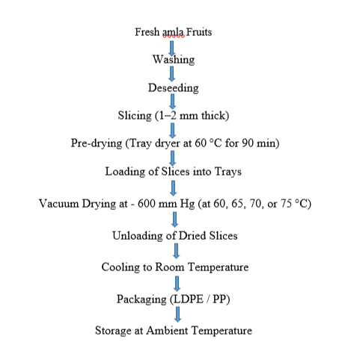
Figure 1. Illustration of the vacuum drying process

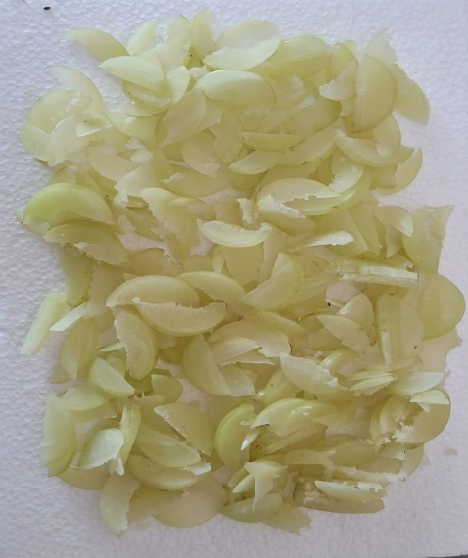 | 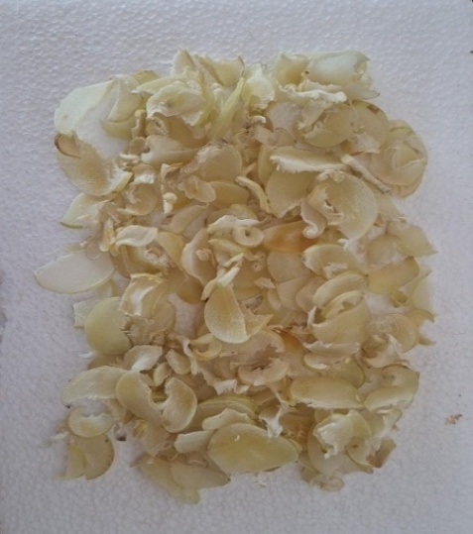
- Fresh sample | - Pre-dried sample
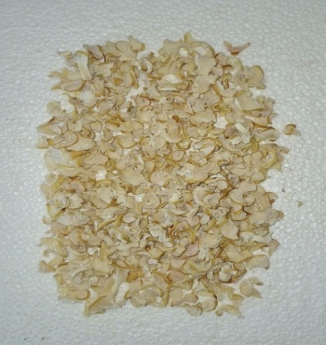 | 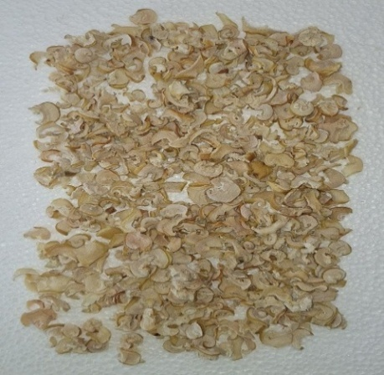
- Vacuum dried at 60 ℃ | - Vacuum dried at 65 ℃
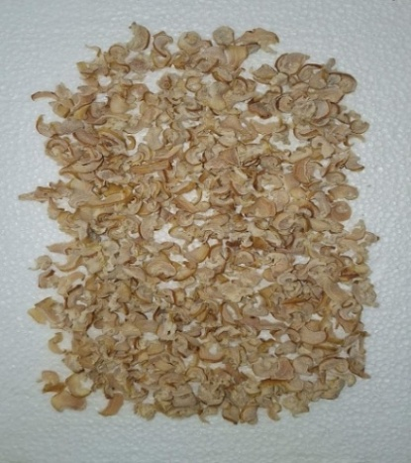 | 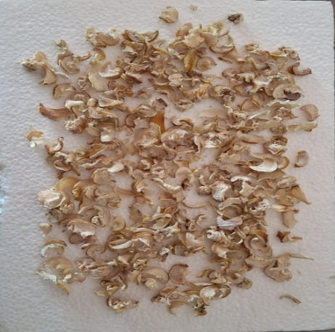
- Vacuum dried at 70 ℃ | - Vacuum dried at 75 ℃

Figure 2. Visual comparison of Phyllanthus emblica (amla) slices at different stages of vacuum drying at 60-75 °C under − 600 mm Hg.

Figure 3. Effect of drying time on moisture content

Figure 4. Effect of drying time on drying rate

Figure 5. Effect of drying time on moisture ratio

Figure 6. Effect of moisture content on drying rate

Figure 7. Drying efficiency of vacuum-assisted drying of Phyllanthus emblica (amla) slices at 60, 65, 70, and 75 °C under − 600 mm Hg.

