Effect of seed treatments and containers on the storability of rice (Var.TRY3)harvested at different maturity stages using a combine harvester.
R.JeyaChandraª, P.Masilamani^{a*}, B.Suthakar^{b}, P.Rajkumarª, S.D.Sivakumar^{c} and V.Manonmani^{d}
ªAgricultural Engineering College and Research Institute, TNAU, Kumulur-621 712, Tiruchirappalli, Tamil Nadu
^{b}Agricultural Engineering College and Research Institute, TNAU, Coimbatore-641 003, Tamil Nadu
^{c}Institute of Agriculture, TNAU, Kumulur-621 712, Tiruchirappalli, Tamil Nadu
^{d}Department of Seed Science and Technology, TNAU, Coimbatore-641 003, Tamil Nadu

*Corresponding author: E-mail: masilamanip@tnau.ac.in

Abstract
The present investigation aims to study the impact of different maturity stages on the moisture content and storability of the rice variety TRY 3. The seeds were harvested using a combine harvester at various maturity stages: physiological maturity, two days after, four days after, and six days after physiological maturity. The seeds were treated with water-soluble polymer at a rate of 4 ml + 12 ml water per kg and vithaiamirtham at 25 ml per kg of seed, and compared with untreated control seeds. The treated seeds were stored under ambient conditions in both super grain and gunny bag containers, alongside the control seeds.Quality parameters were measured initially and at monthly intervals for 12 months to evaluate seed storability. Results showed that seeds harvested at physiological maturity stage exhibited the highest germination percentage, longer root and shoot lengths, increased dry matter production, highest seedling vigour index, lowest pathogen incidence, and lowest seed leachates. Seeds stored in super grain bags demonstrated higher germination rates, seedling vigour index, lower insect and pathogen incidence, and seed leachates compared to seeds stored in gunny bags, regardless of variety or treatment. In conclusion, the TRY 3 rice variety harvested at physiological maturity stage, treated with water-soluble polymer at 4 ml + 12 ml water per kg of seed, and stored in super grain bags maintained seed quality above minimum seed certification standards for up to 12 months.
Key words: TRY 3 rice variety, Maturity stages, Moisture content Storability, Seedling vigour

Introduction
Seed quality is the most crucial factor influencing crop growth, development, and yield processes, potentially increasing yield by 5-20% (Rickman et al., 2006). Seed deterioration during storage is a gradual and inevitable process that causes significant losses. Seeds tend to lose viability and vigour during storage, making information on the storability of seed lots from harvest until the next planting season essential for any seed production program (Govindaraj et al., 2017). Seed vigour and viability during storage are affected not only by genetic differences among genera and varieties but also by various physicochemical factors, including seed moisture content, relative humidity, temperature, initial seed quality, and the physical and chemical composition of the seeds. Factors like gaseous exchange, storage structures, and container types also play a significant role in determining seed longevity. To mitigate quantitative and qualitative losses caused by biotic and abiotic stresses during storage, several strategies have been employed. One such approach involves polymer seed coatings, which act as a binding material to seal minor cracks and imperfections on the seed coat, preventing fungal invasion. Additionally, polymer coatings serve as a physical barrier that restricts oxygen movement and protects against inhibitors from the seed coverings, ultimately reducing seed aging. Proper storage in secure containers further ensures the maintenance of seed quality over time (Mallick et al., 2022; Padhi et al., 2017; Sharma et al., 2017).The combine harvester integrates multiple harvesting operations into a single process, including reaping, threshing, and winnowing, ultimately producing clean seeds of crops such as rice, maize, soybean, and black gram. The adoption of modern mechanized harvesting tools, including combine harvesters, mini-combine harvesters, and reapers, is increasingly essential to save time, reduce labour dependency, minimize harvesting losses, and enhance cropping intensity, crop productivity, and farmers' economic returns (Hasan
et al., 2020). In rice cultivation, combine harvesting is widely recognized as an effective strategy to meet peak labour demand and reduce field losses associated with traditional manual harvesting practices. Despite these advantages, many seed growers and farmers often perceive, without empirical evidence, that combine harvesting may lead to excessive mechanical damage, reduced germination, and diminished seed vigour and viability, making it seemingly unsuitable for seed paddy. Moreover, there is a lack of systematic research evaluating the impact of combine harvesting on seed crops harvested beyond the physiological maturity stage and its seed quality. In view of this knowledge gap, the present study was undertaken to investigate the effect of seed treatments and containers on the storability of TRY3 rice variety harvested at different maturity stages using a combine harvester.
Material and Methods
The study was conducted at the Department of Basic Engineering and Applied Sciences, Agricultural Engineering College and Research Institute, Tamil Nadu Agricultural University, Kumulur, from 2023 to 2025. Rice seed crop (Var. TRY 3) was harvested using a combine harvester at different seed moisture levels (19% to 27%) with four distinct maturity stages. The treatments included harvesting the seed crop at physiological maturity (H1), two days after physiological maturity (H2), four days after physiological maturity (H3), and six days after physiological maturity (H4) stage. The seeds collected from different maturity stages were cleaned and graded. The graded seeds were stored in both super grain bag (C1) and gunny bag (C2) containers with 8 to 10.20 percent moisture content following the treatment of control (T1), water-soluble polymer 4g + 12ml water/kg of seed (T2), and vithai amirtham 25ml/kg of seed (T3). The treated seeds were stored under ambient conditions. The experiment was designed using FCRD with three replications. Various quality parameters were recorded initially and at monthly intervals for 12 months to assess the storability of seeds. For germination test, seeds were placed on a roll towel. Under each treatment, 400 seeds were sown with eight replications of 50 seeds each. Seed germination was calculated as the percentage of seeds producing normal seedlings. Fourteen days after sowing (ISTA, 2011), ten seedlings from each replication were randomly selected, and the root and shoot lengths were measured, with the mean value recorded. Ten random seedlings were dried in a hot air oven at 85°C for 24 hours, and the dry weight was recorded and expressed as g.seedling-10. The vigour index was calculated using the formula (Abdul – Baki and Anderson, 1973): Vigour Index = Percentage germination x Total seedling length (cm). Seeds were also analyzed for electrical conductivity (Presley, 1958), dehydrogenase activity (Kittock and Law, 1968), insect infestation percentage, and pathogen infection percentage (ISTA, 1999) under each treatment. The results were subjected to statistical analysis for significant differences (p=0.05) following Panse and Sukhatme (1999). Percentage values were transformed using arcsine values prior to statistical analysis.
Results and Discussion
The results of the study on the effect of seed treatments and containers on the storability of the TRY3 rice variety, harvested at different maturity stages using a combine harvester, revealed that the moisture content was significantly influenced by the maturity stage of harvest, the container used for storage, the treatment applied, and the period of storage (Fig.1). Among the maturity stages, physiological maturity recorded the highest moisture content (10.65%) compared to six days after physiological maturity (10.54%). The study showed a slight increase in seed moisture content over the storage period, regardless of container and treatment. The moisture content did not fluctuate much during storage, especially in polymer-coated seeds stored in either a super grain bag or gunny bag, mainly due to the protection offered by the polymer, which prevented moisture absorption from the storage environment (West et al., 1985; Govindaraj et al., 2017). Higher moisture content and temperature lead to reduced shelf life of paddy seeds (Kaliyan et al., 2006). Ramanadane and Ponnusamy (2004) reported that moisture content is associated with a decline in seed quality. Harrington’s thumb rule states that storability increases as moisture content decreases. For every one percent reduction in moisture content, the shelf life doubles within a range of 5 to 15%. It was reported that there is a negative logarithmic relation between moisture content and longevity (Ellis et al., 1990).
Germination was significantly influenced by the maturity stage of harvest, containers used for storage, treatments, storage period, and their interactions. Among the maturity stages, physiological maturity stage registered the highest germination of 89%, followed by two days after physiological maturity stage (88%), and the lowest germination was recorded at six days after physiological maturity stage (85%). Seeds stored in super grain bags (C₁) retained higher germination (87%) than those stored in gunny bags (C₂ 86%). Seeds coated with water-soluble polymer @ 4 ml + 12 ml water/kg registered the maximum germination (88%), followed by vithai amirtham (87%), while the control showed the minimum germination (86%). A decrease in seed germination was observed with an increase in the storage period. The maximum germination was observed during the initial period of storage (91%) and reached the minimum after 12 months of storage (83%). Overall, the interaction effects of harvesting method, storage container, and seed treatment were significant (Fig.1). Similar trends were observed in root length, shoot length, dry matter production, and vigour index (Fig.2).
Govindaraj et al. (2017) studied that rice varieties CR1009 Sub 1, improved white ponni, and CO 51 reported higher germination in manual harvesting and manual threshing, followed by combine harvesting, with the lowest germination percentage observed in manual harvesting and mechanical threshing, attributing declines to enzyme activity. Furthermore, super grain bags and seeds coated with water-soluble polymer exhibited the highest germination percentage, dry matter production, and seedling vigour, while the control showed the lowest germination, possibly due to mitochondrial membrane degradation, leading to a reduction in energy supply required for germination. The rice seeds CO51, CR1009 Sub 1, and improved white ponni harvested and threshed by different methods and coated with water-soluble polymer @ 4 ml + 12 ml of water.kg-1 at 8% moisture content and packed in super grain bags maintained seed quality above minimum seed certification standards for up to twelve months of storage. These findings were consistent with previous studies conducted on rice (Pham Long Giang and RameGowda, 2007). The impact of combine harvesting, manual harvesting, and threshing on two rice varieties, namely ADT 36 and BPT 5204, were examined under storage in gunny bags at ambient temperature for 12 months duration, revealing that seeds harvested by the combine harvester maintained an optimum germination reaching 83% for ADT 36 and 82% for BPT 5204 even after 12 months of storage. Their recommendation emphasized harvesting these rice varieties at 20% moisture content using a combine harvester to meet the minimum seed certification standard of 80%, sustaining quality for up to 9 months of storage (Masilamani and Tajuddin, 2012). The use of hermetic storage bags proved more effective than traditional methods, maintaining 97% germination with just 1% damage, whereas traditional storage resulted in 95% germination with 6% damaged grains (Awal et al., 2017). Seeds stored in PICS (Purdue Improved Crop Storage) bags and super grain bags retained the highest seed germination for a longer time than other storage materials in rice (Khatri et al., 2019).
Electrical conductivity and dehydrogenase activity were significantly influenced by harvesting stages, containers, treatments, and storage period. Among the maturity stages, physiological maturity registered the lowest electrical conductivity (0.074 dSm⁻¹) and the highest at six days after physiological maturity (0.087 dSm⁻¹). Super grain bags maintained lower electrical conductivity (0.072 dSm⁻¹) while higher electrical conductivity was observed in seeds stored in gunny bags (0.083 dSm⁻¹). Seeds coated with water-soluble polymer @
4 ml + 12 ml water/kg registered the minimum electrical conductivity (0.079 dSm⁻¹) while the maximum was in the control (0.086 dSm-1). The minimum electrical conductivity was observed during the initial period of storage (0.064 dSm⁻¹) and reached the maximum after 12 months of storage (0.110 dSm⁻¹). In dehydrogenase activity, among the maturity stages, physiological maturity stage registered the highest dehydrogenase activity (0.925) and the lowest at six days after physiological maturity (0.781). Super grain bags maintained higher dehydrogenase activity (0.830) while the lowest was observed in seeds stored in gunny bags (0.819). Seeds coated with water-soluble polymer @ 4 ml + 12 ml water/kg registered the maximum (0.829) while the minimum was in the control (0.821). The maximum dehydrogenase activity was observed during the initial period of storage (0.856) and reached the minimum after 12 months of storage (0.713) (Fig.3; Fig.4).
Doddamani and Betageri (2021) reported that electrical conductivity increased with higher moisture content. A decrease in enzymatic activity in stored seeds over time led to reduced germination and vigor (Khan et al., 2013). Dehydrogenase activity gradually decreased with an increase in storage period, resulting in a loss of seed quality. Ajeet (2015) found that dehydrogenase activity significantly decreased from 8 months (0.163 OD) to 12 months (0.129 OD) in rice. Pathogen and insect infestation were assessed, with infection increasing as maturity stages and storage duration increased. Among the containers, seeds stored in super grain bags had the lowest pathogen infection compared to gunny bags. T1 (control) had the highest infection rate, while T2 (water-soluble polymer) had the lowest (Fig.3). A similar trend was observed with insect infestation, which increased with maturity stages and storage duration in all rice varieties. The highest insect infestation was observed six days after physiological maturity. Super grain bags had the lowest insect infestation compared to gunny bags, with T1 (control) having the highest infestation and T2 (water-soluble polymer) having the lowest.
Conclusion
This study concludes that rice seed crop (Var. TRY3) harvested with a combine harvester at physiological maturity or up to six days after the physiological maturity stage, then reduced to a moisture content of 8%, coated with water-soluble polymer @ 4 ml + 12 ml of water per kilogram of seed, and packed in a super grain bag, maintained more than 80% germination. It also met the Indian Minimum Seed Certification Standards for up to twelve months.

References
Abdul‐Baki, A.A. and J.D. Anderson. 1973. Vigor determination in soybean seed by multiple criteria 1. Crop Science.13(6):630-633. https://doi.org/10.2135/cropsci1973.0011183X001300060013x
Ajeet, P. 2015. Studies on deterioration pattern of paddy (Oryza sativa L.) seeds during storage. M.Sc. (Ag.) Thesis, Tamil Nadu Agricultural University, Coimbatore, India.
Awal, M.A., M.R. Ali, M.A. Hossain, M.M. Alam, P.K. Kalita, and J. Harvey. 2017. Hermetic bag an effective and economic rice storage technology in Bangladesh. 2017 ASABE Annual International Meeting.https://doi:10.13031/aim.201700329.
Doddamani, S.S. and S. Betageri. 2021. Influence of stages of harvesting and threshing methods on soybean [Glycine max (L.) Merrill]. The Pharma Innovation Journal. 10(6):687-696.
Ellis, R.H., Hong, T.D. and Roberts, E.H. 1990. Moisture content and the longevity of seeds of PhaseolusvalgarisL. Annals of Botany. 66:
341-348.https://doi.org/10.1093/oxfordjournals.aob.a088033
Govindaraj, M., P. Masilamani, and V. Alex Albert. Influence of Harvesting and Threshing Methods on Storability of Rice Varieties. 2017. Madras Agricultural Journal. 104
(10-12):395-400.DOI:10.29321/MAJ.2017.000086
Hasan, K., T.S. Tanaka, M. Alam, R. Ali, and C.K. Saha. 2020. Impact of modern rice harvesting practices over traditional ones. Reviews in Agricultural Science8:89-108.DOI:10.7831/ras.8.0_89
ISTA. 1999. International Rules for Seed Testing. SeedScience and Technology Supplement. 27:39.
ISTA. 2011. International rules for seed testing. International Seed Testing Association, Bassersdorf, Switzerland.
Kaliyan, N., Alagusundaram, K. and Gayathri, P. 2006. Effect of temperature and moisture content on shelf life of paddy. The American Society of Agricultural and Biological Engineers. 066-193.DOI:10.13031/2013.21537
Khan, A.M., Khan, H., Khan, R. and Aziz, A. 2013. Decrease in enzymatic activity of stored seeds to estimate seed quality and predict field emergence in wheat. American Journal of Plant Physiology. 4:242-246.
Khatri, N., D. Pokhrel, B. Pandey, K. Pant, and M. Bista. 2019. Effect of different storage materials on the seed temperature, seed moisture content and germination of wheat under farmer's field condition of Kailali district, Nepal. Agricultural Science and Technology. 11(4):352-355, 2019.DOI:10.15547/ast.2019.04.060
Kittock, D., and A. Law. 1968. Relationship of seedling vigor to respiration and tetrazolium chloride reduction by germinating wheat seeds 1. Agronomy Journal. 60(3):
286-288.https://doi.org/10.2134/agronj1968.00021962006000030012x
Mallick, S., S. Mohanty, S. Das, J. Beura, and G. Jyoth. 2022. "Effect of polymer coating on seed quality during storage of groundnut seeds." The Pharma Innovation Journal.11 (11):1396-1401.
Masilamani, P., and A. Tajuddin. 2012. "Can we use combine for seed purpose." Kissan world. 39:38-39.
Padhi, S., S. Behera, S. Mishra, A. Padhiary, and B. Nayak. 2017. "Effect of seed coating materials on seed quality during storage of paddy." Journal of Pharmacognosy and Phytochemistry.6(6):1263-1279.
Panse, V. G. and P.V. Sukhatme. 1999. In: Statistical methods for agricultural workers. ICAR, Publication, New Delhi., 327-340.
Pham Long Giang, P.L.G., and R.G. Rame Gowda. 2007. Influence of seed coating with synthetic polymers and chemicals on seed quality and storability of hybrid rice (Oryza sativa L.). Omonrice.15:68-74
Presley, J.T. 1958. Relation of protoplast permeability to cotton seed viability and predisposition to seedling disease. Plant Disease Reporter.42(7):852.
Ramanadane, T. and Ponnuswamy, A.S. 2004. Ageing and anatomical influence on seed storability in rice (Oryzasativa L.) hybrids and parental lines. Tropical Agricultural Research. 16:37-50.
Rickman, J.F., Bell, M. and Shires, D. 2006. Seed Quality, Available at http// www.knowledgebank.irri.org. Accessed 21/12/2014.
Sharma, A., and K. Dhiman. 2017. Effect of seed coating on seed quality and storability of rice (Oryza sativa L.). Himachal Journal of Agricultural Research.102-111.
West, S.H., Loftin, S.K., Wahl, M., Batich, M. and Beatty, C.L. 1985. Polymers as a moisture barrier to maintainseed quality. Crop Sci. 25:
941-944.https://doi.org/10.2135/cropsci1985.0011183X002500060010x

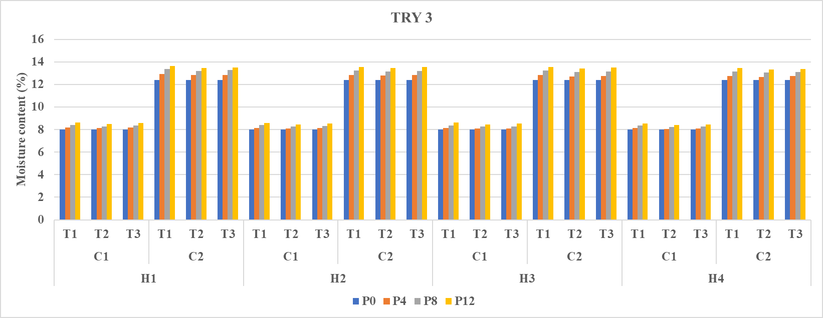
Moisture content (%)
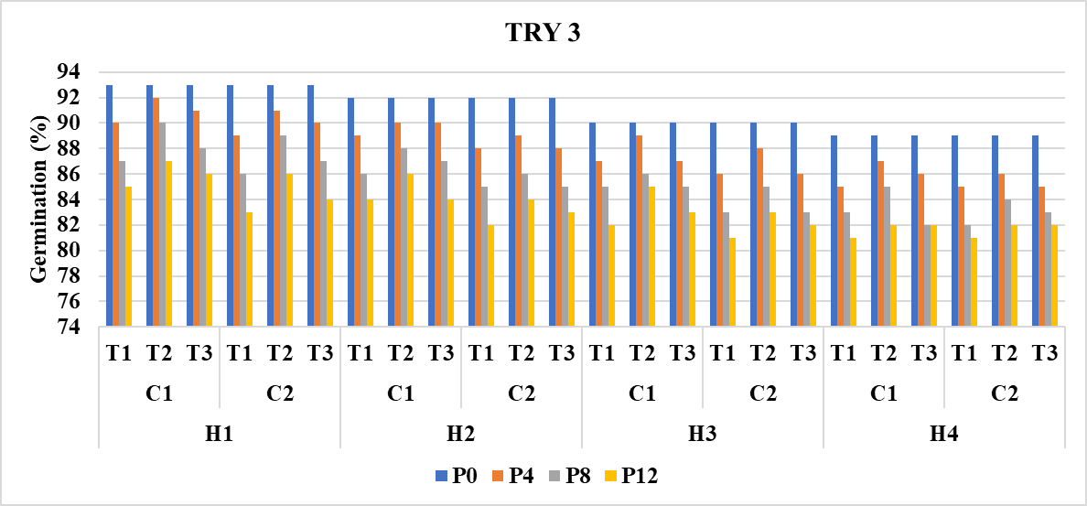
Germination (%)
Fig 1. Effect of maturity stages, combine harvesting, storage containers and seed treatments on moisture content (%) and germination (%) of TRY3 rice variety

H₁ – At Physiological maturity  H₂ – Two days after physiological maturity  H₃ – Four days after Physiological maturity  H₄ – Six days after Physiological maturity | P0- Initial Period of storage  P4- 4 months of storage  P8- 8 months of storage  P12- 12 months of storage  C₁-Super grain bag  C₂-Gunny bag | T₁-Control  T₂-Water Soluble Polymer 4ml + 12 ml water/kg  T₃- Vithai Amirtham 25 ml/kg of seed

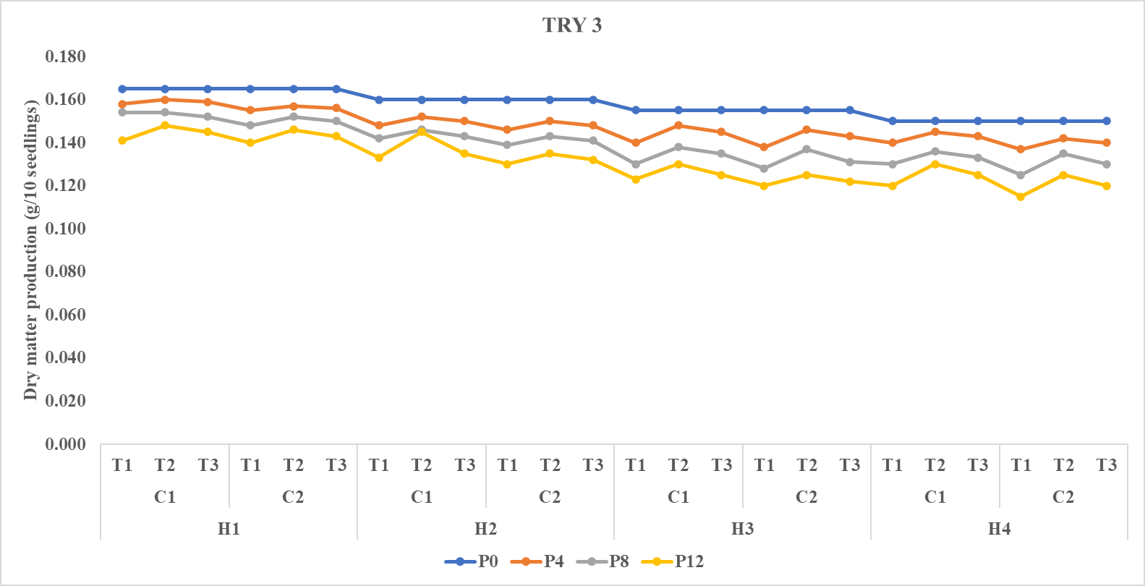
Dry matter production (g/10 seedlings)
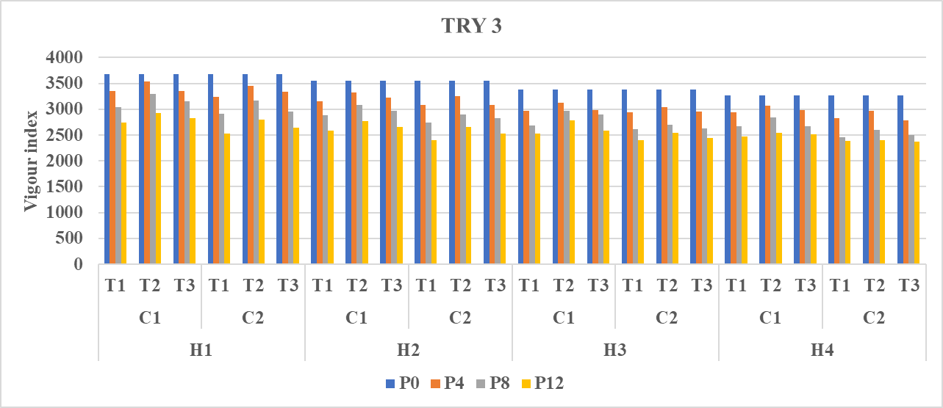
Vigour index
Fig 2. Effect of maturity stages, combine harvesting, storage containers and seed treatments on dry matter production (g/10 seedlings) and vigour index of TRY3 rice variety

H₁ – At Physiological maturity  H₂ – Two days after physiological maturity  H₃ – Four days after Physiological maturity  H₄ – Six days after Physiological maturity | P0- Initial Period of storage  P4- 4 months of storage  P8- 8 months of storage  P12- 12 months of storage  C₁-Super grain bag  C₂-Gunny bag | T₁-Control  T₂-Water Soluble Polymer 4ml + 12 ml water/kg  T₃- Vithai Amirtham 25 ml/kg of seed

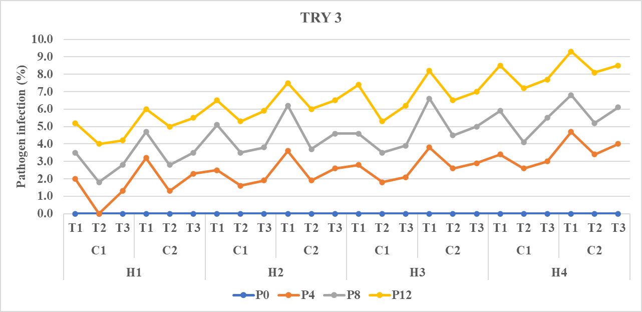
Pathogen infection (%)
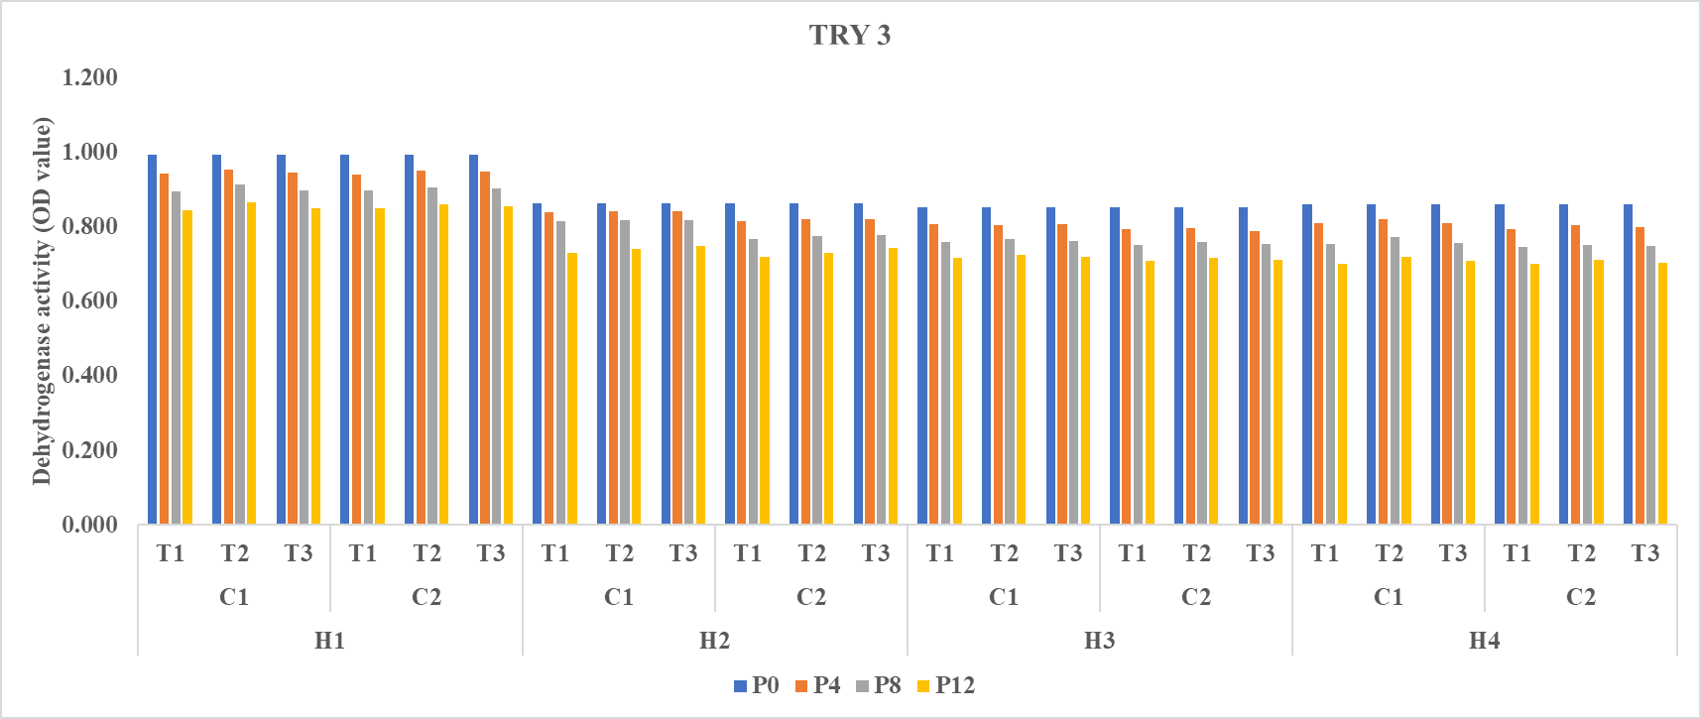
Dehydrogenase activity
Fig 3. Effect of maturity stages, combine harvesting, storage containers and seed treatments on Pathogen infection (%) and dehydrogenase activity of TRY3 rice variety

H₁ – At Physiological maturity  H₂ – Two days after physiological maturity  H₃ – Four days after Physiological maturity  H₄ – Six days after Physiological maturity | P0- Initial Period of storage  P4- 4 months of storage  P8- 8 months of storage  P12- 12 months of storage  C₁-Super grain bag  C₂-Gunny bag | T₁-Control  T₂-Water Soluble Polymer 4ml + 12 ml water/kg  T₃- Vithai Amirtham 25 ml/kg of seed

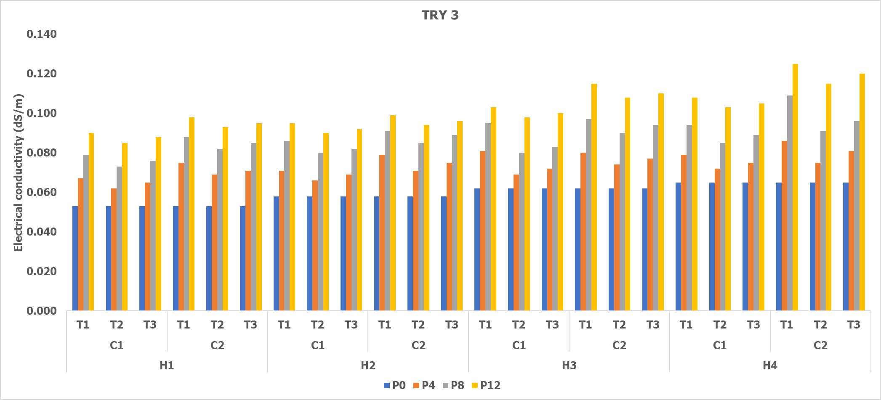

Fig 4. Effect of maturity stages, combine harvesting, storage containers and seed treatments on electrical conductivity (dS/m) of TRY3 rice variety

H₁ – At Physiological maturity  H₂ – Two days after physiological maturity  H₃ – Four days after Physiological maturity  H₄ – Six days after Physiological maturity | P0- Initial Period of storage  P4- 4 months of storage  P8- 8 months of storage  P12- 12 months of storage  C₁-Super grain bag  C₂-Gunny bag | T₁-Control  T₂-Water Soluble Polymer 4ml + 12 ml water/kg  T₃- Vithai Amirtham 25 ml/kg of seed

