Adapting Soils to Climate Change: Conservation Strategies for a Resilient Future
Abstract
Soil represents three phase system which acts as a medium for agriculture production. Notably, at present, there were abrupt climate change like increase in temperature, drastic shift in rainfall pattern, precipitation, relative humidity and many more were noticed which not only affect plant physiological function, but also for soil individual properties (physical, chemical and biological) which ultimately hinders crop growth and development leads to limited food production. Although increase in one degree Celsius was found to increase pest population incidence by 20-30% which reduces yield by 6%. Suitable management practices were crucial in augmenting climate change scenario. Many studies shall focused management practices for crop health due to physiological function neglecting soil management process. This review briefly emphasize the significance effect of changing climate towards various soil indivial properties and the suitable mitigation strategies like system of farming practices, inter-cropping, crop diversification, cover crops, amending beneficial microbes, conservation tillage and other precision technologies were involved for better crop production and to sustain agro-ecological system under changing climate.
Keywords: climate; health; production; soil; sustainability.
1. Introduction
Though some would sensitize the dual role in emphasizing climate change and their effect on agriculture. For the broader sake, it dwells every part of agriculture including crop production, pest population, yield dynamics and finally soil health. Climate change had become one of the most crucial term among global wide and it has to be addressed with immediate effect. According to IPCC, 2023 sixth assessment report, at present day global temperature of 1.1°C which lies above the pre-industrial level which tend to rise up-to 1.5°C by 2050 and there will be a projected increase in temperature by 1.8 to 4.0°C by 2100. The major cause for climate change includes burning of fossil fuels, emission of GHGs and increase in CO₂ level in atmosphere (Kabir et al., 2023). The detrimental effect of climate change had altered ecosystem of environment (Abbass et al., 2022), agriculture (Xie et al., 2018) and most importantly the natural resources which includes soil health and fertility status (Kabato et al., 2025).
Soil system had been functioning for the production of different valuable products like food, fibre, timber etc. by supporting and linking different ecosystem services (Millennium Ecosystem Assessment, 2005; Díaz et al., 2019). Fig. 1 shows how climate change had an interlinked relation among Agriculture, food production and soil health. These factors directly or indirectly influence the system of agriculture and soil health.
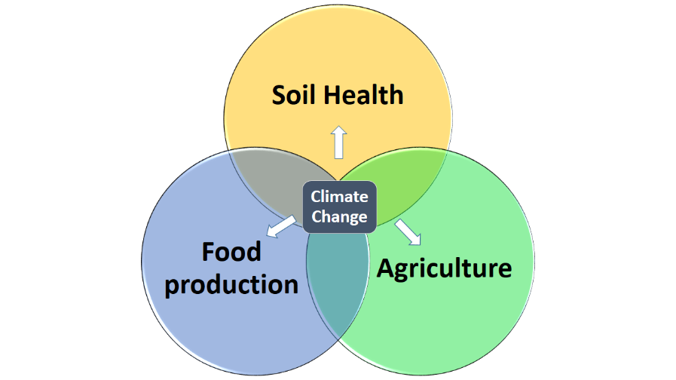

Fig. 1. Triangular perception relating Inter-relation of Soil health, food production and agriculture and its implication due to climate change
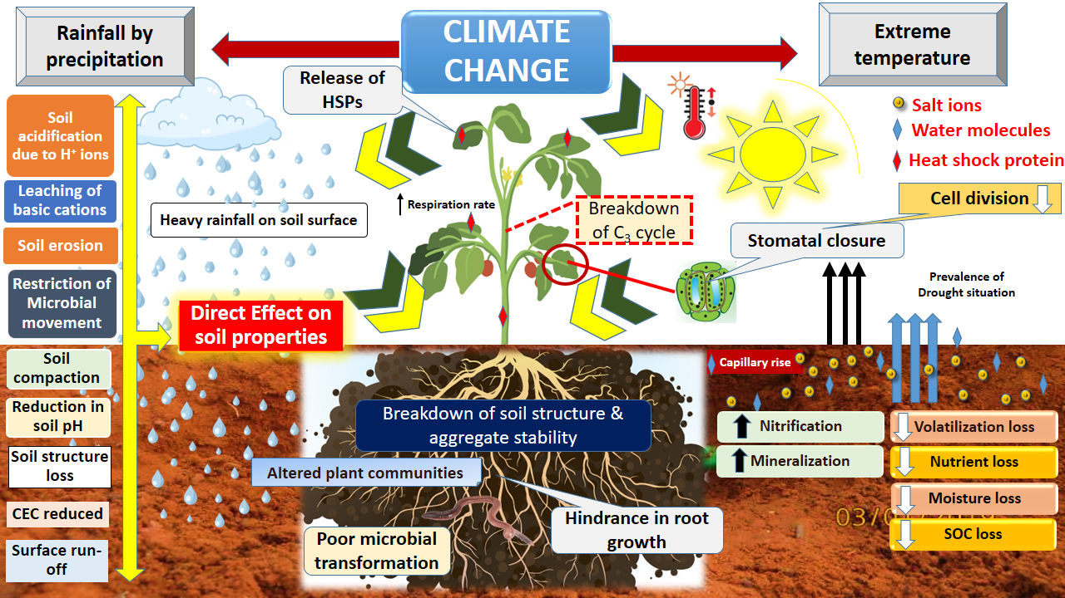
The possession of climate change had ruined soil health which delimits agricultural production thereby rise of risk in food insecurity had been noted. The critics’ gap evolved between climate change pattern and agriculture production should become less and the studies should address this. The direct reflection of climate change towards every ecosystem is well noticed, and it should be minimized in future through suitable management practices like climate smart agriculture (Zhao et al., 2023), precision farming (Roy and George, 2020), optimisation of resource uses (Erdoğdu et al., 2025), enhancement of crop resilient (Yoselin et al., 2023) and most importantly adjusting date of sowing towards climate. The systematic overview effect of climate change on different soil properties were illustrated (Fig. 2.), This strongly urges to address these study gaps and were represented in this paper.

Fig. 2. Overall effect of climate change scenario towards soil physical, chemical, biological properties and its implication on soil health and crop response [H⁺ - Hydrogen ions; pH - soil reaction; CEC - cation exchange capacity; HSP - Heat shock protein; C₃ - Calvin cycle; SOC - soil organic carbon; Temperature and Rainfall alters soil properties. Due to high temperature, the surface soil moisture gets evaporated at faster rate which influence other nutrient losses like volatilization loss, nutrient loss, and biological property of SOC loss; Due to capillary rise of water, the salt remain to present in soil itself; Other properties also gets reduces due to heavy rainfall of intense pattern and causes compaction, acidic pH, structural loss, CEC gets reduced, surface run-off. More over biological property of microbial activity gets restricted, basic cations gets reduced, erosion of surface soil. In plant system, C₃ cycle gets breakdown]
2. Effect of climate change on soil physical properties
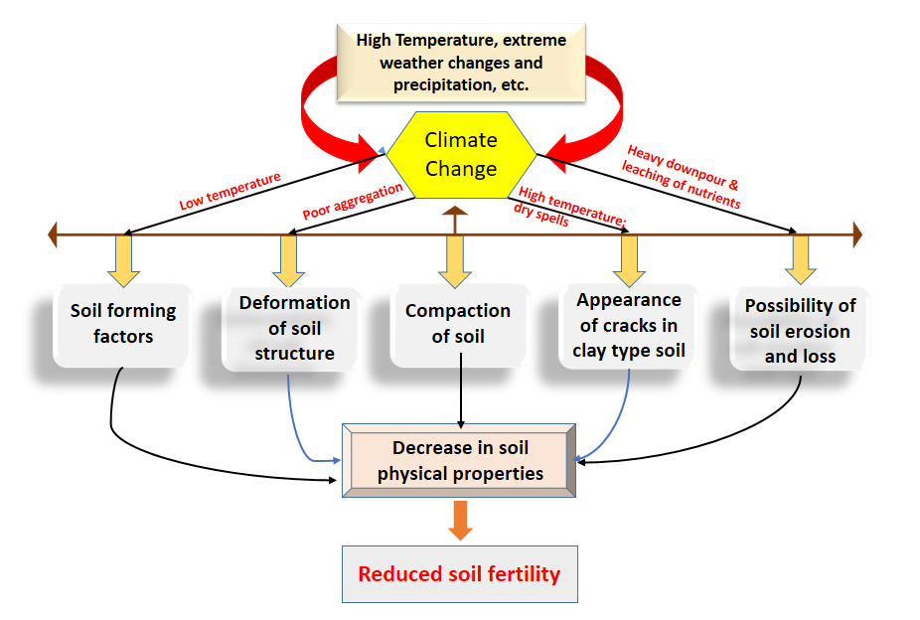
The physical state or properties is a key function for other soil properties. The majority of the research studies encompasses the status of soil health, such as application of remote sensing which acts as a keystone tool that how the basic soil formation and physical structure gets disturbed by climate change (Diaz-Gonzalez et al., 2022). The effect of climate change had a direct implication over soil due to changes in temperature (John et al., 2019), patterns of precipitation and most importantly intensified weather event within short span of time (Mondal, 2021). One among the important factor is moisture content dynamics. Since it was strongly hampered which are brought about by modification in climate precipitation change and altering temperature fluctuation in the climate. Both adverse temperature and severe rainfall can affect and disturb the microbial population and its regular activities in Rhizosphere. Due to erratic continuous rainfall, the soil undergoes reduced condition thereby all the pores (macro and micro) will completely filled with water which affect gaseous flow and heat exchange for both soil and microorganisms. This affects the aggregate stability of the soil system (Zhu and Zhao, 2023). Although due to effect of climate change which has an direct effect on soil compaction (Hamidov et al., 2018).

Fig. 2. Different pathways involving climate change affecting soil physical properties and fertility
Intensified rainfall will prone to heavy runoff which triggers soil erosion thereby it washes away top-layer fertile soil, hence crop become setback in nutrient uptake. Sometimes, strong wind can take away the top 5cm dry soil and minimized vegetative land cover which leads to poor soil productivity (Du et al., 2019). Normally, climate change had a major constrains towards soil physical health which are further multi linked with different other soil factors like chemical, biological properties. (Adimassu et al., 2018) also suggested that research bearing traditional methods following tillage practices will leads to surface run-off an erosion of top surface soil. Overcoming by effective utilisation of conservation tillage or zero tillage will be more effective against climate change thus minimizing the negative effects and thus maintain soil and crop productivity.
3. Effect of climate change on soil chemical properties
Soil chemical properties which gets affected by climate change and weather implications setbacks soil fertility. Most of the chemical properties i.e. soil reaction are govern by soil moisture and temperature. Thermodynamics plays a critical role in completion of every reaction. During intense rainfall, all the basic cation gets washed and leached down (Fig. 3) producing soil nutrient loss. Through changes in temperature and precipitation patterns, which directly affects and alter the levels of soil reaction (pH) and nutrient availability. The anticipated effect of temperature directly influence different soil factors including soil temperature, soil moisture content and most importantly soil organic matter decomposition (Hamidov et al., 2018). Due to high temperature amidst climate change, it forms rapid decomposition of organic matter thereby ease of release of organic acids like nitric acid, oxalic acid, formic acid deposition will be there which increases the soil acidification (Barros et al., 2021; Zhang et al., 2023). Both adverse climate situation like extreme drought condition and precipitation pattern on long term basis would adversely affect soil salinization and soil acidification simultaneously (Molin et al., 2020). According to (Sun et al., 2023), a study conducted at grassland regions on the Tibetan Plateau revealed that under climate condition, the percent of 45.52%, 44.49% and 21.43% of the study area at three different depth of 0–10, 10–20 and 20–30 cm were recorded acidic situation and this might be due to both climate change scenario and anthropogenic activity. Soil electrical conductivity is nothing but total dissolved salt present in soil solution and also acts as a biological indicator in which microorganism thrives (Gil et al., 2009). But due to climate change of increased temperature and limiting precipitation pattern (Smith et al., 2002), the range of soil EC gets increased and over increase in temperature over time causes the molecule of water to get evaporated and salt remains in the soil which hampers crop production. CEC is the second most important chemical reaction in plant system next to photosynthesis as it exchanges cation like (Ca²⁺, Mg²⁺, Na⁺, K⁺) to clay outer surface and exchanges other cations. Most of the soil under alluvium are highly correlated to soil organic matter. Hence increased temperature in atmosphere fastens the rate of decomposition, thus accelerates CEC reaction in soil (Davidson & Janssens, 2006). Also every cycles involving C, N, P, S and water cycles were thus adversely affected by climate change and global temperature. Hence, as a holistic behaviour, the climate change behaviour hampers chemical reaction and thus adversely affect soil ecosystem.

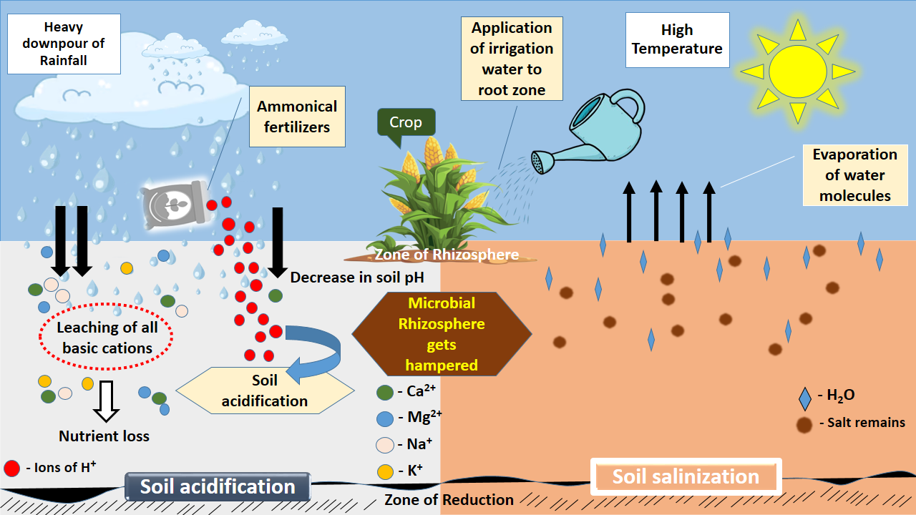

Fig. 3. Effect of Climate change dynamics over soil chemical properties and its implication towards soil health and productivity
4. Effect of climate change on soil biological properties
These climate change pattern modifies the cycles of hydrology (water), nitrogen, phosphorus, sulphur etc. The microorganisms were the active living body responsible for various nutrient transformation, carbon sequestration and cycling under soil system (Cavicchioli et al., 2019). Drastic fluctuation in soil pH due to climate change and precipitation patterns hampers microbial activities in soil over wide range and each organism requisite particular pH by which it can thrive and involve in transformation of nutrients without any loss (Sun et al., 2023). Several models based simulation studies were recently studied in predicting effect of climate change on crop performance (Wallach et al., 2019) which predict linear stream flow generation of data by minimizing human errors, prolonged survey thereby determining in faster way (Ansari et al., 2023). Emphasizing simulation modelling in climate change which helps in dispelling through climate based modelling which involves, calibration, validation, weather parameter conversion, generation of data without involving man power (Giorgi, 2019; Tsujimoto et al., 2022; Masud et al., 2018; Ahrens and Dobler, 2015; Challinor et al., 2009). The prevalence of top fertile soil includes more humus content where abundance of microorganism activity will be more, but amidst leaching of top fertile soil due to heavy rainfall pattern and intensification, the fertile soil gets washed away thereby limits crop growth and development. Repeated and unfavourable situation of short hot and long humidity days affects microbial respiration rate. Since, microbial respiration is essential for carbon cycle and this carbon cycle favours soil organic carbon and stock determination in soil. Due to uncertain weather change, intensified rainfall, heat shock and also wind speed can alter soil organic carbon stock present in the soil. There are majorly two types of soil organic carbon present in the soil system. It includes mineral associated organic carbon (MAOC) and particulate organic carbon (POC) which drives the soil structure, water retention and nutrient availability. But altered atmospheric temperature and global warming hinders the activity thus delimit to soil system and crop function. A critical examiantion study conducted by Rocci et al. (2021) revealed that atmospheric CO₂ emission and increased input of nitrogenous fertilizers from farmers might be the major reason that would affect soil SOC stock and change in POC was more responsive towards global climate change he supposed.

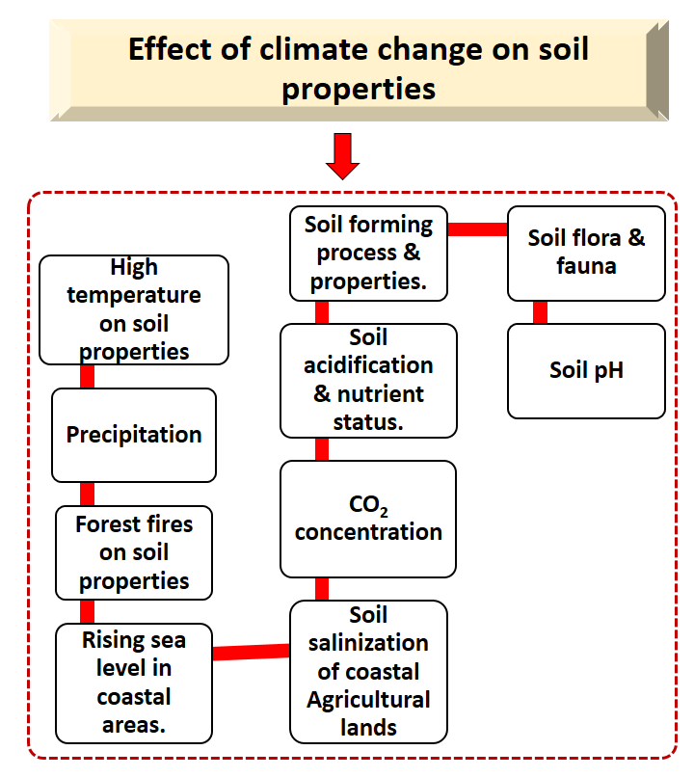

Fig. 4. Overall effect of Climate change on soil properties
5. Mitigation strategies
The various management practices which includes farming practices, inter-cropping, crop diversification, cover crops, amending beneficial microbes, conservation tillage and other precision technologies were adopted for better soil-plant response under surpassing climate change. The various aspects of management schedule were given in Table 1.

Sl. No | Methodology employed | Main benefits | Output with regard to sustainability | References
1 | Precision irrigation management | Potential use of water | Optimizing water-use-efficiency, minimizing water waste, reducing nutrient leaching and soil erosion, and improving soil structure | Kaur et al. (2025)
2 | Optimising fertilizers application (Site specific nutrient management) | Reducing over addition of inorganic fertilizers | Precisely adjusting fertilizer doses based on soil tests to meet a specific crop yield target, thus optimizing fertilizer use, increasing yield, and minimizing environmental impact | Sakthi Priyanka et al. (2024)
3 | Atmospheric carbon-di-oxide level monitoring sensor using low-cost NDIR (Non-Dispersive Infrared) sensors | Monitor soil carbon dynamics | Understand soil health, carbon turnover, and the impact of agricultural practices | Ko et al., (2020)
4 | Nutrient management by STCR-IPNS | Enhances nutrient use efficiency and eliminates over dose on-field application | Optimizing fertilizer use for targeted crop yields, which improves soil health and nutrient cycling, and by promoting integrated nutrient management with organic amendments | Hermoso et al. (2022)
5 | Hyper-spectral drone sensors | Availing soil data at faster rate without man power | Enabling precision agriculture through detailed soil property monitoring (e.g., moisture, nutrients) and crop health assessment | Vahidi et al. (2025)
Table. 1. Various aspects of management process for soil sustainability and crop production

6. Conclusion
Healthy soil provides healthy food through which it aids ecological diversity, nutrient recycling, decomposition of soil organic matter, sequestering organic carbon, and resilience against natural pest and diseases. Increasing anthropogenic activity is a crucial cause for abrupt change and this scenario continues, the world agriculture production will face food shortage in near future. The management practices not only supports agriculture production, it should light long term sustainability. Hence, soil as a system functions better with interactions of physical, chemical and biological properties. Better agronomic practices like crop rotation, inter-cropping, cover cropping, no-till farming, precision farming were employed to boost production and neglecting any one of the factor will leads to supresses the system. Future studies must rely on soil development emphasizing as a holistic approaches encompasses climate change, weather pattern prediction, cropping time, cropping patterns, soil amendment through micro sensors for better prediction. Simulation studies through empirical models like DNDC, Random Forest, Cubist, Info Crop, RothC were effectively be helpful in understanding the prediction of climate change and offers potential solution for soil system in decomposition, effect of temperature, precipitation change etc., thus, a holistic modelling approach along with soil properties will aims to mitigate climate change thus improves soil health and ecosystem sustenance.
7. Acknowledgment
The Authors are grateful to the Department of Soil Science & Agricultural chemistry, Tamil Nadu Agricultural University, Coimbatore and Pandit Jawaharlal Nehru Collage of Agriculture & Research Institute, Karaikal for supporting in completion of this study. I wish to thank my Chairperson and my dear colleagues for their helping hand and extending their full support throughout the preparation of this article.
8. Data Availability Statement
Data sharing is not applicable to this article
9. Conflict of Interest or Declaration of Competing Interest
The authors declare that there is no conflict of interest with the present publication.
10. Consent for Publication
All authors have agreed to the publication of this content.
11. Credit Authorship Contribution Statement
G. Muhilan: Investigation, formal analysis, writing - original draft. U. Bagavathi Ammal: Validation, methodology, writing-reviewing. Elavarasi P: Resources, investigation writing - reviewing. V. G. Venkatesan - Investigation, writing - reviewing. A. Akash: Investigation, writing - reviewing,
12. Ethics Statement
No Human and Animal were used in our study
13. References
- A.J. Challinor, F. Ewert, S. Arnold, E. Simelton, E. Fraser, Crops and climate change: progress, trends, and challenges in simulating impacts and informing adaptation, J. Exp. Bot. 60 (2009) 2775–2789, https://doi.org/10.1093/jxb/erp062.
- Abbass, K., Qasim, M.Z., Song, H. et al. A review of the global climate change impacts, adaptation, and sustainable mitigation measures. Environ Sci Pollut Res 29, 42539–42559 (2022). https://doi.org/10.1007/s11356-022-19718-6
- Adimassu, Z., Alemu, G., Tamene, L., 2018. Effects of tillage and crop residue management on runoff, soil loss and crop yield in the Humid Highlands of Ethiopia. Agric. Syst. 168, 11–18. https://doi.org/10.1016/j.agsy.2018.10.007.
- B. Ahrens, A. Dobler, Regional climate projections, Appl. Geoinformatics Sustain. Integr. L. Water Resour. Manag. Brahmaputra River Basin Results From EcProject Brahmatwinn (2015) 11–15, https://doi.org/10.1007/978-81-322-1967-5_4.
- Barros, N., Rodríguez-Anon, J.A., Proupín, J., P ~ erez-Cruzado, C., 2021. The effect of extreme temperatures on soil organic matter decomposition from Atlantic oak forest ecosystems. iScience 24 (12), 103527. https://doi.org/10.1016/j.isci.2021.103527.
- Bradford John B. , Schlaepfer Daniel R. , Lauenroth William K. , Palmquist Kyle A. , Chambers Jeanne C. , Maestas Jeremy D. , Campbell Steven B. Climate-Driven Shifts in Soil Temperature and Moisture Regimes Suggest Opportunities to Enhance Assessments of Dryland Resilience and Resistance. Frontiers in Ecology and Evolution. Vol 7, 2019, https://www.frontiersin.org/journals/ecology-and-evolution/articles/10.3389/fevo.2019.00358, DOI=10.3389/fevo.2019.00358
- Cavicchioli, R., Ripple, W.J., Timmis, K.N. et al. Scientists’ warning to humanity: microorganisms and climate change. Nat Rev Microbiol 17, 569–586 (2019). https://doi.org/10.1038/s41579-019-0222-5
- D. Wallach, D. Makowski, J.W. Jones, F. Brun, Chapter 12 - multimodel ensembles, in: D. Wallach, D. Makowski, J.W. Jones, F. Brun (Eds.), Working with Dynamic Crop Models, third ed., Academic Press, 2019, pp. 425–443. ISBN 978-0
- DAVIDSON, E. A. AND JANSSENS, I. A., 2006, Temperature sensitivity of soil carbon decomposition and feedbacks to climate change. Nature, 440: 165 - 173.
- Díaz, S., Settele, J., Brondízio, E., Ngo, H.T., Guèze, M., Agard Trinidad, J., Arneth, A., Balvanera, P., Brauman, K., Butchart, S., Chan, K., Garibaldi, L., Ichii, K., Liu, J., Subramanian, S.M., Midgley, G., Miloslavich, P., Molnar, Z., Obura, D., Pfaff, A., Polasky, S., Purvis, A., Razzaque, J., Reyers, B., Chowdhury, R.R., Shin, Y.-J., VIsseren-Hamakers, I., Willis, K., Zayas, C., 2019. Summary for Policymakers of the Global Assessment Report on Biodiversity and Ecosystem Services of the Intergovernmental Science-policy Platform on Biodiversity and Ecosystem Services. Secretariat of the Intergovernmental Science-Policy Platform on Biodiversity and Ecosystem Services, Bonn, Germany.
- Du, H., Zuo, X., Li, S., Wang, T., Xue, X., 2019. Wind erosion changes induced by different grazing intensities in the desert steppe, Northern China. Agric. Ecosyst. Environ. 274, 1–13. https://doi.org/10.1016/j.agee.2019.01.001.
- Erdoğdu, A., Dayi, F., Yanik, A., Yildiz, F., & Ganji, F. (2025). Innovative Solutions for Combating Climate Change: Advancing Sustainable Energy and Consumption Practices for a Greener Future. Sustainability, 17(6), 2697. https://doi.org/10.3390/su17062697
- Freddy A. Diaz-Gonzalez, Jose Vuelvas, Carlos A. Correa, Victoria E. Vallejo, D. Patino, Machine learning and remote sensing techniques applied to estimate soil indicators – Review, Ecological Indicators, Volume 135, 2022, 108517, ISSN 1470-160X, https://doi.org/10.1016/j.ecolind.2021.108517.
- Gil SV, Meriles J, Conforto C, Figoni G, Basanta M, Lovera E et al. Field assessment of soil biological and chemical quality in response to crop management practices. World J Microbiol. Biotech. 2009; 25:439-448.
- Giorgi, F. (2019) Thirty Years of Regional Climate Modeling: Where Are We and Where Are We Going Next? Journal of Geophysical Research: Atmospheres, 124, 5696-5723 https://doi.org/10.1029/2018JD030094
- Hamidov, A., Helming, K., Bellocchi, G., Bojar, W., Dalgaard, T., Ghaley, B. B., Hoffmann, C., Holman, I., Holzkämper, A., Krzeminska, D., Kværnø, S. H., Lehtonen, H., Niedrist, G., Øygarden, L., Reidsma, P., Roggero, P. P., Rusu, T., Santos, C., Seddaiu, G., Skarbøvik, E., … Schönhart, M. (2018). Impacts of climate change adaptation options on soil functions: A review of European case-studies. Land degradation & development, 29(8), 2378–2389. https://doi.org/10.1002/ldr.3006
- Hermoso, V.; Carvalho, S.B.; Giakoumi, S.; Goldsborough, D.; Katsanevakis, S.; Leontiou, S.; Markantonatou, V.; Rumes, B.; Vogiatzakis, I.N.; Yates, K.L. The EU Biodiversity Strategy for 2030: Opportunities and Challenges on the Path towards Biodiversity Recovery. Environ. Sci. Policy 2022, 127, 263–271.
- K. Tsujimoto, N. Kuriya, T. Ohta, K. Homma, M.S. Im, Quantifying the GCM-related uncertainty for climate change impact assessment of rainfed rice production in Cambodia by a combined hydrologic - rice growth model, Ecol. Modell. (2022) 464, https://doi.org/10.1016/j.ecolmodel.2021.109815.
- Kabato, W., Getnet, G. T., Sinore, T., Nemeth, A., & Molnár, Z. (2025). Towards Climate-Smart Agriculture: Strategies for Sustainable Agricultural Production, Food Security, and Greenhouse Gas Reduction. Agronomy, 15(3), 565. https://doi.org/10.3390/agronomy15030565
- Kwanyoung Ko, Ji-yeon Lee, Haegeun Chung, Highly efficient colorimetric CO2 sensors for monitoring CO2 leakage from carbon capture and storage sites, Science of The Total Environment, Volume 729, 2020, 138786, ISSN 0048-9697, https://doi.org/10.1016/j.scitotenv.2020.138786.
- Li-Wei Zhu, Ping Zhao, Climate-driven sapwood-specific hydraulic conductivity and the Huber value but not leaf-specific hydraulic conductivity on a global scale, Science of The Total Environment, Volume 857, Part 1, 2023, 159334, ISSN 0048-9697, https://doi.org/10.1016/j.scitotenv.2022.159334.
- M.B. Masud, T. McAllister, M.R.C. Cordeiro, M. Faramarzi, Modeling future water footprint of barley production in Alberta, Canada: implications for water use and yields to 2064, Sci. Total Environ. 616–617 (2018) 208–222, https://doi.org/10.1016/j.scitotenv.2017.11.004
- Millennium Ecosystem Assessment, 2005. Ecosystems and Human Well-being: Synthesis. Island Press, Washington, D.C.
- Molin, S.J.D., Ernani, P.R., Gerber, J.M., 2020. Soil acidification and nitrogen release following application of nitrogen fertilizers. Commun. Soil Sci. Plant Anal. 51 (20), 2551–2558. https://doi.org/10.1080/00103624.2020.1845347.
- Mondal, S., 2021. Impact of climate change on soil fertility. In: Soil Biology, pp. 551–569. https://doi.org/10.1007/978-3-030-76863-8_28.
- Muhammad Kabir, Um E Habiba, Wali Khan, Amin Shah, Sarvat Rahim, Patricio R. De los Rios-Escalante, Zia-Ur-Rehman Farooqi, Liaqat Ali, Muhammad Shafiq, Climate change due to increasing concentration of carbon dioxide and its impacts on environment in 21st century; a mini review, Journal of King Saud University - Science, Volume 35, Issue 5, 2023, 102693, ISSN 1018-3647, https://doi.org/10.1016/j.jksus.2023.102693.
- Rocci, K.S., Lavallee, J.M., Stewart, C.E., Cotrufo, M.F., 2021. Soil organic carbon response to global environmental change depends on its distribution between mineral-associated and particulate organic matter: a meta-analysis. Sci. Total Environ. 793, 148569. https://doi.org/10.1016/j.scitotenv.2021.148569.
- Roy, T., George K, J. (2020). Precision Farming: A Step Towards Sustainable, Climate-Smart Agriculture. In: Venkatramanan, V., Shah, S., Prasad, R. (eds) Global Climate Change: Resilient and Smart Agriculture. Springer, Singapore. https://doi.org/10.1007/978-981-32-9856-9_10
- S. Sakthi Priyanka, U. Bagavathiammal, R. Sankar, S. Nadaradjan, M. Pradeepa, C. Kanagasuppurathinam & V.M. Vinisha. (2024). Development of Integrated Fertilizer Prescription Based on STCR- IPNS for Cotton through Inductive Cum Targeted Yield Model in Thirunallar Soil Series of Karaikal, Puducherry, India. International Journal of Plant & Soil Science, 36(12), 305–315. https://doi.org/10.9734/ijpss/2024/v36i125204
- Smith JL, Halvorson JJ, Bolton H. Soil properties and microbial activity across a 500 m elevation gradient in a semi-arid environment. Soil Bio. Biochem. 2002; 34:1749-1757.
- Tarandeep Kaur, Pawan K. Sharma, A.S. Brar, Sukhpreet Singh, Surinder Singh, Precision irrigation and fertilization strategies for sustainable cotton-wheat systems in water-scarce regions, Agricultural Water Management, Volume 317, 2025, 109669, ISSN 0378-3774, https://doi.org/10.1016/j.agwat.2025.109669.
- Vahidi, M., Shafian, S., & Frame, W. H. (2025). Precision Soil Moisture Monitoring Through Drone-Based Hyperspectral Imaging and PCA-Driven Machine Learning. Sensors, 25(3), 782. https://doi.org/10.3390/s25030782
- Wei Sun, Shaowei Li, Guangyu Zhang, Gang Fu, Huxiao Qi, Tianyu Li, Effects of climate change and anthropogenic activities on soil pH in grassland regions on the Tibetan Plateau, Global Ecology and Conservation, Volume 45, 2023, e02532, ISSN 2351-9894, https://doi.org/10.1016/j.gecco.2023.e02532.
- Xie W, Huang J, Wang J, Cui Q, Robertson R, Chen K (2018) Climate change impacts on China’s agriculture: the responses from market and trade. China Econ Rev
- Yoselin Benitez-Alfonso, Beth K. Soanes, Sibongile Zimba, Besiana Sinanaj, Liam German, Vinay Sharma, Abhishek Bohra, Anastasia Kolesnikova, Jessica A. Dunn, Azahara C. Martin, Muhammad Khashi u Rahman, Zaki Saati-Santamaría, Paula García-Fraile, Evander A. Ferreira, Leidivan A. Frazão, Wallace A. Cowling, Kadambot H.M. Siddique, Manish K. Pandey, Muhammad Farooq, Rajeev K. Varshney, Mark A. Chapman, Christine Boesch, Agata Daszkowska-Golec, Christine H. Foyer, Enhancing climate change resilience in agricultural crops, Current Biology, Volume 33, Issue 23, 2023, Pages R1246-R1261, ISSN 0960-9822, https://doi.org/10.1016/j.cub.2023.10.028.
- Zhang, S., Zhu, Q., de Vries, W., Ros, G. H., Chen, X., Muneer, M. A., Zhang, F., & Wu, L. (2023). Effects of soil amendments on soil acidity and crop yields in acidic soils: A world-wide meta-analysis. Journal of environmental management, 345, 118531. https://doi.org/10.1016/j.jenvman.2023.118531
- Zhao, J., Liu, D., & Huang, R. (2023). A Review of Climate-Smart Agriculture: Recent Advancements, Challenges, and Future Directions. Sustainability, 15(4), 3404. https://doi.org/10.3390/su15043404

