Assessment of genetic relationships and direct-indirect effects on yield and fiber quality in upland cotton F₁ hybrids

K Keerthivarman¹, S Subhashini¹, K Aravind¹, K Chozhan², M Hariharan³, K Hari³, T Inbarasu³, S Iyyan Samy³,S Hariprasath³,M Jaya Vignesh³,K Gurudev³, & P Gokuleshwaran³

¹Department of Plant Breeding and Genetics, School of Agricultural Sciences, Dhanalakshmi Srinvasan University
²Dean, School of Agricultural Sciences, Dhanalakshmi Srinvasan University
³UG Scholar, School of Agricultural Sciences, Dhanalakshmi Srinvasan University
ABSTRACT
Cotton (Gossypium hirsutum L.) widely known as "White Gold," is a vital fiber crop cultivated in tropical and subtropical regions. The present study evaluated 35 F₁ hybrids to investigate the relationships between yield components and fiber quality traits, employing correlation and path coefficient analyses to identify key selection criteria for breeding programs. Data were recorded on morphological, yield, and fiber quality traits, and statistical analyses were performed using SPSS and TNAU STAT software. Correlation analysis revealed significant positive associations of seed cotton yield per plant with number of sympodial branches, number of bolls per plant, boll weight, upper half mean length, bundle strength, and elongation percentage. Path coefficient analysis indicated that the number of sympodial branches per plant had the highest direct positive effect on yield, followed by lint index, while boll weight and upper half mean length also contributed positively. Indirect effects highlighted the influence of associated traits, emphasizing the combined role of sympodial branches, boll weight, and number of bolls per plant in enhancing yield. Traits such as plant height, seed index, and ginning outturn exhibited negative direct or indirect effects on yield. The study identifies the number of sympodial branches per plant, number of bolls per plant, and boll weight as the most promising traits for selection, providing valuable insights for breeding high-yielding cotton genotypes with improved fiber quality.
Keyword: Gossypium hirsutum, Correlation analysis, Path coefficient analysis, Fibre quality traits
INTRODUCTION
Cotton (Gossypium hirsutum L.), often referred to as "White Gold," belongs to the Malvaceae family and is predominantly cultivated in tropical and subtropical regions as a fiber crop. Globally, cotton improvement programs have continually evolved to meet market demands, as highlighted by Faylet et al. (2014). Farmers and industries have collaborated to achieve higher yields while maintaining desirable fiber quality. In India, a key objective of cotton breeding programs is the development of high-yielding varieties with enhanced fiber traits. Among the various cotton species, G. hirsutum contributes approximately 90% to global cotton trade due to its extensively improved modern cultivars.
The present study focuses on evaluating the relationships between yield components and fiber quality traits to support cotton breeding efforts. Correlation studies play a crucial role in plant breeding by elucidating the associations among different traits. Understanding the relationships between highly heritable and economically important traits, such as fiber quality, provides valuable insights into their contributions to crop improvement. Furthermore, path coefficient analysis serves as an effective tool for breeding decisions, as it partitions the observed correlations into direct and indirect effects, thereby facilitating more precise selection of superior genotypes.
Materials and Methods
The present study was conducted at the Department of Plant breeding and Genetics, Dhanalakshmi Srinivasan University, Trichy-12, during 2025. F₁ hybrids were generated through crosses between selected lines (BSH 18, MCU 5, CO 14, CO 17, TCH 1828, TCH 1199, and Suraj) and testers (KC2, KC3, GTHV 15-32, GISV 323, and RHC 1409). A spacing of 120 × 60 cm was maintained, with one plant per hill. All recommended agronomic and cultural practices were followed throughout the cropping period.
Data were recorded on the F₁ hybrids for the following characters: days to first flowering (days), plant height (cm), number of monopodial branches per plant, number of sympodial branches per plant, number of bolls per plant, boll weight (g), number of locules per boll, seed index (g), lint index (g), 100-seed weight (g), seed cotton yield per plant (g), ginning outturn (%), upper half mean length (mm), uniformity index (%), bundle strength (g/tex), elongation percentage (%), and micronaire value (μg per inch). Correlation analysis was performed using SPSS software version 16.0, and path analysis was carried out using the TNAU STAT program developed by Manivannan (2014).
Result and Discussion
Correlation
Correlation analysis is a key statistical tool for identifying linear associations between traits, enabling effective selection strategies. It not only clarifies the direct relationship between yield and its component traits but also facilitates indirect selection of superior genotypes.
In the present study, days to first flowering showed a significant negative correlation with boll weight (-0.468) and seed cotton yield per plant (-0.436). The number of sympodial branches per plant exhibited a highly significant positive association with plant height (0.547), corroborating the findings of Gauswami Jyoti et al. (2021), Attiq Ur Rehman Gohar (2020), and Rai et al. (2020). Similarly, plant height showed highly significant positive correlations with number of bolls per plant (0.541), boll weight (0.628) (Mudhalvan et al. 2021), and number of locules per boll (0.550). An increase in sympodial branches was directly associated with taller plants, indirectly enhancing cotton yield. Thus, farmers could achieve higher income through increased boll number and boll weight driven by more sympodial branches.
The number of monopodial branches per plant displayed strong negative correlations with several traits, including boll weight (-0.325), ginning outturn (-0.398), upper half mean length (-0.427), and uniformity index (-0.462). It also showed negative correlation with bundle strength (-0.297), but a positive correlation with seed index (0.380). In contrast, the number of sympodial branches per plant recorded highly significant positive correlations with number of bolls per plant (0.982) (Monisha et al., 2018; Baloch et al., 2020), boll weight (0.657), and number of locules per boll (0.526). Since boll number strongly influences fiber yield, this trait benefits the textile sector through higher yarn output.
Further, number of bolls per plant had strong positive correlations with boll weight (0.670) and number of locules per boll (0.534). Similarly, boll weight was positively associated with number of locules per boll (0.683) and uniformity index (0.314). The number of locules per boll also exhibited positive correlations with upper half mean length (0.288), uniformity index (0.391), and seed cotton yield per plant (0.559).
The seed index revealed negative and highly significant correlations with ginning outturn (-0.672) and elongation percentage (-0.372), but positive associations with lint index (0.448) and micronaire value (0.301). Moreover, ginning outturn (0.358) and upper half mean length (0.326) were positively correlated with lint index. The upper half mean length showed positive correlation with bundle strength (0.456) but negative correlation with micronaire value (-0.370). Likewise, bundle strength exhibited a strong positive correlation with elongation percentage (0.444) and a negative correlation with micronaire value (-0.434).
Importantly, seed cotton yield per plant was positively and significantly associated with key fibre quality parameters, including upper half mean length (0.515), bundle strength (0.321), and elongation percentage (0.402). Yield per plant showed highly significant positive associations with sympodial branches per plant (0.456) (Kakar et al., 2021; Rehman et al., 2020), number of bolls per plant (0.633), and boll weight (0.652) (Nikhil et al., 2018; Baloch et al., 2015). Similar trends have been reported by Mudasir et al. (2021), Hampannavar et al. (2020), Saritha et al. (2019), and Handi (2017), confirming that sympodial branches, boll number, and boll weight are key contributors to seed cotton yield.
Overall, the results clearly indicate that improvement of one yield-attributing trait enhances several associated traits, collectively contributing to higher seed cotton yield per plant.

Table 1: Phenotypic correlation of 35 F1 hybrids for yield , yield attributing and fibre quality characters in cotton (Gossypium hirsutum L.)
 | DFF | PH | M | S | NB | BW | NLB | SI | LI | GOT | UHML | UI | STR | EL | MIC | Y
DFF | 1
PH | -0.068 | 1
M | 0.234 | 0.063 | 1
S | -0.268 | .547** | -0.248 | 1
NB | -0.26 | .541** | -0.202 | .982** | 1
BW | -.468** | .628** | -.325* | .657** | .670** | 1
NLB | -0.274 | .550** | -0.151 | .526** | .534** | .683** | 1
SI | -0.11 | .318* | .380** | 0.032 | 0.025 | 0.039 | 0.136 | 1
LI | -0.042 | 0.268 | 0.003 | 0.037 | 0.012 | -0.013 | 0.012 | .448** | 1
GOT | 0.071 | -0.104 | -.398** | -0.004 | -0.016 | -0.046 | -0.123 | -.672** | .358* | 1
UHML | -0.229 | -0.039 | -.427** | 0.123 | 0.108 | 0.212 | .288* | -0.009 | .326* | 0.28 | 1
UI | -0.149 | 0.15 | -.462** | 0.147 | 0.14 | .314* | .391** | -0.104 | -0.033 | 0.092 | 0.095 | 1
STR | -0.131 | -0.101 | -.297* | 0.087 | 0.068 | 0.218 | 0.236 | -0.134 | -0.132 | 0.033 | .456** | 0.242 | 1
EL | -0.16 | -0.133 | -0.274 | 0.239 | 0.267 | 0.171 | 0.135 | -.372** | -0.139 | 0.283 | 0.234 | 0.237 | .444** | 1
MIC | -0.12 | 0.09 | .377** | -0.135 | -0.1 | -0.123 | -0.179 | .301* | 0.065 | -0.261 | -.370** | -0.095 | -.434** | -0.242 | 1
Y | -.436** | 0.214 | -0.24 | .456** | .633** | .652** | .559** | -0.014 | -0.018 | -0.007 | .515** | 0.217 | .321* | .402** | -0.048 | 1
**. Correlation is significant at the 0.01 level (2-tailed).
DFF: Days to first flowering | M: Number of monopodial branches (nos.) | PH: Plant height (cm)
S: Number of sympodial branches (nos.) | GOT: Ginning outturn (%) | SI: Seed index (g)
LI: Lint Index (g) | EL: Elongation percent (%) | NBPP: Number of bolls per plant (Nos.)
NLB: Number of locules per boll (nos.) | Y: Seed Cotton yield per plant (g) | BW: Boll Weight (g)
UHML: Upper Half Mean Length (mm | MIC: Micronaire value (µg/inch) | UI: Uniformity index (%)
STR: Bundle strength (g/tex)
*. Correlation is significant at the 0.05 level (2-tailed).
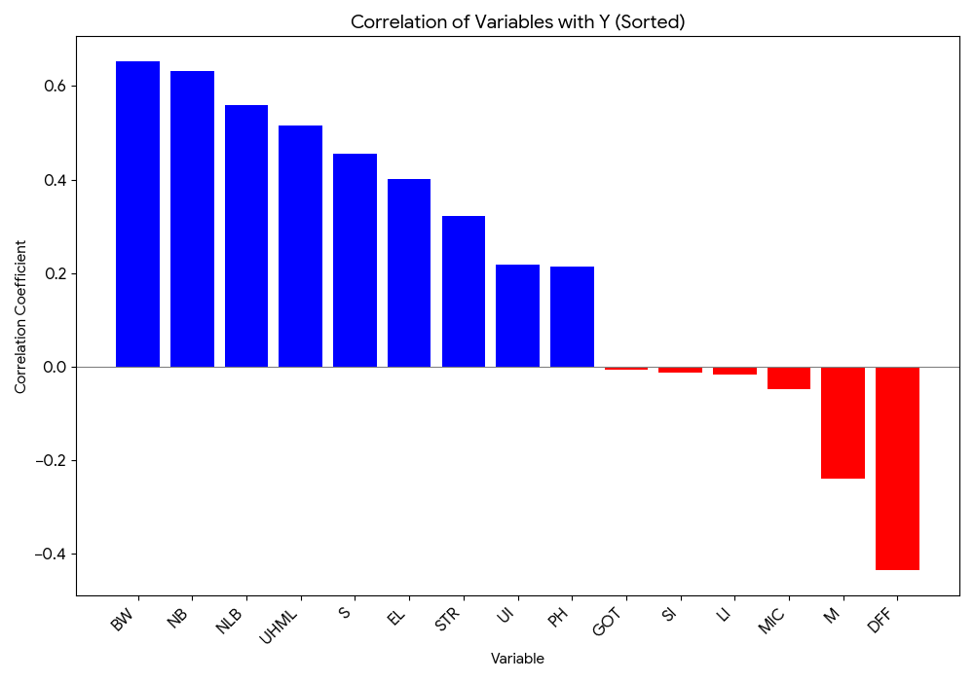
PATH ANALYSIS
Path analysis was employed to partition the correlation coefficients of various yield and quality traits into their direct and indirect effects. Traits that exert a direct influence on single-plant yield are considered the most reliable criteria for selection aimed at improving population-level yield. The direct effect represents the impact of an independent trait on the dependent trait, while the indirect effect refers to the influence of an independent trait on the dependent trait mediated through other independent traits.
DIRECT EFFECTS
From Table 2, among the evaluated traits, the number of sympodial branches per plant (1.5396) exhibited the highest direct positive effect on seed cotton yield per plant, followed by lint index (1.3526), which is consistent with the findings of Monicashree et al. (2018). Similarly, a high direct effect of sympodial branches per plant was also reported by Arunkumar et al. (2020) and Manonmani et al. (2019). The direct effect represents the contribution of a trait directly to the dependent variable, in this case, yield. Therefore, selecting plants with a higher number of sympodial branches per plant can effectively enhance seed cotton yield.
Other traits showing substantial direct positive effects on yield included boll weight (0.6285) and upper half mean fiber length (0.3392), indicating that improvements in these traits can also increase seed cotton yield. Moderate positive direct effects were observed for number of monopodial branches per plant (0.2828), fiber elongation percent (0.2096), and micronaire value (0.2835).
Conversely, plant height contributed a high negative direct effect (-0.5029) on single-plant yield, as reported by Arunkumar et al. (2020) and Jangid (2019), indicating that taller plants are less favorable for yield and should not be targeted in selection. Other traits, including seed index (-1.7377), number of bolls per plant (-1.1177), and ginning outturn (-1.6504), also exhibited high negative direct effects on seed cotton yield. Remaining traits showed only low or negligible direct effects.
The path analysis of the 35 F₁ hybrids revealed a residual effect of 0.4225, suggesting that the included traits accounted for a substantial proportion of the variation in seed cotton yield per plant.
INDIRECT EFFECTS
The number of sympodial branches per plant exhibited a very high positive indirect effect on seed cotton yield via boll weight (1.0212) and an even higher effect through number of bolls per plant (1.5125), consistent with Satish et al. (2020). This trait also showed high positive indirect effects through plant height (0.8424) as reported by Farooq et al. (2018) and Gulhane & Wadikar (2017), as well as through number of locules per boll (0.8099) and fiber elongation percent (0.3686). These findings indicate that selecting for these associated traits can indirectly enhance seed cotton yield.
The number of bolls per plant displayed very high negative indirect effects via sympodial branches per plant (-1.0979) and high negative effects through boll weight (-0.7492) and number of locules per boll (-0.5963). Conversely, boll weight had high indirect positive effects through plant height (0.3946), sympodial branches per plant (0.4132), number of bolls per plant (0.4213), and number of locules per boll (0.4296).
Seed index showed very high positive indirect effects via ginning outturn (1.1672) and high positive effects through fiber elongation percent (0.6472), but also high negative indirect effects via plant height (-0.5528), monopodial branches per plant (-0.6604), lint index (-0.7791), and micronaire value (-0.5233). Lint index contributed high positive indirect effects via plant height (0.0629), ginning outturn (0.4849), and upper half mean fiber length (0.4408). Ginning outturn exhibited very high positive indirect effects through seed index (1.1086) and high positive effects via monopodial branches per plant (0.6573) and micronaire value (0.4314), while also contributing high negative effects via lint index (-0.5916), upper half mean length (-0.4622), and fiber elongation percent (-0.4669).
Boll weight had high negative indirect effects on seed cotton yield via plant height (-0.4126), while plant height moderately negatively influenced yield through sympodial branches (-0.2751), number of bolls per plant (-0.2722), and number of locules per boll (-0.2766).
Overall, correlation and path coefficient analysis identified the most promising traits for improving seed cotton yield. The traits number of sympodial branches per plant, number of bolls per plant, and boll weight exerted the greatest impact on yield through both direct and indirect effects. Thus, selection based on these traits can simultaneously enhance cotton yield and fiber quality, providing valuable guidance for planning effective breeding programs.

Table 2: Phenotypic path analysis of 35 F1 hybrids for yield, yield attributing and fibre quality characters in cotton (Gossypium hirsutum L.)
 | DFF | PH | M | S | NB | BW | NLB | SI | LI | GOT | UHML | UI | STR | EL | MIC | Y
DFF | 0.0614 | 0.0342 | 0.0662 | -0.412 | 0.2909 | -0.2941 | -0.047 | 0.1917 | -0.0568 | -0.1178 | -0.0775 | -0.0091 | 0.0016 | -0.0336 | -0.034 | -0.436
PH | -0.0042 | -0.5029 | 0.0178 | 0.8424 | -0.605 | 0.3946 | 0.0944 | -0.5528 | 0.3629 | 0.1721 | -0.0134 | 0.0092 | 0.0012 | -0.0279 | 0.0256 | 0.2138
M | 0.0144 | -0.0316 | 0.2828 | -0.382 | 0.2254 | -0.2041 | -0.026 | -0.6604 | 0.0045 | 0.6573 | -0.1448 | -0.0284 | 0.0036 | -0.0574 | 0.107 | -0.2398
S | -0.0164 | -0.2751 | -0.0702 | 1.5396 | -1.0979 | 0.4132 | 0.0903 | -0.055 | 0.0497 | 0.0064 | 0.0416 | 0.009 | -0.0011 | 0.0502 | -0.0384 | 0.6459
NB | -0.016 | -0.2722 | -0.057 | 1.5125 | -1.1177 | 0.4213 | 0.0915 | -0.0438 | 0.0162 | 0.0261 | 0.0365 | 0.0086 | -0.0008 | 0.056 | -0.0283 | 0.633
BW | -0.0287 | -0.4126 | -0.0918 | 1.0212 | -0.7492 | 0.6285 | 0.1173 | -0.0685 | -0.0173 | 0.0755 | 0.0721 | 0.0193 | -0.0026 | 0.0358 | -0.0348 | 0.6517
NLB | -0.0168 | -0.2766 | -0.0428 | 0.8099 | -0.5963 | 0.4296 | 0.1716 | -0.2356 | 0.0162 | 0.2035 | 0.0976 | 0.0241 | -0.0029 | 0.0282 | -0.0508 | 0.5588
SI | -0.0068 | -0.16 | 0.1075 | 0.0488 | -0.0282 | 0.0248 | 0.0233 | -1.7377 | 0.6064 | 1.1086 | -0.0029 | -0.0064 | 0.0016 | -0.0781 | 0.0854 | -0.0137
LI | -0.0026 | -0.1349 | 0.0009 | 0.0566 | -0.0134 | -0.008 | 0.0021 | -0.7791 | 1.3526 | -0.5916 | 0.1105 | -0.002 | 0.0016 | -0.0291 | 0.0185 | -0.018
GOT | 0.0044 | 0.0524 | -0.1126 | -0.006 | 0.0177 | -0.0287 | -0.0212 | 1.1672 | 0.4849 | -1.6504 | 0.095 | 0.0056 | -0.0004 | 0.0593 | -0.0741 | -0.0069
UHML | -0.014 | 0.0199 | -0.1207 | 0.1888 | -0.1204 | 0.1335 | 0.0494 | 0.0149 | 0.4408 | -0.4622 | 0.3392 | 0.0059 | -0.0055 | 0.0489 | -0.1049 | 0.4136
UI | -0.0091 | -0.0752 | -0.1306 | 0.2264 | -0.1566 | 0.1971 | 0.0672 | 0.1807 | -0.0451 | -0.1514 | 0.0323 | 0.0614 | -0.0029 | 0.0497 | -0.0268 | 0.2171
STR | -0.008 | 0.0509 | -0.084 | 0.1341 | -0.0765 | 0.1373 | 0.0405 | 0.2331 | -0.1788 | -0.0546 | 0.1547 | 0.0149 | -0.0121 | 0.0931 | -0.1231 | 0.3212
EL | -0.0099 | 0.067 | -0.0775 | 0.3686 | -0.2988 | 0.1073 | 0.0231 | 0.6472 | -0.1879 | -0.4669 | 0.0792 | 0.0146 | -0.0054 | 0.2096 | -0.0685 | 0.4019
MIC | -0.0074 | -0.0454 | 0.1067 | -0.2084 | 0.1115 | -0.0772 | -0.0307 | -0.5233 | 0.0881 | 0.4314 | -0.1255 | -0.0058 | 0.0053 | -0.0506 | 0.2835 | -0.0479
Residual Effect =0.4225
DFF: Days to first flowering | M: Number of monopodial branches (nos.) | PH: Plant height (cm)
S: Number of sympodial branches (nos.) | GOT: Ginning outturn (%) | SI: Seed index (g)
LI: Lint Index (g) | EL: Elongation percent (%) | NBPP: Number of bolls per plant (Nos.)
NLB: Number of locules per boll (nos.) | Y: Seed Cotton yield per plant (g) | BW: Boll Weight (g)
UHML: Upper Half Mean Length (mm | MIC: Micronaire value (µg/inch) | UI: Uniformity index (%)
STR: Bundle strength (g/tex)

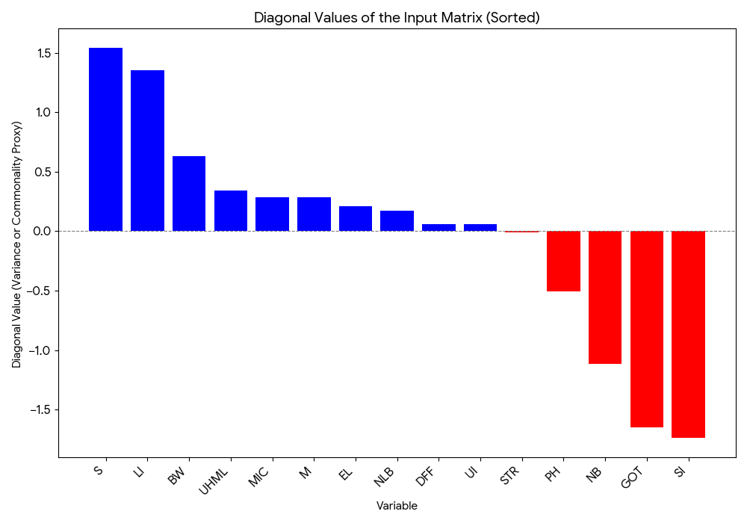

Conclusion
The present study highlights the importance of key yield and fiber-related traits in enhancing seed cotton yield in Gossypium hirsutum L. Correlation analysis revealed significant positive associations of seed cotton yield per plant with number of sympodial branches, number of bolls per plant, and boll weight, as well as with important fiber quality parameters such as upper half mean length, bundle strength, and elongation percentage. Path coefficient analysis further clarified the relative contributions of these traits, demonstrating that the number of sympodial branches per plant exhibited the highest direct positive effect on yield, followed by lint index, while boll weight and upper half mean length also contributed positively.
Indirect effects emphasized the role of associated traits in enhancing yield, with sympodial branches, boll weight, and number of bolls per plant showing strong positive influences via other yield-contributing traits. Conversely, traits such as plant height, seed index, ginning outturn, and number of bolls per plant in some interactions exhibited negative direct or indirect effects, indicating that selection based solely on these traits may not favor higher yield.
Overall, the study identifies number of sympodial branches per plant, number of bolls per plant, and boll weight as the most promising selection criteria for improving seed cotton yield while simultaneously maintaining desirable fiber quality. These findings provide a reliable basis for designing effective breeding programs aimed at developing superior cotton genotypes with high yield potential and improved fiber characteristics.
Acknowledgement
The authors sincerely express their gratitude to their friends and faculty members of the Department of genetic for their invaluable guidance, support, and encouragement throughout the course of this research.
Conflict of Interest
The authors declare that there is no conflict of interest associated with this study.
References
- Arunkumar, B., & Murthy, S. M. (2020). Correlation and path coefficient analysis for seed cotton yield, yield attributing and fibre quality traits in cotton (Gossypium hirsutum L.). International Journal of Current Microbiology and Applied Sciences, 9(2), 200–207.
- Attiq Ur Rehman Gohar, M. (2020). Estimate of correlation and heritability for morphological and yield component traits in introgressive population of Gossypium hirsutum L. (Doctoral dissertation)
- . Baloch, M., Baloch, A. W., Baloch, M. K., Mallano, I. A., Baloch, A. M., Baloch, N. J., & Abro, S. (2015). Association and heritability analysis for yield and fiber traits in promising genotypes of cotton (Gossypium hirsutum L.). Sindh University Research Journal-SURJ (Science Series), 47(2).
- Fayet, L., & Vermeulen, W. J. (2014). Supporting smallholders to access sustainable supply chains: Lessons from the Indian cotton supply chain. Sustainable Development, 22(5), 289–310.
- Farooq, J., Rizwan, M., Saleem, S., Sharif, I., Chohan, S. M., Riaz, M., … Kainth, R. A. (2018). Determination of genetic variation for earliness, yield, and fiber traits in advanced lines of cotton (Gossypium hirsutum). Advances in Agricultural Sciences, 6(2), 59–74.
- Gauswami Jyoti, J., Valu, M. G., & Odedara Geeta, N. (2021). Correlation, path coefficient and D² analysis study of seed cotton yield and fibre quality traits in American cotton (Gossypium hirsutum L.). Journal of Pharmacognosy and Phytochemistry, 10(3), 222–230.
- Gulhane, A., & Wadikar, M. S. (2017). Genotypic path coefficient analysis of cotton derived through introgression. International Journal of Current Microbiology and Applied Sciences, 6(2), 49–55.
- Hampannavar, M. R., Patil, B. R., Katageri, I. S., Kumar, B. A., & Janagoudar, B. S. (2020). Genetic variability and correlation analysis for agronomic and fibre quality traits in intra-specific cotton (G. hirsutum × G. hirsutum) recombinant inbred lines (RILs). International Journal of Current Microbiology and Applied Sciences, 9(1), 493–503.
- Handi, S. S., Ramesh, M., & Katageri, I. S. (2017). Genetic diversity studies for yield traits in upland cotton (Gossypium hirsutum L.). Journal of Pharmacognosy and Phytochemistry, 8(2), 587–593.
- Jangid, K. (2019). Genetic parameters, correlation and path analysis of agro-morphological traits in elite genotypes of upland cotton (Gossypium hirsutum L.). International Journal of Current Science, 7(5), 1885–1889.
- Kakar, M. A., Baloch, A. W., Sootaher, J. K., Gandahi, N., Chang, M. S., Khail, G. F. K., & Kasi, U. A. (2021). Assessment of genetic divergence and character association in upland cotton (Gossypium hirsutum L.) genotypes. International Journal of Biological & Biotechnological Studies, 18(2), 321–327.
- Manivannan, N. (2014). TNAUSTAT–Statistical package. Retrieved from https://sites.google.com/site/tnaustat
- Manonmani, K., Mahalingam, L., Malarvizhi, D., Sritharan, N., & Premalatha, N. (2019). Genetic variability, correlation and path analysis for seed cotton yield improvement in upland cotton (Gossypium hirsutum L.). Journal of Pharmacognosy and Phytochemistry, 8(4), 1358–1361.
- Monicashree, C., & Balu, P. A. (2018). Association and path analysis studies of yield and fibre quality traits in intraspecific hybrids of upland cotton (Gossypium hirsutum L.). Research Journal of Agricultural Sciences, 9(5), 1101–1106.
- Monisha, K. (2018). Genetic variability and correlation studies in upland cotton (Gossypium hirsutum L.). Electronic Journal of Plant Breeding, 9(3), 1053–1059.
- Mudasir, M., Noman, M., Zafar, A., Khalid, M. N., Amjad, I., & Hassan, A. (2021). Genetic evaluation of Gossypium hirsutum L. for yield and fiber contributing attributes in segregating population. International Journal of Recent Biotechnology, 9(3), 1–9..
- Mudhalvan, S., Rajeswari, S., Mahalingam, L., Jeyakumar, P., Muthuswami, M., & Premalatha, N. (2021). Causation studies for kapas yield, yield components and lint quality traits in Mexican cotton (Gossypium hirsutum L.). Environment Conservation Journal, 22(3), 357–363
- Nikhil, P. G., Nidagundi, J. M., & Anusha, H. A. (2018). Correlation and path analysis studies of yield and fibre quality traits in cotton (Gossypium hirsutum L.). Journal of Pharmacognosy and Phytochemistry, 7(5), 2596–2599.
- Parre, S., & Patil, R. S. (2021). Correlation studies and path coefficient analysis of yield attributing traits among selected F2 populations of intra-hirsutum cotton hybrids under rain-fed situation. The Pharma Innovation Journal, 10(3), 942–950.
- Pearson, K. (1920). Notes on the history of correlation. Biometrika, 13(1), 25–45.
- Rai, P., & Sangwan, O. (2020). Correlation studies in elite lines of upland cotton (Gossypium hirsutum L.). Electronic Journal of Plant Breeding, 11(1), 298–300.
- Rehman, A., Mustafa, N., Du, X., & Azhar, M. T. (2020). Heritability and correlation analysis of morphological and yield traits in genetically modified cotton. Journal of Cotton Research, 3(1), 1–9.
- Saritha, H. S., & Patil, R. S. (2019). Association analysis among agronomic and fiber quality traits in color-cotton (Gossypium hirsutum L.). Journal of Pharmacognosy and Phytochemistry, 8(4), 2393–2396.
- Satish, Y., Rani, M. S., & Chapara, R. (2020). Correlation and path coefficient analysis for yield and yield component traits in upland cotton (Gossypium hirsutum L.). International Journal of Chemical Studies, 8(2), 2742–2746

