**Temperature-Dependent Variations in Growth, Agronomic Traits, and Sensory Attributes of Millet Microgreens**

1Geethanjali Sadayandi, 2Thirumurugan Thiruvengadam, 3Yogasri Thamenthiran

1Department of Crop Physiology & Biochemistry, 2Department of Genetics & Plant Breeding, 3IV BSc (Hons.) Agriculture

Anbil Dharmalingam Agricultural College and Research Institute, Navalur kuttapattu, **Tiruchirapalli,** Tamil Nadu, India – 620 027

e-mail- [geethanjali.s@tnau.ac.in](mailto:geethanjali.s@tnau.ac.in)**,** ORCID - **0000-0003-4090-6889**

**Abstract**

Temperature strongly influenced the germination, growth, yield, and sensory quality of six millet microgreens (barnyard, foxtail, kodo, proso, little, and pearl). Germination was optimal at 35°C, with kodo (100%), barnyard (92%), and little millet (84%) recording the highest values, while extreme temperatures (15°C and 40°C) reduced seedling vigor. Growth responses were species-specific: barnyard millet showed superior shoot elongation at lower temperatures, whereas pearl millet invested more in root growth and achieved the greatest seedling length, particularly at 35°C (18.55 cm). Yield analysis confirmed 35°C as the most favourable regime, where barnyard millet (16.65 g/5 g seed) significantly outperformed other species, followed by little and kodo millet, while foxtail millet was the poorest yielder but showed relative adaptability to cooler regimes. Sensory evaluation of 7-day-old microgreens grown at 35°C revealed higher consumer preference when incorporated into vegetable salads compared to plain servings. Appearance, taste, and overall acceptability improved markedly in salad combinations, with kodo and barnyard microgreens emerging as the most acceptable. These findings highlight the importance of temperature in regulating productivity and consumer quality traits, suggesting that 35°C represents the optimal condition for millet microgreen production, with kodo and barnyard showing strong potential for functional food applications.

`

Keywords: *Growth performance, Millet microgreens, Sensory evaluation, Temperature regimes*

## Introduction

Millets, belonging to the Poaceae family, are small-grained cereals widely grown across Asia and Africa. They are appreciated for their resilience under drought and poor soils, and for their rich nutritional profile that includes dietary fiber, essential amino acids, minerals, and antioxidants (Navjot et al. 2024). As climate-smart crops, millets play an important role in ensuring food and nutritional security, particularly in semi-arid regions (Patil et al. 2020). Beyond traditional grain use, they are also gaining recognition for their potential as **microgreens**, the tender seedlings harvested within 7–21 days of sowing.

Microgreens are promoted as functional foods because of their high concentrations of vitamins, minerals, and bioactive compounds. Their nutrient density often exceeds that of mature plants by several folds (Seth et al. 2025). Millet microgreens, in particular, are known to contain phenolic compounds, flavonoids, and carotenoids that provide antioxidant and disease-preventive benefits (Sharma et al. 2021). Their short growth cycle, pleasant flavor, and adaptability to controlled environments make them well suited for urban farming and diet diversification.

Temperature is one of the most critical abiotic factors affecting germination, enzyme activity, photosynthesis, and biomass accumulation. Owing to their short growth cycle, microgreens are especially sensitive to fluctuations in temperature (Proietti et al. 2021). For millet species, optimum germination is generally reported between 25–30°C, although species-specific variations occur (Singh et al. 2019). However, systematic studies on how temperature influences millet microgreens remain limited. This study evaluated the response of six millet species (barnyard, foxtail, kodo, proso, little, and pearl millet) under six temperature regimes (15, 20, 25, 30, 35, and 40 °C) to identify the optimum temperature for microgreen cultivation. Sensory attributes of microgreens produced at the optimized temperature were also assessed.

## Materials and Methods

The study was conducted during May to August 2025 in a controlled plant growth chamber facility at the Department of Crop Physiology and Biochemistry, Anbil Dharmalingam Agricultural College and Research Institute, Tamil Nadu Agricultural University, Tiruchirappalli, India. The growth chamber allowed precise regulation of temperature, light intensity, photoperiod, and humidity to ensure uniform experimental conditions.

### Plant Material

Seeds of six millet species barnyard (Echinochloa frumentacea), foxtail (Setaria italica), kodo (Paspalum scrobiculatum), proso (Panicum miliaceum), little (Panicum sumatrense), and pearl millet (Pennisetum glaucum) were procured from the Centre of Excellence for Millets (CEM), Athiyandal. Seeds belonged to variety ATL 1 with >85% germination and were sown without chemical treatment.

**Growth Medium and Conditions**

A mixture of soil, coirpith, and vermicompost in the ratio of 1:1:1.5 (w/w) was used as the growth medium. Seeds (5 g per cup) were soaked in distilled water for 12 h before sowing in germination cups with drainage holes. The medium was filled to three-fourths of the cup depth, and the soaked seeds were evenly spread on the surface. The cups were irrigated using a handheld sprayer, covered, and kept under dark conditions at 25 ± 3 °C for two days to ensure uniform germination. After germination, the cups were transferred to a controlled plant growth chamber and maintained under six temperature regimes (15, 20, 25, 30, 35, and 40°C) with three replications each. The chamber conditions were standardized with a 16 h light / 8 h dark photoperiod using LED lighting, and relative humidity was maintained at 60–70%. The seedlings were misted twice daily with drinking water to ensure adequate moisture. Observations on germination percentage, agronomic traits, yield and sensory attributes were recorded in microgreens harvested on the 7th day.

**Organoleptic Assessment of millet microgreens**

Sensory evaluation of millet microgreens was conducted using a 9-point hedonic scale as described by Priti et al. (2022). The following parameters were assessed:

1. Appearance – Evaluated based on vibrancy and uniformity of colour, distinct leaf morphology, and consistency in seedling size.
2. Colour – Assessed visually for brightness, intensity, and uniformity of green colouration.
3. Taste – Flavour quality and palatability assessed by consuming a small portion of washed microgreens.
4. Aroma – Fresh earthy or plant-like odor determined by smelling freshly harvested samples.
5. Texture – Tenderness, succulence, and crunchiness assessed through mastication.
6. Overall acceptability – Represented the integrated perception of all sensory attributes to determine consumer preference.

Phenotypic parameters were measured as follows:  
7. Seedling height – Average length from base to shoot tip measured using a ruler.  
8. Fresh weight – Determined by weighing microgreens harvested from unit area using a precision balance.  
9. Dry weight – Recorded after oven-drying samples at 70°C for 2–3 h until constant weight.

**Consumer Acceptance**

One accession from each of the six millet species were selected for the study. All the millet microgreen samples were harvested on the same day and subjected to thorough cleaning, including washing under running water and removal of excess moisture and residues. The samples were equilibrated to room temperature for 10 minutes prior to serving. Consumer evaluation was conducted at Anbil Dharmalingam Agricultural College and Research Institute (ADAC & RI), Trichy, using a convenience panel of 52 participants (aged 20–55 years). Panellists were selected based on their regular consumption of green leafy vegetables, non-smoking status, and absence of conditions such as cold, flu, allergies, or nausea.

Acceptance was measured using a 9-point hedonic scale ranging from 9 (liked extremely) to 1 (disliked extremely) following Priti et al. (2022). Each participant received 5 g of each microgreen accessions, served on white plates labelled alphabetically to ensure blinding. The study was conducted in two sessions with a maximum of 26 participants per session. Panellists were instructed to cleanse their palates with water between tastings and were seated individually in a quiet environment to minimize discussion. Prior to evaluation, participants were provided with detailed instructions on the procedure and sample presentation.

Two salad formulations were tested:

* Plain millet microgreens seasoned with salt and pepper.
* Millet microgreens blended with vegetables (carrot, cabbage, radish, mango, onion, cucumber, and Bengal gram).

## Statistical analysis

One-way analysis of variance (ANOVA) was performed using SPSS software (Version 26.0, USA). Mean differences among treatments were compared using Duncan’s Multiple Range Test (DMRT), and significance was determined at *p* ≤ 0.05.

## Results and Discussion

**Germination and Growth Response of Millet Microgreens to Temperature**

Germination percentage was assessed across six temperature regimes (15-40°C) and the optimum temperature for maximum yield of millet microgreens were determined. At 35°C, kodo millet (100%), barnyard millet (92%), and little millet (84%) recorded the highest germination, followed by pearl millet (80%), proso millet (72%), and foxtail millet(60%). At 40°C, both kodo and barnyard millet produced notably taller seedlings, although overall germination declined (Fig 1). Germination percentage declined markedly under extreme temperature regimes (both 15°C and 40°C) for most species, corroborating earlier reports that temperature stress adversely affects seedling vigor and establishment (Dhaka et al., 2023). Moderate temperatures (25–35°C) generally promoted uniform germination, healthy seedling morphology, and higher yield potential. The controlled environment of the plant growth chamber, equipped with a combination of warm yellow light and LED illumination (Philips 20 W) under a 16 h light / 8 h dark photoperiod, ensured uniform light availability for photosynthetic activity. Regular watering with drinking water, maintained seedling turgidity and supported growth until the emergence of the first true leaves. These conditions collectively optimized the growth of millet microgreens, with temperature playing a decisive role in determining both germination and yield potential.

**Temperature-Dependent Variations in Physical Traits of Millet Microgreens**

Microgreens can be successfully cultivated under stable temperature and humidity conditions (Lone and Pandey, 2024). However, temperature is a key factor influencing their physical appearance, quality, shelf life, and sensory traits (Dubey et al., 2024). In this study, considerable variation in shoot length, root length, and total seedling length was observed among millet species across different temperature regimes. At lower temperatures (15–25°C), barnyard millet consistently exhibited superior shoot elongation, whereas pearl millet invested more in root growth, resulting in the highest total seedling length. At higher temperatures (30-40°C), pearl millet outperformed all other species, attaining the maximum shoot, root, and seedling lengths, particularly at 35°C (11.85 ± 0.24 cm shoot, 6.70 ± 0.26 cm root, and 18.55 ± 0.16 cm seedling). Kodo millet followed with moderate adaptability, while other species recorded comparatively lower growth under heat stress (Fig 2).

These findings indicate species-specific adaptability to temperature conditions, where barnyard millet consistently favoured shoot elongation, while pearl millet invested more in root growth, thereby attaining the highest seedling length. Such variation reflects differential physiological responses, likely associated with temperature-driven metabolic activity and resource allocation during early growth stages.

By comparing growth parameters across temperature regimes, it was evident that barnyard millet, foxtail millet, and pearl millet performed best at 35°C, whereas kodo millet and proso millet showed superior growth at 40 °C. In contrast, little millet exhibited maximum growth at 20°C, indicating species-specific thermal adaptability. Overall, the findings suggest that 35°C (room temperature) represents the optimal condition for millet microgreen production, as it supported superior growth performance in the majority of accessions. Similar temperature-mediated effects on seedling morphology and biomass accumulation have been reported earlier. Sharma et al. (2021) demonstrated that temperature strongly regulates elongation and fresh weight accumulation in microgreens. Kong et al. (2023) further observed that cultivating arugula at 23°C and 28°C enhanced final plant height, elongation rate, and hypocotyl length, corroborating the present findings.

**Influence of thermal regimes on crop productivity**

Temperature had a significant effect (p ≤ 0.05) on the yield of millet microgreens, confirming that thermal conditions are a key factor for productivity. A stable and suitable temperature is essential because it regulates enzymatic activity, nutrient uptake, and biomass accumulation. As also noted by Dubey et al. (2024), the vegetative stage of plants benefits from higher temperatures compared to the reproductive stage.

Statistical analysis (ANOVA and Duncan’s multiple range test at p ≤ 0.05) showed strong differences among species and temperatures, with barnyard millet consistently producing the highest yields. At 35°C, barnyard millet achieved the maximum yield (16.65 g per 5 g seed), which was significantly higher than all other species. Even at lower temperatures, barnyard millet maintained its superiority, producing 5.93 g at 15°C and increasing steadily with temperature. Little millet ranked second, especially at 25 °C (5.07 g) and 35 °C (12.50 g), while kodo millet showed resilience at higher temperatures (30–40 °C), yielding on par with barnyard millet at 40°C (6.21 g vs. 5.68 g).

Foxtail millet consistently had the lowest yields but performed relatively better at cooler temperatures (15°C), suggesting that it prefers low-temperature environments. Its ability to maintain chlorophyll, compact growth, and higher phenolic content under cool conditions likely improved its appearance, texture, and flavour, making it suitable for niche, low-temperature microgreen production. Overall, the results confirm that 35°C is the most favorable temperature for maximum yield, with barnyard millet as the best performer, followed by little and kodo millet. Foxtail millet, though a poor yielder, showed potential under cooler conditions, highlighting species-specific thermal adaptability (Fig 3).

**Organoleptic Assessment and Acceptance of millet microgreens**

Millet microgreens were harvested on the 7th day after sowing. As members of the Poaceae (Gramineae) family, delayed harvest beyond this stage increases fiber content, rendering them fibrous and less palatable. Hence, 7-day-old microgreens were used for both sensory evaluation and phenotypic characterization. Organoleptic assessment was carried out on microgreens grown at 35°C, and sensory scores for six species (pearl, barnyard, kodo, proso, little, and foxtail millet) were recorded for appearance, colour, aroma, taste, texture, and overall acceptability under two serving modes: vegetable salad with microgreens and plain microgreens (Fig. 4).

The appearance scores were significantly higher when microgreens were incorporated into vegetable salads (8.0–8.4) compared to plain microgreens (6.8–7.6). Barnyard (8.4) and Proso (8.2) microgreens received the highest visual appeal in salads, while Pearl (7.1) and Barnyard (6.8) recorded lower values when served plain. Similarly, colour perception was positively influenced by salad incorporation, with Kodo (8.3) and Foxtail (8.1) ranking highest. Pearl microgreens also maintained good colour even in plain form (8.0), suggesting that pigmentation and visual freshness strongly contributed to consumer appeal.

Aroma was the most critical parameter differentiating the two serving modes. Plain microgreens scored poorly (4.8–6.3), with little millet recording the least preference (4.8) due to its pronounced raw, grassy odour. In contrast, salads containing microgreens achieved consistently higher scores (7.8–8.1), with little millet performing the best (8.1). The improvement indicates that blending with vegetables effectively masked the earthy or bitter volatiles characteristic of raw microgreens, thereby enhancing aroma acceptability.

Taste scores revealed a remarkable enhancement when microgreens were consumed with salads (8.0–8.4), while plain consumption was considerably less preferred (5.9–7.6). Kodo (8.4) and Pearl (8.3) emerged as the most palatable in salad combinations, whereas Pearl plain microgreens dropped sharply to 6.1. This indicates that microgreens may carry inherent bitterness or pungency, which can be balanced when consumed in combination with vegetables.

Panelists perceived better textural attributes in salads (7.8–8.1) than in plain samples (5.9–6.7). Proso (8.1) and Barnyard (8.0) microgreens contributed positively to mouthfeel when combined with vegetables, while plain Kodo (5.9) and Foxtail (6.0) scored lower. The fibrous or chewy nature of raw microgreens likely limited texture acceptability when eaten alone.

**Overall Acceptability**

A consistent pattern was observed for overall acceptability, where salad-based microgreens were rated higher (8.1–8.3) compared to plain ones (6.3–7.2). Kodo (8.3) and Barnyard (8.2) were the most preferred in salad form, while Proso (7.2) retained relatively higher acceptability in plain form.

Across all sensory parameters, incorporation into salads improved scores by 1–2 points, demonstrating a strong consumer preference for microgreens as a salad ingredient rather than as a standalone food. Kodo and Barnyard microgreens consistently performed better across sensory dimensions, highlighting their potential for consumer acceptance and commercial promotion in functional food products. Conversely, Little millet showed contrasting responses, excelling in aroma and appearance in salads but performing poorly when consumed plain. This supports earlier reports that consumer acceptance improves when microgreens are used as complementary salad ingredients (Caracciolo et al. 2020).

## Conclusion

Temperature plays a decisive role in determining the germination, growth, yield, and consumer acceptance of millet microgreens. Among the tested regimes, 35°C emerged as the most favorable condition, promoting higher germination, vigorous growth, and maximum yield, particularly in barnyard and kodo millet. While extreme temperatures limited performance, species-specific adaptations were evident, with foxtail millet showing tolerance to cooler conditions and pearl millet investing more in root growth. Sensory evaluation further emphasized that consumer preference was highest when microgreens were incorporated into salads, with barnyard and kodo ranking superior in appearance, taste, and overall acceptability. Collectively, these results suggest that 35°C is the optimal temperature for millet microgreen cultivation, and barnyard and kodo millet hold strong promise for functional food applications due to their superior yield and sensory appeal. Overall, millet microgreens cultivated under optimal conditions represent a sustainable, nutrient-dense food option well suited to urban agriculture and nutrition security, with strong promise in functional food systems. The statistical analysis underscores that barnyard millet is the most productive species across a wide thermal range, while little and kodo millets are strong alternatives under moderately warm to hot conditions.

**Funding and Acknowledgment**

SG acknowledge the financial support provided by the GOI-DST-SHRI (Science and Heritage Research Initiative), New Delhi, India.

**Ethics Statement**:

No ethical approval was required since the studies involving only plants.

**Originality and Plagiarism**:

This manuscript is an original work and not previously published.

**Consent for Publication**:  
All authors must agree to the content of the article and its publication in the journal.

**Competing Interests**:  
The authors declare that they have no conflict of interest.

**Data Availability**:

The data used and/or analyzed during the current study are available from the corresponding author upon reasonable request.

**Author Contributions**:

Conceptualization of research (SG), Designing of experiments (SG, TT & TY), Contribution of experimental materials (SG, TY, Field/lab experiments (TY), Data interpretation (SG and TT), Preparation of manuscript (SG and TT).

**References**

Fageria, N. K., Dos Santos, A. B. and T. Cobucci. 2011. Zinc nutrition of lowland rice. *Commun. Soil Sci. Plant Analysis.*, 42: 1719-1727.<https://doi.org/10.29321/xx.10.001093>

Navjot, K., Sandhya, S. and Arora, S. 2024. Nutritional, health, and economic importance of millets. Front. Sustain. Food Syst. **8**:1–12. <https://doi.org/10.3389/fsufs.2024.123456>

Patil, S., Sharma, R. and Kumar P. 2020. Millets as climate-resilient crops: A review. J. Cereal Res. **12**:251–258. <https://doi.org/10.25174/2582-2675/2020/110521>

Seth, T., Mishra, G., Chattopadhyay, A., Roy, PD., Devi, M., Sahu, A., Sarangi, S.K., Mhatre, C.S., Lyngdoh, Y.A., Chandre, V., Dikshit, H.K. and Nair, R.M. 2025. Microgreens: Functional Food for Nutrition and Dietary Diversification. *Plants*, *14*(4), 526. <https://doi.org/10.3390/plants14040526>

Sharma, P., Kumar A. and Singh R. 2021. Influence of temperature regimes on growth and physiology of millet microgreens. Plant Arch. **21**:450–456.

Proietti, S., Moscatello, S. and Battistelli, A. 2021. Light and temperature interactions on microgreens: Growth and nutritional responses. Sci. Hortic. **281**:109999. <https://doi.org/10.1016/j.scienta.2021.109999>

Singh, R., Kumar P. and Sharma S. 2019. Temperature effect on germination and seedling growth of small millets. Indian J. Plant Physiol. **24**:629–635. <https://doi.org/10.1007/s40502-019-00463-y>

Priti Sangwan, S., Kukreja, B., Mishra, G.P., Dikshit, H.K., Singh, A., Aski, M., Kumar, A., Taak, Y., Stobdan, T. and Das, S., 2022. Yield optimization, microbial load analysis, and sensory evaluation of mungbean (Vigna radiata L.), lentil (Lens culinaris subsp. culinaris), and Indian mustard (Brassica juncea L.) microgreens grown under greenhouse conditions. *Plos one*, *17*(5), p.e0268085.

Dhaka, A.S., Dikshit, H.K., Mishra, G.P., Tontang, M.T., Meena, N.L., Kumar, R.R., Ramesh, S.V., Narwal, S., Aski, M., Thimmegowda, V., Gupta, S., Nair, R.M and Praveen S. 2023. Evaluation of Growth Conditions, Antioxidant Potential, and Sensory Attributes of Six Diverse Microgreens Species. Agriculture, 13, 676. https://doi.org/10.3390/ agriculture13030676

Lone, J.K. and Pandey, R. 2024. Microgreens on the rise: Expanding our horizons from farm to fork. Heliyon. 29;10(4).

Dubey, S., Harbourne, N., Harty, M., Hurley, D. and Elliott-Kingston, C. 2024. Microgreens Production: Exploiting Environmental and Cultural Factors for Enhanced Agronomical Benefits. Plants, 13, 2631. https://doi.org/10.3390/ plants13182631

Kong, Y., Masabni, J. and Niu, G. 2023. Effect of Temperature Variation and Blue and Red LEDs on the Elongation of Arugula and Mustard Microgreens. Horticulturae, 9, 608. https://doi.org/10.3390/ horticulturae9050608

Caracciolo, F., El-Nakhel, C., Raimondo, M., Kyriacou, M.C., Ciriello, M., Pannico, A., De Pascale, S. and Rouphael, Y. 2020. Sensory attributes and consumer acceptability of 12 microgreens species. Agronomy. **10**:1043. [https://doi.org/10.3390/agronomy10071043](https://doi.org/10.3390/agronomy10071043?utm_source=chatgpt.com)

**Table 1: Shoot length, root length and seedling length of different millets at different temperatures**

|  |  |  |  |  |  |  |  |  |  |
| --- | --- | --- | --- | --- | --- | --- | --- | --- | --- |
| **CROP** | **15˚C** | | | **20˚C** | | | **25˚C** | | |
| **SL (cm)** | **RL (cm)** | **SDL (cm)** | **SL (cm)** | **RL (cm)** | **SDL (cm)** | **SL (cm)** | **RL (cm)** | **SDL (cm)** |
| **BM** | **5.83±0.41j** | 5.78±0.25j | 11.61±0.52jj | **5.45±0.10h** | 7.41±0.32h | 12.86±0.28h | **6.25±0.35i** | 6±0.33i | 12.25±0.35i |
| **FM** | 4.39±0.45l | 5.6±0.21m | 9.99±0.47lmn | 2.8±0.26l | 7.42±0.17m | 10.22±0.32 lm | 3.5±0.24r | 3.35±0.24r | 6.85±0.34r |
| **KM** | 3.4±0.32p | 4.8±0.26q | 8.2±0.35pq | 3.18±0.24l | 6.68±0.24m | 9.86±0.43lmn | 4.53±0.13n | 5.16±0.22n | 9.69±0.27n |
| **PrM** | 4.55±0.37l | 5.85±0.58l | 10.4±0.57l | 4.06±0.10k | 6.82±0.23k | 10.88±0.23 k | 5.19±0.14o | 3.6±0.18o | 8.79±0.23o |
| **PeM** | 5.08±0.18e | **9.8±0.26e** | **14.88±0.21e** | 3.9±0.16b | **13.51±0.54b** | **17.41±0.54b** | 4.6±0.32f | **9.5±0.24f** | **14.1±0.39f** |
| **LM** | 2.85±0.34s | 2.65±0.53s | 5.5±0.62s | 4.55±0.26h | 8.58±0.15h | 13.13±0.36h | 4.35±0.24o | 4.65±0.34o | 9±0.24o |

SL- Shoot length, RL- Root length, SDL - Seedling length. According to Duncan’s multiple range test at p ≤ 0.05 the mean with different letters in the same column indicates a significant difference. ## Treatments with same letter are not significant

**Table 2: Growth parameters of millet microgreens under varying temperatures**

|  |  |  |  |  |  |  |  |  |  |
| --- | --- | --- | --- | --- | --- | --- | --- | --- | --- |
| **CROP** | **30˚C** | | | **35˚C** | | | **40˚C** | | |
| **SL** | **RL** | **SDL** | **SL** | **RL** | **SDL** | **SL** | **RL** | **SDL** |
| **BM** | 6.07±0.11l | 4.23±0.21l | 10.3±0.25 l | 9.45±0.26f | 4.1±0.21g | 13.55±0.26fg | 7.34±0.15l | 3.07±0.08l | 10.41±0.18 l |
| **FM** | 4.03±0.12r | 3.08±0.09r | 7.11±0.14r | 9.8±0.26f | 4.3±0.26f | 14.1±0.21f | 4.11±0.12q | 4±0.07q | 8.11±0.12q |
| **KM** | **7.83±0.30g** | **5.65±0.53g** | **13.48±0.48g** | **8.9±0.21f** | **4.85±0.249** | **13.75±0.26fg** | **9.63±0.24d** | **6.12±0.18d** | **15.75±0.26d** |
| **PrM** | 5.14±0.11o | 3.49±0.19p | 8.63±0.23op | 7.8±0.26j | 3.7±0.26j | 11.5±0.24 j | 8.2±0.16i | 3.72±0.27j | 11.92±0.31ij |
| **PeM** | **8.8±0.28c** | **7.46±0.07c** | **16.26±0.30c** | **11.85±0.24a** | **6.7±0.26a** | **18.55±0.16a** | **8.7±0.26d** | **7.08±0.10d** | **15.78±0.29d** |
| **LM** | 5.1±0.09o | 4.49±0.07o | 9.59±0.12o | 7.15±0.24k | 3.85±0.24k | 11±0.00 k | 6.01±0.09k | 4.96±0.05k | 10.97±0.11 k |

SL- Shoot length, RL- Root length, SDL - Seedling length

According to Duncan’s multiple range test at p ≤ 0.05, the mean with different letters in the same column indicates a significant difference. ## Treatments with same letter are not significant

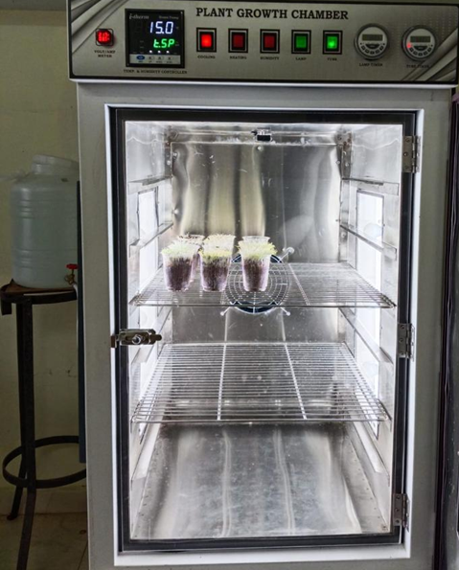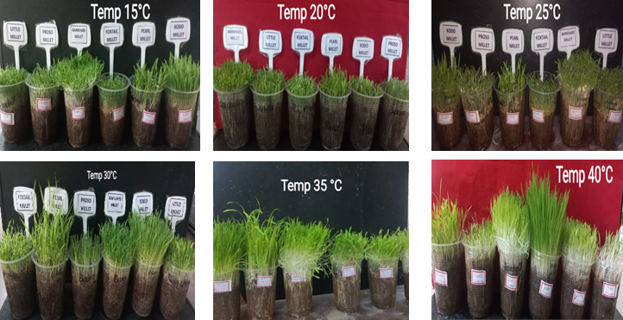

**Plant Growth chamber**

**Millet microgreens**

**Fig 1 Millet microgreens grown at different temperature regimes**

Fig 2 Effect of temperature on seedling length of millet microgreens

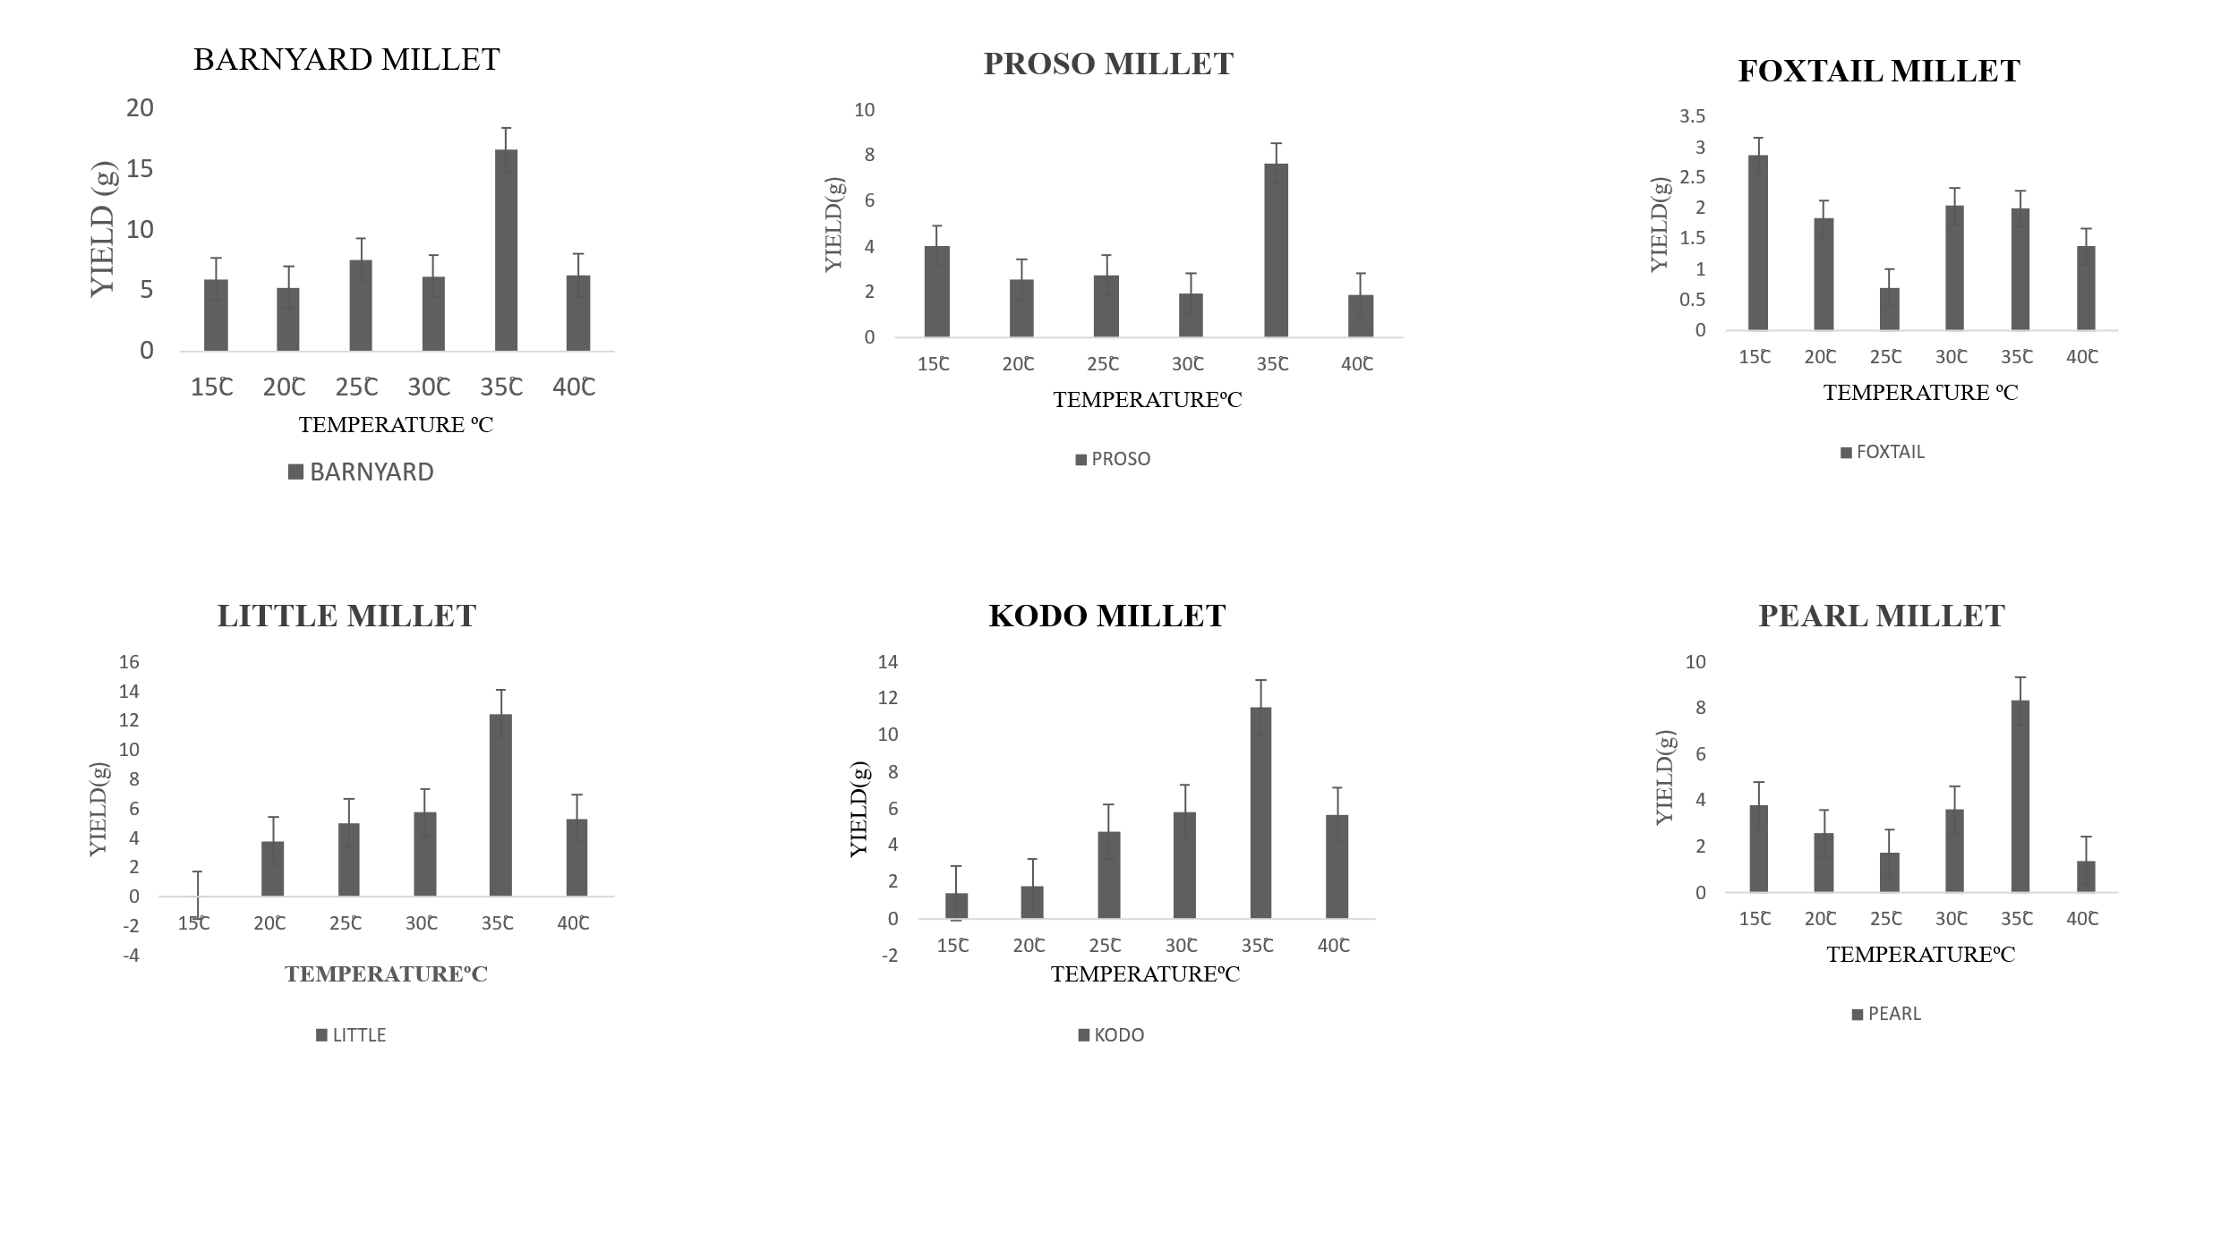

Fig 3 Effect of temperature on different millet microgreens

Bars present is mean ± SE (n = 3)

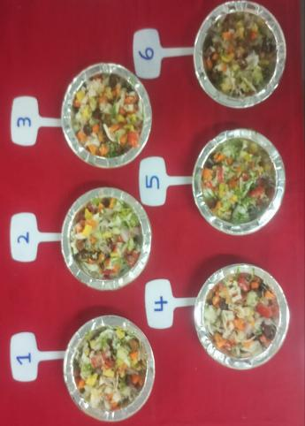

**Vegetable salad**

**with microgreens**

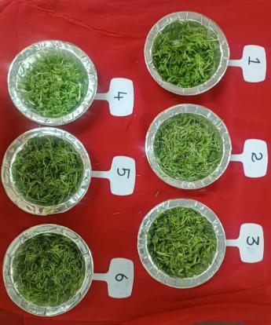

**Plain microgreen salad**

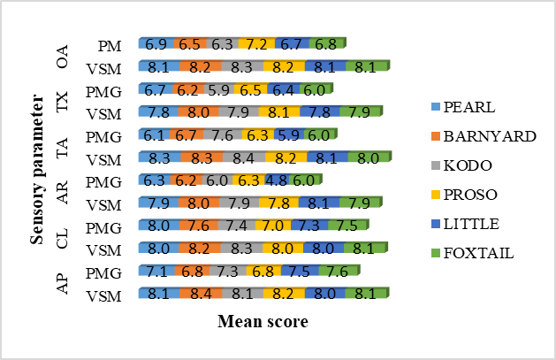

Fig 4 Comparison of Organoleptic Attributes of Millet Microgreens: Plain vs. Salad

**\***9-point hedonic scale [AP – Appearance, CL- Colour, AR-Aroma, TA- Taste, TX – Texture] PM- Plain microgreen, VSM- Vegetable salad+ microgreen