Postharvest Shelf-Life Assessment of Treated Fresh-Cut Onions Under Vacuum Packaging
Priyanka, A¹., Karthika, S¹., Hema, K². and Usha Antony³
¹M.Tech, Department of Food Process Engineering, Agricultural Engineering College and Research Institute, Tamil Nadu Agricultural University, Coimbatore-641003, Tamil Nadu, India.
¹ M.Tech, Department of Food Engineering and Technology, Tezpur University, Tezpur, Assam-784028, India.
²Assistant Professor, Department of Food Safety and Quality Assurance, College of Fish Nutrition and Food Technology, Tamil Nadu Dr. J.Jayalalithaa Fisheries University, Madhavaram Milk Colony, Chennai, Tamil Nadu, India.
³The Dean, College of Fish Nutrition and Food Technology, Madhavaram Milk Colony, Chennai, Tamil Nadu, India.
Correspondence: ²Assistant Professor, Department of Food Safety and Quality Assurance, College of Fish Nutrition and Food Technology, Tamil Nadu Dr. J.Jayalalithaa Fisheries University, Madhavaram Milk Colony, Chennai, Tamil Nadu, India.
E-mail ID: hema@tnfu.ac.in.
Abstract
This study evaluated the effectiveness of sodium benzoate and potassium metabisulfite in preserving fresh-peeled onions stored at 4°C for 21 days. Five treatments were applied: control with no preservative (T0), 0.05% sodium benzoate (T1), 0.1% sodium benzoate (T2), 0.01% potassium metabisulfite (T3), and 0.08% potassium metabisulfite (T4). Samples were vacuum-packed and assessed periodically for physicochemical properties (pH, weight loss, total soluble solids [TSS], texture, and firmness), microbial load (total plate count [TPC], E. coli, lactic acid bacteria), and sensory attributes. Results showed that T1 (0.05% sodium benzoate) was most effective in maintaining quality, exhibiting higher firmness, TSS, and titratable acidity (TA), along with the lowest weight loss. All treatments exhibited increasing TSS, TA, and weight loss, while pH and firmness declined over time. T1 also recorded the lowest TPC, and E. coli and lactic acid bacteria were absent in all samples. Sensory evaluation rated T1 highest in overall acceptability. These findings suggest that 0.05% sodium benzoate effectively preserves the quality and extends the shelf-life of vacuum-packed fresh-peeled onions for up to 21 days under refrigerated conditions.
Keywords: Vacuum Packaging, Minimally Processed Onions, Shelf-Life, Chemical treatments, Preservation.

Introduction
In recent years, there has been a growing consumer demand for fresh-cut, minimally processed vegetables due to changing lifestyles and preferences for convenience foods. Fresh-peeled onions have emerged as a popular choice in this category (Bhuvaneswari et al., 2015). However, processing operations such as peeling and cutting compromise the natural barriers of onion tissues, making them more susceptible to microbial contamination, enzymatic browning, moisture loss, and the release of pungent, lachrymatory compounds (Kim et al., 2011; Lucera et al., 2012). Therefore, effective preservation strategies are essential to ensure product safety, quality, and extended shelf life.
Vacuum packaging is a widely adopted preservation technique in the food industry, offering several advantages for extending the shelf life of perishable products. By removing oxygen from the packaging environment, this method reduces oxidative reactions responsible for lipid peroxidation, pigment degradation, and off-flavor development, while also inhibiting the growth of aerobic spoilage microorganisms (Hong et al., 2003). Additionally, vacuum packaging enhances the physical characteristics of the package, such as rigidity and heat transfer efficiency, and minimizes headspace, thereby improving storage efficiency and product protection (Hong and Charles, 2013). These benefits have been linked to better retention of color, texture, and overall sensory attributes during storage (Zudaire et al., 2020).
Given these advantages, this study aims to investigate the effectiveness of vacuum packaging in preserving the quality of fresh-peeled onions stored under refrigerated conditions. Specifically, the study will evaluate physicochemical, microbial, and sensory parameters over a 21-day storage period at 4°C. The outcomes are expected to provide valuable insights into the potential of vacuum packaging as a postharvest preservation strategy, contributing to reduced losses, improved product quality, and increased consumer acceptability of fresh-cut onions.
Materials and Methods
Materials
Fresh onions (Allium cepa L.) were sourced from the Koyambedu Market in Chennai, India, and stored at ambient room temperature until use. All reagents and solvents employed were of analytical or guaranteed reagent grade. Food-grade Class II preservatives-sodium benzoate (E211) and potassium metabisulfite (E224)- were used to inhibit microbial growth and maintain sample quality.
Culture media for microbiological analyses were obtained from Hi-Media Laboratories (Mumbai, India). Microbiological parameters assessed included Total Plate Count (TPC), Escherichia coli, and Lactic Acid Bacteria (LAB), using Plate Count Agar, MacConkey Agar, and appropriate selective media, respectively.
Onion samples were packaged in multilayer pouches composed of polyamide and polyethylene, procured from Sabena Packaging (Chennai, India).
Preparation of Fresh-Peeled Onions
Fresh onions were manually peeled and immediately subjected to chemical pretreatment. Whole peeled onions were immersed for 5 minutes in preservative solutions as follows:
- T1: 0.05% sodium benzoate
- T2: 0.1% sodium benzoate
- T3: 0.01% potassium metabisulfite
- T4: 0.08% potassium metabisulfite
These concentrations were selected based on the known antimicrobial properties of the preservatives to reduce microbial load and extend shelf life. A control batch, consisting of vacuum-packed onions without any preservative treatment, was included for comparison. After immersion, onions were air-dried at room temperature for 30 minutes to facilitate preservative absorption prior to packaging.
Vacuum Packaging
Vacuum packaging was performed using polyamide–polyethylene multilayer pouches and a MAPS 270 GS vacuum packaging machine. Samples were sealed under vacuum at a pressure of 100–101 atm for 3 seconds. Packaged samples were stored at 4 ± 1 °C for subsequent shelf-life and quality evaluations.
Quality Analysis
Quality assessments were conducted at defined intervals during refrigerated storage. Parameters measured included physiological loss in weight (PLW), total soluble solids (TSS), pH, titratable acidity (TA), sensory quality, and microbiological characteristics. All analyses followed standard procedures.
Physiological Loss in Weight (PLW)
Physiological loss in weight was calculated by weighing samples before and after storage using a precision electronic balance (accuracy: 0.01 g). The percentage weight loss was determined according to the method described by Memon et al. (2020).
Total Soluble Solids (TSS)
Total soluble solids was measured using a handheld refractometer (range: 0–30 °Brix). A few drops of onion extract were placed on the prism, and values were recorded in degrees Brix (°Brix).
pH Measurement
pH was determined following the standard protocol outlined by AOAC (2000), using a calibrated digital pH meter.
Titratable Acidity (TA)
TA was assessed by titrating a mixture of 10 mL onion juice and 50 mL distilled water with 0.1 N NaOH, using phenolphthalein as an indicator. Results were expressed as percentage acidity, as described by Thivya (2022).
Titratable acidity (% lactic acid) = $\frac{(0.1 M NaOH ×volume of NaOH×meq factor)}{weight of sample}×100$

Microbial Analysis
Microbiological evaluation of the onion samples was conducted to determine the Total Plate Count (TPC), Escherichia coli, and Lactic Acid Bacteria (LAB) following the standard procedures outlined by the American Public Health Association (APHA, 1984). The total bacterial count was calculated using the formula:
Total bacterial count (cfu/ml) = $\frac{number of colonies}{volume of sample plated}×dilution factor$
Sensory Analysis
Sensory evaluation of Allium cepa L. samples was carried out using a descriptive test conducted at seven-day intervals throughout the storage period, in accordance with the method described by Bett, (2002). The sensory panel comprised untrained participants drawn from the College of Fish Nutrition and Food Technology, Chennai. Panelists assessed attributes such as appearance, odor, texture, and overall acceptability.

Results and Discussion

Physicochemical analysis of Peeled, Chemically Treated Onion Samples

pH
The pH values of vacuum-packed, chemically treated peeled onion samples during refrigerated storage are presented in Figure 1. The initial pH of the untreated control sample (T0) was 6.08, which decreased to 5.95 by the 21st day. Among the treated samples, T1 (0.05% sodium benzoate) showed a reduction from 6.12 to 5.62, T2 (0.1% sodium benzoate) from 6.08 to 5.54, T3 (0.01% potassium metabisulfite) from 6.18 to 5.37, and T4 (0.08% potassium metabisulfite) from 6.12 to 5.32 over the same period.
A consistent decline in pH was observed across all treatments, with the most significant reduction seen in T4. This greater acidity is attributed to the preservative action of potassium metabisulfite, which may increase the release of organic acids or alter metabolic activity within the onion tissue. By the end of the storage period, all samples exhibited a slightly acidic pH range (5.32–5.95), with treated samples generally showing lower pH values compared to the control. This trend suggests that chemical preservatives contribute to increased acidity, potentially through interactions with cellular components of the onion.
A lower pH environment is known to inhibit microbial proliferation, particularly that of spoilage bacteria and fungi (Thivya, 2022). Additionally, pH reduction may suppress enzyme activity, thereby minimizing enzymatic degradation during storage. These findings align with those reported by Memon et al. (2020), who observed a similar pH decline in sodium benzoate-treated green onions. Decreased pH may also result from microbial metabolism, enzymatic reactions, or cellular damage (Heard, 2002), all of which can contribute to biochemical changes during cold storage.
Total Soluble Solids
Changes in total soluble solids (TSS) of vacuum-packed, chemically treated peeled onions stored at 4 °C are presented in Figure 2. On day 0, the TSS of the untreated control sample was 6.0 °Brix, which increased significantly to 9.9 °Brix by day 21. In the sample treated with 0.05% sodium benzoate (T1), TSS increased from 6.2 to 9.1 °Brix, while the 0.1% sodium benzoate treatment (T2) showed an increase from 6.5 to 9.1 °Brix over the same period. The sample treated with 0.01% potassium metabisulphite (T3) exhibited a rise from 6.7 to 9.7 °Brix, whereas the 0.008% potassium metabisulphite treatment (T4) showed an initial value of 6.8 °Brix, followed by a slight decline at the end of storage.
In general, TSS levels increased in most samples during storage, with the highest final value recorded in the control sample and the lowest in T1. The observed increase in TSS can be attributed to the breakdown of complex carbohydrates such as starch and pectin into simpler sugars due to enzymatic activity during storage, as well as concentration effects resulting from moisture loss (Shah et al., 2022). However, the rate of TSS accumulation was lower in chemically treated samples, particularly in T1 and T2, likely due to suppressed metabolic and physiological processes resulting from preservative action.
Titratable Acidity
The titratable acidity (TA) of vacuum-packed, chemically treated peeled onions exhibited a consistent increase over the 21-day storage period across all treatments (Figure 3). In the control group, TA rose from 0.21 on day 0 to 0.51 by day 21, suggesting substantial acid development in the absence of preservative treatment. Among the sodium benzoate treatments, sample T1 (0.05% sodium benzoate) demonstrated an initial TA of 0.32, which increased to 0.51 at the end of the storage period. Similarly, sample T2, treated with 0.1% sodium benzoate, showed a comparable trend, with TA rising from 0.31 to 0.51 over the same duration. These results indicate that sodium benzoate, at both tested concentrations, did not markedly alter the progression of acidity when compared to the untreated control.
In contrast, samples treated with potassium metabisulphite showed different TA profiles. Sample T3, containing 0.01% potassium metabisulphite, exhibited a higher initial TA of 0.47, which further increased to 0.59 by day 21. Sample T4 (0.008% potassium metabisulphite) showed a smaller rise in TA, from 0.41 to 0.52 over the storage period. The elevated initial acidity in these samples may reflect the chemical characteristics of potassium metabisulphite or interactions with onion constituents upon treatment. The observed progressive increase in TA across all samples underscores the influence of storage time on acidity development, likely due to metabolic activity, microbial growth, or breakdown of onion components. While chemical treatments appeared to modulate the rate and extent of this increase to varying degrees, none fully inhibited the rise in acidity. These findings are consistent with earlier studies suggesting that both preservation method and storage duration significantly affect the physicochemical stability of fresh-cut produce (Thivya, 2022).
Weight Loss
The weight loss of vacuum-packed, chemically treated peeled onions stored at 4 °C over a 21-day period is presented in Figure 4. A progressive reduction in sample weight was observed across all treatments, with varying degrees of weight loss by the end of the storage period. The control sample, which did not receive any preservative treatment, exhibited the highest weight loss at 3.78% on day 21.
Among the treated samples, the lowest weight loss was recorded in sample T1, treated with 0.05% sodium benzoate, at 3.25%. This suggests that this concentration of sodium benzoate was most effective in minimizing moisture loss during cold storage. Sample T2 (0.1% sodium benzoate) showed a slightly higher weight loss of 3.52%, indicating a less pronounced protective effect at the increased concentration.
Samples treated with potassium metabisulphite demonstrated moderate weight loss. Sample T3 (0.01% potassium metabisulphite) exhibited a weight loss of 3.67%, while sample T4 (0.008% potassium metabisulphite) showed a weight loss of 3.71%. Although both treatments reduced weight loss compared to the control, their efficacy was lower than that observed in sodium benzoate-treated samples, particularly T1.
Weight loss in fresh-cut produce during storage is primarily driven by transpiration and respiration, which are influenced by storage conditions, packaging properties, and the physiological state of the tissue. The results of this study are consistent with previous findings, which reported similar trends in chemically treated green onions stored under modified atmosphere packaging (Patil et al., 2024). Furthermore, the magnitude of weight loss is known to be affected by packaging barrier properties, relative humidity, and the surface-to-volume ratio (Bahram-Parvar and Lim, 2018).
The greater weight loss observed in the control sample is attributed to the lack of chemical protection and increased exposure of internal tissues, leading to enhanced moisture evaporation and reduced turgor. This phenomenon is closely associated with firmness degradation and textural deterioration in fresh-cut produce (Shahrajabian et al., 2020). The use of appropriate chemical preservatives thus plays a significant role in maintaining the postharvest quality of minimally processed onions by limiting moisture loss during storage.
Texture Profile Analysis
The firmness of vacuum-packed, fresh-peeled onions stored at 4 °C was assessed over a 21-day period, and the results are presented in Figure 5. The control sample exhibited a significant decline in firmness from 1.86 N on day 0 to 1.03 N on day 21. Among the treated samples, T1 (0.05% sodium benzoate) initially exhibited the highest firmness (2.62 N), which decreased sharply to 0.51 N by day 21. Sample T2 (0.1% sodium benzoate) had missing values in the original dataset, and thus its trend could not be fully evaluated. For sample T3 (0.01% potassium metabisulphite), firmness declined from 2.45 N to 1.33 N, while sample T4 (0.008% potassium metabisulphite) showed a decrease from 2.42 N to 1.22 N over the storage period.
Firmness generally declined across all samples during storage, which can be attributed to physiological changes such as respiration and transpiration, along with enzymatic degradation of cell wall components (Thivya, 2022). Specifically, enzymes like pectin methyl esterase and polygalacturonase are known to break down pectin, resulting in textural softening (Bahram‐Parvar and Lim, 2018; Rico et al., 2009). The untreated control sample showed the most pronounced firmness loss, likely due to the absence of chemical preservatives.
In contrast, firmness retention was more evident in the chemically treated samples, particularly in T3 and T4, indicating that potassium metabisulphite was more effective in maintaining texture than sodium benzoate under vacuum storage conditions. These findings suggest that chemical treatments can significantly contribute to preserving the textural integrity of fresh-cut onions during refrigerated storage.
Microbial Analysis
The microbial load of vacuum-packed, fresh peeled onions stored at 4 °C (Fig. 6) was evaluated over 21 days by monitoring the total plate count (TPC), and assessing the presence of Escherichia coli and lactic acid bacteria (LAB). Neither E. coli nor LAB were detected in any of the samples throughout the storage duration, suggesting the effectiveness of hygienic handling and vacuum packaging in preventing the growth of specific pathogenic or spoilage microorganisms. The TPC values increased progressively over time across all samples (Figure X), indicating microbial proliferation during refrigerated storage. In the control group, TPC rose significantly from 2.00×10⁶ CFU/mL on day 0 to 6.70×10⁶ CFU/mL on day 21, reflecting a high microbial growth rate in the absence of any preservative treatment.
In contrast, sodium benzoate-treated samples exhibited comparatively lower microbial loads. Sample T1 (0.05% sodium benzoate) showed the most effective microbial inhibition, with TPC increasing from 1.25×10⁶ to only 3.50×10⁶ CFU/mL over the storage period. Sample T2 (0.1% sodium benzoate) also reduced microbial growth, with TPC values rising from 1.95×10⁶ to 4.35×10⁶ CFU/mL. These results suggest that sodium benzoate, particularly at 0.05%, possesses notable antimicrobial properties and may be more effective at lower concentrations, potentially due to a more favorable interaction with the onion matrix at that dosage. Potassium metabisulphite-treated samples demonstrated intermediate antimicrobial effects. T3 (0.01%) and T4 (0.008%) showed similar microbial trends, with TPC values increasing from 2.25×10⁶ to 5.35×10⁶ CFU/mL and from 1.52×10⁶ to 4.65×10⁶ CFU/mL, respectively. Although both treatments delayed microbial growth compared to the control, they were less effective than the sodium benzoate treatments, particularly T1.
The superior antimicrobial efficacy of sodium benzoate may be attributed to its role as a surface sanitizer, where it reduces microbial colonization by interfering with microbial metabolism and altering cell membrane integrity (Artes et al., 2009). Its activity is enhanced under acidic conditions, which is relevant given the gradual increase in titratable acidity observed during storage. This mode of action aligns with previous findings that the inclusion of antimicrobial agents in packaged produce can lower internal pH and intensify microbial cell membrane disruption, thereby inhibiting growth (Davidson et al., 2015).
Overall, the results demonstrate that vacuum packaging combined with chemical preservation effectively limits microbial proliferation in fresh-cut onions during refrigerated storage. Among the treatments tested, 0.05% sodium benzoate (T1) provided the most substantial antimicrobial protection and may offer a promising strategy for extending the microbial shelf life of minimally processed onions.
Sensory Analysis
Sensory evaluation of vacuum-packed fresh peeled onions stored at 4 °C (Fig. 7) was conducted using an untrained panel, assessing attributes including odour, texture, colour, taste, appearance, and overall acceptability. Among all samples, T1 (0.05% sodium benzoate) received the highest scores across most parameters, indicating superior preservation of sensory quality. This was followed by T2 (0.1% sodium benzoate) and T3 (0.01% potassium metabisulphite), which also maintained acceptable sensory characteristics throughout the 21-day storage period.
The high acceptability of T1 and T2 can be attributed to the improved firmness, colour retention, and reduced total soluble solids (TSS) content observed in these samples, which align with desirable textural and visual qualities. These findings are consistent with previous studies that reported enhanced sensory stability in chemically treated and vacuum-packed allium vegetables during refrigerated storage (Artes et al., 2009; Patil et al., 2024). Sodium benzoate, in particular, has been noted for its ability to preserve tissue structure and prevent enzymatic browning, contributing to sustained sensory appeal.
In contrast, the control sample, which lacked chemical preservatives, was rated poorly by panelists. Deteriorative changes, including softening, discoloration, and off-odours, negatively impacted its sensory acceptability. These outcomes further highlight the role of chemical preservatives in maintaining the sensory integrity of minimally processed produce under cold storage.
Statistical analysis revealed a significant difference (p < 0.05) between treated and untreated samples across all evaluated sensory parameters. Overall acceptability followed the trend T1 > T2 > T3 > T4 > Control, underscoring the effectiveness of chemical treatments, particularly sodium benzoate, in extending the shelf life and consumer appeal of fresh-cut onions. These results corroborate earlier findings that chemical preservatives combined with vacuum packaging can substantially delay quality deterioration and enhance consumer acceptability (Thivya, 2022; Shahrajabian et al., 2020).
Conclusion
This study evaluated the effect of chemical preservatives in combination with vacuum packaging on the shelf life and quality of fresh-peeled onions (Allium cepa L.) stored at 4 °C for 21 days. Among the treatments, sample T1 (0.05% sodium benzoate) demonstrated the most favorable results in maintaining quality attributes such as colour, firmness, and minimal weight loss. It also exhibited the lowest microbial load throughout the storage period. Compared to the untreated control, which showed significant deterioration, the combination of chemical pretreatment and vacuum packaging significantly enhanced the preservation of sensory and microbiological quality.
Overall, the results indicate that vacuum packaging alone is insufficient for long-term preservation of peeled onions; however, its effectiveness is significantly improved when used alongside chemical preservatives—particularly sodium benzoate. Therefore, 0.05% sodium benzoate in conjunction with vacuum packaging is recommended as an effective method to extend the shelf life of fresh-peeled onions up to 21 days under refrigerated storage at 4 °C.
Acknowledgement
The authors express their sincere gratitude to the Tamil Nadu Dr. J. Jayalalithaa Fisheries University, College of Fish Nutrition and Food Technology, Chennai for providing the necessary facilities and support to carry out this research.
Conflict of Interest
The authors declare no conflict of interest in the current research work.
Ethics Statement:
The research was properly done with all the approvals needed for the research.
Originality and Plagiarism:
The work is purely original research work, and it is completely plagiarism-free and was not published elsewhere.
Consent for Publication:
All authors agreed to the content of the article and its publication in the journal.
Data Availability:
If additional data is required, the authors take responsibility to provide the relevant information regarding the research work.
Author Contribution
Er. A. Priyanka: Writing original draft & editing, Methodology
Er. S. Karthika: Methodology, writing draft, reviewing & validation
Dr. K. Hema: Supervision, investigation.
Dr. Usha Antony: Supervision

Figures:
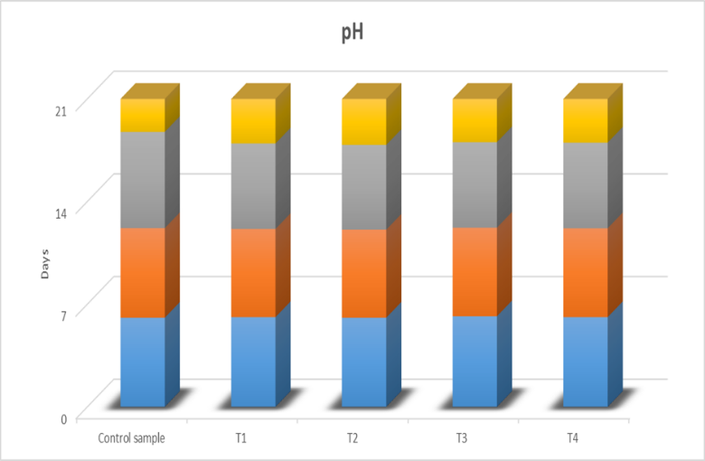
T0 – Control (Raw onion) | T1 – Onion + 0.05% sodium benzoate
T2 – Onion + 0.1% sodium benzoate | T3 – Onion + 0.01% potassium metabisulfite
T4 – Onion + 0.08% potassium metabisulfite.

Fig.1. pH of the vacuum-packed chemically treated peeled onions stored at 4℃

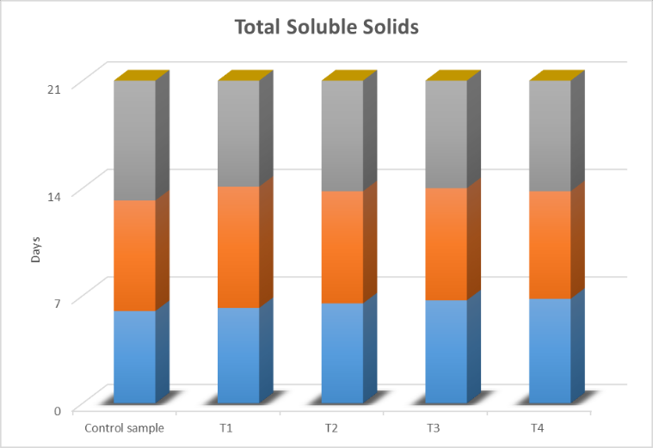
T0 – Control (Raw onion) | T1 – Onion + 0.05% sodium benzoate
T2 – Onion + 0.1% sodium benzoate | T3 – Onion + 0.01% potassium metabisulfite
T4 – Onion + 0.08% potassium metabisulfite .

Fig.2. Total soluble solids of the vacuum-packed chemically treated peeled onions stored at 4℃
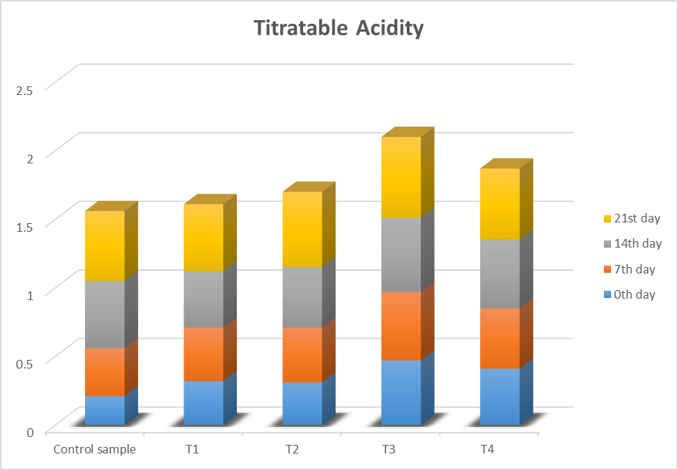

T0 – Control (Raw onion) | T1 – Onion + 0.05% sodium benzoate
T2 – Onion + 0.1% sodium benzoate | T3 – Onion + 0.01% potassium metabisulfite
T4 – Onion + 0.08% potassium metabisulfite .

Fig.3. Titratable acidity of the vacuum-packed chemically treated peeled onions stored at 4℃

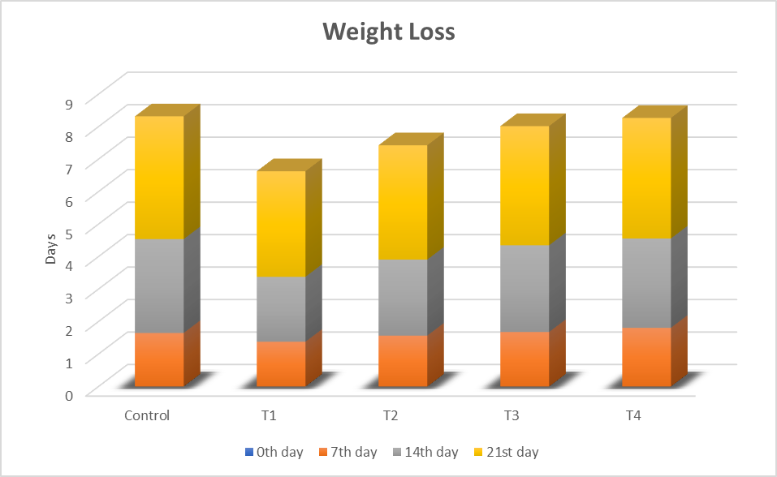
T0 – Control (Raw onion) | T1 – Onion + 0.05% sodium benzoate
T2 – Onion + 0.1% sodium benzoate | T3 – Onion + 0.01% potassium metabisulfite
T4 – Onion + 0.08% potassium metabisulfite .

Fig.4. Weight loss of the vacuum-packed chemically treated peeled onions stored at 4℃
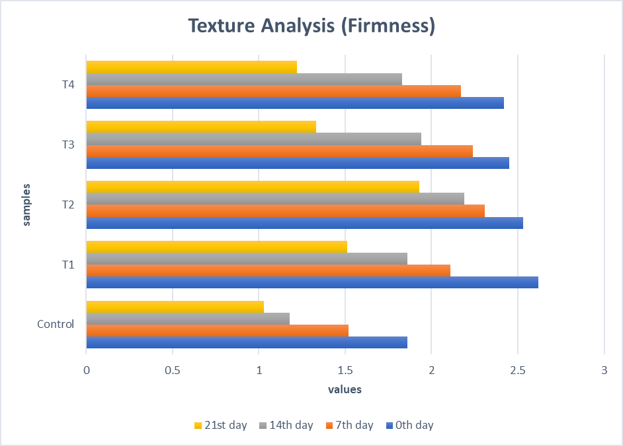
T0 – Control (Raw onion) | T1 – Onion + 0.05% sodium benzoate
T2 – Onion + 0.1% sodium benzoate | T3 – Onion + 0.01% potassium metabisulfite
T4 – Onion + 0.08% potassium metabisulfite .

Fig.5. Texture profile analysis of the vacuum-packed chemically treated peeled onions stored at 4℃

T0 – Control (Raw onion) | T1 – Onion + 0.05% sodium benzoate
T2 – Onion + 0.1% sodium benzoate | T3 – Onion + 0.01% potassium metabisulfite
T4 – Onion + 0.08% potassium metabisulfite .
Fig.6. Microbial Analysis of the vacuum-packed, chemically treated, peeled onions stored at 4℃

T0 – Control (Raw onion) | T1 – Onion + 0.05% sodium benzoate
T2 – Onion + 0.1% sodium benzoate | T3 – Onion + 0.01% potassium metabisulfite
T4 – Onion + 0.08% potassium metabisulfite .

Fig.7. Sensory evaluation of the vacuum-packed, chemically treated, peeled onions stored at 4℃
References
1. Amit, B., V. Yadav, and P. Chahal. 2023. "Knowledge status of onion growers regarding pre and post-harvest management practices." Indian Res. J. Ext. Edu 23 (1):59-63.
2. Artés, F., P. Gómez, E. Aguayo, V. Escalona, and F. Artés-Hernández. 2009. "Sustainable sanitation techniques for keeping quality and safety of fresh-cut plant commodities." Postharvest Biology and Technology 51 (3):287-296.
3. Bahram‐Parvar, M., and L.T. Lim. 2018. "Fresh‐cut onion: A review on processing, health benefits, and shelf‐life." Comprehensive Reviews in Food Science and Food Safety 17 (2):290-308.
4. Bett, K.L. 2002. "Evaluating sensory quality of fresh-cut fruits and vegetables." Fresh-cut fruits and vegetables. Science, technology and market. Boca Raton, Fla.: CRC Press. p:427-438.
5. Carstens, C.K., J.K. Salazar, and C. Darkoh. 2019. "Multistate outbreaks of foodborne illness in the United States associated with fresh produce from 2010 to 2017." Frontiers in microbiology 10:2667.
6. Charles, D.J., and D.J. Charles. 2013. "Onion." Antioxidant Properties of Spices, Herbs and Other Sources:435-448.
7. Davidson, P., H.B. Cekmer, E. Monu, and C. Techathuvanan. 2015. "The use of natural antimicrobials in food: an overview." Handbook of natural antimicrobials for food safety and quality: 1- 27.
8. Heard, G.M. 2002. "Microbiology of fresh-cut produce." Fresh-cut fruits and vegetables: Science, technology, and market:187-249.
9. Kim, S.-H., S.-H. Jo, Y.-I. Kwon, and J.-K. Hwang. 2011. "Effects of onion (Allium cepa L.) extract administration on intestinal α-glucosidases activities and spikes in postprandial blood glucose levels in SD rats model." International journal of molecular sciences 12 (6):3757-3769.
10. Lucera, A., C. Costa, A. Conte, and M.A. Del Nobile. 2012. "Food applications of natural antimicrobial compounds." Frontiers in microbiology 3:287.
11. Memon, N., Y. Gat, S. Arya, and R. Waghmare. 2020. "Combined effect of chemical preservative and different doses of irradiation on green onions to enhance shelf life." Journal of the Saudi Society of Agricultural Sciences 19 (3):207-215.
12. Patil, V., S. Waghmare, M. Kambale, R. Karande, N. Misal, and L. Srikanth. 2024. "Potential Effect of Zinc Solubilizing Bacteria on Yield of Onion (Allium cepa L.)." Ecology, Environment & Conservation (0971765X) 30.
13. Rico, C.W., G.-R. Kim, C.-R. Jo, K.-C. Nam, H.-J. Kang, D.-U. Ahn, and J.-H. Kwon. 2009. "Microbiological and physicochemical quality of irradiated ground beef as affected by added garlic or onion." Food Science of Animal Resources 29 (6):680-684.
14. Shah, M., N. Chand, R. Khan, M. Saeed, M. Ragni, S. Tarricone, V. Laudadio, C. Losacco, and V. Tufarelli. 2022. "Mitigating heat stress in broiler chickens using dietary onion (Allium cepa) and ginger (Zingiber officinale) supplementation." South African Journal of Animal Science 52 (6):811-818.
15. Shahrajabian, M.H., W. Sun, and Q. Cheng. 2020. "Chinese onion (Allium chinense), an evergreen vegetable: A brief review." Polish Journal of Agronomy 42:40-45.
16. Thivya, P. 2022. "Effect of chemical preservatives and packaging treatment on storage quality of peeled shallot onion." Applied Food Research 2 (2):100160.
17. Uddin, Z., P. Suppakul, and W. Boonsupthip. 2016. "Effect of air temperature and velocity on moisture diffusivity about physical and sensory quality of dried pumpkin seeds." Drying technology 34 (12):1423-1433.
18. Zhao, X.-X., F.-J. Lin, H. Li, H.-B. Li, D.-T. Wu, F. Geng, W. Ma, Y. Wang, B.-H. Miao, and R.-Y. Gan. 2021. "Recent advances in bioactive compounds, health functions, and safety concerns of onion (Allium cepa L.)." Frontiers in Nutrition 8:669805.
19. Zudaire, L., I. Viñas, M. Abadias, T. Lafarga, G. Bobo, J. Simó, and I. Aguiló-Aguayo. 2020. "Effects of long-term controlled atmosphere storage, minimal processing, and packaging on quality attributes of calçots (Allium cepa L.)." Food Science and Technology International 26 (5):403-412.

