**Field-Scale Agricultural Monitoring Using Sentinel-2 and GEE: A Study on Cotton and Maize Crop Cycles.**

Mugesh kumar Raja1, Sakthivel R2*, Geethakarthi A2

1 Department of Soil Science and Agricultural Chemistry, Dhanalakshmi Srinivasan Agriculture College, Perambalur - 621212.

2 Department of Civil Engineering, Kumaraguru College of Technology, Coimbatore-641 049.

**Abstract:**

Understanding crop phenology and health using remote sensing tools has gained increasing attention in precision agriculture. This study focuses on a 0.5-acre agricultural plot located at Tamil Nadu Agricultural University (TNAU), Coimbatore, where cotton was cultivated from March 11, 2022, to September 23, 2022. Sentinel-2 imagery was processed using Google Earth Engine (GEE) to derive NDVI (Normalized Difference Vegetation Index) values throughout the crop growth period. A time series analysis of mean NDVI values was conducted to observe the phenological stages of the cotton crop. Post-harvest, maize was cultivated in the same field. An NDVI image captured during this period revealed spatial variability in crop health across the plot. Ground truth photographs confirmed that certain areas exhibited poor crop vigor, aligning with low NDVI values. This study demonstrates the effective application of open-source satellite data and cloud-based platforms like GEE for micro-level crop monitoring and health assessment in precision farming practices.

***Keywords:***

*Cotton Phenology, NDVI Time Series, Sentinel-2, Google Earth Engine, Crop Health Monitoring, Precision Agriculture.*

**Introduction:**

Remote sensing technologies have emerged as essential tools in modern agricultural monitoring, particularly for evaluating crop growth stages, detecting stress, and assessing productivity. Among various vegetation indices, the Normalized Difference Vegetation Index (NDVI) is widely used due to its simplicity, effectiveness, and strong correlation with vegetation vigor and biomass (Tucker, 1979). NDVI has become a standard metric for phenological studies across different crop types and climatic conditions.

Google Earth Engine (GEE), a cloud-based geospatial analysis platform, allows researchers to process large satellite datasets, such as those from Sentinel-2, efficiently and at scale. Its capabilities in time series analysis have been especially useful for understanding vegetation dynamics and crop health (Gorelick et al., 2017; Belgiu and Csillik, 2018). The Sentinel-2 mission by the European Space Agency provides multispectral imagery at 10–20 m spatial resolution and high temporal frequency, making it highly suitable for agricultural applications (Drusch et al., 2012).

Crop phenology, the study of plant life cycle events and their environmental triggers, is vital for managing inputs such as water, fertilizer, and labor. Monitoring phenological stages using NDVI time series helps in optimizing harvest timing and detecting anomalies in growth (Zhang et al., 2003). Several studies have successfully applied NDVI time series from Sentinel-2 imagery to detect phenological patterns in cotton, maize, rice, and other crops (Campos-Taberner et al., 2018; Zhao et al., 2020).

In addition to phenology, NDVI has been widely used for assessing intra-field variability, helping identify spatial differences in crop health due to soil conditions, irrigation patterns, or pest infestations (Vona and De Santis, 2021). Integrating ground truth observations with satellite-derived NDVI enhances the reliability of remote assessments and strengthens decision support for farmers (López-Granados, 2011).

This study aims to monitor the phenological development of cotton crops grown in a 0.5-acre plot at Tamil Nadu Agricultural University (TNAU), Coimbatore, from March to September 2022, using Sentinel-2 NDVI time series derived through Google Earth Engine. Furthermore, the study assesses post-harvest maize crop health using a single-date NDVI image validated with field-level ground truth data. This research highlights the feasibility of using open-access satellite data and cloud computing platforms for precision farming at a micro-plot scale.

**Study Area:**

The study was conducted on a 0.5-acre agricultural field (Fig 1) located within the premises of Tamil Nadu Agricultural University (TNAU), situated in Coimbatore, Tamil Nadu, India. Geographically, the location lies approximately at 11.000°N latitude and 76.935°E longitude, within the semi-arid agro-climatic zone of Southern India.

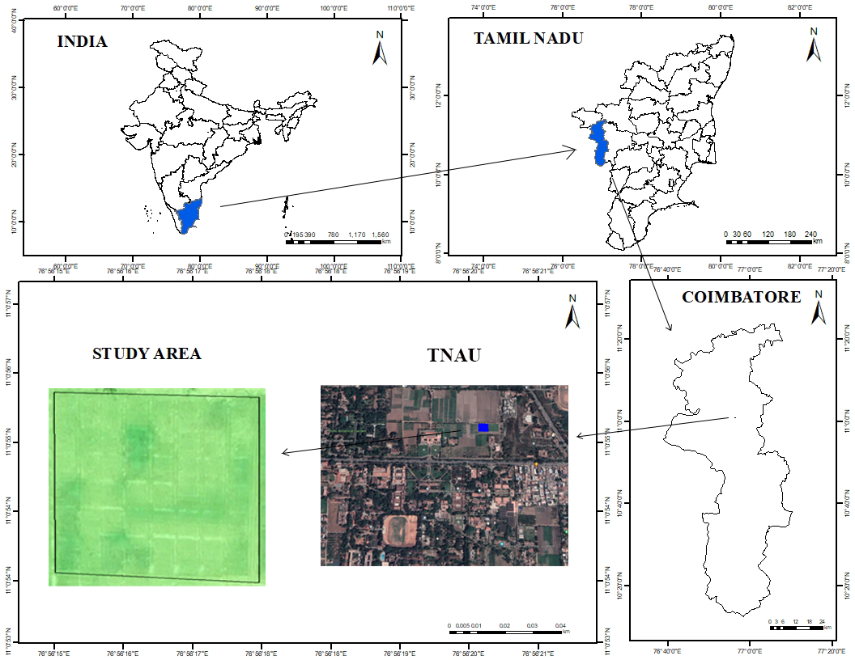

*Figure 1: Study Area*

The region experiences a tropical climate characterized by hot summers, moderate rainfall, and mild winters. The average annual rainfall ranges from 600 to 800 mm, primarily received during the southwest monsoon (June to September). The soil in the study field is predominantly red loamy, suitable for a variety of crops including cotton and maize.

During the study period, cotton was cultivated from March 11, 2022, to September 23, 2022, followed by maize as a short-term post-harvest crop. The controlled plot within a research institution allowed for ground truth verification and precise monitoring of crop conditions, supporting the integration of field observations with satellite-derived NDVI data for phenological and crop health analysis.

**Materials and Methods:**

**Satellite Data Source**

This study utilized imagery from the Sentinel-2 satellite mission (Fig 2), operated by the European Space Agency (ESA), which provides multispectral optical data at spatial resolutions of 10 m, 20 m, and 60 m across 13 spectral bands. The red (Band 4) and near-infrared (Band 8) bands, both at 10 m resolution, were used to calculate the NDVI (Drusch et al., 2012). Sentinel-2’s high revisit frequency (5–10 days) makes it highly suitable for monitoring vegetation dynamics and phenological changes (Zhao et al., 2020; Belgiu and Csillik, 2018).

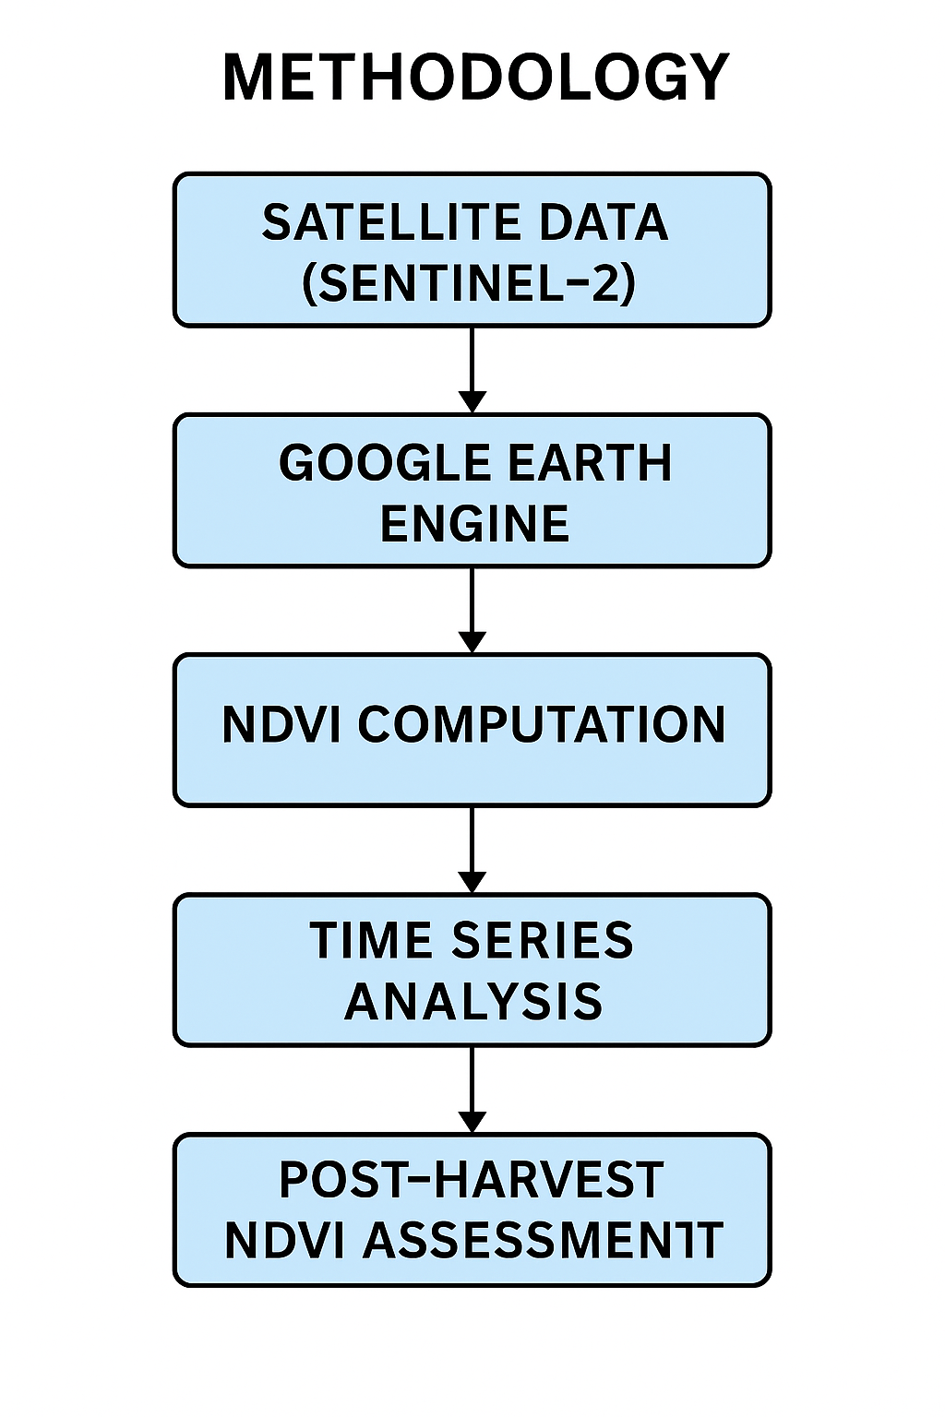

*Figure 2. Methodology.*

**Platform and Tools**

All remote sensing analyses, including image preprocessing, cloud masking, NDVI computation, and time series plotting, were conducted using Google Earth Engine (GEE). GEE is a cloud-based geospatial processing platform that facilitates large-scale environmental data analysis with integrated satellite image archives and APIs for JavaScript and Python (Gorelick et al., 2017).

**NDVI Computation**

NDVI (Normalized Difference Vegetation Index) is computed using the standard equation:

NDVI=(NIR−RED) / (NIR+RED)

where NIR refers to reflectance in the near-infrared band (Band 8) and RED corresponds to reflectance in the red band (Band 4) of Sentinel-2. NDVI is widely used to assess vegetation greenness and is directly correlated with crop health and photosynthetic activity (Tucker, 1979; Campos-Taberner et al., 2018).

**Time Series Analysis**

NDVI values were extracted for the 0.5-acre cotton field from March 11, 2022, to September 23, 2022, aligning with the cotton crop cycle (Fig 2) . A region of interest (ROI) polygon was digitized in GEE to clip the imagery. NDVI values were averaged over this ROI for each available Sentinel-2 image. A time series chart was generated to visualize NDVI variations, reflecting different phenological stages such as emergence, vegetative growth, flowering, and senescence (Zhang et al., 2003; Dash et al., 2023).

**Post-Cotton NDVI Assessment**

After cotton harvest, a single-date NDVI image was generated during the early growth stage of the subsequent maize crop. This image revealed spatial variability in vegetation health. Visual interpretation and pixel-wise NDVI comparisons indicated low values in specific areas, suggesting poor crop establishment. This was further verified through ground truth photographs, showing reduced plant vigor in those parts of the field (Vona and De Santis, 2021; López-Granados, 2011).

**Cloud Masking and Preprocessing**

To ensure accuracy in NDVI estimation, Sentinel-2 Level-1C images were subjected to cloud masking using the Scene Classification Layer (SCL) and QA60 band in GEE (Sibanda et al., 2022). Only cloud-free images were included in the analysis to avoid distortion in spectral reflectance values.

**Results and Discussion:**

**Cotton NDVI Time Series Analysis**

The NDVI time series derived from Sentinel-2 imagery effectively captured the phenological development of the cotton crop grown between March 11, 2022, and September 23, 2022. As illustrated in Figure 3, the NDVI values showed a gradual increase from mid-March, indicating the emergence and early vegetative growth of cotton. The values peaked during mid-July to early August, corresponding to the flowering and boll formation stages, with NDVI values exceeding 0.35, which is typical of dense, healthy cotton canopies (Zhao et al., 2020; Zhang et al., 2003).

Following this peak, a decline in NDVI was observed toward late September, signaling crop maturity and senescence. This temporal pattern aligns with cotton crop development cycles reported in other studies using time-series NDVI analysis (Campos-Taberner et al., 2018; Dash et al., 2023). The cloud-masking and data filtering techniques applied in GEE ensured that only high-quality observations were retained, resulting in a clear seasonal signal with minimal noise.

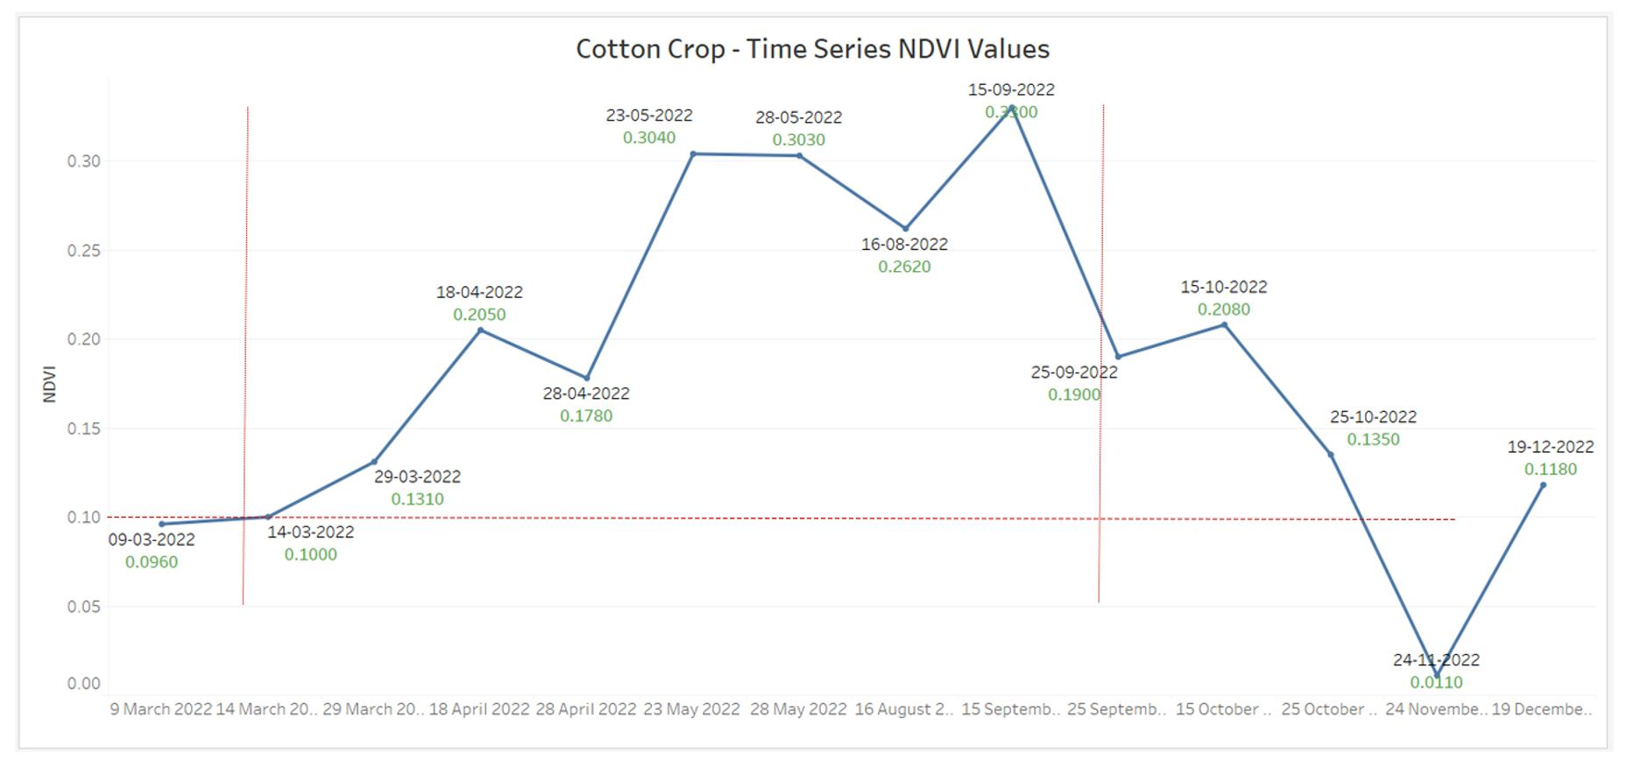

*Figure 3: NDVI time series trend for cotton crop (March–September 2022).*

**Maize Crop Health Assessment Using NDVI**

Post-harvest, the field was replanted with maize. A single-date NDVI image acquired on February 17, 2023, was used to evaluate maize crop health across the same plot. The processed NDVI image is shown in Figure 4. The image reveals noticeable spatial variability in vegetation health, with distinct zones of high NDVI (values > 0.3) in some portions of the field and lower NDVI (< 0.3) in others.

These low-NDVI zones suggest poor crop establishment, possibly due to inadequate soil moisture, pest damage, or nutrient deficiencies—conditions commonly reflected in spectral vegetation indices (Vona and De Santis, 2021). The interpretation was validated using ground truth photographs, which visually confirmed stunted growth and sparse plant cover in the affected areas. This demonstrates the reliability of NDVI as an early indicator of within-field variability and crop stress (López-Granados, 2011).

Moreover, the ability to detect such variability through remote sensing can enable site-specific interventions, such as targeted irrigation or soil treatment, thereby improving overall productivity. Studies have emphasized the role of high-resolution NDVI imagery from Sentinel-2 in guiding precision agriculture practices even at small plot scales (Belgiu and Csillik, 2018; Gorelick et al., 2017).

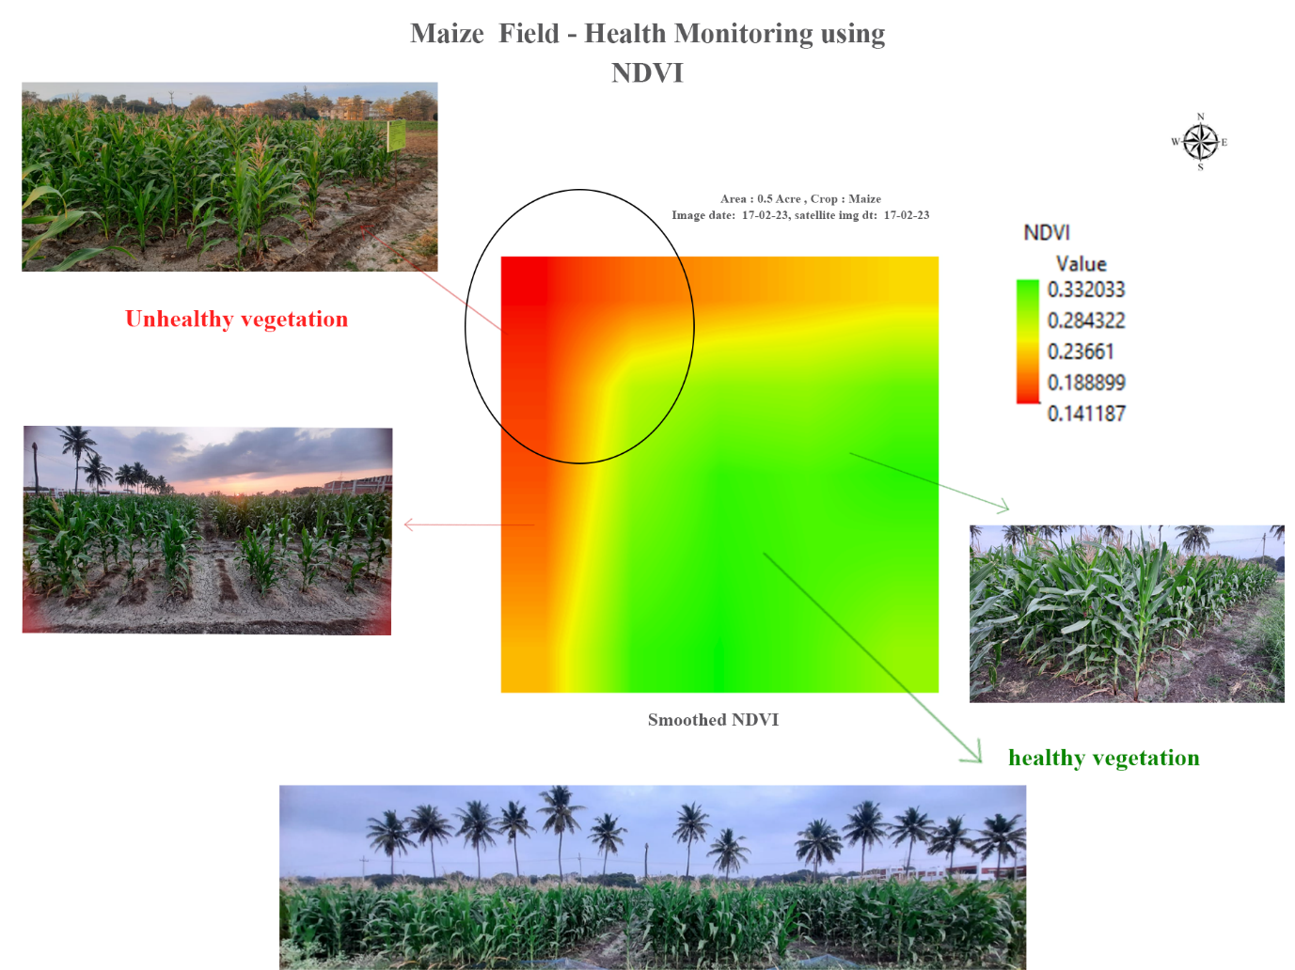

*Figure 4: NDVI image of maize crop field showing healthy (green) and unhealthy (red) vegetation zones (17 February 2023).*

**Conclusion:**

This study demonstrated the effective use of Sentinel-2 satellite imagery and Google Earth Engine (GEE) for monitoring crop phenology and evaluating intra-field crop health in a small-scale agricultural plot. The NDVI time series provided valuable insights into the cotton crop's growth stages, from emergence to senescence, aligning well with ground-based observations. Such temporal vegetation profiles are crucial for understanding crop development and optimizing input management in precision agriculture.

Furthermore, post-harvest assessment of maize crop health using a single-date NDVI image successfully identified spatial variability within the field. The unhealthy zones identified through low NDVI values were verified with ground photographs, reinforcing the reliability of remote sensing in detecting early signs of crop stress.

This work underscores the potential of open-access satellite data and cloud-based analysis platforms for smallholder and research farm applications. With minimal cost and technical infrastructure, even micro-scale farms can adopt remote sensing techniques for better decision-making and yield improvement.

**References:**

* Belgiu, M., & Csillik, O. (2018). Sentinel-2 cropland mapping using pixel-based and object-based time-weighted dynamic time warping analysis. *Remote Sensing of Environment*, 204, 509–523. <https://doi.org/10.1016/j.rse.2017.10.005> .
* Campos-Taberner, M., García-Haro, F. J., Martínez, B., et al. (2018). A critical comparison of remote sensing-based approaches for crop yield estimation. *Remote Sensing of Environment*, 233, 111371. <https://doi.org/10.1016/j.rse.2019.111371>.
* Dash, J., Atzberger, C., & Pandey, B. (2023). Monitoring cropland phenology using satellite time series data: Advances, challenges, and opportunities. *Remote Sensing of Environment*, 293, 113595. <https://doi.org/10.1016/j.rse.2023.113595> .
* Drusch, M., Del Bello, U., Carlier, S., et al. (2012). Sentinel-2: ESA's optical high-resolution mission for GMES operational services. *Remote Sensing of Environment*, 120, 25–36. <https://doi.org/10.1016/j.rse.2011.11.026>.
* Gorelick, N., Hancher, M., Dixon, M., Ilyushchenko, S., Thau, D., & Moore, R. (2017). Google Earth Engine: Planetary-scale geospatial analysis for everyone. *Remote Sensing of Environment*, 202, 18–27. <https://doi.org/10.1016/j.rse.2017.06.031>.
* López-Granados, F. (2011). Weed detection for site-specific weed management: Mapping and real-time approaches. *Weed Research*, 51(1), 1–11. <https://doi.org/10.1111/j.1365-3180.2010.00829.x> .
* Sibanda, M., Mutanga, O., & Dube, T. (2022). Effectiveness of cloud and shadow masking techniques on Sentinel-2 images for vegetation analysis. *Remote Sensing Letters*, 13(6), 605–614. <https://doi.org/10.1080/2150704X.2022.2077765>.
* Tucker, C. J. (1979). Red and photographic infrared linear combinations for monitoring vegetation. *Remote Sensing of Environment*, 8(2), 127–150. <https://doi.org/10.1016/0034-4257(79)90013-0>.
* Vona, M., & De Santis, A. (2021). Intra-field variability of maize crop detected by Sentinel-2 NDVI and UAV imagery. *Agriculture*, 11(5), 412. <https://doi.org/10.3390/agriculture11050412> .
* Zhang, X., Friedl, M. A., Schaaf, C. B., et al. (2003). Monitoring vegetation phenology using MODIS. *Remote Sensing of Environment*, 84(3), 471–475.  
  <https://doi.org/10.1016/S0034-4257(02)00135-9>.
* Zhao, F., Huang, J., Liu, Q., et al. (2020). Detecting crop phenology using Sentinel-2 time series in the North China Plain. *Remote Sensing*, 12(1), 157. <https://doi.org/10.3390/rs12010157>.