Distribution of *Compsopogon caeruleus* (Balbis ex C.Agardh) Montagne (Compsopogonales, Compsopogonophyceae) in West Bengal, India

**Abstract**

*Compsopogon caeruleus* (Balbis ex C. Agardh) Montagne is among the most diverse freshwater red algae, with a widespread distribution across North America, South America, Europe, Africa, Asia, Australasia, and Oceania. Highly adaptable to varied environmental conditions, it thrives in freshwater habitats such as streams, rivers, ponds, and lakes, as well as in brackish ecosystems like lagoons and estuaries. In India, *Compsopogon* ***caeruleus*** is widely distributed, with extensive documentation across multiple states. In West Bengal, previous studies have primarily reported its occurrence in the southern Gangetic plains and estuarine regions, while its diversity in the northern districts remains largely unexplored. This article investigates the extensive diversity of *Compsopogon* ***caeruleus*** in northern West Bengal, highlighting its ecological significance, agricultural utilization and global conservation status.

**Keywords**: *Compsopogon caeruleus;* *Diversity; Freshwater flora; Red Algae; West Bengal.*

**Introduction**

*Compsopogon caeruleus* (Balbis ex C.Agardh) Montagne is one of highly cosmopolitan organism among the freshwater red algae. This alga has been reported different aquatic habitat and various environmental condition. It is found worldwide, with a higher prevalence in tropical and subtropical regions. It can also occasionally be found in northern temperate areas such as the northern states of North America, Europe, Japan, India, Brazil, and Ukraine (Krishnamurthy 1962, Shyam & Sarma 1980, Necchi *et. al.,* 1990, Vis *et. al.,* 1992, Rintoul *et. al.,* 1999).

The family Compsopogonaceae comprises a total of eleven species of *Compsopogon* and three species of *Compsopogonopsis*. *Compsopogon* species are distinguished by their rhizoids, which are confined to the thallus base, whereas *Compsopogonopsis* species have rhizoidal outgrowths throughout the plant (Krishnamurthy 1953). Key characteristics for species identification within the genus include the structure of the basal portion of the thallus, the branching pattern, the size of monosporangia, the number of cortical layers, and the size of cortical cells. The thallus is highly branched, saxicolous or epiphytic, filamentous, uniseriate in younger parts, and multiseriate in older parts. The axial cell is surrounded by a variable number of cortical layers, and the organism reproduces asexually, lacking a sexual life cycle (Fritsch 1945, Bold and Wynne 1978).

However, these thallus characteristics exhibit significant variation between populations and also change with seasons (Necchi *et. al.,* 1990). In a taxonomic revision of the family Compsopogonaceae, Necchi & Dip (1992) classified all taxa into two clearly defined species: *Compsopogon caeruleus* (lacking rhizoidal filaments in the cortex) and *Compsopogon leptocladus* (possessing such filaments in the cortex). Using multivariate morphometrics and image analysis, Vis *et. al.,* (1992) grouped several taxa of Compsopogonaceae into three species: *Compsopogonopsis leptocladus* (Montagne) Krishnamurthy (characterized by rhizoidal cortication throughout the plant), *Compsopogon prolificus* Yadav & Kumano (with U-shaped lateral branches curling around the main axis), and *Compsopogon coeruleus* (Balbis) Montagne (featuring uncurled branches in the axis). Their study also highlighted that microsporangial clusters, the basal system of the thallus, and spine-like branches exhibit significant variability, rendering them unreliable as diagnostic taxonomic characters (Vis *et. al.,* 1992). Based on the molecular studies Necchi *et. al.,* (2013), synonymized all the reported species of *Compsopogon* genus under single species *Compsopogon caeruleus* (Balbis ex C.Agardh) Montagne. In this article all the species earlier reported from West Bengal and currently collected specimens are considered as *Compsopogon caeruleus* (Balbis ex C.Agardh) Montagne.

**Material and Methods**

The study was conducted after a detailed review of literature and the literature showed no report of Compsopogonaceae members from northern districts. Hence the field survey to northern districts of West Bengal (WB) was carried out in December 2023. All the collected samples were properly preserved and processed properly (Elaya Perumal *et. al.,* 2015; Elaya Perumal & Sundararaj, 2019, 2020) and the specimens are housed at CAL (Central National Herbarium, Howrah, WB). Slides were prepared using methods described by Elaya Perumal & Sundararaj (2019, 2020).Microphotographic documentation, along with morphological and morphometric analyses, were conducted using a Nikon Advanced Research Microscope (Nikon Eclipse Ni Series: H600L) in conjunction with NIS-Elements software. Organisms were identified based on standard monographs and various research publications, including Desikachary *et. al.,* (1990, 1998), Kumano (2002), Necchi *et. al.,* (2016), and Elaya Perumal & Sundararaj (2023). The geographic distribution of the *Compsopogon* species in WB was mapped using ArcGIS software (ArcMap desktop version 10.2.2), providing a spatial representation of sampling locations (Map 1).

**Results & Discussions**

Freshwater red algal samples were collected from 34 locations across West Bengal during an extensive field survey conducted in December 2023. Of these, 22 samples contained members of the family Compsopogonaceae, 10 samples included Batrachospermaceae, and 2 samples harboured species of Audouinellaceae. These collections were made from seven northern districts: Alipurduar, Cooch Behar, Dakshin Dinajpur, Darjeeling, Jalpaiguri, Malda, and Uttar Dinajpur (**Table 1**). Previous studies had reported the presence of *Compsopogon caeruleus* (Balbis ex C.Agardh) Montagne primarily in a few southern districts (Chakraborty *et. al.,* 2010; Satpati *et. al.,* 2012; Krishna & Chandan, 2018; Ganesan *et. al.,* 2018; Elaya Perumal & Palanisamy, 2025); however, the current investigation reveals significant species diversity in northern regions as well (**map. 1**). This study effectively expands the known distribution range of *Compsopogon caeruleus*, documenting its presence in seven additional districts of West Bengal, marking the first recorded occurrence of this species in these seven districts. The collected *Compsopogon* specimens exhibited a diverse range of morphological characteristics, consistent with descriptions from previous studies. The thalli varied significantly in size, ranging from microscopic forms to thalli in several meters of height, highlighting the species’ remarkable structural plasticity (Necchi *et. al.,* 2013).

This study reveals the occurrence of *Compsopogon caeruleus* across a range of physicochemical conditions. Atmospheric temperatures recorded at collection sites ranged from 20.2°C to 28.6°C, while corresponding water temperatures varied between 19.0°C and 26.8°C (winter season - December 2023). Incident light intensity during sampling spanned 105.34 to 2024 µmol photons m⁻² s⁻¹. Water physico-chemical parameters such as pH was in range of 6.6 to 8.7, suggesting the species’ tolerance from slightly acidic to alkaline conditions. Electrical conductivity fluctuated between 64 and 398 µS/cm, and total dissolved solids (TDS) ranged from 32 to 172 ppm, reflecting moderate mineral content and low to mild levels of pollution. These observations are consistent with earlier findings (Sheath & Hambrook, 1990; Wehr & Sheath, 2003; Liu & Wang, 2004; Liu et al., 2004; ), which reported the species’ affinity for clear, temperate waters with moderate nutrient loads and resilience to slight anthropogenic disturbances. The current data further support the ecological plasticity of *Compsopogon* *caeruleus*, indicating its ability to inhabit clear to slightly turbid habitats and persist across a broad spectrum of environmental parameters.

Recent studies have highlighted the potential of red algae as sustainable biofertilizers and plant growth promoters. Lakshmi and Sheeja (2021) demonstrated that seaweed liquid extracts derived from marine red algae significantly enhanced the growth and pigment content of *Chlorella vulgaris*, suggesting their efficacy as bio-stimulants in agricultural applications. These findings support the broader use of red algal biomass in promoting plant health and productivity through natural, eco-friendly means. In parallel, *Compsopogon caeruleus*, a freshwater red alga, has shown remarkable ecological tolerance, particularly its ability to thrive in slightly polluted or thermally impacted water bodies (Andrzej & Andrzej, 2022). This resilience makes it a promising candidate for integrated aquaculture-agriculture systems. Its cultivation along with rice plants could serve dual purposes: biomass production for biofertilizer use and phytoremediation of agricultural runoff. The species’ adaptability to variable water quality conditions and its capacity to colonize submerged surfaces further enhance its utility in such agroecological models. Together, these insights underscore the untapped potential of red algae in sustainable agriculture, particularly in regions where water quality and soil fertility are limiting factors.

**SYSTEMATIC TREATMENT**

Compsopogonophyceae G.W.Saunders & Hommersand

Compsopogonales Skuja

Compsopogonaceae F.Schmitz

**Compsopogon** Montagne

***Compsopogon caeruleus*** (Balbis ex C.Agardh) Montagne, Sciences physiques. Botanique. Cryptogamie. 1:154. 1846; *Conferva caerulea* Balbis ex Agardh, (1824); *Compsopogon* *aeruginosus* (J.Agardh) Kützing. (1849); *Compsopogon* *aeruginosus* (J. Agardh) Kützing var. *catenatum* Yadava, & Pandey, (1980); *Compsopogon chalybeus* Kützing, (1849); *Compsopogon hookeri* Montagne, (1846); *Compsopogon lividus* De Toni, (1897); *Compsopogon indicus* Das, (1963); *Compsopogon iyengarii* Krishnamurthy, (1958); *Composopogon prolificus* Yadava & Kumano, (1985); *Compsopogonopsis japonica* Chihara, (1976); *Compsopogon corinaldii* (Meneghini) Kutzing, (1857); *Compsopogon sparsus* S.L.Xie & Y.J.Ling, (1998).

Fig. 1-27.

**Vernacular /Common Name:** Staghorn algae

The *Compsopogon* specimens exhibited diverse morphological characteristics, occurring either as free-floating or attached to various substrates, including aquatic plants (*Vallisneria* sp.), green algae (*Cladophora* sp., *Pithophora* sp.), submerged rocks, and lifeless materials (dead wood, plastics, cloths, etc.) in streams and rivers. The thallus coloration ranged from blue-green to olivaceous green, with heights varying from 0.1 cm to 120 cm and diameters between 0.1 mm and 2 mm. Basal discs facilitated attachment to the host surface, while the thallus was either distinctly constricted or un-constricted, with apex attenuation varying towards both the tip and base. Branching patterns were highly variable, with branches occurring alternately or irregularly. Some specimens exhibited abundant branching, while others showed minimal branching, with branch angles ranges between 10º∆ to 90°∆. The thallus gradually attenuated towards the tips, though some specimens displayed abrupt constriction at the apex. Axial cells measured between 20.00 and 522.50 µm in height and 60.00 to 550.75 µm in breadth, while apical cells were depressed spherical structures, approximately 12-14 µm in diameter. The thallus was corticated with 1-3 layers of cortical cells, and their size ranged from 10.50 to 65.50 µm in length and 15.00 to 30.50 µm in breadth. These cortical cells divided obconical and formed monosporangia, with diameters ranging from 8.50 to 32.80 µm. The liberated monospore adhered to a host, enlarged, and subsequently divided to initiate new thalli growth, establishing attachment on the host.

**Distribution**: **India**-Arunachal Pradesh, Assam, Bihar, Gujarat, Jammu & Kashmir, Jharkhand, Karnataka, Kerala, Maharashtra, Madhya Pradesh, New Delhi, Odisha, Rajasthan, Tamil Nadu, Uttarakhand, Uttar Pradesh, West Bengal- North 24 Parganas, South 24 Parganas, Hoogly, Howrah Districts (Sen & Naskar, 2003; Kathiresan & Quasim, 2005; Chakraborty *et. al.,* 2010; Satpati *et. al.,* 2012; Krishna & Chandan, 2018; Ganesan *et. al.,* 2018; Elaya Perumal & Palanisamy 2025). **Global** - Austria, Britain, Ireland, Croatia, Czech Republic Czechia, France, Germany, Italy, Malta, Poland, Arkansas, Florida, Louisiana, Mexico, New Mexico, North Carolina, Cuba, Lesser Antilles, Martinique, W. Atlantic, Argentina, Brazil, Paraguay, Algeria, Mauritius, Egypt, Iraq, Bangladesh, India, Khandesh, Indonesia, Malaysia, Thailand, Viet Nam, China, Japan, Taiwan, Australia, New South Wales, New Zealand, Queensland, Australia, Hawaiian Islands, Vanuatu (Guiry, 2022).

**Specimens Examined:** **India- West Bengal,** Cooch Behar District, Cooch Behar, Torsa River Bank, 12.12.2023, Dr. U Elaya Perumal, CNH-BSI-97703 (CAL); Alipurduar District, Sonapur, Stream, 12.12.2023, Dr. U Elaya Perumal, CNH-BSI-97709 (CAL); Alipurduar District, Madhya Rangali, River Bank, 13.12.2023, Dr. U Elaya Perumal, CNH-BSI-97715 (CAL); Alipurduar District, Madhya Rangali Bazar, stream, 13.12.2023, Dr. U Elaya Perumal, CNH-BSI-097717 (CAL); Alipurduar District, Madhya Rangali Bazar, River, 13.12.2023, Dr. U Elaya Perumal, CNH-BSI-97718 (CAL); Alipurduar District, Uttar Sisubari, river, Dr. U Elaya Perumal, CNH-BSI-97719; Alipurduar District, Uttar Sisubari, stream, 13.12.2023, Dr. U Elaya Perumal, CNH-BSI-97720 (CAL); Alipurduar District, Uttar Sisubari, stream, 13.12.2023, Dr. U Elaya Perumal, CNH-BSI-97721 (CAL); Jalpaiguri District, Near Nagarakata Toll Plaza, Big stream, 14.12.2023, Dr. U Elaya Perumal, CNH-BSI-97727 (CAL); Jalpaiguri District, Near Nagarakata Toll Plaza, small stream, 14.12.2023, Dr. U Elaya Perumal, CNH-BSI-97728 (CAL); Jalpaiguri District, Near Nagarakata Toll Plaza, stream, 14.12.2023, Dr. U Elaya Perumal, CNH-BSI-97730; Jalpaiguri District, Jalpaiguri, Nokha ghat, River, 16.12.2023, Dr. U Elaya Perumal, CNH-BSI-97761 (CAL); Jalpaiguri District, Sukani, Chauli River, 17.12.2023, Dr. U Elaya Perumal, CNH-BSI-97763 (CAL); Jalpaiguri District, Bahadur, stream, 18.12.2023, Dr. U Elaya Perumal, CNH-BSI-97765 (CAL); Jalpaiguri District, Jhabera Vita, Talma river, 18.12.2023, Dr. U Elaya Perumal, CNH-BSI-97766 (CAL); Jalpaiguri District, Balai Gachh, Kartowa Bridge, 18.12.2023, Dr. U Elaya Perumal, CNH-BSI-97767 (CAL); Jalpaiguri District, Jugibhita, Sau Bridge, 18.12.2023, Dr. U Elaya Perumal, CNH-BSI-97769 (CAL); Darjeeling District, Rahamu, Stream, 18.12.2023, Dr. U Elaya Perumal, CNH-BSI- 97770 (CAL); Darjeeling District, Kantibhita, Stream, 18.12.2023, Dr. U Elaya Perumal, CNH-BSI-97774; Uttar Dinajpur, Uttar Bhagalpur, River, 18.12.2023, Dr. U Elaya Perumal, CNH-BSI-97776 (CAL); Dakshin Dinajpur District, Bansihari, Tangaon River, 20.12.2023, Dr. U Elaya Perumal, CNH-BSI-97781 (CAL); Malda district, Ramchandrapur, River, 21.12.2023, Dr. U Elaya Perumal, CNH-BSI-97785 (CAL).

**IUCN Conservation Status: Least Concern (LC)**

Despite potential threats from increasing anthropogenic activities and habitat degradation, *Compsopogon caeruleus* exhibits a widespread global distribution and remarkable adaptability to extreme (polluted) climatic conditions, where many other red algae struggle to survive. This species is widespread and it occurs in most of continents. In India, *Compsopogon* *caeruleus* is widely distributed, with extensive documentation across multiple states. The corresponding author has critically studied the alga in various states and documented few of its presence in a previous publication (Elaya Perumal & Sundararaj, 2023; Elaya Perumal & Palanisamy, 2025). Based on these observations, the authors concludes that the species maintains a substantial population across many studied locations, with only a few sites exhibiting lower population densities. This alga mostly found highly populated and most of the time the mature individuals will be more than 100 per subpopulation. In few populations alone the alga found in least count (less than 50 mature individuals). This alga is commonly found from the monsoon through mid-to-late summer in many locations. In certain areas, however, it appears predominantly in the post-monsoon season. Even though this alga shows adaptability to pollution it is not found in waters with high pollutions (domestic and industrial polluted water bodies). Hence the increasing anthropogenic activities and water pollution may increase the threats to the organism.

**CONCLUSION**

The present study significantly extends the known distribution of *Compsopogon* *caeruleus* in West Bengal, revealing its presence in seven additional northern districts. This finding highlights the broader ecological adaptability of the species, suggesting its potential resilience in varied aquatic environments. Furthermore, the observed morphological diversity among collected specimens underscores the species’ structural plasticity, aligning with previous taxonomic descriptions. Given that earlier studies primarily reported *Compsopogon caeruleus* in southern districts, these findings contribute valuable new insights into its geographical range and habitat preferences. Future investigations could reveal the diversity and populations of *Compsopogon* *caeruleus*. The authors propose the co-cultivation of *Compsopogon* *caeruleus* alongside rice plants, enabling its direct use as a biofertilizer within the same agricultural landscape, thereby enhancing soil fertility and reducing dependence on synthetic inputs.

**DISCLAIMER (ARTIFICIAL INTELLIGENCE)**

Authors hereby declare that NO generative AI technologies such as Large Language Models (ChatGPT, COPILOT, etc.) and text-to-image generators have been used during the writing or editing of this manuscript.

**ACKNOWLEDGEMENTS**

The authors extend their sincere gratitude to the Director, Botanical Survey of India (BSI), Kolkata, as well as the Heads of Office at BSI Headquarters, the Technical Section in Kolkata, and the Central National Herbarium in Howrah for their invaluable support and encouragement. Dr. U. Elaya Perumal expresses his deep sense of gratitude to the Ministry of Environment, Forest, and Climate Change, Government of India, for funding this research under the BSI-Research Associate Fellowship Programme-2023. The authors also acknowledge the support of the State Forest Departments and the unnamed individuals who provided assistance during the field visits.

**COMPETING INTERESTS**

Authors have declared that no competing interests exist.

**Originality and Plagiarism:**

Authors confirm that the manuscript is an original work. No parts of the manuscript have been previously published, and proper citations are provided wherever needed.

**Consent for Publication:**

All authors agree to the content of the article and its publication in the journal.

**REFERENCES**

Agardh, C. A. (1824). Systema algarum (pp. [i] xxxvii, [1]-312). Lundae [Lund]: Literis Berlingianis [Berling].

Andrzej S. Rybak & Andrzej M. Woyda-Ploszczyca. (2022). Tropical red alga Compsopogon caeruleus: an indicator of thermally polluted waters of Europe in the context of temperature and oxygen requirements. *Algae* **37(4)**: 301-316. <https://doi.org/10.4490/algae.2022.37.11.18>

Bold H.C. and Wynne J.M. (1978). Introduction to the Algae: Structure and Reproduction. Prentice-Hall Inc., N.Y. USA.

Chakraborty, T., Mukhopadhyay, M., & Pal, R. (2010). Micro algal diversity of Kolkata, West Bengal, India. *Indian Hydrobiology,* **12:** 204–224.

Chihara, M. (1976). *Compsopogonopsis* *japonica*, a new species of freshwater red algae. *Japanese Journal of Botany*, **51:** 289–294.

Das, C. R. (1963). The Compsopogonales in India (A systematic account of the Indian representatives of the order). *Proceedings of the National Institute of Sciences of India,* **29B**:239–243.

De Toni, G. B. (1897). Sylloge Algarum (Vol. IV, Section 1). Patavii.

Desikachary, T. V., Krishnamurthy, V., & Balakrishnan, M. S. (1990). Rhodophyta (Vol. 1). Madras Science Foundation, Madras.

Desikachary, T. V., Krishnamurthy, V., & Balakrishnan, M. S. (1998). Rhodophyta (Vol. II). Madras Science Foundation, Madras.

Elaya Perumal, U., & Sundararaj, R. (2019). Studies on szechwanense Batrachospermum (Batrachospermales, Rhodophyta) from Kerala State, India. Indian Hydrobiology, **18(1 & 2):** 138–145.

Elaya Perumal, U., & Sundararaj, R. (2020). Preliminary studies on *Kumanoa zeylanica* (Batrachospermales, Batrachospermaceae) reported from the Western Ghats of India. Environmental and Experimental Biology, **18(1)**: 21–27.

Elaya Perumal, U., & Sundararaj, R. (2023). Some interesting freshwater red algae of Southern India. Annakkili Amma Research Institute (AARI), Chennai.

Elaya Perumal, U., Uma Rani, V., & Chaugule, B. B. (2015). Studies on a red alga *Sirodotia* *huillensis* (Batrachospermaceae) from Orissa State, India. *Journal of Theoretical and Experimental Biology,* **11:**45–50.

Fritsch F.E. (1945). The Structure and Reproduction of the Algae. Vol. 2. Cambridge University Press, Cambridge.

Ganesan, E. K., West, J. A., & Necchi, O., Jr. (2018). A catalogue and bibliography of non-marine (freshwater and estuarine) Rhodophyta (red algae) of India. *Phytotaxa*, **364(1)**: 001–048. <https://doi.org/10.11646/phytotaxa.364.1.1>

Guiry M.D. in Guiry, M.D. & Guiry, G.M. 30 March (2022). AlgaeBase. World-wide electronic publication, National University of Ireland, Galway. https://www.algaebase.org; searched on 10 March, 2025.

Kathiresan, K., & Qasim, S. Z. (2005). Biodiversity of mangrove ecosystems. Hindusthan Publishing Corporation, New Delhi.

Krishna, S. R., & Chandan, S. (2018). Studies on some aspects of taxonomy and ecology of fresh water algae of Hooghly District West Bengal. University of Kalyani, Kalyani. <http://hdl.handle.net/10603/210090>.

Krishnamurthy V. (1953). On the structure and reproduction of *Compsopogon* from Madras. *Phytomorphology* **3**: 369-379.

Krishnamurthy, V. (1962). The formation of “microaplanospores” in Compsopogon coeruleus (Balbis) Montagne. *Current Science*, **31**:99–100.

Kumano, S. (2002). Freshwater Red Algae of the World. Biopress.

Kützing, F. T. (1849). Species algarum (pp. [i]-vi, [1]-922). Lipsiae [Leipzig]: F.A. Brockhaus.

Kützing, F.T. (1857). Tabulae phycologicae; oder, Abbildungen der Tange. Vol. VII pp. i-ii, 1-40, 100 pls. Nordhausen: Gedruckt auf kosten des Verfassers (in commission bei W. Köhne).

Lakshmi, D., & Sheeja L. (2021). Red Seaweed Extract as A Biostimulant on Growth and Biochemical Parameters of Microalgae *Chlorella vulgaris*. *International Journal of Multidisciplinary Research in Arts, Science & Commerce (Ijmrasc).* **1(1)**: 26-37.

Liu, S.-L. and W.-L. Wang. (2004). Two new members of freshwater red algae in Taiwan: *Compsopogon tenellus* and *C. chalybeus* (Compsopogonaceae, Rhodophyta). *Taiwania*, **49**: 32-38.

Liu, S.-L., Wang, L.C. and W.-L. Wang. (2004). Inorganic Carbon Utilization of the Freshwater Red Alga *Compsopogon coeruleus* (Balbis) Montagne (Compsopogonaceae, Rhodophyta) Evaluated by in situ Measurement of Chlorophyll Fluorescence. *Taiwania*, **49(3):** 209-217.

Montagne, C. (1846). Flore d’Algérie. Ordo I. Phyceae Fries. In: Exploration scientifique de l’Algérie pendant les années 1840, 1841, 1842. Durieu De Maisonneuve, M. C. Sciences physiques. *Botanique Cryptogamie,* **1:**1–197.

Necchi, Jr. O. and M.R. Dip. (1992). The family Compsopogonaceae (Rhodophyta) in Brazil. *Algological Studies* **66**:105-118.

Necchi, Jr. O., R.M. Goes and M.R. Dip. (1990). Phenology of *Compsopogon caeruleus* (Balbis) Montagne (Compsopogonaceae, Rhodophyta) and evaluation of taxonomic characters of the genus. *Japanese Journal of Phycology* **38**:1-10.

Necchi, O. Jr., West, J. A., Rai, S. K., Ganesan, E. K., Rossignolo, N. L., & Loiseaux de Goër, S. (2016). Phylogeny and morphology of the freshwater red alga Nemalionopsis shawii (Rhodophyta, Thoreales) from Nepal. *Phycological Research*, **64:**11–18. <https://doi.org/10.1111/pre.12116>.

Rintoul, T.L., R.G. Sheath and M.L. Vis. (1999). Systematics and biogeography of the Compsopogonales (Rhodophyta) with emphasis on the freshwater families in North America. *Phycologia* **38**:517-527.

Satpati, S. S., Barman, N., & Pal, R. (2012). Morphotaxonomic account of some common seaweeds from Indian Sundarbans mangrove forest and inner island area. *Journal of Algal Biomass Utilization*, **3**: 45–51.

Sheath, R. G. and J. A. Hambrook. (1990). Freshwater ecology. In: Cole, K. M. and R. G. Sheath (eds.). Biology of the Red Algae. pp. 423-453. Cambridge University Press. Cambridge.

Shyam, R., & Sarma, Y. S. R. K. (1980). Cultural observations on the morphology, reproduction and cytology of a freshwater red alga *Compsopogon* Mont. from India. *Nova Hedwigia*, **32:** 745–765.

Ulagalanthaperumal, Elaya Perumal, and Palanisamy Mookkan. (2025). “Generic Addition to the Freshwater Red Algal Flora of India from Arunachal Pradesh”. *Asian Journal of Biology* **21(6)**:92-107. <https://doi.org/10.9734/ajob/2025/v21i6516>.

Vis, M.L., R.G. Sheath and K.M. Cole. (1992). Systematics of the freshwater red algal family Compsopogonaceae in North America. *Phycologia* **31**:564-575.

Wehr, J. D. and R. G. Sheath. (2003). Freshwater Algae of North America: Ecology and Classification. Academic Press, California, USA. pp. 197-224.

Xie, S. L., & Ling, Y. J. (1998). Two new species of Compsopogon (Rhodophyta) from Shanxi and Guangxi, China. *Acta Phytotaxonomica Sinica,* **36:**81–83.

Yadava, R. N., & Kumano, S. (1985). *Compsopogon prolificus* sp. nov. (Compsopogonaceae, Rhodophyta) from Allahabad, Uttar Pradesh in India*. Japanese Journal of Phycology*, **33:**13-30.

Yadava, R. N., & Pandey, D. C. (1980). Observations on a new variety of *Compsopogon* (C. *aeruginosus* (J. Ag.) Kützing var. *catenatum* var. nov.). *Phykos*, **19:**15–22.

Table 1: Field Location Data of collection sites

|  |  |  |  |  |  |  |  |
| --- | --- | --- | --- | --- | --- | --- | --- |
| **S.No.** | **Field No.** | **Date** | **Locality** | **Geo-coordinates** | **Habitat** | **Notes** | **Collected  By** |
|  | CNH-BSI-97703 | 12.12.2023 | Torsa River Bank, Cooch Behar, WB | 26.316139,  89.435556 | River | Microscopic, Attached on green macroalgae | Dr. U Elaya Perumal |
|  | CNH-BSI-97709 | 12.12.2023 | Sonapur, Alipurduar District, WB | 26.499052,  89.373532 | Stream | Microscopic, Attached on green macroalgae | Dr. U Elaya Perumal |
|  | CNH-BSI-97715 | 13.12.2023 | Madhya Rangali, Alipurduar District, WB | 26.681779,  89.216266 | River | Fast flowing river with sandy bottom and grass and *Vallisneria* plants | Dr. U Elaya Perumal |
|  | CNH-BSI-97717 | 13.12.2023 | Madhya Rangali Bazar, Alipurduar District, WB | 26.682644,  89.207647 | Stream | Slow flowing stream with sandy bottom and submerged stones | Dr. U Elaya Perumal |
|  | CNH-BSI-97718 | 13.12.2023 | Madhya Rangali Bazar, Alipurduar District, WB | 26.684339,  89.199071 | River | Moderately flowing river with sandy bottom and submerged stones | Dr. U Elaya Perumal |
|  | CNH-BSI-97719 | 13.12.2023 | Uttar Sisubari, Alipurduar District, WB | 26.686944,  89.187128 | Small River | Moderately flowing small river with sandy bottom and submerged stones | Dr. U Elaya Perumal |
|  | CNH-BSI-97720 | 13.12.2023 | Uttar Sisubari, Alipurduar, WB District | 26.689404,  89.179763 | Stream | Slow flowing stream with sandy bottom | Dr. U Elaya Perumal |
|  | CNH-BSI-97721 | 13.12.2023 | Uttar Sisubari, Alipurduar District, WB | 26.689812,  89.179731 | Stream | slow flowing river with sandy bottom, very less amount of water | Dr. U Elaya Perumal |
|  | CNH-BSI-97727 | 14.12.2023 | Near Nagarakata Toll Plaza, Jalpaiguri District, WB | 26.875417,  88.919833 | Stream | Moderately flowing stream with sandy bottom and submerged stones | Dr. U Elaya Perumal |
|  | CNH-BSI-97728 | 14.12.2023 | Near Nagarakata Toll Plaza, Jalpaiguri District, WB | 26.875417,  88.919833 | Stream | Moderately flowing stream with sandy bottom and submerged stones | Dr. U Elaya Perumal |
|  | CNH-BSI-97730 | 14.12.2023 | Near Nagarakata Toll Plaza, Jalpaiguri District, WB | 26.874822,  88.918315 | Stream | Moderately flowing stream with alluvial bottom | Dr. U Elaya Perumal |
|  | CNH-BSI-97761 | 16.12.2023 | Jalpaiguri, Nokha ghat, Jalpaiguri District, WB | 26.687936,  88.405251 | River | Moderately flowing river with sandy and gravel stones as bottom | Dr. U Elaya Perumal |
|  | CNH-BSI-97763 | 17.12.2023 | Chauli River, Sukani, Jalpaiguri District, WB | 26.564279,  88.555898 | River | Moderately flowing river with gravel stones and sandy bottom | Dr. U Elaya Perumal |
|  | CNH-BSI-97765 | 18.12.2023 | NH 27, Bahadur, Jalpaiguri District, WB | 26.541577,  88.628056 | River | Moderately flowing river with gravel stones and sandy bottom | Dr. U Elaya Perumal |
|  | CNH-BSI-97766 | 18.12.2023 | Talma river, Jhabera Vita, Jalpaiguri District, WB | 26.557071,  88.578075 | River | Moderately flowing river with gravel stones and sandy bottom | Dr. U Elaya Perumal |
|  | CNH-BSI-97767 | 18.12.2023 | Kartowa Bridge, Balai Gachh, Jalpaiguri District, WB | 26.593877,  88.49686 | River | Moderately flowing river with gravel stones and sandy bottom | Dr. U Elaya Perumal |
|  | CNH-BSI-97769 | 18.12.2023 | Sau Bridge, Jugibhita, Jalpaiguri District, WB | 26.622727,  88.458043 | River | Moderately flowing river with gravel stones and sandy bottom | Dr. U Elaya Perumal |
|  | CNH-BSI-97770 | 18.12.2023 | Rahamu, Darjeeling District, WB | 26.647203,  88.386244 | Stream | Moderately flowing stream with gravel stones and sandy bottom | Dr. U Elaya Perumal |
|  | CNH-BSI-97774 | 18.12.2023 | Kantibhita, Darjeeling District, WB | 26.585275,  88.325175 | Stream | Moderately flowing river with gravel stones and sandy bottom | Dr. U Elaya Perumal |
|  | CNH-BSI-97776 | 18.12.2023 | Uttar Bhagalpur, Uttar Dinajpur, WB | 26.406195,  88.282779 | River | Moderately flowing river with gravel stones and sandy bottom | Dr. U Elaya Perumal |
|  | CNH-BSI-97781 | 20.12.2023 | Tangaon River, Bansihari, Dakshin Dinajpur District, WB | 25.39609,  88.416258 | River | Moderately flowing river with sandy bottom and submerged rocks | Dr. U Elaya Perumal |
|  | CNH-BSI-97785 | 21.12.2023 | Ramchandrapur, Malda district, WB | 24.924983,  88.099551 | River | Moderately flowing river with sandy bottom and submerged rocks | Dr. U Elaya Perumal |

Table 2. Ecological and Physico-chemical parameters of sampling sites

|  |  |  |  |  |  |  |  |  |
| --- | --- | --- | --- | --- | --- | --- | --- | --- |
| S. No | Field Number | Altitude (m)  mean sea level | pH | Water Temperature (℃) | Atmospheric Temperature (℃) | Light Intensity (µmol/s/m2) | Total Dissolved solids (ppm) | Electrical conductivity (µS/cm) |
|  | CNH-BSI-97703 | 64 | 7.6 | 20.1 | 21 | 211.6 | 93 | 186 |
|  | CNH-BSI-97709 | 80 | 8.3 | 23 | 24.5 | 828 | 98 | 196 |
|  | CNH-BSI-97715 | 106 | 7.6 | 23 | 24.5 | 736 | 149 | 236 |
|  | CNH-BSI-97717 | 105 | 7.8 | 25 | 26 | 828 | 108 | 216 |
|  | CNH-BSI-97718 | 105 | 7.6 | 26 | 26.8 | 598 | 112 | 224 |
|  | CNH-BSI-97719 | 110 | 7.8 | 26.3 | 27 | 736 | 108 | 216 |
|  | CNH-BSI-97720 | 112 | 7.8 | 26.6 | 27 | 736 | 172 | 398 |
|  | CNH-BSI-97721 | 112 | 7.8 | 26.6 | 27 | 736 | 172 | 398 |
|  | CNH-BSI-97727 | 182 | 7 | 19.6 | 20.2 | 105.34 | 33 | 66 |
|  | CNH-BSI-97728 | 182 | 7 | 19.6 | 20.2 | 105.34 | 33 | 66 |
|  | CNH-BSI-97730 | 176 | 6.6 | 22 | 22.9 | 110.4 | 52 | 104 |
|  | CNH-BSI-97761 | 133 | 8.7 | 26.5 | 27.8 | 506 | 35 | 70 |
|  | CNH-BSI-97763 | 111 | 7.6 | 21.9 | 22 | 529 | 53 | 106 |
|  | CNH-BSI-97765 | 107 | 8.2 | 19.3 | 20 | 529 | 53 | 106 |
|  | CNH-BSI-97766 | 147 | 7.6 | 19 | 21.5 | 874 | 32 | 64 |
|  | CNH-BSI-97767 | 115 | 7.6 | 22 | 23 | 1104 | 39 | 78 |
|  | CNH-BSI-97769 | 120 | 7.8 | 23.5 | 24 | 1449 | 33 | 66 |
|  | CNH-BSI-97770 | 125 | 7.4 | 26.3 | 27.8 | 2024 | 49 | 98 |
|  | CNH-BSI-97774 | 120 | 7.8 | 28.5 | 30 | 1426 | 40 | 82 |
|  | CNH-BSI-97776 | 92 | 7.8 | 26.5 | 28.6 | 2024 | 49 | 100 |
|  | CNH-BSI-97781 | 53 | 7.8 | 26.6 | 28 | 2208 | 69 | 136 |
|  | CNH-BSI-97785 | 44 | 7.8 | 26.8 | 28.6 | 1978 | 136 | 276 |

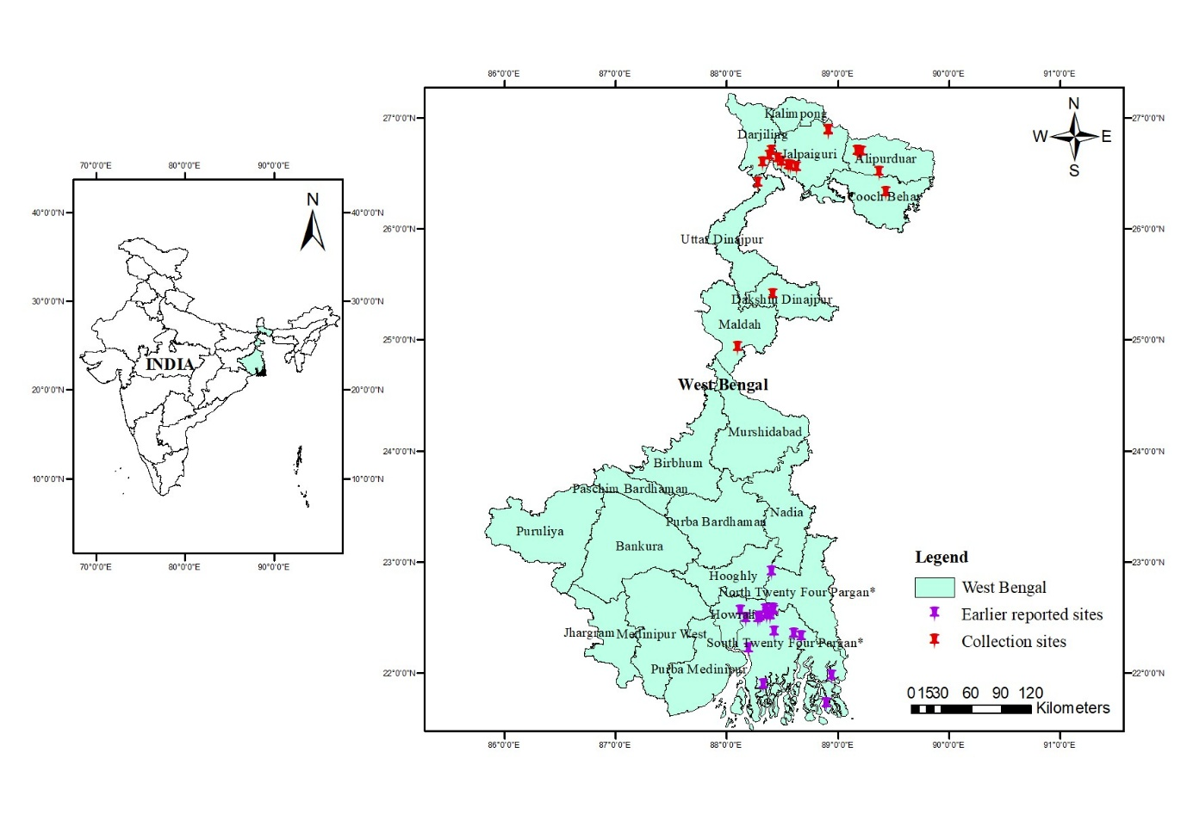

Map. 1: Geographic map shows the distribution of *Compsopogon caeruleus* in West Bengal based on current study and earlier reports.

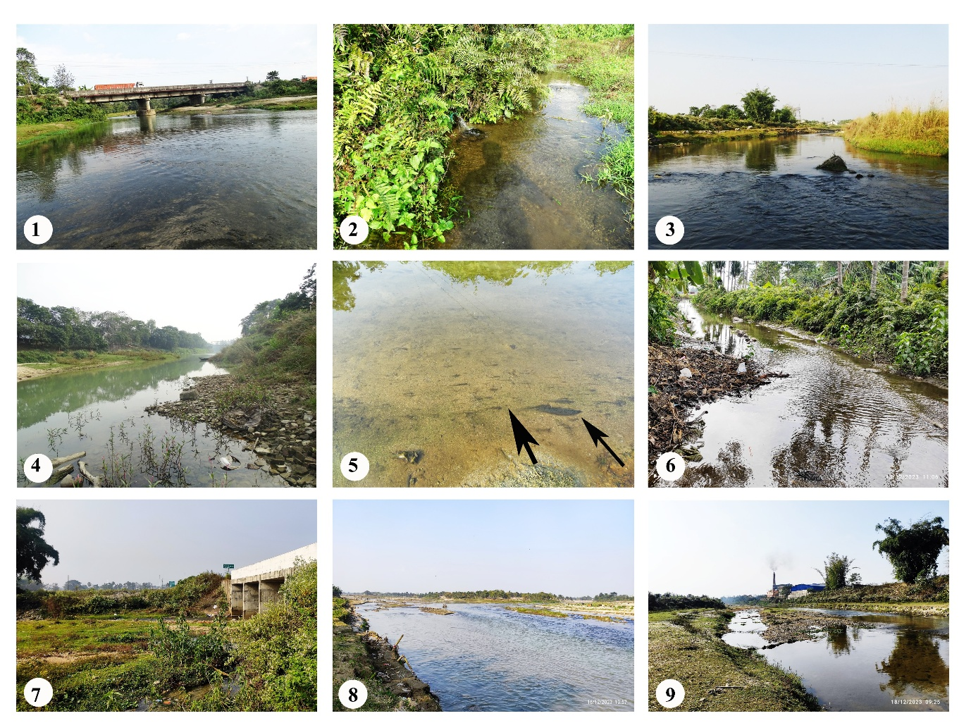

Fig. 1-9. Collection locations in Northen West Bengal; 1. River near Madhya Rangali gaon, Alipruduar district; 2. Small stream near Nagarakata Toll Plaza, Jalpaiguri District; 3. River, at Sau bridge, Jalpaiguri District;4. Tangaon River, Bansihari, Dakshin Dinajpur District; 5. Compsopogon caeruleus growing on sandy bottom of the river in Jalpaiguri District; 6. Stream near Madhya Rangali Bazar, Alipruduar District; 7. Big stream near Nagarakata toll plaza, Jalpaiguri district; 8: Mahananda river, Jalpaiguri-Nokha ghat, Jalpaiguri district; 9. Talma River, Talma, Jalpaiguri District

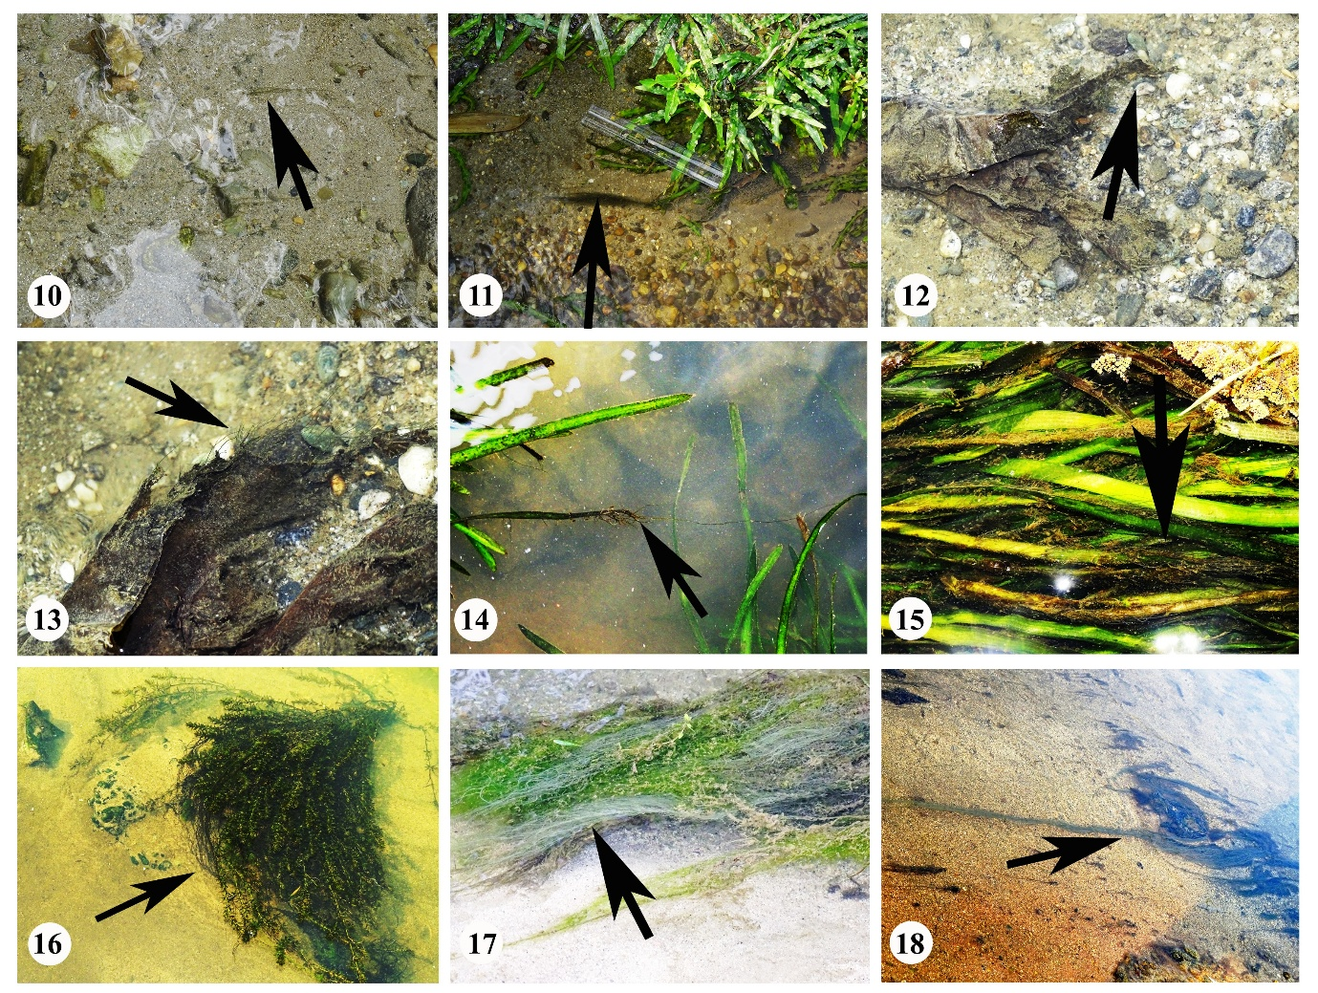

Fig. 10-18, Habitats of *Compsopogon caeruleus* from northern West Bengal; 10. *Compsopogon caeruleus* growing on sandy bottom & pebbles of slow flowing stream; 11,14,15. *Compsopogon caeruleus* growing on *Vallisneria* plant leaves; 12,13. Thallus growing on submerged waste plastic; 16. Thallus growing on Hydrilla plant; 17. Thallus growing along with other algae attached on sandy bottom of stream; 18. Thallus growing attached on sandy bottom of rivers.

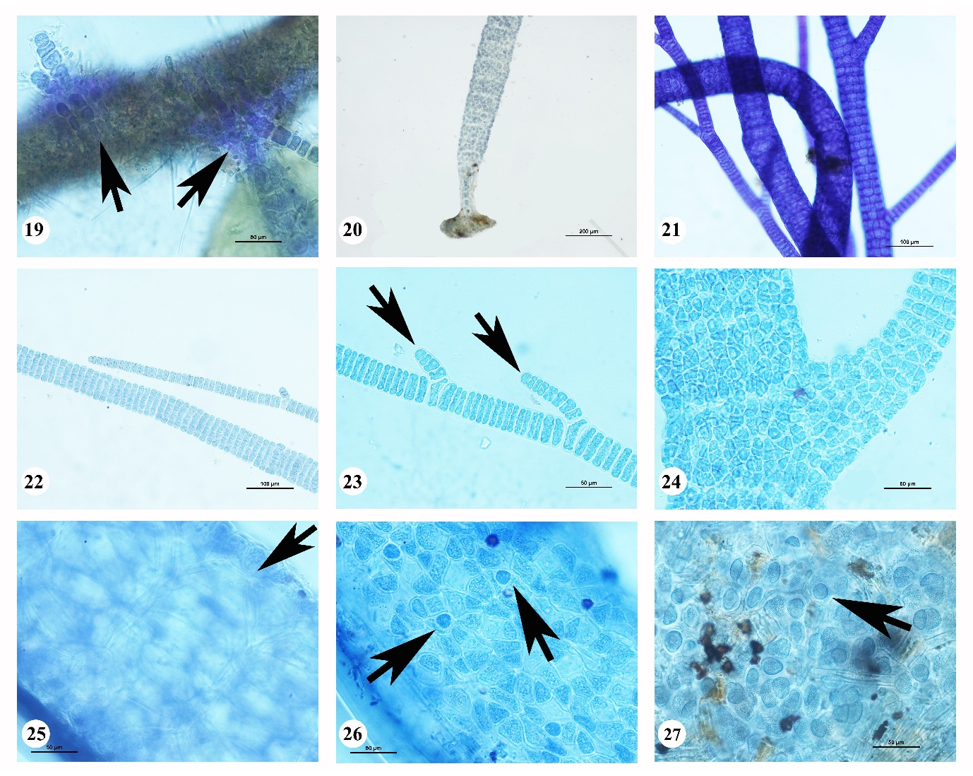

Fig. 19-27 Microscopic images of Compsopogon caeruleus; 19. Microscopic thallus growing on green algae; 20. Basal disc and axial thallus; 21. Thalli showing branches and axial cells covered with cortical cells; 22. Young thalli part; 23. Apical cells and undivided axial cells; 24. Thalli covered with cortical cells; 25. Thallus focused to show axial cells; 26-27. Thallus focused to show monospore and cortical cells.