**Evaluating the Impact of Agricultural Extension Education on Sustainable Farming Practices: A Socioeconomic and Environmental Perspective**

**Abstracts**

This study employs a descriptive survey method to explore the role of agriculture and extension education in promoting sustainable agricultural practices. A total of 87 individuals were chosen at random, including faculty members, expansion managers, and agricultural experts. Experts accepted a structural survey for data collection, and Bernbach Alpha (0.91) confirmed its reliability. These findings emphasize the development model progress, the environmental consequences of land ownership structure and the relevance of education extended to address land degradation. A model with binary-dependent variables was used to evaluate the effects of agricultural education on adopting sustainable methods such as mulching, no-till farming and bio-fertilizer applications. Due to research, increased expansion education has had an important impact on farmers’ choice for environmentally sustainable agriculture. These investigations emphasize the importance of legal coordination and centralized education initiatives to ensure agricultural adaptability for years.

**Keywords**: DurableAgriculture, Expansion Education, Land Ownership, Environmental Durability, Agricultural Practices, Rural Development

**Introduction**

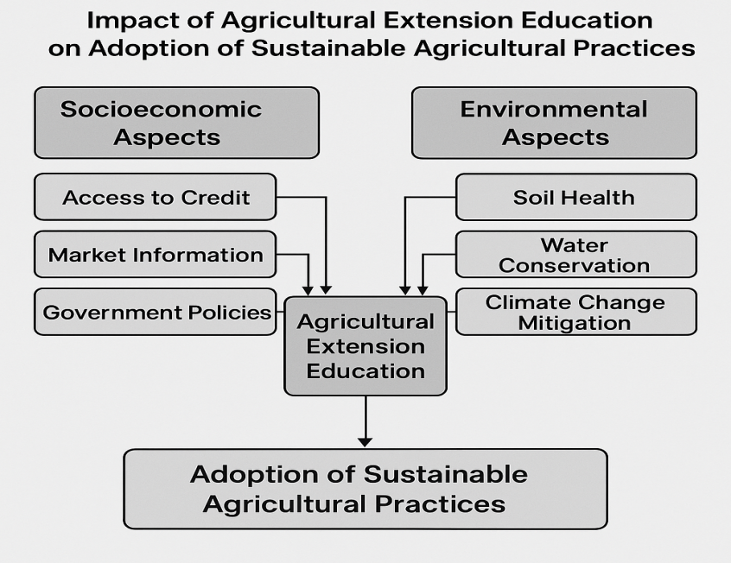Durable Agriculture is important to ensure sustainable food safety, environmental protection and rural economic elasticity**[1,2]**. Nevertheless, agriculture requires an overall strategy to achieve sustainability that combines scientific insights, effective resources management and environment-friendly methods**[3-5].** Agricultural expansion serves as an essential tool to share knowledge of education, encouraging new technology and improving the decision-making skills of farmers**[6, 7].** Expansion services are important in promoting the adoption of sustainable agricultural methods by connecting research institutions with the agricultural community **[8, 9]**. The socioeconomic and environmental aspects of sustainable agriculture are closely related **[10, 11].** On the one hand, economic factors such as the availability of loans, market data and government regulations influence the ability to implement sustainable practice of farmers**.[12, 13]**. In contrast, causes related to the environment, such as soil health, water conservation and climate change mitigation, determine the sustainable future of agriculture **[14-16]**. Agricultural expansion education addresses both aspects of agricultural expansion providing skills and information needed to increase productivity and reduces adverse environmental impacts **[17, 18]**. Although the significance of expansion services is recognized, obstacles such as limited access to expansion agents, insufficient training programs and technical communication errors prevent their skills **[19-21].** Agricultural expansion education is essential to understand how much support it helps in sustainable agricultural methods to increase policy structure and expansion techniques **[22,23].**  
The purpose of this research is to evaluate the impact of agricultural expansion education on adoption of sustainable agricultural methods, especially focusing on socioeconomic and environmental aspects **[24-26].** The aim of this research is to provide insights about the effectiveness of the expansion program and recommend ways to increase sustainable agricultural development by examining farmers’ interactions with expansion services and the methods of agriculture arising resulting in the development of agriculture **[27-29].**

Fig.1**.Impact of Agriculture Extension Education on Adoption of Sustainable Agriculture Practices**

**Research Methodology**

This study used a descriptive survey method to achieve its goal **[30, 31].** The target population included faculty members, extension managers of different provinces and sub-extension experts of agricultural extension and agricultural system of the Ministry of Agriculture. A random sample of 87 individuals was selected out of a total population of 170. Data were collected through survey findings from an extensive literature review **[32-35].**  
The survey was divided into three parts: (1) the demographic and personal characteristics of extension specialists, (2) the current importance of sustainable agricultural extension-education strategies within the extension system in the view of extension specialists, and (3) the importance of prioritizing extension-education strategies to promote sustainable agriculture within the agricultural extension system **[36-40].**  
Answers to the second part were assessed with a low-to-high level of focus **[41, 42]** three-point Like-Rate scale. The third part used a five-point Like-RT scale, with different categories ranging from very low to very high **[43, 44].** The validity of the questionnaire was established through content and face verification conducted by a team of expert faculty members **[45, 46]**. Reliability was assessed using Bernbach's alpha, and the overall tool achieved a reliability coefficient of 0.91. SPSS version 14.0 was used in the data analysis, statistical methods such as frequency distribution, percentage, mean and standard deviation were used**[47-49]** .

**Evolution of Agricultural Development Paradigms and Their Environmental Impacts**

The structural change model became prominent in the 1970s with the aim of developing and expanding the agricultural sector. Originally designed to advance industrial progress, this approach changed to highlight agricultural progress as an essential aspect of economic development **[50-52]**. Academics advocated a shift away from industrialization methods, promoting agricultural innovations that were compatible with the unique resource constraints and market context of labor-rich 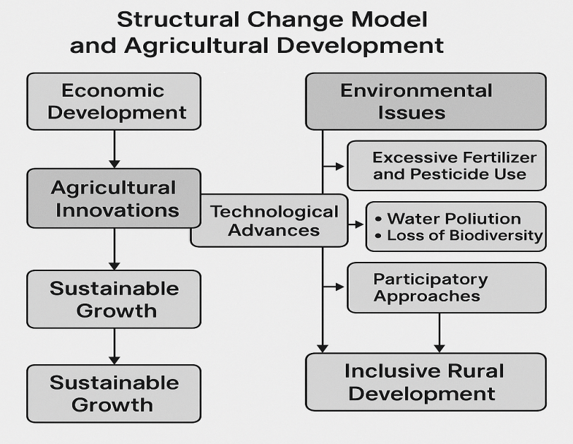economies. This shift highlighted the importance of technological advances in agriculture to promote sustainable growth.  
Throughout this period, development efforts in rural areas focused on comprehensive rural development initiatives **[53-55].** These initiatives sought to improve livelihoods by raising incomes, expanding access to social services, and encouraging inclusive participation in policy development and implementation. Significant funds were allocated for agricultural research, credit services, infrastructure development, education and health care. This strategic move has resulted in significant increases in food production, economic expansion, and reduced poverty - yet, the widespread use of chemical fertilizers and pesticides, especially nitrogen-based ones, has raised environmental issues [56-60].Fertilization of aquatic systems reduces oxygen levels, reduces fish populations and biodiversity, and endangers aquatic habitats sustainability **[61-62]**, In the 1980s and 1990s, rural development strategies were transferred from top to bottom-based participatory mode to community-based **[63-64].**

Fig.2.**Structural change Model and Agriculture Development**

This change recognizes the significance of indigenous knowledge and enables rural communities to take an active role in solving their problems. Participatory methods such as rapid participatory evaluation, participatory rural evaluation and participatory education and action have become essential methods in agricultural development. At the same time, the government’s participation in agriculture has decreased as a result of structural coordination program implemented by financial institutions worldwide. The cancellation of subsidies for important agricultural resources has made fertilizers and other materials expensive for many farmers, resulting in a decline in the soil and reduced agricultural production. As a result, agricultural growth continues, often compromised with forests and natural ecosystems, emphasizing on economic development and environmental complex balance**[65-70].**

**The Impact of Land Tenure Systems on Agricultural Development and Environmental Sustainability**

The traditional African traditional land ownership system has collective ownership, where land ownership is governed by community, descendants or extended families, and heads or family heads over it. Nevertheless, changes in the type of land ownership have become more noticeable **[71-73].** The main types of land ownership systems include traditional, lease and free-holding agreements. In Ghana, traditional land ownership cleans provide control over land leaders, family heads or administrative heads, whose ownership is acquired through inheritance, marriage, gift or transaction. In addition to enabling free-holding systems, individuals or subgroups ownership of land, maintains communal ownership rights, resulting in frequent disputes over land transactions. Lease ownership gives individuals temporary ownership for a certain period of time, after which the property returns to the original leasehold. Although legal changes have been made to increase land security, problems related to geopolitics exist **[74-77].** Modified land ownership system greatly affects agricultural progress. Transformation from land-intensive to land-efficient agriculture has become essential due to increased population density. Unlike the conventional concept that links population growth to food deficit, modern view indicates that population pressure encourages agricultural innovation and technical progress. Nevertheless, rigid land ownership system has hindered this change, restricting land investment and labor-intensive agricultural methods. This stagnation has resulted in low productivity, environmental damage and land efficiency reduced **[78-81].**  
The lack of investment in neglect area and soil preservation is associated with methane emissions, making environmental problems worse **[82,83]**. The need for innovation invented in developing regions is particularly important, where rapid population growth causes significant pressure on rare agricultural resources. Due to lack of land ownership changes, efforts to reduce soil degradation and improve agricultural productivity may fail. Agricultural expansion education with forestry project can increase soil fertility, encourage sustainable land practice and strengthen environmental elasticity. Yet, without changing land ownership and security framework, these efforts may lack the ability to promote **[84-88].**

**The Role of Agricultural and Extension Education in Environmental Sustainability and Land Restoration**

In the last sixty years, the phase of achieving multiple strategies and failure targeting economic growth through agricultural development. An essential aspect of these techniques, agriculture and expansion education, has been influenced by various effects, such as external funding assistance **[89,90].** Reducing government-driven agriculture and expansion initiatives, especially after the failed economic strategies of the 1970s and 1980s, the support of small farmers has decreased, resulting in large-scale agricultural activities. Despite that, recent initiatives from producing organizations, farmers associations and government agencies have revived the attention of agriculture and expansion education as a technique to proceed sustainable agricultural practices and environmental protection. Environmental problems such as pollution, depression of resources, land degradation and climate change have received considerable attention worldwide **[91-94]**. The growth of agriculture, urban development and increased demand of natural resources significantly changed the types of land use, resulting in degradation of forest fleet and ecosystems. Agricultural intensity has significantly influenced land transformation, as the growth of crop production resulted in significant greenhouse gas emissions. To reduce this environmental impact, land-concentric adaptations and preservation methods are constantly being developed. Nevertheless, these measures have limitations, which require increased emphasis on environmental awareness and sustainable practice **[95-98].** Agricultural and Expansion Education can be significantly improved in the awareness of the farmers about environmental degradation, which also encourages the implementation of sustainable land management practices. Considering that rural population is primarily depending on agriculture for their survival, their awareness about environmental concerns directly affect their devotion to land conservation efforts. Research has shown that farmers who understand the seriousness of environmental degradation are more interested in participating in conservation initiatives, which help in land recovery and sustainable practice. Increase in agriculture and expansion education can help farmers’ decision-making capacity, encourage soil preservation methods and help in greater environmental sustainable efforts within the agricultural industry **[99-103].**

**Model Specification for Analyzing Agricultural Practices and Influencing Factors**

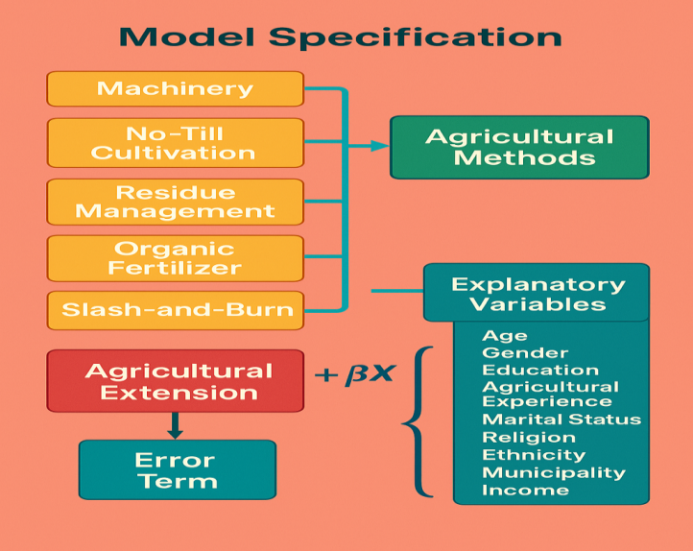Model specification includes essential agricultural methods as dependent variable, such as machining, zero cultivation, crops or household residue use, bio fertilizer application and cutting and burning agriculture. Excoriates considered in analysis include agriculture and expansion education, age, gender, educational achievements, agricultural experience, marital status, religious involvement, ethnicity, municipality and income. Each dependent variable is given a binary value, where 1 represents a specific method by a farmer and 0 indicates the opposite **[104-107].** For example, when a farmer practices the Marching, the relevant variable is set in 1; if they don’t, it is given the value of 0.A comparable binary classification is used for other agricultural methods **[108,109].** The general minimum class (OLS) estimates for each dependent variable are organized in this manner: the agricultural expansion +βX where binary dependent variable indicates that the farmer uses methods such as machining, no-til cultivation, residue management, organic fertilizer, or slash-end-burn cultivation.

Agricultural expansion is a placeholder variable that assumes the value of the farmer 1 I have learned in agriculture and expansion, and if not, 0 **[110-112].** Vector includes control variables such as population characteristics, agricultural experience and financial aspects, while error indicates the term. The main goal of analysis is to investigate how agriculture and expansion education affects the adoption of sustainable agricultural methods, as well as calculating various socioeconomic and demographic variables **[113-115].**

Fig.3.**Analyzing Agriculture Practices and Influencing Factors**

**The Role of Tree Planting in Land Tenure Security and Environmental Sustainability**

Tree Planting acts as a long-term investment that increases land security and increases environmental stability. This method preserves humidity, increases soil nutrients and helps to preserve soil in avoiding degradation. When testing the planting method in different land rights systems, it became clear that farmers of the traditional right system show more tendency to participate in planting than farmers of alternative rights structures. People who cultivate land under traditional rights often plant wood and other trees to increase their land safety. A significant part of these farmers has cultivated trees for the past five years, which has highlighted them as the most contributor to forestry within the three land systems**[116-120].** Conversely, planting in the land system of freehold land is very low, where the insecurity of land prevents farmers from being committed to long-term investments. Despite the intense initiative of planting trees, forest fleeing still remains an important problem as a large part of the population surveyed in recent years. This trend indicates that the benefits of planting trees are gradually decreasing through forest pneumatic. Similarly, the practice of planting and removal of different species reflect this trend, emphasizing the need for strategic system to coordinate forestry and sustainable land management. Agricultural and expansion education can serve as an essential resource to encourage sustainable planting methods and environmental protection. Farmers, composed of tenants, occupiers and conventional land owners, acknowledged the significance of planting in improving land safety. Despite this, a significant number of trees have been cut in the last five years, which highlights the need for educational initiatives that inspire farmers to plant more trees than they cut every year. These initiatives will increase land ownership protection, help retain soil humidity, reduce land degradation and increase environmental health by increasing agricultural productivity **[121-125].** At the ground level, the trend of planting varies according to the condition of land ownership. Owners of formal ownership land exhibit more dedication to planting, which represents a huge part of the wooden tree planting. Unlike occupiers and tenants, land owners get high level of assurance about the safety of their land, which encourages them to engage in long-term environmental protection efforts. These results indicate that policies that encourage planting, with agricultural education and expansion services, may contribute significantly to land conservation and sustainable agricultural progress.**[126-128]**

**Enhancing Women's Participation in Agricultural Development Through Extension Services**

Women are essential in agriculture and represent a significant part of the workforce worldwide. Despite their contributions, they face significant obstacles in achieving development resources compared to their male associates. Over the last few decades, initiatives have been taken to increase women’s role in agriculture, but success is still low due to ongoing obstacles. A big challenge is the inadequate and appropriate availability of agricultural expansion services. The inefficiency of expansion system to provide necessary support to rural women is not only related to organizational structure and functionality but also influenced by research deficit and cultural limitations. Efficient agricultural expansion service is very important to provide knowledge and skills needed for extended productivity and sustainable agricultural methods **[129-131].** Over the years, numerous initiatives have been conducted to improve women’s access to agricultural education and technology, which has resulted in favorable results in crop production and general family welfare. Yet, numerous initiatives have not been successful in dealing with the specific needs and challenges of women, effectively limiting their ability to implement agricultural knowledge. Obstacles such as limited access to agriculture, lack of financial support and customized educational programs continue to hinder women’s participation in agricultural progress**[132-134].** Organizations and organizations engaged in agricultural development must take an active strategy to deal with these challenges by creating interference in line with the unique needs, preferences and requirements of rural women. Education and expansion programs are particularly important in this context, as they present the foundation to address inefficiency in the agricultural expansion system. By implementing gender-sensitive methods and ensuring fair access to resources, agricultural expansion services can play an important role in strengthening women’s participation in agriculture, resulting in increased economic development and food security**.[135-137]**

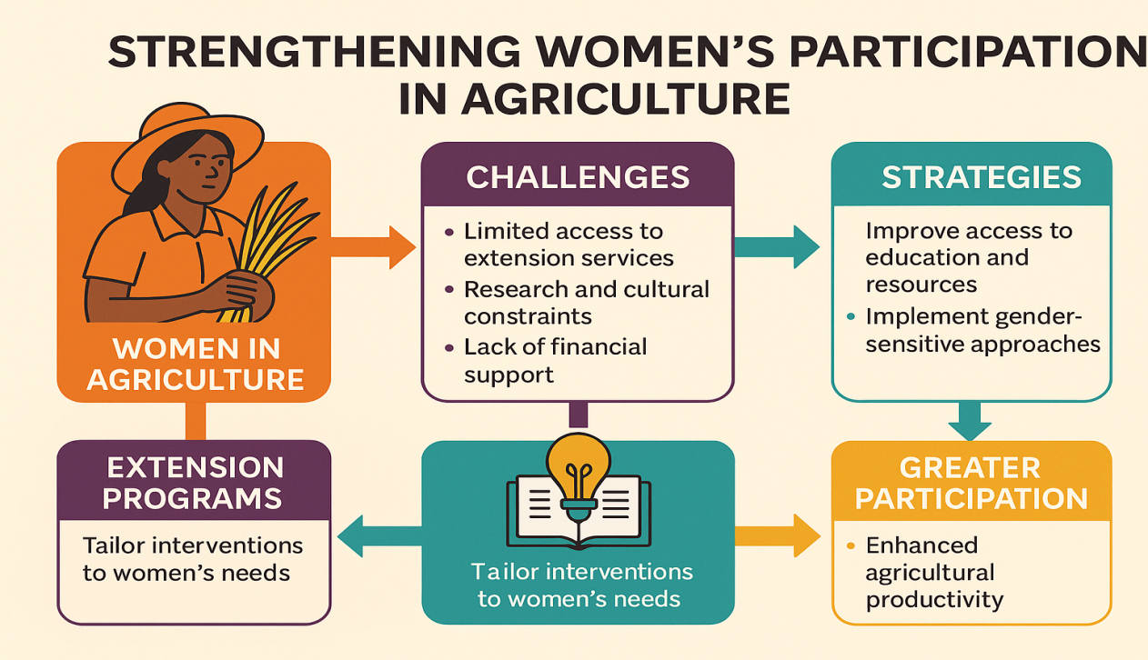

Fig.4.**Strengthening Women’s Participation in agriculture**

**Strengthening Agricultural Extension Services for Women's Empowerment**

Establishing skilled agricultural expansion service is very important for sustainable development, especially for women’s involvement in agriculture. To ensure their access to expansion services, providing professional training and development programs for female farmers is very important to increase communication between women groups and encourage active participation in agricultural projects. In order to improve the efficiency of expansion services and development initiatives for women, several important advice should be taken into consideration: Development programs must be compatible with unique situations and obstacles that women face in agriculture, ensuring that their needs have been properly recognized and met. Program designs must rely on thorough gender demand evaluation to provide suitable and influential solutions **[138-141]**.  
Female farmers should have equal access to expansion services and engage them in the design and implementation of agricultural development initiatives. In order to ensure significant benefits, the alignment, effectiveness and overall impact of the expansion program for women in agriculture must be regularly evaluated. It is very important to hire women as professional and semi-professional workers for increasing service and increasing inclusive in agricultural expansion services **[142-144].** In both management and technical fields, their knowledge and agricultural method will increase the ability to successfully share their knowledge and agricultural methods by providing targeted training for women expansion workers. Creating strong communication networks among rural women groups will increase agricultural development and increase participation in expansion activities. By combining these techniques, agricultural expansion services can be improved to help women more effectively, enhanced productivity, sustainability and economic empowerment in the agricultural field can be encouraged **[145,146].**

**The Impact of Climate Change on Sustainable Development and Agriculture**

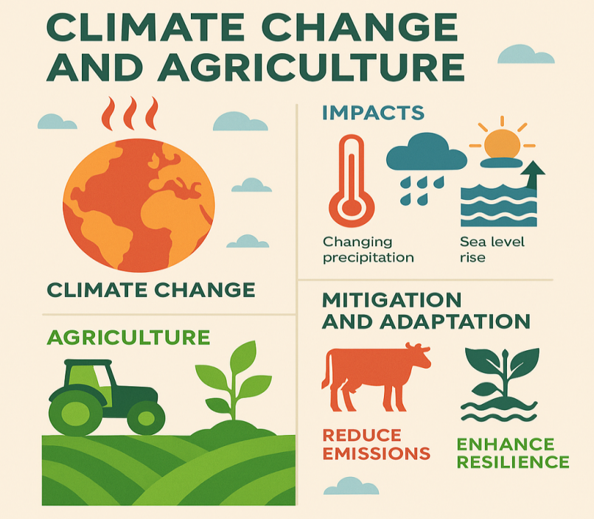Climate change represents the most important danger for global development, which affects ecosystem, economy and human welfare in a wide and unprecedented way. Accepting this, global political reactions began in 1992 through the Rio Earth Summit, which led to the creation of the UN Structure Convention on Climate Change (UNFCCC). Since its implementation in 1994, UNFCCC has gained almost universal membership, which emphasizes global devotion to tackle climate change. The increasing temperature, variable weather type and sea level rise—mainly due to human activities—will interfere in supply of important resources such as fresh water, food and energy. The connection between climate change and sustainable development is particularly important, as most vulnerable countries, especially developing and low-developed countries, face the highest danger with limited compatibility capacity. To address these global challenges, the Paris Agreement was founded in 2015, aimed at restricting global temperature rise below 2°C, which highlights the requirements of united global efforts**[147-150]**. Agriculture is an important element in terms of sustainable development, which is one of the most influenced areas by climate change. Farming depends greatly on the weather, which puts the risk of catastrophic due to changes in rainfall type, long dry weather, floods and geographical spread of insects and illness. In recent decades, soil degradation and climate-related challenges have greatly reduced agricultural production, which has endangered food security worldwide. Moreover, the damage in agriculture is increasing due to pests and diseases, which are making the difficulties in food supply more intensifying **[151-153].** Although climate change significantly affects agriculture, it also plays a role in environmental change through greenhouse gas emissions. The industry contributes significantly to methane emissions from cattle digestion and fertilizer management, as well as nitro-us oxide emissions from bio and artificial fertilizer application. Due to this combined effect, agriculture should be placed at the center of climate adaptation and mitigation techniques, ensuring that agricultural methods encourage both environmental durability and food security. By implementing the climate-smart agricultural methods, reducing greenhouse gas emissions and encouraging sustainable land use, agricultural industry can contribute significantly to tackling climate change, as well as ensuring long-term development goals,**[154-156].**

Fig.5**.Climate Change in Agriculture**

**Challenges and Capacity Development in Agricultural Extension Services**

Expansion workers in Asian countries have sufficient deficit, especially in isolated, marginalized and underdeveloped regions. Numerous expansion officers face additional non-expansion responsibilities, which interrupt the functionality of consultative services and undermine the standards of agricultural promotion. The effectiveness of the expansion service is influenced by the availability of work environment and important resources. Expansion workers are essential to communicate with far-distance agricultural communities; however, insufficient transport, diverse terrain and weak infrastructure interrupts their ability to perform with their responsibility efficiently **[157-160].** Employment of lack of prior experience in rural or agricultural environment causes more difficulties, especially when their field work is assigned. To improve their functionality, expand their content knowledge and improve their communication and promotion techniques are very important. With continuous development of scientific knowledge, in-service training is essential to increase their technical skills and increase professional skills. Training and continuous professional development before recruitment not only increases the skills of expansion officers but also acts as an inspiring material, increase the work performance and increase the effectiveness of expansion initiatives. It is very important to educate agricultural expansion and increase ongoing professional development, so that expansion workers are adequately prepared to assist farmers with the skills and to assist in the overall progress of the agricultural industry.**[161-163].**

**Drought Mitigation and Watershed Development in India**

India has a wide range of risky areas of drought, which includes limited precipitation characteristics, resulting in repeated famine. To address these problems, the central government began the drought-watering area programme (DPAP) in 1973–74, aimed at 947 administrative blocks of 149 districts in 13 states. The programme aimed at low precipitation, ongoing drought and insufficient irrigation capacity areas, with a total range of 746 million square kilometers. The cost of this program was equally distributed between the central and state governments. In more than eight five-year plans, 1,000 crore was spent. 500 crore was paid by the Central Government. From its beginning to March 1995, total expenses reached $17 billion **[164–167]**.The main objectives of this program include sustainable management of water resources, land and water conservation, planting, sheep cultivation, increase animal husbandry, increase in dairy and animal husbandry industry, implementing advanced agricultural techniques and increase in additional rural enterprises. From 1973 to 1995, the program reaches important milestones, such as land conservation and land leveling on 2975,000 hectares, water resources development on 946,000 hectares and forestry on 17,76,000 hectares. In 1995, DPAP was converted to a waterproof development project, whose budget was determined by the central government of Tk 125 crore. As part of this program, 4,957 water-conditioning projects were launched to improve water conservation and land supervision. In fiscal year 1996–97, the government supported his dedication of Rs 125 crore to continuing implementation of reservoir-based systems aimed at increasing environmental sustainability and increased agricultural productivity in drought-prone regions**.[168–170]**

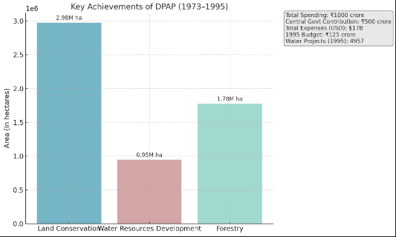

Fig.6.**Key Achievements of DPAP(1973-1995)**

**Rural Employment and Infrastructure Development Program**

The programme, which started in 1983 and received full support from the central government, was aimed at creating employment opportunities for landless laborers primarily in rural areas. The initiative ensured that at least one person from each landless household received 100 days of work per year, while also prioritizing permanent infrastructure development for rural development **[171,172].** As part of the programme, workers were paid both in the form of wages and food assistance. Workers were paid 1 kg of wheat per day at a subsisted rate of Rs 1.50 per kg. In 1987–88, the government allocated 1,35,750 metric tonnes of wheat to the state, directing that 40% of the wages be given as wheat. Workers involved in works such as road construction, irrigation projects and various public welfare activities received Rs 11.50 per day. This program provides economic benefits to workers through subsidized wheat, simultaneously to stabilize food prices on the market and help in creating additional state revenue of about 21 crore.  
Over time, this initiative developed and became part of Maharajah Earnings Trojan, which led to strengthening goals of increasing rural employment, increasing infrastructure and increasing economic stability in rural areas**[173-176].**

|  |  |  |
| --- | --- | --- |
| **YEAR** | **FEATURE** | **DETAILS** |
| **1983** | Program Start | Program launch with central support |
| **1987-88** | Wheat Allocation | 135750 Metric Tons of Wheat allocated |
| **1987-88** | Wheat Wage (Kg/ Day) | 1 Kg wheat/day at Rs. 1.50/ Kg (40% of total wage) |
| **1987-88** | Cash wage (Rs./Day) | Rs. 11.50/ day for public work |

Table 1..**Rural Employment Development Program**

**Role and Responsibilities of the Department of Agricultural Extension**

The Agricultural Expansion Division (DAE) is very important in managing community level expansion activities under supervision of the Ministry of Agriculture (MOA). Through its various functional branches, DAE encourages agricultural development through direct contact with farmers and rural populations **[177,178]**. The main responsibility of DAE is to encourage and assist farmers in adopting modern agricultural techniques aimed at increasing productivity, meeting national consumption needs, increasing export and reducing dependence on imports. It spreads the latest research results and contemporary agricultural methods to improve farmers’ socioeconomic status. Moreover, the department promotes self-sufficiency and cooperation in the community by educating local leaders for integrated group initiatives **[179-181].** Another important role of DAE is to establish communication between farmers and MOA, ensure that agricultural problems and needs are properly informed at the national level. It creates strong connections between farmers and research companies, encourages innovative technology transfer and directs farmer-specific topics to suitable research institutions to test and solve. Moreover, the Department of Agricultural Expansion serves as a communication protector between government and private institutions engaged in farmers and rural socioeconomic development. It plays an important role in connecting loan institutions, materials suppliers and farmers with different partners to ensure agricultural development and sustainability**[182-184].**

**Integrating Local and Scientific Knowledge in Agricultural Education**

Agricultural knowledge extends only beyond scientific interpretation and includes a variety of forms such as practical, experiences and local knowledge systems. It is very important to recognize this diversity for creating more effective and relevant agricultural education and expansion initiatives. For example, in sub-Saharan Africa, agricultural methods have developed for centuries in response to changing agricultural-environmental situation. In this region, conventional rain-based agriculture requires knowledge-rich management techniques that often overcome traditional scientific models. Farmers achieve and improve their understanding through adaptive education, constantly react to changing environmental and socioeconomic factors.The problems they face in their agricultural system provide ongoing education and innovation basis [185–187]. The cognitive aspects of this knowledge are essential to understand, and it should be included in the higher 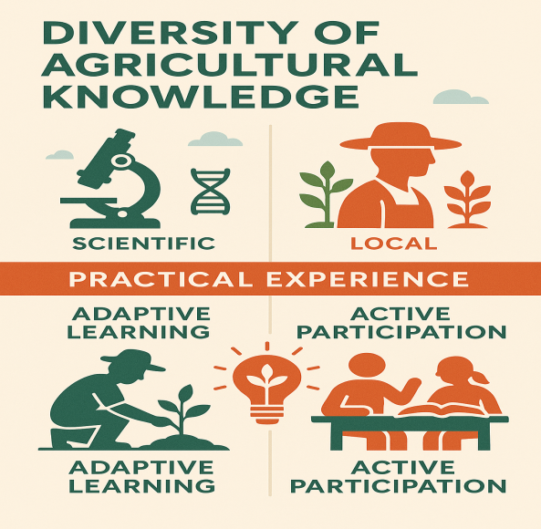education program for agriculture and expansion training. A overall method to understand agricultural education encourages active participation, which inspires students to evaluate and use what they achieve in relation to actual agricultural problems. Education should be viewed as a social activity where students create knowledge collectively through thoughtful reflection and active participation. Conventional, lecture-based instruction to student-centrism, interactive methods encourages independent thinking, effective problem solving and a comprehensive perception of complex agriculture and environmental challenges **[188-190].**

Fig.7.**Diversity of Agricultural knowledge**

Fig.7.**Diversity of Agriculture knowledge**

.**Olive Production and Economic Impact in Jordan**

Jordan plays an important role in global olive production, is widely cultivated in two major regions: rain-based western mountains and irrigated northeast desert. Olive trees are the main fruit crop of the country, which is about 72% of the total fruit planting and 36% of the entire cultivated area **[191,192]**. This industry provides significant economic benefits, with an annual income of 100 million JD, of which 20 million JD comes from export. In recent years, significant growth in olive production has been noticed, of which 30% increased. A large part of the crop, about 69%, designated for olive oil lifting. Northern, especially the Biology, Rasher and Luna, are best in the production of olive oil. Small and medium olive farms are important for the livelihood of numerous Jordanian families, providing seasonal employment opportunities and serve as a major income source for agricultural workers **[193–195].**

**Financial Investment and Efficiency in Agricultural Extension Systems**

The effective supervision of agricultural expansion system with adequate funds creates significant returns on investment. In an ideal situation, about 40% of the budget for an expansion program should be allocated for management costs such as travel, directional materials, publication and field display. Nevertheless, there is a significant difference in expansion costs between developed and developing countries. Advanced countries dedicate significantly more financial resources for every farmer against the developing region, where funds for expansion services are still inadequate **[196,197]**. In some cases, the annual expense for field tests, display and implementation of information and communication technology (ICT) for each farmer is low. A significant part of the overall expansion budget is allocated for organizational expenses, such as salaries, travel, infrastructure maintenance and management costs. Yet, important expansion staff training to enhance knowledge and skills, a small part of the overall budget is allocated. Extended funds are extremely important for professional development and expansion services for aggro productivity and sustainability growth **[198-200].**

**Conclusion:**

Agricultural expansion education is very important for the advancement of sustainable agricultural methods by improving the understanding, efficiency and eco-friendly and affordable methods of farmers. This research emphasizes that well organized expansion initiatives help greatly in improved resource management, greater agricultural production and improved environment preservation. socioeconomic elements such as educational achievements, loans availability and institutional support also influence expansion services on sustainable agricultural promotion. From ecological perspective, expansion education encourages adoption of climate-smart techniques, including conservation agriculture, integrated pest management and water-efficient irrigation methods, thereby reducing the environmental impact of agricultural methods. From the socioeconomic perspective, expansion service users often gain improved elasticity against increased income, increased food security and market and climate change.  
Nevertheless, problems such as insufficient funding, expansion worker deficit and technology transfer shortage are needed to increase the effectiveness of agricultural expansion. Government, research institutions and farmers can improve cooperation between the use of digital technology, as well as the use of knowledge transfer and sustainable practice. In short, this study highlights important importance in agricultural expansion education in sustainable agricultural development from both socioeconomic and environmental perspectives. Investment in efficient expansion programme to ensure long-term agriculture sustainability, rural growth and food security is very important. Future research should focus on creative expansion methods such as digital platforms and participatory techniques to increase the effectiveness of expansion education in sustainable agriculture.

**References:**

1. Allahyari MS, Chizari MO, Mirdamadi SM. Extension-education methods to facilitate learning in sustainable agriculture. Journal of Agriculture & Social Sciences. 2009 Jun 3;5(1-2):27-30.
2. Davis K. Agricultural education and extension in a time of COVID. The Journal of Agricultural Education and Extension. 2020 May 26;26(3):237-8.
3. Koutsouris A. Exploring the emerging intermediation roles (facilitation and brokerage) in agricultural extension education. International journal of agricultural extension. 2014 May 21:21-37.
4. Birkhaeuser D, Evenson RE, Feder G. The economic impact of agricultural extension: A review. Economic development and cultural change. 1991 Apr 1;39(3):607-50.
5. Acker DG, Grieshop JI. University curricula in agricultural and extension education: An analysis of what we teach and what we publish. Journal of International Agricultural and Extension Education. 2004;11(3):53-61.
6. Rogers A. Adult education and agricultural extension: some comparisons. International Journal of Lifelong Education. 1993 Jul 1;12(3):165-76.
7. Adu K, Puthenkalam JJ, Kwabena AE. Agricultural and extension education for sustainability approach. British Journal of Environmental Studies. 2022 Jan 19;2(1):20-37.
8. Shinn GC, Wingenbach GJ, Lindner JR, Briers GE, Baker M. Redefining agricultural and extension education as a field of study: Consensus of fifteen engaged international scholars. Journal of International Agricultural and Extension Education. 2009;16(1):73-88.
9. Roberts TG, Moore LL, Dyer JE. Distance education: A synthesis of research from agricultural and extension education. NACTA journal. 2005 Mar 1:44-51.
10. Sewell AM, Hartnett MK, Gray DI, Blair HT, Kemp PD, Kenyon PR, Morris ST, Wood BA. Using educational theory and research to refine agricultural extension: affordances and barriers for farmers’ learning and practice change. The Journal of Agricultural Education and Extension. 2017 Aug 8;23(4):313-33.
11. Karbasioun M, Biemans H, Mulder M. Supporting role of the agricultural extension services and implications for agricultural extension instructors as perceived by farmers in Esfahan, Iran. Journal of International Agricultural and Extension Education. 2007 Jun 13;14(1):31-44.
12. Maulu S, Hasimuna OJ, Mutale B, Mphande J, Siankwilimba E. Enhancing the role of rural agricultural extension programs in poverty alleviation: A review. Cogent Food & Agriculture. 2021 Jan 1;7(1):1886663.
13. Klerkx L. Advisory services and transformation, plurality and disruption of agriculture and food systems: towards a new research agenda for agricultural education and extension studies. The Journal of Agricultural Education and Extension. 2020 Mar 14;26(2):131-40.
14. Kaur K, Kaur P. Agricultural extension approaches to enhance the knowledge of farmers. International Journal of Current Microbiology and Applied Sciences. 2018;7(2):2367-76.
15. Camillone N, Duiker S, Bruns MA, Onyibe J, Omotayo A. Context, challenges, and prospects for agricultural extension in Nigeria. Journal of International Agricultural and Extension Education. 2020;27(4):144-56.
16. Murphrey TP, Koswatta TJ, Doody KE, Edgar LD. An analysis of evaluation methods implemented in studies published in the journal of international agricultural and extension education from 1994 to 2018: a 25 year review. Journal of International Agricultural and Extension Education. 2018;25(4):27-39.
17. Al-Kaisi MM, Elmore RW, Miller GA, Kwaw-Mensah D. Extension agriculture and natural resources in the US Midwest: A review and analysis of challenges and future opportunities. Natural Sciences Education. 2015 Dec;44(1):26-33.
18. Rivera WM. Public sector agricultural extension system reform and the challenges ahead. Journal of Agricultural Education and Extension. 2011 Apr 1;17(2):165-80.
19. Jayaratne KS, Martin RA, DeWitt JR. Perceptions regarding sustainable agriculture: Emerging trends for educating extension educators. InProceedings of the 17th Annual Conference of the Association for International Agriculture and Extension Education, XVII., Baton Rouge, LA. Retrieved on July 2001 Apr 4 (Vol. 9, p. 2001).
20. Mirando MA, Bewley JM, Blue J, Amaral-Phillips DM, Corriher VA, Whittet KM, Arthur N, Patterson DJ. EXTENSION EDUCATION SYMPOSIUM: Reinventing extension as a resource—What does the future hold?. Journal of animal science. 2012 Oct 1;90(10):3677-92.
21. Msuya CP, Annor-Frempong FK, Magheni MN, Agunga R, Igodan C, Ladele AA, Huhela K, Tselaesele NM, Msatilomo H, Chowa C, Zwane E. The role of agricultural extension in Africa’s development, the importance of extension workers and the need for change. International Journal of Agricultural Extension. 2017 May 1;5(1):51-8.
22. Rivera WM. Agricultural extension as adult education: institutional evolution and forces for change. International journal of lifelong education. 1998 Jul 1;17(4):260-4.
23. Gorman M. Becoming an agricultural advisor–the rationale, the plan and the implementation of a model of reflective practice in extension higher education. The Journal of Agricultural Education and Extension. 2019 Mar 15;25(2):179-91.
24. Altalb AA, Filipek T, Skowron P. The role of agricultural extension in the transfer and adoption of agricultural technologies. Asian Journal of Agriculture and Food Sciences. 2015 Oct 25;3(5).
25. Kotile DG, Martin RA. Sustainable agricultural practices for weed management: Implications to agricultural extension education. Journal of Sustainable Agriculture. 2000 Aug 7;16(2):31-51.
26. Uddin MN. Agricultural extension services in Bangladesh: A review study. Department of Agricultural Extension Education, Bangladesh Agricultural University, Bangladesh. 2008 Oct.
27. Kalogiannidis S, Syndoukas D. The impact of agricultural extension services on farm output: A worldwide viewpoint. Research on World Agricultural Economy. 2024 Mar 31;5(1):96-114.
28. Charatsari C, Lioutas ED. Evaluating agricultural extension and education projects: The VELVET approach. Development in Practice. 2020 May 18;30(4):548-57.
29. Allahyari MS. Agricultural sustainability: Implications for extension systems. African Journal of Agricultural Research. 2009 Sep 1;4(9):781-6.
30. Suvedi M, Ghimire R. How competent are agricultural extension agents and extension educators in Nepal. Innovation for Agricultural Training and Education, Feed the Future, USAID, Michigan State University. Accessed December. 2015 Dec;15:2016.
31. Gikunda RM, Lawver DE, Baker M, Boren-Alpizar AE, Guo W. Extension education needs for improved adoption of sustainable organic agriculture in Central Kenya.
32. Al-Zahrani KH, Khan AQ, Baig MB, Mubushar M, Herab AH. Perceptions of wheat farmers toward agricultural extension services for realizing sustainable biological yields. Saudi Journal of Biological Sciences. 2019 Nov 1;26(7):1503-8.
33. Xu Z, Adeyemi AE, Catalan E, Ma S, Kogut A, Guzman C. A scoping review on technology applications in agricultural extension. Plos one. 2023 Nov 6;18(11):e0292877.
34. Ponnusamy K, Padaria RN. Research in agricultural extension: Review of its contribution and challenges. The Indian Journal of Agricultural Sciences. 2021 May 1;91(5):659-65.
35. Ponnusamy K, Padaria RN. Research in agricultural extension: Review of its contribution and challenges. The Indian Journal of Agricultural Sciences. 2021 May 1;91(5):659-65.
36. Dhital PR. Agricultural extension in Nepal: experiences and issues. Journal of Advances in agriculture. 2017;7(3):1071-82.
37. Manfre C, Rubin D, Allen A, Summerfield G, Colverson K, Akeredolu M. Reducing the gender gap in agricultural extension and advisory services. Modernizing Extension and Advisory Services Discussion Paper United States Agency for International Development. 2013 Apr.
38. Ogundari K. A meta-analysis of the impact of agricultural extension services. China Agricultural Economic Review. 2022 Mar 22;14(2):221-41.
39. Adesoji SA, Famakinwa M, Eghosa AE. Assessment of agricultural extension students’ interest in providing private extension services in Nigeria.
40. Chouhan NS, Dixit D, Tripathi S, Pandey A, Ahmedf+ R. A Comprehensive review on role of agricultural extension services in the sustainable development of global agriculture. Int. J. Environ. Clim. Change. 2023;13(10):3514-25.
41. Garforth GE, Jones C, Jones G, Garforth C. The history, development, and future of agricultural extension. SWANSON, BE; BENTZ, RP; SOFRANKO, AJ Improving agricultural extension: a reference manual. Roma: FAO. 1997.
42. Donye AO, Ja’afar-Furo MR, Obinne CP. Improving smallholder farming and extension in Nigeria: the Sasakawa Africa fund for extension education strategy. Agriculture and Biology Journal of North America. 2013 May 29;4(2):97-102.
43. Idowu OO. Farmers' perception of agricultural extension agents' characteristics as factors for enhancing adult learning in Mezam division of Northwest Province of Cameroon. Australian Journal of Adult Learning. 2005 Jul;45(2):223-37.
44. Laurent C, Cerf M, Labarthe P. Agricultural extension services and market regulation: learning from a comparison of six EU countries. Journal of Agricultural Education and Extension. 2006 Mar 1;12(1):5-16.
45. Moonsammy S, Moonsammy DM. Social media application in agriculture extension programming for small scale rural farmers: is knowledge impeding the lack of adoption?. Journal of International Agricultural and Extension Education. 2020;27(3):27-42.
46. Rezvanfar A, Ghorbanian M, Shafiee F. An investigation of the behaviour of agricultural extension and education engineering students in Tehran University towards employability. Procedia-Social and Behavioral Sciences. 2014 Oct 7;152:65-9.
47. Parrish AM. Agricultural extension education and the transfer of knowledge in an Egyptian oasis. InWhat is Indigenous Knowledge? 2002 Sep 11 (pp. 269-283). Routledge.
48. Nettle R, Major J, Turner L, Harris J. Selecting methods of agricultural extension to support diverse adoption pathways: a review and case studies. Animal Production Science. 2022 Dec 23;64(1):NULL-.
49. Davis KE, Swanson B, Amudavi D, Mekonnen DA, Flohrs A, Riese J, Lamb C, Zerfu E. In-depth assessment of the public agricultural extension system of Ethiopia and recommendations for improvement.
50. Cline LL, Rosson H, Weeks PP. Women faculty in postsecondary agricultural and extension education: A fifteen year update. Journal of Agricultural Education. 2019 Jun 30;60(2):1-4.
51. Donaldson JL, Graham DL, Arnold S, Taylor LK, Jayaratne KS. Extension Education Trends and Research Needs: Views from Professionals and Faculty. Journal of Agricultural Education. 2022;63(3):73-82.
52. Michailidis A. Agricultural extension services in the mountain areas of Greece. Journal of International Agricultural Extension and Education. 2007 Jun 13;14(1):71-80.
53. Sulaiman V R, van den Ban AW. Reorienting agricultural extension curricula in India. The Journal of agricultural education and extension. 2000 Jan 1;7(2):69-78.
54. Jensen JM. Crossing ethnic barriers in the southwest: women’s agricultural extension education, 1914–1940. na; 1986 Apr 1.
55. Anastasios M, Koutsouris A, Konstadinos M. Information and communication technologies as agricultural extension tools: a survey among farmers in West Macedonia, Greece. Journal of Agricultural Education and Extension. 2010 Sep 1;16(3):249-63.
56. Tata JS, McNamara PE. Impact of ICT on agricultural extension services delivery: evidence from the Catholic Relief Services SMART skills and Farmbook project in Kenya. The Journal of Agricultural Education and Extension. 2018 Jan 1;24(1):89-110.
57. Moayedi AA, Azizi M. Participatory management opportunity for optimizing in agricultural extension education. Procedia-Social and Behavioral Sciences. 2011 Jan 1;15:1531-4.
58. Belay K. Agricultural extension in Ethiopia: the case of participatory demonstration and training extension system. Journal of social development in Africa. 2003 Jan 1;18(1):49-84.
59. Kassem HS, Alotaibi BA, Muddassir M, Herab A. Factors influencing farmers’ satisfaction with the quality of agricultural extension services. Evaluation and Program Planning. 2021 Apr 1;85:101912.
60. Wijaya A, Offermans A. Public agricultural extension workers as boundary workers: identifying sustainability perspectives in agriculture using Q-methodology. The Journal of Agricultural Education and Extension. 2019 Jan 1;25(1):3-24.
61. Saravanan R, editor. ICTs for agricultural extension: Global experiments, innovations and experiences. New india publishing; 2010.
62. Boyaci M, Yildiz O. An overview of agricultural extension services in Turkey. Bulgarian Journal of Agricultural Science. 2016;22(1):151-7.
63. Alawa DA, Begianpuye AS, Mohammed I, Akem DA. Inclusion of ecological sustainable development themes into agricultural extension education programme: Content and delivery methods. Global Journal of Agricultural Sciences. 2023 Aug 22;22(1):13-21.
64. Kacharo DK. ICT and challenges of agricultural extension education. Journal of Agricultural Extension and Rural Development. 2020 Aug 31;12(3):57-61.
65. Swanson BE. Global review of good agricultural extension and advisory service practices. Rome: Food and Agriculture Organization of the United Nations; 2008.
66. Bahua MI, Jahi A, Asngari PS, Saleh A, Purnaba IG. Factors affecting the performance agricultural extension and their impact at behavior maize farmers in Gorontalo Province. The Journal of Agricultural Education and Extension. 2013 Aug;1:1-0.
67. Axinn GH. The different systems of agricultural extension education with special attention to Asia and Africa. InAgricultural extension worldwide 2022 Mar 29 (pp. 103-114). Routledge.
68. Belay K, Abebaw D. Challenges facing agricultural extension agents: A Case Study from South‐western Ethiopia. African development review. 2004 Apr;16(1):139-68.
69. Thakur D, Chander M. Use of social media in agricultural extension: Some evidences from India. International Journal of Science, Environment and Technology. 2018;7(4):1334-46.
70. Bhardwaj A. Cognitive levels of the educational programs offered by the Ohio Cooperative Extension Service county agricultural extension agents. The Ohio State University; 1989.
71. Mutimba J. Agricultural extension debatable issues. African Journal of Food, Agriculture, Nutrition and Development. 2024 Apr 6;24(3):25662-76.
72. Shinn GC, Wingenbach GJ, Briers GE, Lindner JR, Baker M. Forecasting doctoral–level content in international agricultural and extension education–2010: Viewpoint of fifteen engaged scholars. Journal of International Agricultural and Extension Education. 2009;16(1):57-71.
73. Salehi M, Abbasi E, Bijani M, Shahpasand MR. Evaluation of agricultural extension model sites approach in Iran. Journal of the Saudi Society of Agricultural Sciences. 2021 Dec 1;20(8):506-18.
74. Cho KM, Boland H. Agricultural training in Myanmar: extension agents’ perceptions of training needs. Journal of International Agricultural and Extension Education. 2004;11(1):5-15.
75. Olayemi SS, Alo Adeola Ope-Oluwa AA, Angba CW. Evolution of agricultural extension models in Sub-Saharan Africa: A critical review. International Journal of Agricultural Extension and Rural Development Studies. 2021 Feb 27;8(1):29-51.
76. Uricchio C, Moore G, Coley M. Corn Clubs: Building the Foundation for Agricultural and Extension Education. Journal of Agricultural Education. 2013;54(3):224-37.
77. Emmanuel D, Owusu-Sekyere E, Owusu V, Jordaan H. Impact of agricultural extension service on adoption of chemical fertilizer: Implications for rice productivity and development in Ghana. NJAS-Wageningen Journal of Life Sciences. 2016 Dec 1;79:41-9.
78. Halbritter A, Wallau M, Benge M, Mackowiak C. Identifying important skills and competencies needed for new Florida agriculture extension agents. Advancements in Agricultural Development. 2021 Oct 28;2(3):61-71.
79. Lindner JR. Handling of nonresponse error in the Journal of International Agricultural and Extension Education. Journal of International Agricultural and Extension Education. 2002;9(3):55-60.
80. Chizari M, Karbasioun M, Lindner JR. Obstacles facing extension agents in the development and delivery of extension educational programs for adult farmers in the province of Esfahan, Iran. Journal of Agricultural Education. 1998 Mar 28;39(1):48-54.
81. Mohammadi IM. Agricultural waste management extension education (AWMEE.) The ultimate need for intellectual productivity. Am J Environ Sci. 2006;2(1):10-4.
82. Lopokoiyit M, Onyango C, Kibett JK. Extension management competency needs of agricultural extension agents in Kenya. Mediterranean Journal of Social Sciences. 2013 Jul;4(6):11.
83. Sulandjari K, Putra A, Sulaminingsih S, Adi Cakranegara P, Yusroni N, Andiyan A. Agricultural extension in the context of the Covid-19 pandemic: Issues and challenges in the field. Caspian Journal of Environmental Sciences. 2022 Jan 1;20(1):137-43.
84. Madan S, Maredia K. Global experiences in agricultural extension, community outreach & advisory services. Innovations in agricultural extension. 2021:1-6.
85. Rusliyadi M, Jamil AB, Othman M, Kumalasari RT. Agricultural extension policy, agricultural growth and poverty reduction in Indonesia. International Journal of Engineering & Technology. 2018;7(4):5539-50.
86. Worth SH. *An assessment of the appropriateness of agricultural extension education in South Africa* (Doctoral dissertation, University of KwaZulu-Natal, Pietermaritzburg).
87. Androulidakis SI, Siardos GC. Agricultural extension agents' perceptions regarding their relevance and competence in certain professional task areas. European Journal of Agricultural Education and Extension. 1994 Dec 1;1(3):1-3.
88. Moyo R, Salawu A. A survey of communication effectiveness by agricultural extension in the Gweru district of Zimbabwe. Journal of Rural Studies. 2018 May 1;60:32-42.
89. Ahmadpour A, Soltani S. Agricultural extension workers’ attitude to and experience of e-learning. African Journal of Agricultural Research. 2012 Jun 26;7(24):3534-40.
90. Gaaya A. Extension education in agricultural and rural development: Role of international organizations-the FAO experience. Cahiers Options Mediterraneennes (CIHEAM). v. 2 (4).. 1994.
91. Rivera WM, Qamar MK. Agricultural extension, rural development and the food security challenge. Rome: Food and Agriculture Organization of the United Nations; 2003.
92. Quizon J, Feder G, Murgai R. Fiscal sustainability of agricultural extension: The case of the farmer field school approach. Journal of International Agricultural and Extension Education. 2001 Mar 1;8(1):13-24.
93. Hunt W, Birch C, Coutts J, Vanclay F. The many turnings of agricultural extension in Australia. The Journal of Agricultural Education and Extension. 2012 Feb 1;18(1):9-26.
94. Anang BT, Bäckman S, Sipiläinen T. Adoption and income effects of agricultural extension in northern Ghana. Scientific African. 2020 Mar 1;7:e00219.
95. Ragasa C. Improving gender responsiveness of agricultural extension. Gender in agriculture: Closing the knowledge gap. 2014:411-30.
96. Oloruntoba A, Adegbite DA. Improving agricultural extension services through university outreach initiatives: a case of farmers in model villages in Ogun State, Nigeria. Journal of agricultural education and extension. 2006 Dec 1;12(4):273-83.
97. Uwakah CT. The training needs of agricultural extension staff in Eastern Nigeria. Agricultural Administration. 1980 Apr 1;7(2):79-86.
98. Bakari N, Managanta AA, Tambingsila M. The increasing capacity of rice farmers through the role agricultural extension. Indonesian Journal of Agricultural Research. 2021;4(3):174-86.
99. Jamil MH, Tika N, Fudjaja L, Tenriawaru AN, Salam M, Ridwan M, Muslim AI, Chand NV. Effectiveness of agricultural extension on paddy rice farmer’s baubau city, southeast sulawesi, indonesia. Sustainability. 2023 Feb 18;15(4):3773.
100. Charatsari C, Papadaki-Klavdianou A, Michailidis A. Farmers as consumers of agricultural education services: Willingness to pay and spend time. The Journal of Agricultural Education and Extension. 2011 Jun 1;17(3):253-66.
101. Aregaw YG, Endris EA, Bojago E. Factors affecting the competence level of agricultural Extension agents: A comprehensive analysis of core competencies in Northwestern Ethiopia. Education Research International. 2023;2023(1):7928467.
102. Surudhi M, Asokhan M, Arunachalam R. Utilization pattern of extension tools and methods by Agricultural Extension Agents. Journal of Extension Education. 2017;29(2).
103. Davis K, Lion K, Arokoyo T. Organisational capacities and management of agricultural extension services in Nigeria: current status. South African Journal of Agricultural Extension. 2019 Aug 8;47(2):118-27.
104. Singh P, Jirli B, Ghadei K, Roy P, Kumari J. Objectives of extension education: An analysis of perception of KVK professionals. Indian Journal of Extension Education. 2023 Apr;59(2):74-8.
105. Kim JH, Kim SS, Kwon IN. A Study on the University Agricultural Extension Education in Korea. Journal of Agricultural Extension & Community Development. 1997;4(1):371-84.
106. Worth SH. Developing curriculum markers for agricultural extension education in South Africa. Journal of Agricultural Education and Extension. 2008 Mar 1;14(1):21-34.
107. Wulandari R. Information needs and source information of agricultural extension workers in DIY. AGRARIS: Journal of Agribusiness and Rural Development Research. 2015;1(2):85-97.
108. Karbasioun M, Mulder M, Biemans H. Towards a job competency profile for agricultural extension instructors: A survey of views of experts. Human Resource Development International. 2007 Jun 1;10(2):137-51.
109. Gwivaha FA. *Factors that impact agricultural extension training programs for smallholder women farmers in Njombe District, Tanzania* (Master's thesis, Iowa State University).
110. Adisa RS. Management of Farmer-herdsmen Conflicts in North Central Nigeria: Implications for Collaboration between Agricultural Extension Service and other Stakeholders. Journal of International Agricultural and Extension Education. 2011;18(1):60-72.
111. Van den Ban AW. Different ways of financing agricultural extension. Wageningen: Agricultural Research and Extension Network; 2000 Jul.
112. Hamid MI, Datta S, Islam MM. Problems faced by the sub-assistant agriculture officers (SAAOs) working in department of agricultural extension. Research in Agriculture Livestock and Fisheries. 2020 Apr 26;7(1):61-73.
113. Seevers B, Stair K. Exploring community partnerships in agricultural and extension education. The Journal of Extension. 2015;53(3):15.
114. Fu X, Akter S. The impact of mobile phone technology on agricultural extension services delivery: Evidence from India. The Journal of development studies. 2016 Nov 1;52(11):1561-76.
115. Davidson AP. Participation, education, and pluralism: towards a new extension ethic. Development in Practice. 2007 Feb 1;17(1):39-50.
116. Hadiyanti P, Wanpeng L, Sasmita K, Syah R, Jafar MM. The Construction of Agricultural Extension Competencies in Cyber Media for Community Education. Journal of Nonformal Education. 2023 Feb 1;9(1):1-9.
117. True AC. A history of agricultural extension work in the United States, 1785-1923. Arno Press; 1969.
118. Von Blanckenburg P. Basic concepts of agricultural extension in developing countries. Agricultural Administration. 1982 May 1;10(1):35-43.
119. Lioutas ED, Charatsari C. Who is the customer of public agricultural extension/education services?. International Journal of Rural Management. 2011 Oct;7(1-2):83-102.
120. Amungwa F, Baye FM. Appraisal of the agricultural extension system of family farm schools in Cameroon. Asian Journal of Agricultural Extension, Economics & Sociology. 2017;3(6):530-43.
121. Haile F. Factors affecting women farmers’ participation in agricultural extension services for improving the production in rural district of Dendi West Shoa Zone, Ethiopia. Journal of Culture, Society and Development. 2016;21(3):30-41.
122. MANIK JR, REFISWAL R, SALSABILA S. Analysis of Factors Affecting the Performance of Agricultural Extension Agent in Langkat District. InProceeding International Conference Sustainable Agriculture and Natural Resources Management (ICoSAaNRM) 2018 (Vol. 2, No. 01).
123. Dube MM. Perceptions of field officers, extension officers, and farmers regarding agricultural extension education in Swaziland. Iowa State University; 1993.
124. Ngomane T, Thomson JS, Radhakrishna RB. Public sector agricultural extension system in the Northern Province of South Africa: A system undergoing transformation. Journal of International Agricultural and Extension Education. 2002;9(3):31-7.
125. Gido EO, Sibiko KW, Ayuya OI, Mwangi JK. Demand for agricultural extension services among small-scale maize farmers: Micro-level evidence from Kenya. The Journal of Agricultural Education and Extension. 2015 Mar 15;21(2):177-92.
126. Reynar R, Bruening T. Agricultural extension issues: Perception of Bangladesh T&V extension personnel. Journal of International Agricultural and Extension Education. 1996;3(1):53-62.
127. Huda N. Open & distance learning (ODL) and agricultural extension workers’ social competence in Indonesia. Journal of education and learning (EduLearn). 2015 Feb 1;9(1):17-24.
128. Aydogdu M. Evaluation of farmers’ willingness to pay for agricultural extension services in GAP-Harran Plain, Turkey. Journal of Agricultural Science and Technology. 2017 Jul 10;19(4):785-96.
129. Diaz II, Najjar D. Gender and agricultural extension: Why a gender focus matters. Journal of Gender, Agriculture and Food Security (Agri-Gender). 2019;4(2):1-0.
130. Omar JA, Bakar AH, Jais HM, Ibraik FM. A review study of the reorganization of agricultural extension toward sustainable agricultural development. International Journal of Engineering Science and Technology. 2011;3(5):4358-66.
131. Tata JS, McNamara PE. Social factors that influence use of ICT in agricultural extension in Southern Africa. Agriculture. 2016 Apr 8;6(2):15.
132. Marsh SP, Pannell D. Agricultural extension policy in Australia: the good, the bad and the misguided. Australian Journal of Agricultural and Resource Economics. 2000 Dec;44(4):605-27.
133. Namyenya A, Zeller M, Rwamigisa PB, Birner R. Analysing the performance of agricultural extension managers: a case study from Uganda. The journal of agricultural education and extension. 2022 May 27;28(3):363-89.
134. Issahaku A. Perceived competencies of agriculture extension workers in extension services delivery in Northern Region of Ghana: Perspective from literature. Developing Country Studies. 2014 Oct 29;4(15):107.
135. Euriga E, Boehme MH, Amanah S. Changing Farmers' Perception towards Sustainable Horticulture: A Case Study of Extension Education in Farming Community in Yogyakarta, Indonesia. AGRARIS: Journal of Agribusiness and Rural Development Research. 2021 Dec 6;7(2):225-40.
136. Witinok-Huber R, Radil S, Sarathchandra D, Nyaplue-Daywhea C. Gender, place, and agricultural extension: a mixed-methods approach to understand farmer needs in Liberia. The Journal of Agricultural Education and Extension. 2021 Aug 8;27(4):553-72.
137. Yadav DS, Pankaj Sood PS, Thakur SK, Choudhary AK. Assessing the training needs of agricultural extension workers about organic farming in the North-Western Himalayas.
138. Nongtdu G, Bordoloi R, Saravanan R, Singh R, Singh NU. Training needs of agricultural extension personnel in Meghalaya. Indian Journal of Hill Farming. 2012;25(1):1-8.
139. Atsan T, Isik HB, Yavuz F, Yurttas Z. Factors affecting agricultural extension services in Northeast Anatolia Region. African Journal of Agricultural Research. 2009 Apr 1;4(4):305-10.
140. Feder G, Willett A, Zijp W. Agricultural Extension: Generic Challenges and the Ingredients for Solutions. World Bank Publications; 1999.
141. Chukwuone NA, Agwu AE, Ozor N. Constraints and strategies toward effective cost-sharing of agricultural technology delivery in Nigeria: Perception of farmers and agricultural extension personnel. Journal of Agricultural and Extension Education, AIAEE. 2006;13(1).
142. Muchena ON. An analysis of indigenous knowledge systems: implications for agricultural extension education with particular reference to natural resource management in Zimbabwe. Iowa State University; 1990.
143. Allahyari MS. Extension mechanisms to support sustainable agriculture in Iran context. American Journal of Agricultural and Biological Sciences. 2008 Jan 1;3(4):647-55.
144. Nwaogu FK, Akinbile LA. Competencies of agricultural development programme personnel in extension service delivery in Oyo and Ogun States Nigeria. Journal of Agricultural Extension. 2018 Oct 16;22(3):40-52.
145. Ghimire RP, Suvedi M, Kaplowitz M, Richardson R. Competency assessment as a way of determining training and educational needs of extension professionals in Nepal. Journal of International Agricultural and Extension Education. 2017;24(2):137-51.
146. Mapiye O, Makombe G, Molotsi A, Dzama K, Mapiye C. Towards a revolutionized agricultural extension system for the sustainability of smallholder livestock production in developing countries: The potential role of icts. Sustainability. 2021 May 24;13(11):5868.
147. Mutimba JK. Reflections on agricultural extension and extension policy in Africa. South African Journal of Agricultural Extension. 2014;42(1):15-26.
148. Davis K, Place N. Non-governmental organizations as an important actor in agricultural extension in semiarid East Africa. Journal of International Agricultural and Extension Education. 2003;10(1):31-6.
149. Abbas M, Lodhi TE, Aujla KM, Saadullah S. Agricultural extension programs in Punjab, Pakistan. Pakistan Journal of Life and Social Sciences. 2009;7(1):1-0.
150. Agunga R, Manda LZ. Communication for strengthening agricultural extension and rural development in Malawi. Journal of Development and Communication Studies. 2014;3(1):1-6.
151. Ayansina SO, Adeogun SO. Professional competency needs of agricultural extension agents of Ogun state agricultural development programme (ogadep). Ife Journal of Agriculture. 2017 Dec 19;29(2):28-38.
152. Mutimba JK, Knipscheer HC, Naibakelao D. The role of universities in food security and safety: Perspectives based on the Sasakawa Africa fund for extension education. Journal of Developments in Sustainable Agriculture. 2010;5(1):12-22.
153. Arifullah M, Zahan A, Rana MM, Adil M, Shamsunnaher S. Attitude of the rural elite farmers towards extension activities performed by personnel of department of agricultural extension. The Agriculturists. 2014 Jul 19;12(1):96-102.
154. Yaseen M, Shiwei X, Wen Y, Hassan S. Policy challenges to agricultural extension system in Pakistan: A review. Int. J. Agric. Appl. Sci. 2015;7(2):111-5.
155. Becerra-Encinales JF, Bernal-Hernandez P, Beltrán-Giraldo JA, Cooman AP, Reyes LH, Cruz JC. Agricultural extension for adopting technological practices in developing countries: A scoping review of barriers and dimensions. Sustainability. 2024 Apr 24;16(9):3555.
156. Lamm AJ, Lamm KW. Using non-probability sampling methods in agricultural and extension education research. Journal of International Agricultural and Extension Education. 2019;26(1):52-9.
157. Birner R, Anderson JR. How to make agricultural extension demand driven? The case of India's agricultural extension policy. Intl Food Policy Res Inst; 2007.
158. Agholor AI, Olorunfemi OD, Ogujiuba K. Socio-demographic context of resilience for adaptation to climate change and implication for agricultural extension in Buffelspruit, South Africa. South African Journal of Agricultural Extension. 2023;51(4):210-33.
159. Anandajayasekeram P. Concepts and practices in agricultural extension in developing countries: A source book. ILRI (aka ILCA and ILRAD); 2008.
160. Shalaby MY, Al-Zahrani KH, Baig MB, Straquadine GS, Aldosari F. Threats and challenges to sustainable agriculture and rural development in Egypt: implications for agricultural extension. The Journal of Animal & Plant Sciences. 2011 Jan 1;21(3):581-8.
161. Coutts JA. Agricultural extension policy as a framework for change. European Journal of Agricultural Education and Extension. 1995 Jun 1;2(1):17-27.
162. Okello DM, Akite I, Atube F, Kalule SW, Ongeng D. Examining the relationship between farmers’ characteristics and access to agricultural extension: Empirical evidence from northern Uganda. The Journal of Agricultural Education and Extension. 2023 Aug 8;29(4):439-61.
163. Shalaby MY, Baig MB, Al-Shayaa MS. Agricultural extension in Egypt: Issues and options for improvement. Arab Gulf Journal of Scientific Research. 2010 Dec 1;28(4):205-13.
164. Khan MH, Kumbhar MI, Khooharo AA, Magsi H. A SWOT analysis of in-service training programs for agricultural extension workers in Southern Punjab, Pakistan. Traditional Journal of Law and Social Sciences. 2024 Dec 31;3(02):84-98.
165. Hainzer K, O’Mullan C, Brown P. The use of local knowledge in agricultural extension: A systematic review of the literature.
166. Davidson AP, Ahmad M. Effectiveness of public and private sector agricultural extension: Implications for privatisation in Pakistan. The Journal of Agricultural Education and Extension. 2002 Oct 1;8(3):117-26.
167. Ragasa C, Ulimwengu J, Randriamamonjy J, Badibanga T. Assessment of the capacity, incentives, and performance of agricultural extension agents in Western Democratic Republic of Congo. Intl Food Policy Res Inst; 2013 Aug 19.
168. Okeowo TA. Analysis of competency and training needs among agricultural extension personnel in Lagos State. Int. J. For. Hort.(IJFH). 2015;1:14-21.
169. David S, Asamoah C. Video as a tool for agricultural extension in Africa: a case study from Ghana. International Journal of Education and Development using ICT. 2011 May 5;7(1):26-41.
170. Mamgain A, Joshi U, Chauhan J. Impact of social media in enhancing Agriculture extension. Agriculture and Food: E-Newsletter. 2020;2(9):367-70.
171. Ferroni M, Zhou Y. Achievements and challenges in agricultural extension in India. Global Journal of Emerging Market Economies. 2012 Sep;4(3):319-46.
172. Rutatora DF, Mattee AZ. Major agricultural extension providers in Tanzania. African Study Monographs. 2001;22(4):155-73.
173. Abi-Ghanem R, Carpenter-Boggs L, Koenig RT, Ullman JL, Murphy KM, Pannkuk C. Access to AgriculturalInputs, Technology and Information, Communicating with Farmers, and the Role of Women in Agriculture: Perceptions of Iraqi Extension Agents. Journal of International Agricultural and Extension Education. 2013;20(1):6-18.
174. Taye H. Evaluating the impact of agricultural extension programmes in sub-Saharan Africa: Challenges and prospects. African Evaluation Journal. 2013 Sep 30;1(1):9.
175. Vanclay F, Lawrence G. Farmer rationality and the adoption of environmentally sound practices; a critique of the assumptions of traditional agricultural extension. European Journal of Agricultural Education and Extension. 1994 Apr 1;1(1):59-90.
176. Akpabio IA, Okon DP, Inyang EB. Constraints affecting ICT utilization by agricultural extension officers in the Niger Delta, Nigeria. Journal of agricultural education and extension. 2007 Dec 1;13(4):263-72.
177. Elias A, Nohmi M, Yasunobu K, Ishida A. Effect of agricultural extension program on smallholders' farm productivity: Evidence from three peasant associations in the highlands of Ethiopia. Journal of Agricultural Science. 2013 Aug 1;5(8):163.
178. Purnomo S, Lee YH. An assessment of readiness and barriers towards ICT program implementation: Perceptions of agricultural extension officers in Indonesia. International Journal of Education and Development using ICT. 2010 Oct 28;6(3):19-36.
179. Hellin J. Agricultural extension, collective action and innovation systems: Lessons on network brokering from Peru and Mexico. The Journal of Agricultural Education and Extension. 2012 Apr 1;18(2):141-59.
180. Dollisso AD, Martin RA. Perceptions regarding preferred educational information sources by farmers: Implications to international agricultural extension education. In2001 Conference Proceedings, 17th Annual Conference. Association for International Agricultural Extension and Education 2001 Apr 4.
181. Gow G, Chowdhury A, Ramjattan J, Ganpat W. Fostering effective use of ICT in agricultural extension: participant responses to an inaugural technology stewardship training program in Trinidad. The journal of agricultural education and extension. 2020 Aug 7;26(4):335-50.
182. Mkuki ZH, Msuya CP. Agricultural extension officers’ perceptions towards their roles: a case study of Simiyu Region. Tanzania Journal of Agricultural Sciences. 2020;19(2):56-66.
183. Tiraieyari N, Idris K, Hamzah A, Uli J. ‘Importance of program development competencies for agricultural extension agents’ performance in process of technology transfer.’’. American Journal of Agricultural and Biological Sciences. 2010;5(3):376-9.
184. Rivera W. Whither agricultural extension worldwide? Reforms and prospects. InKnowledge generation and technical change: institutional innovation in agriculture 2001 (pp. 291-311). Boston, MA: Springer US.
185. Ahmadpour A, Mirdamadi M, Hosseini JF, Chizari M. Factors influencing the design of electronic learning system in agricultural extension.
186. Lodhi TE, Luqman MU, Khan GA. Perceived effectiveness of public sector extension under decentralized agricultural extension system in the Punjab, Pakistan. Journal of Agriculture & Social Sciences. 2006;2(3):195-200.
187. Shiri N, Faghiri M, Pirmoradi A, Agahi H. Attitudes of agricultural extension workers towards organic farming in Iran.
188. Van den Ban AW. Changes in society require changes in agricultural extension: some observations. Asian journal of extension education. 2004;23(1):1Á17.
189. Hancock J. Extension education: Conducting effective agricultural demonstrations. University of Kentucky Cooperative Extension Service. Publication ID-111. 1992.
190. Buehren N, Goldstein M, Molina E, Vaillant J. The impact of strengthening agricultural extension services on women farmers: Evidence from Ethiopia. Agricultural Economics. 2019 Jul;50(4):407-19.
191. Kizilaslan N. Rural women in Agricultural extension training. Research Journal of Social Sciences. 2007;2(3):23-7.
192. Bennett CF. Rationale for public funding of agricultural extension programs. Journal of Agricultural & Food Information. 1996 Oct 1;3(4):3-25.
193. Mgbakor M, Iyobor O, Okezie UP. Contributions of mass media to the development of agricultural extension in Ika North East LGA of Delta State, Nigeria. Academic Journal of Plant Sciences. 2013;6(3):127-33.
194. Uzokwe UN, Ofuoku UA. Changes in gender division of agricultural tasks in Delta State, Nigeria and implications for agricultural extension services. Extension Farming Systems Journal. 2006 Jan;2(1):91-6.
195. Thakur D, Chander M, Sinha S. Whatsapp for farmers: Enhancing the scope and coverage of traditional agricultural extension. International Journal of Science Environment and Technology. 2017;6(4):2190-201.
196. Ghimire RP, Suvedi M. A qualitative study examining core competency needs of agricultural extension professionals in Nepal. Asian Journal of Agricultural Extension, Economics & Sociology. 2017;18(3):1-2.
197. Muyanga M, Jayne TS. Private agricultural extension system in Kenya: Practice and policy lessons. Journal of agricultural education and extension. 2008 Jun 1;14(2):111-24.
198. El Bilali H, Driouech N, Berjan S, Capone R, Abouabdillah A, Ahouate L, Azim K, Najid A. Agricultural extension system in Morocco: problems, resources, governance and reform. In21st European Seminar on Extension Education 2016 (pp. 307-310).
199. Munir A, Davidson A. Privatization and the Crisis of Agricultural Extension: The Case of Pakistan: The Case of Pakistan. Routledge; 2017 Nov 1.
200. Singh KM, Meena MS, Swanson B. Role of State Agricultural Universities and Directorates of Extension Education in Agricultural Extension in India. Available at SSRN 2315381. 2013 Aug 16.