**Trends and Patterns of Publications in the Indian Journal of Agricultural Sciences Through Bibliometric Analysis**

**Abstract:**

The Indian Journal of Agricultural Sciences is the most prominent journal in India committed to experimental agriculture. It publishes articles in all branches of agriculture, including agronomy, genetics, breeding, cytology, soil sciences, agro forestry, horticulture, water management, microbiology, agricultural engineering, plant diseases and pests, statistics and economics. The paper describes the outcomes of a bibliometric analysis of the publication "Indian Journal of Agricultural Sciences" from 2008 to 2022. The data were collected from the Scopus website and analyzed in R-software in version 4.3.2. Over 4000 peer-reviewed papers in the Scopus database explored with the default indicators of bibliometric software tools. The findings revealed that the number of publications had a negative growth rate (-4.99%) during the given period and a greater number of articles were published in 2020 (388). The top five most productive authors were K. A. Gomez (326), M. L. Jackson (292), V. G. Panze (210), S. Kumar (194) and A. K. Singh (188). The results showed that the number of articles increased gradually during 2015-2020 and the fall of publishing of articles were recorded after 2021. The most productive institution was the ICAR- Indian Agricultural Research Institute and followed by Punjab Agricultural University. India leads in the corresponding author’s contribution followed by China and Iran and also India dominated in the citation, production over time and co-author contribution.

**Key words:** Indian Journal of Agricultural Sciences, bibliometric, article, data, wheat

**1.1. Introduction:**

Bibliometrics is the use of statistical approaches to the analysis of manuscripts, books, and other publications, particularly those with scientific content. Bibliometric approaches are widely utilized in library and information science. Pritchard coined the term bibliometrics in 1969 to replace the term "statistical bibliography". The term is defined as the study of the use of documents and publication trends using mathematical and statistical methodologies. InEastern European countries, bibliometric methods have been employed first to track science and scientists (Thanuskodi S, 2010). Bibliometrics defined “the development and application of mathematical models and techniques to all aspects of communication. Bibliometrics is the quantitative study of literature as they are reflected in bibliographies. its task, immodestly enough, is to provide evolutionary models of science, technology and scholarships. “Beck (1978) defined it as “the quantitative evaluation and inter-comparison of scientific activity, productivity and progress.”

According to the National Academy of Agricultural Sciences, The Indian Journal of Agricultural Sciences has a rating of 7.2 and this journal has aninternational impact factor of 0.11. The journal focuses on original articles that report on the findings of problem-oriented, completed research in India and other countries with similar agricultural difficulties. Short notes are published as a result of preliminary data of topical value. The magazine also publishes critical review articles authored by competent scientists who have done major investigations in their disciplines and are capable of pointing out research gaps and recommending new courses of investigation. The journal also publishes book reviews. Articles are accepted on the following broad disciplines: Agric. Engineering & Technology, Genetics, Agronomy, Forestry, Agric. Social & Economic Sci., Fertilization, Biometry, Biosciences, Cytology, Ecology, Microbiology, Environmental Sciences, Horticultural Sciences, Pest, and Weed Control. This journal having h-index of 30 and the publisher is Indian Council of Agricultural Research.

**1.2. Objectives:**

The current study was undertaken with the objective of analyzing the following aspects:

* To analyze the annual scientific production of the journal
* To find out the annual average citations
* To study the authorship pattern, relevant authors and authors production over time
* To trace out the author’s local impact by h-index
* To analyze the trend topics and frequency of words
* To study the country’s scientific production and citation
* To study the subject coverage of articles
* To find out the relevant affiliations and its production over time
* To analyze the collaboration network of different countries and authors

**2.1. Methodology:**

The bibliometric analysis was carried out by using Scopus database, R packages with R studio. Comprehensive data was collected from the Scopus database, and the data extraction was done in 15.10.2023 through Scopus API which employed specific queries. The was collected in CSV file format and pre-processing of data, eliminating of duplicated files and the correction of preliminary details of articles were done in Microsoft Excel. The comprehensive data of 3996 articles, book chapters proceeding papers, meeting abstract, editorial material, review and correction were downloaded from the Scopus database. The latest version 4.3.2 of RStudiowas downloaded and established the bibliometric package within R-environment to analyze and map the bibliographic data. The web interface for bibliometric was given by the application called **biblioshiny.**

**Figure 1: Flow chart of the bibliometric analysis**

Biblioshiny allowed performing relevant bibliometric and visual analyses on an interactive web interface, greatly reduced information input intensity and usage threshold. This analysis covered important key metrics such as h-index, counts of publication and citation, collaboration pattern, thematic map, clustering by coupling and citation network. The investigation was limited to the particular time span (2008-2022) and the specific journal. Scopus, R packages, R studio, R confined Biblioshiny, Microsoft Excel are the basic software tools used for this data analysis.

**3.1. Results:**

The data provided (Table 1.) offers valuable insights into a bibliometric analysis spanning from 2008 to 2022. The dataset, consisting of 3996 documents from the IJAS source, shows an annual growth rate of -4.99%, which indicates that the volume of publications has decreased over time. These records have an average age of 7.68 years, which implies that a significant portion of the research may have been done years before it was published. Remarkably, an average of 3.443 citations per document was identified, indicating the scholarly significance of this research.

There are 9181 author's keywords and 950 keyword terms in the dataset. It includes 6288 authors in total, and 3.478% of the papers have international co-authorships, which is notable because it shows cross-border cooperation. Articles (3834) are the most common document type, followed by reviews (149), which correspond to the main publishing method.

**Table.1. Summary of Indian Journal of Agricultural Sciences (2008-2022)**

|  |  |
| --- | --- |
| **Description** | **Results** |
| **MAIN INFORMATION ABOUT DATA** | |
| Timespan | 2008:2022 |
| Sources (Journals, Books, etc.) | 1 |
| Documents | 3996 |
| Annual Growth Rate % | -4.99 |
| Document Average Age | 7.68 |
| Average citations per doc | 3.443 |
| References | 69314 |
| **DOCUMENT CONTENTS** | |
| Keywords Plus (ID) | 950 |
| Author's Keywords (DE) | 9181 |
| **AUTHORS** | |
| Authors | 6288 |
| Authors of single-authored docs | 103 |
| **AUTHORS COLLABORATION** | |
| Single-authored docs | 122 |
| Co-Authors per Doc | 4.36 |
| International co-authorships % | 3.478 |
| **DOCUMENT TYPES** | |
| Article | 3834 |
| Erratum | 6 |
| Review | 149 |
| Short survey | 7 |

**3.1.1. Annual scientific production**

The data (Figure 2) shows the number of publications released each year between 2008 and 2022. It indicates an upward trend in the work of scholars. Interestingly, there is a remarkable increase in publications from 2015 to 2020, and 1,783 articles were published over this period. However, the trend reverses in the subsequent years, with a noticeable decline in publications, reaching a mere 126 publications in 2022. . This data indicates a possible evolution in the goals of research or publication patterns throughout time, potentially driven by a number of different factors including a global epidemic, research funding, changing research trends, and their impact on academic output.

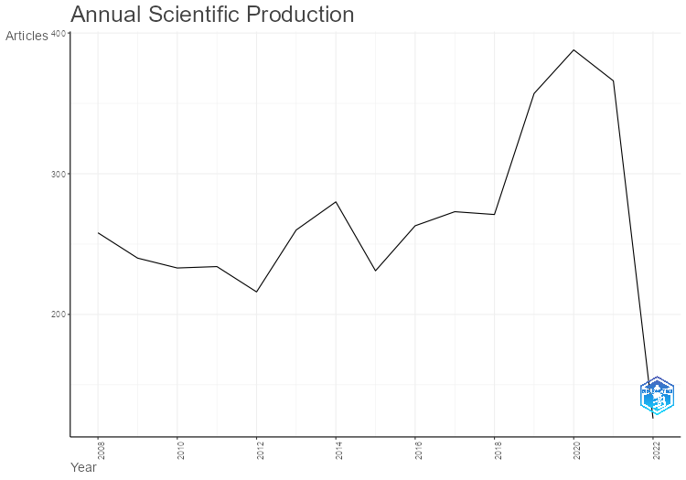

**Figure 2: Annual Scientific Production**

**3.1.2. Average citations per year**

The data (Figure 3) shows the "Indian Journal of Agricultural Sciences" average annual citations from 2008 to 2022. It indicates a remarkable pattern in the influence of journal citations. From 2008 to 2022, the average number of citations per year remained reasonably constant at approximately 3-6, suggesting that the articles' influence and significance remained stable. The average number of citations increased between 2008 and 2011, then continued to fall gradually reaching a peak fall during 2019-2022. This implies that during those years, the "Indian Journal of Agricultural Sciences" had a notable growth in its intellectual impact, maybe as a result of improved editorial policies or rising interest in the journal's publications among scientists.

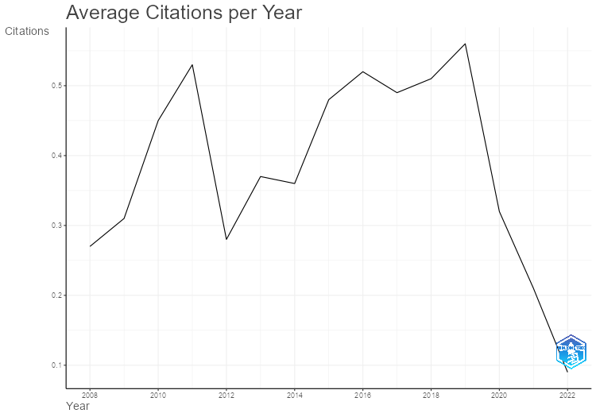

**Figure 3: Average citations per year**

**3.1.3. Documents by subject area and typein ‘Indian Journal of Agricultural Sciences’**

Analyzing document types in bibliometric analysis holds significant importance as it provides insights into the characteristics, distribution, and impact of different types of scholarly documents within a research field. Document types refer to various forms of publications such as articles, reviews, conference papers, books, patents, theses, and more. Figure. 4 indicates higher number of publications were made in Agricultural science (27.7%) followed by soil science (13.4) and engineering (8.0). The lowest contribution was recorded in the fields of biochemistry (3.6) and followed by medicine (3.6).

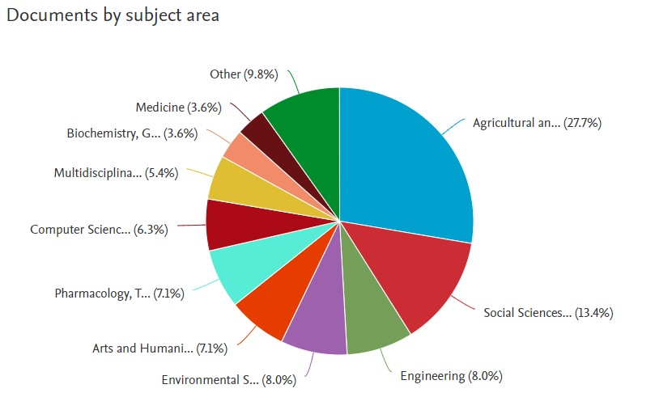

**Figure 4. Documents by subject area in ‘Indian Journal of Agricultural Sciences’**

Most documents were published as an article (67.7%) followed by Erratum (13.5%) and review articles (6.8%). The dominance of a single type of document analysis can occur due to various reasons, reflecting specific characteristics and trends within a particular research field or discipline. The articles were dominated due to academic disciplines prioritizing journal articles as the primary form of scholarly communication and dissemination of research findings. Similarly, articles typically undergo rigorous peer review, enhancing their credibility and acceptance within the academic community (Patil *et al*, 2022).

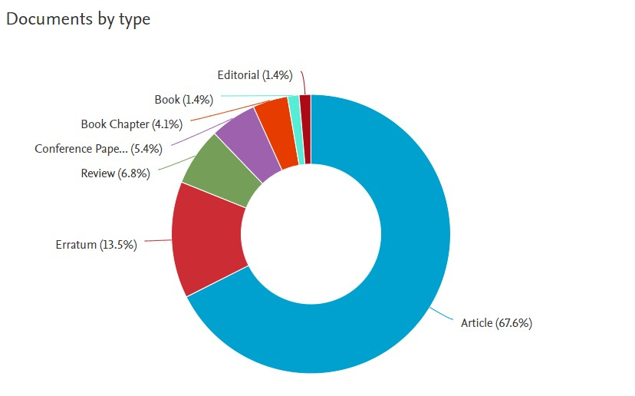

**Figure 5. Documents by Type in ‘Indian Journal of Agricultural Sciences’**

**3.1.4. Sources production over time & most local sited sources in** Indian Journal of Agricultural Sciences"

In “Indian Journal of Agricultural Sciences” the source production was increased gradually over the period of time. The years 2020 and 2021 recorded higher source production of 388 and 366. There are different reasons that are placing major role in the source production in journals. Some important factors are, increased research output, globalization of research, specialization and interdisciplinary studies, open access movement, demand for prestigious output, technology advancement, commercial interest and emerging fields and trends.

G.A. Gomez articles were tops in the Indian Journal of Agricultural Sciences with the citation of 326 and followed by M.L. Jackson (292). There are several reasons for higher citation of individuals articles. Those are innovative research, relevance and timeliness, interdisciplinary appeal, publication in High-impact Journals, citation networks, open access and accessibility, policy Influence or practical applications, collaborations and co-authorship, continuous engagement and follow-up work.

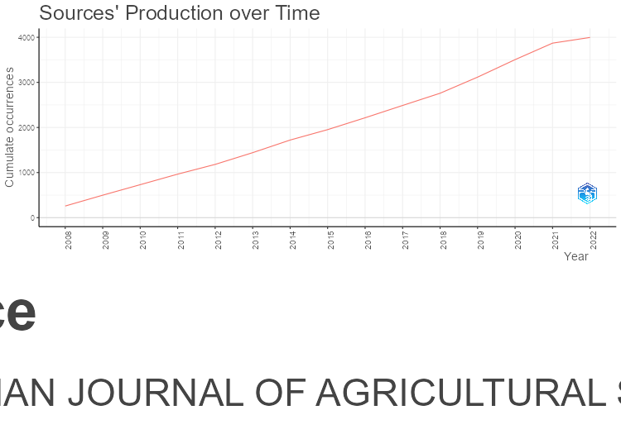

**Figure 6: Sources production over time in “Indian Journal of Agricultural Sciences”**

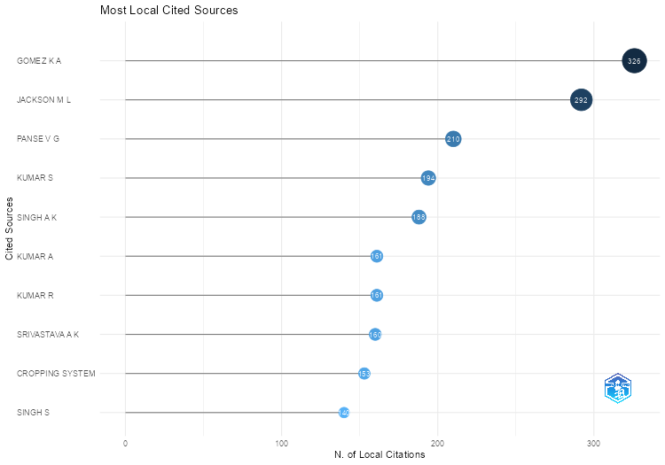

**Figure 7: Most local cited sources in “Indian Journal of Agricultural Sciences”**

**3.1.5. Authors contribution and Authors production in Indian Journal of Agricultural Sciences**

In “Indian Journal of Agricultural Sciences “the list of most prolific authors is dominated Indian scientists. The higher number of articles was published by Kumar A with 272 publications followed by Kumar S (238) and Kumar R (191). This concluded that Indian scientists and scholars are frequently contributing in Indian of Agricultural Sciences. The authors’ production overtime increased from 2018-2020 and in the preceding years, stable productivity was identified among the authors.

Yaacob *et al.,* (2021) convluded that, there are multiple number of reasons are affecting the author’s contribution and production in Journals. Those are, Visibility and Promotion, author reputation and authority, career advancement, funding requirements, research activity expansion, collaborative research, advancements in technology and data analysis, specialization and Fragmentation of Knowledge, publishing opportunities, globalization of research collaboration, pressure to stay relevant and increased competition.

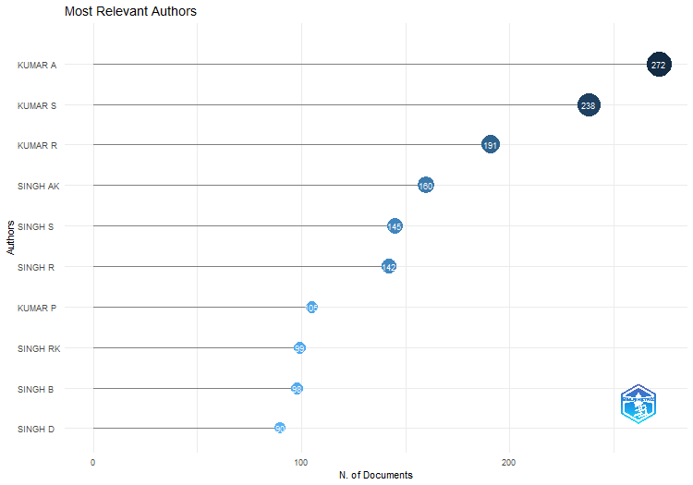

**Figure 8: Most relevant authors in “Indian Journal of Agricultural Sciences”**

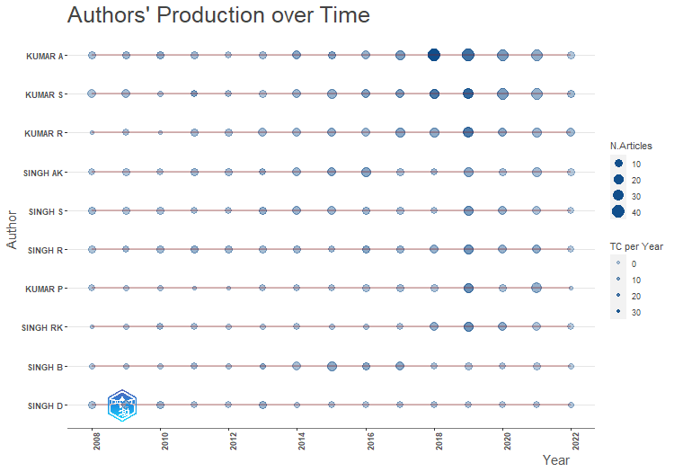

**Figure 9: Author’s Production over time in “Indian Journal of Agricultural Sciences”**

**3.1.6. Author’s local impact by h-index in Indian Journal of Agricultural Sciences:**

The h-index is a metric used to measure the productivity and impact of a researcher's work. It was proposed by physicist Jorge E. Hirsch in 2005 as a way to quantify both the productivity (number of publications) and the impact (citation counts) of a scientist's research output. Rather than just displaying the total number of citations or publications, the h-index provides a single number that aims to quantify the productivity and impact of a researcher's work (Groote *et al.,* 2012). It does have several drawbacks, though, including not taking the age of the researcher or the citation conventions of the particular subject into consideration. Figure.8. illustrated the Authors local impact by h-index in Indian Journal of Agricultural Sciences.

The authors Kumar S, Kumar A, and Singh R have the highest local impact, with h-indices of 15, 14, and 12, respectively, indicating they have a substantial number of moderately cited articles in this journal (Figure 10).An h-index between 10-20 indicates that the author has produced a collection of scholarly papers that have been cited at least 10 to 20 times each. It signifies a respectable level of impact within their field. This range often implies that the author has been active in research for some time and has made a noticeable contribution to the field. They might have several influential papers that have significantly contributed to academic discourse.

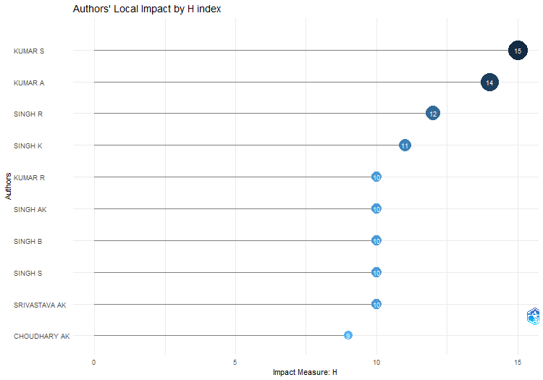

**Figure 10: Author’s local impact by H index in ‘Indian Journal of Agricultural Sciences’**

**3.1.7. Most prolific Affiliations and Affiliations production over time in Indian Journal of Agricultural Sciences**

According to the data (Figure.11), several esteemed organizations and universities are major contributors to the "Indian Journal of Agricultural Sciences." The top three affiliations in terms of publications published are ICAR-Indian Agricultural Research Institute, Punjab Agricultural University and CCS Haryana Agricultural University demonstrating their significant impact and presence in the field. Some important factors for higher affiliations productions were research funding, collaborations and networks, research culture and support, faculty & researcher profile, technology and infrastructure, geography and regional factors.

Affiliations production over the time was denoted in Figure 12. It indicates Indian Agricultural Research Institute made higher affiliation production in the given time span. The gradual elevation and steady linear production were associated with the affiliations of Banaras Agricultural University and Punjab Agricultural University. ICAR-Indian Agricultural Research Institute recorded its higher production in 2019 and reached its peak in the year of 2021.

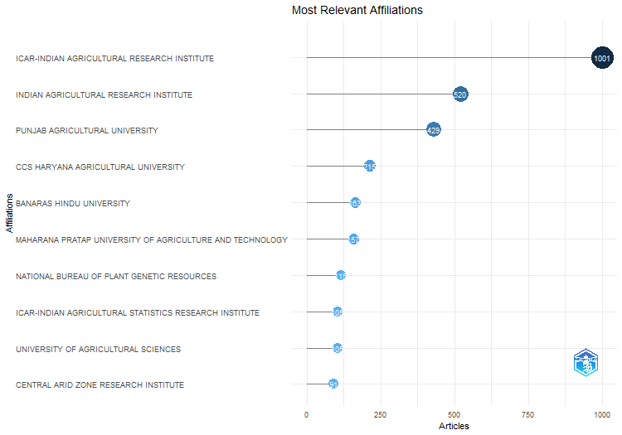

**Figure 11: Most prolific Affiliations in ‘Indian Journal of Agricultural Sciences’**

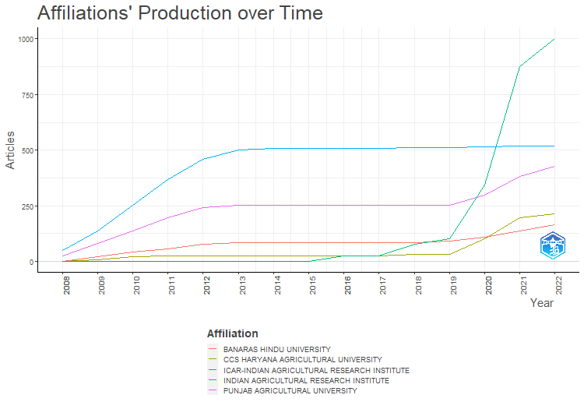

**Figure 12: Affiliations production over time in ‘Indian Journal of Agricultural Sciences’**

**3.1.8. Corresponding Authors country, Country Scientific production and most cited countries in ‘Indian Journal of Agricultural Sciences**

India has the highest number of articles with corresponding authors, with 1,875 publications. The majority of these articles (1,811) are single-country publications (SCP), indicating a strong research presence within India. However, there are also a significant number (64) of multiple-country publications (MCP), demonstrating international collaborations. China is the second most productive country with 17 articles. It has a significant number of SCP (15), but also a considerable number of MCP (2), indicating both domestic and less international research contributions. India leads in the frequency of publication (0.46) over the total frequency of 0.41 in publishing of articles.

|  |  |  |  |  |  |
| --- | --- | --- | --- | --- | --- |
| **Country** | **Articles** | **SCP** | **MCP** | **Freq** | **MCP Ratio** |
| Total | 2057 | 1991 | 66 | 0.5148 | 0.03 |
| **India** | **1875** | **1811** | **64** | **0.4692** | **0.03** |
| China | 17 | 15 | 2 | 0.0043 | 0.12 |
| Iran | 13 | 11 | 2 | 0.0033 | 0.15 |
| Turkey | 12 | 12 | 0 | 0.0030 | 0.00 |
| Egypt | 4 | 4 | 0 | 0.0010 | 0.00 |
| Australia | 2 | 1 | 1 | 0.0005 | 0.50 |
| Serbia | 2 | 2 | 0 | 0.0005 | 0.00 |
| Thailand | 2 | 2 | 0 | 0.0005 | 0.00 |
| Afghanistan | 1 | 1 | 0 | 0.0003 | 0.00 |
| Bulgaria | 1 | 1 | 0 | 0.0003 | 0.00 |

**Table 2: Corresponding Author Countries in ‘Indian Journal of Agricultural Sciences’**

The data (Figure.13) represents the scientific production of various countries in the "Indian Journal of Agricultural Sciences’. India stands out as the leading contributor to the journal, with a significant scientific production of 16,591 articles. This reflects the substantial research activity and impact of the India in the field of life sciences. China is the second most prolific country with 172 articles. China has shown remarkable growth in scientific production, indicating its increasing presence and influence in the field. Similar trend was followed in total citation of articles. India leads with the overall citation of 6364 and followed by Turkey (54) with the average citations of 3.4 (India) and 4.5 (Turkey).

There are different factors involved in higher and lower scientific production throughout the globe. Some important reasons for low competition are limited funding, infrastructure challenges, education system, political instability, language barriers, talent emigration, cultural factors and access to information and resources. Countries with robust research budgets and funding allocations tend to produce more articles due to increased resources available for research. Similarly, countries actively engaged in international collaborations benefit from knowledge exchange, joint projects, and increased article production through collaborations.

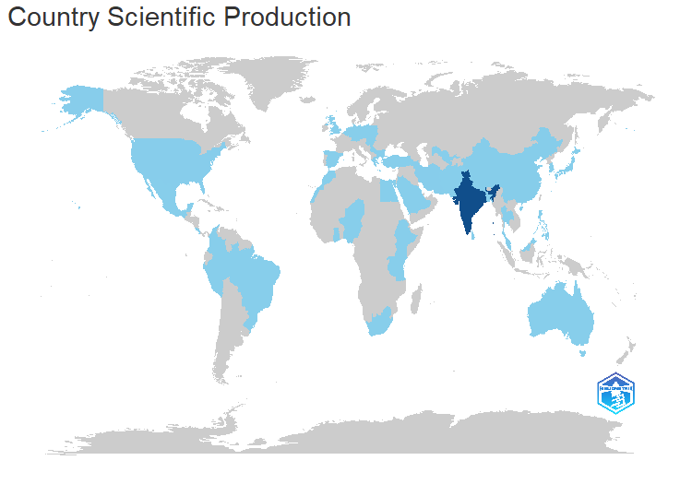

**Figure.13: Country Scientific production in ‘Indian Journal of Agricultural Sciences’**

**3.1.9. Most relevant used words and word frequency over time in ‘Indian Journal of Agricultural Sciences’**

The most appropriate words in were illustrated in Indian Journal of Agricultural Sciences Figure 14. The frequency of these terms reveals information about the areas of focus and research within the journal. The term "frequency of words" describes how frequently a given word or term appears in a body of research papers. Assessing word frequency can reveal information about several research-related topics, trends, and the dominance of concepts within a field.

High-frequency terms often indicate common topics or subjects in literature. Words which appear frequently in a certain field or discipline could be indicators of important ideas, approaches, or topics. Analyzing word frequency helps identify keywords or terms that authors frequently use. These keywords are essential for understanding the central focus of research articles and can be used to categorize or index document. Word frequency changes over time can reveal new trends, changes in the focus of study, or a declining popularity of subjects in a field. Analyzing how the frequency of specific terms evolves can provide insights into the dynamic nature of research (Aria and Cuccurullo, 2017). Visual tools like network analysis, word clouds or clustering techniques can help in interpreting the relationships between high-frequency words, identifying clusters of related terms, and visualizing the overall structure of the research landscape.

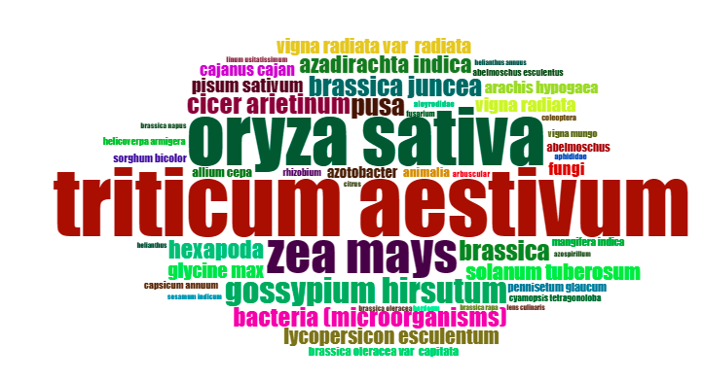

**Figure.15: Most relevant words in ‘Indian Journal of Agricultural Sciences’**

The word ‘*Triticum aestivum’* appears 170 times in the analyzed time span followed by ‘*Oryza sativa*’ (143) and *Zea mays* (99). This indicates the major research work was done in wheat crops and followed by rice and maize. The other appropriate words are *Gossipiumhirsutum* (65) followed by PUSA (52) and *Brassica juncea* (51). It shows, cotton research was predominant for the period of time. The term ‘PUSA’ reminds; the research works may relate with the varieties released by Indian Agricultural Research Institutes and the research works carried out in the IARI-PUSA campus. The words ‘*Brassica*’ repeated for certain period time revealed that researchers shown their interest on vegetable research after the important Indian food crops.

Some other frequent words are ‘bacteria’ (48) and ‘hexapoda’ (46). This concluded the research works on breeding of wheat and insects was carried out by the researchers for the specified duration.

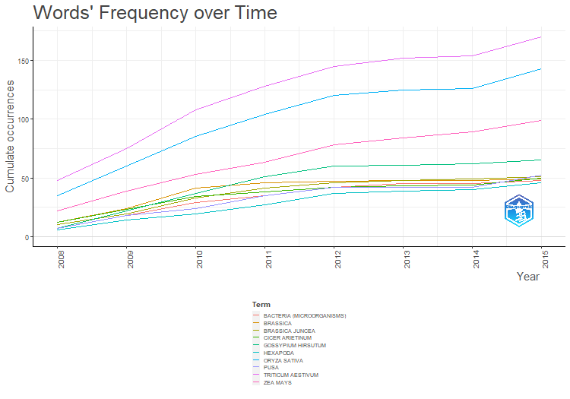**Figure.16: Most frequent words in ‘Indian Journal of Agricultural Sciences’**

**3.1.10. Most relevant topics used in ‘Indian Journal of Agricultural Sciences’**

The most relevant topics and its analysis shows Research shifting or changes in the focus of research. There are different methods available to interpret the research shifting. Those are co-citation analysis, cluster analysis, mapping techniques, topic modeling, comparative analysis, expert validation, and contextual understanding. Temporal analysis leads to changes in the frequency of words, keywords, or specific terms over time and it indicates shifts in research focus. In cluster analysis, grouping publications into clusters based on similarities in content or keywords can help identify shifts in research themes (Raparelli and Bajocco, 2019). Changes in the composition or size of these clusters over time indicate shifts in the field's focus.

More research works was carried out in the topic of *Triticum aestivum* and higher frequency of different works was carried out in this topic followed by *Oryza sativa* and *Zea mays* (FIGURE 13). The Figure 13, Indicates the research shift was changed from major cereals to vegetables and various diseases in major food products in recent years. The research work on “tomato leaf curl virus” was carried out from 2010 to 2015 followed by research on gladiolus. Indian Journal Agriculture Science had some serious research works on weeds and pulse crops on 2008-2012 and interest on research was shifted to vegetables and flower crops.

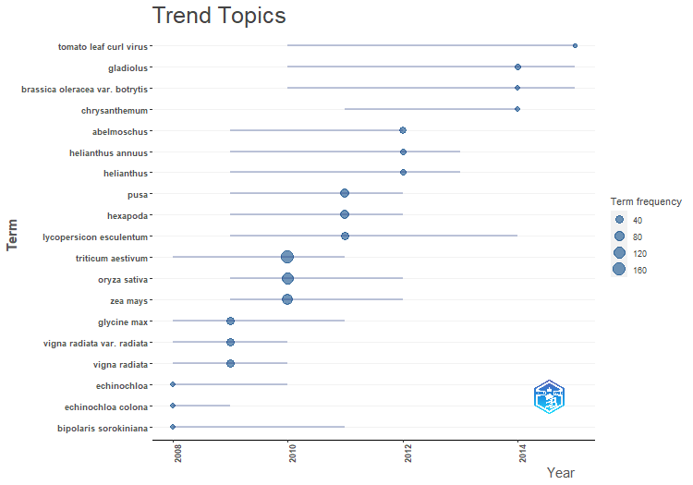**Figure.17: Most Trend topics in ‘Indian Journal of Agricultural Sciences’**

**3.1.11. Keywords Co-occurrence Network and collaboration of network of authors in Indian Journal of Agricultural Sciences**

The keyword co-occurrence network (KCN) and authors network collaboration were discussed in this topic in order to gain further insight into the trends in the field of life science which majorly includes Agricultural sciences. The co-occurrence of terms in a network can reveal important information about the connections between different ideas, terms, or subjects in research papers. As part of this analysis, a network is developed, with nodes representing in for terms (such as keywords, author names, and research topics) and edges (connections between nodes) for the terms' co-occurrence within the same document, paper, or context.

The lines (edges) between nodes (terms, keywords, authors, etc.) represent the connections between these entities based on their co-occurrence within documents, articles, or other sources (Van Leeuwen, 2006). The lines indicate the strength and existence of connections between the nodes. Higher connection was recorded with the words ‘*Triticum aestivum’* and ‘*Oryza sativa*’ (Figure 18). It indicates their high strength of relationship between these two nodes. Similarly, the words, *Brassica* and *Brassica oleraceae* had good connection and it shows closer association or higher frequency of co-occurrence between those terms

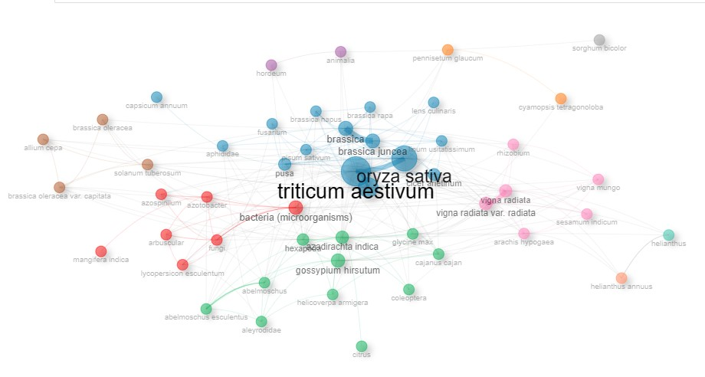

**Figure 18. Keywords Co-occurrence Networkin ‘Indian Journal of Agricultural Sciences’**

Similarly, it (Figure 14) indicates collaboration network of different authors with domestic and international scientists. Analyzing collaboration network of authors involves understanding the relationships between authors based on their co-authorship patterns in scholarly publications. This network helps reveal collaborative patterns, influential authors, research communities, and the structure of scientific collaboration within a specific field or research domain. The thick lines between authors indicate a cohesive network where authors tend to form clusters or groups.

Authors who exhibit high degrees of relationship or degree centrality can be considered as significant individuals or network hubs. They might serve as powerful intermediaries between various authorial communities or research groups. In a Figure 19, Kumar S and Kumar A had a high degree of relationship and they act as bridges between different clusters or groups of authors, facilitating connections across the network. The important advantages of analyzing collaboration network of authors are identification of key players, understanding research dynamics, mapping research communities, assessing interdisciplinary research, tracking evolution of scientific trends, facilitating collaboration opportunities, supporting decision-making, validation and evaluation (Qin *et al.,* 2022).

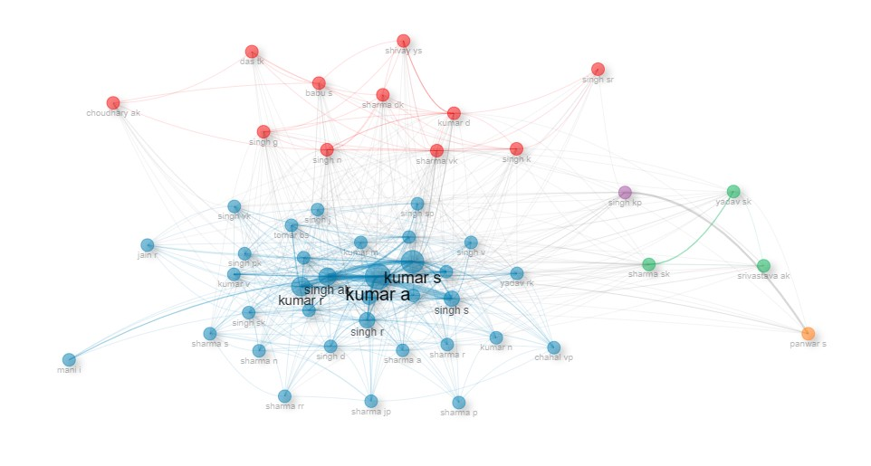

**Figure 19. collaboration of network of authors in Indian Journal of Agricultural Sciences**

**4.1. Conclusion:**

Bibliometrics is the study of the literature's structure through a variety of methods, including citation analysis, rank-frequency distributions, and counting. While the study of literature's structure is important to many fields and particularly important in the area of information retrieval. The journal has published 3996 publications during the period of study. The present study reveals that majority of the contributions appeared under Agricultural science (27.7%) followed by Soil science (13.4%). The major research was carried in Wheat, Rice and Maize.Similarly, most of the contributions are from India and the contribution from foreign authors was very less. It concluded, *Triticum aestivum* and *Oryza sativa* are the most predominant words by abstract and frequently repeated words in article content. The study revealed that the highest contributions were from ICAR- Indian Agricultural Research Institute (1521 articles) and Punjab Agricultural University (429). Indian Journal of Agricultural Sciences is the highly preferred journal for the scientists of agricultural community.

**Acknowledgement and Funding**

The authors sincerely acknowledge the Department of Agronomy and the Nammazhvar Organic Farming Research Centre for their valuable support, guidance, and encouragement. Their constant assistance and the opportunity to undertake and develop this article have been instrumental in bringing this work to fruition. This research did not receive any specific grant from funding agencies in the public, commercial, or not-for-profit sectors.

**Ethics Statement**

This study did not involve humans or animals. The research was conducted exclusively on plants/inanimate materials, and therefore ethical approval was not required.

**Originality and Plagiarism**

The authors confirm that this manuscript is an original work and has not been published elsewhere, either in part or in full. The authors affirm that the manuscript is free from plagiarism in any form.

**Consent for Publication**

All authors have read and approved the final version of the manuscript and consent to its submission and publication in the journal.

**Competing Interests**

The authors declare that there are no competing interests, financial or non-financial, that could have influenced the research or its interpretation.

**Data Availability**

The data supporting the findings of this manuscript are available in the Scopus database. Additional details can be obtained from the corresponding author upon reasonable request.

**Author Contributions**

Konappan Surya prepared the manuscript. Guidance and supervision for the work were provided by Ramanujam Krishnan.

**Reference:**

Aria, M., & Cuccurullo, C. (2017). Bibliometrix: An R-tool for comprehensive science mapping analysis. *Journal of Informetrics*, 11(4), 959–975. <https://doi.org/10.1016/j.joi.2017.08.007>

De Groote, S. L., & Raszewski, R. (2012). Coverage of Google Scholar, Scopus, and Web of Science: A case study of the h-index in nursing. *Nursing Outlook*, 60(6), 391–400. <https://doi.org/10.1016/j.outlook.2012.04.006>

Indian Journal of Agricultural Sciences. (2023). Bibliometric analysis of Indian Journal of Agricultural Sciences. *Indian Journal of Agricultural Sciences*. Retrieved from <https://epubs.icar.org.in/index.php/IJAgS>

Patil, R. R., & Kumar, S. (2022). Priority selection of agro-meteorological parameters for integrated plant diseases management through analytical hierarchy process. *International Journal of Electrical and Computer Engineering*, 12, 649–659. <https://doi.org/10.11591/ijece.v12i1.pp649-659>

Qin, Y., Xu, Z., Wang, X., & Škare, M. (2022). Green energy adoption and its determinants: A bibliometric analysis. *Renewable and Sustainable Energy Reviews*, 153, 111780. <https://doi.org/10.1016/j.rser.2021.111780>

Raparelli, E., & Bajocco, S. (2019). A bibliometric analysis on the use of unmanned aerial vehicles in agricultural and forestry studies. *International Journal of Remote Sensing*, 40(24), 9070–9083. <https://doi.org/10.1080/01431161.2019.1569793>

Scopus. (2023). Indian Journal of Agricultural Sciences. Retrieved from <https://www-scopus-com.elibrarytnau.remotexs.in/results/results>

Thanuskodi, S. (2010). Bibliometric analysis of the journal Library philosophy and practice from 2005–2009. *Library Philosophy and Practice*. Retrieved from <http://www.webpages.uidaho.edu/~mbolin/thanuskodi-lpp.htm>

Van Leeuwen, T. (2006). The application of bibliometric analyses in the evaluation of social science research. *Scientometrics*, 66, 133–154. <https://doi.org/10.1007/s11192-006-0010-8>

Yaacob, A., & Gan, J. (2021). Bibliometric analysis of global research developments on the role of technology during Covid-19: Current trends and future prospect. *Journal of Content Community*, 13, 166–180. <https://doi.org/10.37200/IJPR/V13I9/PR210923>