**Evaluation of Protected Cultivation methods in Vegetable farming -A case study from Western zone of Tamil Nadu**

**Abstract**

Vegetables production is constantly affected by both biotic and abiotic factors. Protected cultivation technology allows farmers to grow vegetables throughout the year in controlled environments. High initial investment, technical skills, huge maintenance costs and environmental impacts are some of the limitations in protected cultivation. A study was undertaken to get more insights on the cost of cultivation of vegetables in protected cultivation and on the current status, practices, problems, and needs of farmers who use or intend to use this technique. Information from a Tomato farmer who is involved in protected cultivation of tomato was collected. Open-ended interview method was used in this study. This study was conducted in Thondamuthur Block of Coimbatore District. The study showed the budgetary constraints of farmers, inadequate logistics and storage facilities for far-off market access decreased the farmers income were noted. The results of the study can be used to promote protected cultivation of vegetables and formulate policies interventions.

**Keywords:** Protected cultivation, Biotic and Abiotic factor, open-ended interview, budgetary constraints

**Introduction**

Protected cultivation methods represent a paradigm shift in the realm of vegetable farming, introducing sophisticated techniques that redefine agricultural practices. This comprehensive case study endeavours to meticulously evaluate and analyse the multifaceted aspects of various protected cultivation methods employed in vegetable farming. By exploring their impacts on agricultural productivity, economic viability, environmental sustainability, technical feasibility, and societal implications, this study aims to provide a thorough understanding of their efficacy and potential in modern farming practices.

Traditional open-field farming has long been the cornerstone of agriculture, yet it faces inherent challenges such as susceptibility to adverse weather conditions, pest infestations, and diseases. Protected cultivation methods, including greenhouse structures, polyhouses, shade netting, hydroponics, and other innovative techniques, serve as a shield against these challenges. They create a controlled environment that allows precise manipulation of environmental factors crucial for plant growth, such as temperature, humidity, light exposure, and nutrient availability. This controlled environment often leads to enhanced yields, improved quality of produce, and extended growing seasons. The economic implications of adopting protected cultivation methods are multifaceted. Initial setup costs, ongoing operational expenses, and maintenance investments constitute significant considerations. Assessing the return on investment, comparative analysis against traditional farming practices, and exploring market opportunities for produce grown through protected cultivation are pivotal in understanding the economic viability of these methods. Furthermore, the study aims to evaluate the scalability of these techniques and their potential for integration into various economic models, including small-scale farming and commercial enterprises.

Environmental sustainability is a crucial aspect of modern agriculture, and protected cultivation methods offer potential solutions to mitigate environmental impacts. This case study seeks to explore how these techniques influence resource utilization, water conservation, energy consumption, and their overall ecological footprint. Analysing their ability to reduce water usage, minimize pesticide and fertilizer runoff, and optimize land utilization will provide insights into their role in promoting sustainable farming practices. The technical feasibility and adaptability of protected cultivation methods across diverse geographical regions and climates are paramount considerations. Variations in climate, soil types, and available resources significantly affect the efficacy of these techniques. Therefore, this study aims to assess the adaptability of different methods in various environments, identifying challenges and opportunities for implementation.

Societal implications are equally crucial in evaluating the impact of protected cultivation methods. These methods have the potential to create employment opportunities, particularly in regions where traditional farming faces challenges due to environmental constraints or limited resources. Additionally, the study aims to analyse their role in enhancing food security, improving access to fresh produce, and contributing to local economies.

Through a holistic evaluation encompassing economic, environmental, technical, and social dimensions, this case study aims to provide a comprehensive understanding of the efficacy and implications of protected cultivation methods in vegetable farming. The insights derived from this study aspire to guide policymakers, agricultural practitioners, and stakeholders in making informed decisions regarding the integration and adoption of these innovative techniques. Ultimately, the goal is to optimize agricultural productivity, ensure food security, and prom Evaluation of Protected Cultivation methods in Vegetable farming -A case study from Western zone of Tamil Nadu sustainable practices within the domain of vegetable farming. The main objectives of the study are:

* To study the protected cultivation in vegetable farming
* To Analysis the environmental impact of protected cultivation method in vegetables
* To Analysis about the protected cultivation of vegetables in Thondamuthur block.

**Methodology**

The present study is based on the information collected from the farmer located in Thondamuthur block. Method to collect data is interview schedule to obtain information about cost of cultivation, challenges faced by the farmers while using protected cultivation, factors motivated for adoption of protected cultivation, management of pests and diseases and overall crop health.

**Current scenario of vegetable production in India:**

Global trade value of vegetables is more than that of cereals. India and Tamil Nadu have a diverse wide range of agroclimatic zones. Vegetable production have been restricted to seasonal and regional needs. Vegetable crops contribute to 22% in area and 40% in production of the total Horticulture crops grown in the State. In terms of land use, vegetable production shares second place in crop production of Tamil Nadu with 3.34 lakh hectare, 82.02 lakh MT, 24.49 MT/ha. (TN policy Note 2022). The standard per capita requirement of vegetables for adults is 300 g/day/person (Recommended Dietary allowance). But In Tamil Nadu, as per our current production levels, 130 g/day alone can be supplied. (department of horticulture, Government of Tamil Nadu,2018).

**Review of literature:**

1. The highly controlled greenhouses sprang up initially in the temperate regions, as growing of vegetables in the freezing temperatures was impracticable (Albright 2002) while the simpler greenhouses provided minimal climatic control and helped in producing an economic yield of the vegetable crops (Enoch 1986)
2. The greenhouse cultivation of vegetables, being an intensive activity, entails perfect planning and numerous phases of operation for its success. Greenhouse design varies depending on its location, whether in a desert, the tropics or in a temperate region (Jensen 2002).
3. In the temperate regions of the world, glasshouses are preferred more while in other sub-tropics and tropics, ‘shading effect ’and ‘windbreak effect’ are provided by greenhouses. Rain shelters are the usual protective structures in the rainy tropical regions to avoid flooding (Garnaud 1987), whereas in the arid regions, the temperature and humidity inside the greenhouse provides an ‘oasis effect’ compared to the hot and dry heat outside the greenhouse (Sirjacobs 1988).
4. Today Dutch protected cultivation is one of the most intensive farming systems in the world with high levels of output by using the latest technologies (Goncharova 2004).
5. With the high adoption of protected cultivation in Asia, there's continuous new development in agriculture crops analysis and production and development within the connected industries (Kang et al., 2013).
6. Climate change is becoming an increasingly significant global problem that can no longer be ignored. The main underlying cause is anthropogenic, i.e., unsustainable use of fossil fuels, forest degradation for industrialization, and rapid urbanization with an overpopulation (Mukherjee et al., 2016).

**Result and discussion:**

The farmer Thangaveni has 20 years of experience in agriculture. She has land holding of 3 ac of which 1.5 ac of area is under protected cultivation She cultivates variety of crops under protected cultivation (greenhouse) like Tomato, chilli and cauliflower of which Tomato holds a major share in the total production. The optimum month of sowing for tomato is March to April and the crop is ready to be harvested from July – August. The average yield of tomato under protected cultivation is approximately 11 tonnes from 1.5 ac. Yield varies month to month due to various reasons. Chilli and Cauliflower are produced and sold to the customers based on market demand. They have invested around 10 lakhs as capital to this protected cultivation. There are 6 skilled labours employed in the farm to carry out the routine activities in the farm. The daily wage of the labours per day is ₹ 250 per labour. The base material for the crops the portrays and the shade net will be replaced once in ten years. Its replacement costs around 3 to 4 lakhs in total. One of the major problems is that the wear and tear of covering material which cause havoc to cultivation in uneven intervals.

National Horticulture Mission encourages the protected cultivation with clusters-based approach in regions near to cities. Infrastructural facilities like cold storage, reefer vans, vending carts and marketing arrangements will be provided by the clusters. Protected cultivation Production of Vegetable and cut flower crops under Protected conditions not only provides year-round production but also increase the productivity by 3-5 folds over open field cultivation of these crops with high water and nutrient use efficiency.

**Increased crop yield:** The case study showed how shielded agriculture significantly increased crop output. Compared to conventional open-field techniques, the controlled environment produced by buildings like greenhouses provides ideal circumstances, accelerating plant growth and increasing production.

**Effective Pest Management:** It has been shown that protected farming methods are effective in controlling pests. Pest penetration was hindered by the physical barriers found in constructions like polytunnels, which decreased the demand for chemical pesticides. In addition to addressing environmental issues, this helps produce veggies that are healthier and more sustainable.

**Higher-quality produce:** The investigation found that the produce was consistently of the highest calibre for the whole growing season under protected settings. Vegetables that were protected from unfavourable weather met strict market requirements. Because of its improved quality, the produce is positioned as a high-end product that might fetch more money on the market.

**Financial Sustainability:** Although the initial expenditure in infrastructure for protected cultivation was acknowledged, it was determined that the long-term advantages outweighed the expenses. Improved quality, higher yields, and lower pest management costs all make protected farming economically feasible. However, the economic impact depends on a number of variables, including market dynamics, crop choices, and farming efficiency.

**Local Conditions and Crop Selection:** The particular crops grown and the local environmental factors are key factors in the success of protected farming. For best results, cultivation techniques must be adjusted to local climates. Vegetables might have different benefits in different protected contexts, which emphasises the necessity for customised strategies.

**Precision Farming Technologies:** The research emphasised that a critical element in augmenting the effectiveness of protected agriculture is the incorporation of precision farming technologies. Real-time monitoring and decision-making are made possible by sensors, automation, and data analytics, which maximise resource utilisation and aid in effective crop management.

**Greenhouse Sustainability:** Environmental sustainability principles are aligned with resource-efficient procedures and reduced use of pesticides in protected farming. Because of the regulated environment, protected cultivation is a viable approach to sustainable agriculture because it reduces the ecological impact of farming activities.

**Dynamics of the Market:** Economic factors emphasised how crucial it is to comprehend market dynamics. Even though there could be a large upfront cost, these expenses might be covered by the increased price premium-quality goods can get. The market's desire for vegetables grown responsibly raises the chances of protected agriculture from an economic stand point.

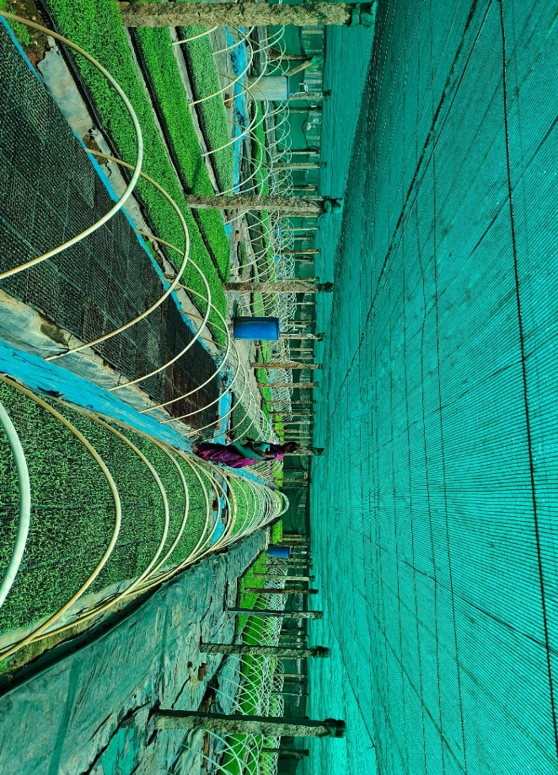

**Fig 1. Setup of farm inside protected cultivation**

**Benefits of protected cultivation:**

Irrespective of weather conditions, protected cultivation helps farmers to grow high-value crops throughout the year, can reduce pest and disease incidence, and minimize the use of pesticides and chemical fertilizers, and improve water & nutrient use efficiency. Optimal Microclimate maintained in the protected cultivation can enhance crop quality and yield. Off season produces of protected cultivation can fetch higher prices and profits for farmers. Organic farming methods can be easily practised in protected cultivation which also increases the profitability.

**Challenges of protected cultivation:**

Huge initial investment for setting up structures and equipment and maintenance cost possess a serious challenge for protected cultivation. Fluctuating demand and supply of vegetables causes market risks and uncertainties which has direct impacts in the revenue of protected cultivation. It also demands skilled labour and technical knowledge for managing crop production.

**Conclusion:**

Protected cultivation of vegetables has emerged as a vital and innovative approach to modern agriculture. Protected cultivation can help to convert crop production into a promising and profitable venture for farmers in Tamil Nadu. The use of greenhouses, polytunnels, and other protective structures provides a controlled environment that shields crops from challenges of climate change, water scarcity, pests, and diseases, low productivity and helps to rowing demand. This method not only extends the growing season but also enhances yield and quality of produce. The ability to manipulate variables such as temperature, humidity, and light fosters optimal conditions for plant growth, leading to higher productivity. Additionally, protected cultivation facilitates water conservation and reduces the need for chemical inputs, promoting sustainable and eco-friendly farming practices. Moreover, the precision control offered by protected cultivation over environmental factors such as temperature, humidity, and light foster optimal growing conditions. This not only leads to increased productivity but also allows for the cultivation of specific crops that might otherwise struggle in the local climate. The adaptability and flexibility of these protective structures cater to a diverse range of vegetables, providing a platform for farmers to experiment with and cultivate a variety of high-demand crops. Careful planning, investment, management and marketing ensure success in protected vegetable production. Selection of suitable crops and varieties based on market demand and can improve profitability of protected cultivation.

**REFERANCE:**

1. Enoch H Z. 1986. Climate and protected cultivation. Acta Hort 176:11–20.
2. Jensen M H. 2002. Controlled environment agriculture in deserts tropics and temperate regions – A world review. Acta Hort 578:19–25
3. Sirjacobs M. 1988. Agro-climatological criteria for selecting the most appropriate areas for protected cultivation in Egypt. (In) Protected Cultivation in the Mediterranean Climate –Greenhouses in Egypt, pp 5–12. FAO, Rome, Italy.
4. Goncharova N A, Van der Vlist J A A M and Verstegen. 2004. Changes in horticulture sector in the Netherlands. Acta Hort 655: 319–31
5. Kang, Yunyan; Chang, Yao-Chien Alex; Choi, HyunSug; Gu, Mengmeng, (2013). Current and future status of protected cultivation techniques in Asia, Acta horticulturae, ISSN: 0567-7572.
6. Mukherjee, A., Rakshit, S., Nag, A., Ray, M., Kharbikar, H. L., Shubha, K., ... & Burman, R. R. (2016). Climate change risk perception, adaptation and mitigation strategy: An extension outlook in mountain Himalaya. In Conservation Agriculture(pp.257-292). Springer, Singapore.