**IMPACT OF FRONTLINE DEMONSTRATIONS ON WHITE JOWAR VARIETY NTJ-5 IN SPSR NELLORE DISTRICT OF ANDHRA PRADESH, INDIA**

**ABSTRACT**

The Frontline Demonstrations (FLDs) were conducted by Krishi Vigyan Kendra, Nellore, to popularize the white jowar variety, Nandyal Tella Jonna-5 (NTJ-5) in the SPSR Nellore district. NTJ-5, released by Acharya N.G. Ranga Agricultural University in 2018, is a short-statured, non-lodging, dual-purpose sorghum variety with medium bold grains, moderately tolerant to shoot fly, stem borer and blight. It has a crop duration of approximately 95-105 days with a yield potential of 4500-5000 kg/ha under optimal conditions. The demonstrations were conducted across 15 locations over three consecutive *rabi* seasons of 2022-23, 2023-24, and 2024-25 in the mandals of Ananthasagaram, Chejerla, Marripadu and Kaluvoya to evaluate the performance of NTJ-5 compared to local varieties/hybrids under farmer field conditions. Standard package of practices including seed treatment, INM, IPM and IDM were followed in FLD plots and yield, economic returns and key agronomic traits were recorded and analyzed. As an outcome of FLD, it was noticed that the demo variety (NTJ-5) recorded an average yield of 3889 kg/ha with a net returns of Rs. 80588/ha as compared to the farmer’s practice, which produced an average yield of 3412 kg/ha with a net returns of Rs. 59706/ha. The other parameters like technology gap, extension gap and technology index were 1111 kg/ha, 519 kg/ha and 22.22%. The average Benefit-Cost ratio was high in NTJ-5 (3.09) compared to local varieties/hybrids (2.43). On average, a 13.98% yield increase was observed in demo plots over the farmer’s practice. The results clearly showed the positive impact of frontline demonstrations over farmer’s practices towards increasing the productivity of white jowar variety, NTJ-5 in the SPSR Nellore district of Andhra Pradesh.

**Keywords:** Benefit Cost Ratio, Frontline Demonstrations, Nandyal Tella Jonna, Net Returns, Sorghum

**1. INTRODUCTION**

Millets are a group of cereal grains with ancient origins, primarily domesticated in the dry tropical regions of Asia and Africa. Over time, their cultivation spread globally. As members of the grass family Poaceae, these crops have played a vital role in sustaining food systems in regions with poor soil fertility and erratic rainfall. Their ability to grow under minimal resource input makes them a dependable option in areas prone to climatic stress (Hassan *et al.,* 2021; Sharma and Ortik, 2000). Millets are categorized into major types, such as sorghum and pearl millet, and minor types, including foxtail, finger, little, kodo, barnyard and proso millets. Additionally, crops like buckwheat and amaranth, often referred to as pseudo-millets, contribute to the diet and livestock feed in various parts of the world (Saleh *et al*., 2013; Shahidi and Chandrasekara, 2013).

Among these, **sorghum (**Sorghum bicolor **L. Moench)** stands out as one of the most important and widely cultivated millets. In India, it plays a vital role as a staple food, fodder and industrial crop, especially for resource-poor, small and marginal farmers in semi-arid and arid regions. Cultivated in both kharif and rabi seasons, sorghum is well-adapted to harsh agro-climatic conditions due to its deep root system, efficient water use and high tolerance to drought and heat stress (Assefa *et al*., 2010). These attributes make grain sorghum especially suitable for rainfed farming and deficit irrigation systems. Beyond its agronomic value, sorghum, along with other millets, plays a significant role in ensuring nutritional security. Despite these advantages, the cultivation area of sorghum and other millets declined over the decades, primarily due to changing food habits, government-subsidized rice distribution schemes and the expansion of irrigated agriculture. However, climate change, increasing input costs and a rising awareness of healthy diets have sparked a renewed interest in nutri-cereals such as sorghum. There is now a growing recognition of their potential to contribute to sustainable food systems by fulfilling the four Fs - food, fodder, feed and fuel especially, in rainfed ecosystems. In the context of varietal development and dissemination, the adoption of improved cultivars remains suboptimal in many regions due to factors such as continued use of local landraces, lack of access to quality seed and limited exposure to improved agronomic practices. This gap between research and on-farm application underscores the need for effective extension strategies.

Frontline Demonstrations (FLDs) are an extension strategy initiated by the Indian Council of Agricultural Research (ICAR) to demonstrate the production potential of newly released crop varieties and associated technologies under real farming conditions. These are organized through Krishi Vigyan Kendra’s (KVKs) to bridge the gap between research stations and farmer fields, thereby validating and popularizing improved agricultural practices among rural communities. To address this gap, the white jowar variety, Nandyal Tella Jonna-5 (NTJ-5), released by Acharya N.G. Ranga Agricultural University (ANGRAU) in 2018, was selected for demonstration in SPSR Nellore district, Andhra Pradesh. NTJ-5 is a short-statured, non-lodging, dual-purpose sorghum variety with medium bold grains, moderately tolerant to shoot fly, stem borer and blight. It has a crop duration of approximately 95-105 days with a yield potential of 4500-5000 kg/ha. This study presents the outcomes of FLDs conducted over three *rabi* seasons to evaluate the performance, profitability and adoption potential of NTJ-5 in comparison to local varieties/hybrids, aiming to enhance productivity and livelihood security of sorghum-growing farmers in the region.

**2. METHODOLOGY:**

Front Line Demonstrations (FLDs) were conducted in four blocks (Ananthasagaram, Marripadu, Chejerla and Kaluvoya) of SPSR Nellore district, Andhra Pradesh, to popularize the high-yielding white jowar variety, NTJ-5 (Nandyal Tella Jonna). These demonstrations were conducted at 15 locations during the *rabi* season of three consecutive years (2022-23, 2023-24 and 2024-25), with each FLD plot covering an area of 0.4 ha. The crop was cultivated under both irrigated and rainfed conditions, across soils ranging from sandy clay loam to clay loam, reflecting the diverse agro-ecological conditions of the region. Rainfall particulars of SPSR Nellore district in 2022-23, 2023-24 and 2024-25 was given in Table 1. Scientific interventions were implemented in the demonstration plots which include the use of an improved seed variety, seed treatment, integrated nutrient management (INM), integrated pest management (IPM) and integrated disease management (IDM), were adopted in the demonstration plots. The NTJ-5 variety was provided as a critical input to the beneficiary farmers. In addition to field demonstrations, training programmes and method demonstrations were organized to equip farmers with knowledge of integrated crop management practices and sustainable production technologies. Awareness campaigns and interaction meetings were also conducted to enhance farmer’s participation and confidence. Regular field visits were conducted by scientists and extension personnel during critical crop growth stages to monitor crop performance and provide timely advisories. Observations were recorded on plant height (cm), panicle length (cm), test weight (g), grain yield (kg/ha), cost of cultivation (Rs./ha), gross returns (Rs./ha), net returns (Rs./ha) and benefit-cost ratio (B:C). Additionally, the technology gap, extension gap and technology index were computed by comparing NTJ-5 with locally cultivated varieties/hybrids.

**The formula used for calculating the aforesaid data was as follows:**

Technology gap = Potential yield - demonstration yield

Extension gap = Demonstration yield - farmers practice yield

Technology index (%) = $\frac{Technology gap}{Potential yield}$ × 100

**3. RESULTS AND DISCUSSION:**

**Rainfall distribution:**

Analysis of rainfall data from 2022-23 to 2024-25 in SPSR Nellore district reveals pronounced inter-annual and intra-seasonal variability, indicative of a shifting rainfall regime in a region predominantly reliant on the North-East monsoon (October-December) for the majority of its annual precipitation. Total annual rainfall was near normal in 2022-23 (763.3 mm), slightly below normal in 2023-24 (794.4 mm) and substantially above normal in 2024-25 (1066.5 mm), with variations largely attributed to anomalous rainfall events during the late and post-monsoon phases. July consistently recorded above normal rainfall; however, a significant decline in rainfall was observed during August and September (key South-West monsoon months), indicating weakened rainfall performance during the core *kharif* period. A sharp spike in October 2024-25 (347.9 mm, +40%) marks a clear temporal shift in rainfall concentration toward the post-monsoon phase. November, which typically contributes a major share of North-East monsoon rainfall, showed a declining trend across years from 313.2 mm (+8.9%) in 2022-23 to 193.2 mm (-35.1%) in 2024-25, potentially shortening the effective N-E monsoon window. Additionally, December recorded unusually high rainfall in 2023-24 (297.4 mm, +200%) and 2024-25 (202.6 mm, +104.4%), driven by cyclonic activity in the Bay of Bengal. Meanwhile, January and February remained persistently dry, with February receiving **0 mm of rainfall** for three consecutive years, intensifying moisture stress during the *rabi* season. This erratic rainfall pattern, especially the late-season dry spells, may have constrained the crop from achieving its potential yield under FLDs (4500-5000 kg/ha).

**Plant growth and yield attributes:**

The NTJ-5 white jowar variety had a shorter average plant height (137.9 cm) compared to the local varieties/hybrids (190.0 cm). This shorter height is an advantage because it helps the plants to resist lodging due to heavy rains and winds, which are common in the SPSR Nellore district. NTJ-5 exhibited a longer average panicle length (27.3 cm) compared to the local varieties and hybrids (24.3 cm). The test weight, which reflects grain filling and quality, was higher in NTJ-5 (33.6 g) than in the local varieties/hybrids (30.7 g). In terms of yield, NTJ-5 recorded an average of 3889 kg/ha, which is 13.98% (477 kg/ha) more than the local varieties/hybrids (3412 kg/ha). The variation in grain and stover yields among the different sorghum varieties is likely due to differences in their genetic potential to efficiently utilize and translocate photosynthates from source to sink.

**Economics:**

The highest net returns and benefit-cost ratio was recorded in NTJ-5 as compared to local varieties/hybrids. The improved NTJ-5 variety recorded a higher average net returns of Rs. 80,588/ha and a benefit-cost ratio of 3.09, compared to the lower net returns of Rs. 59,106/ha and benefit-cost ratio of 2.43 observed in local varieties/hybrids. The highest net returns and benefit-cost ratio in the NTJ-5 variety is due to the lowest incidence of pests and diseases, drought resistance and the highest yields.

**Gap analysis:**

The gap analysis of the white jowar variety, NTJ-5, over the three years from 2022-23 to 2024-25 reveals significant insights into the performance and adoption of the recommended production technology. The technology gap, defined as the difference between the potential yield and the yield realized under frontline demonstrations (FLDs), was observed to be 816 kg/ha in 2022-23, 992 kg/ha in 2023-24 and 1526 kg/ha in 2024-25. The pooled technology gap across the three years was 1111 kg/ha, indicating a considerable difference between the attainable yield and the actual yield achieved under FLD conditions. This gap suggests that recommended technology may not be fully exploited in field conditions due to various constraints such as climatic factors, soil health, or management practices. The extension gap, representing the difference between the yield obtained under frontline demonstrations and that realized by farmers under their prevailing practices, was observed to be 327 kg/ha, 753 kg/ha and 477 kg/ha during the years 2022-23, 2023-24 and 2024-25, respectively. The pooled extension gap across the study period was calculated to be 519 kg/ha. This observed gap underscores the partial adoption of demonstrated technology by the farming community and reflects the potential for yield enhancement through improved dissemination and adoption of recommended agronomic practices. The findings emphasize the critical role of effective extension strategies in narrowing this gap and ensuring the transfer of technologies to the field level. The technology index, which quantifies the feasibility of the demonstrated technology in farmer’s fields, was recorded at 16.32% in 2022-23, 19.84% in 2023-24 and 30.52% in 2024-25, with a pooled average of 22.22%. A lower technology index indicates higher feasibility and effectiveness of the demonstrated technology under real field conditions. Similar findings were reported by Jayalakshmi *et al*. (2022) and Singh *et al*. (2020) in chickpea cultivation across different states of India. These results underscore the importance of continued on-farm validation, targeted training programs, timely input supply and improved extension services to enhance the adoption and effectiveness of demonstrated technologies in jowar cultivation.

**4. CONCLUSION:**

NTJ-5 is a short-statured, non-lodging, dual-purpose jowar variety characterized by medium bold grains and moderate tolerance to shoot fly, stem borer and blight. The variety matures in approximately 95-105 days and exhibits a yield potential of 4,500-5,000 kg/ha under optimal conditions. The frontline demonstration not only introduced this improved variety but also emphasized the promotion of a scientific package of practices. As a result, fields under demonstration plots recorded an average yield of 3,889 kg/ha, which was notably higher than the 3,412 kg/ha observed in farmer practice plots. This translated into a benefit-cost ratio of 3.06 for demonstration plots, compared to 2.43 for traditional practices. The adoption of the improved white jowar variety, NTJ-5, significantly expanded to 447 hectares over the past three years, demonstrating the effectiveness of the promoted technology. The technology has had a substantial impact on the farming community, leading to the horizontal spread of the variety and the adoption of improved practices. These results highlight the positive influence of frontline demonstrations on enhancing farmer’s knowledge and accelerating the adoption of improved agricultural technologies.

**Table 1: Rainfall particulars of SPSR Nellore district in 2022-23, 2023-24 and 2024-25**

|  |  |  |  |  |  |  |
| --- | --- | --- | --- | --- | --- | --- |
| **Month** | **2022-23** | | **2023-24** | | **2024-25** | |
| **Actual** | **Deviation** | **Actual** | **Deviation** | **Actual** | **Deviation** |
| June | 73.1 | 44.8 | 19.2 | -63 | 71.1 | 37 |
| July | 119.6 | 50.6 | 81.5 | 0 | 125.9 | 54 |
| August | 88.9 | 9.6 | 34.1 | -59 | 44.4 | -47 |
| September | 59.5 | -41.2 | 83.3 | -20 | 74.9 | -28 |
| October | 83.4 | -65.6 | 20.6 | -92 | 347.9 | 40 |
| November | 313.2 | 8.9 | 258.1 | -13 | 193.2 | -35.1 |
| December | 263.4 | 174.7 | 297.4 | 200 | 202.6 | 104.4 |
| January | 2.2 | -82.0 | 0.3 | -97 | 2.9 | 40 |
| February | 0.0 | -100.0 | 0.0 | -100 | 0.0 | -35.1 |
| **Total** | **1003.3** | **-0.2** | 794.4 | **-19** | **1066.5** | **7.3** |

**Table 2: Agronomic Performance of White Jowar Variety NTJ-5 in 2022-23, 2023-24, 2024-25 and pooled**

|  |  |  |  |  |  |  |  |  |  |  |  |  |  |  |  |  |
| --- | --- | --- | --- | --- | --- | --- | --- | --- | --- | --- | --- | --- | --- | --- | --- | --- |
| **Particulars** | **Plant height (cm)** | | | | **Panicle length (cm)** | | | | **Test weight (g)** | | | | **Grain yield (kg/ha)** | | | |
| **2022-23** | **2023-24** | **2024-25** | **Pooled** | **2022-23** | **2023-24** | **2024-25** | **Pooled** | **2022-23** | **2023-24** | **2024-25** | **Pooled** | **2022-23** | **2023-24** | **2024-25** | **Pooled** |
| **NTJ-5** | 143.3 | 135.4 | 135.1 | 137.9 | 28.8 | 27.7 | 25.5 | 27.3 | 34.8 | 34.7 | 31.2 | 33.6 | 4184 | 4008 | 3474 | 3889 |
| **Local variety/hybrid** | 198.1 | 187.6 | 184.2 | 190.0 | 25.8 | 24.2 | 22.8 | 24.3 | 32.5 | 29.9 | 29.7 | 30.7 | 3857 | 3255 | 3125 | 3412 |

**Table 3: Economics Analysis of White Jowar Variety NTJ-5 in 2022-23, 2023-24, 2024-25 and pooled**

|  |  |  |  |  |  |  |  |  |  |  |  |  |  |  |  |  |
| --- | --- | --- | --- | --- | --- | --- | --- | --- | --- | --- | --- | --- | --- | --- | --- | --- |
| **Particulars** | **Cost of cultivation (Rs./ha)** | | | | **Gross returns (Rs./ha)** | | | | **Net returns (Rs./ha)** | | | | **B:C ratio** | | | |
| **2022-23** | **2023-24** | **2024-25** | **Pooled** | **2022-23** | **2023-24** | **2024-25** | **Pooled** | **2022-23** | **2023-24** | **2024-25** | **Pooled** | **2022-23** | **2023-24** | **2024-25** | **Pooled** |
| **NTJ-5** | 38796 | 37903 | 39079 | 38593 | 115455 | 127439 | 114649 | 119181 | 76659 | 89536 | 75570 | 80588 | 2.98 | 3.36 | 2.93 | 3.09 |
| **Local variety/hybrid** | 41368 | 40628 | 42375 | 41457 | 95068 | 103509 | 103122 | 100563 | 53700 | 62881 | 60737 | 59106 | 2.30 | 2.55 | 2.43 | 2.43 |

**Table 4: Gap Analysis of White Jowar Variety NTJ-5 in 2022-23, 2023-24, 2024-25 and pooled**

|  |  |  |  |
| --- | --- | --- | --- |
| **Particulars** | **Technology gap (kg/ha)** | **Extension gap (kg/ha)** | **Technology index (%)** |
| **2022-23** | 816 | 327 | 16.32 |
| **2023-24** | 992 | 753 | 19.84 |
| **2024-25** | 1526 | 477 | 30.52 |
| **Pooled** | 1111 | 519 | 22.22 |

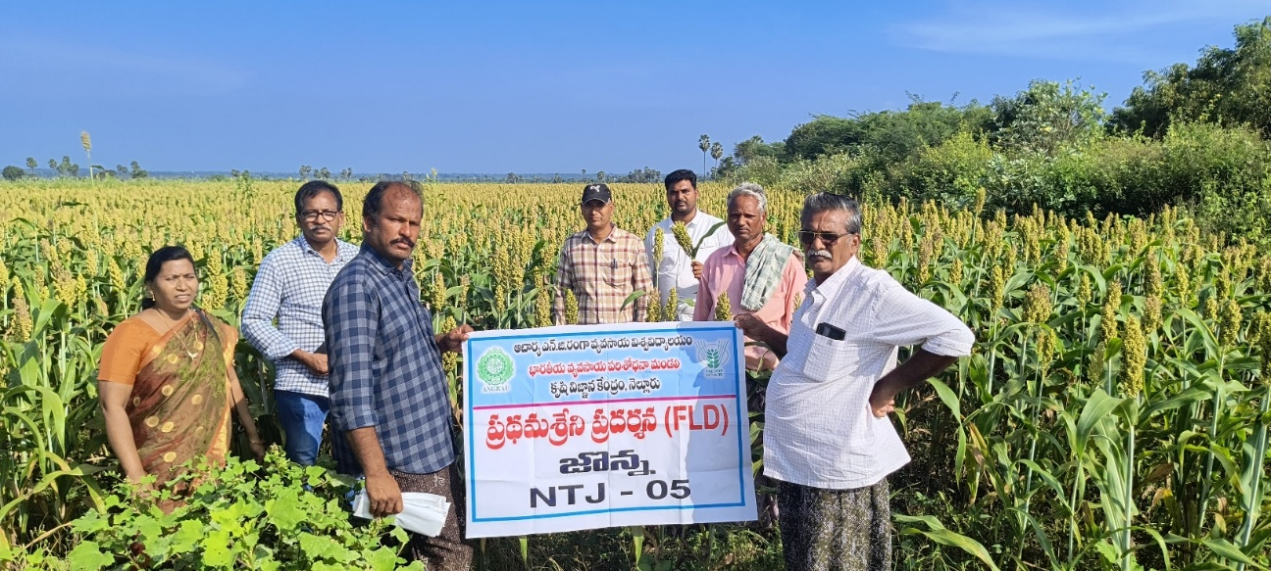

**Fig 1: Front Line Demonstration of White Jowar Variety, NTJ-5 at Nagulavellaturu (V), Chejerla (M)**

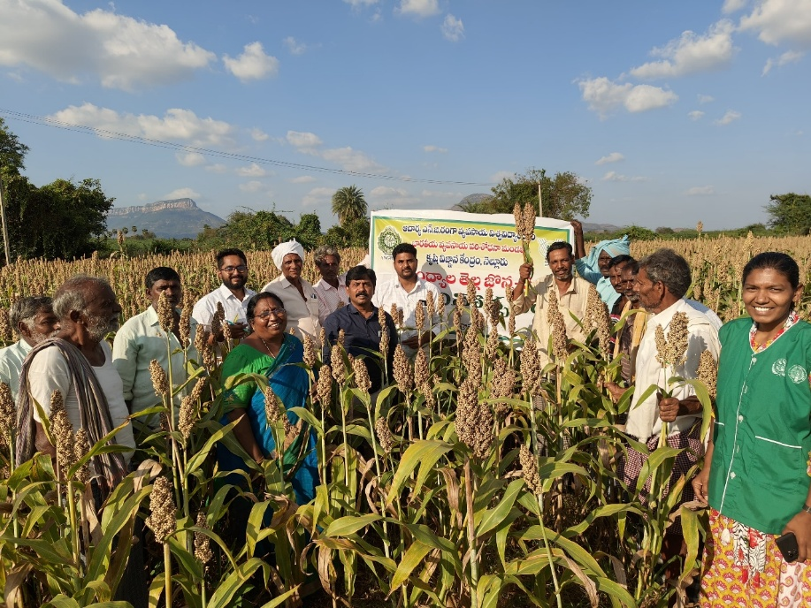

**Fig 2: Front Line Demonstration of White Jowar Variety, NTJ-5 at Kampasamudram (V), Marripadu (M)**

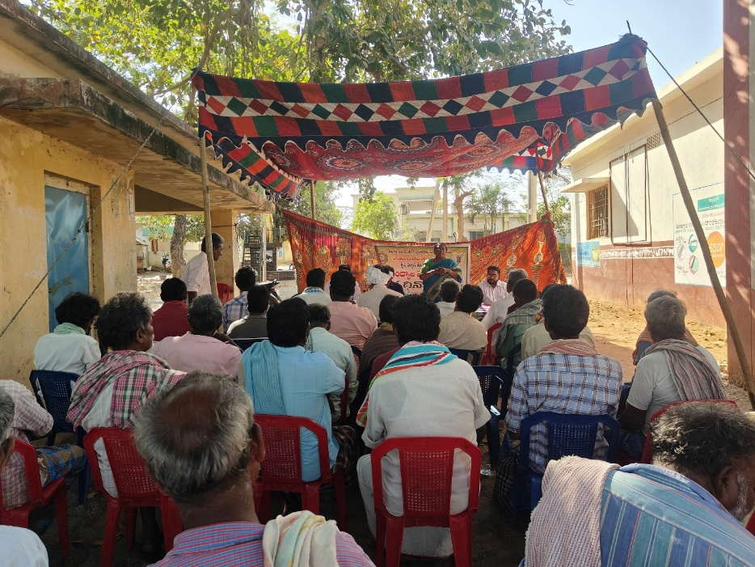

**Fig 3: Field Day on White Jowar Variety, NTJ-5 at Kampasamudram (V), Marripadu (M)**

**Fig 4: Impact of Front Line Demonstrations on Technology Gap, Extension Gap and Technology Index of White Jowar Variety NTJ-5**

**ACKNOWLEDGEMENTS:** The author expresses sincere gratitude to the Director, ATARI, Zone-X, Hyderabad (ICAR), for providing financial assistance for the successful conduct of this Frontline Demonstration.

**COMPETING INTERESTS:** Authors have declared that no competing interests exist.

**DISCLAIMER (ARTIFICIAL INTELLIGENCE):**

Author(s) hereby declare that NO generative AI technologies such as Large Language Models (ChatGPT, COPILOT, etc.) and text-to-image generators have been used during the writing or editing of this manuscript.

**REFERENCES:**

Assefa, Y., Staggenborg, S. A and Prasad, V. P. V. (2010). Grain sorghum water requirement and responses to drought stress: A review. Crop Management. 9(1). Doi:10.1094/CM-2010-1109-01-RV.

**Hassan, Z. M., Sebola, N. A and Mabelebele, M. (2021).** The nutritional use of millet grain for food and feed: A review. Agriculture & Food Security, 10:16. https://doi.org/10.1186/s40066-020-00282-6.

Jayalakshmi, V., Chaithanya, B. H., Manjunath, J., Ahammad, S. K., Kamakshi, N and Devi, S. R. (2022). Impact of Tribal Sub Plan (TSP) intervention on yield and economics of chickpea cultivation in Kurnool district of Andhra Pradesh. Indian Journal of Extension Education, 58(2):217-220. DOI:[10.48165/IJEE.2022.58234](http://dx.doi.org/10.48165/IJEE.2022.58234).

**Saleh, A. S., Zhang, Q., Chen, J and Shen, Q. (2013).** Millet grains: Nutritional quality, processing, and potential health benefits. Comprehensive Reviews in Food Science and Food Safety, 12(3), 281- 295.  https://doi.org/10.1111/1541-4337.12012.

**Shahidi, F and Chandrasekara, A. (2013).** Millet grain phenolics and their role in disease risk reduction and health promotion: A review. Journal of Functional Foods, 5(2), 570-581. DOI:[10.1016/j.jff.2013.02.004](http://dx.doi.org/10.1016/j.jff.2013.02.004).

**Sharma, K. K and Ortiz, R. (2000).** Program for the application of genetic transformation for crop improvement in the semi-arid tropics. In Vitro Cellular & Developmental Biology - Plant, 36(2), 83-92. DOI:[10.1007/s11627-000-0019-1](http://dx.doi.org/10.1007/s11627-000-0019-1).

Singh, N. K., Kumar, S., Singh, B. K and Wajidhasan. (2020). Impact of cluster frontline demonstration on yield of chickpea in Nalanda, Bihar. Journal of Agricultural Search, 7(1):44-46. DOI:[10.21921/jas.v7i01.17634](http://dx.doi.org/10.21921/jas.v7i01.17634).