**Analytical Approaches to Phytochemical Profiling of *Jasminum gra*ndiflorum White pitchi genotype: FTIR and GC–MS Studies on Stem Extracts**

**Keerthivasan R1 and Ganga M2**

**1,2Department of Floriculture and Landscaping, Horticultural College and Research Institute, Tamil Nadu Agricultural University, Coimbatore- 641003, Tamil Nadu, India**

**Abstract**

Plants have long served as a rich source of raw materials for pharmaceuticals, contributing significantly to both traditional and modern medicine. The present study focused on the phytochemical profiling of stems from a novel White Flower Bud genotype of *Jasminum grandiflorum* L. (WF), aiming to explore its potential for pharmacological applications. Methanolic extracts of the stems were subjected to Gas Chromatography–Mass Spectrometry (GC–MS) analysis, which revealed the presence of 16 bioactive compounds. These identified compounds are known to exhibit diverse biological activities, including antimicrobial, antibacterial, antioxidant, and anticancer properties, underscoring their medicinal relevance. Compound identification was achieved through standard protocols and verified using Willey and NIST libraries, while Dr. Duke’s Phytochemical and Ethnobotanical Databases were consulted to confirm their biological functions. Additionally, Fourier Transform Infrared (FTIR) spectroscopy was employed to detect the functional groups and structural features of these secondary metabolites, providing valuable qualitative and quantitative insights into the biomolecular composition. Phytochemical screening of stem and leaf extracts (using n‑hexane, chloroform, ethanol, and aqueous solvents) confirmed the presence of tannins, saponins, flavonoids, alkaloids, and reducing sugars, though their distribution varied across different extracts. The FTIR analysis supported these findings by revealing characteristic peaks corresponding to these metabolites. Overall, this investigation demonstrates that the novel *Jasminum grandiflorum* (White Flower type) genotype is a rich reservoir of bioactive compounds. The results highlight its promising role in the development of natural therapeutic agents and its potential contribution to the ongoing search for plant‑based pharmaceutical resources.

**Keywords:** *Jasminum* spp, GC-MS analysis, Phytochemical, Stem extracts, FTIR, Bioactive compounds

**Introduction:**

Gas chromatograph-mass spectrometry (GC-MS) is a fusion technique for the perfect analysis of volatile compounds including alcohols, acids, and esters and also detects hydrocarbons with long and branched chains. It has been ethnobotanically reported that approximately 80% of the 122 elements employed in modern healthcare products have been found to have similar activities to those registered for their respective original herbal drugs (Parnami & Lakhawat, 2022; Pipon, 2010). Herbal remedy is thus believed to meet indeed about 80% of worldwide health needs, catering to millions residing in developing areas, especially rural. Historically, plant metabolites were regarded as one of the most important sources of nutritional components. In recent times, restrictions on the development, promotion, and use of antibiotics derived from animals have shifted attention toward plant-based alternatives. Consequently, scientific interest has grown in plant metabolites as promising sources for alternative bioactive agents (Adamson *et al*., 2018). In the pharmaceutical field, the focus has increasingly turned to secondary plant metabolites due to their valuable roles in plant stress physiology, as well as their applications in nutrition and cosmetics. These secondary metabolites not only help plants mitigate stress but also serve as protective agents against toxicity (Ingle et al., 2016). Spectroscopic techniques are employed to detect the presence of such metabolites, providing valuable qualitative and quantitative information on biomolecular composition. FTIR is widely used to profile phytochemicals, producing signals that encompass a broad range of compounds detectable when whole cells are analysed. It is recognized as a highly precise analytical technique for identifying compound constituents and elucidating their structural characteristics (Hashimoto & Kameoka, 2008; Hussain *et al*., 2009). Foot-and-mouth disease (FMD) in animals is caused by the highly infectious foot-and-mouth disease virus (FMDV), which affects wild animals as well as domesticated livestock such as cattle, buffaloes, pigs, goats, and sheep. The disease is characterized by fever, vesicular lesions, and sores on the feet, nose, tongue, or teats, with low mortality but high morbidity. Younus *et al*. (2017) employed the MTT assay [3-(4,5-dimethylthiazol-2-yl)-2,5-diphenyltetrazolium bromide] to evaluate extracts of *Azadirachta indica*, *Moringa oleifera*, and *Morus alba* against FMDV, assessing their antiviral and cytotoxic activities. The present investigation was set up to evaluate the pharmaceutical values of stem extracts of these three genotypes, to thus serve as a supplementary income for the jasmine farmer. FTIR was utilized to detect chemical compounds with strong antimicrobial and antioxidant properties.

**Plant Material Collection**

The Jasminum genotypes studied included a white flower bud type of *Jasminum grandiflorum* (White Flower), developed at Tamil Nadu Agricultural University (TNAU). This genotype is distinctive among jasmine varieties, as most commercial cultivars typically produce white-tinged buds. Fresh stem samples from three *Jasminum* genotypes were collected during 2023–2024 from the jasmine germplasm maintained at the Department of Floriculture and Landscaping, TNAU, Coimbatore District, Tamil Nadu, India.

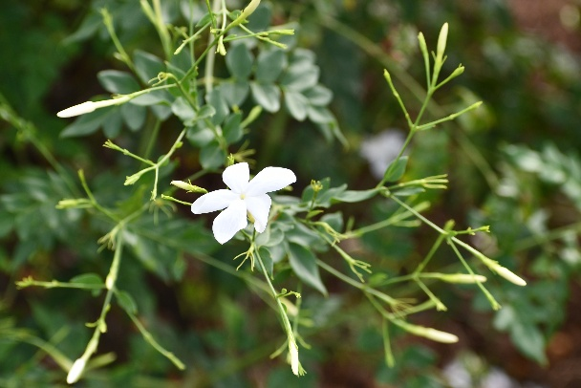

**Fig 1: *Jasminum grandiflorum* (White budded flower type)**

**Preparation of Methanolic Stem Extract**

The harvested stems were thoroughly cleaned, chopped into small pieces, and washed twice with deionized water. They were then air-dried in a cool, shaded environment. Once fully dried, the stems were ground into a fine powder using a blender and stored in an airtight container for subsequent analysis (Guha *et al*., 2010; Sultana *et al*., 2009)

To extract the active constituents, 50 grams of the powdered material were placed in a 500 mL conical flask. A total of 300 mL of 70% methanol (methanol: water) was added, and the mixture was macerated at room temperature for three days with intermittent stirring (Salisu & Garba, 2008)**.** The mixture was then filtered, and the filtrate was concentrated using a rotary evaporator (Brinkmann, R110). The concentrated extracts were stored in labelled vials and refrigerated at 4°C for further analysis.

**Gas Chromatography–Mass Spectrometry (GC-MS) Analysis**

Volatile components of the methanolic stem extract were analysed using an Agilent Technologies 7890A gas chromatograph coupled with a 5975C Mass Selective Detector (MSD), operating in electron ionization mode at 70 eV with the ion source temperature maintained at 250°C. A DB-5MS capillary column (30 m × 0.25 mm × 0.25 µm, Agilent) was used, with helium (99.9%) as the carrier gas at a constant flow rate of 1 mL/min. Injection was performed in split mode (1:60) with an injection volume of 1 μL. The oven temperature was initially set at 100°C and held for 0.5 minutes, then ramped to 140°C at 20°C/min and held for 1 minute, followed by a final increase to 280°C at 11°C/min over 20 minutes. Data acquisition and peak integration were carried out using Mass Hunter software. Compound identification was performed by comparing the obtained mass spectra with those in the NIST Wiley 2008 and W9N11 libraries. Biological activities of the identified bioactive compounds were confirmed using Dr. Duke’s Phytochemical and Ethnobotanical Databases, while molecular formula and weights were validated via PubChem.

**ATR-FTIR (Attenuated Total Reflectance–Fourier Transform Infrared) Spectroscopy**

The powdered stem samples were analysed using ATR-FTIR spectroscopy with a Thermo Scientific Nicolet iS10 spectrometer equipped with a Germanium ATR crystal. The sample was firmly pressed against the crystal to ensure optimal contact. Infrared spectra were recorded over the wavenumber range of 4000–550 cm⁻¹. The infrared beam entered the crystal and generated evanescent waves, which interacted with the sample. The modified infrared signal was then collected by a detector for spectral interpretation.

**Results and Discussion**

The paramount importance of GC-MS applications lies in the determination of volatile organic compounds like alcohol or ester. The GC-MS also had the ability to discriminate long-chain aliphatic hydrocarbons from olefins and aromatics - naphthene’s or alkyl benzenes. GC-MS proved its worth in aroma profiling of several *Jasminum* species (Ranchana *et al*., 2017) and in profiling metabolites and their biosynthetic pathways in putative mutants of *J. grandiflorum* (Soundarya *et al*., 2022). The study performed GC-MS analysis on stem extracts of Jasmine revealing various phytochemical constituents. Retention time, molecular formulae, and peak area provided confirmation for these phytochemicals. Present experimental outcomes are shown in the figures 2. The NIST Database predicted the compounds. The GC-MS of the sample revealed 9,12-Octadecadienoic acid (Z,Z)-, methyl ester (RT 13.8411 min) as the most dominant compound, covering 13.39% of the total peak area. Other major compounds were γ-Sitosterol (RT 22.2512 min, 6.02%), 4-((1E)-3-Hydroxy-1-propenyl)-2-methoxyphenol (RT 11.4859 min, 5.53%), Benzoic acid, 2-formyl-, methyl ester (RT 8.5085 min, 3.43%), and Homovanillyl alcohol (RT 9.8639 min, 3.33%). Also detected were some other important compounds like Papaveroline, 1,2,3,4-tetrahydro-3-O-methyl- (3.06%), Hexadecenoic acid, methyl ester (2.91%), and Benzene ethanol, 4-hydroxy- (2.61%). These chemical compositions show a heterogeneous composition being dominated by fatty acid esters, phytosterols, and phenolic derivatives that can contribute much to the bio-functional properties of the extract.

**Table 1: Phytochemical compounds identified in the methanol extract of *J. grandiflorum* (White Flower type) stem**

|  |  |  |  |  |
| --- | --- | --- | --- | --- |
| **RT (min)** | **Chemical Compound** | **Molecular Formula** | **Molecular Weight (g/mol)** | **Area %** |
| 5.1867 | Benzyl alcohol | C7H8O | 108.14 | 2.02 |
| 6.3310 | 4H-Pyran-4-one, 2,3-dihydro-3,5-dihydroxy-6-methyl- | C6H8O4 | 144.13 | 1.49 |
| 8.5085 | Benzoic acid, 2-formyl-, methyl ester | C9H8O3 | 164.16 | 3.43 |
| 8.9418 | Benzeneethanol, 4-hydroxy- | C8H10O2 | 138.16 | 2.61 |
| 9.2528 | Dimethyl{bis[(2Z)-pent-2-en-1-yloxy]} silane | C12H24O2Si | 244.41 | 1.61 |
| 9.3084 | Doconexent | C22H32O2 | 328.49 | 1.32 |
| 9.4084 | Benzo[b]thiophene 1,1-dioxide, 3-methyl- | C9H8O2S | 180.23 | 2.49 |
| 9.8639 | Homovanillyl alcohol | C9H12O3 | 168.19 | 3.33 |
| 11.4859 | 4-((1E)-3-Hydroxy-1-propenyl)-2-methoxyphenol | C10H12O3 | 180.20 | 5.53 |
| 11.7970 | Papaveroline, 1,2,3,4-tetrahydro-3-O-methyl- | C17H19NO4 | 301.34 | 3.06 |
| 12.7413 | Hexadecanoic acid, methyl ester | C17H34O2 | 270.45 | 2.91 |
| 13.8411 | 9,12-Octadecadienoic acid (Z,Z)-, methyl ester | C19H34O2 | 294.48 | 13.39 |
| 17.7962 | Squalene | C30H50 | 410.72 | 1.68 |
| 20.1070 | Vitamin E | C29H50O2 | 430.71 | 1.85 |
| 22.2512 | γ-Sitosterol | C29H50O | 414.71 | 6.02 |

**Figure 2: GC-MS chromatogram of *J. grandiflorum* (WF) stem.**

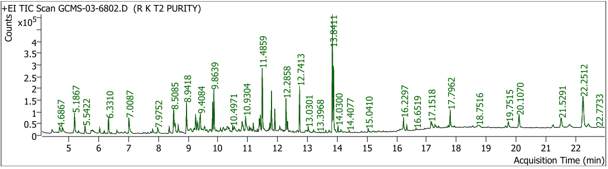

**FTIR peak values and functional groups.**

In evaluating the FTIR of the stem extract of *Jasminum grandiflorum*, the hydroxyl group stretch finally arrived from the 3280/cm peak, confirming the presence of polyphenols in the stem macerates of *Jasminum grandiflorum* with a white flower bud type. Then again, at 2884/cm peak, the spectra were attributed to terpenes (C-H). At 2353/cm, C=N stretches were assigned to nitrites as per Table 2 and Fig. 3. At 1730/cm, thereby, stretches of C=O (carboxylic) were observed. Following this are alkaloids found at 1514/cm and stressed through N-H stretching, while at 1600/cm peak, primary amines were recorded (Table 2). The esters showed the presence of amines (C-N) or C-O stretches at 1232/cm and 1155/cm-1012/cm, respectively (Fig. 3).

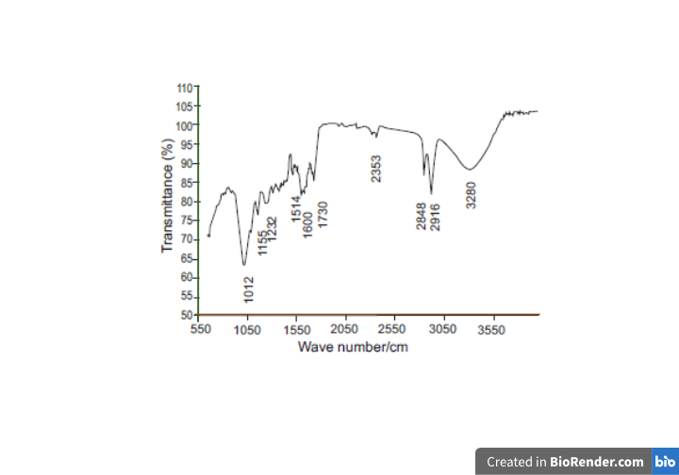

**Figure 3.** *Jasminum grandiflorum* stem’s FTIR spectra.

**Table 2.** FTIR peak values and functional groups

|  |  |  |
| --- | --- | --- |
| **Wavenumber (cm⁻¹)** | **Bond / Compound** | **Functional Group / Possible Assignment** |
| 3290 | O–H | Polyphenols |
| 3280 | – | – |
| 2916 | – | Phenols |
| 2848 | C–O | Carboxylic acid |
| 2353 | C≡N | Nitriles |
| 1730 | C=O | Saponins |
| 1631 | C=O | Flavonoids |
| 1602 | – | Alkenes |
| 1600 | – | Primary amines |
| 1514 | N–H | Alkaloids |
| 1454 | C–H | Terpenes |
| 1305 | S=O | Sulphate esters |
| 1232 | C–N | Amines |
| 1157 | C–O | Esters |
| 1155 | C–O | Esters |
| 1012 | C–O | Esters |

**Discussion**

Various potential pharmacological properties are ascribed to the compounds identified from *Jasminum grandiflorum*. Those reported to show antioxidant activities within this study include homovanillyl alcohol (Benincasa *et al*., 2024; Bernini *et al*., 2019), (4-((1E)-3-hydroxy-1-propenyl)-2-methoxyphenol (Mahatheeranont, 2020) and octadecenoic acid, methyl ester (Yu *et al*., 2005). In the same way, hexadecenoic acid, methyl ester has been reported to show antifungal activity (Sharma *et al*., 2021). Antimicrobial activities have been reported for benzoic acid, 4-ethoxy ethyl ester (Sheela & Uthayakumari, 2013), whereas antibacterial activities are attributed to hexadecenoic acid, methyl ester (Shaaban *et al*., 2021) and 9,12-octadecadienoic acid, methyl ester (Shoge & Amusan, 2020). Among the plant sterols, γ-sitosterol (Sundarraj *et* *al*., 2012) is one with its health benefits in antiinflammation, lowering cholesterol, promotion of cardiovascular health, and metabolic disorder management; it could also retard cancer cell growth. Further, benzeneethanol, 4-hydroxy- (Li *et al*., 2018) has also exhibited nematicidal activity.

For FTIIR analysis, stem powders of Jasminum grandiflorum were subjected to detect and document the functional groups existing in different parts of plants. Depending upon the peak portions that act as a fingerprint and functional groups, differences and similarities among the different parts of plants were identified. Functional groups were characterized in this study as C-O, N=O, C=O, C-N, C-H, and C-O and were recorded at their corresponding absorbance peaks. These functional groups are attributed to alkyl, anhydrites, deoxyribose, esters, and alcoholic group formations (Sohrabi & Ebrahiminezhad, 2020). The present work was in agreement with the results of Mariswamy *et al*. (2012) who carried out FTIR in *Aerva lanata* (L.) Juss. Ex Schult. Correspondingly, this study also supported the work of Maobe and Nyarango (2013), or that of (Bobby *et al*., 2012) who reported that these groups exhibited relevant absorption values of peak intensities in the leaves of *Utrica dioica* as well as *Albizia lebbeck* Benth.s.

**Conclusion:**

The current study revealed that the stems of *Jasminum grandiflorum* (White Flower bud type) are a rich biorepository of varied nature of bioactive compounds, supported by GC–MS and FTIR analyses. GC–MS profiling exhibited fatty acid esters, phytosterols, and phenolic derivatives as the chief components, most of which have reported antioxidant, antimicrobial, antifungal, antibacterial, anti-inflammatory, and nematicidal activities. Through FTIR spectroscopy, some of the functional groups present in phenols, terpenes, saponins, flavonoids, alkaloids, amines, esters, and carboxylic acids were identified, thereby indicating the complex phytochemical nature of the extract. Thus, the stem extracts of *J. grandiflorum* can be promoted for their significance in natural therapeutic agents and thus earning position in the pharmaceutical, nutraceutical, and agro-industries.

References:

Adamson, V., Barrass, E., McConville, S., Irikok, C., Taylor, K., Pitt, S., Van Duyn, R., Bennett, S., Jackson, L., & Carroll, J. (2018). Implementing the access and waiting time standard for early intervention in psychosis in the United Kingdom: An evaluation of referrals and post‐assessment outcomes over the first year of operation. *Early Intervention in Psychiatry*, *12*(5), 979-986.

Benincasa, C., Cersosimo, A., Perri, E., Nicoletti, R., La Torre, C., Fazio, A., Cione, E., Abrego-Guandique, D. M., Caroleo, M. C., & Plastina, P. (2024). Homovanillyl oleate, a novel lipophenol from olive plant with antioxidant properties. *ACS Food Science & Technology*.

Bernini, R., Carastro, I., Santoni, F., & Clemente, M. (2019). Synthesis of lipophilic esters of tyrosol, homovanillyl alcohol and hydroxytyrosol. *Antioxidants*, *8*(6), 174.

Bobby, M., Wesely, E., & Johnson, M. (2012). FT-IR studies on the leaves of Albizia lebbeck benth. *Int J Pharm Pharm Sci*, *4*(3), 293-296.

Guha, G., Rajkumar, V., Ashok Kumar, R., & Mathew, L. (2010). Aqueous extract of Phyllanthus amarus inhibits chromium (VI)-induced toxicity in MDA-MB-435S cells. *Food Chem Toxicol*, *48*, 396-401.

Hashimoto, A., & Kameoka, T. (2008). Applications of infrared spectroscopy to biochemical, food, and agricultural processes. *Applied Spectroscopy Reviews*, *43*(5), 416-451.

Hussain, K., Ismail, Z., Sadikun, A., & Ibrahim, P. (2009). Evaluation of metabolic changes in fruit of Piper Sarmentosum in various seasons by metabolomics using Fourier Transform Infrared (FTIR) spectroscopy. *Int J Pharm Clin Res*, *1*(2), 68-71.

Ingle, K., Padole, D., & VC, K. (2016). Secondary metabolites for plant growth promotion and plant protection. *Adv Life Sci*, *5*, 10888-10891.

Li, T., Wang, H., Xia, X., Cao, S., Yao, J., & Zhang, L. (2018). Inhibitory effects of components from root exudates of Welsh onion against root knot nematodes. *PLoS One*, *13*(7), e0201471.

Mahatheeranont, S. (2020). Changes in contents of simple phenols and volatile compounds in leaves of Black Rice varieties following growth stages. *Journal of Food Technology & Nutrition Sciences*, *110*, 2-9.

Mariswamy, Y., Gnanaraj, W. E., & Antonisamy, J. M. (2012). FTIR spectroscopic studies on Aerva lanata (L.) Juss. ex Schult. *Asian Journal of Pharmaceutical and Clinical Research*, *5*(2), 82-86.

Parnami, K., & Lakhawat, S. (2022). Practices of using home remedies as an immunity booster during COVID-19. *Ann. Phytomed.*, *11*(3), 64-71.

Pipon, C. N. (2010). Phytochemical and biological investigation of tridax procumbens leaves. a thesis report submitted to the Department of Pharmacy, East West University, Bangladesh.

Ranchana, P., Ganga, M., Jawaharlal, M., & Kannan, M. (2017). Investigation of Volatile Compounds from the Concrete of *Jasminum auriculatum* Flowers. *International Journal of Current Microbiology and Applied Science*, *6*, 1525-1531.

Salisu, L., & Garba, S. (2008). Phytochemical screening and insecticidal activity of *Hyptissau veolens* and *Striga hermonthica*. *BEST Journal*, *5*(1), 160-163.

Shaaban, M. T., Ghaly, M. F., & Fahmi, S. M. (2021). Antibacterial activities of hexadecanoic acid methyl ester and green‐synthesized silver nanoparticles against multidrug‐resistant bacteria. *Journal of basic microbiology*, *61*(6), 557-568.

Sharma, N., Sinha, V. B., Prem Kumar, N. A., Subrahmanyam, D., Neeraja, C., Kuchi, S., Jha, A., Parsad, R., Sitaramam, V., & Raghuram, N. (2021). Nitrogen use efficiency phenotype and associated genes: roles of germination, flowering, root/shoot length and biomass. *Frontiers in plant science*, *11*, 587464.

Sheela, D., & Uthayakumari, F. (2013). GC-MS analysis of bioactive constituents from coastal sand dune taxon-*Sesuvium portulacastrum* (L.). *Bioscience discovery*, *4*(1), 47-53.

Shoge, M., & Amusan, T. (2020). Phytochemical, antidiarrhoeal activity, isolation and characterisation of 11-octadecenoic acid, methyl ester isolated from the seeds of *Acacia nilotica* Linn. *J. Biotechnol. Immunol*, *2*, 1-12.

Sohrabi, M., & Ebrahiminezhad, F. (2020). Novel multi-function polycarbonate/activated-carbon-fabric individual/environmental radon twin badges. *Radiation Measurements*, *134*, 106332.

Soundarya, S. M., Ganga, M., Malarvizhi, D., Iyanar, K., Gnanam, R., & Jawaharlal, M. (2022). Metabolite profiling in the flowers of *Jasminum grandiflorum* (L.) genotype white Pitchi and its mutants. *Pharma Innovation*, *11*(5), 961-967.

Sultana, B., Anwar, F., & Ashraf, M. (2009). Effect of extraction solvent/ technique on the antioxidant activity of selected medicinal plant extracts. *14*(6), 2167-2180.

Sundarraj, S., Thangam, R., Sreevani, V., Kaveri, K., Gunasekaran, P., Achiraman, S., & Kannan, S. (2012). γ-Sitosterol from *Acacia nilotica* L. induces G2/M cell cycle arrest and apoptosis through c-Myc suppression in MCF-7 and A549 cells. *Journal of ethnopharmacology*, *141*(3), 803-809.

Younus, I., Ashraf, M., Fatima, A., Altaf, I., & Javeed, A. (2017). Evaluation of cytotoxic and antiviral activities of aqueous leaves extracts of different plants against foot and mouth disease virus infection in farming animals. *Pakistan journal of pharmaceutical sciences*, *30*(6).

Yu, F. R., Lian, X. Z., Guo, H. Y., McGuire, P. M., Li, R. D., Wang, R., & Yu, F. H. (2005). solation and characterization of methyl esters and derivatives from *Euphorbia kansui* (Euphorbiaceae) and their inhibitory effects on the human SGC-7901 cells. *J Pharm Pharm Sci*, *8*(3), 528-535.