RESEARCH ARTICLE
Integrated Zinc and Boron Fertilization Enhances Growth and Yield of Fine Rice (cv. Binadhan-25)
Received: dd/mm/2025  Revised: dd/mm/2025  Accepted: dd/mm/2025 | ABSTRACT  Micronutrient deficiencies, especially zinc (Zn) and boron (B), are widespread in the rice-growing regions of Bangladesh and pose a significant barrier to achieving optimal crop productivity. To address this issue, a field experiment was conducted during the Boro season at the Agronomy Field Laboratory, Bangladesh Agricultural University, Mymensingh, to assess the effects of integrated use of Zn and B on the growth and yield performance of fine rice variety Binadhan-25. The study comprised eleven treatments involving different combinations of basal and foliar applications of Zn and B and was laid out in a Randomized Complete Block Design (RCBD) with three replications. Among the treatments, the combined application of 50% Zn and B as basal and 50% as foliar spray showed superior results in terms of plant height (114.66 cm), number of effective tillers hill⁻¹ (9.89), grain yield (6.98 t ha⁻¹), straw yield (7.42 t ha⁻¹), 1000-grain weight (21.88 g), biological yield (14.40 t ha⁻¹), and harvest index (48.46%). These results were significantly higher than those recorded in the control plots, which showed the poorest performance across most parameters. The findings suggest that integrated application of Zn and B, both as basal and foliar spray, in combination with recommended NPK fertilization, can effectively overcome micronutrient deficiencies and improve rice growth and productivity, offering a practical solution for sustainable rice production.
Keywords: Micronutrients, Rice productivity, Agronomic Yield

INTRODUCTION
Rice (Oryza sativa L.) is a staple cereal crop and primary food source in Bangladesh cultivated in 78% of the country’s total cropped area (Mamun et al., 2021; Paul et al., 2017; Roy et al., 2024). Bangladesh ranks fourth among the countries that cultivate rice in terms of production (BRRI, 2020). Rice is grown on over 11.7 million hectares in Bangladesh and produce 20768 metric tons Boro rice in the year of 2023-2024 (BBS, 2024). With the population growing by approximately 2 million people each year, the total population is projected to reach 238 million by 2050 (Shelley et al., 2016). To ensure food security for this expanding population, a substantial increase in rice production will be essential.
Boosting rice production requires effective fertilizer management and the correction of micronutrient deficiencies. Micronutrient deficiencies, such as those in zinc (Zn) and Boron (B), are highly prevalent in many Asian nations as well as Bangladesh due to factors such as high soil pH, low organic matter, salinity, drought, calcareous soils, and unbalanced fertilizer use (Akhtar et al., 2013; Chatzistathis, 2014; Malakouti, 2008). Zinc is essential for the synthesis of tryptophan, a precursor of the plant hormone auxin, and functions as a cofactor for over 300 enzymes. It plays a vital role in preserving the integrity of biological membranes, supporting pollen development, enhancing disease resistance, and facilitating protein synthesis and photosynthesis (Bhadra et al., 2023; Farooq et al., 2018). Rice yield increased with basal treatment of ZnSO₄, as reported by Zulfiqar et al., (2021). The research on micronutrients, will help satisfy the growing demand for more food production in the millennium with improved nutritional content from minerals.
Boron is responsible for better pollination, seed setting and grain formation in different rice varieties, maximum number of grains panicle⁻¹ against control plots might be due to the reduction in pollen sterility of rice and proper grain filling (Bithy et al., 2020; Das et al., 2022). Fatima et al., (2018) stated that maximum grain yield by soil application of B at the flowering stage might be the direct effect of higher number of grains panicle⁻¹ and 1000-grain weight. Many reports indicate that B applied at the heading or flowering stage in rice resulted increased rice grain yield and number of grains panicle⁻¹ (Hanifuzzaman et al., 2022). Similarly, Rehman et al., (2018) reported enhanced paddy yield due to reduced panicle sterility by B application appreciably.
Due to the deficiency and crop responses, the farmers of Bangladesh have been applying Zn and B fertilizers to their crop lately. There is a great deal of interactions among nutrients when they are applied in soil and their interactions are very complex and depend on a great array of factors (Hanifuzzaman et al., 2022). However, to our knowledge, limited study has been reported till date on the interactions and efficiency of zinc and boron fertilizers applied together in rice crop. Therefore, this study was undertaken to find out the effect of Zn and B using basal and foliar application on the growth and yield of fine rice (cv. Binadhan-25).

MATERIALS AND METHODS

Location and climate

The experiment was carried out at the Agronomy Field Laboratory of Bangladesh Agricultural University, Mymensingh, Bangladesh (24°25′ N latitude and 90°50′ E longitude, 18 meters above sea level) from November 2023 to April 2024 to evaluate the impact of various zinc and boron application methods on the growth and yield performance of rice. The experimental site is situated on non-calcareous dark grey floodplain soil, classified under the Sonatala soil series, which falls within the Old Brahmaputra Floodplain (Agro-Ecological Zone 9, AEZ-9). The field was medium-high land with moderate drainage capacity. The soil was silty loam in texture, nearly neutral in pH (6.48), low in organic matter (0.88%), and contained 0.67% total nitrogen, 15.37 ppm available phosphorus, 0.23 meq/100g exchangeable potassium, and 13.46 ppm available sulfur. Soil tests indicated that available zinc (0.23 ppm) and boron (0.16 ppm) were in the deficient range. Meteorological data recorded during the experimental period (Figure 1) provided information on temperature, rainfall, and relative humidity trends, which are important factors influencing crop growth and yield performance.
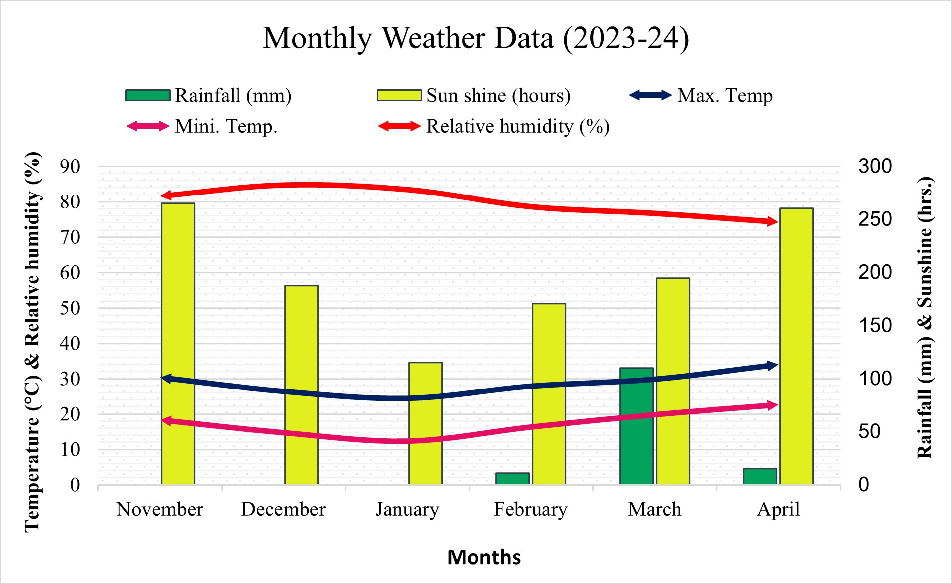
Figure 1: Meteorological data for November 2023 to February 2024 of the experimental site

Experimental Design
The experiment was laid out using a randomized complete block design with three replications and eleven zinc and boron application using basal and foliar methods:
- Control (no zinc and no boron) (F₀)
- Zn (2.0 kg ha⁻¹) and B (2.0 kg ha⁻¹) as basal (F₁)
- 100% Zn as basal (without B) (F₂)
- 100% B as basal (without Zn) (F₃)
- 100% Zn foliar spray at pre-flowering stage (without B) (F₄)
- 100% B foliar spray at pre- flowering stage (without Zn) (F₅)
- 75% Zn and B as basal + 25% Zn and B foliar spray at pre- flowering stage (F₆)
- 50% Zn and B as basal + 50% Zn and B foliar spray (F₇)
- 100% Zn and B as basal + 25% Zn and B foliar spray (F₈)
- 100% Zn and B as basal + 25% Zn foliar spray (F₉)
- 100% Zn and B as basal + 25% B foliar spray (F₁₀)
Each block was divided into 11-unit plots, where the 11 treatments were allocated at random. Altogether there were 33-unit plots in the experiment. The net size of each unit plot was 2.5 m × 2.0m. The spaces between replications and between plots were 1 m and 0.5 m, respectively.
Land Preparation and Intercultural operation
Seeds of rice variety Binadhan-25 were collected from Bangladesh Institute of Nuclear Agriculture (BINA), Mymensingh. Then seeds were immersed in a water bucket for 24 hrs. These seeds were taken out from the bucket and tightly covered by gunny bags. The seeds started sprouting after 48 hrs. which became prepared for sowing in next 72 hrs.
The nursery bed was prepared by puddling with repeated ploughing nursery beds of 1.0 m length and 1.0 m width. Later the seed was covered immediately and then a light irrigation was given. The field was prepared by ploughing with tractor drawn cultivars followed by cross harrowing to pulverize the soil. All uprooted weeds and crop residues were removed from the field after plowing and laddering. The experimental plots were fertilized with urea, triple superphosphate and muriate of potash, calcium sulfate @ 217, 119, 130, 77, 9.1, 11.8 kg ha⁻¹ respectively. Except urea, the whole amount of other fertilizer was applied before final land preparation. Urea was top dressed in three installments at 15, 30 and 45 days after transplanting. The Zn and B was supplied at 2 kg ha⁻¹ in form of zinc sulfate and boric acid following respective treatments. The seedlings of 35 days were transplanted in the main field with a spacing cm as row to row and hill to hill distance, respectively with 2-3 seedlings hill⁻¹. A thin layer of water was kept at the time of transplanting for better establishment of the seedlings. From the third day onwards, 2 to 3 cm depth of water was maintained up to the panicle initiation stage except at the time of top dressing of urea, where the water was drained out and re-irrigated to maintain 5 cm depth of water up to physiological maturity. After dough stage, water was entirely drained out to make harvesting easier.
Data collection and Harvesting
The crop was harvested at full maturity, when approximately 80% of the seeds turned golden yellow. Five hills (excluding border hills) were randomly pre-selected from each plot and uprooted before harvest to record data on various plant characteristics. After harvesting, the crops from each plot were separately bundled, tagged, and brought to the threshing floor. The crops were threshed using a pedal thresher, and the grains were sun-dried and cleaned. The straws were also properly sun-dried. Both grain and straw yields were then converted to t ha⁻¹.
Plant height
Five hills were randomly selected soon after transplanting and marked with bamboo sticks in each plot excluding border rows to record the data on plant height at 45, 60 and 75 DAT. Then the plant height at 45, 60 and 75 DAT was measured from the base to the tip of the longest panicle and expressed in cm.
Total tillers hill⁻¹
Five hills were randomly selected in each plot excluding border rows to record the data of number of tillers hill⁻¹ at 45, 60 and 75 DAT. Then the number of tillers hill⁻¹ at 45, 60 and 75 DAT was measured.
Effective tillers hill⁻¹
The panicles which had at least one grain were considered effective tillers. The number of effective tillers hill⁻¹ was recorded and finally averaged for counting number of effective tillers hill⁻¹ and non-effective tiller hill⁻¹. The tiller having no panicle was regarded as ineffective tillers. The number of effective tillers hill⁻¹ was recorded and finally averaged for counting ineffective tillers number hill⁻¹.
Panicle length
Panicle length was recorded from the basal node of the rachis to the apex of each panicle.

Grains panicle⁻¹
Grain was considered to be filled if any kernel was present there. The number of total filled grains present on five panicles were recorded and finally averaged.

Sterile spikelet panicle⁻¹
Unfilled grains mean the absence of any kernel inside and such grains present on each of five panicles were counted and finally averaged.
1000-grain weight
One thousand cleaned dried grains were counted randomly from each sample and weighed by using a digital electric balance at the stage the grain retained about 14% moisture and the mean weights were expressed in grams.
Grain yield
Grain yield was determined from the central 1 m² areas of each plot and expressed as t ha⁻¹ on about a 14% moisture basis. Grain moisture content was measured by using a digital moisture tester.
Straw yield
The straw yield was determined from the central 1 m² areas of each plot. After separating of grains, the sub-samples were oven-dried to a constant weight and finally converted to t ha⁻¹.
Biological yield
Grain yield and straw yield was all together regarded as biological yield. The biological yield was calculated with the following formula:
Biological yield (t ha⁻¹) = Grain yield (t ha⁻¹) + Straw yield (t ha⁻¹)
Harvest index (%)
It denotes the ratio of grain yield to biological yield and was calculated with the following formula:
Harvest Index (%) = 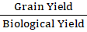× 100.
3.9 Statistical Analysis
The data collected for various traits were subjected to statistical analysis to evaluate significant differences among the treatments. Analysis of Variance (ANOVA) was conducted for all recorded parameters using the R software package (R Core Team, 2024). Treatment means were compared using Duncan’s New Multiple Range Test (DNMRT), as described by Gomez and Gomez (1984).

RESULTS AND DISCUSSION
Growth Parameters
At different growth stages, growth parameters such as plant height, number of tillers hill⁻¹, and dry weight showed significant variation due to the effect of different Zn and B management treatments. The treatment F₇ (50% Zn and B as basal + 50% Zn and B as foliar spray) consistently produced the tallest plants at 45, 60, and 75 DAT, as well as at harvest, while the shortest plants were recorded in the control (F₀: no Zn and B). Treatments like F₆ (75% Zn and B as basal + 25% Zn and B foliar spray at pre-flowering stage) and F₈ (100% Zn and B as basal + 25% Zn and B foliar spray) exhibited similar trends to F₇ throughout the growth period. A similar pattern was observed for number of tillers and dry weight. The number of tillers increased from 45 to 60 DAT, then decreased at 75 DAT, with F₇ producing the highest tiller numbers at all stages and F₀ the lowest. In terms of dry weight, F₇ recorded the highest values at 45, 60, and 75 DAT, whereas F₀ consistently showed the lowest values across all stages. The enhanced growth, dry matter accumulation, and tillering under optimal Zn and B application (basal + foliar) may be due to improved nutrient uptake and physiological functions such as enzyme activity, cell division, and sugar translocation. This balanced supply likely supported sustained growth during critical stages (Abbas et al., 2013; Shaygany et al., 2012; Singh et al., 2021). Our results are supported by some previous studies (Chattha et al., 2023; Hanifuzzaman et al., 2022; Zaman et al., 2018) where it is observed that growth of rice is subsequently influenced by different doses and methods of Zn and B. Arif et al., (2012) reported that improvement in rice growth parameters are related to Zn and B is associated with the development of cell wall and cell differentiation and hence, helps in root elongation and shoot growth of plant.
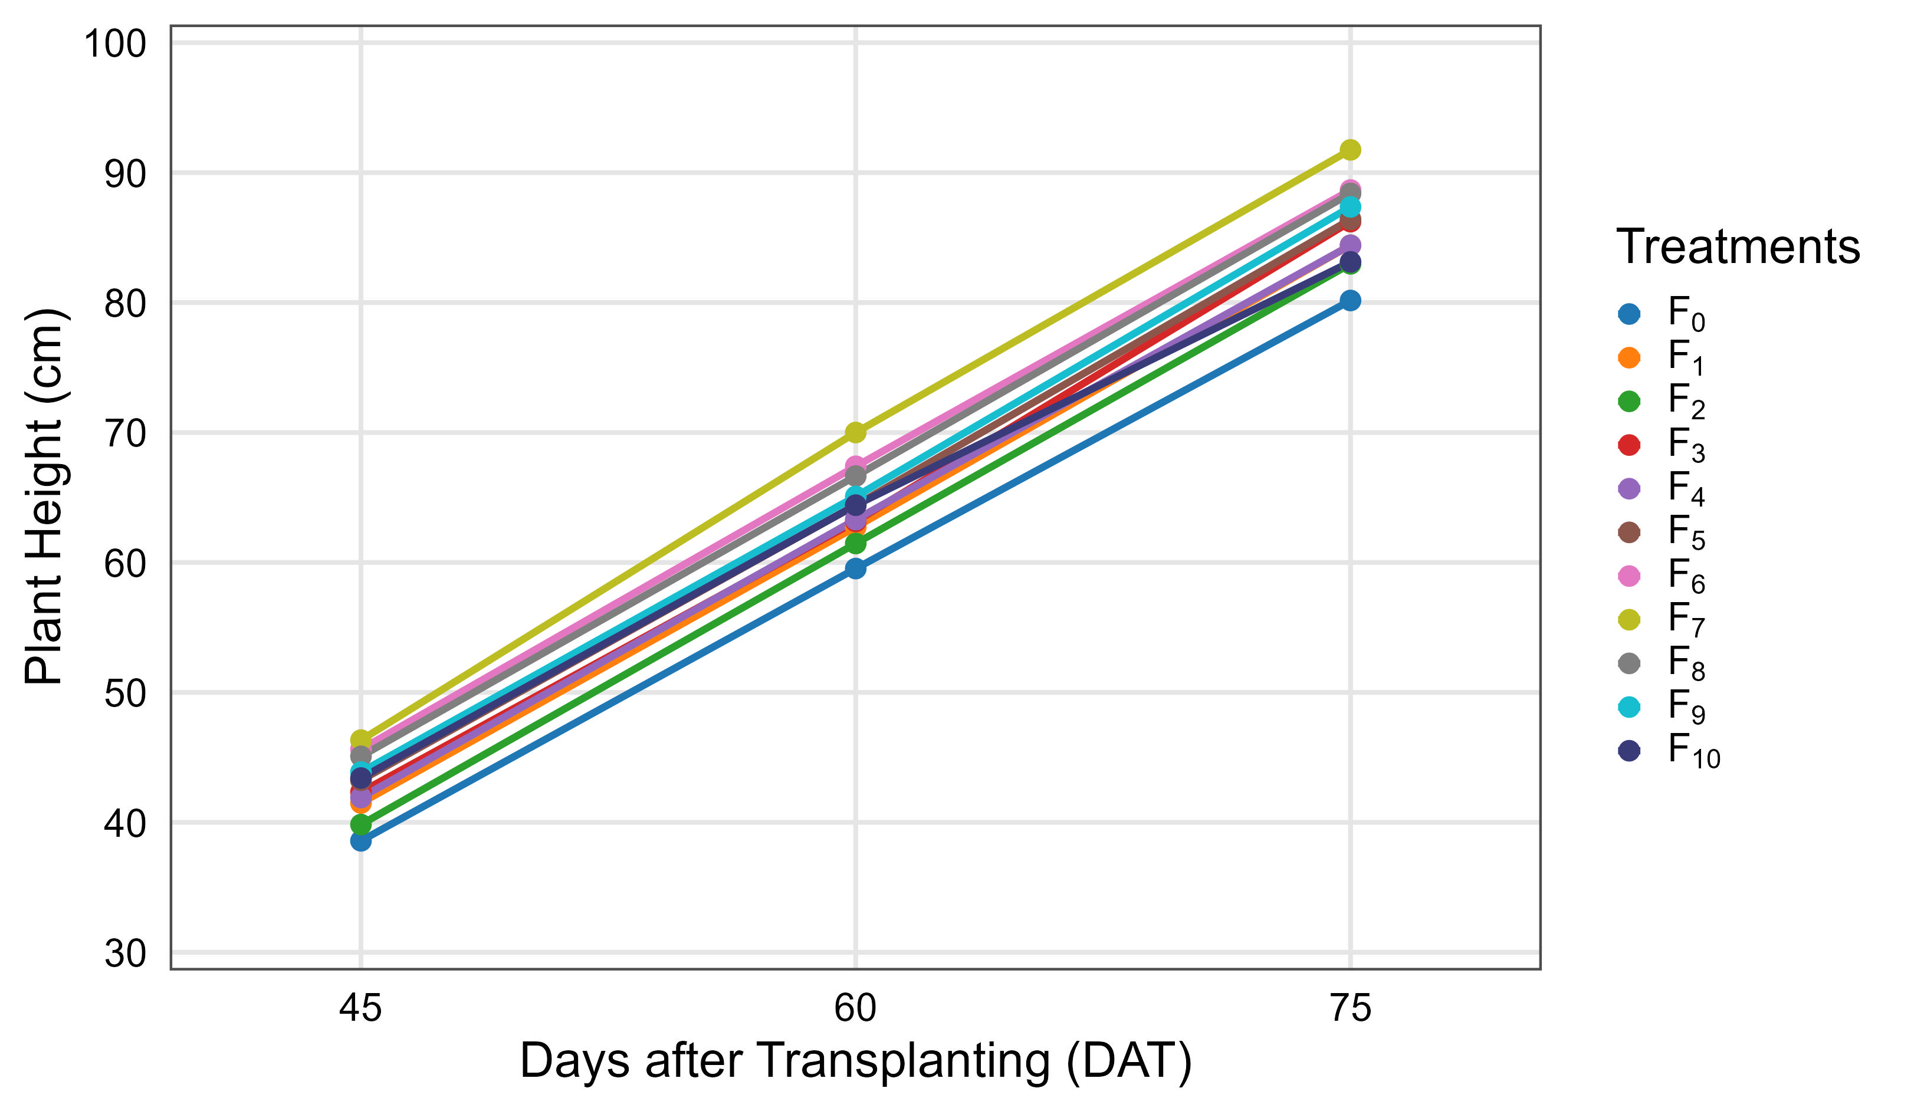
Figure 2. Effect of various zinc and boron application methods on the plant height of fine rice. Here, F₀ – Control (no Zn and B), F₁ – Zn (2.0 kg ha⁻¹) + B (2.0 kg ha⁻¹) as basal, F₂ – 100% Zn as basal (no B), F₃ – 100% B as basal (no Zn), F₄ – 100% Zn as foliar spray (no B), F₅ – 100% B as foliar spray (no Zn), F₆ – 75% Zn and B as basal + 25% as foliar spray, F₇ – 50% Zn and B as basal + 50% as foliar spray, F₈ – 100% Zn and B as basal + 25% Zn and B as foliar spray, F₉ – 100% Zn and B as basal + 25% Zn as foliar spray, F₁₀ – 100% Zn and B as basal + 25% B as foliar spray.
Table 1. Effect of zinc and boron on growth attributes of fine rice (cv. Binadhan-25)
Treatments | Tillers hill⁻¹ (no.) |  |  | Dry weight hill⁻¹ (g)
Treatments | 45 DAT | 60 DAT | 75 DAT | 45 DAT | 60 DAT | 75 DAT
F₀ | 5.16f | 9.88f | 8.83f | 5.04ef | 20.78e | 69.56b
F₁ | 5.33ef | 10.08f | 10.00de | 5.48def | 21.67e | 69.70b
F₂ | 5.41def | 10.50ef | 9.50ef | 4.63f | 22.06e | 71.94b
F₃ | 6.16cde | 10.66ef | 10.25cde | 5.68de | 25.06d | 72.90b
F₄ | 6.00def | 10.91ef | 10.40cde | 4.86ef | 24.98d | 72.77b
F₅ | 6.25cd | 12.23cde | 10.83bcd | 6.43cd | 27.35cd | 73.63b
F₆ | 7.50ab | 14.25ab | 13.08a | 7.46ab | 30.40ab | 81.30a
F₇ | 8.00a | 14.75a | 14.08a | 8.36a | 32.57a | 82.57a
F₈ | 7.75ab | 14.00abc | 11.58b | 6.78bc | 29.32bc | 82.13a
F₉ | 6.91bc | 12.83bcd | 11.16bc | 6.74bc | 28.11bc | 74.46b
F₁₀ | 6.25cd | 11.91de | 10.33cde | 5.53def | 27.54cd | 73.86b
Level of Sig. | ** | ** | ** | ** | ** | **
CV% | 8.26 | 8.92 | 5.70 | 9.27 | 5.76 | 5.15
Here in the column having similar letter does not differ significantly as per DMRT
** = Significant at 1% level of probability
F₀: (Control) (no zinc and boron), F₁: Zn (2.0 kg ha⁻¹) and B (2.0 kg ha⁻¹) as basal, F₂: 100% Zn as basal (without B), F₃: 100% B as basal (without Zn), F₄: 100% Zn foliar spray at pre-flowering stage (without B), F₅: 100% B foliar spray at pre- flowering stage ( without Zn), F₆: 75% Zn and B as basal + 25% Zn and B foliar spray at pre- flowering stage, F₇: 50% Zn and B as basal + 50% Zn and B foliar spray, F₈: 100% Zn and B as basal + 25% Zn and B foliar spray, F₉: 100% Zn and B as basal + 25% Zn foliar spray, F₁₀: 100% Zn and B as basal + 25% B foliar spray

Yield components and yield
The application of different levels and combinations of zinc (Zn) and boron (B) fertilizers significantly influenced the growth parameters, yield attributes, and yield of rice. Agronomic traits such as total tillers hill⁻¹, effective tillers hill⁻¹, non-effective tillers hill⁻¹, panicle length, grains panicle⁻¹, sterile spikelets panicle⁻¹, 1000-grain weight, grain yield, straw yield, biological yield, and harvest index were all markedly affected by the fertilizer treatments. The highest number of total tillers hill⁻¹ was observed in treatment F₇ (50% Zn and B as basal + 50% as foliar spray), which was statistically similar to F₆ (75% Zn and B as basal + 25% foliar spray at pre-flowering) and F₈ (100% Zn and B as basal + 25% foliar). The lowest number was recorded in the control (F₀). A similar trend was observed for effective tillers hill⁻¹, where F₇ produced the highest count, followed by F₆, while the lowest was in F₀. Treatment F₇ enhanced the number of effective tillers by 37.36% compared to the control. In contrast, the highest number of non-effective tillers hill⁻¹ was also recorded in F₇, whereas the lowest was found in F₄ (100% Zn foliar spray). The maximum panicle length was observed in F₇, while the minimum occurred in F₃ (100% B as basal). Among the yield components, the number of grains panicle⁻¹ and 1000-grain weight were highest in F₇, followed by F₈, with the control showing the lowest values. Notably, F₇ resulted in approximately a 15% increase in 1000-grain weight compared to F₀. The highest number of sterile spikelets panicle⁻¹ was found in F₃, whereas the lowest (11.00) was recorded in F₆.
Grain yield was significantly influenced by the treatments. The highest grain yield (6.98 t ha⁻¹) was obtained in F₇, which was statistically comparable to F₆, while the lowest (5.82 t ha⁻¹) was observed in the control. The combined application of Zn and B (50% basal + 50% foliar) resulted in a yield increase of approximately 20% over the control, 2% over 100% Zn basal application, and 9% over 100% B basal application. Separate foliar applications of Zn or B increased yield by 7.3% and 12.18%, respectively. Similarly, the highest straw yield (7.42 t ha⁻¹), biological yield (14.40 t ha⁻¹), and harvest index (48.46%) were recorded in F7, whereas the control recorded the lowest values for these parameters (7.18 t ha⁻¹, 13.00 t ha⁻¹, and 44.77%, respectively). The improvement in yield attributes can be attributed to enhanced nutrient uptake and utilization efficiency, which supports key physiological processes such as photosynthesis, better assimilate partitioning, and optimized reproductive development. The synergistic effect of Zn and B likely addressed specific micronutrient deficiencies, promoting overall plant vigor and, ultimately, higher yield.
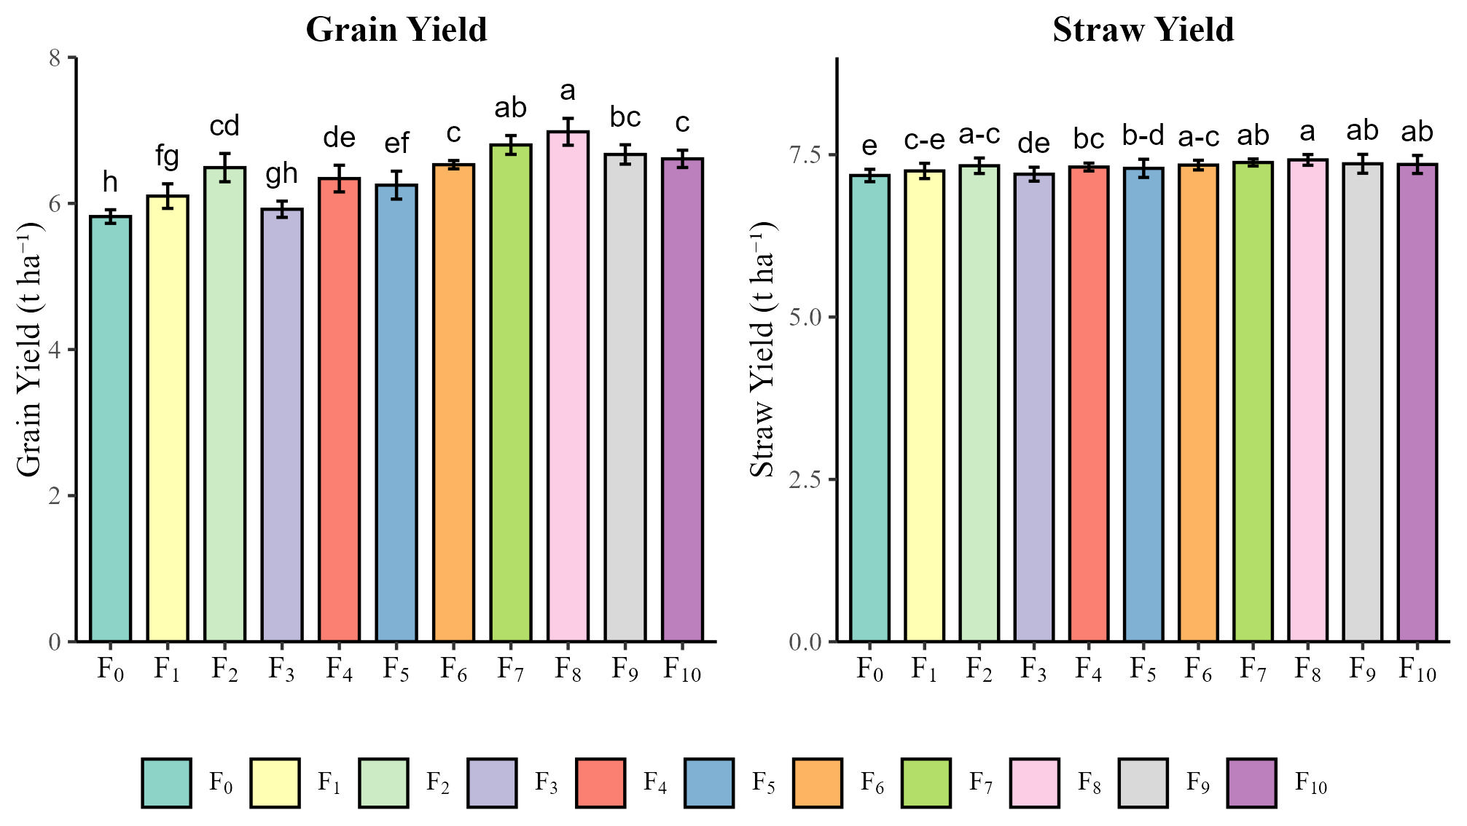
Figure 3: Effect of various zinc and boron application methods on the grain yield and straw yield of fine rice. Here, F₀ – Control (no Zn and B), F₁ – Zn (2.0 kg ha⁻¹) + B (2.0 kg ha⁻¹) as basal, F₂ – 100% Zn as basal (no B), F₃ – 100% B as basal (no Zn), F₄ – 100% Zn as foliar spray (no B), F₅ – 100% B as foliar spray (no Zn), F₆ – 75% Zn and B as basal + 25% as foliar spray, F₇ – 50% Zn and B as basal + 50% as foliar spray, F₈ – 100% Zn and B as basal + 25% Zn and B as foliar spray, F₉ – 100% Zn and B as basal + 25% Zn as foliar spray, F₁₀ – 100% Zn and B as basal + 25% B as foliar spray.

These findings are consistent with previous studies involving basal and foliar applications of Zn and B in rice and other agronomic crops (Quddus et al., 2011; Yogi et al., 2024; Zaman et al., 2018). Arif et al., (2012) found that the synergy of zinc and boron in combined use demonstrated a notably greater increase in crop yield compared to their application. Soltani et al., (2020) reported that the maximum spikelets per panicle, grains per panicle, 1000-grain weight, grain yield, and biomass were achieved with basal Zn application, whereas foliar application at maximum tillering and flowering stages yielded the highest values for these traits. Zaman et al., (2018) stated that foliar and soil application of ZnSO₄·7H₂O enhanced early seedling growth in rice genotypes by improving agronomic traits associated with water use and biochemical properties. Higher harvest index values reflect more efficient translocation of photosynthates from the source to the sink, indicating improved allocation of resources towards reproductive growth (Saikh et al., 2022).

Correlation Analysis
Pearson’s correlation coefficients were computed to examine the relationships among growth, yield, and yield-contributing traits of rice under different Zn and B fertilizer treatments (Figure 4). Grain yield (GY) exhibited a strong positive correlation (p < 0.001) with all major yield components and agronomic traits, including biological yield (BY), straw yield (SY), effective tillers hill⁻¹ (ET), 1000-grain weight (GW), total tillers hill⁻¹ (TT), panicle length (PL), and grains panicle⁻¹ (GP). Similarly, biological yield had perfect or near-perfect positive correlations with SY, ET, GW, TT, and GY. Harvest index also showed significant positive associations with GY, ET, GW, TT, and GP, further highlighting the yield-dependency on these traits. Effective tillers hill⁻¹ (ET) were significantly and positively correlated with TT, GW, and SY. Total tillers hill⁻¹ (TT) showed strong correlations with GW, SY, and PH. Plant height (PH) was positively associated with almost all traits, notably TT, HI, and GY.
In contrast, sterile spikelets panicle⁻¹ displayed weak to negative correlations with most traits, though not statistically significant (p ≥ 0.05). It was negatively correlated with ET, GW, TT, and PL, suggesting a detrimental role of spikelet sterility in yield performance. Overall, the correlation matrix confirmed that effective tillering, panicle traits, and grain weight are strongly associated with higher yield performance, while increased spikelet sterility has an adverse effect.

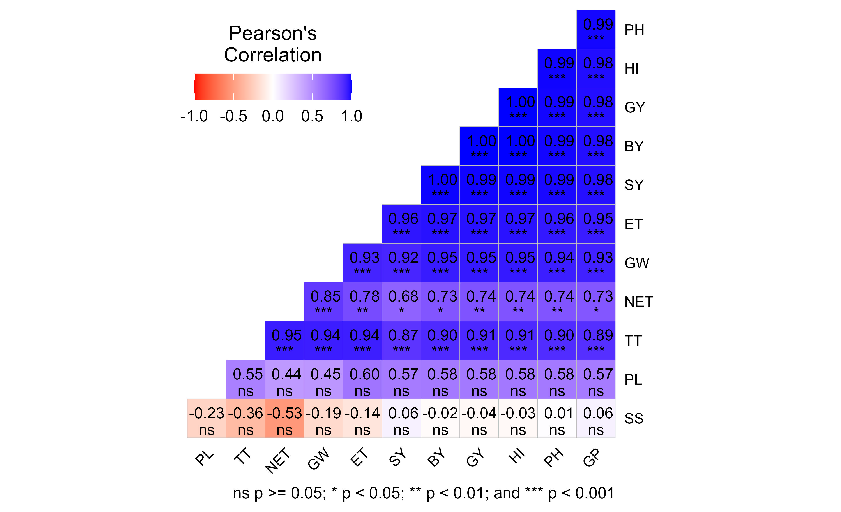
Figure 4: Pearson correlation matrix illustrating the relationships among growth and yield-related traits of fine rice under different zinc (Zn) and boron (B) management treatments. Trait abbreviations: PH – Plant height (cm), TT – Total tillers hill⁻¹, ET – Effective tillers hill⁻¹, NET – Non-effective tillers hill⁻¹, PL – Panicle length (cm), GP – Grains panicle⁻¹ (no.), SS – Sterile spikelets (no.), GW – 1000-grain weight (g), GY – Grain yield (t ha⁻¹), SY – Straw yield (t ha⁻¹), BY – Biological yield (t ha⁻¹), HI – Harvest index (%).

Principal Component Analysis (PCA)
Principal Component Analysis (PCA) was performed to explore the interrelationships among the measured agronomic traits and to assess the variation in rice responses under different Zn and B fertilizer treatments (Figure 5). The first two principal components (Dim1 and Dim2) accounted for a cumulative 92.3% of the total variability, with Dim1 explaining 80.6% and Dim2 explaining 11.7%. Treatments F₇ and F₆ were positively associated with key yield-contributing parameters such as total tillers hill⁻¹ (TT), effective tillers hill⁻¹ (ET), panicle length (PL), 1000-grain weight (GW), grains

Table 2. Effect of zinc and boron on yield regulating characters of fine rice (cv. Binadhan-25)
Treatments | Plant height (cm) | Non effective tillers  hill⁻¹ (no.) | Effective tillers hill⁻¹  (no.) | 1000-grain weight (g) | Panicle length (cm) | Grains panicle⁻¹  (no.) | Sterile spikelets  (no.) | Biological yield  (t ha⁻¹) | Harvest index  (%)
F₀ | 110.10e | 0.35c | 7.20h | 19.06d | 27.27ef | 138.13b | 11.43de | 13.00h | 44.77h
F₁ | 111.56cde | 0.06de | 8.05f | 19.13d | 27.48cd | 140.15ab | 11.69cde | 13.35fg | 45.69fg
F₂ | 110.89de | 0.40c | 7.55g | 19.10d | 27.40de | 139.78ab | 11.51de | 13.12gh | 45.12gh
F₃ | 112.53abcd | 0.30cd | 8.26de | 19.99c | 27.13f | 142.52ab | 13.35a | 13.65de | 46.44de
F₄ | 112.05bcde | 0.02e | 8.13ef | 19.18d | 27.68ab | 141.44ab | 13.00ab | 13.54ef | 46.15ef
F₅ | 113.13abcd | 0.30cd | 8.60c | 20.35c | 27.74a | 143.56ab | 12.22bcd | 13.87cd | 47.07c
F₆ | 114.35a | 1.87ab | 9.06b | 21.63a | 27.61abc | 144.79ab | 11.00e | 14.18ab | 47.95ab
F₇ | 114.66a | 2.11a | 9.89a | 21.88a | 27.71a | 145.88a | 11.05e | 14.40a | 48.46a
F₈ | 114.12ab | 1.67b | 8.96b | 21.08b | 27.69ab | 145.52a | 12.43bc | 14.03bc | 47.54bc
F₉ | 113.46abc | 0.47c | 8.73c | 20.98b | 27.42de | 143.92ab | 12.99ab | 13.96bc | 47.34bc
F₁₀ | 113.08abcd | 0.33c | 8.30d | 20.15c | 27.54bcd | 142.98ab | 12.87ab | 13.82cd | 46.96cd
Level of Significance | ** | ** | ** | ** | ** | * | ** | ** | **
CV% | 3.18 | 10.63 | 3.95 | 3.59 | 2.33 | 2.88 | 4.10 | 5.01 | 3.78
Here in the column having similar letter does not differ significantly as per DMRT
** = Significant at 1% level of probability
F₀: (Control) (no zinc and boron), F₁: Zn (2.0 kg ha⁻¹) and B (2.0 kg ha⁻¹) as basal, F₂: 100% Zn as basal (without B), F₃: 100% B as basal (without Zn), F₄: 100% Zn foliar spray at pre-flowering stage (without B), F₅: 100% B foliar spray at pre- flowering stage ( without Zn), F₆: 75% Zn and B as basal + 25% Zn and B foliar spray at pre- flowering stage, F₇: 50% Zn and B as basal + 50% Zn and B foliar spray, F₈: 100% Zn and B as basal + 25% Zn and B foliar spray, F₉: 100% Zn and B as basal + 25% Zn foliar spray, F₁₀: 100% Zn and B as basal + 25% B foliar spray

panicle⁻¹ (GP), grain yield (GY), straw yield (SY), biological yield (BY), and harvest index (HI). This indicates that moderate to balanced combined applications of Zn and B (both basal and foliar) contributed substantially to improved performance in these traits. In contrast, treatments F₀ (control) and F₂ were distantly positioned from most of the yield-related traits, suggesting poor performance across those parameters. Treatments F₃ and F₄ were positively aligned with sterile spikelets panicle⁻¹ (SS), indicating higher spikelet sterility and hence lower yield performance. Overall, the PCA analysis showed that the effectiveness of treatment F₇, and to a slightly lesser extent F₆ and F₈, in enhancing yield and yield components in rice through integrated Zn and B nutrient management.

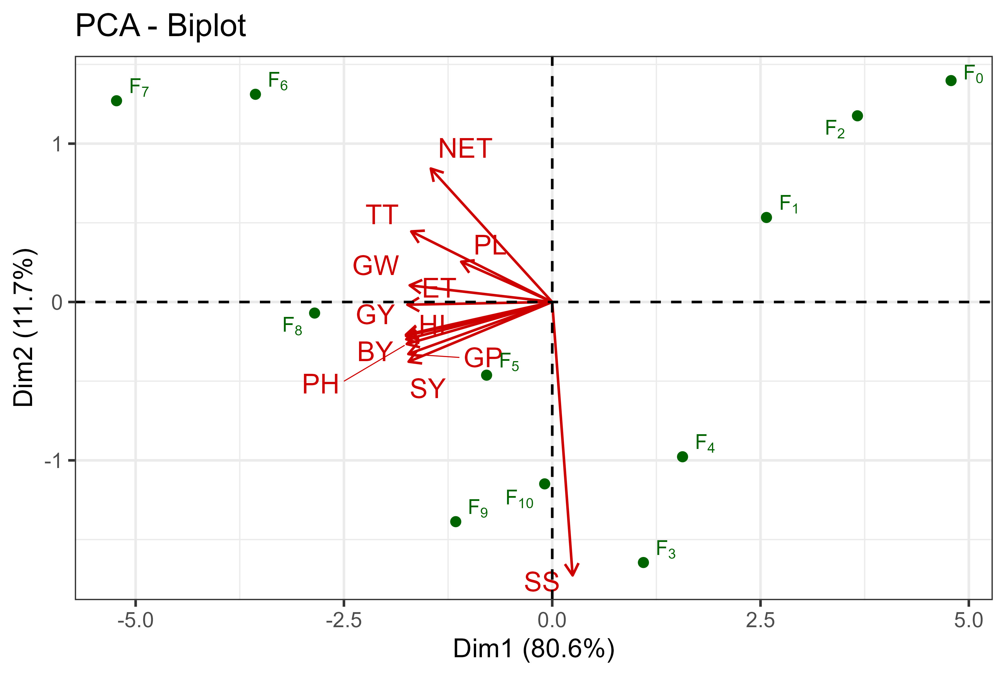
Figure 5: Biplot of principal component analysis (PCA) showing the distribution of growth and yield-related traits of fine rice across different zinc (Zn) and boron (B) management treatments. The first two principal components (Dim 1 and Dim 2) represent the major variation among traits and treatments. Trait abbreviations: PH – Plant height (cm), TT – Total tillers hill⁻¹, ET – Effective tillers hill⁻¹, NET – Non-effective tillers hill⁻¹, PL – Panicle length (cm), GP – Grains panicle⁻¹, SS – Sterile spikelets (no.), GW – 1000-grain weight (g), GY – Grain yield (t ha⁻¹), SY – Straw yield (t ha⁻¹), BY – Biological yield (t ha⁻¹), HI – Harvest index (%). Treatments: F0 – Control (no Zn and B), F1 – Zn (2.0 kg ha⁻¹) + B (2.0 kg ha⁻¹) as basal, F2 – 100% Zn as basal (no B), F3 – 100% B as basal (no Zn), F4 – 100% Zn as foliar spray (no B), F5 – 100% B as foliar spray (no Zn), F6 – 75% Zn and B as basal + 25% as foliar spray, F7 – 50% Zn and B as basal + 50% as foliar spray, F8 – 100% Zn and B as basal + 25% Zn and B as foliar spray, F9 – 100% Zn and B as basal + 25% Zn as foliar spray, F10 – 100% Zn and B as basal + 25% B as foliar spray.

Functional relationship between number of tillers hill⁻¹ and grain yield
A positive linear relationship between grain yield and number of tillers hill⁻¹ at 60 DAT of fine rice which indicated that higher the number of tillers hill⁻¹ and the higher the grain yield (t ha⁻¹). The relationship of number of tillers hill⁻¹ and grain yield of fine rice was determined by using the respective interaction data between Zn and B fertilizer application. The response of number of hills on the grain yield of fine rice followed a linear positive relationship which could be adequately described by regression equation Y = 4.5452x - 17.135 (R² = 0.8858) in Figure 6. Similar result also observed by Paul et al. (2021).

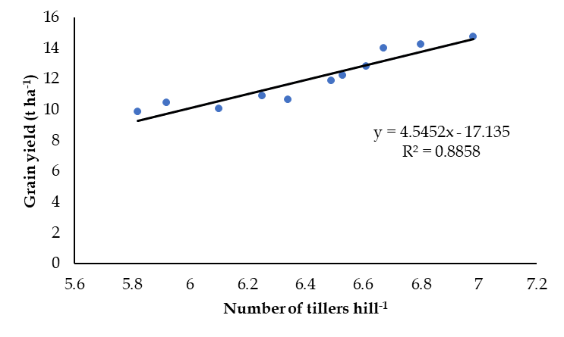
Figure 6: Functional relationship between number of tillers hill⁻¹ and grain yield of fine rice

Functional relationship between dry weight and grain yield
The response of total dry matter at 60 DAT to the grain yield of fine rice followed a linear positive relationship which could be adequately described by regression equation. In Figure 7, the regression equation indicates that an increase in dry weight would lead to an increase in the grain yield of fine rice. The functional relationship can be determined by the regression equation Y= 10.311x - 39.746 (R² = 0.9728) (Figure 7). Similar result also observed by Paul et al. (2021).

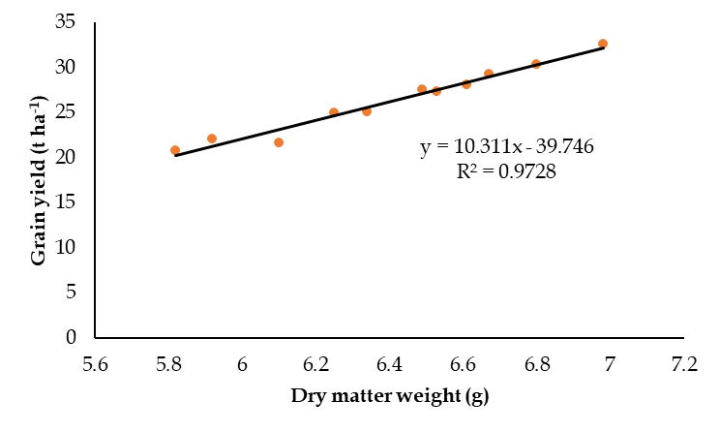
Figure 7: Functional relationship between dry matter weight and grain yield of fine rice

Conclusion
This study highlights the necessity of addressing micronutrient deficiencies, particularly zinc and boron, to enhance rice productivity in Bangladesh. The combined application of 50% Zn and B as basal and 50% as foliar spray significantly improved key growth parameters and yield components of Binadhan-25, including plant height, tiller number, grain yield (6.98 t ha⁻¹), and harvest index (48.46%), compared to the control. These findings underscore the importance of balanced micronutrient management alongside NPK fertilization for sustainable rice production. The study provides a practical strategy for optimizing nutrient use efficiency and boosting crop performance. However, its single-location and single-season design limit the generalizability of the results. Future research should evaluate the effectiveness of this approach across diverse rice varieties, soil conditions, and agro-ecological zones, along with a cost-benefit analysis to support its adoption by farmers.

Funding and Acknowledgment:
The authors should acknowledge any financial support received during the research process. For instance, if the research was funded by a specific organization or grant, it should be mentioned here. Similarly, acknowledgment of any collaborators or institutions that contributed to the research must also be included.
Ethics Statement:
This section should indicate whether ethical approval was needed for the research. If no ethical approval was required (for example, in studies involving only plants or inanimate objects), this should be clearly stated.
Originality and Plagiarism:
Authors must confirm that their manuscript is an original work. If any parts of the manuscript have been previously published, proper citations should be provided. Plagiarism in any form is unacceptable.
Consent for Publication:
All authors must agree to the content of the article and its publication in the journal.
Competing Interests:
Authors should declare any potential conflicts of interest, financial or otherwise, that could affect the research or its interpretation.
Data Availability:
It is essential to mention where the data supporting the manuscript’s conclusions can be found. If the data is included within the manuscript, this should be stated. If additional data is required, contact information for the corresponding author should be provided.
Author Contributions:
Clearly define each author’s contribution to the research and writing of the manuscript. For example, who conceived the research idea, who performed experiments, who wrote the manuscript, etc.

REFERENCES

Abbas, M., Zahida, T. M., Uddin, R., Sajjid, I., Akhlaq, A., Moheyuddin, K., Salahuddin, J., Mari, A. H., & Panhwar, R. N. (2013). Effect of Zinc and Boron Fertilizers Application on Some Physicochemical Attributes of Five Rice Varieties Grown in Agro-Ecosystem of Sindh, Pakistan. American-Eurasian J. Agric. & Environ. Sci., 13(4), 433–439.
Abbas, M., Z. Zahida, T. M. Uddin, R. Sajjid, I. Akhlaq, A. Moheyuddin, K. Salahuddin, J. Mari and A. H. Panhwar. 2013. Effect of Zinc and Boron Fertilizers Application on Some Physicochemical Attributes of Five Rice Varieties Grown in Agro-Ecosystem of Sindh, Pakistan. American-Eurasian J. Agric. & Environ. Sci., 13(4): 433–439.
Akhtar, S., T. Ismail, S. Atukorala and N. Arlappa. 2013. Micronutrient deficiencies in South Asia – Current status and strategies. Trends in Food Science & Technology, 31(1): 55–62. https://doi.org/10.1016/j.tifs.2013.02.005
Arif, M., M. A. Shehzad, F. Bashir, M. Tasneem, G. Yasin and M. Iqbal. 2012. Boron, zinc and microtone effects on growth, chlorophyll contents and yield attributes in rice (Oryza sativa L.) cultivar. African Journal of Biotechnology, 11(48): 10897–10905. https://doi.org/10.5897/AJB12.393
BBS. 2024. Yearbook of Agricultural Statistics of Bangladesh. Government of Bangladesh.
Bhadra, T., C. K. Mahapatra, M. Hosenuzzaman, D. R. Gupta, A. Hashem, G. D. Avila-Quezada, E. F. Abd_Allah, M. A. Hoque and S. K. Paul. 2023. Zinc and Boron Soil Applications Affect Athelia rolfsii Stress Response in Sugar Beet (Beta vulgaris L.) Plants. Plants, 12(19): 3509. https://doi.org/10.3390/plants12193509
Bithy, S., S. K. Paul, Md. A. Kader, S. K. Sarkar, C. K. Mahapatra and A. K. M. R. Islam. 2020. Foliar application of boron boosts the performance of tropical sugar beet. Journal of Bangladesh Agricultural University, 18(3): 537–544. https://doi.org/10.5455/JBAU.121026
BRRI. 2020. Krishi Projukti Hat Boi. Bangladesh Rice Research Institute.
Chattha, M. B., Q. Ali, M. N. Subhani, M. Ashfaq, S. Ahmad, Z. Iqbal, M. Ijaz, M. A. Ayub, M. R. Anwar, M. Aljabri, M. U. Hassan and S. H. Qari. 2023. Foliar applied zinc on different growth stages to improves the growth, yield, quality and kernel bio-fortification of fine rice. Notulae Botanicae Horti Agrobotanici Cluj-Napoca, 51(2): 13221. https://doi.org/10.15835/nbha51213221
Chatzistathis, T. 2014. Chapter 13—Plant Responses to Iron, Manganese, and Zinc Deficiency Stress. In P. Ahmad and S. Rasool (Eds.), Emerging Technologies and Management of Crop Stress Tolerance (pp. 293–311). Academic Press. https://doi.org/10.1016/B978-0-12-800876-8.00013-8
Das, S., S. K. Paul, M. R. Rahman, S. Roy, F. M. J. Uddin and M. H. Rashid. 2022. Growth and Yield Response of Soybean to Sulphur and Boron Application. Journal of the Bangladesh Agricultural University, 20(1): 1–10. https://doi.org/10.5455/JBAU.100644
Farooq, M., A. Ullah, A. Rehman, A. Nawaz, A. Nadeem, A. Wakeel, F. Nadeem and K. H. M. Siddique. 2018. Application of zinc improves the productivity and biofortification of fine grain aromatic rice grown in dry seeded and puddled transplanted production systems. Field Crops Research, 216: 53–62. https://doi.org/10.1016/j.fcr.2017.11.004
Fatima, A., S. Ali, M. Ijaz, R. Mahmood, S. Sattar, J. Khan, A. I. Dar and M. Ahmad. 2018. Boron Application Improves the Grain Yield and Quality of Fine Grain Rice Cultivars in Punjab, Pakistan. Pak. J. Agri. Sci., 55(4): 761–766.
Gomez, K. A. and A. A. Gomez. 1984. Statistical Procedures for Agricultural Research. 2nd Ed., John Wiley and Sons. New York. pp. 97-111.
Hanifuzzaman, M., F. M. J. Uddin, M. G. Mostofa, S. K. Sarkar, S. K. Paul and M. H. Rashid. 2022. Effect of zinc and boron management on yield and yield contributing characters of Aus rice (Oryza sativa). Research on Crops, 23(1): 1–8. https://doi.org/10.31830/2348-7542.2022.001
Malakouti, M. 2008. The Effect of Micronutrients in Ensuring Efficient Use of Macronutrients. Turkish Journal of Agriculture and Forestry, 32(3): 215–220.
Mamun, M. A. A., S. A. I. Nihad, M. A. R. Sarkar, M. A. Aziz, M. A. Qayum, R. Ahmed, N. M. F. Rahman, M. I. Hossain and M. S. Kabir. 2021. Growth and trend analysis of area, production and yield of rice: A scenario of rice security in Bangladesh. PLOS ONE, 16(12): e0261128. https://doi.org/10.1371/journal.pone.0261128
Paul, N. C., S. K. Paul, A. Salam and S. C. Paul. 2021. Dry Matter Partitioning, Yield and Grain Protein Content of Fine Aromatic Boro Rice (cv. BRRI Dhan50) in Response to Nitrogen and Potassium Fertilization. Bangladesh Journal of Botany, 50(1): 103–111.
Paul, S. K., B. Roy, A. K. Hasan and A. R. Sarkar. 2017. Yield and yield components of short duration transplant Aus rice (cv. Parija) as influenced by plant spacing and nitrogen level. Fundamental and Applied Agriculture, 2(2): 233–236.
Quddus, M. A., M. H. Rashid, M. A. Hossain and H. M. Naser. 2011. Effect Of Zinc and Boron on Yield and Yield Contributing Characters of Mungbean in Low Ganges River Floodplain Soil at Madaripur, Bangladesh. Bangladesh Journal of Agricultural Research, 36(1): 73–81. https://doi.org/10.3329/bjar.v36i1.9231
R Core Team. 2024. R: A Language and Environment for Statistical Computing (version 4.2.2). Vienna, Austria: R Foundation for Statistical Computing.
Rehman, A. U., M. Farooq, A. Rashid, F. Nadeem, S. Stuerz, F. Asch, R. W. Bell and K. H. M. Siddique. 2018. Boron nutrition of rice in different production systems. A review. Agronomy for Sustainable Development, 38(3): 25. https://doi.org/10.1007/s13593-018-0504-8
Roy, T. R., M. A. R. Sarkar, M. S. Kabiraj, U. K. Sarker, M. H. Rashid, A. Hashem, G. D. Avila-Quezada, E. F. Abd_Allah and S. K. Paul. 2024. Productivity and Grain Protein Status of Transplanted Aman Rice as Influenced by Three Major Agronomic Practices Under Subtropical Conditions. Applied Ecology and Environmental Research, 22(2): 1013–1028. https://doi.org/10.15666/aeer/2202_10131028
Saikh, R., K. Murmu, A. Sarkar, R. Mondal and K. Jana. 2022. Effect of foliar zinc application on growth and yield of rice (Oryza sativa) in the Indo-Gangetic Plains of India. Nusantara Bioscience, 14(2): 182–189. https://doi.org/10.13057/nusbiosci/n140208
Shaygany, J., N. Peivandy and S. Ghasemi. 2012. Increased yield of direct seeded rice (Oryza sativa L.) by foliar fertilization through multi-component fertilizers. Archives of Agronomy and Soil Science, 58(10): 1091–1098. https://doi.org/10.1080/03650340.2011.570336
Shelley, I. J., M. Takahashi-Nosaka, M. Kano-Nakata, M. S. Haque and Y. Inukai. 2016. Rice Cultivation in Bangladesh: Present Scenario, Problems, and Prospects. Journal of International Cooperation for Agricultural Development, 14: 20–29. https://doi.org/10.50907/jicad.14.0_20
Singh, V. P., S. S. Singh, R. P. Singh, K. Singh, A. P. Singh and S. K. Yadav. 2021. Study the effect of soil and foliar application of Fe, Zn and B on growth factors of rice. International Journal of Chemical Studies, 9(2): 179–182. https://doi.org/10.22271/chemi.2021.v9.i2c.11802
Soltani, S. M., M. Allahgholipoor, M. S. Katigari and A. P. Tabalvandani. 2020. Effect of Basal and Foliar Application of Zinc Sulphate Fertilizer on Zinc Uptake, Yield and Yield Components of Rice (Hashemi Cultivar). Iranian Journal of Soil and Water Research, 51(4): 1013–1026. https://doi.org/10.22059/ijswr.2020.291977.668383
Yogi, L. N., S. Bhandari, T. Thalal, M. Bhattarai, A. Upadhyay and B. Kharel. 2024. Enhancing rice yields through foliar application of essential micronutrients: A study on zinc, copper, and boron nutrition in context of Nepal. Archives of Agriculture and Environmental Science, 9(2): 373–378. https://doi.org/10.26832/24566632.2024.0902024
Zaman, Q. U., Z. Aslam, M. Rashid, A. Khaliq and M. Yaseen. 2018. Influence of Zinc Fertilization on Morpho-Physiological Attributes, Growth, Productivity and Hematic Appraisal of Paddy Rice. The Journal of Animal & Plant Sciences, 28(3): 778–790.
Zulfiqar, U., S. Hussain, M. Maqsood, M. Ishfaq and N. Ali. 2021. Zinc nutrition to enhance rice productivity, zinc use efficiency, and grain biofortification under different production systems. Crop Science, 61(1): 739–749. https://doi.org/10.1002/csc2.20381

