GC-MS ANALYSIS OF ESSENTIAL OIL FROM THE LEAVES OF Hyptis suaveolens IDENTIFIES BIOACTIVE PHYTOCHEMICALS WITH ANTIOXIDANT ACTIVITY

Abstract
Essential oils have been identified for their vital relevance and uses in many areas ranging from pharmaceutical, medicinal, food flavouring and preservation. The potency of essential oils and their viability for various applications are attributed to the constituent bioactive compounds, which constitute their active agents. Essential oils are mainly isolated and recovered from plant substrates by adopting different methods of extraction. In this study, the essential oil is extracted from Hyptis suaveolens leaves using Cleventure apparatus. The oil extracted was analysed for antioxidant activity and subjected to GC-MS analysis. The results indicated the antioxidant power of essential oil and the compounds identified through GC-MS analysis were reported to contain numerous biological activities.
Keywords: Hyptis suaveolens; Cleventure apparatus; Essential oil; GC-MS analysis.
Introduction
Plants and other natural sources can provide a huge range of complex and structurally diverse compounds. Medicinal properties of plants have received a great interest because of their pharmacological activities, economic viability and low toxicity. It is estimated that there are 250,000 to 500,000 species of plants on earth. A relatively small percentage (1 to 10) of these is used as foods by both humans and other animal species. It is possible that even more are used for medicinal purpose ¹
In the recent times, studies focus on exploring the benefits of plant-extracted phytochemicals and its effect on human health. There has been an increase in the food industry’s interest in natural compounds either for direct addition or for use in synergy with other compounds. Additives obtained naturally from plants can be compounds, groups of compounds, or essential oils. Plant extracts and essential oils possess antifungal and antibacterial properties and have been screened on a global scale as potential sources of novel antimicrobial compounds agents promoting food preservation and alternatives to treat infectious diseases ^{2.}
Essential oils (EOs) contain unique aromatic compounds that give each essential oil its characteristic essence. They are extracted from various plant parts, such as wood, leaves, roots, flowers, and fruits, using steam or hydro-distillation techniques and by mechanical methods, such as cold pressing. These oils are complex combinations of terpenic chemicals, mainly monoterpenes and sesquiterpenes, along with alcohols, aldehydes, ethers, esters, ketones, and phenols, which contribute to their distinctive scents. Being natural mixtures of very complex nature, essential oils contains more than 200 chemical components, but some are many times more complex. Among them two or three major compounds are usually present at fairly high concentration (20-70) in comparison to other components that are present in trace amounts. The amount of the different components of essentials oils varies amongst different plant parts and different plant species They can be essentially classified into two groups: Volatile fraction: Essential oil constituting of 90-95 percentage of the oil in weight, containing the monoterpene and sesquiterpene hydrocarbons, as well as their oxygenated derivatives along with aliphatic aldehydes, alcohols, and esters. Nonvolatile residue: This comprises 1-10% of the oil, containing hydrocarbons, fatty acids, sterols, carotenoids, waxes, and flavonoids ³.
The biological activities exhibited by essential oils derived from aromatic and medicinal plants have garnered significant interest due to their ability to scavenge free radicals. Various diseases, including cancer, the decline of food quality, and neurodegenerative disorders, have been linked to free radicals. Research indicates that the direct incorporation of essential oils and extracts from aromatic plants into food products can provide antioxidant and antimicrobial benefits. These essential oils are known to demonstrate considerable antibacterial, anti-parasitic, antifungal, and insecticidal properties. Consequently, essential oils can be an effective means of combating bacterial resistance. Specifically, the antimicrobial properties of plant oils and their extracts have led to numerous applications in areas such as food preservation, pharmaceuticals, alternative medicine, and natural therapies².
Essential oils are most commonly used in the practice of aromatherapy. During inhalation they directly go from olfactory system to limbic system of the brain, the part that plays a role in control of emotions, behaviours, sense of smell, and long-term memory. The limbic system also plays a role in controlling several unconscious physiological functions, such as breathing, heart rate, and blood pressure hence helps in promoting mental clarity, relaxation, and stress relief. It is easily absorbed when applied on skin and carried throughout the body via the circulatory system and reach all internal organs ⁴.
In pharmaceutical industry, essential oils have versatile applications ⁵ as detailed below.
Antiseptics: The antiseptic properties of Essential Oil make them active against wide range of bacteria as on antibiotic resistant strains. In addition to this they are also effective against fungi and yeasts. The most common sources of essential oils used as antiseptics are: Cinnamon, Thyme, Clover, Eucalyptus, Culinsavory, and Lavender. Citral, geraniol, linabool and thymol are much more potent than phenol.
Expectorants and diuretics: When used externally, essential oils increase microcirculation and provide a slight local anesthetic action. Essential oils are used in a number of ointments, cream and gels, whereby they are known to be very effective in relieving sprains and other articular pains. Oral administration of essential oils like eucalyptus or pin oils, stimulate ciliated epithelial cells to secrete mucus. On the renal system, these are known to increase vasodilation and in consequence bring about a diuretic effect.
Spasmolytic and sedative: Essential oils from the Umbellifereae family, Mentha species and verbena are reputed to decrease or eliminate gastro intestinal spasms. These essential oils increase secretion of gastric juices. In other cases, they are known to be effective against insomnia.
In addition they have been used to treat stress and anxiety , headaches and migraines, to improve the sleep quality of women after birth and exerts anti-inflammatory effects.
A Clevenger apparatus method for essential oil extraction was first developed in the middle ages by Arabs, and is the most common method for commercially obtaining essential oils. Essential oils are volatile liquid since their density is lower than water, They are rarely coloured, and soluble in organic solvents. An important characteristic of essential oils and their components is hydrophobicity, which enables them to partition with the lipids present in the cell membrane of bacteria and mitochondria, rendering them more permeable by disturbing the cell structures. This eventually results in the death of bacterial cell due to leakage of critical molecules and ions from the bacterial cell to a great extent. Some compounds modulate drug resistance by targeting efflux mechanisms in several species of Gram-negative bacteria. Health, Human and Public Health services have recognized essential oils as safe substances that can be used as antibacterial additives ⁶.
Hyptis is a genus belonging to the mint family (Lamiaceae) that includes approximately 300 species⁷ and is native to the tropical and subtropical regions of the Americas⁸. Hyptis suaveolens is an upright, annual or short-lived perennial herbaceous plant that typically reaches heights of 1 to 1.5 meters. The leaves, measuring between 2 to 10 cm in length and 1 to 7 cm in width, are arranged oppositely. The flowers are small, ranging from 5 to 7 mm in length, and exhibit colors such as pink, bluish-purple, or lavender⁹. This species is indigenous to the Neotropics, spanning from Central America and the West Indies down to approximately the tropic of Capricorn. It has been introduced to various tropical and subtropical regions worldwide, including certain Pacific Islands, where it has become extensively naturalized.. It is identified as a perennial herb that proliferates rapidly in dense clusters in various environments, including roadsides ¹⁰. Currently, H. suaveolens is recognized as a prevalent invasive weed on a global scale. It is recognized as an invasive species in regions such as Hawaii, Guam, Niue, Papua New Guinea, the Philippines, Singapore, and Taiwan ¹¹. According to GBIF ¹², it is also deemed invasive in certain areas of Africa and South Asia. This species has been identified as one of the most significant invasive threats in the highlands of West-Central India ⁸.
The present study aimed to analyse the phytochemicals in water extract and extraction of essential oil from the leaves of Hyptis suaveolens (L) and also to reveal its chemical constituents using GC-MS and assess its antioxidant activity.

Table 1: Scientific Classification
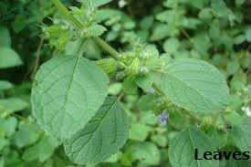
Kingdom | Plantae
Family: | Lamiceae
Genus: | Hyptis
Species: | H. suaveolens
Binomial name | Hyptis suaveolens  (L.) Poit. 1806
Figure 1: Hyptis suaveolens

Materials and methods
Collection of Plant material:
The plant materials for the proposed study, Hyptis suaveolens were collected from Kolumam, Tirupur district, Tamil Nadu, India. The plant was authenticated by Dr. C. Murugan, Botanical survey of India, TNAU campus Coimbatore, with the voucher number BSI/SRC/5/23/2018/Tech. 3328.
Phytochemical screening
Phytochemical screening is used check the presence or absence of secondary metabolites in a sample. The sample extracted with water was used for the analysis, by following the standard protocol given by Trease and Evans ¹³.
Essential oil extraction
Clevenger apparatus
The Clevenger apparatus functions based on the principle of steam distillation followed by separation according to density. Plant material is heated in the presence of water, which leads to the vaporization of essential oils alongside the steam. The vapor subsequently condenses, and since the essential oil is less dense than water, it rises to the surface, facilitating straightforward separation and collection. Essential oils comprise compounds with boiling points reaching up to 80°C or even higher. In the Clevenger apparatus, these compounds are volatilized at a temperature near 50°C, under atmospheric pressure.
The experimental setup is shown Figure 2. Clevenger’s Apparatus consist of one round bottom flask of 1000ml which is connected with another two way round flask which holds raw material. The top flask is connected with condenser through the connecter.
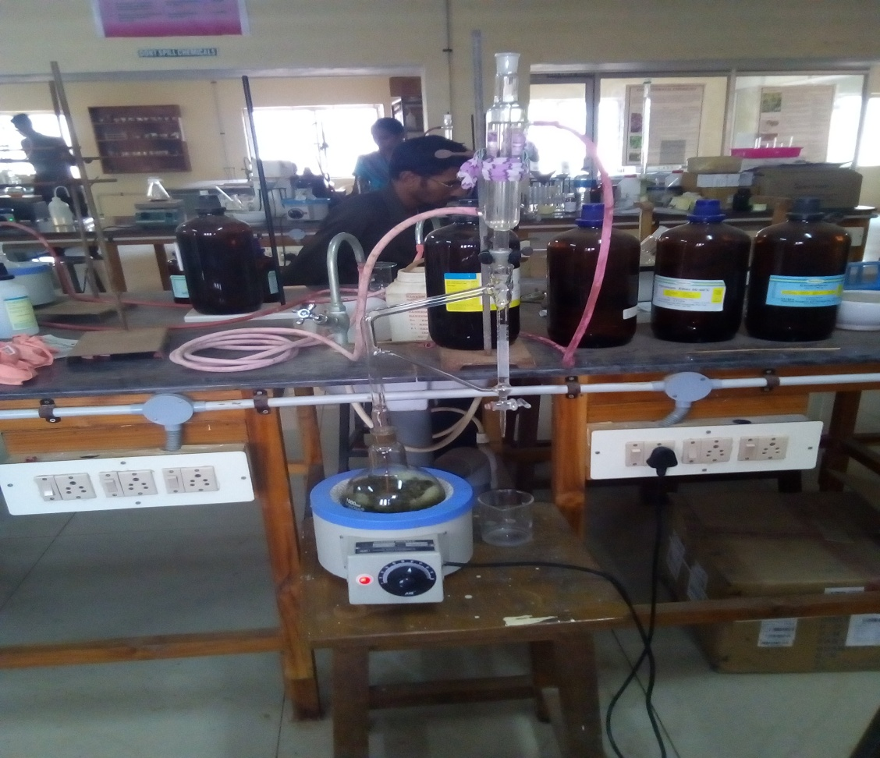
Figure 2: Extraction of essential oil using Clevenger apparatus
Extraction process
Fresh leaves of Hyptis suaveolens (200 g) are cut into pieces less than 2 X 2 cm immediately after collection and placed in the still with boiled with 500 ml of distilled water and the apparatus allows the passage of the herb material under pressure which softens the cells and allows the essential Oil to escape in vapor form. Besides the Clevenger, the tiny droplets of essential oil evaporates and travel through a tube into still’s condensation chamber, where essential oil vapors condense in the clevenger apparatus. The essential oil forms a film on the surface of the water, oil distillation ceased after 5-6 hrs. The separating funnel is used for the separation of essential oil and water.. The volume of essential oils was determined from a calibrated trap. The essential oils in the distillate were dried over anhydrous Na₂SO₄ and kept in the freezer. The yield was calculated as prescribed by Aguele et al., ².
Volume of extracted essential oil *100
Extraction Yield (% v/w) = Mass of dried material extracted

Analysis of Essential Oils:
Antioxidant activity
The essential oil was analysed for its antioxidant activity using Reducing power assay¹⁴ and DPPH radical scavenging activity¹⁵.
Gas Chromatography - Mass Spectroscopy (GC-MS) analysis
The oil was also analysed using Gas Chromatography with Mass spectrometer to know the composition of oil and to the quantity of each components. It is a method that combines the features of gas-liquid chromatography and mass spectrometry to identify different substances within a test sample
GC-MS analysis of the essential oil was performed using the equipment, Thermo GC-Trace Ultra Version: 5.0, Thermo MS DSQ II. The equipment has a DB 35 – MS Capillary Standard Non-polar column with dimensions of 30 mts x 0.25 mm ID x 0.25 µm Film. The carrier gas used is Helium with at flow of 1.0ml/minute. The injector was operated at 250°C and the oven temperature was programmed as follows; 60°C for 15 minutes, then gradually increased to 280°C for 3 minutes. The identification of components were based on comparison of their mass spectra with those of Wiley and NBS libraries as well as comparison of their retention indices. The constituents were identified after comparison with data available in the computer library (NIST -National Institute of Standard and Technology database) attached to the GC-MS instrument and the results obtained have been tabulated.
Results and Discussion
Phytochemical screening of Hyptis suaveolens leaf
The results of phytochemical screening are tabulated in Table -1. From the table it is evident that the H. suaveolens leaf is a rich source of phytochemicals.
Table -2: Phytochemical screening of Hyptis suaveolens
Solvent | AL | FL | TN | CG | SA | OF | TP | ST
Water | + | + | + | - | + | + | + | +

Al-Alkaloids FL- Flavanoids
TP- Tannin and phenolic compounds CG-Cardiac glycosides
Sa-Saponins OF- oil and Fats
TP- Terpenoids ST- Steroids
“+” - Present “ – “ - Absent
Terpenoids, phenols, flavonoid, steroid, alkaloid, tannin and saponins were the phytochemicals present. Phytoconstituents such as tannin, quinine, terpenoid, flavonoid, steroid, alkaloid, cardiac glycoside, glycoside, and volatile oils have been identified in various plants. Flavonoids have been linked to a decreased risk of cardiovascular diseases, cancer and also serve as effective antibacterial agents. Certain classes of phytochemicals, including flavonoids, alkaloids, and tannins, have demonstrated cytotoxic effect. Furthermore, saponins are recognized for their cholesterol-lowering effects, cytotoxic characteristics, and antibacterial and antiviral properties. Tannins exhibit anticancer properties, as evidenced by their inhibitory effects on growth¹. Alkaloids have a wide range of pharmacological activities including antimalarial, antiasthma, anticancer, vasodilatory, analgesic, antibacterial and antihyperglycemic activities. Plant terpenoids are used for their aromatic qualities and play a role in traditional herbal remedies. They have strong antimicrobial qualities, antispasmodic, smooth muscle relaxant, antipruritic and pheromonal effects in insects. ¹⁶

Essential oil - extraction, biological activity assessment and analysis
EOs Yield
Clevenger apparatus method of extraction is a special type of extraction or a separation process for temperature sensitive materials like oils, hydrocarbons, etc. which are insoluble in water and may decompose at their boiling point. The fundamental nature of Clevenger extraction is that it enables a compound or mixture of compounds to be extracted at a temperature substantially below that of the boiling point(s) of the individual constituents(s).
The essential oil yield from H. suaveolens was 0.6ml from 200 g of fresh leaves and it is calculated as 0.3 %. Several factors determine the final quality of an essential oil. Apart from the plant material, most important are time, temperature and pressure, and the quality of the extraction equipment. Essential oils are very complex products. It is reported that possible that longer extraction times may give more complete oil with improved odour with added fullness of pleasantness
In vitro free radical scavenging activity
Phytochemicals and antioxidant constituents in plant material have raised interest among scientists, food manufacturers, producers and consumers for their roles in the maintenance of human health ¹⁷.
DPPH radical scavenging activity
Numerous natural antioxidants have been identified in plants, demonstrating significant free radical scavenging properties. The ability to scavenge DPPH free radicals is extensively utilized to assess the antioxidant potential of plant extracts. Antioxidants are believed to play a crucial role in disease protection by their capacity to neutralize free radicals within biological systems. The DPPH assay is among the most commonly employed techniques for evaluating the antioxidant activity of plant extracts¹⁸.
Figure 3.DPPH radical scavenging activity of Essential oil extract
of Hyptis suaveolens
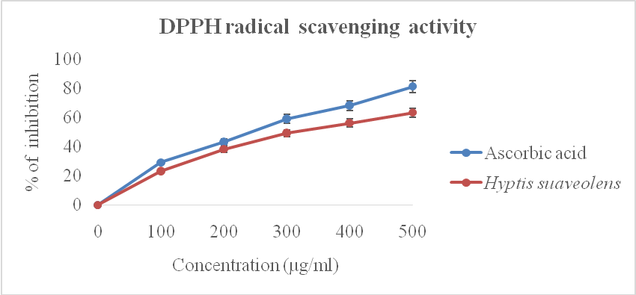
The values are expressed as mean ± SD of triplicates
The reduction capability of DPPH radical was determined by the decrease in its absorbance. Figure 3 illustrates a significant decrease in the DPPH radical due to the scavenging ability of extract. The essential oil extract showed maximum activity of 63% at 500 µg/ml, where as ascorbic acid at the same concentration exhibited 81% inhibition. The Ic₅₀ values were found to be 348.68 µg/ml for essential oil extract and 272.95 mg/ml for ascorbic acid respectively.

Reducing power activity
The reducing capacity of a compound may serve as a significant indicator of its potential antioxidant activity. Fe (III) reduction is often used as an indicator of electron donating activity, which is an important mechanism of phenolic antioxidant action. The reducing ability of a compound generally depends on the presence of reductones (antioxidants), which exert the antioxidant activity by breaking the free radical chain by donating a hydrogen atom ¹⁹.
Figure 4: Reducing power activity of Essential oil extract
of H. suaveolens
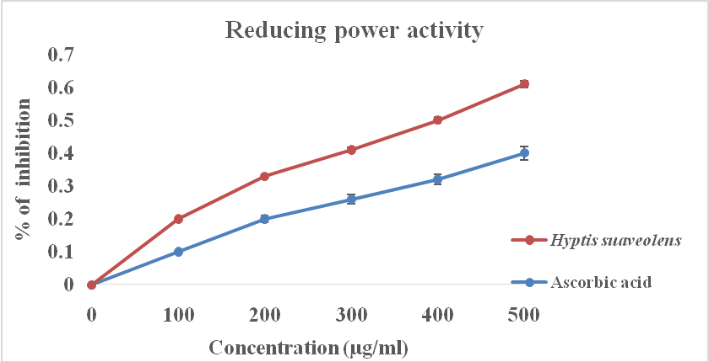
The values are expressed as Mean ± SD of triplicates
Standard curve of ascorbic acid as well as the essential oil extract of Hypti ssuaveolens was shown in figure 3. For which the Hyptis suaveolens essential oil extract ability increases with increasing concentration (100-500 µg/ml) like the antioxidant activity of standard curve. An earlier study by Tanaka et al., ²⁰ have reported a direct correlation between antioxidant activity and reducing power of certain plant extracts.
The assay for reducing power is predicated on the conversion of ferric ions (Fe3⁺) to ferrous ions (Fe2⁺), which is detected by an increase in absorbance measured spectrophotometrically at 700 nm. This increase in absorbance correlates with higher concentrations of the extracts, indicating enhanced reducing power. A prior study by Oyaizu¹⁴ corroborated this transformation, suggesting it may be attributed to the phytochemicals present in the plant extracts. Furthermore, the reducing properties of these extracts are typically linked to the presence of reductones, which have demonstrated antioxidant capabilities by interrupting free radical chains through hydrogen atom donation. The reducing power of the essential oil extract from Hyptis suaveolens was observed to increase progressively with higher extract concentrations.
Essentail oil and the extracts of H. suaveolens and other plants have been acclaimed by researchers to have antioxidant activities, with medicinal values exploited in the treatment of degenerative diseases.^{21,22}. This has implied effects on the importance and uses of essential oils in food and allied industries, as aromas, flavouring substances and preservatives ²³. The antioxidant activities of EOs were attributed to the presence of eugenol and methyl eugenol as the active agents
Antimicrobial activity studies of essential oil from H. Suaveolens leaves exerted significant effect on bacterial strains like Staphylococcus aureus, (a gram positive bacteria strain) than the gram negative bacterial strains ²⁴. Hyptis Suaveolens essential oil showed anti fungal activity on some potentially pathogenic Aspergilli (A. flavus, A. parasiticus, A. ochraceus, A. fumigatus and A. niger)and authenticate it use as antifungal agent and its possible use as a therapeutic alternative for the treatment of infections caused by Aspergillus species ²⁵ .
The leaf extracted essential oil of Hyptis suaveolens has diaplayed dose dependent mosquitocidal activity to Cx. Quinquefasciatus with LC₅₀ and LC₉₀ values of 6 and 21ppm respectively²⁶. This emphasise that Hyptis suaveolens as a possible attractive, safe and environmental friendly replacement for chemical larvicides against Cx. Quinquefasciatus. The study also implied its antioxidant content and its biological role 2(Aguele et al., 2023). According to Adjou et al., ²⁷, extract from Hyptis suaveolens has a higher repellent capacity than the product of Ocimum canum against Tenebroides mauritanicus (L.) in the post-harvest application.
The active compounds present in these oils can help to alleviate inflammation, making them valuable in addressing inflammatory conditions such as arthritis, respiratory ailments, and skin disorders. Respiratory health benefits are another prominent aspect of essential oils. Inhalation of these oils can help promote clear airways, relieve congestion, and ease symptoms of respiratory conditions like coughs, colds, and sinusitis. They are often utilized in inhalation therapies and chest rubs. They can be used topically or in massage oils to alleviate muscle and joint pain. Furthermore, these oils have shown potential in supporting wound healing. Their antimicrobial activity helps prevent infection, while their anti-inflammatory and analgesic properties contribute to reducing inflammation and pain associated with wounds ²⁸.
GS MS analysis of essential oil from H. suaveolens:
Findings from previous studies on GC-MS analyses of vast array of plant extracts revealed that most of the herbal extracts with medicinal attributes contained some of the phytocomponents ²⁹.

GC-MS analysis of the essential oil extract of H. suaveolens, identified 19 bioactive compounds (Table 3 & Fig 5). The identification of compounds is based on the peak area, molecular weight and molecular formula.

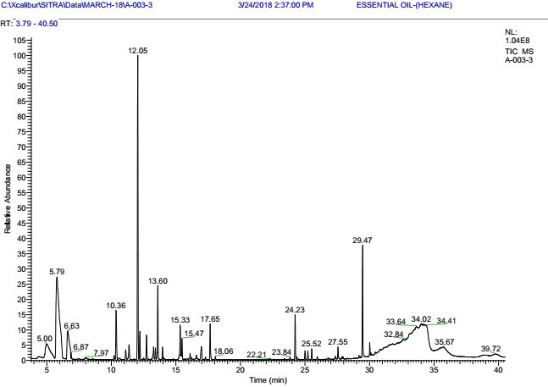
Figure 5: GC-MS analysis of the essential oil extract of Hyptis suaveolens

The major constituents identified in the extract were trans-Caryophyllen, eucalyptol(1,8-cineole), Z-2-[1-(2,5-Dimethyl-3-furyl)-2-methylpropyldene]-3-isopropylidene succinic anhydride, α-Terpinolene, Bicycloelemen and 5,10-rimuene while all the other compounds were identified in low level.
Table 3: GC-MS analysis of the essential oil extract of Hyptis suaveolens
S.No | Compound Name | Probability | Molecular Formula | Molecular  Weight | Area %
1 | Eucalyptol | 53.98 | C₁₀H₁₈O | 154 | 15.99
2 | α-Terpinolene | 33.47 | C₁₀H₁₆ | 136 | 6.08
3 | Bicycloelemen | 41.85 | C₁₅H₂₄ | 204 | 4.44
4 | α-Copaene | 21.18 | C₁₅H₂₄ | 204 | 0.75
5 | α-Elemene | 20.20 | C₁₅H₂₄ | 204 | 1.39
6 | trans-Caryophyllen | 32.70 | C₁₅H₂₄ | 204 | 23.22
7 | α-Bergamotene (CAS) | 40.70 | C₁₅H₂₄ | 204 | 0.42
8 | α-Humulene (CAS) | 57.78 | C₁₅H₂₄ | 204 | 1.89
9 | Germacrene-D | 26.27 | C₁₅H₂₄ | 204 | 1.12
10 | Cubedol | 30.57 | C₁₅H₂₆O | 222 | 0.89
11 | (-)-Spathulenol (CAS) | 39.87 | C₁₅H₂₄O | 220 | 3.77
12 | Tricyclo[5.2.2.0(1,6)]undecan-3-ol | 15.61 | C₁₅H₂₄O | 220 | 0.43
13 | Veridiflorol | 17.46 | C₁₅H₂₆O | 222 | 1.41
14 | Bergamotol, Z-à-trans | 64.95 | C₁₅H₂₄O | 220 | 2.46
15 | 5,10 –rimuene | 15.53 | C₂₀H₃₂ | 272 | 2.96
16 | Phenanthrene | 77.45 | C₂₀H₃₀ | 270 | 0.54
17 | (Z)-2-[1-(2,5-Dimethyl-3-furyl)-2-methylpropyldene]-3-isopropylidene  succinic anhydride | 14.58 | C₁₇H₂₀O₄ | 288 | 7.67
18 | 4-Epidehydro Abietlol | 50.07 | C₂₀H₃₀O | 286 | 0.89
19 | 9-Octadecenoic acid (Z)-, 9-hexadecenyl ester, (Z)- (CAS) | 28.61 | C₃₄H₆₄O₂ | 504 | 0.36

The terpenes, found in essential oils of different plants, are micro-constituents most commonly used as flavour additives in food, toiletries, and perfumes ^{30.}
trans-Caryophyllene plays asignificant role in the essential oil of number of plant species. It is a member of the sesquiterpenes chemical class. Numerous pharmacological effects including analgesic activity ³¹ and antimicrobial properties ³² have been reported for trans-Caryophyllene. The endo cannabinoid system is triggered by it. Additionally, trans-Caryophyllene has a well- established anti-inflammatory effect ^{33,34}. trans-Caryophyllene also works on intestinal smooth muscle, preventing the excitation-contraction coupling through pharmacomechanical means. Because of these reactions, it can be regarded as a possible anti-spasmodic agent in tracheal smooth muscle ^{35, 28}.
Eucalyptol 1,8-cineole is found in many essential oils. It is the main ingredient of both eucalyptus (70%) and rosemary oils, where its concentration can exceed 45%. It is reported that 1.8-cineol (eucalyptol), the major monoterpene of eucalyptus oil suppressed arachidonic acid metabolism and cytokine production in human monocytes and also has anti inflammatory activity. It exhibits an array of biological properties, including anti-inflammatory, antioxidant, antimicrobial, bronchodilatory, analgesic, and pro-apoptotic effects ³⁶.
Z-2-[1-(2,5-Dimethyl-3-furyl)-2-methylpropylidene]-3-isopropylidene succinic anhydride is known for its photochromic effect(light-induced reversible change in color) due to properties reversible photo-switching and well-separated absorption bands. Common applications of this compound includes optical data storage, sunglasses and smart windows. It also used in security inks, cosmetics, and even biological systems. Organic usage of photochromic compounds in plastic ophthalmic lenses make it more comfortable to wear. It is now competing with silver salts glasses even though it has shorter lifetime due to its organic nature ³⁷.
α-Terpinolene is a monoterpene found in essential oil of many aromatic plant species. The pharmacological analysis of this compound reveals that it diaplays wide range of biological effects like antioxidant, larvicidal and insecticidal activity ³⁸. It also displayed anti proliferative activity against brain tumour cells ³⁹.
Antimicrobial, anti-inflammatory, and anticancer properties of Bicycloelemene were studied and the results make this compound as special molecule for the development of new therapeutic agents (https://www.ncbi.nlm.nih.gov/)⁴⁰. Additionally, its antimicrobial properties were exploited in the development of new antibiotics.
Spathulenol, isolated from Aristolochia yunnanensis was reported for its antioxidant, anti-inflammatory, antiproliferative and antimycobacterial activities. It shows high antioxidant activity with an IC₅₀ of 85.60 μg/mL in the DPPH system ⁴¹.
Bergamotol, specifically the Z-alpha-trans isomer, exhibits a range of biological activities, including antimicrobial, antioxidant, and potentially insecticidal properties. It is a component of bergamotenes, which are sesquiterpenes found in various plants, insects, and fungi. Some research suggests that bergamotenes, including Z-alpha-trans-bergamotol, can act as pheromones for certain insects ⁴².
Rimuene, a sesquiterpene compound, exhibits various biological activities, including antiasthmatic, antibacterial, antifungal, anti-inflammatory, antioxidant, and antineoplastic effects. It is a major compound found in the leaves and stem bark extracts of Agathis borneensis ⁴⁰.
Conclusion
Extraction using Clevenger apparatus was found to be one of the promising techniques for the extraction of Essential Oil from plants as this process can preserve the original qualities of the plant. Present study revealed that the essential oil extracted from Hyptis suaveolens exhibits antioxidant activity and the chemical components identified using Gas Chromatography-Mass Spectrometry (GC-MS) were found to have diverse biological activity due to the possession of abundant phytochemicals. Isolation or chemical synthesis of these compounds find its applications in food, cosmetic and pharmaceutical industries since they are safer, cheaper, and ecofriendly nature. Further, the studies can be extended to exploit other biological activities and also to establish their safety for using H.suaveolens oil in food and other industries.

Acknowledgement
The authors’ express their sincere thanks to Tamil Nadu Agricultural University, Coimbatore for providing required assistance for the publication of this research work.
Ethics statement
No specific permits were required for the described field studies because no human or animal subjects were involved in this research.
Conflict of interest
The authors declare that there are no conflicts of interest in the publication of this content
Consent for publication
All the authors agreed to publish the content.
References

1. Sharma, T., Pandey, B., Shresth BK. ., Koju GM., Thusa, R., Karki, N.,(2020).
Phytochemical screening of medicinal plants and study of the effect of
phytoconstituents in seed germination, Tribhuvan University Journal, 35(2), 1-11.
DOI: https://doi.org/10.3126/tuj.v35i2.36183
- Aguele, FO., Oke, EO., Abam, FI., Nnabodo, D. and A.S Agbana. 2023. Biological and antioxidant activities, extraction methodology and prospects of essential oil from Hyptis suaveolens (L.): A review. Cleaner Engineering and Technology. 17 (2023) 100685
- Dhakad, AK., Pandey, VV., Beg, S., Rawat, JM. and Singh, A. 2018. Biological, medicinal and toxicological significance of Eucalyptus leaf essential oil: a review. J Sci Food Agric. 98:833–848. doi.org/10.1007/s10787-024-01588-8
- Ali, B., Al-Wabel, NA., Shams, S. and Ahmad, A. 2015. Essential oils used in aromatherapy, A systemic review. Asian Pacific Journal of Tropical Biomedicine. 5(8):589-598
- Halder, D., Barik, B., Dasgupta, RK. and Roy SD (2018). Aroma therapy: An art of healing. Indian Research Journal of Pharmacy and Science 5(3):1540-1558
- Baratta, MT., Dorman, HJD., Dean, SG., Brondi, DM. and Ruberto, G. 1998. Chemical composition, antimicrobial and antioxidant activity of laurel, sage, reosemary, oregano and coriander essential oils. J Essent Oil Res. 10: 618-27
- The Plant List, 2013. The Plant List: a working list of all plant species. Version 1.1. London, UK: Royal Botanic Gardens, Kew. http://www.theplantlist.org
- Handayani, RS. 2003. Hyptis Jacq. In: Lemmens RHMJ, Bunyapraphatsara, (Eds). Plant Resources of South-East Asia. No 12(3). Medicinal and poisonous plants. Leiden, The Netherlands: Backhuys Publishers. pp. 257-259. https://doi.org/10.1016/j.phymed.2021.153768
- India Biodiversity Portal, 2016. Online Portal of India Biodiversity. http://indiabiodiversity.org/species/list
- Sharma, G.P., Raizada, P., Raghubanshi, A. S., 2009. Hyptis suaveolens: an emerging invader of Vindhyan plateau, India. Weed Biology and Management, 9(3), 185-191. http://www.blackwell-synergy.com/loi/wbm
- PIER, 2016. Pacific Islands Ecosystems at Risk. Honolulu, USA: HEAR, University of Hawaii. http://www.hear.org/pier/index.htm
- GBIF, 2016. Global Biodiversity Information Facility. http://www.gbif.org/species
- Trease, WC. and Evans. 2000. Pharmacognosy (4th ed.), WB Saunders Co, London (2000).
- Oyaizu, M. 1986. Studies on products of browning reactions: Antioxidative activities of products of browning reaction prepared from glucosamine. Jpn. J. Nutr. 44: 307-315.
- Blois, MS. 1958. Antioxidant determinations by the use of stable free radical. Nature, 1: 1199-2000.
- Huang, W., Wang, Y., Tian, W., Cui, X., Tu, P., Li, J., Shi, S. and Liu, X. 2022. Biosynthesis Investigations of Terpenoid, Alkaloid, and Flavonoid Antimicrobial Agents Derived from Medicinal Plants. Antibiotics (Basel). 9;11(10):1380.
- Milner, JA. 2001. Mechanisms by which garlic and allyl sulfur compounds suppress carcinogen bioactivation. Garlic and carcinogenesis. Adv. Exp. Med. Biol, 492: 69-81.
- Nanjo, FK., Goto, R., Seto, M., Suzuki, M. and Hara, Y. 1996 . Scavenging effects of tea catechins and their derivatives on 1,1- diphenyl-2-picryl hydrazyl radical. Free Rad BiolMed. 21: 895-902.
- Pavithra, K. and Vadivukkarasi, S. 2015. Evaluation of free radical scavenging activity of various extracts of leaves from Kedrostis foetidissima (Jacq.) Cogn. Food Science and Human Wellness, 4(1), 42-46.
- Tanaka, M., Kuie, CW., Nagashima, Y.and Taguchi, T.1998. Applications of antioxidative Maillard reaction products from histidine and glucose to sardine products. Nippon Suisan Gakk. 54; 1409–1414
- Gavani, U. and Paarakh, PM. 2008. Antioxidant activities of Hyptis suaveolens poit. Int. J. Pharmacol. 4 (3), 227–229.
- El Asbahani, A., Miladi, K., Badri, W., Sala, M., Azıt Addi, E.H. and Casabianca, H. 2015. Essential oils: from extraction to encapsulation. Int. J. Pharm. 483, 220–243.
- Aguilar-Veloz, LM., Calder´on-Santoyo, M., Gonz´alez, YV., Ragazzo-S´anchez, JA., 2020. Application of essential oils and polyphenols as natural antimicrobial agents in postharvest treatments: advances and challenges. Food Sci. Nutr. Wiley
- Okonogi, S/, Chansakaow, S/, Vejabhikul, S, Tharavichitkul, P., Lerphokanont, J., Nakano, A. and Ikegami, F. 2005. Antimicrobial activity and pharmaceutical development of essential oil from Hyptis suaveolens. Acta Hortic. 678, 163–169.
- Moreira, P., Lima, AC., Wanderley, PA. and Carmo, ES. 201). Chemical composition and antifungal activity of Hyptis Suaveolens (L.) Poit leaves essential oil against Aspergillus species. Brazilian Journal of Microbiology, 41(1), 28.
- Duniya, SV., Joseph, BC. And Sokoato, MI. 2022. Insecticidal and mosquito repellency property of essential oil from hyptis suaveolens leaves. Open Access J Sci. 5(1):77-83.
- Adjou, ES., Chougourou, D. and Soumanou, MM. 2019. Insecticidal and repellent effects of essential oils from leaves of Hyptis suaveolens and Ocimum canum against Tenebroides mauritanicus (L.) isolated from peanut in post-harvest. J. Consumer Protection Food Safety 14 (1), 25–30
- Pinho-da-Silva, L., Mendes-Maia, PV/, Teófilo, TMNG/, Barbosa, R., Ceccatto, VM., Coelho-de-Souza, AN., Cruz, AJ. and Leal-Cardoso, JH. 2012. trans-Caryophyllene, a Natural Sesquiterpene, Causes Tracheal Smooth Muscle Relaxation through Blockade of Voltage-Dependent Ca²⁺ Channels. Molecules. 11;17(10):11965–11977.
- Ezekwe, SA., and Chikezie, PC. 2017. GC–MS Analysis of Aqueous Extract of Unripe Fruit of Carica papaya. J Nutr Food Sci, 7(602), p.2.
- Craveiro, AA., Fernandes, AG., Andrade, CHS., Matos, FJA., Alencar, JW. and Machado, ML. 1981. Óleos Essenciais de Plantas do Nordeste. UFC; Fortaleza, Brazil
- Chavan, MJ., Wakte, PS. And Shinde DB.2010. Analgesic and anti-inflammatory activity of Caryophyllene oxide from Annona squamosa L. bark. Phytomedicine. 17:149–151
- Astani A., Reichling J., Schnitzler P.2011. Screening for Antiviral Activities of Isolated Compounds from Essential Oils. Evid. Based Complement Alternat. Med.
- Fernandes, ES., Passos, GF., Medeiros, R., Cunha, FM. and Ferreira, J., Campos, MM., Pianowski, LF. and Calixto, JB. 2007. Anti-inflammatory effects of compounds alpha-humulene and (−-)-trans-caryophyllene isolated from the essential oil of Cordia verbenacea. Eur. J. Pharmacol. 2007;569:228–236.
- Medeiros, R., Passos, GF., Vitor, CE., Koepp, J., Mazzuco, TL., Pianowski, LF., Campos, MM. and Calixto JB. 2007. Effect of two active compounds obtained from the essential oil of Cordia verbenacea on the acute inflammatory responses elicited by LPS in the rat paw. Br. J. Pharmacol. 151:618–627.
- Leonhardt, V., Leal-Cardoso, JH., Lahlou, S., Albuquerque, AA., Porto, RS., Celedônio, NR., Oliveira, AC., Pereira, RF., Silva, LP. and Garcia-Teófilo, TM. 2010. Antispasmodic effects of essential oil of Pterodon polygalaeflorus and its main constituent beta-caryophyllene on rat isolated ileum. Fundam. Clin. Pharm. 24:749–758.
- Riham, A., Shiekh, EI., Atwa, AM., Elgindy, AM., Mustafa, AM., Senna, MM., Alkabbani, MA. and Ibrahim, KM. 2025. Therapeutic applications of eucalyptus essential oil. Infammo pharmacology. 33:163–182
- Yokoyama, Y., Harada, J. and Taira, M. 2000. Fulgides for Memories and Switches. Chemical Reviews.100(5): 1717-1740.
- Menezes, IS., Scherf, JR., Martins, AO., Ramos, AGB., Quintans, JS., Coutinho, HDM., Ribeiro-Filho, J and Alencar de Menezes, IR. 2021. Biological properties of terpinolene evidenced by in silico, in vitro and in vivo studies: A systematic review.Phytomedicine.93; 153768
- Avdin, E., Turkez, H. and Tasddemr, S. 2013. Anticancer and antioxidany
properties of terpinollene in rat brain cells.Archives of Industrial Hygiene and Toxicology. 63(3); 415-424
- https://www.ncbi.nlm.nih.gov/
- Nascimento, KF. 2018. Antioxidant, anti-inflammatory, antiproliferative and antimycobacterial activities of the essential oil of Psidium guineense Sw. and spathulenol. J Ethnopharmacol. 10;210:351-358.
- Schnee, C., Kollner, TG., Held, M., Turlings, TCJ., Gershenzon, J. and Degenhardt, J. (2006). The products of a single maize sesquiterpene synthase form a volatile defense signal that attracts natural enemies of maize herbivores. Proceedings of the National Academy of Sciences. 103 (4): 1129–1134.
- Jaramillo, D., Calva, J., Bec, N., Larroque, C., Vidari, G. and Armijos, C . 2022. Chemical Characterization and Biological Activity of the Essential Oil from Araucaria brasiliensis Collected in Ecuador. Molecules.13; 27(12):3793.

