RESEARCH ARTICLE

Seasonal Dynamics and Temporal Trends of SO₂ Pollution in Tamil Nadu (2024–2025) through Remote Sensing and Geographic Information System
Maheshkumar P¹, Chrish Sam¹, Balaji Kannan¹,Mahendiran R¹ ,Sakthivel R².

¹Agricultural Engineering College & Research Institute,

Tamil Nadu Agricultural University, Coimbatore-641 003.

²Department of Civil Engineering, Kumaraguru College of Technology,

Coimbatore-641 049.
.
Received: dd/mm/2025  Revised: dd/mm/2025  Accepted: dd/mm/2025 | ABSTRACT  This study investigates the spatial and temporal distribution of sulphur dioxide (SO₂) pollution across Tamil Nadu, India, utilizing Sentinel-5P satellite data accessed through Google Earth Engine. Covering the year of 2024 and the initial two months of 2025, the research categorizes SO₂ concentrations into distinct seasonal periods: Summer (March–May), Monsoon (June–October), and Winter (November–February), offering insights into spatial and temporal variations in atmospheric SO₂ concentrations, the study aims to generate seasonal SO₂ pollution maps to highlight regional hotspots and variations. Furthermore, a time-series analysis for the entire 2024-2025 period will be conducted to identify overarching trends and significant pollution events. The finding revealed high SO₂ concentrations in northeastern Tamil Nadu, Seasonal analysis showed reduced levels during monsoon due to rainfall cleansing, with moderate resurgence in winter.
Keywords: sulphur Dioxide (SO₂); Air Pollution; Sentinel-5P;Google Earth Engine;Quantum Geographic Information System;Tamil Nadu, India; Seasonal Variations;Time Series Analysis.

General instructions
1. (et al) must be italicized
2. Single space between number and the unit (3 kg)
3. SI unit must be followed (mL)
4. Single space after fullstop.
5. Single space between the number and degree Celsius

INTRODUCTION
Atmospheric sulphur dioxide (SO₂) is a major air pollutant with significant environmental and health implications. Primarily originating from the combustion of fossil fuels in industrial activities, power generation, and volcanic eruptions, SO₂ contributes to acid rain, fine particulate matter formation, and respiratory ailments (Smith et al., 2011; WHO, 2006). In rapidly developing regions like Tamil Nadu, India, industrial growth and increased energy demand often lead to elevated levels of atmospheric pollutants, necessitating continuous monitoring and assessment. Understanding the spatial and temporal patterns of SO₂ concentrations is crucial for effective environmental management, policy formulation, and public health protection.
Traditional ground-based monitoring networks, while accurate, often suffer from limited spatial coverage, particularly in vast and diverse geographical areas. Satellite-based remote sensing offers a robust and comprehensive alternative for large-scale atmospheric pollutant monitoring. The Copernicus Sentinel-5P mission, equipped with the TROPOspheric Monitoring Instrument (TROPOMI), provides high-resolution data on a range of atmospheric constituents, including SO_{2,} thereby enabling detailed investigations into air quality dynamics at regional scales (Veefkind et al., 2012).
This study leverages the capabilities of Sentinel-5P data, processed through the Google Earth Engine (GEE) cloud-based platform, to analyze SO₂ pollution patterns across Tamil Nadu. By examining seasonal variations (Summer, Monsoon, Winter) and conducting a comprehensive time-series analysis for 2024 and early 2025, this research aims to identify areas with persistently high SO₂ levels, understand the influence of seasonal variation on pollutant dispersion, and provide an updated assessment of SO₂ air quality in the region. The generated pollution maps and time-series charts will serve as valuable resources for environmental agencies and policymakers in addressing air pollution challenges in Tamil Nadu.

MATERIALS AND METHODS

Study Area
The study area for this research is Tamil Nadu, a southern state in India (Figure 1). Geographically, Tamil Nadu extends from approximately 8°5′ N to 13°35′ N latitude and between 76°15′ E and 80°20′ E longitude, covering a total area of 130,060 sq.km., which accounts for about 4 percent of the total land area of India. The state is characterized by a diverse geography, including coastal plains, hills (Western and Eastern Ghats), and fertile river basins. Tamil Nadu experiences a tropical climate, influenced by the Bay of Bengal and the Indian Ocean, with distinct seasonal variations including hot summers, a monsoon season, and milder winters. The State lies at the South Eastern extremity of the Indian Peninsula, bordered by Karnataka to the north-west, Andhra Pradesh to the north, the Bay of Bengal to the east, the Indian Ocean to the south, and Kerala State to the west. Tamil Nadu boasts a significant coastline stretching 1076 km along its eastern and southern boundaries.
The climate of Tamil Nadu is notably distinct from the general climate of the Indian subcontinent, characterized as semi-arid and tropical monsoon, influenced by its unique topographical features and geographical positioning. The long coastal stretch in the east, the hill orography of the Western Ghats along its western rim, and extensive plain inlands all play a significant role in shaping the State's climate. The State generally experiences tropical temperatures with minimal variation between summer and winter, maintaining relatively high temperatures and humidity throughout the year, except during the monsoon seasons. Summers are hot, with temperatures rising to 43°C and typically extending from April to June. The coolest winter period is from November to February, with temperatures around 18°C.
There are also indications of an increase in heavy rainfall events during the northeast monsoon season, while the southwest monsoon season may experience a slight decrease. These climatic sensitivities underscore the importance of monitoring atmospheric pollutants like SO₂ , which can exacerbate environmental and health issues in an already vulnerable region. The state is highly industrialized, with significant sectors including manufacturing, power generation (thermal power plants), textiles, and automobile industries, fire cracker industries which are potential sources of atmospheric SO₂ emissions. Its complex interplay of urban centers, industrial zones, and agricultural lands makes it an ideal region for studying air pollution dynamics.
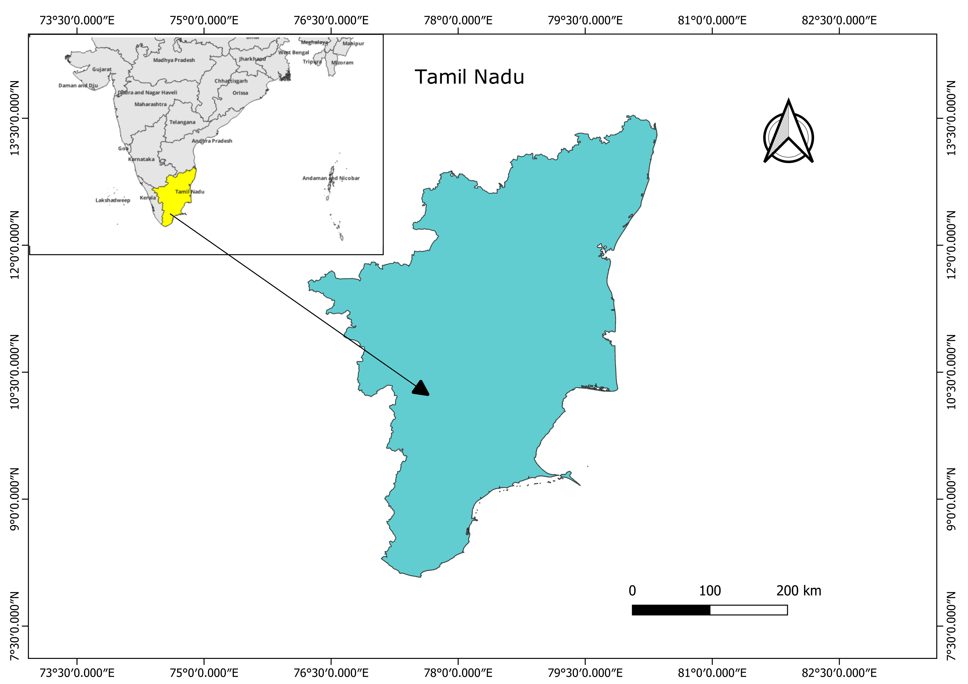
Figure 1: Study Area of Tamil Nadu, India.

Data Sources

Data: The dataset, derived from the Sentinel-5P TROPOMI instrument, The TROPOMI instrument offers a high spatial resolution of 3.5 x 7 km, allowing for the detection of smaller SO₂ plum. Near-real-time SO₂ data is available, enabling timely monitoring of events like volcanic eruptions. The 'SO2_column_number_density' band was selected for focused analysis. A time series chart was generated using the 'ui.Chart.image.series' function in Google Earth Engine, illustrating temporal fluctuations in SO₂ levels across the study duration

Boundary data for Tamil Nadu: A shapefile or feature collection representing the administrative boundary of Tamil Nadu will be imported into Google Earth Engine to clip the SO₂ data to the study area.

Methodology

The Sentinel-5P SO₂ dataset will be accessed through the Google Earth Engine (GEE) for the study period spanning January 1, 2024, to February 28, 2025. Spatial filtering will be applied by clipping the data to the administrative boundary of Tamil Nadu using a pre-defined shapefile. To ensure data reliability, a quality assurance (QA) threshold of 0.75 will be implemented, excluding low-quality or cloud-affected observations as per TROPOMI guidelines. Seasonal aggregation will be performed by computing the mean SO₂ concentrations for summer, monsoon and winter. Additionally, a time series analysis will be conducted by aggregating daily SO₂ values into monthly averages to capture temporal trends across the entire regions. Seasonal SO₂ maps exported from GEE will be visualized in QGIS with cartographic elements. Monthly mean SO₂ data for the time series will be exported as comma separated value and graph for trend analysis.
· Spatial Analysis: Seasonal SO₂ concentration maps will be visually inspected to identify pollution hotspots and spatial distribution patterns across Tamil Nadu for each season.
· Temporal Analysis: The time-series chart will be examined to detect trends, fluctuations, and peak SO₂ levels during the 2024–2025 period. These temporal patterns will be cross-referenced with the seasonal maps to understand seasonal influences.
· Interpretation: The spatial and temporal findings will be interpreted considering the region's industrial activities, meteorological factors such as wind and rainfall, and significant events that may impact SO₂ emissions or atmospheric dispersion within Tamil Nadu.

RESULTS
This section presents the findings from the spatial and temporal analysis of SO₂ concentrations across Tamil Nadu, India, for the period of March 2024 to February 2025. The results are categorized into seasonal pollution maps and a monthly average time series chart.
Spatial Distribution of SO₂ Pollution
The seasonal SO₂ pollution concentration maps (Figure 2: Summer, Figure 3: Monsoon, Figure 4: Winter) reveal distinct spatial patterns across Tamil Nadu. In all three seasons, a prominent hotspot of high SO₂ concentration is consistently observed in the northwestern part of Tamil Nadu, particularly concentrated around the region of neyveli and its surrounding industrial belt.
- Summer (March–May 2024) (Figure 2): The summer map indicates a pronounced area of high SO₂ concentration in the northeastern region, with the highest values depicted in red and orange, gradually transitioning to lower concentrations (blue and purple) towards the north and western parts of the state. The extent and intensity of the hotspot appear to be at their peak during this period.
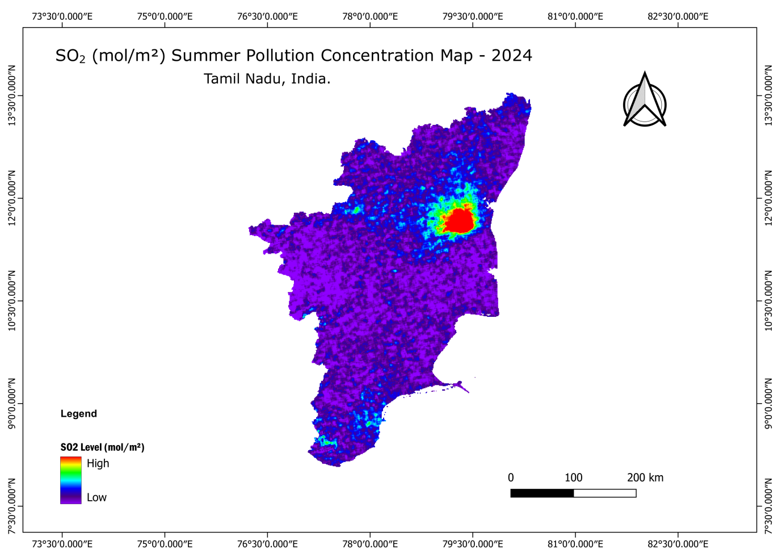
Figure 2: Mean SO₂ (mol/m²) Summer Pollution Concentration Map – 2024
- Monsoon (June–October 2024) (Figure 3): During the monsoon season, the overall SO₂ concentrations across Tamil Nadu generally appear to be lower compared to the summer months. While the northeastern hotspot is still identifiable, its intensity (represented by lighter orange/yellow tones rather than dark red) and spatial spread seem to be slightly reduced. Much of the state shows low SO₂ levels, depicted in various shades of blue and purple.
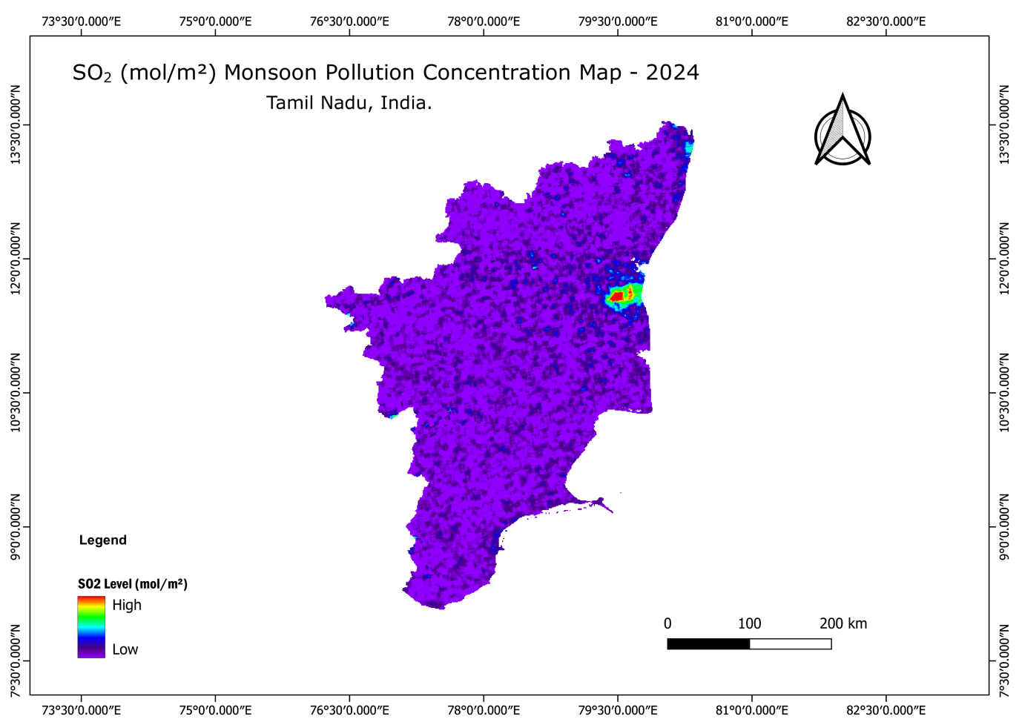
Figure 3: Mean SO₂ (mol/m²) Monsoon Pollution Concentration Map – 2024.
- Winter (November 2024 – February 2025) (Figure 4): The winter map shows a notable increase in SO₂ concentration in the northeastern hotspot compared to the monsoon season, although it might not reach the peak levels observed in summer. The area of elevated SO₂ is clearly visible in red and orange, suggesting a resurgence of pollution during this cooler period. Similar to other seasons, the rest of Tamil Nadu maintains relatively low SO₂ levels.
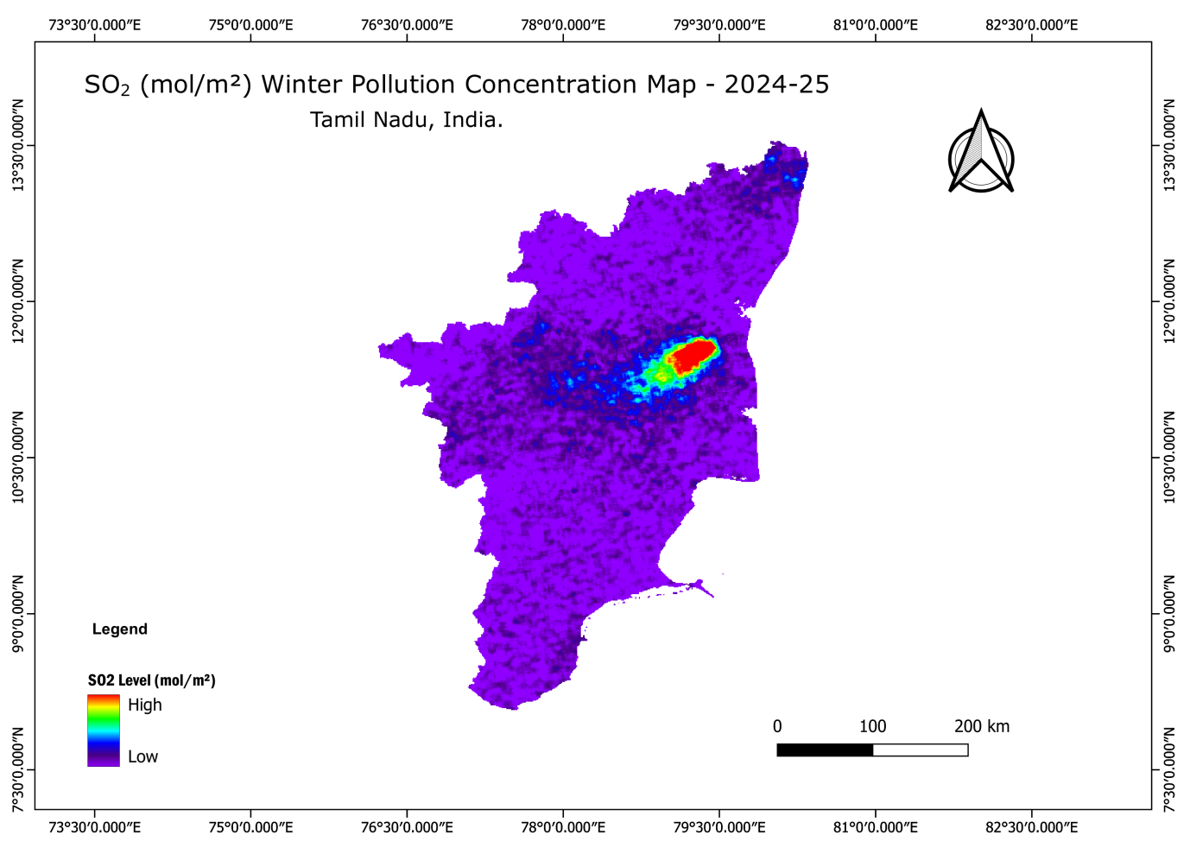
Figure 4: Mean SO₂ (mol/m²) Winter Pollution Concentration Map - 2024-25.
Temporal Variation of SO₂ Concentration
The monthly average SO₂ concentration time series chart for Tamil Nadu (Figure 5) provides a detailed overview of temporal variations from March 2024 to February 2025. The time series analysis of SO₂ concentrations over Tamil Nadu from March 2024 to February 2025 reveals clear seasonal trends driven by climatic conditions and anthropogenic activities.
Summer Season : SO₂ concentrations peaked in April 2024 at approximately 0.00037 mol/m², driven by intense industrial activities, energy production and dry, stagnant atmospheric conditions typical of summer. By May 2024, concentrations started to decline as temperatures began to moderate.
Monsoon Season : During the monsoon months, SO₂ levels reduced significantly due to the cleansing effect of rainfall and active wind patterns. Concentrations dropped to 0.00027 mol/m² in June and further to 0.00024 mol/m² by September 2024. A slight post-monsoon increase to 0.00026 mol/m² was noted in October 2024.
Winter Season : In winter, SO₂ concentrations gradually declined, reaching the lowest level of 0.00019 mol/m² in January 2025. This was due to cooler temperatures, lower energy demand, and residual monsoon effects. By February 2025, there was a minor increase to 0.00022 mol/m², likely due to renewed industrial emissions.
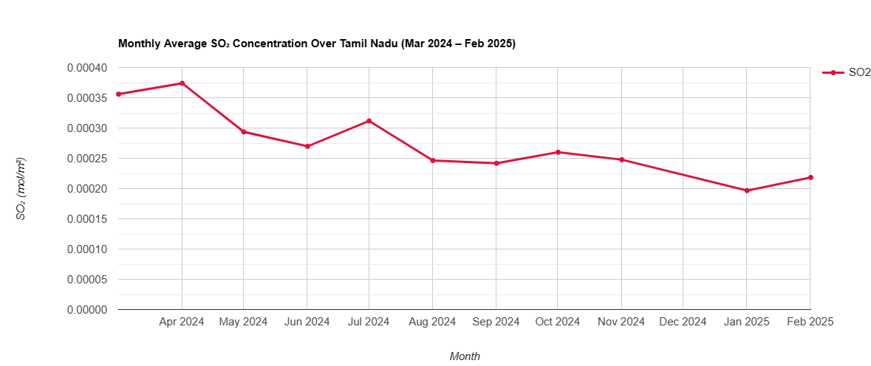
Figure 5: Monthly Average SO₂ concentration Over Tamil Nadu (Mar 2024 – Feb 2025).
DISCUSSION
The results of this study consistently highlight the northeastern region of Tamil Nadu has a significant hotspot for SO₂ pollution. This finding aligns with the known industrial landscape of the region, which hosts numerous power plants, refineries, chemical industries, and manufacturing units. These industrial activities, heavily reliant on fossil fuel combustion, are primary contributors to atmospheric SO₂ emissions.
Seasonal Variations in SO₂ Levels
Summer Season (March to May): The sulphur dioxide (SO₂) concentrations in Tamil Nadu were significantly influenced by emissions from major thermal power plants. Higher temperatures and increased energy demand for cooling during this period likely lead to intensified operations in thermal power plants and industries, consequently increasing SO₂ emissions. The Neyveli Thermal Power Plant emerged as the primary contributor, followed by the Mettur Thermal Power Plant in Salem, North Chennai Thermal Power Plant, and the Tuticorin (Thoothukudi) Thermal Power Station.
In summer, the SO₂ emissions from the Neyveli Thermal Power Plant predominantly dispersed towards the north and partially towards the south, driven by prevailing wind patterns. The highest concentrations were recorded in the eastern part of Cuddalore district, with further dispersion extending into Villupuram, Kallakurichi, Dharmapuri, Vellore, and Tiruvannamalai districts.
Similarly, in the southern region, the Tuticorin Thermal Power Station significantly elevated SO₂ levels within Thoothukudi district and its surroundings. Apart from these major power plants, several other industrial operations across Tamil Nadu also contributed to notable SO₂ pollution during the summer months, further exacerbating regional air quality concerns. Furthermore, meteorological conditions typical of summer, such as stable atmospheric conditions and lower wind speeds, can lead to the stagnation of pollutants, preventing their efficient dispersion and resulting in higher ground-level concentrations.
Monsoon Season: Conversely, the reduction in SO₂ concentrations during the monsoon season (June-October) is a well-documented phenomenon for air pollutants. The scavenging effect of rainfall effectively washes out SO₂ from the atmosphere, leading to lower ambient concentrations. Increased wind speeds associated with monsoon systems can also contribute to better dispersion of pollutants.
During the monsoon season (June to October), the dispersion of SO₂ emissions from the Neyveli Thermal Power Plant is predominantly directed towards the Bay of Bengal, driven by the prevailing southwest monsoon winds. As a result, the pollutant plume often reaches the coastal areas and dissipates over the sea, reducing its impact on inland regions.
During this period, SO₂ pollution from Neyveli primarily affects only the Cuddalore district with minimal dispersion beyond this zone. Similarly, emissions from the North Chennai Thermal Power Plant are also reduced, with only a limited and localized impact.
Overall, during the monsoon season, Tamil Nadu experiences lower SO₂ concentrations across the state due to frequent rainfall, higher humidity, and enhanced atmospheric cleansing. These meteorological conditions facilitate the washout of pollutants, thereby mitigating the extent of air pollution during this season. The slight resurgence in July, as seen in the time series, might warrant further investigation into specific industrial activities or localized meteorological events during that month.
Winter Season :The increase in SO₂ levels during winter (November-February), while not as high as summer, is also a common trend in many parts of India. During winter, cooler temperatures often lead to an inversion layer in the atmosphere, trapping pollutants close to the ground. Additionally, reduced vertical mixing and lower wind speeds can hinder pollutant dispersion, leading to accumulation. Increased demand for heating (though less prevalent in Tamil Nadu compared to northern India, industrial heating could still play a role) and the burning of agricultural waste (though less directly linked to SO₂ from industrial sources, it can contribute to overall air quality issues) might also contribute.
During the winter season, following the post-monsoon period, the dispersion pattern of SO₂ emissions from the Neyveli Thermal Power Plant shifts predominantly towards southern Tamil Nadu. The pollutant plume extends over Perambalur, Ariyalur, Namakkal, Tiruchirappalli, and partially over Salem district.
The Mettur Thermal Power Plant in Salem contributes to localized SO₂ pollution, primarily affecting the surrounding regions with limited dispersion. Similarly, in Chennai, emissions from the North Chennai Thermal Power Plant continue to influence nearby areas, although with reduced intensity compared to summer.
In contrast, the SO₂ emissions from the Tuticorin (Thoothukudi) Thermal Power Station tend to decline significantly during the winter season, contributing less to regional air pollution. Overall, SO₂ concentrations across Tamil Nadu are generally lower in winter, attributed to meteorological factors such as lower temperatures, higher humidity, and altered wind patterns that limit long-range pollutant transport.

Spatial and Temporal Dispersion Patterns
The time series chart (Figure 5) corroborates the patterns observed in the seasonal maps. The peak in April 2024 clearly corresponds to the summer high, and the subsequent dip from May to October reflects the cleansing effect of the monsoon. The gradual rise from November onwards signifies the onset of winter atmospheric conditions conducive to pollutant accumulation. The consistency between the spatial maps and the time series chart strengthens the validity of the findings.
Future research could delve deeper into correlating these SO₂ patterns with specific industrial clusters, meteorological data (wind speed, direction, rainfall, boundary layer height), and major policy interventions or economic shifts in Tamil Nadu. High-resolution dispersion modeling could further pinpoint the precise sources and their contributions to the observed hotspots. The information derived from this study can serve as a crucial input for local environmental agencies in developing targeted pollution control strategies and assessing the effectiveness of existing air quality regulations in Tamil Nadu.

CONCLUSION
In summary, this valuable insights to the growing body of research on air quality monitoring in South Asian countries, specifically focusing on the spatial and seasonal dynamics of sulphur dioxide (SO₂) concentrations in Tamil Nadu. By leveraging advanced remote sensing data and GIS analytical methods, the research effectively identifies key pollution hotspots, dominant industrial contributors, and the seasonal variability of SO₂ emissions across the state.
These findings provide a scientific basis for formulating targeted, evidence-based environmental management policies aimed at mitigating air pollution and safeguarding public health. Moreover, the methodologies and outcomes of this research can inform sustainable development strategies and support regulatory frameworks in Tamil Nadu and similar industrial regions. Future studies integrating meteorological data, emission inventories, and predictive modeling will further enhance the understanding of air pollution dynamics and assist policymakers in designing effective intervention measures.

REFERENCES
Smith, S. J., van Aardenne, J., Klimont, Z., Andres, R. J., Volke, A., & Delgado Arias, S. (2011). Anthropogenic sulphur dioxide emissions: 1850–2005. Atmospheric Chemistry and Physics, 11(3), 1101–1116. https://doi.org/10.5194/acp-11-1101-2011
Veefkind, J. P., et al. (2012). TROPOMI on the Sentinel-5 Precursor: A GMES mission for global observations of the atmospheric composition. Atmospheric Measurement Techniques, 5(2), 2719-2741. https://doi.org/10.1016/j.rse.2011.09.027
World Health Organization (WHO). (2006). WHO Air Quality Guidelines for Particulate Matter, Ozone, Nitrogen Dioxide and sulphur Dioxide: Global Update 2005. WHO Press.
Gupta, P., Christopher, S. A. (2021). Spatiotemporal analysis of air pollution in India using satellite data and Google Earth Engine. Science of The Total Environment, 754, 146198. https://doi.org/10.1016/j.scitotenv.2021.146198
Choudhary, S., Ghosh, S., & Prasad, K. (2021). Using Google Earth Engine for Long-Term Air Pollution Monitoring in India. Remote Sensing, 13(6), 1133. https://doi.org/10.3390/rs13061133
Singh, R. P., & Shukla, S. (2021). QGIS and Remote Sensing in Urban Air Quality Monitoring: A Case Study. In Advances in Geospatial Data Science (pp. 157–170). Springer. https://doi.org/10.1007/978-3-030-73569-2_10
Xue, T., Tong, D., Zheng, Y., et al. (2020). Satellite-based PM2.5 estimation using Google Earth Engine and machine learning. Science of The Total Environment, 739, 141396. https://doi.org/10.1016/j.scitotenv.2020.141396
Kumar, P., Tripathi, S., & Singh, D. (2022). Spatio-temporal patterns of air pollutants over India using remote sensing and Google Earth Engine. Environmental Modelling & Software, 147, 105437. https://doi.org/10.1016/j.envsoft.2022.105437
· Guttikunda, S. K., & Jawahar, P. (2020). Air pollution and health in South Asia: A review. Environmental Research, 185, 109993. https://doi.org/10.1016/j.envres.2020.109993
· Mahesh, A., & Gupta, M. (2018). Assessment of air quality during the winter season in India. Atmospheric Environment, 198, 54-64. https://doi.org/10.1016/j.atmosenv.2018.11.023
· Nair, M., & Rajeevan, M. (2019). Influence of monsoon variability on air quality in India. Science of the Total Environment, 692, 133618. https://doi.org/10.1016/j.scitotenv.2019.133618
Chen, Yutao, Ronald J. van der A, Jieying Ding, et al. "SO₂ Emissions Derived from TROPOMI Observations over India Using a Flux-Divergence Method with Variable Lifetimes." Atmospheric Chemistry and Physics, vol. 25, 2025, pp. 1851–1870. https://doi.org/10.5194/acp-25-1851-2025
Tov, et al. "Version 2 of the Global Catalogue of Large Anthropogenic and Volcanic SO₂ Sources and Emissions Derived from Satellite Observations." Earth System Science Data, vol. 15, 2023, pp. 75–101. https://doi.org/10.5194/essd-15-75-2023

