Table 1. Percent reduction of physiological traits over control under simulated drought conditions in groundnut
Genotypes | Percent reduction over control
 | GP (%) | GVI (%) | RL (%)
VRI7 | 77.78 | 95.33 | 80.06
CO 1 | 60.00 | 79.52 | 34.52
TMV 7 | 90.00 | 97.38 | 33.87
CO7 | 12.50 | 19.34 | 13.91
VRI5 | 10.00 | 56.07 | 27.22
CO4 | 66.67 | 89.15 | 65.52
TMV 13 | 60.00 | 79.22 | 67.31
COG18-37 | 50.00 | 87.41 | 72.48
VRI6 | 60.00 | 89.93 | 60.13
ALR 1 | 14.29 | 73.70 | 82.80
COG17006 | 60.00 | 86.19 | 66.00
VRI 8 | 88.89 | 96.76 | 75.76
BSR 2 | 50.00 | 59.31 | 64.85
CO 2 | 66.67 | 65.14 | 4.00
COG0539 | 25.00 | 74.94 | 76.40
TMV 1 | 60.00 | 87.56 | 45.21
ALR 2 | 55.56 | 64.63 | 28.41
VRI 4 | 60.00 | 88.73 | 25.00
VRI 9 | 80.00 | 92.62 | 68.18
VRI 3 | 100.00 | 100.00 | 100.00
ALR 3 | 70.00 | 90.98 | 74.13
COG 0549 | 33.33 | 63.26 | 74.57
COG17007 | 40.00 | 81.95 | 95.77
TMV 14 | 57.14 | 82.41 | 40.61
VRI 10 | 80.00 | 94.75 | 87.90
TMV 10 | 50.00 | 83.13 | 54.77
CO 6 | 30.00 | 71.98 | 84.45
COG0537 | 70.00 | 89.05 | 61.41
(GP- Germination percentage, GVI- Germination velocity index, RL- Root length)
Figure 1. Variations observed in the root length of the groundnut variety CO2 | Figure 2. Variations observed in the root length of the groundnut COG17007
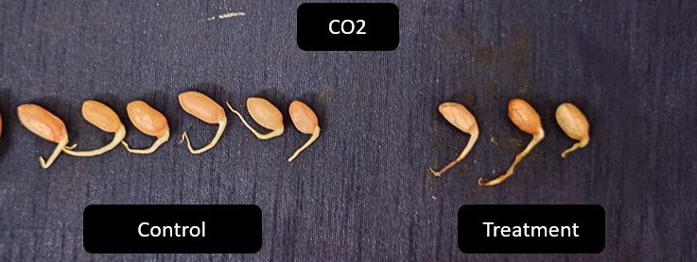 | 