**Title Page**

**Development and Evaluation of Punching Mechanism for De-seeding of Ber Fruit**

**Bharath Kumar Komatineni123*, Manjula B1, Sanwal Singh Meena2, Kavan Kumar V2, Utkarsh Dwivedi3, Akuleti Saikumar1, Jai Krishna S1, Sumit Kumar Vishwakarma4**

1College of Agricultural Engineering (CAE), ANGRAU, Madakasira, Andhra Pradesh, India – 515301

2College of Technology and Engineering, MPUAT, Udaipur, Rajasthan, India – 313001

3College of Agricultural Engineering and Postharvest Technology (CAEPHT), CAU, Ranipool, Sikkim, India – 313001.

4Indian Institute of Technology (IIT), Roorkee, Uttarakhand, India - 247667

*Corresponding author Email ID: [bharathkumar.komatineni@gmail.com](bharathkumar.komatineni@gmail.com%20)

**Acknowledgments**

This work was supported by college of agricultural engineering (CAE), ANGRAU, Madakasira, Anantapur, Andhra Pradesh, India.

**Authors Contribution**

**BKK:** Data curation, Formal analysis, Investigation, Methodology, Software, Writing– original draft.

**MB:** Conceptualization, Supervision, Project administration, Writing – review & editing

**KKV and UD:** Software, Methodology, Validation, Visualization

**SKA:** Formal analysis and Writing – review & editing.

**JK and SKV:** Funding acquisition andWriting – review & editing.

**Declarations**

**Data Availability Statement**

All data analyzed during this study are included in this article

**Conflict of Interest**

The author and Co-authors declare that they have no known competing financial interests or personal relationships that could have appeared to influence the work reported in this paper.

**Graphical Abstract**

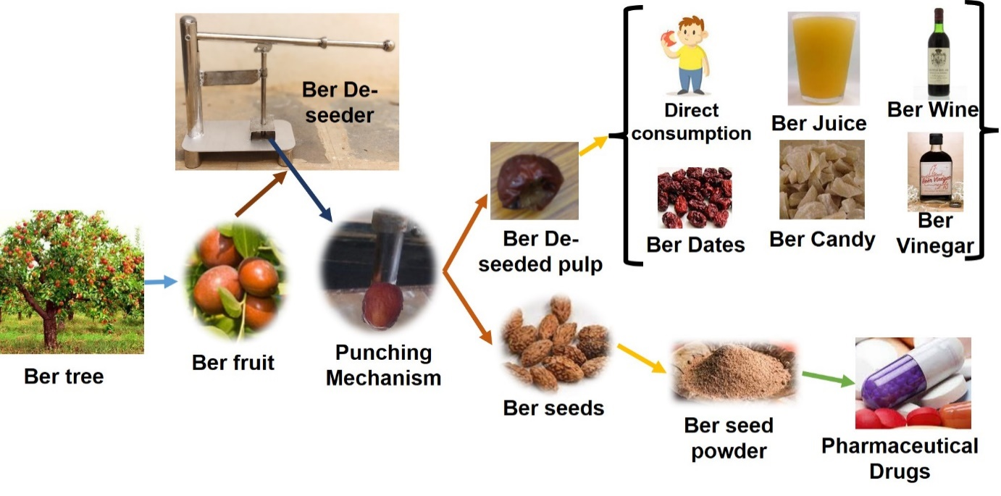

**Covering Letter**

26/12/2024

To

Editor in Chief

Respected sir,

I am Bharath Kumar K, Ph.D. scholar CTAE, MPUAT, Udaipur, India. I am sending my research article titled “**Development and Evaluation of Punching Mechanism for De-seeding of Ber Fruit.”** to your journal. It is an original research work. This article was sent as per your guidelines mentioned. Please consider my research article for publication.

Thanking you sir,

Your sincerely,

Bharath Kumar Komatineni

Ph.D. Scholar

College of Technology and Engineering (CTAE),

MPUAT, Udaipur

Rajasthan, India-313001

Ph. No - +91 9494920730

e-mail – <bharathkumar.komatineni@gmail.com>