**Unlocking Genetic Variability in Rice: Enhancing Rice Bran Oil and Quality Traits**

## ABSTRACT

The unpolished white rice with bran is highly nutritious than milled or polished white rice. The edible, Rice-bran oil (RBO) is extracted from rice bran, which contains 12 to 23% lipid and the quantity of oil extracted, influenced by factors *viz*., Variety of seed, extent of milling, extraction technique and agro climatic conditions. The rich in antioxidants improves the shelf life of RBO. This study assessed genetic variability and trait associations in rice genotypes to identify those with superior RBO content and quality traits. Significant differences were observed among genotypes for all studied traits. Bran oil percentage ranged from 12.3% to 20.2%, with the highest levels in varieties ADT54 and Kichadi Samba, and the lowest in *Boothakali Karupan, Moota Kuruva*, and *Kallan Samba*. High phenotypic (PCV) and genotypic (GCV) coefficients of variation were noted for the number of productive tillers, flag leaf length, total spikelets per panicle, thousand grain weight, and grain yield per plant. Heritability estimates ranged from 73.68% to 99.49%, with high heritability coupled with high genetic advance as a percentage of mean (GAM) for key traits indicating additive gene action. Bran oil percentage showed positive significance and correlation with brown rice recovery, productive tillers, and milling percentage. Path analysis revealed that flag leaf width, grain yield per plant, head rice recovery, and brown rice had high positive direct effects on bran oil percentage. In conclusion, the genotypes ADT54, *Kichadi Samba*, and CR 1009 demonstrated high potential for RBO content. These findings provide valuable insights for breeding programs focused on enhancing rice bran oil yield and quality, highlighting the potential of genetic selection to meet the increasing demand for RBO and improve rice quality traits.

**Key words:** Rice, Bran Oil, Quality traits, variability, correlation

## INTRODUCTION

Rice (*Oryza sativa* L.) is a crucial cereal crop that serves as a primary food source for half of the global population. India, being one of the world's largest producers and consumers of rice, has made significant progress in rice cultivation. Rice serves as a staple food for a majority of the Indian population, especially in the eastern and southern regions. Due to the rapid increase in the global population, it is expected to feed 9 billion people by 2050 (Arunkumar *et al.*, 2022). Rice grain quality has emerged as a primary concern for both rice breeders and consumers alike. The milling yield of the grain plays a crucial role in determining both the yield of head rice and the rate of broken kernels in milled rice (Chen *et al.*, 2012).

Rice bran, which comprises the outer brown layer of the rice kernel consisting of the pericarp, aleurone, seed coat, and germ, is a valuable by-product obtained after the rice polishing process (Sohail *et al.*, 2017). Unpolished rice containing its bran is more nutritious than milled or polished white rice due to its high nutrient content. Nevertheless, rice consumers prefer to consume polished white rice, despite the fact that brown rice contains valuable nutrient content (Devi *et al.*, 2015). Rice bran, which contains 12 to 23 percent lipid, can be extracted to obtain rice-bran oil (RBO). Typically, the yield of rice bran is around 8-10% of paddy rice (Punia *et al.*, 2021). The amount of RBO extracted depends on various factors such as seed variety, degree of milling, extraction method, and agro-climatic conditions (Ghosh, 2007).

Rice bran oil is a healthy edible oil that have a balanced source of 39% polyunsaturated (linoleic acid), 19% saturated (palmictic acid) and 42% monounsaturated (oleic acid) fatty acid, so RBO is one of the most nutritious edible oils (Mezouari *et al.*, 2006). Bran has sufficient amount of antioxidant (γ-oryzanol) and nutritionally important components such as minerals, vitamin E (tocopherols and tocotrienols), phytosterols and phenolic components (Moldenhauer *et al.*, 1998, Sohail *et al.*, 2017). It also help to reduce LDL cholesterol, protect cardiovascular diseases and have anticancer effects (Awad-Allah *et al.*, 2022, Punia *et al.*, 2021). RBO has a significantly long shelf life compared to other cooking oils because of the antioxidants it contains. Due to its low viscosity, it absorbs less oil during cooking, resulting in less calories overall (Chakrabarty, 1989). To enhance the cooking quality of rice bran oil, it is commonly blended with other vegetable oils due to its relatively low smoking point.

The prime objective of plant breeding programmes is genetic variability, which results from genetic differences among individuals within a population. Proper management of diversity can result in a permanent improvement in the performance of the plant and can serve as a buffer against seasonal instabilities. Genetic variability among traits is important for breeding and in selecting desirable types (Sadhana *et al.*, 2022).Estimates of heritability helps plant breeders in selecting traits for which selection would be effective. Heritability, along with genetic advance helps to identify the gene action. The association studies between quantitative and quality traits is helpful for the breeders in their selection strategies for crop improvement. This study aims to evaluate the genetic variability and trait associations among rice genotypes to identify those with superior rice bran oil (RBO) content and quality traits.

## MATERIALS AND METHODS

The experimental material comprised of 32 genotypes including landraces and improved cultivars. All the genotypes were obtained from Department of Rice, Tamil Nadu Agricultural University, Coimbatore. The field experiment was laid out in Randomized Block Design (RBD) with three replications at Department of Rice, TNAU, Tamil Nadu, during *rabi* season, 2023 following standard agronomical practices. The observations were recorded on each genotype *viz.,* Plant height (cm), flag leaf length(cm), flag leaf width(cm), panicle length(cm), number of grains per panicle, thousand grain weight (g), single plant yield (g), brown rice recovery, milling (%), head rice recovery, Bran(%), bran oil(%).

Rice bran was extracted from all the genotypes with laboratory miller and was kept immediately at 4ºC to control the growth of rice bran free fatty acid (FFA). The rice bran oil content was determined using soxhlet apparatus, 5 grams of bran were placed in a packed bed within a thimble, which was then inserted into a distillation flask in a Soxhlet apparatus containing 10 ml of petroleum ether. The extraction process continued until completion. Following extraction, the petroleum ether was evaporated to separate it from the oil. The weight of the extracted rice bran oil was then measured and recorded and standardized in the near infra-red spectroscopy (NIR) instrument (M/s ZEUTEC, Germany; Model: SPA 1.0) was calibrated with the oil content of rice bran ranging from 12 – 23%. R2 value was 92.8 .The analysis of unknown oil content samples of each genotype was recorded by scanning samples in a wave number range of 1400 – 2400 wave length/nm.

### ***Statistical analysis***

ANOVA for the randomized block design (RBD) was computed at the 5% significance level. The biometrics analysis like PCV, GCV, heritability (h2) and GAM were calculated. Path coefficient analysis was carried out as per the standard method suggested by Dewey and Lu (1959). The statistical analysis *viz.,* variability and path analysis was carried out using TNAUSTAT statistical package (Manivannan, 2014). The correlation coefficient was computed by Pearson’s method using R software version 4.2.3.

## RESULTS AND DISCUSSION

The significant differences were observed among the genotypes for the examined traits while performing ANOVA **(Table 1)**. The finding suggested the presence of inherent genetic variability among the genotypes, and responds positively to the selection. Genetic variability is an essential prerequisite for crop improvement program and represents the enough variation for all traits. Our results are in accordance with Sadhana *et al.* (2022) the traits plant height, number of productive tillers, panicle length, thousand grain weight, grain yield per plant, milling percentage and head rice recovery showed significant differences.

The bran oil percentage ranged from 12.3% to 20.2%, indicated significant differences in the percentage of oil content with respect to selected varieties. The highest mean bran oil percentage of 20.2% and 20.1% was observed in the variety ADT54 and *Kichadi samba* respectively. The results indicate that, the two varieties had a potential for improving bran oil content in rice. In the experiment, the varieties *viz*., ASD16 (19.5%), CR 1009 (19.6%) and C053 (19.1%) also exhibited relatively higher mean bran oil percentages and further considered for bran oil characteristics improvement. On the lower end of the spectrum, the varieties *Boothakali karupan*, *Moota kuruva* and *Kallan samba* possessed lower mean bran oil percentage of 12.5% (**Figure 1**).

The success of genetic improvement depends upon the existing genetic variability and the efficiency in selection of traits. The quantification of variation in the genotypes is indispensable for the improvement of the traits. Therefore, the quantification of genotypic variance helps in enhancing the trait of interest. The assessment of existing variation can be made by discriminating the genetic variance from the phenotypic variance by avoiding the environmental variance. The variance components estimated werePCV, GCV, heritability (h2) and genetic advance as per cent of mean and tabulated in the **table 2.**

The difference between PCV and GCV was found minimum and it indicated the lesser influence of environment on the expression of traits. The PCV was considerably higher than the GCV for all the traits. The traits *viz.,* number of productive traits, flag leaf length, total spikelets per panicle, thousand grain weight, and grain yield per plant revealed high PCV and GCV. It showed the presence of a significant amount of genetic variability for these traits and similar results were reported by Sadhana *et al.* (2022) and Zahid *et al.* (2006). These traits suitable for selection in crop improvement programme. Whereas, moderate GCV was observed for the traits plant height, bran and bran oil %. This result was in agreement with earlier reports GUPTA *et al.* (2016) and (Babu *et al.*, 2017). The traits panicle length, brown rice, milling % and head rice recovery displayed a low PCV and GCV. The obtained results represent the need for special breeding procedures for improving the traits, which exhibit low PCV and GCV. Similar results were obtained by Adjah *et al.* (2020).

The heritability ranged from 73.68 - 99.49 %. High heritability was noticed for all the evaluated traits *viz.,* plant height (92.73 %), number of productive tillers (81.96 %), flag leaf length (86.59 %), flag leaf width (73.68 %), panicle length (89.18%), TSP (98.06%), thousand grain weight (97.22%), grain yield per plant (92.67%), brown rice (95.27%), milling % (96.51%), head rice recovery (95.40%), bran (99.12%) and bran oil % (99.49%) . Sadhana *et al.* (2022) obtained similar results and reported high heritability for the characters *viz.,* plant height, number of productive tillers per plant, panicle length, number of grains per panicle, thousand grain weight, grain yield per plant, milling percentage and head rice recovery. Arya *et al.* (2024) reported same results for the trait bran oil content had high heritability.

The genetic advance as per cent of mean (GAM) varied between 10.80 - 91.81%. The high GAM was obtained for the traits *viz.,*plant height (30.26 %), number of productive tillers (48. 24 %), flag leaf length (39.04), TSP (91.81 %), thousand grain weight (45.11 %), grain yield per plant (53.02), bran (28.72 %) and bran oil % (25.89 %). The similar result were observed by Sadhana *et al.* (2022) only for the traits thousand grain weight and grain yield per plant. Other traits *viz.,* flag leaf width (19.69%), panicle length (18.28%), brown rice (11.46%), milling % (10.48%) and head rice recovery (11.97%) recorded moderate GAM in the genotypes. Similarly Adjah *et al.* (2020) reported same results for the traits brown rice and milling percentage. The high heritability along with high GAM was accompanied by the traits plant height, number of productive tillers, flag leaf length, TSP, thousand grain weight, grain yield per plant, bran and bran oil %. The obtained outcomes indicated that these characters were presided by additive gene action, the environmental effect was minimal and the selection could be effective for the genetic enhancement of the traits.

The assessment of relationship between yield and its component traits aids the plant breeders to improve the genetic potential of the genotypes in a desirable direction. The correlation coefficient among different traits is presented in **figure 2.** Bran oil % showed a positive and significant correlation with brow rice recovery (r = 0.610), productive tillers (r = 0.433), milling percentage (r = 0.497) and NGP (r = 0.301). Similar results were reported by Adjah *et al.* (2020) and Velprabakaran *et al.* (2020). These outcomes figured out the traits *viz.,* productive tillers, number of grains per panicle and milling % were the important selection indices to improve the bran oil % trait. The bran oil percentage trait was non-significant and positively related with flag leaf length (r = 0.045), flag leaf width (r = 0.212), grain yield per plant (r = 0.196) and head rice recovery (r = 0.210). The characters *viz.,* plant height (r = -0.065), panicle length (r = -0.003), thousand grain weight (r = -0.233) and bran (r = -0.135) were non-significant and negatively associated with bran oil %. The similar results were provided by authors Manivelan *et al.* (2022) for the traits panicle length, head rice recovery.

In terms of inter-correlation, the number of productive tillers displayed significant and positively associated with number of grains per panicle, brown rice recovery, milling % and significant negatively correlated with thousand grain weight. Similarly Sadhana *et al.* (2022) reported for the traits brown rice and milling percentage. The trait brown rice recovery expressed significant and positively inter-correlated with milling %, head rice recovery and significant negatively correlated with Bran. Milling % exposed positive and significantly associated with head rice recovery and negatively significant with bran. Number of grains per panicle showed positive and significant correlation with milling %, brown rice and negatively significant with thousand grain weight. Lakshmi and Chamundeswari (2021) reported positive and significant correlation for the traits brown rice, head rice recovery and milling percentage.

The minimal residual effect implies that the chosen traits were highly suitable for conducting path analysis to determine their impact on bran oil %. Path analysis is the partition of correlation coefficient into direct and indirect effects **(Table 3).** This analysis was made to study about the cause and effect of the dependent and independent traits. The traits, flag leaf width (0.413), grain yield per plant (0.469), head rice recovery (0.300) and BR (0.979) exhibited a high positive direct effect on bran oil %. Sadhana *et al.* (2022) also reported same results for the traits grain yield and head rice recovery. Bran showed moderately positive direct effect on bran oil %. The traits *viz.*, head rice recovery (0.300) and bran (0.203) exhibited moderate positive effect on bran oil %. Manivelan *et al.* (2022) concluded same result for head rice recovery. The characters *viz.,* flag leaf length (-0.184), panicle length (-0.145), NGP (-0.604), thousand grain weight (-0.573) and milling % (-0.443) revealed negative direct effect on bran oil % trait. The residual effect was observed as 0.387. These fallouts indicated that the studied traits reliable in contributing to the trait bran oil %. Eventhough, 38.71% of the variability remain unexplored in this study, which may contribute some others traits for the enhancement of trait bran oil %.

## CONCLUSION

In this study Bran and bran oil yield percentage showed high heritability coupled with genetic advance as percent of mean, the expression indicates additive action of genes, further selection and exploitation of traits is beneficial and improves bran oil properties in rice. The *per se* performance for the trait rice bran oil, was observed high for genotypes ADT 54, *Kichadi samba* and CR 1009. These genotypes can be utilized in breeding programmes for improving the percentage of rice bran oil than existing. The obtained results infer that selection of high bran oil yielding varieties helps in reducing the demand existing for rice bran oil. These results provide valuable insights for selecting varieties with higher oil content for specific applications in the bran oil industry.

**Funding and Acknowledgment**

No external funding was received to carry out this research.

**Ethics statement**

There was no human participants and animal included in this research.

**Originality and plagiarism**

The authors assure that the contents were written by us and were not plagiarized.

**Consent for publication**

All the authors agreed to publish the content.

**Competing interests**

There were no conflict of interest in the publication of this content

**Authors contribution**

Idea conceptualization – MA, SG and GA; Experiments – MA and GA; Guidance - SG, Writing original draft – MA and RS; Writing - reviewing & editing – PS and RS.

## REFERENCES

Adjah, Kossi Lorimpo, Ayodeji Abe, Victor O Adetimirin, and Maxwell Darko Asante. 2020. "Genetic variability, heritability and correlations for milling and grain appearance qualities in some accessions of rice (*Oryza sativa* L.)." *Physiology and Molecular Biology of Plants* **26**:1309-1317.

Arunkumar, M, S Geetha, K Amudha, R Suresh, V Ravichandran, and K Geetha. 2022. "Genetic diversity and QTL-marker association analysis of rice germplasm for grain number per panicle and its contributing traits." *Electronic Journal of Plant Breeding* **13 (2)**:558-566.

Arya, B., B. Lovely, G. Seeja, V. Mini, and S. Jyothilekshmi. "Unravelling the biochemical traits of traditional rice landraces of Kerala.2024." *Electronic Journal of Plant Breeding* 15, no. 2 : 435-442.

Awad-Allah, Mamdouh MA, Azza H Mohamed, Mohamed A El-Bana, Samira AF El-Okkiah, Mohamed FM Abdelkader, Mohamed H Mahmoud, Mohamed Z El-Diasty, Manal M Said, Sahar AM Shamseldin, and Mohamed A Abdein. 2022. "Assessment of genetic variability and bran oil characters of new developed restorer lines of rice (*Oryza sativa* L.)." *Genes* **13 (3)**:509.

Babu, P Mahesh, Y Chandramohan, V Ravindrababu, and CH Arunakumari. 2017. "Assessment of genetic variability for yield and bran oil content in segregating generations of rice." *Int. J. Curr. Microbiol. App. Sci* **6 (11)**:117-124.

Chakrabarty, MM. 1989. "Rice bran: a new source for edible and industrial oil." Proceedings of world conference on edible fats and oils processing. AOCS Press, Champaign.

Chen, Yi, Mei Wang, and Pieter BF Ouwerkerk. 2012. "Molecular and environmental factors determining grain quality in rice." *Food and Energy Security* **1 (2)**:111-132.

Devi, G Nirmala, G Padmavathi, V Ravindra Babu, and K Waghray. 2015. "Proximate nutritional evaluation of rice (Oryza sativa L.)." *J Rice Res* **8 (1)**:23-32.

Dewey, Douglas R, and KH Lu. 1959. "A correlation and path‐coefficient analysis of components of crested wheatgrass seed production 1." *Agronomy journal* **51 (9)**:515-518.

Ghosh, Mahua. 2007. "Review on recent trends in rice bran oil processing." *Journal of the American oil chemists' society* **84**:315-324.

Gupta, Ruplata, Sangeeta Tetwar, Ishu Kumar Khute, and Sunil Kumar. 2016. "Quantitative Analysis of Rice Germplasm of Chhattisgarh." *Advances* **5 (3)**: 1034-1038.

Lakshmi, K, and N Chamundeswari. 2021. "Evaluation of grain quality traits in popular rice varieties of Andhra Pradesh." *Journal of Pharmacognosy and Phytochemistry* **10 (1)**:217-224.

Manivannan, N. 2014. TNAUSTAT-Statistical package.

Manivelan, K, S Juliet Hepziba, R Suresh, M Theradimani, R Renuka, and RP Gnanamalar. 2022. "Inherent variability, correlation and path analysis in lowland rice (*Oryza sativa* L.)." Biological Forum–An International Journal. **14(2)**: 771-778

Mezouari, Samia, Karl Eichner, S Parkash Kochhar, Ludger Brühl, and Karin Schwarz. 2006. "Effect of the full refining process on rice bran oil composition and its heat stability." *European Journal of Lipid Science and Technology* **108 (3)**:193-199.

Moldenhauer, KA, ET Champagne, DR McCaskill, H Guraya, and G Mazza. 1998. "Functional products from rice." *Functional Foods: Biochemical and Processing Aspects* **1**:71-89.

Punia, Sneh, Manoj Kumar, Anil Kumar Siroha, and Sukhvinder Singh Purewal. 2021. "Rice bran oil: Emerging trends in extraction, health benefit, and its industrial application." *Rice Science* **28 (3)**:217-232.

Sadhana, P, Ch Damodar Raju, LV Rao, and Aparna Kuna. 2022. "Studies on variability, correlation and path coefficient analysis for yield and quality traits in rice (*Oryza sativa* L.) genotypes." *Electronic Journal of Plant Breeding* **13 (2)**:670-678.

Sohail, Muhammad, Allah Rakha, Masood Sadiq Butt, Muhammad Jawad Iqbal, and Summer Rashid. 2017. "Rice bran nutraceutics: A comprehensive review." *Critical Reviews in Food Science and Nutrition* **57 (17)**:3771-3780.

Velprabakaran, S, S Rajeswari, P Jeyaprakash, and M Raveendran. 2020. "Variability and association analysis on traditional rice grain parameters for better plant selection." *J. Pharm. Innov* **9 (3)**: 753-757

Zahid, M Afzal, M Akhter, M Sabar, Zaheen Manzoor, and Tahir Awan. 2006. "Correlation and path analysis studies of yield and economic traits in Basmati rice (Oryza sativa L.)." *Asian J. Plant Sci* **5 (4)**:643-645.

## Table 1: ANOVA for thirteen traits in rice genotypes

|  |  |  |  |  |  |  |  |  |  |  |  |  |  |  |
| --- | --- | --- | --- | --- | --- | --- | --- | --- | --- | --- | --- | --- | --- | --- |
| Source of variation | df | Mean Sum of Squares | | | | | | | | | | | | |
| **PH** | **NPT** | **FLL** | **FLW** | **PL** | **NGP** | **TGW** | **SPY** | **BR** | **MILL** | **HRR** | **BRAN** | **BRAN OIL%** |
| Replication | 1 | 40.01 | 16.00 | 07.63 | 0.001 | 5.29 | 420.25 | 2.10 | 38.22 | 11.44 | 7.22 | 2.25 | 0.02 | 0.37 |
| Genotypes | 31 | 524.53* | 37.73* | 84.67* | 0.05* | 11.20* | 17232.55* | 44.45* | 96.72* | 36.06* | 25.48* | 26.47* | 1.33* | 9.04* |
| Error | 31 | 19.79 | 03.74 | 06.09 | 0.008 | 0.64 | 168.96 | 0.63 | 3.68 | 0.87 | 0.45 | 0.62 | 0.01 | 0.02 |

|  |  |  |  |  |  |  |
| --- | --- | --- | --- | --- | --- | --- |
| **Traits** | **Minimum** | **Maximum** | **PCV%** | **GCV%** | **h2 %** | **GAM %** |
| **PH** | 83.5 | 166.0 | 15.84 | 15.25 | 92.73 | 30.26 |
| **NOPT** | 10.5 | 27.0 | 28.57 | 25.86 | 81.96 | 48.24 |
| **FLL** | 16.0 | 46.0 | 21.89 | 20.37 | 86.59 | 39.04 |
| **FLW** | 1.2 | 2.0 | 12.97 | 11.13 | 73.68 | 19.69 |
| **PL** | 21.4 | 29.6 | 9.95 | 9.39 | 89.18 | 18.28 |
| **NGP** | 82.0 | 441.5 | 45.45 | 45.00 | 98.06 | 91.81 |
| **TGW** | 11.6 | 28.9 | 22.52 | 22.21 | 97.22 | 45.11 |
| **GYP** | 12.8 | 41.8 | 27.77 | 26.64 | 92.67 | 53.02 |
| **BR** | 61.6 | 79.2 | 5.84 | 5.70 | 95.27 | 11.46 |
| **Mill** | 59.2 | 72.5 | 5.43 | 5.33 | 96.51 | 10.80 |
| **HRR** | 50.4 | 68.0 | 6.09 | 5.95 | 95.40 | 11.97 |
| **Bran** | 4.3 | 8.1 | 14.08 | 14.02 | 99.12 | 28.76 |
| **Bran Oil** | 12.3 | 20.2 | 12.63 | 12.60 | 99.49 | 25.89 |

## Table 2: Estimates of genetic variability for thirteen characters in rice genotypes

(PH-plant height, NPT-number of productive tillers, FLL- flag leaf length, FLW- flag leaf width, PL-panicle length, NGP-number of grains per panicle, TGW-thousand grain weight, SPY-single plant yield, BR- brown rice recovery, MILL- milling %, HRR-head rice recovery)

## Table 3: Path co-efficient analysis of direct (diagonal) and indirect effects of thirteen traits on bran oil % in rice genotypes

|  |  |  |  |  |  |  |  |  |  |  |  |  |  |
| --- | --- | --- | --- | --- | --- | --- | --- | --- | --- | --- | --- | --- | --- |
| Characters | PH | NPT | FLL | FLW | PL | NGP | TGW | SPY | BR | MILL | HRR | Bran | Bran Oil% |
| PH | **0.037** | -0.008 | -0.046 | 0.108 | -0.028 | -0.188 | 0.059 | -0.024 | 0.154 | -0.024 | -0.061 | -0.046 | -0.065NS |
| NPT | -0.003 | **0.079** | -0.014 | 0.026 | 0.0007 | -0.329 | 0.239 | 0.091 | 0.531 | -0.140 | 0.026 | -0.028 | 0.433** |
| FLL | 0.009 | 0.006 | **-0.184** | 0.204 | -0.011 | -0.128 | 0.097 | 0.046 | 0.110 | -0.041 | -0.017 | -0.043 | 0.045NS |
| FLW | 0.009 | 0.005 | -0.091 | **0.413** | -0.052 | -0.170 | -0.031 | 0.065 | 0.216 | -0.072 | -0.006 | -0.026 | 0.212NS |
| PL | 0.007 | -0.0003 | -0.014 | 0.149 | **-0.145** | -0.206 | -0.091 | 0.198 | 0.185 | -0.121 | 0.090 | -0.0581 | -0.003NS |
| NGP | 0.011 | 0.043 | -0.039 | 0.116 | -0.049 | **-0.604** | 0.349 | 0.090 | 0.578 | -0.214 | 0.065 | -0.043 | 0.301* |
| TGW | -0.003 | -0.033 | 0.031 | 0.022 | -0.023 | 0.368 | **-0.573** | 0.135 | -0.270 | 0.120 | -0.030 | 0.017 | -0.233NS |
| SPY | -0.001 | 0.015 | -0.018 | 0.057 | -0.061 | -0.116 | -0.165 | **0.469** | 0.154 | -0.099 | 0.031 | -0.063 | 0.196NS |
| BR | 0.005 | 0.043 | -0.020 | 0.091 | -0.027 | -0.356 | 0.158 | 0.073 | **0.979** | -0.354 | 0.111 | -0.075 | 0.610** |
| MILL | 0.002 | 0.025 | -0.017 | 0.067 | -0.039 | -0.292 | 0.156 | 0.105 | 0.784 | **-0.443** | 0.228 | -0.068 | 0.497** |
| HRR | -0.007 | 0.007 | 0.010 | -0.009 | -0.043 | -0.131 | 0.059 | 0.049 | 0.362 | -0.335 | **0.300** | -0.042 | 0.210NS |
| Bran | -0.008 | -0.011 | 0.039 | -0.054 | 0.041 | 0.130 | -0.048 | -0.146 | -0.366 | 0.148 | -0.062 | **0.203** | -0.135NS |

(**PH**-plant height, **NPT**-number of productive tillers, **FLL**- flag leaf length, **FLW**- flag leaf width, **PL**-panicle length, **NGP**-number of grains per panicle, **TGW**-thousand grain weight, **SPY**-single plant yield, **BR**- brown rice recovery, **MILL**- milling %, **HRR**-head rice recovery)

**Residuals 0.3871**

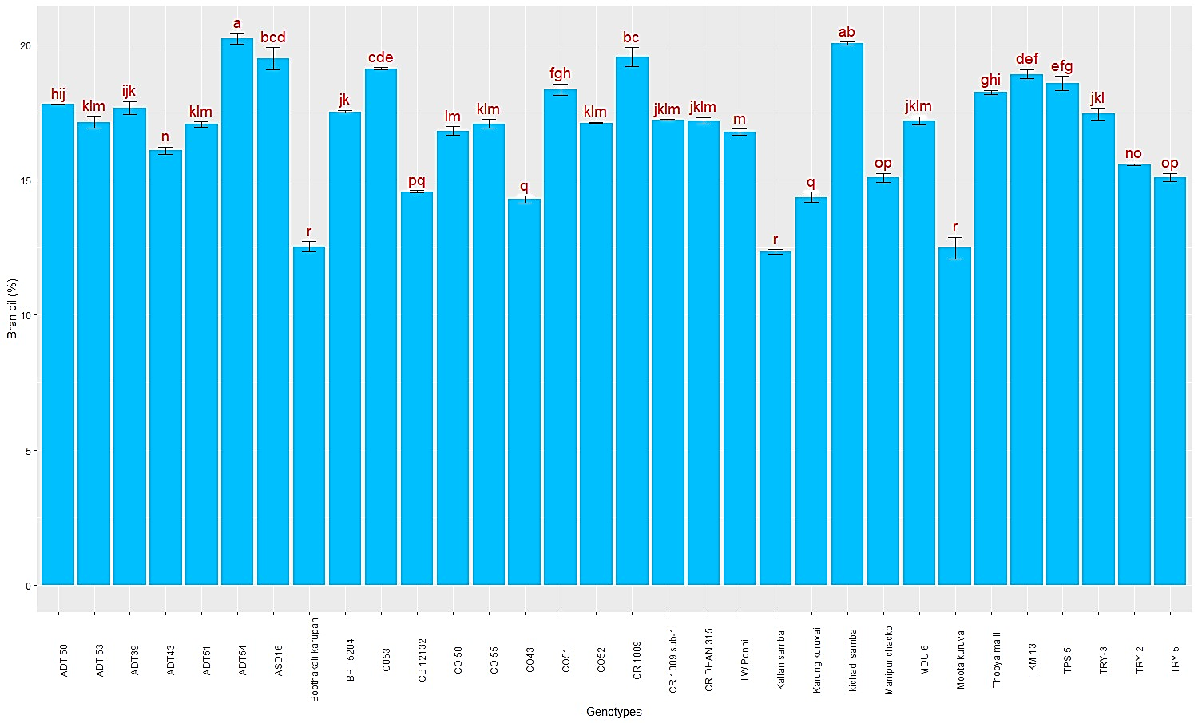

**Figure 1. Mean Performance of 32 Rice Genotypes for Bran Oil Percentage**

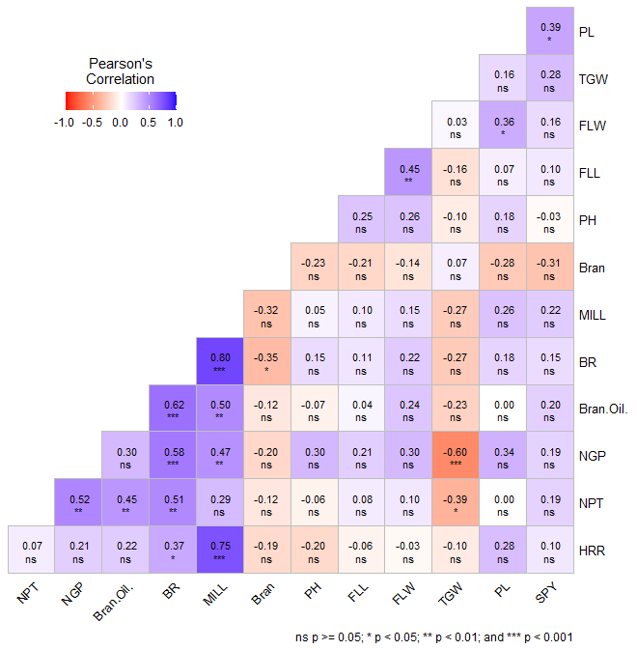

**Figure 2. The Pearson’s Correlation co efficient among quantitative and quality traits *, ** Significant at 5% and 1% level, respectively**