**Use of Virtual Reality Simulation Practices for Farmers Training**

**Abstract****:** Virtual reality (VR) improves farming training by mirroring real-life farm scenarios. VR employs immersive technology, e.g., digital twin systems, to mimic the development of crops, handle livestock rearing and enhance supply chain management. Training based on VR improves experiential competencies, allows informed decision-making and delivers low-cost, eco-friendly agriculture solutions while addressing misinformation on climate change. The simulation of virtual reality (VR) revolutionizes agricultural education by crafting engaging environments that reflect authentic farming experiences. The research highlights the components of the VR system and examines its uses in areas like virtual crop simulation, precision farming, digital twin-based management of livestock and optimizing supply chains. Additionally, VR has the capability to combat misinformation about climate change, boosting practical competencies and strategic decision-making for sustainable agricultural methods.

**Keywords:** Virtual Reality; Simulation; Digital Twin Technology; Industry 4.0; Predictive Analytics; Precision Farming; Supply Chain Management

**Introduction:** Nowadays, computer graphics are incorporated into various aspects of our lives. As we approached the end of the 20th century, it became hard to envision an architect, engineer, or interior designer working without a graphics workstation. In recent years, rapid advancements in microprocessor technology have led to the release of faster computers. These devices come with improved and quicker graphics cards and their costs are decreasing swiftly. It is now feasible for even the average user to enter the realm of computer graphics. This excitement for a new reality often begins with video games and endures over time. It enables us to view our surroundings from a different perspective and to engage in experiences that are unattainable in real life or have yet to be created. Furthermore, the domain of three-dimensional graphics knows no limits or restrictions and can be formed and adjusted by our own choices – we can even augment it with a fourth dimension: the realm of our imagination. Yet, that’s not enough; people continuously seek more. They desire to immerse themselves in this realm and interact with it – rather than simply observing a display on the screen. This technology, which has gained immense popularity and trendiness in the current decade, is referred to as Virtual Reality (VR).

VR is a computer-generated technique in a simulated environment to bring auditory and visual experience to people (Zhou and Calvo, 2018). It is a simulation system as well as 3D dynamic scene fused multi-source information (Zou *et al.,* 2004). Through the use of three-dimensional graphics, interactive tools and high-resolution screens, it is possible to create a virtual environment where users can manipulate imaginary objects as if they exist in the real world. As a result, key aspects of experiencing virtual reality include the virtual environment, immersion, tactile feedback (responses to user actions) and interaction. In fact, the benefits and importance of rapid product development and cost efficiency have been acknowledged in recent years. Consequently, countries around the globe are exploring virtual reality and its uses, with numerous researchers focusing on various techniques, shifting their priorities from purely technical aspects to practical applications of VR and its potential benefits for individuals. Virtual reality, as a practical technology, is well-established and is currently being explored for its applications across various industries, including computer graphics, CAD, CAM, CIM, robotics, healthcare, architectural design, entertainment, education, multimedia, gaming and more (Hu *et al.,* 2009). Numerous companies have released commercial products designed to assist in the advancement of VR application systems. However, its use in virtual experiments for agricultural machinery is still limited. The ultimate aim of this research is to present VR technology and create a virtual experimental framework for agricultural equipment utilizing VR.

**FEATURES OF VIRTUAL REALITY**

The initial idea of virtual reality was proposed by Ivan Sutherland in 1965: “make that (virtual) world in the window look real, sound real, feel real and respond realistically to the viewer’s actions” (Feng et al, 2010).

According to the definitions, one could assert that the quality of a VR system is influenced by specific features. Basic features of VR system can be illustrated through the 3'I' concept (Burdea & Philippe, 2003; Shen & Zeng, 2009). The 3’I’ stands for Immersion, Interaction and Imagination.

* **Immersion**, often referred to as presence, is the experience of engaging with or belonging to the digitally created environment. This occurs due to the activation of human senses (sight, sound, touch, smell, etc.) by the system.
* **Interaction** serves as a way to communicate with the system; however, in contrast to conventional Human-Computer Interaction that employs one or two-dimensional (1D, 2D) methods such as a mouse, keyboard, or keypad, interaction in virtual reality (VR) typically involves three-dimensional (3D) techniques like a space ball and a head-mounted display (HMD). Key characteristics of interaction in VR systems include efficiency, immediate response and human involvement.
* **Imagination** can be viewed as the designer's vision for achieving a specific objective. Given the versatility of VR system components in tackling complex problems across various domains, it is undeniable that VR serves as a more efficient and effective way to convey ideas compared to traditional 2D drawings or written descriptions**.**

**The Structure of VR Technology**: Virtual Reality (VR) involves the use of computer-generated simulations of environments, allowing users to interact with them through various specialized equipment. This technology enables users to engage with virtual objects in a way that mimics natural interaction, providing an intuitive experience through visual, auditory, tactile and other sensory feedback in real-time. The composition of virtual reality consists of three essential components: the environment, which is computer-generated and offers sensory experiences that may replicate the real world or create entirely imaginative scenarios; the machine, which includes computer systems and interactive hardware such as helmets for three-dimensional experiences, data gloves and 3D mice; and the individual, who participates in this simulated environment with their actions processed by the computer to create an immersive experience.

A standard virtual reality system is primarily made up of six components: systems for computer-generated virtual reality and processes, software application systems and theories and technologies related to virtual reality, input and output human-machine interface devices, users and databases. The architecture of a VR system is illustrated in Figure 1:

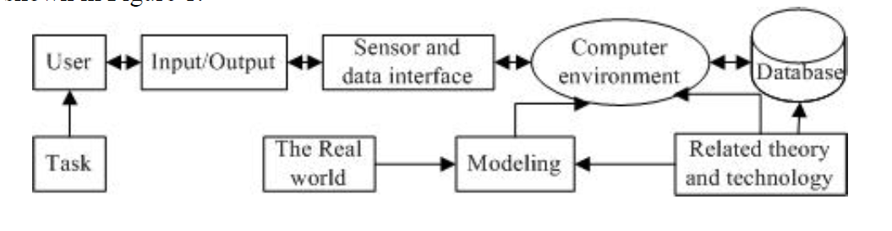

**Figure 1**: Structure of VR system (Feng et al, 2009)

In the virtual reality system, the computer is responsible for generating the virtual world and the realization of human-computer interaction. As the virtual world is a high degree of complexity, making deep into the virtual world a large amount of computing, therefore, virtual reality has higher requirements for the computer system configuration. This shows that the computer is the heart of VR systems. For the realization of the virtual world and natural interaction, it is necessary to adopt special input and output devices to identify various forms of user input and generate real-time feedback to achieve a dialogue between man and computer. The underlying theories and technologies needed to build a virtual environment deliver essential theoretical and technical support. Key functions include modeling geometric objects in the virtual world, physical modeling, behavior modeling, generating three-dimensional virtual stereo images, managing models and implementing real-time display technologies while also setting up and managing a virtual world database that stores comprehensive information about the objects within the virtual setting. Ultimately, virtual reality systems are made available for user applications. The essential technologies associated with Virtual Reality include techniques for modeling large-scale three-dimensional scenes, dynamic real-time generation of visual and auditory elements, three-dimensional positioning systems, interactive software and system integration technologies.

**Components of VR Systems**

A virtual reality (VR) system consists of two main components: hardware and software. The hardware includes the computer or VR engine, along with input and output devices, while the software is divided into database software and application software, as illustrated in the following section.

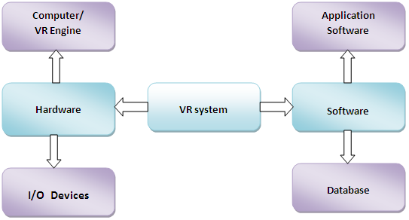

**Figure 2**: A high-level VR system architecture showing the flow between hardware, I/O devices, computer/VR engine, software components and databases (Bamodu & Ye, 2013)

**Virtual Reality System Hardware**: The key hardware components include the computer system or VR engine, as well as input and output devices, as illustrated in Figure 3 below.

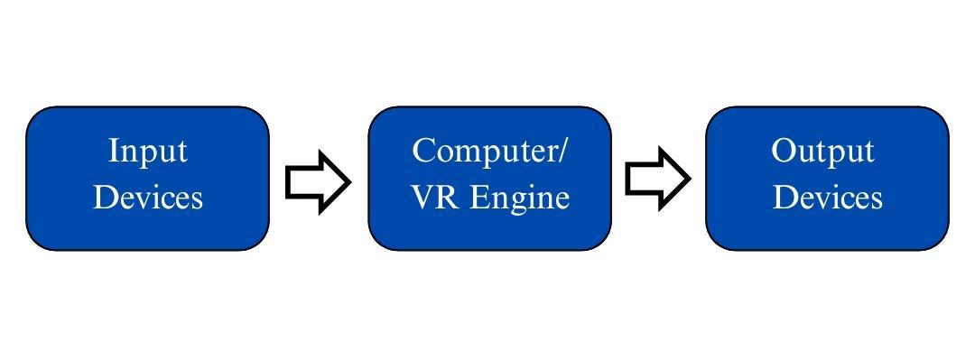

**Figure 3**: Basic data flow in a VR system from input devices through the VR engine to output devices

**Input Devices**: Input devices are the tools that enable the user to engage with the virtual environment. They transmit signals to the system regarding the user's actions, allowing for timely responses through the output devices. These devices can be categorized into tracking devices, pointer input devices, bio-controllers and voice input devices. Tracking devices, also known as position sensors, are utilized to monitor the user's location (Dani & Rajit, 1998) and they encompass electromagnetic, ultrasonic, optical, mechanical and gyroscopic sensors, as well as data gloves, neural and bio or muscular controllers (Craig, William & Jeffrey, 2009). Examples of point-input devices are the 6DOF mouse and force or space ball. These devices utilise technology that builds upon the standard mouse, offering improved functions and features specifically designed for 3D applications. Communication through voice is a prevalent form of interaction among people, making it a logical choice to integrate it into a VR system. Voice recognition or processing software can facilitate this.

**VR Engine**: In virtual reality systems, selecting the appropriate VR engine or computer system is crucial based on the specific needs of the application. Generating graphics and displaying images are among the most critical and labour-intensive tasks in a VR system. The selection of the virtual environment engine is determined by the application area, user preferences, input/output devices, desired level of immersion and required graphic quality, as it is tasked with computing and producing graphical models, rendering objects, providing lighting, performing mapping, applying texturing and displaying simulations in real-time. Additionally, the computer manages user interactions and acts as a bridge with the input/output devices.

A crucial factor to consider when selecting a VR engine is the processing power of the computer. This processing power determines how many sensory elements (such as graphics, sound, haptics, etc.) can be rendered within a given time period, as highlighted. The VR engine must update the virtual environment roughly every 33 milliseconds and maintain a real-time simulation of at least 24 fps (Burdea & Philippe, 2003). Additionally, the accompanying graphics engine should be able to generate stereoscopic images. The VR engine could consist of a standard PC with enhanced processing capabilities and a high-performance graphics card, or it could be a network of distributed computer systems connected via high-speed communication.

**Output Devices:** Output devices receive feedback from the VR engine and relay it to users via the appropriate devices to engage the senses. The various types of output devices can be classified based on the senses: graphics (visual), audio (aural), haptic (touch or force), as well as smell and taste. Among these, the first three are commonly utilized in VR systems, while the latter two are not yet widely adopted. Two prevalent options for graphics include the stereo display monitor and the head-mounted display (HMD), which offers a greater level of immersion. Within the HMD, the brain interprets the two distinct views generated, creating a 3D representation of the virtual environment. Sound plays an important role in VR, second only to visuals in importance. 3D audio can enhance realism by emitting sounds from various locations within the VR application. Haptic technology enables users to experience sensations of virtual objects, which can be realized through electronic signals or mechanical devices.

**Virtual Reality System Software and Tools**: Software for virtual reality systems consists of various tools and applications used for creating, developing and managing virtual environments, as well as the databases that store the associated information. These tools can be categorized into modeling tools and development tools.

**VR Modeling Tools**: There are many modeling tools available for VR designing, the most common ones are , 3ds Max, Maya and Creator. Engineering specific applications may utilize software like CATIA, Pro/E, Solidworks, UG, etc.

**VR Development Tools**: VR is a multifaceted and integrated technology that draws from various other technologies, including real-time 3D graphics, tracking systems, audio processing and haptic feedback, among others, necessitating flexibility in software development and real-time interaction. Beginning the development of a VR system from foundational code in languages like C/C++, Java, OpenGL, etc., demands considerable effort and the reliability of such systems is typically low; hence, VR development tools are utilized.

Careful thought is required in selecting VR development tools because of the variation in flexibility offered by various software packages with respect to model input available, interface compatibility, file format, ease of animation, collision detection, supported I/O devices and support community accessible to the users.

The equipment for developing VR content includes virtual world authoring tools, VR toolkits/software development kits (SDKs) and application programming interfaces (APIs). It is also not unusual to encounter APIs that function as toolkits, such as the OpenGL optimizer and the Java 3D API (Dani & Rajit, 1998; Isdale, n.d.).

**Utilizing VR Simulation for Agricultural Training**

**Development of Virtual Crops:** Virtual reality can give users a powerful feeling of reality and real experience and occupy a new interactive concept-immersed interactive environment. By utilizing this technology, years of crop growth data can be simulated in just a few minutes. This allows for quick operation, observation, testing and collection of crop data (Su *et al.,* 2005).

Virtual crops technology uses virtual reality to replicate the structure, growth processes and environment of crops in a three-dimensional space. It uses a data collecting system to monitor environment factors changes and crops growth trends and to study regular patterns of crops and environment. The virtual crops system is highly valuable for investigating optimal crop models, enhancing growth strategies, shaping crops, designing gardens, and providing educational opportunities (Sun, 2000; Song *et al.,* 2000; Holt & Sonka, 2003).

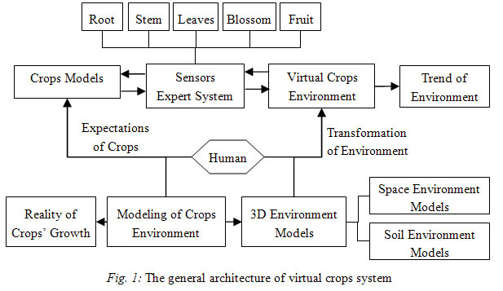.

**Figure 4**: General Architecture of a Virtual Crop System (Li, 2008)

**Precision Agriculture**: Simulation systems have become indispensable tools in modern research and virtual laboratory experiments, providing an advanced platform for in-depth analysis and replication of intricate processes. A prime example of innovation in the agri-food sector is the SIMAGRI platform, a high-fidelity driving simulator specifically designed for tractors and agricultural machinery. Developed to support precision agriculture (PA) research, SIMAGRI employs advanced algorithms and real-time data processing to mimic the dynamic conditions of modern farming practices (Cutini et al., 2023). Beyond enabling rigorous scientific exploration of innovative PA techniques, this cutting-edge system also functions as a critical training resource for professional farm operators. By allowing drivers to refine their skills in a controlled, risk-free virtual environment, SIMAGRI bridges the gap between theoretical knowledge and practical implementation, ultimately fostering the advancement of sustainable and efficient agricultural practices. Through its virtual environment, researchers can evaluate the effects and adjustments of PA operational strategies by either replicating real-world scenarios or designing new ones in diverse contexts and configurations. At present, the simulator includes an agricultural tractor capable of towing or transporting various farming equipment, such as sprayers, seeders, and fertilizer spreaders. It is integrated with embedded sensors and human-machine interfaces, which may include joysticks, consoles, or touchscreens, all connected to four virtual environment displays.

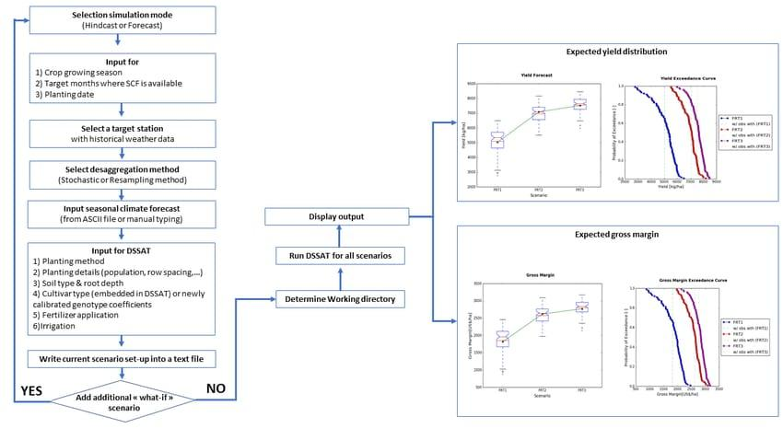

**Figure 5**: SIMAGRI workflow (version 2 linked with SCF) (Sosa *et al.,* 2017)

**Livestock Management:** Climate change effects on farm productivity are more severe now, leading to increased food insecurity. It is important to adopt more sophisticated practices like smart farming instead of conventional methods for increasing production. As a result, livestock farming is quickly transitioning to smart farming systems, driven by rapid advancements in technologies such as cloud computing, the Internet of Things, big data, machine learning, augmented reality and robotics. A Digital Twin (DT), an element of state-of-the-art digital agricultural technology, serves as a virtual representation or model of any physical entity (physical twin) connected through real-time data sharing. A digital twin (DT) continuously mirrors the state of its physical counterpart in real time and can also influence it in return. The application of DTs in the livestock sector is currently in its nascent stage, reflecting a knowledge gap in their holistic application within livestock systems. The application of DTs in livestock has vast potential to promote animal health, welfare and productivity (Arulmozhi *et al.,* 2024). The digital transformation landscape in the livestock sector includes monitoring animals, managing the environment, implementing precision agriculture techniques, and optimizing the supply chain. It emphasizes the significance of collecting quality data, maintaining robust data privacy measures and having seamless data source integration to ensure effective and accurate implementation.

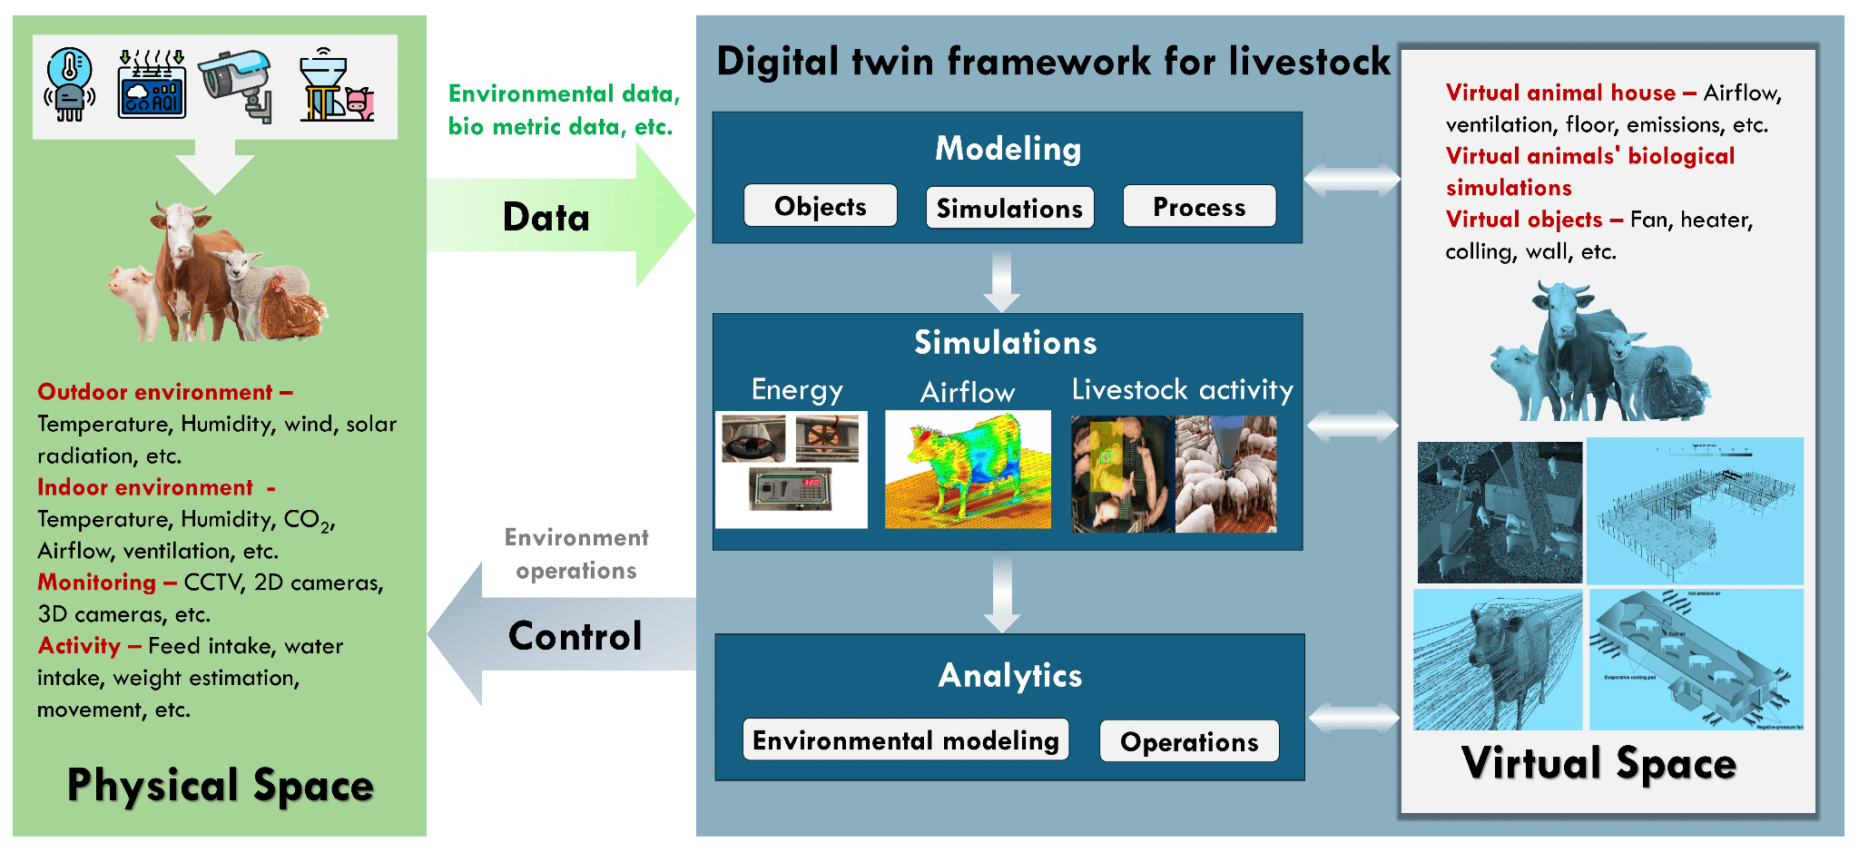

**Figure 6**: Potential application of digital twins in overall livestock management (Arulmozhi *et al.,* 2024)

**Rationale for Adopting Digital Twins in the Livestock Industry**: Even though there has been a recent breakthrough in DT technology, its use in the livestock industry is at the nascent phase of development. However, some industries like aero manufacturing (Ibrion *et al.,* 2019), oil field services (Mayani *et al.,* 2018), software (Brenner & Hummel, 2017), fast-moving consumer goods (Erol, Mendi, & Doğan, 2020) and tire manufacturing (Erol, Mendi, & Doğan, 2020) are already utilizing the benefits of DTs.From the authors’ viewpoint, the analysis of prior studies and reviews suggests that DTs offer numerous benefits for improving livestock production. This includes the following:

* **Precision Livestock Farming**: Health and nutrition are enhanced by technology that utilizes real-time data and monitoring for each individual animal, optimizing productivity on a case-by-case basis. Such growth not only increases animal welfare but also optimizes profitability for livestock farms. This allows farmers the chance to select alternative breeding in order to select based on parameters that give optimal productivity, which may include superior growth rates, fertility, or resistance to diseases. Another strategy involves enhancing genetic progress within herds. Digital twins (DTs) can detect early changes in physiological indicators, behavior, and environmental factors linked to disease. Predictive models provide farmers with early alerts to help minimize mortality and treatment expenses for emerging health problems. By continuously monitoring the animals' physical condition and their immediate environment, it becomes easier to identify signs of discomfort or stress. This approach enhances overall animal welfare, resulting in healthier and more productive livestock.
* **Sustainability and Environmental Impact**: DTs can greatly minimize waste and lessen environmental impact by enhancing the efficiency of feed and water consumption, along with other resources. This results in more sustainable farming practices that align with the increasing global demand for eco-friendly methods of livestock production.
* **Labour Efficiency**: The use of DTs in automation minimizes the requirement for additional human oversight. With a virtual system for monitoring and management, farmers can strategically organize multiple schedules for the feeding and care of their animals, thereby enhancing efficiency and reducing the likelihood of human mistakes.
* **Compliance with Regulations**: Digital twins (DTs) offer comprehensive records of animal health, farm management practices, and environmental impacts, while ensuring adherence to both local and international standards for animal welfare and sustainability. This improves traceability across the supply chain.
* **Remote Management**: Digital twin technology enables farmers to manage livestock operations remotely using cloud-based systems. This capability is essential for multi-site farms or large-scale operations, allowing for improved management without the need for physical presence.
* **Operational Cost Efficiency**: While costlier to establish overall, in the long run, the DTs improve resource efficiency, minimize waste feed and save on healthcare expenditures through early treatment of animal diseases.
* **Training and Education:** The simulated replicas of the livestock system can train employees in innovative management techniques without affecting the real animals, thereby improving the skills and knowledge of farm workers.

**Combating Misinformation on Climate Change:** Misinformation, whether accidental or deliberate, pertains to incorrect or deceptive information (Lewandowsky, Ecker, & Cook, 2020) and can have serious adverse effects on both individuals and society. Misinformation about climate change, especially the denial of its human-induced aspects, can lead to confusion and doubt, which undermines efforts to tackle the problem (van der Linden, 2023). It reduces public backing for mitigation strategies, impeding investments in renewable energy, sustainable development and practices that enhance climate resilience (Winter *et al.,* 2022). Additionally, political divisions and social tensions may emerge from climate change misinformation, creating a split between those who accept the scientific consensus and those who reject or question it (Hart *et al.,* 2015). Combating misinformation, advancing accurate scientific knowledge and encouraging informed public discussions about climate change are essential for fostering a sustainable future.

To comprehensively grasp the psychology and context behind misinformation, it is crucial to explore the impact of contemporary technology (Ecker et al., 2022). Studies suggest that tackling the complexities of the post-truth era demands technological solutions informed by psychological principles (Lewandowsky et al., 2017). Virtual reality (VR) has emerged as a promising tool in this regard, offering immersive environments that allow users to engage deeply with simulated experiences, thereby providing a unique platform for developing and implementing effective corrective measures (Slater & Sanchez-Vives, 2016). By immersing users in realistic, interactive scenarios, VR can challenge and correct false beliefs and assumptions, making it a powerful tool against misinformation (Slater et al., 2020). Additionally, VR can create engaging and memorable experiences that foster critical thinking, learning, and fact-checking (Queiroz et al., 2023). This technology holds the potential to boost media literacy and deepen understanding of intricate issues by allowing users to witness the consequences of misinformation in a controlled setting (Jones et al., 2022). Moreover, VR can be combined with data visualization and interactive storytelling to present factual information in a captivating and impactful way (Krokos et al., 2019; Slater & Sanchez-Vives, 2016).

The same advantages that make VR effective for delivering persuasive messages can also render it a powerful means of spreading misinformation (Ahn, 2021; Brown *et al.,* 2023). Although creating high-quality VR content is challenging and there are currently low levels of familiarity with VR devices, the significant investment in this technology suggests that VR platforms are likely to gain popularity in the future (Trauthig & Woolley, 2023). Therefore, it is increasingly important to comprehend how VR can be used in harmful ways, such as for disinformation campaigns and to develop strategies for countering these activities within the VR environment.

**Supply Chain Management**: Supply chains are becoming increasingly important, with competition shifting from individual companies to entire supply chains (Farahani *et al.,* 2014).The swift development of supply chain management (SCM) as an essential area within operations management is propelled by technological advancements such as digital twin (DT) technology, which is a part of Industry 4.0 progress. Digital twin (DT) technology, originally created by NASA in the 1960s, generates a virtual representation of physical assets and processes, continuously updated through sensor information and analytics. Supported by IoT, cloud computing, AI, robotics and 3D printing (Verboven *et al.,* 2020), digital supply chains derive actionable insights from real-time data, improving efficiency, adaptability and value generation. Initial findings indicate that DT technology enhances performance throughout operations and supply chains.

Contemporary supply chain management (SCM) software encompasses a variety of solutions, including advanced planning and scheduling (APS) systems, warehouse management systems (WMS), and transportation management systems (TMS). Over the last decade, these technologies have streamlined many aspects of supply chain operations, significantly improving collaboration and communication between suppliers, buyers, and logistics providers.

Digital twins can complement existing SCM solutions by acting as an innovative layer that enhances the technology stack. In this way, digital twins can refine data inputs for SCM tools, producing predictive analytics to tackle and respond to numerous possible situations. For example, a multinational OEM created a digital twin to optimize the strategies integrated into its transportation management system (TMS) for managing outbound logistics. Consequently, the OEM achieved an 8 percent reduction in freight and damage costs.

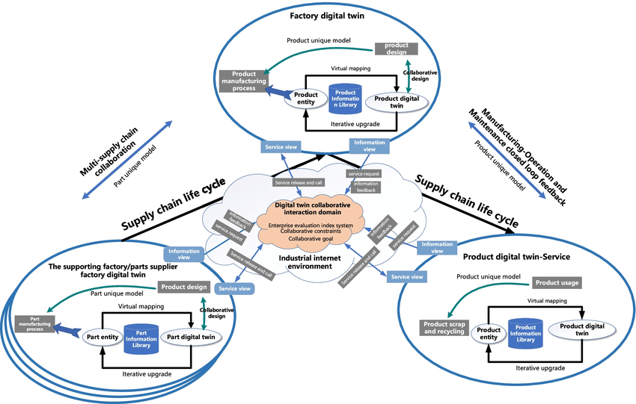

**Figure 7**: Supply chain digital twin system based on a unique product model (Xia *et al.,* 2022)

Digital twins enhance supply chain management (SCM) tools in several ways: Digital twins enable comprehensive integration across supply chain management (SCM) software, providing a unified view of performance and the broader impact of decisions across upstream and downstream operations, thereby eliminating fragmented, isolated systems and fostering collaboration—for instance, a retailer used digital twins to connect planning, inventory, and transportation systems. In volatile markets, especially post-COVID-19, supply chain leaders must adapt to shifting demand and disruptions like port delays or material shortages; digital twins paired with SCM tools offer real-time insights, predictive analytics, and actionable recommendations to mitigate risks, as demonstrated by an OEM that reduced last-mile delivery costs by 5% through monitoring carrier performance and surcharges. Additionally, digital twins help balance competing priorities and complex constraints, enabling rapid responses to market changes, such as an automotive manufacturer dynamically aligning demand with supply and operational challenges to optimize sales and production goals. Furthermore, SCM systems enhanced with digital twins can simulate diverse scenarios by analyzing variables like lead times, demand patterns, and supplier reliability, predicting outcomes to strengthen resilience—for example, a consumer goods company reduced distribution costs by 15% by evaluating fluctuating demand and labor levels in its distribution network.

**Conclusion:** The use of virtual reality (VR) simulation is a huge milestone in agricultural education that surpasses conventional methods by combining immersive technology with actual farming practice. This technology provides a precisely controlled, interactive environment where farmers can address complex scenarios ranging from accurate crop management and animal care to optimizing supply chain operations without the risks associated with hands-on testing. Consequently, VR simulation not only facilitates the growth of essential technical skills but also promotes higher-order decision-making, strategic problem-solving and adaptive learning in environments characterized by uncertainty and complexity. The combination of VR with emerging digital technologies such as digital twin technology, the Internet of Things (IoT), cloud computing and artificial intelligence (AI) further propels its revolutionary potential. Digital twins are always updated virtual representations of physical assets and processes, allowing for the incorporation of real-time sensor data with predictive analytics, which gives stakeholders valuable insights into operations. This collaborative interaction between advanced technologies creates a holistic framework for sustainable, efficient and resilient agriculture, enhancing resource management and environmental care in a more competitive global environment. Further, VR simulation provides advantages well beyond the realm of technical training, solving systemic problems like dissemination and refutation of climate misinformation. Its capacity to produce engaging, multisensory simulations makes VR a powerful medium for increasing media literacy and promoting an enhanced understanding of complex environmental issues. Therefore, VR not only fosters a more educated and adaptable farming labour force but also helps in the development of supply chain management strategies, eventually supporting the strategic improvement of farming activities. In summary, the inclusion of VR simulation in farming education marks the beginning of an era of new education innovation and operational competency. It serves as a productive link between theoretical understanding and functional application, developing a worker base that is not only technically proficient but also strategically resilient in face of rapid technological and environmental changes. Continued research and further innovation in this field will play the key role in unleashing the entire transformative potential of VR, making sure that agriculture remains on the cutting-edge of innovation and sustainable development.

**References:**

Ahn, S. (2021). 9. Designing for persuasion through embodied experiences in virtual reality. In T. De La Hera, J. Jansz, J. Raessens, & B. Schouten (Eds.), Persuasive gaming in context (pp. 163–180). Amsterdam University Press. <https://doi.org/10.1515/9789048543939-011>

Arulmozhi, E., Deb, N. C., Tamrakar, N., Kang, D. Y., Kang, M. Y., Kook, J., Basak, J. K., & Kim, H. T. (2024). From Reality to Virtuality: Revolutionizing Livestock Farming Through Digital Twins. *Agriculture*, **14**(12): 2231. <https://doi.org/10.3390/agriculture14122231>

Bamodu, O., & Ye, X. (2013). Virtual reality and virtual reality system components. *Advanced Materials Research,* 765–767.<https://doi.org/10.2991/icsem.2013.192>

Brenner, B., & Hummel, V. (2017). Digital twin as enabler for an innovative digital shopfloor management system in the ESB Logistics Learning Factory at Reutlingen-University. Procedia Manufacturing, **9**: 198-205.

Brown, J., Bailenson, J., & Hancock, J. (2023). Misinformation in virtual reality. Journal of Online Trust and Safety, **1**(5). <https://doi.org/10.54501/jots.v1i5.120>

Burdea, G. C., & Philippe, C. (2003). *Virtual reality technology* (2nd ed.). John Wiley & Sons, Inc.

Craig, A. B., William, R. S., & Jeffrey, D. W. (2009). *Developing virtual reality applications: Foundations of effective design*. Morgan Kaufmann Publishers.

Cutini, M., Bisaglia, C., Brambilla, M., Bragaglio, A., Pallottino, F., Assirelli, A., Romano, E., Montaghi, A., Leo, E., Pezzola, M., Maroni, C., & Menesatti, P. (2023). A Co-Simulation Virtual Reality Machinery Simulator for Advanced Precision Agriculture Applications. *Agriculture*, **13**(8), 1603. <https://doi.org/10.3390/agriculture13081603>

Dani, T. H., & Rajit, G. (1998). Virtual reality: A new technology for the mechanical engineer. In M. Kutz (Ed.), *Mechanical engineers’ handbook* (2nd ed., pp. 319–327). John Wiley & Sons, Inc.

Ecker, U. K. H., Lewandowsky, S., Cook, J., Schmid, P., Fazio, L. K., Brashier, N., Kendeou, P., Vraga, E. K., & Amazeen, M. A. (2022). The psychological drivers of misinformation belief and its resistance to correction. Nature Reviews Psychology, **1**: 13–29. <https://doi.org/10.1038/s44159-021-00006-y>

Erol, T., Mendi, A. F., & Doğan, D. (2020). Digital transformation revolution with digital twin technology. In 2020 4th international symposium on multidisciplinary studies and innovative technologies (ISMSIT) (pp. 1-7). IEEE.

Farahani, R. Z., Rezapour, S., Drezner, T., & Fallah, S. (2014). Competitive supply chain network design: An overview of classifications, models, solution techniques and applications. *Omega,* **45**: 92–118. <https://doi.org/10.1016/j.omega.2013.08.006>

Feng, Y., Zhang, J., Zhao, Y., Zhao, J., Tan, C., & Luan, R. (2010). The research and application of virtual reality technology in agricultural sciences. *International Federation for Information Processing,* **4**(2): 546-550.

Feng, Y., Zhang, J.-F., Zhao, Y., Zhao, J.-C., Tan, C., et al. (2009, October). The research and application of virtual reality (VR) technology in agriculture science. In *Proceedings of the Third IFIP TC12 International Conference on Computer and Computing Technologies in Agriculture III (CCTA)* (pp. 546–550).<https://doi.org/10.1007/978-3-642-12220-0_79>

Hart, P. S., Nisbet, E. C., & Myers, T. A. (2015). Public attention and concern about climate change: How to build public engagement around a social issue. Wiley Interdisciplinary Reviews: Climate Change, **6**(3): 211–225.

Holt, D. A., & Sonka, S. T. (2003). *Virtual agriculture: Developing and transferring agricultural technology in the 21st century*. Retrieved from<http://www.agr.uiuc.edu/virtagl.html>

Hu, J., Dong, C., Chen, Y., et al. (2009). Application of virtual reality technology in urban 3D geosciences modeling. *Computer Engineering and Design,* **30**(8), 2001-2007.

Ibrion, M., Paltrinieri, N., & Nejad, A. R. (2019). On risk of digital twin implementation in marine industry: Learning from aviation industry. In Journal of Physics: Conference Series (Vol. 1357, No. 1, p. 012009). IOP Publishing.

Isdale, J. (Ed.). *What is virtual reality? A web-based introduction (Version 4)*. <http://vr.isdale.com/WhatIsVR/frames/WhatIsVR4.1.html>

Jones, S., Dawkins, S., & McDougall, J. (Eds.). (2022). Understanding virtual reality challenging perspectives for media literacy and education. Routledge.

Krokos, E., Plaisant, C., & Varshney, A. (2019). Virtual memory palaces: Immersion aids recall. Virtual Reality, **23**(1), 1–9.

Lewandowsky, S., Cook, J., Ecker, U. K. H., Albarracín, D., Amazeen, M. A., Kendeou, P., Lombardi, D., Newman, E. J., Pennycook, G., Porter, E., Rand, D. G., Rapp, D. N., Reifler, J., Rozenbeek, J., Schmid, P., Seifert, C. M., Sinatra, G. M., Swire-Thompson, B., van der Linden, S., & Zaragoza, M. S. (2020). *Under the hood of the Debunking Handbook 2020: A consensus-based handbook of recommendations for correcting or preventing misinformation*. <https://www.climatechangecommunication.org/wp-content/uploads/2020/0/DB20paper.pdf>

Lewandowsky, S., Ecker, U. K. H., & Cook, J. (2017). Beyond misinformation: Understanding and coping with the “post-truth” era. Journal of Applied Research in Memory and Cognition, **6**(4): 353–369.

Li, H. (2008). Analysis of Virtual Reality Technology Applications in Agriculture. In: Li, D. (eds) Computer and Computing Technologies In Agriculture, Volume I. CCTA 2007. The International Federation for Information Processing, vol 258. Springer, Boston, MA. <https://doi.org/10.1007/978-0-387-77251-6_15>

Mayani, M. G., Svendsen, M., & Oedegaard, S. I. (2018). Drilling digital twin success stories the last 10 years. In SPE Norway Subsurface Conference (p. D011S007R001). SPE.

Queiroz, A. C. M., Fauville, G., Abeles, A. T., Levett, A., & Bailenson, J. N. (2023). The efficacy of virtual reality in climate change education increases with amount of body movement and message specificity. Sustainability, **15**(7): 5814.

Shen, W., & Zeng, W. Q. (2009). *Virtual reality technology* [in Chinese]. Tsinghua University Press.

Slater, M., Gonzalez-Franco, M., Vink, R., & Sanchez-Vives, M. V. (2020). Inducing illusory ownership of a virtual body. Frontiers in Robotics and AI, **7**: 1–10. <https://doi.org/10.3389/frobt.2020.00006>

Slater, M., & Sanchez-Vives, M. V. (2016). Enhancing our lives with immersive virtual reality. Frontiers in Robotics and AI, **3**: 74. <https://doi.org/10.3389/frobt.2016.00074>

Song, Y., Jia, W., Guo, Y., et al. (2000). Advances in virtual crops research [in Chinese]. *Computer and Agriculture,* **6**: 6–8.

Sosa, Raquel & Silveira, Fernando & Ibarburu, Maite & Vera andres & Schandy, Javier & Steinfeld, Leonardo. (2017). Sensor Data Analysis and Sensor Management for Crop Monitoring.

Su, Z., Meng, F., Li, K., et al. (2005). Virtual plant modeling based on agent technology [in Chinese]. *Transactions of the CSAE,* **8**, 114–117.

Sun, J. (2000). Agriculture information engineering: Theory, method and application [in Chinese]. *Engineering Science of China,* **3**, 89–91.

Trauthig, I., & Woolley, S. (2023). Addressing hateful and misleading content in the metaverse. Journal of Online Trust and Safety, **1**(5). <https://doi.org/10.54501/jots.v1i5.109>

van der Linden, S. (2023). Foolproof: Why misinformation infects our minds and how to build immunity. W.W. Norton & Company.

Verboven, P., Defraeye, T., Datta, A. K., & Nicolai, B. (2020). Digital twins of food process operations: The next step for food process models? *Current Opinion in Food Science,* **35**: 79-87.

Winter, K., Hornsey, M. J., Pummerer, L., & Sassenberg, K. (2022). Anticipating and defusing the role of conspiracy beliefs in shaping opposition to wind farms. Nature Energy, **7**: 1200–1207.  [https:// doi. org/ 10. 1038/ s4156 0-022-01164-w](https://doi.org/10.1038/s41560-022-01164-w)

Xia, L., Lu, J., Zhang, H., Xu, M., & Li, Z. (2022). Construction and application of smart factory digital twin system based on DTME. *The International Journal of Advanced Manufacturing Technology,* **120**(5-6), 4159–4178. <https://doi.org/10.1007/s00170-022-08971-1>

Zhou, Y., & Calvo, J. V. (2018). *Virtual reality to boost agriculture in Colombia: A report* [Report].<https://doi.org/10.13140/RG.2.2.10052.48006>

Zou, X., Sun, J., He, H., et al. (2004). The development and prospects of virtual reality. *Journal of System Simulation,* **16**(9): 1905-1909.