**Cultivating arecanut in India: challenges, opportunities and sustainable practices**

**Premalatha, K1*. and Soundarya, H.L.1, Keerti Sharma2, Meghana Suresh Nayak2**

**1Centre of Excellence on Watershed Management, University of Agricultural Sciences, Bangalore**

**2 Keladi Shivappa Nayaka University of Agricultural and Horticultural Sciences**

**\*Corrrespondingauthor:** [**kpremalatha1996@gmail.com**](mailto:kpremalatha1996@gmail.com)

**Abstract**

Arecanut cultivation faces numerous challenges and opportunities. Key issues include vulnerability to climatic variations, declining soil fertility, and pest infestations, all of which negatively affect crop yield and quality. Traditional farming methods and limited access to modern agricultural knowledge exacerbate these problems. Additionally, fluctuating market prices contribute to the financial instability of arecanut farmers. However, there are promising prospects for arecanut cultivation. Diversified farming practices, such as intercropping with pepper, banana, and cocoa, and integrated farming systems combining crop production with livestock and fish farming, can enhance productivity and sustainability. Adopting modern agricultural techniques and improving market access can increase yield quality and economic returns. This study emphasizes the need for a holistic approach to arecanut farming, integrating modern technology, diversified farming practices, and strong support systems to address challenges and seize opportunities for a sustainable future in India.

**Keywords:** *Arecanut; Climate; Diversified farming; Integrated farming System; Marketing; Challenges*

**1.Introduction**

[Areca nut](https://en.wikipedia.org/wiki/Areca_nut) (*Areca catechu*), a tropical crop, is popularly known as betel nut, as its common usage in the country is for mastication with [betel](https://en.wikipedia.org/wiki/Betel) leaves. It is a palm tree species under the family of [Arecaceae](https://en.wikipedia.org/wiki/Arecaceae" \o "Arecaceae) (Rangaswami, 1977; Ramappa, 2013). The crop is mainly grown in the states of Karnataka, Kerala, Tamil Nadu, Assam, West Bengal, Meghalaya, Maharashtra and Andaman & Nicobar group of Islands. The economic produce is the fruit called betelnut or 'supari' which is used mainly for mastigatory purpose (Schoneman, 2010; Balanagouda *et al.,* 2021). Areca nut is an essential ingredient of ‘gutka’ and ‘pan masala.’ It is consumed both as a raw/ripe nut (adaka or kacha tamul), as dried ripe nut (chali supari) and as semi-mature, cut and processed varieties `Bateldike’ or `Kalipak’. In India, it is extensively used and is very much linked to religious practices (Nair and Nair, 2021; Palanna *et al.,* 2020).

India is the largest producer of arecanut and at the same time largest consumer also. Major states cultivating this crop are Karnataka (40 per cent), Kerala (25 per cent), Assam (20 per cent), Tamil Nadu, Meghalaya and West Bengal (Bhat *et al.,* 2024).

[Areca](https://en.wikipedia.org/wiki/Betel_nut_tree) nut production in India is dominant in the coastal region within 400 kilometres (250 mi) from the coast line and also in some other non-coastal states of India. Its production in India is the largest in the world, as per [the Food and Agriculture Organization of the United Nations](https://en.wikipedia.org/wiki/Food_and_Agriculture_Organization) (FAO) statistics for 2017, accounting for 54.07% of its world output and is exported to many countries. Within India, as of 2013–14, [Karnataka](https://en.wikipedia.org/wiki/Karnataka) produces 62.69% of the crop followed by [Kerala](https://en.wikipedia.org/wiki/Kerala) and [Assam](https://en.wikipedia.org/wiki/Assam), all three states together account for 88.59% of its production. In the other states of [Meghalaya](https://en.wikipedia.org/wiki/Meghalaya), [Tamil Nadu](https://en.wikipedia.org/wiki/Tamil_Nadu) and [West Bengal](https://en.wikipedia.org/wiki/West_Bengal), where it is also consumed, the crop is grown in a very small area. In Karnataka, in the [Uttara Kannada District](https://en.wikipedia.org/wiki/Uttara_Kannada_District) and [Shivamogga District](https://en.wikipedia.org/wiki/Shivamogga_District) the crop is grown extensively.

**Table 1: Area, production and productivity in India**

|  |  |  |  |
| --- | --- | --- | --- |
| **Year** | **Area (‘000 Ha)** | **Production (‘000 MT)** | **Productivity (kg/ha)** |
| 2004-05 | 364 | 453 | 1245 |
| 2005-06 | 381 | 483 | 1268 |
| 2006-07 | 382 | 473 | 1238 |
| 2008-09 | 387 | 481 | 1243 |
| 2009-10 | 400 | 478 | 1195 |
| 2010-11 | 400 | 478 | 1195 |
| 2011-12 | 464 | 681 | 1468 |
| 2012-13 | 446 | 609 | 1365 |
| 2013-14 | 452 | 622 | 1376 |
| 2014-15 | 450 | 747 | 1660 |
| 2015-16 | 474 | 714 | 1506 |
| 2016-17 | 455 | 723 | 1589 |
| 2017-18 | 497 | 833 | 1676 |
| 2018-19 | 718 | 1144 | 1593 |
| 2019-20 | 732 | 1353 | 1848 |
| 2020-21 | 731 | 1209 | 1654 |
| 2021-22 | 770 | 1400 | 1818 |

**Fig 1: Statiscal analysis of area production and productivity of arecanut in India**

**2. Factors influencing the production and productivity of areca**

**2.1. Climate action**

Weather conditions plays an important role in development and productivity of the crops. As we know arecanut can be grown in varying climatic conditions, but its productivity is highly influenced by weather factors mainly during critical stages of the crop (Jose et al., 2019). About 66 per cent of the crop production is dependent on weather conditions. Change in the climate mainly during intre and intra annual, causes the negative impact on the productivity of the crop (Nellemann et al., 2009). Sujatha *et al.* (2018) reported that the productivity of the crop is highly dependent on weather, which can affect both the quantity and quality of the nut and showed differential response of arecanut to weather variability.

The relationship between yield of areca and weather parameters like temperature, relative humidity and rainfall were critical. Particularly during the flowering stage *i.e.,* January to March, an increase in temperature, relative humidity and rainfall had significant positive effect on nut yield whereas, the rainfall during the nut development stage (from June to July) adversely affected the crop productivity (Sunil *et al.,* 2011).

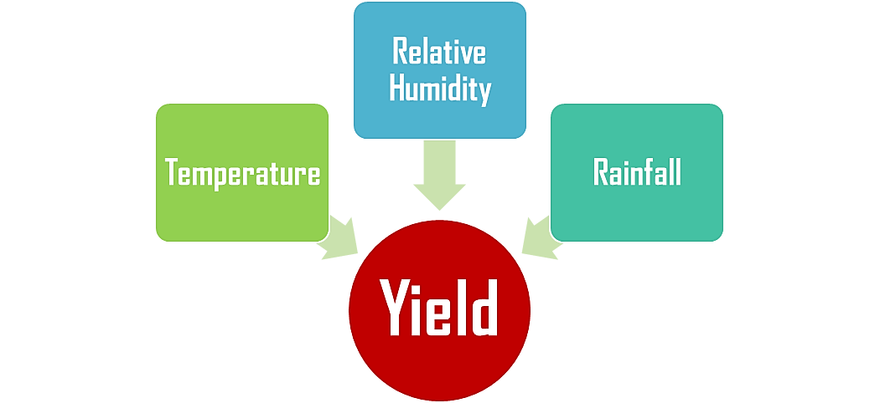Areca production is sensitive to daily temperature, relative humidity, annual rainfall and sunshine hours. Heavy rainfall, high relative humidity and low temperatures are the major constraints in arecanut production mainly in coastal regions of Karnataka. Whereas in other regions low rainfall and high temperatures are major constraints in crop production. High rainfall in malnad regions lead to leaching of nutrients (potassium and calcium) and high relative humidity is responsible for pests and diseases. Heavy rainfalls during fruit development period and evening relative humidity had significant negative effect on yield of arecanut (Sujatha et al., 2017).

**2.2. Temperature**

The maximum temperature during November (31-34 ⁰C), December (32.3-34.4 ⁰C), January (32.8 -34 ⁰C) and May (32.9 -36.2 ⁰C) of the previous year and July (27 -30 ⁰C) and September (29-32 ⁰C) of the current year shows the significantly positive correlation with flowering and fruit setting of areca. In contrast, minimum temperature of 25 ⁰C during May directly influenced the arecanut yield whereas yield declined when the minimum temperature reached more than 25 ⁰C (Jose *et al.,* 2019).

**2.3. Rainfall**

Rainfall has showed significant negative correlation with annual areca yield. In certain case, heavy rainfall during November effects the flowering period of the crop and high rainfall during May and July affects the fruit setting period of areca which indirectly affects the productivity. On an average, the rainfall of 175->1100 mm, reduces the yield and marketing value of the crop (Jose *et al.,* 2019).

**2.4. Humidity**

High relative humidity has negative impact on the arecanut yield. In case, high relative humidity during September (94-97 %), November (91-97 %) and February to may (90-93 %) adversely affects the next year’s yield where as high relative humidity during July, September and October of the current year also had negative impact on yield. Vise versa, decreased RH cent showed increased yield for next year. While in case of summer months (February to may), increased RH of more than 93 per cent, increased the rate of yield reduction.

**2.5. Soil**

Areca nut grows well within the temperature range of 14ºC and 36ºC and is adversely affected by temperatures below 10ºC and above 40ºC. Extremes of temperature and wide diurnal variations are not conducive for the healthy growth of the palms. It can be grown in areas receiving annual rainfall of 750 mm to 4,500 mm. In areas where there is prolonged dry spell, the palms are irrigated. Due to its susceptibility to low temperature, a good crop of areca nut cannot be obtained at an altitude of more than 1000 m MSL.

The largest area under the crop is found in gravelly laterite soils of red clay type. It can also be grown on fertile clay loam soils. Sticky clay, sandy, alluvial, brackish and calcareous soils are not suitable for areca nut cultivation.

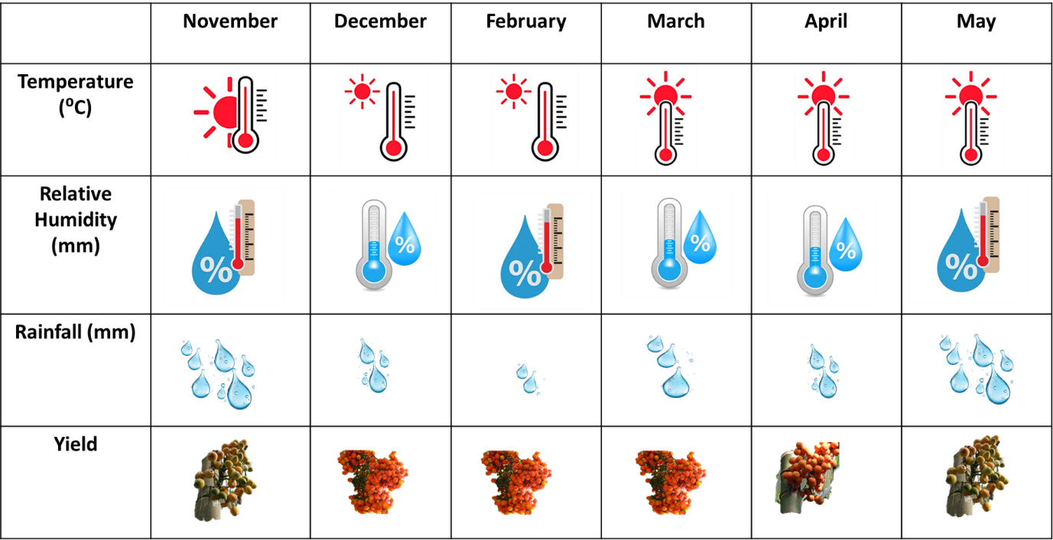**Table 2: Impact of temperature, relative humidity, rainfall on yield of arecanut**

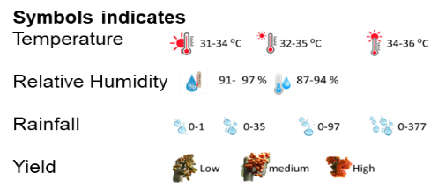

**3. Diversified farming**

Diversified farming is a strategy that integrates various agricultural practices and crops within a single farming system to enhance productivity, sustainability and profitability. It mainly includes functional biodiversity at multiple spatial or temporal scales through the practices developed *via* traditional or agroecological scientific knowledge (Zhang *et al.,* 2007).

Diversified farming in areca plantations is a sustainable and profitable agricultural practice that addresses the challenges of traditional monoculture farming. In arecanut cultivation, diversification plays a crucial role in optimizing resource use, improving soil health, increasing biodiversity and providing multiple sources of income (Sujatha *et al.,* 2016: Sujatha *et al.,* 2011a). Though arecanut is capable of surviving in diverse climatic conditions and its productivity is directly affected by weather factors like rainfall, relative humidity and temperature. Crop diversification in arecanut garden is essential for areca farmers as there are facing the recurring problems (Sunil *et al.,* 2011; Sujatha *et al.,* 2006).

Doubling farmers income is possible through proper planning and adoption of advanced package of practices in which new technologies like high yielding and disease resistant varieties, marketability and post-harvest technological support are provided. By integrating various crops and farming practices, farmers can optimize resource use, enhance soil health, increase biodiversity and achieve economic stability. As global agricultural practices continue to evolve, diversified farming offers a promising pathway towards resilient and sustainable arecanut cultivation (Ray *et al.,* 2011).

**3.1. Important methods of diversified farming in arecanut**

Arecanut is predominantly grown in India and Southeast Asia. Traditional monoculture farming of arecanut can lead to several issues, including soil nutrient depletion, increased vulnerability to pests and diseases and economic risks associated with market fluctuations. Diversified farming addresses these challenges by promoting a more resilient and sustainable agricultural system. The brief information regarding diversified farming in arecanut has been described below.

**3.1.1. Intercropping**

Previous studies reported by Vishwanathan *et al.* (1992) revealed that the availability of congenial microclimate and minute utilization of resources for intercropping in arecanut plantations is very important. The scope for intercropping in plantation crops mainly arecanut crop is well documented (Sujatha *et al.,* 2011).

Intercropping mainly involves growing multiple crops alongside the areca palms. Common intercrops include pepper (*Piper nigrum*), betel vine (*Piper beetle*), banana, cocoa (*Theobroma cacao*) and coffee (Kumar *et al.,* 2016). These crops are compatible with areca is due to their similar shade and water requirements. For instance, pepper vines can climb arecanut palms, while bananas can be planted in between the rows and is represented in the figure 2. This approach maximizes the use of available space, sunlight and soil nutrients, leading to higher overall productivity (Rajaseger *et al.,* 2023: Crews *et al.,* 2018).

**3.1.2. Agroforestry**

Agroforestry integrates trees and shrubs into arecanut farming systems. Planting valuable timber species like teak (*Tectona grandis*) and mahogany (*Swietenia macrophylla*) within or around arecanut plantations can provide long-term income from timber sales (Arunachalam, 2022; Vinodhini *et al.,* 2023).

Additionally, these trees offer shade, reduce wind erosion and enhance biodiversity, contributing to a more table and healthy ecosystem (Barrios *et al.,* 2018).

**3.1.3. Sequential Cropping**

Sequential cropping involves growing different crops in succession within a year on the same land (Gliessman, 1985). Farmers can plant seasonal vegetables such as tomatoes, brinjal, and chili, or legumes like cowpea and green gram, and tuber crops like yam and sweet potato after harvesting arecanut. This practice helps in maintaining soil fertility, improving soil structure, and breaking pest and disease cycles (Thomas *et al.,* 2018; Alexander *et al.,* 2009).

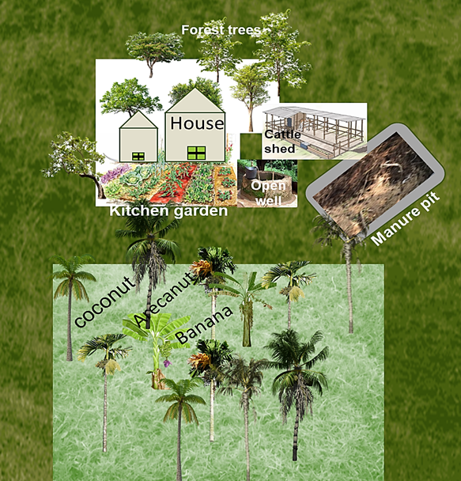

**Fig 2: Cropping systems in arecanut plantation**

**3.1.4. Cover Cropping**

Cover crops are grown primarily to cover the soil rather than for harvest (Baggs, 2000). Leguminous cover crops like cowpea, sun hemp (*Crotalaria juncea*) and green gram are commonly used in arecanut plantations. These plants improve soil fertility through nitrogen fixation, prevent soil erosion and add organic matter to the soil, enhancing its structure and health (Pokharel *et al.,* 2023).

**3.1.5. Alley Cropping**

Alley cropping involves planting rows of trees or shrubs with alleys of crops between them. In arecanut plantations, various annual or perennial crops can be planted in the alleys. This system improves microclimates, enhances biodiversity and provides additional sources of income to the farmers (Mohamad Ashraf *et al.,* 2019).

**3.1.6. Integrated Farming Systems**

Integrated farming systems combine crops with livestock and fish farming. For example, poultry, goats, dairy cows and fish ponds can be integrated into arecanut farms (Walia *et al.,* 2019). This enhances farm resilience, provides multiple sources of income and makes efficient use of resources like water and feed (Paramesh *et al.,* 2022) and is represented in figure 3.

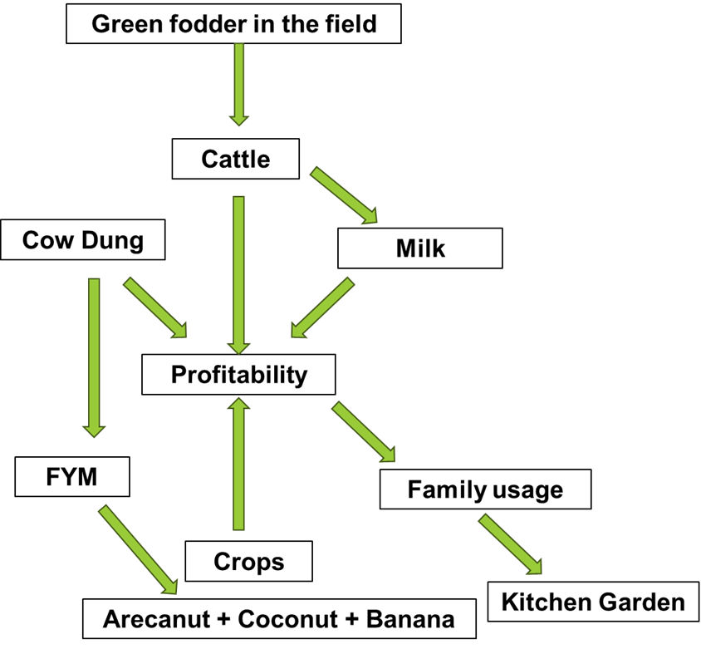

**Fig 3: Profitability through integrated farming systems**

**3.1.7. Organic Farming**

Organic farming emphasizes the use of natural inputs and processes. The practices include composting, green manuring and using biofertilizers and biopesticides (Gamage *et al.,* 2022; Rao *et al.,* 2010). This approach improves soil health, reduces dependence on chemical inputs and can command premium prices in the market.

**3.2. Benefits of diversified farming in arecanut**

* Diversified farming provides multiple income streams, reducing the economic risks associated with price fluctuations and crop failures (Kurdys-Kujawska *et al.,* 2021; Duffy *et al.,* 2021). Farmers can earn from various sources such as pepper, bananas, timber, and livestock, ensuring a more stable and reliable income.
* The inclusion of legumes and cover crops in arecanut plantations improves soil fertility through nitrogen fixation and organic matter addition. Sequential cropping and organic farming practices further enhance soil structure and nutrient availability, leading to healthier and more productive soils (Pandey *et al.,* 2024; Kebede, 2021).
* It enhances biodiversity by introducing various plant and animal species into the farming system (Bengtsson *et al.,* 2005; Scherr *et al.,* 2008). This contributes to a balanced ecosystem, promoting natural pest control and reducing the incidence of diseases.
* By integrating multiple crops and farming practices, diversified farming makes efficient use of available resources such as land, water and sunlight. Intercropping and sequential cropping ensure that no space is wasted and that resources are utilized throughout the year (Yang *et al.,* 2020).
* Farming practices such as agroforestry and organic farming, promote environmental sustainability by reducing reliance on chemical inputs, enhancing soil and water conservation and maintaining ecological balance (Kumar and Singh, 2024).

Integrated agro-ecosystem was explained below in brief to know their importance in areca plantations.

**4. Integrated agro-ecosystem**

Integrated agro-ecosystem in arecanut farming involves incorporating various sustainable agricultural practices to optimize production while minimizing environmental impact. Here are some components of an integrated agro-ecosystem in arecanut farming

* **Crop Diversity:** Intercropping arecanut with compatible crops such as cocoa, pepper, banana or pineapple can enhance soil fertility, reduce pest pressure and provide additional income for farmers.
* **Organic Farming Practices:** Implementing organic farming techniques like composting, mulching and biofertilizers reduces reliance on synthetic inputs, improves soil health and enhances the overall sustainability of the farming system.
* **Water Management:** Efficient water management practices such as drip irrigation or rainwater harvesting can help conserve water resources, especially in regions prone to water scarcity.
* **Agroforestry:** Integrating trees within arecanut plantations, such as nitrogen-fixing trees or fruit trees, contributes to biodiversity, soil fertility and provides additional sources of income.
* **Biological Pest Control:** Encouraging natural predators and beneficial insects, practicing crop rotation and using botanical extracts or biopesticides can effectively manage pests and diseases while minimizing chemical usage.
* **Soil Conservation:** Employing techniques like contour bunding, terracing and cover cropping helps prevent soil erosion, improves moisture retention and maintains soil structure.
* **Integrated Nutrient Management:** Balancing nutrient inputs through the use of organic amendments, green manures and mineral fertilizers based on soil testing optimizes nutrient availability for arecanut plants while minimizing nutrient runoff.
* **Community Involvement:** Engaging local communities in sustainable farming practices through training programs, farmer cooperatives and knowledge-sharing initiatives fosters collective action and promotes the adoption of integrated agro-ecosystems.
* **Agro-ecological Zoning:** Considering local ecological conditions, including climate, soil types and topography, helps tailor farming practices to specific agro-ecological zones, optimizing resource use and resilience to environmental stressors.
* **Market Diversification:** Exploring diverse markets for arecanut products, including value-added products like processed nuts or extracts, enhances market resilience and provides additional income streams for farmers.

By integrating these practices, farmers can develop resilient and sustainable arecanut farming systems that promote both environmental conservation and economic viability

.

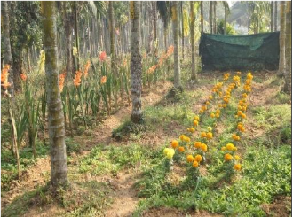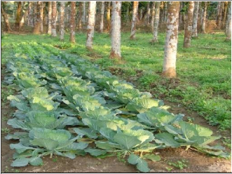

d. Intercropping of vegetable and flower crops in arecanut garden

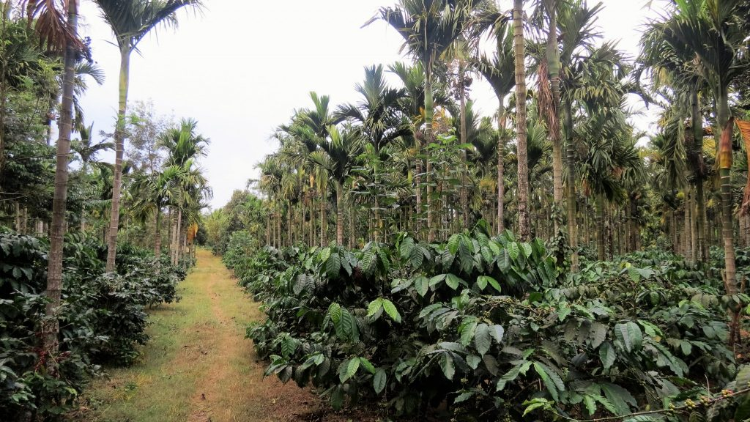

b. Arecanut intercropped with coffee

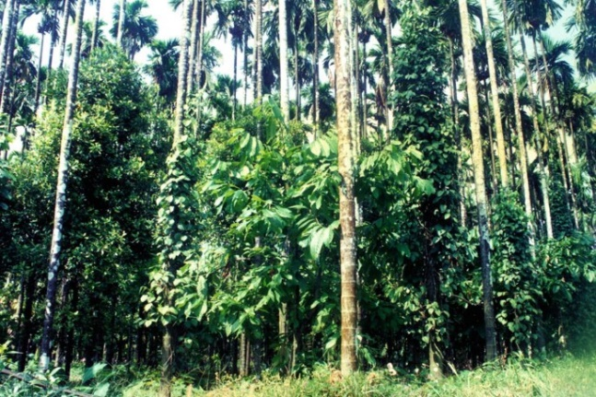

1. Coconut, arecanut and cocoa

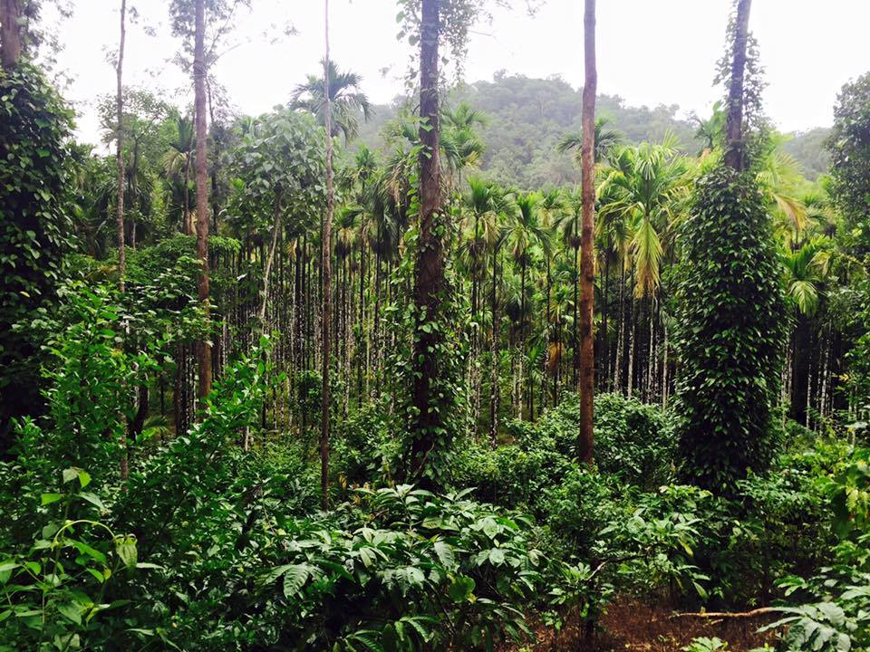

C. Arecanut intercropped with coffee and black pepper

**Fig 4: Representing the different integrated ecosystems**

**5. Integrated farming system in arecanut plantation**

In recent years, several factors such as climate change, degradation of natural resources, declining factor productivity, shrinking landholdings and reduced profitability have increased vulnerability to biotic and abiotic stresses in the agriculture sector (Behera and France, 2016; Tuo misto *et al.,* 2017; Agovino *et al.,* 2019). Additionally, traditional monocropping practices have led to reduced farm productivity, degradation of ecosystem functions, deterioration of soil health, loss of biodiversity (Clark *et al.*, 2017; Yang *et al.*, 2020; Panklang *et al.*, 2022) and altered soil food web interactions (Pervaiz *et al.*, 2020). To address these challenges, crop diversification is essential, as it enhances profitability, soil fertility and resilience to climate change (Nunes *et al.*, 2018; Mishra *et al.*, 2022).

The Integrated Farming System (IFS) involves integrating crop production with livestock, fish, poultry, plantation crops and other systems in a sustainable and holistic manner and is presented in figure 3. This approach improves soil fertility, enhances synergies among components and recycles resources, leading to higher crop production and economic returns (Paramesh *et al.*, 2021; Palsaniya *et al.*, 2022).

IFS models are more resilient to extreme weather conditions, reduce dependence on external inputs, utilize natural resources efficiently and exhibit favorable crop-livestock interactions, while also providing employment, food and nutritional security (Paramesh *et al.*, 2019; Sneessens *et al.*, 2019; Walia *et al.*, 2019). Furthermore, IFS involving agroforestry, agri-silvi-horti-pastoral or horticultural components reduces soil erosion, sustains soil health and ensures food security (Choudhury *et al.*, 2022). IFS also aids in biodiversity conservation through the integration of diversified crops, indigenous livestock breeds and regional bird species, ultimately contributing to food and nutrition security (Ranganathan *et al.*, 2008; Paramesh *et al.*, 2022).

The west coast region of India, rich in natural resources and home to the Western Ghats, a global biodiversity hotspot, has been under cultivation for over 2000 years (Ranganathan *et al.*, 2008). In this region, plantation crops such as arecanut and coconut dominate. The arecanut-based farming system, prevalent in this area, typically includes perennial plantation crops like arecanut and coconut, mixed with banana, nutmeg, black pepper, betel leaf, other spices, vegetables, flowers and forest trees, integrated with a dairy component. However, the risk associated with arecanut cultivation has increased due to fluctuating prices and reduced profitability (Jaya sekhar *et al.*, 2012; Manjunath *et al.*, 2017). Diversifying income sources by integrating multiple components into the arecanut-based farming system can ensure income security (Sujatha and Bhat, 2015; Paramesh *et al.*, 2022). Studies by Aditya *et al.* (2017) found that the arecanut-based farming system is economically viable, improving the economic status of farmers and reducing poverty. Bhargavi and Behera (2020) concluded that the income of small and marginal farmers can be improved by diversifying the IFS system compared to conventional systems.

**6. Impacts of illiteracy and lack of technical knowledge on scientific cultivation**

Many farmers rely on traditional methods passed down through generations. These methods may not be efficient or sustainable in the long term (Hamadani *et al.,* 2021; Sekhar *et al.,* 2024). Without knowledge of modern techniques, farmers may not optimize inputs such as water, fertilizers and pesticides, leading to lower yields and poor-quality produce (Melash *et al.,* 2023).

Illiteracy and lack of technical knowledge hinder the use of technological tools like mobile apps, online resources and digital platforms that provide valuable information on farming practices (Bai *et al.,* 2023; Zondi *et al.,* 2024). Farmers may not be able to interpret and apply findings from scientific research on crop management, pest control, and disease prevention (Jena *et al.,* 2023).

Limited understanding of market dynamics can prevent farmers from accessing better markets or getting fair prices for their produce (Magesa *et al.,* 2014; D’souza, 2020; Bizikova *et al.,* 2020). Illiteracy can lead to poor financial management, making it difficult for farmers to take advantage of credit facilities, insurance and subsidies offered by the government.

Without knowledge of sustainable farming practices, farmers might overuse chemical inputs, leading to soil degradation, water pollution, and a decline in biodiversity. Farmers may lack the knowledge to adapt to changing climate conditions, making their crops more vulnerable to extreme weather events (Ahsan *et al.,* 2021; Dhanaraju *et al.,* 2022; Gamage *et al.,* 2023).

These can provide hands-on training in scientific cultivation techniques, pest management, and sustainable practices (Waddington *et al.,* 2014). Initiatives to improve basic literacy among farmers can empower them to access and utilize agricultural information effectively (Yang *et al.,* 2008; Tamo *et al.,* 2022). Deploying more extension officers to rural areas to provide personalized guidance and support to farmers (Singh *et al.,* 2014; Mungai et al., 2018). Setting up model farms where farmers can see the benefits of scientific cultivation practices firsthand (Rai *et al.,* 2023).

Developing and promoting user-friendly mobile applications that provide information in local languages and through audio-visual means for illiterate farmers (Patel and Patel, 2016; Rege and Nagarkar, 2010). Leveraging local media to broadcast educational programs on modern farming techniques and market information (Razaque and Sallah, 2013).

Providing financial incentives for farmers to adopt new technologies and practices (De Vries *et al.,* 2005; Alimohammad *et al.,* 2022). Collaborations between the government, private sector, and NGOs to fund and implement training and support programs. Encouraging the formation of farmer cooperatives to facilitate shared learning, collective bargaining and easier access to resources. Promoting peer-to-peer learning where experienced farmers mentor others in their community (Ramberg, 2020; Bose *et al.,* 2017).

**7. Conclusion**

Arecanut cultivation signifies the challenges and promising opportunities for farmers. The key issues identified include climatic vulnerabilities, such as temperature fluctuations and heavy rainfall, which adversely affect crop productivity. Soil fertility degradation and pest infestations further exacerbate these problems. Farmers' reliance on traditional methods, coupled with limited access to modern agricultural techniques and market information, hinders their ability to maximize productivity and profitability. The volatile market prices of arecanut also contribute to financial instability among farmers, creating a precarious economic environment. However, the prospects for arecanut cultivation are encouraging. Embracing diversified farming practices, such as intercropping and integrated farming systems, can significantly enhance productivity and sustainability. Integrating compatible crops like pepper, banana and cocoa within arecanut plantations can optimize resource use, improve soil health, and provide additional income streams. Moreover, the adoption of modern agricultural technologies and improved market access can lead to higher yields and better-quality produce, ultimately improving the economic viability of arecanut farming. To achieve a sustainable and profitable future for arecanut cultivation, a comprehensive approach is essential. This includes enhancing farmers' knowledge through training and extension services, promoting diversified and integrated farming practices and ensuring better access to markets and modern technologies. By addressing these challenges and leveraging the opportunities, arecanut farmers can achieve greater resilience, economic stability and long-term sustainability in their farming practices.

**References:**

Aditya, K.S., Praveen, K.V. and Kammardi, T.N.P., 2017. Integrated farming systems and income security: the case of arecanut farmers in Karnataka, *India. Econ. Aff*., 62, 243–251. <https://doi.org/10.5958/0976-4666.2017.00006.7>.

Agovino, M., Casaccia, M., Ciommi, M., Ferrara, M. and Marchesano, K., 2019. Agriculture, climate change and sustainability: the case of EU-28. *Ecol. Indicat.,* 105, 525–543. <https://doi.org/10.1016/j.ecolind.2018.04.064>.

Ahsan, D., Brandt, U.S. and Faruque, H., 2021. Local agricultural practices to adapt with climate change. Is sustainability a priority?. *Current Research in Environmental Sustainability*, *3*, p.100065.

Alexander, D., Rajan, S., Rajamony, L., Ushakumari, K. and Kurien, S., 2009. The adhoc Package of Practices recommendations for organic farming. *Organic farming*.

Alimohammad, M., Hosseini, S.J.F., Mirdamadi, S.M. and Dehyouri, S., 2022. Collaborative networking among agricultural production cooperatives in Iran. *Heliyon*, *8*(11).

Baggs, E.M., Watson, C.A. and Rees, R.M., 2000. The fate of nitrogen from incorporated cover crop and green manure residues. *Nutrient cycling in agroecosystems*, *56*, pp.153-163.

Bai, Q., Chen, H., Zhou, J., Li, G., Zang, D., Sow, Y. and Shen, Q., 2023. Digital literacy and farmers’ entrepreneurial behaviour-Empirical analysis based on CHFS2019 micro data. *Plos one*, *18*(7), p.e0288245.

Balanagouda, P., Vinayaka, H., Maheswarappa, H.P. and Narayanaswamy, H., 2021. Phytophthora diseases of arecanut in India: Prior findings, present status and future prospects. *Indian Phytopathology*, *74*(3), pp.561-572.

Barrios, E., Valencia, V., Jonsson, M., Brauman, A., Hairiah, K., Mortimer, P.E. and Okubo, S., 2018. Contribution of trees to the conservation of biodiversity and ecosystem services in agricultural landscapes. *International Journal of Biodiversity Science, Ecosystem Services & Management*, *14*(1), pp.1-16.

Behera, U.K. and France, J., 2016. Integrated farming systems and the livelihood security of small and marginal farmers in India and other developing countries. In: Sparks, D.L. (Ed.), Advances in Agronomy. Academic Press, pp. 235–282.

Bengtsson, J., Ahnstrom, J. and Weibull, A.C., 2005. The effects of organic agriculture on biodiversity and abundance: a meta‐analysis. *Journal of applied ecology*, 42(2), pp.261-269.

Bhargavi, B. and Behera, U., 2020. Securing the livelihood of small and marginal farmers by diversifying farming systems. Curr. Sci. 119, 854–860.

Bhat, R., Sujatha, S., Bhavishya, Priya, U.K., Gupta, A. and Uchoi, A., 2024. Arecanut (Areca catechu L.). In *Soil Health Management for Plantation Crops: Recent Advances and New Paradigms* (pp. 177-206). Singapore: Springer Nature Singapore.

Bizikova, L., Nkonya, E., Minah, M., Hanisch, M., Turaga, R.M.R., Speranza, C.I., Karthikeyan, M., Tang, L., Ghezzi-Kopel, K., Kelly, J. and Celestin, A.C., 2020. A scoping review of the contributions of farmers’ organizations to smallholder agriculture. *Nature Food*, *1*(10), pp.620-630.

Bose, S., Al-Jabri, O., Osman, N., Al Habsi, S. and Al Shidi, R., 2017. Role of small and medium enterprises and agricultural cooperatives in promoting sustainable agriculture for rural development and food security. *Amity Journal of Agribusiness*, *2*(2), pp.1-21.

Choudhury, B.U., Nengzouzam, G., Mandal, S., Sethy, B.K., Hazarika, S., Mishra, V.K., 2022. Long-term effect of integrated farming systems on soil erosion in hilly micro watersheds (Indian Eastern Himalayas). *Land Degrad. Dev.,* 33, 2554-2566.

Clark, K.M., Boardman, D.L., Staples, J.S., Easterby, S., Reinbott, T.M., Kremer, R.J., Kitchen, N.R., Veum, K.S., 2017. Crop yield and soil organic carbon in conventional and no-till organic systems on a claypan soil. *Agron. J.,* 109, 588-599.

Crews, T.E., Carton, W. and Olsson, L., 2018. Is the future of agriculture perennial? Imperatives and opportunities to reinvent agriculture by shifting from annual monocultures to perennial polycultures. *Global Sustainability*, *1*, p.e11.

D’souza, R., 2020. Improving access to agricultural credit: New perspectives. *Occasional Paper*, *230*.

De Vries, F.P., Sally, H. and Inocencio, A., 2005. *Opportunities for private sector participation in agricultural water development and management* (Vol. 100). IWMI.

Dhanaraju, M., Chenniappan, P., Ramalingam, K., Pazhanivelan, S. and Kaliaperumal, R., 2022. Smart farming: Internet of Things (IoT)-based sustainable agriculture. *Agriculture*, *12*(10), p.1745.

Duffy, C., Toth, G.G., Hagan, R.P., McKeown, P.C., Rahman, S.A., Widyaningsih, Y., Sunderland, T.C. and Spillane, C., 2021. Agroforestry contributions to smallholder farmer food security in Indonesia. *Agroforestry Systems*, *95*(6), pp.1109-1124.

Gamage, A., Gangahagedara, R., Gamage, J., Jayasinghe, N., Kodikara, N., Suraweera, P. and Merah, O., 2023. Role of organic farming for achieving sustainability in agriculture. *Farming System*, *1*(1), p.100005.

Gliessman, S.R., 1985. Multiple cropping systems: A basis for developing an alternative agriculture. In *US Congress Office of Technology Assessment. Innovative biological technologies for lesser developed countries: workshop proceedings. Congress of the USA. Washington, DC, USA* (pp. 67-83).

Hamadani, H., Rashid, S.M., Parrah, J.D., Khan, A.A., Dar, K.A., Ganie, A.A., Gazal, A., Dar, R.A. and Ali, A., 2021. Traditional farming practices and its consequences. *Microbiota and Biofertilizers, Vol 2: Ecofriendly Tools for Reclamation of Degraded Soil Environs*, pp.119-128.

Hebbar K.B., Neethu P., Sukumar P.A., Sujithra M., Santhosh A., Ramesh S.V., Niral V., Hareesh G.S., Nameer P.O. and Prasad P.V.V. Understanding physiology and impacts of high temperature stress on the progamic phase of coconut (*Cocos nucifera* L.) *Plants.*2020;9(12):1651.

Jayasekhar, S., Jose, C.T., Thamban, C. and Muralidharan, K., 2012. Economic impact of arecanut based cropping systems: a study of Dakshina Kannada district-Karnataka. *J. Plant. Crops*, 40, 50-55.

Jena, P., Chauhan, A.S., Tigga, A.S., Kumar, S., Kumari, M., Behera, S.K., Homa, F. and Saryam, M., 2023. Problems Faced by Farmers Using Digital Tools in Agriculture in Central Zone of India. *Asian Journal of Agricultural Extension, Economics & Sociology*, *41*(10), pp.311-316.

Jose, C. T., Chandran, K. P., Muralidharan, K., and Jayasekhar, S. (2019). Crop weather relationship in arecanut. *Journal of Plantation Crops*, *47*(3), 145-151.

Kebede, E., 2021. Contribution, utilization, and improvement of legumes-driven biological nitrogen fixation in agricultural systems. *Frontiers in Sustainable Food Systems*, *5*, p.767998.

KUMAR, H. and SINGH, S.K., 2024. Simple Techniques for Improving Sustainability in Agriculture: Practical Solutions for Farmers.

Kumara, N., Farooquee, N.A. and Sasidhar, P.V.K., 2016. Performance of Areca catechu and Piper betle as a mixed cropping under organic condition in Tumkur district of Karnataka.

Kurdys-Kujawska, A., Strzelecka, A. and Zawadzka, D., 2021. The impact of crop diversification on the economic efficiency of small farms in Poland. *Agriculture*, *11*(3), p.250.

Magesa, M.M., Michael, K. and Ko, J., 2014. Access to agricultural market information by rural farmers in Tanzania.

Manjunath, B.L., Paramesh, V., Mahajan, G.R., Das, B., Reddy, K.V., Chakurkar and E.B., Singh, N.P., 2017. Sustainability through resource recycling, soil fertility and carbon sequestration from integrated farming systems in West Coast India. *Bioscan* 12, 1875-1880.

Melash, A.A., Bogale, A.A., Migbaru, A.T., Chakilu, G.G., Percze, A., Abraham, E.B. and Mengistu, D.K., 2023. Indigenous agricultural knowledge: A neglected human based resource for sustainable crop protection and production. *Heliyon*, *9*(1).

Mishra, A.K., Sinha, D.D., Grover, D., Roohi Mishra, S., Tyagi, R., Sheoran, H.S., Sharma, S., 2022. Regenerative agriculture as climate smart solution to improve soil health and crop productivity thereby catalysing farmers' livelihood and sustainability. In: Rani, M., Chaudhary, B.S., Jamal, S., Kumar, P. (Eds.), Towards Sustainable Natural Resources: Monitoring and Managing Ecosystem Biodiversity. Springer International Publishing, Cham, pp. 295–309. https://doi.org/10.1007/ 978-3-031-06443-2_16.

Mohamad Ashraf, M.A., Ruzana Sanusi, R.S., Raja Zulkifli, R.Z., Tohiran, K.A., Ramle Moslim, R.M., Ashton-Butt, A. and Badrul Azhar, B.A., 2019. Alley-cropping system increases vegetation heterogeneity and moderates extreme microclimates in oil palm plantations.

Mungai, C., Muchaba, T., Szilagyi, L., Radeny, M.A., Atakos, V. and Ntiokam, D., 2018. Youth Engagement in Climate-Smart Agriculture in Africa: Opportunities and Challenges.

Nair, K.P. and Nair, K.P., 2021. Arecanut (Areca Catechu L.). *Tree Crops: Harvesting Cash from the World's Important Cash Crops*, pp.1-25.

Nellemann, C. (Ed.). (2009). The environmental food crisis: the environment's role in averting future food crises: a UNEP rapid response assessment. UNEP/Earthprint.

Nunes, M.R., van Es, H.M., Schindelbeck, R., Ristow, A.J., Ryan, M., 2018. No-till and cropping system diversification improve soil health and crop yield. *Geoderma,* 328, 30–43. <https://doi.org/10.1016/j.geoderma.2018.04.031>.

Palanna, K.B., Shreenivasa, K.R., Basavaraj, S. and Narendrappa, T., 2020. Review of genus Ganoderma causing basal stem rot (coconut) and foot rot (arecanut) with respect etiology and management.

Palsaniya, D.R., Kumar, S., Das, M.M., Kumar, T.K., Chaudhary, M., Chand, K., Rai, S.K., Ahmed, A., Kumar, S., Sahay, C.S., 2022. Ecosystem services from smallholder dairy based integrated farming system vis-a-vis double cropping. *Agroecol. Sustain. Food Syst.,* 46, 1456–1481. <https://doi.org/10.1080/21683565.2022.2108192>.

Pandey, A., Tiwari, P., Manpoong, C. and Jatav, H.S., 2024. Agroforestry for Restoring and Improving Soil Health. In *Agroforestry to Combat Global Challenges: Current Prospects and Future Challenges* (pp. 147-164) Springer Nature Singapore.

Panklang, P., Thaler, P., Thoumazeau, A., Chiarawipa, R., Sdoodee, S., Brauman, A., 2022. How 75 years of rubber monocropping affects soil fauna and nematodes as the bioindicators for soil biodiversity quality index. *Acta Agric. Scand.- B Soil Plant Sci.,* 72, 612–622. <https://doi.org/10.1080/09064710.2022.2034930>.

Paramesh, V., Arunachalam, V., Nath, A.J., 2019. Enhancing ecosystem services and energy use efficiency under organic and conventional nutrient management system to a sustainable arecanut based cropping system. *Energy*, 187, 115902. https://doi.org/ 10.1016/j.energy.2019.115902.

Paramesh, V., Chakurkar, E.B., Bhagat, T., Sreekanth, G.B., Kumar, H.B.C., Rajkumar, S., Gokuldas, P.P., Mahajan, G.R., Manohara, K.K., Ravisankar, N., 2021. Impact of integrated farming system on residue recycling, nutrient budgeting and soil health. *Indian J. Agric. Sci.,* 91, 44–48.

Paramesh, V., Ravisankar, N., Behera, U., Arunachalam, V., Kumar, P., Solomon Rajkumar, R., Dhar Misra, S., Mohan Kumar, R., Prusty, A.K., Jacob, D. and Panwar, A.S., 2022. Integrated farming system approaches to achieve food and nutritional security for enhancing profitability, employment, and climate resilience in India. *Food and energy security*, *11*(2), p.e321.

Paramesh, V., Ravisankar, N., Behera, U., Arunachalam, V., Kumar, P., Solomon Rajkumar, R., Dhar Misra, S., Mohan Kumar, R., Prusty, A.K., Jacob, D., Panwar, A.S., Mayenkar, T., Reddy, V.K., Rajkumar, S., 2022. Integrated farming system approaches to achieve food and nutritional security for enhancing profitability, employment, and climate resilience in India. *Food Energy Secur.,* 11, e321. https:// doi.org/10.1002/fes3.321.

Patel, H. and Patel, D., 2016. Survey of android apps for agriculture sector. *International Journal of Information Sciences and Techniques*, *6*(1-2), pp.61-67.

Pervaiz, Z.H., Iqbal, J., Zhang, Q., Chen, D., Wei, H., Saleem, M., 2020. Continuous cropping alters multiple biotic and abiotic indicators of soil health. *Soil Syst.,* 4, 59. <https://doi.org/10.3390/soilsystems4040059>.

Pokharel, S.S., Yu, H., Fang, W., Parajulee, M.N. and Chen, F., 2023. Intercropping cover crops for a vital ecosystem service: A review of the biocontrol of insect pests in tea agroecosystems. *Plants*, *12*(12), p.2361.

Rai, A.K., Singh, B.V., Bharti, S.D. and Saikanth, D.R.K., 2023. Agricultural Extension's Key Role in Modern Farming: A Review. *Asian Journal of Agricultural Extension, Economics & Sociology*, *41*(9), pp.475-485.

Rajaseger, G., Chan, K.L., Tan, K.Y., Ramasamy, S., Khin, M.C., Amaladoss, A. and Haribhai, P.K., 2023. Hydroponics: current trends in sustainable crop production. *Bioinformation*, *19*(9), p.925.

Ramappa, B.T., 2013. Economics of areca nut cultivation in Karnataka, a case study of Shivamogga District. *Journal of Agriculture and Veterinary Science*, *3*(1), pp.50-59.

Ramberg, L., 2020. Farmer knowledge sharing and social networks in agricultural extension.

Ranganathan, J., Daniels, R.J.R., Chandran, M.D.S., Ehrlich, P.R., Daily, G.C., 2008. Sustaining biodiversity in ancient tropical countryside. *Proc. Natl. Acad. Sci.,* USA 105, 17852–17854. <https://doi.org/10.1073/pnas.0808874105>.

Rangaswami, G., 1977. Palm tree crops in India. *Outlook on Agriculture*, *9*(4), pp.167-173.

Rao, V.P., Veeraraghavaiah, R., Hemalatha, S. and Joseph, B., 2010. Farming systems and sustainable agriculture.

Ray A K, Acharya G C, Maheswarappa H P and Krishnakumar V.2011. Arecanut based cropping systems in North East Region of India. Arecanut based Cropping/Farming Systems, pp 45–54.

Razaque, A. and Sallah, M., 2013. The use of mobile phone among farmers for agriculture development. *Int. J. Sci. Res.*, *2*, pp.95-98.

Rege, R. and Nagarkar, S., 2010, March. Krishi-Mitra: case study of a user-centric ICT solution for semi-literate and illiterate farmers in India. In *India HCI 2010/Interaction Design & International Development 2010*. BCS Learning & Development.

Scherr, S.J. and McNeely, J.A., 2008. Biodiversity conservation and agricultural sustainability: towards a new paradigm of ‘eco-agriculture’ landscapes. *Philosophical Transactions of the Royal Society B: Biological Sciences*, *363*(1491), pp.477-494.

Schoneman, J.P., 2010. Overview of uses of palms with an emphasis on old world and Australasian medicinal uses.

Sekhar, M., Rastogi, M., CM, R., Saikanth, D.R.K., Rout, S., Kumar, S. and Patel, A.K., 2024. Exploring Traditional Agricultural Techniques Integrated with Modern Farming for a Sustainable Future: A Review. *Journal of Scientific Research and Reports*, *30*(3), pp.185-198.

Singh, K.M., Meena, M.S., Swanson, B.E., Reddy, M.N. and Bahal, R., 2014. In-Depth Study of the Pluralistic Agricultural Extension System in India.

Sneessens, I., Sauvee, L., Randrianasolo-Rakotobe and H., Ingrand, S., 2019. A framework to assess the economic vulnerability of farming systems: application to mixed crop livestock systems. *Agric. Syst.*

Sujatha S, Bhat Ravi, Kannan C and Balasimha D. 2011a. Impact of intercropping of medicinal and aromatic plants with organic farming approach on resource use efficiency in arecanut (Arecacatechu L.) plantation in India. Industrial Crops and Products 33(1): 78–83.

Sujatha, S., Bhat, R. and Chowdappa, P., 2016. Cropping systems approach for improving resource use in arecanut (*Areca catechu*) plantation.

Sujatha, S., Bhat, R., 2015. Resource use and benefits of mixed farming approach in arecanut ecosystem in *India. Agric. Syst.* 141, 126–137.

Sujatha, S., Bhat, R., Balasimha, D. and Kannan, C., 2006. Crop diversification in arecanut plantation through intercropping of medicinal and aromatic plants.

Sujatha, S., Bhat, R., Kannan, C. and Balasimha, D., 2011. Impact of intercropping of medicinal and aromatic plants with organic farming approach on resource use efficiency in arecanut (Areca catechu L.) plantation in India. *Industrial crops and products*, *33*(1), pp.78-83.

Sujatha, S., Ravi Bhat and Elain Apshara, S. 2018. Climate change, weather variability and associated impact on arecanut and cocoa in humid tropics of India.

Sujatha, S., Ravi, B. and Chowdappa, P. 2017. Soil health management in arecanut and cocoa. Today & Tomorrow’s Printers and Publishers.

 Sunil K.M., Devadas V.S., George P.S. Influence of weather parameters on yield and yield attributes of areca nut (*Areca catechu* L.) *J. Agric. Phys.,*2011;11:88–90.

Tamo, M., Glitho, I., Tepa-Yotto, G. and Muniappan, R., 2022. How does IPM 3.0 look like (and why do we need it in Africa)?. *Current Opinion in Insect Science*, *53*, p.100961.

Thomas G V, Krishnakumar V, Maheshwarappa H P, BhatRavi and Balasimha D (Eds). CPCRI,Kasaragod.

Thomas, G.V., Krishnakumar, V., Dhanapal, R. and Srinivasa Reddy, D.V., 2018. Agro-management practices for sustainable coconut production. *The coconut palm (Cocos nucifera L.)-research and development perspectives*, pp.227-322.

Tuomisto, H.L., Scheelbeek, P.F.D., Chalabi, Z., Green, R., Smith, R.D., Haines, A., Dangour, A.D., 2017. Effects of environmental change on agriculture, nutrition and health: a framework with a focus on fruits and vegetables. Wellcome Open Res 2, 21. <https://doi.org/10.12688/wellcomeopenres.11190.2>.

Vijaya kumar B.G., Veerappadevaru G., Balasimha D., Abdul Khader K.B., Ranganna G. Influence of weather on areca nut and coconut yield. *J. Plant. Crops.*1991; 19:33–36.

Vinodhini, S.M., Manibharathi, S., Pavithra, G. and Sakthivel, S., 2023. Agroforestry: Integrating Trees into Agricultural Systems. *Recent Approaches in Agriculture Volume*, *2*, pp.246-272.

Viswanathan, V., Radhakrishnan, R., Reghunath, R. and Sosamma Cherian, S.C., 1992. Patchouli (*Pogostemon cablin*) as an intercrop in young coconut (*Cocos nucifera*) garden.

Waddington, H., Snilstveit, B., Hombrados, J., Vojtkova, M., Phillips, D., Davies, P. and White, H., 2014. Farmer field schools for improving farming practices and farmer outcomes: A systematic review. *Campbell systematic reviews*, *10*(1), pp.i-335.

Walia, S.S., Dhawan, V., Dhawan, A.K. and Ravisankar, N., 2019. Integrated farming system: enhancing income source for marginal and small farmers. *Natural resource management: ecological perspectives*, pp.63-94.

Yang, P., Liu, W., Shan, X., Li, P., Zhou, J., Lu, J. and Li, Y., 2008. Effects of training on acquisition of pest management knowledge and skills by small vegetable farmers. *Crop Protection*, *27*(12), pp.1504-1510.

Yang, P., Luo, Y., Gao, Y., Gao, X., Gao, J., Wang, P., Feng, B., 2020. Soil properties, bacterial and fungal community compositions and the key factors after 5-year continuous monocropping of three minor crops. PLoS One 15, e0237164. https:// doi.org/10.1371/journal.pone.0237164.

Yang, T., Siddique, K.H. and Liu, K., 2020. Cropping systems in agriculture and their impact on soil health-A review. *Global Ecology and Conservation*, *23*, p.e01118.

Zhang, W., T. H. Ricketts, C. Kremen, K. Carney, and S. M. Swinton. 2007. Ecosystem services and dis-services to agriculture. Ecological Economics 64:253-260. http://dx.doi.org/10.1016/j.ecolecon.2007.02.024

Zondi, L.P., Ehiane, S.O., Maapola-Thobejane, H., Mkhize, N.N. and Roboji, Z., 2024. The Digitalisation of Elitism and Sifting? Observations on the Online Registration of First-Year University Students in KwaZulu-Natal, South Africa. International Journal, 11(1), pp.142-151.