Study wilts resistant with high yield performance of 86 promising lines of sesame

Ismail M. A. Bedawy¹ and Haitham M. A. Elsayed²

¹Agronomy Department, Faculty of Agriculture, Sohag University, Sohag, Egypt.
²Genetic Department, Faculty of Agriculture, Sohag University, Sohag, Egypt.
²Corresponding author: dhaithamm@agr.sohag.edu.eg

Abstract
One of the most saucerful methods for managing pathogenic diseases problems in sesame is utilize genetic improvement. So, this study aims to assess wilt resistance of 80 sesame lines, four check verities and two inserted lines based on agronomic traits under artificial inoculation of Macrophomina phaseolina and Fusarium oxysporum f.sp. sesame during seasons (2021 and 2022) in the field of research farm of faculty of agriculture, Sohag university, Sohag, Egypt. The results noticed that, analysis of variance confirmed genetic variability for every studied trait and season. In addition, all studied traits had high estimates of broad sense heritability, suggesting presence of large number of fixable additive genes that controls these traits, which is highly advantageous for selection efficiency. Besides, Macrophomina phaseolina and Fusarium oxysporum f.sp. sesami Pearson correlation for seasons 2021-2022 demonstrates significant positive correlation between Seed yield per plant, Number of capsules per plant and Flowering date 50% as well as Plant height and Height of first capsule. Similarly, there were significant positive correlation between Seed yield per plant, Number of capsules per plant, Capsules length, Plant height, Flowering date 50%, 1000 seeds weight and Height of first capsule, respectively, signifying yield improvement. However, Plant height exhibited significant negative correlation between Capsules length and 1000 seeds weight. Also, significant negative correlation found between Wilt %, Seed yield per plant and Number of capsules per plant. On the other hand, with Macrophomina phaseolina season 2022, Wilt % showed significant negative correlation with 1000 seeds weight. Although, in season 2021-2022, Wilt % revealed significant negative correlation with Flowering date 50% for Fusarium oxysporum f.sp. sesame. Regardless, Number of capsules per plant, Capsules length and 1000 seeds weight % showed significant negative correlation with Capsules length and plant height, respectively. With the exception of Fusarium oxysporum f.sp. sesame, Capsules length presented significant negative correlation with plant height and Height of first capsule in seasons 2021-2022. In addition, three groups of traits in both seasons 2021-2011 presented in Euclidian heatmap double dendrogram cluster analysis. As can be seen from PCA pattern, the ordinate of lines on PC1 and PC2 revealed significantly intercorrelation between each other except lines 85 and 86 in both seasons 2021-2011, indicating that, these lines should be used as source for genetic improvement. Broadly, high performance lines in this study could serve as a valuable resource as parental material for wilt resistance with high yield performance in breeding strategies.

Keywords: Sesame, Macrophomina phaseolina, Fusarium oxysporum f.sp. sesami, Broad sense heritability, Pearson correlation, Euclidian heatmap double dendrogram cluster analysis, PCA.

Introduction
Sesame (Sesamum indicum L.) (2n = 26), member of the family Pedaliaceae, consider one of the oldest oilseeds (Abhijatha et al., 2017; Weres, 2020; Mahdy et al., 2021 and İzgi and Bulut, 2023) cultivated in tropical and sub-tropical regions worldwide for edible oil (Patel et al., 2023) and medicinal targets (Stamatov et al., 2018; Ali1 et al., 2020; Usman et al., 2021; Awoke and Muhaba, 2022 and Gawarkar et al., 2023). It has 14-20% carbohydrate, 20% proteins and 50- 60% oil (Ibrahim et al., 2016 and Abdus Salam et al., 2020). Because it contains some naturally antioxidants including Sesamolin, Seamin and Sesamol, sesame oil has superior stability. (Ranjithkumar and Rajani, 2021). On the other hand, in comparison to other agricultural plant crops, sesame exhibited low yielding capability because of its indetermined growth behavior, asynchronous capsule ripening and seed shattering leading to low in harvest index and disease susceptibility (Bedawy and Moharam, 2018). In the absence of management pathogen infections consider major yield restriction in range from 50 to 100% in sesame seed production and storage. (El-Shakhess and Khalifa, 2007; El-Bramawy, 2010; Nayyar et al., 2018; Najafiniya and Ahmed, 2021 and Arun and Mahabeer, 2023).
Wilt in sesame is the most common and destructive disease caused by several species of Macrophomina phaseolina and Fusarium oxysporum f.sp. sesame (Khalifa, 2003; El-Bramawy, 2011 and Gupta et al., 2018) resulting toxics accumulation in seeds leading to moisture loss in seedling subsequently death of whole plant at flowering time (Farhan et al., 2010; Shabana et al., 2014 and Kebede et al., 2020). Due to various strains of pathogen disease, quantitative traits expressions influenced by gene actions that are responsible for wilt resistance (Goudappagoudra et al., 2011; Bedawy and Mohamed, 2018; Navaneetha et al., 2019 and Ngamba et al., 2020). Therefore, the objective of this study is to investigate for genetic improvement of wilt resistance wilt with high yield in the studied 86 promising lines of sesame.

Materials and Methods
A total of four sesame varieties (Giza-25, Giza-32, Shandweil-3 and Toshka-1), two introduced lines ((Intr.153515 and Intr.158071) and 80 potential lines produced by (Giza-25 x Giza-32) for lines (1 – 31), (Intr.153515 x Intr.158071) for lines (32 – 62) and (Giza-25 x Intr.153515) for lines (63 – 80) were factorially investigated in randomized complete block design (RCBD) with three biological replication over Macrophomina phaseolina and Fusarium oxysporum f.sp. sesame artificial infectious during summer seasons (2021 and 2022) in the field of research farm of faculty of agriculture, Sohag university, Sohag, Egypt.
About 40 gm inoculum amount of Macrophomina phaseolina and Fusarium oxysporum f.sp. sesami were added at the same time along with seeds of each 86 promising lines of sesame planted in hills in rows of 4 m long, 60 cm apart and 20 cm between hills (two rows for each promising line). In each row each seedling was carefully thinned to two plants per hill, and all approved cultivation methods of sesame were carried out. Once the plants reached flowering stage, Flowering date 50% and Wilt % symptoms were recorded to determine resistance level for each line (Bedawy and Moharam, 2018) (Table 1). At harvest time, ten guarded plants were randomly selected from each line in order to note Plant height, Height of first capsual, Number of capsules per plant, Capsules length, 1000 seeds weight and Seed Yield per plant.

Table 1. Scale of disease resistance.
Scores % | Description
0.0 % | Immune
0.1 – 20 % | Resistant
21 - 40 % | Moderately Resistant
41 – 50 % | Moderately Susceptible
51 – 75 % | Susceptible
76 – 100 % | Highly Susceptible

SAS statistical software version 9.2 (SAS, 2008) was used to analyze data statistically. Additionally, broad sense heritability (h²_{b}) was analyzed as suggested by Johnson et al., (1955). Pearson correlation and heatmap double dendrogram cluster analysis were performed by statistical package software NCSS24. While, PCA was done by statistical package software Past3.

Results
During summer seasons 2021 – 2022 under artificial infestation of Macrophomina phaseolina and Fusarium oxysporum f.sp. sesami, 86 promising lines of sesame were performed as a filed trial, the results showed that, analysis of variance (Table 2) displayed highly significant differences for all traits among lines, suggesting that phenotypic selection could be effective due to their variabilities for further selection criterion. Additionally, broad sense heritability was very high among all the studied traits, indicating presence large number of fixable additive genes, but selection should be made very carefully as heritability measured in broad sense, because of the broad sense heritability imply to genetic distribution in traits expression.
The values of mean ± std. dev. Were near to each other in both pathogenic infectious in both sesanos, except plant height drifted to (150.05±9.48) in Macrophomina phaseolina in season 2021 as exhibited in Table (3) and Figs (1 and 2).
Pearson correlation in both seasons among traits were illustrated in Tables (4 and 5) and Fig (3). Concerning Macrophomina phaseolina infectious. number of capsules per plant, plant height and height of first capsule had significant positive correlation with seed yield per plant, this definitely indicates that higher number of capsules per plant, plant height and height of first capsule improved seed yield per plant. In addition, there was significant positive correlation between number of capsules per plant with flowering date 50%, plant height and height of first capsule, this clearly indicates that, early flowering date results increase number of capsules per plant. Likewise, capsule length had significant positive correlation with 1000 seeds weight, referring that increase in capsule length results increased 1000 seeds weight. Besides, flowering date 50% showed significant positive correlation with plant height and height of first capsule, suggesting that, earlier flowering date causes increase in plant height and height of first capsule. Also, plant height exhibited significant positive correlation with height of first capsule, indicating that as plant height increase, height of first capsule increase as well. On the other hand, wilt%, number of capsules per plant and seed yield per plant were all had significant negative correlation with 1000 seeds weight, this means that, lines with high wilt% values had low number of capsules per plant and 1000 seeds weight, which in turn led to low seed yield per plant. Moreover, magnitude number of capsules per plant had significant negative correlation with capsule length, referring that increase number of capsules per plant results decrease capsule length. Along with, the magnitude of capsule length showed significant negative correlation with plant height and height of first capsule, suggesting that, increase in capsule length causes decrease in plant height and height of first capsule. Further, 1000 seeds weight and plant height showed significant negative correlation, reflecting that, maximum plant high results minimum 1000 seeds weight.
In regard to infections caused by Fusarium oxysporum f.sp. sesame, there was significant positive correlation between seed yield per plant and number of capsules per plant, plant height and height of first capsule, revealing that as these variables increased, seed yield per plant increased as well. Additionally, there was significant positive correlation between flowering date 50%, plant height, height of first capsule and number of capsules per plant and, this means that earlier flowering date, results increase values of plant height, height of first capsule and number of capsules per plant. Along with, flowering date 50% had significant positive correlation with plant height and height of first capsule, indicating that earlier flowering date causes maximum values of plant height and height of first capsule. Besides, there was significant positive correlation between plant height and height of first capsules, suggesting that, the height of first capsules increase with higher plant height. Nonetheless, there was significant negative correlation between flowering date 50%, wilt%, number of capsules per plants and seed yield per plant, indicating that lines with early flowering date had low values of wilt% and high values of number of capsules per plant and seed yield per plant. In the meantime, there was significant negative correlation between number of capsules per plant and capsule length, suggesting that with increase number of capsules per plant, capsule length decrease. Likewise, there was significant negative correlation between plant height and 1000 seeds weight, reflecting that, 1000 seeds weight declined as increased pf plant height. On the other hand, in both seasons also, capsules length exhibited significant positive correlation with 1000 seeds weight, and negative correlation with plant heigh, indicating that increase in capsule length resulted increase in 1000 seeds weight and decrease in plant height.

To determine the similarity index for relationships and contribution of studies lines and traits in seasons 2021 - 2022, double dendrogram cluster analysis heatmap (Euclidian Method) was conducted and three groups were displayed as shown in Tables (6 and 7) and Figs (4). In terms of Macrophomina phaseolina, the results included that, most of lines showed relationships with capsules length and 1000 seeds weight and seed yield per plant, suggesting that these lines have high yield potential. While, wilt%, flowering date 50% and height of first capsule were found in the other lines with the exception of (25, 31, 32, 35, 36, 47, 48, 71, 72, 85 and 86) which show superior results with respect to number of capsules per plant and plant height. In comparison, in season 2022, most examined lines showed high performance with regard to wilt%, flowering date 50% and height of first capsule, indicating that, these lines have ability in wilt resistance due to its earlier flowering. Whereas, lines (17, 25, 31, 32, 35, 36, 47, 48, 71, 72, 73, 74, 81, 82 and 84) and (85 and 86) demonstrating high performance in traits (seed yield per plant, capsule length and 1000 seed weight) and (number of capsules per plant and plant height), respectively.
Concerning Fusarium oxysporum f.sp. sesami in both seasons, the results demonstrated that, most of studies lines showed relationships with wilt%, flowering date 50% and height of first capsule, suggesting that these lines have capability in wilt resistance due to its earlier flowering. Meanwhile, lines (18, 31, 32, 36, 73, 74, 81, 82, 83 and 84) performed well in terms of 1000 seed weight, capsules length and seed yield per plant, reflecting that these lines have high yield potential. With the exception of lines (25, 52, 71 and 72) which were shown only in season 2022, lines (35, 47, 48, 85 and 86) displayed in number of capsules per plant and plant height in both seasons.
PCA had been used to find relationship between studied lines in seasons 2021 - 2022 (Fig. 5). The results showed that, most lines revealed highly relationship between each other except (85 and 86) which linked to each other separately as seen in the overlapping pattern along axes, indicating that these lines had same performance on number of capsules per plant and plant height than the other lines, which had same performance on the other studies traits, as confirmed by Euclidian dendrograms cluster analysis.

Table. 2. Mean squares and broad sense heritability (h²_{b}) of the studied 86 promising lines sesame in seasons 2021 - 2022.
Mean Square Macrophomina phaseolina, Season 2021
Source | DF | Wilt Resistance | Seed Yield per plant | Number of capsules per plant | Capsules length | Flowering date 50% | 1000 seeds weight | Plant height | Height of first capsual
Rep | 2 | 4.83 | 0.405 | 29.13 | 0.002 | 0.75 | 54.7 | 33.88 | 5.24
genotype | 85 | 576.24** | 8.901** | 465.71** | 0.052** | 83.81** | 254.19** | 269.37** | 494.34**
Error | 170 | 13.26 | 0.44 | 20.83 | 0.001 | 1.92 | 10.14 | 7.37 | 3.74
h²b |  | 93.4 | 86.5 | 87.68 | 94.44 | 93.43 | 96 | 92.22 | 99
Mean Square Macrophomina phaseolina, Season 2022
Rep | 2 | 12.29 | 0.206 | 2.83 | 0.001 | 3.04 | 0.399 | 2.79 | 5.31
genotype | 85 | 639.89** | 10.496** | 518.88** | 0.053** | 96.14** | 254.022** | 283.64** | 487.62**
Error | 170 | 10.7 | 0.245 | 13.14 | 0.001 | 1.34 | 14.44 | 11.44 | 3.86
h²b |  | 95.14 | 93.17 | 92.77 | 94.44 | 95.93 | 95 | 88.8 | 99
Mean Square Fusarium oxysporum f.sp. sesami, Season 2021
Rep | 2 | 6.69 | 0.072 | 6.25 | 0.004 | 2.21 | 53.03 | 37.96 | 2.72
genotype | 85 | 554.53** | 8.11** | 455.91** | 0.054** | 85.59** | 263.1** | 285.26** | 533.67**
Error | 170 | 12.33 | 0.434 | 17.82 | 0.001 | 1.52 | 12.82 | 8.73 | 4.21
h²b |  | 93.61 | 85.62 | 89.12 | 94.62 | 94.85 | 86.67 | 91.33 | 97.67
Mean Square Fusarium oxysporum f.sp. sesami, Season 2022
Rep | 2 | 4.13 | 0.092 | 40.24 | 0.0009 | 0.42 | 3.01 | 4.43 | 2
genotype | 85 | 580.99** | 9.148** | 603.17** | 0.054** | 96.11** | 262.73** | 273.54** | 528.39**
Error | 170 | 10.66 | 0.256 | 53.26 | 0.001 | 1.54 | 16.07 | 11.58 | 4.21
h²b |  | 94.69 | 91.92 | 77.48 | 94.62 | 95.34 | 83.65 | 90.31 | 97.64
D.F.; Degrees of freedom; *, ** Significant and highly significant, respectively; h²b (Broad sense heritability).

Table. 3. Mean ± Std. Dev. of the studied traits in in seasons 2021 - 2022.
 | Macrophomina phaseolina  Season 2021 | Fusarium oxysporum f.sp. sesami  Season 2021
 | Mean ± Std. Dev. | Mean ± Std. Dev.
Wilt % | 38.41±13.86 | 37.18±13.596
Seed yield per plant | 14.28±1.72 | 14.35±1.64
Number of capsules per plant | 135.93±12.46 | 136.49±12.33
Capsules length | 2.56±0.132 | 2.56±0.133
Flowering date 50% | 58.31±5.29 | 58.53±5.34
1000 seeds weight | 3.56±0.296 | 3.67±0.29
Plant height | 150.05±9.48 | 160.13±9.75
Height of first capsule | 61.54±12.84 | 61.24±13.34
 | Macrophomina phaseolina  Season 2022 | Fusarium oxysporum f.sp. sesami  Season 2022
 | Mean ± Std. Dev. | Mean ± Std. Dev.
Wilt % | 37.34±14.604 | 38.29±13.92
Seed yield per plant | 14.40±1.87 | 14.46±1.75
Number of capsules per plant | 136.16±13.15 | 136.62±14.18
Capsules length | 2.57±0.133 | 2.57±0.134
Flowering date 50% | 58.81±5.66` | 58.99±5.66
1000 seeds weight | 3.68±0.29 | 3.69±0.28
Plant height | 160.50±9.72 | 160.98±9.55
Height of first capsule | 61.44±12.75 | 61.16±13.24

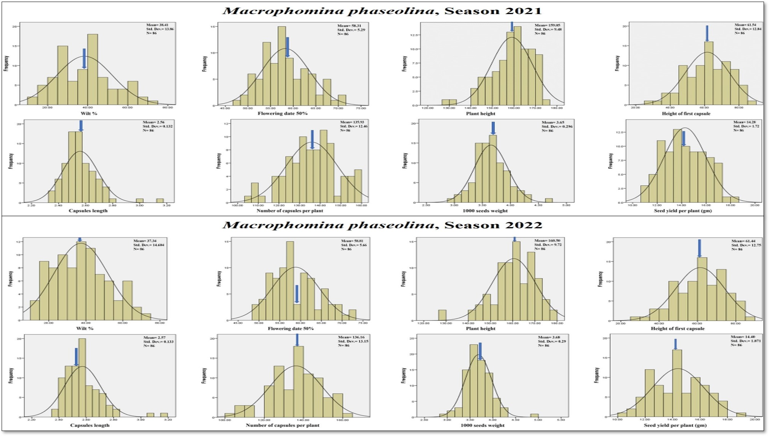Fig. 1. Frequency distribution of Macrophomina phaseolina in seasons 2021 - 2022.

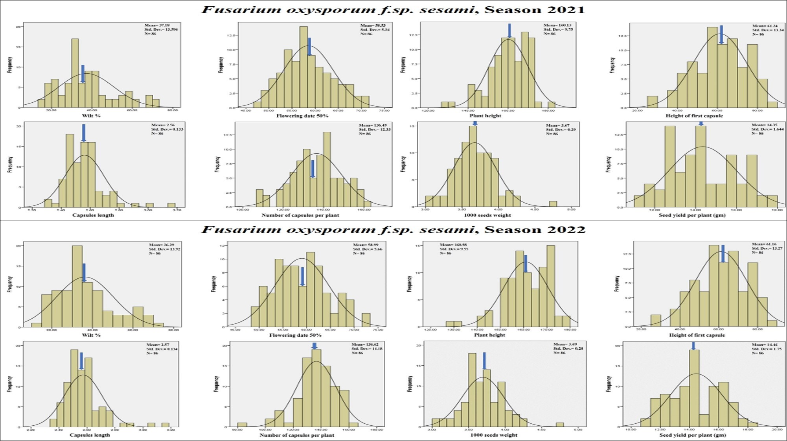 Fig. 2. Frequency distribution of Fusarium oxysporum f.sp. sesame in seasons 2021 - 2022.

Table. 4. Pearson correlation of Macrophomina phaseolina in seasons 2021 - 2022.
Pearson Correlation Macrophomina phaseolina, Season 2021
 | Wilt % | Seed yield per plant | Number of capsules per plant | Capsules length | Flowering date 50% | 1000 seeds weight | Plant height
Seed yield per plant | -0.355**
Number of capsules per plant | -0.183* | 0.718**
Capsules length | -0.012 | -0.033 | -0.367**
Flowering date 50% | -0.046 | 0.064 | 0.283** | -0.1
1000 seeds weight | -0.141 | 0.069 | -0.045 | 0.296** | -0.064
Plant height | -0.08 | 0.273** | 0.456** | -0.376** | 0.481** | -0.185*
Height of first capsule | -0.079 | 0.219* | 0.342** | -0.215* | 0.541** | -0.11 | 0.698**
Pearson Correlation Macrophomina phaseolina, Season 2022
 | Wilt % | Seed yield per plant | Number of capsules per plant | Capsules length | Flowering date 50% | 1000 seeds weight | Plant height
Seed yield per plant | -0.354**
Number of capsules per plant | -0.179* | 0.708**
Capsules length | -0.02 | -0.006 | -0.332**
Flowering date 50% | 0.013 | 0.083 | 0.272** | -0.109
1000 seeds weight | -0.199* | 0.113 | 0.046 | 0.255** | -0.049
Plant height | -0.101 | 0.232* | 0.438** | -0.397** | 0.463** | -0.192*
Height of first capsule | -0.104 | 0.220* | 0.352** | -0.201* | 0.540** | -0.087 | 0.695**
* and **, correlation significant at 0.05 and 0.01 level, respectively.

Table. 5. Pearson correlation of Fusarium oxysporum f.sp. sesame in seasons 2021 - 2022.
Pearson Correlation Fusarium oxysporum f.sp. sesami, Season 2021
 | Wilt % | Seed yield per plant | Number of capsules per plant | Capsules length | Flowering date 50% | 1000 seeds weight | Plant height
Seed yield per plant | -0.216**
Number of capsules per plant | -0.225* | 0.704**
Capsules length | -0.057 | -0.059 | -0.367**
Flowering date 50% | -0.284** | 0.112 | 0.308** | -0.043
1000 seeds weight | 0.037 | 0.072 | -0.013 | 0.272** | -0.064
Plant height | -0.171 | 0.296** | 0.484** | -0.391** | 0.497** | -0.192*
Height of first capsule | 0.022 | 0.243* | 0.348** | -0.156 | 0.556** | -0.12 | 0.712**
Pearson Correlation Fusarium oxysporum f.sp. sesami, Season 2022
 | Wilt % | Seed yield per plant | Number of capsules per plant | Capsules length | Flowering date 50% | 1000 seeds weight | Plant height
Seed yield per plant | -0.261**
Number of capsules per plant | -0.196* | 0.680**
Capsules length | -0.092 | -0.017 | -0.308**
Flowering date 50% | -0.293** | 0.149 | 0.328** | -0.084
1000 seeds weight | 0.0579 | 0.041 | 0.023 | 0.266** | -0.093
Plant height | -0.139 | 0.259** | 0.422** | -0.391** | 0.516** | -0.208*
Height of first capsule | 0.033 | 0.230* | 0.348** | -0.172 | 0.549** | -0.105 | 0.709**
* and **, correlation significant at 0.05 and 0.01 level, respectively.

Table. 6. Relationship of studied lines and traits over Macrophomina phaseolina in seasons 2021 - 2022.
Macrophomina phaseolina, Season 2021
Traits | promising lines
Wilt %, Flowering date 50% and Height of first capsule | 1, 2, 3, 4, 5, 6, 7, 8, 9, 10, 11, 12, 13, 14, 15, 16, 23, 29, 30, 33, 34, 37, 38, 49, 50, 54, 56, 75, 76, 79, 80
Seed yield per plant, Capsules length and 1000 seeds weight | 17, 18, 19, 20, 21, 22, 24, 26, 27, 28, 39, 40, 41, 42, 43, 44, 45, 46, 51, 52, 53, 55, 57, 58, 59, 60, 61, 62, 63, 64, 65, 66, 67, 68, 69, 70, 73, 74, 77, 78, 81, 82, 83, 84
Number of capsules per plant and Plant height | 25, 31, 32, 35, 36, 47, 48, 71, 72, 85, 86
Macrophomina phaseolina, Season 2022
Traits | promising lines
Wilt %, Flowering date 50% and Height of first capsule | 1, 2, 3, 4, 5, 6, 7, 8, 9, 10, 11, 12, 13, 14, 15, 16, 18, 19, 20, 21, 22, 23, 24, 26, 27, 28, 29, 30, 33, 34, 37, 38, 39, 40, 41, 42, 43, 44, 45, 46, 49, 50, 51, 52, 53, 54, 55, 56, 57, 58, 59, 60, 61, 62, 63, 64, 65, 66, 67, 68, 69, 70, 75, 76, 77, 78, 79, 80, 83
Seed yield per plant, Capsules length and 1000 seeds weight | 17, 25, 31, 32, 35, 36, 47, 48, 71, 72, 73, 74, 81, 82, 84,
Number of capsules per plant and Plant height | 85, 86

Table. 7. Relationship of studied lines and traits over Fusarium oxysporum f.sp. sesame in seasons 2021 - 2022.
Fusarium oxysporum f.sp. sesami, Season 2021
Traits |  | promising lines
Wilt %, Flowering date 50% and Height of first capsule |  | 1, 2, 3, 4, 5, 6, 7, 8, 9, 10, 11, 12, 13, 14, 15, 16, 17, 19, 20, 21, 22, 23, 24, 25, 26, 27, 28, 29, 30, 33, 34, 37, 38, 39, 40, 41, 42, 43, 44, 45, 46, 49, 50, 51, 52, 53, 54, 55, 56, 57, 58, 59, 60, 61, 62, 63, 64, 65, 66, 67, 68, 69, 70, 71, 72, 75, 76, 77, 78, 79, 80
Seed yield per plant, Capsules length and 1000 seeds weight |  | 18, 31, 32, 36, 73, 74, 81, 82, 83, 84
Number of capsules per plant and Plant height |  | 35, 47, 48, 85, 86
Fusarium oxysporum f.sp. sesami, Season 2022
 | Traits | promising lines
Wilt %, Flowering date 50% and Height of first capsule |  | 1, 2, 3, 4, 5, 6, 7, 8, 9, 10, 11, 12, 13, 14, 15, 16, 17, 19, 20, 21, 22, 23, 24, 26, 27, 28, 29, 30, 33, 34, 37, 38, 39, 40, 41, 42, 43, 44, 45, 46, 49, 50, 51, 53, 54, 55, 56, 57, 58, 59, 60, 61, 62, 63, 64, 65, 66, 67, 68, 69, 70, 75, 76, 77, 78, 79, 80
Seed yield per plant, Capsules length and 1000 seeds weight |  | 18, 31, 32, 36, 73, 74, 81, 82, 83, 84
Number of capsules per plant and Plant height |  | 25, 35, 47, 48, 52, 71, 72, 85, 86

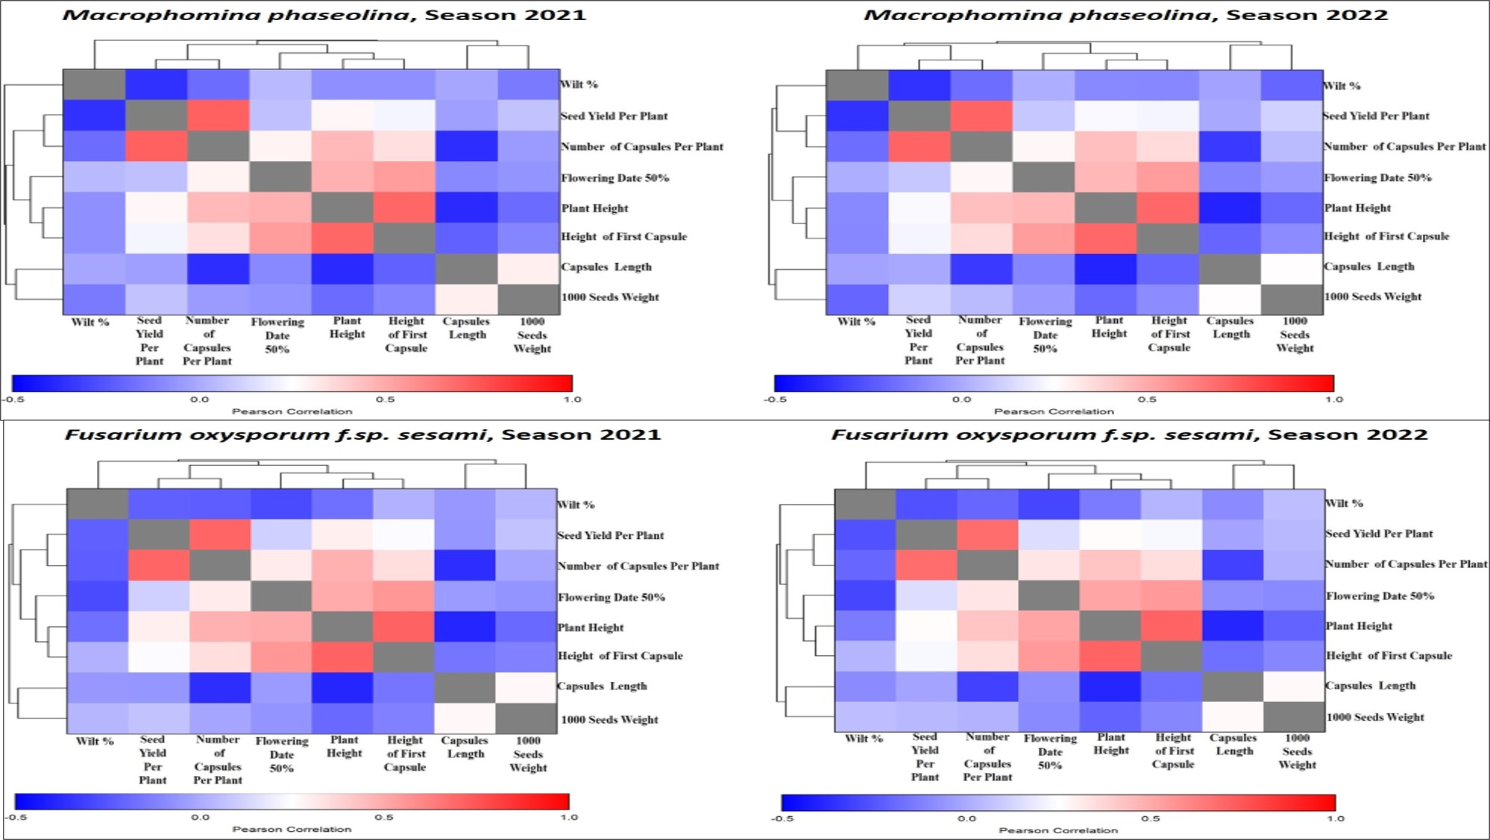
Fig. 3. Pearson heatmap double dendrogram cluster between studied traits in seasons 2021 - 2022.

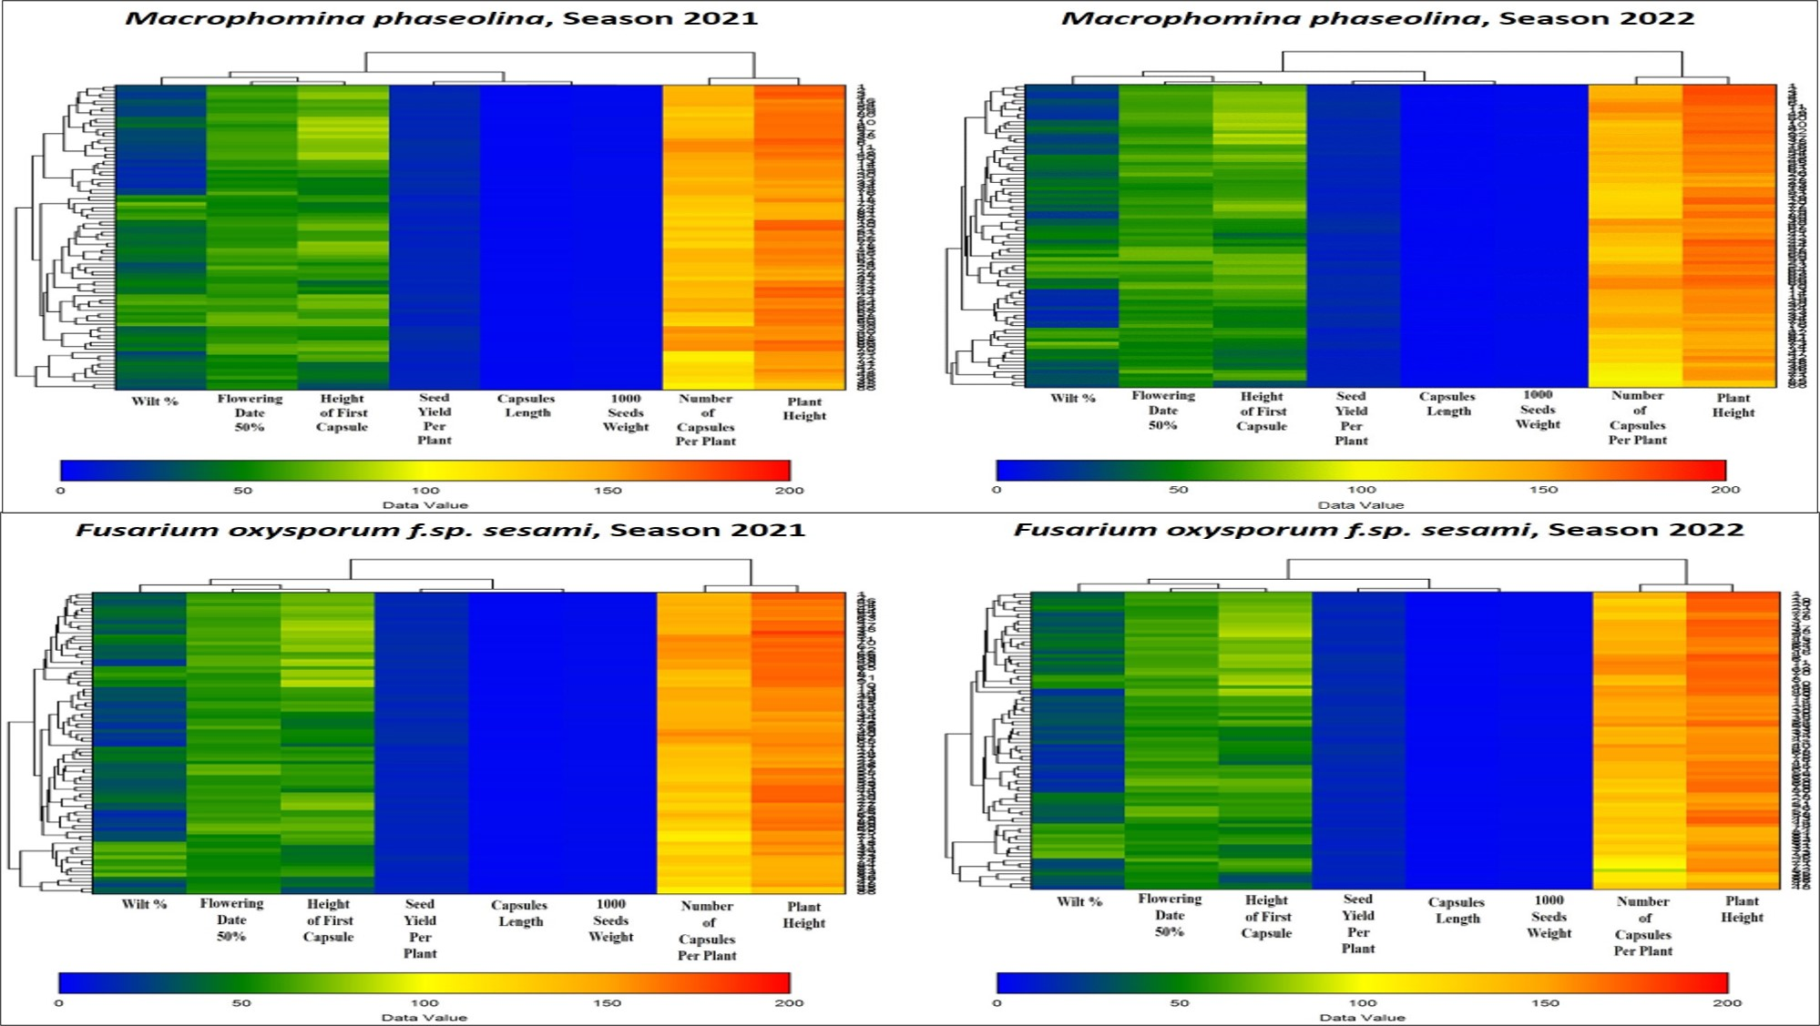
Fig. 4. Euclidean heatmap double dendrogram cluster between studied lines and traits in seasons 2021 - 2022.

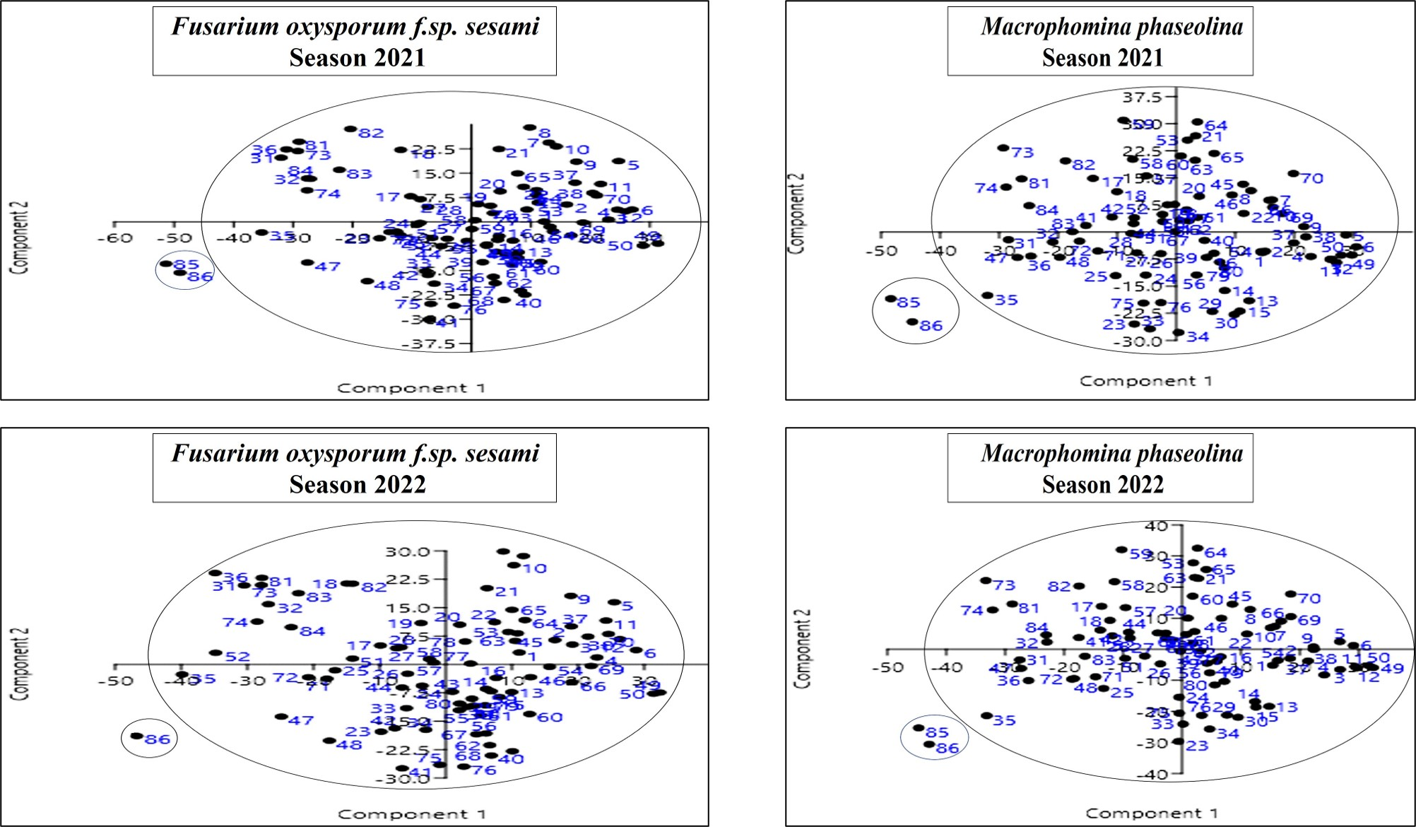
Fig. 5. PCA of studied lines in seasons 2021 - 2022.

Discussion
Sesame crop plants are severely damaged to wilt resulted from various pathogens such as Macrophomina phaseolina and Fusarium oxysporum f.sp. sesame, which results loss in yield productions. These infections produce charcoal root rot in plants by penetrating the roots of sesame plants and moving up into stem through water conducting vessels, caused by Macrophomina phaseolina, or rot from top to bottom or below roots, break in plant vessels, that resulted by Fusarium oxysporum f.sp. sesame as mentioned by Jyothi et al., (2011); Ngamba et al., 2020 and Mahdy et al., (2021). Also, El-Bramawy and Abd Al-Wahid (2007) found that the plants with highest resistance lead lowest yield, so, during selection for breeding extreme caution should be taken. Therefore, effective studies are essential to increase wilt resistant with high yield potential in sesame plants. Thereby, the purpose of this investigation is to study wilt resistant with high yield performance of 86 promising lines of sesame throughout seasons 2021 – 2022. The study found variation in wilt resistant with high yielding in the studied lines, which may be influenced by environmental factors besides genetic which is in agreement with (Mousa and Ahmad, 2021). Most of these factors such as moisture, soil pH and temperature have been reported to interact with soil born pathogens which affects disease occurrence. According to Silme and Cagirgan (2010); Radhakrishnan et al. (2014) and Ngamba et al., (2020) plant could escape when temperature is unfavorable for pathogen, which is approved with the present observation. Also, Gupta et al. (2018) demonstrated that wilt diseases result significant losses in crop from seedling time until maturity.
The finding demonstrated highly significant values with stable performance of all studied lines, which may be helpful in developing more breeding techniques for wilt resistant management with high yield. The genetic variation between examined lines could be the cause of this as referred by Tadesse and Misgana (2020); Fiseha and Muez (2019) and Weres (2020). Since serious seed rot didn’t affect germination rate than growing. These findings are in agreement with Abhijatha et al., (2017); Begum et al. (2017); Bedawy and Mohamed, (2018) and Ngamba et al., (2020). Furthermore, Aye et al., (2018) stated that genetic variability is crucial to sesame breeding techniques during hybridization and sections, which also supported by Ismail and Naheif, (2018) and Awoke and Muhaba (2022). In addition, Hika et al. (2015), El Soury et al. (2016) and Patil & Lokesha (2018) pointed that high yield performance may be in agreement with high broad sense heritability percentage, and these are in agreement with our study, which may be preferred in prediction gain in selection. Additionally, Kanak and Rajani, (2016) stated high broad sense heritability in seed yield per plant (97.5 %) followed by number of capsules per plant (96.6 %), indicating that selection could be effective for improvement of these traits.
Our results also exhibited significant positive and negative correlation between studied traits, suggesting that studied lines were subjected to direct and indirect selection for wilt resistant with high yield performance as mentioned by Bamrotiya et al. (2016); Kanak and Rajani (2016); Abhijatha et al., (2017); Lalpantluangi and Shah (2018); Ismail and Naheif, (2018); Navaneetha et al., (2019); Disowja et al., (2020); Kebede (2020) and Mahdy et al., (2021) who found significant positive correlation between seed yield per plant and both or plant height and number of capsules per plant, and had negative correlation with flowering date 50%. Likewise, Soundharya et al., (2017) noted that number of capsules per plants revealed significant positive correlation between seed yield per plant.
Heatmap and PCA analysis were referred certain groups, which approved that, none of the studied line could be classified as immune to wilt diseases as concluded by El-Bramawy et al., (2001); Jyothi et al., (2011); Shabana et al., (2014); Anyanga et al. (2016); Ismail and Naheif, (2018) and Ngamba et al., (2020).

Conclusion
The finding gathered some lines have favorable genes toward separate traits as showed in heatmap, which could be used as parental material in future breeding programs for sesame crop improvement. Overall, the results showed genetic variability among studied lines, which could be used as parental material to produce new populations over wilt resistant with high yield performance. Moreover, for long term, more germplasm should be assembled besides studied lines for sesame enhancement against Macrophomina phaseolina and Fusarium oxysporum f.sp. sesami.

Acknowledgment
Authors are thankful faculty of agric., Sohag univ., Sohag, Egypt, for their support.

Conflict of Interests
The authors have not declared any conflict of interests.

Author Contributions
This work was carried out in collaboration among all authors. All authors read and approved the final manuscript.
Data Availability
All data available within the article.

References
Abdus Salam M. D., Akhi Khatun and Abdul Kader M. D. 2020. Effect of Levels of Nitrogen on the Growth and Yield of Sesame (Sesamum indicum L.) Cultivars. Journal of Bangladesh Agricultural University. 18(4): 949–955.
Abhijatha A., Arya K., Kuduka Madhukar and Srinivas Gogineni. 2017. Evaluation of Sesame (Sesamum indicum L.) Genotypes to the Shaded Uplands of Southern Region. International Journal of Current Microbiology and Applied Sciences. 6(7): 332-339.
Ali Adam Yousif Adam, Zhou Guishen, Atif Hassan, Samia Osman Yagoub, Gafar Ali Farah, Nimir Eltyb Ahamed, Aboagla Mohammed Ibrahim, Muhi Eldeen Hussien Ibrahim, Mohamed Suliman, Safiya Babiker Elradi, Ebtehal Gabralla Ibrahim and Samia Mahgoub Omer. 2020. Sesame Seed Yield and Growth Traits Response to Different Row Spacing in Semi-Arid Regions. Universal Journal of Agricultural Research 8(4): 88-96.
Anyanga W. O., Rubaihayo P., Gibson P. and Okori P. 2016. Combining ability and gene action in sesame (Sesamum indicum L) elite genotypes by diallel mating design. Journal Plant Breeding Crop Science. 8:250-256.
Arun A. T. and Arun Mahabeer Singh. 2023. Seed Mycoflora of Sesame (Sesamum indicum L.) and their Phytopathogenic Effect. International Journal of Current Microbiology and Applied Sciences. 12(8): 49 – 67.
Awoke T. and Muhaba S. 2022. Evaluation of Yield and Yield Components of Sesame (Sesamum indicum L.) Varieties under Irrigation in Lowland Area of South Omo Zone, Southern Ethiopia1. International Journal of Life Science and Agriculture Research. 1(1): 1-5.
Aye M., Khaing T.T. and Hom N. H. 2018. Morphological characterization and genetic divergence in Myanmar Sesame (Sesamum indicum L.) germplasm. Int. J. Adv. Res. 6(4): 297-307.
Bamrotiya M. M., Patel J. B., Ashok M., Chetariya C. P., Ahir D. and Kadiyara J. 2016. Genetic variability, character association and path analysis in (Sesamum indicum L.). Inter. J. Agric. Sci. 8 (54): 2912-2916.
Bedawy I. M. A. 2004. Pedigree selection for wilt resistance in some sesame populations, Sesamum indicum L. M. Sc. Assiut University.
Bedawy I. M. A. and Mohamed N. E. 2018. Phenotypic and genotypic variability in some sesame (Sesamum indicum L.) genotypes. Egyptian Journal of Agronomy. 40(3): 193- 205.
Bedawy, I. M. A.and Moharam M. H. A. 2018. Performance of some Sesame (Sesamum indicum L.) Genotypes for Resistance to Wilt Disease Caused by Fusarium oxysporum f.sp. Sesami. J. Plant Production, Mansoura Univ. 9(12): 1063 – 1068.
Begum T., Iqbal A. and Dasgupta T. 2017. Genetic variability and divergence among genotypes of Sesame (Sesamum inducum L.). Bangladesh J. Bot. 46(3): 955-962.
Disowja A., Parameswari C. Gnanamalar R. P. and Vellaikumar S. 2020. Evaluation of sesame (Sesamum indicum L.) based on correlation and path analyses. Electronic Journal of Plant Breeding 11(2): 511-514.
El Soury H. F., El Bashir G. and Ginaro M. K. 2016. Phenotypic and genotypic coefficients of variation and other growth attributes in sesame genotype under rain-fed conditions. Adv. Agric. Agric. Sci. 2(3): 79-84.
El-Bramawy M. A. S. 2010. Genetic analysis of yield components and disease resistance in sesame (Sesamum indicum L.) using two progenies of diallel lines. Res. J. of Agronomy. 4 (3): 44-56.
El-Bramawy M. A. S. 2011. Anti-nutritional factors as screening criteria for some diseases resistance in sesame (Sesamum indicum L.) genotypes. Journal of Plant Breeding and Crop Science. 3(13): 352-366.
El-Bramawy M. A. S. and Abdul Wahid O. A. 2007. Resistance of some sesame (Sesamum indicum L.) collections against root rot disease (Rhizoctoina solani) Kuhn under field conditions. Journal Plant Protection Research. 47(3): 322-327.
El-Bramawy M. A., Veverka K., Veverka S., El-Shazly M. S., El-Sattar M. A., El-Ashary M. A. and Ammar S. E. 2001. Evaluation of resistance to Fusarium oxysporum f.sp. sesami in hybrid lines of sesame (Sesamum indicum L.) under greenhouse conditions. Plant Protection Science. 37:74-79.
El-Shakhess Samar A. M. and Khalifa M. M. A. 2007. Combining ability and heterosis for yield, yield components, charcoal-rot and Fusarium wilt diseases in sesame. Egypt J. Plant Breed. 11(1): 351-371.
Farhan H. N., Abdullah B. H. and Hameed A. T. 2010. The biological activity of bacterial vaccine of Pseudomonas putida2 and Pseudomonas fluorescens3 isolates to protect sesame crop (Sesamum indicum) from Fusarium fungi under field conditions. Agriculture and Biology Journal of North America. 1(5): 803–811.
Fiseha Baraki and Muez Berhe. 2019. Evaluating performance of sesame (sesamum indicum l.) genotypes in different growing seasons in northern Ethiopia. hindawi international journal of agronomy. 2: 1-7.
Gawarkar S. V., Patil M. J., Ingle R. W., Tini Pillai and Tambe V. J. 2023. Effect of Fusarium oxysporum on germination and seedling growth of sesamum. The Pharma Innovation Journal. 12(3): 1187-1191.
Goudappagoudra Renuka, Lokesha R. and Ranganatha A. R. G. 2011. Trait association and path coefficient analysis for yield and yield attributing traits in sesame (Sesamum indicum L.). Electronic Journal of Plant Breeding. 2(3): 448-452.
Gupta K. N., Naik K. R. and Bisen R. 2018. Status of sesame diseases and their integrated management using indigenous practices. International Journal of Chemical Studies. 6:1945-1952.
Hika G., Geleta N. and Jaleta Z. 2015. Genetic variability, heritability and genetic advance for the phenotypic traits in Sesame (Sesamum indicum L.) populations from Ethiopia. Sci. Technol. Arts Res. J. 4(1), 20-26.
Ibrahim A., Mohammed Z. H., Gambo B. A., Muhammad A. and Abubakar I. U. 2016. Effects of Sowing Date on Performance of Sesame Supported by (Sesamum indicum L.) Varieties in Maiduguri, Borno State-Nigeria. Fuw Trends in Science and Technology Journal. 1(2): 563 – 566.
Ismail M. Bedawy and Naheif E. Mohamed. 2018. Phenotypic and Genotypic Variability in a Set of Sesame (Sesamum indicum L.) Genotypes. Egypt. J. Agron. 40(3): 193 – 205.
İzgi M. N. and Bulut B. 2023. Agronomic Characteristics and Yield Values of Sesame (Sesamum indicum L.) Cultivars at Various Sowing Dates. Turkish Journal of Agricultural Research. 10(1): 109-120.
Johnson H. W., Robinson H. F. and Comstock R. E. 1955. Estimates of genetic and environmental variability in soyabeans. Agron. J. 47: 314-318.
Jyothi B., Ansari N. A., Vijay Y., Anuradha G., Sarkar A., Sudhakar R. and Siddiq E. A. 2011. Assessment of resistance to Fusarium wilt disease in sesame (Sesamum indicum L.) germplasm. Austr. Plant Pathol. 40: 471-475.
Kanak S. and Rajani B. 2016. Genetic variability, correlation and path analysis studies for yield and yield component traits in sesame (Sesamum indicum L.). Inter. J. Agric. Sci. 8 (61): 3487-3489.
Kebede Abadi Assefa, Weres Negash Golla and Yirga Belay Kindeya. 2020. Screening of Sesame Genotypes Resistance to Fusarium Wilt Disease (Fusarium oxysporum F. Sp. Sesumi) in Western Tigray, Ethiopia. International Journal of Agriculture and Biosciences. 9(3): 120-124.
Khalifa M. M. A. 2003. Pathological studies on charcoal rot disease of sesame. Ph.D. Thesis., Fac. Agric., Moshtohor, Zagazig Univ., Benha Branch.295 pp.
Lalpantluangi P. C. and Shah P. 2018. Character association and path coefficient analysis in sesame (Sesamum indicum L.) genotypes under foothill condition of Nagaland. The Pharma Innovation Journal. 7(5): 82-87.
Mahdy E. E., Bakheit R. R., Motawea M. M. and Bedawy I. M. 2005. Pedigree selection for resistance to Fusarium oxysporum in three sesame populations. Assiut J. Agric. Sci. 36(1): 141-157.
Mahdy E. E., El- Shimy A. A., Sayed M. A., Amer F. Mahmoud and Aya Salah. 2021. Pedigree selection in sesame under artificial infection of Fusarium oxysporum f. sp. sesame. SVU-International Journal of Agricultural Sciences. 3(4): 141-158.
Najafiniya Mousa and Ahmed Aien. 2021. Evaluations of partial resistance of native sesame germplasms to Fusarium wilt disease. J. Crop Prot. 10 (1): 51-62.
Navaneetha J. S., Murugan E. and Parameswari C. 2019. Correlation and path analysis for seed yield and its components in sesame (Sesamum indicum L.). Electronic Journal of Plant Breeding. 10 (3): 1262 – 1268.
Nayyar B. G., Woodward S., Mur L., Akram A., Arshad M., Saqlan Naqvi S. M. and Akhund S. 2018. Identification and pathogenicity of Fusarium species associated with sesame (Sesamum indicum L.) seeds from the Punjab, Pakistan. Physiological and Molecular Plant Pathology 102: 128-135.
Ngamba Z. S., Tusiime G., Gibson P., Edema R., Biruma M., Anyanga W. O., Masawe P. A. L., Kafiriti E. 2020. Screening of sesame genotypes for resistance against Fusarium wilt pathogen. African Journal of Agricultural Research. 15(1): 102 – 112.
Patel A. Hardik, Raj A. D., Chirag V. Khambhu and Sonal J. Vaja. 2023. Effect on growth and yield characteristics of summer sesame (Sesamum indicum L.) as influenced by different levels of nitrogen, phosphorus and biofertilizers. The Pharma Innovation Journal. 12(6): 5130-5134.
Patil M. K. and Lokesha R. 2018. Estimation of genetic variability, heritability, genetic advance, correlations and path analysis in advanced mutant breeding lines of sesame (Sesamum indicum L.). J. Pharmacog. Nat. Prod. An open Access Journal. 4(1): 100-151.
Radhakrishnan R., Kang S., Park P., Lee S., Baek I. and Lee I. 2014. An Evaluation of Resistance to Fusarium Disease in Korean Sesame (Sesamum indicum L.) Germplasm. 3rd International Conference on Applied Life Sciences. 18-20 September, 2014, Malaysia, Republic of Korea.
Ranjithkumar Gangishetti and Rajani Bisen. 2021. Morphological Characterization of Sesame (Sesamum indicum L.). Biological Forum –An International Journal. 13(4): 758-764.
SAS Institute. 2008. The SAS system for Windows, release 9.2. SAS Institute, Cary, N.C. USA.
Shabana R., Abd El-Mohsen A. A., Khalifa M. M. A and Saber A. A. 2014. Quantification of resistance of F₆ sesame elite lines against Charcoal-rot and Fusarium wilt diseases. Advance in Agriculture and Biology. 1(3): 144-150.
Silme R. S. and Cagirgan M. I. 2010. Screening for resistance to Fusarium wilt in induced mutants and world collection of sesame under intensive management. Turkish Journal of Field Crops. 15: 89-93.
Sivasubraramanian S. and Menon M. 1973. Heterosis and inbreeding depression in rice. Madras Agric. J. 60: 1139.
Soundharya B., Hemalatha V., Rani T. S. and Edukondalu B. 2017. Trait association and path coefficient analysis for yield and yield attributing traits in sesame (Sesamum indicum. L). Environment and Ecology. 35(4): 3617—3620.
Stamatov Stanislav, Nikolaya Velcheva and Manol Deshev. 2018. Introduced sesame accessions as donors of useful qualities for breeding of mechanized harvesting cultivars. Bulgarian Journal of Agricultural Science. 24(5): 820–824.
Tadesse and Misgana. 2017. Performance evaluation of sesame (Sesamum indicum L.) varieties in lowland area of south omo zone, snnpr, Ethiopia. International journal of research in agriculture and forestry. 4: 9.
Usman A., Ali A. and Agber P. I. 2021. Productivity of sesame (Sesamum indicum L.) varieties as influenced by tillage practices in two agro-ecological zones of Nigeria. Direct Research Journal of Agriculture and Food Science. 9(2): 18 – 28.
Weres Negash Golla. 2020. Yield Performance of Sesame (Sesamum indicum L.) Varieties at Different Levels of Plant Population in Optimum Moisture Areas of Western Tigray, Northern Ethiopia. Journal of Biology, Agriculture and Healthcare. 10(4): 16 – 21.

