Abstract
Rice productivity faces significant challenges from climate change and sudden outbreaks of pests and diseases. Conventional breeding alone struggles to produce stress-resistant varieties, making marker-assisted breeding (MAB) a valuable complement. MAB enhances conventional breeding by employing molecular markers tightly linked to target genes, increasing efficiency without fully replacing traditional methods. This review evaluates gene introgression effects and the role of MAB in improving rice productivity, based on secondary data sources. Notable gene targets include Xa4, Xa5, Xa13, Xa21, and Xa27 for bacterial blight; Pi2, Pi5, Pi9, and QTLs on chromosomes 1, 2, 11, and 12 for blast resistance; Gm1 and Gm4 for gall midge; Saltol for salinity tolerance; qDTY1.1, qDTY2.1, and qDTY3.1 for drought tolerance; Sub1A for submergence; and yld1.1, yld2.1, and GW6 for yield enhancement. Introgressing these genes has led to the development of resilient rice lines capable of thriving under biotic and abiotic stresses, with notable increases in yield over susceptible recurrent parents. For instance, the introgression line DHA-10 (5,680 kg/ha) yields more than its parent BPT5204 (4,973 kg/ha), while the submergence-tolerant BR9157-12-2-37-13-17 produces 3.44 t/ha, outperforming BRRI dhan33 (1.73 t/ha). These cases illustrate the transformative impact of MAB in developing high-yielding, resilient rice varieties, underscoring its invaluable role in enhancing rice productivity under diverse stress conditions.

Keywords: Marker-assisted breeding (MAB), Rice (Oryza sativa L.), Stress tolerance, Gene introgression, Yield enhancement

Introduction
Rice (Oryza sativa L.) is a primary staple crop, vital to the food security of over half the world’s population, particularly in Asia and Africa where it is fundamental to both dietary intake and economic stability (Suela et al., 2019). Globally, rice supplies nearly one-fifth of caloric intake and contributes around 15% of dietary protein, underscoring its importance in global nutrition (Rashid et al., 2017). Originating in South-East Asia, rice cultivation has expanded worldwide, with China, India and Bangladesh currently leading in production, reporting outputs of 146.73, 118.00 and 35.85 million metric tons, respectively. These countries achieve average yields of 7.06, 4.02 and 4.55 metric tons per hectare from cultivation areas spanning 29.69, 44.00 and 11.83 million hectares, respectively (USDA, 2020). However, the challenges facing rice production are intensifying with accelerated industrialization, urbanization and population growth. The availability of arable land is decreasing, resulting in agricultural areas being repurposed for non-agricultural use. This is particularly concerning as rice yield growth is stagnating in regions like Bangladesh, where yields are averaging only 4.5 t/ha (BRRI, 2018). Additionally, rice breeders face mounting pressures from a range of biotic and abiotic stresses, exacerbated by climatic variability.
Rice production is vulnerable to a multitude of stress factors. Biotic stresses—including pathogens and pests endemic to tropical rice ecosystems—impose substantial yield losses. Major diseases like bacterial blight, rice blast and sheath blight, as well as insect pests such as stem borers, brown plant hopper and leaf folders, significantly compromise rice productivity (Peng, 2003; Khush & Virk, 2005; Jiang et al., 2012). On the other hand, abiotic stresses, such as drought, flooding, salinity and extreme temperatures are equally detrimental to rice yield, particularly under rainfed conditions where farmers have limited control over water availability (Wang et al., 2003; Das and Rao, 2015; Dar et al., 2017; Dar et al., 2020). For instance, Bailey-Serres et al. (2012) reported that drought and submergence collectively caused a 70% harvest failure rate in 2011, underscoring the severity of these challenges.
The increasing prevalence of biotic and abiotic stresses, compounded by the impacts of climate change, necessitates the development of resilient rice varieties. Given the extended time frames (10–12 years) and costs associated with conventional breeding methods, accelerating the breeding cycle is crucial (Collard & Mackill, 2008). Conventional breeding approaches often fail to fully eliminate undesirable alleles from breeding lines, which can be inadvertently retained across generations. Addressing these limitations, breeders now employ marker-assisted breeding (MAB) to enhance selection efficiency and precision. Marker-assisted breeding (MAB) leverages molecular markers linked to target traits, facilitating the rapid and precise introgression of desirable genes while reducing the number of backcross generations needed (Hasan et al., 2015). DNA markers are especially valuable in removing unwanted genes that are tightly linked to target loci, allowing breeders to enhance specific regions of the rice genome with greater accuracy (Kottearachchi, 2013). Compared to traditional methods, MAB is cost-effective and significantly reduces the time required for developing stress-resilient varieties, making it a more sustainable and economical approach. Through marker-assisted selection (MAS), breeders can pyramid multiple stress-resistant genes into a single genotype, thus achieving broader resilience against biotic and abiotic stresses (Das and Rao, 2015; Dar et al., 2018; Chukwu et al., 2019; Dar et al., 2021).
This review examines the role of marker-assisted selection in enhancing rice productivity by introgressing stress-resistant genes, highlighting MAB’s capacity to overcome the limitations of conventional breeding and foster the development of climate-resilient, high-yielding rice varieties.

Why Marker Assisted Breeding?
Marker-assisted breeding (MAB) serves as a complementary approach to traditional breeding, enhancing its efficiency and effectiveness rather than replacing it (Chukwu et al., 2019). Introduced in the 1990s, molecular selection techniques have revolutionized rice breeding by enabling precise identification and selection of desirable traits, thereby accelerating breeding timelines and improving productivity (Jonas and Koning, 2013). The impacts of climate change have exacerbated the prevalence and severity of both biotic and abiotic stresses, posing serious threats to global crop yields. For rice, biotic stresses such as pest infestations, as well as abiotic challenges like drought, salinity and temperature extremes, contribute to substantial yield losses (Table 1). MAB addresses these issues by allowing breeders to incorporate stress-resistance genes more efficiently, thereby developing resilient varieties that can withstand the increasing environmental pressures brought on by a changing climate.
Table 1. Reports related to the consequences of biotic and abiotic stresses in rice cultivation
Stresses | Causes | Consequences | References
Bacterial Blight | Xanthomonas oryzae pv.oryzae | Partial grain filling leads severe yield loss | Pradhan et al. (2015)
Blast | Magnaporthe grisea | 70–80% yield loss during severe condition | Babujee and Gnanamanickha (2000)
Gall Midge | Orseolia oryzae | 0.8% yield losses of total production | Biradar et al. (2004)
Stem borer | Scirpophaga incertulas (yellow), S. innotata (white) | Deadheart and whitehead, reduced plant vigor | Nogoy et al. (2016)
Submergence | Rain-fed lowland conditions | Hamper growth and average productivity | Das and Rao (2015)
Salinity | Saline containing water (Sodium), in southern region | >50% yield losses | Molla et al. (2015)
Drought | Shortage of rainfall | Severe yield loss | Das et al. (2017)

To address the pressing challenges posed by climate change, emerging biotic and abiotic stresses, and the need to secure food for a growing population, rice breeders are actively engaged in targeted research efforts (Nogoy et al., 2016). Through the use of molecular markers, breeders have been able to identify numerous stress-resistance genes, facilitating the development of rice varieties that are more resilient and better suited to withstand these complex environmental pressures (Table 2).
Table 2. QTLs/genes reported to overcome the stress related problems in rice
Recent Discovery | References
42 bacterial blight resistance genes such as  Xa5, Xa13, Xa21, Xa17, Xa29(t), Xa42 etc. | Chukwu et al. (2019)
100 blast resistance genes but 14 genes widely used namely, Pi1, Pi2, Pi9, Pi20 (t), Pi33, Pi39, Pi40 (t), Pi47, Pi48, Pi54rh, Pi56, Piz, Piz-t, and Pigm | Hayashi et al. (2010); Huang et al. (2011); Das et al. (2012); Hua et al. (2015); Liu et al. (2013)
11 gall midge resistance genes | Dutta et al. (2014); Hasan et al. (2015)
Submergence1 (Sub1) in chromosome 9 for submergence tolerance | Septiningsih et al. (2013); Manivong et al. (2014)
Saltol for salinity tolerance | Das and Rao (2015)
Dreb1, qDTY1.1, qDTY2.1, qDTY3.1, QTLs for drought tolerance | Reddy et al. (2009); Lin et al. (2007); Das et al. (2017); Sandhu et al. (2019)

Developing highly resistant rice varieties is a crucial strategy to combat the anticipated stresses associated with climate change. To achieve this, it is essential to compile a robust set of resistance genes within a single genotype that can perform consistently across diverse climatic conditions (Das and Rao, 2015). Marker-assisted breeding (MAB) enables breeders to efficiently incorporate target genes early in the breeding process, allowing for rapid development of varieties with strong, broad-spectrum resistance to both biotic and abiotic stresses with greater precision (Das et al., 2017).

Types of Markers used in Marker Assisted Breeding
According to Chukwu et al. (2019), there are three primary types of markers used for identifying genes of interest in rice breeding: morphological markers, biochemical markers and molecular markers. Among these, molecular markers—also referred to as DNA-based markers—are particularly advantageous due to their ability to scan the entire rice genome and provide high-density coverage of each chromosome (Akhtar et al., 2010). Molecular markers can be further categorized into two main types based on detection methods: PCR-based markers and hybridization-based markers (Yang et al., 2015). Molecular markers are widely preferred in rice breeding due to their high precision and flexibility. Their number is virtually unlimited, allowing for comprehensive genome-wide scanning and enabling high-resolution mapping of traits. For effective phenotypic prediction in rice, the genetic distance between markers should be less than 5 cM. Additionally, intragenic markers improve reliability by closely associating markers with phenotypic traits, making them highly effective in rice breeding programs.
Examples of commonly used DNA-based markers in rice include RG556, pTA 248, Xa13prom, RG64, P28, RM444, RM547, SUB1BC2, RM10745, Os01g0197700, RM212, and RM319. These markers are used for selecting genes linked to resistance against various biotic and abiotic stresses, ultimately improving the resilience and productivity of rice (Das et al., 2017).

Conventional Breeding vs Marker Assisted Breeding
While markers can be applied at any stage of the breeding process, their benefits are most pronounced during early-stage selection. By identifying and discarding undesirable lines in initial generations, marker-assisted breeding (MAB) allows breeders to focus resources on more promising lines compared to conventional methods (Akhtar et al., 2010). Ribaut and Betrán (1999) demonstrated that MAB enables efficient early-generation selection, reducing the number of lines requiring evaluation in later stages. In conventional breeding approaches such as bulk or single seed descent, homozygous lines are typically selected at advanced generations (e.g., F₅ or F₆). However, with MAB, breeders can screen for homozygous lines as early as the F₂ generation by targeting and fixing specific alleles, thereby expediting the breeding process (Fig. 1).
Fig. 1. Conventional breeding verses marker assisted breeding

Marker Assisted Gene Pyramiding
The process of incorporating multiple resistance or tolerance genes into a single genotype is known as gene pyramiding (Collard and Mackill, 2008). This approach is essential for enhancing the durability of resistance and minimizing the risk of resistance breakdown, especially under escalating biotic and abiotic pressures. Molecular markers enable precise selection in gene pyramiding, making it a feasible strategy within marker-assisted breeding (MAB) frameworks (Das and Rao, 2015). According to Das et al. (2017), marker-assisted gene pyramiding generally involves two critical steps. The first is the accumulation step, where all genes of interest (GOI) are sequentially introduced into a single genotype. The second is the fixation step, wherein the accumulated genes are converted into a homozygous state, ensuring stable inheritance.
An example of successful gene pyramiding is provided by Luo et al. (2016), who introduced the resistance genes Xa4 and Xa21 into the variety Mianhui 725, creating a new line, Wanhui 421, with 96.9% genetic similarity to Mianhui 725 through marker-assisted backcrossing. Wanhui 421 (Xa4, Xa21) was then crossed with IRBB27 (Xa27) and other lines, resulting in various F1 generations containing combinations of resistance genes: (Xa4, Xa21, Xa27), (Xa4, Xa21, Pi9), and (Xa4, Xa21, Sub1A). Through multiple backcrosses (five generations) with the recurrent parent Wanhui 421, a high genetic similarity was achieved, while maintaining the desired resistance genes. Further crossings and selfing of F1 generations led to F2 progeny carrying a pyramided set of genes (Xa4, Xa21, Xa27, Pi9, Sub1A), enhancing resistance and stabilizing the genotype for field deployment. This strategy exemplifies the precision and efficiency of MAB in developing resilient rice varieties through gene pyramiding (Fig. 2).
Wanhui 421× IRBB27

Wanhui 421 × 75-1-127

Wanhui 421× IR64

F₁ × Wanhui 421
F₁ × Wanhui 421
F₁ × Wanhui 421

BC₁F₁ × Wanhui 421
BC₁F₁ × Wanhui 421

BC₁F₁ × Wanhui 421

BC₅F₁ (Xa4, Xa21, Sub1A)
BC₅F₁ (Xa4, Xa21, Pi9)
×

BC₅F₁ (Xa4, Xa21, Xa27)
×
F₁ (Xa4, Xa21, Pi9, Sub1A)

F₁ (Xa4, Xa21, Xa27, Pi9, Sub1A)

Selfing

Wanhui 6725 (Xa4, Xa21, Xa27, Pi9, Sub1A)

Fig. 2. Marker assisted backcrossing for accumulating different resistance genes in one genotype

Marker Assisted Gene Introgression: Case Studies
Bacterial Blight (BB) Resistance Genes Introgression
According to Luo et al. (2016), the introgression line Wanhui 6725 (Xa4, Xa21, Xa27, Pi9, Sub1A) and its hybrid, II-32A/WH6725, exhibit resistance to 27 Xanthomonas oryzae pv. oryzae (Xoo) strains originating from 10 countries. In contrast, the recurrent parent Mianhui 725, its hybrid II-32A/MH725 and the CMS line II-32A show susceptibility to 26, 23 and 24 Xoo strains, respectively. Wanhui 421 (Xa4, Xa21) and IRBB27 (Xa27) display resistance or moderate resistance to 22 and 24 Xoo strains, respectively (Table 3). Disease scoring for bacterial blight (BB) is based on lesion length (LL). LL ≤3.0 cm indicates resistance (R); 3.0 cm < LL ≤ 6.0 cm indicates moderate resistance (MR); 6.0 cm < LL ≤ 9.0 cm indicates moderate susceptibility (MS) and LL > 9.0 cm indicates susceptibility (S).
Table 3. Resistance score of 7 lines against 5 Xanthomonas oryzae pv. Oryzae strains originated from China and India
Rice Lines | Strain from China |  |  | Strain from India
Rice Lines | HB17 | HB21 | JS49-6 | A3842 | A3857
Mianhui 725 | Susceptible | Susceptible | Susceptible | Susceptible | Susceptible
II-32A/MH725 | Susceptible | Susceptible | Susceptible | Susceptible | Susceptible
Wanhui 421 | Moderately Resistant | Moderately Resistant | Resistant | Susceptible | Moderately Resistant
Wanhui 6725 | Resistant | Resistant | Resistant | Resistant | Resistant
II-32A/WH6725 | Resistant | Resistant | Resistant | Resistant | Resistant
II-32A | Susceptible | Susceptible | Susceptible | Susceptible | Susceptible
IRBB27 | Resistant | Resistant | Resistant | Resistant | Resistant

Blast Resistance Genes Introgression
According to Yang et al. (2019), the blast-resistant gene (Pi2) from the donor parent, Hua1201S, was introduced into the recipient line, Feng39S, through marker-assisted backcrossing, resulting in the BC₂F₅ lines DB16206–34 and DB16206–38. Markers were employed at each step to select the desirable lines. The male parent, 9311, which is susceptible to blast, was used to produce hybrids. An evaluation trial in China (2018) assessed resistance to leaf and neck blast (Fig. 3A). Hua1201S showed a leaf blast score of 2, while DB16206–34, DB16206–38, and their hybrids (DB16206–34/9311 and DB16206–38/9311) exhibited resistance with scores of 1, 3, and 3, respectively. Conversely, Feng39S, 9311, and their hybrid (Feng39S/9311) displayed susceptibility with scores of 5, 8, and 4, respectively, and high susceptibility to neck blast, with infection rates ranging from 52% to 87%. Hua1201S, DB16206–34, DB16206–38, and their hybrids showed resistance to neck blast, with little or no infection.
Similarly, Murthy et al. (2017) reported that the popular but blast-susceptible variety Samba Mahsuri (BPT5204) was improved by introgressing Pi2 and Pi5 genes from C101A51 and IRBL-5M through MAB. The Pi2 (DHA-1, DHA-2, DHA-10) and Pi5 (DHB-19, DHB-25, DHB-27) introgressed lines demonstrated higher yields than the recurrent parent BPT5204, with DHA-10 achieving the highest yield (5,680 kg ha⁻¹) compared to BPT5204 (4,973 kg ha⁻¹) (Fig. 3B).
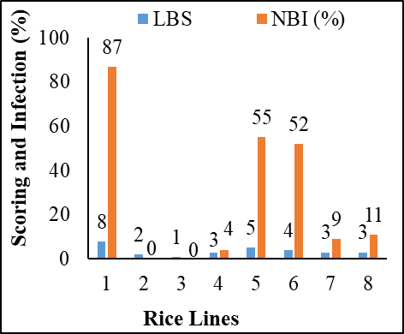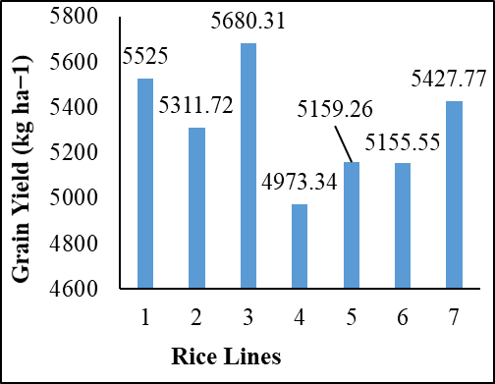
A
B
Fig. 3. Evaluation of rice lines against blast.
A. Blast scoring and Results of Infection (%) (resistant: 1–3, susceptible: 4-9); 1. Feng39S; 2. Hua1201S; 3. DB16206–34; 4. DB16206–38; 5. 9311; 6. Feng39S/9311; 7. DB16206–34/9311; 8. DB16206–38/9311; LBS. Leaf blast score; NBI (%). Neck blast infection (%) (Yang et al., 2019).
B. Performance for Yield; 1. DHA-1; 2. DHA-2; 3. DHA-10; 4. BPT5204; 5. DHB-19; 6. DHB-25; 7. DHB-27 (Murthy et al., 2017)

Nan et al. (2019) conducted an experiment at Khon Kaen University (KKU) and Khon Kaen Rice Research Center (KKRRC) in Thailand. They pyramided blast-resistant QTLs from Jao Hom Nin (on chromosomes 1 and 11) and P0489 (on chromosomes 2 and 12), along with the bacterial blight resistance gene Xa5 from IR62266, into the rice variety RD6. Using marker-assisted backcrossing, they developed introgression lines that showed higher grain yields than the recurrent parent RD6 (Fig. 4). Among these, the BC₂F₃ line 2-8-2-36 achieved the highest yield compared to other lines and the recurrent parent at KKRRC.
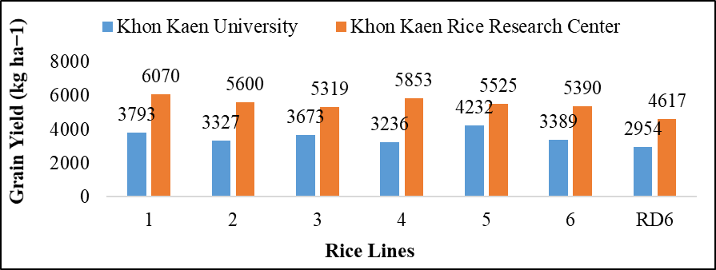
Fig. 4. Performance of 6 introgression lines including recurrent parent for yield at two locations. 1. BC2F3 2-8-2-36; 2. BC2F3 2-7-5-43; 3. BC2F3 2-8-2-19; 4. BC2F3 2-8-2-25; 5. BC2F3 9-1/15-1-28; 6. BC2F3 2-8-2-27 (Nan et al., 2019)

Gall midge Resistance Gene Introgression
Das and Rao (2015) report the development of ILGP (Improved Line for Gall Midge Resistance) lines, achieved by pyramiding resistance genes such as Gm1 and Gm4, originally derived from cultivars Kavya and Abhaya, respectively. These lines exhibit a significant positive response to gall midge infestation, ranging from 75% to 100%, with Kavya (Gm1) and Abhaya (Gm4) showing close to 100% resistance. In contrast, the recurrent ILP parent line remains susceptible to gall midge, displaying only about 6.8% resistance (Fig. 5A). Kumar et al. (2017) further advanced a stable restorer line, RPHR-1005, used in the hybrid DRRH-3, by incorporating bacterial blight and gall midge resistance genes through marker-assisted breeding (MAB). This was accomplished by crossing Improved Samba Mahsuri (ISM), possessing the Xa21 gene for bacterial blight resistance, with Abhaya (Gm4) and Aganni (Gm8) for gall midge resistance. Resulting lines SM1 (Xa21, Gm4) and SM2 (Xa21, Gm8) served as donors to RPHR-1005, enhancing its resilience against these stresses. Additionally, the introgression line RPIC-16-65-125 demonstrated superior performance in yield and yield-related traits over both its recurrent and donor parents (Fig. 5B). This combination of gene pyramiding and marker-assisted selection demonstrates the effectiveness of integrating multiple resistance genes to improve crop resilience against specific pests and diseases.

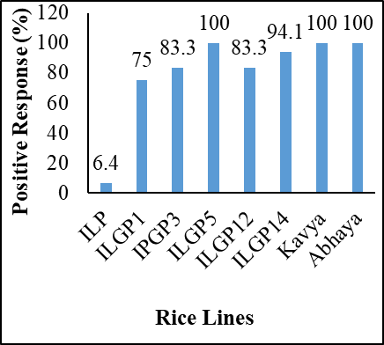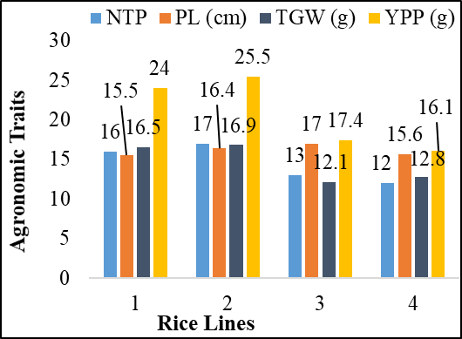
A
B
Fig. 5. Evaluation of rice lines against gall midge.
A. Positive Response (%); ILP. Improved Lalat Parent; ILGP. Improved Lalat Gene Pyramid) (Das and Rao, 2015).
B Agronomic Performance; 1. RPHR-1005; 2. RPIC-16-65-125; 3. SM1 (ISM/Abhaya); 4. SM2 (ISM/Aganni); NTP. No. of productive tillers/plant; PL. Panicle length (cm); TGW. 1000 grain weight (g); YPP. Yield per plant (g) (Kumar et al., 2017).

Submergence Tolerance Gene Introgression
Luo et al. (2016) described the introgression line Wanhui 6725, which contains multiple resistance genes (Xa4, Xa21, Xa27, Pi9, and Sub1A) and its hybrid II-32A/WH6725, both of which demonstrated tolerance to two weeks of submergence. This tolerance is also observed in the donor parent, IR64 (Sub1A), which exhibits high viability and robust recovery following submergence. In contrast, the recipient parent, Mianhui 725, its hybrid II-32A/MH725 and the CMS line II-32A are susceptible to submergence, with poor recovery and often leading to high mortality or poor plant health post-submergence (Fig. 6A). Wanhui 6725, II-32A/WH6725 and IR64 show approximately 80% survival rate post-submergence recovery, underscoring the effectiveness of the Sub1A gene in improving submergence tolerance.
Iftekharuddaula et al. (2016) further highlight the introgression of the SUB1 gene into BRRI dhan33 from BRRI dhan52 using marker-assisted breeding (MAB). This enhancement led to the development of three promising introgression lines: BR9157-12-2-37-13-15, BR9157-12-2-37-13-17, and BR9157-12-2-37-13-71. These lines exhibit an increased yield advantage of 1.24–1.71 t/ha over the recurrent parent and outperform it in key agronomic traits (Fig. 6B).

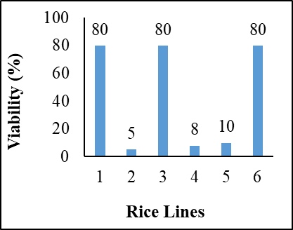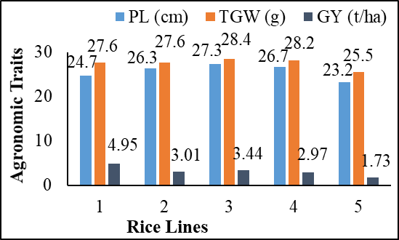
A
B
Fig. 6. Tolerance capacity of rice lines after recovery from two weeks of submergence.
A. Viability % (1. IR64; 2. MH725; 3. WH6725; 4. II-32A; 5. II-32A/MH725; 6. II-32A/WH6725) (Luo et al., 2016).
B Agronomic Performance under field conditions (1. BRRI dhan52; 2. BR9157-12-2-37-13-15; 3. BR9157-12-2-37-13-17; 4. BR9157-12-2-37-13-71; 5. BRRI dhan33; PL. Panicle length (cm); TGW. 1000 grain weight (g); GY. Grain yield (t/ha) (Iftekharuddaula et al., 2016).

Salinity Tolerance Gene Introgression
Thomson et al. (2010) report significant differences in salt tolerance traits between the donor parent FL478 (IR 66946-3R-178-1-1) and the recurrent parent IR29. FL478, a salt-tolerant line, shows a lower SES (Standard Evaluation System) score and reduced Na+/K+ ratios in both shoots and roots compared to IR29, which is sensitive to salt stress (Fig. 7A). Consequently, salt-tolerant Saltol introgression lines derived from FL478 exhibit enhanced yield under salinity stress, yielding 24-33% more than IR29. These lines maintain about 20% more yield under saline conditions relative to non-stressed conditions. This study utilized SSR markers to select for salt tolerance traits, with seedlings evaluated in a hydroponic system at 12 dS m−1 EC. Das and Rao (2015) also highlight the robustness of Saltol introgression lines under severe salinity, noting survival capacities of up to 98% for lines like ILGP, compared to only 5.8% for the recurrent parent ILP, which carries bacterial blight resistance genes (Xa4, Xa5, Xa13, and Xa21). FL478 achieves 100% survival under salinity stress, whereas IR29, being highly susceptible, shows minimal survival. These findings underscore the value of salt tolerance breeding through Saltol gene introgression for enhancing resilience in saline-prone rice cultivation areas.

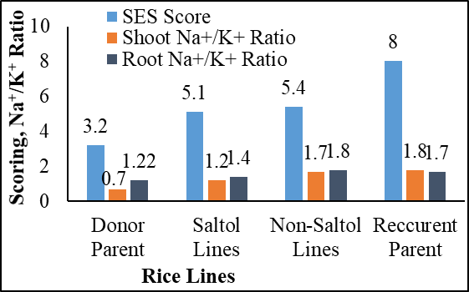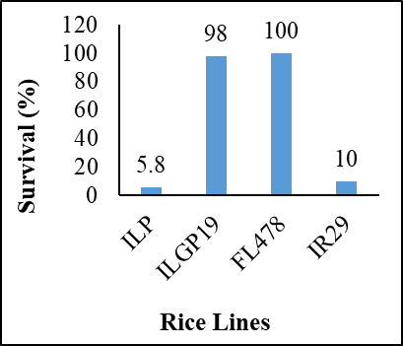
A
B
Fig. 7. Evaluation of rice lines for salinity tolerance.
A. Comparison for SES score, shoot Na⁺/K⁺ ratio and root Na⁺/K⁺ ratio (Thomson et al., 2010).
B. Survival percentage against salinity stress (ILP. Improved Lalat Parent; ILGP. Improved Lalat Gene Pyramid) (Das and Rao, 2015).

Drought Tolerance Gene Introgression
Sandhu et al. (2019) reported the successful development of drought-tolerant rice lines by introgressing qDTY1.1, qDTY2.1 and qDTY3.1 quantitative trait loci (QTLs) into the high-yielding but drought-sensitive variety Swarna. These introgression lines include IR 96321-1447-651-B-1-1-2 (qDTY1.1, qDTY3.1), IR 96321-558-563-B-2-1-1 (qDTY3.1), IR 96322-34-260-B-5-1-1 (qDTY1.1, qDTY2.1, qDTY3.1) and IR 96322-34-223-B-1-1-1 (qDTY1.1, qDTY2.1, qDTY3.1). These lines show improved yield performance under both moderate and severe drought conditions compared to the recurrent parent, Swarna (Fig. 8). In severe drought, IR 96322-34-260-B-5-1-1 achieved the highest yield at 1,411 kg/ha, while under moderate drought, IR 96321-1447-651-B-1-1-2 demonstrated the best performance with a yield of 3,298 kg/ha. In contrast, the drought-susceptible Swarna produced significantly lower yields under both stress conditions. These results highlight the effectiveness of marker-assisted selection in pyramiding multiple drought-resistance QTLs, which can significantly enhance drought resilience and yield stability in rice varieties tailored for drought-prone regions.

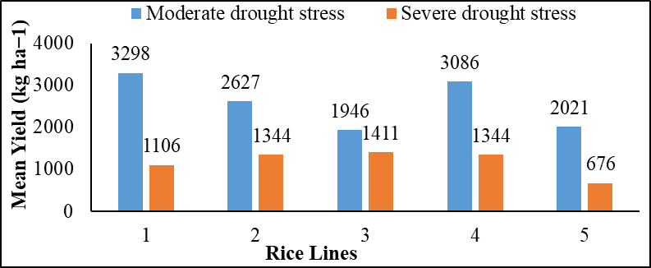
Fig. 8. Mean yield performance of rice lines under moderate and severe drought in field conditions (1. IR 96321-1447-651-B-1-1-2; 2. IR 96321-558-563-B-2-1-1; 3. IR 96322-34-260-B-5-1-1; 4. IR 96322-34-223-B-1-1-1 and 5. Swarna) (Sandhu et al., 2019).

According to Muthu et al. (2020), a popular rice variety, Improved White Ponni (IWP) is introgressed with the abiotic stress tolerant genes for drought (qDTY1.1, qDTY2.1), salinity (Saltol) and submergence (Sub1) through MAB from Apo, Pokkali FL478 and FR13A, respectively. Backcrossed inbred lines (BILs) (3-11-11-1, 3-11-11-2) gather all four resistant genes showing better performance for yield and yield related traits than the recipient parent IWP (Fig. 9).
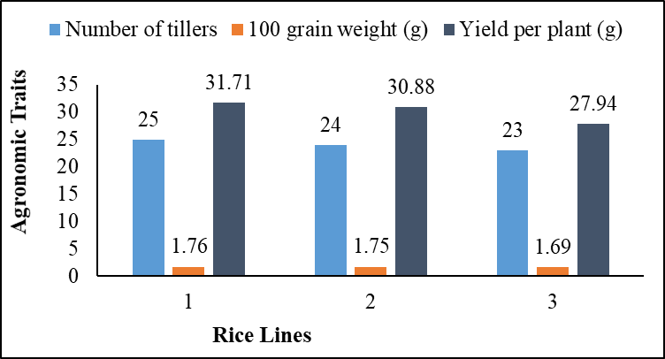
Fig. 9. Performance of rice lines for yield and yield related traits under field conditions (1. BIL 3-11-11-2; 2. BIL 3-11-9-2; 3. Improved White Ponni (IWP)) (Muthu et al., 2020).

Yield Enhancing Gene Introgression
Liang et al. (2004) utilized Oryza rufipogon (IRGC 105491) as a donor parent for introducing yield-enhancing genes (yld1.1 and yld2.1) into the popular hybrid rice parent line 9311 in China. The introgression lines developed showed improved yield and yield-related traits compared to 9311, which served as the recurrent parent. Marker-assisted selection (MAS) was used to screen five BC₃F₁ lines, all of which demonstrated superior performance in terms of grains per panicle, surpassing 9311 (Fig. 10A). Additionally, most BC₃F₁ lines had higher thousand-grain weight than 9311, except for BC₃F₁-₃ and BC₃F₁-₄. Yield per plant was also enhanced, with the derived lines achieving more than 28 g/plant, in contrast to 9311’s yield of 23 g/plant (Fig. 10B). This study emphasizes the potential of incorporating genes from wild relatives like O. rufipogon to boost yields in cultivated rice, demonstrating MAS as a viable method for enhancing productivity traits.

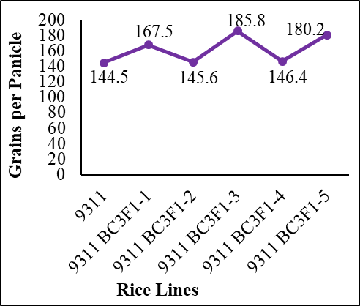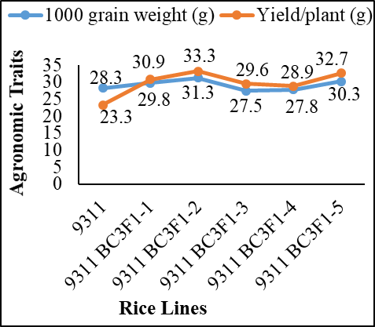
B
A
Fig. 10. Effects of yield enhancing genes for yield and yield related traits.
A. Grains per Panicle; B. 1000 grain weight and yield per plant (Liang et al., 2004).

Li et al. (2014) reported the successful transfer of the GW6 gene from Baodali into both Zhonghua 11 (japonica) and 9311 (indica) rice varieties through marker-assisted backcrossing (MAB). Three introgression lines of Zhonghua 11 and one of 9311 demonstrated enhanced agronomic traits compared to the recurrent parents (Fig. 11). In particular, the line SSL-1 achieved a significant increase in yield, producing 19% more yield per plant than 9311. This study illustrates the potential of using MAB to improve yield-related genes in both japonica and indica types, highlighting GW6 as a valuable gene for yield enhancement in rice breeding programs.

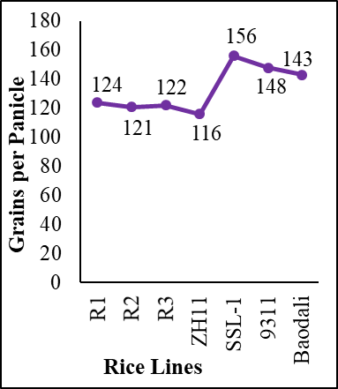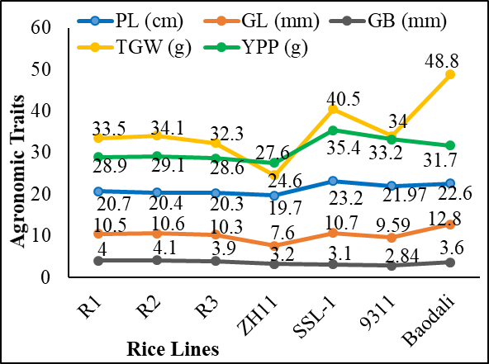
A
B
Fig. 11. Performance of GW6 gene introgressed lines compared to donor and recipient parents for yield and yield related traits.
A. Grains per Panicle, B. Agronomic Traits (ZH11. Zhonghua 11; Near Isogenic Lines R1, R2, R3 for ZH11; SSL-1 for 9311; PL. Panicle Length (cm); GL. Grain Length (mm); GB, Grain Breadth (mm); TGW. 1000 Grain Weight (g); YPP. Yield per Plant (g)) (Yuan et al., 2014).

Considerations for Marker Assisted Breeding
Akhtar et al. (2010) outlined five key factors for successful marker-assisted backcrossing (MAB): reliability, marker assay technical procedure, polymorphism level, cost and DNA quality/quantity. Markers used in MAB should be reliable, highly polymorphic and cost-effective, with genetic distances ideally under 5 cM for effective gene transfer. The accuracy of MAB hinges on the proximity of molecular markers to the target gene, with closer markers leading to more precise selection (Nogoy et al., 2016). Additionally, intragenic markers can enhance phenotype prediction reliability. The technical procedure for marker assays should be efficient, simple and fast, ensuring feasibility and minimizing procedural delays.

Recent Progress in Marker Assisted Breeding of Rice
Rice breeders have successfully developed genotypes capable of withstanding various biotic and abiotic stresses, utilizing marker-assisted breeding (MAB) techniques that rely on closely linked molecular markers (Das et al., 2017). Through marker-assisted pyramiding, multiple stress-resistance genes have been introduced simultaneously, resulting in rice lines resilient to diseases/pests like bacterial blight, blast and gall midge, as well as environmental stresses such as drought, salinity and submergence. The effectiveness of these improved genotypes has significantly contributed to stable rice yields under diverse and changing climatic conditions. Table 4, as referenced, likely details specific genotypes and their associated resistance traits, highlighting the impact of these advanced breeding efforts.
Table 4. List of genotypes and traits improved by marker assisted selection
Improved Genotypes | Traits | Resistant Genes | References
Pusa basmati I | Bacterial blight | Xa13 + Xa21 | Kottapalli et al. (2010)
Samba Mahsuri | Bacterial blight | Xa5 + Xa13 + Xa21 | Kottapalli et al. (2010)
Wanhui 6725 | Bacterial blight | Xa4+Xa21+Xa27 | Luo et al. (2016)
Swarna sub1 | Submergence | Sub1 | Nandi et al. (1997)
IR64 sub1 | Submergence | Sub1 | Reddy et al. (2009)
Pusa RH10 | Rice blast | Piz5 + Pi54 | Singh et al. (2013)
Feng39S | Rice blast | Pi2 | Yang et al. (2019)
Lalat | Gal midge | Gm1+Gm4 | Das and Rao, (2015)
Swarna | Drought | qDTY1.1+qDTY2.1+qDTY3.1 | Sandhu et al. (2019)
Tapaswini | Bacterial blight | Xa4 + Xa5 + Xa13 + Xa21 | Dokku et al. (2013)
Mangeumbye | Bacterial blight | Xa4 + Xa5 + Xa21 | Suh et al. (2013)
IR29 | Salinity | Saltol | Thomson et al. (2010)
Dongan | Anaerobic germination | AG1 + AG2 | Kim et al. (2019)

Conclusion
Marker-assisted breeding (MAB) has significantly enhanced conventional breeding efficiency by integrating molecular markers linked to target genes. The positive impacts of gene introgression has demonstrated the advancements in developing rice lines with enhanced resistance to various biotic and abiotic stresses. For instance, Wanhui 6725 and its hybrid (II-32A/WH6725) have become resistant to 27 Xoo strains, while the recurrent parent Mianhui 725 and related hybrids remain susceptible. Similarly, blast-resistant lines such as DB16206–34 and DB16206–38, as well as their hybrids, outperform susceptible recurrent lines like Feng39S. Against gall midge, ILGP lines (e.g., ILGP 1, ILGP 3) exhibit improved survival, whereas the recurrent parent ILP shows minimal resistance. Submergence tolerance is also achieved, with WH6725 and its hybrid surviving two weeks of submergence while Mianhui 725 and related hybrids suffer high mortality. Similarly, yield gains are seen in blast-resistant lines such as DHA-10, which outperforms the recurrent parent BPT5204, yielding 5,680 kg/ha compared to 4,973 kg/ha. The bacterial blight-resistant line BC2F3 2-8-2-36 shows similar yield advantages. Triple-stress tolerant lines (drought, salinity, and submergence) have also been developed, showing a higher per-plant yield (>31 g) than the recurrent parent IWP (28 g). Submergence-tolerant lines like BR9157-12-2-37-13-17 outperform their recurrent parent BRRI dhan33 in submerged conditions, yielding 3.44 t/ha compared to 1.73 t/ha. Introgression of the GW6 gene has also boosted yield, with lines like SSL-1 producing 19% more yield per plant than the popular hybrid parent 9311. This evidence underlines the role of MAB in increasing rice productivity and resilience, with introgression lines consistently demonstrating superior performance in yield and stress tolerance compared to recurrent parents. These results emphasize MAB as a crucial tool in sustainable rice breeding and food security initiatives.

Acknowledgements
The authors would like to acknowledge authorities of Bangabandhu Sheikh Mujibur Rahman Agricultural University, Gazipur 1706, Bangladesh for the logistic support. The authors also greatly acknowledge IRRI for funding through the project entitled “Establishment of Breeding Zone Trial in Bangladesh for Favorable Breeding Environment”.

REFERENCES
Akhtar, S., Bhat, M. A., Wani, S. A., Bhat, K. A., Chalkoo, S., Mir, M. R. and Wani, S. A. (2010). Marker assisted selection in rice. Journal of Phytology, 2(10), 66-81.
Aung Nan, M. S., Janto, J., Sribunrueang, A., Monkham, T., Sanitchon, J. and Chankaew, S. (2019). Field evaluation of RD6 introgression lines for yield performance, blast, bacterial blight resistance, and cooking and eating qualities. Agronomy, 9(12), 825.
Bailey-Serres, J., Lee, S. C. and Brinton, E. (2012). Waterproofing crops: effective flooding survival strategies. Plant Physiology, 160(4), 1698-1709.
BBS (2019). Bangladesh Bureau of Statistics, Agriculture Wing. Government of the People's Republic of Bangladesh. Parishankhyan Bhaban, E-27/A, Agargaon, Dhaka-1207.
BRRI (2018). Modern Rice Cultivation. Twenty edition. Gazipur, Bangladesh P 91.
Chukwu, S. C., Rafii, M. Y., Ramlee, S. I., Ismail, S. I., Hasan, M. M., Oladosu, Y. A. and Olalekan, K. K. (2019). Bacterial leaf blight resistance in rice: a review of conventional breeding to molecular approach. Molecular Biology Reports, 46(1), 1519-1532.
Collard, B. C. and Mackill, D. J. (2008). Marker assisted selection: an approach for precision plant breeding in the twenty-first century. Philosophical Transactions of the Royal Society B: Biological Sciences, 363(1491), 557-572.
Dar, M.H., Bano, D.A., Waza, S.A., Zaidi, N.W., Majid, A., Shikari, A.B., Singh, U.S., 2021. Abiotic stress tolerance—progress and pathways of sustainable rice production. Sustainability 13 (4), 2078.
Dar, M.H., Chakravorty, R., Waza, S.A., Sharma, M., Zaidi, N.W., Singh, A.N., Singh, U.S., Ismail, A.M., 2017. Transforming rice cultivation in flood-prone coastal Odisha to ensure food and economic security. Food Security 4, 711–722.
Dar, M.H., Waza, S.A., Shukla, S., Zaidi, N.W., Nayak, S., Hossain, M., Kumar, A., Ismail, A.M., Singh, U.S., 2020. Drought tolerant rice for ensuring food security in Eastern India. Sustainability 12, 2214.
Dar, M.H., Zaidi, N.W., Waza, S.A., Verulkar, S.B., Ahmed, T., Singh, P.K., Bardhan Roy, S.K., Chaudhary, B., Yadav, R., Islam, M.M., 2018. No yield penalty under favorable conditions paving the way for successful adoption of flood tolerant rice. Scientific Reports 8, 9245.
Das, G. and Rao, G. J. N. (2015). Molecular marker assisted gene stacking for biotic and abiotic stress resistance genes in an elite rice cultivar. Frontiers in Plant Science, 6, 698.
Das, G., Patra, J. K. and Baek, K. H. (2017). Insight into MAS: a molecular tool for development of stress resistant and quality of rice through gene stacking. Frontiers in Plant Science, 8, 985.
FAO (2020). Food and Agriculture Organization. Quarterly Global Report No.1. Crop Prospects and Food Situation. Rome.
Hasan, M. M., Rafii, M. Y., Ismail, M. R., Mahmood, M., Rahim, H. A., Alam, M. A. and Latif, M. A. (2015). Marker assisted backcrossing: a useful method for rice improvement. Biotechnology and Biotechnological Equipment, 29(2), 237-254.
Iftekharuddaula, K. M., Ahmed, H. U., Ghosal, S., Amin, A., Moni, Z. R., Ray, B. P. and Septiningsih, E. M. (2016). Development of early maturing submergence-tolerant rice varieties for Bangladesh. Field Crops Research, 190, 44-53.
Jiang, Y., Cai, Z., Xie, W., Long, T., Yu, H. and Zhang, Q. (2012). Rice functional genomics research: progress and implications for crop genetic improvement. Biotechnology Advances, 30(5), 1059-1070.
Jonas, E. and de Koning, D. J. (2013). Does genomic selection have a future in plant breeding?. Trends in Biotechnology, 31(9), 497-504.
Khan, M. H., Dar, Z. A. and Dar, S. A. (2015). Breeding strategies for improving rice yield—a review. Agricultural Sciences, 6(5), 467.
Khush G.S and Virk P.S. (2005) IR varieties and their impact. Los Banos, Philippines: International Rice Research Institute. 163 p.
Kim, S. M., Kim, C. S., Jeong, J. U., Reinke, R. F. and Jeong, J. M. (2019). Marker‐assisted breeding for improvement of anaerobic germination in japonica rice (Oryza sativa). Plant Breeding, 138(6), 810-819.
Kottearachchi, N. S. (2013). Utility of DNA markers in rice breeding. European International Journal of Science and Technology, 2, 111-122.
Kumar, V. A., Balachiranjeevi, C. H., Naik, S. B., Rekha, G., Rambabu, R., Harika, G. and Kale, R. (2017). Marker assisted pyramiding of bacterial blight and gall midge resistance genes into RPHR-1005, the restorer line of the popular rice hybrid DRRH-3. Molecular Breeding, 37(7), 86.
Li, Y. Y., Tao, H. J., Zhao, X. Q., Jie, X. U., Li, G. M., Hu, S. K. and Ye, G. Y. (2014). Molecular improvement of grain weight and yield in rice by using GW6 gene. Rice Science, 21(3), 127-132.
Liang, F., Deng, Q., Wang, Y., Xiong, Y., Jin, D., Li, J. and Wang, B. (2004). Molecular marker assisted selection for yield-enhancing genes in the progeny of “9311× O. rufipogon” using SSR. Euphytica, 139(2), 159-165.
Luo, Y., Ma, T., Zhang, A., Ong, K. H., Li, Z., Yang, J. and Yin, Z. (2016). Marker assisted breeding of the rice restorer line Wanhui 6725 for disease resistance, submergence tolerance and aromatic fragrance. Rice, 9(1), 66.
Muthu, V., Abbai, R., Nallathambi, J., Rahman, H., Ramasamy, S., Kambale, R. and Muthurajan, R. (2020). Pyramiding QTLs controlling tolerance against drought, salinity, and submergence in rice through marker assisted breeding. Plos One, 15(1), e0227421.
Nogoy, F. M., Song, J. Y., Ouk, S., Rahimi, S., Kwon, S. W., Kang, K. K. and Cho, Y. G. (2016). Current applicable DNA markers for marker assisted breeding in abiotic and biotic stress tolerance in rice (Oryza sativa L.). Plant Breeding and Biotechnology, 4(3), 271-284.
Peng, S. and Khush, G. S. (2003). Four decades of breeding for varietal improvement of irrigated lowland rice in the International Rice Research Institute. Plant Production Science, 6(3), 157-164.
Ribaut, J. M. and Betrán, J. (1999). Single large-scale marker assisted selection (SLS-MAS). Molecular Breeding, 5(6), 531-541.
Sagar Krishna Murthy, P., Deshmukh, D. B., Yashvanth Kumar, K. J., Patil, S., Jakkeral, S., Nemappa, G. H. and Singh, A. K. (2017). Introgression of Pi2 and Pi5 genes for blast (Magnaporthe oryzae) resistance in rice and field evaluation of introgression lines for resistance and yield traits. Journal of Phytopathology, 165(6), 397-405.
Sandhu, N., Dixit, S., Swamy, B. P. M., Raman, A., Kumar, S., Singh, S. P. and Yadav, S. (2019). Marker assisted breeding to develop multiple stress tolerant varieties for flood and drought prone areas. Rice, 12(1), 8.
Suela, M. M., Lima, L. P., Azevedo, C. F., Resende, M. D. V. D. and Nascimento, M. (2019). Combined index of genomic prediction methods applied to productivity. Ciência Rural, 49(6), 1678-4596.
Thomson, M. J., de Ocampo, M., Egdane, J., Rahman, M. A., Sajise, A. G., Adorada, D. L. and Gregorio, G. B. (2010). Characterizing the Saltol quantitative trait locus for salinity tolerance in rice. Rice, 3(2-3), 148-160.
USDA (2020). United States Department of Agriculture. Foreign Agricultural Service, Global Market Analysis. Circular Series, WAP, 4-20.
Wang, W., Vinocur, B. and Altman, A. (2003). Plant responses to drought, salinity and extreme temperatures: towards genetic engineering for stress tolerance. Planta, 218(1), 1-14.
Yang, D., Tang, J., Yang, D., Chen, Y., Ali, J. and Mou, T. (2019). Improving rice blast resistance of Feng39S through molecular marker assisted backcrossing. Rice, 12(1), 70.
Yang, H. B., Kang, W. H., Nahm, S. H. and Kang, B. C. (2015). Methods for developing molecular markers. In Current Technologies in Plant Molecular Breeding (pp. 15-50).

