**RESEARCH ARTICLE**

**Optimization of Malting Process for Pearl Millet Milk Extraction**

Er. S. Baranidharan1*, Dr. V. Perasiriyan2, Dr. N. Karthikeyan3 and Dr. S.K. Mathanghi4

1*Department of Food Processing Technology, CFDT, TANUVAS, Chennai- 6000 52, Tamil Nadu, India

2Department of Food Business Management, CFDT, TANUVAS, Chennai- 6000 52, Tamil Nadu, India

3Department of Livestock Products Technology, VCRI-Namakkal, TANUVAS, Namakkal- 6370 02, Tamil Nadu, India

4Department of Food Processing Technology, CFDT, TANUVAS, Chennai- 6000 52, Tamil Nadu, India

|  |
| --- |
| ABSTRACT Pearl millet, a vital cereal in the arid and semi-arid regions of Asia and Africa, is renowned for its high energy, dietary fiber, proteins, and essential minerals. However, its anti-nutritional factors can affect nutrient bioavailability. This study aimed to optimize malting parameters to reduce these anti-nutritional factors and improve the nutritional profile of pearl millet milk. Notably, the tannin and phytic acid decreased by 58.31 and 32.08 % respectively, dropping from 171.3±2.28 to 71.4±1.13 mg/100 g and 830.31±0.477 to 563.88±0.65 mg/100 g, following 12 hours of soaking and 48 hours of germination. The extraction process was optimized, and nisin was added at a concentration of 50 parts per million (ppm) to extend the milk's shelf life to 12 days. The proximate composition of the extracted milk was determined, revealing moisture content of 88.91±0.19 %, carbohydrate content of 8.31±0.08 %, protein content of 1.46±0.02 %, fat content of 0.57±0.03 %, fiber content of 0.35±0.08 %, and ash content of 0.34±0.08 %. The milk was also evaluated for its physicochemical properties and mineral content. These findings demonstrate the successful application of malting and nisin treatment in enhancing the nutritional quality and shelf life of pearl millet milk, making it a promising alternative for dietary improvement. |

**Keywords:** *Pearl millet; Malting; Milk extraction;**Anti-nutrition; Analysis*

## **INTRODUCTION**

There are an estimated 500 million vegetarians worldwide, as reported by the Food and Agriculture Organization (FAO) in 2002. According to a 2018 survey conducted by Ipsos (Institut Public de Sondage d'Opinion Secteur), vegans comprise approximately 3% of the global population, which translates to over 230 million people. The popularity of vegan diet foods has grown significantly in recent years. By choosing plant-based alternatives, individuals can reduce their carbon footprint and contribute to a more sustainable future, as suggested by Scarborough et al. (2014).

Milk is widely regarded as an essential component of the human diet due to its high nutritional content and the numerous health benefits it provides. It is a primary source of crucial nutrients, including calcium, vitamin D, proteins, and minerals that are necessary for overall health and development. However, vegans do not consume animal products, which means that cow's milk is not included in their dietary choices. This can limit the nutritional content of their diet compared to a typical diet. As a result, researchers are conducting studies to develop non-dairy and plant-based milk alternatives to overcome this limitation in vegan diets.

Plant-based beverages are a crucial component of vegan diets, providing a diverse range of flavors and types to cater to different tastes and nutritional needs. These beverages are a convenient way for vegans to fulfill their daily requirements for essential minerals like calcium, potassium, magnesium, phosphorus, zinc, iron, and vitamin B12, while also reducing their intake of saturated fat, sodium, and sugar (Key *et al*., 2022).

Millet drink is a plant-based beverage made from millet, a gluten-free cereal that is rich in fiber, polyphenols, minerals and B vitamins. It has several potential benefits including a low glycaemic index and can help to maintain blood glucose levels, insulin resistance, and HbA1c levels. The millet-based drink is lactose-free and suitable for people with lactose intolerance or dairy allergies has a lower environmental impact and requires less water and land than dairy milk (Semwal *et al*., 2021).

This study endeavors to optimize the malting parameters to extract the milk from Pearl millet (*Pennisetum Glaucum)* and to analyze its physico-chemical, proximate and mineral composition.

## **2. MATERIALS AND METHODS**

### ***2.1 Pearl millet grains***

The Pearl millet variety taken for milk production was a traditional (*Pennisetum Glaucum) variety.*The pearl millet grains harvested in the year 2024 were purchased from the local market in Chennai. Samples of pearl millet grain (100 grams) were washed, 4 to 5 times, with potable water (22-24 ℃) to remove foreign material.

### ***2.1.1 Quality characteristics of pearl millet grains***

### ***2.1.1.1 Thousand kernel weight (TKW)***

The 1,000-kernel weight was determined using method de- scribed by Serna-Saldivar (2012).

### ***2.1.1.2 Determination of germinative energy***

Two filter papers (Whatman No. 1; Whatman plc., Maidstone, UK) were saturated with 4 milliliters (mL) of distilled water and positioned at the base of a petri dish, with 100 grain kernels carefully arranged on top to ensure contact with the moist filter papers. The petri dish was then covered and maintained at an average temperature of 30 ℃ for 48 hours. After the incubation period, the kernels that had sprouted were counted, and the germinative energy (GE) was calculated according to Agbo's *et al*. (1995) suggestion (Eqn.1).

$GE (\%)=100 – N$………. (1)

where N = number of ungerminated grains

### ***2.1.1.3 Determination of germinative capacity***

One hundred pearl millet grains were soaked for 48 hours in 100 mL of hydrogen peroxide solution at a concentration of 7.5 %, at a temperature of 25 ℃, in a glass beaker. Following draining the soaked water, the sprouted grains were separated from the unsprouted grains, and the sprouted grains were placed on moist filter paper in a petri dish, covered with another moist filter paper, and allowed to germinate at 32 degrees Celsius for approximately 24 hours. Distilled water was added during germination, and the count of newly germinated grains was added to the initial count (Agbo, 1995; Badau, 2004). The germinative capacity (GC) was calculated using Eqn.2.

$GC (\%) =\frac{(200 – N)}{2}$…….. (2)

Where N = number of ungerminated grains.

### ***2.1.1.4 Water sensitivity***

Two lots of 100 grains were grown on filter papers in petri dishes; one moistened with 4 mL and the other with 8 mL water. The water was changed every 4 hrs to avoid foul smelling. The difference in the number of grains that germinated after 48 hrs at 28 ℃ in the two petri dishes was noted as the water sensitivity value (Briggs and Hough, 1981).

### ***2.2 Standardization of soaking time***

The soaking time was optimized based on the water absorption capacity of grains at three different temperatures 25 ℃, 30 ℃ and 35 ℃ (Ituen *et al*., 1986). Using a pre-weighed wetted muslin cloth, 100 grams (g) of grains were enclosed. Subsequently, the grains underwent soaking in water at a 1:3 ratio. Over 35 hours, the absorbed water was measured at two-hour intervals.

### ***2.3 Standardization of germination time and temperature***

Germination time was optimized based on the extent of sprout (both root and shoot) growth and moisture content. Prior to sprouting, the seeds were cleaned and surface sterilized with a 0.1 % (w/v) potassium permanganate solution, as described by Bembem and Agrahar-Murugkar (2020). The soaked seeds were then drained and covered with a muslin cloth before being placed in the dark and allowed to germinate at four different temperatures at 95% relative humidity (R.H) for four days. To prevent the roots and shoots from becoming entangled, the grains were occasionally rotated. After each day, the roots and shoots were gently rubbed off with a nylon cloth, and their weights were expressed as a percentage (%) of the overall weight.

***2.4 Drying and extraction of milk***

Grains were dried in a hot air oven at 48 ℃ for 8 hours to degrade the starch and retain moisture content. The grains are then milled in a high-speed blender to extract milk. To the sprouted grains water was added in a ratio of 1:7 and then the milk was extracted (Geetha and Preethi, 2020)and the residual cake was again mixed with extracted milk, blended and then pressed in hydraulic press.

### ***2.5 Standardization of preservative levels***

Preliminary trials were carried out to standardize the preservative nisin for fresh pearl millet drink. Nisin was added at 50 ppm/L (Sukumaran and Radhakrishnan, 2021), 25 ppm/L and 10 ppm/L (Sunil, A. N *et al*., 2013) level. Then, pH and sensory evaluation were carried out as per a 9-point hedonic scale with a regular interval of 4 days.

### ***2.6 Storage of pearl millet milk***

The extracted milk was stored in a sterile glass bottle at refrigerated temperature (4±2 ℃) and its quality was evaluated (Fig 1.).

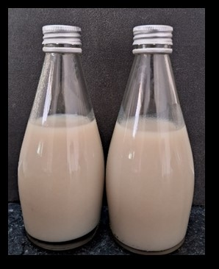

**Figure 1. Pearl millet milk stored in glass bottle**

### ***2.7 Physico-chemical properties***

### ***2.7.1 Determination of pH***

pH was determined using a Labman LMPH-10 pH meter.

### ***2.7.2 Determination of titratable acidity (T. A)***

By titrating a known quantity of product with 0.1 N NaOH and using phenolphthalein as an indicator, the titratable acidity was expressed as a percentage of acetic acid (AOAC, 2000).

### ***2.7.3 Determination of total soluble solids (TSS)***

TSS of pearl millet drink was determined by the standard method of AOAC (2006), using a hand refractometer (0-32 °Brix) at refrigerated temperature.

### ***2.7.4 Determination of viscosity***

The viscosity of pearl millet milk was measured with a Rotational Viscometer (Cole-Parmer, India) using LV1 Spindle. The torque value was adjusted between 10 to 100 %) to obtain an accurate value (Ahlawat, 2007).

### ***2.7.5 Colour analysis***

Color measurement (Plate 3) was carried out using a Hunter colorimeter model 45/0-L mini scan XE PLUS (Hunter Associates Labs, Reston, VA, USA) based on three variables, namely, L, a, and b. A comparison was made with each sample at different times of storage. Hue, chroma values, and color coordinates were obtained from L, a* and b* values by using the following formulae (Eqn.3, 4 and 5) (García-Toledo *et al*., 2016).

$Hue =\tan^{-1}({b*}/{a*})$……. (3)

$Chroma = {{(a}^{2}+b^{2})}^{-1/2}$……. (4)

$Color coordinate = a/b$……. (5)

### ***2.8 Sensory evaluation***

A descriptive 9-point hedonic scale was used to evaluate the sensory attributes (Appearance & color, flavor, taste, odor and overall acceptability) of the extracted milk.

### ***2.9 Proximate composition of pearl millet milk***

Proximate composition (moisture, crude fat, fiber, protein, total ash) was analyzed using AOAC (2000).

***2.10 Mineral composition of pearl millet milk***

The mineral composition was analyzed using the method described by AOAC (2011).

### ***2.11. Estimation of anti-nutritional factors***

### ***2.11.1 Tannin***

The tannin content in the samples was measured using the method described by AOAC (2000).

### ***2.11.2 Phytic acid***

The phytic acid was determined using the procedure described by Vaintraub and Lapteva, (1988). A 0.5 g of dried sample was weighed into a 250 mL conical flask. A 25 mL of 2.4 % HCl was added, allowed to stand for one hour at ambient temperature, and centrifuged at 3000 rotation per minute (rpm) for 30 minutes (min). The clear supernatant was used for phytate analysis. A 1 mL of Wade reagent (0.03% solution of FeCl.6H2O containing 0.3 % sulfosalicylic acid in water) was added to 3 mL of the supernatant, and vortexed for a minute. The absorbance was read at 500 nanometre (nm) using a spectrophotometer. The concentration of phytate was calculated from a standard calibration curve of phytic acid (2 to 10 mg/mL), and the result was expressed as phytic acid milligram (mg)/100 g.

## **3. RESULTS AND DISCUSSION**

### ***3.1 Quality characteristics of pearl millet grains***

The results on various quality characteristics of pearl millet grains as studied are shown in Table 1. The TKW was recorded to be 9.45 g. Higher thousand kernel weight tends to have higher potential extract yields (Nso *et al*., 2003). The moisture content of the grains was 11.60 %. GE and GC of pearl millet grains were high (96.83 and 99.32 %, respectively), compared with the recommended value i.e. >90 % for malting (O’Rouke, T., 2004). The higher germination count of pearl millet grains (above 92 %) was indicative of the good viability of the grains for malting.

Table 1. Table for quality characteristics of pearl millet grains (Mean ±SE)@

|  |  |  |
| --- | --- | --- |
| S.I No. | Parameter | Value |
|  | 1000 kernel weight (g) | 9.45±0.05 |
|  | Moisture content (%) | 10.90±0.23 |
|  | Germination capacity (%) | 93.32±0.14 |
|  | Germination energy (%) | 96.83±0.16 |
|  | Water sensitivity | 1.98±0.00 |

### 

### ***3.2 Standardization of soaking time***

The result showed that the grains attained their saturation at 30, 24 and 12 hours when it is soaked at 25, 30 and 35 ℃ respectively. It showed a highly significant difference (P<0.01) at all the time.

Table 2. displays data on water uptake by Pearl millet grains at various soaking durations under different temperature conditions. As observed from the table, water absorption increases significantly with rising temperature. This can be attributed to the increased molecular activity and quicker diffusion rate. Pearl millet grains attained their maximum water absorption capacity at 30, 24, and 12 hours, when soaked at 25 ℃, 30 ℃, and 35 ℃ respectively. The degree of steeping of pearl millet grains is affected by both steeping time and temperature (Balkrishna and Visvanathan, 2019) (Dewar, J., 1997). At 18 hours of soaking, pearl millet absorbs the maximum amount of water, and further absorption ceases as it reaches its saturation point. However, the time taken for the grain to reach saturation is significantly affected by temperature. According to Novellie L, (1962) the steep moisture increases as steeping temperature rises from 10 ℃ to 30 ℃. Initially, water absorption is rapid in the first 6 hours, followed by a gradual decrease. After 12 hours of soaking, the rate of water absorption becomes very low because the grains nearly reach their saturation point. Fig 2. represents a higher water absorption rate occurring at 35 ℃ and the rate of absorption decreases significantly after 12 hours indicating that soaking over 12 hours does not significantly affect the water absorption.

Table 2. Table for water absorption capacity of soaked pearl millet grains over time (Mean ±SE)@

|  |  |  |  |
| --- | --- | --- | --- |
|  | Temperature | | |
| Soaking Time (hours) | 25℃ | 30℃ | 35℃ |
| 0 | 16.2a±0.68 | 16.2a ±0.68 | 16.2a±0.68 |
| 6 | 58.25b±1.10 | 61.19b±1.10 | 68.75b±1.84 |
| 12 | 66.52c±0.62 | 71.83c±0.38 | 73.76±0.57 |
| 18 | 70.36d±0.47 | 74.5d±0.53 | 75.17c±0.20 |
| 24 | 73.65e±0.24 | 75.92d±0.31 | 76.07c ±0.42 |
| 30 | 74.22e ±0.43 | 75.93d0.31 | 76.08c ±0.42 |
| 36 | 74.22e ±0.43 | 75.93d±0.31 | 76.08c ±0.42 |
| F value | 1115.877** | 1396.321** | 715.239** |

@Average of six trials, **Highly significant (P<0.01), *Significant (0.01<P<0.05), NSNon-significant (P>0.05), Different superscripts in a row (capital letters) and column (small letters) differ significantly.

Table 3. shows that the hydration coefficient of grain is different at different temperature. An increase in temperature increases the hydration coefficient of grains. Foods with a higher hydration coefficient tend to absorb water more readily during rehydration. As a result, their texture becomes softer and more palatable. Foods that absorb water efficiently can retain more water-soluble vitamins and minerals compared to the other 2 treatments i.e., 25 ℃ and 30 ℃. Hence soaking the grains at 35 ℃ for 12 hours results in higher water absorption in a short period. Similar studies undertaken by Balkrishna and Visvanathan, (2019) showed that little millet reached equilibrium moisture content in 18.5 hours at 30 ℃ and 3.5 hours at 70 ℃, while Proso millet took 4 hours at 70 ℃ and 19 hours at 30 ℃. A similar result was observed in the study conducted by Ituen *et al*. (1986) showed the hydration coefficient of Pearl millet (Ex Brono variety) was found to be 159.04 at 28 ℃.

Table 3. Table for hydration coefficient of grains steeped at different temperatures (Mean ±SE)@

|  |  |  |
| --- | --- | --- |
| Treatment | Temperature | Hydration Coefficient |
| T1 | 25℃ | 174.22 |
| T2 | 30℃ | 175.93 |
| T3 | 35℃ | 176.08 |

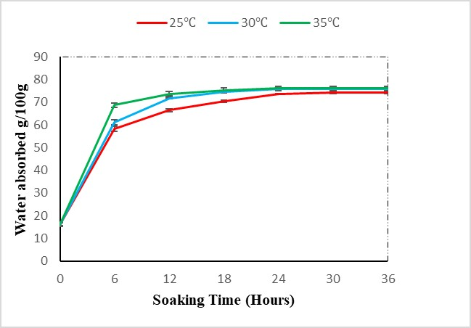

**Figure 2. Water absorption capacity of soaked pearl millet grains over time**

### ***3.3 Standardization of germination time and temperature***

It has been observed that the growth of root and shoot increases with an increase in temperature and time until 35 ℃ (Fig 3.). It showed a highly significant difference (P<0.01) on the 1st, 2nd, 3rd and 4th day of germination among all the treatments. Table 4. shows that root and shoot growth of germinating grains were noticeably affected at 40°C, with reduced growth compared to other temperatures. In contrast, grains sprouted at 35°C exhibited the highest sprout growth among the temperatures tested. Fig 4. represents the rate of growth of root and shoots decreased after 48 hours of germination and there is a highly significant difference (P<0.01) at 48 hours of germination among all the treatments. Similar results were obtained by Pelembe *et a*l. (2002) in their studies on the effect of malting conditions on pearl millet malt quality.

Table 4. Table for standardization of germination time based on root and shoot growth (Mean ±SE)@

|  |  |  |  |  |  |
| --- | --- | --- | --- | --- | --- |
|  | Germination Period (Hours) | | | | |
| Temperature | 0 | 24 h | 48 h | 72 h | 96 h |
| 25 ℃ | 0 | 0.16a ±0.006 | 2.43b± 0.023 | 2.75a±0.026 | 2.93b±0.068 |
| 30 ℃ | 0 | 0.58b ± 0.023 | 3.7c ±0.02 | 3.92c±0.11 | 4.36d±0.093 |
| 35 ℃ | 0 | 0.83c ±0.026 | 4.27d ± 0.023 | 4.6c±0.11 | 4.79b±0.028 |
| 40 ℃ | 0 | 0.18a± 0.014 | 2.22a±0.026 | 2.64a±0.17 | 2.83a±0.089 |
| F value | - | 282.618** | 1789.582** | 81.622** | 167.016** |

@Average of six trials, **Highly significant (P<0.01), *Significant (0.01<P<0.05), NSNon-significant (P>0.05), Different superscripts in a row (capital letters) and column (small letters) differ significantly.

Table 5. proves that the moisture content of the grains increases with an increase in germination period for a particular period and then it decreases. Regardless of the germination time, the moisture content of the grains increases with an increase in temperature up to 35 ℃ further increase in germination temperature results in loss of moisture content (Fig 5.). Statistical analysis showed that there is a significant difference (P<0.01) over 24 hours, a highly significant difference (0.01<P<0.05) over 48 hours and 72 hours. The results coincide with the findings of Dahiya *et al.* (2018) who examined the quality characteristics of pearl millet malt affected by steeping temperature and germination period.

Table 5. Table for standardization of germination time based on moisture content (Mean ±SE)@

|  |  |  |  |
| --- | --- | --- | --- |
|  | Moisture content | | |
| Temperature | 24 h | 48 h | 72 h |
| 25 ℃ | 37.3a±1.29 | 42.8a±2.54 | 41.8c±2.59 |
| 30 ℃ | 45.66ab±1.94 | 45.1a±0.24 | 41.4c±1.91 |
| 35 ℃ | 52.65b±3.33 | 64.16b±3.26 | 32.6b±0.18 |
| 40 ℃ | 45ab±2.78 | 43.4a±1.29 | 25.8a±0.13 |
| F value | 6.476* | 22.215** | 22.523** |

@Average of six trials, **Highly significant (P<0.01), *Significant (0.01<P<0.05), NSNon-significant (P>0.05), Different superscripts in a row (capital letters) and column (small letters) differ significantly.

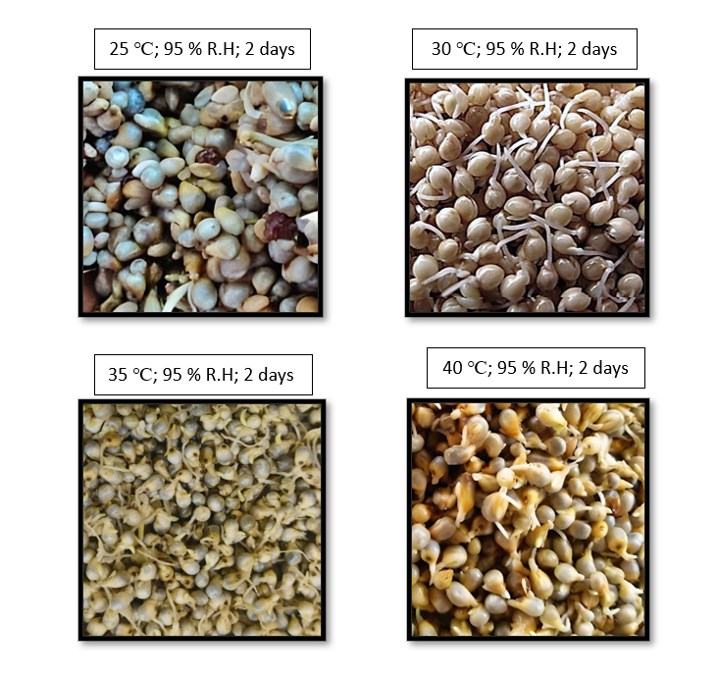

**Figure 3. Pearl millet germinated at different temperatures**

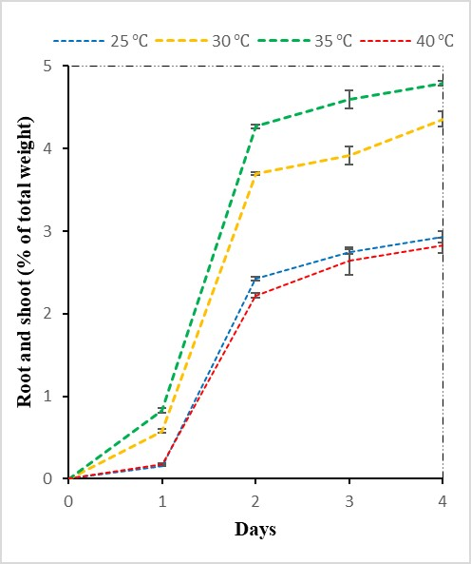

**Figure 4. Root and shoot growth percentage of pearl millet grains over time**

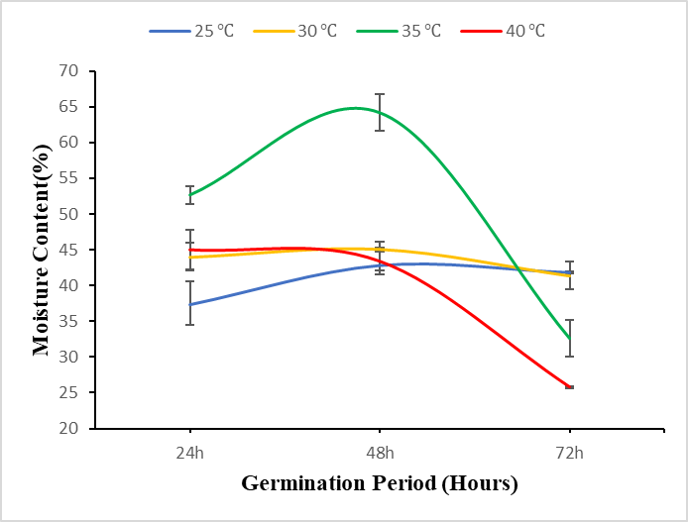

**Figure 5. Moisture content percentage of pearl millet grains over time**

### ***3.4 Drying and extraction of milk***

Table 6. shows milk yield at different temperatures (25 ℃, 30 ℃, 35 ℃, and 40 ℃) over three germination periods (24, 48, and 72 hours). It has been observed that the yield of milk increases with an increase in germination period up to 48 hours and an increase in temperature up to 35 ℃, further beyond both conditions the yield was reduced. Fig 6. Represents the highest milk yield occurs at 35 ℃ after 48 hours (477±1.527 mL). The variation in milk yield across different temperatures remains highly significant after 24 hours (P<0.01), highlighting the crucial role temperature plays in influencing milk yield during the initial period. The impact of temperature on the moisture content of the grain contributes to these differences in yield. This trend continues after 48 hours and 72 hours with the variation still showing high significance (F value = 94.98, P<0.01), indicating that temperature continues to exert a significant influence on milk yield. The optimized condition was adopted and then the grains were dried in a hot air oven (45 ℃ for 8 hrs) (Shunmugapriya *et a*l., 2020). Similar studies were conducted by Sheela *et al*. (2018), in their studies and observed that a combination of 8 hours of soaking and 18 hours of germination high milk yield. Sudha *et al.* (2016) extracted milk from millets which are soaked for 12 hours and germinated for 48 hours.

Table 6. Table for milk yield of raw and malted pearl millet

|  |  |  |  |
| --- | --- | --- | --- |
|  | Milk yield | | |
| Temperature | 24 h | 48 h | 72 h |
| 25 ℃ | 430a±2.081 | 455.67a±1.855 | 443.33c±1.20 |
| 30 ℃ | 441.66c±1.452 | 465.6b±2.02 | 454d±1.154 |
| 35 ℃ | 458d±1.154 | 477c±1.527 | 435b±1.157 |
| 40 ℃ | 449.67b±0.881 | 459.3a±2.027 | 425.3a±1.763 |
| F value | 66.511** | 24.981** | 82.313** |

@Average of six trials, **Highly significant (P<0.01), *Significant (0.01<P<0.05), NSNon-significant (P>0.05), Different superscripts in a row (capital letters) and column (small letters) differ significantly.

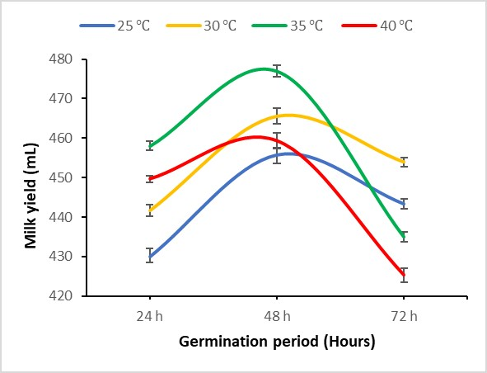

**Figure 6. Milk yield of sprouted pearl millet grain**

### ***3.5 Standardization of preservative level***

Table 7. shows the overall acceptability of various levels of preservative added to pearl millet milk at 4±1 ℃. The result showed maximum overall acceptability in T3 among all the treatments. The results revealed that there is no significant difference on the 0th day among all the treatments and a highly significant difference (P≥0.05) on the 12th day among all the treatments and there is a significant difference observed in the 4th and 8th day among all the treatments. It has been observed that throughout the storage days, the overall acceptability of products decreases slightly, specifically, T0 experiences a rapid decrease, while T3 shows a slower decline (Fig 7.). This is due to an increase in acidity of the product caused by fermentation.

Table 7. Table for standardization of preservative with overall acceptability (Mean ±SE)@

|  |  |  |  |  |
| --- | --- | --- | --- | --- |
|  | Storage period in days | | | |
| Treatment | 0 | 4 | 8 | 12 |
| T0 | 8.59b±0.07 | 5.88a±0.23 | 7.08a±0.27 | 6.32a±0.13 |
| T1 | 8.39ab±0.03 | 8.29b±0.17 | 7.73ab±0.37 | 7.06b±0.29 |
| T2 | 8..25a±0.13 | 8.2b±0.25 | 8.07b±0.28 | 7.68c±0.08 |
| T3 | 8.56b±0.06 | 8.53b±0.08 | 8.35b±0.09 | 7.75c±0.28 |
| F value | 3.313NS | 5.084* | 3.944* | 15.632** |

@Average of six trials, **Highly significant (P<0.01), *Significant (0.01<P<0.05), NSNon-significant (P>0.05), T0 - Refrigerated pearl millet drink (PMD), T1 -PMD with 10 ppm nisin, T2– PMD with 25 ppm nisin and T3- PMD with 50 ppm nisin, Different superscripts in a row (capital letters) and column (small letters) differ significantly.

pH of various preservatives added to pearl millet drink stored at 4±1 ℃ was given in Table 8. The results revealed that there is no significant difference on the 0th day among all the treatments and a highly significant difference (P≥0.05) in pH value on the 4th, 8th and 12th day for all treatments. Among all the trials 50 ppm of nisin gives a more stable pH level throughout the storage days when compared to other treatments (Fig 8.).

Table 8. Table for standardization of preservative with pH levels (Mean ±SE)@

|  |  |  |  |  |
| --- | --- | --- | --- | --- |
| ` | Storage period in days | | | |
| Treatment | 0 | 4 | 8 | 12 |
| T0 | 6.8 | 5.5a ± 0.57 | 4.2a±0.88 | 4.16a±0.06 |
| T1 | 6.8 | 6.8b | 6.5b±0.05 | 5.9b±0.05 |
| T2 | 6.8 | 6.8b | 6.8c | 6.1c±0.05 |
| T3 | 6.8 | 6.8b±0.58 | 6.8c | 6.4d±0.05 |
| F value | 0 | 507** | 540.1** | 279.46** |

@- Average of six trials, **Highly significant (P<0.01), *Significant (0.01<P<0.05), NSNon-significant (P>0.05), (Different superscripts in the same row differ significantly), T1 -PMD with 10 ppm nisin, T2– PMD with 25 ppm nisin and T3- PMD with 50 ppm nisin, Different superscripts in a row (capital letters) and column (small letters) differ significantly.

Among the three different levels of preservatives *viz.,* 10 ppm, 25 ppm and 50 ppm, it was found that 50 ppm of nisin gave maximum shelf life to pearl millet drink due to its potential to inhibit the growth of microorganisms. This is because nisin primarily kills bacteria by binding to anionic phospholipids in the cell membrane of bacteria. This binding disrupts the cell wall structure, leading to leakage of intracellular components and eventual cell death (O’Mahony *et al*., 2000). The results were used for further processing to optimize the stability of the product. These results correlated with the findings of Maeda *et al*. (1991) and Talasila *et al*. (2012) who stated that the shelf life of fermented juices increased by the addition of preservatives.

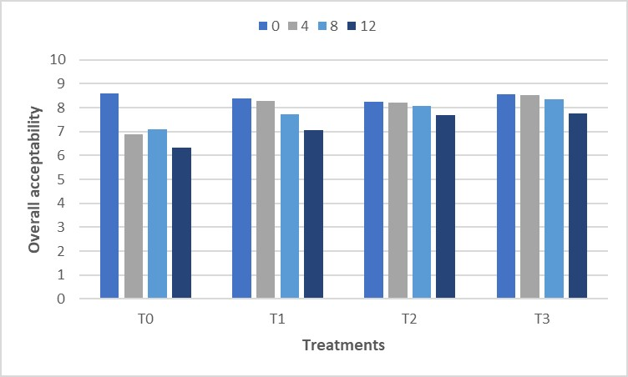

**Figure 7. Overall acceptability of preservatives added milk during the storage period**

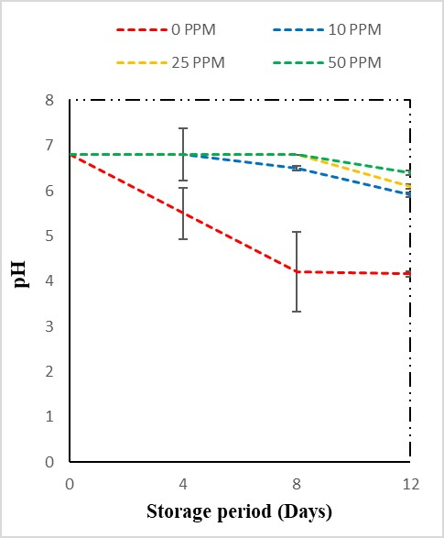

**Figure 8. Variation in pH during storage days in pearl millet milk with varying nisin concentrations**

### ***Estimation of physico-chemical properties of extracted milk***

The physicochemical properties of raw pearl millet milk were analyzed over a storage period of 16 days. The results are summarized in Table 9. It has been observed that the pH of the milk significantly decreased from 6.4±0.0 on day 0 to 4.10±0.06 on day 16, with a highly significant t value of 10.561 (P<0.01) and there was a significant increase in titratable acidity from 0.036±0.005 % on day 0 to 0.117±0.006 % on day 16, with a t value of 4.267 (P<0.01). The significant decrease in pH and increase in titratable acidity over the storage period indicate that the raw pearl millet milk underwent acidification, likely due to microbial activity. This acidification could affect the sensory properties and shelf life of the milk. Total soluble solids increased from 0.9±0.0 °Brix on day 0 to 1.23±0.03 °Brix on day 16, while viscosity showed a slight increase from 0.934±0.001 cP (Centipoise) to 0.941±0.0008 cP (t value = 12.102, P<0.01). This increase in viscosity and TSS suggests that there was a significant change in the concentration of dissolved substances and could be attributed to minor changes in the milk’s physical properties over time. These findings highlight the importance of monitoring physicochemical properties to ensure the quality and safety of pearl millet milk during storage.

Table 9. Table for physico-chemical properties (Mean ±SE)@ in raw pearl millet milk

|  |  |  |  |
| --- | --- | --- | --- |
| Parameters | Storage days | | t value |
| 0 | 12 |
| pH | 6.4±0.0 | 4.16±0.06 | 10.561** |
| Titratable acidity (%) | 0.0356±0.005 | 0.117±0.001 | 4.267** |
| Total soluble solids (°Brix) | 0.9±0.0 | 1.23±0.03 | 14.033** |
| Viscosity (cP) | 0.934±0.001 | 0.941±0.0008 | 12.102** |

@Average of six trials, **Highly significant (P<0.01), *Significant (0.01<P<0.05), NSNon-significant (P>0.05)

Hunter color values (L*, a*, b* and ∆E) of pearl millet milk were also shown in Table 10. Lightness (L*) increased significantly from 78.27±0.02 on day 0 to 79.38±0.10 on day 12 and remained stable through day 12 (t = 318.184). The redness (a*) decreased significantly from 3.84±0.016 on day 0 to 2.13±0.028 by day 12 (t = 7.832).TheYellowness (b*) decreased from 18.19±0.014 on day 0 to 16.84±0.10 by day 12 (t = 58.142). Total color difference (ΔE) averaged a change of 2.43±0.037 over the storage period.The observed increase in lightness (L*) suggests that the raw pearl millet milk became visually lighter over time, which could be due to browning of beverage during storage at ambient temperature. Similar outcomes were reported by Deka et al. (2005) in their study involving the development of a mango-pineapple spiced beverage stored at room temperature for six months. The significant decrease in redness (a*) and yellowness (b*) indicates a reduction in the intensity of these color components, possibly due to oxidative reactions or microbial activity affecting the milk’s composition. The stability of lightness after day 12 suggests that the most significant changes occur early in the storage period. The total color difference (ΔE) provides a quantitative measure of the overall color change, which is essential for quality control in food processing. Fig 9. Represent the change in hue, chroma and color coordinate value of pearl millet milk on the 0th and 12th day with both the hue and chroma value increased by 6.02 and 9.49 % respectively while color coordinate decreased by 40.28 %. Ramashia *et al*. (2018) reported that the hue angle is most important to humans with a usual colour vision for perception and acceptability.

Table 10. Table for color analysis (Mean ±SE)@ in raw pearl millet milk

|  |  |  |  |
| --- | --- | --- | --- |
| Parameters | Storage days | | t value |
|  | 0 | 12 |  |
| Lightness (L*) | 78.27±0.02 | 79.38±0.017 | 318.184 |
| Redness (a*) | 3.84±0.016 | 2.13±0.028 | 7.832** |
| Yellowness (b*) | 18.19±0.014 | 16.84±0.02 | 58.142** |
| Total color difference (∆E) | 2.43±0.037 | |  |

@Average of six trials, **Highly significant (P<0.01), *Significant (0.01<P<0.05), NSNon-significant (P>0.05)

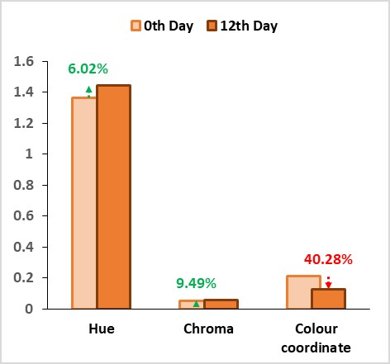

**Figure 9. Changes in hue, chroma and color coordinate in pearl millet milk**

* 1. **Sensory evaluation of extracted milk during the storage period**

The bar graph (Fig 7.) shows the overall acceptability of pearl millet milk during different storage days (0, 4, 8, and 12). All treatments exhibit high acceptability at day zero (close to or above 8). As storage days increase, overall acceptability declines across all treatments. Treatment T0 continues its rapid downward trend, while T3 shows higher overall acceptability but also follows a downward trajectory. Similar studies on plant-based milk alternatives show the negative effects of prolonged storage on product quality (Modha and Pal, 2011).

### ***3.8 Estimation of proximate, mineral composition and anti-nutritional factors of Pearl millet drink***

### ***3.8.1 Estimation of proximate composition***

The results of proximate composition *viz.,* moisture, carbohydrate, protein, fat, fiber, total ash content and total calories of the Pearl millet milk are shown in Table 11. The mean values of moisture, carbohydrate, protein, fat, fiber, total ash content, and total calories were 88.91 %, 8.31 %, 1.46 %, 0.57 %, 0.35 %, 0.34 % and 44.23 kilo calories (Kcal).

Table 11. Table for proximate composition (Mean ±SE)@ of raw pearl millet milk

|  |  |  |
| --- | --- | --- |
| S. No. | Proximate | Pearl Millet Milk |
|  | Moisture (%) | 88.91±0.19 |
|  | Carbohydrates (%) | 8.31±0.08 |
|  | Protein (%) | 1.46±0.02 |
|  | Fat (%) | 0.57±0.03 |
|  | Fibre (%) | 0.35±0.08 |
|  | Ash (%) | 0.34±0.080 |
|  | Total calorie (Kcal) | 44.23±0.74 |

@Average of six trials, **Highly significant (P<0.01), *Significant (0.01<P<0.05), NSNon-significant (P>0.05)

### ***3.8.2 Estimation of mineral composition***

Table 12. represents the mineral concentration of Pearl millet milk estimated by Inductively coupled plasma-optical emission spectrometry. The minerals such as phosphorous, zinc, calcium, iron, manganese and copper estimated in Pearl millet milk were found to be 86.194 mg/200 mL, 0.62 mg/200 mL, 10.3 mg/200 mL, 1.2 mg/200 mL, 7.63 mg/200 mL and 0.277 mg/200 mL respectively. High concentration of phosphorous, making it a valuable dietary source for bone health and energy production (Hassan *et al*., 2021). Presence of iron is significant, as it plays a vital role in oxygen transport within the blood (Kulthe *et al*., 2016).

Table 12. Table for mineral composition (Mean ±SE)@ of raw pearl millet milk

|  |  |  |
| --- | --- | --- |
| S. No. | Minerals (mg/200 ml) | Pearl millet milk |
|  | Phosphorous | 60.2±0.017 |
|  | Zinc | 0.628±0.012 |
|  | Calcium | 8.208±0.02 |
|  | Iron | 1.2±0.011 |
|  | Manganese | 0.228±0.012 |
|  | Copper | 0.212±0.01 |

### ***3.9. Estimation of anti-nutritional factors***

### ***3.9.1 Tannin***

The tannin content in raw pearl millet ranges from 171.3±2.28 mg/100 g. It is evident from Table 13. that 12 hours of soaking and 24 hours of germination reduce the tannin content to 78.1±0.4 mg/100 g. Followed by a decrease in tannin at 48 hours of germination observed to be 71.4±1.13 mg/100 g. Germination has been reported to reduce the tannin content and improve in vitro digestibility of proteins in legumes (Maeda *et al*., 1991). The reduction in tannin was observed to be 58.31 % (Fig 10.). A decrease in anti-nutritional factors during germination could lead to leaching of polyphenols in the soaking water (Jood *et al*., 1987) and increased enzymatic treatment during germination (Bishnoi *et al*., 1994). Statistical analysis revealed that there is a highly significant difference (P <0.01) between the raw and sprouted grain.

### ***3.9.2 Phytic Acid***

Table 13. gives the quantity of phytic acid in raw and sprouted pearl millet. It is observed that the amount of phytic acid decreases significantly (P<0.01) with an increase in the germination period.Phytic acid has a strong chelating ability and readily forms complexes with monovalent and multivalent cations of potassium, calcium, iron, zinc, magnesium and other cations, reducing their bioavailability and creating a deficit in their absorption (Boncompagni *et al*., 2018). During germination phytic acid content decreased by 9.83 % (830.31±0.477 to 748.9599±0.901 mg/ 100 g) at 24 hours of germination and 32.08 % (Fig 10.) reduction on 48 hours of germination (830.31±0.477 to 563.88±0.65 mg/100 g). It is reported that malting of millet reduces 23.9 % phytic acid after 72 h and 45.3 % after 96 h *(Makokha et al*., 2002; Coulibaly *et al*., 2011). The results also coincide with the work of Abdelrahaman *et* *al*. (2007), revealing that the phytic acid content decreases with increase in germination time.

Table 13. Table for tannin, phytic acid and total phenol content (Mean ±SE)@ in raw and sprouted pearl millet

|  |  |  |  |
| --- | --- | --- | --- |
|  | Raw | Germination (48 h) | t value |
| Tannin (mg/100 g) | 171.3±2.28 | 71.4±1.13 | 5.389** |
| Phytic acid (mg/100 g) | 830.31±0.477 | 563.88±0.65 | 11.701** |

@Average of six trials, **Highly significant (P<0.01), *Significant (0.01<P<0.05), NSNon-significant (P>0.05)

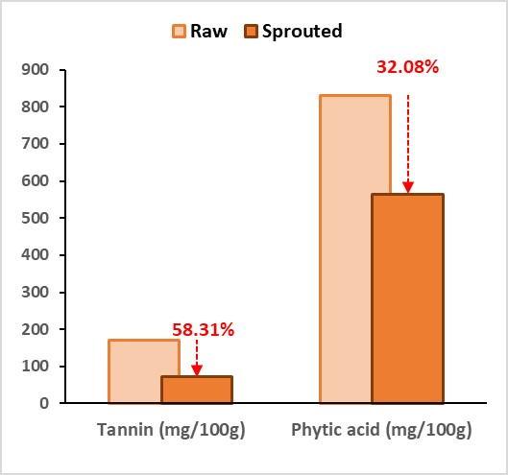

**Figure 10. Changes in anti-nutritional factors in pearl millet milk during germination**

## **4. Conclusion**

In conclusion, this study successfully demonstrates that optimizing malting parameters and incorporating nisin significantly enhances the nutritional quality and shelf life of pearl millet milk. The substantial reduction in anti-nutritional factors, coupled with the preservation of key nutrients, underscores the potential of this process to improve the bioavailability of essential minerals in pearl millet. The resultant milk, with its improved physicochemical properties and extended shelf life, presents a promising alternative for nutritional enhancement, particularly in regions where pearl millet is a dietary staple. These findings pave the way for further exploration and adoption of pearl millet milk as a valuable component in health-promoting diets.

## Funding and Acknowledgment

SB, VP, NK and SKM acknowledge the financial support provided to SB by TANUVAS, through scheme code: 1300. The authors are grateful to Tamil Nadu Veterinary and Animal Sciences University, Chennai, India for providing the necessary facilities. The authors would also like to thank Dr. N. Kumaravelu, Dean, College of Food and Dairy Technology, Koduveli, Chennai for his support throughout the research work.

## Ethics statement

No specific permits were required for the described field studies because no human or animal subjects were involved in this research.

## Originality and plagiarism

SB, VP, NK and SKM ensure that they have written and submitted only entirely original works, and the work and/or words of others has been appropriately cited.

## Consent for publication

All the authors agreed to publish the content.

## Competing interests

There was no conflict of interest in the publication of this content.

Data availability

All the data of this manuscript are included in the MS. No separate external data source is required. If anything is required from the MS, certainly, this will be extended by communicating with the corresponding author through the corresponding official mail; : vperasiriyan@gmail.com

## Author contributions

Research grant- SB, Idea conceptualization - SB, Experiments - SB, Guidance -VP, SKM, NK, writing original draft - SB, Writing- reviewing & editing – SB, VP, SKM, NK

## References

Association of Official Analytical Chemists., 2000. *Official methods of analysis* (17th ed.). AOAC International.

Association of Official Analytical Chemists., 2006. *Official methods of analysis* (18th ed.). AOAC International.

Association of Official Analytical Chemists., 2019. *Official methods of analysis* (21st ed.). AOAC International

Abdelrahaman, S.M., Elmaki, H.B., Idris, W.H., Hassan, A.B. and E.E. Babiker. *et al*. 2007. Antinutritional factor content and hydrochloric acid extractability of minerals in pearl millet cultivars as affected by germination. *Int. J. Food Sci. Nutr*., **58(1)**: 6–17. https://doi.org/10.1080/09637480601093236.

Agbo, E.B. 1995. Studies on the malting properties of Sorghum varieties used for larger production. *Phd Thesis Abubakar Tafawa Balewa Univ.*

Ahlawat, D., 2007. Studies on production and packaging of mango milk powder using spray drying technology. *Int. Dairy J.,* **14(5):** 429-435.

Badau, M.H. 2004. Malting characteristics of pearl millet cultivars and their food applications. *Abubakar Tafawa Balewa Univ. PhD Thesis Bauchi Niger.*

Balkrishna, S.P. and R. Visvanathan. 2019. Hydration kinetics of little millet and proso millet grains: effect of soaking temperature. *J. Food Sci. Technol*., **56(7)**: 3534–3539. <https://doi.org/10.1007/s13197-019-03789-4>.

Bembem, K. and D. Agrahar-Murugkar. 2020. Development of millet based ready-to-drink beverage for geriatric population. *J. Food Sci.* Technol., **57(9)**: 3278–3283. <https://doi.org/10.1007/s13197-020-04359-9>.

Bishnoi, S., Khetarpaul, N. and R.K. Yadav. 1994. Effect of domestic processing and cooking methods on phytic acid and polyphenol contents of pea cultivars (Pisum sativum). *Plant Foods Hum. Nutr*., **45(4)**: 381–388. <https://doi.org/10.1007/BF01088088>

Boncompagni, E., Orozco-Arroyo, G., Cominelli, E., Gangashetty, P.I. and S. Grando. *et al.* 2018. Antinutritional factors in pearl millet grains: Phytate and goitrogens content variability and molecular characterization of genes involved in their pathways. *PloS One*., **13(6)**: e0198394. <https://doi.org/10.1371/journal.pone.0198394>

Briggs, D.E. and J.S. Hough. 1981. Malting and brewing science: malt and sweet wort. *Springer Science & Business Media*.

Coulibaly, A., Kouakou, B. and C. J. Chen Jie. 2011. Phytic acid in cereal grains: structure, healthy or harmful ways to reduce phytic acid in cereal grains and their effects on nutritional quality. *Am. J. Plant Nutr. Fertil.* Technol., **(1):** 1-22**.**

Dahiya, R., Yadav, R. B., Yadav, B. S. and R. Yadav. 2018. Quality characteristics of pearl millet malt as affected by steeping temperature and germination period. *Qual. Assur. Saf. Crops Foods.*, **10(1):** 41-50. <http://dx.doi.org/10.3920/QAS2016.0930>.

Deka, B. C., Sethi V. and A. Saikia, 2005. Changes in quality of mango- pineapple spiced beverage during storage. Indian *J. Hort*., **62:** 71–75.

Dewar, J., Taylor, J.R.N. and P. Berjak. 1997. Effect of germination conditions, with optimised steeping on sorghum malt quality with particular reference to free amino nitrogen. *J. Inst. Brew*., **103**: 171–175. <https://doi.org/10.1002/j.2050-0416.1997.tb00946.x>

FAO, WHO. 2002. Human vitamin and mineral requirements: report of a joint FAO. *WHO expert consultation Bangkok, Thailand, Rome*.

García-Toledo, J. A., Ruiz-López, I. I., Martínez-Sánchez, C. E., Rodríguez-Miranda, J., Carmona-García, R., Torruco-Uco, J. G. and E. Herman-Lara. 2016. Effect of osmotic dehydration on the physical and chemical properties of Mexican ginger (Zingiber officinale var. Grand Cayman). *CyTA - J. Food.*, **14(1)**: 27-34. https://doi.org/10.1080/19476337.2015.1039068.

Geetha, P. and P. Preethi. 2020. Development of kodo millet based functional milk beverage. *IJCS*.,**8(6)**: 1034–1037. <http://dx.doi.org/10.22271/chemi.2020.v8.i6o.10900>.

Hassan, Z.M., Sebola, N.A. and M. Mabelebele. 2021. The nutritional use of millet grain for food and feed: a review. *Agri. Food Secur*., **10**:16. https://doi.org/10.1186/s40066-020-00282-6.

Ituen, E.U.U., Mittal, J.P. and J.S. Adeoti. 1986. WATER ABSORPTION IN CEREAL GRAINS and ITS EFFECT ON THEIR RUPTURE STRESS. *J. Food Process Eng*., **8(3):** 147–158. <https://doi.org/10.1111/j.1745-4530.1986.tb00108.x>.

Janda, K., Jakubczyk, K., Baranowska-Bosiacka, I., Kapczuk, P., Kochman, J., Rębacz-Maron, E. and I. Gutowska. 2020. Mineral composition and antioxidant potential of coffee beverages depending on the brewing method. *Foods*, **9(2):** 121. https://doi.org/10.3390/foods9020121.

Jood, S., Chauhan, B.M. and A.C. Kapoor. 1987. Polyphenols of chickpea and blackgram as affected by domestic processing and cooking methods. *J. Sci. Food Agric*., **39(2):** 145–149. <https://doi.org/10.1002/jsfa.2740390207>.

Key, T.J., Papier, K. and T.Y.Tong. 2022. Plant-based diets and long-term health: findings from the EPIC-Oxford study. *Proc. Nutr. Soc*., **81(2)**: 190–198. <https://doi.org/10.1017/S0029665121003748>.

Kulthe, A. A., Thorat, S. S. and S.B. Lande. 2016. Characterization of pearl millet cultivars for proximate composition, minerals and anti-nutritional contents. *Adv. life Sci.*,***5*(11):**4672-4675.

Maeda, E.E., Sule, C.N. and M.J. Samuel. 1991. Effect of sprouting on bean nutritional quality. Proceedings of Seminar on Development of High Protein-Energy Foods from Grain Legumes, *University of Ghana, Legon*., p. 62–74.

Makokha, A. O., Oniang'o, R. K., Njoroge, S. M. and O. K. Kamar. 2002. Effect of traditional fermentation and malting on phytic acid and mineral availability from sorghum (Sorghum bicolor) and finger millet (Eleusine coracana) grain varieties grown in Kenya. *Food nutri. bulletin*, **23(3)**: 241-245. <https://doi.org/10.1177/15648265020233S147>.

Modha, H. and D. Pal. 2011. Optimization of Rabadi-like fermented milk beverage using pearl millet. *J. food sci. tech.*, **48:**190-196.  https://doi.org/10.1007/s13197-010-0146-6.

Novellie, L. 1962. Kaffircorn malting and brewing studies: effects of malting conditions on the diastatic power of kaffircorn malts. *J. Sci. of Food Agric*., **13(2)**: 115-120. <https://doi.org/10.1002/jsfa.2740130210>.

Nso, Ej., Ajebesome, P.E., Mbofung, C.M. and G.H. Palmer. 2003. Properties of Three Sorghum Cultivars Used for the Production of Bili-Bili Beverage in Northern Cameroon. *J. Inst.* Brew., **109(3)**: 245–250. <https://doi.org/10.1002/j.2050-0416.2003.tb00165.x>.

O’Mahony, A., O’Sullivan, T., Walsh, Y., Vaughan, A. and M. Maher, *et al.* 2000. Characterisation of Antimicrobial Producing Lactic Acid Bacteria from Malted Barley. *J. Inst. Brew*., **106(6)**: 403–410. <https://doi.org/10.1002/j.2050-0416.2000.tb00531.x>.

O’Rouke, T. 2004. Malting of barley. *J. Inst. Brew*., **109**: 21–23.

Pelembe, L. A. M., Dewar, J. and J. R. N. Taylor. 2002. Effect of malting conditions on pearl millet malt quality. *J. Inst. Brew.*, **108(1)**: 7-12. <https://doi.org/10.1002/j.2050-0416.2002.tb00113.x>.

Ramashia, S. E., Gwata, E. T., Meddows-Taylor, S., Anyasi, T. A. and A. I. O. Jideani. 2018. Some physical and functional properties of finger millet (Eleusine coracana) obtained in sub-Saharan Africa. *Food Res. Int.*, **104:**110-118. https://doi.org/10.1016/j.foodres.2017.09.065.

Scarborough, P., Appleby, P.N., Mizdrak, A., Briggs, A.D.M. and R.C. Travis. *et al.* 2014. Dietary greenhouse gas emissions of meat-eaters, fish-eaters, vegetarians and vegans in the UK. *Clim. Change*., **125(2)**: 179–192. <https://doi.org/10.1007/s10584-014-1169-1>.

Semwal, J., Kamani, M. H. And M.S. Meera. 2021. Fermented Millet Technology and Products. *Millets and Millet Technology*, 255-271. <https://doi.org/10.1007/978-981-16-0676-2_12>.

Serna-Saldivar, S. O. 2012. Cereal grains: laboratory reference and procedures manual. *CRC Press. 9.*

Sheela, P., Kanchana, S., Maheswari, T. U. and G. Hemalatha. 2018. Optimization of parameters for the extraction of millet milk for product development. *Res J. Agri. Sci*., **9(6):** 1345-1349.

Shunmugapriya, K., Kanchana, S., Maheswari, T. U., Kumar, R. S. and C. Vanniaraja. 2020. Standardization and stabilization of Millet milk by enzyme and its physicochemical evaluation Eur. J. Nutr. Food Saf., **12(1)**: 30-38. https://doi.org/10.9734/ejnfs/2020/v12i130181.

Sudha, A., Devi, K. S., Sangeetha, V. and A. Sangeeth. 2016. Development of fermented millet sprout milk beverage based on physicochemical property studies and consumer acceptability data. *JSIR*., **75:** 239-243. http://nopr.niscpr.res.in/handle/123456789/34056.

Sukumaran, L. and M. Radhakrishnan. 2021. Impact of Nisin in Combination with Sodium Benzoate and Calcium Carbonate on the Bacterial and Yeast Population of Coconut Neera (Coconut Inflorescence sap). *J. Pure Appl. Microbiol*., **15(4)**. 10.22207/JPAM.15.4.27.

Sunil, A. N., Jose, M., Regi, J.T. and R.V. Nair. 2013. Production of Neera. *Indian Coconut J*., p. 25–26.

Talasila, U., Vechalapu, R. and K.B.Shaik. 2012. Clarification, preservation, and shelf life evaluation of cashew apple juice. *Food Sci*.,Biotechnol., **21**. <https://doi.org/10.1007/s10068-012-0092-3>.

Vaintraub, I.A. and N.A.Lapteva. 1988. Colorimetric determination of phytate in unpurified extracts of seeds and the products of their processing. *Anal. Biochem*., **175(1)**: 227–230. <https://doi.org/10.1016/0003-2697(88)90382-X>.