**EFFECT OF DRY LAND TECHNOLOGIES ON WATER USE AND   
YIELD OF MILLET CROPS**

**ABSTRACT**

Preserving soil moisture is important means to maintain the necessary water for agricultural production, and also to minimize irrigation needs of the crops. This is especially important in areas where rainwater for irrigation is scarce or decreasing due to climate change or other causes. A field trail was conducted with Ragi crop to study the increase in infiltration rate and moisture content under subsoil and to estimate the yield and water use efficiency of millet crop at Agricultural Engineering College & Research Institute, Kumulur. A non replicated trail with the treatments of deep tillage with chisel plough, coir pith application in sub soil, random tie ridging, broad bed and furrows, straw mulching, vetiver bunding was conducted. The average raise of moisture content, higher range (8%) was observed in the treatment of coir pith application (T2), and followed by 6% raise in deep tillage, random tied ridgeing broad bed furrows and straw mulching. The maximum infiltration was found to be in deep tillage (4.7 cm/hr), followed by straw mulching in the range of 4.5 cm/hr. The higher yield 1121 kg/ha and WUE 5.20 kg/ha mm was obtained in treatment T2 (coir pith application) followed by treatment T3 (random tied ridging) as 1067 kg/ha & WUE of 4.95 kg/ha mm.

Keywords: Dryland technologies, Ragi crop, Coir pith applicator, Vetiver, Broad bed furrows, Random tied ridging

**1. INTRODUCTION**

Dry lands in India make up 68.4% of the cropped area out of a total cultivated extent of 162.03 million hectares (Ashwani Kumar et al., 2018). Due to the greater focus on irrigated agriculture during the Green Revolution, rainfed agriculture has received comparatively minimal attention. To meet the growing demand for food, expanding agricultural area is feasible primarily through the utilization of drylands. Bringing these vast stretches of dry lands under green cover is an urgent requirement for ecological restoration (Ramos et al., 2011).

Rainfall is the primary source of water, directly influencing crop and biomass production by falling on fields and supporting surface and groundwater irrigation. The mean annual rainfall in Kumulur ranges from 800 mm to 900 mm, with the highest rainfall occurring between August and November. This rainfall can be effectively utilized by implementing appropriate dryland technologies (Vaidheki and Arulanandu, 2017)

The key to improving the sustainability of dryland farming systems lies in enhancing soil productivity. Soil productivity is measured by comparing the outputs or harvests with the inputs of production factors for specific soil types under a defined management system (Ebi and Bowen, 2016). Various degradative processes, such as soil erosion, nutrient runoff, waterlogging, desertification, acidification, compaction, crusting, organic matter loss, salinization, nutrient depletion through leaching, and the accumulation of toxic substances, negatively impact soil productivity (Sharma et al., 2013).

However, soil conservation practices, including conservation tillage, crop rotation, improved drainage, residue management, water conservation, terracing, contour farming, the use of chemical and organic fertilizers, improved nutrient cycling, and systems tailored to match soil, climate, and cultivation methods, can positively affect soil productivity (He et al., 2009). Therefore, a truly sustainable farming system is one in which the positive effects of various conservation practices outweigh or equal the negative effects of degradative processes. The primary objective of this research is to study the increase in infiltration rate and moisture content under subsoil conditions and to estimate the yield and water use efficiency of millet crops.

**2. MATERIALS AND METHODS**

**2.1 Study Area**

A field trial with Ragi crops was conducted at the Agricultural Engineering College & Research Institute, Kumulur, from September 2020 to January 2021, with a confirmation trial conducted from September 2021 to January 2022. The institution is located at 10.9338° N, 78.8257° E, at an elevation of 72.2376 meters above mean sea level. The campus covers a total area of 280 acres. The average annual rainfall in Kumulur is 881.412 mm, and the average monthly relative humidity is 60.5%. Various crops, including rice, maize, sugarcane, ragi, and vegetables, are grown on the campus.

**2.2 Treatments**

A non-replicated trial was conducted to study the increase in infiltration rate and moisture content under subsoil conditions, as well as to estimate the yield and water use efficiency of millet crops.

The field and crop details are given below. The images of all the seven treatments are shown in Fig.

Design : Non replicated trail

Plot size : 16 x 16 m = 256 m2

Crop : Ragi

Variety : Try 1

Crop spacing : 30 x 15 cm

**Treatments**

|  |  |  |
| --- | --- | --- |
| T1 | : | Deep tillage with chisel plough |
| T2 | : | Coir pith application in sub soil |
| T3 | : | Random tie ridging |
| T4 | : | Broad bed and furrow |
| T5 | : | Straw mulching |
| T6 | : | Vetiver bunding |
| T7 | : | Control |

**2.3 Methodology**

**2.3.1 Soil properties**

The initial physical and chemical properties of the soil were analyzed. Various dryland technologies, such as deep tillage with a chisel plough, coir pith application in the subsoil, random tied ridging, broad bed and furrow formation, and straw mulching, were implemented as different treatments to conserve rainfall and runoff water. Moisture storage was monitored daily in each treatment using a ThetaProbe soil moisture sensor to measure volumetric moisture content.

**2.3.2 Study on crop geometry**

The Ragi crop was initially raised in a separate nursery and then transplanted into the main field for all treatments 20 days after sowing (DAS). Sowing, manuring, weeding, and harvesting were carried out according to the crop production guide. Throughout the crop period, the increase in soil infiltration rate and moisture content, plant growth, pod development, yield performance, and water use efficiency under different dryland technology treatments were observed. The soil infiltration rate was estimated using a double-ring infiltrometer, while soil moisture content was monitored daily using a ThetaProbe soil moisture sensor (volumetric method) for the entire crop period.

Coirpith was injected into the subsoil using a coir pith applicator attached to a tractor, with the pith placed at a depth of 15 to 30 cm (Sai Monaj Kumar et al., 2021). Straw for the treatment was chopped into small pieces and spread across the entire plot, serving as straw mulch (Agri Info, 2015; Chopra and Koul, 2020). In treatment T5, a chisel plough was used to loosen the soil at a depth of 30-45 cm. For the random tied ridging treatment (T3), 30 cm ridges and furrows were constructed with randomized barriers in each furrow. The broad bed and furrow treatment (T4) involved constructing furrows 170 cm wide and 30 x 30 cm around the bed (Gosai et al., 2009). In treatment T6, Vetiver grass was planted between the rows of the Ragi crop, while the control plot followed the traditional sowing method with a spacing of 30 x 15 cm.

**3.0 RESULTS AND DISCUSSION**

The experiment was conducted during 2021 & 2022 in the month of September to January by Ragi – Try 1 with seven main treatments and non replications.

**3.1 Effect of dry land technologies on growth of Ragi**

Before implementing the treatments, the soil's physical properties were studied, and the results are presented in Table 1. The results revealed a significant impact on plant height and ear head development across all treatments, as shown in Table 2. The highest plant height (108 cm) was recorded in the coir pith application treatment (T2), followed by deep tillage (T1) at 98.3 cm. The shortest height (72.2 cm) was observed in the vetiver strip cropping treatment (T6). It was found that increasing water stress significantly decreased plant height. Additionally, the maximum number of ear heads per hill (12.6) was observed in the coir pith application treatment (T2), followed by deep tillage, which recorded 12.0 ear heads per hill. The fewest ear heads per hill (6.8) were recorded in the vetiver strip cropping treatment.

**3.2 Impact on treatment of soil moisture**

Furthermore, soil moisture content was monitored continuously on a daily basis for all treatments. The results revealed that, from an overall perspective, all treatments led to a significant increase in soil moisture content after implementation, compared to the period before the treatments (Fig. 2). The highest average increase in moisture content, at 8%, was observed in the coir pith application treatment (T2), followed by a 6% increase in deep tillage, random tied ridging, broad bed furrows, and straw mulching (Fig. 3). The smallest average increase in soil moisture, at 4%, was observed in the vetiver strip cropping and control treatments.

**3.3 Impact on treatment of Infiltration rate**

The infiltration rate was measured using a double-ring infiltrometer before and after the implementation of the treatments. The average soil infiltration rate was found to be 2.52 cm/hr. Infiltration rates for all treatments were calculated at three different crop stages (initial, mid, and final), showing a significant increase in infiltration rate across all treatments. The highest infiltration rate was observed in deep tillage (4.7 cm/hr), followed by straw mulching at 4.5 cm/hr. Among the various treatments evaluated, vetiver strip cropping exhibited the smallest increase in infiltration rate, with a recorded value of 2.9 cm/hr, which was lower compared to the control, as shown in Fig. 4.

**3.4 Effect of treatments on crop yield**

A significantly higher yield of 1085 kg/ha was recorded with coir pith application (T1), followed by random tied ridging with a yield of 1050 kg/ha. The lowest yield of 742 kg/ha was observed with vetiver strip cropping, while the control yielded 850 kg/ha. The control yield was 13% higher than vetiver strip cropping and 22% lower than the coir pith application. In terms of water use efficiency (WUE), the highest efficiency was found in coir pith application, with a WUE of 5.31 kg/ha mm (water productivity of Rs. 106.22/ha/mm). This was followed by random tied ridging and deep tillage, which had comparable WUE values of 5.12 kg/ha mm (water productivity of Rs. 102.30/ha/mm). The lowest WUE was observed in vetiver strip cropping, at 3.63 kg/ha mm (water productivity of Rs. 72.64/ha/mm), while the control recorded a WUE of 4.16 kg/ha mm (water productivity of Rs. 83.21/ha/mm) (Fig. 5).

**Table 1. Soil physical properties**

|  |  |  |
| --- | --- | --- |
| Soil type | : | Sandy clay loam |
| F.C | : | 23.8% |
| PWP | : | 13.48 % |
| pH | : | 7.8 |
| EC | : | 0.1 ds/m |
| O.C | : | 0.57 % |
| N:P:K (kg/ha) | : | 220: 18: 246 |

**Table 2. Influence of treatments on crop growth parameters & soil parameters.**

|  |  |  |  |  |  |  |
| --- | --- | --- | --- | --- | --- | --- |
| **Treatments** | **Plant Ht. (cm)** | **No. of ear heads/ hill** | **Moisture content @ F.C (%) – before treatment imposed** | **Avg. level of Increased moisture content (@ tillering) after treatment imposed (%)** | **Infiltration rate before treatment imposed (cm/hr)** | **Infiltration rate after treatment imposed (cm/hr)** |
| Deep tillage (T1) | 98.3 | 12.0 | 23.1 | 6 | 2.52 | 4.7 |
| Coir pith application (T2) | 108.0 | 12.6 | 23.3 | 8 | 4.1 |
| Random tied Ridging (T3) | 93.1 | 10.4 | 23.9 | 6 | 3.4 |
| Broad bed (T4) | 91.3 | 8.0 | 23.5 | 6 | 3.2 |
| Straw mulching (T5) | 85.5 | 7.6 | 22.7 | 6 | 4.5 |
| Vetiver Strip cropping (T6) | 72.2 | 6.8 | 23.1 | 4 | 2.9 |
| Control (T7) | 85.8 | 8.0 | 23.5 | - | 2.6 |

**Table 3. Yield and water productivity**

|  |  |  |  |  |  |  |  |
| --- | --- | --- | --- | --- | --- | --- | --- |
| **Treatments** | **Total R.F & ERF (mm)** | **Irrigation @ transplanting (mm)** | **Total water consumed (mm)** | **Yield (kg/ ha)** | **WUE (kg/ ha mm)** | **Water Productivity (Rs./ ha mm)** | **Water Productivity (kg/ m3)** |
| Deep tillage (T1) | 308.65 & 154.3 | 50 | 204.3 | 1045 | 5.12 | 153.45 | 0.51 |
| Coir pith application (T2) | 1085 | 5.31 | 159.32 | 0.53 |
| Random tied Ridging (T3) | 1050 | 5.14 | 154.19 | 0.51 |
| Broad bed (T4) | 1025 | 5.02 | 150.51 | 0.50 |
| Straw mulching (T5) | 920 | 4.50 | 135.10 | 0.45 |
| Vetiver Strip cropping (T6) | 742 | 3.63 | 108.96 | 0.36 |
| Control (T7) | 850 | 4.16 | 124.82 | 0.42 |

|  |  |
| --- | --- |
| **E:\AEC&RI, Kumulur\Sub project\Action plan - dryland\PHOTOS 2022\field photos\20221026_152423.jpg** | **E:\AEC&RI, Kumulur\Sub project\Action plan - dryland\PHOTOS 2022\field photos\20221027_160354.jpg** |
| **Chisel plough operation** | **Coirpith applicator** |
| **E:\AEC&RI, Kumulur\Sub project\Action plan - dryland\Photos\IMG-20190911-WA0024 (1).jpg** | **E:\AEC&RI, Kumulur\Sub project\Action plan - dryland\Photos\IMG-20190911-WA0028.jpg** |
| **Broad bed furrows** | **Random tied ridging** |
| **E:\AEC&RI, Kumulur\Sub project\Action plan - dryland\PHOTOS 2022\field photos\WhatsApp Image 2022-10-25 at 15.17.17.jpeg** | **E:\AEC&RI, Kumulur\Sub project\Action plan - dryland\photos-2020\Ragi photo\20201012_094209.jpg** |
| **Cultivation in between vertiver** | **Straw mulching** |
| **Fig. 1 Treatments imposed** | |

**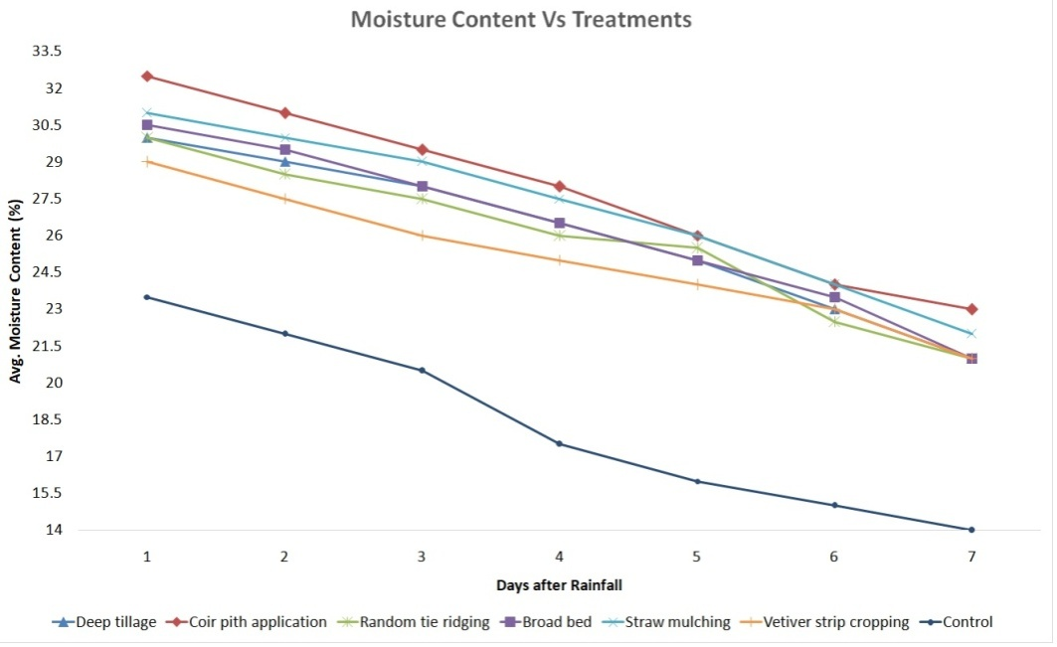**

**Fig. 2 Average soil moisture content after the treatment implemented**

**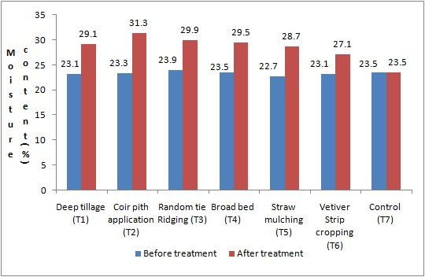**

**Fig. 3 Average rise of soil moisture before and after the treatment**

**Fig. 4 Average infiltration rate of soil before and after treatment**

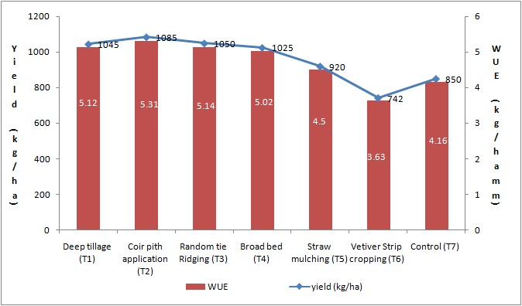

**Fig. 5 Yield and water use efficiency**

**CONCLUSIONS**

In the current agricultural scenario, optimizing water productivity within land use is crucial to feeding the growing population. An important aspect of improving water productivity is soil moisture conservation. In dryland and rainfed agriculture, conserving soil moisture is essential to prevent moisture deficiencies in the soil. In arid and semi-arid regions, even when rainfall is sufficient for crop growth, dry spells and uneven rainfall distribution during critical growth stages can reduce yields by 50-60%. To mitigate yield loss and maintain optimal crop production, effective soil moisture conservation techniques such as coir pith application, random tied ridging, broad bed furrows, chisel ploughing, and mulching should be adopted. These techniques not only conserve moisture but also enhance soil properties, reduce soil erosion, and prevent degradation.

**ACKNOWLEDGEMENTS**

The authors express my deep respect and gratitude to The Dean, AEC & RI, Kumulur, and record his gratefulness to The Vice Chancellor and Registrar of Tamil Nadu Agricultural University, Coimbatore, Tamil Nadu, for the facilities and support provided.

**REFERENCES**

Agri Info (2015). A Proceedings of Soil and Water Conservation Methods and Management.

[Ashwani Kumar](https://link.springer.com/article/10.1186/s40066-018-0183-3#auth-Ashwani-Kumar-Aff1-Aff2), [Vidisha Tomer](https://link.springer.com/article/10.1186/s40066-018-0183-3" \l "auth-Vidisha-Tomer-Aff2), [Amarjeet Kaur](https://link.springer.com/article/10.1186/s40066-018-0183-3" \l "auth-Amarjeet-Kaur-Aff1),  [Vikas Kumar](https://link.springer.com/article/10.1186/s40066-018-0183-3" \l "auth-Vikas-Kumar-Aff2) &  [Kritika Gupta](https://link.springer.com/article/10.1186/s40066-018-0183-3#auth-Kritika-Gupta-Aff2) (2018). Millets: a solution to agrarian and nutritional challenges. [*Agriculture & Food Security*](https://link.springer.com/journal/40066) Vol. 7,: 31 (2018)

Chopra, M. and Koul, B. (2020). Comparative assessment of different types of mulching in various crops. Plantarchives 20(2). 1620- 162.

Ebi, K.L. and Bowen, K. (2016). Extreme events as sources of health vulnerability: Drought as an example. Weather and Climate Extremes 11 (2016), 95-102.

Gosai, K., Arunachalam, A. and Dutta, B. K. (2009). Influence of conservation tillage on soil physiologicalproperties in a tropical rainfed agricultural system. Soil and tillage research, 105(1): 63-71.9

He,, J.E, Q.Wang, H. Li et al., “Soil physical properties and infiltration after long-term no-tillage and ploughing on the Chinese Loess Plateau,” *New Zealand Journal of Crop and Horticultural Science*, vol. 37, no. 3, pp. 157–166, 2009.

Ramos,M.E., A. B. Robles, A. S´anchez-Navarro, and J. L. Gonz ´alez-Rebollar, “Soil responses to different management practices in rainfed orchards in semiarid environments,” *Soil and Tillage Research*, vol. 112, no. 1, pp. 85–91, 2011.

Sai Manoj Kumar, P., Masina Sairam, Sagar Maitra, Subashisha Prahara (2021). [Soil Moisture Conservation Techniques for Dry land and Rainfed Agriculture](https://www.researchgate.net/publication/357570615_Soil_Moisture_Conservation_Techniques_for_Dry_land_and_Rainfed_Agriculture?_tp=eyJjb250ZXh0Ijp7ImZpcnN0UGFnZSI6InB1YmxpY2F0aW9uRGV0YWlsIiwicGFnZSI6InB1YmxpY2F0aW9uRGV0YWlsIn19). Indian Journal of Natural Sciences, Vol. 12, Issue 69, Dec. 2021

Sharma, K.L., J. K. Grace, R. Milakh et al., “Improvement and assessment of soil quality under long-term conservation agricultural practices in hot, arid tropical aridisol,” *Communications in Soil Science and Plant Analysis*, vol. 44, no. 6, pp. 1033–1055, 2013.

Vaidheki, M and U. Arulanandu (2017). Estimating Extreme Temperature at Agricultural Engineering College and Research Institute, Kumulur Station by Using Generalized Extreme Value Distribution. International Journal of Current Microbiology and Applied Sciences ISSN: 2319-7706 Volume 6 Number 11 (2017) pp. 3874-3886.