**Preliminary studies on use of Botanical Extracts as an Eco-Friendly Approach to Manage Pests of Rice in Karaikal, U.T. of Puducherry**

**ABSTRACT**

Field experiments were conducted at the Eastern farm of Pandit Jawaharlal Nehru College of Agriculture and Research Institute (PAJANCOA and RI), Karaikal, during *Rabi* 2019-2020 to study the effect of botanical extracts against the major pests of rice. Gall midge (*Orseolia oryzae*)*,* it was found that Significant differences (P < 0.01) were recorded, the overall mean silver shoot damage was low in thiamethoxam 25 WG at 40 g / ac (4.94 %) with a percent reduction of 31.52 %, and among the botanical treatments, garlic and chilli extract at 5 % recorded the lower damage of 5.63 % with a percent reduction of 21.95 %. Case worm (*Parapoynx stagnalis*) mean leaf damage was low in novaluron 10 EC at 400 ml/ac (4.15 %) with a percent reduction of 50.36 %, and garlic and chilli extract recorded the lower damage of 4.85 % with a percent reduction of 41.99 %. Green leafhopper (*Nephotettix virescens*) and brown planthopper (*Nilaparvata lugens*)population was low in thiamethoxam 25 WG at 40 g/ac with a percent reduction of 59.34 and 68.72 % followed by five leaf extract with reduction of 44.04 and 50.19 % compared to the untreated check.

**KEYWORDS:** *Rice, Leaf extracts, Gall midge, Case worm, Leaf hoppers, Garlic and Chilli extract, Five Leaf extract*

**INTRODUCTION**

One of the most significant crops in the world, rice (*Oryza sativa* L.) is a staple food for almost half of the world's population (FAO, 2004) as well as for 2.7 billion people in developing Asian nations. With a yield of 483 million tons, rice is grown on around 148 million hectares of land worldwide, with Asia accounting for nearly 90% of the total area. A fifth of the world's cropland used for cereal production is used for rice (Pathak and Khan, 1994).

Rice is highly susceptible to a variety of abiotic and biotic stresses that significantly affect yield and quality. Abiotic stresses such as drought, salinity, heat, and flooding adversely impact rice growth, development, and grain productivity. Drought stress reduces photosynthesis and disrupts metabolic functions, while salinity leads to ion toxicity and osmotic imbalance, causing reduced seed germination and stunted growth (Munns and Tester, 2008). High temperatures during the reproductive stage lead to pollen sterility, poor grain filling, and yield loss (Jadadish *et al.,* 2010), while submergence stress affects root respiration and nutrient uptake. Biotic stresses, on the other hand, include attacks by insect pests and diseases caused by fungi, bacteria, and viruses (Horgan *et al.,* 2021). More than 300 insect pests are known to devastate rice fields in the tropics, but the majority of them do not cause enough economic harm to necessitate management measures due to the rice plants' robust compensatory mechanisms for recovering from such damage while in the vegetative stage (Pasalu and Katti, 2006). Nonetheless, certain insect pest species have the capacity to destroy crops, and they often impact output and jeopardize food security when they are present in significant quantities.

One of the most significant pests that can cause significant damage in Puducherry in general and in the state's endemic areas in particular is the gall midge (*Orseolia oryzae* Wood-Mason) and it was noted as a regular pest in the Cauvery Delta region where rice is grown as the main crop during the kharif and rabi seasons each year. The rice gall midge maggots are producing galls in the rice's central leaf sheath, which leads to the development of silver shoots that are subsequently unable to produce panicles. In favourable agroclimatic conditions, the pest may be able to reduce yield in the state of Puducherry by 10–25% (Prasad and Prasad, 2006). The rice case worm (*Parapoynx stagnalis* Zeller) utilizes its gills to breathe and is in its full aquatic larval stage. It uses oxygen that has been dissolved in a drop of water that it carries in the rice-leaf casing to breathe. Rice in the seedling stage is susceptible to pest attacks and is more prevalent in fields with standing water (Nilamudeen *et al.,* 2024). It creates cases and cuts rice leaves at a sharp right angle which leads to reduction in photosynthetic area accordingly reduction in yield. The main sucking pests that cause significant financial losses in rice are hoppers such as the brown planthopper *Nilaparvata lugens* (Stal.) and the green leafhopper *Nephotettix virescens* (Distant). This insect's nymph and adults both drain the plant's sap, which causes the rice plant to become chlorotic, wilt, and dry out. This feeding damage is often known as ‘hopper burn’ and up to 60 % yield loss is common in sensitive rice cultivars attacked by brown plant hopper. *N. lugens* also transmits the grassy stunt disease (Prasannakumar *et al.,* 2015).

Chemical pest control, primarily through the use of synthetic insecticides, is a common practice in rice cultivation to mitigate pest infestations and ensure higher yields. Insecticides such as organophosphates (e.g., chlorpyrifos), carbamates, and pyrethroids are widely applied to control key pests like rice stem borers, brown planthopper, and leaf folder (Pasalu *et al.,* 2006). Although these chemicals provide immediate pest suppression, their indiscriminate and prolonged use often leads to pesticide resistance, resurgence of secondary pests and environmental pollution. Moreover, residues of these chemicals accumulate in soil and water, posing severe health hazards to humans and non-target organisms. Chronic exposure to pesticide residues in rice has been linked to adverse health effects such as neurotoxicity, carcinogenicity, and endocrine disruption in humans (Aktar *et al.,* 2009). Organochlorine compounds, though banned in many countries, persist in the environment and bioaccumulate in the food chain, posing long-term health risks (Singh *et al.,* 2018; Rajashekhar *et al.,* 2021). Additionally, pesticide runoff contaminates water bodies, leading to the destruction of aquatic ecosystems and biodiversity. To mitigate these consequences, promoting botanical insecticides and reducing reliance on chemical pesticides is essential for ensuring sustainable rice production and safeguarding human health and the environment.

Insecticide use can have negative effects on the ecosystem, eliminate beneficial insects, and leave residues in harvested produce (Chinnaiah *et al.,* 2002; Prakash *et al.,* 2008). Botanical insecticides have long been marketed as appealing substitutes for synthetic chemical insecticides in pest management (Isman, 2006; Echereobia *et al.,* 2010). Given the significance of environmentally friendly methods for managing pests, the experiment was designed to ascertain the effect of botanical extracts against the main pests of rice. Plant-based insecticides derived from a combination of five leaf extracts *Azadirachta indica* (neem), *Vitex negundo* (Indian privet), *Lantana camara* (lantana), *Annona squamosa* (custard apple), and *Clerodendrum inerme* (wild jasmine) have shown promising results in controlling major rice pests such as the rice stem borer, rice leaf folder and brown planthopper. These extracts possess a variety of bioactive compounds, including alkaloids, flavonoids, and terpenoids, which exhibit insecticidal, antifeedant, and growth-regulating effects on pests (SenthilNathan *et al.,* 2006). The synergistic effect of these leaf extracts enhances pest control by disrupting the pest's physiological processes and reducing feeding and oviposition. Studies have demonstrated that foliar applications of these extracts significantly reduce pest infestation and improve rice yield without causing harm to beneficial insects (Kumar *et al.,* 2015). Garlic (*Allium sativum*) and chilli (*Capsicum frutescens*) extracts have demonstrated significant bioefficacy against major rice pests. Garlic extract, rich in organosulfur compounds such as allicin, exhibits insecticidal, antifeedant, and repellent properties that disrupt the metabolic activities of pests, leading to reduced feeding and growth inhibition (Dougoud *et al.,* 2019). Similarly, chilli extract contains capsaicinoids, which exhibit neurotoxic and antifeedant effects, impairing pest behavior and reducing insect proliferation in rice fields (Baidoo and Mochiah, 2016). Combined application of garlic and chilli extracts enhances their insecticidal properties due to their synergistic effects, resulting in higher pest mortality and decreased pest infestation. Field trials have shown that foliar application of these extracts reduces pest incidence by up to 60%, improving overall rice yield and minimizing environmental contamination (Tuan *et al.,* 2014).

Taking into account the significance of efficacy of mixtures of plant extracts and eco-friendly approaches to pest management in the rice ecosystem, the goal of the current inquiry was to look at the effect of plant extracts on key pest of rice.

**METHODOLOGY**

***Field experiments***

To study the effect of botanical extracts, a supervised field experiment was conducted during Rabi 2019-2020 as an irrigated crop in the eastern farm of PAJANCOA and RI, Karaikal, UT of Puducherry, which lies between 10.95 N latitude and 79.78 E longitude with a height of 4 m above MSL. The climate at the study site during May is very hot due to intense solar radiation. The daytime temperature reaches about 40°C and nighttime above 30°C. The study area receives heavy rainfall only during northeast monsoon (Debaje et al., 2003). The month January is the representative for the winter season. Fair weather prevails with wind speed in the order of 3-4 m/s with northeasterly direction, and clear sky and moderate relative humidity exists during the winter season (January-February). The month July is the representative for the pre-monsoon season. Partly cloudy sky and hot weather with no rain characterizing the pre-monsoon season (June-September) (Debaje and Johnson, 2011).

The experiment was set up in a Randomized Block Design (RBD) with eight treatments repeated three times and the rice variety used was ADT 45. The main field of 500 m2 was divided into 5 x 4 m2 plot size and outs area, total of 24 plot was prepared. Rice seedlings were transplanted with row x plant spacing of 15 x 10 cm with recommended agronomic procedures being followed except plant protection measures. Each plot contains 1333 plants from that 10 plants were randomly selected observed form insect damage symptoms at weekly intervals from 7 DAT, When pest incidence reached the Economic Threshold (ETL), the treatments were imposed. Three foliar applications were given 24, 39 and 54 days after transplanting in experiment. Pre-treatment observations one day before application of treatment and post-treatment observations 1, 3, 5, 7, 10 and 14 days after treatment (DAT) were recorded. The treatments of the experiment were given in Table 1.

**Table 1. Treatments of the experiment**

|  |  |  |
| --- | --- | --- |
| **Treatment No.** | **Treatments** | **Conc.**  **%/ml/g**  **per acre** |
| T1 | Five leaf extract | 10 |
| T2 | Garlic and chilli extract | 5 |
| T3 | Bitter apple leaf extract | 10 |
| T4 | Ponneem 45 % | 1500 |
| T5 | Azadirachtin 0.03 % | 800 |
| T6 | Thiamethoxam 25 WG | 40 |
| T7 | Novaluron 10 EC | 400 |
| T8 | Untreated check | - |

***Preparation of the botanical extracts***

Five leaf extracts was prepared by using plant materials *viz.* giant milkweed (Calotropis *gigantea* Linnaeus), leaves of neem (Azadirachta *indica*), jatropha (*Jatropha curcas* Linnaeus), five leaved chaste (*Vitex negundo*) and adhathoda (*Justicia* *adhatoda* Linnaeus) were collected from the local area of Karaikal district, U.T. of Puducherry, India. About 2 kg of fresh leaves from each plant was taken, washed with tap water and diced into small pieces. The diced pieces of leaves were macerated individually with an electric blender into paste was added to 12–15 litres of cow urine (add additional if needed to thoroughly submerge the plant material in the urine), followed by the addition of 3-5 kg of cow dung and, if available, 100–250 gms of turmeric powder. The mixture was then left to ferment for 7–15 days. Leaves were fermented and the solution was filtered with double layered muslin cloth and the filtrate was sprayed on rice crop in the trial.

The outer layers of developed garlic were peeled off, and matured green chilli was removed to make garlic and chilli extract. To make juice, 200 g of each was combined with 1 L of water and ground using an electric blender. One litre of water was used to completely blend this juice. The mixture was then sieved to get a turbidity-free, homogeneous extract (Tuan et al., 2014).

Bitter apple leaves, *Citrullus colocynthis* Schrad, were picked locally and rinsed with running tap water to eliminate debris before being cut into small pieces using a sharp knife. In a mixer grinder, 500 g of leaves were mixed into a fine paste with 500 ml of water.

***Data collection***

**Gall midge, *O. oryzae***

The total number of tillers and gall midge damaged tillers from 10 randomly chosen hills per plot were used to assess gall midge damage. The formula was used to calculate the percentage of leaf damage (Seni and Naik, 2017).

Percent incidence = $\frac{ Number of silver shoot}{Total number of tiller}×100$

**Case worm, *P. stagnalis***

The total number of leaves and damaged leaves from 10 randomly chosen hills per plot were used to assess case worm leaf damage. The formula was used to calculate the percentage of leaf damage (Dumra et al., 2018).

Percent incidence = $\frac{ Number of damaged leaves}{Total undamaged leaves}×100$

**Assessment of green leafhopper – *N. virescens*, brown planthopper – *N. lugens* population**

Observation on the number of green leafhopper and brown planthoppr were recorded on ten randomly selected hills per plot (Hedge and Nidagundi, 2009).

***Statistical Analysis***

The percent data was translated into the equivalent angular transformation (Arc sine) and population was translated into square root transformation. Statistical analysis of the data was carried out using one-way analysis of variance (ANOVA) (SPSS version 22.0, IBM Corporation, New York, USA), and Duncan’s multiple range test was used to determine the significant variation (P<0.05) and plot was made in Graphpad prism.

**RESULTS AND DISCUSSION**

The pest’s gall midge, case worm, green leafhopper and brown planthopper had outbreak during *Rabi* 2019 -2020, since the season had favourable environment conditions for their occurrence.

The efficacy of different botanical was evaluated across three foliar spray applications to assess their impact on the incidence of silver-shoot in rice. The data, presented in Figure 1, show the percentage of silver-shoot incidence after the 1st, 2nd, and 3rd foliar sprays. The results indicated that after the 1st foliar spray, no significant differences (NS) were observed among the treatments. The percentage of silver-shoot ranged between 1.0% and 2.5% across all treatments, including botanical extracts (five leaf extract, garlic and chilli extract, and bitter apple leaf extract), synthetic insecticides (Ponneem 45%, azadirachtin 0.03%, thiamethoxam 25 WG, and novaluron 10 EC), and the untreated control. Since no statistically significant differences were observed (P > 0.05), the initial spray had a minimal effect on silver-shoot incidence, suggesting that a single spray may not be sufficient to suppress the pest population effectively. Significant differences (P < 0.01) were recorded after the 2nd foliar spray, where all treatments demonstrated a noticeable reduction in silver-shoot incidence compared to the untreated control. Among the botanical extracts, the garlic and chilli extract showed a notable reduction, with a silver-shoot incidence of approximately 6.5%. Among the synthetic insecticides, thiamethoxam 25 WG recorded the lowest silver-shoot incidence (5.2%). A further reduction in silver-shoot incidence was observed after the 3rd foliar spray, with significant differences among treatments (P < 0.01). Garlic and chilli extract showed superior efficacy among botanical treatments, reducing silver-shoot incidence to 5.1%. Among the synthetic insecticides, thiamethoxam 25 WG recorded the lowest incidence (4.0%), followed closely by novaluron 10 EC (4.6%). The results indicated that thiamethoxam 25 WG at 40 g / ac was found to be superior among the treatments (31.52 % reduction) and garlic and chilli extract at 5 % (21.95 %) was superior among the botanicals compared to the untreated check (Table 2). The results clearly indicate that repeated foliar sprays significantly reduced silver-shoot incidence in treated plots compared to the untreated control. Synthetic insecticides, particularly thiamethoxam 25 WG and novaluron 10 EC, demonstrated the highest efficacy, followed by botanical extracts such as garlic and chilli extract. The five leaf extract and bitter apple leaf extract also contributed to pest suppression but were relatively less effective. The present study aligns with several previous reports highlighting the efficacy of both chemical insecticides and botanical extracts in managing insect pests of rice. Among the chemical insecticides, Thiamethoxam 25 WG demonstrated significant efficacy in minimizing the percent silver shoot and effectively controlling major rice pests, particularly the green leafhopper (*Nephotettix virescens*) and brown planthopper (*Nilaparvata lugens*). These results are consistent with the findings of Panse *et al.* (2016), reported that thiamethoxam at 50 g a.i./ha significantly minimized silver shoot percentage and that a dose of 30 g a.i./ha was highly effective in controlling green leafhopper and brown planthopper populations. Similarly, Shashank *et al.* (2012) reported that buprofezin at 0.20 kg a.i./ha and thiamethoxam at 0.025 kg a.i./ha were highly effective in reducing the population of green leafhoppers, underscoring the role of neonicotinoid insecticides in rice pest management.

Moreover, Novaluron 10 EC, an insect growth regulator (IGR), demonstrated strong efficacy in controlling leaf folder infestations, which concurs with the findings of Sahithi and Misra (2006) reported that cartap hydrochloride 50 SP at 500 g a.i./ha showed maximum efficacy against rice leaf folder and was on par with novaluron 10 EC at 450 ml/ha. Novaluron’s mode of action, which disrupts chitin synthesis and interferes with the molting process of immature insects, resulted in substantial pest population reduction in the current study. This finding is also supported by Maxwell and Fadamiro (2006), demonstrated that infestations of imported cabbage worm (*Pieris rapae*), diamondback moth (*Plutella xylostella*), and cabbage looper (*Trichoplusia ni*) were effectively managed by four applications of novaluron per season. Additionally, Kumar *et al.* (2003) found that novaluron alone achieved 90% mortality of *P. xylostella* larvae, highlighting its effectiveness in pest control.

Garlic and chilli extract, in particular, exhibited remarkable pest control properties in the present study. Similar observations were made by Ladji *et al.,* (2011), reported that garlic-chilli kerosene (0.5%) and garlic-chilli aqueous (2%) formulations led to a 46.85% reduction in the larvae population of the chickpea pod borer, *Helicoverpa armigera*. Moreover, garlic bulb extract, either alone or in combination with kerosene, chilli, neem oil, and other plant-based extracts, effectively controlled various lepidopteran borer pests such as *Earias vittella* and *Chilo partellus*. The bioactive compounds in garlic (allicin) and chilli (capsaicin) are known to exhibit insecticidal, repellent, and antifeedant properties, thereby interfering with the feeding, development, and reproduction of insect pests (Lakshmanan, 2001).

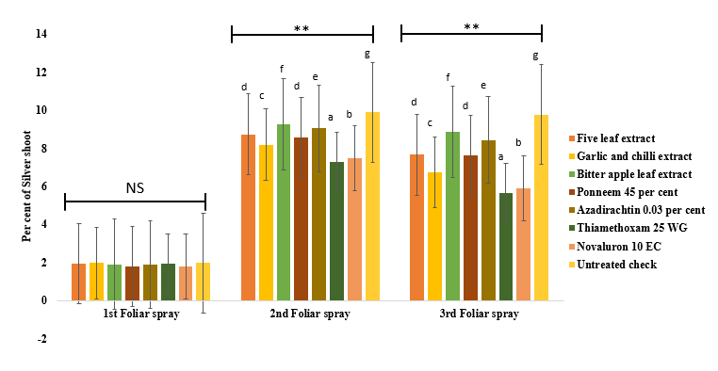

**Fig 1. Bioefficacy of botanical extracts against the gall midge, *O. oryzae* in the rice variety ADT 45 during *Rabi* 2019-2020; NS – Non Significant; **- significant at 0.0%; Each bar war Observed on pretreatment, 1, 3, 5, 7, 10, and 14 days following treatment with common letter not substantially different by DMRT (P<0.05)**

The effect of botanical extracts against thecase worm on the rice variety ADT 45 during *Rabi* 2019-2020 (Fig. 2). After the 1st foliar spray, significant differences were observed among the treatments (P < 0.01), with leaf damage percentages ranging from approximately 8.5% to 13.5%. The botanical extracts, including garlic and chilli extract, five leaf extract, and bitter apple leaf extract, resulted in moderate leaf damage, with values between 9.8% and 10.5%. Following the 2nd foliar spray, a substantial reduction in leaf damage was observed across all treatments (P < 0.01), with significant differences noted among them. The untreated control again recorded the highest leaf damage (12.5%), indicating continued pest pressure. Novaluron 10 EC and thiamethoxam 25 WG demonstrated superior efficacy, reducing leaf damage to 4.2% and 4.8%, respectively. Garlic and chilli extract and Ponneem 45% exhibited moderate efficacy, with leaf damage levels at 5.3% and 5.7%, respectively. Bitter apple leaf extract and five leaf extract resulted in slightly higher leaf damage at 6.4% and 6.8%, respectively. Azadirachtin 0.03% recorded 7.5% leaf damage, showing moderate efficacy compared to synthetic insecticides. By the 3rd foliar spray, all treatments effectively reduced leaf damage to minimal levels, and no significant differences (NS) were observed between treatments. Leaf damage percentages ranged between 0.5% and 1.8%, indicating that successive sprays significantly controlled pest infestation. Novaluron 10 EC and thiamethoxam 25 WG exhibited the lowest leaf damage levels at 0.5% and 0.7%, respectively. The botanical extracts, including garlic and chilli extract, five leaf extract, and bitter apple leaf extract, recorded minimal leaf damage between 0.8% and 1.2%. The results indicated that novaluron 10 EC at 400 ml/ac was found to be superior among the treatments (50.36 % reduction) and garlic and chilli extract at 5 % (41.99 %) was superior among the botanicals compared to the untreated check (Table 2).

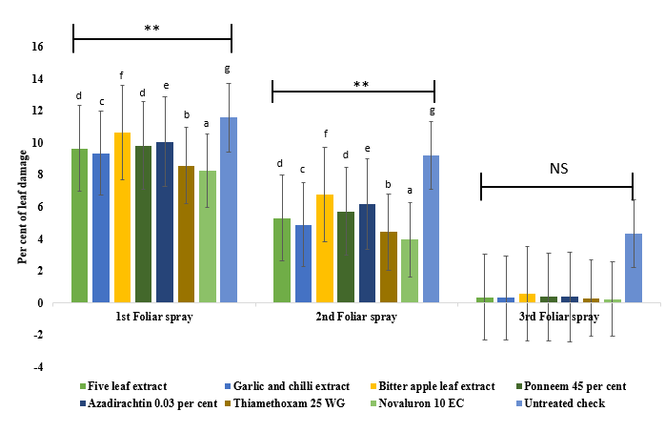

**Fig 2. Bioefficacy of botanical extracts against the case worm, *P. stagnalis* in the rice variety ADT 45 during *Rabi* 2019- 2020; NS – Non Significant; **- significant at 0.0%; Each bar war Observed on pretreatment, 1, 3, 5, 7, 10, and 14 days following treatment with common letter not substantially different by DMRT (P<0.05)**

The effect of botanical extracts against thegreen leafhopper and brown planthopper, on the rice variety ADT 45 during *Rabi* 2019-2020 (Fig 3 and 4). In green leafhopper, the number of insects per hill was significantly reduced after the 2nd and 3rd foliar sprays (p < 0.01) across treatments. During the 1st foliar spray, all treatments showed non-significant differences (NS) with similar insect numbers. After the 2nd and 3rd foliar sprays, thiamethoxam 25 WG and novaluron 10 EC resulted in the lowest insect count compared to other treatments. Among the botanical extracts, five leaf extract and garlic and chilli extract were more effective in reducing insect populations compared to others. Similar trends were observed, where the number of insects per hill was significantly reduced (p < 0.01) after the 2nd and 3rd foliar sprays for brown planthopper. The results indicated that thiamethoxam 25 WG at 40 g / ac was found to be superior among the treatments (59.34, 68.72% reduction) and five leaf extract at 10 % (44.04, 50.19%) was superior among the botanicals compared to the untreated check (Table 2). Current findings are in accordance with In terms of botanical insecticides, five leaf extract, garlic and chilli extracts are demonstrated moderate efficacy against rice pests. The findings corroborate the results reported by Prakash et al. (2008), who found that extracts from vitex, pongamia, and calotropis were effective against planthoppers. Further supported these findings by demonstrating that a 5% concentration of Vitex leaf extract exhibited significant efficacy against rice hoppers, suggesting that plant-based extracts can be viable alternatives to synthetic insecticides (Mohapatra *et al.,* 2009).

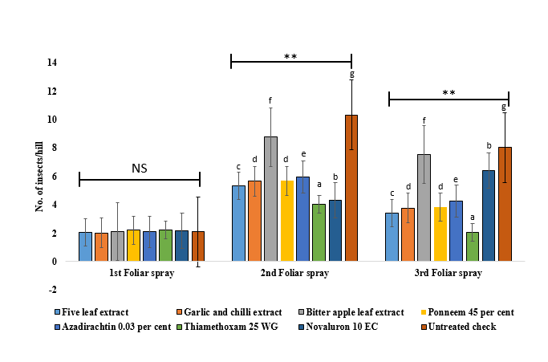

**Fig 3. Bioefficacy of botanical extracts on the population of the green leafhopper,*****N. virescens* in the rice variety ADT 45 during *Rabi* 2019-2020; NS – Non Significant; **- significant at 0.0%; Each bar war Observed on pretreatment, 1, 3, 5, 7, 10, and 14 days following treatment with common letter not substantially different by DMRT (P<0.05)**

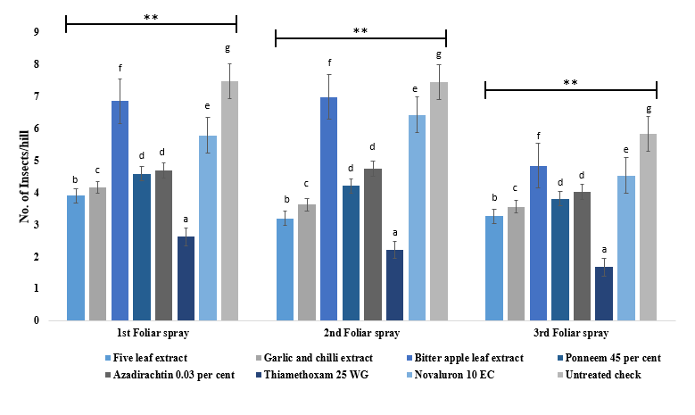

**Fig 4. Bioefficacy of botanical extracts on the population of the brown planthopper,*****N. lugens* in the rice variety ADT 45 during *Rabi* 2019-2020; **- significant at 0.0%; Each bar war Observed on pretreatment, 1, 3, 5, 7, 10, and 14 days following treatment with common letter not substantially different by DMRT (P<0.05)**

|  |  |  |  |  |  |  |  |  |  |  |
| --- | --- | --- | --- | --- | --- | --- | --- | --- | --- | --- |
| **Sl.  No.** | **Treatments** | **Conc.**  **%/ml/g**  **per acre** | ***O. oryzae*** | | ***P. stagnalis*** | | ***N. virescens*** | | ***N. lugens*** | |
| **Mean of Three Spraying** | **Percent reduction over control** | **Mean of 3 Spraying** | **Percent reduction over control** | **Mean of 3 Spraying** | **Percent reduction over control** | **Mean of 3 Spraying** | **Percent reduction over control** |
| 1. | Five leaf extract | 10 | 6.11 | 15.30 | 5.10 | 39.00 | 3.60 | 47.17 | 3.45 | 50.19 |
| 2. | Garlic and chilli extract | 5 | 5.63 | 21.95 | 4.85 | 41.99 | 3.82 | 44.04 | 3.78 | 45.43 |
| 3. | Bitter apple leaf extract | 10 | 6.69 | 7.26 | 5.99 | 28.41 | 6.15 | 9.87 | 6.22 | 10.15 |
| 4. | Ponneem 45 % | 1500 | 5.99 | 16.96 | 5.31 | 36.57 | 3.92 | 42.52 | 4.20 | 39.36 |
| 5. | Azadirachtin 0.03 % | 800 | 6.45 | 10.54 | 5.54 | 33.78 | 4.11 | 39.78 | 4.49 | 35.23 |
| 6. | Thiamethoxam 25 WG | 40 | 4.94 | 31.52 | 4.43 | 47.01 | 2.77 | 59.34 | 2.17 | 68.72 |
| 7. | Novaluron 10 EC | 400 | 5.05 | 29.94 | 4.15 | 50.36 | 5.61 | 17.79 | 5.58 | 19.44 |
| 8. | Untreated check | - | 7.21 | - | 8.37 | - | 6.82 | - | 6.93 | - |

**Table 2. Bioefficacy of botanical extracts against the important pests in the rice variety ADT 45 during *Rabi* 2019- 2020**

The present findings on the effectiveness of garlic and chilli extracts are further supported by the work of Rahman *et al.* (2022) investigated the effects of different botanical insecticides, including garlic and chilli extract, and found that they exhibited strong repellent and antifeedant properties against *Chilo suppressalis* (rice stem borer). Also, the effectiveness of vitex, pongamia, and calotropis extracts against rice planthoppers and found that plant-based bio-pesticides provided sustainable pest control while reducing the risk of pesticide resistance (Alam *et al.,* 2019). Garlic and chilli extract showed over 50% mortality of *Helicoverpa armigera* larvae in chickpea fields, supporting its role as an eco-friendly alternative to synthetic insecticides (Borah *et al.,* 2022). Similarly, combination of garlic and chilli extracts effectively suppressed populations of major rice pests, including leaf folders and planthoppers (Zhang *et al.,* 2020).

Panhwar (2002), who reported that garlic (70–80%) and chilli pepper (60–70%) were effective biocontrol agents against insect pests of cowpea. Rani (2013) reported that a combination of ginger, garlic, and chilli extract (10%) recorded no larvae of leaf folder on treated plants 6 hours after release, and the percent leaf area fed was reduced to 13.03% 48 hours after release. These findings demonstrate that botanical formulations, particularly garlic and chilli extracts, can provide sustainable pest management solutions in rice ecosystems. Bhaskaran (1995) also reported that the least leaf folder damage was observed in plots treated with lime + ash and green chilli extract, supporting the use of plant-based treatments as effective alternatives to synthetic chemicals.

According to Tuan *et al.* (2014), demonstrated that a combination of garlic and chilli extract reduced populations of cutworm by 56.55%, cabbage diamondback moth by 62.03%, and flea beetle by 88.16%, indicating broad-spectrum efficacy against multiple insect pests. Baidoo and Mochiah (2016) also reported that garlic and hot pepper (*Capsicum frutescens*) effectively controlled pests of cabbage, including *P. xylostella*, *H. undalis*, and *Trichoplusia ni*, with mortality reductions ranging from 10.76% to 55.94%. Furthermore, Kushram *et al.* (2017) demonstrated that a plant product combination of garlic and green chilli at 8.75 kg/ha was the most effective treatment against defoliators such as *Spodoptera litura* and *Clavigralla acuta* in soybean. These results are in close agreement with the present findings, highlighting the potential of combining plant-based bio pesticides for effective pest control.

**CONCLUSIONS**

It was concluded that 5% extract of garlic and chilli and 10 % five leaf extract might effectively lessen the adverse effects of key pest in rice crop. Secondary metabolites of garlic and chilli extract and five leaf extracts shows that botanical mixtures were responsible in reducing the feeding of leaf folder larvae on the treated leaf surface of rice plants can be identified. Even while the results strongly suggest using all of the studied plant extracts, particularly the extracts from garlic and chillies and much research still has to be done to determine the right dosage and concentration. Plant material's effective dosage and spraying schedules are to be determined, more testing is also required in future.

**Author contributions** M.K. conceived the idea and K.N. conducted the experiment and analyzed the observations. K.N. and M.K. wrotethe first draft of manuscript. M.K. reviewed and edited the manuscript.

**Consent for publication** All the authors agreed to publish the content.

**Competing Interests** The authors declare no conflict of interest in the publication of this content

**REFERENCES**

Aktar, W., Sengupta, D., and Chowdhury, A. 2009. Impact of pesticide use in agriculture: Their benefits and hazards. Interdisciplinary Toxicology, **2(1):** 1–12.

Alam, S. N., Sarder, R., and Begum, S. 2019. Effect of plant-based bio-pesticides (Vitex, Pongamia, and Calotropis) on rice planthoppers. International Journal of Agricultural Sustainability, **17(3):** 345–358.

Baidoo, P. K., and Mochiah, M. B. (2016. Comparing the effectiveness of garlic (Allium sativum L.) and hot pepper (Capsicum frutescens L.) in the management of the major pests of cabbage (Brassica oleracea L.). Sustainable Agriculture Research, **5(2):** 83–91.

Bhaskaran, S. 1995. Studies on traditional pest control practices of Tamil Nadu. M.Sc. thesis, Annamalai University, Tamil Nadu, 120.

Borah, R., Choudhury, P., and Nath, S. 2022. Evaluation of botanical insecticides against Helicoverpa armigera: Garlic and chilli extract as potential biopesticides. Journal of Biopesticides, **15(1):** 120–130.

Chinnaiah, Pasalu, I. C., Krishnaiah, N. V., Katti, G., and Varma, N. R. G. 2002. IPM in rice. IPM Newsletter, 45–55.

Debaje, S. B., and Johnson, J. S. 2011. High ozone at coastal sites in India. International Journal of Remote Sensing, **22(4):** 993–1015.

Debaje, S. B., Johnson Jeyakumar, S., Ganesan, K., Jadhav, D. B., and Seetaramayya, P. 2003. Surface ozone measurements at tropical rural coastal station Tranquebar, India. Atmospheric Environment, **37**: 4911–4916.

Dougoud, J., Toepfer, S., Bateman, M., and Jenner, W. H. 2019. Efficacy of homemade botanical insecticides based on traditional knowledge: A review. Agronomy for Sustainable Development, **39(37):** 1–22.

Dumra, N., Srivastava, A., and Tandon, V. 2018. Field efficacy of certain insecticides and botanicals against caseworm on paddy under mid hill conditions of Himachal Pradesh, India. Journal of Entomology and Zoology Studies, **6(6):** 1315–1317.

Echereobia, C. O., Okerere, C. S., and Emeaso, K. C. 2010. Determination of repellence potentials of some aqueous plant extracts against okra flea beetles, Podagrica uniforma. Journal of Biopesticides, **3(2):** 505–507.

FAO. 2004. The state of food security in the world. Food and Agriculture Organization of the United Nations, 30–31.

Hedge, M., and Nidagundi, J. 2009. Effect of newer chemicals on planthoppers and their mirid predator in rice. Karnataka Journal of Agricultural Sciences, **22(3):** 511–513.

Horgan, F. G., Srinivasan, T. S., Naik, B. S., and Bernal, C. C. 2021. Integrating resistance and resilience in rice pest management: Ecological and evolutionary perspectives. Field Crops Research, **260:** 107986. <https://doi.org/10.1016/j.fcr.2020.107986>

Isman, M. B. 2006. Botanical insecticides, deterrents, and repellents in modern agriculture and an increasingly regulated world. Annual Review of Entomology, **51:** 45–66.

Jagadish, S. V. K., Craufurd, P. Q., and Wheeler, T. R. 2010. High temperature stress and spikelet fertility in rice (Oryza sativa L.). Journal of Experimental Botany, **61(1):** 191–198. <https://doi.org/10.1093/jxb/erp289>

Kumar, H., Jaglan, R. S., Rohilla, H. R., and Chauhan, R. 2003. Relative efficacy of novaluron alone and in combination with other insecticides against diamondback moth, Plutella xylostella L. Journal of Entomological Research, **27:** 221–231.

Kumar, R., Singh, S., and Patel, R. 2015. Evaluation of botanical formulations in integrated pest management of rice. Journal of Pest Management, **21(2):** 103–110.

Kushram, T., Yadu, Y. K., Sahu, M. K., Kulmitra, A. K., and Kumar, R. 2017. Bioefficacy of botanical insecticides against defoliator pests on soybean. International Journal of Current Microbiology and Applied Sciences, **6(3)**: 2196–2204.

Ladji, R., Mallapur, C. P., Ambika, D. S., Amitha, K., Rudraswamy, S. M., and Thimmegowda, P. R. 2011. Management of chickpea pod borer, Helicoverpa armigera (Hubner) using indigenous materials. International Journal of Science and Nature, **2(2):** 263–265.

Lakshmanan, K. K. 2001. Garlic: A natural pesticide. The Hindu, 8.

Maxwell, E. M., and Fadamiro, H. Y. 2006. Evaluation of several reduced-risk insecticides in combination with an action threshold for managing lepidopteran pests of cole crops in Alabama. Florida Entomologist, **89(2):** 117–126.

Mohapatra, P., Pannurasan, N., and Narayanasamy, P. 2009. Tribal pest control practices of Tamil Nadu for sustainable agriculture. Indian Journal of Traditional Knowledge, **8(2):** 218–224.

Munns, R., and Tester, M. 2008. Mechanisms of salinity tolerance. Annual Review of Plant Biology, **59**: 651–681. <https://doi.org/10.1146/annurev.arplant.59.032607.092911>

Nilamudeen, M. K., Karthikeyan, K., Raji, P., and Arshad, M. V. 2024. Evaluation of botanicals against rice caseworm Parapoynx stagnalis Zeller (Lepidoptera: Pyralidae). Journal of Agricultural Ecology and Research International, **25(3):** 1–4.

Panhwar, S. B. 2002. Farmers’ adoption of plant materials for insect control. International Series on Natural Agricultural Research, **4**: 61–68.

Panse, R. K., Bhandarkar, A. P., and Rajak, S. K. 2016. Evaluation of thiamethoxam 25 percent WG against major insect pests of rice (Oryza sativa L.). International Journal of Plant Protection, **9(2):** 551.

Pasalu, I. C., and Katti, G. 2006. Advances in ecofriendly approaches in rice IPM. Journal of Rice Research, **1(1):** 83–90.

Pasalu, I. C., Katti, G., and Padmavathi, C. 2006. Sustainable rice pest management in India: A review. Journal of Rice Research, **1(1):** 83–90.

Pathak, M. D., and Khan, Z. R. 1994. Insect pests of rice. International Rice Research Institute Publication, Philippines, 89.

Prakash, A., Rao, J., and Nandagopal, V. 2008. Future of botanical pesticides in rice, wheat, pulses and vegetables pest management. Journal of Biopesticides, **1(2):** 154–169.

Prasad, R., and Prasad, D. 2006. Account of insect pest problem in rice ecosystem in Ranchi. Indian Journal of Entomology, **68(3):** 240–246.

Prasannakumar, N. R., Chander, S., and Vijaykumar, L. 2015. Development of weather-based rice yellow stem borer prediction model for the Cauvery command rice areas, Karnataka, India. Cogent Food & Agriculture, 1: 995281.

Rahman, M. A., Islam, S., and Hossain, M. M. 2022. Botanical insecticides as potential alternatives: Efficacy of garlic and chilli extract against Chilo suppressalis. Journal of Pest Science, **95(2):** 210–223.

Rajashekhar, M., Rajashekar, B., Reddy, T. P., Ramakrishna, K., Kumar, V. P., Vanisree, K., Neelima, G., Madhuri, G., and Shaila, O. P. 2021. Microbial pesticides for insect pest management success and risk analysis. International Journal of Environment and Climate Change, **11(4):** 18–32.

Rani, T. 2013. Studies on the effect of certain botanicals and their compatibility with myco-insecticides in the management of key insect pests of rice. Ph.D. thesis, Annamalai University, Tamil Nadu, 97–113.

Sahithi, S., and Misra, H. P. 2006. Field evaluation of some insecticides against rice leaf folder, Cnaphalocrocis medinalis. Indian Journal of Plant Protection, **34(1)**: 134–135.

Seni, A., and Naik, B. S. 2017. Efficacy of some insecticides against major insect pests of rice, Oryza sativa L. Journal of Entomology and Zoology Studies, **5(4):** 1381–1385.

SenthilNathan, S., Chung, P. G., and Murugan, K. 2006. Effect of botanical insecticides and bacterial toxins on the gut enzyme of the rice leaf folder Cnaphalocrocis medinalis. Phytoparasitica, **32(5)**: 433–443.

Shashank, P. R., Mallikarjuna, J., Chalam, M. S. V., and Madhumathi, T. 2012. Efficacy of new insecticide molecules against leafhoppers and planthoppers in rice (Oryza sativa L.). International Journal of Plant Protection, **5(2):** 397–400.

Singh, N., Kumar, D., and Ravichandran, S. 2018. Pesticide residues and human health: Risk analysis in rice cultivation. Journal of Environmental Science and Health, Part B, **53(6):** 415–424. <https://doi.org/10.1080/03601234.2018.1461966>

Tuan, N. M., Anh, B. L., and Anh, B. N. H. 2014. Efficacy of garlic and chili combination solution on cabbage insect pests and crop growth in Vietnam. International Journal of Agricultural and Biosystems Engineering, **8(10):** 1146–1149.

Zhang, Z., Li, Y., and Zhou, W. 2020. Suppressive effects of garlic and chilli extracts on rice pest populations and plant health improvement. Crop Protection, 130: 105063.