**Species diversity of stem borers and Leaf folders (Lepidoptera) in rice ecosystem at PAJANCOA & RI, Karaikal, U.T. of Puducherry**

**ABSTRACT**

On field experiment during *Kharif* 2019 and *Rabi* 2019-2020 at Pandit Jawaharlal Nehru college of agriculture and research institute, Karaikal to study the species diversity of stem borer and leaf folder of rice. Three species of rice stemborer occurred, namely *Scirpophaga incertulas*, *Sesamia inferens* and *Chilo polychrysus*, the first of which was dominant. There were three species of rice leaf moth, namely *Cnaphalocrocis medinalis*, *Marasmia ruralis* and *Marasmia exigua*, the first of which was dominant.

**KEYWORDS:** Rice, species diversity, stem borers, leaf folders, pest management

**INTRODUCTION**

Lepidoptera is the second-largest insect group comprising moths and butterflies (Lee *et al.,* 2002). Lepidopteran is also very diverse in many agricultural ecosystems such as in rice fields, oil palm plantations, orchards, and secondary forest ecosystems. This group of species mostly acts as pests during their larval stages (Ghazali *et al.,* 2020). Paddy fields are considered temporary aquatic and terrestrial habitats for these species. The paddy ecosystem or area is flooded with water throughout the planting season and is dried after the harvesting season. Thus, conditions become an ideal environment for lepidopteran species (Bahaar and Bhat, 2011). Paddy grains are one of the most economically important products because it is a food source for human beings (Sampathkumar, 2010), but the crops have also been recorded to be infested by lepidopteran species (Srivastava *et al.,* 2012). Stem borers and leaf folders are widely distributed in various parts of the world. Currently, stem borer, *Scirpophaga incertulas* and leaf folders, *Cnaphalocrocis medinalis* have attained pest status on rice (Pandya *et al.,* 1987). The rice stem borer *S. incertulas* is the most serious rice pest in rice-growing regions in Asia and Japan. In southern India, it is common in the Northern Circars, Ceded, Ramanathapuram, Tanjore and Malabar districts. In rice ecosystems, *S. incertulas*, a monophagous rice pest, is considered the major plague of rainfed, low land and flood prone (Deka and Barthakur, 2010). Recently, *S. fusciflua* from North India (Sie *et al.,* 2008). *C. medinalis,* *Marasmia exigua*, *M. patnalis* and *M. ruralis* are the four superficially similar species commonly found in the rice ecosystem of Asia and the Philippines. The rice leaf folder complex has changed from minor to major pest status in Philippines, South and South East Asia (Khan *et al.,* 1988). The discovery of *M. patnalis* by Bradley in 1981, initially led to the realization that it was a complex of leaf folder species. *Cnaphalocrocis* has been used as a synonym for *Marasmia* in updated data in LEPINDEX(Lepindex, 2011). The identification of stem borers and leaf folders fauna in PAJANCOA & RI, Karaikal is needed for better control measures of these two important pest generas. By keeping this in view, the present studies were planned with an objective to study the species diversity and distribution of stem borer and leaf folder species complex in Karaikal rice eco-system.

**METHODOLOGY**

***Sampling Location***

This study was conducted at cultivated paddy field at the eastern farm of PAJANCOA and RI, Karaikal, U.T. of Puducherry as an irrigated crop, which lies between 1095˚ N latitude and 7978˚ E longitude with a height of 4 m above MSL.

***Insect Sampling***

Sampling was carried out during Kharif 2019 and Rabi 2019-2020 (2 season) according to paddy growth stages; vegetative, reproductive and mature stages. Stems/plants were also collected from paddy plants that were selected randomly from fields. Paddy stems were later cut longitudinally to examine the presence of larvae and pupae and larval stage specimens of leaf folders were handpicked from the plots. All the field specimens were brought back to the Entomology Laboratory for rearing and emerged adults were sorted and identification was done.

**RESULTS AND DISCUSSION**

The prevalence of different species of stem borer and leaf folder was observed during *Kharif* 2019 and *Rabi* 2019-2020. The present study revealed that three species of rice stem borers occurred in PAJANCOA & RI, Karaikal district *viz.,* *S. incertulas*, *S. inferens*, *C. polychrysus* among which the first was dominant (Fig. 1). The incidence of *S. incertulas* and *S. inferens* was found throughout the year whereas *C. polychrysus* was found low. This is in line with findings, during Kar and Pishanam seasons of 2013, among the 290 larvae collected in rice fields, the yellow stem borer, *S. incertulus* (96.79%) was found to the predominant species throughout the cropping season followed by dark headed borer, *C. polychrysus* (3.21%) (Elanchezhyan *et al.,* 2015). While, three stem borers species *viz.,* yellow stem borer, pink stem borer and dark headed borer were found in all the regions except in the hilly Zone where YSB was the only species present (Rautaray *et al.,* 2019). This is agreement with findings of five stem borer species *viz.,* *S. incertulas*, *S. inferens*, *C. polychrysus*, Stripped stem borer, *C. suppressalis,* White stem borer *S. innotata* and nine different natural enemies were collected from the rice fields and recorded (Rahman *et al.,* 2014). The present work is in agreement with findings that three species of stem borer including *S. incertulas*, *C. suppressalis* and *S. innotata* were found attacking rice among them, *S. incertulas* dominated (MuraliBaskaran *et al.,* 2017).

In the present study, three species of rice leaf folders occurred in Karaikal district *viz.,* *C. medinalis*, *M. ruralis* and *M. exigua* among which the first was dominant (Fig. 2). The incidence of all the three species of leaf folder were found throughout the year. This is line with findings Syarifah *et al.* (2018) reported that *C. medinalis*, *M. exigua* and *Brachimea arotraea* (Meyrick) with the predominance of *C. medinalis* at North Eastern Coastal Plains of Odisha. In Madurai, recorded diversity of *C. medinalis*, *C. patnalis* and *C. ruralis*(BabyRani *et al.,* 2007). Three species *viz.,* *C. medinalis*, *M. patnalis* and *M. ruralis*. The first two species were abundant in all sampling dates (Gunathilagaraj *et al.,* 1986).

**CONCLUSION**

Rice ecosystem in PAJANCOA & RI, Karaikal has an unusually high record of different species of insect pest. However, it does denote that an appropriate method of pest control should be implemented. More studies should be carried out in future to ensure updated and credible data on richness and abundance of Lepidoptera (stem borers and leaf folders) in cultivated and conventional rice ecosystems based on different growth stages, longer sampling durations (several seasons) and with similar sampling methods. The outcomes from this study are very important for the initial stages of conservation, especially for rice pest management strategies.

**Ethics statement**

This article does not contain any studies with human participants or animals performed by any of the authors**.**

**Consent for publication**

All the authors agreed to publish the content.

**Competing Interests**

The authors declare no conflict of interest in publication of this content

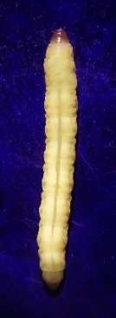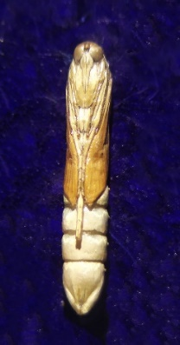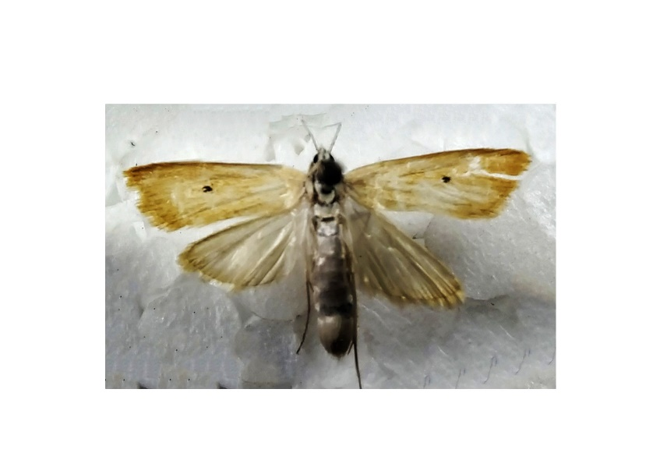

Adult

Larva

Pupa

**1a. Yellow stem borer, *Scirpophaga incertulas* (Walker)**

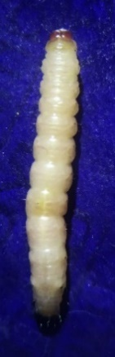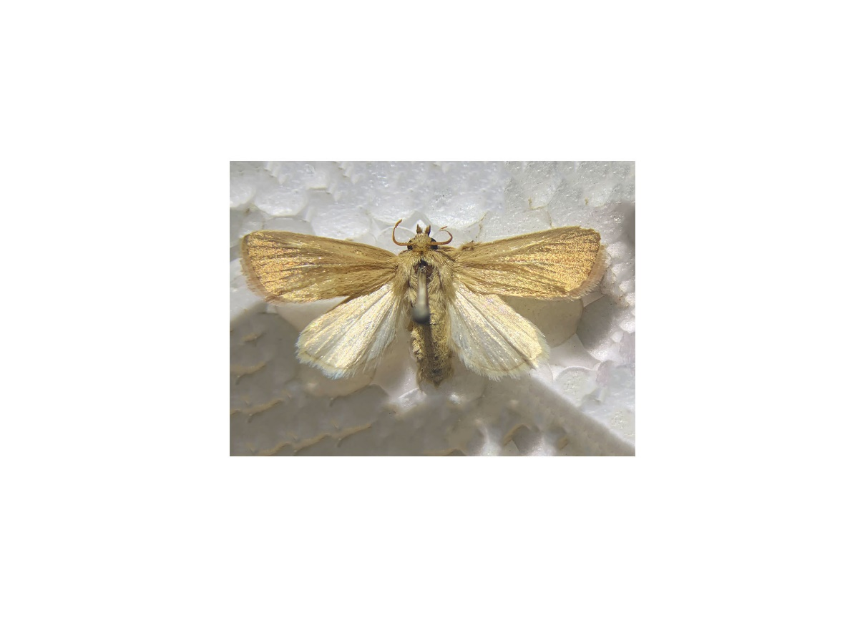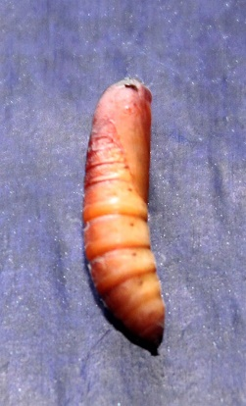

Adult

Pupa

Larva

**1b. Pink stem borer, *Sesamia inferens* (Walker)**

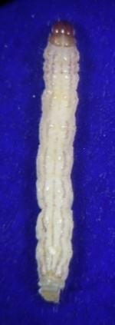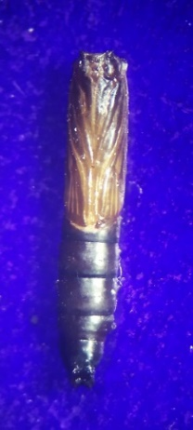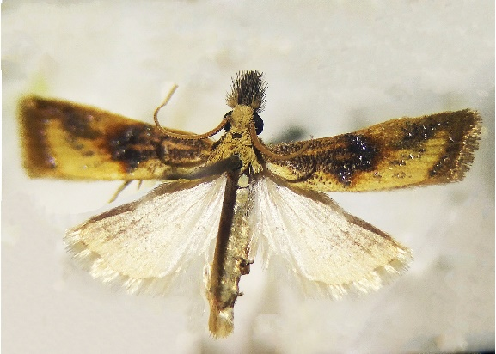

Larva

Adult

Pupa

**1c. Dark headed stem borer, *Chilo polychrysus* (Meyrick)**

**Figure 1. Picture of larval, pupal and adult stages of rice stem borers in Karaikal, U.T. of Puducherry**

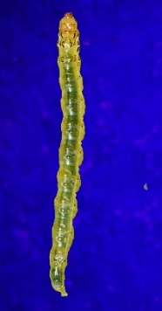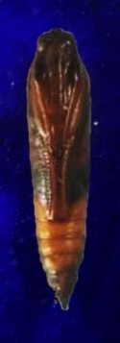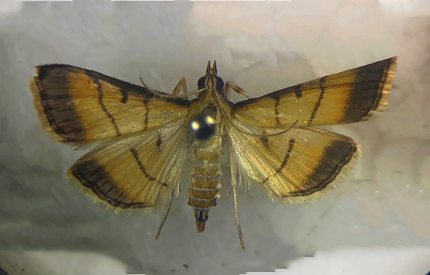

Larva

Adult

Pupa

**2a. *Cnaphalocrocis medinalis*(*Guenee*)**

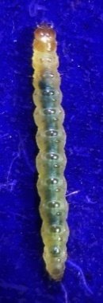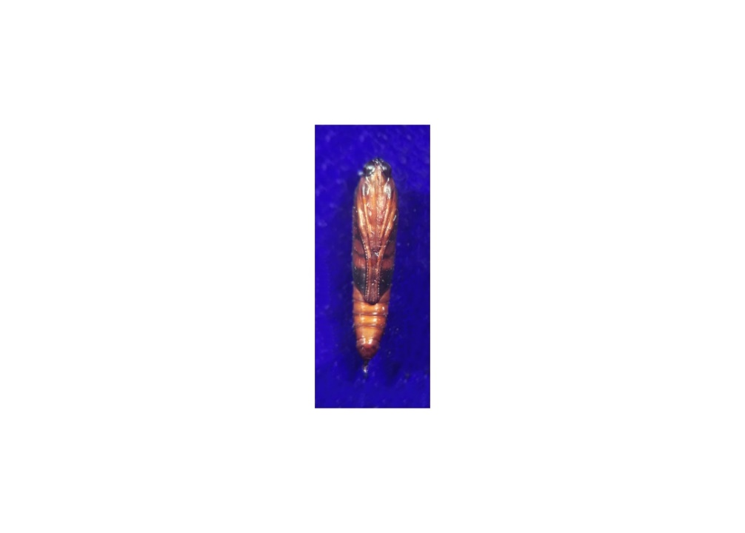

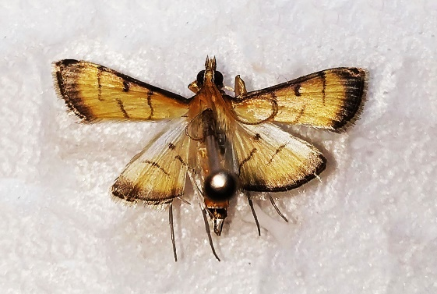

Adult

Pupa

Larva

**2b. *Marasmia ruralis*(*Walker*)**

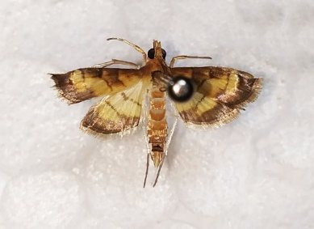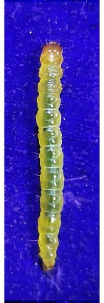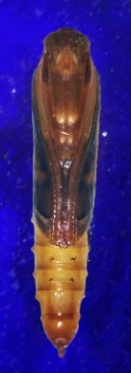

Pupa

Adult

Larva

**2c. *Marasmia exigua*(*Butler*)**

**Figure 2. Picture of larval, pupal and adult stages of rice leaf folders in Karaikal, U.T. of Puducherry**

**REFERENCES**

BabyRani, W., Amutha, R., Muthulakshmi, S., Indira, K. and Mareeswari, P. 2007. Diversity of rice leaf folders and their natural enemies, Regional Research Station, Aruppukottai, Tamil Nadu. *Res. J. Agric. Biol. Sci*., **3(5):** 394-397.

Bahaar, N.S.W. and Bhat, A. G. 2011. Community organization and distribution of Lepidoptera in the rice fields of Kashmir (J and K) India. *Asian J. Biol. Sci*., **4(7):** 563-569.

Deka, S. and Barthakur, S. 2010. Overview on current status of biotechnological interventions on yellow stem borer, *Scirpophaga incertulas* (Wlk.) (Lepidoptera: Crambidae) resistance in rice. *Biotechnol. Adv*., **28(1):** 70-81.

Elanchezhyan, K., Murugesan, N. and Ravi, G. 2015. Diversity of stem borers in rice. International Conference on Innovative Insect Management Approaches for Sustainable Agro Eco System (IIMASAE). Department of Agricultural Entomology, Agricultural College and Research Institute; 27-30.

Ghazali, S. Z., Md-Zain, B. M. and Yaakop, S. 2020. *Phylogeny of Economically Important Insect Pests That Infesting Several Crops Species in Malaysia*. Retrieved from https:. http://aip.scitation.org/doi/pdf/10.1063/1.4895288.

Gunathilagaraj, K., Mohan, R. and Gopalan, M. 1986. Rice Leaf Folder Complex in Madurai. IRRN; **11(6):** 24.

Khan, Z. R., Barrion, A. T., Litsinger, J. A., Castilla, N. P. and Joshi, R. C. 1988. A bibliography of rice leaf folders (Lepidoptera: Pyralidae). *Insect Sci Appl*., **9**: 129-174.

Lee, S. S., Yaakob, N. S., Boon, K. S. and Chua, L. S. L. 2002. The role of selected animals in pollination and dispersal of trees in the forest: implications for conservation and management. *J Trop Forest Sci*., **14(2):**234-263.

Lepindex, W. P. 2011. *Updated Data of the Taxa Bombycoidea and Microlepidoptera*. http://www.nhm.ac.uk/research−curation/research/projects/lepindex/people.htm/accessed.

MuraliBaskaran, R. K., Sharma, K. C. and Kumar, J. 2017. Seasonal and relative abundance of stem-borer and leaf-folder in wetland rice eco-system. *J Entomol Zool Stud*., **5(2):** 879-884.

Pandya, H. V., Singh, S. A. H. and Purohit, M. S. 1987. Yield loss caused by leaf folder damage alone and combined with yellow stem borer damage. *Int Rice Res Newsl*., **12(5):** 28.

Rahman, M. R., Begum, M. and Bulbul, S. H. 2014. Effect of alternate wetting and drying (AWD) irrigation for Boro rice cultivation in Bangladesh. *Agric For Fish*., **3(2):** 86-92.

Rautaray, B. K., Bhattacharya, S., Panigrahi, D. and Dash, S. R. 2019. Studied on Species Diversity of Rice Leaf Folder and their Natural Enemies in North Eastern Coastal Plains of Odisha. *Int J Curr Microbiol Appl Sci.,* **8(10):** 634-45.

Sampathkumar, M. 2010. *Studies on Rice Stem Borer Management Using Indigenous Pheromone Technology* [PhD Thesis]. Tamil Nadu Agricultural University, Coimbatore.

Sie, M., Sere, Y., Sanyang S, et al. 2008. Regional yield evaluation of the interspecific hybrids (*O. glaberrima* x *O. sativa*) and intraspecific (*O. sativa* x *O. sativa*) lowland rice. *Asian J Plant Sci*. **7(2):** 130-139.

Srivastava, A., Sarao, P. S., Ram, L. and Salaia, R. 2012. Singh A. New record of *Scirpophaga fusciflua* Hampson from North India. *Rice Res*., **5(1-2):** 61.

Syarifah Zulaikha, S. A., Halim, M., Nor Atikah, A. R. and Yaakop, S. 2018. Diversity and abundance of storage pest in rice warehouses in Klang, Selangor, Malaysia. *Serangga*. **23(2):** 259-267.