Long-term regional trends (1981-2023) of temperature, Rainfall, drought indices and environmental impacts in southern India

Guhan V¹*, Dharma Raju A¹, Sravani A¹, Nagaratna K¹

¹Meteorological Centre, Airport Colony, Indian Meteorological Department, Begumpet, Hyderabad, Telangana, India

*Corresponding Author – guhanthiran@gmail.com

Abstract:
In this study, we investigated historical data from 1981-2023 to examine at changes in temperature and rainfall in drought-prone districts of Telangana. Here we present, importance of drought indicators in understanding drought conditions. We examined the monthly and annual data and calculated the average, standard deviation, and coefficient of variation (CV) for rainfall, minimum and maximum temperatures. We utilized the indicators of Z-Score Index (ZSI), Deciles Index (DI), Percent of Normal Index (PNI), Standardized Precipitation Index (SPI), China-Z Index (CZI), Rainfall Anomaly Index (RAI), and Deciles Index (DI). In this present study found that maximum temperatures in these regions rose dramatically over time, whereas minimum temperatures and rainfall in all drought-prone areas remained unchanged. Every district has had mild to severe drought years, with every district experiencing severe and extreme droughts. By combining these indices, researchers and policymakers can gain an extensive understanding of drought risk, which is crucial for managing water supplies, developing plans for climate change, and preventing the effects of drought. A comprehensive drought response may develop adaptive and drought-resistant strategies, preserving Telangana's agricultural, water supply, and economic stability.

Keywords: Rainfall, Temperature, Trend analysis, Coefficient of variation (CV), Drought Indices.
Introduction
Global warming has increased the frequency of extreme weather events such as heatwaves, droughts, and heavy rains around the world. However, identifying and quantifying drought is more challenging than other extreme weather phenomena such as floods and rainfall. Guan (2022), Khadka (2022), Zhuang (2024), and Xue Li (2024). Droughts are slow-onset risks that might endure for years or months (Boult, 2022; Fathi-Taperasht, 2022; Spinoni, 2020). Holmberg and Hellsten (2016) suggest that climatic variability increases the likelihood of drought and flooding by increasing the frequency and intensity of extreme rainfall events. The fluctuation of rainfall and weather-related threats including windstorms, floods, and droughts have an impact on agricultural activity (Meharie et al., 2023; Motha, 2011, Yiran and Stringer, 2017). Drought has developed as a complex natural hazard with the potential to considerably disrupt terrestrial ecosystems due to its severity, duration, and environmental impact (Allen, 2018; Buttafuoco, 2015; Zhong, 2022; Zhong, 2021). Meteorological, agricultural, and hydrological droughts generally arise by differences in a region's long-term average rainfall during a specific time period (Vicente-Serrano, 2020; Wilhite and Glantz, 1985).

Climate change in India has an adverse effect on monsoon timing, temperature, and other climatic parameters, potentially affecting the atmosphere (Goddard and Gershunov, 2020). Extremely minimal temperature increases can produce heat waves, harm, and changes in animal and plant species (Guhathakurta et al., 2020). According to a number of studies, the pattern and scale of warming recorded over the last century in India or the Indian subcontinent are completely consistent with the worldwide pattern and amplitude (Hayes et al., 2012; Handmer et al., 2012; Qin, X and Dai, C., 2022). After analyzing temperature and precipitation data for 139 major Indian cities between 1901 and 2015, Mohammad and Goswami (2023) found a tendency of rising temperatures in southeast regions and declining temperatures in northwest regions. In addition, they observed that the rainfall patterns were unpredictable, with the eastern part receiving less rain than the western side.

Here we selected the Telangana, and it is extremely vulnerable to climate change and has little capacity for adaptation. It is shown that the drought-prone areas of Telangana seldom use trend analysis of weather variability data, and the region has never published any previous research showing historical trends of weather parameters. Here, we provide an innovative technique that enables the district's drought conditions to be accurately deduced from the Z-Score Index (ZSI), Deciles Index (DI), Rainfall Anomaly In-dex (RAI), Standardized Precipitation Index (SPI), Percent of Normal Index (PNI), and Chi-na-Z Index (CZI). Drought indicators will be used to gauge the severity, length, and geographical scope of the drought. These indicators are important for measuring the impacts on agriculture and water availability. In addition, we used the trend analysis examines and long-term patterns in drought conditions and several drought indexes exist, understanding their patterns over time is essential. A comprehensive approach to drought assessment provides extensive information to decision-makers and policymakers.

Materials and Methods
Study Area
Telangana is located in a semi-arid zone, which contributes to its mostly hot and dry climate. The state experiences a high summer temperature of around 42°C, with an average annual temperature ranging from 27.5°C to 27.8°C. The state receives 906 millimeters of precipitation on average every year, most of which falls between June and September during the southwest monsoon season. Telangana is a region of the Deccan Plateau in terms of geology, and it is distinguished by the variety of soil types it has, such as lateritic, black cotton, and red soils. In this regions environment is a mix of steep terrain and flat plains, which contribute to its diversified agricultural practices. Telangana's Drought Prone Area Programme categorized the districts of Adilabad, Khammam, Mahbubnagar, Medak, Nalgonda, and Rangareddy as drought-prone areas of the state, and these were the study sites. Figure 1 depicts the study territory and the locations of the selected districts, while Table 1 provides land statistics for the research area.

Table 1. The land details of the study area
District | Latitude | Longitude | Area (sq.kms) | % area of the state
Adilabad | 19.67 | 78.53 | 4153 | 3.6
Khammam | 17.24 | 80.15 | 4361 | 3.8
Mahbubnagar | 16.74 | 78 | 5285 | 4.6
Medak | 18.04 | 78.26 | 2786 | 2.4
Nalgonda | 17.05 | 79.26 | 7122 | 6.2
Rangareddy | 17.04 | 78.38 | 5031 | 4.4
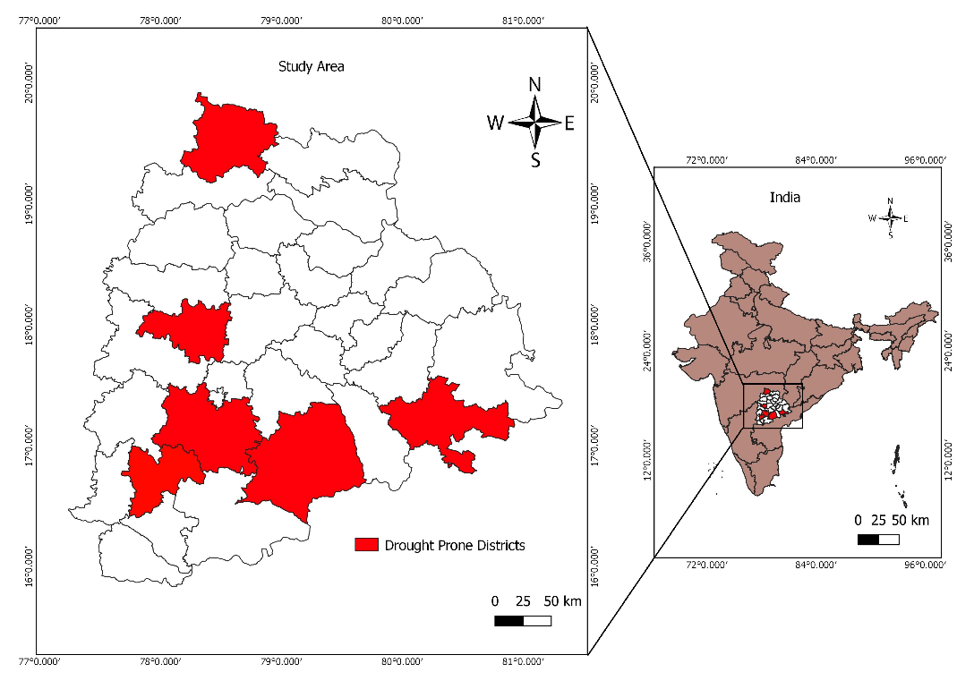
Fig 1. Map of the study area.

Datasets
The Telangana districts of Adilabad, Khammam, Mahbubnagar, Medak, Nalgonda, and Rangareddy's rainfall, minimum temperature, and maximum temperature historical data were collected for this study during a 43-year period ending in 2023. In order to identify trends and carry out additional analysis, the mean of the low and high temperatures as well as the annual average rainfall has been calculated and processed in Excel files. The data collection period covered by the CRSI and Meteorological division in Pune was from 1981 to 2023.
Trend analysis
According to Webber and Hawkins, a trend is the general trend of a series over time (1980). Additionally, it explains the long-term changes in the dependant variable. Trend is defined by the temporal resolution and correlation between the two factors, the temperature and the rainfall. Regression analysis and the coefficient of determination (R2) are two statistical techniques used to assess the significance of temperature and rainfall trends. The Mann-Kendall (M-K) trend test was used to develop and evaluate the trend, and the least squares method was used to determine the regression line's slope. Utilizing the mean, standard deviation (SD), and coefficient of variation (CV), calculations were performed to evaluate the relationship between temperature and precipitation.

Mann–Kendall's Test
A prominent nonparametric statistical technique for identifying trends in meteorological and hydrological time series data is the MK test. The test was developed by Mann in 1945 (Kendall, 1945), and since then, environmental time series have been used in a number of applications. Taking this test has two advantages. Firstly, since this test is nonparametric, uniformly distributed data are not required. Second, unexpected pauses are less sensitive to the test in non-uniform time series. For this test, the null hypothesis (H0) states that there is no trend. By contrast, the alternative theory H1 confirms that a trend is present. This is how the MK statistics is computed.


We do a trend test on a time series Xk that is ranked from j = i + 1, i + 2, i + 3…..n and rated from k = 1,2,3,…,n-1. A point of reference is served by each and every data point xj.
sgn (xj-xk) | = | 1 if xj-xk > 0
 | = | 0 if xj-xk = 0
 | = | -1 if xj-xk < 0

Sen's Slope Estimator Test
Sen's estimate (Sen, 1968) is a nonparametric technique for determining the amplitude of a time series trend. Sen's nonparametric approach is used to determine the real slope of an existing trend, such the yearly change in amount, and is checked using R software. A positive Sen's slope indicates a growing or expanding trend in the time series, whereas a negative Sen's slope indicates a declining or contracting trend.

Drought Indices
Standardized Precipitation Index (SPI)
Karabulut (2015) states that the SPI is the most often utilized drought indicator (Supplementary Table 1). It is generally agreed upon as a valuable tool for describing meteorological droughts. SPI was developed across diverse time periods (1, 3, 6, 12, 24, and 48 months) (McKee, 1993; 1995), with output values ranging from -2.0 to 2.0.
The SPI is calculated using the probability density function shown below, as precipitation data may be fitted by a gamma distribution:

Where
T(\alpha) stands for the gamma function, α (α>0) for the shape parameter, β for the scale parameter, and x (mm) for precipitation. Further information can be found in McKee (1995).

Percent of Normal Index (PNI)
The PNI has been developed by Willeke, 1994 and the percentage of normal precipitation (Table 2). A variety of time intervals, including seasonal, annual, and monthly, can be used to compute it. Hayes et al. (2005) state that PNI has shown to be highly effective in describing drought for a particular region or for a period of time.
PNI is determined in this way:

Deciles Index (DI)
According to Gibson and Maher (1967), the DI (Supplementary Table 1) rates the amount of precipitation that occurred over a specific period of time across the whole historical era. Monthly recorded rainfall data is sorted from low to high and to generate ten equal divisions, or deciles. Deciles can also be used to contextualize precipitation within a certain month's historical context.
China-Z Index (CZI)
The National Climate Center of China developed the CZI (Table 2) in 1995 as an alternate for the SPI, if the average rainfall follows the Pearson type III distribution (Chen et al., 2005).
For the CZI, the formula is
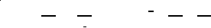
where i is the interest time scale and j is the current month. The CZI amount for period I's current month (j) is denoted as CZI ij, where Csi is the coefficient of skewness and φtj is the standardized variation. Wu et al. (2001) provide further details. Furthermore, the MCZI may be calculated using the same approach, but with median precipitation instead of mean precipitation.

Rainfall Anomaly Index (RAI)
The RAI examines at both positive and negative anomalies (Table 1). The precipitation data is shown first, descending in order. Averaging the top 10 results establishes a positive anomaly threshold, whereas averaging the lowest ten numbers establishes a negative anomaly obstacles.
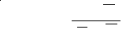
where m is the mean of the ten highest and ten lowest p values for the positive and negative anomalies, respectively, and p is the actual precipitation for each year (mm). The long-term average precipitation is denoted by p.

Z-Score Index (ZSI)
There are situations in which ZSI and SPI (Table 2) are not understood. It is more similar to CZI even though it does not need fitting precipitation data to the gamma or Pearson type III distributions. To compute ZSI, use this formula:

where P is the average monthly precipitation (mm), SD is the standard deviation of any time period (mm), and Pi is the precipitation in a certain month (mm).

Results and Discussion
The average, standard deviation, and coefficient of variation (CV) for rainfall, minimum and maximum temperatures were determined by analyzing monthly and annual data (Fig 2). The subsequence tables for each of the six drought-vulnerable locations show the basic statistical characteristics of selected variables month by month. Even during the rainy season, the region received little to no rainfall, according to average rainfall estimates. July and August observed the highest rainfall, although with a lower CV value. Adilabad, Khammam, and Mahbubnagar received over 900 mm of rain on average during the monsoon season, whereas Rangareddy received the least (548.9 mm on average and 98.6 mm in June). Furthermore, data mining revealed that the Adilabad district experienced the highest average rainfall of 774.0 mm in July 1988. In 2005, Khammam experienced a record high rainfall of 928.9 mm. In July 2022, a comparable amount was recorded for Mahbubnagar, Medak, and Nalgonda, respectively, with 484.7 mm in 1988 and 427.2 mm in 1989. On the other hand, Rangareddy had 396.8 mm of precipitation in August. An additional investigation conducted in 2022 by Bellamkonda et al. revealed no significant trend in Telangana's pre-monsoon, monsoon, and post-monsoon rainfall patterns. The Modified Mann-Kendall test revealed no significant yearly rainfall trend in Telangana. While the other months exhibited no noteworthy changes, May experienced a significant rise in rainfall. Patra et al. (2012) conducted the detecting rainfall trends in the twentieth century over Odisha state, India. It discovered that yearly and monsoon rainfall in Odisha was increasing after the monsoon season but decreasing over time. Rainfall increased over the winter and summer.
Figure 2 depicts May month is hot of the year in these regions, with maximum temperatures reaching 42.2oC. Khammam, Medak, and Rangareddy reported the lowest maximum temperature of 29.6ºC, which could be attributed to their geographical location. The average temperature in Adilabad was higher than in surrounding places. The highest mean maximum temperature observed in Khammam was 44.1°C in May 1984, according to an analysis of mean monthly data. In May, Adilabad, Mahbubnagar, Medak, Nalgonda, and Rangareddy had temperatures of 43.9ºC in 1984, 43.0ºC in 1984 and 2019, 42.3^{oC} in 1984 and 2019, 42.9ºC in 2012, and 42.3ºC in both 1984 and 2019. Figure 2 shows how the lowest temperature in each of the states under investigation varied from 14.1°C in December to 27.7°C in May. Based on average monthly statistics, Khammam had the highest mean minimum temperature of 29.2ºC in May 1988. May temperatures in Adilabad, Mahbubnagar, Medak, Nalgonda, and Rangareddy peaked at 28.7°C in 2013, 28.6°C in 1988, 28.0°C in 2003, 28.5°C in 2001, and 28.0°C in 2003.

Figure 3 displays the annual trends in rainfall, maximum and lowest temperatures using trendline graphs. Previous studies found a similar linear regression analysis for rainfall changes in Telangana state's Jagtial district from 1980 to 2019 (Navatha et al., 2021). The linear regression trend technique observed an increasing trend pattern for the temperature data provided. The modified Mann-Kendall test revealed no significant change in temperature patterns in January, November, and December, but significant trends (* P < 0.05) in the remaining months. Pre-summer, post-summer, and yearly temperature patterns showed statistically significant trends (* P < 0.05). In contrast, the modified Mann Kendall test indicated no statistically significant trend (NS) in summer temperatures (Laasya et al., 2024).
Sen's slope, the MK test, and trends in temperature, precipitation, and maximum and minimum values have all been calculated. An independent trend analysis was conducted on the variables that were chosen. The MK test results are displayed in Figures 4, 5, and 6, along with the P value and Sen's slope, which show the magnitude of the trend appears. With the exception of Adilabad and Mahbubnagar (P values 0.07 and 0.08), which showed a 5% increase, Fig. 5 shows a substantial rise in max temperature (P value <0.05) in districts that are susceptible to drought. In all drought-prone locations, minimum temperatures increased, though not much. Sen's slope values, depicted in Fig 7, show an increased trend in temperature throughout all drought-prone districts. Rainfall data show both positive and negative trends (Figure 8). While drought-prone areas experienced a non-significant increase in rainfall, Mahbubnagar did not experience a significant decrease. Sen's slope ranged from -0.6 to 3.5. Some studies using the Modified Mann-Kendall test found similar trend results (Mckee, 1993; 1995). Similar research hae been indicate that August was the month with the highest percentage of rainfall during the southwest monsoon. June, July, and September placed second and third, respectively, with contributions of 18.6%, 21.2%, and 29.7%. The southwest monsoon provided roughly 78.8% of the yearly precipitation in the state of Telangana. In Tel-Angana State, annual precipitation was 20.5%, while the monsoon brought in 22.5%.

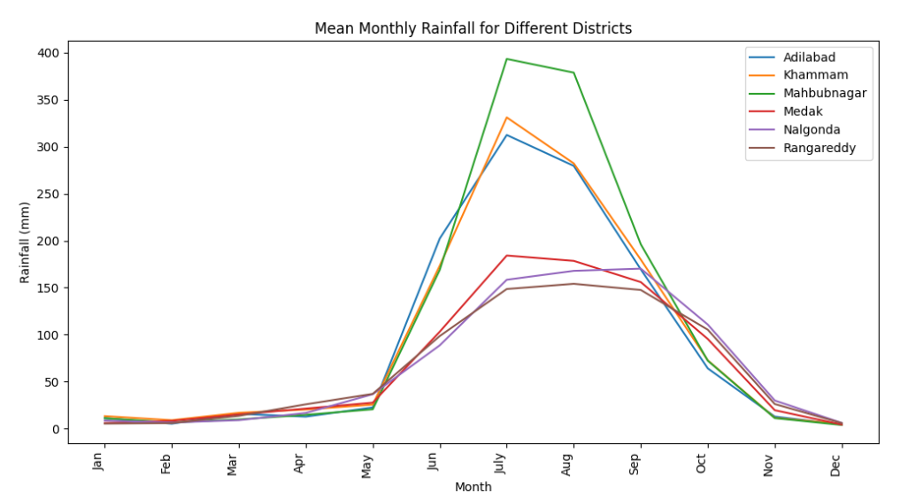 | 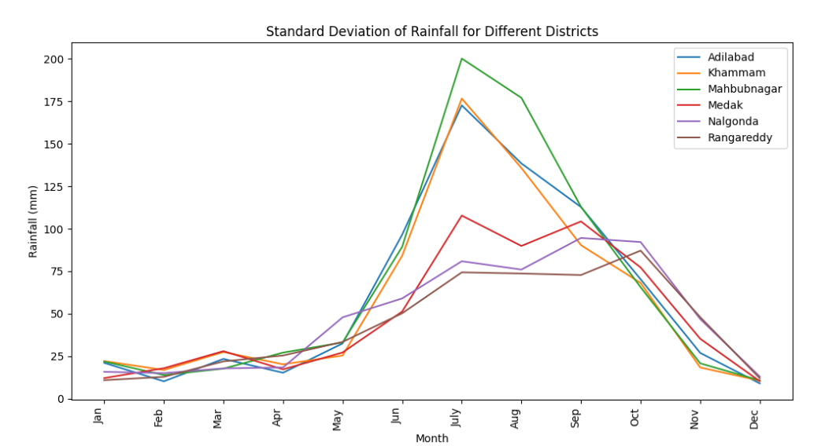 | 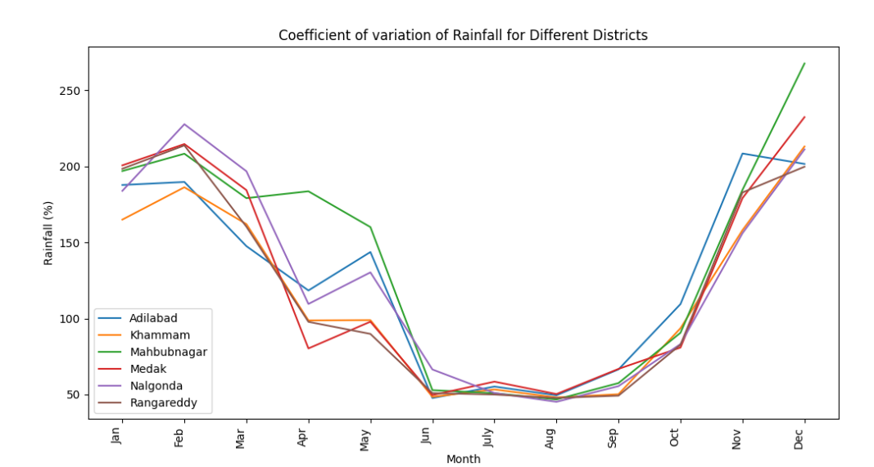
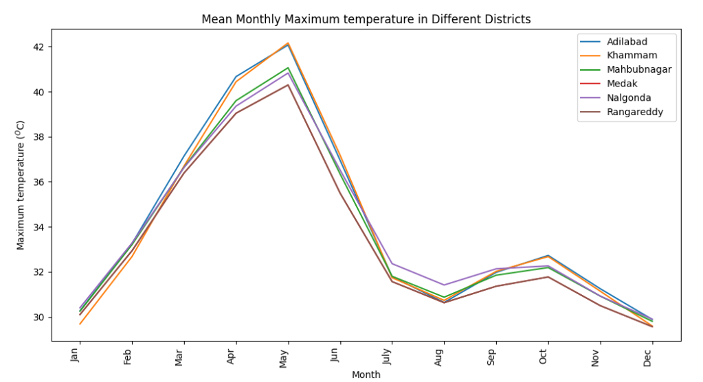 | 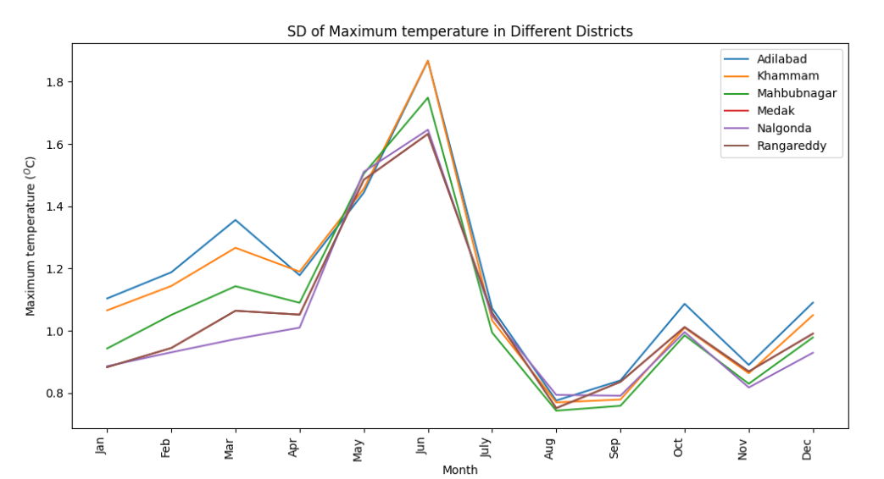 | 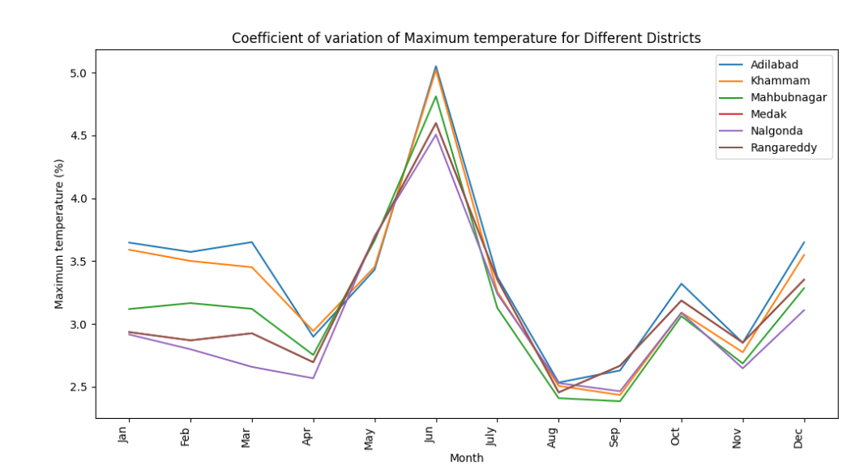
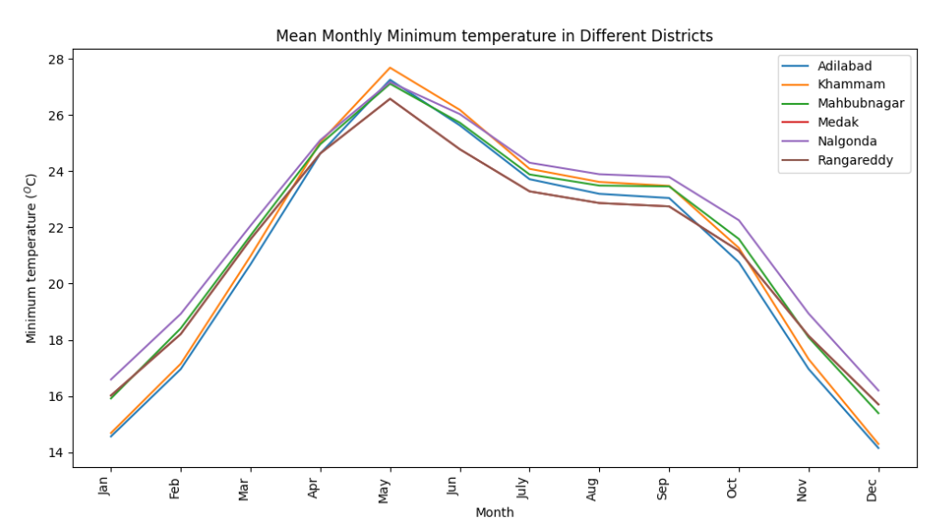 | 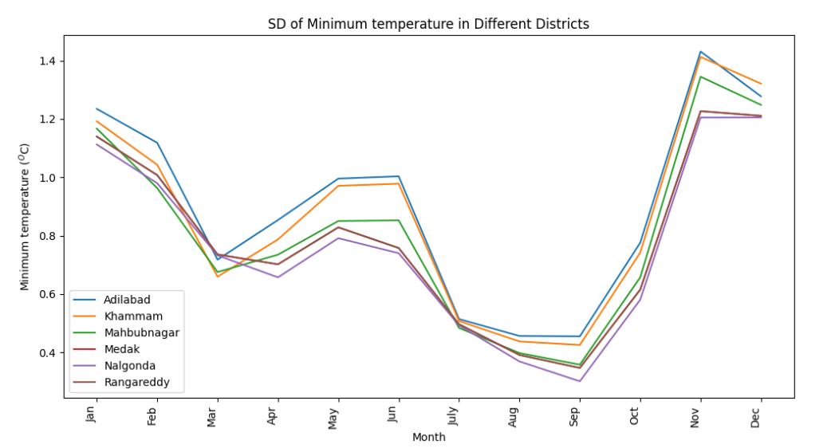 | 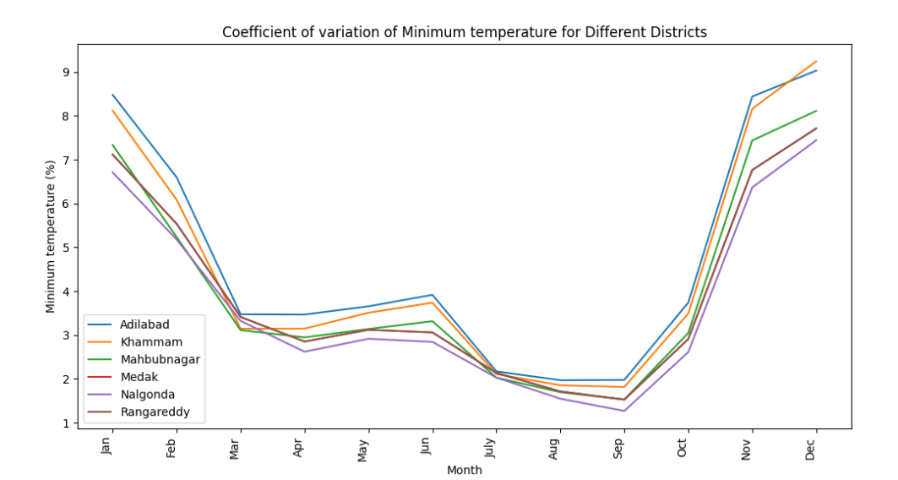

Fig 2. Mean, Standard Deviation (SD), and Coefficient of Variation (CV) for rainfall, minimum and maximum temperatures.

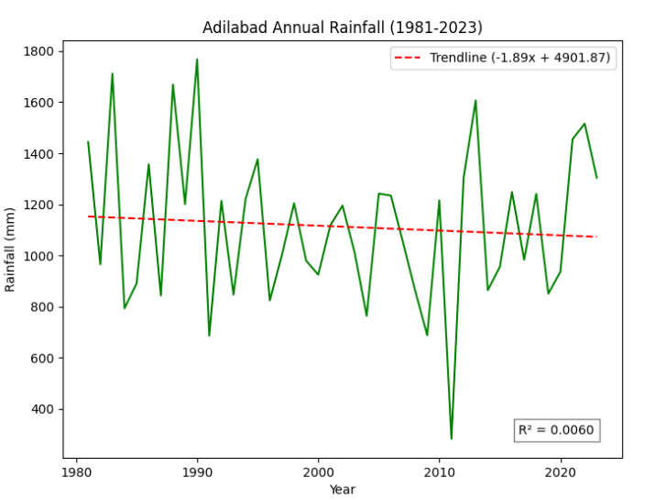 | 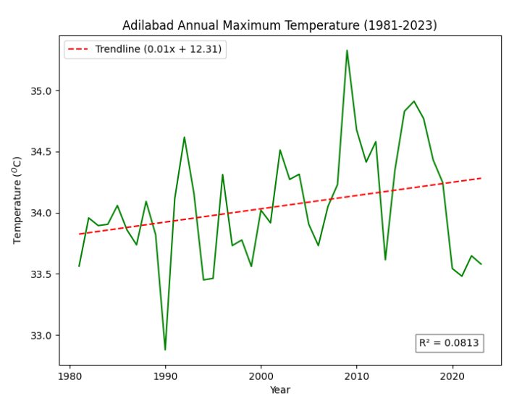 | 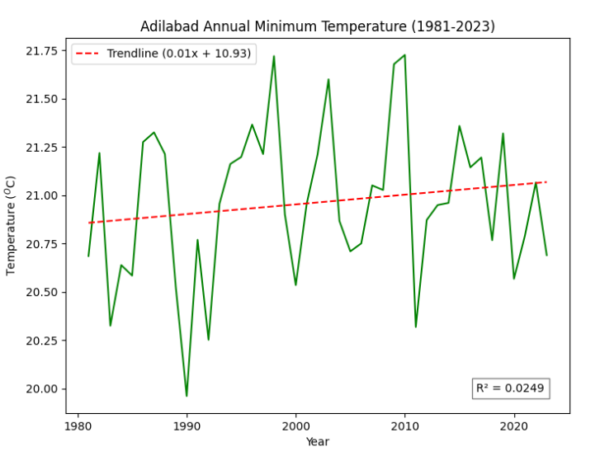
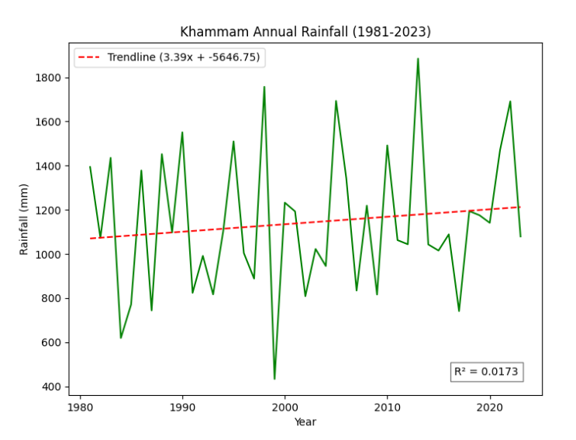 | 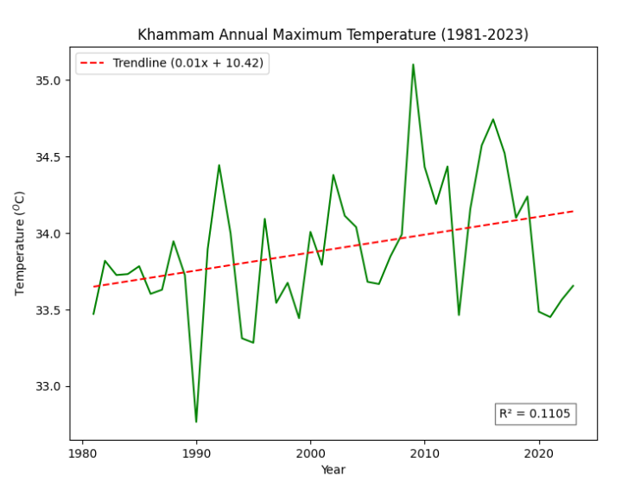 | 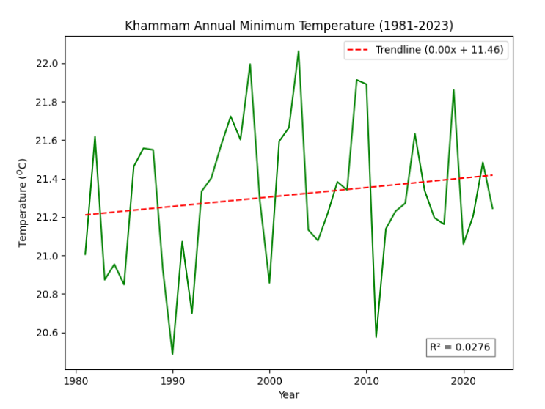
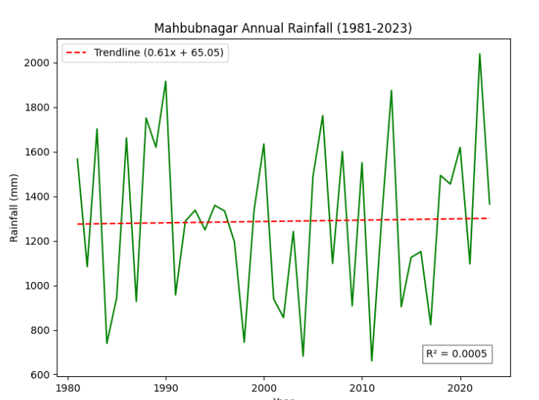 | 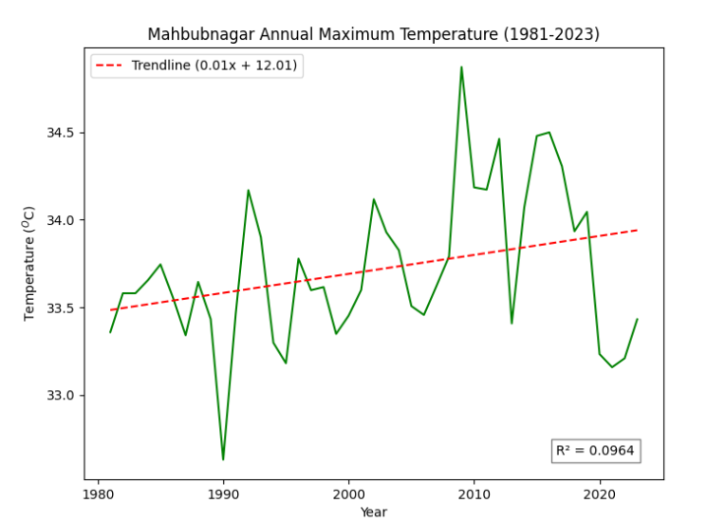 | 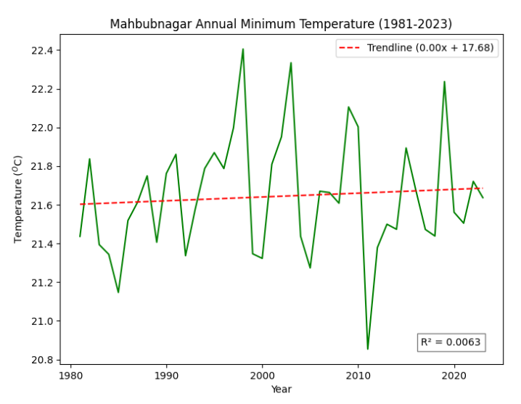
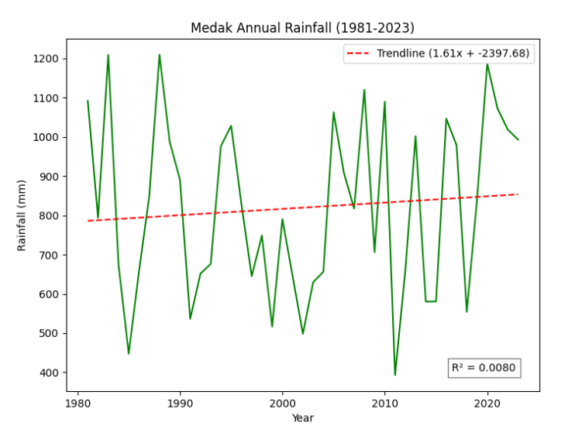 | 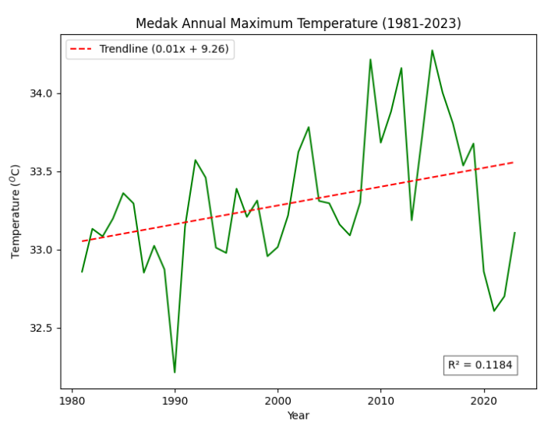 | 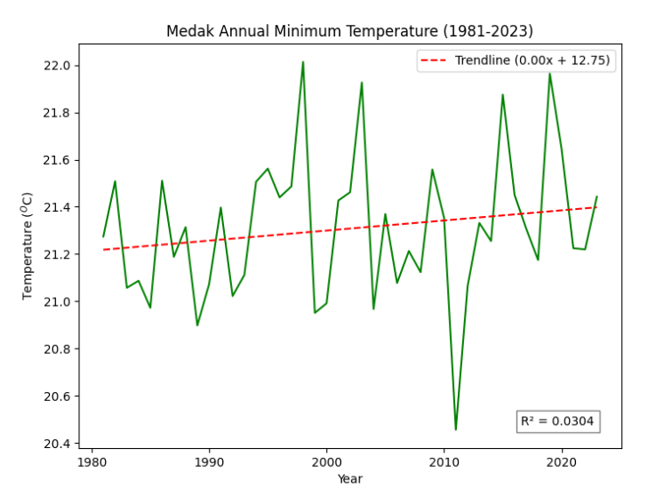
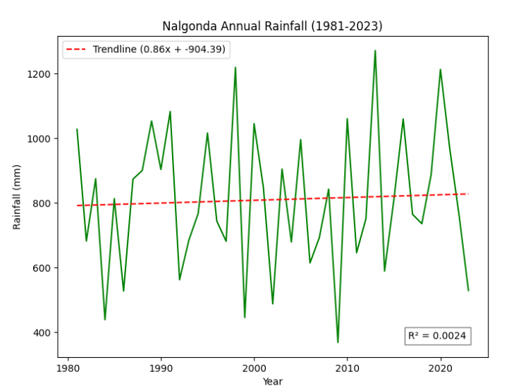 | 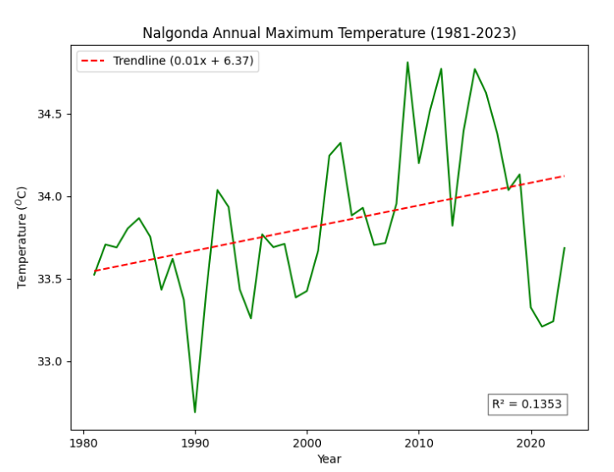 | 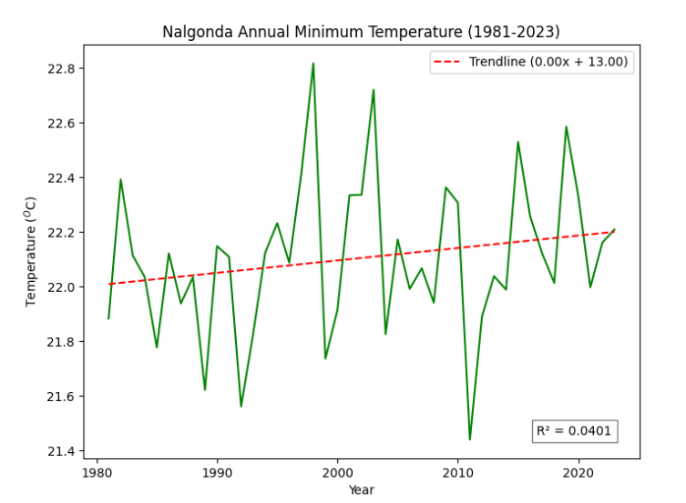
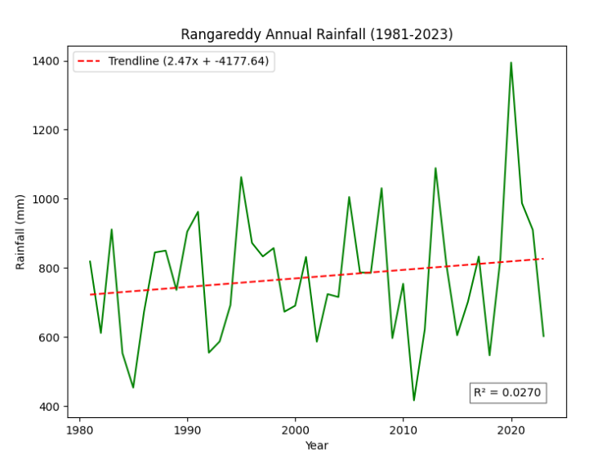 | 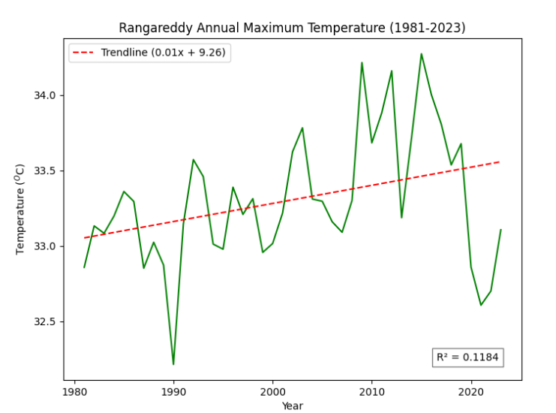 | 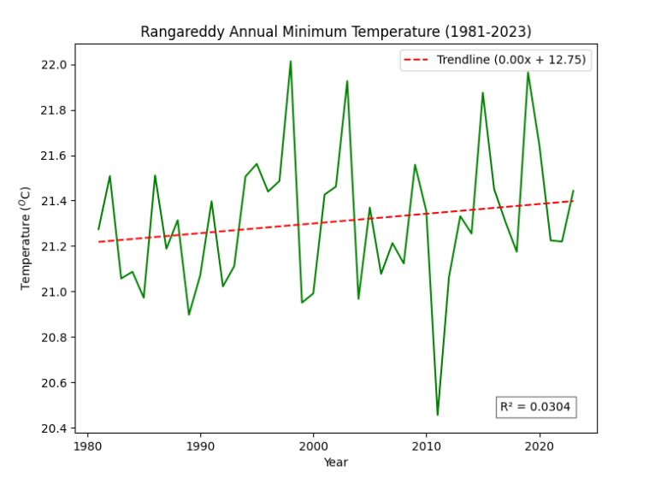

Fig 3: Rainfall of minimum, and maximum temperature trends annually from 1981 to 2023.
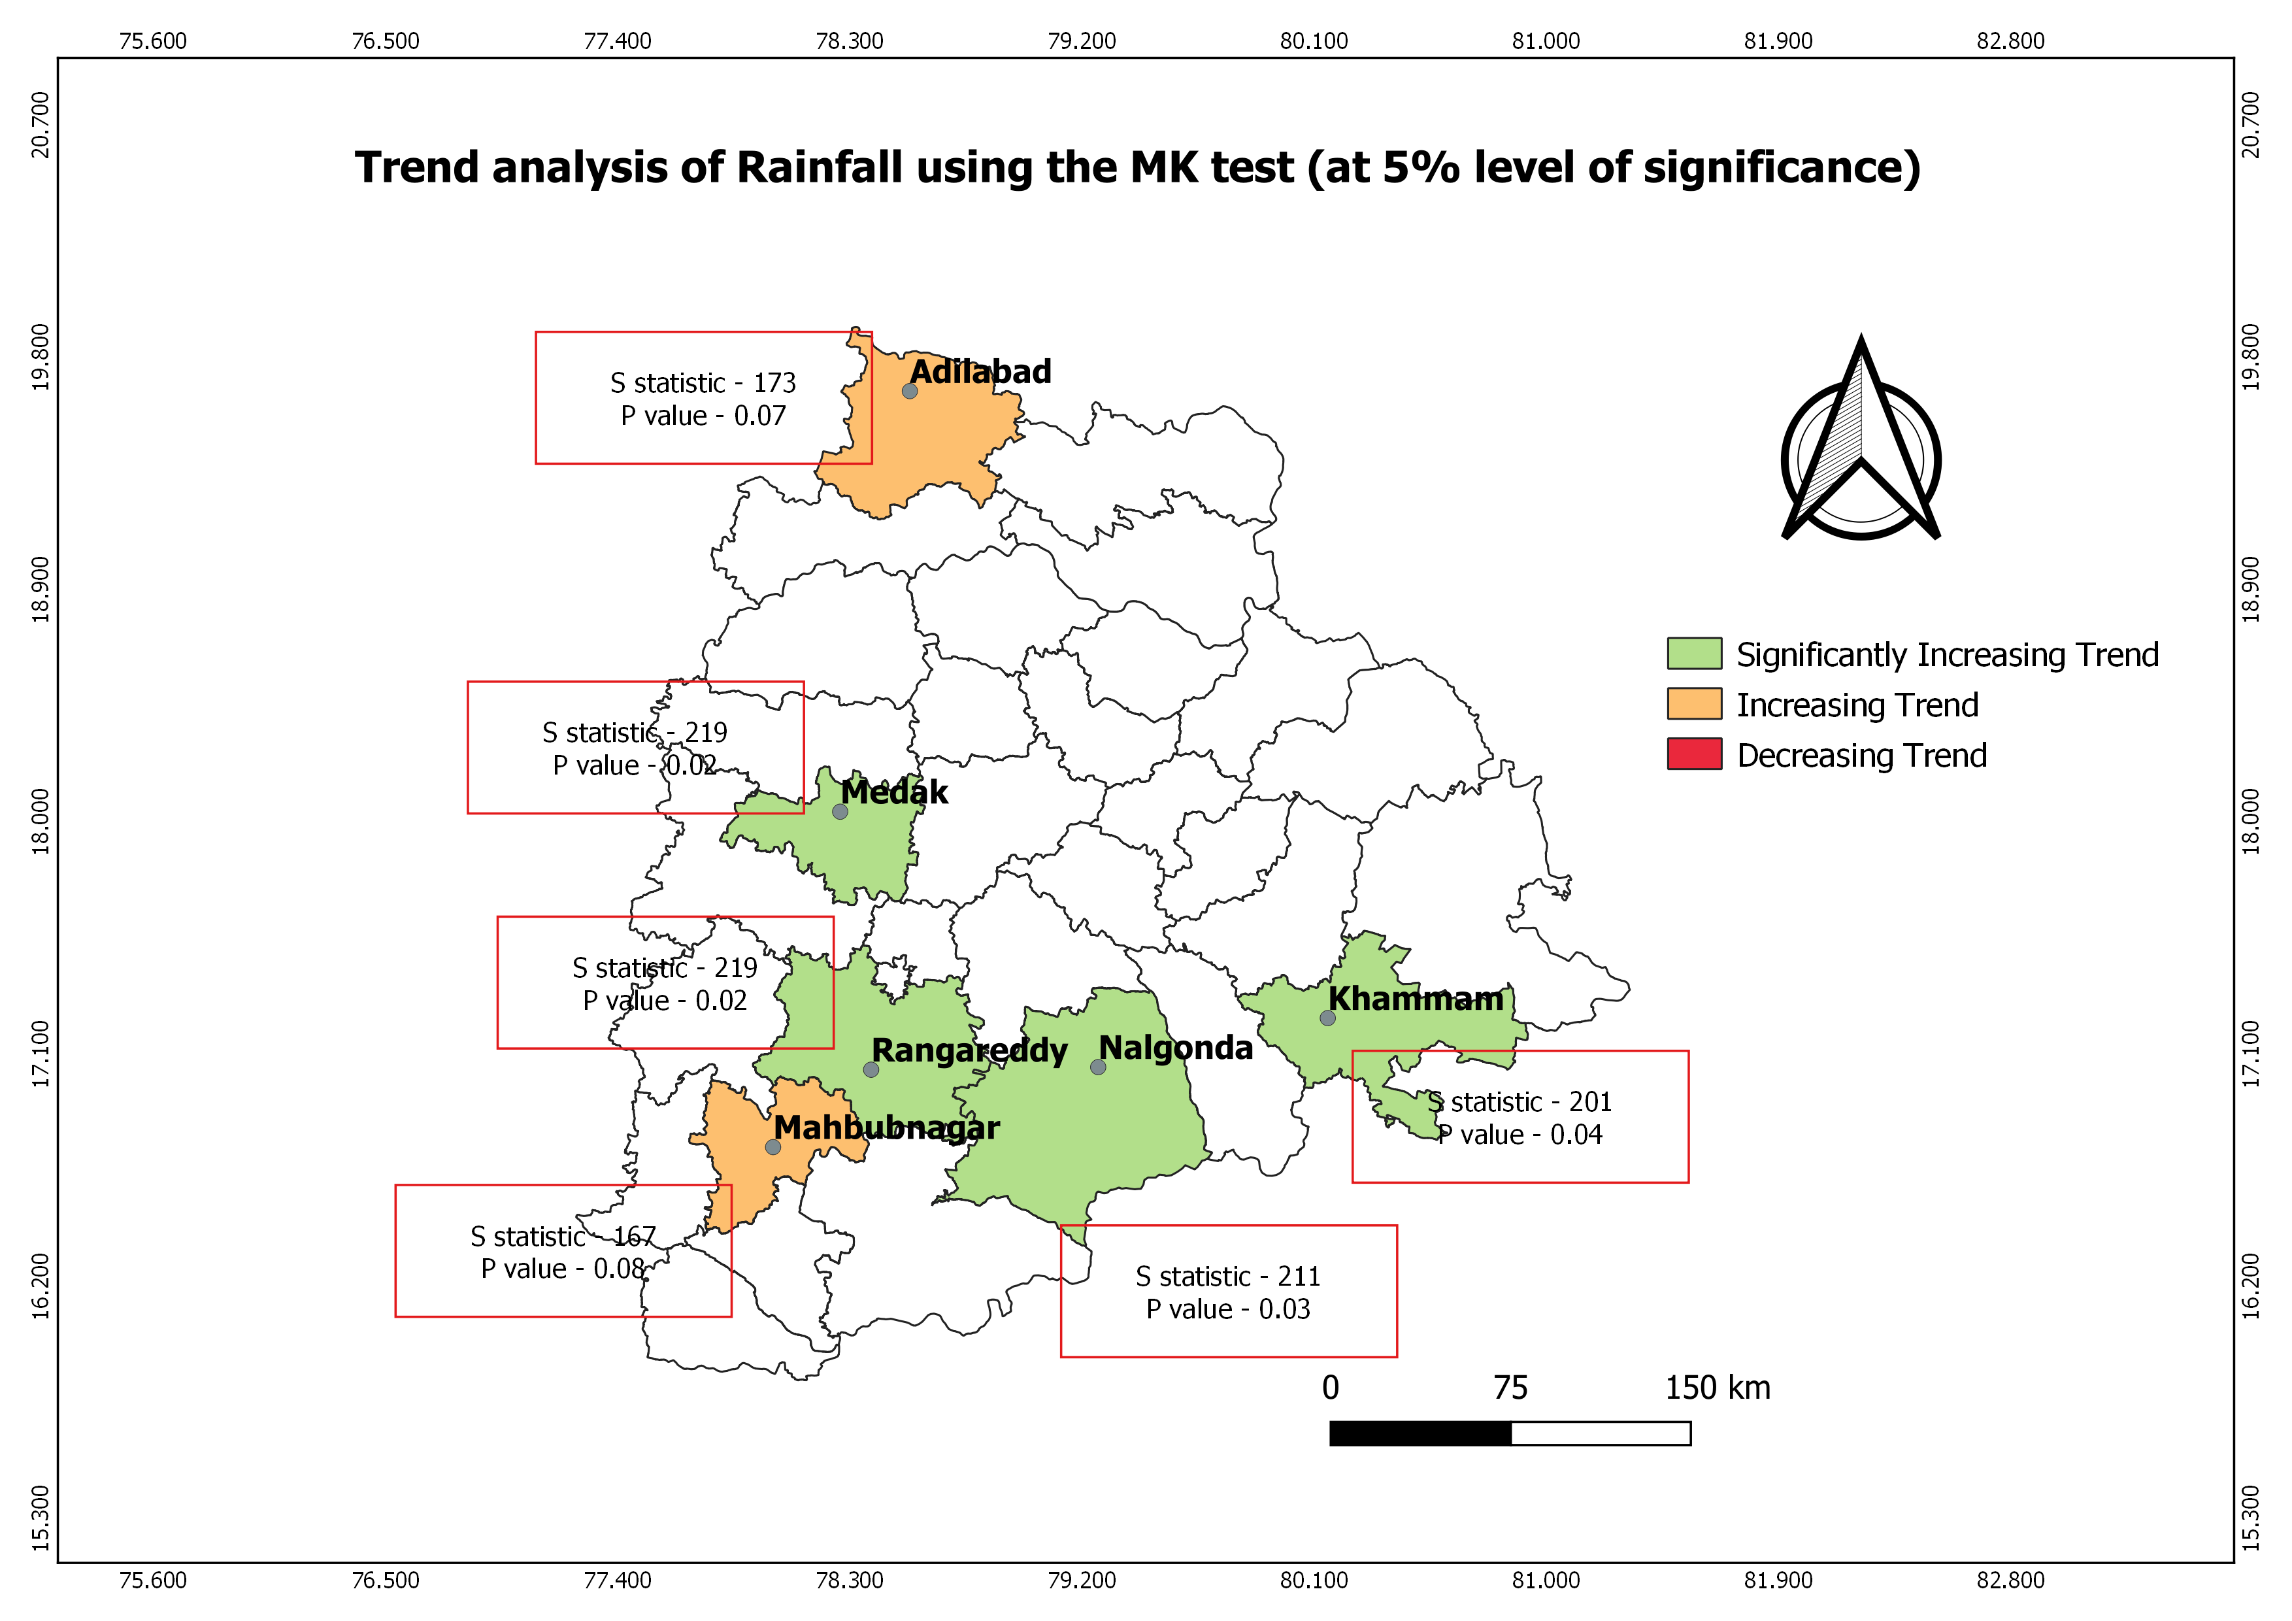

Fig 4. Rainfall trend analysis in the MK test (at a significance level of 5%).

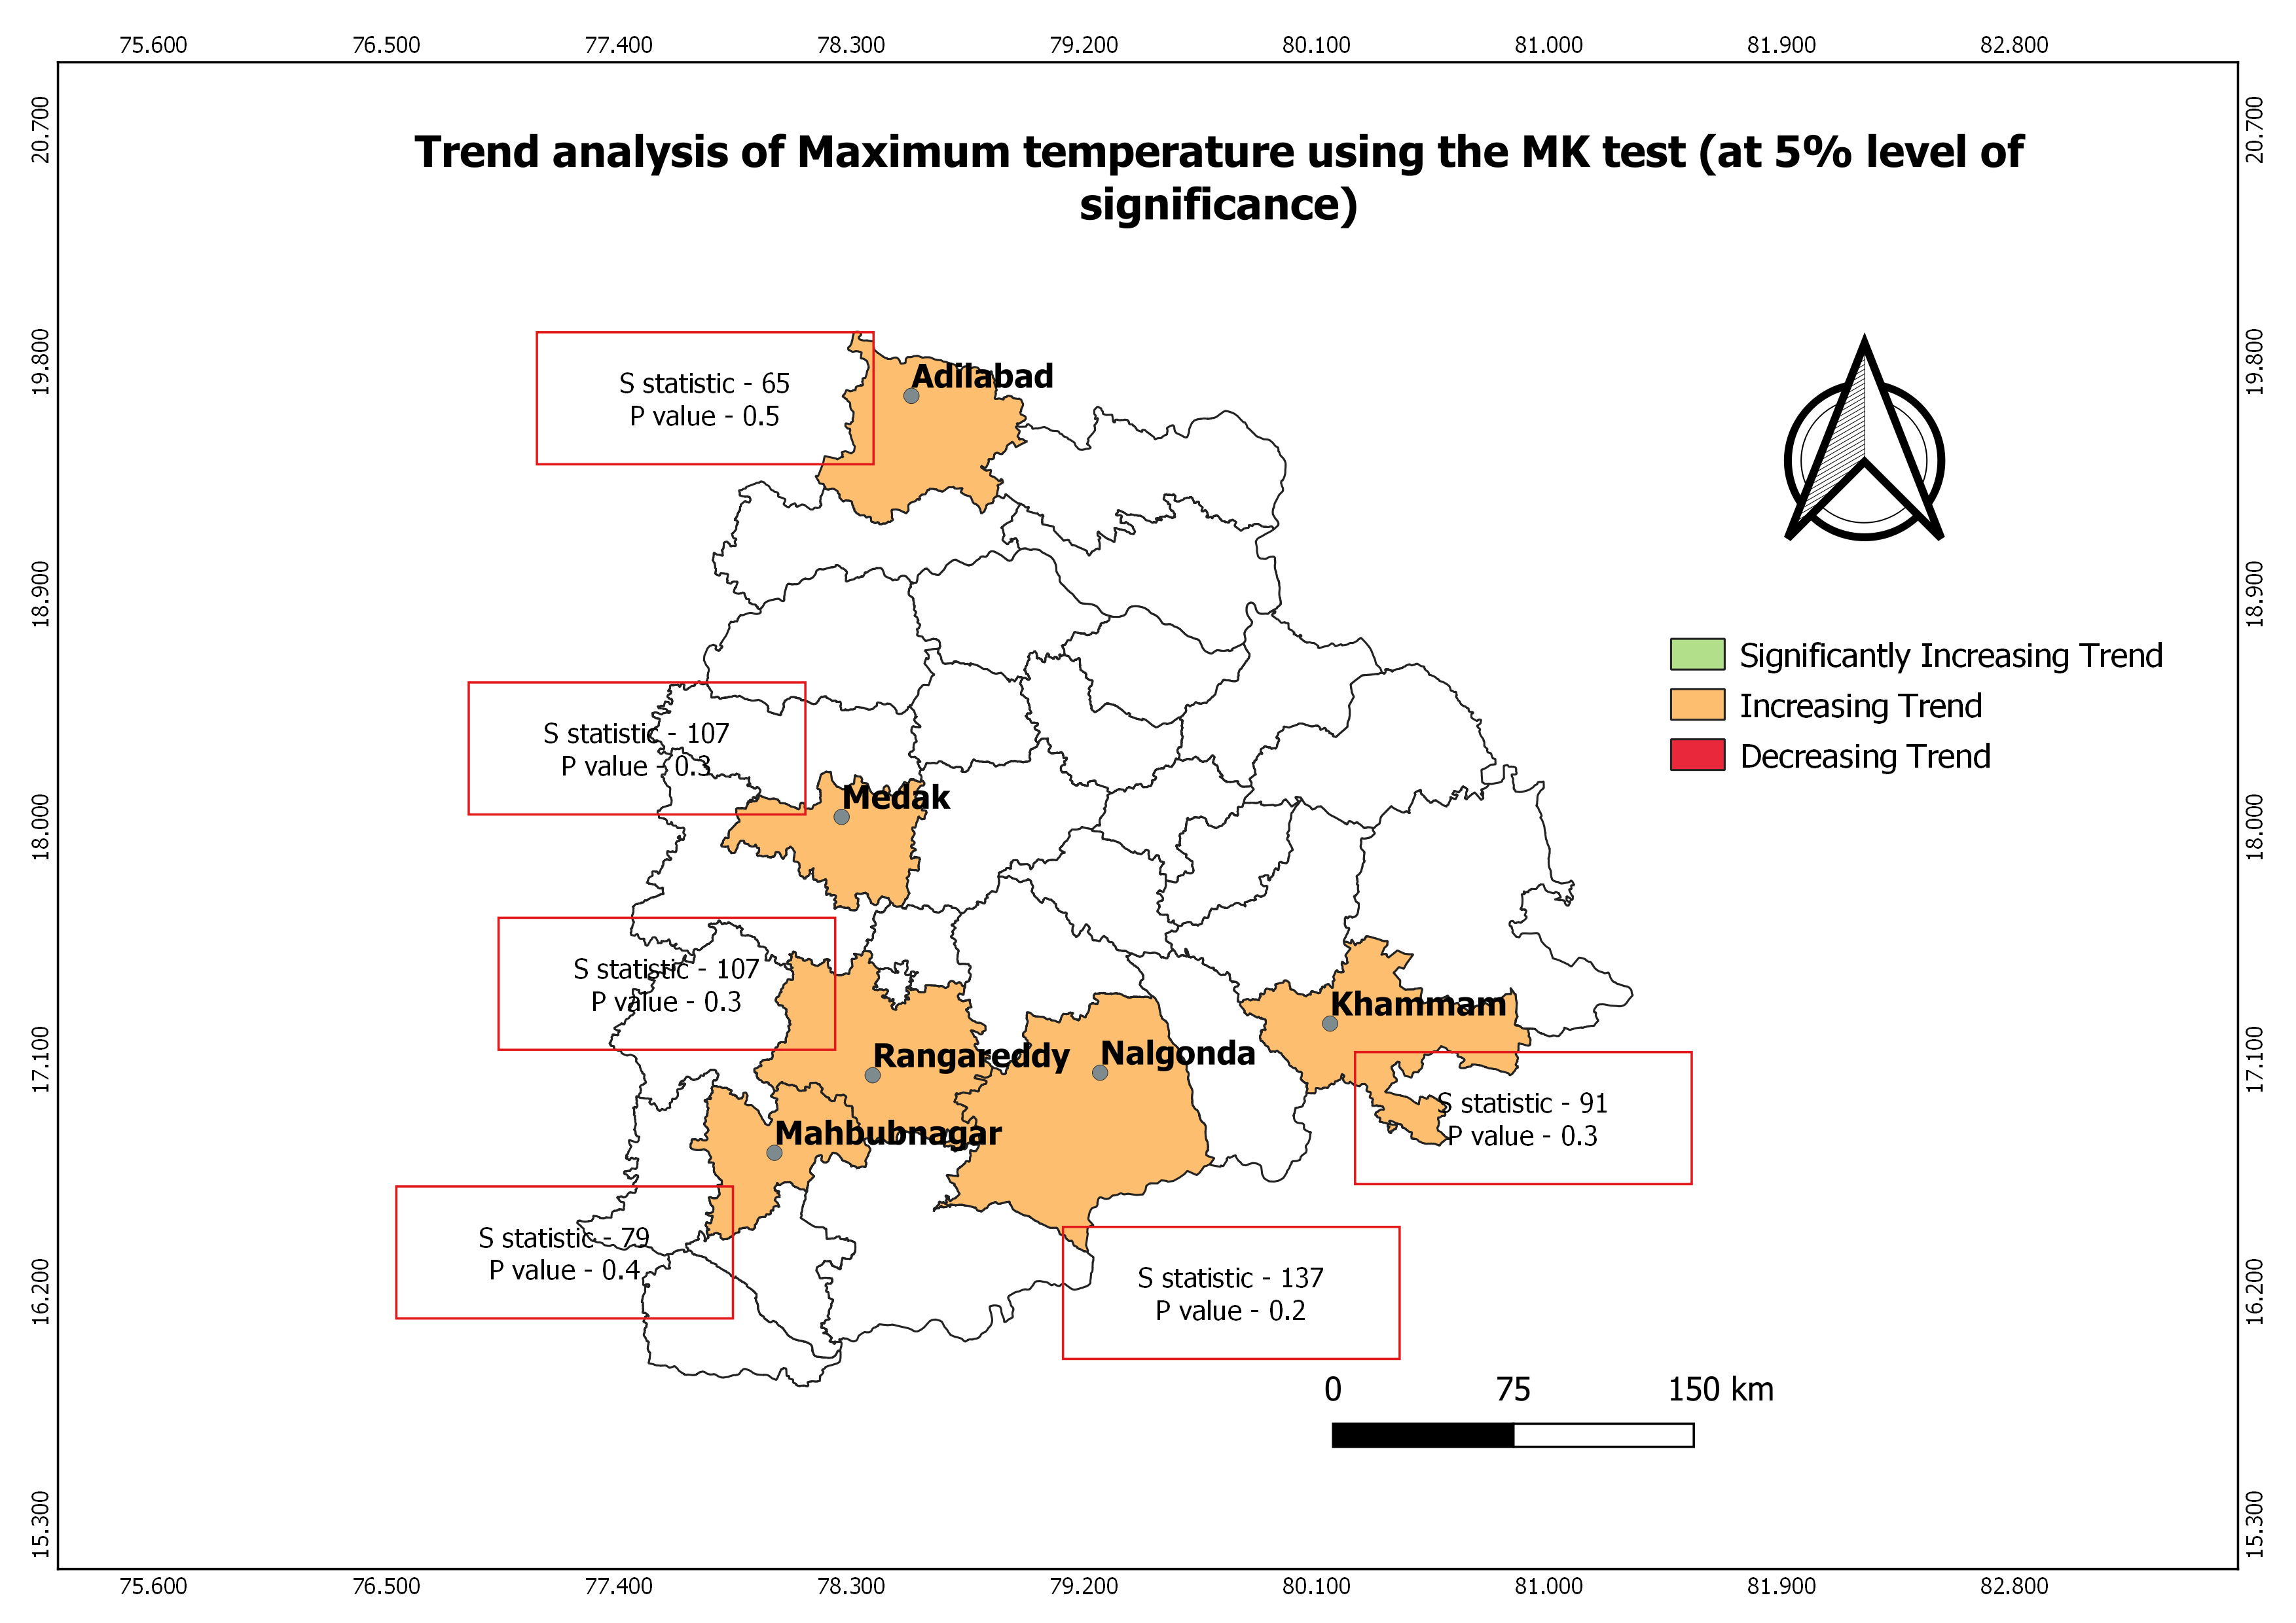

Fig 5. MK test analysis of maximum temperature trends (at a level of significance of 5%).

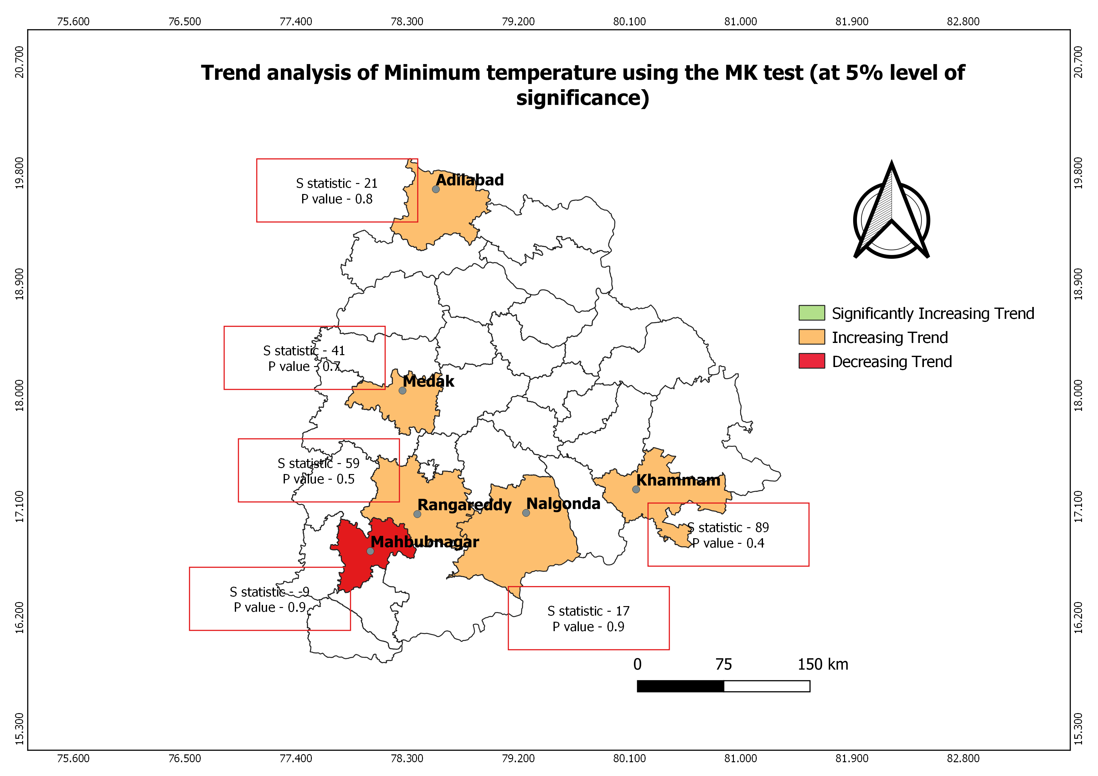
Fig 6. Trend analysis of minimum temperature using the MK test (at 5% level of significance).

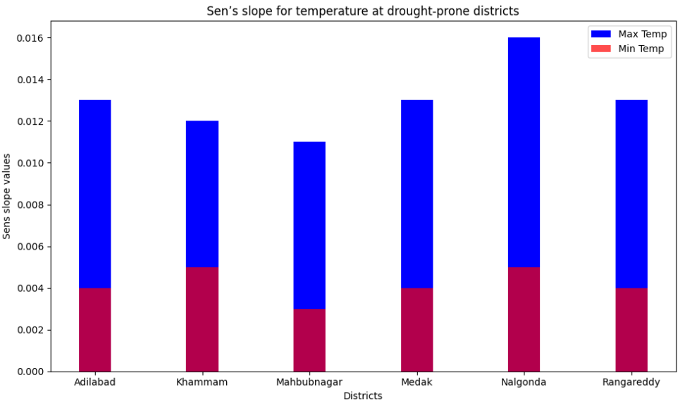

Fig 7: Sen’s slope for temperatures at drought-prone districts of Telangana

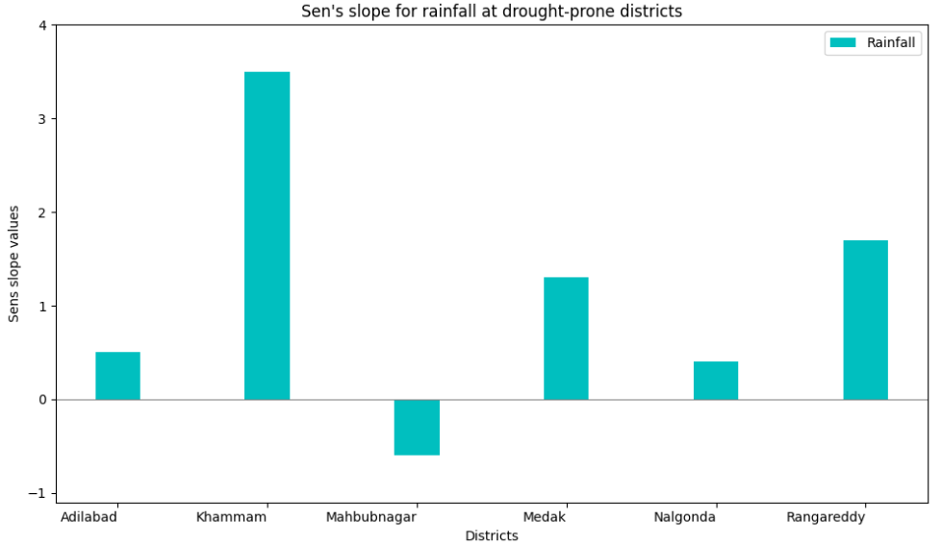

Fig 8: Sen's slope of rainfall in drought-prone areas of Telangana.

Drought Indices
Meteorological drought indicators, such as the China Z Index (CZI) and the Standardized Precipitation Index (SPI) (Fig. 9), have been used to describe the drought conditions in Telangana. It has been "Near Normal" for a number of years, indicating that the levels of precipitation were nearly normal. Khavise et al. (2015) state that the quantity of data points and climatic fluctuation are the two most important aspects. Each district has a different combination of normal, wet, and dry years, according to the PNI study. These variations may be related to environmental factors, climate change, or regional considerations (Dash et al.,2007). Every district has had mild to severe drought years, with every district experiencing severe and extreme droughts. The Deciles Index (DI) shows that most years in each district are drought-free, even though certain districts have more frequent or severe droughts. The Adilabad district experiences both wet and dry weather, with a slight trend toward wet and near-normal years, according to the RAI findings. The districts of Khammam, Mahbubnagar, Medak, Nalgonda, and Rangareddy experience a mixture of wet, near-normal, and dry weather conditions. The Z-Score Index (ZSI) demonstrates varying drought patterns between districts, with most years having near-normal rainfall. These data show the region's diverse weather patterns. Figure 6 shows the distribution and density of different droughts. When compared to other indices, Adilabad has a higher deviation, while the other towns have equal deviations. The description above clearly demonstrates that this station's rainfall pattern varies significantly across the seasons (Gajbhiye et al 2016).

A multivariate integrated drought monitoring index (MIDMI) has been developed for the Warangal region of Telangana, India, using Landsat-8 data. The MSI, NDVI, NDWI, NMDI, and SWCI were each assigned a different weight using the Iyengar and Sudarshan method. The percentage of the Warangal region falling into the Extreme Drought category remains consistent across all five drought indicators. The percentage of MIDMI area classed as Extremely Drought has not changed. Compared to other drought indicators, the NDWI and NDVI show higher percentages of areas in the Severe and Moderate drought zones in Telangana, India. When compared to other drought indices, the MSI shows that the Warangal area of Telangana, India, has the fewest acres of land classified as Severe Drought. According to the MSI, the Warangal region of Telangana, India, has the highest percentage of land classified as Slight Drought or No Drought. The NDVI has the highest weight in the MIDMI because the Warangal region's water availability restricts vegetation growth (Tapas et al., 2022).

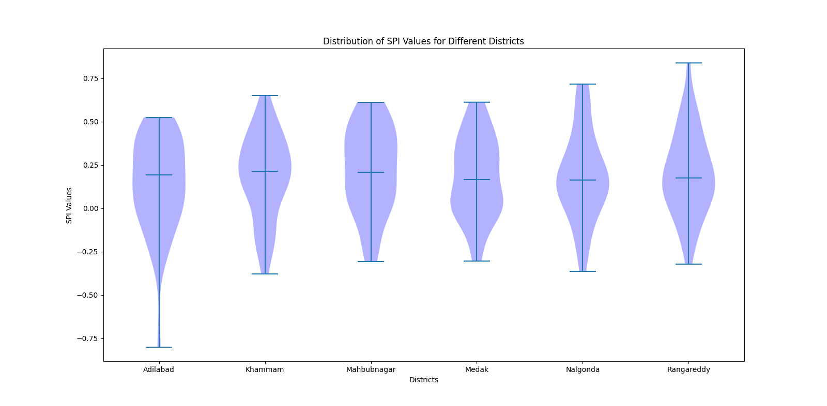 | 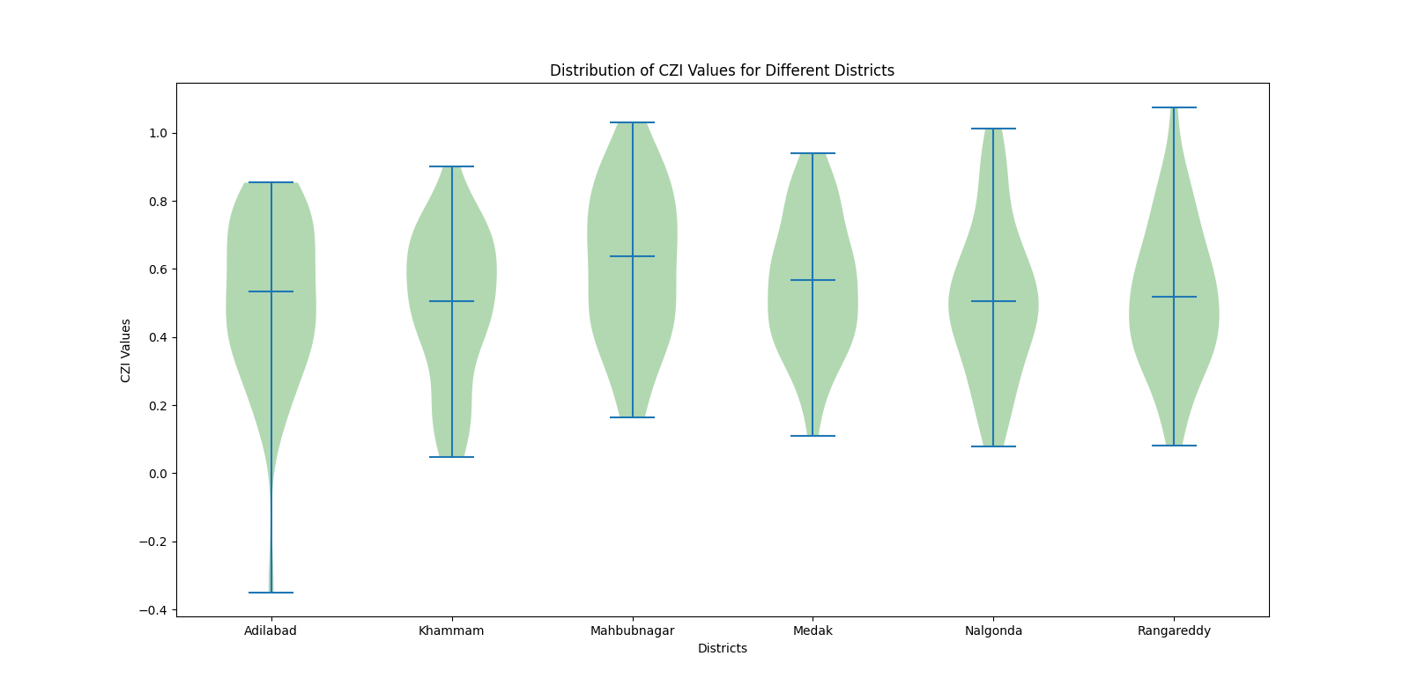
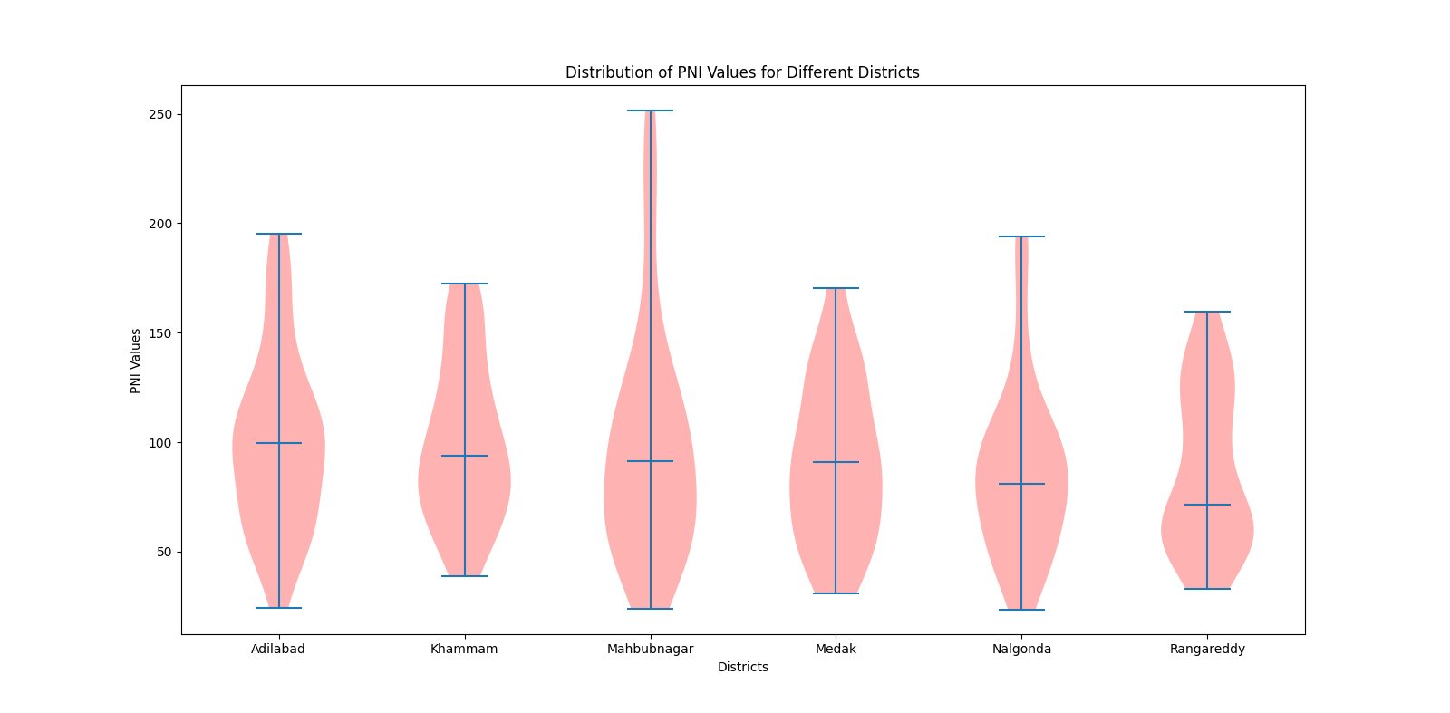 | 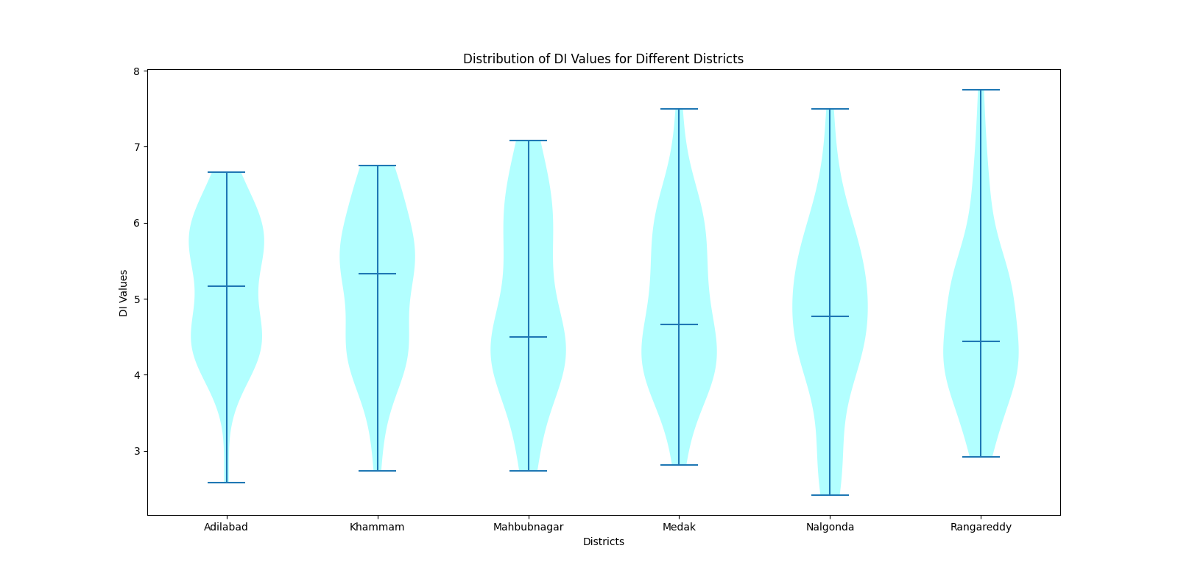
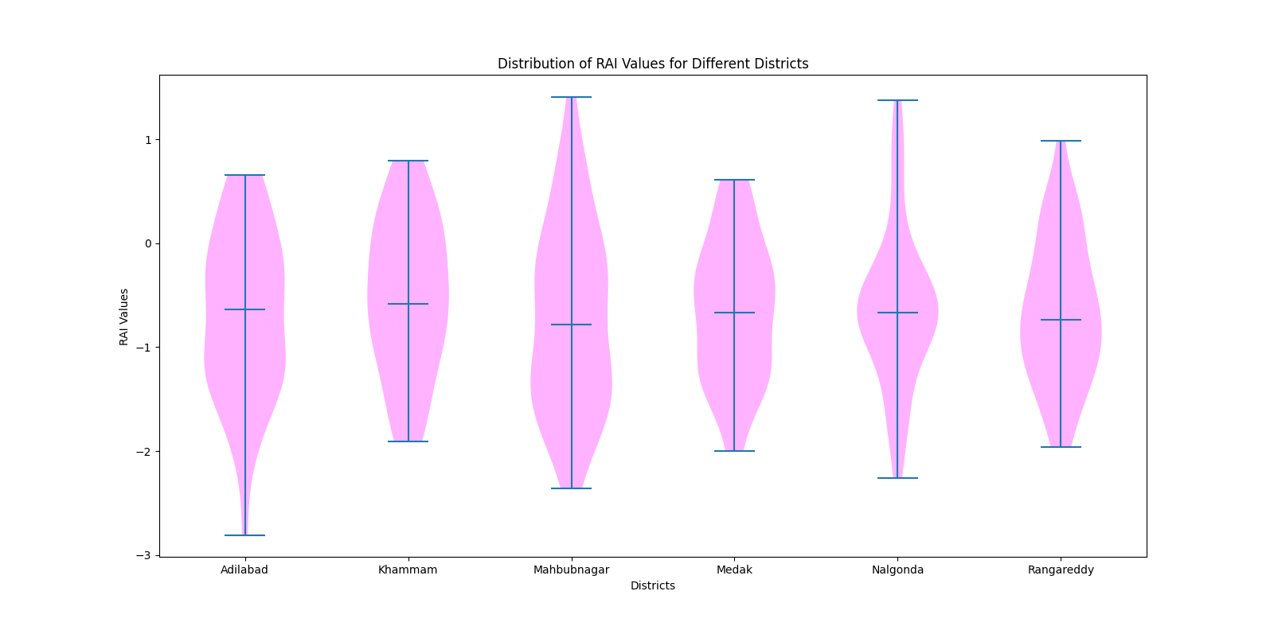 | 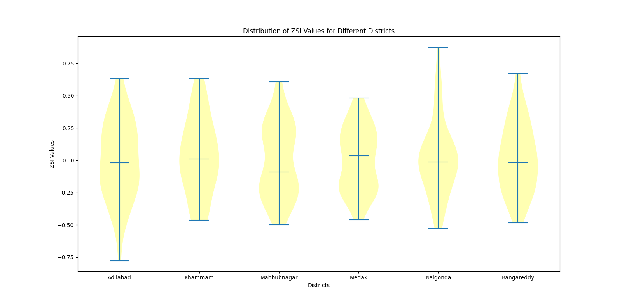

Fig 9. Distribution and Density along with the frequency for different drought
indices
Environmental Impacts and Changes
During the rainy season, the region receives little or no rainfall. The wettest months are July and August. Adilabad received the highest mean rainfall in July 1988, while Khammam recorded ahigh in 2005. Mahbubnagar, Medak, and Nalgonda all have different rainfall patterns. May is the hottest month, with maximum temperatures of over 42.2°C. Khammam, Medak, and Rangareddy have the lowest maximum temperatures. Adilabad consistently has higher average temperatures. There have been tendencies over time toward higher maximum and lowest temperatures. Guntukula and Goyari published a study that was comparable in 2020. The impact of climate conditions on Telangana's crops varies. The highest temperature drastically decreases the yields of groundnuts, rice, and cotton. The minimal temperature is very beneficial to rice, cot-ton, and groundnuts. Rainfall and groundnut and cotton yields also have a negative correlation. For all research crops, the maximum temperature has been demonstrated to lower risk, whilst the lowest temperature is associated with higher risk for jowar, cotton, and rice. Lastly, rainfall has been found to raise the risk of rice and groundnuts while decreasing the risk of cotton and jowar.

Implications for Urban Planning and Policy-Making in drought prone areas of Telangana:
In order to address rising temperatures, urban planners must provide green areas, cooling techniques, and heat-resilient infrastructure. To lessen the consequences of heat regions, policies can support energy-efficient construction and urban forests. Water scarcity is a major concern because of the minimal rainfall. Rainwater collection, sustainable water supply systems, and efficient water usage should be the main priorities of urban development. It is crucial to strike a balance between historic preservation and urban regeneration. Zoning regulations ought to discourage sprawl and encourage mixed-use development. Policies should ensure equitable resource distribution, especially during extreme weather events. Vulnerable populations require specific measures in order to be resilient to climate change. A study was carried out in Hyderabad by (Kishanet al., 2019). When land surface temperature and impermeable surface temperature positively correlate on warm days, an urban area is considered to have an urban heat island. This occurs when temperatures in the urban area rise by 6–8°F (3.5–4.5°C). It observed that there are three phases to urban growth and that scenarios are developed to evaluate the effects of urban growth on various environmental variables, including the need for water and electricity, the quality of the air, and the use of land. By 2020, every region that may be developed will be urbanized, and an increasing number of cars on the road will be a major contributor to air pollution, according to the research. The demand for power and water in the city will rise, increasing the likelihood of shortages. The scenarios also show that increasing affluence and economic development will raise local environmental requirements.

Conclusion
The present investigation utilizes a nonparametric approach to examine variations of rainfall, temperature and drought indices in Telangana, India. In this research results show a considerable variation in rainfall and temperature over the last 40 years and across different months. According to our study, High and low temperature trends were significantly positive in drought-prone areas, but not significantly positive. In addition to being utilized for upcoming forecast research, the data can be utilized to monitor variations in the state's rainfall and temperature. Additionally, this study found that SPI and CZI provide valuable insights into drought conditions, and these are relevant in studies pertaining to drought forecasting, as demonstrated by their significant correlations. The research investigated emphasizes the need of an all-encompassing approach to drought mitigation, climate change adaptation, and water resource management. By integrating these data, agricultural, water supply, economic stability, and resilience to drought and adaptation techniques can all be improved.

Data Availability
Historical rainfall, minimum temperature, and maximum temperature data for the Telangana districts of Adilabad, Khammam, Mahbubnagar, Medak, Nalgonda, and Rangareddy were available on the Climate Research and Services India Meteorological Department webpage (https://cdsp.imdpune.gov.in/).

Conflicts of Interest
The authors declare that they have no conflicts of interest.

References
Allen, J. T. , 2018. Climate change and severe thunderstorms. In Oxford research encyclopedia of climate science.
Bellamkonda, J., Meena, A., Rathod, S., Tuti, M. D., Kallakuri, S., Bhanusree, D., Reddy, B. N. K.,2022. Trend analysis of rainfall in Telangana state (India) using advanced statistical approaches. International Journal of Environment and Climate Change, 12(11), 3405-3413.
Boult, V. L., Black, E., Abdillahi, H. S., Bailey, M., Harris, C., Kilavi, M., Todd, M. C., 2022. Towards drought impact-based forecasting in a multi-hazard context. Climate Risk Management, 35, 100402.
Buttafuoco, G., Caloiero, T., Coscarelli, R., 2015. Analyses of drought events in Calabria (Southern Italy) using standardized precipitation index. Water Resources Management, 29, 557-573.
Chen, J., Shi, P., & Wang, D.,2005. Spatial Distribution and Seasonal Variabilty of the Rainfall Observed from TRMM Precipitation Radar (PR) in the South China Sea Area (SCSA). Advances in Earth Science, 20(1), 29.
Dash, S. K., Jenamani, R. K., Kalsi, S. R., Panda, S. K.,2007. Some evidence of climate change in twentieth-century India. Climatic change, 85(3), 299-321.
Fathi-Taperasht, A., Shafizadeh-Moghadam, H., Kouchakzadeh, M., 2022. MODIS-based evaluation of agricultural drought, water use efficiency and post-drought in Iran; considering the influence of heterogeneous climatic regions. Journal of Cleaner Production, 374, 133836.
Gibbs, W. J., Maher, J. V.,1967. Rainfall deciles drought indicators.
Goddard, L., Gershunov, A., 2020. Impact of El Niño on weather and climate extremes. El Niño Southern Oscillation in a changing climate, 361-375.
Guan, J., Yao, J., Li, M., Li, D., Zheng, J., 2022. Historical changes and projected trends of extreme climate events in Xinjiang, China. Climate Dynamics, 1-22.
Guhathakurta, P., Sudeepkumar, B. L., Menon, P., Prasad, A. K., Sable, S. T., Advani, S. C., 2020. Observed rainfall variability and changes over Kerala State. India Meteorological Department.
Guntukula, R., Goyari, P.,2020. Climate change effects on the crop yield and its variability in Telangana, India. Studies in Microeconomics, 8(1), 119-148.
Handmer, J., Honda, Y., Kundzewicz, Z. W., Arnell, N., Benito, G., Hatfield, J. Yamano, H., 2012. Changes in impacts of climate extremes: human systems and ecosystems. Managing the risks of extreme events and disasters to advance climate change adaptation special report of the intergovernmental panel on climate change, 231-290.
Handmer, J., Honda, Y., Kundzewicz, Z. W., Arnell, N., Benito, G., Hatfield, J., Yamano, H., 2012. Changes in impacts of climate extremes: human systems and ecosystems. Managing the risks of extreme events and disasters to advance climate change adaptation special report of the intergovernmental panel on climate change, 231-290.
Hayes, M. J., Svoboda, M. D., Wardlow, B. D., Anderson, M. C., Kogan, F., 2012. Drought monitoring: Historical and current perspectives.
Hayes, M., Svoboda, M., Le Comte, D., Redmond, K. T., Pasteris, P., 2005. Drought monitoring: New tools for the 21st century. Drought and water crises: Science, technology, and management issues, 53, 69.
Holmberg, K.and Hellsten, I., 2016. Twitter campaigns around the fifth IPCC report: Campaign spreading, shared hashtags, and separate communities. SAGE Open, 6(3), 2158244016659117.
Huang, Z., Tan, X., Liu, B.,2024. Relative contributions of large‐scale atmospheric circulation dynamics and anthropogenic warming to the unprecedented 2022 Yangtze River Basin heatwave. Journal of Geophysical Research: Atmospheres, 129(4), e2023JD039330.
Karabulut, M.,2015. Drought analysis in Antakya-Kahramanmaraş Graben, Turkey. Journal of Arid Land, 7, 741-754.
Kendall, M. G.,1945. On the analysis of oscillatory time-series. Journal of the Royal Statistical Society, 108(1/2), 93-141.
Khadka, N., Chen, X., Sharma, S., Shrestha, B. (2023). Climate change and its impacts on glaciers and glacial lakes in Nepal Himalayas. Regional Environmental Change, 23(4), 143.
Khavse, R., Deshmukh, R., Manikandan, N., Chaudhary, J. L., Kaushik, D.,2015. Statistical analysis of temperature and rainfall trend in Raipur district of Chhattisgarh. Current World Environment, 10(1), 305-312.
Kishan, A. B.,2019. URBAN FORESTRY AND ITS ROLE IN REGULATING CITIES ENVIRONMENT: A STUDY OF HYDERABAD CITY.
Laasya, K. N. V. L., Kallakuri, S., Rathod, S., Neelima, L., Meena, A.,Jyostna, B.,2024. Statistical Assessment of Temperature Trends and Change Points in Telangana State, India. International Journal of Environment and Climate Change, 14(4), 397-407.
Lu, P., Liu, R., Luo, Z., Li, S., Wu, Y., Hu, W., Xue.,2024. Impacts of compound extreme weather events on summer ozone in the Beijing-Tianjin-Hebei region. Atmospheric Pollution Research, 15(3), 102030.
McKee, T. B., Doesken, N. J., Kleist, J.,1993. The relationship of drought frequency and duration to time scales. In Proceedings of the 8th Conference on Applied Climatology (Vol. 17, No. 22, pp. 179-183).
McKee, T. B., Doesken, N. J., Kleist, J.,1995. Drought monitoring with multiple time scales. PROCEEDINGS OF THE CONFERENCE ON APPLIED CLIMATOLOGY.
Meharie, E. A., Taye, M. A., Alemu, M. M., Lema, A. T.,2023. Extreme Rainfall Indices and its Effect on Meher Season Crop Calendar: An Agro-Climatic Zone Based Study.
Mohammad, P and Goswami, A., 2023. Exploring different indicators for quantifying surface urban heat and cool island together: a case study over two metropolitan cities of India. Environment, Development and Sustainability, 25(10), 10857-10878.
Motha, R. P., 2011. The impact of extreme weather events on agriculture in the United States. Challenges and opportunities in agrometeorology, 397-407.
Navatha, N., Sreenivas, G., Umareddy, R.,2021. Rainfall and temperature trends in Jagtial district of Telangana state. International Journal of Environment and Climate Change, 11(11), 47-59.
Patra, J. P., Mishra, A., Singh, R., Raghuwanshi, N. S.,2012. Detecting rainfall trends in twentieth century (1871–2006) over Orissa State, India. Climatic Change, 111, 801-817.
Qin, X and Dai, C., 2022. Comparison of different quantile delta mapping schemes in frequency analysis of precipitation extremes over mainland Southeast Asia under climate change. Journal of Hydrology, 606, 127421.
Sens, A. D.,1968. The Newly Independent States, the United Nations, and some thoughts on the nature of the Development Process. The Journal of Politics, 30(1), 114-136.
Spinoni, J., Barbosa, P., Bucchignani, E., Cassano, J., Cavazos, T., Cescatti, A., Dosio, A., 2021. Global exposure of population and land??? use to meteorological droughts under different warming levels and: A??? based study. International Journal of Climatology, 41, 6825-6853.
Tapas, M. R., Kumar, U., Mogili, S., Jayakumar, K. V.,2022. Development of multivariate integrated drought monitoring index (MIDMI) for Warangal region of Telangana, India. Journal of Water and Climate Change, 13(3), 1612-1630.
Vicente-Serrano, S. M., Quiring, S. M., Peña-Gallardo, M., Yuan, S.,Domínguez-Castro, F., 2020. A review of environmental droughts: Increased risk under global warming?. Earth-Science Reviews, 201, 102953.
Webber, J and Hawkins, C.,1980. Statistical analysis application to business and economics.
Wilhite, D. A and Glantz, M. H., 1985. Understanding: the drought phenomenon: the role of definitions. Water international, 10(3), 111-120.
Willeke, G., J. R. M. Hosking, J. R. Wallis, and N. B. Guttman, 1994. The National Drought Atlas. Institute for Water Resources Report 94-NDS-4, U.S. Army Corps of Engineers
Wu, H., Hayes, M. J., Weiss, A., Hu, Q. I.,2001. An evaluation of the Standardized Precipitation Index, the China‐Z Index and the statistical Z‐Score. International Journal of Climatology: A Journal of the Royal Meteorological Society, 21(6), 745-758.
Xiaosheng, J., Xianwei, Y., Lijuan, C., Youmin, W.,1997. Research on determination of station indexes and division of regional flood/drought grades in China. 应用气象学报, 8(1), 26-33.
Yiran, G. A and Stringer, L. C., 2017. Adaptation to climatic hazards in the savannah ecosystem: improving adaptation policy and action. Environmental management, 60(4), 665-678.
Zhong, P., Huser, R., Opitz, T., 2022. Modeling nonstationary temperature maxima based on extremal dependence changing with event magnitude. The Annals of Applied Statistics, 16(1), 272-299.
Zhong, S., Cheng, Q., Huang, C. R., Wang, Z., 2021. Establishment and validation of health vulnerability and adaptation indices under extreme weather events on the basis of the 2016 flood in Anhui province, China. Advances in Climate Change Research, 12(5), 649-659.

