# Long-term regional trends (1981-2023) of temperature, Rainfall, drought indices and

1. **environmental impacts in southern India**

3

4 Guhan V1*, Dharma Raju A1, Sravani A1, Nagaratna K1 5

1. 1Meteorological Centre, Airport Colony, Indian Meteorological Department, Begumpet, Hy-
2. derabad, Telangana, India

8

# *Corresponding Author – [guhanthiran@gmail.com](mailto:guhanthiran@gmail.com)

1. **Abstract**
2. In this study, we investigated historical data from 1981-2023 to examine at changes in tem-
3. perature and rainfall in drought-prone districts of Telangana. Here we present, importance of
4. drought indicators in understanding drought conditions. We examined the monthly and annu-
5. al data and calculated the average, standard deviation, and coefficient of variation (CV) for
6. rainfall, minimum and maximum temperatures. We utilized the indicators of Z-Score Index
7. (ZSI), Deciles Index (DI), Percent of Normal Index (PNI), Standardized Precipitation Index
8. (SPI), China-Z Index (CZI), Rainfall Anomaly Index (RAI), and Deciles Index (DI). In this
9. present study found that maximum temperatures in these regions rose dramatically over time,
10. whereas minimum temperatures and rainfall in all drought-prone areas remained unchanged.
11. Every district has had mild to severe drought years, with every district experiencing severe
12. and extreme droughts. By combining these indices, researchers and policymakers can gain an
13. extensive understanding of drought risk, which is crucial for managing water supplies, devel-
14. oping plans for climate change, and preventing the effects of drought. A comprehensive
15. drought response may develop adaptive and drought-resistant strategies, preserving Telanga-
16. na's agricultural, water supply, and economic stability. 26
17. **Keywords** – Rainfall, Temperature, Trend analysis, Coefficient of variation (CV), Drought
18. Indices.

# Introduction

1. Global warming has increased the frequency of extreme weather events such as heatwaves,
2. droughts, and heavy rains around the world. However, identifying and quantifying drought is
3. more challenging than other extreme weather phenomena such as floods and rainfall. Guan
4. (2022), Khadka (2022), Zhuang (2024), and Xue Li (2024). Droughts are slow-onset risks
5. that might endure for years or months (Boult, 2022; Fathi-Taperasht, 2022; Spinoni, 2020).
6. Holmberg and Hellsten (2016) suggest that climatic variability increases the likelihood of
7. drought and flooding by increasing the frequency and intensity of extreme rainfall events.
8. The fluctuation of rainfall and weather-related threats including windstorms, floods, and
9. droughts have an impact on agricultural activity (Meharie et al., 2023; Motha, 2011, Yiran
10. and Stringer, 2017). Drought has developed as a complex natural hazard with the potential to
11. considerably disrupt terrestrial ecosystems due to its severity, duration, and environmental
12. impact (Allen, 2018; Buttafuoco, 2015; Zhong, 2022; Zhong, 2021). Meteorological, agricul-
13. tural, and hydrological droughts generally arise by differences in a region's long-term average
14. rainfall during a specific time period (Vicente-Serrano, 2020; Wilhite and Glantz, 1985). 44
15. Climate change in India has an adverse effect on monsoon timing, temperature, and other
16. climatic parameters, potentially affecting the atmosphere (Goddard and Gershunov, 2020).
17. Extremely minimal temperature increases can produce heat waves, harm, and changes in an-
18. imal and plant species (Guhathakurta et al., 2020). According to a number of studies, the pat-
19. tern and scale of warming recorded over the last century in India or the Indian subcontinent
20. are completely consistent with the worldwide pattern and amplitude (Hayes et al., 2012;
21. Handmer et al., 2012; Qin, X and Dai, C., 2022). After analyzing temperature and precipita-
22. tion data for 139 major Indian cities between 1901 and 2015, Mohammad and Goswami
23. (2023) found a tendency of rising temperatures in southeast regions and declining tempera-
24. tures in northwest regions. In addition, they observed that the rainfall patterns were unpre-
25. dictable, with the eastern part receiving less rain than the western side. 56
26. Here we selected the Telangana, and it is extremely vulnerable to climate change and has lit-
27. tle capacity for adaptation. It is shown that the drought-prone areas of Telangana seldom use
28. trend analysis of weather variability data, and the region has never published any previous
29. research showing historical trends of weather parameters. Here, we provide an innovative
30. technique that enables the district's drought conditions to be accurately deduced from the Z-
31. Score Index (ZSI), Deciles Index (DI), Rainfall Anomaly In-dex (RAI), Standardized Precipi-
32. tation Index (SPI), Percent of Normal Index (PNI), and Chi-na-Z Index (CZI). Drought indi-
33. cators will be used to gauge the severity, length, and geographical scope of the drought.
34. These indicators are important for measuring the impacts on agriculture and water availabil-
35. ity. In addition, we used the trend analysis examines and long-term patterns in drought condi-
36. tions and several drought indexes exist, understanding their patterns over time is essential. A
37. comprehensive approach to drought assessment provides extensive information to decision-
38. makers and policymakers. 70

# Materials and Methods

1. **Study Area**
2. Telangana is located in a semi-arid zone, which contributes to its mostly hot and dry climate.
3. The state experiences a high summer temperature of around 42°C, with an average annual
4. temperature ranging from 27.5°C to 27.8°C. The state receives 906 millimeters of precipita-
5. tion on average every year, most of which falls between June and September during the
6. southwest monsoon season. Telangana is a region of the Deccan Plateau in terms of geology,
7. and it is distinguished by the variety of soil types it has, such as lateritic, black cotton, and
8. red soils. In this regions environment is a mix of steep terrain and flat plains, which contrib-
9. ute to its diversified agricultural practices. Telangana's Drought Prone Area Programme cate-
10. gorized the districts of Adilabad, Khammam, Mahbubnagar, Medak, Nalgonda, and Ran-
11. gareddy as drought-prone areas of the state, and these were the study sites. Figure 1 depicts
12. the study territory and the locations of the selected districts, while Table 1 provides land sta-
13. tistics for the research area. 85

# 86 Table 1. The land details of the study area

|  |  |  |  |  |
| --- | --- | --- | --- | --- |
| District | Latitude | Longitude | Area  (sq.kms) | % area of the  state |
| Adilabad | 19.67 | 78.53 | 4153 | 3.6 |
| Khammam | 17.24 | 80.15 | 4361 | 3.8 |
| Mahbubnagar | 16.74 | 78 | 5285 | 4.6 |
| Medak | 18.04 | 78.26 | 2786 | 2.4 |
| Nalgonda | 17.05 | 79.26 | 7122 | 6.2 |
| Rangareddy | 17.04 | 78.38 | 5031 | 4.4 |

87

88

89

# Datasets

# Fig 1. Map of the study area.

1. The Telangana districts of Adilabad, Khammam, Mahbubnagar, Medak, Nalgonda, and Ran-
2. gareddy's rainfall, minimum temperature, and maximum temperature historical data were col-
3. lected for this study during a 43-year period ending in 2023. In order to identify trends and
4. carry out additional analysis, the mean of the low and high temperatures as well as the annual
5. average rainfall has been calculated and processed in Excel files. The data collection period
6. covered by the CRSI and Meteorological division in Pune was from 1981 to 2023.

# Trend analysis

1. According to Webber and Hawkins, a trend is the general trend of a series over time (1980).
2. Additionally, it explains the long-term changes in the dependant variable. Trend is defined by
3. the temporal resolution and correlation between the two factors, the temperature and the rain-
4. fall. Regression analysis and the coefficient of determination (R2) are two statistical tech-
5. niques used to assess the significance of temperature and rainfall trends. The Mann-Kendall
6. (M-K) trend test was used to develop and evaluate the trend, and the least squares method
7. was used to determine the regression line's slope. Utilizing the mean, standard deviation
8. (SD), and coefficient of variation (CV), calculations were performed to evaluate the relation-
9. ship between temperature and precipitation. 107

# Mann–Kendall's Test

1. A prominent nonparametric statistical technique for identifying trends in meteorological and
2. hydrological time series data is the MK test. The test was developed by Mann in 1945 (Ken-
3. dall, 1945), and since then, environmental time series have been used in a number of applica-
4. tions. Taking this test has two advantages. Firstly, since this test is nonparametric, uniformly
5. distributed data are not required. Second, unexpected pauses are less sensitive to the test in
6. non-uniform time series. For this test, the null hypothesis (H0) states that there is no trend.
7. By contrast, the alternative theory H1 confirms that a trend is present. This is how the MK
8. statistics is computed.



117

118

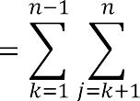

1. We do a trend test on a time series Xk that is ranked from j = i + 1, i + 2, i + 3…..n and rated
2. from k = 1,2,3,…,n-1. A point of reference is served by each and every data point xj. 121

|  |  |  |
| --- | --- | --- |
| sgn (*xj-xk*) | = | 1 if *xj-xk* > 0 |
|  | = | 0 if *xj-xk* = 0 |
|  | = | -1 if *xj-xk* < 0 |

122

123

124

125

# Sen's Slope Estimator Test

1. Sen's estimate (Sen, 1968) is a nonparametric technique for determining the amplitude of a
2. time series trend. Sen's nonparametric approach is used to determine the real slope of an ex-
3. isting trend, such the yearly change in amount, and is checked using R software. A positive
4. Sen's slope indicates a growing or expanding trend in the time series, whereas a negative
5. Sen's slope indicates a declining or contracting trend. 132

# Drought Indices

1. **Standardized Precipitation Index (SPI)**
2. Karabulut (2015) states that the SPI is the most often utilized drought indicator (Supplemen-
3. tary Table 1). It is generally agreed upon as a valuable tool for describing meteorological
4. droughts. SPI was developed across diverse time periods (1, 3, 6, 12, 24, and 48 months)
5. (McKee, 1993; 1995), with output values ranging from -2.0 to 2.0.
6. The SPI is calculated using the probability density function shown below, as precipitation
7. data may be fitted by a gamma distribution:



141

1. Where



1. T(\alpha) stands for the gamma function, α (α>0) for the shape parameter, β for the scale pa-
2. rameter, and x (mm) for precipitation. Further information can be found in McKee (1995). 145

# Percent of Normal Index (PNI)

1. The PNI has been developed by Willeke, 1994 and the percentage of normal precipitation
2. (Table 2). A variety of time intervals, including seasonal, annual, and monthly, can be used to
3. compute it. Hayes et al. (2005) state that PNI has shown to be highly effective in describing
4. drought for a particular region or for a period of time.
5. PNI is determined in this way:



152

# Deciles Index (DI)

1. According to Gibson and Maher (1967), the DI (Supplementary Table 1) rates the amount of
2. precipitation that occurred over a specific period of time across the whole historical era.
3. Monthly recorded rainfall data is sorted from low to high and to generate ten equal divisions,
4. or deciles. Deciles can also be used to contextualize precipitation within a certain month's
5. historical context.

# China-Z Index (CZI)

1. The National Climate Center of China developed the CZI (Table 2) in 1995 as an alternate for
2. the SPI, if the average rainfall follows the Pearson type III distribution (Chen et al., 2005).
3. For the CZI, the formula is







163



1. where i is the interest time scale and j is the current month. The CZI amount for period I's
2. current month (j) is denoted as CZI ij, where Csi is the coefficient of skewness and φtj is the
3. standardized variation. Wu et al. (2001) provide further details. Furthermore, the MCZI may
4. be calculated using the same approach, but with median precipitation instead of mean precipi-
5. tation.

169

# Rainfall Anomaly Index (RAI)

1. The RAI examines at both positive and negative anomalies (Table 1). The precipitation data
2. is shown first, descending in order. Averaging the top 10 results establishes a positive anoma-
3. ly threshold, whereas averaging the lowest ten numbers establishes a negative anomaly ob-
4. stacles.

175



1. where m is the mean of the ten highest and ten lowest p values for the positive and negative
2. anomalies, respectively, and p is the actual precipitation for each year (mm). The long-term
3. average precipitation is denoted by p. 179

# Z-Score Index (ZSI)

1. There are situations in which ZSI and SPI (Table 2) are not understood. It is more similar to
2. CZI even though it does not need fitting precipitation data to the gamma or Pearson type III
3. distributions. To compute ZSI, use this formula: 184



185

1. where P is the average monthly precipitation (mm), SD is the standard deviation of any time



1. period (mm), and Pi is the precipitation in a certain month (mm). 188

# Results and Discussion

1. The average, standard deviation, and coefficient of variation (CV) for rainfall, minimum and
2. maximum temperatures were determined by analyzing monthly and annual data (Fig 2). The
3. subsequence tables for each of the six drought-vulnerable locations show the basic statistical
4. characteristics of selected variables month by month. Even during the rainy season, the re-
5. gion received little to no rainfall, according to average rainfall estimates. July and August ob-
6. served the highest rainfall, although with a lower CV value. Adilabad, Khammam, and
7. Mahbubnagar received over 900 mm of rain on average during the monsoon season, whereas
8. Rangareddy received the least (548.9 mm on average and 98.6 mm in June). Furthermore,
9. data mining revealed that the Adilabad district experienced the highest average rainfall of
10. 774.0 mm in July 1988. In 2005, Khammam experienced a record high rainfall of 928.9 mm.
11. In July 2022, a comparable amount was recorded for Mahbubnagar, Medak, and Nalgonda,
12. respectively, with 484.7 mm in 1988 and 427.2 mm in 1989. On the other hand, Rangared-
13. dy had 396.8 mm of precipitation in August. An additional investigation conducted in 2022
14. by Bellamkonda et al. revealed no significant trend in Telangana's pre-monsoon, monsoon,
15. and post-monsoon rainfall patterns. The Modified Mann-Kendall test revealed no significant
16. yearly rainfall trend in Telangana. While the other months exhibited no noteworthy changes,
17. May experienced a significant rise in rainfall. Patra et al. (2012) conducted the detecting rain-
18. fall trends in the twentieth century over Odisha state, India. It discovered that yearly and
19. monsoon rainfall in Odisha was increasing after the monsoon season but decreasing over
20. time. Rainfall increased over the winter and summer. 210
21. Figure 2 depicts May month is hot of the year in these regions, with maximum temperatures
22. reaching 42.2oC. Khammam, Medak, and Rangareddy reported the lowest maximum temper-
23. ature of 29.6oC, which could be attributed to their geographical location. The average tem-
24. perature in Adilabad was higher than in surrounding places. The highest mean maximum
25. temperature observed in Khammam was 44.1°C in May 1984, according to an analysis of
26. mean monthly data. In May, Adilabad, Mahbubnagar, Medak, Nalgonda, and Rangareddy
27. had temperatures of 43.9oC in 1984, 43.0oC in 1984 and 2019, 42.3oC in 1984 and 2019,
28. 42.9oC in 2012, and 42.3oC in both 1984 and 2019. Figure 2 shows how the lowest tempera-
29. ture in each of the states under investigation varied from 14.1°C in December to 27.7°C in
30. May. Based on average monthly statistics, Khammam had the highest mean minimum tem-
31. perature of 29.2oC in May 1988. May temperatures in Adilabad, Mahbubnagar, Medak,
32. Nalgonda, and Rangareddy peaked at 28.7°C in 2013, 28.6°C in 1988, 28.0°C in 2003,
33. 28.5°C in 2001, and 28.0°C in 2003.

224

1. Figure 3 displays the annual trends in rainfall, maximum and lowest temperatures using
2. trendline graphs. Previous studies found a similar linear regression analysis for rainfall
3. changes in Telangana state's Jagtial district from 1980 to 2019 (Navatha et al., 2021). The
4. linear regression trend technique observed an increasing trend pattern for the temperature da-
5. ta provided. The modified Mann-Kendall test revealed no significant change in temperature
6. patterns in January, November, and December, but significant trends (* P < 0.05) in the re-
7. maining months. Pre-summer, post-summer, and yearly temperature patterns showed statisti-
8. cally significant trends (* P < 0.05). In contrast, the modified Mann Kendall test indicated no
9. statistically significant trend (NS) in summer temperatures (Laasya et al., 2024). 234
10. Sen's slope, the MK test, and trends in temperature, precipitation, and maximum and mini-
11. mum values have all been calculated. An independent trend analysis was conducted on the
12. variables that were chosen. The MK test results are displayed in Figures 4, 5, and 6, along
13. with the P value and Sen's slope, which show the magnitude of the trend appears. With the
14. exception of Adilabad and Mahbubnagar (P values 0.07 and 0.08), which showed a 5% in-
15. crease, Fig. 5 shows a substantial rise in max temperature (P value <0.05) in districts that are
16. susceptible to drought. In all drought-prone locations, minimum temperatures increased,
17. though not much. Sen's slope values, depicted in Fig 7, show an increased trend in tempera-
18. ture throughout all drought-prone districts. Rainfall data show both positive and negative
19. trends (Figure 8). While drought-prone areas experienced a non-significant increase in rain-
20. fall, Mahbubnagar did not experience a significant decrease. Sen's slope ranged from -0.6 to
21. 3.5. Some studies using the Modified Mann-Kendall test found similar trend results (Mckee,
22. 1993; 1995). Similar research hae been indicate that August was the month with the highest
23. percentage of rainfall during the southwest monsoon. June, July, and September placed sec-
24. ond and third, respectively, with contributions of 18.6%, 21.2%, and 29.7%. The southwest
25. monsoon provided roughly 78.8% of the yearly precipitation in the state of Telangana. In Tel-
26. Angana State, annual precipitation was 20.5%, while the monsoon brought in 22.5%. 252

253

254

255

256

257

258

259

260

261

|  |  |  |
| --- | --- | --- |
|  |  |  |
|  |  |  |
|  |  |  |

262

# Fig 2. Mean, Standard Deviation (SD), and Coefficient of Variation (CV) for rainfall,

1. **minimum and maximum temperatures.**

265

|  |  |  |
| --- | --- | --- |
|  |  |  |
|  |  |  |

|  |  |  |
| --- | --- | --- |
|  |  |  |
|  |  |  |
|  |  |  |
|  |  |  |

266

# 267 Fig 3: Rainfall of minimum, and maximum temperature trends annually from 1981 to

268 **2023.**

269

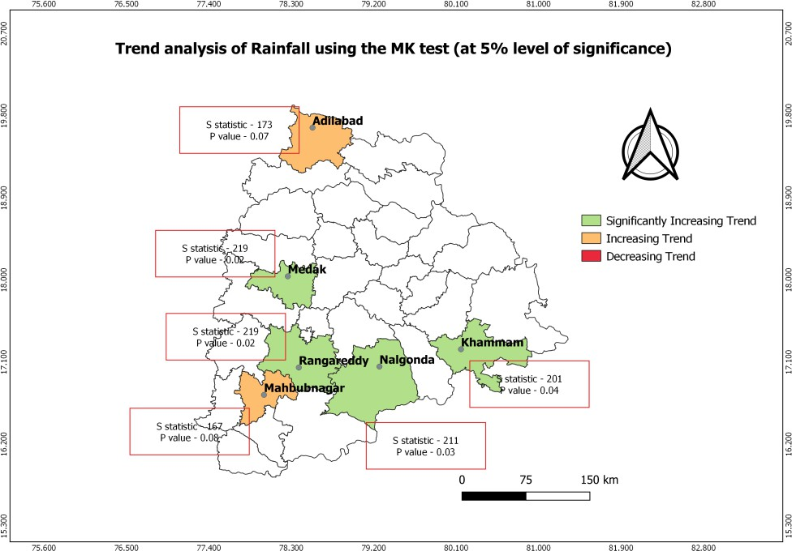270

271

# 272 Fig 4. Rainfall trend analysis in the MK test (at a significance level of 5%).

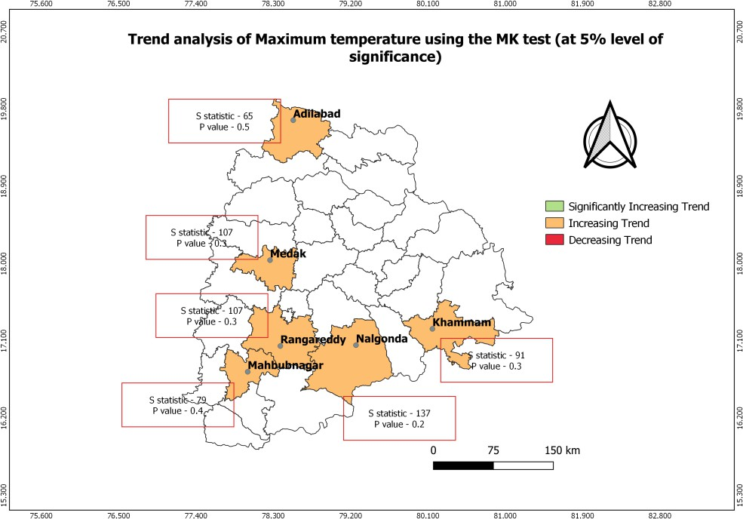273

274

275

# 276 Fig 5. MK test analysis of maximum temperature trends (at a level of significance of

277 **5%).**

278

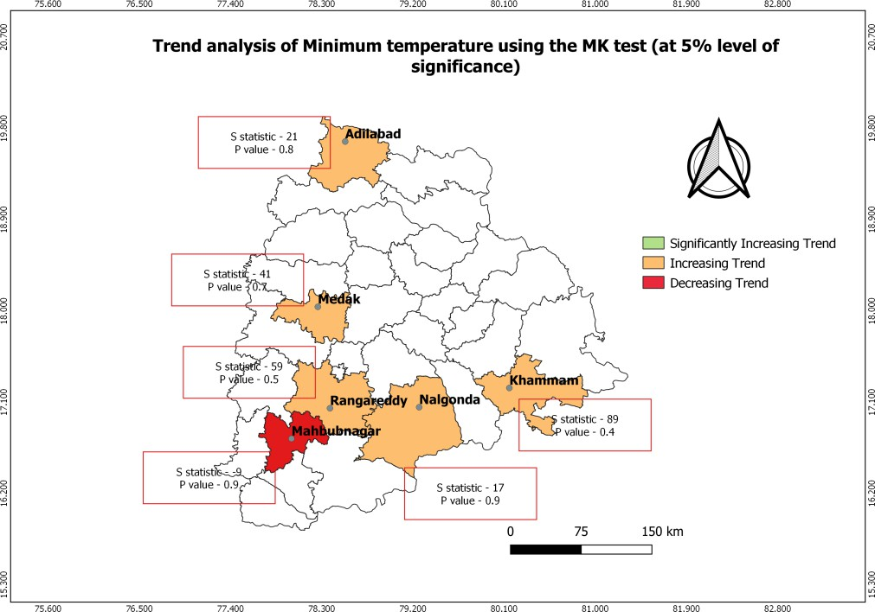279

# 280 Fig 6. Trend analysis of minimum temperature using the MK test (at 5% level of signifi-

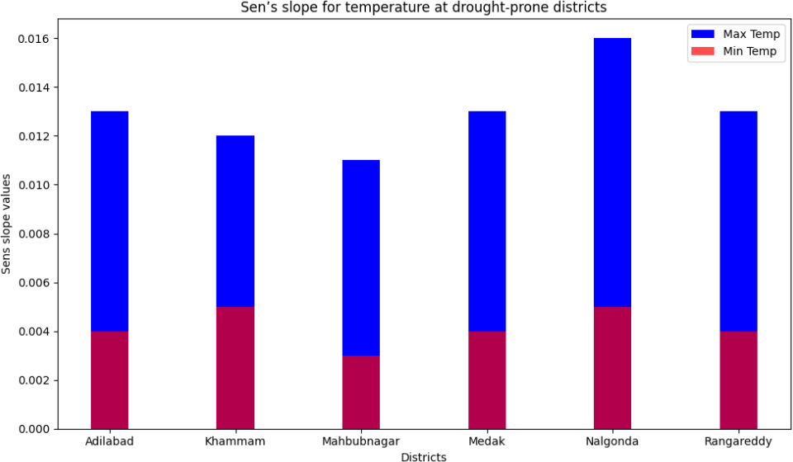281 **cance).**

282

283

284

# 285 Fig 7: Sen’s slope for temperatures at drought-prone districts of Telangana

286

287

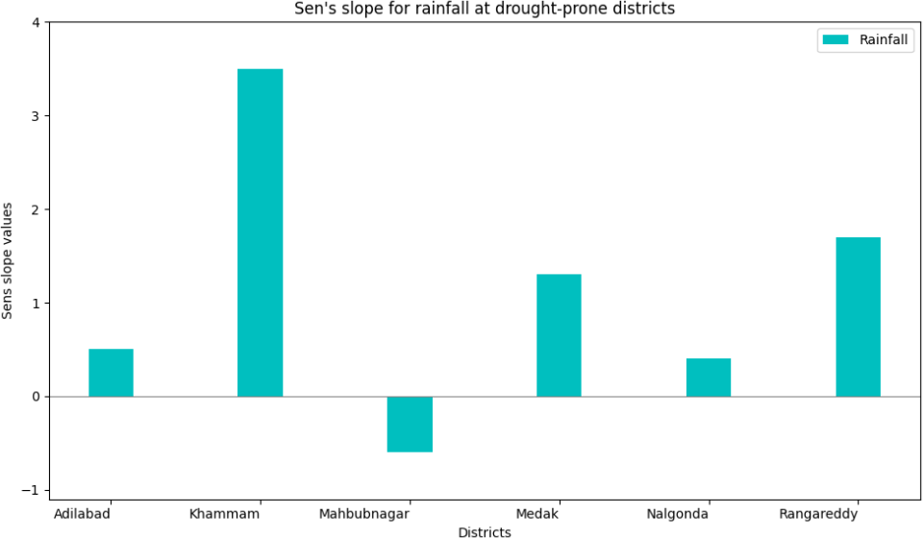288

289

# 290 Fig 8: Sen's slope of rainfall in drought-prone areas of Telangana.

291

292

# Drought Indices

1. Meteorological drought indicators, such as the China Z Index (CZI) and the Standardized
2. Precipitation Index (SPI) (Fig. 9), have been used to describe the drought conditions in Tel-
3. angana. It has been "Near Normal" for a number of years, indicating that the levels of precipi-
4. tation were nearly normal. Khavise et al. (2015) state that the quantity of data points and cli-
5. matic fluctuation are the two most important aspects. Each district has a different combina-
6. tion of normal, wet, and dry years, according to the PNI study. These variations may be relat-
7. ed to environmental factors, climate change, or regional considerations (Dash et al.,2007).
8. Every district has had mild to severe drought years, with every district experiencing severe
9. and extreme droughts. The Deciles Index (DI) shows that most years in each district are
10. drought-free, even though certain districts have more frequent or severe droughts. The Adila-
11. bad district experiences both wet and dry weather, with a slight trend toward wet and near-
12. normal years, according to the RAI findings. The districts of Khammam, Mahbubnagar,
13. Medak, Nalgonda, and Rangareddy experience a mixture of wet, near-normal, and dry weath-
14. er conditions. The Z-Score Index (ZSI) demonstrates varying drought patterns between dis-
15. tricts, with most years having near-normal rainfall. These data show the region's diverse
16. weather patterns. Figure 6 shows the distribution and density of different droughts. When
17. compared to other indices, Adilabad has a higher deviation, while the other towns have equal
18. deviations. The description above clearly demonstrates that this station's rainfall pattern var-
19. ies significantly across the seasons (Gajbhiye et al 2016). 313
20. A multivariate integrated drought monitoring index (MIDMI) has been developed for the Wa-
21. rangal region of Telangana, India, using Landsat-8 data. The MSI, NDVI, NDWI, NMDI, and
22. SWCI were each assigned a different weight using the Iyengar and Sudarshan method. The
23. percentage of the Warangal region falling into the Extreme Drought category remains con-
24. sistent across all five drought indicators. The percentage of MIDMI area classed as Extremely
25. Drought has not changed. Compared to other drought indicators, the NDWI and NDVI show
26. higher percentages of areas in the Severe and Moderate drought zones in Telangana, India.
27. When compared to other drought indices, the MSI shows that the Warangal area of Telanga-
28. na, India, has the fewest acres of land classified as Severe Drought. According to the MSI,
29. the Warangal region of Telangana, India, has the highest percentage of land classified as
30. Slight Drought or No Drought. The NDVI has the highest weight in the MIDMI because the
31. Warangal region's water availability restricts vegetation growth (Tapas et al., 2022). 326

|  |  |
| --- | --- |
|  |  |
|  |  |

|  |  |
| --- | --- |
|  |  |

327

1. **Fig 9. Distribution and Density along with the frequency for different drought**
2. **indices**
3. **Environmental Impacts and Changes**
4. During the rainy season, the region receives little or no rainfall. The wettest months are July
5. and August. Adilabad received the highest mean rainfall in July 1988, while Khammam rec-
6. orded ahigh in 2005. Mahbubnagar, Medak, and Nalgonda all have different rainfall patterns.
7. May is the hottest month, with maximum temperatures of over 42.2°C. Khammam, Medak,
8. and Rangareddy have the lowest maximum temperatures. Adilabad consistently has higher
9. average temperatures. There have been tendencies over time toward higher maximum and
10. lowest temperatures. Guntukula and Goyari published a study that was comparable in 2020.
11. The impact of climate conditions on Telangana's crops varies. The highest temperature dras-
12. tically decreases the yields of groundnuts, rice, and cotton. The minimal temperature is very
13. beneficial to rice, cot-ton, and groundnuts. Rainfall and groundnut and cotton yields also have
14. a negative correlation. For all research crops, the maximum temperature has been demon-
15. strated to lower risk, whilst the lowest temperature is associated with higher risk for jowar,
16. cotton, and rice. Lastly, rainfall has been found to raise the risk of rice and groundnuts while
17. decreasing the risk of cotton and jowar. 345

# Implications for Urban Planning and Policy-Making in drought prone areas of Tel-

1. **angana:**
2. In order to address rising temperatures, urban planners must provide green areas, cooling
3. techniques, and heat-resilient infrastructure. To lessen the consequences of heat regions, poli-
4. cies can support energy-efficient construction and urban forests. Water scarcity is a major
5. concern because of the minimal rainfall. Rainwater collection, sustainable water supply sys-
6. tems, and efficient water usage should be the main priorities of urban development. It is cru-
7. cial to strike a balance between historic preservation and urban regeneration. Zoning regula-
8. tions ought to discourage sprawl and encourage mixed-use development. Policies should en-
9. sure equitable resource distribution, especially during extreme weather events. Vulnerable
10. populations require specific measures in order to be resilient to climate change. A study was
11. carried out in Hyderabad by (Kishanet al., 2019). When land surface temperature and imper-
12. meable surface temperature positively correlate on warm days, an urban area is considered to
13. have an urban heat island. This occurs when temperatures in the urban area rise by 6–8°F
14. (3.5–4.5°C). It observed that there are three phases to urban growth and that scenarios are
15. developed to evaluate the effects of urban growth on various environmental variables, includ-
16. ing the need for water and electricity, the quality of the air, and the use of land. By 2020, eve-
17. ry region that may be developed will be urbanized, and an increasing number of cars on the
18. road will be a major contributor to air pollution, according to the research. The demand for
19. power and water in the city will rise, increasing the likelihood of shortages. The scenarios
20. also show that increasing affluence and economic development will raise local environmental
21. requirements.

368

# Conclusion

1. The present investigation utilizes a nonparametric approach to examine variations of rainfall,
2. temperature and drought indices in Telangana, India. In this research results show a consider-
3. able variation in rainfall and temperature over the last 40 years and across different months.
4. According to our study, High and low temperature trends were significantly positive in
5. drought-prone areas, but not significantly positive. In addition to being utilized for upcoming
6. forecast research, the data can be utilized to monitor variations in the state's rainfall and tem-
7. perature. Additionally, this study found that SPI and CZI provide valuable insights into
8. drought conditions, and these are relevant in studies pertaining to drought forecasting, as
9. demonstrated by their significant correlations. The research investigated emphasizes the need
10. of an all-encompassing approach to drought mitigation, climate change adaptation, and water
11. resource management. By integrating these data, agricultural, water supply, economic stabil-
12. ity, and resilience to drought and adaptation techniques can all be improved. 382

# Data Availability

1. Historical rainfall, minimum temperature, and maximum temperature data for the Telangana
2. districts of Adilabad, Khammam, Mahbubnagar, Medak, Nalgonda, and Rangareddy were
3. available on the Climate Research and Services India Meteorological Department webpage
4. (<https://cdsp.imdpune.gov.in/>).

388

# Conflicts of Interest

1. The authors declare that they have no conflicts of interest. 391
2. **References**
3. Allen, J. T. , 2018. Climate change and severe thunderstorms. In Oxford research encyclope-
4. dia of climate science.
5. Bellamkonda, J., Meena, A., Rathod, S., Tuti, M. D., Kallakuri, S., Bhanusree, D., Reddy, B.
6. N. K.,2022. Trend analysis of rainfall in Telangana state (India) using advanced statisti-
7. cal approaches. International Journal of Environment and Climate Change, 12(11),
8. 3405-3413.
9. Boult, V. L., Black, E., Abdillahi, H. S., Bailey, M., Harris, C., Kilavi, M., Todd, M. C.,
10. 2022. Towards drought impact-based forecasting in a multi-hazard context. Climate
11. Risk Management, 35, 100402.
12. Buttafuoco, G., Caloiero, T., Coscarelli, R., 2015. Analyses of drought events in Calabria
13. (Southern Italy) using standardized precipitation index. Water Resources Manage-
14. ment, 29, 557-573.
15. Chen, J., Shi, P., & Wang, D.,2005. Spatial Distribution and Seasonal Variabilty of the Rain-
16. fall Observed from TRMM Precipitation Radar (PR) in the South China Sea Area
17. (SCSA) . Advances in Earth Science, 20(1), 29.



1. Dash, S. K., Jenamani, R. K., Kalsi, S. R., Panda, S. K.,2007. Some evidence of climate
2. change in twentieth-century India. Climatic change, 85(3), 299-321.
3. Fathi-Taperasht, A., Shafizadeh-Moghadam, H., Kouchakzadeh, M., 2022. MODIS-based
4. evaluation of agricultural drought, water use efficiency and post-drought in Iran; consid-
5. ering the influence of heterogeneous climatic regions. Journal of Cleaner Produc-
6. tion, 374, 133836.
7. Gibbs, W. J., Maher, J. V.,1967. Rainfall deciles drought indicators.
8. Goddard, L., Gershunov, A., 2020. Impact of El Niño on weather and climate extremes. El
9. Niño Southern Oscillation in a changing climate, 361-375.
10. Guan, J., Yao, J., Li, M., Li, D., Zheng, J., 2022. Historical changes and projected trends of
11. extreme climate events in Xinjiang, China. Climate Dynamics, 1-22.
12. Guhathakurta, P., Sudeepkumar, B. L., Menon, P., Prasad, A. K., Sable, S. T., Advani, S. C.,
13. 2020. Observed rainfall variability and changes over Kerala State. India Meteorological
14. Department.
15. Guntukula, R., Goyari, P.,2020. Climate change effects on the crop yield and its variability
16. in Telangana, India. Studies in Microeconomics, 8(1), 119-148.
17. Handmer, J., Honda, Y., Kundzewicz, Z. W., Arnell, N., Benito, G., Hatfield, J. Yamano, H.,
18. 2012. Changes in impacts of climate extremes: human systems and ecosys-
19. tems. Managing the risks of extreme events and disasters to advance climate change ad-
20. aptation special report of the intergovernmental panel on climate change, 231-290.
21. Handmer, J., Honda, Y., Kundzewicz, Z. W., Arnell, N., Benito, G., Hatfield, J., Yamano, H.,
22. 2012. Changes in impacts of climate extremes: human systems and ecosys-
23. tems. Managing the risks of extreme events and disasters to advance climate change ad-
24. aptation special report of the intergovernmental panel on climate change, 231-290.
25. Hayes, M. J., Svoboda, M. D., Wardlow, B. D., Anderson, M. C., Kogan, F., 2012. Drought
26. monitoring: Historical and current perspectives.
27. Hayes, M., Svoboda, M., Le Comte, D., Redmond, K. T., Pasteris, P., 2005. Drought moni-
28. toring: New tools for the 21st century. Drought and water crises: Science, technology,
29. and management issues, 53, 69.
30. Holmberg, K.and Hellsten, I., 2016. Twitter campaigns around the fifth IPCC report: Cam-
31. paign spreading, shared hashtags, and separate communities. SAGE Open, 6(3),
32. 2158244016659117.
33. Huang, Z., Tan, X., Liu, B.,2024. Relative contributions of large‐scale atmospheric circula-
34. tion dynamics and anthropogenic warming to the unprecedented 2022 Yangtze River
35. Basin heatwave. Journal of Geophysical Research: Atmospheres, 129(4),
36. e2023JD039330.
37. Karabulut, M.,2015. Drought analysis in Antakya-Kahramanmaraş Graben, Turkey. Journal

445 of Arid Land, 7, 741-754.

446 Kendall, M. G.,1945. On the analysis of oscillatory time-series. Journal of the Royal Statisti-

447 cal Society, 108(1/2), 93-141.

1. Khadka, N., Chen, X., Sharma, S., Shrestha, B. (2023). Climate change and its impacts on
2. glaciers and glacial lakes in Nepal Himalayas. Regional Environmental Change, 23(4),
3. 143.
4. Khavse, R., Deshmukh, R., Manikandan, N., Chaudhary, J. L., Kaushik, D.,2015. Statistical
5. analysis of temperature and rainfall trend in Raipur district of Chhattisgarh. Current
6. World Environment, 10(1), 305-312.
7. Kishan, A. B.,2019. URBAN FORESTRY AND ITS ROLE IN REGULATING CITIES
8. ENVIRONMENT: A STUDY OF HYDERABAD CITY.
9. Laasya, K. N. V. L., Kallakuri, S., Rathod, S., Neelima, L., Meena, A.,Jyostna, B.,2024. Sta-
10. tistical Assessment of Temperature Trends and Change Points in Telangana State, In-
11. dia. International Journal of Environment and Climate Change, 14(4), 397-407.
12. Lu, P., Liu, R., Luo, Z., Li, S., Wu, Y., Hu, W., Xue.,2024. Impacts of compound extreme
13. weather events on summer ozone in the Beijing-Tianjin-Hebei region. Atmospheric Pol-
14. lution Research, 15(3), 102030.
15. McKee, T. B., Doesken, N. J., Kleist, J.,1993. The relationship of drought frequency and du-
16. ration to time scales. In Proceedings of the 8th Conference on Applied Climatolo-
17. gy (Vol. 17, No. 22, pp. 179-183).
18. McKee, T. B., Doesken, N. J., Kleist, J.,1995. Drought monitoring with multiple time scales.
19. PROCEEDINGS OF THE CONFERENCE ON APPLIED CLIMATOLOGY.
20. Meharie, E. A., Taye, M. A., Alemu, M. M., Lema, A. T.,2023. Extreme Rainfall Indices and
21. its Effect on Meher Season Crop Calendar: An Agro-Climatic Zone Based Study.
22. Mohammad, P and Goswami, A., 2023. Exploring different indicators for quantifying surface
23. urban heat and cool island together: a case study over two metropolitan cities of In-
24. dia. Environment, Development and Sustainability, 25(10), 10857-10878.
25. Motha, R. P., 2011. The impact of extreme weather events on agriculture in the United
26. States. Challenges and opportunities in agrometeorology, 397-407.
27. Navatha, N., Sreenivas, G., Umareddy, R.,2021. Rainfall and temperature trends in Jagtial
28. district of Telangana state. International Journal of Environment and Climate
29. Change, 11(11), 47-59.
30. Patra, J. P., Mishra, A., Singh, R., Raghuwanshi, N. S.,2012. Detecting rainfall trends in
31. twentieth century (1871–2006) over Orissa State, India. Climatic Change, 111, 801-817.
32. Qin, X and Dai, C., 2022. Comparison of different quantile delta mapping schemes in fre-
33. quency analysis of precipitation extremes over mainland Southeast Asia under climate
34. change. Journal of Hydrology, 606, 127421.
35. Sens, A. D.,1968. The Newly Independent States, the United Nations, and some thoughts on
36. the nature of the Development Process. The Journal of Politics, 30(1), 114-136.
37. Spinoni, J., Barbosa, P., Bucchignani, E., Cassano, J., Cavazos, T., Cescatti, A., Dosio, A.,
38. 2021. Global exposure of population and land??? use to meteorological droughts under
39. different warming levels and: A??? based study. International Journal of Climatolo-
40. gy, 41, 6825-6853.
41. Tapas, M. R., Kumar, U., Mogili, S., Jayakumar, K. V.,2022. Development of multivariate
42. integrated drought monitoring index (MIDMI) for Warangal region of Telangana, In-
43. dia. Journal of Water and Climate Change, 13(3), 1612-1630.
44. Vicente-Serrano, S. M., Quiring, S. M., Peña-Gallardo, M., Yuan, S.,Domínguez-Castro, F.,
45. 2020. A review of environmental droughts: Increased risk under global warm-
46. ing?. Earth-Science Reviews, 201, 102953.
47. Webber, J and Hawkins, C.,1980. Statistical analysis application to business and economics.
48. Wilhite, D. A and Glantz, M. H., 1985. Understanding: the drought phenomenon: the role of
49. definitions. Water international, 10(3), 111-120.
50. Willeke, G., J. R. M. Hosking, J. R. Wallis, and N. B. Guttman, 1994. The National Drought
51. Atlas. Institute for Water Resources Report 94-NDS-4, U.S. Army Corps of Engineers
52. Wu, H., Hayes, M. J., Weiss, A., Hu, Q. I.,2001. An evaluation of the Standardized Precipita-
53. tion Index, the China‐Z Index and the statistical Z‐Score. International Journal of Clima-
54. tology: A Journal of the Royal Meteorological Society, 21(6), 745-758.
55. Xiaosheng, J., Xianwei, Y., Lijuan, C., Youmin, W.,1997. Research on determination of sta-
56. tion indexes and division of regional flood/drought grades in Chi-
57. na. 应用气象学报, 8(1), 26-33.
58. Yiran, G. A and Stringer, L. C., 2017. Adaptation to climatic hazards in the savannah eco-
59. system: improving adaptation policy and action. Environmental management, 60(4),
60. 665-678.
61. Zhong, P., Huser, R., Opitz, T., 2022. Modeling nonstationary temperature maxima based on
62. extremal dependence changing with event magnitude. The Annals of Applied Statis-
63. tics, 16(1), 272-299.
64. Zhong, S., Cheng, Q., Huang, C. R., Wang, Z., 2021. Establishment and validation of health
65. vulnerability and adaptation indices under extreme weather events on the basis of the
66. 2016 flood in Anhui province, China. Advances in Climate Change Research, 12(5),
67. 649-659.

515