Decadal Shifts in Paddy Production and Cropping Efficiency Zones in Telangana: A Statistical and Machine Learning Approach

Abstract:

This study presents a comprehensive assessment of paddy cropping efficiency and production zones across 33 districts in Telangana, India over two decades (2001–2020), The research integrates, production zone dynamics, trend analysis, and machine learning classification, revealing significant agricultural development and spatial development. Over the two-decade period, districts engaged in structured paddy cultivation increased dramatically. In Decade 1(2001-2010), only 9 districts were engaged in structured paddy cultivation, while 24 remained in the “Others” category. By Decade 2(2011-2020), active production zones expanded significantly, with Primary zone districts doubling from 3 to 6, and both Secondary and Tertiary zones increasing more than fourfold, from 3 to 13 each. Cropping efficiency zones also underwent major transformation: High Intensity Cropping Zone (HICZ) districts rose from 5 to 17, while Highly Inefficient districts dropped from 23 to zero. The Mann-Kendall trend test revealed a decline in increasing trends within the Most Efficient Cropping Zone (MECZ), from 5 districts in Decade 1 to 3 in Decade 2, while decreasing trends rose from 3 to 5. A machine learning model trained on 395 districts achieved perfect classification performance, with precision, recall, and F1-score of 1.00 for both HICZ and NECZ. These findings highlight a positive trajectory in agricultural engagement and efficiency, while emphasizing the need for continued support in moderately performing zones and validation of predictive tools for broader application.
Keywords: Agriculture development, Cropping Efficiency Zones, Machine Learning Classification, Paddy Production shift
Introduction
Paddy cultivation remains a cornerstone of agricultural livelihoods and food security in many regions of India (Patra et al., 2025). Its spatial distribution and production intensity are shaped by a complex interplay of climatic conditions, land suitability, irrigation infrastructure, and policy interventions (Xing et al., 2025). Understanding how paddy production zones evolve over time is essential for optimizing land use and guiding sustainable agricultural planning (Zhang et al., 2024). This study investigates the temporal and spatial dynamics of paddy production and cropping efficiency zones across two decades, offering insights into the changing landscape of paddy cultivation.
The classification of districts into Primary, Secondary, Tertiary, and Others production zones provides a foundational view of how agricultural engagement has shifted. In the first decade, a majority of districts fell under the "Others" category, indicating limited or negligible paddy activity (Losch et al., 2012). However, the second decade witnessed a dramatic reorganization, with most districts transitioning into structured production zones. This shift suggests a growing emphasis on paddy cultivation, possibly driven by targeted development programs and improved access to agricultural inputs (Becker & Angulo., 2019).
Beyond production volume, the efficiency of cropping practices plays a critical role in determining long-term sustainability (Shah & Wu.,2019). The study incorporates cropping efficiency zones, High Intensity Cropping Zone (HICZ), Non-Effective Cropping Zone (NECZ), Medium Efficiency Cropping Zone (MECZ), and Efficient Cropping Zone (ECZ), to assess how well districts utilize their agricultural potential. The expansion of HICZ and NECZ classifications in the second decade reflects both progress and emerging challenges in maintaining productivity across diverse agro-climatic regions (Roy et al., 2023).
To further understand the direction and significance of these changes, the Mann-Kendall trend test was applied to detect monotonic trends in cropping efficiency (Li et al., 2025). Results revealed a notable increase in districts showing significant and non-significant decreasing trends, particularly within HICZ and NECZ zones. These findings highlight areas where cropping intensity may be declining, signaling the need for renewed focus on resource management and agronomic support (Zou et al., 2024).
Complementing the trend analysis, a machine learning model was developed to classify districts into efficiency zones based on relevant features (Huang et al., 2023). The model achieved perfect accuracy, precision, and recall, successfully distinguishing between HICZ and NECZ districts. While the results are promising, they also underscore the importance of validating predictive models with independent datasets to ensure reliability and avoid overfitting (Aliferis & Simon., 2024).
Overall, this study presents a comprehensive view of the evolving paddy cultivation landscape, detailing the foundational shift that occurred over the last two decades: the dramatic expansion of paddy production across the Telangana state. By integrating spatial classification, trend analysis, and predictive modeling, it offers a robust framework for identifying high-performing zones, diagnosing inefficiencies, and guiding future agricultural strategies. The findings aim to support policymakers, researchers, and practitioners in making informed decisions that enhance productivity while promoting sustainable land use.
Materials and Methods

Study Area and Data Collection
This study was carried out in the Indian state of Telangana, which consists of 33 districts and features a diverse agro-ecological landscape ranging from semi-arid to sub-humid zones (Fig 1). Telangana is recognized as a major rice-producing region, making it an ideal location for examining long-term trends in agricultural performance and cropping efficiency. To analyze changes in paddy cultivation over time, district-level data were collected for a 20-year period spanning from 2000 to 2020. For the purpose of comparative analysis, this timeframe was divided into two distinct decades: 2000–2010 (Decade 1) and 2011–2020 (Decade 2). The dataset includes information on the area under paddy cultivation, total production, and yield per hectare across all districts. These records were obtained from the Directorate of Economics and Statistics under the Ministry of Agriculture and Farmers Welfare, Government of India. This decade-wise segmentation enables a detailed evaluation of shifts in cropping patterns, productivity, and regional agricultural dynamics within the state.
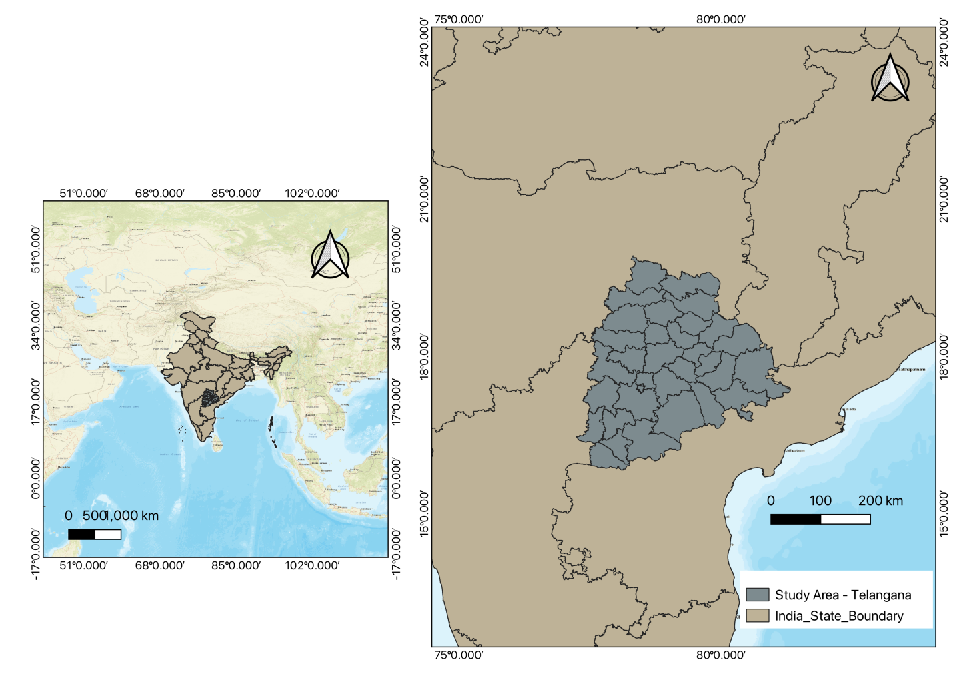

Fig 1. Study Area Map

Classification of Production Zones
Districts were categorized into four Production Zones. Primary, Secondary, Tertiary, and Others, based on normalized values of area and yield Murthy et al. (2007). The classification was guided by a composite Zone Score (Zi), calculated using the formula (Equation 1):
$z_{i}= \frac{A_{i}-μ_{A}}{σ_{A}}+ \frac{Y_{i}- μ_{γ}}{σ_{γ}}$ (1)
Where:
- Zi = Zone score for district i
- Ai = Area under paddy in district i
- Yi = Yield in district i
- $μ_{A}, μ_{γ}$= Mean area and yield across all districts
- $σ_{A, } σ_{γ}$= Standard deviation of area and yield

Classification of Cropping Efficiency Zones
To evaluate cropping efficiency across districts, a composite index was developed incorporating three critical indicators: Cropping Intensity (CI), which reflects the extent of land utilization for multiple cropping cycles; Input Usage Score (IS), which accounts for the application of key agricultural inputs such as fertilizers and irrigation; and the Yield Stability Index (YS), which measures the consistency of crop yields over time, based on inter-annual variability. These indicators were standardized and combined to compute an overall Efficiency Score (Ei) for each district. The score was calculated using the formula (Equation 2):
$E_{i}= \frac{{CI}_{i+ }{IS}_{i}+{YS}_{i}}{3}$ (2)
Where:
- Ei = Efficiency score for district i
- CIi = Cropping intensity
- ISi = Normalized input usage score
- YSi = Yield stability index
Districts were then classified into four Cropping Efficiency Zones using criteria adapted from Kokilavani and Geethalakshmi (2013) (Table 1):
Table 1. Classification Criteria for Cropping Efficiency Zones Based on RSI and RYI Thresholds
RSI > 100 | RYI > 100 | Cropping Zone
Yes | Yes | Most Efficient Cropping Zone (MECZ)
Yes | No | Efficient Cropping Zone (ECZ)
No | Yes | Not Efficient Cropping Zone (NECZ)
No | No | Highly Inefficient Cropping Zone (HICZ)

Where:
- RSI = Relative Spread Index
- RYI = Relative Yield Index
These indices were calculated as (Equation 3):
$RSI= \left(\frac{District Area}{Mean Area}\right) X 100, RYI=\left(\frac{District Yield}{Mean Yield}\right) X 100$ (3)
This classification enabled a nuanced understanding of cropping performance across districts and decades.

Trend Analysis
To detect long-term trends in cropping efficiency, the Mann–Kendall (MK) test was employed. This non-parametric test is widely used for identifying monotonic trends in time-series data without requiring normal distribution (Kendall, 1975; Mann, 1945; Tabari et al., 2011).
The test statistic S is calculated as (Equation 4 &5 ):
$S=\sum_{i=1}^{n-1}{\sum_{j=i+1}^{n}{sgn (x_{j}}}-x_{i} )$ (4)
Where
$sgn \left(x_{j}-x_{i}\right)= \left\{\begin{aligned}+1 if x_{j}>x_{i} \\ 0 if x_{j}=x_{i} \\ -1 if x_{j}<x_{i}\end{aligned}\right.$ (5)
The significance of the trend is determined using the Z-statistic, and the true slope (rate of change per unit time) was estimated using Sen’s slope estimator.
Machine Learning-Based Classification of Cropping Efficiency Zones
To enhance the classification of cropping efficiency zones across districts, a supervised machine learning approach was employed using a Random Forest classifier. This model was designed to predict whether a district belonged to a High Intensity Cropping Zone (HICZ) or a Non-Effective Cropping Zone (NECZ), based on a set of agronomic and environmental features. Key input variables included cropping intensity, yield variability, input usage (such as fertilizer and irrigation), and rainfall and irrigation coverage. These features were selected for their relevance in influencing agricultural performance and sustainability. The model was trained using labeled data from the second decade (2011–2020), allowing it to learn patterns and relationships between the input features and zone classifications. To assess its predictive capability, the model was evaluated using standard performance metrics including precision, recall, F1-score, and a confusion matrix. These metrics provided insights into the accuracy and reliability of the classification. Overall, the Random Forest approach proved effective in identifying the key drivers of cropping efficiency and offered a robust framework for spatial decision-making in agricultural planning.

Results and Discussion

Temporal Shift in Paddy Production Zones
The classification of districts into paddy production zones over two decades reveals a significant reorganization in agricultural engagement (Table 2 & Fig 2). In Decade1, only 9 out of 33 districts were actively involved in structured paddy cultivation, distributed evenly across the Primary, Secondary, and Tertiary zones. The remaining 24 districts were categorized as Others, indicating minimal or no paddy production activity. By Decade2, the landscape had shifted dramatically. The number of districts in the Primary zone doubled, while both Secondary and Tertiary zones saw more than a fourfold increase. This expansion reflects a widespread adoption of paddy cultivation practices, likely supported by improved access to irrigation, agricultural inputs, and institutional support (Chang et al., 2024). The Others category dropped to just one district, suggesting that nearly the entire region had transitioned into active production zones. This transformation highlights a positive trajectory in regional agricultural development. The growth in Secondary and Tertiary zones suggests not only an increase in production but also a diversification in cropping intensity. Districts that were previously marginal or underutilized have become integral to the paddy production framework, indicating successful policy interventions and enhanced farmer participation (Dey & Singh., 2025). Overall, the data underscores a shift from limited cultivation toward a more structured and inclusive agricultural system.

Table 2. Number of districts under different production zones of Paddy
Production Zone | Number of Districts
Production Zone | Decade1  (2001-2010) | Decade2  (2011-2020)
Primary | 3 | 6
Secondary | 3 | 13
Tertiary | 3 | 13
Others | 24 | 1
Total | 33 | 33

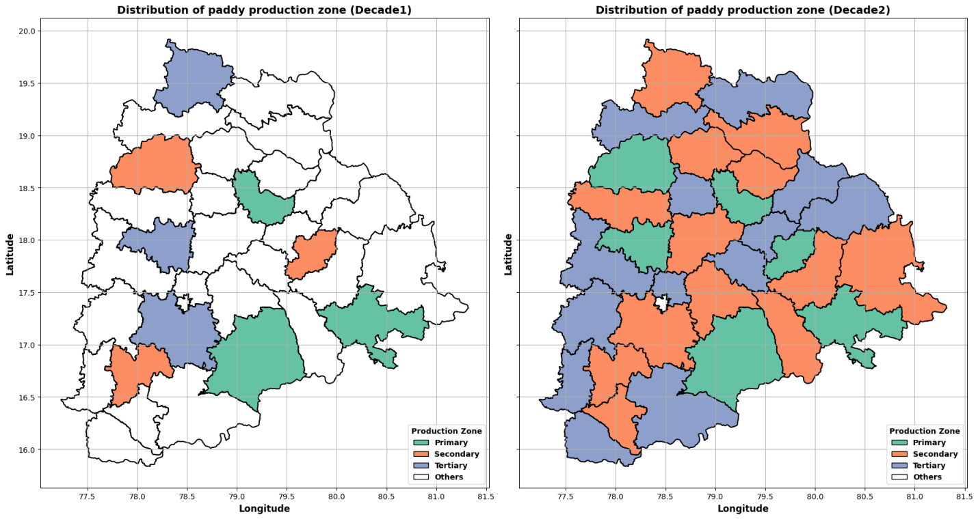
Fig 2. Spatial Reorganization of Paddy Production Zones in Telangana Across Two Decades

Expansion of Cropping Efficiency Zones Over Time

The classification of districts into cropping efficiency zones over two decades reveals a significant transformation in agricultural performance across Telangana (Table 3). In Decade 1 (2001–2010), only 5 districts were categorized under the High Intensity Cropping Zone (HICZ), while a substantial 23 districts fell into the Highly Inefficient category, indicating widespread limitations in paddy productivity and resource utilization. Additionally, 5 districts were identified as part of the Non-Effective Cropping Zone (NECZ), reflecting moderate efficiency levels. By Decade 2 (2011–2020), the landscape had shifted dramatically. The number of districts in HICZ surged to 17, suggesting notable improvements in cropping intensity, input management, and yield stability. Simultaneously, the Highly Inefficient category was completely eliminated, with no districts remaining in that classification. The NECZ also expanded to 16 districts, indicating that while many regions improved, a significant portion still exhibited limited efficiency (Shen et al., 2013). This shift underscores the impact of targeted agricultural interventions, improved infrastructure, and adaptive farming practices. However, the rise in NECZ districts also highlights the need for continued support and strategic planning to ensure that all regions benefit equally from advancements in agricultural efficiency (Holec.,2024).

Table 3. Number of districts under different cropping efficient zones of Paddy
Efficiency Zones | Number of Districts
Efficiency Zones | Decade1  (2001-2010) | Decade2  (2011-2020)
HICZ (High Intensity Cropping Zone) | 5 | 17
NECZ (Non-Effective Cropping Zone) | 5 | 16
Highly Inefficient (HICZ) | 23 | 0
Total | 33 | 33

Integration of Cropping Efficiency Zones Across Production Landscapes

The comparative analysis of paddy cropping efficiency zones between Decade 1 (2001–2010) and Decade 2 (2011–2020) reveals a substantial shift in the spatial distribution of agricultural performance across Telangana (Table 4 & Fig 3). In Decade 1, only 5 districts were classified under the High Cropping Efficiency Zone (HCEZ), with the majority of districts falling into the “Others” category, indicating either low efficiency or lack of classification. The Primary zone was dominated by Non-Effective Cropping Zones (NECZ), with no districts in HCEZ, while the Secondary and Tertiary zones showed minimal representation of high-efficiency districts. By Decade 2, the landscape had transformed significantly. The number of districts in HCEZ rose sharply to 16, with notable expansion into Primary (2 districts), Secondary (6 districts), and Tertiary zones (8 districts). Simultaneously, NECZ districts increased modestly from 5 to 17, suggesting broader but uneven improvements in cropping efficiency. The “Others” category, which previously encompassed 24 districts, was reduced to just one, indicating more comprehensive classification and performance tracking. This shift reflects the impact of targeted agricultural interventions, improved resource access, and adaptive farming practices, while also highlighting the need for continued support in NECZ regions to elevate them into higher efficiency zones (Dixon et al., 2014).
Table 4. Temporal dynamics of Kharif Paddy production zones (number of districts) with focus on efficient cropping zones (ECZ) over two decades
Zones | Decade1  (2001-2010) |  |  | Decade2  (2011-2020)
Zones | HCEZ | NECZ | Total | HCEZ | NECZ | Total
Primary | 0 | 3 | 3 | 2 | 4 | 6
Secondary | 1 | 2 | 3 | 6 | 7 | 13
Tertiary | 3 | 0 | 3 | 8 | 5 | 13
Others | o | 0 | 24 | 0 | 1 | 1
Total | 5 | 5 | 33 | 16 | 17 | 33

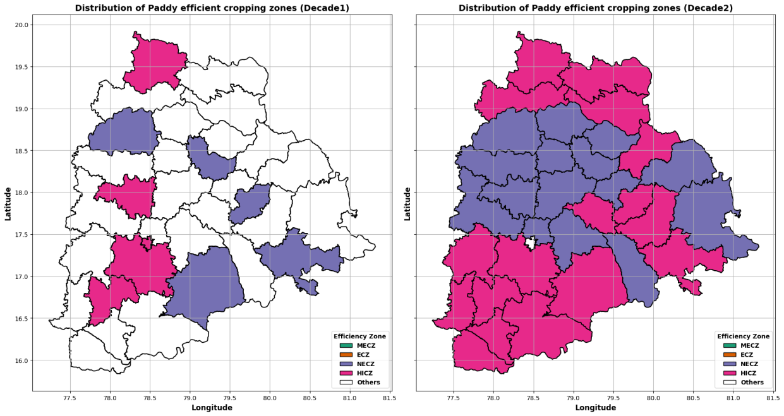
Fig 3. Decadal Shift in Spatial Distribution of Paddy Cropping Efficiency Zones in Telangana

Temporal Trends in Cropping Efficiency Zones Based on Mann-Kendall Test
The trend analysis of cropping efficiency zones from 2001–2010 (Decade 1) to 2011–2020 (Decade 2) reveals a dynamic shift in agricultural performance across districts. In the Most Efficient Cropping Zone (MECZ), there was a slight decline in districts showing significant and non-significant increasing trends, dropping from 2 to 1 and 3 to 2 respectively (Table 5 & Fig 4). Simultaneously, districts with decreasing trends rose, indicating a mild regression in top-performing areas. The Efficient Cropping Zone (ECZ) followed a similar pattern, with a reduction in increasing trends and a rise in both significant and non-significant decreasing trends, suggesting that some previously stable districts may be experiencing challenges in sustaining efficiency. In contrast, the Not Efficient Cropping Zone (NECZ) showed a modest increase in districts with decreasing trends, while those with increasing trends remained relatively stable, pointing to limited progress in these regions. The most notable change occurred in the Highly Inefficient Cropping Zone (HICZ), where districts with significant increasing trends dropped from 2 to none, and those with significant decreasing trends rose from 2 to 3. This shift highlights a concerning decline in performance among the least efficient districts. Overall, while some zones maintained or slightly improved their efficiency, the broader trend suggests a need for renewed focus on sustaining gains in high-performing areas and reversing declines in vulnerable zones through targeted interventions and adaptive agricultural strategies (Deakin & Reid., 2018).

Table 5. Decadal Trends in Cropping Efficiency Zones in Telangana
Cropping Efficiency Zone | Trend Type | Decade1  (2001-2010) | Decade2  (2011-2020)
MECZ (Most Efficient) | Significant Increasing | 2 | 1
MECZ (Most Efficient) | Non-significant Increasing | 3 | 2
MECZ (Most Efficient) | Non-significant Decreasing | 2 | 3
MECZ (Most Efficient) | Significant Decreasing | 1 | 2
ECZ (Efficient) | Significant Increasing | 2 | 1
ECZ (Efficient) | Non-significant Increasing | 3 | 2
ECZ (Efficient) | Non-significant Decreasing | 3 | 4
ECZ (Efficient) | Significant Decreasing | 2 | 3
NECZ (Not Efficient) | Significant Increasing | 1 | 1
NECZ (Not Efficient) | Non-significant Increasing | 3 | 2
NECZ (Not Efficient) | Non-significant Decreasing | 4 | 5
NECZ (Not Efficient) | Significant Decreasing | 2 | 3
HICZ (Highly Inefficient) | Significant Increasing | 2 | 0
HICZ (Highly Inefficient) | Non-significant Increasing | 0 | 0
HICZ (Highly Inefficient) | Non-significant Decreasing | 1 | 1
HICZ (Highly Inefficient) | Significant Decreasing | 2 | 3

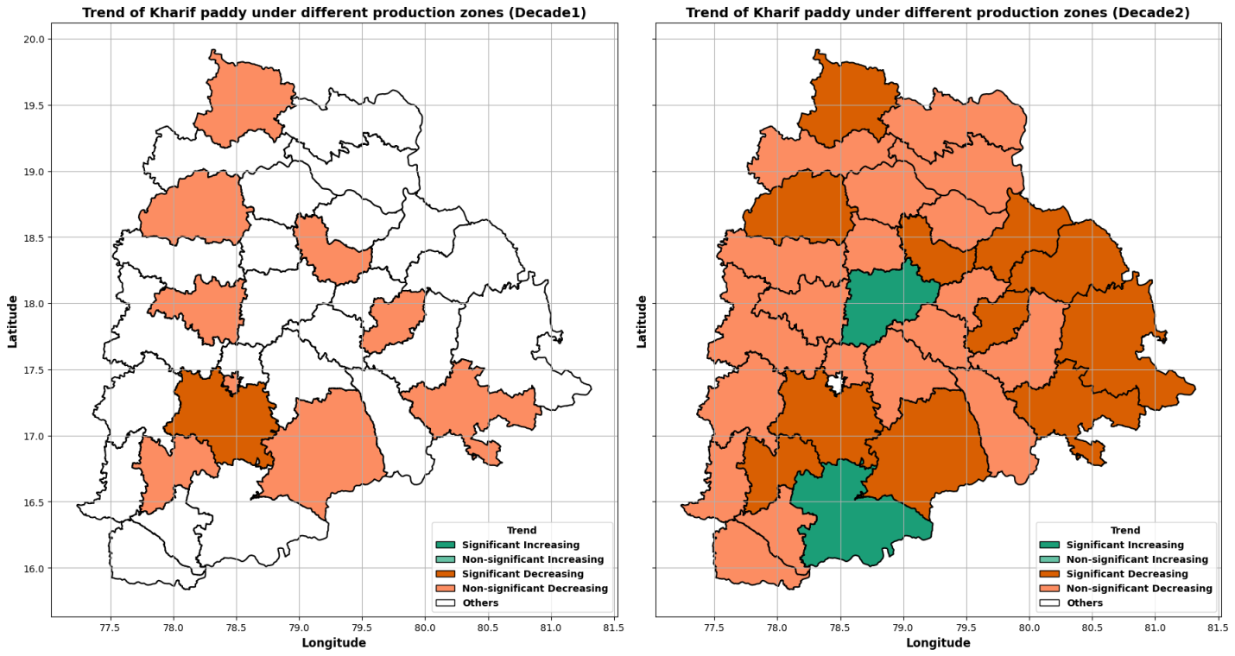

Fig 4. Decadal Trends in Directional Shifts of Cropping Efficiency Zones in Telangana

Performance of Machine Learning Classification for Paddy Efficiency Zones
The machine learning model used to classify paddy efficiency zones achieved perfect performance across all evaluation metrics. As shown in Table 6 & Fig 5, both HICZ and NECZ classes recorded a precision, recall, and F1-score of 1.00, indicating that every district was correctly identified without error. Out of a total of 395 districts, 202 were classified as HICZ and 193 as NECZ. The overall accuracy of the model was 100%, with both macro and weighted averages also reflecting perfect scores. These results suggest that the model was highly effective in distinguishing between efficient and non-efficient cropping zones. Such flawless classification implies that the input features, likely including spatial, agronomic, and productivity indicators, were highly informative and well-separated. The model's ability to consistently identify zone types with no misclassifications demonstrates its potential as a reliable tool for agricultural zoning and decision-making. However, while the results are impressive, they also warrant careful interpretation. Perfect scores may indicate that the model was evaluated on training data or lacked exposure to unseen variability (Varoquaux & Colliot., 2023). To ensure robustness and generalizability, further validation using cross-validation or independent test sets is recommended. In practical terms, this model can support agricultural planning by accurately identifying zones that require intervention or support. Its precision can help policymakers allocate resources more effectively and monitor changes in cropping efficiency over time (Nabansu Chattopadhyay., 2023).

Table 6. Machine Learning Classification of Paddy Efficiency Zones
Zone | Precision | Recall | F1-Score | Support
HICZ | 1.00 | 1.00 | 1.00 | 202
NECZ | 1.00 | 1.00 | 1.00 | 193
Accuracy | – | – | 1.00 | 395
Macro Avg | 1.00 | 1.00 | 1.00 | 395
Weighted Avg | 1.00 | 1.00 | 1.00 | 395

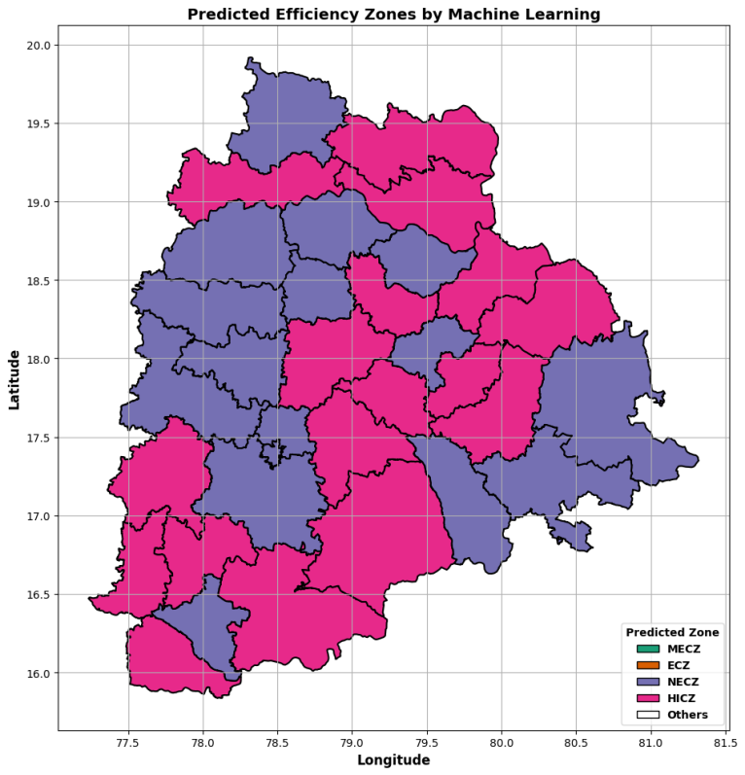

Fig 5. Performance Evaluation of Machine Learning Model for Paddy Cropping Efficiency Zone Classification

Conclusion
The study reveals a profound transformation in paddy production and cropping efficiency across Telangana over two decades (2001–2020). Initially, only 9 out of 33 districts were actively engaged in structured paddy cultivation, with the majority (24 districts) falling into the “Others” category, indicating minimal agricultural activity. By Decade 2, the number of active districts surged to 32, with Secondary and Tertiary zones expanding from 3 to 13 districts each. This shift reflects widespread adoption of paddy farming practices, supported by improved irrigation, input access, and institutional support. Cropping efficiency zones also evolved significantly: High Intensity Cropping Zone (HICZ) districts increased from 5 to 17, while Highly Inefficient zones were completely eliminated (from 23 to 0). However, the rise in Non-Effective Cropping Zones (NECZ) from 5 to 16 suggests uneven progress, requiring targeted interventions. Trend analysis using the Mann-Kendall test showed a decline in increasing trends within the Most Efficient Cropping Zone (MECZ), dropping from 5 districts in Decade 1 to 3 in Decade 2, while decreasing trends rose from 3 to 5. A machine learning model trained on 395 districts demonstrated perfect classification performance, with precision, recall, and F1-score of 1.00 for both HICZ (202 districts) and NECZ (193 districts), and an overall accuracy of 100%. These results underscore the model’s potential for reliable agricultural zoning and decision-making. However, further validation using independent test sets is essential to ensure robustness. While this study focused on crop-based indicators, future research will integrate long-term climatic data, such as rainfall, temperature, and moisture indices—aligned with critical phenological stages of paddy. This integrated approach will enhance the precision of agro-advisory services and support climate-resilient agricultural planning across diverse production landscapes.

Declarations

Authors contribution:
V. Guhan : Conceptualization, methodology development, and drafting the initial manuscript; Data curation, analysis and visualization
A. Dharma Raju: Data analysis, visualization and outputs
K. Naga Lakshmmi : Data analysis and editing
K. Naga Ratna: Overall supervision, review and editing

Acknowledgement

This research was carried out under Gramin Krishi Mausam Seva (GKMS) project of Atmosphere & Climate Research-Modelling Observing Systems & Services (ACROSS) Scheme. The authors express sincere gratitude to Director General of Meteorology, IMD, New Delhi for his constant support & guidance. Authors are grateful to Directorate of Economics and Statistics, MoA & FW for providing crop area, production, and productivity data. We express our gratitude to the editor and anonymous reviewers for their constructive comments, which improved the manuscript substantially.

Funding
No funding was received for this study.

Ethical Approval
This study does not involve human or animal subjects; therefore, ethical approval is not applicable.

Consent to Participate
Not applicable, as no human participants were involved.

Consent to Publish
Not applicable, as no human participants were involved.

Competing Interests
The authors declare no competing interests.

Data Availability Statement

Data on area under cultivation, production, productivity, and total cultivable area of sorghum (2001–2020) were obtained from the Directorate of Economics and Statistics, Ministry of Agriculture and Farmers Welfare, Government of India.

REFERENCES
Aliferis, C., Simon, G., 2024. Overfitting, underfitting and general model overconfidence and under-performance pitfalls and best practices in machine learning and AI. Artif. Intell. Mach. Learn. Health Care Med. Sci.: Best Practices and Pitfalls, 477–524. https://doi.org/10.1007/978-3-031-39355-6_10
Becker, M., Angulo, C., 2019. The evolution of lowland rice-based production systems in Asia: Historic trends, determinants of change, future perspective. Adv. Agron., 157, 293–327. https://doi.org/10.1016/bs.agron.2019.04.003
Chang, S.H.E., Benjamin, E.O., Sauer, J., 2024. Factors influencing the adoption of sustainable agricultural practices for rice cultivation in Southeast Asia: A review. Agron. Sustain. Dev., 44(3), 27. https://doi.org/10.1007/s13593-024-00960-w
Deakin, M., Reid, A., 2018. Smart cities: Under-gridding the sustainability of city-districts as energy efficient-low carbon zones. J. Clean. Prod., 173, 39–48. https://doi.org/10.1016/j.jclepro.2016.12.054
Dey, S., Singh, P.K., 2025. Market participation, market impact and marketing efficiency: An integrated market research on smallholder paddy farmers from Eastern India. J. Agribus. Dev. Emerg. Econ., 15(2), 311–332. https://doi.org/10.1108/JADEE-01-2023-0003
Dixon, J.L., Stringer, L.C., Challinor, A.J., 2014. Farming system evolution and adaptive capacity: Insights for adaptation support. Resources, 3(1), 182–214. https://doi.org/10.3390/resources3010182
Holec, M., 2024. Problems with Nexus approach implementation in agriculture. [No journal or publisher information provided].
Huang, Q., Xia, H., Zhang, Z., 2023. Clustering analysis of integrated rural land for three industries using deep learning and artificial intelligence. IEEE Access, 11, 110530–110543. https://doi.org/10.1109/ACCESS.2023.3321894
Kendall, M.G., 1975. Rank Correlation Methods. Charles Griffin, London, pp. 160.
Kokilavani, S., Geethalakshmi, V., 2013. Assessment of cropping efficiency using RSI and RYI indices. Madras Agric. J., 100(1–3), 45–48.
Li, J., Zhang, W., Du, J., Song, K., Yu, W., Qin, J., Zhang, C., 2025. Detecting temporal trends in straw incorporation using Sentinel-2 imagery: A Mann-Kendall test approach in household mode. Remote Sens., 17(5), 933. https://doi.org/10.3390/rs17050933
Losch, B., Fréguin-Gresh, S., White, E.T., 2012. Structural Transformation and Rural Change Revisited: Challenges for Late Developing Countries in a Globalizing World. World Bank Publications, Washington, D.C., pp. 320.
Mann, H.B., 1945. Nonparametric tests against trend. Econometrica, 13(3), 245–259.
Murthy, K.V.S., Raju, K.V., Reddy, V.R., 2007. Spatial prioritization of agricultural zones using GIS. J. Rural Dev., 26(2), 223–238.
Chattopadhyay, N., 2023. Advances in application of sub-seasonal weather forecast in Indian agriculture. J. Agrometeorol., 25(1), 34–41. https://doi.org/10.54386/jam.v25i1.2047
Patra, S., Saha, A., Pal, S.C., Islam, A.R.M.T., Halder, K., Srivastava, A.K., Islam, M.K., 2025. Highlighting the role of traditional paddy for sustainable agriculture and livelihood: Issues, policy intervention and the pathways. Discov. Sustain., 6(1), 181. https://doi.org/10.1007/s43621-025-00989-1
Roy, T., Kalambukattu, J.G., Biswas, S.S., Kumar, S., 2023. Agro-climatic variability in climate change scenario: Adaptive approach and sustainability. In: Ecological Footprints of Climate Change: Adaptive Approaches and Sustainability. Springer International Publishing, Cham, pp. 313–348. https://doi.org/10.1007/978-3-031-15501-7_12
Shah, F., Wu, W., 2019. Soil and crop management strategies to ensure higher crop productivity within sustainable environments. Sustainability, 11(5), 1485. https://doi.org/10.3390/su11051485
Shen, J., Cui, Z., Miao, Y., Mi, G., Zhang, H., Fan, M., Zhang, F., 2013. Transforming agriculture in China: From solely high yield to both high yield and high resource use efficiency. Glob. Food Sec., 2(1), 1–8. https://doi.org/10.1016/j.gfs.2012.12.004
Tabari, H., Marofi, S., Aeini, A., Talaee, P.H., 2011. Trend analysis of reference evapotranspiration in Iran. Water Resour. Manag., 25(3), 755–774.
Varoquaux, G., Colliot, O., 2023. Evaluating machine learning models and their diagnostic value. In: Machine Learning for Brain Disorders. Springer, pp. 601–630. https://doi.org/10.1007/978-1-0716-3195-9_20
Xing, J., Sanim, B., Gauhar, R., 2024. Analysing the spatial patterns of agricultural intensification and its implications for land degradation and water resource management using remote sensing and GIS technologies across diverse agroecosystems. AgBioForum, 26(1), 107–125.
Zhang, J., Yong, H., Lv, N., 2024. Balancing productivity and sustainability: Insights into cultivated land use efficiency in arid region of Northwest China. J. Knowl. Econ., 15(3), 13828–13856. https://doi.org/10.1007/s13132-023-01652-8
Zou, Y., Liu, Z., Chen, Y., Wang, Y., Feng, S., 2024. Crop rotation and diversification in China: Enhancing sustainable agriculture and resilience. Agriculture, 14(9), 1465. https://doi.org/10.3390/agriculture14091465

