**Next-Gen Soil Monitoring: Biosensors to Monitor Soil Health or Toxicity**

Sujithkumar. P.1, S. Anu Rajan 2, N. Chitra2, and S. Kaviyazhagan3

**1** Department of Agronomy, College of Agriculture, Kerala Agricultural University, Vellayani, Kerala, India

**2** Department of Agricultural Microbiology, College of Agriculture, Kerala Agricultural University, Vellayani, Kerala, India

**3**Department of Agronomy, Tamil Nadu Agricultural University, Coimbatore, Tamil Nadu, India

Email: sujithprssk@gmail.com

**Abstract**

Pollution triggers significant environmental and ecological changes. The industrial manufacturing of items used on a daily basis, pharmaceuticals, and agricultural products is one of the main human activities that releases toxins into the environment. An accurate sensing technique, procedures and sensors are required for the detection of these pollutants. As a result of a recent progression, biosensor technology shows great promise for continuously detecting environmental contaminants. Since using microorganisms to detect soil pollutants is a cost-effective method, it has been thoroughly explored. A biosensor is an analytical tool made up of immobilised biological material in close proximity to an appropriate transducer that transforms the biochemical signal into an electrical signal that can be measured. The primary uses of these biosensors are in the food and agricultural industries, as well as in the monitoring of ecological pollution control.

Keywords: Biosensor, Soil pollution, Soil health, Toxicity, Microorganisms, Agriculture, Innovative solutions

**Introduction**

Human existence, as well as the vitality of other organisms, is largely contingent upon the health of soil. Soil serves as a crucial fundamental component for human sustenance, intimately intertwined with public well-being. Notably, many vital trace elements essential for human health originate from soil. Soil contamination arises from the introduction of anthropogenic substances or alterations to the typical soil environment. This contamination results in soil pollution, precipitating alterations in natural water bodies through the accumulation and leaching of chemicals into groundwater. Consequently, these changes affect the soil fertility and ultimately results in the reduction of agricultural productivity and related losses.

**Soil Contamination**

Soil contamination encompasses various detrimental elements including disease-causing bacteria, accumulation of heavy metals such as arsenic (As), cadmium (Cd), chromium (Cr), cobalt (Co), copper (Cu), mercury (Hg), manganese (Mn), nickel (Ni), lead (Pb), and zinc (Zn), industrial waste, pesticides like organophosphates (OPP) and organochlorines (OCPs) such as dichloro-diphenyl-trichloroethane and hexachlorocyclohexane, herbicides, and polycyclic aromatic hydrocarbons derived from industrial processes like naphthalene, phenanthrene, or benzo[a]pyrene. These contaminants infiltrate the soil environment, presenting significant risks to human health and the natural ecosystem.

**Traditional approaches for evaluating soil contaminants**

Traditional techniques employed in the evaluation of soil contaminants encompass methodologies such as gas chromatography, high-performance liquid chromatography, atomic absorption spectroscopy, inductively coupled plasma-atomic emission/mass spectroscopy (ICP-AE/MS), and nitrogen-phosphorus or flame-photometric detection.

**Biosensors and components**

Biosensors represent devices leveraging specific biochemical reactions facilitated by isolated enzymes, immune systems, tissues, organelles, or whole cells to detect chemical compounds, typically through electrical, thermal, or optical signals. Within biosensors, a biological component such as an enzyme, antibody, microbe/tissue, or nucleic acid interacts with the analyte, inducing a physical or chemical alteration. This alteration is then detected by the transducer, which converts it into an electrical signal. Subsequently, this signal is interpreted to determine the analyte concentration within the sample. A transducer functions as a device capable of converting radiation or physical quantities like pressure or brightness into an electrical signal, or vice versa.

**Analyte** refers to the substance targeted for detection, encompassing molecules such as proteins, toxins, peptides, vitamins, sugars, and metal ions. **Biological elements**, including antibodies, enzymes, cells, and polymers, interact with the analyte and convey alterations in its composition as a signal. The **transducer** serves as a physical component that enhances the biochemical signal acquired from the detector, transforming the resultant signal into electrical form and presenting it in an accessible manner. The **electrical circuit** comprises components such as the Signal Conditioning Unit, a Processor or Micro-controller, and a Display Unit, collectively facilitating signal processing and presentation.

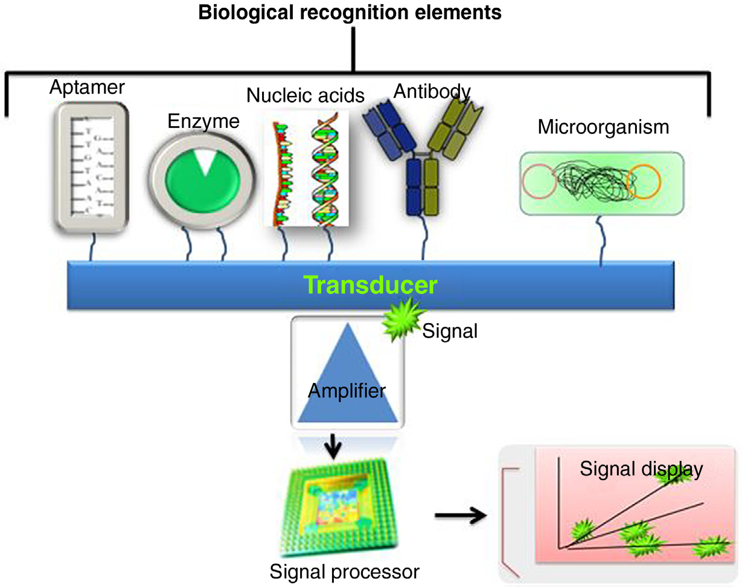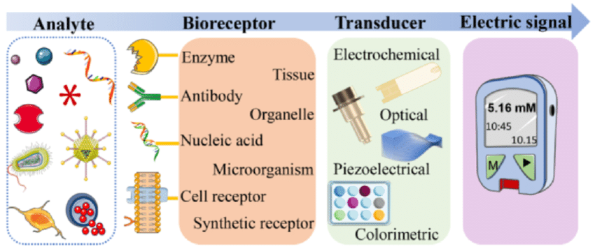**Schematic diagram of Biosensors (Rajkumar *et al.*, 2017)**

**Types of Biosensors**

Biosensors are categorized based on their biological element or bioreceptor, which includes enzyme-based, microbial, and antibody-based biosensors. Enzyme biosensors leverage their catalytic activity and binding properties to achieve specific detection, as seen in glucose sensors. Microbial biosensors utilize microorganisms such as bacteria and fungi to detect specific molecules or assess the overall environmental condition, utilizing indicators such as cell metabolism, viability, respiration, and bio-luminescence. For instance, *Rhodococcus erythropolis* can be employed for biochemical oxygen demand (BOD) measurement. Antibody-based biosensors capitalize on the high specificity between antibodies and antigens. Detection of binding events can be achieved through methods like fluorescent labeling or observation of changes in refractive index or reflectivity. Antibody-based biosensors are commonly used for detecting polychlorinated biphenyls (PCBs), such as nonbiodegradable chemical insecticides and herbicides.

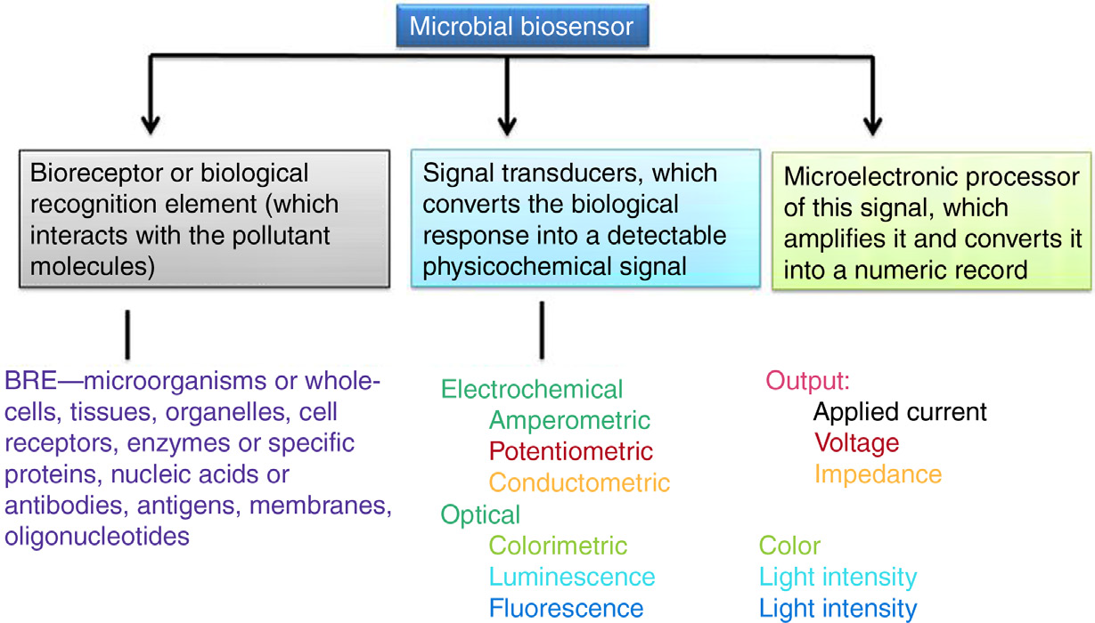**Schematic illustration delineates the constituent elements comprising of microbial biosensor (Rajkumar *et al.*, 2017)**

**ELECTROCHEMICAL BIOSENSORS**

Electrochemical biosensors often rely on enzymatic catalysis to initiate reactions that either generate or consume electrons. The resultant reporter signal is assessed through electrochemical reactions. This methodology enables the assessment of bacterial metabolic activity through the analysis of electrical parameters derived from impedance spectra, which are fitted using an equivalent electrical circuit. Amperometric Microbial Biosensors used in detection of pathogenic microorganism, organophosphate pesticides, cyanide, heavy metals and pollutants like Cd, Pb, Hg, Zn and Cu. Amperometric monooxygenase biosensors are designed to detect aromatic hydrocarbons like phenols and catechol.

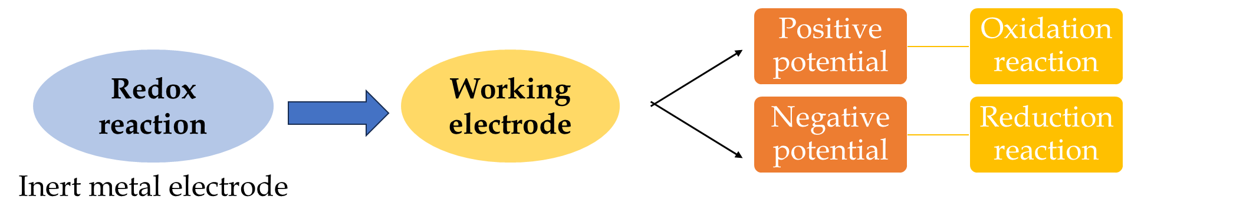

Potentiometric microbial biosensors are employed for the detection of environmental pollutants. The urea-detecting potentiometric biosensor functions as an enzyme-based system. Conductometric microbial biosensors are designed to detect and identify environmental contaminants, including pesticides. Specifically, the conductometric biosensor has been utilized to identify the pesticide methyl parathion (O, O-dimethyl O-4-nitrophenyl phosphorothioate).

**OPTICAL MICROBIAL BIOSENSORS**

An optical biosensor is a device that utilizes an optical transducer to induce changes in various optical properties corresponding to the analyte concentration. Microorganisms capable of detecting analytes can generate optical signals directly proportional to the analyte concentration. These biosensors are crucial for identifying pathogenic organisms, such as *Campylobacter* spp., and offer significant advantages in detecting pesticides like metaphos and methyl parathion. Fluorescent microbial biosensors emit light proportional to the analyte concentration, even at low levels. These biosensors couple stress-responsive genes or promoters with the GFP (Green Fluorescent Protein) coding sequence, allowing for straightforward monitoring of fluorescent signals. An *in vivo* fluorescent biosensor can autonomously produce fluorescent proteins without the need for external stimulation or fluorescent elements and is effectively used for detecting toxic metals. Bioluminescent microbial biosensors, based on the natural bioluminescence (refers to the visible light emitted by living organisms) of certain bacteria, are highly sensitive to various environmental contaminants, such as industrial heavy metals and pesticides. For instance, luminescent-dependent *E. coli* WCB, such as *Ralstonia metallidurans*, has been utilized to assess heavy metals in polluted soil and environments. Colorimetric microbial biosensors detect analyte concentrations by observing changes in the colour of specific compounds. For example, methyl parathion can be hydrolyzed by bacteria into a chromophoric product that can be quantified using colorimetric methods. These indicators are effective for detecting heavy metal contamination in soil. Prussian blue (PB), for instance, has been used as a colorimetric indicator for the detection of contaminants like 3,5-dichlorophenol (DCP), arsenic (As³⁺), and chromium (Cr⁶⁺).

**Properties of a good biosensor**

A good biosensor exhibits several key properties. Firstly, it should demonstrate high specificity for the analyte in question, ensuring accurate detection. Additionally, its response should maintain linearity over a wide range of substrates, enhancing its versatility. The device itself should be compact and bio-compatible, facilitating ease of use and minimizing any potential adverse effects. Moreover, cost-effectiveness is crucial, necessitating that the biosensor be affordable, small, and straightforward to operate. Ideally, the assay cost should undercut that of conventional tests, promoting its widespread adoption. Finally, the assay process should be swift, reliable, and reproducible, ensuring consistent and timely results.

**Advantages and disadvantages**

The method is straightforward and requires no sample processing. A limited number of samples suffice for assessment due to its high sensitivity. It is economically viable and offers good accuracy. Experimental periods for assessment are short, and it is user-friendly. Additionally, it boasts a low detection limit and long-term stability, addressing shortcomings of conventional techniques such as time consumption, sample preparation needs, high cost, and poor selectivity.

However, it cannot undergo heating sterilization as this would damage the biological component of the biosensor, and its cost is relatively high. Some biosensors, like calorimetric test strips, are for single use only, reducing their reusability. Moreover, complex environmental matrices may cause significant interferences during the detection of target analytes by biosensors.

**Conclusion**

Pollution has catastrophic effects on ecosystems, severely hampering economic growth. Pollutants pose significant threats to human health and other living organisms. Commercial sensor techniques are employed specifically for detecting nitrogenous compounds like nitrates and dioxins. Biosensors play a vital role in environmental monitoring and industrial applications, significantly contributing to biotechnology. Microbial biosensors are capable of analyzing moderately complex samples without the need for sample enrichment, while maintaining high sensitivity and selectivity. These biosensors are cost-effective, time-efficient, and excellent for monitoring soil conditions. They are essential tools for reducing expenses and optimizing environmental monitoring. Nano biosensors are crucial in detecting and monitoring pesticides and herbicides, and tracking their bioaccumulation in vegetables. The integration of nanoparticles in biosensor design offers promising future opportunities. Future research should focus on developing smaller, cost-effective, and flexible biosensor technologies to facilitate large-scale soil condition assessments.

**References**

Rajkumar, P., Ramprasath, T., and Selvam, G.S. 2017. A simple whole cell microbial biosensors to monitor soil pollution. In: Grumezescu, A.M. *New pesticides and soil sensors*. Academic Press, pp. 437-481.

Huang, C.W., Lin, C., Nguyen, M.K., Hussain, A., Bui, X.T., and Ngo, H.H. 2023. A review of biosensor for environmental monitoring: principle, application, and corresponding achievement of sustainable development goals. *Bioengineered* 14(1): 58-80.

Bilal, M. and Iqbal, H.M. 2019. Microbial-derived biosensors for monitoring environmental contaminants: Recent advances and future outlook. *Process Safety and Environmental Protection*, 124: 8-17.