**Effect of varied levels of gibberellin, anti-gibberellin and cytokinin on growth and tuberization in potato**

**Bharath1, S. R. and Mohan Raju1*, B.**

1Department of Crop Physiology, University of Agricultural Sciences, GKVK, Bengaluru

Author’s e-mail: [bharathsrramu8@yahoo.com](mailto:bharathsrramu8@yahoo.com)

*Corresponding author’s e-mail: [bmohanraju@gmail.com](mailto:bmohanraju@gmail.com)

**Abstract**

Plant hormones play a significant role in potato tuberization. While Gibberellins inhibit tuberization, anti-gibberellins (PBZ and CCC) and cytokinins promote tuberization in potato. Our experiments demonstrated the clear roles of these hormones in facilitating tuberization in potato. Treatment with 25 ppm GA significantly increased plant height (44.56 cm) compared to the control (32.22 cm), while CCC, a GA inhibitor, reduced the plant height by inhibiting GA-induced stem elongation. Hormonal treatments affected the number of nodes, leaves, branches, SPAD readings, stem girth, root length and root weight with significantly higher values observed compared to the control. 50 ppm GA showed the highest number of stolons per plant (6.33), but surprisingly resulted in a few tubers per plant (1.7) compared to the control (1.8). However, both 5 ppm and 10 ppm BAP led to significantly more tubers per plant (2.1 and 3.2 respectively), as did 5 ppm and 10 ppm Kinetin (2.8 and 2.6 respectively). Regarding tuber fresh weight, all treatments except CCC and higher concentration of kinetin showed significantly higher fresh weight compared to control. In summary, 50 ppm Gibberellins increased the stolon number, while 10 ppm BAP increased the tuber number and fresh weight in potato.

***Keywords***: Potato · Plant Hormone · Gibberellins · Anti-gibberellins · Cytokinin · Tuberization

**Introduction**

Potato (*Solanum tuberosum* L.), a tuber crop is the fourth most important food crop after wheat, rice and maize and is being cultivated worldwide in temperate, tropical and sub-tropical zones. It is the major food crop of the world and by far the most important food crop in terms of quantities produced and consumed worldwide ranking fourth position (375 million metric tons/year) after maize, rice and wheat with an estimated production area of 17.78 million hectares at an average yield of 21.09 tons/ha (FAOSTAT, 2022). The production and consumption of potato is growing in the developing world, whereas it is decreasing in the developed world (Keijbets, 2008). Potato is an important food and cash crop in eastern and Central Africa, playing a major role in national food security and nutrition, poverty alleviation and income generation and provide employment in the production, processing and marketing sub-sectors (Merga and Dechassa, 2019).

Potato is grown for its starchy tubers produced underground from the stolons. Besides starch, tubers are also rich in proteins, fats, dietary fibers and an array of essential nutrients and the vital amino acids like leucine, isoleucine and tryptophan. However, the cultivation of this cool-season crop faces geographical constraints. Potatoes thrive best in specific conditions characterized by shorter days, lower temperatures and sandy soils with acidic pH, which promote tuberization. Genetic, environmental and physiological factors influence tuberization to a large extent (Vreugdenhil and Struik, 1989). Available evidences indicate that, photoperiod, temperature, irradiance and physiological age of the mother tuber affects tuberization either directly or indirectly by mediating changes in hormonal concentrations (Ewing,1995). The process of tuberization involves the cessation of growth in the stolon apical meristem and the induction of first longitudinal and later, random cell division and expansion in the sub-apical region (Xu *et al*., 1998). This is accompanied by deposition of storage carbohydrates (Viola et al., 2007) and proteins (Shewry, 2003) in the tubers.

Several environmental factors such as photoperiods, temperature, plant hormones and light found to regulate tuberization. The photoperiods (Short days 8h light/16h dark) and lower temperature (18° C) has been found to favor tuberization (Tengli *et al*., 2022). With respect to plant hormones, cytokinins favour tuberization, while the gibberellic acid inhibits it. Internally-produced gibberellic acid (GA3), a natural plant hormone (Thomas and Sun 2004; Busov et al. 2008) is known to be involved in promoting stolon growth (Koda and Okazawa 1983) while inhibiting tuber formation (Vreugdenhil and Sergeeva 1999). The application of GA3 to potato plants dramatically increased the misshaping, including pointy ends and dumbbells of harvested tubers (Pavlista, 2013).

Plant hormones play a pivotal role in regulating this process. It is widely acknowledged that, the endogenous phytohormone levels govern tuberization (Gopal *et al*., 2004) and external factors like day-length and temperature can impact tuberization by altering these phytohormone levels (Pathak and Upadhyaya, 2021). All the classes of known hormones exhibit some effect on different stages of tuberization in potato (Aksenova *et al*., 2014). Auxins and cytokinins affect tuber size, while ethylene hinders tuber induction. The application of exogenous gibberellins promotes the development of new stolons, increases the plant height and internodal length (Chindi and Tsegaw, 2019), but inhibits the induction of potato tubers (Alexopoulos *et al*., 2006). Cytokinins such as BAP and Kinetin play a significant role in regulating tuberization in potato. BAP stands out as a crucial plant hormone for inducing tuber formation in potato.

Tuberization in potato is a complex process regulated by various plant hormones that influence the molecular mechanisms involved. Plant hormones such as Gibberellins (GA), Paclobutrazol (PBZ), Chlormequat Chloride (CCC), 6-Benzylaminopurine (BAP) and Kinetin play critical roles in regulating the molecular mechanisms of tuberization in potato (Aksenova *et al*., 2012). Gibberellins are generally known to inhibit tuber formation. High levels of GAs promote stem elongation and vegetative growth, which counteracts the initiation of tuberization (Suttle 2004; Yamaguchi 2008; Gebrehanna *et al*., 2018). PBZ (Paclobutrazol) and CCC (Chlormequat Chloride)are GA biosynthesis inhibitor and thus promote tuberization (Herrera-Isidron *et al*., 2021).By inhibiting GA biosynthesis, PBZ reduces GA levels in the plant, which removes the inhibitory effect of GAs on tuber formation.PBZ treatment leads to the upregulation of tuber-inducing genes and downregulation of GA-responsive growth-promoting genes. This shift in gene expression favors tuber initiation and development (Hedden and Sponsel, 2015).

The 6-Benzylaminopurine (BAP), a cytokinin that promotes tuber formation in potato. Cytokinins like BAP enhance cell division and expansion in the stolons, which are the precursors to the tubers. BAP increases the expression of cytokinin-responsive genes that promote cell division and differentiation in the stolon tips, aiding in tuber development (Dessoky *et al*., 2016; Borna *et al*., 2019; Meenakshi, 2020; Olga *et al*., 2022). It also interacts with other hormones to create a favorable balance for tuberization. Kinetin, another cytokinin source similar to BAP, works synergistically with other hormones to regulate tuberization (Ali *et al*., 2018; Sembiring *et al*. 2020). Hormones signal through specific pathways involving receptors, secondary messengers, and transcription factors converge to regulate the expression of key genes involved in tuberization (Kondhare *et al*., 2021). Hormones modulate the expression of genes like *StBEL5* and *StSP6A*, which are critical for tuber development. *StBEL5* is a transcription factor that promotes tuberization, while *StSP6A* is a mobile RNA acting as a signal for tuber induction (Hannapel *et al*., 2021). The hormones interact in a network where the balance between promoting (e.g., cytokinins, ABA) and inhibiting (e.g., GAs) signals determines the initiation and growth of tubers. This balance is tightly regulated through feedback mechanisms (Xu et al., 2012). In summary, the regulation of tuberization in potato involves a delicate balance of hormonal signals that control the expression of key genes and coordinate the growth and differentiation of stolons into tubers.

**Material and methods:**

**Planting material**

Top of Form

The experiments were conducted at the Plant Tissue Culture Laboratory, Department of Crop Physiology, University of Agricultural Sciences, GKVK, Bangalore, India. The virus-free planting material of potato (*Solanum tuberosum L*.) cultivar, Kufri Jyothi (KJ) was procured from the Central Potato Research Institute (CPRI), Shimla, India and used for the experiments.

***In-vivo* studies to examine the role of plant hormones on tuberization in potato**

Plant hormones have been shown to regulate tuberization in potato. Studies from our own laboratory showed the role of cytokinin inducing mini-tubers in potato (Tengli *et al*., 2022). In this regard, we tested different hormones including anti-GA to examine whether or not these plant hormones and hormonal combinations do influence tuberization in potato. For this experiment, *in vitro* grown potato plantlets were used. The single node cuttings made from virus free plant material were cultured in vitro in MS media and after 21 days, the plantlets developed from single node cuttings were used for further experiments after their hardening.

**Details of the experiment**

Potato plantlets grown in tissue culture bottles were hardened by transferring the plants to portrays and gradually exposing them to increased temperature under a poly house condition. These acclimatized plantlets were then transferred to pots with coir pith to encourage root growth. Once the plantlets displayed a strong root development, they were moved to pots with a soil medium to support overall plant growth. To investigate tuberization in potato, various plant hormones such as Gibberellic acid (GA3) and anti-GA like paclobutrazol (PBZ) and CCC, cytokinin like BAP (Benzyl Amino Purine) and kinetin (cytokinin sources) were applied separately as foliar sprays in different concentrations at stolonization period. The experiment was conducted in three replications following completely randomized block design to evaluate the influence of these plant hormones on the tuberization process in potato.

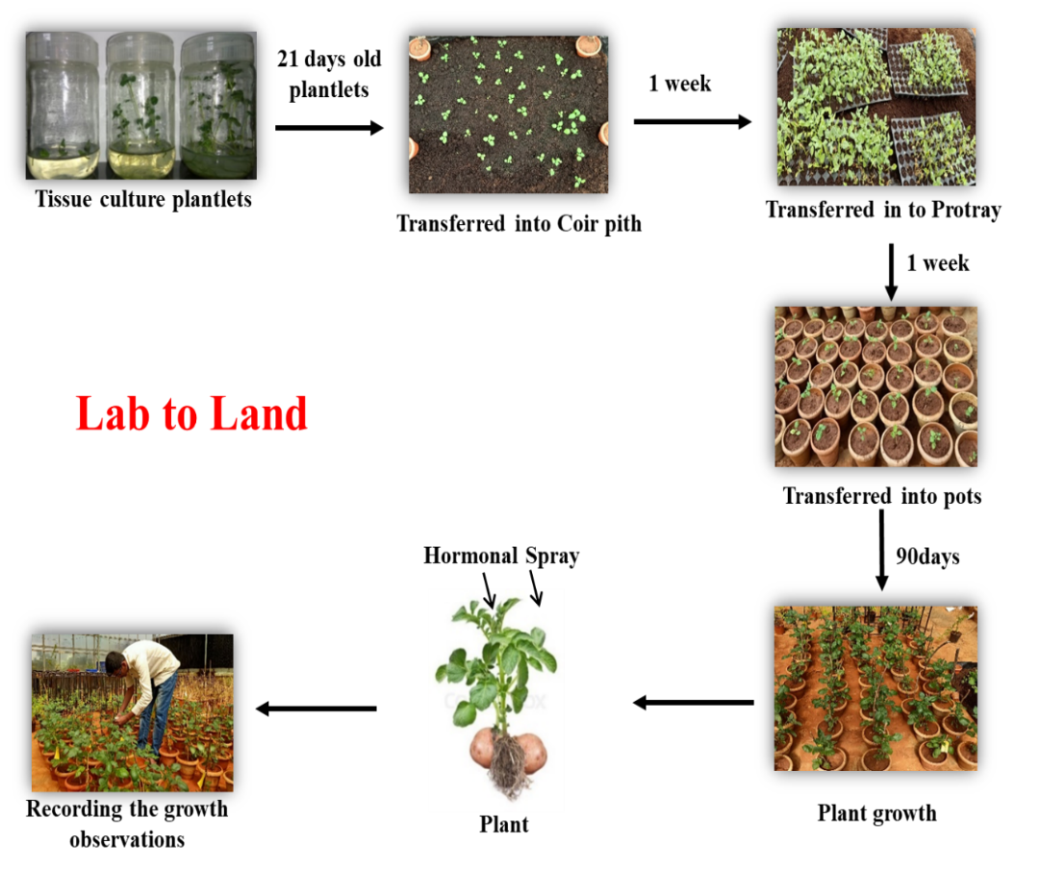The experiment utilized various hormonal sources including Benzyl Amino Purine (BAP) and kinetin at a concentration of 5 and 10 ppm alongside gibberellins and anti-gibberellin (anti-GA) sources such as paclobutrazol at 5 and 10 ppm and Chlormequat chloride (CCC) at 5 and 10 ppm. These hormones were applied through foliar sprays at 45 days after sowing, specifically during the initiation of stolonization and tuber development stages. The growth observations were recorded at 90 days after planting on plant height, number of nodes, number of leaves, stem girth, SPAD, root length, root fresh weight, number of stolons per plant, number of tubers per plant and tuber fresh weight was examined (Flowchart 1).

Flowchart 1: **Schematic representation of lab to land.** Transfer of tissue cultured plants from laboratory conditions to greenhouse conditions and studied for phytohormone response on tuberization.

**Results and discussion**

**Effect of plant hormones on tuberization under *in-vivo* conditions**

This study investigated the effect of different plant hormones on the growth parameters of potato plantlets. The tested plant hormones encompassed Gibberellic Acid (GA) at 25 and 50 ppm, Paclobutrazol (PBZ) at 5 and 10 ppm, CCC at 5 and 10 ppm, Benzylaminopurine (BAP) at 5 and 10 ppm, and Kinetin (KIN) at 5 and 10 ppm. The control group received water treatment. The study aimed to assess the various growth parameters such as plant height, leaf number, root length and overall biomass as influenced by the plant hormones. By comparing the results of the hormone-treated groups with the control, the study seeks to elucidate the specific effects of each hormones and their concentrations on potato plantlet growth and development besides tuberization. This research holds significance for understanding how diverse hormonal treatments can be employed to enhance the growth of potato plantlets potentially impacting agricultural practices and future crop yields.

The results indicate that, different plant hormonal treatments showed significantly higher plant height compared to control. Plants treated with GA showed significantly higher plant height compared to those treated with GA inhibitors and cytokinin. Although GA inhibitors such as CCC and paclobutrazol reduces the plant height, the reduction is not as low as control plants (Table 1; Plate 1). The results of the experiment also revealed a significant variation in the number of nodes across different hormonal treatments. Except 25 ppm GA, all other treatments had significantly higher number of nodes per plant compared to control. GA inhibitors shown to exhibit significantly higher number of nodes (Table 1; Plate 1). In conclusion, the findings suggest that, certain concentrations of PBZ (5 and 10ppm) and Kinetin (10ppm) resulted in a notable increase in the number of nodes compared to the control treatment. Likewise, the number of leaves remained unaffected by 25 and 50 ppm GA (20.44 and 20.78, respectively) compared to the control treatment (19.11). However, other hormonal treatments resulted in increased leaf number and the data is highly significant These results offer valuable insights into the impact of various hormonal concentrations on the growth parameters of *in-vivo* cultivated potato plantlets (Table 1; Plate 1).

Gibberellic acid present in leaves, stems and below-ground parts plays a crucial role in the tuberization process of potato (Sattelmacher and Marschner, 1979). Throughout the plant's life cycle, gibberellic acid functions to stimulate the growth of various plant organs by enhancing both cell division and cell elongation (Pal *et al*., 2023). When potato plants were sprayed with gibberellic acid (GA) during the emergence of the 15th leaf, it resulted in an increased leaf area and elevated total gibberellin content. GA also led to an augmentation in chlorophyll content per leaf, but the increase in leaf area was more pronounced causing a reduction in chlorophyll per unit area. Consequently, the treated leaves appeared paler compared to untreated leaves (Verdun, 1959).

**Table 1: Effect of different concentrations of hormones on various growth parameters in *in-vivo* grown potato plantlets (Var. Kufri Jyoti)**

|  |  |  |  |  |  |
| --- | --- | --- | --- | --- | --- |
| **Treatments** | | **Plant height (cm)** | **No. of nodes** | **No. of leaves** | **No. of branches** |
| Control | Water | 32.22**g** | 17.78**f** | 19.11**e** | 1.32**b** |
| GA | 25 ppm | 44.56**a** | 18.56**ef** | 20.44**e** | 1.22**bc** |
| 50 ppm | 42.22**b** | 20.22**e** | 20.78**e** | 1.33**b** |
| PBZ | 5 ppm | 41.89**b** | 38.22**a** | 38.22**ab** | 1.32**b** |
| 10 ppm | 35.44**f** | 35.00**bc** | 36.33**bc** | 1.67**a** |
| CCC | 5 ppm | 36.11**ef** | 29.33**d** | 35.33**c** | 1.00**c** |
| 10 ppm | 37.94**de** | 38.00**a** | 37.67**abc** | 1.11**bc** |
| BAP | 5 ppm | 40.33**bc** | 38.11**a** | 38.11**ab** | 1.22**bc** |
| 10 ppm | 38.89**cd** | 31.33**d** | 38.89**a** | 1.11**bc** |
| Kinetin | 5 ppm | 36.22**ef** | 34.11**c** | 32.89**d** | 1.67**a** |
| 10 ppm | 38.56**cd** | 36.33**ab** | 39.00**a** | 1.11**bc** |
| **CD (P<0.01)** | | **1.952\*\*** | **2.098\*\*** | **2.302\*\*** | **0.219\*\*** |
| **SE(m)** | | **0.661** | **0.711** | **0.78** | **0.074** |
| **SE(d)** | | **0.935** | **1.005** | **1.103** | **0.105** |
| **CV (%)** | | **2.969** | **4.018** | **4.165** | **10.052** |

** Significant at 1% level

The data also indicated that, both the 10 ppm PBZ and 5 ppm KIN treatments displayed a significantly higher number of branches (1.67 each) compared to the control treatment (1.32). Interestingly, treatments with 25 ppm GA, 50 ppm GA, 5 ppm PBZ and 10 ppm CCC did not exhibit any significant differences among themselves demonstrating similar numbers of branches (1.22, 1.33, 1.32 and 1.11, respectively) when compared to the control treatment (1.32). Additionally, treatments with 5 ppm BAP, 10 ppm BAP and 10 ppm Kinetin demonstrated numbers of branches (1.22, 1.11, and 1.11, respectively) that were significantly comparable to the control treatment (1.32). These findings suggest that, specific concentrations of PBZ and Kinetin (5 ppm and 10 ppm) significantly promote branching, while certain concentrations of GA, PBZ and CCC maintain a similar number of branches as observed in the control (Table 1; Plate 1). Regarding the stem girth, GA treated plants showed reduced stem girth compared to the control. However, plants treated with GA inhibitors showed improved stem girth over control and GA suggesting the inhibition of GA induced stem elongation (Table 2; Plate 1). In conclusion, the study highlights the concentration-dependent effects of PBZ, BAP, CCC, KIN, and GA on the growth parameters of potato plantlets providing valuable insights for optimizing hormones applications in potato cultivation.

The study also revealed the diverse impacts of different hormonal concentrations on the leaf nitrogen status as assessed through SPAD measurements. Specifically, 10 ppm concentrations of PBZ, CCC, and BAP resulted in significantly higher SPAD readings, while 5 ppm concentrations of CCC, BAP, and 25 ppm GA also led to significantly higher SPAD readings compared to the control treatment. Conversely, 5 ppm KIN and 50 ppm GA showed significantly lower SPAD readings compared to the control treatment (Table 2; Plate 1). It appears, higher concentration of GA stimulates the plant height making the plants to put on vegetative growth with deficit of nitrogen and hence, the SPAD values are low in plants treated with high concentration of GA.

Hormonal treatment also influenced root length and root fresh weight with significantly higher root length and root weight observed under different hormonal treatments compared to control. This suggest that, different plant hormones influence root growth (Table 2; Plate 1). The GA concentration of 25 ppm (4.72) demonstrated a significantly higher number of stolons per plant compared to the control treatment (1.61). The GA concentration of 50 ppm exhibited an even higher number of stolons per plant (6.33) surpassing not only the control (1.61) but also all other treatments. Both the 5 and 10 ppm concentrations of PBZ resulted in a significantly higher number of stolons per plant (4.11 and 4.33 respectively) compared to the control (1.61) treatment. The 5 ppm and 10 ppm concentrations of CCC led to a significantly higher number of stolons per plant (4.44 and 3.66 respectively) compared to the control (1.61) treatment. Nevertheless, the stolon count was lower than that observed with GA treatments. Both the 5 ppm and 10 ppm concentrations of BAP resulted in significantly higher number of stolons per plant (3.55 and 2.56 respectively) compared to the control treatment (1.61). However, the stolon count was lower when compared to GA treatments, suggesting a differential effect on stolon development. The 5 ppm and 10 ppm concentrations of Kinetin led to a significantly higher number of stolons per plant (4.44 and 2.33 respectively) compared to the control treatment (1.61) (Figure 1; Plate 1).

**Table 2: Effect of different concentrations of hormones on various parameters in *in-vivo* grown potato plantlets (Var. Kufri Jyoti)**

|  |  |  |  |  |  |
| --- | --- | --- | --- | --- | --- |
| **Treatments** | | **SPAD Reading** | **Stem girth** | **Root length (cm)** | **Root fresh weight (gm)** |
| Control | Water | 42.82**h** | 3.31**cd** | 22.00**f** | 0.15**f** |
| GA | 25 ppm | 43.17**gh** | 3.28**cd** | 23.33**ef** | 0.25**f** |
| 50 ppm | 35.38**j** | 3.08**d** | 24.89**de** | 0.27**f** |
| PBZ | 5 ppm | 84.53**a** | 3.58**bc** | 32.70**a** | 1.23**a** |
| 10 ppm | 57.94**b** | 3.53**bc** | 30.00**b** | 0.81**d** |
| CCC | 5 ppm | 51.22**d** | 3.42**cd** | 29.94**b** | 0.83**cd** |
| 10 ppm | 56.42**c** | 3.84**ab** | 26.33**cd** | 1.24**a** |
| BAP | 5 ppm | 44.44**fg** | 3.47**c** | 31.17**ab** | 0.55**e** |
| 10 ppm | 48.42**e** | 3.96**a** | 26.67**cd** | 0.95**bc** |
| Kinetin | 5 ppm | 41.44**i** | 3.57**bc** | 32.21**a** | 1.01**b** |
| 10 ppm | 45.19**f** | 3.22**cd** | 27.67**c** | 1.23**a** |
| **CD (P<0.01)** | | **1.354\*\*** | **0.331\*\*** | **1.828\*\*** | **0.133\*\*** |
| **SE(m)** | | **0.459** | **0.112** | **0.619** | **0.045** |
| **SE(d)** | | **0.649** | **0.159** | **0.876** | **0.064** |
| **CV (%)** | | **1.586** | **5.591** | **3.844** | **10.084** |

** Significant at 1% level

Stolon initiation in potato significantly coincides with the period of tuber initiation (Claassens and Vreugdenhil, 2000). Evidently, the hormonal status is not uniform for each stolon and variations may even exist between individual tips of a branched stolon. This lack of synchronization in various developmental steps is frequently overlooked in descriptions of tuber formation. Additionally, gibberellins are known to prevent, inhibit or delay tuber initiation (Vreugdenhil and Struik, 1989; Pharis, 1991). Consequently, the reduction of gibberellin levels under short-day (SD) conditions has a dual effect as it decreases stolon elongation and facilitates tuber initiation. However, this does not imply that, gibberellins are the sole determinants of tuber initiation. They exert a negative influence, while other factors play a positive regulatory role and under short-day (SD) conditions, the application of gibberellin does not prevent tuber formation (Hannapel, 2007) suggesting GA alone may not inhibit tuberiztion in potato rather controlled by many factors.



Figure 1: **Influence of different phytohormones on tuberization in potato:** (a) Stolon number per plant.

The results illustrate the varied impacts of different concentrations of plant hormones on the number of stolons per potato plant. Gibberellic Acid, particularly at 50 ppm emerged as the most effective hormone in promoting stolon development. However, other hormones such as PBZ, CCC, BAP and Kinetin also exhibited a significant effects indicating their potential roles in regulating specific aspects of potato plantlet growth (Figure 1; Plate 1).

The 25 ppm GA concentration (2.4) significantly enhanced the number of tubers per plant compared to the control treatment (1.8). Surprisingly, the 50 ppm GA concentration (1.7) resulted in a significantly lower number of tubers per plant compared to both the control (1.8) and other hormone-treated samples. Al-Doori (2023) demonstrated that, applying gibberellic acid (GA3) through foliar spray at three-day intervals during the tuberization stage led to a decrease in tuber yield. This finding aligns with Yopp’s (2018) observation, where daily spraying of GA3 on the shoots from plant emergence up to three weeks at 10 ppm resulted in a reduction in total tuber number. In essence, the application of GA3 is associated with a decrease in tuber number and overall tuber yield in potato.

Both 5 and 10 ppm of PBZ and CCC led to a significantly higher number of tubers per plant (2.6 and 2.8 respectively) and (1.9 and 2.2 respectively) compared to the control treatment (1.8). Paclobutrazol, a triazolic fungicide, regulates plant growth by disrupting ent-kaurene oxidase activity in the ent-kaurene oxidation pathway, a critical step in gibberellic acid biosynthesis resulting in decreased gibberellic acid levels (Hanson and Willis, 1992). It inhibits three oxidative steps from ent-kaurene to ent-kaurenoic acid blocking the synthesis of gibberellins in the early phase of the biosynthetic pathway (Rademacher, 2020). This inhibitory effect is supported by lower gibberellic acid levels in treated plants, and some paclobutrazol effects can be reversed by gibberellic acid application (Tsegaw, 2007). Tekalign and Hammes (2005) demonstrated that, thirty days after planting (early stolon initiation), foliar application of PBZ to leaves significantly affected fresh tuber yield in potato plants.

Both 5 and 10 ppm of BAP led to a significantly higher number of tubers per plant (2.1 and 3.2 respectively) compared to the control treatment (1.8). Notably, the 10 ppm BAP resulted in a higher number of tubers per plant (3.2) compared to other concentrations. Similarly, both 5 and 10 ppm Kinetin resulted in a significantly higher number of tubers per plant (2.8 and 2.6 respectively) compared to the control treatment (1.8) (Figure 2; Plate 1). Cytokinins (CKs), classical plant hormones are recognized for promoting potato tuber formation particularly in conventional in vitro systems (Lomin *et al*., 2020). CKs play a role in tuber development in potato (Eviatar-Ribak *et al*., 2013) and the formation of tuber-shaped rounded tumors on agrobacteria-infected plants. Besides stimulating tuber formation, CKs contribute to tuber sprouting (Lomin *et al*., 2020). The morphogenic impact of CKs is rooted in their ability to induce cell divisions (Thu *et al.,* 2017) although their influence extends beyond this aspect. Collectively, the literature emphasizes the crucial role of the CK regulatory system in enhancing tuber yield in valuable tuber-producing crops like potato.



Figure 2: **Influence of different phytohormones on tuberization in potato:** (b)Tuber number per plant.

With respect to fresh weight of tubers, except BAP, PBZ and lower concentration of kinetin treatment, in all other treatments, the fresh weight did not differ significantly with control treatment(Figure 3; Plate 1).The study reveals varied effects of different plant hormonal concentrations on tuber fresh weight in in-vivo grown potato plantlets. PBZ, BAP, and 5ppm Kinetin exhibit positive influence, while GA, CCC, and 10 ppm Kinetin have negative impacts. These findings provide valuable insights for optimizing growth conditions in potato cultivation by manipulating plant hormone concentrations. Caldiz (1996) demonstrated that, cytokinins when applied as foliar-spray on potato plants, improved tuber yield from 7.2 to 12.7 t/h. Similarly, Chugh and Kumar (2022) found that, 50 ppm of the cytokinin source, 6-benzyl adenine purine (BAP) applied 34 days after planting, significantly influenced early tuberization and increased tuber yield. In another study, El-Areiny *et al*. (2019) showed that, CPPU, a cytokinin source applied as a foliar application at 0.12 M concentration resulted in more tubers per plant and higher tuber yield. Similarly, Malek *et al*. (2021) demonstrated that, foliar application of cytokinin increased the number of tubers per plant, tuber fresh weight, yield/plant and total yield. Hence, the available information unequivocally proves that, cytokinin promotes tuberization, while GA inhibits tuberization in potato. However, the effects of GA can be mitigated with anti-GA applications.



Figure 3: **Influence of different phytohormones on tuberization in potato:** (c) Tuber fresh weight.

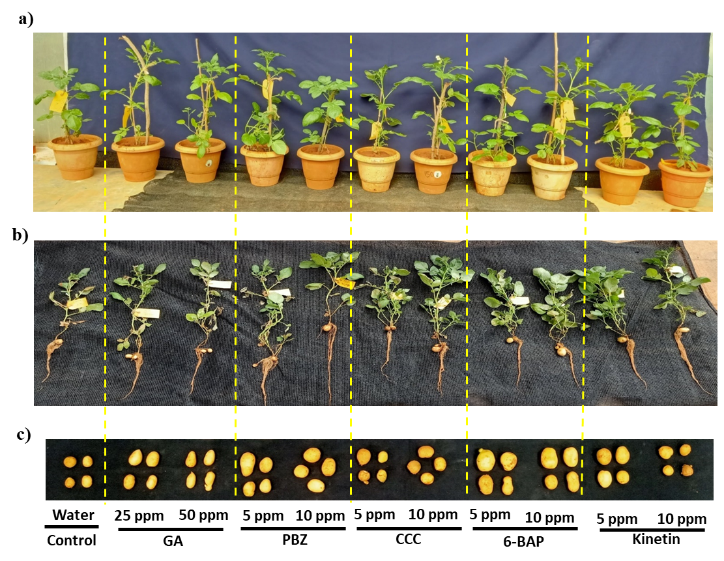

Plate 1: **Effect of phytohormones on plant growth and tuberization in potato *under in vivo* condition.** a) Plants in the greenhouse before harvest. b) After uprooting from pots. c) Potato tubers were collected and taken observations.

In summary, the study unveiled diverse effects of different plant hormones on tuber formation in in-vivo cultivated potato plantlets. While GA inhibits tuber numbers, the others such as PBZ, CCC, BAP, and Kinetin treatments at both 5 and 10 ppm concentrations consistently showed higher number of tubers per plant compared to the control. Additionally, the study underscores the significance of hormonal concentration with certain concentrations such as 10 ppm of BAP demonstrating superior effects on tuber formation. These findings contribute valuable insights into optimizing plant hormone applications for enhancing tuber yield in potato cultivation.

**Conclusion**

Plant hormones play a significant role in potato tuberization. Gibberellins, anti-gibberellins (PBZ and CCC), and cytokinins promote the processes of stolonization and tuberization in potato. 50 ppm of Gibberellins increased the number of stolons, while 10 ppm of BAP increased the number and fresh weight of tubers in potato.

***Acknowledgments***

The authors acknowledge the CPRI, Shimla and the College of Horticulture, UHS, Bagalkot for sparing the material and the Plant tissue culture laboratory, Department of Crop Physiology, University of Agricultural Sciences for the facilities extended in the successful completion of this investigation.

***Conflict of interest***

The authors disclose no conflict of interest

**References**

Aksenova, N. P., Konstantinova, T. N., Golyanovskaya, S. A., Sergeeva, L. I. and Romanov, G. A. 2012. Hormonal regulation of tuber formation in potato plants. *Russian J. Plant Physiology*, **59** (4): 451-466. <https://doi.org/10.1134/s1021443712040024>

Aksenova, N. P., Sergeeva, L. I., Kolachevskaya, O. O. and Romanov, G. A. 2014. Hormonal regulation of tuber formation in potato. *Bulbous plants: Biotechnology*, 3-36.

Al-doori, S. 2023. Determining of Optimum Concentration of Foliar Spraying with Gibberellic (GA3) and Indole acetic acid (IAA) on Growth and Productivity of Three Sesame Genotypes (Sesamum indicum L.). *Muthanna Journal for Agricultural Sciences*, **10** (2): 1-15. <https://doi.org/10.52113/mjas04/10.2/28>.

Alexopoulos, A. A., Akoumianakis, K. A. and Passam, H. C. 2006. Effect of plant growth regulators on the tuberisation and physiological age of potato (*Solanum tuberosum* L.) tubers grown from true potato seed. *Canadian Journal of Plant Science*, **86**(4): 1217-1225.

Ali, S., Khan, N., Nouroz, F., Erum, S., Nasim, W. and Shahid, M. A., 2018, *In vitro* effects of GA3 on morphogenesis of CIP potato explants and acclimatization of plantlets in field. *In Vitro Cellular and amp; Developmental Biology Plant*, 54(1):104–111. <https://doi.org/10.1007/s11627-017-9874-x>

Borna, R. S., Hoque, M., I. and Sarker R., H. 2019. *In vitro* microtuber induction and regeneration of plantlets from microtuber discs of cultivated potato (*Solanum tuberosum* L.). *Plant Tissue Cult. and Biotech.,* **29**(1):63-72. <https://doi.org/10.3329/ptcb.v29i1.41979>

Busov, V. B., Brunner, A. M. and Strauss, S. H. 2008. Genes for control of plant stature and form. *New Phytologist,* **177**: 589-607.

Caldiz, D. 1996. Seed potato (*Solarium tuberosum* L.) yield and tuber number increase after foliar applications of cytokinins and gibberellic acid under field and glasshouse conditions. *Plant Growth Regulation*, **20**: 185-188. <https://doi.org/10.1007/bf00043306>

Chindi, A. and Tsegaw, T. 2019. Effect of gibberellic acid on growth, yield and quality of potato (*Solanum tuberosum* L.) in central highlands of Ethiopia. *J. Hortic. Sci. For*, **1**(2):1-10.

Chugh, P., and Kumar, A. 2022. Novel plant growth regulators in i*n vitro* establishment of horticulture and plantation crops. Commercial scale tissue culture for horticulture and plantation crops, 65–84. <https://doi.org/10.1007/978-981-19-0055-6_4>

Claassens, M. M. and Vreugdenhil, D., 2000, Is dormancy breaking of potato tubers the reverse of tuber initiation? *Potato Research*, **43**: 347-369.

Dessoky, E. L. D. S., Attia O. A., Ismail A. I. and Ehab El-hallous, I. 2016. In vitro Propagation of Potato under Different Hormonal Combination. *Int. J. of Advanced Research*., **4** (1) :684– 689.

El-areiny, A. A., Alkharpotly, A. A., Gabal, A. A., and Abido, A. I. 2019. Potato yield and quality as affected by foliar application with cytokinin and salicylic acid. *Journal of the Advances in Agricultural Researches*, **24**(1): 52-77.

Eviatar-Ribak Tamar, Akiva Shalit-Kaneh, Louise CHappell-Maor, Ziva Amsellem, Yuval Eshed and Eliezer Lifschitz. 2013. A Cytokinin-Activating Enzyme Promotes Tuber Formation in Tomato. *Current Biology*, **23**: 1057–1064. <https://doi.org/10.1016/j.cub.2013.04.061>

Ewing, E. E. 1995. The role of hormones in potato (*Solanum tuberosum L*.) tuberization. In *Plant hormones: Physiology, biochemistry and molecular biology* (pp. 698-724). Dordrecht: Springer Netherlands.

FAO (Food and Agriculture Organization), 2022. Production Yearbook. Rome, Italy.

Gebrehanna, L. T., Chindi, A., Wgiorgis, G., Solomon, A., Shunka, E. and Seid, E. 2018. Accelerating seed potato production by using rapid multiplication systems in ethiopia*. Open Science Journal*, **3** (1). <https://doi.org/10.23954/osj.v3i1.753>.

Gopal, J., Chamail A. and Sarkar, D. 2004. In vitro production of microtubers for conservation of potato germplasm: effect of genotype, abscisic acid, and sucrose. *In Vitro Cell. Dev. Biol. Plant*., **40**: 485-490. <https://doi.org/10.1079/ivp2004540>

Hannapel David J.., Pooja Sharma., Tian Lin. and Anjan K. Banerjee. 2021. The Multiple Signals That Control Tuber Formation, *Plant Physiology*, **174**: 845–856.

Hannapel, D. J. 2007. Signalling the induction of tuber formation. In *Potato biology and biotechnology,* (237-256). Elsevier Science BV.

Hanson, J. R. and Willis, C. L. 1992. The effect of some Ent-kaurene alcohols on gibberellic acid biosynthesis in Gibberella fujikuroi. *Phytochemistry*, **31**(8): 2709-2712. <https://doi.org/10.1016/0031-9422(92)83616-7>.

Hedden, P. and Sponsel, V., 2015, A Century of gibberellin research. *Journal of Plant Growth Regulation*, **34** (4): 740-760. <https://doi.org/10.1007/s00344-015-9546-1>

Herrera-Isidron Lisset, Eliana Valencia-Lozano, Pablo Yamild Rosiles-loeza, Maria Guadalupe Robles-Hernández, Abigail Napsuciale-Heredia and Jose Luis Cabrera-Ponce. 2021. Gene Expression Analysis of Microtubers of Potato Solanum tuberosum L. Induced in Cytokinin Containing Medium and Osmotic Stress. *Plants*, **10** (5): 876. <https://doi.org/10.3390/plants10050876>

Keijbets, M. J. H., 2008. Potato Processing for the Consumer: Developments and Future Challenges. *Potato Res*. 51:271–281.

Koda, Y. and Okazawa, Y. 1983. Characteristic changes in the levels of endogenous plant hormones in relation to the onset of potato tuberization. *Japanese Journal of Crop Science* **52**: 592–597.

Kondhare, K. R., Kumar, A., Patil, N. S., Malankar, N. N., Saha, K. and Banerjee, A. K. 2021. Development of aerial and belowground tubers in potato is governed by photoperiod and epigenetic mechanism. *Plant Physiology*, **187** (3): 1071–1086. <https://doi.org/10.1093/plphys/kiab409>

Lomin, S. N., Myakushina, Y. A., Kolachevskaya, O. O., Getman, I. A., Savelieva, E. M., Arkhipov, D. V. and Romanov, G. A. 2020. Global view on the cytokinin regulatory system in potato. *Frontiers in Plant Science*, 11: 613624.

Malek, S., Ali Abido, A. I., Khalil, G. A. N., Ziton, M. and Gabel, A. A. 2021. Yield and quality of potato as affected by foliar spraying of boron and cytokinin. *Journal of the Advances in Agricultural Researches*, **26**(2): 86-99.

Meenakshi, K. 2020. Modulation in growth and development of potato (Solanum tuberosum L.) micro-tubers by different concentration of 6-benzyl amino-purine. *African J. of Plant Sci*., 14(2): 102-107. <https://doi.org/10.5897/ajps2019.1897>

Merga, B. and Dechassa, N. 2019. Growth and productivity of different potato cultivars. *Journal of Agricultural Science*, **11**(3): 528.

Olga, V. G., Eugeny S. P. B., Gafitskaya Irina V. A., Vereshchagina Yulia V. A., Burkovskaya Elena V. A., Khrolenko Yulia A. A., Grigorchuk Valeria P. A., Nakonechnaya Olga V. A., Bulgakov Victor P. A. and Kulchin Yuri N. B. 2022. Growth of Micro-propagated Solanum tuberosum L. Plantlets under Artificial Solar Spectrum and Different Mono- and Polychromatic LED Lights. *Horticultural Plant J*., **8** (2): 205–214. <https://doi.org/10.1016/j.hpj.2021.04.007>.

Pal, P., Ansari, S. A., Jalil, S. U. and Ansari, M. I. 2023. Regulatory role of phytohormones in plant growth and development. In *Plant Hormones in Crop Improvement* (1-13). Academic Press.

Pathak, A. and Upadhyaya, C. P. 2021. A Brief Insight on the Role of Various Phytohormones in Potato (*Solanum tuberosum* L) Tuber Development. *Salicylic Acid-A Versatile Plant Growth Regulator*, 249-263.

Pavlista, A. D. 2013. Influence of foliar-applied growth retardants on russet burbank potato tuber production. *American Journal of Potato Research*, **90**: 395-401.

Pharis, R. P. 1991. Physiology of Gibberellins in Relation to Floral Initiation and Early Floral Differentiation. *Gibberellins*, 166–178. <https://doi.org/10.1007/978-1-4612-3002-1_16>.

Rademacher, W. 2020. Gibberellins: metabolic pathways and inhibitors of biosynthesis. In *Target sites of herbicide action,* (127-145). CRC Press.

Sattelmacher, B. and Marschner, H. 1979. Tuberization in potato plants as affected by applications of nitrogen to the roots and leaves. *Potato Research*, **22**(1): 49-57. <https://doi.org/10.1007/bf02356732>.

Sembiring R Hayati, M and Kesumawati E. 2020. Formation of potato micro tubers (*Solanum tuberosum* L.) by using BAP and coconut water in the in vitro culture*. Earth and Environmental Science*, **425**: 012072. <https://doi.org/10.1088/1755-1315/425/1/012072>

Shewry, P. R. 2003. Tuber Storage Proteins. *Annals of Botany*, 91(7): 755–769. <https://doi.org/10.1093/aob/mcg084>

Suttle, J. C. and Banowetz, J. 2000. Comparing potato tuberization and sprouting opposite phenomena. *American journals of Potato Research*, July/Aug. 2004.

Tekalign, T. and Hammes, P. S. 2005. Growth responses of potato *(Solanum tuberosum*) grown in a hot tropical lowland to applied paclobutrazol: 2. Tuber attributes. *New Zealand Journal of Crop and Horticultural Science*, **33**(1): 43-51.

Tengli, S., Swetha T. N, Koppad, A., Geetha Govind, Mohan Raju, B. 2022. Shoot and root zone temperatures are critical in bidirectional regulation of tuberization in potato. [*Environmental and Experimental Botany*](https://www.sciencedirect.com/journal/environmental-and-experimental-botany)*,* 201: 1-12.

Thomas, S. G. and Sun, T. P. 2004. Update on gibberellin signaling. A tale of the tall and the short. *Plant Physiology,* **135**: 668-676.

Thu, N. B. A., Hoang, X. L. T., Truc, M. T., SUlieman, S., Thao, N. P. and Tran, L. S. P. 2017. Cytokinin signaling in plant response to abiotic stresses. *Mechanism of plant hormone signaling under stress*, 1: 71-100.

Tsegaw, T. 2007. *Response of potato to paclobutrazol and manipulation of reproductive growth under tropical conditions* (Doctoral dissertation, University of Pretoria).

Verdun, J. 1959. Photosynthesis in Conifers Computed Per Unit Leaf Area, Dry Weight, Volume, Chlorophyll Content and Respiratory Rate. *Ecology,* **40**(4): 738-738. Portico. <https://doi.org/10.2307/1929836>

Viola, R., Pelloux, J., Van Der Ploeg, A., Gillespie, T., MARQUIS, N., ROBERTS, A. G., & HANCOCK, R. D. 2007. Symplastic connection is required for bud outgrowth following dormancy in potato (*Solanum tuberosum L*.) tubers. *Plant, Cell and Environment*, **30** (8): 973-983.

Vreugdenhil, D. AND Sergeeva, L. I. 1999. Gibberellins and tuberization in potato. *Potato Research*, **42**(3-4): 471-481. <https://doi.org/10.1007/bf02358163>

Vreugdenhil, D. and Struik, P. C. 1989. An integrated view of the hormonal regulation of tuber formation in potato (*Solanum tuberosum*). *Physiologia Plantarum*, **75** (4), 525-531.<https://doi.org/10.1111/j.1399-3054.1989.tb05619.x>

Xu Xin, Andre´ A. M. Van lammeren, Evert Vermeer and Dick Vreugdenhil. 1998. The Role of Gibberellin, Abscisic Acid and Sucrose in the Regulation of Potato Tuber Formation in Vitro. *Plant Physiol*. **117**: 575–584. <https://doi.org/10.1104/pp.117.2.575>

Xu, W., Jia, L., Shi, W., Liang, J., Zhou, F., Li, Q. and Zhang, J. 2012. Abscisic acid accumulation modulates auxin transport in the root tip to enhance proton secretion for maintaining root growth under moderate water stress. *New Phytologist*, **197**(1): 139-150. Portico. <https://doi.org/10.1111/nph.12004>.

Yamaguchi, S. 2008. Gibberellin metabolism and its regulation. *Annual Review of Plant Biology,* **59**(1): 225-251. <https://doi.org/10.1146/annurev.arplant.59.032607.092804>.

Yopp, J. H. 2018. Bioassays for plant hormones and other naturally occurring plant growth regulators. *Handbook of Natural Pesticides: Methods: Vol.,* I*: Theory, Practice, and Detection*, 329.