Influence of abiotic factors and enzyme activities on the biocontrol potential of nematophagous fungus, *Clonostachys rosea***(**TNAU CRN 01)on root knot nematode in bitter gourd.

**G. Jothi 1, N. Swarnakumari1 and L. Rajendran2**

1Department of Nematology, AC & RI, TNAU, Coimbatore, Tamil Nadu, India.

2Department of Plant Pathology, AC & RI, TNAU, Coimbatore, Tamil Nadu, India.

### ABSTRACT

*Clonostachys rosea* (Link: Fr.) Schroers a soil-borne mycoparasitic fungus which is an effective biological control agent for control of root-knot nematodes. However, the efficiency of many biological control agents, depends on abiotic factors viz., soil types, moisture, PH etc., The efficacy of *C. rosea* **(**TNAU CRN 01)on different types of soil against root knot nematode in bitter gourd crop were tested by using sandy soil, red loam soil, clay (cotton) soil, pot mixture (sandy clay loam) based on texture analysis. Among the above, clay soil from cotton ecosystem showed higher fungal population (14.33 CFU/g of soil), greater shoot (249.3cm), root length (40.31cm) and shoot (34.7cm), root weight (2.51cm) and fewer root galls (5.67/5g of root), nematode population in root(5.67 & 5.33/5g of root) and soil (72.67/250g of soil). The CFU of *C. rosea* on different levels of moisture recorded maximum CFU in daily irrigated soil and it was directly proportion to the moisture content of the soil. The proliferation of *C. rosea* on decomposed organic matter, undecomposed organic matter and vermicompost were tested for the rate of multiplication and observed the proliferation of *C. rosea* recorded highest in vermicompost (7.40 CFU/g of soil) when compared to decomposed and undecomposed organic matter @ 10 days after inoculation. Enzymes secreted by *C. rosea* were detected as lipase, protease, cellulase and chitinase which was responsible for the parasitization of nematodes by *C. rosea*.

### KEY WORDS: *Clonostachys rosea ,* root-knot nematodes, organic matter and vermicompost.

**INTRODUCTION**

The sedentary endoparasitic nematodes are among the most destructive agricultural pests, attacking an extensive variety of crops ( Williamson and Gleason,2003). Second-stage juveniles (J2) hatch from eggs in the soil and subsequently enter roots and start the infection (Sharon et al. 2001). All life stages of migratory endoparasitic nematodes can be found inside host tissues (Moens and Perry,2009) and have great negative impact on crop production all over the world (Ganguly and Ganguly,2008). Plant- parasitic nematodes are able to reduce both yield and quality of the crop. Chemical control is a widely used option for plant-parasitic nematode management. However, chemical pesticides are now being reappraised in respect of environmental hazard, high costs, or their unsatisfactory effectiveness following repeated applications. Consequently, there has been a growing awareness of the role of some natural enemies to combat plant parasitic nematodes. In the recent past, efforts have been directed towards a better understanding of the biological effects of natural enemies. Antagonistic fungi are one of the safer options for nematode management. It is established that many fungi are known to produce nematicidal and nematostatic compounds (Ashoub *et al.,* 2009).

*Clonostachys rosea* (Link: Fr.) Schroers is a soil-borne mycoparasitic fungus and an effective biocontrol agent against fungal crop pathogens and direct parasitism on several nematode life stages, including eggs and cysts (Zou *et al.*, 2010; Goh,2020). *C. rosea* is also reported to produce nematicidal compounds, such as leptosins, chetracin A, 24 chaetocin and gliocladines A, B, C, D and E (Dong *et al.*, 2005), enzymes, such as extracellular serine proteases (Zou *et al.*, 2010) and chitinases (Tzelepis *et al.*, 2015), which is involved in the biocontrol effect against plant-parasitic nematodes. Hence the present study aimed to test the abiotic factors and enzyme activities on the biocontrol potential of nematophagous fungus, *Clonostachys rosea***(**TNAU CRN 01)on root knot nematode in bitter gourd.

### MATERIALS AND METHODS

Laboratory and Green house studies were conducted to study the biocontrol potential of nematophagous fungus, *Clonostachys rosea* (TNAU CRN 01)on root knot nematode in bitter gourd.

### Pure culture of fungus, *C. rosea* (TNAU CRN 01)

*C. rosea* was isolated and multiplied in Potato Dextrose Agar (PDA) and maintained the fungus. The PDB medium (100 mL in 250 mL flasks) was autoclaved for 30 minutes at 15 psi. Each flask was then infected with four (5mm diameter) scoops of the fungus from an actively developing culture on Potato Dextrose Agar under sterile conditions and incubated at 25°C for 10 days.

**Effect of *Clonostachys rosea* on different soil types (Garden soil, red soil and black cotton soil, pot mixture).**

Four different soil types were collected from the campus of Tamil Nadu Agricultural University in Coimbatore. A glass-house experiment was carried out to examine the establishment of the fungus and *M. incognita* on bitter gourd plants. Seeds were sown in three kg earthen pots with sterilized soil of various types’ *viz.,* sandy soil, red loam soil, clay (cotton) soil, Sandy clay loam soil and after 25 days, inoculation of fungus and nematodes were carried out. *C. rosea* was inoculated at a rate of 1ml per plant (broth). After one week, *M. incognita* juveniles @ 1J2/g soil were inoculated. Eleven treatments and three replications were used in the experiment, which was carried out using a completely randomized design (CRD). Observations were made after 60 days and documented.

**Effect of *Clonostachys rosea* on different levels of moisture content on** *C. rosea* **(TNAU CRN 01) against root knot nematode in bitter gourd.**

Seeds were sown in twelve tumbler pots filled with sterile soil and after 15 days, inoculation of fungus and nematodes were carried out. *C. rosea*  was inoculated at a rate of 1ml per plant (broth). After one week, *M. incognita* juveniles @ 1J2/g soil were inoculated. Four treatments and three replications were used in the experiment, with completely randomized design (CRD). Colony Forming Units (CFU) of *C. rosea* at 3rd , 5th and 7th days later was recorded.

### Proliferation of *C. rosea* (TNAU CRN 01) on decomposed organic matter, undecomposed organic matter and Vermicompost

Decomposed organic matter, undecomposed organic matter and vermicompost were collected and placed in a 200 cc capacity tumblers. Three *C. rosea*  fungal discs were placed to each container. The container was tied with polythene sheet. It was frequently weighed and watered if further moisture was needed. Each treatment was replicated five times. Colony Forming Units (CFU) of *C. rosea* at the initiation and at 3, 5, 7, 9, 10, 13 and 15 days later was recorded. *C. rosea* population (CFU) estimation was performed using successive dilutions of 1 g samples of the mixture in 10 ml sterile distilled water. One millilitre of 10-6 dilution was plated in Potato Dextrose Agar medium.

Colony Forming Unit = No. of colonies in petriplate x dilution factor.

**Enzymatic action of *C. rosea* (TNAU CRN 01).**

### Lipolytic (Lipase) Enzyme Activity (Gesener, 1980)

Growing the *C. rosea* on a lipid-containing medium was used to measure lipase activity. Tween 20 was used as a lipid source and was sterilized independently from the other components of the medium at 121°C for 20 min. The above mixture was poured into the petri dish; the medium was left to solidify under aseptic condition. The solidified Tween-20-containing medium was placed with 5mm *C. rosea* fungal disc. As a control, medium without Tween-20 was used. The Petriplates were placed in an incubator (a Genuine BOD Incubator) at 25°C for 10-day incubation to monitor the formation of fatty acid crystals.

### Proteolytic (Protease) Enzyme Activity (Alnahdi, 2012)

*C. rosea* was grown on a gelatin-based protease-specific media in a Petri plate assay to measure the activity of the protease enzyme. Gelatin is the protein source and the medium was sterilized and placed in the petriplates and allowed to solidify. Then, under aseptic conditions, the fungal disc of *C. rosea* (5mm) was inoculated in the Petri plates. As a control, a Petri plate without a fungal disc was used. The Petriplates was cultured in an incubator for 5 days at a temperature of 25 °C (Genuine BOD Incubator). Petri plates were flooded with mercuric chloride solution following the incubation time, and the plates were checked for a gelatin clear zone.

### Cellulolytic (Cellulase) Enzyme Activity (Pointing, 1999)

Cellulolysis basal medium (CBM) was supplemented with 1.8 % agar to determine cellulolytic activity. After being sterilized, the medium was poured into glass culture flasks and allowed to solidify. A layer of CBM medium was placed on top of the agar surface enhanced with 1 percent remazol brilliant blue dye and was properly mixed. Then, the bi-layered media was inoculated with fungal disc *C. rosea* under aseptic conditions, and cultured at 25°C temperature in an incubator for 5 days (Genuine BOD incubator). Petri plates were checked for dye migration after the incubation time.

### Preparation of colloidal chitin

Colloidal chitin was prepared by mixing 1g of crab-shell chitin powder with acetone to form a paste, adding 20ml of concentrated hydrochloric acid (HCL) gradually, and crushing the mixture in a mortar at a constant temperature of 5°C. In order to precipitate the chitin in a highly dispersed state, the syrupy liquid was filtered through glass wool and then added to 50% aqueous ethanol with vigorous stirring after a period of time. The residue was dialyzed against tap water after being sedimented and repeatedly rinsed in distilled water to eliminate extra acid and alcohol. The material was dried in vacuum before being suspended in distilled water at a final concentration of 10 mg ml-1 (dry weight/volume) and kept at 5°C to assess the suspension's chitin content (Berger and Reynolds, 1958).

**Chitinase Activity (Agarwal and Kotasthane, 2012)**

Colloidal Chitin medium was made and tested for the presence of Chitinase enzymes. The medium's pH was adjusted to 4.7 before being autoclaved at 121°C for 15 minutes. The medium was placed into the Petri plates after cooling and allowed to solidify. The fungal disc was inoculated in Chitinase medium-containing petri plates and incubated at 25±2°C for 5-7 days.

**RESULTS AND DISCUSSION**

**Effect of soil type on *C. rosea* (TNAU CRN 01) against root knot nematode in bitter gourd**

### Texture analysis of soil

Soil samples were gathered from diverse regions and sites. The texture and nutrients of soil samples were examined. Clay, silt, coarse and fine sand were used to identify the texture of the acquired soil sample. The soil texture or type was classified as follows: sample 1- Sandy soil, sample 2- Red loam soil, sample 3- Clay (Cotton) soil, and sample 4- Sandy clay loam soil (Table 1).

The availability of major nutrients (Nitrogen, Phosphorus, and Potassium), minor nutrients (Iron, Manganese, Zinc, and Copper), pH, EC, and lime status of all four samples were also recorded (Table 2). The nutrient study findings revealed that Clay (Cotton) soil contained the most accessible nitrogen, followed by sandy and red loam soil. The pH of all soil types was virtually neutral. The EC concentration was greater in the Clay (Cotton) soil (0.66).

### Table 1: Texture / soil type of the collected soil samples

|  |  |  |  |  |  |
| --- | --- | --- | --- | --- | --- |
| **Treatments** | **Silt** | **Clay** | **Sand** | **Texture / Soil type** | **Colour** |
| **Sample S1** | 11.75 | 9.08 | 86.74 | Sandy soil | Brown |
| **Sample S2** | 32.25 | 49.03 | 51.71 | Red loamy soil | Red |
| **Sample S3** | 28.01 | 76.74 | 21.79 | Clay (cotton) soil | Black |
| **Sample S4** | 18.31 | 41.93 | 57.65 | Sandy clay loam soil | Brown |

**Table 2: pH, Ec, Nutrient status and lime status of soil samples**

|  |  |  |  |  |  |  |  |  |  |  |
| --- | --- | --- | --- | --- | --- | --- | --- | --- | --- | --- |
| **Treatments** | **pH** | **Ec** | **N** | **P** | **K** | **Fe** | **Mn** | **Zn** | **Cu** | **Lime Status** |
| **T1 – Sandy soil** | 7.70 | 0.58 | 74 | 5.6 | 205 | 3.0 | 1.6 | 0.6 | 0.6 | Calcareous |
| **T2 – Red loamy soil** | 7.70 | 0.64 | 64 | 7.0 | 80 | 4.6 | 1.0 | 0.7 | 0.5 | Calcareous |
| **T3 – Clay (cotton) soil** | 7.20 | 0.66 | 82 | 6.4 | 350 | 3.1 | 1.8 | 0.8 | 0.5 | Non Calcareous |
| **T4 – Pot mixture** | 7.80 | 0.41 | 112 | 12.8 | 274 | 3.6 | 1.1 | 0.6 | 0.5 | Calcareous |

### Effect of soil type on *C. rosea* against *M. incognita* on plant growth parameters in bittergourd under pot culture condition

The effect of different soil type as sandy soil, red loam soil, clay (cotton) soil along with pot mixture (sandy clay loam soil) on this plant growth promotion were observed and recorded. After 60 days, the observation were taken and compared with uninoculated control. The inoculated control plant produced the most galls (78.00/5 g root). The Clay (Cotton) soil inoculated with *C. rosea* prior to *M. incognita* had the fewest galls (5.67/5 g of root) with a 92.73 percent decrease, followed by Sandy *C. rosea* prior to *M. incognita* (10.3/5 g of root) with an 86.79 percent decrease over control (Table 3). *C. rosea* alone treated pots had the largest fungal population (23.67 CFU/ g of soil), followed by *C. rosea* inoculated prior to *M. incognita* in Clay (Cotton) soil (14.33 CFU/ g of soil) than control (Table 4, Fig 1)

The current investigation showed that, compared to the control, clay (cotton) soil significantly reduced the number of galls, egg masses, J2 population, egg production per root system, and rate of nematode reproduction. This is in accordance with Sindhu *et al.* (2019) discovered that clay (cotton) soil had the highest colonization (6.53×107cfu/g). Iqbal *et al.* (2019) reported that *C. rosea* was also able to lower the numbers of *Pratylenchus spp*., *Heterodera spp*., *Helicotylenchus spp*., and *Trichodorus spp*. on bare soil in the absence of plants. This demonstrates that the presence of plants has no impact on the direct effects of *C. rosea* on nematode survival.

The clay and silt concentration of soil determines pore size (30-90 m) and the habitability of soil nematodes (Hassink *et al*., 1993). *Meloidogyne* eggs hatch earlier and in higher numbers in soils with larger holes than in soils with smaller pores (Evans and Perry, 2009). Thus, in fine-textured soils rather than sandy soils, unhatched eggs in egg masses may be exposed to fungal egg parasites for a longer period of time, increasing the risk of parasitization. Furthermore, fine-textured soils have a higher water holding capacity than coarse soils, which might keep soil humidity high enough to support the activity of fungal-egg parasites.

### Table 3: Interaction effect of *M. incognita* and *C. rosea* on growth parameters, J2 and CFU on bitter gourd under glasshouse condition

|  |  |  |  |  |  |  |
| --- | --- | --- | --- | --- | --- | --- |
| **Treatments** | **Shoot length (cm) \*** | **Shoot fresh weight (g) \*** | **Root length (cm) \*** | **Root fresh weight (g) \*** | **No. of J2/ 250g of soil** | **No. of CFU /**  **1g of soil (10-6)** |
| **T1 – Sandy soil**  ***C. rosea* + *M. incognita*** | 175.26de (13.23) | 29.36c (5.41) | 22.8gh (4.77) | 1.02f (1.00) | 104.33d (10.20) | 10.34e (3.21) |
| **T2 – Red loamy soil**  ***C. rosea* + *M. incognita*** | 136.76i (11.69) | 25.25e (5.02) | 24.45ef (4.93) | 0.94g (0.96) | 140.60e (11.85) | 11.00d (3.31) |
| **T3 – Clay (cotton) soil**  ***C. rosea* + *M. incognita*** | 249.3a (15.78) | 40.31a (6.34) | 34.7a (5.88) | 2.51a (1.58) | 72.67b (8.51) | 14.33b (3.78) |
| **T4 - Pot Mixture**  ***C. rosea* + *M. incognita*** | 175.97de (13.26) | 26.6 d  (5.15) | 26.4d (5.13) | 1.16e (1.07) | 79.30c (8.9) | 13.66c (3.69) |
| **T5 – Sandy soil**  ***M. incognita* + *C. rosea*** | 170.52f (13.05) | 24.67e (4.96) | 21.85h (4.67) | 0.82h (0.90) | 221.34h (14.87) | 3.33i (1.82) |
| **T6 – Red loamy soil**  ***M. incognita* + *C. rosea*** | 106.00k (10.29) | 21.30f (4.61) | 18.45i (4.29) | 0.68ij (0.82) | 251.30i (15.85) | 8.30g (2.87) |
| **T7 – Clay (cotton) soil**  ***M. incognita* + *C. rosea*** | 212.46c (14.57) | 29.84c (5.45) | 27.9c (5.27) | 1.56c (1.24) | 211.00g (14.52) | 4.60h (2.14 |
| **T8 – Pot Mixture**  ***M. incognita* + *C. rosea*** | 159.44g (12.62) | 22.35f (4.72) | 25.25e (4.90) | 0.72ij (0.84) | 152.00f (12.32) | 9.00f (2.99) |
| **T9 – Pot Mixture Only *C. rosea*** | 231.91b (15.22) | 38.16b (6.17) | 33.2b (5.75) | 2.38b (1.53) | 0.00a (0.71) | 2.38b (1.53) |
| **T10 – Pot Mixture Only *M. incognita*** | 119.6j (10.93) | 21.87f (4.67) | 14.3j (3.77) | 0.50k (0.70) | 360.66j (18.98) | 0.00j (0.71) |
| **T11 – Pot Mixture Uninoculated control** | 141.53h (11.89) | 27.66d (5.25) | 23.75fg (4.86) | 1.35d (1.15) | 0.00a (0.71) | 0.00j (0.71) |
| **SEd** | 0.01 | 0.05 | 0.05 | 0.003 | 0.13 | 0.03 |
| **CD (0.01)** | 0.05 | 0.16 | 0.15 | 0.008 | 0.36 | 0.09 |

*Values are mean of three replications. Values in parenthesis are square root transformed value. In a column, means followed by common alphabet are not significantly differ from each other at 1% level by Duncan’s Multiple Range Test (DMRT).

### Table 4: Interaction effect of *M. incognita* and *C. rosea* on nematode reproduction of bitter gourd under glasshouse condition

|  |  |  |  |  |  |  |  |
| --- | --- | --- | --- | --- | --- | --- | --- |
| **Treatments** | **Nematode population in roots (Mean of three replications)** | | | | | | |
| **No. of galls/5g of root** | | | **No. of females/5g of root** | | **No. of egg masses/5g of root** | |
| **Mean and transformed value** | **Per cent (%) decrease over control** | **Gall index** | **Mean and transformed value** | **Per cent (%) decrease over control** | **Mean and transformed value** | **Per cent (%) decrease over control** |
| **T1 – Sandy soil**  ***C. rosea* + *M. incognita*** | 10.3c (3.20) | 86.75 | 3 | 7.67c (2.76) | 90.49 | 9.00d (2.99) | 88.26 |
| **T2 – Red loamy soil**  ***C. rosea* + *M. incognita*** | 11.67def (3.41) | 85.03 | 3 | 16.33e (4.03) | 79.75 | 15.33f (3.91) | 80.00 |
| **T3 – Clay (cotton) soil**  ***C. rosea* + *M. incognita*** | 5.67b (2.37) | 92.73 | 2 | 5.67b (2.37) | 92.97 | 5.33b (2.30) | 93.04 |
| **T4 - Pot Mixture**  ***C. rosea* + *M. incognita*** | 12.33def (3.50) | 84.19 | 3 | 16.00e (3.99) | 80.16 | 18.33i (4.27) | 76.09 |
| **T5 – Sandy soil**  ***M. incognita* + *C. rosea*** | 25.67i (5.06) | 67.08 | 3 | 8.00c (2.82) | 90.08 | 6.33c (2.51) | 91.74 |
| **T6 – Red loamy soil**  ***M. incognita* + *C. rosea*** | 13.67g (3.69) | 82.47 | 3 | 18.33f (4.27) | 77.27 | 16.67g (4.08) | 78.25 |
| **T7 – Clay (cotton) soil**  ***M. incognita* + *C. rosea*** | 23.67h (4.86) | 69.65 | 3 | 15.00d (3.87) | 81.40 | 13.00e (3.60) | 83.04 |
| **T8 – Pot Mixture *M. incognita***  **+ *C. rosea*** | 12.00def (3.63) | 84.61 | 3 | 16.67e (4.08) | 79.33 | 17.67h (4.20) | 76.95 |
| **T9 – Pot Mixture Only *C. rosea*** | 0.00a (0.71) |  | 1 | 0.00a (0.71) |  | 0.00a (0.71) |  |
| **T10 – Pot Mixture Only *M. incognita*** | 78.00j (8.82) |  | 5 | 80.67g (8.97) |  | 76.67j (8.75) |  |
| **T11 – Pot Mixture Uninoculated control** | 0.00a (0.71) |  | 1 | 0.00a (0.71) |  | 0.00a (0.71) |  |
| **SEd** | 0.045 | |  | 0.044 | | 0.043 | |
| **CD (p=0.01%)** | 0.127 | | 0.125 | | 0.123 | |

*Values are mean of three replications. Values in parenthesis are square root transformed value. In a column, means followed by common alphabet are not significantly differ from each other at 1% level by Duncan’s Multiple Range Test (DMRT).

### Figure 1: Nematode population in root of different type of soil

90

80

70

60

50

40

30

20

10

0

T1

T2

T3

T4

T5

T6

T7

T8

T9

T10

T11

No. of galls/5g of root

No. of females/5g of root

No. of egg masses/5g of root

**Effect of *Clonostachys rosea* on different levels of moisture content on *Clonostachys rosea* (TNAU CRN 01) against root knot nematode in bitter gourd.**

# C. rosea CFU were observed on 3rd, 5th and 7th day after inoculation of bittergourd plants. It was observed that the CFU was maximum in daily irrigated soil and it was directly proportion to the moisture content of the soil. (Table 5). Available moisture at a material surface has been identified as most relevant to fungal growth. An elevated inoculum by pathogens could be largely responsible for the increased incidence of fungal disease documented in moister habitats (Talley, et al.,2002). In general, the fungal community structural composition was stable in the high water environment, indicating that the fungal communities in the grassland ecosystem on the south shore (Chen, et al., 2023)

**Table 5. Colony forming units per gram of soil**

|  |  |  |  |  |
| --- | --- | --- | --- | --- |
| Days | T1- Daily | T2 - alternate days | T3 - once in 3 days | T4 - once in a week |
| 3rd | 20 × 104 | 13× 104 | 11× 104 | 6× 104 |
| 5th | 23× 104 | 14× 104 | 12× 104 | 9× 104 |
| 7th | 27× 104 | 14× 104 | 15× 104 | 11× 104 |

### Proliferation of *C. rosea* on undecomposed, decomposed organic matter and vermicompost

By using serial dilution, it was possible to see fungus growth on organic material that had not decomposed, had decomposed, and vermicompost up to 15 days after inoculation (DAI) (Fig.2). The findings demonstrated that the amount of fungus proliferation significantly increased over time by 0.40, 1.00, 1.60, 2.80, 3.00, 5.80 CFU/

g of soil in undecomposed organic matter, 0.60, 1.40, 0.40, 5.60, 2.00, 1.60 CFU/ g of

soil in decomposed organic matter, and 1.80, 2.80, 3.00, 7.40, 2.00, 2.80 CFU/ g of soil in

vermicompost.

The outcomes showed that fungal growth occurs regardless of DAI. Vermicompost (7.40 CFU/ g of soil) showed the highest level of proliferation after

10 days, followed by decomposed organic matter (5.60 CFU/ g of soil) and undecomposed organic matter (2.80 CFU/ g of soil) (Table 6).The fungal growth occurs regardless of DAI; Vermicompost (19.80 CFU/ g of soil) showed the highest level of proliferation after 15 days followed by undecomposed and decomposed organic matter. Research by Luambano *et al.* (2015) demonstrated that degraded organic matter and soil were the main areas of colonization. The soil had a higher fungal colonisation rate after the addition of vermicompost. Fungi produce a variety of exoenzymes to digest nutrients. These enzymes are either released into the substrate or remain bound to the outside of the fungal cell wall. Large molecules are broken down into small molecules, which are transported into the cell by a system of protein carriers embedded in the cell membrane. Because the movement of small molecules and enzymes is dependent on the presence of water, active growth depends on a relatively-high percentage of moisture in the environment.

### Table 6: Proliferation of *C. rosea* on Undecomposed organic matter, Decomposed organic matter and Vermicompost

|  |  |  |  |  |  |  |
| --- | --- | --- | --- | --- | --- | --- |
| **Treatments** | **No. of CFU/ 1g of soil (10-6)** | | | | | |
| **3rd day** | **5th day** | **7th day** | **10th day** | **13th day** | **15th day** |
| **T1– Undecomposed organic matter** | 0.40c (0.63) | 1.00c (0.99) | 1.60c (1.26) | 2.80bc (1.66) | 3.00c (1.73) | 5.80bc (2.40) |
| **T2 – Decomposed organic matter** | 0.60b (0.78) | 1.40b (1.19) | 0.40b (0.62) | 5.60bc (2.34) | 2.00b (1.41) | 1.60bc (1.26) |
| **T3 - Vermicompost** | 1.80a (1.34) | 2.80a (1.65) | 3.00a (1.71) | 7.40a (2.74) | 2.00a (1.44) | 2.80a (1.67) |
| **SEd** | 0.05 | 0.08 | 0.11 | 0.17 | 0.19 | 0.22 |
| **CD (p=0.01%)** | 0.15 | 0.27 | 0.34 | 0.51 | 0.59 | 0.69 |

*Values are mean of five replications. Values in parenthesis are square root transformed value. In a column, means followed by common alphabet are not significantly differ from each other at 1% level by Duncan’s Multiple Range Test (DMRT).

**Figure 2: Proliferation of *C. rosea* in organic matter**



**8**

**7**

**6**

**5**

**4**

**3**

**2**

**1**

**0**

**3rd day**

**5th day**

**7th day**

**10th day**

**13th day**

**15th day**

**T1– Undecomposed organic matter**

**T3 - Vermicompost**

**T2 – Decomposed organic matter**

**Enzyme secretion of *C. rosea***

### Lipolytic enzyme

*C. rosea* lipase activity was measured by culturing the fungus in media containing Tween 20 as a lipid source. The fungus was allowed to develop on the lipase spread medium for 15 days before being examined under a compound microscope for reactivity. The investigation indicated that the activity of the lipase enzyme caused fatty acids to crystallize, and the crystals were located around the fungus (Table 7) (Plate 1). The lipase enzyme secreted by *C. rosea* is essential for the parasitic activity. This finding is in accordance with Nafady *et al.* (2022), *T. harzianum* exhibited the highest levels of protease and lipase enzyme activity in root extracts from infected and inoculated tomato plants.

### Proteolytic enzyme

The gelatin-based media was employed to measure protease enzyme activity. Gelatin was used as a protein source. After 10 days of incubation, the petri plates were inundated with 0.12 percent mercuric chloride solution. *C. rosea* protease activity was shown by the formation of a hydrolytic zone or clear zone around the fungal colony. As a result, the observation confirmed *C. rosea*'s production of Proteolytic enzymes (Plate 2). *C. rosea* protease activity was detected in a petri plate assay. *C. rosea* strain 611 produces the extracellular serine protease PrC while growing on PDB, which after 48 hours of incubation can kill up to 80% of *P. redivivus* nematodes (Li *et al.,* 2006). More proteases, including Mlx, PrC, and Ds1, were discovered in *L. psalliotae*, *C. rosea*, and *Dactylella shizishanna*, respectively (Yang *et al.,* 2005; Li *et al.,* 2006; Wang *et al.,* 2006). All these proteases contributed to the hydrolytic activity and binding of the enzymes to the cuticle surface of nematodes and insects during the nematode parasitism (Wang *et al.,* 2006).

### Cellulolytic enzyme

CBM medium, agar, and 1% remazol brilliant blue dye (w/v) were used to detect

*C. rosea* cellulase enzyme activity. The dye moved into the clear lower layer of the BI-layered media, indicating the existence of cellulase activity in *C. rosea* (Plate 3). In the present studies, *C. rosea* was able to express cellulase enzyme activity. This is corroborated by the findings of Dallemole-Giaretta *et al.* (2015), who discovered that *P*. *chlamydosporia* can grow using cellulose as a carbon source.

### Chitinolytic enzyme

Chitinase activity evaluated using a medium enriched with colloidal chitin and bromocresol purple developed surrounding the colony as against a control plate indicating that *C. rosea* has chitinolytic activity (Plate 4). In addition to impacting second stage juveniles, *C. rosea* also releases hydrolytic enzymes like proteases, collagenases, and chitinases that penetrate the nematode's cuticle and cause host cell degradation (Yang *et al.,* 2007; Hussain *et al.,* 2017). Dackman *et al.* (1989) showed that nematophagous fungi create proteinases that have an impact on nematode eggs and J2, and Blaxster *et al.* (2003) revealed that the J2 cuticle is primarily made of proteins.

The chitinolytic activity of *C. rosea*, one of the key enzymes involved in parasitization, was discovered using the colloidal chitin agar plate approach. The results also in accordance with most of the investigated fungi also showed mechanical penetration, but since majority of *Meloidogyne* eggshells are made of chitin; the presence of chitinase in culture suggests that enzymatic penetration was also present. Chitinase and proteases are enzymes that hydrolyze the nematode egg walls - (1-4) glycosidic linkages (Yang *et al.,* 2010).

**Table 7. Enzyme secretion of *C. rosea***

|  |  |  |  |  |
| --- | --- | --- | --- | --- |
| **S. No.** | **Lytic enzymes** | **Activity** | **Reaction** | **Reference** |
| **1.** | Lipase | ++ | Fatty acid crystals around colony | Gessner (1980) |
| **2.** | Protease | ++ | Clear zone around colony | Alnahdi (2012) |
| **3.** | Cellulase | ++ | Migration of dye into lower layer in the Bi-layered medium | Pointing (1999) |
| **4.** | Chitinase | ++ | Purple color zone formation | Agrawal and Kotasthane (2012) |

### Enzymatic secretion of *C. rosea*

**Plate 1. Lipase**

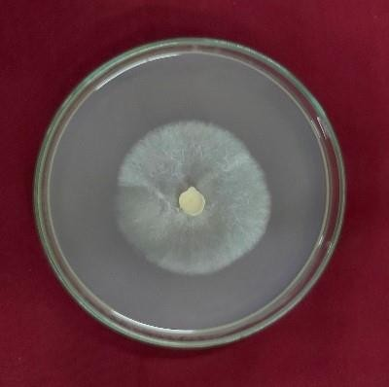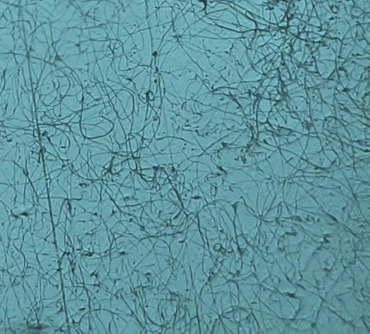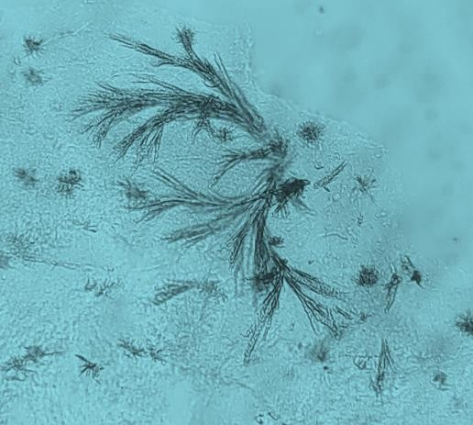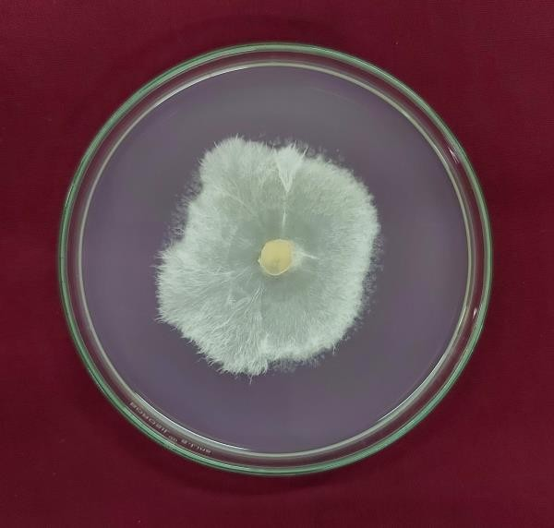

**Secretion of lipase enzyme around** Control Fatty acid crystals formationHyphae growth in **fungus colony Control**

### C:\Users\user\OneDrive\Desktop\review\epa.jpgC:\Users\user\OneDrive\Desktop\review\epc.jpg Plate 2. Protease

Secretion of Protease enzymeControl

### C:\Users\user\OneDrive\Desktop\review\epd.jpgPlate 3. Cellulase

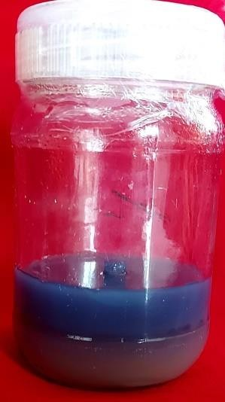

**Migration of dye into lower layer**

### Plate 4 Secretion of chitinase

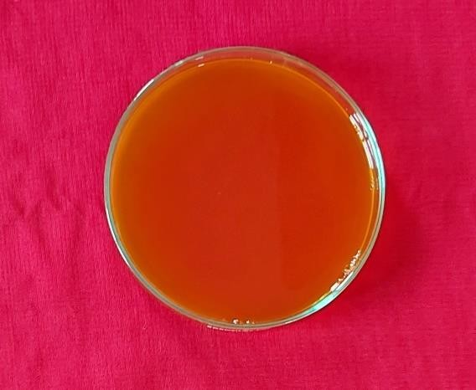

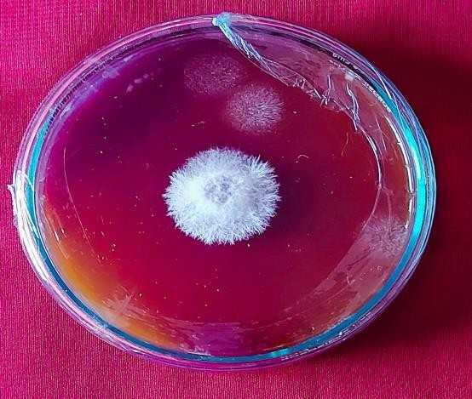

CONCLUSION

*Clonostachys rosea* (syn. *Gliocladium roseum*) is a mycoparasite and opponent of pathogenic fungi, insects, and parasitic nematodes that has been well documented . *C. rosea* exhibits biological control ability towards nematodes including *Bursaphelenchus xylophilus*, *Caenorhabditis elegans*, *Haemonchus contortus*, *Meloidogyne sp*., *Oncometopia tucumana* and *Panagrellus redivivus*. *C. rosea* produces two different forms of spores during its life cycle: conidia and chlamydospores. Current investigation was carried out to understand biocontrol potential of *C. rosea* for the effective utilization as biocontrol agent for nematode management. In order to research the impact of nematophagous fungi, *C. rosea* (TNAU CRN 01) against the root knot nematode, *M. incognita*, *C. rosea* was abundant in clay-textured soil among the four soil types studied. *C. rosea* growth increased considerably on vermicompost, followed by decomposed and undecomposed organic matter. *C. rosea* enzyme production was responsible for colonisation, parasitization, and endophytic nature. *C. rosea* enzymes were found, as lipase, protease, cellulase, and chitinase. These enzymes are involved in the breakdown of egg layers and the cuticle of nematodes. *Clonostachys rosea* is already today an important factor in sustainable plant protection strategies, and the recent developments in our understanding of its ecology, genetics and application promise an even more significant role in the future.

***Funding and Acknowledgment***

No funding was received for conducting this study

***Ethics statement***

No specific permits were required for the described field studies because no human or animal subjects were involved in this research.

***Originality and plagiarism***

Authors should ensure that they have written and submit only entirely original works, and if they have used the work and/or words of others, that this has been appropriately cited. Plagiarism in all its forms constitutes unethical publishing behavior and is unacceptable.

***Consent for publication***

All the authors agreed to publish the content.

***Competing interests***

There were no conflict of interest in the publication of this content

***Data availability***

All the data of this manuscript are included in the MS. No separate external data source is required. If anything is required from the MS, certainly, this will be extended by communicating with the corresponding author through corresponding official mail; padhushree1996@gmail.com

***Author contributions***

# Idea conceptualization - MMS, Experiments - IP ,Guidance - KS, SR, NMB, Writing original draft - IP, Writing- reviewing & editing - MMS, KS, Correction - KS, SR, NMB

ACKNOWLEDGMENT

# The authors are thankful to the Department of Nematology, Tamil Nadu Agricultural University, Coimbatore for providing the support during the research work

# References

Agrawal, Toshy, and Anil S Kotasthane. 2012. Chitinolytic Assay of Indigenous *Trichoderma* Isolates Collected from Different Geographical Locations of Chhattisgarh in Central India. *SpringerPlus* **1**, (1): 1-10.

Alnahdi, Hanan S. 2012. Isolation and Screening of Extracellular Proteases Produced by New Isolated *Bacillus sp.* *Journal of Applied Pharmaceutical Science* **2,** (9): 071-74.

Ashoub,A.H., Montasser, S.A., Mourad, M.H. and Gamal, M. 2009. Impact of some fungi species against the root knot nematode ,*Meloidogyne incognita. Australian Journal of Basic & Applied Sciences,* **3** (4): 3617-3624.

Blaxter, Mark L. 2003. Nematoda: Genes, Genomes and the Evolution of Parasitism.

Advances in Parasitology .**54**: 101-95.

Berger, Leslie Ralph, and Donald M Reynold. 1958. The Chitinase System of a Strain of *Streptomyces griseus*. *Biochimica et biophysica acta* **29**(3): 522-34.

# Chen, X., Wang, Y., Wang, Y., Zhang, Y., Shen, Y., He, X., Xiao, C. 2023. A Natural Moisture Gradient Affects Soil Fungal Communities on the South Shore of Hulun Lake, Inner Mongolia, China. J. Fungi, 9, 549. https://doi.org/10.3390/jof9050549

Dackman, Carin, Ilan Chet, ad Birgit Nordbring-Hertz. 1989. Fungal Parasitism of the Cyst Nematode *Heterodera schachtii*: Infection and Enzymatic Activity. *FEMS Microbiology Ecology.* 5 (3): 201-08.

Dallemole-Giaretta, Rosangela, Leandro Grassi de Freitas, Everaldo Antônio Lopes, Marliane de Cássia Soares da Silva, Maria Catarina Megumi Kasuya, and Silamar Ferraz. 2015. *Pochonia chlamydosporia* Promotes the Growth of Tomato and Lettuce Plants. *Acta Scientiarum. Agronomy.* **37**: 417-23.

# Dedesko, S., Siegel, J.A. 2015. Moisture parameters and fungal communities associated with gypsum drywall in buildings. Microbiome 3, 71. https://doi.org/10.1186/s40168-015-0137-y

Dong, J. Y., He, H. P., Shen, Y. M., and Zhang, K. Q. 2005. Nematicidal epipolysulfanyldioxopiperazines from *Gliocladium roseum*. Journal of Natural Products**.** **68**:1510-1513.

Ganguly, S., and Ganguly, A. 2008. *Pratylenchus* (Nematoda: Pratylenchidae): Diagnosis, biology, pathogenicity and management. *Indian Journal of Nematology*. **38**:126.

Gessner, RV. 1980. Degradative Enzyme Production by Salt-Marsh Fungi.

Goh, Y. K., Marzuki, N. F., Tuan Pa, T. N. F., Goh, T. K.,Kee, Z. S., Goh, Y. K., & Goh, K. J. 2020. Biocontrol and plant-growth-promoting traits of *Talaromyces apiculatus* and *Clonostachys rosea* consortium against Ganoderma basal stem rot disease of oil palm. *Microorganisms*, ***8*(**8): 1138.

Hussain, M, M Zouhar, and P Ryšánek. 2017. Effects of Nematophagous Fungi on Viability of Eggs and Juveniles of *M. incognita*. *JAPS: Journal of Animal & Plant Sciences.* **27:** 1 213-223

Iqbal, Mudassir, Mukesh Dubey, Anders Broberg, Maria Viketoft, Dan Funck Jensen, and Magnus Karlsson. 2019. Deletion of the Nonribosomal Peptide Synthetase Gene Nps1 in the Fungus *C. rosea* Attenuates Antagonism and Biocontrol of Plant Pathogenic Fusarium and Nematodes. *Phytopathology.* **109** (10): 1698-709.

Li Y, Jeewon R, Hyde KD, Mo MH, Zhang KQ. 2006. Two new species of nematode trapping fungi: relationships inferred from morphology, rDNA and protein gene sequence analyses. *Mycological Research*. **110**:790–800.

Moens, M., and Perry, R. N. 2009. Migratory plant endoparasitic nematodes: A group rich in contrasts and divergence. Annual Review of Phytopathology. **47**:313-332.

Nafady, N. A., Sultan, R., El-Zawahry, A. M., Mostafa, Y. S., Alamri, S., Mostafa, R. G.,

& Hassan, E. A. 2022. Effective and Promising Strategy in Management of Tomato Root-Knot Nematodes by *Trichoderma harzianum* and *Arbuscular Mycorrhizae*. *Agronomy*, **12**(2): 315.

Pointing, Stephen B. 1999. Qualitative Methods for the Determination of Lignocellulolytic Enzyme Production by Tropical Fungi. *Fungal diversity*.

Sindhu, R, N Swarnakumari, G Thiribhuvanamala, and A Shanthi. 2019. Colonization Pattern of Nematode Egg Parasitic Fungus, *Pochonia chlamydosporia* (Tnau Pc-001) in Soil. *Journal of Entomology and Zoology Studies.* **7**(3): 456-60.

Sharon, E., Bar-Eyal, M., Chet, I., Herrera-Estrella, A., Kleifeld, O., and Spiegel, Y. 2001. Biological control of the root-knot nematode *Meloidogyne* *javanica* by *Trichoderma harzianum*. *Phytopathology.* **91**:687-693.

# Talley SM, Coley PD, Kursar TA. 2002. The effects of weather on fungal abundance and richness among 25 communities in the Intermountain West. BMC Ecol. Jun 13;2:7. doi: 10.1186/1472-6785-2-7. PMID: 12079496; PMCID: PMC117440.

Tzelepis, G., Dubey, M., Jensen, D. F., and Karlsson, M. 2015. Identifying glycoside hydrolase family 18 genes in the mycoparasitic fungal species *Clonostachys rosea*. *Microbiology.* **161**:1407-1419. Wang, R.B., Yang, J.K., Lin, C. and Zhang, K.Q. 2006. Purification and characterization of an extracellular serine protease from the nematode-trapping fungus *Dactylella shizishanna*. Applied Microbiology. **42:** 589-594.

Williamson, V. M., and Gleason, C. A. 2003. Plant–nematode interactions. Current Opinion in Plant Biology. **6**:327-333.

Yang, J., Huang, X., Tian, B., Sun, H., Duan, J., Wu, W. and Zhang, K., 2005. Characterization of an extracellular serine protease gene from the nematophagous fungus *Lecanicillium psalliotae. Biotechnology.***27**: 1329-1334.

Yang, Jinkui, Baoyu Tian, Lianming Liang, and Ke-Qin Zhang. 2007.Extracellular Enzymes and the Pathogenesis of Nematophagous Fungi. *Applied Microbiology and Biotechnology.***75.** 1: 21-31.

Zou, C. G., Tao, N., Liu, W. J., Yang, J. K., Huang, X. W., Liu, X. Y., Tu, H. H., Gan, Z. W., and Zhang, K. Q. 2010. Regulation of subtilisin-like protease *prC* expression by nematode cuticle in the nematophagous fungus *Clonostachys rosea*. *Environmental Microbiology.* **12**:3243-3252.

# 