**Value Added Products of Veldt grape** **(*Cissus quadrangularis*) and their Organoleptic Evaluation**

## ABSTRACT

Veldt grape is called as Pirandai in Tamil is a succulent herbal plant, belonging to the family, Vitaceae. Various active principles present in it are used to treat different ailments. Raw form of stem cannot be stored for long time and also not available in all vegetable markets throughout the year. Hence this study was initially focussed to develop dehydrated nutri powder as a base material and added with other ingredients so as to get three products *viz.,* veldt grape idly powder, veldt grape dhal powder and veldt grape soup mix. The study results of organoleptic evaluation showed that, among the three products veldt grape soup mix recorded highest score values for the sensory attributes viz., texture, flavour, taste and overall acceptance which was followed by veldt grape idly powder and veldt grape dhal powder.

Keywords: Veldt grape, ailments, nutri powder, acceptance

## INTRODUCTION

A value-added product is a saleable commodity that has been enhanced with additional qualities that make it worth a higher price than the raw materials used to make it. It may be made more convenient, more attractive, more palatable, or easier to use than its raw ingredients. Veldt grape botanically known as *Cissus quadrangularis*is a succulent herbal plant, belonging to the family, Vitaceae. Compounds such as triterpenes including α- and β- amyrins, β- sitosterol, ketosteroids, phenols, tannins, carotene, vitamin C and several other constituents such as flavonoids quercetin and kaempferol, and stilbene derivatives*, quadrangularins*A,B,C and many others e.g. resveratrol, piceatanon, pallidol, perthenocissi and phyto-sterols have been isolated from plant (Jaiganesh*et al.,* 2021).

In siddha medicine it is considered as a tonic and analgesic, and is believed to heal broken bones, thus its name asthisamharaka (that which prevents the destruction of bones) (Bloomer *et al.,*2013). Stem is also used in ayurveda as alterative, anthelmintic, dyspeptic, digestive, tonic, analgesic in eye and ear diseases, in the treatment of irregular menstruation and asthma, in complaints of the back and spine, anti-inflammatory and anti-diarrheal and against headache. Almost all the active principles present in it has anti-obesity, analgesic, anti-inflammatory and venotonic effects (Kannaa*et al.,* 2022; Panthong*et al.,* 2007;Oben, *et al.,* 2007). This plant also has antioxidant, antimicrobial and anticancer activity (Murthy *et al*., 2003;Vijayalakshmi*et al.,* 2013).

Although the plant is used in the preparation of various medicines, it’s use as a vegetable has not still been explored as it is acrid in nature. Though the Veldt grape is rich in phosphorous, calcium, vitamin C, ketosterols, flavonoids it is highly recommended to overcome calcium deficiency, however still remaining as under exploited crop. Since the raw form of stem cannot be stored for long time and also not available in all vegetable markets throughout the year it is dehydrated and made into powder and various value added products like veldt grape idly powder, veldt grape dhal powder and veldt grape soup mix were prepared in this study which could be made widely available in market for consumers with good palatability.

## MATERIALS AND METHODS

### *Collection of raw sample*

*Cissus quadrangularis* tender stem samples were collected from the experimental field of Orchard, Tamil Nadu Agricultural University, Coimbatore. The leaves, tendrils and fibres were removed and the fleshy stems were chopped to small pieces (Fig.1).

### *Preparation of Veldt grape nutri powder*

The chopped stems were subjected to drying at 55°C for 4 days in hot air oven with frequent turning till it reaches constant weight. The dehydrated sample was made into powder and it was immediately stored in air tight container (Fig.1)

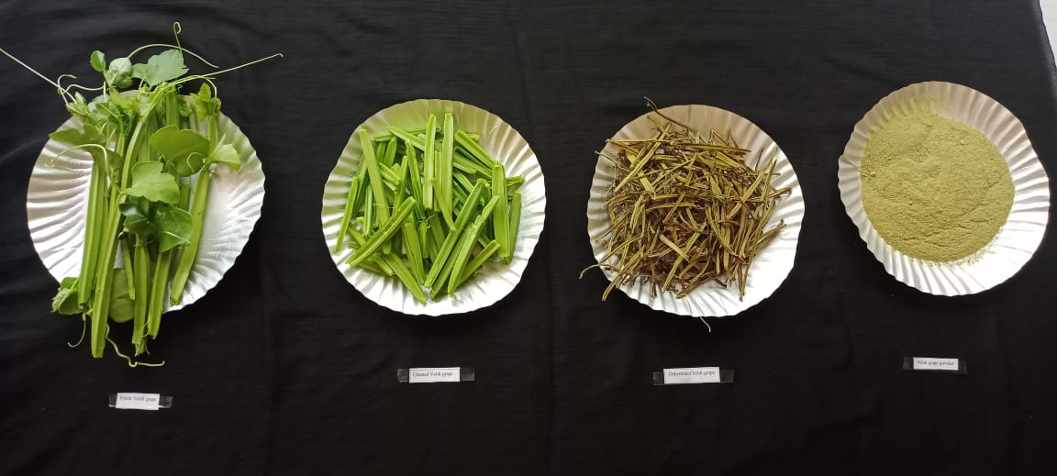

**A**

**D**

**C**

**B**

**Figure 1. (A) Veldt grape stem, (B) Peeled stem, (C) Dehydrated veldt grape and (D) Veldt grape nutripowder**

### *Preparation of Veldt grape idly powder*

Split bengal gram(200 g), red chilli (20 g), rice (10 g), curry leaf (10 g), asafoetida powder (3g) , salt (30 g) and veldt grape nutri powder (20 g) were taken. The ingredients were roasted individually in low flame and allowed to reach the normal room temperature. Then all the ingredients were mixed and ground to course textured powder(Fig. 2).

### *Preparation of Veldt grape dhal powder*

Red gram (100 g), split bengal gram (80 g), red chilli 2 no's, black gram (white) (10 g), cumin (2 g), Black pepper (2 g), curry leaf (2 g), asafoetida powder (1 g), salt (4 g) and veldt grape nutri powder (20 g) were taken.Ingredients were roasted individually in the low flame and allowed to cool to room temperature. All the ingredients were mixed and ground to course textured powder by using mixer jar(Fig 2).

### *Preparation of veldt grape soup mix*

Carrot and beans of 500 g each was taken, cut into small pieces and blanched for 5 minutes. Carrot was soaked in brine solution for 20 min before drying and the vegetables were kept in cabinet drier for 24 hrs at 510 c (for dehydration). Remaining ingredients, dehydrated vegetables (100 g), cumin (10 g), black pepper (6 g), corn flour (40 g), salt (5 g), sugar (10 g) and veldt grape nutri powder (15 g) were taken. Pepper and Cumin were ground and all the ingredients were mixed together to obtain soup mix (Fig 2).

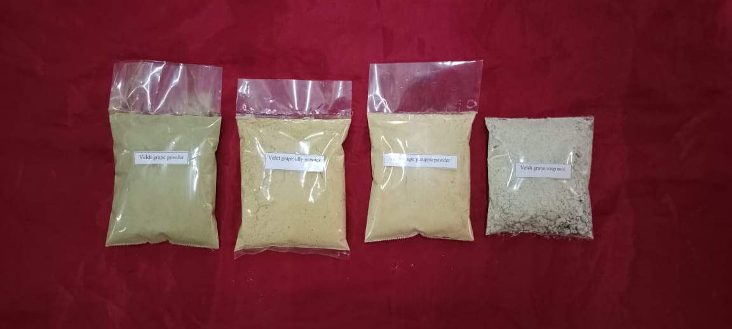

**Figure 2. Veldt grapenutri powder, Idly powder,Dhal powder and Soup mix**

## RESULTS AND DISCUSSION

The veldt grape nutri powder value added products were evaluated organoleptically by a panel of judges of various age groups and scoring was given on the basis of 9 to 1 hedonic scale. The sensory attributes viz., appearance, texture, flavour,taste and overall acceptability of the products were assessed and it was compared with one another (Table.1).It was observed that the Veldt grape soup mix resulted better in all the sensory attributes.

**Figure 3. Sensory evaluation for prepared veldt grape nutri powder products**

Among the three products veldt grape soup mix recorded highest score values for the sensory attributes viz., texture, flavour, taste and overall acceptance which was followed by veldt grape idly powder and veldt grape dhal powder. Owing to its high score values, mean acceptance was also high for veldt grape soup mix. Value added products from Pirandai have also been reported by Kelbore*et al.* (2022).

## CONCLUSION

It is concluded that Veldt grape soup mix scored highest in attributes like texture, flavour, taste and overall acceptability than other two products which is highly desirable. The product is also free from acridity with good consumer preference. Hence future line of work can be carried in the aspects of determining nutrient content and shelf life of the products so that it can be made available throughout the year and can be produced in large scale commercially and marketed in order to meet out the nutrient requirements of the people as veldt grape is rich in vitamin C and calcium which helps in maintaining bone health and improving digestive health of human beings. The intake of veldt grape based products are suggested especially for elder population and growing children.

**Funding acknowledgement**

No external funding was received to carry out this research.

**Ethics Statement**

There was no animal included in this research

**Consent for publication**

All the authors agreed to publish the content.

**Competing interest**

There is no conflict of interest for publishing this content

**Authors contribution**

Experiment conducted under the guidance of Praneetha S,and Kousalya. R. Experiment conducted by Kamaleshwaran N K, Kalaivani Pand Kamaraju A, Article manuscript prepared by Praneetha S and Kousalya R, Reviewing and editing- Praneetha S

**Reference**

1. Bloomer, R. J., Farney, T. M., McCarthy, C. G., and S. R. Lee.2013. *Cissusquadrangularis* reduces joint pain in exercise-trained men: a pilot study. Phys. Sportsmed*.*, **41(3)**: 29-35. <https://doi.org/10.3810/psm.2013.09.2021>
2. Chidambara Murthy, K. N., Vanitha, A., MahadevaSwamy, M., and G. A. Ravishankar. 2003. Antioxidant and antimicrobial activity of *Cissusquadrangularis* L. J. Med. Food*.*, ***6*(2)**: 99-105. <https://doi.org/10.1089/109662003322233495>
3. Jaiganesh, K. P., Prathap, B., Baskaran, D., Mageswaran, M., and G. Pravin. 2021. Review on Ethnobotony, Phytochemistry and Pharmacology of *Cissusquadrangularis*, Linn. *World J. Pharm. Res.*, **10(14):** 408-428. DOI: 10.20959/wjpr202114-22280
4. Kannaa, N. G., Sujatha, P. L., Rao, V. A., and I. A Manikkavasagan.2022.Systematic Way to Understand the Anti-obese Potentials of *Cissusquadrangularis* (Pirandai): A Nutraceutical Approach,Asian J. Dairy Food Res., 1-7. DOI: 10.18805/ajdfr.DR-1702
5. Kelbore, T., Yilma, B., and Srinivasan, B. 2022. Value addition of *Cissusquadrangularis* stem powder in Ethiopian flat bread: Injera and its effect on Nutritional composition, Sensory attributes and Microbial load. *J Food Sci Techno.*, **59(4)**:1450-1459. http://dx.doi.org/10.1007/s13197-021-05154-w
6. Oben, J., Kuate, D., Agbor, G., Momo, C., and X.Talla.2006. The use of a Cissusquadrangularis formulation in the management of weight loss and metabolic syndrome.  Lipids Health Dis*.*, ***5*(24):** 1-7.<https://doi.org/10.1186/1476-511X-5-24>
7. Panthong, A., Supraditaporn, W., Kanjanapothi, D., Taesotikul, T., and V. Reutrakul. 2007. Analgesic, anti-inflammatory and venotoniceffects of *Cissusquadrangularis* Linn.J Ethnopharmacol*.*, **110(2)**: 264-270. <https://doi.org/10.1016/j.jep.2006.09.018>
8. Vijayalakshmi, A., Kumar, P. R., SakthiPriyadarsini, S., and C. Meenaxshi C. 2013. In vitro antioxidant and anticancer activity of flavonoid fraction from the aerial parts of *Cissusquadrangularis* Linn. against human breast carcinoma cell lines. J*. Chem.*, 2013: 1-9.<http://dx.doi.org/10.1155/2013/150675>

**Table 1. Organoleptic score for the products developed using veldt grape nutri powder**

|  |  |  |  |  |  |  |  |
| --- | --- | --- | --- | --- | --- | --- | --- |
| Products | Appearance | Texture | Flavour | Taste | Overall acceptance | Mean acceptance±SD | Mean  CV |
| Veldt grape idly powder | 8.50 | 8.40 | 8.46 | 8.49 | 8.51 | 8.47±0.039 | 0.004 |
| Veldt grape dhal powder | 8.48 | 8.40 | 8.44 | 8.44 | 8.48 | 8.45±0.030 | 0.004 |
| Veldt grape soup mix | 8.40 | 8.42 | 8.47 | 8.53 | 8.56 | 8.47±0.061 | 0.007 |