**Assessment and Economic Aspects of Pivoting arm Intra-Row Weeder**K. RAJU YADAV1\*, A.SURENDRAKUMAR1\*, DHANANCHEZHIYAN P1\*, R KAVITHA1\*, SD SIVAKUMAR2 AND MR DURAISAMY2

1\*Department of farm machinery and power engineering, aec&ri- coimbatore- 641 003 TNAU

**Corresponding author** – [rajuyadavk001@gmail.com](mailto:rajuyadavk001@gmail.com), **ORCID** - 0000-0001-6464-2190

**Abstract**

Weeding is a tedious process and labor-intensive task but it is a challenging task to do weeding in intra row zone. Manual weeding demands extensive labour and generate discomfort in bending posture, time consumption and non availability of labours at peak stage. Chemical weeding, effects human health and crops, though it is costly, it can increase the cost of cultivation to remove weeding. Mechanical inter row weeders are available in the market and are working in the field in inter row zone only but for the intra row no such type of machineries are not available in India still researchers and scientists are working on the intra row weeding mechanisms and machines to get the permanent solution. To overcome from the forementioned problems hydraulic actuated inter and intra row weeder was developed and evaluated in the field conditions. The performance parameters of developed unit are as follows actual field capacity, effective field capacity, performance index, time required to do weeding, payback period, break-even point and the total cost of operation of weeding were calculated as 0.0768 ha.h-1, 0.07725 ha.h-1, 481.8, 13.1 h. ha-1 and 3.17 years and 3.15 payback period respectively. In terms of operational efficiency and cost savings, the developed weeder outperforms manual weeding.

**Keywords** – weeder, intra row, inter row, hydraulic, performance index and pay back period

**Introduction**

Agriculture plays an vital role in the economy of India and the total labor force involved in agriculture and allied sector in our country is 54.6%. Weeding stands as a crucial agricultural task, known for its demanding labor requirements. Notably, a substantial portion i.e., one-third of cultivation expenses is incur to manual weeding. This is a labor-intensive process commands a significant workforce, accounting for approximately 25% of the overall labor demand, equivalent to 900-1200 man-hours per hectare (Srinivas et al., 2023). In India, manual labor ruins the dominant approach for weeding, often involving the use of traditional hand weeding tools such as khurpi, hand hoes or trench hoes & sickels. This practice comes with drawbacks, including the continuous weeding in bending posture gives discomfort and back pain to the laborers. Furthermore, manual weeding is not only labor-intensive but also time-consuming process. After mechanical weeders like cono weeder, star weeder, cultivator and rotary weeders are used in the inter row zone. Next one is chemical weeding, chemicals applied regularly on the weeds at critical period of weed growth but it is harmful to the crop as well as to the humen being directly while spraying.

Around 92% of the landholding people in the country depending on the agriculture are small and marginal farmers. The percentage of small and marginal land holdings is 74.3% of total land holdings in Rajasthan for the year 2023-24 (Anonymous, 2021). Rotary power weeders are exclusively developed to cater to this demographic, offering an economical alternative in comparison to other weed management approaches. The rising interest in mechanical inter-row weeders can be attributed to concerns surrounding diminishing labor availability, environmental degradation, and the increasing demand for organic food.

The advancement of power and mini tractor and tractor operated inter-row weeders are used to control weeds and mainly holds promise in meeting both customer and ecological necessities. This progress significantly contributes to the safer production of food for the population. The rotary power weeder’s are very precise operation it also lies in between ability to pulverize the soil, uprooting weeds, and bury them in the same soil (Srinivas and Meena, 2020). Moreover, this process aids in maintaining soil pulverisation, sunlight, nutrients and promoting proper aeration to the particular crop. A key advantage of the power weeder lies in its efficient utilization of power for blade operation, resulting in reduced draft and enhanced field performance. The cost of weeding by engine operated weeder is about one-third of weeding by manual labour. In intra row weeding is a challenging and tedious task which can be done manually in India still they are following traditional methods to remove the weeds in intra row zones but to remove the weeds in some other countries advanced technologies like robotic weeding and robotic sprayers and flame weeders are developed to remove the weeds.

This aims to achieve increased weeding efficiency, reduce the labour requirement, minimized the plant damage plants and finally reducing the cost economics to the weeding. Considering all these problems, To overcome from the above inter and intra row weeding problems we have design and developed a inter and intra row hydraulic actuated system to remove the weeds. The intra row weeding mechanism is operated with oblique crank rocker mechanism which converts the rotary to reciprocating mechanism and finally it forms the sinusoidal pattern in between the plants and reduces the plant damage and increase the weeding efficiency and in intra row weeding was done by using duck foot sweeps. This novelty enables the weeding operation to be executed across different crops with varying row spacing. Subsequently, an economic assessment of the hydraulic actuated inter and intra row weeder was developed in the field applications.

**Materials and methods**

**The pivot arm working principle**

The hydraulic system is made up of several components that work together to generate a reciprocating motion in the intra-row weeding tool. The system includes a hydraulic motor (EPRM-25) that is directly connected to a chain drive with a 3:1 ratio. This chain drive is then connected to a flywheel. The flywheel receives rotational energy from the chain drive, which is driven by the hydraulic motor. A specially designed oblique crank is set at an angle relative to the rocker arm and connecting rod. This crank generates an oblique motion rather than a standard rotational one. As the hydraulic motor drives the chain drive, it transfers rotational motion to the flywheel connected with the oblique crank. This imparts a reciprocating motion to the connecting rod, causing it to move back and forth instead of in a simple circular motion. The connecting rod's other end is attached to the rocker, which is a rigid lever pivoting around a fixed point called the rocker pivot. This transfers the reciprocating motion to the rocker, which oscillates back and forth around the rocker pivot. The motion of the rocker is then conveyed to the reciprocating arm, which is a mechanical linkage designed to harness the back-and-forth motion. Finally, the reciprocating arm is connected to the intra-row weeding tool, which is specially designed for efficient weed removal within crop rows.

The assessment of the developed hydraulic actuated inter and intra row weeder was accomplished at AEC&RI, (TNAU), Coimbatore. Detailed specifications of the weeder are represented in Table 1. The components of this weeder comprise the hydraulic motor, flywheel, crank, lever, oscillating weeding blade, flow check hydraulic analyser and pressure relief valve. The total expenditure for the developed weeder was Rs.40,600/-.

Assessment of developed unit and developed weeder performance and evaluation was conducted in vegetable crops. Prior to the evaluation, a preliminary operation of the machine was carried out within plants as well as in rows each crop to confirm its effective functioning. Specifically, the machine testing focused on vegetable crops such as tomato and chilli crops, both featuring a 800 mm working width of the machine. These crops were selected with consideration of their row-to-row spacing of 600 mm and plant to plant spacing about 450mm.

**Table.1. Specifications of inter and intra weeder**

|  |  |  |
| --- | --- | --- |
| **S. No.** | **Particular** | **Specification** |
| 1. | Name of machine | Inter and Intra Row Weeder |
| 2. | Make | TNAU |
| 3. | Model | Prototype |
| 4. | Type of machine | tractor operated |
| 6. | Overall width of machine, mm | 850 |
| 7. | Overall length of machine, mm | 850 |
| 7. | Overall height of machine, mm | 550 |
| 8. | No. of rows covered | 1 (intra) 2 (inter) |
| 9. | Type of transmission system | The hydraulic system of the tractor |
| 10. | No. of pillow block bearings | 6 |
| 11. | No. of flange bearings | 1 |
| 12. | width of weeding tool, mm | 58, 78 and 98mm |
| 13. | Type of linkage system | 3 |

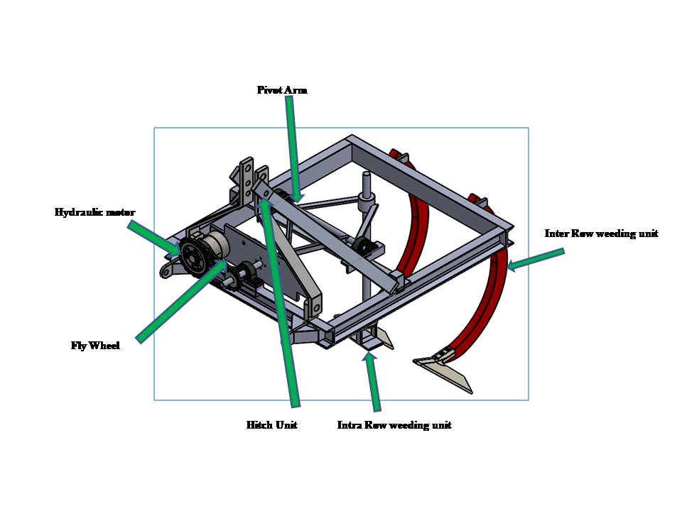

**Fig.1. Isometric view of intra row weeder pivot arm**

**Weeding efficiency**

Weeding efficiency represents the proportion of weeds eliminated by a weeder in relation to the total number of weeds in a given area, expressed as a percentage. The count of weeds both before and after each test was recorded and repeated three times. The resulting averages were computed for various forward speeds 0.84, 0.96 and 1.09 km. h-1at different operating depths (D1, D2, and D3) for chili, tomato, and cotton crops.

Weeding efficiency (%) = $\frac{W1-W2}{W1}$ X 100 (Kumar *et al.*, 2014) (1)

where,

W1 = Number of weeds before weeding

W2 = Number of weeds after weeding

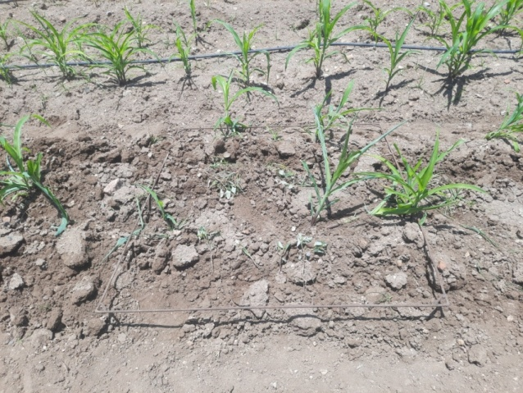 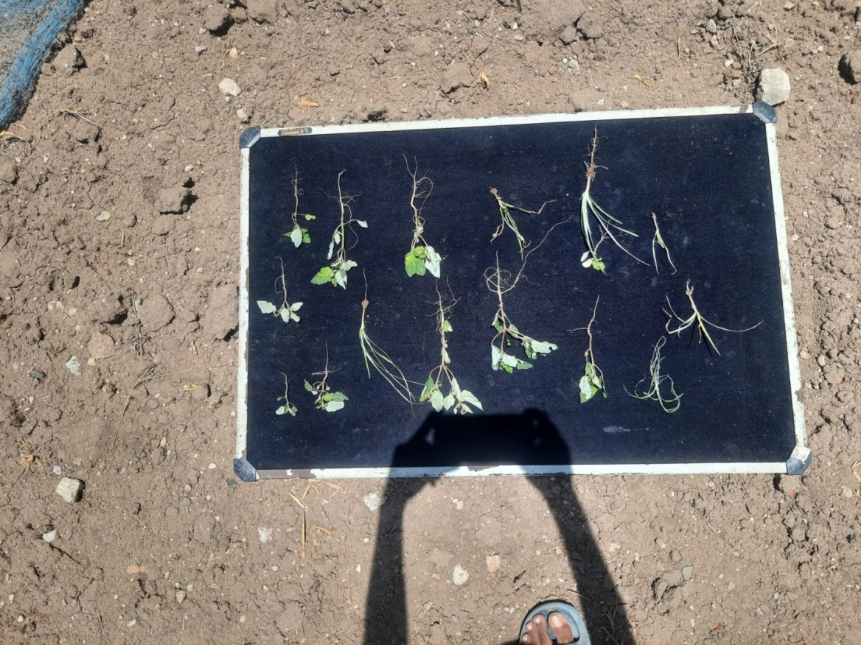

**Fig.2. Measuremet of weeding efficiecy in field**

**Plant damage**

It represents the proportion of plants that have been damaged in a row compared to the total number of plants present, expressed as a percentage. The number of plants in a 30 m in field were recorded before and after the operation and replicated thrice and the average plant damage percentage was calculated at all forward speeds of 0.84, 0.96 and 1.09 km. h-1at D1, D2 and D3 depth of operation levels for chilli, tomato and cotton crops (Shakya *et al.*, 2016)*.*

Plant damage, (%) = x 100 (Khan and Khan; Khan *et al.*, 2023) (2)

where,

q = Number of plants left in a 30 m length after weeding

p = Number of plants in a 30 m length before weeding

**Theoretical field capacity**

Theoretical field capacity refers to the maximum capacity or rate at which a machine, such as inter and intra row weeder, is theoretically capable of covering a field under ideal conditions without considering any operational constraints or interruptions. (Kiran *et al.*, 2014).

Theoretical field capacity, ha.h -1 = (3)

Where,

TFC = Theoretical field capacity, ha. h-1

S = forward speed, km. h-1

W = width of coverage, m

**Effective field capacity**

Effective field capacity is the practical average speed at which the weeder covers the field, taking into account the total time spent operating, and is expressed as (Hossen *et al.*, 2014).

Ceff = (4)

Where,

Ceff = effective field capacity, ha. h-1

A = Field coverage, ha

T = Actual time of operation, hr

**Field efficiency**

Field efficiency is calculated as the percentage ratio between the effective field capacity and the theoretical field capacity. The field capacity is determined using the following formula (Ragesh *et al.*, 2018)*.*

Field efficiency Ef = ×100 (5)

Where,

Ef= Field efficiency, %

EFC = Effective field capacity, ha. h-1

TFC = Theoretical field capacity, ha. h-1

**Performance Index**

The weeder's performance was evaluated using the Performance Index (PI), employing the following relationship as proposed by the Performance Index (Srinivas *et al.*, 2010).

𝑃𝐼 = $\frac{FC × \left(100 – PD\right)× WE}{P}$ (7)

Where,

FC = Field capacity, ha/hr

PD = Plant damage, %

WE= Weeding efficiency, %

P = Power, hp.

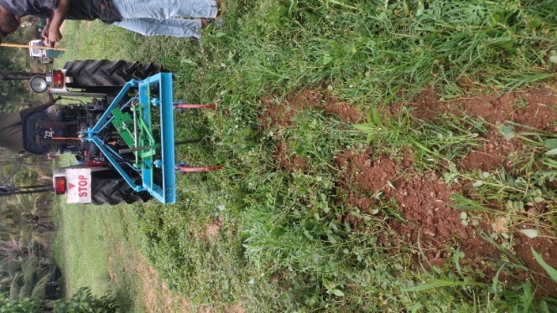

**Fig.3. Assessment of pivot arm in field conditions**

**Cost economics of inter and intra weeder**

In the realm of agricultural equipment design, paramount consideration is given to its cost-effectiveness. The objective is to create machinery that not only exhibits optimal field performance but also boasts a minimized expenditure. Hence, the economic viability of both inter-row and intra-row weeders was evaluated using the straight-line method. The operational expenses of the newly devised inter-row and intra-row weeders were meticulously calculated and juxtaposed against the manual weeding approach. Fixed and variable costs associated with utilizing the prototype weeder per hour were determined following the procedure outlined in IS: 9164-1979. By extrapolating the field capacity of the inter-row and intra-row weeders, the operational cost per hectare was computed. This figure was then contrasted with the cost incurred through manual weeding. The cost-effectiveness achieved through the weeder, in comparison to manual weeding, was quantified as the amount saved.

**Determination of break-even point**

Conducted to determine the point at which profit and loss balance out, the break-even analysis gauges the required duration of work at a given price to cover all costs and expenditures. The break-even point is marked by the juncture where the total cost line intersects the custom hiring cost line. If the break-even point falls below the machinery's annual utility time, owning the equipment proves advantageous for the farmer. Conversely, if the break-even point exceeds the machinery's annual utility time, machinery ownership could result in losses; in such cases, opting for custom hiring becomes a more viable choice for the farmer.

**Payback period**

The payback period is the duration required for an investment to recover its initial cost through yearly cash revenues generated. The calculation of the payback period involves the utilization of the following formula. Typically, this period is expressed in years for farm machinery(Venkat *et al.*, 2021)*.*

Payback period = $\frac{Initial investment }{Average net annual benefit }$ (8)

Where,

The average net annual benefit, Rs = (CHC – TOP) × Annual utility

CHC = Custom hiring charge, Rs.h-1 = (25 % over total cost of operation Rs.h-1)

TOP = Total operating cost

**Theoretical field capacity**

The interrelationship between forward speed and theoretical field capacity in weeding operations is evident from the **Fig.4**. As forward speed increases, the theoretical field capacity also tends to rise. This relationship is intuitive, as higher speeds enable the machine to cover more ground in the same amount of time, resulting in an increased theoretical field capacity. For instance, when the forward speed increases from 0.84 km.h-1 to 0.96 km.h-1, the field capacity goes up from 0.0672 ha.h-1 to 0.0768 ha.h-1, and further increases to 0.0872 ha.h-1at 1.09 km.h-1. This connection underscores the importance of selecting an appropriate forward speed to optimize productivity and efficiency during weeding as it directly impacts the operation of weeding ability to complete work within a given time frame.

**Fig.4.Effect of forward speed on theoretical field capacity**

### **Effective field capacity**

### The connection between forward speed and effective field capacity in weeding operations becomes apparent when examining **Fig.5**. As the forward speed accelerates, the effective field capacity shows a corresponding increase. This correlation is quite intuitive since higher speeds allow the machine to cover a larger area within the same time frame, resulting in a noticeable boost in the effective field capacity. For instance, when the forward speed rises from 0.84 km.h-1 to 0.96 km.h-1, the field capacity increases from 0.063 ha.h-1(Olaoye and Adekanye, 2006) to 0.0695 ha.h-1, and it continues to climb, reaching 0.07725 ha.h-1 at a speed of 1.09 km.h-1. This relationship underscores the pivotal role of selecting an appropriate forward speed to optimize efficiency and productivity during weeding operations, as it directly impacts the amount of work that can be completed within a given time frame.

### **Fig.5. Effect of forward speed on effective field capacity**

### **Field efficiency**

### The minimum field efficiency i.e. 88.6 % was found with F3(1.09 km.h-1). Maximumfieldefficiencyi.e.94.2% (Hegazy *et al.*, 2014) was found with F1(0.84 km.h-1) forwards peed but optimum field efficiency of 90.1% at forward speed of 0.96 km.h-1. The results conclude that forward speed increases the field efficiency decreases **Fig.6**.

### **Fig.6. Effect of forward speed on-field efficiency**

### **4.4.8 Performance index**

### The Performance Index is found maximum of 481.8 at a forward speed is 1.09 km.h-1and the minimum performance index is 400.8 at a forward speed of 0.84 km.h-1 as shown in **(Fig.7)**. The performance Index directly depends on the effective field capacity, plant damage, and weeding efficiency and indirectly depends on the power of the weeder.

### **Fig.7. Performance index of inter intra row weeder**

### **Table.2. Average wheel slip**

|  |  |  |  |  |  |  |
| --- | --- | --- | --- | --- | --- | --- |
| **S. No.** | **Particulars** | **Test No.** | | | **Average** | **Slip** |
| **T1** | **T2** | **T3** |
| 1 | Distance Covered in 10 revolutions under no load, m | 22.6 | 22.5 | 20.3 | 21.8 | 9.17% |
| 2 | Distance Covered in 10 revolutions under load, m | 19.5 | 20.2 | 19.8 | 19.8 |

**Cost economics of inter and intra row weeder**

Nowadays, there is a significant shortage of available labour for manual weeding, resulting in considerably longer durations required to weed each hectare of a given area. With the introduction of the developed inter and intra-row weeder, the time needed for weeding 1.0 hectare of land has been reduced to 13.1 hours. This innovative approach has led to a weeding cost of ₹2803 per hectare. In comparison to traditional weeding methods, the inter and intra-row weeding technique has achieved an impressive 88% reduction in time and a 40.9% reduction in weeding costs. The payback period for the machine has been calculated at 3.15 years, with a favourable B-C ratio of 3.17.

The implementation of the developed inter and intra-row weeder has not only significantly reduced the time and cost associated with weeding when compared to traditional methods but has also proven to be economically feasible. Additionally, it addresses the issue of labour scarcity, reducing the reliance on manual weeding and alleviating associated challenges.

To put it succinctly, the developed weeder has resulted in substantial cost savings of ₹15684.8 per hectare, translating to a 40.9% reduction in weeding expenses when compared to conventional methods. The inter and intra-row weeder only requires 13.1 hours for weeding, a remarkable improvement over the 130 hours needed for traditional weeding of a 1-hectare area as **tabulated .3**.

**Table.3.Inter and Intra row weeding and traditional weeding method**

|  |  |  |  |  |
| --- | --- | --- | --- | --- |
| **S. No.** | **Particular** | **inter and intra row weeding** | **Traditional weeding method** | **Increase /decrease over manual weeding (%)** |
| **X** | **Y** | **X 100** |
| 1. | Total time required, man-h/ha | 13.1 | 103 | -88% |
| 2. | Total cost of weeding,₹/ha | 2803 | 5687.5 | -40.9% |
| 4. | Pay back period, years | 3.15 | - | - |
| 5. | B-C ratio | 3.17 | - | - |

**Conclusion**

The oblique crank rocker mechanism was chosen after an assessment in the soil bin. It was found to operate smoothly and produce better results than the other mechanisms. Maximum weeding efficiency found was 92.72% at 30 mm depth with forward speed of 1.09 km.h-1. It was observed that the weeding efficiency increased with increase in depth of the cutting blade at all forward speeds. This was due to reduction in bite length. Higher depth and minimum forward speed led to finer soil breakup because of shorter bite length. When the blade stroke length increased from 130 mm to 210 mm, plant damage escalated from 21% to 29% at depths of 20 and 50 mm at operational speed of 0.96 km.h-1.

The optimum field capacity found was 0.0672 ha.h-1 at 1.09 km.h-1. The optimum effective field capacity was 0.0695 ha.h-1, and it continues to climb, As the forward speed accelerates, the effective field capacity shows a corresponding increase. The minimum field efficiency of 88.6 % was found with F3 (1.09 km.h-1). Maximum field efficiency of 94.2% was found with F1 (0.84 km.h-1) forward speed. The results conclude that as forward speed increases the field efficiency decreases.The relationship is intuitive, as higher speeds enable the machine to cover more ground in the same amount of time, resulting in an increased theoretical field capacity.The performance index is found maximum of 481.8 at a forward speed 1.09 km.h-1**.** The performance Indexdirectly depends onthe effective field capacity, plant damage, and weeding efficiency and indirectly depends on thepower ofthe weeder. The performance index is found maximum of 481.8 at a forward speed 1.09 km.h-1. The performance Indexdirectly depends onthe effective field capacity, plant damage, and weeding efficiency and indirectly depends on thepower ofthe weeder.

The time needed for weeding 1.0 hectare of land has been reduced to 13.1 hours. This innovative approach has led to a weeding cost of ₹2803 per hectare. In comparison to traditional weeding methods, the inter and intra-row weeding technique has achieved an impressive 88% reduction in time and a 40.9% reduction in weeding costs. The payback period for the machine has been calculated at 3.15 years, with a favourable B-C ratio of 3.17.

**References**

Assirelli, A., and P. Liberati. 2022. "Simulation modelling of mechanical systems for intra-row weeding in a precision farming approach." *Spanish Journal of Agricultural Research* 20 (1):e0201-e0201.

Azadbakht, M., B. Azadbakht, R.J. Galogah, A. Kiapei, and H. Jafari. 2014. "Soil properties after plowing with vertical and horizontal axis rotavator." *International Journal of Environmental and Ecological Engineering* 8 (1):61-65.

Beeny, J., and D. Khoo. 1970. "Preliminary investigations into the performance of different shaped blades for the rotary tillage of wet rice soil." *Journal of Agricultural Engineering Research* 15 (1):27-33.

Chandel, N.S., A.K. Chandel, A.K. Roul, K.R. Solanke, and C. Mehta. 2021. "An integrated inter-and intra-row weeding system for row crops." *Crop Protection* 145:105642.

Chaudhary, S.K., V.R. Kar, and K.K. Shukla. 2021. "Flexural behavior of perforated functionally graded composite panels under complex loading conditions: higher-order finite-element approach." *Journal of Aerospace Engineering* 34 (6):04021081.

Gharde, Yogita, P. K. Singh, R. P. Dubey, and P. K. Gupta 2018. "Assessment of yield and economic losses in agriculture due to weeds in India." *Crop Protection,* 107: 12-18.

Gupta, R., and R.K. Gupta. 2019. "Study on work pattern and drudgery experience of hill farm women of Himachal." *Indian Journal of Ecology* 46 (4):926-932.

Jakasania, R., A. Vadher, and R. Kathiria. 2017. "Performance evaluation of vertical rotary plough." *Journal of Scientific Research and Reports* 13 (6):1-7.

Jiao, J., Wang, Z., Luo, H., Chen, G., Liu, H., Guan, J., ... and Zang, Y. 2022. Development of a mechanical weeder and experiment on the growth, yield and quality of rice. *International Journal of Agricultural and Biological Engineering*, *15*(3): 92-99.

Khan, Muhammad Azam, Abdul Wahid, Maqsood Ahmad, Muhammad Tayab Tahir, Mukhtar Ahmed, Shakeel Ahmad, and Mirza Hasanuzzaman(2020). "World cotton production and consumption: An overview." *Cotton production and uses: Agronomy, crop protection, and postharvest technologies*, 1-7.

K. Raju Yadav, A. Suredrakumar, P. Dhananchezhiyan, Kavitha, S. D. Sivakumar and M. R. Duraisamy (2024). Study on Trajectory Motion of Intra Row Weeder. *Current Applied Science and Technology. 24 (5)* (September-October)*. DOI:[10.55003/cast.2024.258685](http://dx.doi.org/10.55003/cast.2024.258685" \t "_blank)*

K. Raju Yadav, vasuki G, nisha nelson, Yallappa D, P. Samba sivarao and T. Mahesh Babu (2024). assessment of cotton uprooter. *Journal of Propulsion Technology*. 45(4):1883-1893.

K. Raju Yadav, Shasikumar, P.Samba sivarao, P. chinna vani, vinoth kumar and A.Ajay (2024). Assessment of Electronic Fish Skinning Hand Device. *Journal of Propulsion Technology.* 45(4): 1870-1882.

Kshetri, S., B.L. Steward, and M.Z. Tekeste. 2021. "Modeling soil forces on a rotary tine tool in artificial soil." *Transactions of the ASABE* 64 (5):1693-1704.

Kumar, S.P., V. Tewari, A.K. Chandel, C. Mehta, B. Nare, C. Chethan, K. Mundhada, P. Shrivastava, C. Gupta, and S. Hota. 2020. "A fuzzy logic algorithm derived mechatronic concept prototype for crop damage avoidance during eco-friendly eradication of intra-row weeds." *Artificial intelligence in Agriculture* 4:116-126.

Kumar, S.P., V. Tewari, C. Chethan, C. Mehta, B. Nare, and A. Chandel. 2019. "Development of non-powered self-propelling vertical axis inter row rotary weeder." *Indian Society of Weed Science* 51 (3):284-289.

Mehta, C., N. Chandel, P. Jena, and A. Jha. 2019. "Indian agriculture counting on farm mechanization." *Agricultural Mechanization in Asia, Africa and Latin America* 50 (1):84-89.

Mohan, S.S., G. Sanjana, D. Avinash, M. Rohitha, and D.A. Kumar. 2020. "Performance evaluation of power weeder in sugarcane crop." *Current Journal of Applied Science and Technology* 39 (38):70-81.

Osipitan, O.A., J.A. Dille, Y. Assefa, and S.Z. Knezevic. 2018. "Cover crop for early season weed suppression in crops: Systematic review and meta‐analysis." *Agronomy Journal* 110 (6):2211-2221.

Raju Yadav K, A Surendrakumar, Dhananchezhiyan P, SD Sivakumar ad MR Duraisamy (2023). [Investigation of physiological parameters of weeds for the](https://scholar.google.com/citations?view_op=view_citation&hl=en&user=7YU57HQAAAAJ&citation_for_view=7YU57HQAAAAJ%3AqjMakFHDy7sC) [development of inter and intra row weeder.](https://scholar.google.com/citations?view_op=view_citation&hl=en&user=7YU57HQAAAAJ&citation_for_view=7YU57HQAAAAJ%3AqjMakFHDy7sC) *European Chemical Bulletin.* 12 (10), 2926-2944

Raju Yadav K, Ashok Kumar., Madhusudhana Reddy, J Gitanjali and Yallappa D (2023). [Cost economics of cotton uprooter cum shredder.](https://scholar.google.com/citations?view_op=view_citation&hl=en&user=7YU57HQAAAAJ&citation_for_view=7YU57HQAAAAJ%3Au-x6o8ySG0sC) *Ecology, Environment and Conservation* 29: (60-64).

Venkat, R., M.S. Sai, P. Mohnot, and M. Vinayak. 2021. "Economic analysis and feasibility of rotary weeder-cum-fertilizer drill." *Ecoomic Affairs* 66 (3):451-457.

Zhang, X., and Y. Chen. 2017. "Soil disturbance and cutting forces of four different sweeps for mechanical weeding." *Soil and Tillage Research* 168:167-175.