**UAV Technology: Applications, Economical Reliance and Feasibility in Indian Agriculture**

A Ajay* and S Sai Mohan

*Department of Farm Machinery and Power Engineering, KCAET, KAU, Tavanur-679573, Kerala

Department of Farm Machinery and Power Engineering, Dr. NTR College of Agricultural Engineering, ANGRAU, Bapatla-522 101, Andhra Pradesh

**\***Corresponding author: [ajayarigela1997@gmail.com](mailto:ajayarigela1997@gmail.com)

ORCID ID: 0000-0002-3193-7731

**Abstracts**

Recent advances and significant changes in agriculture are aiming to produce enough food as well as to remain sustainable. With the introduction of modern precision farming technologies, farmers are able to optimize both farm productivity and profitability with real-time field information obtained from field. And drone is one such emerging technology which brings revolutionary changes into farming. The study was intended to promote the recent advances in drone technology over the world and its economic reliability in Indian agriculture. Basic and primary agricultural operations that need attention in terms of efficiency anddrudgery are listed out. Each operation was described in such a way to point out how better a UAV can perform in terms of precision and control, capability, spray utilization efficiency, adaptibility and labour dependency. Recent and highly peer reviewed articles which focuses on monitoring plant and soil health, application of chemicals, irrigation, farm surveillance, drone pollination, planting and seeding were discussed. Also the current scenario of aerial vehicles, their investment costs and how better a farmer can economically justify holding a drone were discussed. Intervention of drone technology in Indian agriculture is a hard task as its capital cost is very high and its repair and maintenance require specialized trainee at the field level. With decreasing labour availability and increasing energy spent in the field, may be in the future, need of drone technologies may raise. Drone implication may interest and encourage young people to involve in agriculture.

**Keywords:** UAV, Precision agriculture, Remote sensing, NDVI, Satellite images

**Highlights:**

* Plant and soil health monitoring were discussed.
* Farm scouting and surveillance by drones were presented.
* Economical reliance and current scenario of UAV technology in India was pointed out.

Technology in farming is constantly evolving. In the new agricultural era, farmers can use various high-tech sensing devices based on GPS, variable rate application, automatic steering systems and remote sensing. And Drone is one such emerging technology which brings revolutionary changes into farming. Drone (Dynamic Remotely Operated Navigation Equipment) technology is an extraordinary breakthrough that has potential to change the way of routine manual activities carried out in agriculture. Drone technology is widely being used by agriculture sector around the world to modernize the farming. Drone is a device that can fly either with the help of autopilot and GPS coordinates on the pre-set course or can be operated with manually with radio signals using the remote control or smartphone app.

Drones, also called unmanned aerial vehicles are used to help optimize agriculture operations, monitor crop health and provide sustainable farming. Drones are fitted with so many sensors that can generate real time information on crop status or livestock movement, resulting in more efficient and precise decision-making agricultural operations and management. It can be fitted with a variety of sensors with digital imagining capabilities, like multi spectral, high resolution image sensors and actuators, for field surveys, crop scouting, spraying and spreading operations, and livestock and fishery monitoring. Farmers can exactly calculate their field sizes, categorise crop types and varieties, generate soil maps with pest control, and appropriately plan the harvesting of their crops using data analytics.

Drones can be useful for pesticide spraying, as they can replace labour- intensive and harmful traditional methods, especially in difficult areas like hills. Farmers, agronomists and researchers traditionally scout crops by walking in the field. But these practices are time taking and labour intensive to effectively cover hundreds of acres of crop. On the other hand, the same operations can be carried out by drones which help capture data over an entire farm from a single take-off zone. Unmanned arial vehicles (UAV) technology provides information about the location of the crop under stress and applies chemical sprays if necessary (Mohan *et al.,* 2023). Recent advances in drones are offering longer flight time, greater payload capacities and ability to work in varying climatic conditions which make them more accessible. The agriculture labour shortage that occurred from the COVID-19 outbreak, promoted the implementation of physical distancing measures, and started various possibilities for the use of drones in agriculture.

**Table. 1** **Electromagnetic waves and their uses in drones**

|  |  |  |
| --- | --- | --- |
| **S.No,** | **Type of Electromagnetic wave** | **Uses** |
| 1 | Near Infra-Red (NIR) band | Crop health evaluation, erosion analysis, water management, number of plants and soil moisture evaluation |
| 2 | Red, Green and Blue (RGB) bands | Plant counting, elevation modelling and crop field visual inspection |
| 3 | Red Edge band (RE) | Water management and crop health assessment |
| 4 | Thermal Infra-Red band | Irrigation scheduling, plant physiology analysis and yield estimation |

**LITERATURE SURVEY**

The study was conducted as a part of Master’s seminar in College of Agricultural Engineering, ANGRAU, Bapatla. Primary agricultural operations that need attention in terms of efficiency anddrudgery are listed out and described in such a way to point out how better a UAV can perform in terms of precision and control, capability, spray utilization efficiency, adaptibility and labour dependency.

Recent and highly peer reviewed articles which focuses on monitoring plant and soil health, application of chemicals, irrigation, farm surveillance, drone pollination, planting and seeding were discussed. Also the current scenario of aerial vehicles, their investment costs and how better a farmer can economically justify holding a drone were discussed. Importance and reliability of these advanced technologies in Indian field conditions were put forth.

**Different Types of UAV Models**

Drones are divided into two types depending on operating it. One is directly, which a human has complete control of the vehicle by a wireless remote. Other is autonomously, which the vehicle is able to control itself based on the data from GPS and other sensors. Also depending on the type of wing and controller, drones are classified as fixed wing, rotary wing and tethered vehicle.

Fixed wing and multirotor UAVs are the two types of UAVs depending on their structure. Multi-rotor UAVs further categorized by the number of rotors in its platform. In comparison to multi-rotor UAVs, fixed wing UAVs have a completely different design. Multirotor UAVs are better for surveillance and detection of crop pests, diseases, and weeds, while fixed wing UAVs are best for aerial images, mapping, and land surveying. A quad copter is a special type of UAV with four rotors. These four rotors are essential for the quad copters lift. The two opposite rotors rotate in a clockwise direction, while the other two rotate in a counter clockwise direction.

**Application of drones in various agricultural practices**

Purpose for which a UAV is used plays a major role in picking the right drone with subsequent attachments. If farmers simply need to get aerial photos of a field or divide it into equally sized blocks, they can use the visual camera. If, on the other hand a farmer needs more in-depth information, such as detecting heat stress or poor growth, the infrared sensor may be required. Cost is also a driver for the choice in camera. It is more expensive to operate the infrared camera than the visual camera (Reinecke and Prinsloo, 2017).

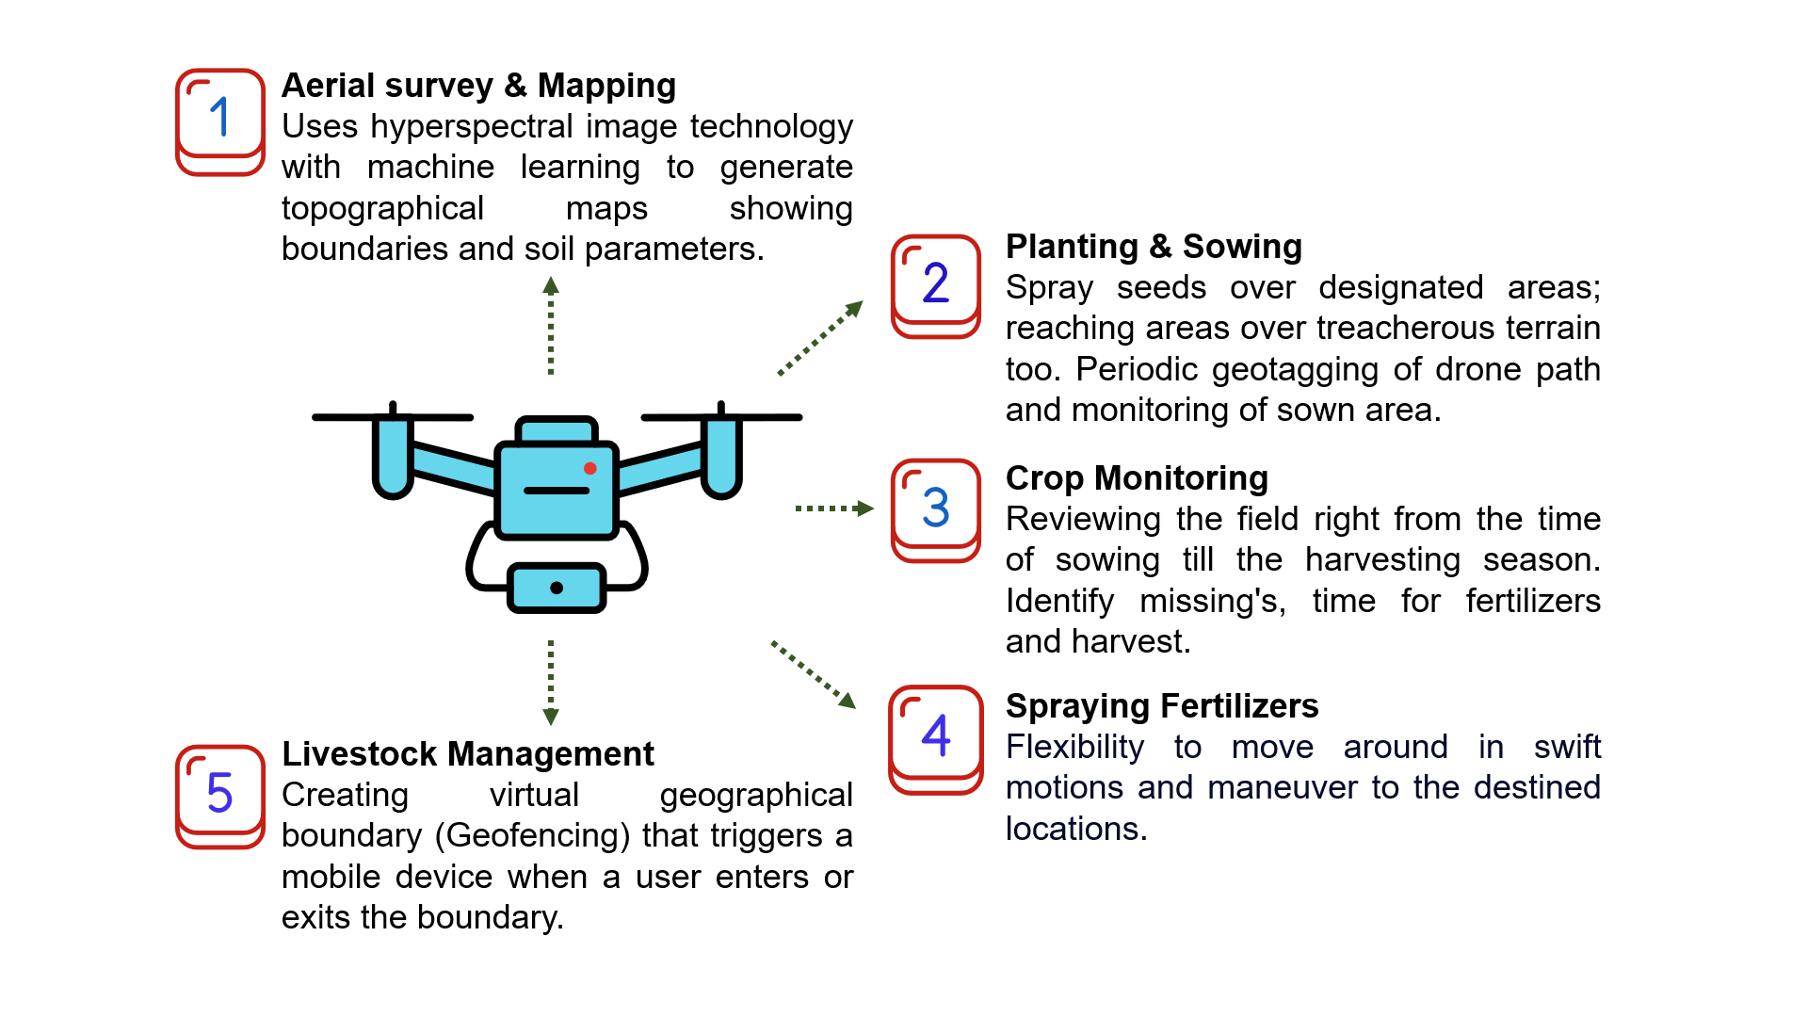

**Fig. 1. Applications of drones in Indian Agriculture**

Some of the common operations carried out by drones:

1. Monitering plant and soil health
2. Application of chemicals
3. Irrigation
4. Farm surveillance
5. Drone pollination
6. Planting and seeding

**Monitoring plant and soil health**

Plant health monitoring is one of the many applications for drone imaging that have already proven to be successful. Drones equipped with NDVI imaging equipment provides detailed colour information to determine plant health. This helps farmers to monitor their crops regularly, and take quick and appropriate action to save the plants and reduce yeild loss. In some contries most farmers are using satellite images to check crop growth, density, and coloration, but satellite data is expensive and in many cases not effective as compare to drone imaging. Cloud cover and bad light conditions don’t impact as much with drone photography as they do with satellite imagery as drones fly near to fields. The below figure illustrates how NDVI work.

NDVI is calculated from the plants unique reflection combination of visible red light and near infrared light (NIR) light (Mohan *et al.,* 2021). It combines the information available in red and near IR bands into a single representative value given by NDVI (Table. 1). NDVI value always lies between -1 & +1.

Cuaran and Leon (2021) reviewed a total of 50 articles related to crop monitoring applications of UAV in agriculture. About 60 % of the articles reviewed are related to cereals like corn, wheat and barley which indicates the need for further research in other crops. Some of the most common vegetation indexes in the literature are: NDVI, EXG, GNDVI, NGRDI and SAVI accounting for more than 60% of the total studied cases. Fixed wing UAVs account for just 20 % of the total studied articles, since they are limited to the monitoring of large areas at a higher speed. They further added that multirotor is the most common type of UAV used for remote sensing (almost 50 %) and, RGB and multispectral cameras are mostly used as sensors for this application.

To enable understanding of soil conditions, plant health and crop yield estimation, artificial intelligence and machine learning can be integrated with NDVI (Normalised Difference vegetation index) imaging technology- based high resolution images taken by drones.

**Table. 2 Vegetation indices and their application**

|  |  |  |  |
| --- | --- | --- | --- |
| **Index** | **Formula** | **Application** | **References** |
| NDVI (Normalized Difference Vegetation Index) | NDVI = $\frac{NIR-Red}{NIR+Red}$ | Detects soil vegetation and calculates hydric stress. | Bendig et al., 2015;  Díaz-Varela et al., 2015; |
| EXG (Excess Green Index) | EXG = 2 × Green – Red - Blue | Used to differentiate soil from vegetation. | Li et al., 2016 |
| GNDVI (Green Normalized Difference Vegetation Index) | GNDVI = $\frac{NIR-Green}{NDVI-Green}$ | Measures nitrogen contents | Shi et al., 2016 |
| NGRDI (Normalized Green-Red Difference Index) | NGRDI = $\frac{Green-Red}{Green+Red}$ | Used to differentiate vegetal layer from soil | Li et al., 2016 |
| SAVI (Soil Adjusted Vegetation Index) | SAVI = $\frac{NIR-Red}{NIR+Red+L}×$ (1+L) | Similar to NDVI but adjusts to soil reflection alone. Preferable where vegetative area is less. | Bendig et al., 2015;  Shi et al., 2016 |

Reinecke and Prinsloo (2017) studied the influence of drone monitoring on crop health and harvest size. Drones help farmers in maximizing their harvest by detecting problems early, and managing the crops by using specific cameras to detect pests and water shortages. Study showed a comparision between orthomosaic and DEM softwares under aerobotics. Aerobotics software is fully automated in that it requires no user input to generate statistics and high resolution images from the data sent by the drone. It generates outputs such as georeference orthomosaics, NDVI, per tree analysis, and volumetrics & contours.

It is helpful to monitor the soil health and field analysis for irrigation palnning, sowing purpose and nutrients level monitoring in soil with the enhanced sensors. Drones may be used to create precise 3-D maps that can be utilize to undertake the soil study on soil characteristics, moisture content and soil erosion. Knowing the elevation of a field helps determine drainage patterns and wet or dry zones, allowing for more efficient watering practices.

**Application of Chemicals**

Drones are attached with medium sized tanks that can be filled with fertilizers, herbicides and pesticides for crop sparying on huge scale in short time. Drone sprayers offer extremely fine spray treatments that are aimed to specific locations, increasing efficency and lowering the usage of chemicals. Drones also use ultrasonic echoes, TOF lasers and GNSS signals to self adjust their altitude and speed to ensure uniform and optimum spraying results over different topography. Drones are being used for agricultural spraying, reducing human exposure to harmful chemicals. Spraying capacity has been increased up to five times faster using drones than with traditional equipment.

Xinyu *et al.,* (2016) developed an unmanned aerial vehicle based automatic aerial spraying system to perform plant protection operations. Crosswind, flying height, swath width and uniformity of spread were taken into consideration. Increase in the crosswind led to route deviations which might affect the surrounding crops. Spray uniformity of UAV was noted to be superior to than the ultra-low volume spray.

**Table. 3** Comparision between spraying with manual/tractor operation and drone operation

|  |  |  |
| --- | --- | --- |
| **Parameter** | **Manual/Tractor** | **Drone** |
| Precision and Control | Manual control is prone to human error. | Highly precise electronic stepwise control using a remote. |
| Capability | Takes hours to cover a hectare. | Drone can cover a hectare in just few minutes. |
| Spray utilization efficiency | Only certain amount of chemical is effectively used and rest goes waste and pollutes the environment. | With ULV nozzles, maximum spray deposition takes place. |
| Adaptibility | Difficult for farmers to reach out for work in wet farms, mountain areas and bushy crops. | Farmers can reach any area even in uneven and rough terrains with an autonomous drone. |
| Labour dependency | Farmers with large land holdings are highly dependent on labour and become vulnerable to operational costs. | No need of labour. Effectivness of the operation remains same whether it may be day or night. |
| Yield | To allow intercultural operations (either with a tractor or manual) spaces are left between the rows. As a result crop yield per ha will be less. | Almost 5 to 10% saving in area of cultivation since no walkways/headlands are needed. |

Yallappa *et al.,* (2017) developed and evaluated a drone mounted sprayer for pesticide application to crops. Drone was developed with the assistance of Maavan Aeronautics Pvt Ltd, Chennai and field trials were conducted in the Research Farm of UAS, Raichur, Karnataka. Discharge rate was measured at different operating pressures, height of spray, swath width, uniformity of spray and droplet size. The developed drone mounted sprayer was evaluated for its field performance in groundnut and paddy crop and the average field capacity was found to be 1.15 ha h-1 and 1.08 ha h-1, respectively at a forward speed of 3.6 km h-1 and 1m height of spray.

**Irrigation**

Remote sensing technologies (viz., spectral images and vegetation indices taken by drones and satellites) are being widely used for managing irrigation and other agricultural practices. Drones equipped with multispectral, thermal or hyperspectral sensors can be used to identify portions of the field with moisture deflicts. This aids in the precise planning of irrigation to the indicated regions. It will minimize amount of water waste and ensure that irrigation water is used efficiently.

Gao *et al.,* (2019) developed an UAV imagery based technology for field measurement of water level. Monitoring water level in the field is an important operation for water conservation and hydrological forecasting. Aerial photogrammetry was integrated with image recognition technology to recognize the water levels at subsequent times in the field. In the study, quadcopter DJI MAVIC 2 was used as an aerial platform attached with L1D-20c RGB lens camera. Image pre-processing adopted in this study includes extracting of ROI (Region of Interest), image greying, binarization, and opening operation. The technology was tested and the results showed that the method is reliable and adoptable.

Cancela *et al.,* (2019) studied several aspects of managing water in agricultural systems with drones and satellites. In this study, eight papers that focus on aspects such as the design of new equipment for sampling and monitoring water bodies, tools for assessing crop water requirement from satellite images and development of noval algorithms for determining crop water status were included.

A custom built hexacopter equipped with a multi probe for measuring water temperature, EC, DO and pH was developed by Koparan *et al.,* 2018 and was tested on a 1.1 ha agricultural pond. These types of drones help in conducting measurements even in remote and inaccessible waterbodies.

Erena *et al.,* (2019) performed topographic and bathymetric surveys in water reservoirs using an aerial, floating and underwater drones. A bathymetric survey is a water-based survey that maps the depths and shapes of underwater terrain to illustrate the land that lies below. Aerial drones were tested to perform photogrammetry survey and underwater vehicles were mostly used for water quality measurements.

**Farm surveillance**

In huge fields, analyzing the overall state of crops is difficult. Drones use infrared cameras to inspect the field and determine light absorption rates to assess crop health. During the nights, these cameras will help to identify animals or humans. As a results, it can be used to safeguard crop against animal damage, which is otherwise difficult to detect in large fields at night. It will be more effective than human guards.

Srivastava *et al.,* (2019) developed an UAVs technology for precision agriculture and environmental research. Information gap between the farmers and information about the location of the crop under stress in the given area was addressed by using a unique application called as Vegnet (Vegetative Network). It aims to provide the necessary tools to detect stressed crop locations using the spectral images obtained from UAVs and provide location and area covered under those stressed crops. Solar panels were installed on the drone itself to eliminate the charge during the day when it is operating on the field. This GUI based platform will work with satellite datasets such as Landsat and other images.

**Drone pollination**

Pollination happens unintentionally in many ways through bees, butterflies, moths, birds, wind and water. The disappearance of natural bees has devastated the crop pollination that occurs naturally. It has brought many crops on the verge of extinction. Without them, many varieties of fruits and vegetables would come to an end. Small drones are being developed by reserchers in the Netherlands and Japan to pollinate plants without damaging them. Small drones are being developed in labs all over the world to address this global problem by replicating the pollination role of bees.

Researchers at the Japan Advanced Institute of Science and Technology (JAIST) have come up with a pollen-infused soap bubbles blown out of a bubble maker mounted to a drone. Yang and Miyako (2020) developed an autonomous controllable UAV equipped with a mechanically stabilized soap bubbles maker which help in plant pollination. It is a vast study involving study of pollen and soap bubble properties, development of simple bubble ejection system and integrating it which a drone. Further innovative technologies, such as state-of-the-art localization and mapping, visual perception, path planning, motion control, and manipulation techniques, would be essential for developing autonomous precision robotic pollination.

**Planting and Seeding**

Drones are being used to plant seeds, which is a newer and less widely used applications of drones in agriculture. At the moment, automated drone seeders are largely utilised in the forestry, and they have the potential to become more widely used in the near future. Planting with drones allows us to practice replanting in difficult locations without endangering workers.

Recent trends in UAV's technology are making drones to withstand and work under strong winds and difficult climatic conditions. Drones capable of shooting seeds can be used for reforestration of large number of trees that are destroyed due to front fire and natural calamities. Hexacopter configured drone was used for sowing application as it requires to lift more payload and more flight time. Partially germinated seeds in biodegradable pods makes them bury quickly into the ground are preferred. Pneumatic mechanism is mostly used in these lauchers.

Arun kumar *et al.,* (2020) developed a UAV system for sowing seed balls in agriculture field. The general structure of the drone was designed by using CATIA V5 software. The basic design structure was estimated based on the weight of components used for the applications. The overall flying time of the drone with payload (700g seed balls) was found to be 26.31 mins based on the proper thrust calculation. Drone has the capability of dropping the seed balls at an interval of 15 m in all directions and a capacity of 28800 seed balls in one eight-hour peration.

Andrio (2019) developed a UAV technology in seed dropping for revegetation practices in Indonesia. The study aims to develop a quadcopter drone that is capable of dispersing Tamarindus indica seeds in revegetation fields with potential for revegetation. Primarily drone takes aerial photos of experimental plot to detect the existing vegetation and obstructions. The information was further fed into the drone which helps in assisting the seed dropping system for efficient revegetation. Seed canister consists of a plastic container, door, motor, battery and receiver designed in such a way that the signal will be sent through receiver to open the door. The developed system plays an important role in improving ecosystem even in areas which are difficult to access.

**Economical reliance and current scenario of UAV technology in India**

A drone is and will always be a costly and sensitive machine which require high investment and maintenance. Drones are being advertised as a fancy toy highlighting its field capacity and the drudgery it can overcome. But the ground reality is completely different. A 10L capacity commerical agricultural drone costs around 15 Lakhs and has a field capacity of 1 to 3 ha h-1 with a flight time of less than 20 min in single charge (Yallappa *et al.,* 2017) (Koondee *et al.,* 2020). So to cover an acre, it need take off and landing time, tank filling time and battery changing time. On an average at least 10 min per hectare goes into passive activties which is negligable for a machine of that capacity. Since indian farms are small and fragmented, a single farmer might not be able to economically justify its holding and cross wind during drone spraying operation might be a big concern to look out.

Moreover, operating and maintaining a drone needs technical knowledge which might take longer than expected to train farmers. In short, a machine with such a high capital cost and maintainence must be purchased as a group by progressive farmers who can justify its holding by custom hiring it to other farmers. Government is providing 50 % subcidy which is a huge boost for drawing the attention of young farmers into agriculture. With custom hiring centre (CHC), machinery like these available at finger tips, farmers might find it safe and sound to access. Provided the staff in CHC, large areas can be managed effectively. As of now drones are proved to be a reliable technology with chemical spraying and aerial photography but extensive research needs to be carried out on multiple crops and climate conditions.

On the other hand, disadvantages due to misuse of drones has been a hot topic and is rising questions regarding the accessability of UAV's in India. In foreign countries drones are classified under 3 categories where category 1 consists of small drones requires no license or certification to fly them (usually toy drones). Category 2 drones are medium range UAV's that requires proper license. Category 3 drones are heavy and military based aviation drones that require license, certification and proper training to fly them.

In India, government has started a digital sky platform requesting RPAS manufacturers, owners and remote pilots to register and get licensed. Keeping in mind the current situation of drone technology, one can use it on illegal purpose which is a serious threat on society. Rules, excemptions and guidelines imposed by the government of India should be the first priority while exercising drone activities.

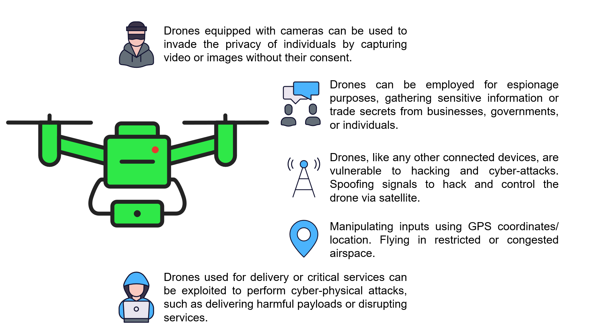

**Fig. 2. Security and privacy threats due to UAV’s**

Easy availability of this advanced technology is making the security and privacy threats particularly concerning. Anti Drone Technology is a fast growing radar system providing 360 degree coverage. It detects microdrones within the range of 4 km would give the military both soft kill and hard kill options to tackle the new and faster modern aerial threats.

**Limitations of drones in their operation:**

* Drones have a limited battery capacity that become inefficient to use after exceeding limited number of recharge cycles.
* Large batteries can help overcome the battery issue, but adds more weight resulting in more power consumption to maintain altitude.
* Except some specialized drones, most drones are restricted to dry weather use as they are not waterproof.
* Drones equiped with near infrared can only be used at night as sun causes interference.
* Not only hyperspectral camera's are expensive, but also their generated images are large and require more storage space.

**CONCLUSION**

UAV technologies are beneficial in situations when human interactions is not possible, such as spraying chemicals on crops, scouting and where labour availability is scarce. Initially drones were used for chemical spraying but today it plays an important role in aerial imagery. Drones help in capturing crop data from the air by carrying various navigation systems, recording devices such as RGB cameras, infrared cameras and other sensors. They have the ability to capture high resolution low cost images of crop. These multi-spectral images are further processed by using remote sensing softwares to assess different aspects of plant health, weeds and land boundaries. Drone technology offers a lot of potential for efficiently carrying out a variety of agricultural tasks.

* Drone implication may interest and encourage young people to involve in agriculture.
* Drones can assist farmers in enhancing the use of inputs (seed, fertilizers and water), responding more immediately to threats (weeds, pests and fungi), reducing crop scouting time, improving variable-rate prescriptions in real time, and estimating yeild from field.
* UAV applications in small land holder’s agricultural production could enhance input efficiency, environmental sustainability, as well as farmers income and livehoods.
* Drones can be beneficial to farmers in a number of ways, but it is crucial to understand their limitations and uses before investing in costly technology.
* Precision agriculture and environmental monitoring will be more significant benefits of these systems. More technologies should be integrated in agriculture to get best crop quality and yield in the near future.

**REFERENCES**

Andrio, A. 2019. Development of UAV technology in seed dropping for aerial revegetation practices in Indonesia. IOP Conf. Series: Earth and Environmental Science, 308. [*http://dx.doi.org/10.1088/1755-1315/308/1/012051*](http://dx.doi.org/10.1088/1755-1315/308/1/012051)

Arun kumar, M., Nagarjuna, T., Mohankumar, N., Ismail, K. and Rajasekar, T. 2020. Design and implementation of real-time amphibious unmanned aerial vehicle system for sowing seed balls in the agriculture field. *International Journal on Emerging Technologies*, **11**(2): 213-218.

Bendig, J., Yu, K., Aasen, H., Bolten, A., Bennertz, S. and Broscheit, J. 2015. Combining UAV-based plant height from crop surface models, visible and near infrared vegetation indices for biomass monitoring in barley. *International Journal of Applied Earth Observation and Geoinformation*, **39**: 79-87.

Cancela, J.J., Gonzalez, X.P., Vilanova, M. and Miras-Avalos, J.M. 2019. Water management using drones and satellites in agriculture. *Water*, **11**: 874-877. [*http://dx.doi.org/10.3390/w11050874*](http://dx.doi.org/10.3390/w11050874)

Cuaran, J. and Leon, J. 2021. Crop Monitoring using Unmanned Aerial Vehicles – A Review. *Agricultural Reviews*, 1-12. [*http://dx.doi.org/10.18805/ag.R-180*](http://dx.doi.org/10.18805/ag.R-180)

Díaz-Varela, R., de la Rosa, R., León, L. and Zarco-Tejada, P. 2015. High-Resolution Airborne UAV Imagery to Assess Olive Tree Crown Parameters Using 3D Photo Reconstruction: Application in Breeding Trials. *Remote Sensing*, **7**(4): 4213-4232.

Erena, M., Atenza, J.F., Garcia-Galiano, S., Dominguez, J.A. and Bernabe, J.M. 2019. Use of drones for the topo-bathymetric monitoring of the reservoirs of the Segura River Basin. *Water*, **11**: 445-461. [*http://dx.doi.org/10.3390/w11030445*](http://dx.doi.org/10.3390/w11030445)

Gao, A., Wu, S., Wang, F., Wu X., Xu, P., Yu, L. and Zhu, S. 2019. A newly developed unmanned aerial vehicle (UAV) imagery based technology for field measurement of water level. *Water*, **11**: 124-139. [*http://dx.doi.org/10.3390/w11010124*](http://dx.doi.org/10.3390/w11010124)

Koondee, P., Saengprachathanarug, K., Posam, J., Watyotha, C. and Wongphati, M. Study of field capacity and variables of UAV operation time during spraying hormone fertilizer in sugarcane field. IOP Conf. Series: Earth and Environmental Science, 2020.

Koparan, C., Koc, A.B., Privette, C.V. and Sawyer, C.B. 2018. In situ water quality measurements using an unmanned aerial vehicle (UAV) system. *Water*, **10**: 264-278. [*http://dx.doi.org/10.3390/w10030264*](http://dx.doi.org/10.3390/w10030264)

Li, W., Niu, Z., Chen, H., Li, D., Wu, M., and Zhao, W. 2016. Remote estimation of canopy height and aboveground biomass of maize using high-resolution stereo images from a low cost unmanned aerial vehicle system. *Ecological Indicators,* **67**: 637-648.

Mogili, U.R. and Deepak, B.B.V.L. 2019. Review on application of dronesystems in precision agriclture. *Procedia computer science*, **133**:502-509.

Mohan, S.S., Ajay, A. and Jayan, P.R. 2021. GPS and sensor based technologies in variable rate fertilizer application. *International Journal of Agriculture, Environment and Biotechnology,* **14**(1): 21-27. [*http://dx.doi.org/10.30954/0974-1712.01.2021.4*](http://dx.doi.org/10.30954/0974-1712.01.2021.4)

Mohan, S.S., Venkat, R., Rahaman, S., Vinayak, M. and Hari Babu, B. 2023. Role of AI in Agriculture: Applications, Limitations and Challenges: A Review. *Agricultural Reviews*. 44(2): 231-237. [*http://dx.doi.org/10.18805/ag.R-2215*](http://dx.doi.org/10.18805/ag.R-2215)

Pathak, H., Kumar, G.A.K., Mohapatra, S.D. and Gaikwad, B.B. 2020. Use of Drones in Agriculture: Potentials, Problems and Policy Needs. *ICAR-NIASM.*

Puri, V., Nayyar, A. and Raja, L. 2017. Agricultural drones: A modern breakthrough in precision agriculture. *Journal of Statistics and Management Systems*, **20**(4):507-518.

Shaw, K.K. and Vimal kumar, R. 2020. Design and development of a drone for spraying pesticides, fertilizers and disinfectants. *Engineering Research and Technology,*1181-1185.

Shi, Y., Thomasson, J.A., Murray, S.C., Pugh, N.A., Rooney, W.L. and Shafian, S. 2016. Unmanned aerial vehicles for high-throughput phenotyping and agronomic research. *PLOS ONE*. **11**(7).

Srivastava, K., Bhutoria, A.J., Jyoti, K.S., Aakash, S. and Pandey, P.C. 2019. UAVs technology for the development of GUI based application for precision agriculture and environmental research. *Remote Sensing Applications: Society and Environment*, **16**: 246-258.

Xinyu, X., Yubin, L., Zhu, S., Chang, C. and Hoffmann, C. 2016. Develop an unmanned aerial vehicle based automatic aerial spraying system. *Computers and Electronics in Agriculture*, **128**: 58-66.

Yallappa, D., Veerangouda, M., Maski, D., Palled, V. and Bheemanna, M. Development and evaluation of drone mounted sprayer for pesticide applications to crops. IEEE Global Humanitarian Technology Conference, 1-7, 2017.

Yang, X. and Miyako, E. 2020. Soap bubble pollination. *Iscience*, **23**: 1-33.