**Estimation of Crop Water Requirement of Sweet corn crop using CROPWAT 8.0 model**

**V.K.Pavithra*, Dr.R.GaneshBabua, Dr.G.RaviBabub and Dr.M.Lathac**

**\*M.Tech Student,*Dr. NTR College of Agricultural Engineering, Bapatla, Acharya N.G.Ranga Agricultural University, Guntur, Andhra Pradesh, India-522101.***

***aAssistant Professor and Head, Department of Irrigation and Drainage Engineering, Dr. NTR College of Agricultural Engineering, Bapatla, Acharya N.G.Ranga Agricultural University, Guntur, Andhra Pradesh, India-522101.***

***bAssociate Dean, College of Agriculture Engineering, Madakasira, Acharya N.G.RangaAgricultural University, Guntur, Andhra Pradesh, India-522101.***

***cAssociate Professor, Department of Soil Science and Agricultural Chemistry, Agricultural College, Bapatla, Acharya N.G.Ranga Agricultural University, Guntur, Andhra Pradesh, India-522101.***

**Corresponding Author E-mail:** [**paviagrlengg@gmail.com**](mailto:paviagrlengg@gmail.com)

**Phone number: 9677485166**

**Abstract:** Most of the crops are watered through traditional methods of irrigation, which have the more wastage of water.The Crop Water Requirement (CWR) is necessary to design the irrigation system, which is the total quantity of water required for the crop from sowing to harvest.Optimisation of water applied to the crop is very essential as the yields of the crop is adversely effected either with excess or deficit water supply. CROPWAT 8.0 requires meteorological data as input such as maximum and minimum temperatures, wind speed, relative humidity and sun shine hours. The soil and crop data were also given as input for calculating the CWR of sweet corn. The meteorological data of the past ten years collected from meteorological observatory which is located at Agricultural College Farm, Bapatla. The average values of the above said data were calculated for ten years (2012-2021) to estimate the crop water requirement using CROPWAT 8.0.Crop water requirement was estimated as 332 mm using CROPWAT 8.0 model. It was found minimum in the initial stages (15.60 mm/dec) and found maximum in the middle stages (64.80 mm/dec)and again at harvesting stage it started declining(16.70 mm/dec).CROPWAT 8.0 model gives more accurate amount of water needed to the crop which in turns helps the crop growers to design the appropriate irrigation scheduling.

**Keywords:** Crop Water Requirement,;CROPWAT 8.0 model, Sweet corn.

1. **INTRODUCTION**

In agriculture, most of the crops are watered through traditional methods of irrigation, which have the more wastage of water. Under the present circumstances of meagre availability of surface water and dwindling ground water sources day by day, the only alternative is to optimise the amount of water applied to the cropto cope up the needs of the food security of growing population by bringing more area under cultivation by way of utilizing the available scarce resources of water judicially.

The Crop Water Requirement (CWR) is necessary to design the irrigation system, which is the total quantity of water required for the crop from sowing to harvest. Several computer models are available to estimate the crop water requirement. CROPWAT 8.0, a computer program developed at the Netherlands, calculates the CWR and Irrigation Water Requirement of various crops under different climatic conditions. The Penman Monteith method had been recommended by FAO to calculate the crop evapotranspiration (ETc) under different conditions which gives accurate and wider suitability (Patel *et al*., 2017) compared to Penman, BlaneyCriddle and other methods.

The CWR requires for preparation of irrigation scheduling which includes planning and decision making in irrigation process. Irrigation scheduling is one of the most important factors in the agricultural sector to get sustainable crop productivity. Optimisation of water applied to the crop is very essential as the yields of the crop is adversely effected either with excess or deficit water supply.

1. **MATERIAL AND METHODS**
   1. **Experimental site**

The field experiment was carried out at the field irrigation laboratory, Department of Soil and Water Engineering, Dr.N.T.R. College of Agricultural Engineering, Bapatla, Bapatla district of Andhra Pradesh state, India. The experiment was conducted on sweet corn crop during *kharif* season of the year 2022. Sowing of Sweet corn crop was done on August 3, 2022. The experimental site is geographically located at latitude of 16°N and longitude of 88°E with an altitude of 6 m above sea level (Fig. 2.1). Bapatla is one of the districts in Andhra Pradesh and it is located in the southeastern part of that state which is very near to coast of Bay of Bengal and the town experiences hot summer and cool winter. The maximum temperature ranges between 30°C to 40°C in summer and the minimum temperature ranges between 18°C to 28°C in winter. The annual precipitation is about 700-1150 mm with an average of 897 mm of which 25% is received during crop growing period of *kharif* 2022. The average relative humidity is 75% and average wind speed is 108 km/day. Mean daily evaporation ranged between 2.59 to 3.32 mm/day during crop growing period.

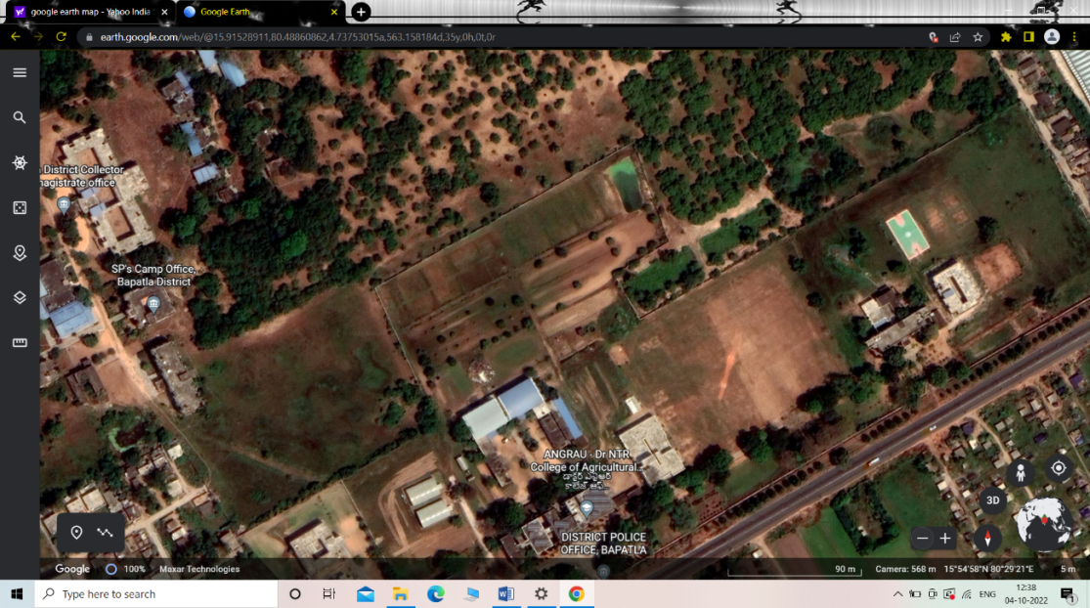

Location of Experimental field

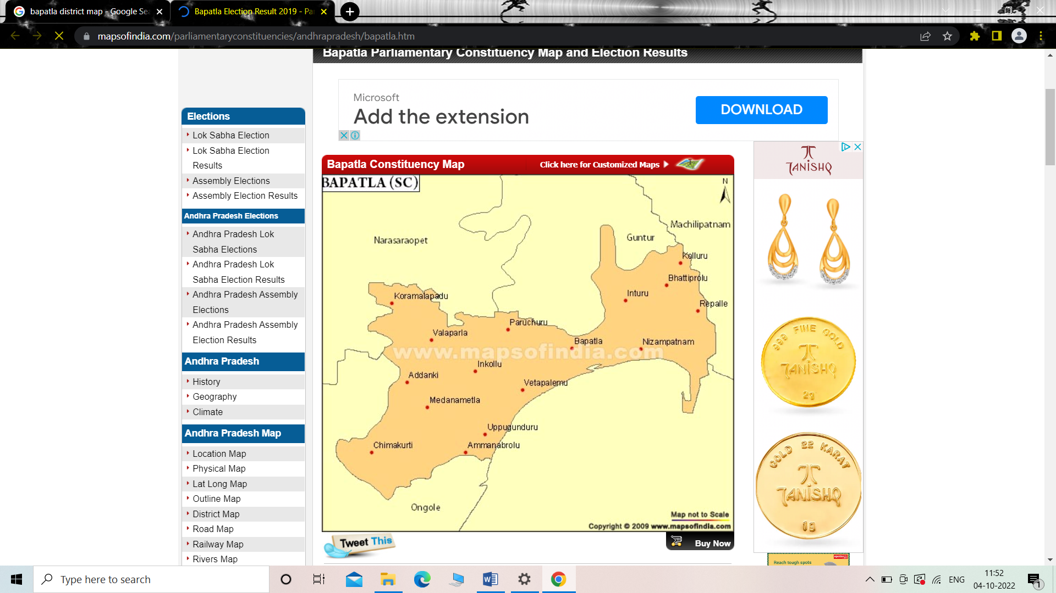

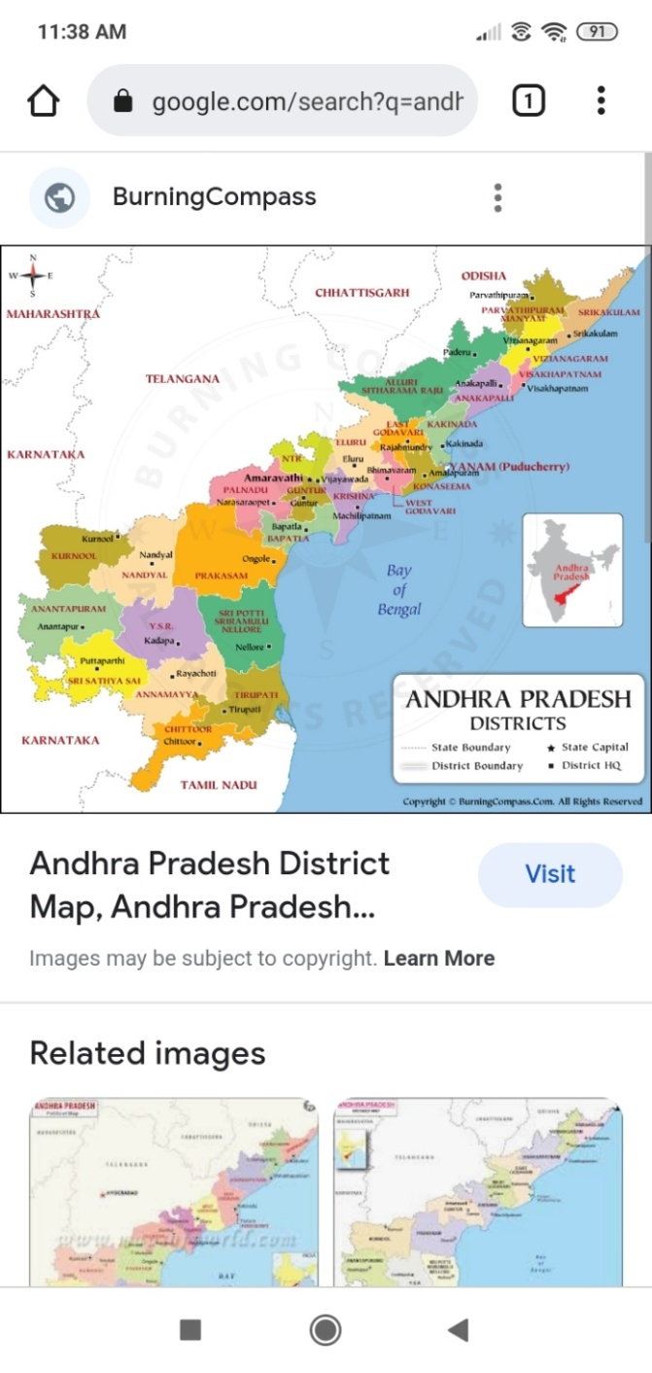

**Fig. 2.1 Location of Experimental field**

* 1. **Collection of Meteorological Data**

Many softwares like CRIWAR, CROPWAT, SWATRE, etc., were available to estimate the crop water requirement of the crop. In the present study CROPWAT 8.0 was used to estimate the crop water requirement of the sweet corn. CROPWAT 8.0 requires meteorological data as input such as maximum and minimum temperatures, wind speed, relative humidity and sun shine hours. The soil and crop data were also given as input for calculating the CWR of sweet corn. The meteorological data of the past ten years collected from meteorological observatory which is located at Agricultural College Farm, Bapatla. The average values of the above said data were calculated for ten years (2012-2021) to estimate the crop water requirement using CROPWAT 8.0. Input files of CROPWAT 8.0 is shown in Fig 2.2 and Table 2.1. The meteorological data during the crop growing period is presented in the Table 2.2.

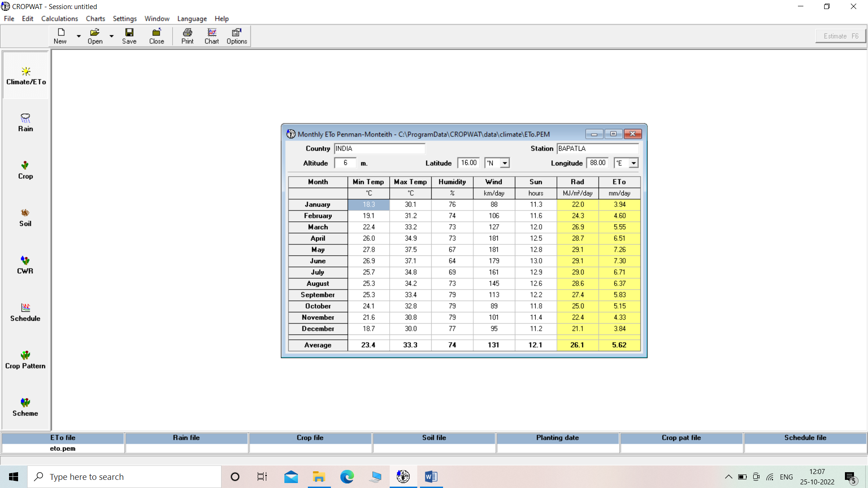 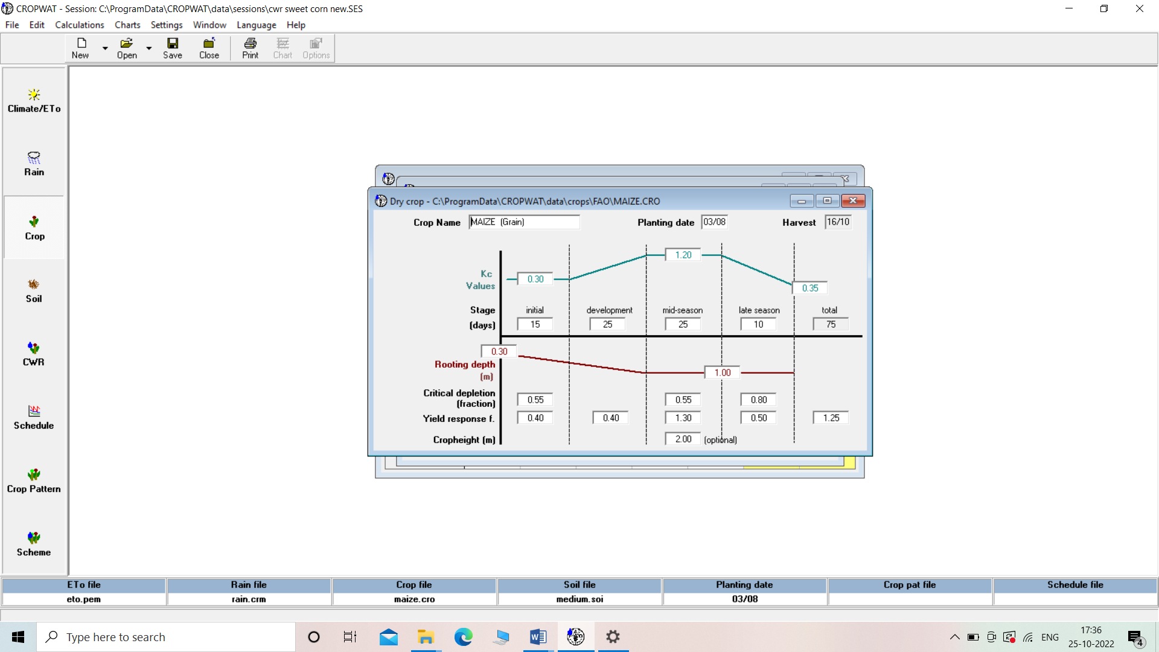 **Fig.2.2 Input data files of CROPWAT 8.0**

**Table 2.1 Average values of past ten years (2012-2021) meteorological data**

|  |  |  |  |  |  |  |
| --- | --- | --- | --- | --- | --- | --- |
| **Month** | **Min. temp**  **(°C)** | **Max. temp**  **(°C)** | **RH**  **(%)** | **Wind speed**  **(km/day)** | **Sunshine**  **hours** | **Rainfall**  **(mm)** |
| **January** | 18.30 | 30.09 | 76 | 88 | 11.3 | 0.513 |
| **Feburary** | 19.15 | 31.19 | 74 | 106 | 11.6 | 7.467 |
| **March** | 22.44 | 33.24 | 73 | 127 | 12.0 | 0.06 |
| **April** | 26.00 | 34.89 | 73 | 181 | 12.5 | 5.2372 |
| **May** | 27.76 | 37.49 | 67 | 181 | 12.8 | 31.955 |
| **June** | 26.91 | 37.12 | 64 | 179 | 13.0 | 68.491 |
| **July** | 25.74 | 34.79 | 69 | 161 | 12.9 | 73.461 |
| **August** | 25.31 | 34.18 | 73 | 145 | 12.6 | 128.56 |
| **September** | 25.31 | 33.40 | 79 | 113 | 12.2 | 152.32 |
| **October** | 24.13 | 32.80 | 79 | 89 | 11.8 | 106.629 |
| **November** | 21.61 | 30.82 | 79 | 101 | 11.4 | 49.235 |
| **December** | 18.67 | 30.03 | 77 | 95 | 11.2 | 11.8753 |

**Table 2.2 Weather parameters recorded during crop growing period (*Kharif*2022)**

|  |  |  |  |  |  |  |  |
| --- | --- | --- | --- | --- | --- | --- | --- |
| **Month** | **Average daily Temperature (**°C**)** | | **Relative Humidity**  **(%)** | | **Average wind speed (km/day)** | **Total Rainfall (mm)** | **Average daily evaporation (mm)** |
| **Max.** | **Min.** | **Max.** | **Min.** |
| **August** | 34.22 | 25.54 | 96.48 | 64.81 | 142 | 123.20 | 3.32 |
| **September** | 33.90 | 25.37 | 98.13 | 66.30 | 112 | 54.90 | 3.29 |
| **October** | 31.97 | 23.58 | 99.58 | 72.84 | 88 | 159.80 | 2.59 |

* 1. **Soil properties of the experimental plot**

Soil properties of the experimental plot was collected from the Department of Soil and Water Engineering, Dr. N. T. R. College of Agricultural Engineering, Bapatla where the experiment was carried out. The physical properties such as textural class, hydraulic conductivity (cm/h), bulk density (g/cm3), field capacity (% vol) and permanent wilting point (% vol) were collected and shown in Table 2.3.

**Table 2.3 Physical properties of the experimental soil**

|  |  |  |  |  |  |  |  |  |
| --- | --- | --- | --- | --- | --- | --- | --- | --- |
| **Soil depth from surface (cm)** | **Mineral content**  **(% mass)** | | | **Textural class** | **Hydraulic conductivity (cm/h)** | **Bulk density (g/cm3)** | **Field capacity (% vol)** | **Permanent wilting point (% vol)** |
| **Clay** | **Silt** | **Sand** |
| 0-15 | 35 | 10 | 55 | Sandy clay loam | 0.94 | 1.37 | 21.48 | 6.73 |
| 15-30 | 35 | 10 | 55 | Sandy clay loam | 0.50 | 1.57 | 27.17 | 9.12 |
| 30-45 | 30 | 10 | 60 | Sandy clay | 0.46 | 1.53 | 28.24 | 10.56 |
| 45-60 | 35 | 5 | 60 | Sandy clay loam | 0.96 | 1.63 | 27.69 | 10.92 |
| 60-75 | 35 | 5 | 60 | Sandy clay loam | 0.96 | 1.63 | 27.73 | 11.61 |
| 75-90 | 30 | 5 | 65 | Sandy clay loam | 0.95 | 1.67 | 26.62 | 10.75 |

1. **RESULT AND DISCUSSION**

**Estimation of Crop Water Requirement**

Crop Water Requirement of sweet corn was estimated using meteorological data of past 10 years with the help of CROPWAT 8.0 software. The outcome of the CROPWAT 8.0 was shown in Table 3.1 and these results showed that water required for the crop (crop evapotranspiration) is less during the initial period of crop growing because of less canopy area of the sweet corn crop and it was gradually increased.In the first decade of August it was found as 15.60 mm/dec, on second decade it was 20.40 mm/dec. In third decade it keep on increasing as 40.30 mm/dec and in first decade of September it was found as 56.10 mm/dec. It was found maximum at second decade of September when there was more canopy area coverage and then decreased until the end of the crop period.

At harvesting stage of the crop, the water needed to the crop was found minimum with value of 16.70 mm/dec.Irrigation Schedule was prepared on daily basis based on the crop water requirement of sweet corn which was calculated by CROPWAT 8.0. Similar finding was observed by Bahadur*et al.* 2021; Bhat*et al.*2017; Gowda*et al*. 2013; Gul*et al.* 2021; Roja*et al.* 2020.

**Table 3.1 Crop Evapotranspiration of sweet corn during growing period**

|  |  |  |  |  |  |
| --- | --- | --- | --- | --- | --- |
| **Month** | **Decade** | **Stage** | **KC**  **Coefficient** | **ETC**  **mm/day** | **ETC**  **mm/dec** |
| **August** | **1** | **Initial** | **0.30** | **1.95** | **15.60** |
| **August** | **2** | **Development** | **0.32** | **2.04** | **20.40** |
| **August** | **3** | **Development** | **0.59** | **3.67** | **40.30** |
| **September** | **1** | **Development** | **0.93** | **5.61** | **56.10** |
| **September** | **2** | **Middle** | **1.11** | **6.48** | **64.80** |
| **September** | **3** | **Middle** | **1.11** | **6.23** | **62.30** |
| **October** | **1** | **Late** | **1.04** | **5.57** | **55.70** |
| **October** | **2** | **Late** | **0.54** | **2.79** | **16.70** |
| **Total** | | | | | **332.00** |

1. **CONCLUSION**

CROPWAT 8.0 model gives more accurate amount of water needed to the crop which in turns helps the crop growers to design the appropriate irrigation scheduling.

**REFERENCES**

# Patel, A., Shradha, R., Patel, S and Meena, P. 2017. Reference evapotranspiration estimation using CROPWAT model at Ludhiana District (Punjab). *International Journal of science, environment and technology.* 6(1):620-629.

Bahadur, A., Bazai, Z.A., Khair, S.H., Nafisa, Bahadur, F and Bokhari, S.M.A. 2021. Modeling crop water requirement of grapes by using FAO-CROPWAT model in Quetta district, Balochistan. *Journal of Agrometeorology*. 23 (4): 468-470.

Bhat, S.A., Pandit, B.A., Khan, J.N., Kumar, R and Jan, R. 2017. Water Requirements and Irrigation Scheduling of Maize Crop using CROPWAT Model. *International Journal of Current Microbiology and Applied Sciences.* 6(11).

Gowda, P.T., Manjunaththa, S.B., Yogesh, T.C and Satyareddi, S.A. 2013. Study on Water Requirement of Maize (Zea mays L.) using CROPWAT Model in Northern Transitional Zone of Karnataka. *Journal of Environmental Science, Computer Science and Engineering & Technology*. 2(1): 105-113.

Gul, N., Haq, Z., Munsif, F., Malik, A., Akbar, G., Khalil, A and Ajmal, M. 2021. Pakistan’s Northern Dry Mountain Agricultural Ecological Zone Autumn Maize Crop Water Requirement, and Irrigation Scheduling Using FAO Computer Programming Cropwat 8.0. *Natural Volatiles & Essential Oils*. 8(5): 9476-9481.

Roja, M., Deepthi, C and Reddy, M.D. 2020. Estimation of Crop Water Requirement of Maize Crop Using FAO CROPWAT 8.0 Model. *Indian Journal of Pure and Applied Bioscience*. 8(6): 222-228.