Formulation of flavored desserts fortified with tender palmyra (Ice apple) (Borassus flabellifer)
K.Jothilakshmi *, T.Roja, G.Gayathry, S.Amutha and S.Kanchana

Corresponding author : K.Jothilakshmi
jothilakshmi.k@tnau.ac.in
K.Jothilakshmi,Assistant Professor , Food Science and Nutrition, Community Science College and Research Institute, Madurai
T.Roja ,FND student
G.Gayathry Assistant Professor, ICAR –KVK Vridhachalam
S.Amutha ,Professor and Head, HDFS , Community Science College and Research Institute, Madurai
S.Kanchana, Dean, Community Science College and Research Institute, Madurai

Abstract

Tender Palmyra (Borassus flabellifer) fruit endosperm, also known as Nungu (Ice apple) is consumed during the summer months especially in Southern and Eastern India can hydrate our body and can supplement healthy nutrients to our diet. Processing of the fruit makes it stay fresh for long time with the same nutrient content and flavor and it can make the product attractive to the children and easy way of consuming the same nutrients. Under normal conditions, palmyra endosperm is prone to spoilage within few hours due to oxidation and fermentation. In this study ice apple incorporated desserts (ice apple milkshake and ice apple ice cream) were formulated with different proportions of milk and ice apple pulp. The results discovered that the ice apple milk shake prepared from 30% of ice apple pulp and 70% of milk was most acceptable and ranked between like very much to like extremely and 100 ml contained 130.3 kcal of energy, 26.42g of carbohydrate, 9.2 of fat, 3.69 g of protein, 0.98mg of vitamin C, 0.12 g ash content and 130.8mg of calcium. 100 per cent ice apple ice cream have high overall acceptability .100g of ice apple ice cream contained 176.56 kcal of energy ,27.12 g of carbohydrate, 22.3 of fat, 12.10 g of protein, 1.75mg of vitamin C, 0.13 g ash content and 230.3 mg of calcium.
Keywords: Delicious desserts, Ice Apple, calcium rich, consumption throughout year

Introduction

Palmyra is a tall growing tree which belongs to the family, Arecaceae, order Arecales. It is botanically known as Borassus flabellifer L. having a genus of six species of fan palms. The name borassus was derived from a Greek word means leathery covering of the fruit and the word flabellifer means Fan bearer. B. flabellifer is a robust tree that can live more than 100 years and reach the height of 50 to 60 meters. These can be grown in waste lands, farm filed boundaries, sea costs, parks, industrial estates and house colonies. The trunk is grey, robust and old leaves remain attached to the trunk for several years before falling cleanly. The leaves are look like fan-shaped and it grow up to 3 meters long with robust black teeth on the petiole margins. (Veilmuthu, et al.,2020)
In India, palmyrah adorns the dry landscape of the semi arid regions of Tamil Nadu, Andhra Pradesh, Gujarat, Odisha, West Bengal, Bihar, Karnataka and Maharashtra. Currently, palmyrah palm wealth of India is estimated as 102 million palms and half of them are in Tamil Nadu. Out of 51.90 million palms in Tamil Nadu, more than 50% of palms are concentrated in the Southern district of Thoothukudi. Government of Tamil Nadu in the year 1978 recognized Palmyrah as State Tree.
Palmyra palms are economically useful and widely cultivated in tropical regions. All the parts of this tree various purposes. The edible food products obtained from this tree are sap for juice, palm jaggery, edible mesocarp, unripe endosperm and palm tuber. The seeds are planted and made to germinate and the fleshy stems are boiled and eaten. It fibrous and nutritious, known as ‘Panai Kizhangu’. The ripe fibrous outer layer of the palm fruits are also boiled or heated in fire and eaten. When the tree is cut we get an edible cake from which the leave grow out. This is called ‘Pananchoru’. The tender fruit inside hard shell called ‘Nungu fruit’. It provides a perfect balance of minerals and sugar for the body during the summer season. The fruit, which is available in abundance during the hot season, is rich in B vitamins, iron and calcium. It is used as a remedy for ulcer, urinary infection and heat rashes which mainly occur during summer months (Ramya, 2014).

The endosperm of tender palmyra fruit has the outer fibrous covering containing the sugary gelatinous pod. The outer skin of the jelly is yellowish brown in color and is much prone to oxidation and the taste and flavor of the endosperm tends to change due to this. The whole tender palmyra fruit suffers from weight loss, shrinkage, etc. after 2 weeks of storage. Moreover the ice apple or palmyra endosperm is sold by the road side vendors wherein the hygienic packaging is greatly limited. Fresh Palmyra tender fruit endosperm (Nungu), is perishable and highly prone to post harvest losses due to spoilage. After removing from husk, outer skin of Palmyra tender fruit endosperm starts browning and looses appearance and will be fermented which cause sour odour. It is main factor for consumer to judge its freshness. In normal conditions, nungu will have very short shelf life of 2–3 days. Under these circumstances, the processing of tender fruit endosperm into value added products with sufficient shelf life is most important to utilize the products further. Thus the shelf life, quality and availability of the products can be improved by concept of value addition and the value added products have to be commercialized. Hence, there is a need to study the scope of postharvest techniques for value added products and their shelf life in Palmyra (Gummadi et al.,2016). Hence the study was planned to standardize ice apple desserts and study the shelf life shelf life of the developed products
Materials and Methods
The present project was carried out in, Community Science College And Research Institute, TNAU, Madurai. Experimental materials include Ice apple, Milk, milk cream, Sugar, Chocolate bars, Rose milk essence, and storage containers were procured from a local market, Madurai.
Standardization of ice apple milk shake
The formula of ice apple milk shake was developed by following blends of pulp and milk
Table: 1. Standardization of ice apple milkshake
Treatment | Ice apple pulp (%) | Milk (%) | Sugar (g)
T₀ | - | 100 | 20
T₁ | 10 | 90 | 20
T₂ | 20 | 80 | 20
T₃ | 30 | 70 | 20
T₄ | 40 | 60 | 20
T₅ | 50 | 50 | 20

Preparation of ice apple milkshake
Milkshake is a cold beverage which is obtained by combination of milk, skim milk powder and sugar followed by speed mixing of the product in a mixer to make it pourable.
The flow chart of preparation of ice apple milk shake is shown in Fig 1.
ice apple
Washing

Peeling

Chopping

Weighing

Pulping

Heating milk (80 ⁰ C for 15 mins)

Cooling at room temperature

Adding sugar

Thickening

Adding pulp

Heating (65⁰ C for 15 mins)

Homogenization (120 and 35 kg/wm2)

Filling and capping in glass bottles

Heating (90º C for 5 mins)

Cooling and storage at 4ºC

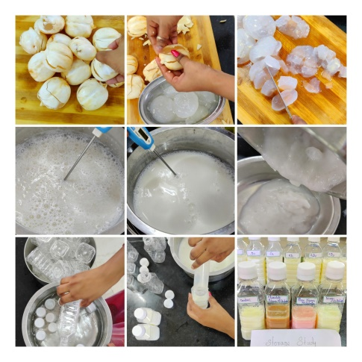 | 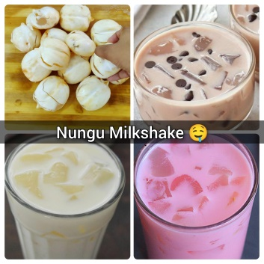
Fig:2 Development of different flavoured ice apple milkshake

Standardization of ice apple ice cream
Table: 2 Standardization of ice apple ice cream

Treatment | Ice apple pulp % | Milk % | Cream ml | Sugar g | Emulsifier  GMS g | Stabilizer  Gelatin g
T₀ | - | 100 | 100 | 100g | 0.4g | 0.8g
T₁ | 10 | 90 | 100
T₂ | 20 | 80 | 100
T₃ | 30 | 70 | 100
T₄ | 40 | 60 | 100
T₅ | 50 | 50 | 100
(GMS –Glycerol Monostearate)
Preparation of ice apple ice-cream
Ice cream is a sweetened frozen food typically eaten as a snack or dessert. Ice apple ice cream was Standardized with 100g ice apple is converted to homogenous mass of pulp . 100 ml milk of sweetened condensed milk make by addition of 100g sugar.After prepared soft peaked cream with using blender then to add a fruit pulp and condensed milk allowed to churn for formation of thick consistency using ice cream churner.
The flow chart of preparation of ice apple ice cream is shown in Fig .3
Raw milk
Heating to 50 ºC
Adding sugar
Adding emulsifier and stabilizer
Pasteurization at 85ºC for 5 mins
Cooling to 50ºC
Whipping the fresh cream
Adding sweetened condensed milk
Mixing
Pulping
Blending the mixture
Adding of fruit pulp
Homogenization for 5 mins
Keeping the mixture in the freezer (-4 to -5 ºC) for 8 hrs
Removing the mixture From the freezer
Beating for 20 mins
Hardening at -24ºC
Storage at -32ºC
Serve at -18⁰C
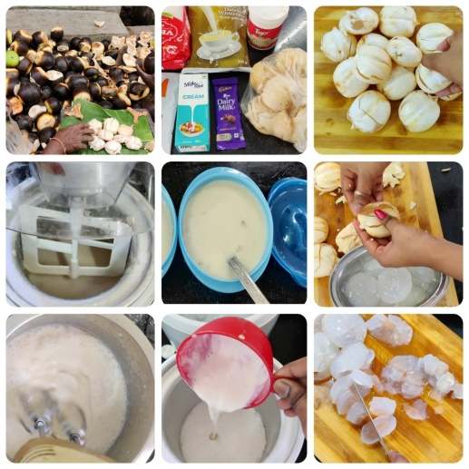 | 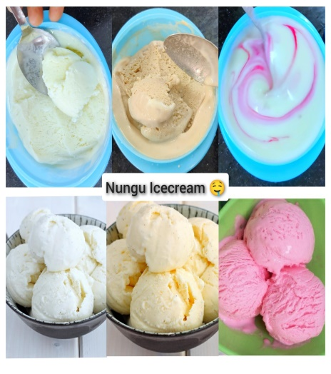
Fig:4 Development of different flavoured ice apple ice cream

Sensory evaluation
The standardized ice apple milkshake and ice apple ice cream were served to 10 panel members using by 9 point hedonic scale (9-like extremely to 1- dislike extremely). In this study is very important to assess the consumer acceptability and over all sensory acceptability. The sensory characteristics, viz., colour and appearance, flavor, consistency, mouth feel and overall acceptability were evaluated by this 10 panel members. The judgment were made to rating product on a using “9-point Hedonic scale”.
Storage study
The developed ice apple milk shake was filled in two different bottles .Bottles are made from PET material (Polyethylene terephthalate) and glass material. These bottles were kept under two different condition, ambient temperature and refrigerator condition at 2-4⁰C. Every 2 days assess the sensory evaluation used to find out any spoilage occurred and ice cream was packed in pet containers.
Biochemical analysis
Following standard protocols were used for qualitative and quantitative analysis of the presence of carbohydrates, protein, fats, minerals, and some chemical characteristics of ice apple desserts.
Total soluble solid (TSS)and Total sugar was measured by using Erma hand refractometer, acidity was determined by titration method (AOAC.,1995)., while total sugar of ice apple desserts were measured .Moisture content was determined by hot air oven method,Ash content was determined by muffle furnace. crude fiber was determined by fibra plus,fat content was determined by sac plus Protein content was determined by Kjeldahl nitrogen method ,pH was determined by pH meter, Carbohydrates was determined by Anthrone method ,Vitamin C was determined by titration and Calcium content was determined by volumetrically using permanganate solution. (AOAC, 1990).

Microbiological evaluation of the product

Microbiological study was done every after 5 days of storage study that it was very important to find out any microbes which growing in freezing condition. For microbial analysis, 1 gm of sample was serially diluted 10⁻² dilution and the aliquots of all the dilutions (10⁻⁰, 10⁻¹and 10⁻²) were plates on nutrient agar for total bacterial count and on potato dextrose agar for fungus. The experiment was carried out in triplicates for each sample. All plates were incubated at 37°C for 24 hours. (Sahni C et al,,2014 .,Jamkhande PG et al,,2016)
Results and discussion
Sensory evaluation of prepared ice apple milkshake
The ice apple milkshake was standardized by different combination of ice apple pulp and milk along with sugar.
Table :3 Sensory Evaluation of ice apple Milkshake
Sensory parameters | T₀ | T₁ | T₂ | T₃ | T₄ | T₅
Appearance | 7 | 7 | 7 | 8 | 6 | 7
Colour | 7 | 7 | 7 | 8 | 6 | 6
Flavor | 7 | 7 | 7 | 8 | 6 | 6
Taste | 7 | 7 | 8 | 8 | 6 | 6
Over all acceptability | 7 | 7 | 8 | 8 | 6 | 6

This figure showed T₃ – treatment, 50% ice apple incorporated milk shake was scored good taste, appearance, color and flavor hence T₃ was suitable to make a creamy milkshake.T₁ and T₂ treatments gives very bright white colour, good appearance but watery consistency and slightly ice apple flavor because of 20% and 30% incorporated of ice apple. T₄and T₅treatments gives very bright white colour, good appearance, wellness of nungu flavor but very thick consistency like smoothie hence 40 % and 50% incorporated of ice apple milkshake was not accepted.
Sensory evaluation of prepared ice apple ice cream
The ice apple ice cream was prepared by different treatment with ice apple pulp, milk cream ,condensed sweet milk along with sugar.
Table :4 Sensory Evaluation of ice apple ice cream.
Sensory parameters | T₀ | T₁ | T₂ | T₃ | T₄ | T₅
Appearance | 6 | 7 | 7 | 7 | 8 | 9
Colour | 6 | 6 | 6 | 8 | 8 | 9
Flavor | 6 | 6 | 6 | 8 | 7 | 8
Taste | 6 | 6 | 6 | 7 | 8 | 9
Consistency | 5 | 5 | 6 | 7 | 8 | 9
Mouth feel | 6 | 6 | 6 | 8 | 8 | 9
Over all acceptability | 6 | 6 | 6 | 7 | 8 | 9

Table :4 showed T₅ of treatment of 50 % ice apple incorporated ice cream was to give good test ,texture, appearance, colour and flavor so this treatment method was very suitable to make a creamy ice apple ice cream. The over all acceptability was 9 this data was given by 10 panel members using 9 point hedonic scale.T₁ and T₂, 10 % and 20% of ice apple incorporated treatments, gives good colour, appearance but slightly nungu flavor and highly watery texture to help ice crystal formation.T₃ and T₄ treatment gives good colour, appearance ,nungu flavor and but texture was not good because 30 % and 40% of ice apple incorporation.

In addition, the flavor of the ice apple milkshake and ice cream enhanced with chocolate and rose milk flavors to increase the market potentiality.
Storage study of ice apple milkshake
The standardized ice apple milkshake was kept under ambient condition and refrigerator condition to assess the shelf life for the duration of one month, every 5 days to evaluate the organoleptic properties it was good to keep up to 10th day after that it was not suited for consumer preferences.
Storage study of ice apple ice cream
The prepared milkshake was kept under refrigerator condition for used to assess the shelf life of the ice apple ice cream the duration of 2 month, every 5 days to evaluate the organoleptic properties it was good to keep on but the organoleptic properties were bad to discard.
showed the prepared milkshake had have very good sensory properties still the duration of 40 the initial day of over all acceptability was 9 and after 40 days the over all acceptability was 8 in this study to assess the shelf life of ice apple ice cream had 40 days then the duration of storage would be increased at the same time the organoleptic properties were decreased
Bio chemical study of ice apple desserts
Bio chemical parameters, total soluble solids, TSS, _{P}H, acidity and total sugars were analysed in the prepared different flavored desserts (plain, chocolate, rose flavoured ice apple milkshake and ice apple ice cream).
Desserts | TSS brix | pH | Acidity % | Total sugar (g)
Ice apple Milkshake | 18.4 | 6.6 | 0.1 | 16.2
Ice apple Ice Cream | 22.7 | 6.4 | 0.1 | 28.7

Table:8 showed ice apple milkshake contain acceptable level of pH range (6.6) and ice cream ph was 6.4,TSS range between 18.4 to 22.7º brix, acidity of iceapple milk shake and ice cream was 0.1 and Total sugar range between 16.2 to 28.7 respectively. Hence this values proved ice apple value added foods are ready for commercialization and hold good market potentiality .
Desserts | Energy  (kcal) | Carbohydrate (g) | Protein (g) | Fat (g) | Ash (g) | Calcium (mg) | Vitamin c (mg)
Milkshake | 130.30 | 26.42 | 3.69 | 9.30 | 0.12 | 130.80 | 0.98
Ice cream | 176.56 | 27.12 | 12.10 | 22.30 | 0.13 | 230.30 | 1.75

Nutritional factors of energy, carbohydrates, protein, fat, ash, calcium and vitamin C were analysed in the ice apples desserts (ice apple milkshake and ice apple ice cream ).Table:10 and chart represents 100 ml of ice apple milkshake contained 130.3 kcal of energy ,26.42g of carbohydrate, 9.3 of fat, 3.69 g of protein, 0.98mg of vitamin C, 0.12 g ash content and 130.8mg of calcium and 100g of ice apple ice cream contained 176.56 kcal of energy ,27.12 g of carbohydrate, 22.3 of fat, 12.10 g of protein, 1.75mg of vitamin C, 0.13 g ash content and 230.3 mg of calcium. The developed ice apple desserts provide immediate energy and rich in calcium content , hence it is proved its most suitable for children.
Microbial study of ice apple dessert
Microbial load of ice apple milkshake contain the average level of colony forming unit between (1.5X10³to 3 X10³⁾ ice apple ice cream contain the average level of colony forming unit between (1.5X10³to 1.6X10^{3) .}Hence the developed ice apple desserts were fit for consumption because of safest load of microbial content .
Conclusion
Palmyra tree plays an important role in human life. Every part of the tree is used for preparation of various types of products and it gives more health benefits. This study is successfully enhanced the shelflife of the seasonal fruit of ice apples,duration of 2 months which is incorporated ice apples with some desserts like milkshake and ice cream .In off season of ice apple we also feel the taste and flavor through nungu incorporated desserts were ice apple milkshake and ice apple ice cream
REFERENCE
- AOAC. (1990). Official methods of analysis 15th Ed. Association of official analytical chemists. Washington DC, USA.
- AOAC. (1995). Official methods of analysis 16th Ed. Association of official analytical chemists. Washington DC, USA.
- Gummadi VP, Battu GR, Keerthana Diyya MS, Manda K. A review on palmyra palm (Borassus flabellifer). Int J Curr Pharm Res. 2016;8(2):17-20. 7. Jerry A. A Comprehensive Review on the Medicinal Properties of Borassus flabellifer. J. Acad. Indus. Res. 2018;7(7):93-97.
- Jamkhande PG, Suryawanshi VA, Kaylankar TM, Patwekar SL. Biological activities of leaves of ethnomedicinal plant, Borassus flabellifer Linn. (Palmyra palm): An antibacterial, antifungal and antioxidant evaluation. Bulletin of Faculty of Pharmacy, Cairo University. 2016;54(1):59-66.
- Sahni C, Najam AS, Vidyanath J, Rajinder KG. Screening of nutritional, phytochemical, antioxidant and antibacterial activity of the roots of Borassus flabellifer (Asian Palmyra Palm). J. Pharmacog. Phytochem. 2014;3(4):5868.
- V.Ramya,2014.FouramazingbenefitsofPalmfruit. http://www.wildturmeric.net/2014/12/4-amazing health benefits of palm fruit nungutadgolamunjal fruit.html
- Veilmuthu P. Palmyra – nature’s perennial gift in the face of climate crisis; 2020. Available:http://climatesouthasia.org/palmyra-natures-perennial-gift-in-the-face-ofclimate-crisis/ (Accessed on 04.07.2020)

