**Detection and Estimation of endogenous Jasmonic acid and Salicylic acid in Potato genotypes imposed with defense modulators using High Performance Liquid Chromatography**

**Abstract:**

Jasmonic Acid (JA) and Salicylic Acid (SA) are pivotal signaling molecules involved in the complex network of plant defense mechanisms. Enhancing the levels of JA and SA through exogenous application or genetic manipulation has shown promising results in bolstering plant resistance to a wide range of diseases. This study investigates the effects of Jasmonic Acid (JA), Salicylic Acid (SA) and Compost Tea (CT) treatments on the endogenous JA and SA responses of four distinct potato genotypes-KH (Kufri Himalini, *Solanum tuberosum*), KJ (Kufri Jyothi, *Solanum tuberosum*), AC4 (*Solanum sparsipillium*) and AC6 (*Solanum spegzinii*). High-Performance Liquid Chromatography (HPLC) analysis was conducted to determine endogenous detectable levels of JA and SA defence phytohormones. The absorption spectra showed peak absorptions at 295 nm and 325 nm for JA (25 µg ml-1) and SA (10 µg ml-1) respectively. Retention times of JA and SA were determined to be RT-3.74 and RT-2.86 min respectively. The genotypes were subjected to various concentrations of JA and SA, and their respective impacts on endogenous JA and SA were measured. Genotype-specific responses were evident, with all genotypes displaying distinct sensitivities with respect to endogenous detectable JA in CT (KH-15.42 µg ml-1, KJ-133.67 µg ml-1, AC4-10.36 µg ml-1, AC6-7.92 µg ml-1), JA (KH-83.03 µg ml-1, KJ-184.14 µg ml-1, AC4-286.95 µg ml-1, AC6-9.2 µg ml-1) treatments while no detectable JA and SA was observed in Control, SA and JA+SA combined treatments. JA could enhance higher amount of detectable endogenous JA than CT treatment. The application of JA and SA enhancement could demonstrate success in various other crops rendering resistance against diseases in an eco-friendly approach.

Keywords: Jasmonic acid, Salicylic acid, Compost tea, HPLC.

**Introduction:**

Plants, as sessile organisms, have evolved sophisticated defense mechanisms to protect themselves against various biotic and abiotic stressors. Among the key signaling pathways involved in plant defense responses are those mediated by phytohormones, such as jasmonic acid (JA) and salicylic acid (SA). These compounds play pivotal roles in regulating plant growth, development, and responses to environmental challenges. Jasmonic acid is primarily associated with defense responses against herbivores and necrotrophic pathogens, while salicylic acid is a key player in defense against biotrophic pathogens (Monte. 2023) . The intricate crosstalk between these two signaling pathways determines the overall outcome of a plant's defense response (Yang *et al*., 2019). Understanding the dynamics of JA and SA levels in plants exposed to different stress treatments is crucial for unravelling the complex network of plant defense mechanisms.

High-Performance Liquid Chromatography (HPLC) has emerged as a powerful analytical technique for the precise and simultaneous quantification of phytohormones, including JA and SA, in plant tissues. HPLC offers high sensitivity, selectivity, and reproducibility, making it an ideal method for studying the intricate hormonal balance in response to various treatments. In the context of potato plants, a staple food crop globally, investigating the dynamics of JA and SA levels in leaf tissues subjected to different treatments provides valuable insights into the plant's stress responses. The outcomes of such studies contribute not only to basic plant biology but also have practical implications for crop management and breeding programs aimed at enhancing stress tolerance.

The standardization of the HPLC based detection and estimation of JA and SA will be a simpler approach as opposed to various purification techniques, such as liquid partition and immunoaffinity chromatography, as well as detection methods like immunoassay and electrochemical analysis (JiHong *et al*. 2011) which are generally used in estimations of these phytohormones, but are time consuming and cumbersome.

This research aims to elucidate the impact of diverse defence modulators on the levels of jasmonic acid and salicylic acid in potato leaves using HPLC. The results obtained from this study will enhance to some extent our understanding of the complex regulatory mechanisms underlying plant stress responses, ultimately facilitating the development of strategies for improving crop resilience and productivity.

**Material and Methods:**

**Chemicals:** AllHPLC grade solvents used for the study were procured from Sisco Research Laboratories Pvt. Ltd. Highly pure Jasmonic acid and Salicylic acid were procured from Sigma Aldrich chemical company and used without further purification.

**Study material**

Four genotypes *viz.,*Cultivars- KH (Kufri Himalini, *Solanum tuberosum*), KJ (Kufri Jyothi, *Solanum tuberosum* and wild potato species- , AC4 (*Solanum sparsipillium*) and AC6 (*Solanum spegzinii*) were used for the experiment. Kufri Jyoti, Kufri Himalini , AC4 and AC6 were procured from CPRI, Shimla. Kufri Jyoti and AC6 are susceptible to late blight disease and Kufri Himalini and AC4 are resistant counterparts (Table 1). The cultivars and wild genotypes used for the experiment were planted in pots in the green house at the Department of Plant Biotechnology, GKVK, University of Agricultural Sciences, Bangalore. The experiment was conducted with five treatments and four replicates using CRD design. Treatments used are as mentioned in the table 2. Concentration of JA and SA used for a study was 0.5 mM L-1 (Faried *et al*., 2017).

**Preparation of Compost tea:**

Compost tea was crafted using well-structured compost, following the method established (Anil *et al*. 2017). Non-aerated compost tea was prepared in a manner similar to the process described earlier, with the exception that continuous aeration was omitted during the fermentation/incubation period. Instead, the mixture was stirred once daily using a stick to provide minimal aeration. The resulting compost tea is characterized by its lack of odour and its clear, brown liquid suspension. This prepared compost tea is utilized for one week, after which a fresh batch is prepared for the subsequent week.

**JA and SA Standard solution preparation and detection of absorption maxima**

Jasmonic acid and Salicylic acid stock solutions of 0.1 mg ml-1 were prepared by dissolving

appropriate amount of both chemicals in methanol and were stored at 4°C. Working solutions

were prepared immediately before analyses by diluting stock solution with mobile phase to

obtain the required concentrations for standard curve calibration measurements. Before

preparing a standard curve, a spectral scan (180-800 nm) was carried out for the Sigma-

Aldrich sourced Jasmonic acid using BioTek Synergy HTX Reader to obtain absorption

spectra of Jasmonic acid (25 µg ml-1) and salicylic acid (10 µg ml-1). Thus, absorption

maxima of jasmonic acid and salicylic acid were determined using the spectra and further

this wavelentgth was used to generate the standard curve and also for the estimations of

endogenous JA and SA. .

**Determination of the retention times of JA and SA compounds**

To determine the retention time of JA and SA for HPLC analysis, working solutions of Jasmonic acid (25 µg ml-1) and Salicylic acid (10 µg ml-1) were prepared using the primary standard stock (0.1mg ml-1). The dilution of the standards was made using acetonitrile: water in the ratio 75:25 (V/V). Chromatographic analysis was performed using HPLC system, Shimadzu, Japan, LC-10AD consisting of binary pump, column oven and UV detector. HPLC separations were performed by a reverse phase Phenomenex C18 (250 x 4.6mm), 5μm. Column temperature was controlled at 30°C (Anil *et al*., 2017). The retention times of JA and SA were determined.

**Generation of standard curves for JA and SA:**

Working solutions of 25 µg ml-1, 50 µg ml-1, 100 µg ml-1, 150 µg ml-1, 200 µg ml-1 for

Jasmonic acid and 10 µg ml-1, 20 µg ml-1, 30 µg ml-1, 40 µg ml-1, 50 µg ml-1 for Salicylic acid

Concentrations using standard stock were prepared to generate a standard curve using the

absorption maximum wavelength for JA and SA using HPLC. Chromatographic analysis was

performed using HPLC system, Shimadju, Japan, LC-10AD consisting of binary pump,

column oven and UV detector. HPLC separations were performed by a reverse phase

Phenomenex C18 (250 x 4.6mm), 5μm. Column temperature was controlled at 30°C (Anil *et*

*al*., 2017).

**Extraction of endogenous Jasmonic acid and Salicylic acid using High Performance liquid chromatography**

Jasmonic acid extraction and estimation were carried out by slightly modified protocol of Islam and coworkers, (Islam *et al*, 2019). Potato leaves were collected from potted plants at 45 DAP after completion of all treatments mentioned in Table 2. Leaves were crushed in liquid nitrogen then 20 mg of powdered tissue was weighed into 2 ml microfuge tube and extracted with 400 μl of 10 % methanol containing 1% acetic acid. Placed on ice for 30 min then centrifuged at 13,000 g for 10 min at 4°C. The supernatant was carefully removed and the pellet was re-extracted with 400 μl of 10% methanol containing 1% acetic acid. Following further 30 min incubation on ice the extract was centrifuged and the supernatants pooled (Forcat *et al*., 2008). Water and acetonitrile were used as mobile phase. Injection volume was 20 µl. Quantification of JA and SA compounds in the samples were carried out using external standard method (Anil *et al*., 2017). Reverse-phase HPLC gradient parameters for JA and SA analysis are as mentioned below. Mobile phase: Solvent A: 100 % HPLC grade water; Solvent B: 100 % HPLC grade acetonitrile.

**Statistical analysis**

The linear regression method was employed to establish a standard curve for

JA and SA in HPLC. Linear regression analysis was performed using MS-Excel. Standard

curve is represented by a linear equation in the standard form of y=β0+β1x.

**Results and Discussion**

**Detection of absorption maxima of JA and SA**

High purity, Jasmonic acid (JA) and Salicylic acid (SA) were purchased from Sigma Aldrich

Chemical Company, USA. The Absorption spectra was recorded to determine the absorption

maxima of jasmonic acid and salicylic acid. The absorption spectra showed peak absorptions

at 295 nm and 325 nm for JA (25 µg ml-1) and SA (10 µg ml-1) respectively, as shown in the

fig 1. Similarly, the retention time of JA and SA for HPLC analysis were determined using standard JA (25 µg ml-1) and SA (10 µg ml-1) at 295 nm and 325 nm respectively. Retention times of JA and SA were determined as RT-3.74 and RT-2.86 min respectively as shown in the fig. 2.

Following these preliminary data acquisitions, respective standard curves using standard JA and SA were first generated (Fig. 2). The peak area was estimated for each of the concentrations used and standard curve generated by plotting peak area as a function of JA or SA concentrations which was further used for the estimation of endogenous JA and SA under different treatments.

**Estimation of endogenous Jasmonic acid and Salicylic acid in leaves of potato plants**

The Leaves from treated potato plants were used to extract JA and SA in solvent methenol as indicated in material and method section. Quantification of compounds was carried out using external standard method. 5.01(µg ml-1) and 1.39 (µg ml-1) are considered as a basal levels/threshold values of JA and SA respectively indicated in table 3 and Fig. 3, only above these values JA and SA were successfully detected using HPLC in this study. Hence, 5.01 and 1.39 are considered as negligible values of JA and SA respectively. Detectable levels of Jasmonic acid was induced in the treatments Compost tea (T2 (CT)) in KJ (133.67 µg ml-1) and mildly in all other genotypes. Jasmonic acid treatment (T3) also induced endogenous JA in KH (83.03 µg ml-1), KJ (184.14 µg ml-1) and AC4 (286.95 µg ml-1) genotypes. Mild Salicylic acid induction was observed in compost tea (T2) treatment of KJ (1.51 µg ml-1) as shown in the table 3 and Fig. 3. CT and JA treatment induced detectable endogenous JA levels in all the genotypes. CT induced detectable SA in KJ (1.51 µg ml-1) and AC4 (1.49 µg ml-1), JA induced endogenous SA levels in KJ and AC6. CT inducing both JA and SA levels in KJ favours the results of Vanishree and Anil. (2019) wherein CT is found to enhance endogenous JA levels significantly of paddy leaf samples when sprayed. This result also corroborates with the study conducted previously wherein CT enhanced the resistance to late blight and hypersensitive response in field and calli respectively of KJ (Anil *et al*, 2017, Poster: Kakade and Anil, 2019, Poster). Induction of detectable endogenous JA by CT could be one of the factors contributing to resistance. No detectable induction of JA or SA were noticed in T1 (Con), T4 (SA) and T5 (JA+SA) treatments correlating with the enhanced susceptibility of potato plants observed in field experiments with treatment with SA (Anil et al 2017), and more recently in Kharif 2019 and 2022 with SA (T4) alone and the; combinations of SA+JA (T5) treatments against late blight (Data not shown here). Highest response to CT was observed in KJ, wherein 133.67 µg ml-1 of JA was detected followed 15.42 µg ml-1 of JA in KH. Least amount of JA and SA were detected in AC6. Thus, cultivars responded better to external CT application in terms of endogenous JA in leaves. Similarly, higher detectable JA was recorded in JA treatment of KJ (184.14 µg ml-1) and AC4 (286.95 µg ml-1) followed by KH (83.03 µg ml-1). It is to be noted that both resistant genotypes (KH and AC4) responded with high endogenous JA to external JA applications. In addition, KJ which was earlier a Late blight resistant cultivar also responded by increasing endogenous JA levels. Indeed, KJ showed detectable and higher amount of endogenous JA in both external JA and CT applications. Detectable amount of JA and SA were reported in CT (KJ), CT (AC4), and JA (KH) though the field and pot experiments in this study satisfactorily explains the antagonistic effect of these hormones when present together (Data not shown here). This could be probably because of the higher amount of JA and SA used in field and pot experiments which is 0.5 mM L-1 each. And the endogenous JA and SA detected are in very low concentrations (µg ml-1) when compared to that applied in the field or pot experiment. In addition, the ratio of endogenous JA to SA is high as SA levels are comparatively low, and this is opposed to the 1:1 ratio that was used in treatments such as JA+SA in the field experiment. The low values of SA detected by HPLC may be insufficient to be causing an antagonistic inhibition and in fact may also represent more optimal ratios of JA: SA for optimal results in terms of disease resistance and also yield enhancement.

**Conclusion:**

HPLC based of Leaf –endogenous JA and SA estimations in the present study validates the HPLC technique to be efficient in effective estimation of phytohormone levels in response to different defence modulators (JA, SA and CT). Additionally, it can be inferred that CT in fact induces endogenous JA and thus may be activating JA dependent pathways to lead to the beneficial results in terms of Late blight resistance and yield enhancement seen in pot and field experiments (Data not shown).

**Acknowledgement**

This research work was partly funded by DST-inspire fellowship, GOI. We acknowledge DST-FIST program at the Department of Plant Biotechnology, UAS-B, for the facilities.

**REFERENCES**

Anil, V. S., Kavitha, P. and Roopashree, K. M., 2017. Microbial synthesis of indole-3-acetic acid and gibberellic acid in growth promoting compost tea: HPLC based metabolite profiling. *J. Soil Biol. Ecol.,* 37 (1): 70-78.

Faried, H.N, Ayyub, C.M and Amjad, M., 2017. Salicylic acid confers salt tolerance in potato plants by improving water relations, gaseous exchange, antioxidant activities and osmoregulation. *J Sci Food Agric* **97**(6): 1868–1875.

Forcat, S., Bennett, M.H., Mansfield, J.W. and Grant, M.R., 2008. A rapid and robust method for simultaneously measuring changes in the phytohormones ABA, JA and SA in plants following biotic and abiotic stress. *Plant methods*, *4*, 1-8.

Islam, J., Phukan, S. and Chattopadhyay, P., 2019. Development of a validated RP-HPLC/DAD method for the quantitative determination of methyl jasmonate in an insect repellent semi-solid formulation. Heliyon, **5**(5).

Jiang, C., He, Y. and Liu, Y., 2020. Recent advances in sensors for electrochemical analysis of nitrate in food and environmental matrices. *Analyst*, **145**(16), 5400-5413.

Yang, J., Duan, G., Li, C., Liu, L., Han, G., Zhang, Y. and Wang, C., 2019. The crosstalks between jasmonic acid and other plant hormone signaling highlight the involvement of jasmonic acid as a core component in plant response to biotic and abiotic stresses. *Front. Plant Sci*, **10**:1349.

**Table 1:** **Wild species and cultivars of potato used for HPLC analysis.**

|  |  |  |  |  |  |
| --- | --- | --- | --- | --- | --- |
| Sl No. | Genotype | Referred name | Species Name | Ploidy | Resistance/ susceptibility to Late Blight |
| 1 | Kufri Jyoti | KJ | *Solanum tuberosum* | 4n | Susceptible |
| 2 | Kufri Himalini | KH | *Solanum tuberosum* | 4n | Moderately Resistant |
| 3 | SS-1724-07 | AC4 | *Solanum sparsipillium* | 2n | Resistant |
| 4 | SS-1725-54 | AC6 | *Solanum spegzinii* | 2n | Susceptible - |

**Table 2: Treatment details for Pot experimentation**

|  |  |  |
| --- | --- | --- |
| **Sl.** | **Treatments** | **Treatment details** |
| **T1** | Control | No applications |
| **T2** | Jasmonic acid (JA) | JA (0.5 mM L-1) foliar applications from 25 DAP distributed as one application per week for three weeks. |
| **T3** | Salicylic acid (SA) | SA (0.5 mM L-1) foliar applications from 25 DAP distributed as one application per week for three weeks. |
| **T4** | Jasmonic acid+ Salicylic acid (JA+SA) | Combined treatment of JA (0.5 mM L-1) SA (0.5 mM L-1) from 25 DAP distributed as one application per week for three weeks. |
| **T5.** | Compost tea (CT) | Five sprays of compost tea from 25 DAP distributed as one application per week for five weeks. |

**Table 3: HPLC analysis for endogenous JA and SA levels in potato leaves of different genotypes in pot experiment**

|  |  |  |  |  |  |  |  |  |
| --- | --- | --- | --- | --- | --- | --- | --- | --- |
| **Genotypes** | **KH** | | **KJ** | | **AC4** | | **AC6** | |
| **Treatments** | JA (µg ml-1) | SA (µg ml-1) | JA (µg ml-1) | SA (µg ml-1) | JA (µg ml-1) | SA (µg ml-1) | JA (µg ml-1) | SA (µg ml-1) |
| **T1 (**CON) | 5.01 | 1.39 | 5.01 | 1.39 | 5.01 | 1.39 | 5.01 | 1.39 |
| **T2 (**CT) | 15.42 | 1.39 | 133.67 | 1.51 | 10.36 | 1.49 | 7.92 | 1.39 |
| **T3 (**JA) | 83.03 | 1.39 | 184.14 | 1.40 | 286.95 | 1.39 | 9.82 | 1.39 |
| **T4 (**SA) | 5.01 | 1.39 | 5.01 | 1.39 | 5.01 | 1.39 | 5.01 | 1.39 |
| **T5 (**JA+SA) | 5.01 | 1.39 | 5.01 | 1.39 | 5.01 | 1.39 | 5.01 | 1.39 |

**T1-**CON**, T2-**CT**, T3-**JA**, T4-**SA **and T5-**JA+SA; **CON**-Control, **CT**-Compost tea, **JA**-Jasmonic acid; **SA**- Salicylic acid**. KH-**Kufri Himalini**; KJ-**Kufri Jyoti**; AC4-** *Solanum sparsipillium*; AC6- *Solanum spegzinii*

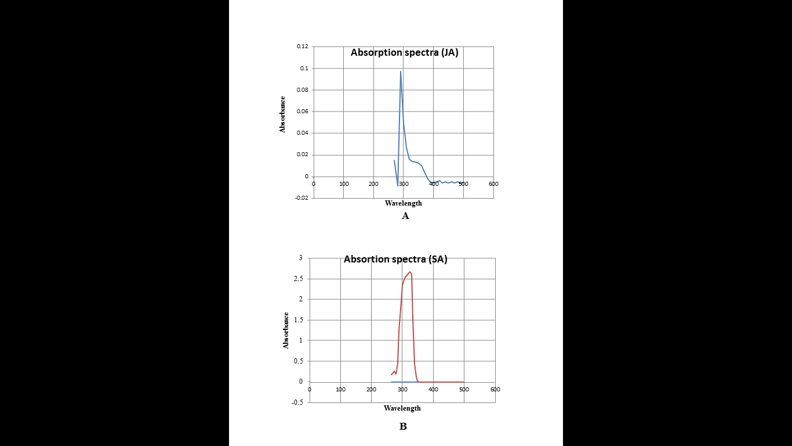

**Fig 1: The absorption spectra showing peak absorptions at 295 nm and 325 nm for JA and SA**; A, **Absorption spectra of JA showing peak absorption at 295 nm; B, Absorption spectra of SA showing peak absorption at 325 nm.**

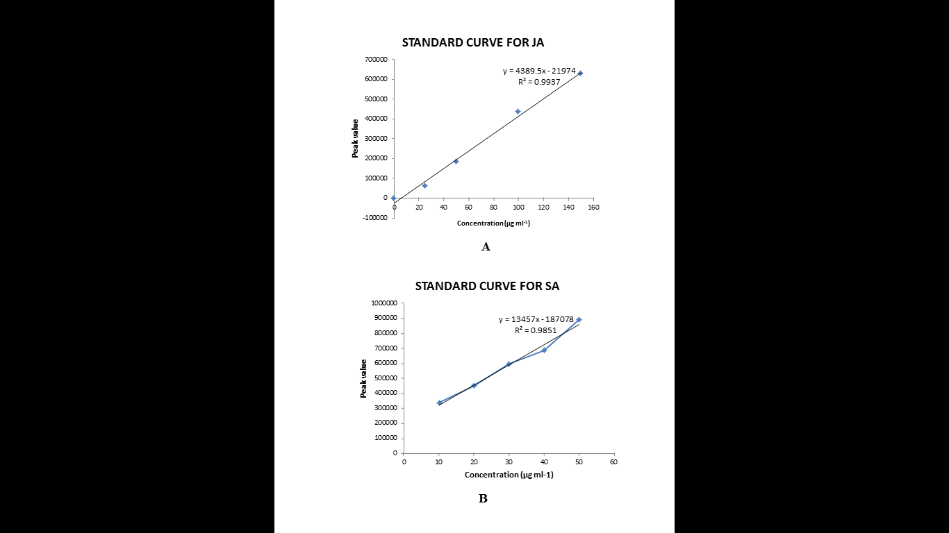

**Fig 2: Standard curve of JA and SA read at 295 nm and 325 nm**; A, **Standard curve of JA at 295 nm; B, Standard curve of SA at 325 nm.**

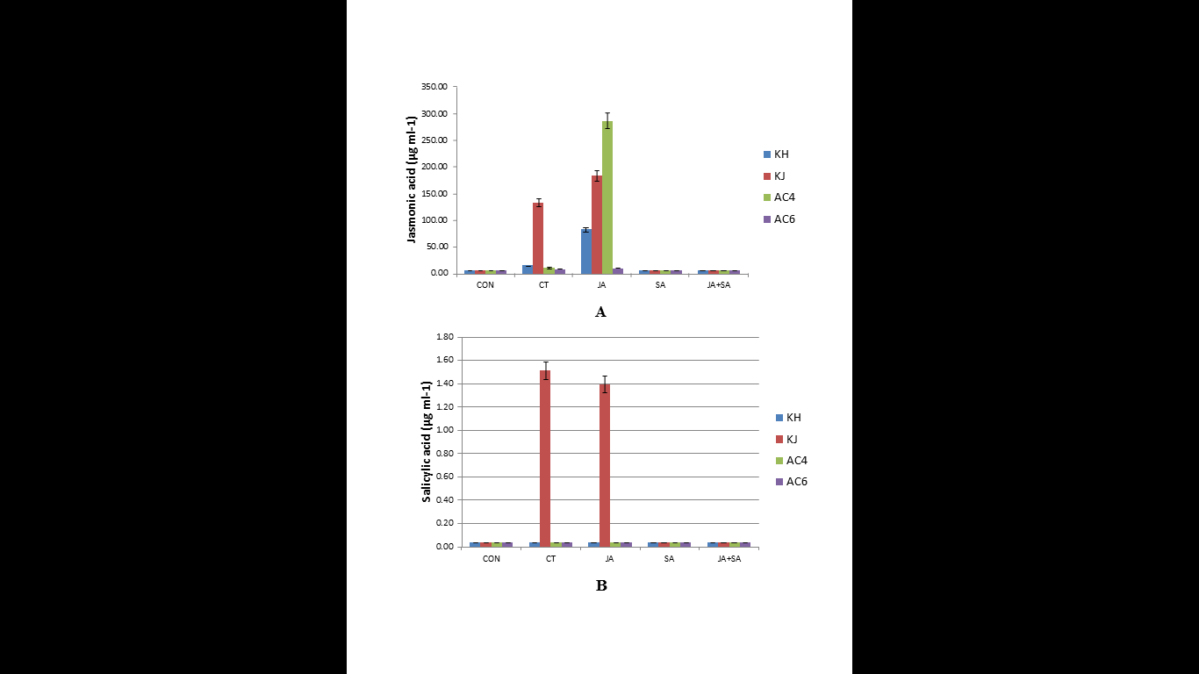

**Fig 3: Induction of JA and SA in different treatments imposed on four genotypes KJ, KH, AC4, AC6 read at 295 nm and 325 nm respectively using HPLC**; **A, Induction of JA in different treatments imposed on four genotypes KJ, KH, AC4, AC6; B, Induction of SA in different treatments imposed on four genotypes KJ, KH, AC4, AC6. T1-**CON**, T2-**CT**, T3-**JA**, T4-**SA **and T5-**JA+SA; **CON**-Control, **CT**-Compost tea, **JA**-Jasmonic acid; **SA**- Salicylic acid**.**