**Challenges in Pomegranate Production -Review**

**Chandana M R**1**\*, Gayatri B K2, Abeer Ali**1**, Chukkamettu Anusha**1**, Shiv Kumar N3 ,Hatkari Vittal**1**,**

1PhD Scholar Division of Fruits and Horticultural Technology, ICAR- IARI New Delhi

**2**PhD Scholar Division of Vegetable Science, ICAR- IARI New Delhi-110012

3M.Sc. Scholar Division of Fruits and Horticultural Technology, ICAR- IARI New Delhi

*Corresponding: chandanamr1997@gmail.com

**Abstract**

Pomegranate (*Punica granatum*) is a popular and economically important fruit crop, known for its high nutritional value and health benefits. The cultivation of pomegranate faces several significant challenges that impact its production and quality. This review article highlights key obstacles in pomegranate related to diseases, pests, and physiological disorders. In pomegranate, both fungal and bacterial diseases cause major loss during cultivation, which includes pomegranate wilt, bacterial blight and anthracnose. The pest infestation in pomegranate orchards can lead to substantial crop losses if not managed effectively. Some key pests such as pomegranate butterfly, fruit borer, and fruit-sucking moth, damage the fruits, and reduce fruit quality as well as yield. This review discusses potential solutions and management strategies to address these challenges and enhance pomegranate production. Understanding and mitigating these problems is essential for the sustainable growth of the pomegranate industry. Continuous research and innovation in pest and disease management are vital to support pomegranate growers in maintaining healthy and high-yielding orchards.

Keywords: Pomegranate, Biotic stress, Punica, Bacterial blight, Diseases, Pest

**Introduction**

The pomegranate, also known as the 'fruit of paradise,' is an ancient domesticated fruit crop that holds significant economic importance in tropical and subtropical regions across the globe. It belongs to the Lythraceae family having chromosome number 2n=18(2x). The botanically fruit is called Balusta (modified berry), *Punica granatum* L, which is derived from the Latin words, "*Pomum*" (meaning apple) and "*granatus*" (meaning grainy or seeded), referring to its apple-like appearance and abundant seeds. While the pomegranate's native origins can be traced back to Iran and its neighbouring regions, it has experienced extensive cultivation across various territories. Noteworthy pomegranate growing regions encompass India and various Mediterranean areas in Asia, Africa, and Europe. All the parts of a plant are important sources of medicinal, nutritional, and therapeutic activities. Pomegranates are known to contain a specific compound called punicalagin, which is exclusively found in the outer skin of the fruit. This compound in pomegranates acts as a powerful antioxidant, contributing to heart and blood vessel health and aiding in stroke prevention. Besides punicalagin, pomegranate juice is a source of numerous nutrients, including sugars, iron, phosphorus, calcium, and magnesium, along with vital vitamins such as riboflavin, thiamine, niacin, and vitamin C. Pomegranates, encompassing their edible and inedible components, host a range of metabolites thought to offer potential health benefits. (Priya *et al*., 2016). India is the largest producer, continuously cultivated in various parts of the country. The cultivation area is 2.76 lakh ha with a production of 31.48 lakh MT (NHB, 2021-22 third advance estimate). The pomegranate cultivation area is rapidly decreasing, with more than 30% of farmers uprooting pomegranate trees in the last four years due to various diseases such as bacterial blight, wilt, dieback, leaf spots, fruit spots, etc (Jamadar *et al.,* 2011). The estimated losses of pomegranate due to major pests and diseases are provided in Table 1. In India, the most popular varieties Ganesh, Mridula, Arakta, and Bhagwa (Kesar), have been susceptible to disease since long. Dealing problems related to pomegranate production in a cost-effective way can improve profit margins and encourage farming communities. Several horticultural practices are followed to boost fruit quality and protect fruits from pests, diseases, and physiological disorders (Munhuweyi *et al*., 2016).

|  |  |  |  |
| --- | --- | --- | --- |
| **Disease/ Pest** | **Area of distribution** | **Yield loss** | **Reference** |
| Bacterial blight | Maharashtra, karnataka, and Anthra Pardesh | 60 - 80 % or up to 100% | (Sharma *et al.,* 2010)  (Bagal *et al.,* 2022) |
| Bacterial wilt | Maharashtra, karnataka, and Anthra Pardesh | 33% or 36% | (Sharma *et al.,* 2010)  (Das *et al.,* 2021) |
| Anthracnose | Maharashtra | 10 to 80% | (Cara *et al.,* 2020) |
| Fruit borer | All over India | 65 to 70% | (Khandare *et al.,* 2018) |
| Fruit sucking moth | Karnataka and Maharashtra | 40% | (Jayanthi *et al.,* 2015) |

**Table 1: Major pests and diseases, their distribution, and yield loss impact**

**Diseases of pomegranate**

1. **Bacterial blight**

Bacterial blight is a most devastating disease in pomegranate cultivation affecting the above-ground parts. It has been the most devastating natural calamity in India for the past 24 years since its first appearance in 1952, causing substantial losses (Arora, 2016). The peak period of blight incidence coincides with the mrig bahar leading to the estimated loss of about 60 to 80%. which brings down domestic and export production. Having causal organism *Xanthomonas axonopodis pv. punicae* (Chowdappa *et al.,* 2018). A new causal organism, *Pseudomonas* sp. SK 10, was isolated from Maharashtra, India (Jagdale *et al.,* 2019).

**Symptoms**

**Leaves:** The first symptom on leaves is irregular to circular oily, translucent spots.

**Stems**: Lesions that range from brownish to black on the stem extend along the bark, causing it to girdle and break off. Advanced stages of disease development form canker which restricts growth (Sharma *et al.,* 2015).

**Fruits**: Symptoms observed on fruit cause lesions formed Y or L-shaped small fissures not as visible as spots caused by fungus. Blighted fruits with lesions show splitting (Sharma *et al.,* 2010). Dark brown, raised and oily-looking water-soaked spots frequently form, and they are prone to developing secondary infections, ultimately leading to spoilage and rendering the product unsuitable for consumption and sale (Petersen *et al.,* 2010) (Fig. 1 and Fig. 2).

**Etiology**

A single polar flagellum is responsible for the motility of a gram-negative rod shaped bacterium *Xanthomonas axonopodis pv punicae*, It does not form spores and produces a yellow pigment that is not diffusible. Infected plant debris in the soil and stem infections on the plant are the primary sources of inoculation for initial infections and mainly spreads through rain splashes carried by the wind and infected propagating materials, lenticel, stomata and wounds serve as secondary source of inoculum. It remains prevalent throughout the year as it can infect during the temperature range from 9℃ to 43℃. However, in the rainy seasons, it exacerbates in severity when exposed to high humidity levels (above 80%) and moderate temperatures ranging from 25 to 35 ℃. (Vauterin *et al.,* 1995; Petersen *et al.,* 2010; Arora, 2016; Parihar *et al.,* 2021).

**Control measures:**

Bacterial blight is effectively managed by adopting integrated disease management (IDM), and the incidence can be reduced by 5% and the crop yield can be increased to 9-12 tons /ha from 4-5 tons/ha. (Benagi *et al.,* 2012)

1. **Cultural practices**

Orchard sanitation includes complete defoliation after harvesting the crop during the rainy season, followed by a 3-4 month resting period due to a higher incidence of diseases during the rainy season or "bahar," which occurs from January to July. The use of disease-free propagating material should be procured from a certified nursery for establishing an orchard. Tissue culture-raised planting material and a plant spacing of about 4.5 x 4.5 meters should be used.

1. **Biological methods**

The application of bacterial antagonistic biocontrol agents, such as *Pseudomonas fluorescens* (0.1%), *Bacillus subtilis* (Raju *et al*., 2012), *Streptomyces violaceus*, *Lactococcus lactis* *subsp. cremoris* PB6, *Lactobacillus brevis* PFR77 (Gajbhiye et al., 2023), is recommended. The use of Arka microbial consortium at a rate of 1.5 L per 200 L of water on pomegranate trees at fortnightly intervals is suggested. This can be applied through soil drenching by mixing with water at a rate of 20 g per liter on the 10th day after transplanting. For standing crop application, a mixture of 5 kg with 500 kg of FYM should be applied near the root zone. The application of plant extracts from Pongamia Oil, Neem, Coleus, Ocimum, Periwinkle (*Catharanthus rosea*, *Albizia lebbeck*, and *Calotropis gigantea* (Doddaraju *et al*., 2019; Mottadi *et al*., 2018)), and plant oils such as clove oil, which acts as an insect repellent and nematicide (Arangale *et al*., 2020), is recommended.

**c) Resting of the tree**

After harvesting, the tree should be allowed to rest by restricting irrigation, nutrients, and organic manure for up to 3-4 months, which leads to defoliation. Following this period, rigorous pruning of diseased branches is recommended. Additionally, application of Bordeaux paste (1.0%) at monthly intervals is recommended (Benagi *et al.,* 2012).

**d) Use of resistant cultivars or varieties**

Host resistance is the most important aspects of IDM as it is environment friendly as well as reduces the cost of production hence leading to more returns. The resistance has been broken down in the popular varieties due evolution of pathogen.

**e) Organic manure application**

Neem based products like NSKE, neem cake and neem oil should be applied from the stage of land preparation to flowering and fruit development. Application of 10 kg farmyard manure and 75 g ammonium sulphate to 5 year old tree annually is adequate , whereas application of 50 kg. farmyard manure and 3.5 kg. oil cake or 1 kg. sulphate of ammonia prior to flowering is ideal for healthy growth and fruiting. The time of application is December/January for ambe bahar, May/June for Mrig bahar and October/November for hasthe bahar.

**f) Chemical control:**

Streptocycline @500 ppm along with the combination of copper oxychloride @ 0.2% followed by Bronopol (2-bromo-2-nitropropane-1,3-diol @ 500 ppm) and copper oxychloride (0.2%) application at 15 days interval was found to be effective in the management of bacterial blight of pomegranate (Doddaraju *et al.,* 2019). Application of streptocycline (250 ppm)/Bactronol (750 ppm) + copper oxychloride (0.25%)/copper hydroxide (0.2%)/captan (0.2%)/ carbendazim (0.1%). The spray interval of 7 days should be adopted in mrig bahar and 10-14 days in hasta and ambe bahar season (Jadhav and Sharma, 2009). Application of plant growth regulators ethylene (200 ppm). In controlling disease, application of antimicrobial formulation metal-based nano copper at 2 ppm performed better and increasing yield (Mondal *et al.,* 2012; Chikte *et al.,* 2019). compared to standard streptocycline the pomegranate bacterial blight disease reduced efficiently through the foliar spray of 0.5% whitening clay liquid formulation of the bacteriophages PRɸL2 and SSɸL8 (Jagdale *et al.,* 2021). Application of paushamycin (500 ppm) + copper oxychloride (2000 ppm) was the most effective management of bacterial blight of pomegranate (Kumar *et al.,* 2006).

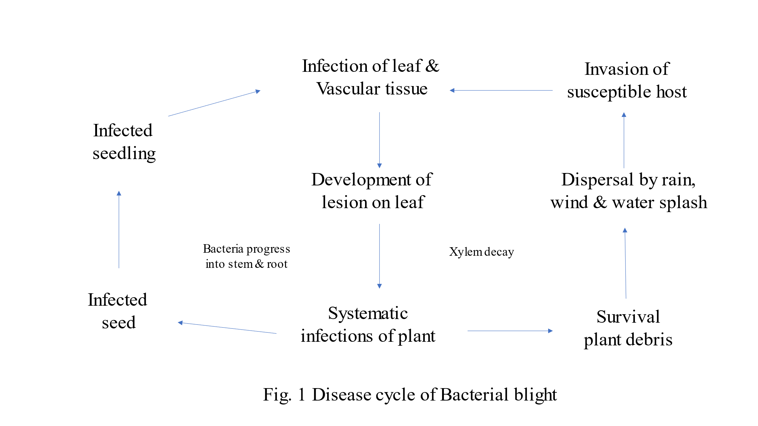

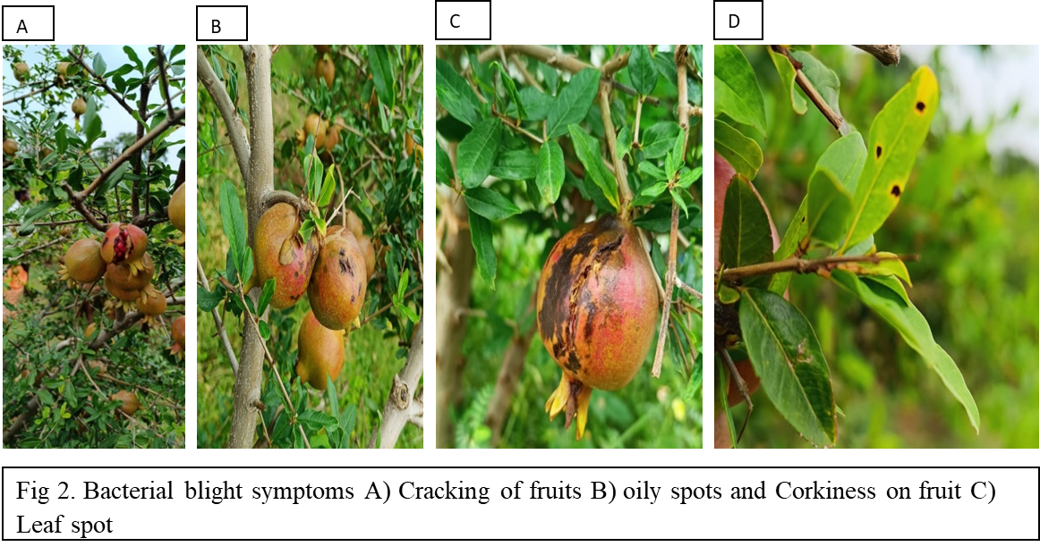

**2. Pomegranate wilt**

Pomegranate wilt causes major economic losses if timely measures are not taken however, a drying plant does not always mean it is a wilt disease.

**Symptoms**

Symptoms such as yellowing, drooping, and drying of leaves, which resemble signs of nutrient deficiency. These symptoms can affect certain branches or the entire plant. The affected xylem area can exhibit dark reddish-brown to deep purple or black staining. In some cases, the entire foliage of a tree can turn completely yellow, and the vertical stem may develop cracks. When you examine infected plant parts in cross and vertical sections, typically symptom is dark greyish-brown streaks in the vascular and adjoining cortex tissues (Sharma *et al.,* 2010) (Fig. 3).

**Etiology**

The disease is caused by fungus, *Ceratocyastis frimbriata* which is reported first in India. Pathogen is soil-borne and survive in the soil through their thick-walled conidia and chlamydospores. These can spread via infected seedlings, irrigation, rainwater, root contact, insects, implements, pruning and budding tools. After entering the host, the disease progresses through the xylem in water-conducting cells, causing rapid wilting of the plant and broad dark discoloration of the vesicular system

**Management**

Effective management of this disease can be achieved through integrated practices that involve maintaining good sanitation, considering resistant cultivars, adopting cultural methods, biological methods and chemical control measures. Apply promising bio formulations such as *Aspergillus niger* AN27 @ 1kg/acre and mycorrhiza *Rhizophagus irregularis* Syn. *Glomus irregularis* @ 1-5Kg/acre), *Trichoderma harzianum*, *Pseudomonas spp*. etc., at six months interval right from the planting. These serve as the best preventive measure for all types of wilt pathogens. Grow green manure crops like daincha (*Sesbania aculeata*) and sun hemp (*Crotalaria juncea*) during the rainy season and incorporate them into the soil before flowering. Apply boron depending on soil test value. The wounds caused by root-knot nematodes (RKN) can be prevented by application of *Paecilomyces lilacinus* @4-5Kg/acre (Sharma *et al.,* 2010). Application of carbendazim @ 2g/l along with @ Chlorpyriphos 2ml/l can be taken-up (Pal *et al.,* 2014).

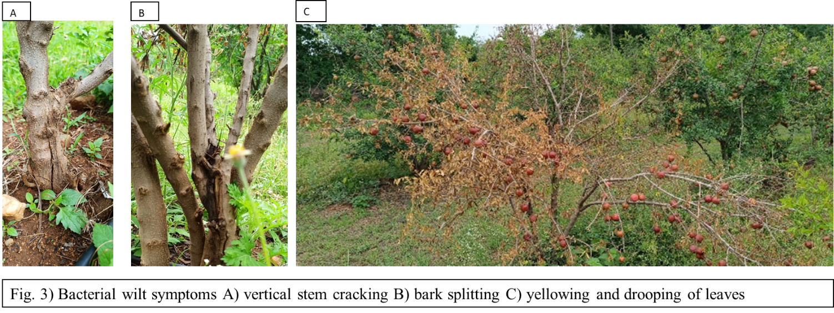

**3. Anthracnose**

Anthracnose disease of pomegranate is caused by *Colletotrichum gloeosporioides*. All stages of fruit development are susceptible to the disease, which affects the quality and marketing of fruits.

**Symptoms**

Infected leaves turn yellow and drop off. Diseased portions initially reveal minute circular spots with yellowish halos, later becoming irregular, dark brown that eventually cover the fruit partly or wholly with sunken centers (Munhuwey *et al.,* 2016).

**Etiology:**

The mrig bahar followed by ambe bahar are the most vulnerable seasons for the attack of anthracnose due to the favorable environmental conditions where temperature of about 21 to 33oC and maximum incidence during August – September (Nargund et al., 2012)

**Management**

Application of carbendazim + mancozeb at 0.3% and propiconazole at 0.1% concentration effectively reduce the percent disease index of anthracnose under field conditions. Use of biocontrol agent, *Trichoderma viride* that effectively controls the disease.

**Major insect -pest management in pomegranate**

1. **Thrips (** *Rhiphiphorothrips cruentatus* and *Scirtothrips dorsalis*)

Thrips feed on the underside of leaves by rasping the surface and suck out the oozing cell sap. Scrapping on fruits leads to scab formation, reducing market value.

**Management practices**

Setting up blue sticky traps per 10 plants is recommended. Spraying with Thiamethoxam 25WG at dose of 0.3g/l in 15days interval or whenever necessary. The same chemical sprays should not be used consistently and should be altered with acetamiprid 20SP@ 0.3g/l and imidacloprid 17.8SL @0.3ml/l**.** *Verticillium lecani* (2x108 cfu/g) is grown at 200 g /100 l starting before flowering and being monitored for 10 days.

**2. Anar Butterfly/ Fruit Borer**

Bluish brown butterfly *Dudorix isocrates,* a polyphagous pestand it has orange spot on each fore wings while black spots on the hind wings. Single eggs are laid on flowers and tender fruits.

**Management**

The infestations can be reduced by removing and destroying all the affected fruits. One of the ways to manage butterfly sustainably is through fruit bagging (Gethe *et al.,* 2021). At the flowering stage, spray NSKE 5% or neem formulations 2 ml/1 azadirachtin 1500 ppm @ 3.0 ml/l at 15-day intervals is recommended. Spray deltamethrin 2.8 EC (1.5ml/l of water) at fortnightly interval from flowering stage to fruit development .

1. **Fruit Sucking Moth**

Pomegranate is being attacked by three species of fruit sucking moth such as *Othreis fullonia, O. materna and O. homaena* during mrig bahar in different parts of India and these remain active from August to October. At night, adult males and females of the moth penetrate and puncture the fruits. Oozing of fruit juice from the punctured holes on fruits is being observed and damaged fruits become soft owing to secondary infections of different fungi and bacteria eventually fruits drop down.

**Management**

Collection and destruction of moths using torch in the night is the usual practice adopted by growers. As the activity of fruit sucking moth remains from August to October, avoid taking mrig bahar crop in pomegranate. Fruit bagging with butter paper, newspaper or polymer bags as per the feasibility of covering materials. Destroy alternate hosts like *Lantana camara* and Castor in and around the field. Install poison baits (95% jaggery + 5% malathion) in the big flat earthen pots in the field.

1. **Bark-eating caterpillar**

This being the polyphgus pest feeds the bark of the tree by boring into stem at night. Severe damaging during the month of September to October.

**Symptoms**

Caterpillar feeds inside the bark by making holes or zig zag tunnels on the tree trunk. Weak points created on the trees due to tunnelling where breakage occurs affecting the vitality of the trees badly. At the joints of the branches several holes can be seen. Wood dust and excreta pellets hangs in the form of a web around the affected portions.

**Management practices**

Avoiding overcrowding and intermingling of trees to maintain clean orchard. Clean the webs around the damaged area and pour kerosene oil into the holes and cover them with mud. Inject larval holes with quinalphos @ 0.01% or fenvalerate @ 0.05%. Spray with carbaryl @ 0.04% or dichlorovos @ 0.08% on the stem or on the affected part.

**Physiological disorders**

**Fruit cracking**

Cracking of fruits occurs at a rate of about 20-40% at the maturity stage in arid and semi-arid conditions. This is primarily attributed to a sudden change in soil moisture content, with soil becoming excessively dry, followed by sudden irrigation and higher air temperatures. It is often associated with a deficiency of calcium and boron. Fruit cracking is more likely to occur when there are high levels of leaf nitrogen and an imbalanced potassium-to-calcium (K/Ca) ratio (Hepaksoy et al., 2000). Thin-rind cultivars tend to be more susceptible to cracking than those with thicker rinds. According to Fraschetti et al. (2023), cracked fruits are sweeter, more nutritionally rich, and contain higher levels of anthocyanin, exhibiting α-glucosidase inhibition.

**Management**

Use of cultivars which showed minimum incidence of cracking cvs. Karkai, Guleshah and Bedana and resistant cultivar Bhagwa. Maintaining adequate and regular irrigation and interculturing throughout the maturity period may reduce cracking. Application of antitranspirant 5 % pinolene as vapour guard 4-5 weeks before harvest. Spraying of GA3 @ 120 ppm (Pal *et al.,* 2014). Foliar application of nano-Ca at a concentration of 0.50 g and CaCl2 reduced fruit cracking (Davarpanah *et al*., 2018). Controlled irrigation, bagging, and spraying with 1% zinc sulfate (ZnSO4) and 6% kaolin effectively reduce cracking (Abd El-Rhman *et al.,* 2010)

**Internal breakdown**

The phenomenon where the arils inside a ripe pomegranate fruit break down and turn from soft, light creamy brown to dark blackish brown, rendering them inedible is referred as aril disintegration or internal breakdown. This issue is a severe problem that is not visually detectable externally and calcium affects the fruits quality. The occurrence of this problem ranges from 25% to 55% in certain regions, but in others, it can be as high as 80% (Nerya *et al.,* 2006). Ganesh and Bhagwa exhibits a significant vulnerability to this ailment (Shivashankar *et al.* in 2012; Kavand *et al.*2020), additionally larger fruits are more prone to this condition (Pal et al., 2014). Meighani *et al*. (2014) attributed aril browning to high mineral content, which subsequently leads to diminished level of bioactive compounds like phenolics and flavonoids, as well as alteration in antioxidants activity, color and enzyme functions. Collectively these alterations result in a decrease in the affected fruits nutritional and functional values.

**Management**

Application of growth regulators like salicylic acid and sodium nitroprusside at 10-4 M reduces internal browning. This also increases the total anthocyanin content, ascorbic acid in the fruit (Khodaei *et al.,* 2015).

**References**

Abd El-Rhman, I. E. (2010). Physiological studies on cracking phenomena of pomegranates. *J. Appl. Sci. Res,* 6(6), 696-703.

Arangale, K. B., Bagwan, R. A., Whagmare, D. N., and Giri, S. P. (2020). Antibacterial activity of plant extracts against *Xanthomonas axonopodis* *Pv. Punicae* causing Bacterial blight of Pomegranate (*Punica granatum* L.). *Journal of Xidian University*, 14(11).

Arora, A. (2016). An overview of bacterial blight disease: A serious threat to pomegranate production. *International Journal of Agriculture, Environment and Biotechnology*, 9(4), 629-636.

Bagal, S. N., Patil, M. S., Thite, S. V., Chandanshive, A. A., and Pise, N. M. (2022). Survey of Diseases and Pest on Pomegranate from Solapur District. *Journal of Pharmaceutical Sciences and Research*, 14(7), 818-824.

Benagi, V. I., Ravikumar, M. R., and Nargund, V. B. (2012). Threat of bacterial blight on pomegranate in India–Mitigation by an integrated approach. In *II International Symposium on the Pomegranate*,103, 113-116.

Cara, M., Mincuzzi, A., Merkuri, J., Vrapi, H., Cara, O., Ippolito, A., ... & Sanzani, S. M. (2020). Colletotrichum gloeosporioides sensu stricto as causal agent of anthracnose on pomegranate fruit in Albania. *Crop protection*, 137, 105291.

Chikte, R. G., Paknikar, K. M., Rajwade, J. M., and Sharma, J. (2019). Nanomaterials for the control of bacterial blight disease in pomegranate. *Applied microbiology and biotechnology*, 103, 4605-4621.

Chowdappa, A., Kamalakannan, A., Kousalya, S., Gopalakrishnan, C., Venkatesan, K., and Raju, G. S. (2018). A survey on the incidence of bacterial blight *Xanthomonas axonopodis pv. punicae of Pomegranate* in Tamil Nadu. *Journal of Pharmacognosy and Phytochemistry*, 7(3), 3740-3742.

Das, A. J., Ravinath, R., Usha, T., Rohith, B. S., Ekambaram, H., Prasannakumar, M. K., and Middha, S. K. (2021). Microbiome analysis of the rhizosphere from wilt infected pomegranate reveals complex adaptations in fusarium—a preliminary study. *Agriculture*, *11*(9), 831.

Davarpanah, S., Tehranifar, A., Abadía, J., Val, J., Davarynejad, G., Aran, M., and Khorassani, R. (2018). Foliar calcium fertilization reduces fruit cracking in pomegranate (Punica granatum cv. Ardestani). *Scientia Horticulturae*, *230*, 86-91.

Doddaraju, P., Kumar, P., Gunnaiah, R., Gowda, A. A., Lokesh, V., Pujer, P., and Manjunatha, G. (2019). Reliable and early diagnosis of bacterial blight in pomegranate caused by *Xanthomonas axonopodis pv. punicae* using sensitive PCR techniques. *Scientific reports*, *9*(1), 10097.

Fraschetti, C., Goci, E., Nicolescu, A., Cairone, F., Carradori, S., Filippi, A., ... and Cesa, S. (2023). Pomegranate Fruit Cracking during Maturation: From Waste to Valuable Fruits. Foods, 12(9), 1908.

Gajbhiye, M. H., Bankar, A. V., and Kapadnis, B. P. (2023). Lactic acid bacteria in the management of oily spot disease of pomegranate. *Current Microbiology*, 80(1), 19.

Gethe, A. S., Hiray, S. A., Pujari, C. V., Patil, R. V., and Lalge, P. M. (2021). Effect of pre-harvest bagging on fruit yield, physiological disorders, pest and diseases in pomegranate. *Journal of Entomology and Zoology Studies*, *9*(1), 1543-1549.

Hepaksoy, S., Aksoy, U., Can, H. Z., and Ui, M. A. (2000). Determination of relationship between fruit cracking and some physiological responses, leaf characteristics and nutritional status of some pomegranate varieties. *Options Méditerr. Sér. A*, *42*, 87-92.

Jadhav, V. T., and Sharma, K. K. (2009). Integrated management of diseases in pomegranate. In *Souvenir and abstracts 2nd international symposium on pomegranate and minor including Mediterranean fruits, UAS Dharwad*, 23-27.

Jagdale, S., Ahiwale, S., Gajbhiye, M., and Kapadnis, B. (2019). Green approach to phytopathogen: Characterization of lytic bacteriophages of Pseudomonas sp., an etiology of the bacterial blight of pomegranate. *Microbiological research*, *228*, 126300.

Jagdale, S., and Kapadnis, B. (2021). Bacteriophage liquid formulation: A potential green tool for the management of pomegranate bacterial blight. *Biological Control*, *158*, 104597.

Jamadar, M. M., Jawadagi, R. S., Sataraddi, A. R., Patil, D. R., and Patil, R. V. (2011). Status of pomegranate diseases of Northern Karnataka in India. *Acta horticulturae*, *890*, 501-507.

Jayanthi, P. K., Aurade, R. M., Kempraj, V., and Verghese, A. (2015). Aromatic fruits as baits for the management of fruit-piercing moths in pomegranate: exploiting olfaction. *Current Science*, 1476-1479.

Kavand, M., Arzani, K., Barzegar, M., and Mirlatifi, M. (2020). Pomegranate (*Punica granatum* L.) fruit quality attributes in relation to aril browning disorder. *Journal of Agricultural Science and Technology*, *22*(4), 1053-1065.

Khandare, R. Y., Kadam, D. R., and Jayewar, N. E. (2018). Biology of pomegranate fruit borer, Deudorix isocrates (Fab.) (Lycaenidae: lepidoptera) on pomegranate, Punica granatum L. *Journal of Pharmacognosy and Phytochemistry*, *7*(5), pp.328-330.

Khodaei, M., Nahandi, F. Z., Motallebi-Azar, A., and Dadpour, M. (2015). Effect of salicylic acid and sodium nitro proside on the pomegranate aril browning disorder. In *Biological Forum* (Vol. 7, No. 2, pp. 1014-1020). Research Trend.

Kumar, R., Shamarao Jahagirdar, M. R., Yenjerappa, S. T., and Patil, H. B. (2006). Epidemiology and management of bacterial blight of pomegranate caused by *Xanthomonas axonopodis pv. punicae*. In  *I International Symposium on Pomegranate and Minor Mediterranean Fruits 818* (pp. 291-296).

Meighani, H., Ghasemnezhad, M., & Bakshi, D. (2014). Evaluation of biochemical composition and enzyme activities in browned arils of pomegranate fruits. *International Journal of Horticultural Science and Technology*, 1(1), 53-65.

Mondal, K. K., & Mani, C. (2012). Investigation of the antibacterial properties of nanocopper against *Xanthomonas axonopodis pv. punicae*, the incitant of pomegranate bacterial blight. *Annals of microbiology*, *62*, 889-893.

Mottadi, L. S., Devara, S. D., and Shaik, T. I. (2018). Anti-microbial activity of some Botanicals against the *Xanthomonas axonopodis pv punicae* in Pomegranate. *Journal of Pharmacognosy and Phytochemistry*, *7*(4), 2812-2815.

Munhuweyi, K., Lennox, C. L., Meitz-Hopkins, J. C., Caleb, O. J., and Opara, U. L. (2016). Major diseases of pomegranate (*Punica granatum* L.), their causes and management—A review. *Scientia Horticulturae*, *211*, 126-139.

Nargund, V. B., Jayalakshmi, K., Benagi, V. I., Byadgi, A. S., Patil, R. V., Melgarejo, P., and Valero, D. (2012). Status and management of anthracnose of pomegranate in Karnataka State of India. *Options Méditerranéennes Ser. A Semin. Mediterr*, *103*, 117-120.

Nerya, O., Gizis, A., Tsyilling, A., Gemarasni, D., Sharabi-Nov, A., and Ben-Arie, R. (2006, August). Controlled atmosphere storage of pomegranate. In *IV International Conference on Managing Quality in Chains-The Integrated View on Fruits and Vegetables Quality 712* (pp. 655-660).

Pal, R. K., Babu, K. D., Singh, N. V., Maity, A., and Gaikwad, N. (2014). Pomegranate Research in India–Status and future challenges. *Progressive horticulture*, *46*(2), 184-201.

Parihar, T., Patil, Y., and Thakur, M. (2021). Development of polymerase chain reaction based assay for diagnosis of Bacterial blight of Pomegranate. *Journal of Advanced Scientific Research*,  (HBIA), 05-09.

Petersen, Y., Mansvelt, E. L., Venter, E., and Langenhoven, W. E. (2010). Detection of *Xanthomonas axonopodis pv. punicae* causing bacterial blight on pomegranate in South Africa. *Australasian Plant Pathology*, *39*(6), 544-546.

Priya, B. T., Murthy, B. N. S., Gopalakrishnan, C., Artal, R. B., and Jagannath, S. (2016). Identification of new resistant sources for bacterial blight in pomegranate. *European journal of plant pathology*, 146, 609-624.

Raju, J., Benagi, V. I., Jayalakshmi, K., Nargund, V. B., and Sonavane, P. S. (2012). In vitro evaluation of chemicals, botanicals and bioagents against the bacterial blight of pomegranate caused by *Xanthomonas axonopodis pv. punicae*. *International Journal of Plant Protection*, *5*(2), 315-318.

Sharma, J., Manjunath, G., Xavier, K. V., and Vallad, G. E. (2020). 12 Diseases and Management. *The Pomegranate: Botany, Production and Uses*, 357.

Sharma, K. K., Sharma, J., and Jadhav, V. T. (2010). Etiology of pomegranate wilt and its management. *Fruit, Vegetable and Cereal Science and Biotechnology*, 4(2), 96-101.

Sharma, K. K., Sharma, J., and Jadhav, V. T. (2010). Status of bacterial blight of pomegranate in India. *Fruit, vegetable, cereal science and biotechnology*, *4*(2), 102-105.

Sharma, K. K., Sharma, J., and Jadhav, V. T. (2015). Recent developments in bacterial blight of pomegranate and its management. *Recent advances in the diagnosis and management of plant diseases*, 119-126.

Sharma, K. K., Sharma, J., and Jadhav, V. T. (2015). Recent developments in bacterial blight of pomegranate and its management. *Recent advances in the diagnosis and management of plant diseases*, 119-126.

Sharma, K. K., Sharma, J., and Jadhav, V. T. (2010). Etiology of pomegranate wilt and its management. *Fruit, Vegetable and Cereal Science and Biotechnology*, *4*(2), 96-101.

Shivashankar, S., Hemlata, S., and Sumathi, M. (2012). Aril browning in pomegranate (*Punica granatum* L.) is caused by the seed. *Current Science*, *103*(1), 26-28.

Vauterin, L., Hoste, B., Kersters, K., and Swings, J. (1995). Reclassification of *xanthomonas*. *International Journal of Systematic and Evolutionary Microbiology*, 45(3), 472-489.