

RESEARCH ARTICLE

**Exploring *OsHAK* Transporters for the Salt Responsiveness in Rice**

Akshara Balachandra1, Varanavasiappan Shanmugam1, Kumar K Krish1, Ravichandran Veerasamy2, Kokiladevi Easwaran1, Sudhakar Duraialagaraja1, Arul Loganathan1*

1Department of Plant Biotechnology, Centre for Plant Molecular Biology and Biotechnology, TNAU, Coimbatore- 641003, Tamil Nadu, India

2Department of Crop Physiology, TNAU, Coimbatore- 641003, Tamil Nadu, India

*E-mail: [arul@tnau.ac.in](mailto:arul@tnau.ac.in)

**ABSTRACT**

Environmental stresses are the major constraint in crop growth and productivity, particularly in rice. Improving rice against major abiotic stressors such as salinity is one of the major thrust areas. In this direction, the trait of sodium exclusion was the primary focus among the rice breeders to enhance salt tolerance. Along similar lines, increased uptake of potassium, the counter ion of Na+, through high-affinity potassium transporters (HAK) assumes significance in the context of maintaining a favorable Na/K ratio, a low Na/K is an indicator of salt tolerance. The *OsHAK* family in rice includes 27 members and an insight into the evolution, structure, and expression through *in silico* approaches was attempted. Phylogenetic analysis exhibited four distinct groupings of the *OsHAK* family, and functional motif analysis revealed a characteristic consensus sequence among the OsHAK transporters. Relative gene expression analysis based on published microarray data put forth the differential regulation of *OsHAK3 X2, OsHAK8, OsHAK14*(X2)*, OsHAK15* and *OsHAK26* between salt-tolerant landrace *Pokkali* and susceptible cultivar IR29 and their tissue-specific expression profiles predicted. This study narrowed down a set of putative *OsHAKs* from the larger family for their role in enhancing cellular potassium under salt stress thus paving the way for crop improvement.

.

Key words: *Rice; HAK, Transporters; Potassium; Salinity*

**INTRODUCTION**

Rice, the major calorie crop for half of the world’s population was classified as salt-sensitive (Maas, 1993; Sen *et al.,* 2020). Salinity is one of the major abiotic stress factors, severely affecting growth and productivity, particularly rice is highly susceptible to salt stress (Amaravel *et al*., 2019). In India, around 6.73 M ha of arable land area was estimated to be salt affected which substantially reduces the global rice production to a tune of fifty percent (NRSA, 2008). Salt stress was attributed to an excess of dissolved salts primarily the chlorides and sulfates of sodium, magnesium, and calcium, in soil as well as in irrigation water (Bernstein,1975; Wali *et al*., 2021). Accordingly, the saline soil was characteristic of an electrical conductivity (EC) of above 4 dS/m at 25 °C, exchangeable sodium percent (ESP) of less than 15, and pH of below 8.5 (Allison and Richards, 1954). Besides, NO3- was also reported to contribute to soil salinity (Stavi *et al*., 2021). Salt stress impacts crop growth via stuntedness, smaller leaves, reduced vegetative vigor, and ultimately poor yield (FAO, 2020). Physiologically, excess sodium ions lead to damage to chloroplast, and cell membranes and affect various vital cellular processes (Hameed *et al*., 2021). Towards improving rice crop in particular against salt stress, breeders have been continuously engaged in the introgression of several salt tolerant quantitative trait loci (QTLs) of which SALTOL harboring *OsHKT1;5* transporter remains the mainstay (Ren *et al.,* 2005; Thomson *et al*., 2010), this in turn had resulted in a fair success in improving rice crop for salt tolerance.

In contrast, enhancing cellular K+ content could be another promising and complementing approach toward the maintenance of Na/K homeostasis (Shabala and Cuin, 2008; Shabala and Pottosin, 2010). Potassium is the most abundant inorganic cation in plants and has turned out to be an inevitable ion in plant growth and development (Talbott and Zeiger, 1996; Pandey and Mahiwal, 2020). Thus, potassium has evolved to be a functional component of several enzymes involved in different metabolic processes such as photosynthesis, carbon, nitrogen metabolism, protein synthesis, osmoregulation, transport of sugars, disease resistance, etc. (Hasanuzzaman *et al.,* 2018). The K+ uptake and its homeostasis were in turn regulated by several membrane-bound transporters and channels that facilitate the K+ uptake from the external environment and its transport within the plant (Maathuis and Sanders, 1994; Maathuis *et al*., 1997). These transporters and channels were further classified into four multigene families (i.e.) high-affinity K/Na transporter (*HKT*), K+ uptake permease (*KT/KUP/HAK*), K+ exchange antiporters (*KEA*) and cation/H+ exchangers (*CHX* transporters) (Zhang *et al*., 2012). Among these, the *KT/KUP/HAK* family is the largest of the K+ transporter family comprising 13 members in *Arabidopsis*, 24 in *Poplar,* and 27 members in rice. Baneulos *et al*. (2002) have identified 14 gene encodes for HAK transporters in rice *viz*., *OsHAK2*, *OsHAK3, OsHAK5-15,* and *OsHAK17*. Later, Gupta *et al*. (2008) identified twenty-six *OsHAK* transporters and Amrutha *et al*. (2007) reported 27 *OsHAK* transporters in rice. Further, the *OsHAK* transporter family was known to enhance the potassium content even under K+ limiting conditions by enhancing their expression levels thereby improving the salinity tolerance in rice (Okada *et al*., 2008). In this study, we have attempted to characterize the members of the *OsHAK* family for their evolutionary relatedness, analysis of the functional motifs, and their differential expression status between salt-tolerant and susceptible rice genotypes.

**MATERIALS AND METHODS**

***Construction of phylogenetic tree***

The nucleotide sequences for all 27 *OsHAK* transporters in rice were retrieved from the National Center for Biotechnology Information (NCBI) (<https://www.ncbi.nlm.nih.gov/>) and downloaded in FASTA format. Multiple sequence alignment was done using Clustal W2 (www.ebi.ac.uk/Tools/) and the phylogenetic tree was constructed using the MEGA-X software (https://www.megasoftware.net/).

***Identification of functional motifs***

The amino acid sequences for all 27 OsHAKs were retrieved from NCBI and downloaded in FASTA format. Multiple Em for Motif Elicitation (MEME) suite was used to identify the functional motifs (https://meme-suite.org/meme/).

***In silico differential expression analysis of OsHAK transporters***

The publically available microarray dataset involving the roots of salt-tolerant rice landrace *Pokkali* and salt-susceptible cultivar IR29 performed as a seedling stage salt stress experiment by Cotsaftis *et al.* (2011) with the following identifier GSE14403 was downloaded from the NCBI GEO Omnibus database (https://www.ncbi.nlm.nih.gov/geo/). The expression values for the 27 *OsHAKs* were extracted from the series matrix file both from the salt-tolerant landrace *Pokkali* and salt-susceptible cv. IR29. The CREP database facilitated the querying process (CREP-Query (ncpgr. cn).

***Tissue-specific expression analysis of selected OsHAKs***

Selected differentially expressed *OsHAK* genes were further analyzed to explore their tissue-specific expression profiles using the RNASeq dataset available in ExPath2.0 ([expath.itps.ncku.edu.tw/expression/rice/search.php](http://expath.itps.ncku.edu.tw/expression/rice/search.php)). Transcript abundance of selected *OsHAKs* in the roots and shoots of one-week-old seedlings under 150 mM salt stress were analyzed for their tissue-specific expression.

**RESULTS AND DISCUSSION**

Towards understanding the evolutionary relatedness amongst the 27 *OsHAK* transporters identified in rice, a phylogenetic tree was constructed based on the gene sequences using Mega X software. The 27 *OsHAKs* were distinctly grouped into four clades viz., clade I, clade II, clade III, and clade IV wherein, the majority of the *OsHAKs* were found clustered under clade IV. This is as per the earlier report by Gupta *et al*. (2008), wherein, the twenty-seven transporters were sub-grouped into four clades. The clade I consisted of three members *viz*., *OsHAK14*, *OsHAK15* and *OsHAK23*. The clade II included seven transporters viz., *OsHAK5*, *OsHAK18*, *OsHAK12* and *OsHAK11*. Similarly, clade III comprised seven members which were further classified into two clusters, cluster I consisted of *OsHAK2* and *OsHAK7* and cluster II included *OsHAK8*, *OsHAK9*, *OsHAK10*, *OsHAK24,* and *OsHAK25*. The clade IV consisted of the remaining 13 *OsHAKs* which were further classified into two clusters. The cluster I of clade IV consisted of only one member *OsHAK13* and the cluster II included rest of them viz., *OsHAK26*, *OsHAK6*, *OsHAK3*, *OsHAK17*, *OsHAK4*, *OsHAK20*, *OsHAK19*, *OsHAK1*, *OsHAK22*, *OsHAK16*, *OsHAK21* and *OsHAK27* (Fig. 1). The chromosomal locations of the 27 *OsHAKs* were found distributed across eight of the 12 rice chromosomes viz., chr 1, chr 2, chr 3, chr 4, chr 6, chr 7, chr 8 and chr 9. No *OsHAK* genes were detected on chromosomes 5, 10, 11, and 12 (Yang *et al*., 2009; Gupta *et al*., 2008). The average length of the coding sequence (CDS) and polypeptide were 3070 bp and 770 amino acids, respectively (Table 1).

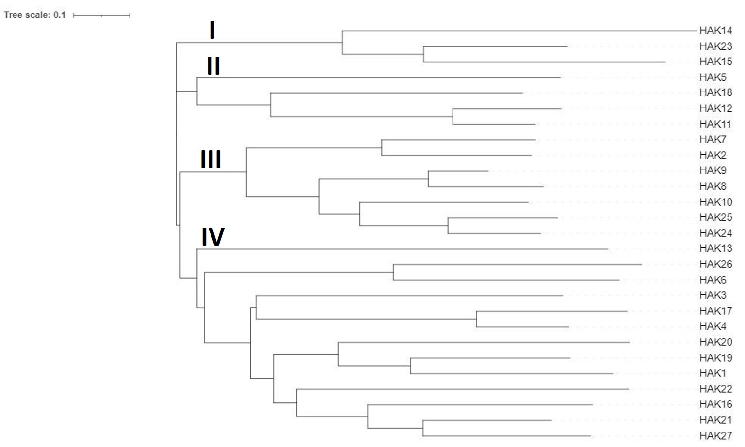

**Fig. 1: Phylogenetic tree showing the evolutionary relationship among 27 *OsHAK* transporters in rice.**

I, II, III, and IV denote clades of the tree

**Table 1: List of *OsHAK* transporters in rice with gene name, locus ID, chromosome, length of coding sequence (CDS), length of the polypeptide**

|  |  |  |  |  |  |
| --- | --- | --- | --- | --- | --- |
| **Sl. No** | **Gene** | **Gene Id.** | **Chromosome** | **CDS length (bp)** | **Length of polypeptide (aa)** |
|  | *Os HAK1* (X1) | LOC_Os04g32920 | 4 | 3092 | 792 |
|  | *Os HAK1* (X2) | LOC_Os04g32920 | 4 | 3174 | 801 |
|  | *OsHAK2* | LOC_Os01g70940 | 1 | 3678 | 640 |
|  | *OsHAK3* (X1) | LOC_Os01g27170 | 1 | 3152 | 808 |
|  | *OsHAK3* (X2) | LOC_Os01g27170 | 1 | 3041 | 791 |
|  | *OsHAK4* | LOC_Os08g36340 | 8 | 2584 | 697 |
|  | *OsHAK5* | LOC_Os01g70490 | 1 | 2757 | 770 |
|  | *OsHAK6* | LOC_Os01g70660 | 1 | 2411 | 748 |
|  | *OsHAK7* | LOC_Os07g47350 | 7 | 2803 | 811 |
|  | *OsHAK8* | LOC_Os03g21890 | 3 | 2577 | 793 |
|  | *OsHAK9* | LOC_Os07g48130 | 7 | 3282 | 635 |
|  | *OsHAK10* | LOC_Os06g42030 | 6 | 5864 | 843 |
|  | *OsHAK11* | LOC_Os04g52390 | 4 | 3493 | 791 |
|  | *OsHAK12* | LOC_Os08g10550 | 8 | 3404 | 582 |
|  | *OsHAK13* | LOC_Os06g45940 | 6 | 2954 | 778 |
|  | *OsHAK14* (X1) | LOC_Os07g32530 | 7 | 3121 | 842 |
|  | *OsHAK14* (X2) | LOC_Os07g32530 | 7 | 3246 | 859 |
|  | *OsHAK15* | LOC_Os04g52120 | 4 | 3138 | 867 |
|  | *OsHAK16* | LOC_Os03g37840 | 3 | 2909 | 811 |
|  | *OsHAK17* (X1) | LOC_Os09g27580 | 9 | 2894 | 707 |
|  | *OsHAK17* (X2) | LOC_Os09g27580 | 9 | 2352 | 649 |
|  | *OsHAK18* | LOC_Os09g38960 | 9 | 3408 | 793 |
|  | *OsHAK19* | LOC_Os02g31910 | 2 | 2874 | 742 |
|  | *OsHAK20* | LOC_Os02g31940 | 2 | 2795 | 747 |
|  | *OsHAK21* | LOC_Os03g37930 | 3 | 2625 | 799 |
|  | *OsHAK22* | LOC_Os07g01214 | 7 | 3255 | 808 |
|  | *OsHAK23* | LOC_Os09g21000 | 9 | 3170 | 877 |
|  | *OsHAK24* | LOC_Os06g15910 | 6 | 2319 | 772 |
|  | *OsHAK25* | LOC_Os02g49760 | 2 | 3204 | 771 |
|  | *OsHAK26* | LOC_Os08g39950 | 8 | 2739 | 739 |
|  | *OsHAK27* | LOC_Os03g37830 | 3 | 2832 | 811 |

Note: X1 and X2 are the splice variants of the respective genes

Further, the functional motifs present in the 27 OsHAK transporters were predicted using the MEME suite (Fig. 2). A total of 14 different functional motifs were predicted across the transporters.

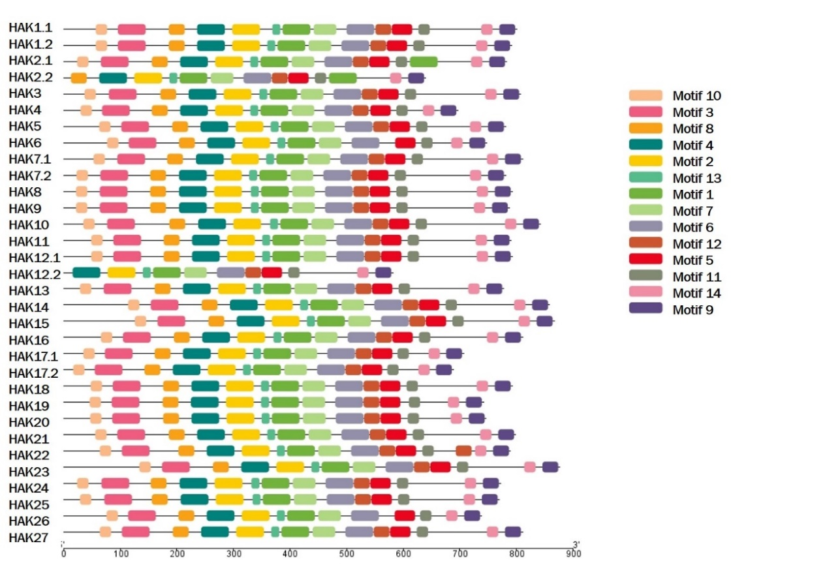

**Fig. 2: Functional motif analysis among the OsHAK family using MEME Suite.**

The characteristic feature of these transporters was the presence of a consensus motif viz., ‘**GVVYGDLGTSPLY**’ (Rodriguez-Navarro, 2000). In our study, the 10th motif was found to harbor the above consensus amino acid sequence which appeared to be the signature of the OsHAK transporter family (Fig. 3). The consensus amino acid sequence across the 14 identified motifs showed a higher frequency of alanine and glycine.

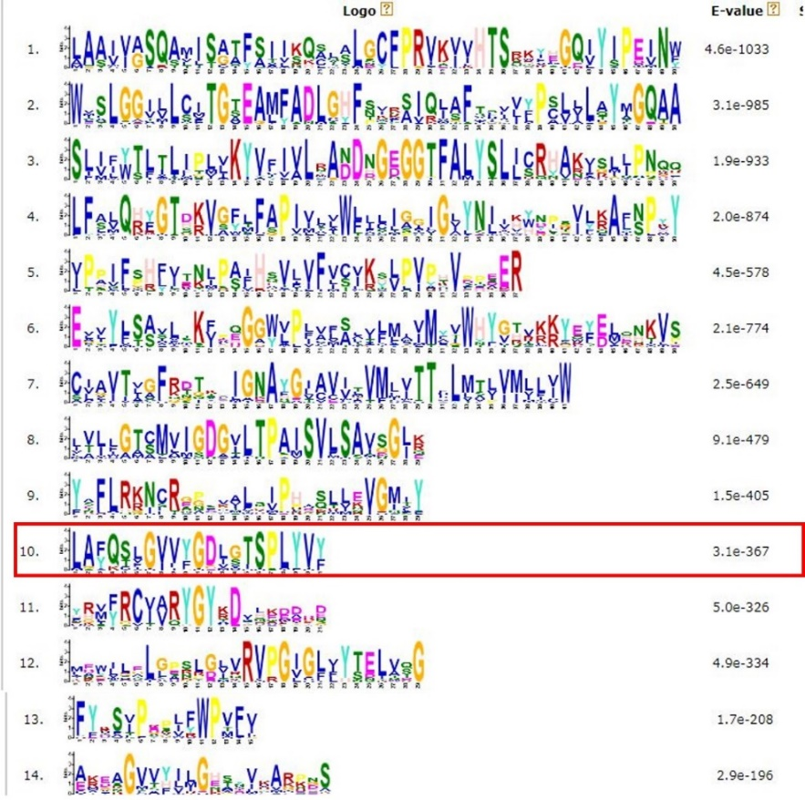

**Fig.3: Consensus sequence observed among the OsHAK transporters in rice.** The red box on motif 10 reveals the consensus sequence for the OsHAK transporter family

Further, towards exploring the role of putative *OsHAK* transporter(s) involved in enhancing the K+ uptake under salt stress conditions in rice, *in silico* differential expression analysis of the 27 *OsHAK* genes was performed based on the expression values extracted from the publically available microarray data set, NCBI (GSE14403; Cotsaftis *et al*., 2011). Landrace *Pokkali* is a well-known rice genotype and was extensively subjected to molecular investigations towards uncovering the mechanisms underlying salt tolerance. On the other hand, the rice cultivar IR29 was known for its salt susceptibility. Differential expression analysis revealed the putative role of a few *OsHAKs* which were found to be differentially regulated under salt stress between the salt-tolerant landrace *Pokkali* and salt susceptible cv. IR29 at the seedling stage. As stated above, *OsHAK* transporters viz., *OsHAK3* splice variant (X2), *OsHAK8*, *OsHAK14* splice variant (X2), *OsHAK15* and *OsHAK26* were upregulated upon salt stress in *Pokkali*, and these might be considered to have a role during salt stress. Besides, *OsHAK6* and *OsHAK13* were found to show no variations in their expression levels under salt stress for *Pokkali* and cv. IR29. On the contrary, a few *OsHAK* transporters *viz*., *OsHAK1*, *OsHAK2*, *OsHAK10,* and *OsHAK18* showed a declining expression in both *Pokkali* and cv. IR29. On expected lines, a majority of the *OsHAK* transporters showed downregulation in salt susceptible rice cv. IR29 (Fig. 4).

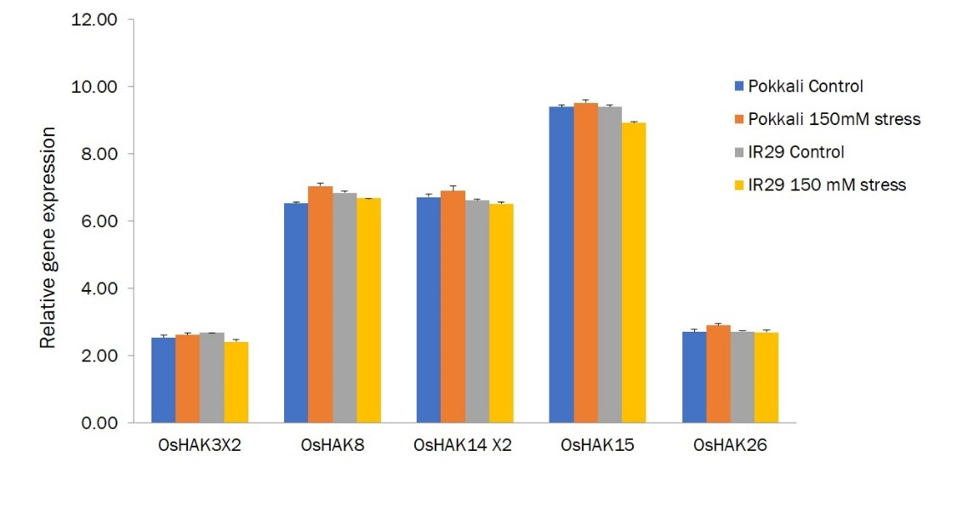

**Fig. 4: Differentially expressed *OsHAK* transporters between *Pokkali* and cv. IR29 under salt stress**

In this investigation, the *OsHAK3* splice variant (X2) was one of the OsHAK family found to be upregulated in the salt-tolerant rice *Pokkali*. In support of this observation, the work of Zhang *et al*. (2020) aimed at functionally characterizing *OsHAK3* reported that the loss of function of *OsHAK3* resulted in a reduction in cellular K+ uptake leading to stunted plant growth, especially under K+ limiting conditions. Subsequently, in an attempt to identify the key players involved in salinity tolerance during the seedling germination Ju *et al*. (2022) explored the importance of *OsHAK3* along with *OsHAK5* as a promising candidate gene for improving salt stress tolerance in rice. *OsHAK3* expression was found to be primarily associated with roots and was found to play a crucial role in maintaining the cellular K homeostasis in turn leading to a favorable Na/K ratio.

A study conducted by Wang *et al*. (2021) revealed the major play of *OsHAK8* in potassium uptake as well as root-to-shoot K+ transport within the plant. The expression level of *OsHAK8* was significantly downregulated upon salt stress in *oshak8* mutants and K+ uptake was impaired. In another study by Gupta *et al*. (2008), *OsHAK8* was found to be differentially expressed upon salt stress, especially in panicles implicating its role in panicle development and in turn crop productivity.

In this study, we observed that *OsHAK14* and *OsHAK15* were grouped under the clade I. A genome-wide association analysis conducted by Li *et al*. (2019) within *japonica* cultivars at the seedling stage revealed that *OsHAK15* plays a key role in salinity tolerance in rice besides, demonstrating a significant homology with *OsHAK14*. This probably reflects on the co-expression of *OsHAK14* and *OsHAK15* as observed from gene expression analysis. Earlier, Baneulos *et al. (*2002) also reported that *OsHAK15* shared a close homology with *OsHAK14*.

Further analysis of these differentially expressed genes was performed to explore the tissue-specific expression in rice seedlings under salt stress using EXPath 2.0. *OsHAK14* was found to be very highly expressed in the leaf sheath and root upon salt stress followed by *OsHAK15*. The other differentially expressed *OsHAKs* viz., *OsHAK3* and *OsHAK8* showed only a moderate level of expression as compared to *OsHAK14* and *OsHAK15* whereas, *OsHAK26* showed the least in both leaves and roots. Majorly, the differentially expressed set of transporters exhibited a low level of expression in the leaf sheath as compared to the leaf blade and roots during the vegetative stage (Fig. 5).

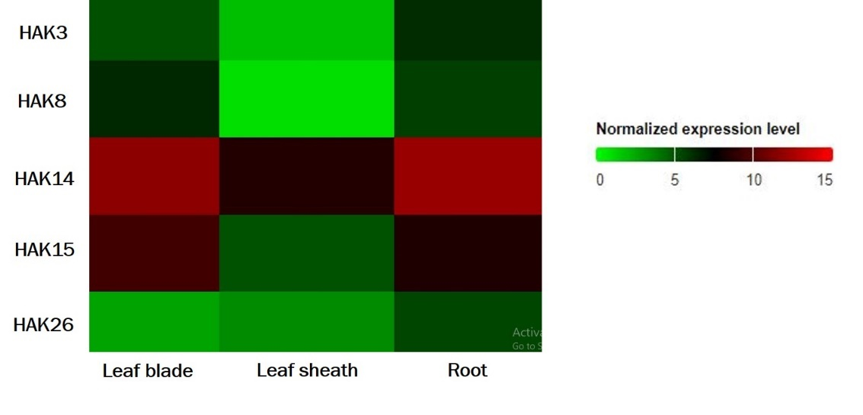

**Fig. 5: Tissue-specific expression levels of selected *OsHAK* transporters in rice seedlings under salt stress**

A study on pollen development and fertility by Li *et al*. (2022) implicated the role of golgi bound *OsHAK26* to play a major role in anther development. Knockout of *OsHAK26* in *Nipponbare* caused a reduction in the number, viability, and germination of pollen grains. As the *OsHAK26* plays a major role in pollen development, they might be expressed in anthers and this could be the reason for the reduced level of expression of *OsHAK26* within the vegetative tissues of the plant.

ExPath 2.0 analysis also paved the way for exploring the transcript abundance of *OsHAK3*(X2)*, OsHAK8, OsHAK14*(X2), *OsHAK15* and *OsHAK26* under salt stress (Fig. 6 and Fig. 7). Among the five differentially expressed set of genes, *OsHAK8*, *OsHAK14* and *OsHAK15* were significantly upregulated in the roots as compared to *OsHAK3* and *OsHAK26*. In the case of shoots, *OsHAK8* is found to be significantly upregulated compared to other HAK transporters such as *OsHAK3, OsHAK14, OsHAK15*, and *OsHAK26*.

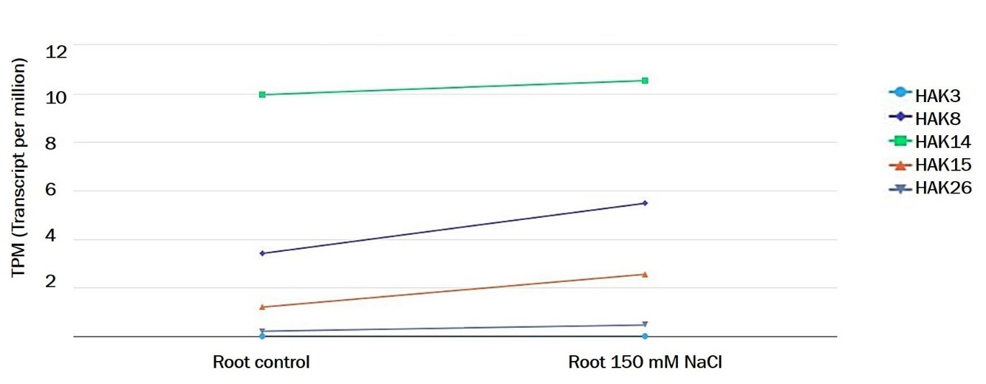

**Fig.6: Transcript abundance levels of selected OsHAK transporters in roots of rice seedlings under salt stress**

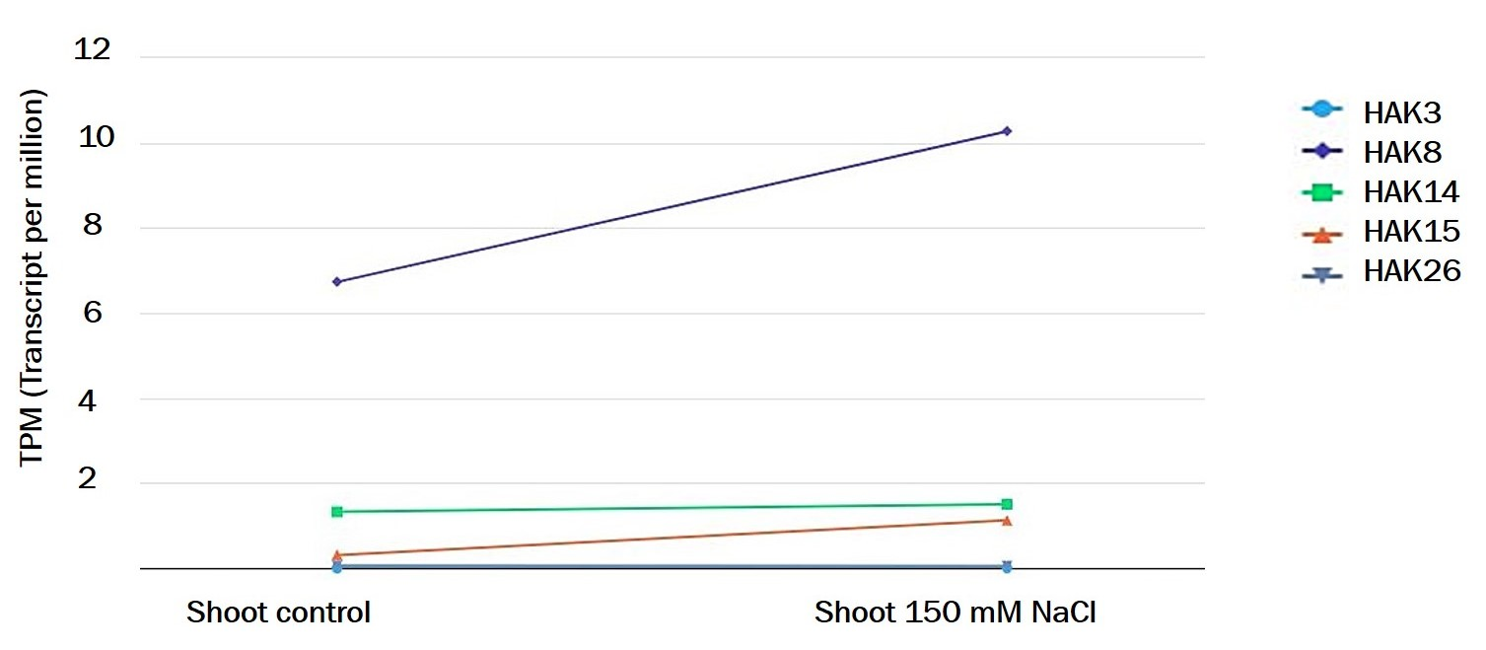

**Fig.7: Transcript abundance levels of selected OsHAK transporters in shoots of rice seedlings under salt stress**

Most of the differentially expressed set of transporters showed significant upregulation in roots as compared to shoots and therefore, these genes might play a role in enhancing the root K+ uptake under salt stress. Thus, identification and characterization of differentially expressed genes involved in K+ uptake as well as transport and their subsequent introgression into elite rice cultivar(s) help in improving the K/Na ratio thereby leading to salt tolerance in rice.

**CONCLUSION**

*In silico* analysis of the *OsHAK* transporter gene family indicated the upregulation of a few selected transporters such as *OsHAK3*(X2)*, OsHAK8, OsHAK14*(X2), *OsHAK15* and *OsHAK26* under salt stress in salt-tolerant rice landrace *Pokkali* compared to the salt susceptible cv. IR29. In addition, the tissue-specific expression of these differentially expressed transporters is suggestive of their expression confined to the leaf blade as well as roots. Further experimental validation of the differentially upregulated set of *OsHAK* transporters through real-time PCR may pave the way for exploiting their usefulness in translational research leading to rice improvement against salt stress.

***Acknowledgments***

The authors acknowledge the Bioinformatics Centre, Department of Plant Molecular Biology and Biotechnology, Tamil Nadu Agricultural University for the facilities extended in the successful completion of this investigation.

***Conflict of interest***

The authors disclose no conflict of interest.

**REFERENCE**

Allison, L.E. and L. A. Richards. 1954. Diagnosis and improvement of saline and alkali soils (No. 60). Soil and Water Conservative Research Branch, Agricultural Research Service, US Department of Agriculture. doi: 10.1097/00010694-195408000-00012

Amaravel, M., Kumari, S.M.P., Pillai, M.A., Saravanan, S., Mini, M.L. and A. K. Binodh. 2019. Mass screening for salinity tolerance in rice (*Oryza sativa*. L) genotypes at early seedling stage by hydroponics. *Electron. J. Plant Breed.,* **10(1):**137-142. doi: 10.5958/0975-928X.2019.00016.4

Amrutha, R.N., Sekhar, P.N., Varshney, R.K. and P. K. Kishor. 2007. Genome-wide analysis and identification of genes related to potassium transporter families in rice (*Oryza sativa* L.). *Plant Sci.,* **172(4):**708-721. doi: 10.1016/j.plantsci.2006.11.019

Banuelos, M.A., Garciadeblas, B., Cubero, B. and A. Rodrıguez-Navarro. 2002. Inventory and functional characterization of the HAK potassium transporters of rice. *Plant Physiol.*, **130(2):** 784-795. doi: 10.1104/PP.007781.

Bernstein, L.1975. Effects of salinity and sodicity on plant growth. *Annu. Rev.Phytopathol.*, **13(1):**295-312. doi: 10.1146/annurev.py.13.090175.001455

Cotsaftis, O., Plett, D., Johnson, A.A., Walia, H., Wilson, C., Ismail, A.M., Close, T.J., Tester, M. and U. Baumann. 2011. Root-specific transcript profiling of contrasting rice genotypes in response to salinity stress. *Mol. Plant*., **4(1):**.25-41. doi: 10.1093/mp/ssq056.

FAO. 2020. The State of Food and Agriculture 2020. Overcoming water challenges in agriculture. Rome. doi: 10.4060/cb1447en

Gupta, M., Qiu, X., Wang, L., Xie, W., Zhang, C., Xiong, L., Lian, X. and Q. Zhang, Q. 2008. KT/HAK/KUP potassium transporters gene family and their whole-life cycle expression profile in rice (*Oryzasativa*). *Mol. Genet. Genomics*., **280:**437-452.  doi:  10.1007/s00438-008-0377-7

Hameed, A., Ahmed, M.Z., Hussain, T., Aziz, I., Ahmad, N., Gul, B. and B. L. Nielsen. 2021. Effects of salinity stress on chloroplast structure and function. *Cells*., **10(8):**2023. doi: 10.3390/cells10082023

Hasanuzzaman, M., Bhuyan, M.B., Nahar, K., Hossain, M.S., Mahmud, J.A., Hossen, M.S., Masud, A.A.C., Moumita and M. Fujita. 2018. Potassium: A vital regulator of plant responses and tolerance to abiotic stresses. *Agronomy*., **8(3):**31. doi: 10.3390/agronomy8030031

Ju, C., Ma, X., Han, B., Zhang, W., Zhao, Z., Geng, L., Cui, D. and L. Han. 2022. Candidate gene discovery for salt tolerance in rice (*Oryza sativa* L.) at the germination stage based on genome-wide association study. *Front. Plant Sci.*, **13:**1010654. doi: 10.3389/fpls.2022.1010654

Li, N., Zheng, H., Cui, J., Wang, J., Liu, H., Sun, J., Liu, T., Zhao, H., Lai, Y. and D. Zou. 2019. Genome-wide association study and candidate gene analysis of alkalinity tolerance in japonica rice germplasm at the seedling stage. *Rice*., **12:** 1-12. doi: 10.1186/s12284-019-0285-y

Li, W., Li, M., Li, S., Zhang, Y., Li, X., Xu, G. and Yu, L., 2022. Function of rice high-affinity potassium transporters in pollen development and fertility. *Plant and Cell Physiology*, *63*(7), pp.967-980.doi: 10.1093/pcp/pcac061

Maas, E. V. 1993. Testing crops for salinity tolerance. In *Proc. workshop on adaptation of plants to soil stresses*., **94**: 234-247.

Maathuis, F.J. and D. Sanders. 1994. Mechanism of high-affinity potassium uptake in roots of Arabidopsis thaliana. *Proceedings of the National Academy of Sciences*, **91(20):** 9272-9276.doi: 10.1073/pnas.91.20.9272

Maathuis, F.J., Ichida, A.M., Sanders, D. and J. I. Schroeder. 1997. Roles of higher plant K+ channels. *Plant Physiol.,* **114(4):**1141. doi:  10.1104/pp.114.4.1141

NRSA. 2008. National wide mapping of land degradation on 1:50,000 scale using multitemporal satellite data. NRSA, Hyderabad, India.

Okada, T., Nakayama, H., Shinmyo, A. and K. Yoshida, K. 2008. Expression of *OsHAK* genes encoding potassium ion transporters in rice. *Plant Biotech.,* **25(3):** 241-245.doi: [10.5511/plantbiotechnology.25.241](https://doi.org/10.5511/plantbiotechnology.25.241)

Pandey, G.K. and S. Mahiwal. 2020. *Role of potassium in plants*. **1:**45-49. Springer. doi: 10.1007/978-3-030-45953-6

Ren, Z.H., Gao, J.P., Li, L.G., Cai, X.L., Huang, W., Chao, D.Y., Zhu, M.Z., Wang, Z.Y., Luan, S. and H. X. Lin. 2005. A rice quantitative trait locus for salt tolerance encodes a sodium transporter. *Nat. Genet.,* **37(10)**: 1141-1146. doi: 10.1038/ng1643

Rodrı́guez-Navarro, A. 2000. Potassium transport in fungi and plants. *BBA Biomembranes*., **1469(1):**1-30. doi: 10.1016/S0304-4157(99)00013-1

Sen, S.K., Chouhan, D., Das, D., Ghosh, R. and P. Mandal. 2020. Improvisation of salinity stress response in mung bean through solid matrix priming with normal and nano-sized chitosan. *Int.J. Biol.Macromol.,* **145:**108-123. doi: 10.1016/j.ijbiomac.2019.12.170

Shabala, S. and I. J. Pottosin. 2010. Potassium and potassium-permeable channels in plant salt tolerance. *Ion channels and plant stress responses*., 87-110. doi: 10.1007/978-3-642-10494-7_5.

Shabala, S. and T. A. Cuin. 2008. Potassium transport and plant salt tolerance. *Physiol. Plantarum*., **133(4):**651-669. doi: 10.1111/j.1399-3054.2007.01008. x.

Stavi, I., Thevs, N. and S. Priori. 2021. Soil salinity and sodicity in drylands: A review of causes, effects, monitoring, and restoration measures. *Front. Environ. Sci.,* **4:**330. doi: 10.3389/fenvs.2021.712831.

Talbott, L.D. and E. Zeiger. 1996. Central roles for potassium and sucrose in guard-cell osmoregulation. *Plant physiol.,* **111(4):**1051-1057. doi: 10.1104/pp.111.4.1051

Thomson, M.J., De Ocampo, M., Egdane, J., Rahman, M.A., Sajise, A.G., Adorada, D.L., Tumimbang-Raiz, E., Blumwald, E., Seraj, Z.I., Singh, R.K. and G. B. Gregorio. 2010. Characterizing the *Saltol* quantitative trait locus for salinity tolerance in rice. *Rice*., **3(2):** 148-160. doi: 10.1007/s12284-010-9053-8

Wali, S.U., Gada, M.A., Umar, K.J., Abba, A. and A. Umar. 2021. Understanding the causes, effects, and remediation of salinity in irrigated fields: A review. *Int. J. Agric. Animal Prod.,* **1(1):** 9-42.doi: 10.55529/jeimp.11.10.43

Wang, X., Li, J., Li, F., Pan, Y., Cai, D., Mao, D., Chen, L. and S. Luan. 2021. Rice potassium transporter *OsHAK8* mediates K+ uptake and translocation in response to low K+ stress. *Front. Plant Sci.,* **12:** 730002.doi: 10.3389/fpls.2021.730002

Zhang, L., Sun, X., Chen, X., Huang, M., Xiao, T., Mo, Y., Pan, Y., Guo, S., Li, Y., Sun, Z. and Z. Chen. 2020. A potassium (K) transporter, *OsHAK3*, is required for K-homeostasis in rice under low-K and high-salinity conditions. *Authorea.,*1-12.doi:10.22541/au.160269754.40987920/v1

Zhang, Z., Zhang, J., Chen, Y., Li, R., Wang, H. and J. Wei. 2012. Genome-wide analysis and identification of HAK potassium transporter gene family in maize (*Zea mays* L.). *Mol. Biol. Rep.*, **39:** 8465-8473.doi: 10.1007/s11033-012-1700-2