**CORRELATION AND PATH COEFFICIENT ANALYSIS IN RICE (*Oryza sativa* L.)**

**J.R. JERISH1, S. SARAVANAN2, R. GANGAI SELVI3 and R. NARAYANAN5**

1 Ph.D Scholar, Department of Genetics and Plant Breeding, VOC Agricultural College and Research Institute, Killikulam, Vallanadu,Thuthukudi- 628252, Tamil Nadu, India.

2 Associate Professor and Head, Rice Research Station, Ambasamudram, Tamil Nadu Agricultural University, Tirunelveli– 627401, Tamil Nadu, India.

3 Associate Professor, Department of Physical Sciences and Information Technology, Tamil Nadu Agricultural University, Coimbatore– 641003, Tamil Nadu, India.

4 Assistant Professor, Department of Genetics and Plant Breeding, Faculty of Agriculture, Annamalai University, Annamalai Nagar – 608002, Tamil Nadu, India.

**ABSTRACT**

Rice (*Oryza sativa* L.) is one of the major cereal food crops for more than fifty per cent of the world population. Grain yield in rice is a quantitatively inherited trait and involves interaction of several components. Selection of superior genotypes based on yield is difficult due to the multiple phenotypic interaction of plant in which the component characters are interdependent and are governed by a greater number of genes. The present study was undertaken to assess the correlation and path coefficient analysis that existed among thirty five rice genotypes with nine yield and its component traits. Genotypic correlation studies for morphological characters revealed that single plant yield showed positive and significant correlation with plant height (0.46), thousand grain weight (0.45), days to fifty per cent flowering (0.26) and panicle length (0.23). Studies on path coefficient analysis for quantitative traits using genotypic correlation revealed that the direct effects on single plant yield was exhibited by thousand grain weight (0.40) followed by grain breadth (0.39), panicle length (0.34), number of productive tillers (0.34), plant height (0.33), number of grains per panicle (0.27), grain length (0.01) and days to fifty per cent flowering (-0.09). Thus, traits thousand grain weight, days to fifty per cent flowering, grain breadth and panicle length should be given more importance for enhancing grain yield under rainfed rice ecosystem.

**Keywords:** Rice (*Oryza sativa* L.), Correlation, Path coefficient analysis.

**INTRODUCTION**

Rice (*Oryza sativa* L.) is an important staple food sustaining more than half of the world’s population and hence, is referred to as “Global Grain” (Prasad *et al.,* 2018). Globally it is cultivated over 167 million hectares with the production of 780 million tonnes (FAOSTAT, 2017). Selection of superior genotypes based on yield is difficult due to multiple phenotypic intervention along with greater effect of genes. An idea on the extent of association between traits conferring higher yield will be much helpful to decide upon the traits to be given importance in selection process. A positive association between traits warrants the simultaneous improvement of both the traits while restricting selection to any one of the associated traits. On the other hand, a negative relationship between two traits necessitates equal weightage to be given on both the traits during selection. Inter relationship of traits directed towards seed yield concerned with correlation and path coefficient analysis shedding part of light on suitable selection of traits controlling yield improvement. At genetic level, a positive correlation occurs due to coupling phase of linkage and negative correlation arises due to repulsion phase of linkage of genes controlling two different traits (Nadarajan and Gunasekaran, 2008). Path analysis has been used to organize the relationship between predictor variables and response variables. The advantage of path analysis is that it permits the partitioning of the correlation coefficient into its components-one component being the path coefficient (or standardized partial regression coefficient) that measures the direct effect of a predictor variable upon its response variables, the second component being the indirect effect(s) of a predictor variable on the response variable through other predictor variables (Deway and Lu, 1959). Path coefficient analysis plant breeders in identifying traits on which selection pressure should be given for improving yield. With these points in view, the present study was framed to study the relationship between yield related traits under rainfed rice ecosystem.

**MATERIALS AND METHODS**

The experimental material comprised with thirty-five rice genotypes which were evaluated in a randomized block design with three replications at the Plant Breeding Experimental farm, Annamalai University, Tamil Nadu, India during Rabi season of 2022-23. The recommended agronomic practices followed to raise good crop stand. The data were recorded on ten randomly selected plants from each replication for various quantitative traits studied were *viz,* plant height, number of productive tillers per plant, panicle length, days to fifty per cent flowering, number of grains per panicle, thousand grain weight, grain length, grain breadth and single plant yield. The genotypic correlation coefficients between yield and yield components as well as among the yield components were worked out. From the analysis of variance and covariance tables, the corresponding genotypic variances and covariances were calculated by using the mean square values and mean sum of products as suggested by Al-Jibouri *et al.* (1958).

**Correlation**

The genotypic correlation between yield and its component traits were worked out as per the methods suggested by Johnson *et al.* (1955).

Genotypic correlation coefficient = rg(xy) = 

Where

rg(xy) = Genotypic correlation coefficient

COVG(xy) = genotypic covariance between ‘x’ and ‘y’

(σ2gx) = genotypic variance of the trait ‘x’

(σ2gy) = genotypic variance of the trait ‘y’

x = dependent variable x

y = independent variable y.

The phenotypic correlation between yield and its component traits were worked out as per the methods suggested by Johnson *et al.* (1955).

Phenotypic correlation coefficient = rp(xy) = 

Where

rp(xy) = Phenotypic correlation coefficient

COVp(xy) = Phenotypic covariance between ‘x’ and ‘y’

(σ2px) = Phenotypic variance of the trait ‘x’

(σ2py) = Phenotypic variance of the trait ‘y’

x = dependent variable x

y = independent variable y.

Path Coefficient Analysis

Path coefficient analysis was carried out separately by using the correlation coefficient to know the direct and indirect effects of the components on yield as suggested by Wright (1921) and illustrated by Dewey and Lu (1959).

Path coefficients were obtained by solving the simultaneous equations, which express the basic relationship between correlation and path coefficients. The equations were as follows.

r1y=P1y+r12P2y+r13P3y+.....+r1 8P8y

r2y=r21P1y+P2y+r23P3y+.....+r2 8P8y

r3y=r31P1y+r23P2y+P3y+.....+r1 8P8y

..............................................

..............................................

r8y=r1 8P1y+r2 8 P2y+r3 8P3y+.....+r7 8P7 8 +P8y

Where,

r1y to r8y denotes the correlation coefficients between independent characters   
1 to 8 and dependent character ‘y’, r1 to r7 8 denotes correlation coefficients between all possible combinations of independent characters. P1y to P8y denotes the direct effects of characters to 1 to 8 on character y.

The direct and indirect effects are rated as follows by Lenka and Mishra (1973).

|  |  |
| --- | --- |
| **Values of direct and indirect effects** | **Rate/Scale** |
| 0.00-0.09 | Negligible |
| 0.10-0.19 | Low |
| 0.20-0.29 | Moderate |
| 0.30-1.00 | High |
| More than 1.00 | Very High |

**RESULTS AND DISCUSSION**

**Association studies**

The association analysis revealed the positive or negative effects of different traits to the yield. The genotypic correlations between traits indicated the direction and magnitude of correlated responses to selection, the relative efficiency of indirect selection and permit calculation of optimal multiple trait selection indices (Falconer, 1967). The estimates of simple correlation coefficients (genotypic and phenotypic) computed between nine quantitative traits under study are presented in Table 1, 2 and graphically represented in Figure 1. Genotypic correlations were higher than phenotypic ones in magnitude for all the characters. The characters had showed negative correlation at both genotypic and phenotypic levels.

**Correlation studies**

Genotypic correlation studies for morphological characters revealed that single plant yield had showed positive and significant correlation with plant height (0.46), thousand grain weight (0.45), days to fifty per cent flowering (0.26) and panicle length (0.23). Although, Plant height showed positively significant correlation with panicle length (0.24), days to fifty per cent flowering (0.65), thousand grain weight (0.52), grain breadth (0.25) and single plant yield (0.46). Negative correlation was exhibited by panicle length with number of grains per panicle (-0.03). These were in agreement with the findings of Tamilarasan *et al.* (2018) and Sabesan *et al.* (2010). Plant height (0.46) and panicle length (0.23) showed positive and significant correlation with single plant yield to emerge as most important associates of grain yield in rice which is in conformity with the findings of Kumar *et al.* (2018) and Vanisri *et al.* (2020).

**Path Analysis**

The direct effect of various characters on single plant yield at genotypic level is represented in Table 3. The highest positive direct effect on single plant yield was exhibited by thousand grain weight (0.40) followed by grain breadth (0.39), while the negative direct effect on single plant yield was shown by days to fifty percent flowering (-0.09). The direct effects of remaining five characters were number of productive tillers (0.34), panicle length (0.34), plant height (0.33), number of grains per panicle (0.27) and grain length (0.01). The indirect effect of various characters on single plant yield at genotypic level is represented in Table 3 and Figure 2. Path coefficient analysis in the present study thus identified that plant height (0.33), panicle length (0.34) and number of grains per panicle (0.27) exhibited direct positive effect on yield, suggesting selection for these traits would help in improving seed yield ( Vanisri *et al.*2020).

**CONCLUSION**

Selection of superior genotypes based on yield is difficult due to the integrated structure of plant in which the component characters are interdependent and are governed by a large number of genes. A positive association between traits warrants the simultaneous improvement of both the traits while restricting selection to any one of the associated traits. Thus identified traits such as thousand grain weight, days to fifty per cent flowering, grain breadth and panicle length should be given more importance for enhancing grain yield under rainfed rice ecosystem from this study.

**REFERENCES**

Al-Jibouri HR, Miller PA, Robinson HF. Genotypic and environmental variances and covariances in aneupland cotton cross of inter specific origin. Agronomy Journal 1958, 50:633-636.

Anandan, A., Eswaran, R., & Prakash, M. (2011). Diversity in rice genotypes under salt affected soil based on multivariate analysis. *Pertanika. Journal of Tropical Agricultural Science*,*34*(1), 33-40.

Banumathy, S., Manimaran, R., Sheeba, A., Manivannan, N., Ramya, B., Kumar, D., & Ramasubramanian, G. V. (2010). Genetic diversity analysis of rice germplasm lines for yield attributing traits. *Electronic Journal of Plant Breeding*, *1*(4), 500-504.

Devi A, Kumar P, Dwivedi R, Verma O P, Singh PK, Dwivedi DK et al. Gene action, combining ability analysis for yield and yield contributing traits in rice over environment. Journal of Pharmacognosy and Phytochemistry. 2017: 6(3):662-671.

Dey, S., Badri, J., Eswari, K. B., & Prakasam, V. (2020). Diversity analysis for yield traits and sheath blight resistance in rice genotypes. *Electronic Journal of Plant Breeding*, *11*(1), 60-64.

FAOSTAT.2017. Available at http://faostat3.fao.org/faostatgateway/go/to/download/ Q/QC/E. FAO, Rome, Italy.

Khan, M.G. 1996. A brief note on rice research institute Kalashah Kaku. In: Report of the monitoring visit on fine grain aromatic rice in India, Iran, Pakistan and Thailand. *IRRI*, Manila, Philippines. Pp. 96-101.

Mahalanobis, P. 1949. Historical not on the D2-statistics, *Appendix I. Anthropological survey of United Provinces*, 1941: a statistical study.

Mahalanobis, P.C. 1936. On the generalized distance in statistics. *Proc. Nat. Sci.*, India, 2: 49-55.

Marcaida III, M., Li, T., Angeles, O., Evangelista, G. K., Fontanilla, M. A., Xu, J., ... & Ali, J. (2014). Biomass accumulation and partitioning of newly developed Green Super Rice (GSR) cultivars under drought stress during the reproductive stage. *Field Crops Research*, *162*, 30-38.

Nagendran, K. Karthikeyan, G. Peeran, M. F. Raveendran, M. Prabakar, K. and Raguchander, T. 2013. Management of bacterial leaf blight disease in rice with endophytic bacteria. *World Appl Sci J*, 28(12), 2229-2241.

Prasad RKK, Suneetha Y, Srinivas T. Genetic diversity studies in rice (*Oryza sativa* L.). Electronic Journal of Plant Breeding. 2018; 9(4):1335-1341.

Rafi, A., Hameed, A., Akhtar, M. A., Shah, S. M. A., Junaid, M., Shahid, M., & Shah, S. F. (2013). Field based assessment of rice bacterial leaf blight in major rice growing zones of Pakistan. *Sarhad Journal of Agriculture*, *29*(3), 415-422.

Rao, K.K., Lakshminarasu, M. and Jena, K. 2002. DNA markers and marker-assisted breeding for durable resistance to bacterial blight disease in rice. *Biotechnology Advances*, 20(1), 33-47.

Shin, M. S., Shin, H. T., Jun, B. T., & Choi, B. S. (1992). Effects of inoculation of compatible and incompatible bacterial blight races on grain yield and quality of two rice cultivars. *Korean Journal of Breeding (Korea Republic)*.

Solanki, U. I., Parmar, M. B., & Gediya, L. N. (2019). Assessment of genetic divergence in rice genotypes under middle Gujarat condition. *IJCS*, *7*(3), 2825-2828.

Tamilarasan, G., Pillai, M. A., Kannan, R., & Kumari, S. (2018). Genetic divergence analysis for bacterial leaf blight (BLB) disease resistance in rice (Oryza sativa L.). *Electronic Journal of Plant Breeding*, *9*(3), 1194-1204.

**Table 1.**

**Genotypic** **Correlation among various biometric traits in rice genotypes**

|  |  |  |  |  |  |  |  |  |  |
| --- | --- | --- | --- | --- | --- | --- | --- | --- | --- |
|  | **PH** | **NPT** | **PL** | **DFF** | **NGP** | **TGW** | **GL** | **GB** | **SPY** |
| **PH** | 1.00 | -0.19* | 0.24* | 0.65** | -0.50** | 0.52** | 0.18 | 0.25* | 0.46** |
| **NPT** |  | 1.00 | -0.10 | -0.12 | -0.19 | -0.01 | -0.12 | -0.42** | 0.04 |
| **PL** |  |  | 1.00 | 0.35** | -0.03 | -0.09 | -0.08 | -0.21* | 0.23* |
| **DFF** |  |  |  | 1.00 | -0.26** | 0.30** | -0.08 | 0.02 | 0.26** |
| **NGP** |  |  |  |  | 1.00 | -0.33** | -0.33** | -0.18 | -0.15 |
| **TGW** |  |  |  |  |  | 1.00 | -0.002 | 0.07 | 0.45** |
| **GL** |  |  |  |  |  |  | 1.00 | 0.29** | 0.04 |
| **GB** |  |  |  |  |  |  |  | 1.00 | 0.24* |
| **SPY** |  |  |  |  |  |  |  |  | 1.00 |

PH – Plant height; NPT - Number of productive tillers; PL - Panicle length; DFF - Days to fifty per cent flowering; NGP - Number of filled grains per panicle; TGW - Thousand grain weight; GL - Grain length; GB - Grain breadth; SPY - Single plant yield

**Table 2.**

Phenotypic Correlation among various biometric traits in rice genotypes

|  |  |  |  |  |  |  |  |  |  |
| --- | --- | --- | --- | --- | --- | --- | --- | --- | --- |
|  | **PH** | **NPT** | **PL** | **DFF** | **NGP** | **TGW** | **GL** | **GB** | **SPY** |
| **PH** | 1.00 | -0.18 | 0.23* | 0.64** | -0.49** | 0.51** | 0.17 | 0.25* | 0.45** |
| **NPT** |  | 1.00 | -0.09 | -0.12 | -0.18 | -0.01 | -0.12 | -0.41** | 0.05 |
| **PL** |  |  | 1.00 | 0.33** | -0.02 | -0.08 | -0.08 | -0.20* | 0.23* |
| **DFF** |  |  |  | 1.00 | -0.26** | 0.30** | -0.08 | 0.02 | 0.25** |
| **NGP** |  |  |  |  | 1.00 | -0.33** | -0.33** | -0.18 | -0.15 |
| **TGW** |  |  |  |  |  | 1.00 | -0.003 | 0.07 | 0.45** |
| **GL** |  |  |  |  |  |  | 1.00 | 0.28** | 0.04 |
| **GB** |  |  |  |  |  |  |  | 1.00 | 0.24* |
| **SPY** |  |  |  |  |  |  |  |  | 1.00 |

PH – Plant height; NPT - Number of productive tillers; PL - Panicle length; DFF - Days to fifty per cent flowering; NGP - Number of filled grains per panicle; TGW - Thousand grain weight; GL - Grain length; GB - Grain breadth; SPY - Single plant yield

**56**

**Table 3.**

Direct (Bold diagonal figures) and indirect effects of biometric traits on single plant yield at genotypic level

|  |  |  |  |  |  |  |  |  |  |
| --- | --- | --- | --- | --- | --- | --- | --- | --- | --- |
|  | **PH** | **NPT** | **PL** | **DFF** | **NGP** | **TGW** | **GL** | **GB** | **SPY** |
| **PH** | **0.33** | -0.07 | 0.08 | -0.06 | -0.13 | 0.21 | 0.002 | 0.10 | 0.46 |
| **NPT** | -0.06 | **0.34** | -0.03 | 0.01 | -0.05 | -0.01 | -0.002 | -0.16 | 0.04 |
| **PL** | 0.08 | -0.03 | **0.34** | -0.03 | -0.01 | -0.04 | -0.001 | -0.08 | 0.23 |
| **DFF** | 0.21 | -0.04 | 0.12 | **-0.09** | -0.07 | 0.12 | -0.001 | 0.007 | 0.26 |
| **NGP** | -0.16 | -0.06 | -0.01 | 0.02 | **0.27** | -0.13 | -0.01 | -0.07 | -0.15 |
| **TGW** | 0.17 | -0.01 | -0.03 | -0.03 | -0.09 | **0.40** | -0.00003 | 0.03 | 0.45 |
| **GL** | 0.06 | -0.04 | -0.03 | 0.01 | -0.09 | -0.001 | **0.01** | 0.11 | 0.04 |
| **GB** | 0.08 | -0.14 | -0.07 | -0.002 | -0.05 | 0.03 | 0.004 | **0.39** | 0.24 |

Residual effect= 0.55

PH – Plant height; NPT - Number of productive tillers; PL - Panicle length; DFF - Days to fifty per cent flowering; NGP - Number of filled grains per panicle; TGW - Thousand grain weight; GL - Grain length; GB - Grain breadth; SPY - Single plant yield

**60**

Table 4.

Direct (Bold diagonal figures) and indirect effects of biometric traits on single plant yield at phenotypic level

|  |  |  |  |  |  |  |  |  |  |
| --- | --- | --- | --- | --- | --- | --- | --- | --- | --- |
|  | **PH** | **NPT** | **PL** | **DFF** | **NGP** | **TGW** | **GL** | **GB** | **SPY** |
| **PH** | **0.32** | -0.06 | 0.07 | -0.04 | -0.13 | 0.20 | 0.004 | 0.09 | 0.45 |
| **NPT** | -0.06 | **0.34** | -0.03 | 0.01 | -0.05 | -0.004 | -0.002 | -0.15 | 0.05 |
| **PL** | 0.07 | -0.03 | **0.32** | -0.02 | -0.01 | -0.03 | -0.002 | -0.07 | 0.23 |
| **DFF** | 0.20 | -0.04 | 0.11 | **-0.07** | -0.07 | 0.12 | -0.002 | 0.01 | 0.25 |
| **NGP** | -0.15 | -0.06 | -0.01 | 0.02 | **0.26** | -0.13 | -0.01 | -0.07 | -0.15 |
| **TGW** | 0.16 | -0.003 | -0.03 | -0.02 | -0.08 | **0.40** | -0.0001 | 0.03 | 0.45 |
| **GL** | 0.05 | -0.04 | -0.02 | 0.01 | -0.08 | -0.001 | **0.02** | 0.11 | 0.04 |
| **GB** | 0.08 | -0.14 | -0.06 | -0.001 | -0.05 | 0.03 | 0.006 | **0.37** | 0.24 |

Residual effect= 0.56

PH – Plant height; NPT - Number of productive tillers; PL - Panicle length; DFF - Days to fifty per cent flowering; NGP - Number of filled grains per panicle; TGW - Thousand grain weight; GL - Grain length; GB - Grain breadth; SPY - Single plant yield

**61**

Figure 1. Genotypic correlogram among various traits

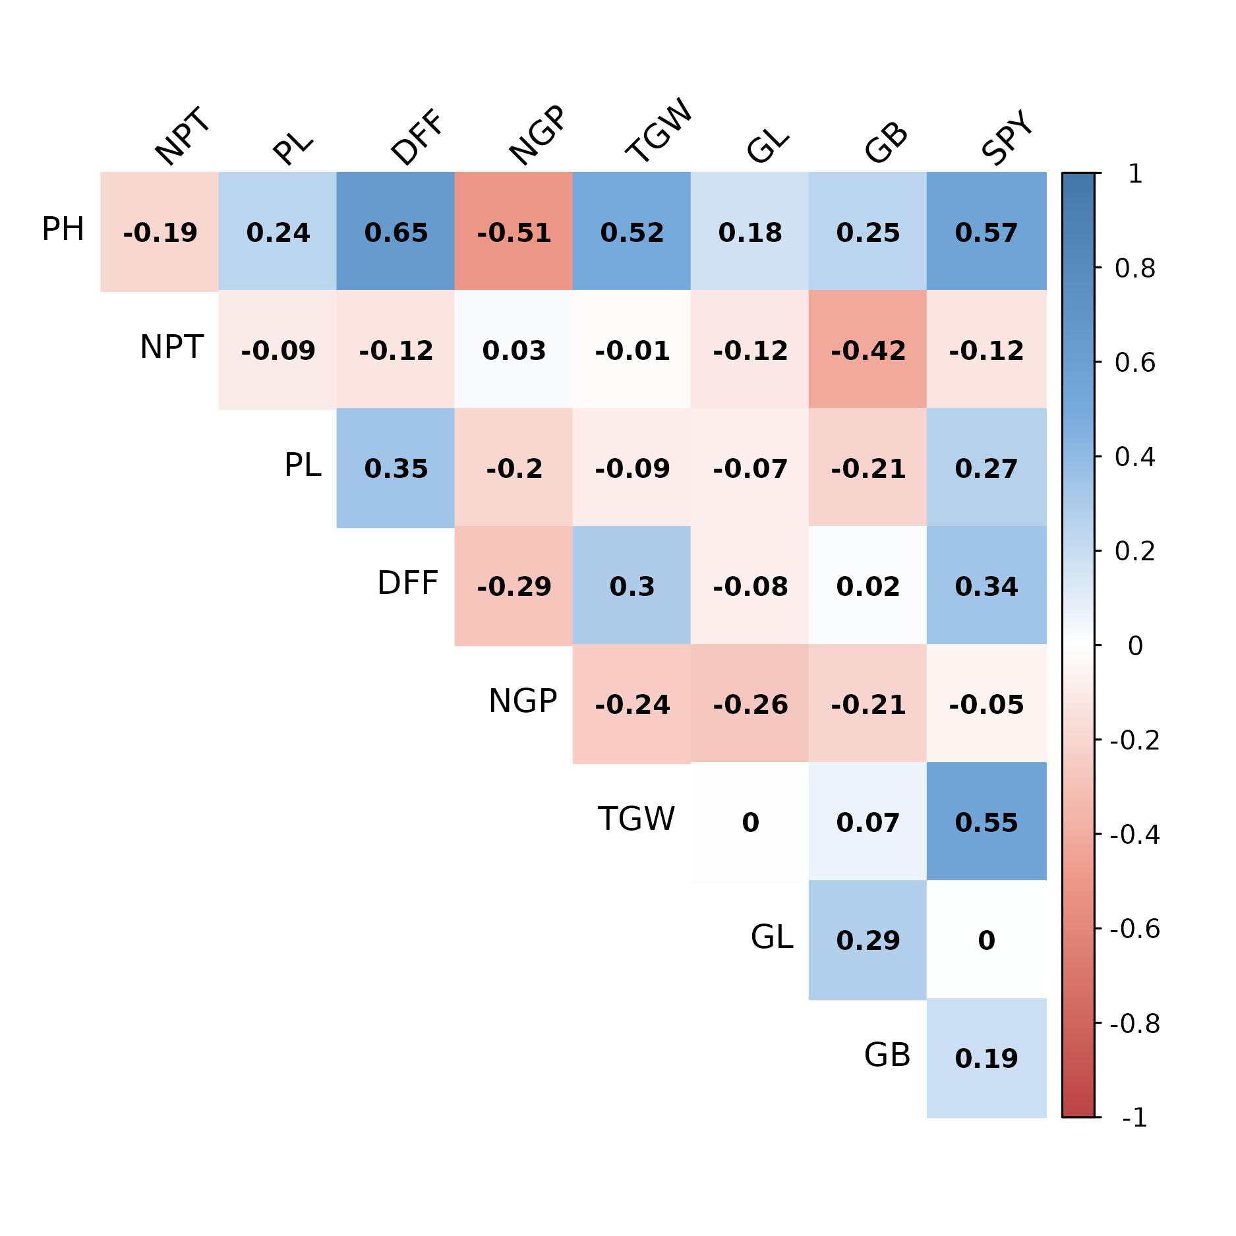

PH – Plant height; TGW - Thousand grain weight;

NPT - Number of productive tillers; GL - Grain length;

PL - Panicle length; GB - Grain breadth;

DFF - Days to fifty per cent flowering; SPY - Single plant yield

NGP - Number of filled grains per panicle;

Figure 2. Graphical representation of path analysis   
among various traits

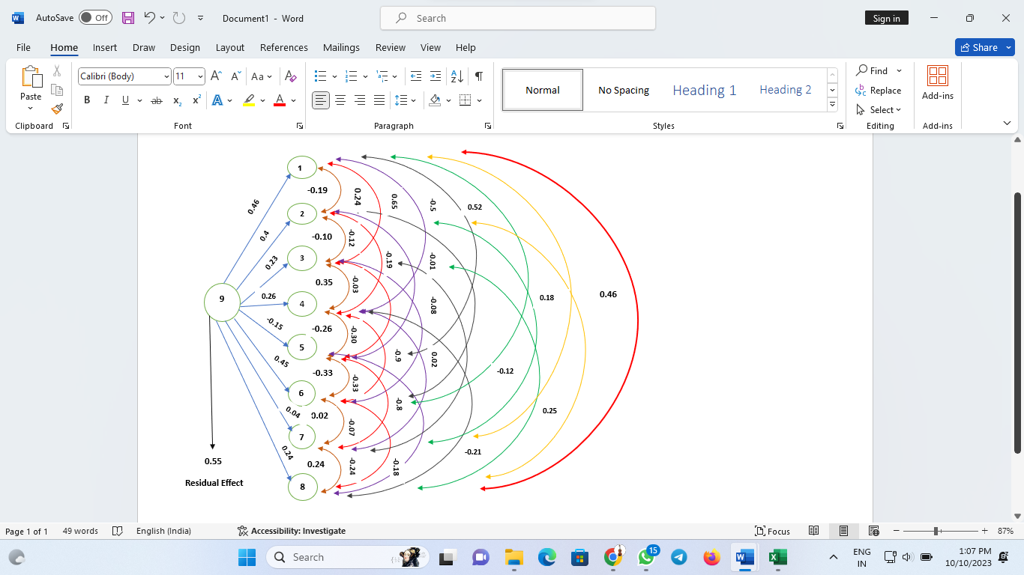

9: SPY (Dependent Trait)

1,2,3,4,5,6,7,8: PH, NPT, PL, DFF, NGP, TGW, GL and GB respectively (Independent Traits)