**SUSTAINABLE LIVESTOCK PRODUCTION UNDER CHANGING CLIMATE: AN ECONOMIC ASPECT**

**Introduction**

Domesticated animals raised in an agricultural context for diverse uses such as meat, eggs, milk, wool, fur, leather, and labor are referred to as livestock. Livestock production is considered to be an important component of the global food system. Production of livestock products in a sustainable way helps in alleviating poverty, ensuring food security, and promoting agricultural development (World Bank, 2022). Precise livestock farming is required to increase the sustainability of livestock output. There are different types of livestock production systems, and their sustainability varies greatly depending on resource quality, environmental conditions, and social and economic situations. According to Jackson (2023), Climate change is defined as the long-term transformation of the Earth's climate, which includes changes in temperature, precipitation, and weather patterns. As noted in the United Nations web page, human activities have been the primary cause of climate change, owing mostly to the use of fossil fuels such as coal, oil, and gas since 1800. The current quick speed of modernity has resulted in excessive expansion in industrialization, urbanization, transportation, deforestation, and so on, generating disturbances in the ecological and environmental balance, as shown by climate change (Vataliya *et al*., 2014). Climate change is threatening not only crops but also cattle. Sejian *et al.*, in 2016 classified the impact of climate change on livestock into two, namely, direct and indirect impact. Heat stress is the most major direct impact of climate change on cattle production. The majority of production losses are caused by the indirect impacts of climate change, which result in reduced or non-availability of feed and water availability. Sikiru *et al.,* (2023) proposed various techniques to address these difficulties, including improving feed quality and efficiency, reducing greenhouse gas emissions from livestock farming, promoting animal health and wellbeing, and increasing the resilience of livestock systems to climate change. Livestock are susceptible to temperature changes and water scarcity, which is the leading cause of economic loss for both agriculture and livestock dependent countries (Reilly *et al.,* 2003; Kannan &Anandhi, 2020). In tropical and subtropical nations where summers are severe, increasing livestock production under the current changing climatic scenario is a jockey. According to estimates, dairy and beef production in the United States will fall by 6.8% by 2030, while India, a major dairy producing country, will lose more than 45% of its dairy farms owing to increased heat stress (Anonymous, 2022a). With this background, this review paper concentrates on the ways in which Sustainable Livestock Production (SLP) is affected by varying climate and the techniques to overcome those challenges by opting various sustainable methods.

**Obstacles to SLP by Climate Change**

The climatic extremes in the atmosphere often depict more temperature and precipitation variation, and more frequent extremes than usual. This is caused by rising levels of carbon dioxide (CO2). These modifications have been discovered to have an impact on the sustainability of livestock and associated feed production. SLP is an important part of agriculture that tries to mitigate the negative environmental impacts of livestock farming while still ensuring the industry's long-term survival (Opio, 2020). Change in climate such as variations in temperature, rainfall, and patterns of weather creates substantial obstacles to SLP that can have an impact on animal health, productivity, and wellbeing.

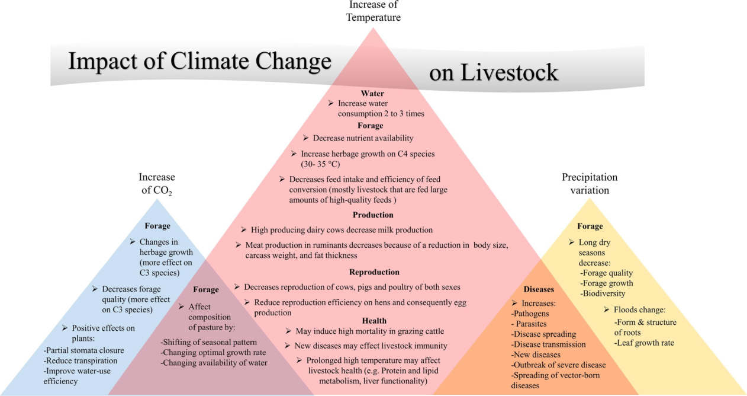

Fig. 1 Impact of Climate Change on Livestock

Source: Rojas-Downing *et al*., 2017

**Impact on animal health:** Climate change may have four major effects on animal health such as heat-related diseases and stress, adverse weather events, adaptation of animal production systems to new circumstances, and the emergence or re-emergence of infectious diseases (Forman *et al*., 2000; Magiri *et al.*, 2021). The emission of greenhouse gasses through various anthropogenic activities increases the global temperature which finally impairs the dairy production, animal weight, reproduction, and feed-conversion efficiency in warm regions. Due to the increased temperature, the animal starts to intake more water which in turn reduces the feed intake which may finally affect the animal's health. With minimal heat stress abatement, economic losses in the United States are projected to be $2.4 billion per year (Baumgard *et al*., 2012). McCarthy, 2001 in his report submitted to Intergovernmental Panel on climate Change (IPCC,2001) stressed that the droughts in Africa between 1981 and 1999 have been shown to cause mortality rates of 20-60% of national herds. Temperature and/or humidity increases in air have the potential to alter conception rates in domestic animals that are not accustomed to those conditions (Tubiello *et al.*, 2017). The ability of animals to adapt to adverse climatic conditions is determined by the sensitivity of production to regional climate. As a result, the consequences may be favorable or negative, and they may vary among geographical regions, animal species, and adaptive capacity. However, the negative effects are most likely to be felt in tropical and subtropical regions, particularly countries with the highest current and future need for nutrition (Henry *et al*., 2018).In major livestock animals, the majority of illnesses are caused by pests, pathogens and nematodes. Development stages of most pathogens, pests and nematodes are frequently temperature dependent. Climatic variations affect the emergence and proliferation of disease hosts or vectors, as well as the breeding, development, and transmission of infections (Nejash, 2016). Pierre *et al*., 2003 noticed that heat stress caused economic losses to livestock industries in the United States. The estimated total annual economic losses ranged from $1.69 to $2.36 billion. To be specific, losses in various sectors of livestock in the US were mentioned below in the table.

Table No. 1 Estimated annual economic losses of various livestock sector in USA

|  |  |
| --- | --- |
| **Livestock Sectors** | **Annual Economic Losses** |
| Dairy industry | $897 to $1500 million |
| Beef industry | $370 million |
| Swine industry | $299 to $316 million |
| Poultry industry | $128 to $165 million |

Source: Pierre *et al*., 2003

**Impact on productivity:** The physiological impacts of heat stress on productivity are financially detrimental to the livestock sectors. Climate change has the potential to affect the quantity and quality of products, the reliability of production, and the natural resource base on which livestock production is based. Heat stress has been shown to lower the resistance of animals to diseases as well as reproductive efficiency and productivity in general (Magiri *et al.*, 2020). According to Smit *et al.,* 1996, climate change factors influence livestock productivity such as availability and price of grains and, fodder and pasture production and quality, changing patterns of livestock disease and the direct effect of weather on livestock health. The livestock production in Ethiopia has been impacted by climate change by causing feed and water shortage, reduced weight and productivity, mature weight issues, more conflicts, increased disease prevalence and mortality. Among those, impact on productivity was considered to be the highest (Yilma *et al.,* 2009). Choudhary (2017) in his doctoral research studied the Climate Sensitivity of Agriculture in Trans and Upper Gangetic Plains of India and found that the milk yield of Crossbred animals, Buffalo and Indigenous breeds decreased as the temperature increased. Poultry, because they lack sweat glands, are not well suited to high ambient temperatures (Chatterjee & Rajkumar, 2015). Thus, the temperature fluctuations result in decreased productivity in poultry birds. In the instance, if sows are accommodated at high ambient temperatures (29oC vs 18oC), feed intake may drop by more than 50% during the entire lactation period, resulting in a loss of body condition much above the optimum and disadvantaged piglet growth was seen (Babinszky *et al*., 2011). Climate change was also considered as having a negative impact on cattle yield and quality features by Chingala et al., 2017. Under the most favorable scenario, the overall cost of Brazilian beef cattle production in the Cerrado approached US$ 2.88 per Kg, whereas under the catastrophic scenario, the cost reached US$ 4.16 per Kg, putting this economic segment's international competitiveness in jeopardy (Naas *et al.,* 2010).

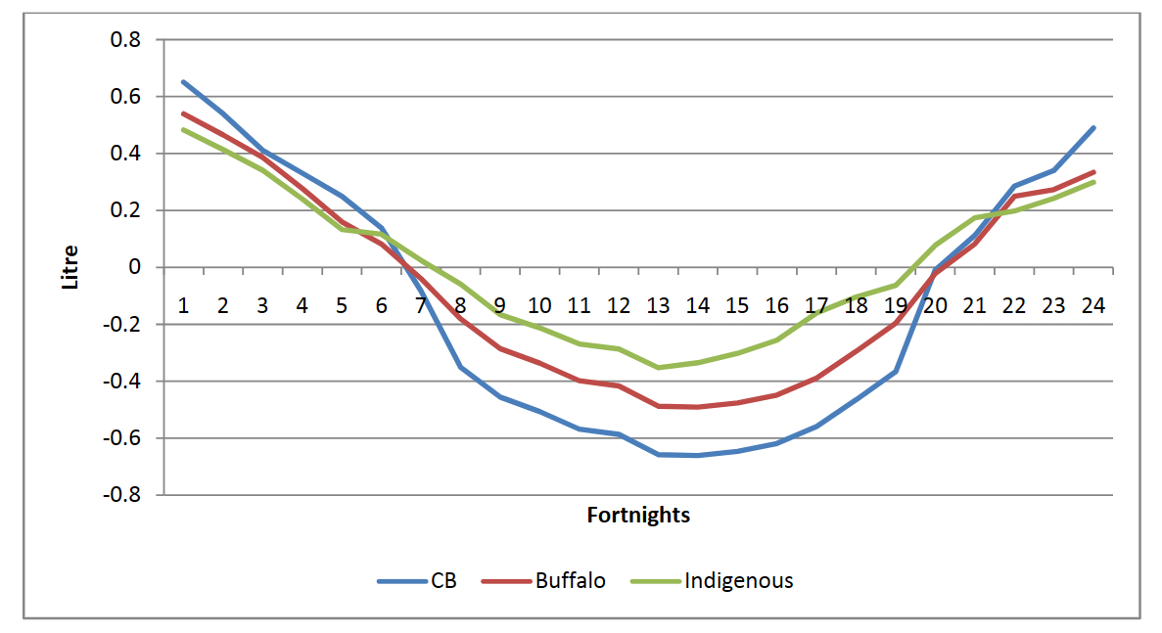

Fig 2. Marginal effect of average THI (Temperature Heat Index) on fortnightly milk yield

Source: Choudhary, 2017

**Impact on animal wellbeing:** Climate change has a significant impact on animal welfare. Since the 1800s, the Earth's temperature has risen by 1.1°C (2°F), and it is expected to climb by 2.7°C (4.8°F) by the end of the century (Anonymous, 2022b). Climate change has a negative impact on terrestrial, aquatic, and marine ecosystems. It is likely that many animals have suffered and will continue to suffer as a result of these impacts (Fey *et al*., 2015). According to a new study, the impact of climate change on animals would be "multifaceted" with "cascading impacts" across five welfare domains, including nutrition, environment, behavior, physical and mental health (Anonymous, 2023). These domains are detailed by Mellor *et al*., 2020 in his paper. Nutritional domain includes deprivation of food and water which in turn leads to malnutrition in livestock animals. Physical and atmospheric challenges such as fluctuating temperature, water and feed scarcity, reduced grazing land, uneven rainfall, severe winters, unexpected droughts and floods etc., come under environmental domains. Behavioral and/or interactive movement restrictions fall under the behavioral welfare domain. Physical and mental health domains cover thirst, hunger, anxiety, fear, pain and distress. However, with the change in climate, the animal’s natural habitat gets modified which in turn affects their feeding habit, water intake, grazing period and resting period. This results in affecting the overall wellbeing of animals. As indicated by Grace *et al*., 2015, livestock diseases are predicted to reduce productivity by 25 percent, with the poor bearing the brunt of the cost. Yilma *et al., 2009* listed the livestock based on the level of susceptibility to climate change and concluded that cattle are more susceptible to climate change. Ali in 2007 found a relationship between poverty and output share of livestock sector to agriculture sector in major states of India and summarized that as the output share decreases the poverty in the states increases and thus the poor people dependent on livestock farming will diversify to other sectors which directly impact global food security.

|  |
| --- |
| Fig 3. Poverty and livestock output across major Indian states, 1999 to 2000  Source: Ali, 2017 |

Table no. 2 Livestock species and Order of susceptibility

|  |  |
| --- | --- |
| **Livestock species** | **Order of susceptibility** |
| Cattle | 1st |
| Sheep | 2nd |
| Donkey | 3rd |
| Goat | 4th |
| Camel | 5th |
| Chicken | Not affected |

Source: Yilma *et al.,* 2009

**Techniques to overcome the obstacles of climate change under SLP**

Under SLP, many approaches can be employed to overcome climate change obstacles, such as boosting cattle resilience, conserving natural resources, and lowering greenhouse gas emissions etc. Some of them are detailed below.

**Water management:**  In the first decade of the twenty-first century, India, the United States, Iran, Saudi Arabia, and China had the greatest groundwater depletion rates (Doll *et al*., 2014). Water management is an essential part for sustainable livestock production. The key area for improvement in water usage efficiency and livestock productivity is through sustainable livestock and feed base management in order to maximize production efficiency and create improved living conditions for the rural population. Moreover, the water use for livestock production should be emphasized as an integral part of agricultural water resource management, by prefocusing the type of production system (such as grain-fed or mixed crop-livestock) and scale (whether intensive or extensive), species and breeds of livestock in the farm, and the social and cultural aspects of livestock farming in various countries (Schlink *et al*., 2010).

**On-and-off farm diversification:** Diversified practices are considered as the alternative for sustainable livestock development. On-farm diversification is the recombination and reallocation of available farm resources into non-agricultural enterprises or new non-conventional crops and/or livestock. On-farm diversification in the context of sustainable livestock production might involve strategies such as crop-livestock integration, agro forestry, and pasture management. Off-farm diversification mainly aims at adding value to the available assets with the aim of increasing income by reducing the risk (Moraru & Bodescu, 2022). Off-farm diversification can include operations such as livestock products processing and marketing, as well as non-farm income-generating operations (Hussein & Nelson, 1998; Asante *et al*., 2018). On-and-off farm diversification is an approach that combines on- and off-farm activities to provide extra revenue for households. This can be accomplished by producing various agricultural and non-agricultural goods and services, selling waged labor, or working for self in smaller enterprises (Hussein & Nelson, 1998). Diversification can help farmers pass on risk and adapt to shocks such as climate change. It may additionally assist to ensure the long-term sustainability of livestock production systems by decreasing their burden on natural resources and encouraging biodiversity (FAO, 2018; Danso-Abbeam *et al*., 2021).

**Altered rotation of pastures:** Altered rotation of pastures is a sustainable livestock production method that can assist increase soil health and plant biodiversity while lowering the impact of livestock farming on environment and climate (Opio,2020; Grandin, 2022). Rowntree *et al*., 2020 compared the necessary acreage for food production between the two systems, Multi Species Pasture Rotation (MSPR) which required 2.5 times more land than the Commodity Production System (COM) which is because the MSPR may regenerate land and so requires a far larger land area than COM. The practice of rotational grazing is clearly explained in the figure given below. According to the FAO (2018), integrating livestock species with complementary grazing behavior might boost overall biomass collection and productivity while decreasing health hazards associated with animal parasitism.

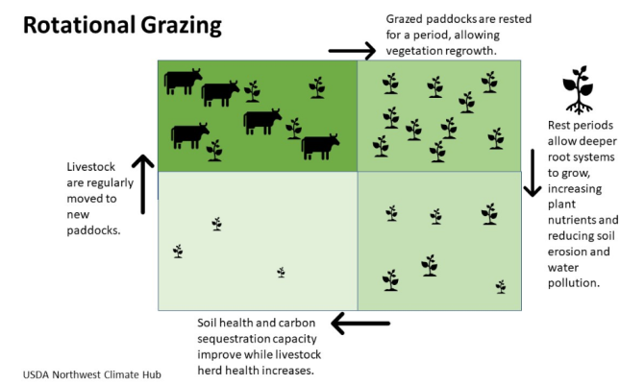

Fig 4. USDA

**Modification of grazing times:** For commercial livestock production, grazing management that allows for significant neglect of forage species is pernicious (Norton,1998). Grazing management is adjusting grazing times, stocking rates, and intensity of grazing to make sure that the land is used sustainably while safeguarding livestock health and productivity (Teague & Kreuter, 2020; Opio, 2020). Changing grazing schedules is one method for achieving sustainable livestock production. It entails altering the time of day when animals are permitted to graze in order to maximize feed intake and reduce heat stress. In hot and arid climates, for example, grazing should be done during cooler times of the day, such as early morning or late afternoon. This method may help animals reduce heat stress and increase productivity. Thus, modifying grazing times can aid in the restoration of soil health, ecosystem function, and biodiversity (Teague & Kreuter, 2020). Using the "herd effect" and limiting grazing duration to avoid regrazing forage plants can help trample down dead plants, break up hard soil crusts, and incorporate dung, urine, and plant organic matter into soils to improve soil carbon, increase water infiltration and retention, and accelerate nutrient flow for grass regrowth (Morris, 2021).

**Reducing greenhouse gas emissions from livestock farming:** The Greenhouse Gas emissions from livestock are more compared to crop production **(**Neufeldt & Schäfe, 2008, Thamo *et al*., 2013). As mentioned by Leip *et al*., 2015 the livestock are blamed in European countries for the increased emissions of nitrogen, sulfur, phosphorus and greenhouse gasses. This has resulted in a gradual demonization of the livestock sector, and hence it is essential to balance the drawbacks with some rewards. To address GHG emissions, the livestock sector must challenge itself to design and execute mitigation strategies that are effective, efficient, and equitable (Moran & Wall, 2011). Diet manipulation, direct inhibitors, feed additives, propionate enhancers, methane oxidizers, probiotics, defaunation, and hormones can all help to reduce carbon emissions from animal feces (Sirohi & Michaelowa, 2007).

**Disease control and surveillance:** The most efficient and cost-effective method of disease management is to prevent illnesses from entering and spreading in herds of livestock (Wobeser, 2002). Animal disease control is a top priority in the sustainable livestock production, owing to the high cost of infectious diseases. Some of these diseases are treatable with relatively inexpensive vaccinations. It is possible to lower disease incidence in livestock populations by implementing effective disease prevention programs and adopting appropriate livestock management techniques. Disease surveillance enables the detection of new ailments as well as changes to existing diseases.An effective and efficient surveillance system necessitates the combined efforts of relevant stakeholders working toward a common objective with a shared sense of responsibility (George *et al*., 2021).

**Agroforestry:** Agroforestry is a land use practice that integrates trees, fodder, and livestock to build a sustainable system. Silvo pasture is a particular kind of agroforestry that has begun to gain prominence in recent years as an environmentally benign and economically viable alternative land use system (Jose & Dollinger, 2019). It entails mixing trees and livestock with forage to produce a well-planned system. According to a World Bank report 2022, between 2011 and 2018, the use of Silvo pastoral systems increased milk production by 17 per cent, reduced production costs by 18.5 per cent, and increased the mean number of cows / hectares by 23 per cent.

**Continuously matching of stocking rates with pasture production:** Stocking rate is an important management component in determining grazing system productivity and profitability (Fales *et al*., 1995). Matching stocking rates with pasture production entails optimizing the total number of animals grazing on a given amount of land to avoid overgrazing or undergrazing. The goal is to strike a balance between the number of animals and the available pasture, which can help increase livestock productivity while reducing environmental degradation. To reach end-point objectives, stocking strategies must incorporate periodic and total forage mass, accompanying nutritional qualities, specific defoliation regimen behaviors, and weather circumstances (Rouquette, 2015).

**Changes in cropping calendar:** Crop calendars offer information on sowing of seeds, growing of crops and harvesting of matured crops (Omran, 2020).Crop production strategies, cropping patterns, and cropping calendars, for example, will be largely similar, with the exception of crop types grown and animal and breed selection according to the specific Agro Ecological Zone (Devendra, 2012). Crop calendars for livestock feed keep track of the available supply of animal feeds month by month, similar to a 'fodder-flow' exercise. Because of labor demands (a "labor calendar") and the availability of crop residue as feed sources, this should be linked to the cropping system (Donkin., 2005).

**Cooling (indoor systems or provide shade):** The most that can typically be done to decrease heat stress on animals is to provide shade. Planting trees will provide Shade and can assist animals to avoid heat stress and enhance productivity. Furthermore, indoor cooling systems can be employed to reduce the radiant heat load on feedlot cattle, hence lowering the demand for water and energy for thermoregulation (Firfiris *et al.*, 2019; Maia *et al*., 2023). Commercial beef and dairy breeds such as Holstein, Jersey, Charolais, Limousin, Blonde d'Aquitaine, and Belgian Blue are faster growing and more productive (de Vries, 1994) are considered less suited to being kept in a variety of climatic conditions and are generally kept indoors in deep winter.

**Increase mobility for resources:** This approach entails moving livestock to places with greater resources, especially water and pasture. By enhancing feed quality, avoiding overgrazing, and conserving natural resources, this technique can help maintain sustainable livestock production. The circular economic model based on biogas is an excellent technique to achieve sustainable livestock and poultry waste management while limiting the greenhouse effect (Xue *et al.*, 2019) and in turn the waste after extraction used for crop growth and the final crop residue is used as livestock feed. Intensification of livestock into the commercial small mixed-farming systems entails more zero-grazing systems and optimum allocation of available resources which in turn enables better control of parasites both ecto and endo, collection and strategic use of animal wastes, and crop damage reduction (Kaasschieter *et al*., 1992).

**CONCLUSION**

By reviewing various scholarly papers, it is clear that the impact on livestock due to changing climate is various which also reduces the productivity of livestock products, this in turn affects the global food security. It is also evident that the livestock sector is also contributing much to the atmospheric climate variability when compared to agriculture, that is the share of livestock to the agricultural sector in increasing global temperature is noticed to be high. Thus, there is a need for Sustainable livestock production which entails increased production and a better use of natural resources, lowering the environmental impact of livestock systems. To advance the livestock sector toward environmental sustainability, it is critical to enhance animal health and wellbeing, minimize the economic cost of animal diseases, improve food safety, and reduce antibiotic resistance threats. The World Bank is committed to boosting the livestock sector's contribution to sustainable development by assisting countries in managing and responding to rising demand for animal protein via methods that are less detrimental to the environment as well as contributing much less to climate change.

**References**

1. 20th Livestock Census, 2019. Department of Animal Husbandry & Dairying. Retrieved from [20th Livestock census 2019-All India Report | Department of Animal Husbandry & Dairying (dahd.nic.in)](https://dahd.nic.in/ahs-division/20th-livestock-census-2019-all-india-report)
2. Ali J. (2007). – Livestock sector development and implications for rural poverty alleviation in India. *Livestock Res. rural Develop*., **19** (2), 1-11.
3. Anonymous, 2022a. Cattle production faces annual loss of $40 billion, due to climate change. *Open access government*. Retrieved from [Cattle production to lose up to $40 billion yearly due to heat stress (openaccessgovernment.org)](https://www.openaccessgovernment.org/cattle-production-heat-stress-climate-change-meat-industry/131373/#:~:text=Researchers%20state%20that%20cattle%20producers%20could%20endure%20a,tropical%20regions%20in%20South%20America%2C%20Asia%20and%20Africa.).
4. Anonymous, 2022b. The impact of climate change on our planet’s animals. *International Fund for Animal Welfare*. Retrieved from [the impact of climate change on our planet’s animals (ifaw.org)](https://www.ifaw.org/journal/impact-climate-change-animals)
5. Anonymous, 2023. Impacts of climate change on animal welfare, *CABI Reviews* (2023). DOI: <https://dx.doi.org/10.1079/cabireviews.2023.0020>
6. Asante, B. O., Villano, R. A., Patrick, I. W., & Battese, G. E. (2018). Determinants of farm diversification in integrated crop–livestock farming systems in Ghana. *Renewable Agriculture and Food Systems*, **33**(2), 131-149.
7. Babinszky, L., Halas, V., & Verstegen, M. W. (2011). Impacts of climate change on animal production and quality of animal food products. *Climate change socioeconomic effects.Rijeka: InTech*, 165-190.
8. Baumgard, L. H., Rhoads, R. P., Rhoads, M. L., Gabler, N. K., Ross, J. W., Keating, A. F., & Sejian, V. (2012). Impact of climate change on livestock production. *Environmental stress and amelioration in livestock production*, 413-468.
9. Chatterjee, R. N., & Rajkumar, U. (2015). An overview of poultry production in India. *Indian Journal of Animal Health*, **54**(2), 89-108.
10. Chingala, G., Mapiye, C., Raffrenato, E., Hoffman, L., & Dzama, K. (2017). Determinants of smallholder farmers’ perceptions of impact of climate change on beef production in Malawi. *Climatic Change*, **142**, 129-141.
11. Choudhary, B. B. (2017). Climate Sensitivity of Agriculture in Trans and Upper Gangetic Plains of India Potential Economic Impact and Vulnerability. *Doctoral dissertation, NDRI*.
12. Danso-Abbeam, G., Dagunga, G., Ehiakpor, D. S., Ogundeji, A. A., Setsoafia, E. D., & Awuni, J. A. (2021). Crop–livestock diversification in the mixed farming systems: implication on food security in Northern Ghana. *Agriculture & Food Security*, **10**(1), 1-14.
13. De Vries, M. W. (1994). Do breed differences in cattle have implications for conservation management? In: Foraging in a landscape mosaic: diet selection and performance of free-ranging cattle in heathland and riverine grassland. 97110.
14. Devendra, C. (2012). Climate change threats and effects: challenges for agriculture and food security. *Kuala Lumpur: Academy of Sciences Malaysia*.
15. Doll, P., Muller Schmied, H., Schuh, C., Portmann, F. T., & Eicker, A. (2014). Global‐scale assessment of groundwater depletion and related groundwater abstractions: Combining hydrological modeling with information from well observations and GRACE satellites. *Water Resources Research*, ***50***(7), 5698-5720.
16. Donkin, E. F. (2005). Sustainable livestock development in Africa: How do we help Africa to feed itself. *SA-Anim. Sci*, ***6,*** 56-67.
17. Fales, S. L., Muller, L. D., Ford, S. A., O'sullivan, M., Hoover, R. J., Holden, L. A., & Buckmaster, D. R. (1995). Stocking rate affects production and profitability in a rotationally grazed pasture system. *Journal of production agriculture*, ***8***(1), 88-96.
18. FAO (2018). Livestock and Agroecology: How They Can Support the Transition towards Sustainable Food and Agriculture. *FAO: Rome, Italy*.
19. FAO. 2018. World Livestock: Transforming the livestock sector through the Sustainable Development Goals. Rome. 222 pp. https://doi.org/10.4060/ca1201en. Licence: CC BY-NC-SA 3.0 IGO.
20. Fey, S. B., Siepielski, A. M., Nusslé, S., Cervantes-Yoshida, K., Hwan, J. L., Huber, E. R., & Carlson, S. M. (2015). Recent shifts in the occurrence, cause, and magnitude of animal mass mortality events. *Proceedings of the National Academy of Sciences*, **112**(4), 1083-1088.
21. Firfiris, V. K., Martzopoulou, A. G., & Kotsopoulos, T. A. (2019). Passive cooling systems in livestock buildings towards energy saving: A critical review. *Energy and Buildings*, ***202***, 109368.
22. Forman, S., Hungerford, N., Yamakawa, M., Yanase, T., Tsai, H. J., Joo, Y. S., ... & Nha, J. J. (2008). Climate change impacts and risks for animal health in Asia. *Rev Sci Tech Off Int Epiz*, ***27***(2), 581-97.
23. George, J., Hasler, B., Komba, E. V., Sindato, C., Rweyemamu, M., Kimera, S. I., & Mlangwa, J. E. (2021). Leveraging sub-national collaboration and influence for improving animal health surveillance and response: a stakeholder mapping in Tanzania. *Frontiers in Veterinary Science*, **8**, 738888.
24. Grace, D., Bett, B. K., Lindahl, J. F., & Robinson, T. P. (2015). Climate and livestock disease: assessing the vulnerability of agricultural systems to livestock pests under climate change scenarios. *CCAFS* Working Paper.
25. Grandin, T. (2022). Grazing cattle, sheep, and goats are important parts of a sustainable agricultural future. *Animals*, **12**(16), 2092.
26. Henry, B. K., Eckard, R. J., & Beauchemin, K. A. (2018). Adaptation of ruminant livestock production systems to climate changes. *Animal*, 12(s2), s445-s456.
27. Hussein, K., & Nelson, J. (1998). Sustainable livelihoods and livelihood diversification. *IDS Working Paper,***69.**
28. Jackson, S. T. (2023). climate change. *Encyclopedia Britannica*. <https://www.britannica.com/science/climate-change>
29. Jose, S., & Dollinger, J. (2019). Silvopasture: a sustainable livestock production system. *Agroforestry systems*, ***93***, 1-9.
30. Kaasschieter, G. A., De Jong, R., Schiere, J. B., & Zwart, D. (1992). Towards a sustainable livestock production in developing countries and the importance of animal health strategy therein. *Veterinary Quarterly*, ***14***(2), 66-75.
31. Kannan, N., & Anandhi, A. (2020). Water management for sustainable food production. *Water*, **12**(3), 778.
32. Leip, A., Billen, G., Garnier, J., Grizzetti, B., Lassaletta, L., Reis, S. & Westhoek, H. (2015). Impacts of European livestock production: nitrogen, sulphur, phosphorus and greenhouse gas emissions, land-use, water eutrophication and biodiversity. *Environmental Research Letters*, **10**(11), 115004.
33. Magiri, R., Muzandu, K., Gitau, G., Choongo, K., & Iji, P. (2020). Impact of climate change on animal health, emerging and re-emerging diseases in Africa. *African Handbook of Climate Change Adaptation*, 1-18.
34. Maia, A. S., Moura, G. A., Fonsêca, V. F., Gebremedhin, K. G., Milan, H. M., Chiquitelli Neto, M., & Pacheco, R. D. L. (2023). Economically sustainable shade design for feedlot cattle. *Frontiers in Veterinary Science*, ***10***, 1110671.
35. McCarthy, J. J. (Ed.). (2001). Climate change 2001: impacts, adaptation, and vulnerability: contribution of Working Group II to the third assessment report of the Intergovernmental Panel on Climate Change (Vol. 2). *Cambridge University Press*.
36. Mellor, D. J., Beausoleil, N. J., Littlewood, K. E., McLean, A. N., McGreevy, P. D., Jones, B., & Wilkins, C. (2020). The 2020 five domains model: Including human–animal interactions in assessments of animal welfare. *Animals*, **10**(10), 1870.
37. Moran, D., & Wall, E. (2011). Livestock production and greenhouse gas emissions: Defining the problem and specifying solutions. *Animal Frontiers*, **1**(1), 19-25.
38. Moraru, R. A., & Bodescu, D. (2022). Diversification As An Alternative Strategy For Sustainable Farm Development. *Agronomy Series of Scientific Research/Lucrări Ştiinţifice Seria Agronomie*, ***65***(2).
39. Morris, C. D. (2021). How Biodiversity-Friendly Is Regenerative Grazing?.*Frontiers in Ecology and Evolution*, ***9***, 816374.
40. Nääs, I. D. A., Romanini, C. E. B., Salgado, D. D. A., Lima, K. A. O., Vale, M. M. D., Labigalini, M. R., & Moura, D. J. D. (2010). Impact of global warming on beef cattle production cost in Brazil. *Scientia Agricola*, **67**, 01-08.
41. Nejash, A., & Kula, J. (2016). Impact of climate change on livestock health: A review. *Global Veterinaria*, **16**(5), 419-424.
42. Neufeldt, H., & Schäfer, M. (2008). Mitigation strategies for greenhouse gas emissions from agriculture using a regional economic-ecosystem model. *Agriculture, ecosystems & environment*, ***123***(4), 305-316.
43. Norton, B. E. (1998). The application of grazing management to increase sustainable livestock production. *Animal production in Australia*, **22**(1), 15-26.
44. Omran, E. S. E. (2020). Exploring Changes in the Agricultural Calendar as a Response to Climate Variability in Egypt. *Climate Change Impacts on Agriculture and Food Security in Egypt*. *Springer*, 249-271.
45. Opio, C. (2020). Livestock under climate change. Adaptation of livestock systems to climate change. Presented on ‘*koronivia Workshop On: Improved Livestock Management Systems, Including Agropastoral Production Systems And Others*’.
46. Reilly, J., Tubiello, F., McCarl, B., Abler, D., Darwin, R., Fuglie, K., ... & Rosenzweig, C. (2003). US agriculture and climate change: new results. *Climatic Change*, **57**, 43-67.
47. Rojas-Downing, M. M., Nejadhashemi, A. P., Harrigan, T., & Woznicki, S. A. (2017). Climate change and livestock: Impacts, adaptation, and mitigation. C*limate risk management*, **16**, 145-163.
48. Rouquette Jr, F. M. (2015). Grazing systems research and impact of stocking strategies on pasture–animal production efficiencies. *Crop Science*, ***55***(6), 2513-2530.
49. Rowntree, J. E., Stanley, P. L., Maciel, I. C., Thorbecke, M., Rosenzweig, S. T., Hancock, D. W., & Raven, M. R. (2020). Ecosystem impacts and productive capacity of a multi-species pastured livestock system. *Frontiers in Sustainable Food Systems*, ***4***, 232.
50. Schlink, A. C., Nguyen, M. L., & Viljoen, G. J. (2010). Water requirements for livestock production: a global perspective. *Rev. Sci. Tech*, ***29***(3), 603-619.
51. Sejian, V., Gaughan, J. B., Bhatta, R., & Naqvi, S. M. K. (2016). Impact of climate change on livestock productivity. *Feedipedia-Animal Feed Resources Information System-INRA CIRAD AFZ and FAO*, *2016*, 1-4.
52. Sharma, H., Kalamkar, S. S., & Makwana, M. C. (2022). Cost effective analysis of milk production in Gujarat, India. *Journal of Livestock Science* (ISSN online 2277-6214), **13**, 20-24.
53. Sikiru, A. B., Velayyudhan, S. M., Nair, M. R. R., Veerasamy, S., & Makinde, J. O. (2023). Sustaining Livestock Production Under the Changing Climate: Africa Scenario for Nigeria Resilience and Adaptation Actions. *Climate Change Impacts on Nigeria: Environment and Sustainable Development. Cham: Springer International Publishing.* 233-259.
54. Sirohi, S., & Michaelowa, A. (2007). Sufferer and cause: Indian livestock and climate change. *Climatic change*, **85**(3-4), 285-298.
55. Smit, B., McNabb, D., & Smithers, J. (1996). Agricultural adaptation to climatic variation. *Climatic change*, **33**(1), 7-29.
56. St-Pierre, N. R., Cobanov, B., & Schnitkey, G. (2003). Economic losses from heat stress by US livestock industries. *Journal of dairy science*, ***86***, E52-E77.
57. Teague, R., & Kreuter, U. (2020). Managing grazing to restore soil health, ecosystem function, and ecosystem services. *Frontiers in Sustainable Food Systems*, 157.
58. Thamo, T., Kingwell, R. S., & Pannell, D. J. (2013). Measurement of greenhouse gas emissions from agriculture: economic implications for policy and agricultural producers. *Australian Journal of Agricultural and Resource Economics*, ***57***(2), 234-252.
59. Tubiello, F. N., Soussana, J. F., & Howden, S. M. (2007). Crop and pasture response to climate change. *Proceedings of the National Academy of Sciences*, ***104***(50), 19686-19690.
60. Vataliya, P. H., Dongre, V. B., Ahlawat, A. R., & Dangar, N. S (2014). Climate Change and Domestic Animal Biodiversity: Gujarat Perspective. Presented on “*National Seminar on ‘Revisiting Management Policies and Practices for Indigenous Livestock & Poultry Breed as Eco- friendly Economic Producers’”*. 161-168
61. [What Is Climate Change? | United Nations](https://www.un.org/en/climatechange/what-is-climate-change)
62. Wobeser, G.(2002). Disease management strategies for wildlife. *Rev Sci Tech*, **21**(1),159-78.
63. World Bank. (2022). Moving Towards Sustainability: The Livestock Sector and the World Bank. The World Bank. Retrieved from [Moving Towards Sustainability: The Livestock Sector and the World Bank](https://www.worldbank.org/en/topic/agriculture/brief/moving-towards-sustainability-the-livestock-sector-and-the-world-bank)
64. Xue, Y. N., Luan, W. X., Wang, H., & Yang, Y. J. (2019). Environmental and economic benefits of carbon emission reduction in animal husbandry via the circular economy: case study of pig farming in Liaoning, China. *Journal of Cleaner Production*, ***238***, 117968.
65. Yilma, Z., Haile, A., GuerneBleich, E., & Ababa, A. (2009). Effect of climate change on livestock production and livelihood of pastoralists in selected pastoral areas of Borana, Ethiopia. *ESAP Proceedings*.