**Blossom Harmony: Investigating Peak Pollinator Visitation Patterns in Mustard, Bhendi and Maize Crops**

**BALAJI B. N1*, SUMITHRAMMA N1, MANJUNATHA R2 ANDVIDYAMULIMANI3**

1Department of Entomology, College of Agriculture, University of Agricultural Sciences, GKVK, Bangalore- 560065, India.

2Department of Entomology, College of Sericulture, Chintamani, University of Agricultural Sciences, GKVK, Bangalore- 560065, India.

3All India Network Project on Acarology, Department of Entomology, University of Agricultural Sciences, GKVK, Bangalore- 560065, India

**\***Corresponding author- balajibvn123@gmail.com

**ABSTRACT**

As the global population surges, the demand for sustainable food production intensifies, highlighting the pivotal role of pollinators in agricultural systems. With 87 out of 115 major crops relying on animal pollination, the decline in global pollinator populations raises concerns about its impact on agricultural productivity. This study delves into the temporal dynamics of pollinator visitation in three crucial crops—mustard, bhendi, and maize—essential for human nutrition and global agro-economies. Through meticulous field observations and data analytics, the research reveals peak pollinator activities in these crops. *A. florea* and *A. cerana* emerge as significant pollinators in mustard and bhendi, exhibiting distinct peak hours. Syrphids also contribute notably, particularly during morning hours. In maize, wind pollination prevails, with *A. cerana* as the sole observed pollinator. The study emphasizes the necessity of understanding and managing pollinator communities to optimize crop yield and ecosystem health. The findings offer insights for farmers and policymakers to implement targeted strategies supporting pollinator populations. By fostering blossom harmony, where crops and pollinators coexist synergistically, sustainable agricultural practices can be promoted. This research advances our comprehension of crop-specific pollination patterns, laying a foundation for future studies to optimize pollination strategies and enhance agricultural productivity.

**Keywords:** Peak visitation time, *Apis cerena*, *A. florea*, Syrphids, Mustard, blossom harmony

**INTRODUCTION**

As the human population increases rapidly, our demand for food grows with it. To cope with this, in the future, our agricultural systems will need to produce more food sustainably. Pollinators are and will continue to be, crucial to these systems. Both wild and managed pollinators offer essential pollination services – either provided by nature or arranged for by people (Anonymous, 2023). Of the 115 leading global crops consumed by humans, 87 rely on animal pollination, to some degree (Klein *et al*., 2007). 35 percent of the crops we eat, in terms of the volume produced globally, depend on animal pollination, to some extent (Maus, 2015). It is estimated that five to eight percent of global crop production, with an annual market value of 235 billion - 577 billion US dollars (IPBES, 2016), is directly attributable to animal pollination.

In recent years, the global decline in pollinator populations has raised concerns about its potential impact on agricultural productivity and ecosystem stability. Pollinators play a crucial role in the reproduction of many flowering plants, including key crops that form the backbone of our food supply. Among these crops, mustard (*Brassica* spp.), bhendi (*Abelmoschus esculentus*) and maize (*Zea mays*) stand out as essential contributors to human nutrition and agro-economies worldwide. Understanding the temporal dynamics of pollinator visitation in these crops is vital for optimizing agricultural practices, ensuring sustainable yields, and safeguarding biodiversity.

The intricate relationship between flowering crops and their pollinators has been a subject of growing interest among researchers. Recent studies emphasize the significance of pollination services for enhancing crop yield and quality (Klein *et al*., 2007; IPBES, 2016). Mustard, a member of the Brassicaceae family, serves as a model system for investigating plant-pollinator interactions due to its economic importance and reliance on pollinators for successful seed production (Stanley *et al*., 2020). Bhendi, commonly known as okra, and maize, a staple cereal crop, are also known to benefit from effective pollination, impacting both the quantity and quality of their yields (Bartomeus *et al*., 2014; Kremen and Kramer, 2007).

Despite the critical role of pollinators, there is a paucity of comprehensive studies examining the temporal patterns of peak visitation in these specific crops. This study, aims to fill this knowledge gap by systematically analyzing the temporal dynamics of pollinator visitation across flowering stages in these agriculturally significant crops. As global agriculture grapples with the challenges of sustainable food production in the face of environmental changes, a nuanced understanding of pollinator dynamics becomes imperative. Through a combination of field observations, data analytics, we seek to unravel the intricate interplay between crop phenology and pollinator activity.

**MATERIAL AND METHODS**

The field experiment of pollination studies was conducted at the College of Sericulture, UAS, GKVK, Bengaluru, Karnataka. The Bhendi variety used was ‘Bhindi No. 10’ which was grown in an area of 11.5*11 sq.m with a spacing of 45*45 cm, all other operations were carried out as per the standard package of practices. As the border crop maize and mustard were grown.

On mustard, bhendi and maize the observations on the pollinator's visit were recorded for every hour at 10-minute intervals from 8.00 am to 5.00 pm. The observations were continuously recorded on the ten plants at the peak flowering stage and the major pollinators such as *Apis dorsata, A. cerana, A. florea* and syrphids were observed and recorded (Fig. 1).

The data collected was pooled and subsequent analysis involved calculating the mean and standard deviation. Graphs were generated to assess the peak activity of pollinators across various time intervals in mustard, bhendi and maize.

**RESULTS AND DISCUSSION**

In the mustard, the pollinators observed were *Apis dorsata, A. cerana, A. florea*, syrphids and some other flies (unidentified). The peak activity of *A. florae* was between 9.00 a.m. – 11.00 a.m. The peak activity of *A. cerana* was during morning hours between 9.00-11.00 a.m. Whereas, syrphids were present constantly but were found in more numbers during the morning hours. Further, *A. florea* and *A. cerana* were found to be major pollinators in mustard and *A. dorsata* were seen as very less pollinating mustard flowers (Fig. 2; Table 1).

In Bhendi, *A. cerana, A. florea*, syrphids were seen along with the ants. The peak activity of *A. florae* was seen between 09.00 a.m. to 12.00 p.m. and the peak activity of *A. cerana* was during morning hours i.e., 9.00-10.00 a.m. Likewise, the peak activity of *Syrphids* was also during morning hours between 08.00 and 11.00 am. The ants were also seen in large amounts but their role in pollination has to be studied deeply further, as of now they attend the flowers for the nectar. *A. florea* and syrphids were found to be the major pollinators in Bhendi and *A. dorsata* was not recorded pollinating bhendi flowers (Fig. 3; Table 1).

In Maize, only *A. cerana,* was observed pollinating and it was seen from morning to evening, but in large numbers was observed between 9.00 a.m. - 4.00 p.m. (Fig. 4; Table 1). The flowers of maize are majorly wind-pollinated as they have dry and light pollen grains so that they can be easily carried by the wind. So, the wind-pollination plays a major role in the maize.

The present findings are on par with Stanley *et al*., (2017) who found more bees in mustard at 13.00 h followed by 10.00 and 16.00 h. The foraging activity of *A. cerana* *indica* on mustard bloom was reportedly at its peak at 11.00 h (Chand *et al*., 1994). The foraging rate of *A. mellifera* on *B. napus* was significantly higher at 12:00 PM followed by 2:00 PM and 10:00 AM at weekly intervals, respectively (Khan and Ghramh, 2021). Ghosh *et al*. (2020) found similar results that the foraging activity of honeybees was highest on Brassica crops during 12:00 PM of the days. The amount of pollen collected was higher in the afternoon as compared to the morning. Similarly, Yucel and Duman (2005) documented that forager bees had more foraging activity and pollen collection in onion crop from 11:00 AM to 12:00 PM of the day. Khan *et al*. (2021) found that the highest number of bees with pollen entered into the hive at 12:00 PM of the day.

This peak activity time is more important in terms of pollen deposition at the time of stigma receptiveness. Mustard florets open between 09.00 h and noon and remain open for 3 days. Usually, the stigma projects about 2 mm beyond the petals, the afternoon preceding the opening of the flower and is immediately receptive. Soon afterward, however, the corolla begins to grow and rein gulfs the stigma. Then the stamens lengthen so that the anthers are at level with the stigma, but when the corolla opens, they turn half around. At this period, nectar secretion by the inner nectaries begins. Just before the flower closes, the anthers turn to their former position and, if any degree of self-fertility exists, selfing can result (Howard, 1916). So selfing in mustard if at all happens is the last resort. Stigma becomes receptive at noon time at which the peak activity of A. cerana also coincides. The availability of A. cerana in the mustard field almost coincides with the anthesis, dehiscence of anthers and liberation of pollen (Rao, 1997).

These results conform with the earlier recorded observations of Tara and Sharma (2010) on *Brassica campestris* var. Sarson revealed that the seed set was less (79.96%) in the controlled experiment as compared to open-pollinated flowers (88.05%). Significant differences were observed between pollinated and covered plants for three yield parameters i.e., total yield, number of seeds per silique, and weight of 100 seeds. Average yields were 189.3 pods/plant in the pollinated plot and 142.2 pods/plant in the covered plots. There was an average of 150 seeds/ silique in pollinated plots and in covered plots 11 seeds/silique. The weight of 100 seeds was 0.55 gm in pollinated plots and 0.37 gm in covered plots (Shakeel and Inayatullah, 2013).

The syrphid population was relatively seen in both the mustard and Bhendi. This may be attributed to the presence of aphids on mustard since syrphid grubs are good predators of aphids and adults a flower pollinator. Horn (1981) stated that syrphids locate aggregations of aphids as they fly and hover to inspect the foliage with aphids. Though syrphids are less efficient pollinators of brassicas compared to honey bees, still regarded as a pollinator (Orford *et al*., 2015)

Okra flowers can be self-pollinated, but cross-pollination by insects can improve effective fruiting, yields and the seed quality of okra. The pollination time of 8:00 am to 10:00 am was found to be optimum for hybrid seed production of okra as it has recorded better fruit set, fruit weight per plant, fruit length, fruit girth, hybrid seed weight per fruit, seed number, seed yield per plant, 100 seed weight, seed germination, shoot length, root length, seedling dry weight and vigour index, compared to 11:00 am to 1:00 pm and 2:00 pm to 4:00 pm pollination period. On the other hand, seed quality traits were lower in the treatment of 2:00 pm to 4:00 pm pollination time which can be attributed to immature and thinner seeds obtained from fruits of delayed pollination (Sruthi *et al*., 2020). Also, similar findings were reported by Priya *et al*. (2009) in chilli, Singh *et al*. (2010) and Abhishek *et al*. (2013) in okra.

Maize is an important pollen source for honey bees. Because maize is wind pollinated, increasing the pollinators in maize systems would not directly benefit the maize crop; however, supporting pollinators at the farm would benefit other crops such as Brassica napus L., as well as wild flora (Norris *et al*., 2017).

The results demonstrate that the timing of pesticide and herbicide application is important for different pollinator groups because a reduction in the number of flowers reduces visitation rates (Norris *et al*., 2017). Other studies have shown that relatively small areas of flowering plants like in patches, and border crops within agricultural landscapes can better support pollinator populations (Dicks *et al*., 2015) and that agri-environmental policies should be developed to support pollinators within the agricultural landscape to help reduce decline.

**CONCLUSION**

The study provides valuable insights into the pollinator dynamics in mustard, Bhendi, and Maize crops*. A. florea* and *A. cerana* emerged as significant pollinators in both mustard and Bhendi, with distinct peak activity hours. Syrphids also played a notable role, particularly during morning hours. The presence of ants in Bhendi raises intriguing questions about their potential role in pollination, warranting further investigation. In Maize, *A. cerana* was the sole observed pollinator, and the findings reaffirm the predominantly wind-pollinated nature of maize flowers. The findings underscore the importance of understanding and managing pollinator communities to enhance crop yield and overall ecosystem health. By identifying peak visitation periods, farmers and policymakers can implement targeted strategies to support and sustain pollinator populations. Also, by fostering blossom harmony, where crops and pollinators coexist in a synergistic relationship, we can promote sustainable agricultural practices that benefit both the environment and human well-being. Overall, this research enhances our understanding of crop-specific pollination patterns, laying the groundwork for future studies to optimize pollination strategies and enhance agricultural productivity.

**REFERENCES**

Abhishek, K., Tirakannanvar, S., Jagadeesha, R. C., Jayappa, J., Gasti, V. D. and Shankarappa, K. S. 2013. Studies on emasculation and pollination time in hybrid seed production of okra (Abelmoschus esculentus L.). *Ann. Hortic*., **6**(2): 291-297.

Anonymous, 2023, https://www.bayer.com/sites/default/files/BEEINFOrmed_7_The-Importance-of-Insect-Pollinatorsjlouz8q1.pdf.

Bartomeus, I., Potts, S. G., Steffan-Dewenter, I., Vaissiere, B. E., Woyciechowski, M., Krewenka, K. M., Tscheulin, T., Roberts, S. P., Szentgyörgyi, H., Westphal, C. and Bommarco, R. 2014. Contribution of insect pollinators to crop yield and quality varies with agricultural intensification. *PeerJ*, ***2***: e328.

Chand, H., Singh, R. and Hameed, S. F. 1994. Population dynamics of honey bees and insect pollinators on Indian mustard, (*Brassica juncea* L.). *J. Entomol. Res*., **18:** 233–239.

Ghosh, S., Jeon, H., Jung, C. 2020. Foraging behaviour and preference of pollen sources by honey bee (*Apis mellifera*) relative to protein contents. *J. Ecol. Environ*., **44**(1): 4.

Horn, D. J. 1981. Effect of weedy backgrounds on colonization of collards by green peach aphid, *Myzus persicae*, and its major predators. *Environ. Entomol.,* **10**: 285–289.

Howard, A. 1916. Studies in Indian oil-seeds. I. Safflower and mustard. Mem. *Agric. India. bot.*, **7**: 237-272.

IPBES. 2016. Deliverable 3a: Thematic assessment of pollinators, pollination and food production. Retrieved from [http://www.ipbes.net/sites/default/files/downloads/pdf/3a_pollination_individual_chapt ers_20161124.pdf](http://www.ipbes.net/sites/default/files/downloads/pdf/3a_pollination_individual_chapt%20ers_20161124.pdf).

Khan, K. A. and Ghramh, H. A. 2021. Pollen source preferences and pollination efficacy of honey bee, *Apis mellifera* (Apidae: Hymenoptera) on Brassica napus crop. *J. King Saud Univ. Sci.*, **33**(6): 101487.

Khan, K.A., Bashir, M.A., Mahmood, R., Qadir, Z.A., Rafiq, K., Khan, M.H., *et al*., 2021. Foraging behavior of western honey bee (Apis mellifera) in different time intervals on *Brassica campestrisc* L. *Fresenius Environ. Bull*. **30**: 2606–2607.

Klein, A. M., Vaissière, B. E., Cane, J. H., Steffan‐Dewenter, I., Cunningham, S. A., Kremen, C. and Tscharntke, T. 2007. Importance of pollinators in changing landscapes for world crops. Proceedings of the Royal Society B – Biological Sciences. 303–313.

Kremen, C. and Chaplin-Kramer, R. 2007. June. Insects as providers of ecosystem services: crop pollination and pest control. In *Insect conservation biology: proceedings of the royal entomological society’s 23rd symposium* (pp. 349-382). Wallingford, UK: CABI Publishing.

Maus, C. 2015. The importance of pollinators in agriculture and for seed production. Presentation at the World Seed Congress, Krakow, 26th May 2015. Bayer CropScience AG, Monheim, Germany

Norris, S. L., Blackshaw, R. P., Critchley, C. N. R., Dunn, R. M., Smith, K. E., Williams, J., Randall, N. P. and Murray, P. J. 2018. Intercropping flowering plants in maize systems increases pollinator diversity. *Agric. For. Entomol.,* **20**(2): 246-254.

Orford, K. A., Vaughan, I. P., and Memmott, J. 2015. The forgotten flies: The importance of non-syrphid Diptera as pollinators. Proceedings of Royal Society of London. B., **282**: 2014–2934.

Priya, K., Deshpande, V. K., Vyakaranahal, B. S. and Mohankumar, H. D. 2009. Studies on emasculation and pollination in hybrid seed production of chilli (*Capsicum annuum* L.). *Karnataka J. Agril. Sci*., **22**(2): 301- 305.

Rao, G. M. 1997. Bee pollination of crops. Indian Bee J., **59**: 91–94.

Shakeel, M, and Inayatullah, M. 2013. Impact of insect pollinators on the yield of canola in Peshawar, Pakistan. *J. Agric. Urban Entomol.*, **29**(1).

Singh, A. K., Vyakaranahal, B. S., Deshpande, V. K., Basavaraj, N. and Patil, M. S. 2010. Studies on stigma receptivity, bud size and pollination frequency for hybrid seed production in bhendi (*Abelmoschus esculentus* (L.) Moench). *Karnataka J. Agril. Sci*., **23**(3): 426-430.

Sruthi, D., Babariya, C. A., Hemalatha, M. and Mahesh, B. 2020. Effect of Time of Pollination on Fruit Set, Seed Yield and Seed Quality of Okra Hybrid (*Abelmoschus esculentus* (L.) Moench). *Ind. J. Pure App. Biosci.*, **8**(4): 517-521.

Stanley, D. A., Msweli, S. M. and Johnson, S. D. 2020. Native honeybees as flower visitors and pollinators in wild plant communities in a biodiversity hotspot. *Ecosphere*, **11**(2): e02957.

Tara, J. S. and Sharma, P. 2010. Role of honeybees and other insects in enhancing the yield of *Brassica campestris* var. Sarson. *Halteres*. **1**(2): 35-37.

Yucel, B. and Duman, I. 2005. Effects of foraging activity of honeybees (*Apis mellifera* L.) on onion (*Allium cepa*) seed production and quality. *Pak. J. Biol. Sci.*, **8**(1): 123-126.

**Table 1. Mean and standard deviation across the crops and pollinators**

|  |  |  |  |
| --- | --- | --- | --- |
| **Pollinators** | **Mean±SD** | | |
| **Mustard** | **Bhendi** | **Maize** |
| ***A. dorsata*** | 0.40±0.70 | 0±0.00 | 0±0.00 |
| ***A. cerana*** | 7.90±10.14 | 1.30±1.42 | 24.80±12.32 |
| ***A. florea*** | 8.40±10.02 | 2.50±2.33 | 0±0.00 |
| **Syrphids** | 1.60±2.60 | 2.20±2.75 | 0±0.00 |

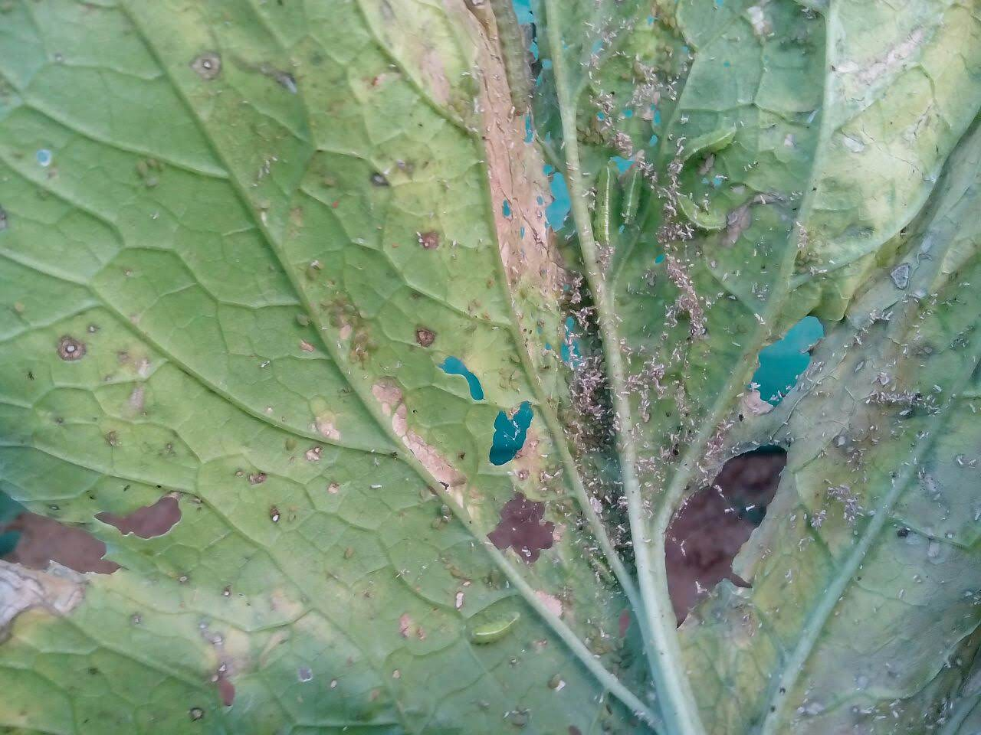 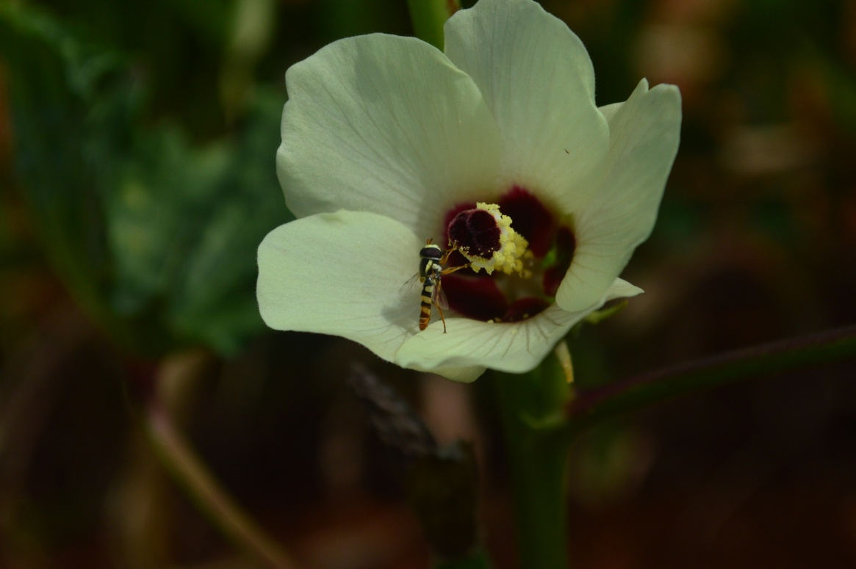

a. Syrphid maggots on mustard b. Syrphid adults pollinating Bhendi flower

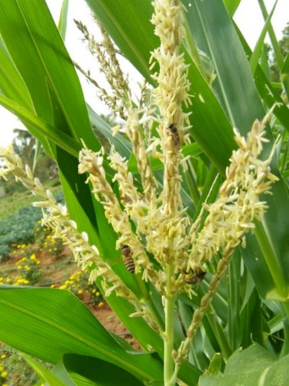 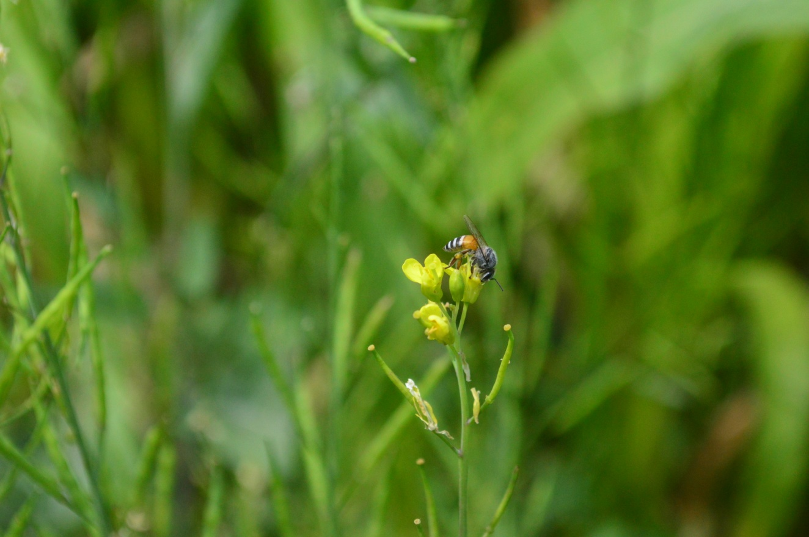 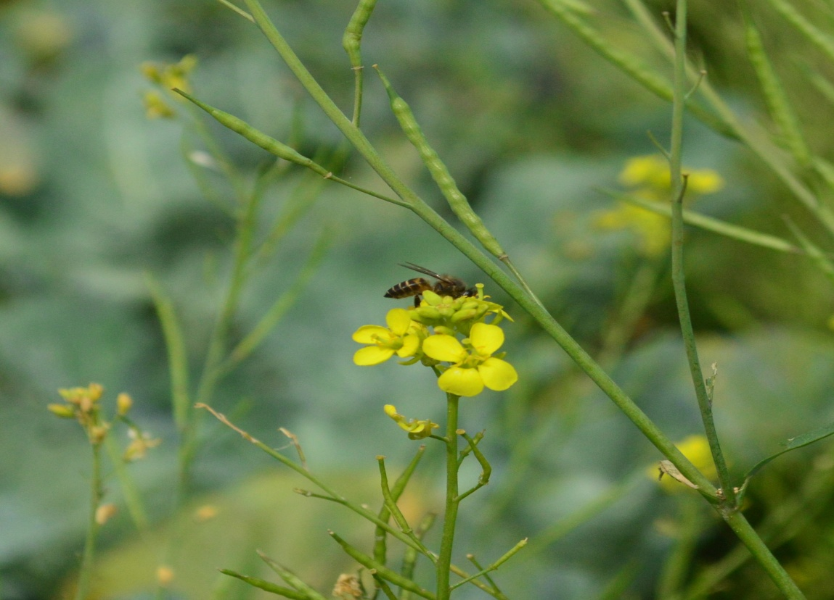

c. Apis cerana on Maize tassel d. *Apis florea* on Mustard e. *Apis cerana* on Mustard

**Fig. 1. Pollinators in Mustard, Bhendi and Maize**

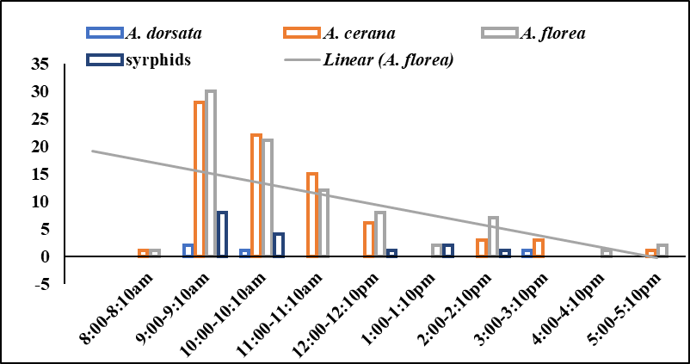

**Fig. 2. Occurrence of pollinators across different time intervals in Mustard**

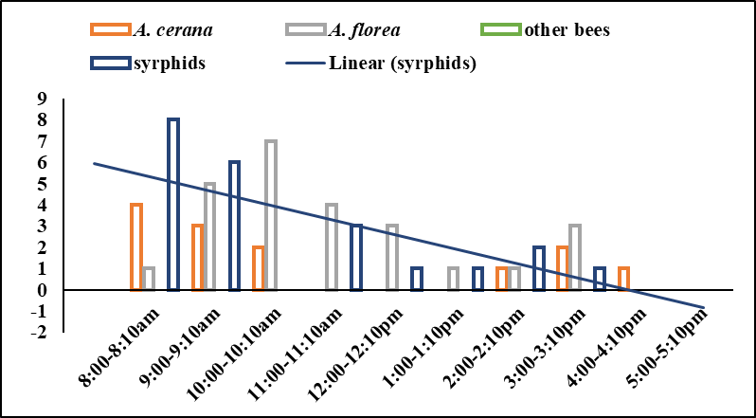

**Fig. 3. Occurrence of pollinators across different time intervals in Bhendi (Okra)**

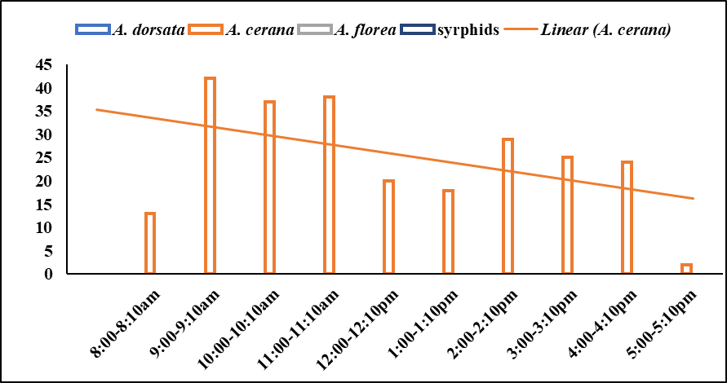

**Fig. 4. Occurrence of pollinators across different time intervals in Maize**