Role of Entomology in the Era of Precision Agriculture: A Review
BALAJI BN^{1*,} SHUDEER¹ AND PAMPAREDDY¹
¹Department of Agricultural Entomology, College of Agriculture, UAS, GKVK, Bengaluru-560065.
*Corresponding author: balajibvn123@gmail.com

ABSTRACT
Precision agriculture (PA) represents a transformative approach to farming by utilizing advanced technologies like GPS remote sensing, and data analytics to optimize crop production and minimize environmental impacts. While technological advancements in PA are well-documented, the role of entomology is often overlooked. This review highlights the critical intersection between entomology and PA, demonstrating how understanding insect behavior, population dynamics, and ecological interactions enhances PA practices. Insects play pivotal roles in pest management, pollination, and ecosystem health, making their study essential for developing effective PA strategies. The review examines how entomological research has informed precision pest management, integrated pest management (IPM) systems, and the use of biological control agents within the PA framework. It discusses how integrating entomological insights with PA technologies, such as remote sensing and sensor networks, enables real-time monitoring and targeted pest control, thus improving crop yields and reducing pesticide use. Additionally, the review addresses challenges such as data integration, technology accessibility, resistance management, and environmental concerns, and highlights prospects including advancements in technology, innovation in monitoring techniques, and the integration of biological control methods. By emphasizing the need for interdisciplinary collaboration, this review underscores the importance of combining entomological knowledge with PA tools to develop more sustainable and efficient agricultural practices. The integration of entomology into PA not only enhances pest management but also contributes to broader goals of environmental sustainability and agricultural resilience. Overall, this review offers a comprehensive overview of how entomology can advance precision agriculture and foster sustainable food production systems.
Keywords: Precision agriculture, Integrated pest management, Challenges, Prospects

Introduction
Precision agriculture (PA) represents a significant shift in how agricultural practices are approached, leveraging advanced technologies to optimize crop production and reduce environmental impact. This modern farming approach involves the use of various tools and techniques such as Global Positioning System (GPS), remote sensing, and data analytics to monitor and manage crops at a micro-level, ensuring that resources like water, fertilizers, and pesticides are applied precisely where and when needed (Mulla, 2013; Bongiovanni and Lowenberg-Deboer, 2004; Gebbers and Adamchuk, 2010). While much of the focus in PA has been on the technological aspects, the role of entomology cannot be overstated.
Insects, both beneficial and harmful, play a crucial role in agricultural ecosystems. Pest management, pollination, and the maintenance of biodiversity are integral components of sustainable farming practices (Landis et al., 2000; Oerke, 2006). Understanding insect behavior, population dynamics, and crop interactions is essential for developing effective PA strategies. By integrating entomological knowledge with PA technologies, farmers can enhance pest control measures, reduce pesticide use, and improve crop yields, leading to more sustainable and profitable agricultural systems (Ge et al., 2016; Koch et al., 2018).
This review article explores the intersection of entomology and precision agriculture, highlighting the contributions of insect science to the advancement of PA practices. Examining how entomological research has informed precision pest management, the use of biological control agents, and the development of integrated pest management (IPM) systems tailored for precision farming (Ehler, 2006; Gullan and Cranston, 2014). The article also discusses the potential challenges and future directions for incorporating entomology into PA, emphasizing the need for interdisciplinary collaboration to fully realize the benefits of this innovative approach to agriculture (Bongiovanni and Lowenberg-Deboer, 2004; Savary et al., 2019).
Entomology in Precision Agriculture
Entomology is integral to the success of precision agriculture, where technology and data are leveraged to enhance agricultural productivity sustainably. The study of insect behavior, population dynamics, and ecological interactions, contributes to pest monitoring using techniques such as pheromone traps and remote sensing with drones, enabling real-time assessments of insect populations across fields (Sishodia et al., 2020). Collaborating with agronomists and data scientists, entomologists can develop decision support systems that integrate insect data with environmental factors, guiding farmers on optimal timing and location for pest control interventions like variable rate application of pesticides. Moreover, entomologists explore biological control methods harnessing natural enemies of pests and advocate for integrated pest management strategies tailored to specific crop and pest complexes, incorporating cultural, biological, and chemical control tactics (Geiger et al., 2010; Barbosa, 1998). Utilizing remote sensing technologies helps to detect early signs of insect damage, enabling proactive management strategies to mitigate crop losses (Eibeck et al., 2024). In essence, entomology in precision agriculture facilitates targeted, sustainable pest management practices that optimize crop yields while minimizing environmental impact (Figure 1).
A. Role of Insects in Agricultural Ecosystems
In agricultural ecosystems, insects fulfill diverse roles, serving as crucial pollinators, natural pest controllers, decomposers, and indicators of ecosystem health (Klein et al., 2007; Cardinale et al., 2012). Beneficial insects such as bees and predatory species contribute to crop pollination, pest regulation, and nutrient cycling, enhancing agricultural productivity and sustainability (Bale et al., 2008; Landis et al., 2000). However, certain insects also pose challenges as pests and disease vectors, causing crop damage and economic losses (Oerke, 2006; Pimentel et al., 2005). Sustainable agricultural practices seek to harness the beneficial aspects of insect biodiversity while mitigating the negative impacts through integrated pest management strategies, conservation efforts, and ecosystem-based approaches, aiming to maintain a balance that supports both agricultural production and environmental health (Gurr et al., 2004).
B. Impact of Insect Pests on Crop Yield and Quality
Insect pests exert significant impacts on crop yield and quality through direct feeding damage, which can hinder photosynthesis, impair plant growth, and reduce biomass accumulation, ultimately leading to decreased yields (Oerke, 2006; Savary et al., 2019). Furthermore, these pests serve as vectors for plant diseases, transmitting pathogens that cause infections such as viral diseases and fungal rots, further compromising crop quality and resulting in market value depreciation (Koch et al., 2018). Additionally, insect-infested crops may suffer from physical deformities, discoloration, and altered flavor profiles, making them less appealing to consumers and processors (Li et al., 2021; Ragsdale et al., 2011). Indirectly, insect pests can facilitate secondary infestations and post-harvest losses, as stored product pests continue to damage crops during storage and transportation, contributing to spoilage and contamination (Phillips and Throne, 2010). Effective pest management strategies, including cultural practices and integrated pest management approaches, are crucial for mitigating these impacts and sustaining agricultural productivity and profitability (Ehler, 2006).
C. Monitoring and Surveillance of Insect Pests Using Precision Agriculture Techniques
Monitoring and surveillance of insect pests using precision agriculture techniques involves the application of advanced technologies and data-driven approaches to track, identify, and manage pest populations in agricultural fields. This process is essential for early detection, timely intervention, and effective pest management strategies. Here's a detailed overview of how precision agriculture techniques are utilized for monitoring and surveillance of insect pests:
1. Remote Sensing Technologies: Precision agriculture relies on remote sensing technologies such as satellites, drones, and aerial imagery to collect high-resolution spatial data over large agricultural areas. These platforms capture multispectral or hyperspectral images that can detect variations in crop health, including stress induced by insect infestations (Mulla, 2013; Eibeck et al., 2024). By analyzing spectral signatures and vegetation indices, agronomists and entomologists can identify areas of the field exhibiting abnormal vegetation patterns, which may indicate pest activity (Sishodia et al., 2020).
2. Sensor Networks: Deploying sensor networks within fields enables real-time monitoring of environmental parameters such as temperature, humidity, and soil moisture, which influence insect behavior and population dynamics (Geiger et al., 2010). Wireless sensor networks equipped with insect traps or pheromone lures can also capture data on insect presence, abundance, and activity levels. These sensor networks provide continuous monitoring capabilities, allowing for early detection of pest outbreaks and timely decision-making regarding pest management interventions (Eibeck et al., 2024; Koch et al., 2018).
3. Geographic Information Systems (GIS): GIS technology is used to integrate spatial data from multiple sources, including remote sensing imagery, sensor networks, and field surveys, into a unified geographic database (Gebbers and Adamchuk, 2010). By overlaying insect population data with other spatial layers such as crop type, soil characteristics, and topography, GIS enables spatial analysis and visualization of pest distribution patterns within agricultural landscapes. This spatial information aids in targeting pest management efforts to specific areas of the field where pest pressure is highest (Sishodia et al., 2020).
4. Data Analytics and Modeling: Advanced data analytics techniques, including machine learning algorithms and predictive modeling, are applied to analyze large volumes of insect population data collected through precision agriculture technologies (Mulla, 2013). These models can forecast pest outbreaks, estimate population growth rates, and assess the efficacy of pest management strategies over time (Eibeck et al., 2024). By integrating historical data with real-time observations, predictive models provide valuable insights into future pest dynamics, allowing farmers to proactively implement preventive measures (Geiger et al., 2010).
5. Decision Support Systems (DSS): DSS software platforms integrate data from monitoring and surveillance efforts with agronomic knowledge and management guidelines to generate actionable recommendations for farmers. These systems consider factors such as pest thresholds, economic injury levels, and environmental conditions to suggest optimal timing and methods for pest control interventions. DSS also facilitates communication between farmers, agronomists, and pest management professionals, ensuring coordinated and informed decision-making (Geiger et al., 2010; Eibeck et al., 2024).
6. Collaborative Networks and Information Sharing: Precision agriculture facilitates collaboration among stakeholders, including farmers, researchers, extension agents, and pest management professionals, through online platforms and mobile applications. These collaborative networks enable real-time information sharing, pest alerts, and best practices dissemination, fostering a collective approach to pest monitoring and management. By leveraging collective intelligence and crowd-sourced data, stakeholders can collectively address pest challenges more effectively and sustainably.
D. Integrated Pest Management (IPM) Approaches in Precision Agriculture
Integrated Pest Management (IPM) approaches in precision agriculture combine various strategies and technologies to effectively manage pest populations while minimizing negative impacts on the environment, human health, and non-target organisms. Recent studies emphasize the role of precision agriculture in enhancing IPM strategies (Iost Filho et al., 2020; Kebe et al., 2023). IPM can be implemented within the framework of precision agriculture with the following components:
1. Pest Monitoring and Surveillance: Precision agriculture techniques, such as remote sensing, sensor networks, and GPS-guided mapping, are used to monitor and surveil pest populations in real-time (Sishodia et al., 2020; Zhang et al., 2022). By collecting data on pest abundance, distribution, and activity levels, farmers can accurately assess pest pressures and make informed decisions about pest management strategies.
2. Threshold-Based Decision Making: IPM in precision agriculture relies on establishing pest population thresholds, which are predetermined levels of pest abundance at which action should be taken to prevent economic damage to crops (Iost Filho et al., 2020). Precision monitoring enables farmers to detect pest outbreaks early and implement control measures promptly when pest populations exceed threshold levels, reducing the need for broad-spectrum pesticide applications.
3. Biological Control: Precision agriculture incorporates biological control methods, such as the release of natural enemies like predators, parasitoids, and microbial agents, to suppress pest populations (Kebe et al., 2023). Beneficial organisms are strategically deployed based on pest dynamics and field conditions, maximizing their effectiveness while minimizing disruption to natural ecosystems.
4. Cultural and Mechanical Controls: IPM practices in precision agriculture emphasize cultural and mechanical controls to manage pests through non-chemical means (Sishodia et al., 2020). Crop rotation, planting resistant varieties, using trap crops, and employing physical barriers or mechanical devices are examples of strategies employed to disrupt pest lifecycles and reduce pest pressures.
5. Chemical Control with Precision Application: While chemical pesticides are used as a last resort in IPM, precision agriculture techniques enable targeted and judicious application of pesticides only when necessary (Zhang et al., 2022). Variable rate application (VRA) systems, GPS-guided sprayers, and aerial drones equipped with precision spraying technologies allow farmers to apply pesticides only to areas of the field where pest pressures exceed threshold levels, minimizing chemical usage and reducing environmental impacts.
6. Information and Decision Support Systems: IPM in precision agriculture is supported by decision support systems (DSS) and data analytics platforms that integrate pest monitoring data with environmental parameters, crop growth stages, and economic thresholds (Iost Filho et al., 2020). These systems provide farmers with timely recommendations on pest management strategies tailored to specific field conditions, optimizing the effectiveness of pest control efforts.
7. Continuous Monitoring and Adaptive Management: IPM in precision agriculture is a dynamic process that involves continuous monitoring of pest populations and adaptation of management strategies based on changing environmental conditions and pest dynamics (Kebe et al., 2023). Farmers can respond proactively to emerging pest threats and optimize pest control practices over time by employing adaptive management approaches.
E. Use of Drones, Sensors, and GIS Technology for Insect Pest Management
The use of drones, sensors, and GIS (Geographic Information System) technology for insect pest management represents a cutting-edge approach to addressing pest challenges in agriculture.
1. Drones: Drones, also known as unmanned aerial vehicles (UAVs), are small, remotely operated aircraft equipped with cameras, sensors, and GPS technology. In insect pest management, drones capture high-resolution aerial imagery of agricultural fields (Sishodia et al., 2020). These images provide valuable insights into crop health, pest infestations, and field conditions. Drones can fly over large areas quickly and efficiently, allowing farmers and agronomists to monitor insect populations and identify pest hotspots with precision. By providing real-time aerial views of fields, drones facilitate early detection of pest outbreaks, enabling timely intervention and targeted pest management strategies.
2. Sensors: Sensors play a crucial role in collecting data on environmental parameters such as temperature, humidity, soil moisture, and pest activity (Zhang et al., 2022). Insect traps equipped with sensors can detect the presence of specific pests based on their behavior, such as pheromone emissions or movement patterns. These sensors provide continuous monitoring capabilities, allowing farmers to track pest populations in real time and assess the effectiveness of pest management interventions.
3. GIS Technology: GIS technology enables the integration, analysis, and visualization of spatial data related to insect pest management (Iost Filho et al., 2020). Geographic Information Systems (GIS) software allows users to overlay and analyze multiple layers of spatial information, including aerial imagery, field boundaries, soil types, and pest distribution maps. By mapping insect populations and their spatial distribution within agricultural landscapes, GIS technology helps farmers and agronomists identify areas of high pest pressure and prioritize pest management efforts.
F. Challenges and Future Prospects of Entomology in Precision Agriculture
Entomology in precision agriculture faces several challenges and holds promising prospects as technology advances and agricultural practices evolve (Figure 2).
Challenges
1. Data Integration and Interpretation: One of the primary challenges in entomology within precision agriculture is the integration and interpretation of vast amounts of data collected from various sources (Sishodia et al., 2020). Effective utilization of these data requires advanced analytical tools and interdisciplinary collaboration among entomologists, agronomists, data scientists, and engineers.
2. Technology Accessibility and Affordability: Despite rapid advancements in technology, accessibility and affordability remain barriers to the widespread adoption of precision agriculture tools and techniques (Kebe et al., 2023). Ensuring equitable access to these technologies and providing training and support to farmers and agricultural professionals is essential for maximizing their benefits.
3. Resistance Management: The development of insecticide resistance poses a significant challenge to pest management in precision agriculture (Zhang et al., 2022). Over-reliance on chemical pesticides can lead to the emergence of resistant pest populations, reducing the efficacy of control measures and increasing production costs.
4. Environmental Concerns: While precision agriculture offers opportunities for more targeted and sustainable pest management, there are environmental concerns associated with its implementation (Iost Filho et al., 2020). These include potential impacts on non-target organisms, soil health, water quality, and biodiversity.
5. Knowledge Gaps and Research Needs: Entomology in precision agriculture is a rapidly evolving field, and there are still many knowledge gaps and research need to be addressed (Sishodia et al., 2020). This includes understanding insect behavior, ecology, and interactions within agricultural ecosystems.
Future Prospects
1. Advancements in Technology: The future of entomology in precision agriculture is closely linked to advancements in technology, including sensors, drones, artificial intelligence, and machine learning (Kebe et al., 2023). These technologies will continue to improve data collection, analysis, and decision-making processes.
2. Integration of Biological Control: As concerns over pesticide use and environmental sustainability grow, there is increasing interest in the integration of biological control methods into precision agriculture systems (Zhang et al., 2022).
3. Innovation in Monitoring and Surveillance: The development of novel monitoring and surveillance techniques, such as automated insect traps, molecular diagnostics, and remote sensing technologies, holds promise for improving early pest detection and intervention (Sishodia et al., 2020).
4. Data-driven Decision Support Systems: The future of entomology in precision agriculture lies in the continued development and implementation of data-driven decision support systems (DSS) (Iost Filho et al., 2020).
5. Sustainability and Resilience: Sustainable pest management practices that prioritize environmental stewardship, biodiversity conservation, and resilience to climate change will be central to the future of entomology in precision agriculture (Kebe et al., 2023).
CONCLUSION
While challenges such as knowledge gaps, technological barriers, and socio-economic constraints may hinder the implementation of integrated approaches in agriculture, there are ample opportunities for progress and innovation. Interdisciplinary collaboration, innovative research, stakeholder engagement, and supportive policies can help overcome these challenges and harness the full potential of integrated approaches to address complex agricultural problems and promote sustainable food production systems. Entomology in precision agriculture faces challenges, including data integration, technology accessibility, resistance management, environmental concerns, and knowledge gaps, it also holds promising prospects driven by advancements in technology, integration of biological control, innovation in monitoring and surveillance, data-driven decision support systems, and a focus on sustainability and resilience. By addressing these challenges and capitalizing on future opportunities, entomologists can play a vital role in shaping the future of agriculture toward more sustainable and resilient food systems. Overall, monitoring and surveillance of insect pests using precision agriculture techniques empower farmers and stakeholders with timely, data-driven insights to make informed decisions and manage pest pressures more effectively. By integrating cutting-edge technologies with traditional pest management practices, precision agriculture contributes to sustainable agriculture by reducing pesticide use, minimizing crop losses, and optimizing resource allocation in pest management efforts.
REFERENCES
Bale, J. S., Van Lenteren, J. C. and Bigler, F. 2008. Biological control and sustainable food production. Philos. Trans. R. Soc. B, Biol. Sci., 363(1492): 761-776.
Barbosa, P. A. 1998. Conservation biological control. Elsevier.
Bongiovanni, R. and Lowenberg-DeBoer, J. 2004. Precision agriculture and sustainability. Precis. Agric., 5: 359-387.
Cardinale, B. J., Duffy, J. E., Gonzalez, A., Hooper, D. U., Perrings, C., Venail, P., Narwani, A., Mace, G. M., Tilman, D., Wardle, D. A. and Kinzig, A. P. 2012. Biodiversity loss and its impact on humanity. Nature, 486(7401): 59-67.
Ehler, L. E., 2006. Integrated pest management (IPM): definition, historical development and implementation, and the other IPM. Pest Manag. Sci., 62(9): 787-789.
Eibeck, A., Shaocong, Z., Mei Qi, L. and Kraft, M. 2024. Research data supporting" A Simple and Efficient Approach to Unsupervised Instance Matching and its Application to Linked Data of Power Plants".
Ge, Y., Bai, G., Stoerger, V. and Schnable, J. C. 2016. Temporal dynamics of maize plant growth, water use, and leaf water content using automated high throughput RGB and hyperspectral imaging. Comput. Electron. Agric., 127: 625-632.
Gebbers, R. and Adamchuk, V. I. 2010. Precision agriculture and food security. Science, 327(5967): 828-831.
Geiger, F., Bengtsson, J., Berendse, F., Weisser, W. W., Emmerson, M., Morales, M. B., Ceryngier, P., Liira, J., Tscharntke, T., Winqvist, C. and Eggers, S. 2010. Persistent negative effects of pesticides on biodiversity and biological control potential on European farmland. Basic and Appl. Ecol., 11(2): 97-105.
Gullan, P. J. and Cranston, P. S. 2014. The insects: an outline of entomology. John Wiley and Sons.
Gurr, G., Wratten, S. D. and Altieri, M. A. eds. 2004. Ecological engineering for pest management: advances in habitat manipulation for arthropods. CSIRO publishing.
Iost Filho, F. H., Heldens, W. B., Kong, Z. and de Lange, E. S. 2020. Drones: innovative technology for use in precision pest management. J. Econ. Entomol., 113(1): 1-25.
Kebe, A. A., Hameed, S., Farooq, M. S., Sufyan, A., Malook, M. B., Awais, S., Riaz, M., Waseem, M., Amjad, U. and Abbas, N. 2023. Enhancing Crop Protection and Yield through Precision Agriculture and Integrated Pest Management: A Comprehensive Review. Asian J. Crop Sci., 8(4): 443-453.
Klein, A. M., Vaissière, B. E., Cane, J. H., Steffan-Dewenter, I., Cunningham, S. A., Kremen, C. and Tscharntke, T. 2007. Importance of pollinators in changing landscapes for world crops. Proc. R. Soc. B: Biol. Sci., 274(1608): 303-313.
Koch, R. L., Hodgson, E. W., Knodel, J. J., Varenhorst, A. J. and Potter, B. D. 2018. Management of insecticide-resistant soybean aphids in the Upper Midwest of the United States. J. Integr. Pest Manag., 9(1): 23.
Landis, D. A., Wratten, S. D. and Gurr, G. M. 2000. Habitat management to conserve natural enemies of arthropod pests in agriculture. Annu. Rev. Entomol., 45(1): 175-201.
Li, N., Yao, N., Li, Y., Chen, J., Liu, D., Biswas, A., Li, L., Wang, T. and Chen, X. 2021. A meta-analysis of the possible impact of climate change on global cotton yield based on crop simulation approaches. Agric. Syst., 193: 103221.
Losey, J. E. and Vaughan, M. 2006. The economic value of ecological services provided by insects. Biosci., 56(4): 311-323.
Matthews, R. E. F. and Hull, R. 2002. Matthews' plant virology. Gulf professional publishing.
Mulla, D. J. 2013. Twenty five years of remote sensing in precision agriculture: Key advances and remaining knowledge gaps. Biosyst. Eng., 114(4): 358-371.
Oerke, E. C. 2006. Crop losses to pests. The Journal of agricultural science, 144(1): 31-43.
Phillips, T. W. and Throne, J. E. 2010. Biorational approaches to managing stored-product insects. Annu. Rev. Entomol., 55(1): 375-397.
Pimentel, D., Zuniga, R. and Morrison, D. 2005. Update on the environmental and economic costs associated with alien-invasive species in the United States. Ecological economics, 52(3): 273-288.
Ragsdale, D. W., Landis, D. A., Brodeur, J., Heimpel, G. E. and Desneux, N. 2011. Ecology and management of the soybean aphid in North America. Annu. Rev. Entomol., 56(1): 375-399.
Savary, S., Willocquet, L., Pethybridge, S. J., Esker, P., McRoberts, N. and Nelson, A. 2019. The global burden of pathogens and pests on major food crops. Nat. Ecol. Evol., 3(3): 430-439.
Sishodia, R. P., Ray, R. L. and Singh, S. K. 2020. Applications of remote sensing in precision agriculture: A review. Remote sens., 12(19): 3136.
Zhang, T., Bi, Y., Hao, F., Du, J., Zhu, X. and Gao, X. 2022. Transformer attention network and unmanned aerial vehicle hyperspectral remote sensing for grassland rodent pest monitoring research. J. Appl. Remote Sens., 16(4): 044525-044525.

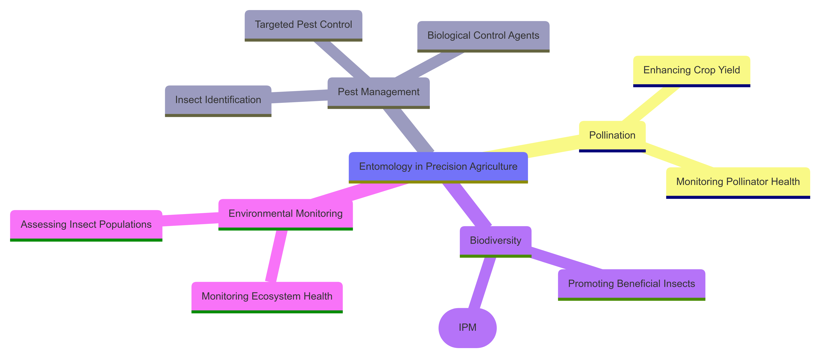
Figure 1. Role of Entomology in Precision Agriculture
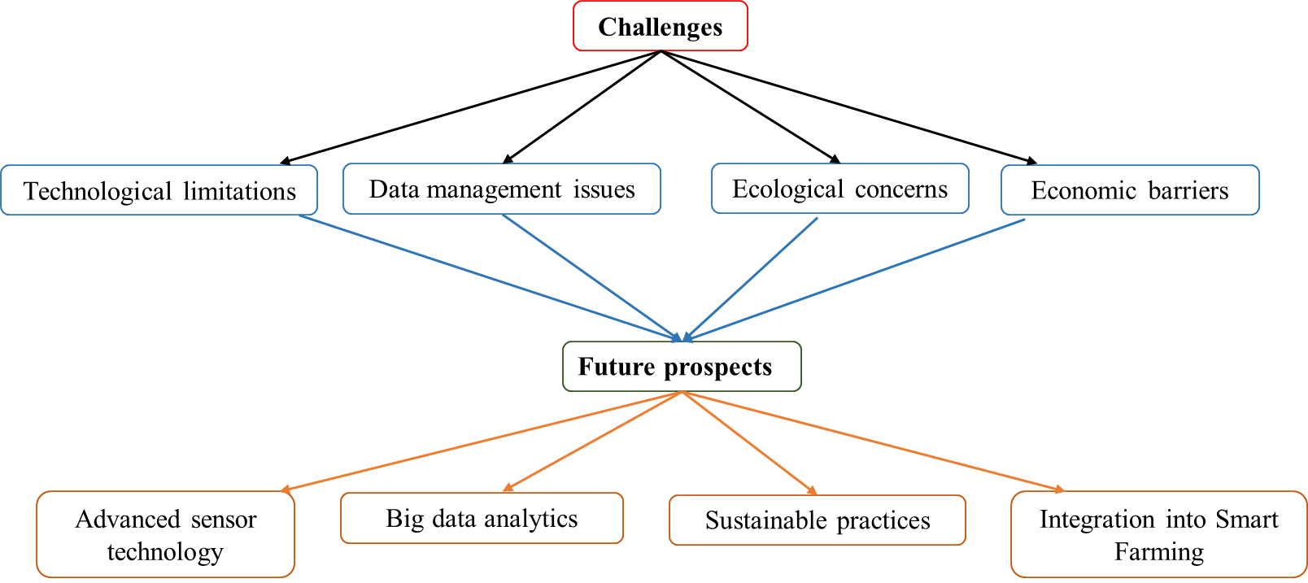
Figure 2. Challenges and Future Prospects of Entomology in Precision Agriculture

