Cover letter
Blossom Harmony: Investigating Peak Pollinator Visitation Patterns in Mustard, Bhendi and Maize Crops

To,
The Editor
Madras Agricultural Journal
10/01/2024
Dear Editor-in-Chief
We would like to submit the manuscript entitled “Blossom Harmony: Investigating Peak Pollinator Visitation Patterns in Mustard, Bhendi and Maize Crops” by BALAJI BN, SUMITHRAMMA N, MANJUNATHA R AND VIDYAMULIMANI to be considered for publication as an original article in the Madras Agricultural Journal. We believe our findings will be of interest to the readers of your journal. Also, we declare that this manuscript is original and has not been published before elsewhere. We know of no conflicts of interest associated with this publication. As the corresponding author, I confirm that the manuscript has been read and approved for submission by all the named authors.
Kindly contact me at the following address for any future correspondence
Corresponding author
BALAJI B N
Ph.D. Scholar, Dept. of Entomology, UAS, GKVK, Bengaluru
E-mail – balajibvn123@gmail.com
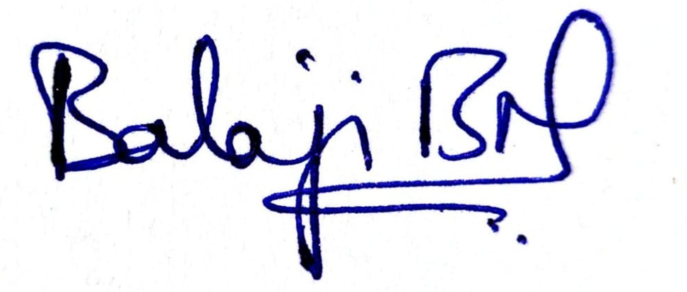
Second author – SUMITHRAMMA N
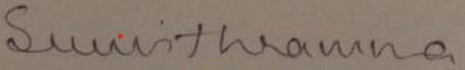
Third author – MANJUNATHA R Fourth author - VIDYAMULIMANI
