RESEARCH ARTICLE
Effect of different cropping systems on productivity and soil fertility of Western Zone of Tamil Nadu
Sangeetha S.P.^{1*}, Renukadevi A² and Varshini S.V¹
¹Department of Agronomy, Tamil Nadu Agricultural University, Coimbatore-641 003, Tamil Nadu, India
²Department of Soil Science and Agricultural Chemistry, Tamil Nadu Agricultural University, Coimbatore - 641 003, Tamil Nadu, India
Corresponding author mail id: sangeetha.sp@tnau.ac.in

ABSTRACT
A field experiment was conducted at the Department of Agronomy, Tamil Nadu Agricultural University, Coimbatore to study the effect of different cropping systems on productivity and soil fertility. The results of the experiment indicated that among the food crops, maize - chillies - radish cropping system registered highest total maize equivalent yield of 26.75 t ha⁻¹ yr⁻¹ followed by onion - cotton - maize cropping system (26.39 t ha⁻¹ yr⁻¹). Vegetable included cropping systems were recorded higher productivity. The increased soil available nitrogen and phosphorus was registered in maize - bengalgram - cowpea and soil available potassium was higher in perennial fodder system bajra napier hybrid and desmanthus (4:2). At the end of cropping system cycle, higher soil organic carbon was recorded in fodder maize + fodder cowpea (5.46 g kg⁻¹) and maize - bengalgram - cowpea (5.45 g kg⁻¹) systems. Soil pH and EC showed non significant difference.
Keywords: Cropping system; Productivity; Nutrient uptake; Soil available nutrients.

INTRODUCTION
Increasing food production to meet growing demands is a major global challenge, particularly in the population-dense and impoverished South Asia where smallholder agriculture predominates. Crop rotation is meant to boost agricultural output, however concerns about the ecological impact of intensive farming practices have grown (Fargione et al., 2018). Soil health management is a prime concern to ensure agricultural sustainability. Dwindling soil fertility as well as declining soil health is one of the great challenges of the present time to feed the world population. Cropping patterns can have an impact on soil quality depending on the crop species and management techniques employed in the rotation. The fertility of the soil is influenced by crop production techniques that include conservation agriculture, mixed cropping, strip cropping, and related agricultural activities (Vukicevich et al., 2016). In agriculture, soil fertility is crucial and can be affected or preserved by different crop rotations, fertiliser applications and irrigation techniques. The pH, electrical conductivity (EC), organic carbon, N, P₂O₅, K₂O, and other chemical properties of the soil were changed based on the quality of the soil. This allowed the soil to supply the necessary amount of fertilisers, and appropriate cropping patterns and sequences had a positive effect on the soil's health and quality, which helps to provide essential nutrients for crop production (Hari et al., 2022). In Tamil Nadu, maize, cotton, and rice are the main crops that are either cultivated solely or in rotation with other crops. Since all of these crops are exhausting and non-leguminous by nature, prolonged cultivation of them could quickly deteriorate the soil. Hence, in order to maintain soil fertility by including a legume component into current cropping systems, a significant priority for agricultural research is required. Adoption of suitable cropping system is essential for ensuring the most rational use of land, increasing productivity per unit area per unit time and improving soil fertility. Any crop's ability to absorb nutrients depends on both the application of external sources and the availability of nutrients in the soil. During the growing season, nutrients are consumed in accordance to the demand for them, which is indicated by the increasing biomass of crops. Hence to evolve best cropping system with new introduced crops for the zone of recent released short duration high yielding varieties and nutrient addition to the soil for better soil health are to be evaluated. In this context, a research has been conducted to study the productivity, nutrient uptake and soil fertility status of different crops grown in Western zone of Tamil Nadu under cropping systems appropriate for various agricultural system models.
MATERIALS AND METHODS
Field experiment was carried out in the Eastern Block farm of Tamil Nadu Agricultural University, Coimbatore during 2019 to 2020 to study the different cropping systems on productivity, soil fertility and nutrient uptake of crops. The experimental location is Western Zone of Tamil Nadu at 10°12’ and 11°24’ N latitude and between 76°39’ and 77°30’ E longitude and at an a altitude of 427m above Mean Sea Level. The average annual rainfall of the area was 695.8 mm and maximum and minimum temperature ranged between 27.8°C to 35.2°C and 20.4°C to 32.1°C respectively during the crop growth period. The soil has montmorrillionitic type of clay. The soil reaction is alkaline and has low to medium soluble salt content. With regard to available nutrient status, the experimental soils are low in available nitrogen, medium in available phosphorus and high in available potassium. The initial soil samples were collected and analysed for its nutrient content. The soil characteristics analysed are pH of 8.30, Electrical conductivity of 0.63 dS m⁻¹, soil organic carbon of 5.90 g kg⁻¹, available nitrogen of 244 kg ha⁻¹, available phosphorus of 27.3 kg ha⁻¹, available potassium of 545 kg ha⁻¹. The experiment was laid out with ten cropping systems as treatments in Randomized Block Design (RBD) with three replications. The ten combinations of cropping sequence tested were T₁: sorghum - cotton - ragi, T₂: onion - cotton - maize, T₃: maize - bengal gram - cowpea (grain), T₄: sorghum - horse gram - groundnut, T₅: gingelly - bengal gram - ragi, T₆: prosomillet - cowpea (G) - sunflower, T₇: fodder maize + fodder cowpea, T₈: bajra napier grass + desmanthus, T₉: beet root - cotton - maize and T₁₀: maize - chillies - radish during kharif, rabi and summer seasons respectively.
All the crops in different cropping systems were raised in accordance with recommended package of practices. Crop sequences during rabi and summer were taken up as and when the preceding kharif and rabi crops were harvested in the respective plots. For comparison of different crop sequences, the yields of all the crops were converted in to maize grain equivalent yield on price basis. Crop yields were recorded at the end of each season and maize equivalent yield (MEY) was computed at the end of the cropping system cycle. Soil samples collected from a depth of 0–15 cm after the harvest of various crops during kharif, rabi and summer were used for determination of various chemical parameters. The processed soil samples were analysed for available nitrogen, phosphorus, and potassium by adopting standard procedures. The statistical analysis wherever the results were significant, the critical difference at 5 % level of significance was worked out as given by Gomez and Gomez (1984).
RESULTS AND DISCUSSION
Productivity (Maize Equivalent Yield)
The various cropping systems were significantly influenced the productivity of the cropping systems (Table 1). During kharif season, higher economical yield of 19119 kg ha⁻¹ was recorded in beetroot followed by onion (10135 kg ha⁻¹) and the lower economical yield of 765 kg ha⁻¹ was recorded with gingelly. In rabi season, chillies recorded 8780 kg ha⁻¹ of economical yield followed by cotton with 1875 kg ha⁻¹ and the lower economical yield was noticed in bengalgram (791 kg ha⁻¹). A proper and efficient vegetable based cropping system allows for year-round production and additional revenue can successfully solve the issue of guaranteeing nutritional security for consumers and growers alike (Arti et al., 2019). However, during summer, radish recorded maximum economical yield of 16038 kg ha⁻¹ followed by maize (5560 kg ha⁻¹) and the lower economical yield was found in cowpea (1175 kg ha⁻¹). In all the seasons, perennial forage crops with bajra napier hybrid grass along with desmanthus have registered higher economical yields (328219 kg ha⁻¹ and 24574 kg ha⁻¹ respectively) indicating the profitable nature than annual fodder crops. Total maize equivalent yield was significantly influenced by various cropping systems. Among the food crops, maize - chillies - radish cropping system registered highest total maize equivalent yield of 26.75 t ha⁻¹ yr⁻¹ followed by onion - cotton - maize cropping system that produced highest total maize equivalent yield of 26.39 t ha⁻¹ yr⁻¹ (Table 1). Multiple cropping systems including legume and vegetable have unique benefits and reduce the risk of low income for small and marginal farmers as reported by Sharma and Behera (2009) and Rana et al. (2011). Katyal et al. (2002) revealed that inclusion of vegetables in the system distinctly gave better yields in terms of wheat equivalent yield and productivity. Tripathi and Singh (2008) reported that diversification of rice-wheat cropping sequences particularly with vegetables gave highest rice equivalent yield.
Soil fertility
Different cropping systems had significant influence on soil available nutrient status (Fig. 1, 2 & 3). During kharif and rabi season significantly higher soil available nitrogen (236 kg ha⁻¹ and 258 kg ha⁻¹) was recorded with maize - bengal gram - cowpea followed by bajra napier hybrid and desmanthus. In summer season, higher soil available nitrogen of 252 kg ha⁻¹ was recorded in bajra napier hybrid and desmanthus. This is mainly because of inclusion of N fixing legume crop such as cowpea in the cropping system. Similarly Crews and Peoples (2004) found that crop rotation with legume crops significantly increased the overall soil fertility through atmospheric nitrogen fixation. These findings were further supported by Dong et al. (2018) who revealed that maize legume intercropping system improved the soil available nitrogen due to interspecific facilitation by processes of N₂ fixation, N transfer and increased resource availability. Similar findings were observed by Dahmardeh et al. (2010) and Bama et al. (2020). On contrast lower soil available nitrogen, phosphorus and potassium was observed with gingelly - bengal gram - ragi. During kharif, rabi and summer season, significantly higher soil available phosphorus of 21.3 kg ha⁻¹, 20.6 kg ha⁻¹ and 21.1 kg ha⁻¹ respectively was received in maize - bengal gram - cowpea cropping system. This might be due to excreting organic acids solubilize unavailable form of phosphate by releasing phosphatase enzymes to hydrolyze organic P compound thus improved the soil available phosphorus (George et al., 2011 and Richardson et al., 2011). The phosphorus solubilizing bacteria which is present in the rhizospheric zone also enhances the soil available phosphorus (Meena et al., 2018). With regard to soil available potassium, bajra napier hybrid and desmanthus (4:2) recorded higher value of 692 kg ha⁻¹, 688 kg ha⁻¹ and 650 kg ha⁻¹ in kharif, rabi and summer season respectively. This might be due to contributions from the decomposition of plant residues and direct addition of potassium to the soil available pool. The similar result was given by Prasad et al. (2010).
At the end of the cropping system, soil physio chemical properties such as pH, EC showed non significant difference but soil organic carbon had significant difference (Fig 4). Higher soil organic carbon of 5.46 g kg⁻¹ was recorded with fodder maize + fodder cowpea and which was on par with maize – bengalgram - cowpea (5.45 g kg⁻¹). Leguminous crops such as cowpea produce higher biomass thus improved the soil organic carbon through which soil microbial population enhanced with increased soil health (Hauggaard-Nielsen et al., 2007). Further, Lemke et al. (2007) revealed that, adding legume crop in the cropping sequences increased carbon and humus contents thus improved the microbial population which further enhanced the soil organic carbon stocks in the soil. This result was in agreement with the findings of Lithourgidis et al. (2011).
CONCLUSION
It is concluded from the study that, vegetable based cropping system maize - chillies - radish registered highest total maize equivalent yield. Soil fertility was improved in maize - bengalgram - cowpea and leguminuos fodder systems. Therfore, inclusion of vegetables and legume crops in cropping system improves the productivity and soil fertility.
Funding and Acknowledgment
The authors are extremely thankful to All India Coordinated Research Project (AICRP on IFS) , Indian Council of Agricultural Research with financial help and technical guidance to carry out this research work at Tamil Nadu Agricultural University, Coimbatore.
Ethics statement
No specific permits were required for the described field experiment studies because no human or animal subjects were involved in this research.
Originality and plagiarism
This is original research work and any work and/ or words of others, has been appropriately cited
Consent for publication
All the authors agreed to publish the content.
Competing interests
There were no conflict of interest in the publication of this content
Data availability
All the data of this manuscript are included in the MS. No separate external data source is required.
Author contributions

Idea conceptualization- RC, RN, TS Experiments- TS, Guidance –RC, NR, Writing original draft - TS, Writing- reviewing &editing - TS, VP,

REFERENCES
Arti, B. E., Jha, K. K., Lily, M. and M. Kispotta. 2019. Identification of suitable vegetable based cropping sequences in relation to economic yield and profitability J. pharmacogn. phytochem., SP5: 37-41.
Bama, K. S., Karthikeyan, P. and A. Ramalakhsmi. 2020. Continuous cultivation of fodder maize and its impact on soil fertility and economics in western zone of tamil nadu. Forage Res., 45 (4): 318-322.
Crews, T. and M. Peoples. 2004. Legume versus fertilizer sources of nitrogen: ecological tradeoffs and human needs.Agric. Ecosyst. Environ., 102(3): 279-297.
Dahmardeh, M., Ghanbari, A., Syahsar, B. A. and M. Ramrodi, 2010. The role of intercropping maize (Zea mays L.) and cowpea (Vigna unguiculata L.) on yield and soil chemical properties. Afr. J. Agric. Res., 5(8): 631-636.
Dong, N., Tang, M., Zhang, W., Bao, X., Wang, Y. and P. Christie. 2018. Temporal differentiation of crop growth as one of the drivers of intercropping yield advantage. Sci. Rep., 8: 3110.
Fargione, J. E., Bassett, S., Boucher, T.. Bridgham, S. D., Conant, R. T. and S.C. Cook-Patton. 2018. Natural climate solutions for the United States. Sci. Adv.. 4(11):1869.
George, T. S., Fransson, A. M., Hammond, J. P. and P. J. White. 2011. Phosphorus nutrition: rhizosphere processes, plant response and adaptation. In: Bünemann EK, Oberson A, Frossard E (eds) Phosphorus in action. Soil Biol., 26: 245–274.
Gomez, K. A. and A. A. Gomez. 1984. Analysis of data from a series of experiments. Statistical Procedures for Agricultural Research. 2nd ed. New York: J. Wiley, 316-356.
Hari, S. R., Pallerla Vishnu, Y. R., Yasasvi, B. and M. C. Nitin. 2022. Effect on soil fertility under different cropping sequences, irrigation levels and fertilizer doses: A review. J. Pharm. Innov., 11(5): 2189-2193.
Hauggaard-Nielsen, H., Jornsgaard, B., Kinane, J., Jensen. E. S. 2007. Grain legume–cereal intercropping: the practical application of diversity, competition and facilitation in arable and organic cropping systems. Renew. Agric. Food Syst., 23: 3-12.
Katyal, V., Gangwar, B. and A. L. Bhandari. 2002. Productivity and yield stability of crop sequences in Haryana and Punjab. Ind. J of Agril. Sci., 72: 260-262.
Lemke, R. L., Zhonga, Z., Campbell, A. C. and R. Zentner. 2007. Can pulse crops play a role in mitigating greenhouse gases from north American agriculture. Agron. J., 99(6): 1719-1725.
Lithourgidis, A. S., Dordas, C. A., Damalas, C. A. and D. N. Vlachostergios, 2011. Annual intercrops: an alternative pathway for sustainable agriculture. Aust. J. Crop Sci., 5: 396-410.
Meena, R. S., Vijayakumar, V. G., Yadav, S. and T. Mitran. 2018. Response and interaction of Bradyrhizobium japonicum and arbuscular mycorrhizal fungi in the soybean rhizosphere. Plant Growth Regul., 84: 207–223.
Prasad, J., Karmakar, S., Kumar, R., Mishra, B. 2010. Influence of integrated nutrient management on yield and soil properties in maize-wheat cropping system in an Alfisol of Jharkhand. Journal of the Indian Society of Soil Science., 58(2): 200-204.
Rana, S. S., Sharma, H. L. Subehia, S. K. Negi, S. C. and S. K. Sharma. 2011. Promising cropping systems for mid hill agro climatic conditions of Himachal Pradesh. Himachal J. Agric. Res., 37(2): 138-148.
Richardson, A. E., Lynch, J. P., Ryan, P. R., Delhaize, E., Smith, F. A., Smith, S. E., Harvey, P. R., Ryan, M. H., Veneklaas, E. J., Lambers, H., Oberson, A., Culvenor, R. A. and R. J. Simpson. 2011. Plant and microbial strategies to improve the phosphorus efficiency of agriculture. Plant Soil., 349: 121–156.
Sharma, A. R., and U. K. Behera. 2009. Recycling of legume residues for nitrogen economy and higher productivity in maize-wheat cropping system. Nutr. Cycl. Agroecosystems., 83(3): 197-210.
Tripathi, S. C. and R. P. Singh, 2008. Effect of crop diversification on productivity and profitability of rice (Oryza sativa)- Wheat (Triticum aestivum) cropping system. Ind. J of Agron., 53: 27-31.
Vukicevich, E., Lowery, T., Bowen, P., Úrbez-Torres, J. R. and M. Hart. 2016. Cover crops to increase soil microbial diversity and mitigate the decline in perennial agriculture. A review. Agron. Sustain. Dev., 36(3): 1-14.
Table 1. Yield and Maize Equivalent Yield (MEY) of crops in different cropping Systems
Treatment | Crop sequence | Yield (kg ha⁻¹) |  |  | Total MEY  (t ha⁻¹ yr⁻¹)
Treatment | Crop sequence | Kharif | Rabi | Summer | Total MEY  (t ha⁻¹ yr⁻¹)
T₁ | Sorghum - Cotton - Ragi | 2911 | 1793 | 2151 | 11.52
T₂ | Onion - Cotton - Maize | 10135 | 1875 | 5560 | 26.39
T₃ | Maize - Bengal gram - Cowpea | 5920 | 791 | 1175 | 11.42
T₄ | Sorghum - Horse gram - Groundnut | 2866 | 826 | 1549 | 8.34
T₅ | Gingelly - Bengal gram - Ragi | 765 | 916 | 2044 | 7.84
T₆ | Prosomillet - Cowpea (G) - Sunflower | 1973 | 1040 | 1545 | 9.38
T₇ | Fodder maize + Fodder cowpea (6:2) (twice) | 45884  +  14155 | 17160  +  8527 | 14920  +  7438 | 11.56
T₈ | BN hybrid and Desmanthus (4:2) | 328219 + 24574 |  |  | 27.69
T₉ | Beet root - Cotton - Maize | 19119 | 1758 | 5411 | 25.02
T₁₀ | Maize - Chillies - Radish | 5940 | 8780 | 16038 | 26.75
 |  |  |  | SEd | 1.30
 |  |  |  | CD (P=0.05) | 2.72

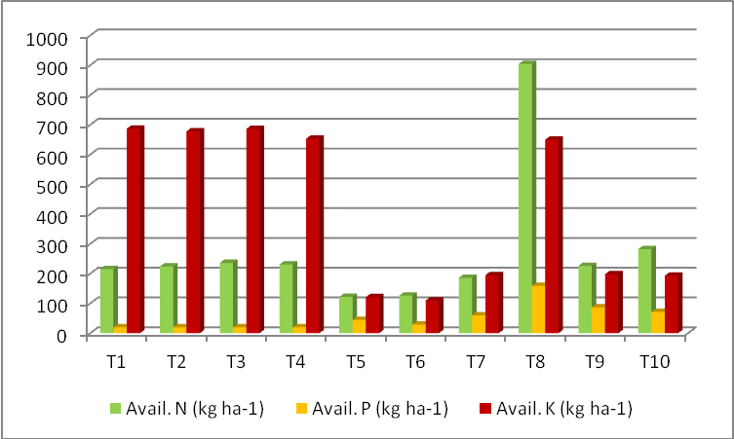
Figure. 1. Effect of different cropping systems on soil available nutrients during kharif

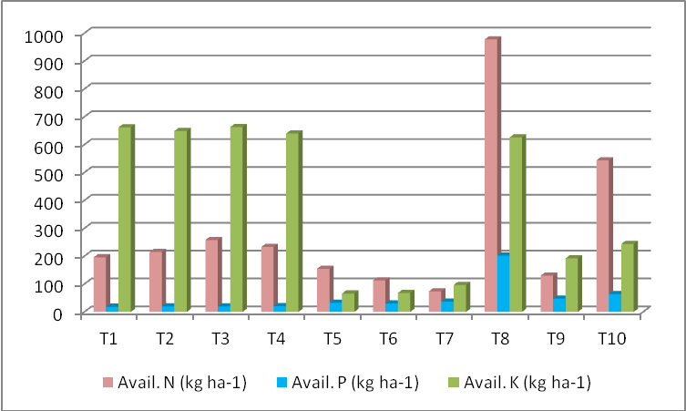
Figure. 2. Effect of different cropping systems on soil available nutrients during rabi

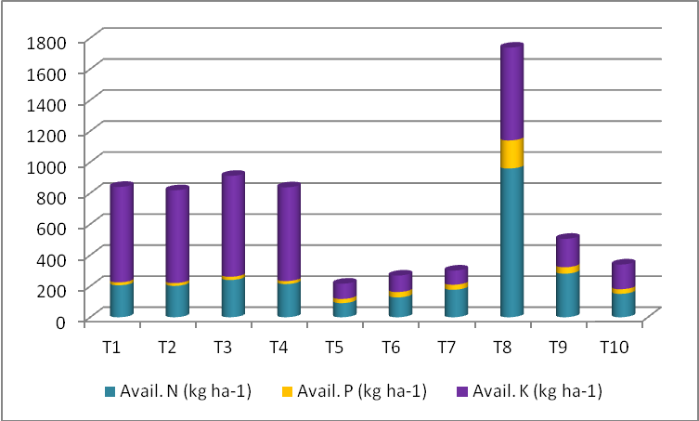
Figure. 3. Effect of different cropping systems on soil available nutrients during summer
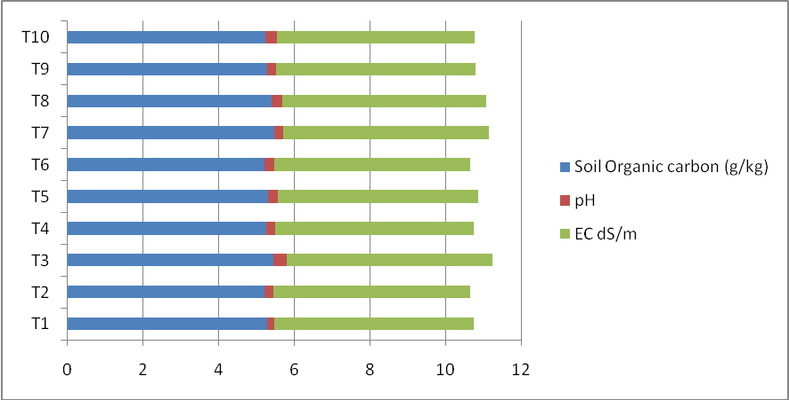
Figure. 4. Effect of different cropping systems on soil organic carbon, pH and EC

