**Applicability of Hargreaves–Samani and Valiantzas’ models for Solar Radiation Estimation in Coimbatore using Temperature and Humidity Inputs**

**ABSTRACT**

Precise estimation of reference evapotranspiration (ET₀) is essential for effective irrigation planning and water resource management, particularly in semi-arid regions like Coimbatore, Tamil Nadu. The FAO56 Penman–Monteith (FAO56-PM) method is widely regarded as the standard approach for ET₀ estimation, but its application is limited by the requirement of multiple meteorological inputs, including solar radiation (Rs) and wind speed, which are often unavailable or unreliable in many regions. This study evaluates two simplified models for estimating Rs, the Hargreaves–Samani (HS) model and the modified version by Valiantzas (2017), which incorporates relative humidity (RH) along with temperature, and examines their impact on FAO56-PM ET₀ estimation using 21 years (2004–2024) of NASA POWER meteorological data for Coimbatore. Results showed a strong correlation between measured Rs and estimated Rs values, with the HS model achieving an R² of 0.7866 and the Valiantzas’ model an R² of 0.7034. When used to compute ET₀, both models showed excellent agreement with FAO56-PM ET₀ derived from measured Rs, with R² values of 0.9477 (HS) and 0.9281 (Valiantzas), and low standard error estimates (SEE < 0.22 mm day⁻¹). Seasonal analysis revealed that the models preserved the expected ET₀ patterns, with peak values in summer and minima in winter, aligning with solar radiation trends. The findings confirm that both HS and Valiantzas’ models provide reliable alternatives for Rs estimation and ET₀ computation in data-scarce environments. The HS model, due to its simplicity and robustness under clear-sky conditions, is particularly well-suited for semi-arid climates, while the Valiantzas’ model offers added flexibility in regions with variable humidity. These results underscore the potential of simplified radiation models to enhance irrigation planning where comprehensive weather data are lacking.

**Keywords:** Reference evapotranspiration; FAO56-PM; Hargreaves–Samani; Valiantzas’ model; solar radiation estimation; semi-arid; Coimbatore; NASA POWER

**INTRODUCTION**

Accurate estimation of reference evapotranspiration (ET₀) plays a pivotal role in designing efficient irrigation schedules and managing water resources sustainably, especially in semi-arid regions like Coimbatore, Tamil Nadu. Among the numerous models available, the FAO56 Penman–Monteith (FAO56-PM) method (Allen *et al*., 1998) is internationally accepted as the standard method for ET₀ estimation due to its physical basis and reliability. However, its application requires a comprehensive set of meteorological inputs, including maximum and minimum air temperatures (Tmax and Tmin), solar radiation (Rs), maximum and minimum relative humidity (RHmax and RHmin), wind speed (u), and geographic parameters such as latitude and altitude.

In many developing countries, including parts of India, collecting all these inputs at consistent quality and resolution remains a major challenge. Weather stations often suffer from incomplete data due to equipment malfunction, limited instrumentation, or high costs of maintenance. Furthermore, the sophisticated sensors required for solar radiation and wind speed measurement are expensive, making their widespread installation unfeasible (Valiantzas, 2012, 2013d; Exner-Kittridge, 2012; Exner-Kittridge & Rains, 2010). This results in gaps in long-term meteorological datasets and limits the applicability of the FAO56-PM model in many regions, including Coimbatore.

To overcome these limitations, several researchers have developed simplified models that attempt to estimate ET₀ using fewer, more commonly available weather parameters without significantly compromising accuracy. Valiantzas (2006, 2013a, 2013b, 2013c, 2013d, 2014a, 2014b, 2015, 2018a, 2018b) introduced a series of progressively refined equations that simplify the estimation of reference evapotranspiration (ET₀) by reducing the number of input parameters required compared to the standard FAO56 Penman–Monteith (PM) method. His work builds on the physical foundation of the PM equation but systematically modifies and re-derives components such as the aerodynamic and radiation terms to eliminate the need for hard-to-obtain variables like wind speed and solar radiation. The first major contribution (Valiantzas, 2006) proposed alternative formulations of the radiation term using air temperature and sunshine duration, making it suitable for areas where radiation data are missing.

In later studies, such as Valiantzas (2013a, 2013b), he developed empirical factors to approximate the aerodynamic component using only temperature and elevation, effectively removing the need for wind speed data. He further extended this idea in Valiantzas (2013c, 2013d) by presenting multiple forms of ET₀ equations that can be used under different data availability scenarios, for example, with or without relative humidity or wind speed. These forms offer flexibility and adaptability in application depending on what climatic data are accessible.

In his 2014a and 2014b studies, Valiantzas provided clarifications, performance evaluations, and methodological discussions to support the robustness of his simplified models. In Valiantzas (2015), the focus was on adapting his limited-data models specifically for humid locations, improving their accuracy in such climates. Finally, in his 2018 works, he compared the temperature- and humidity-based simplified models to other empirical methods, including Hargreaves–Samani, and further validated their suitability under diverse climatic conditions.

Overall, Valiantzas' models significantly contribute to expanding the usability of ET₀ estimation in data-scarce regions by providing reliable alternatives that require only a minimal set of routine weather observations (e.g., temperature, relative humidity, and elevation). This makes them especially valuable in regions like Coimbatore, where continuous and high-quality meteorological records, especially solar radiation and wind speed, are often unavailable.

These models offer a practical alternative for regions with limited data availability and have been shown to produce results comparable to the FAO56-PM method under certain conditions (Djaman *et al*., 2016).

A key variable in ET₀ estimation is solar radiation (Rs), but it is rarely measured directly at most weather stations due to the high cost and maintenance of pyranometers. To address this, Hargreaves and Samani (1982) developed an empirical model to estimate Rs using only Tmax and Tmin, two variables that are routinely recorded at nearly all-weather stations. This model, and its later refinements (Samani, 2000; Samani *et al*., 2011; Hargreaves & Allen, 2003), remains one of the most widely used approaches for estimating Rs where direct measurements are unavailable.

More recently, Valiantzas (2017) proposed an enhanced version of the Hargreaves–Samani model that incorporates relative humidity (RH) along with air temperature. This modification takes advantage of the fact that RH sensors are significantly more affordable than radiation or wind sensors (Exner-Kittridge & Rains, 2010). The inclusion of RH helps improve the accuracy of solar radiation estimation, especially in humid and semi-arid climates. Studies conducted in diverse regions such as Iran (Valipour, 2014), the Mediterranean basin (Kisi, 2014), Western Australia (Ahooghalandari *et al*., 2016), Senegal (Djaman *et al*., 2015), and Burkina Faso (Djaman *et al*., 2016) have validated the reliability and adaptability of Valiantzas’ simplified models under various climatic conditions.

In this context, the present study was undertaken to assess the performance of the modified Hargreaves–Samani model proposed by Valiantzas (2017) for estimating solar radiation using daily temperature and relative humidity data. The goal is to evaluate whether these simplified models can provide reliable inputs for the FAO56-PM method and thereby estimate reference evapotranspiration accurately under data-limited conditions. Specifically, the study compares the ET₀ values obtained using the FAO56-PM method by substituting Rs estimated from both the original Hargreaves–Samani model and the Valiantzas’ model.

The evaluation was carried out on a daily time scale using 21 years of meteorological data (from 2004 to 2024) retrieved from the NASA POWER database for the semi-arid region of Coimbatore, Tamil Nadu. This study not only investigates the suitability of these models under local climatic conditions but also provides insights into improving irrigation planning in areas where complete meteorological datasets are unavailable.

**MATERIALS AND METHODS**

**Study area**

Meteorological data required for estimating reference evapotranspiration using the FAO56-PM method were obtained from the NASA POWER database for a period of twenty-one years (2004–2024), corresponding to the geographical location of Coimbatore, Tamil Nadu. The coordinates of the study area are approximately 11°00′ N latitude, 76°97′ E longitude, with an elevation of 411 meters above mean sea level (MSL).

**Estimation of Solar Radiation**

**Hargreaves-Samani RS formula based on T (HS Rs [T])**

Hargreaves and Samani (1982) recommended a simplified equation to estimate solar radiation:

 (1)

Where,

RA is extra-terrestrial radiation [MJ m-2 day-1];

Tmax is the maximum temperature [°C]; and

Tmin is the minimum temperature [°C].

Ra for each day of the year and different latitudes can be estimated from the solar constant, the solar declination, and the time of the year by the following equation

 (2)

Where,

Ra is extraterrestrial radiation [MJ m-2 day-1],

Gsc is solar constant = 0.0820 MJ m-2 min-1,

dr is the inverse relative distance Earth-Sun,

ωs is sunset hour angle [rad],

ϕ is latitude [rad] and

δ is solar declination [rad].

**Valiantzas' RS formula based on T and RH (Val Rs [T & RH])**

Hargreaves’ model for estimating the solar radiation as a function of RH (Hargreaves and Allen, 2003) is given as follows:

 (3)

Where x is an empirical exponent.

By combining Eq. (1) & Eq. (3), Rs is considered as a function of temperature and RH. Valiantzas (2017) identified the regression coefficients by following a calibration procedure. They used a global climatic data set, including monthly data, the FAO-CLIMWAT (Smith 1993) from thirteen countries that essentially cover the typical range and proposed the following simple empirical and mathematical form of the equation in which Rs is estimated from the T and RH data. The new version of the Hargreaves–Samani Model requires temperature and RH data:

 (4)

In Eq. (4), the value of 1.001 was used instead of 1 because of the singularity appearing when RH/100 = 1. Hence, the final form of Valiantzas' R's equation is given as:

 (5)

**Estimation of Reference Evapotranspiration**

The FAO56-PM equation for estimating the daily grass-reference evapotranspiration is given by

 (6)

Where,

ET0is reference evapotranspiration [mm day-1],

Rn is net radiation at the crop surface [MJ m-2 day-1],

G is soil heat flux density [MJ m-2 day-1],

T is the mean daily air temperature [°C],

U is wind speed at 2 m height [m s-1],

es is saturation vapour pressure [kPa],

ea is actual vapour pressure [kPa],

es-ea is saturation vapour pressure deficit [kPa],

Δ is the slope of the vapour pressure curve [kPa °C-1],

Γ is the psychrometric constant [kPa °C-1].

**Comparison of methods**

A comparison was made between the measured solar radiation and solar radiation derived under the HS Rs [T] model and the Val Rs [T & RH] models separately. In addition, a comparison was made between the reference evapotranspiration estimated from the FAO56-PM equation by substituting the measured Rs values and solar radiation derived by using the HS Rs [T] model and Val Rs [T & RH] models separately.

In this study, a comparison has been made using the simple error analysis and linear regression.

 (7)

Where,

S is the regression coefficient (slope of the line),

Y is the reference measured values of RS, and

X = corresponding estimates of RS by the comparison formula.

The indices used in the error analysis is standard error estimate (SEE) and long-term average ratio (rt).

 (8)

 (9)

Where,

Yi is the reference measured value at ith data point;

Xi is the corresponding estimates by the comparison formula;

n is the total number of observations;

Xav and Yav are the long-term average values of the tested models and the reference values, respectively.

**RESULTS AND DISCUSSION**

**Evaluation of Solar Radiation Estimation Models**

The primary objective of this study was to evaluate the performance of two empirical models, the Hargreaves–Samani (HS) model and the Valiantzas’ (VAL) model, for estimating solar radiation (Rs) under semi-arid conditions in Coimbatore, using readily available meteorological parameters. The performance of these models was assessed by comparing estimated Rs with measured Rs, and subsequently examining their impact on FAO56-PM reference evapotranspiration (ET₀) estimations.

**Solar Radiation Estimation:**

The mean solar radiation values show that both the Hargreaves–Samani (HS) model (17.48 MJ m⁻² day⁻¹) and the Valiantzas’ (Val) model (17.51 MJ m⁻² day⁻¹) slightly underestimate the observed (measured) Rs (18.36 MJ m⁻² day⁻¹) by about 4.8–4.7%, consistent with earlier error metrics (rt values). The standard deviation (SD) of the Val Rs (3.35) is higher than that of HS Rs (2.73), suggesting that Valiantzas' model produces more variable Rs estimates, possibly due to the inclusion of relative humidity, which adds seasonal variability.

The minimum and maximum values indicate that Val Rs has a wider range (13.17 to 24.74 MJ m-² day-¹) than HS Rs (13.89 to 23.36 MJ m-² day-¹), again pointing to greater sensitivity of the Val model. The coefficient of variation (CV%) also supports this, with Val Rs showing the highest variability (19.13%) compared to measured Rs (15.34%) and HS Rs (15.62%), which may be a trade-off for capturing more dynamic climatic variations.

**Reference Evapotranspiration Estimation:**

The mean ET₀ values derived using the estimated Rs from HS (3.76 mm day⁻¹) and Val (3.77 mm day⁻¹) models are very close to that obtained using measured Rs (3.89 mm day⁻¹). This shows that both models are effective in reproducing average ET₀ values.

The standard deviation of ET₀ using Val Rs (0.92) is slightly higher than HS Rs and measured Rs (both ~0.82), indicating that the Val-based ET₀ estimates also exhibit more variability, again consistent with the more variable radiation inputs. The maximum ET₀ using Val Rs is 5.77 mm day⁻¹, slightly higher than that from measured Rs (5.55 mm day⁻¹), which may reflect the model’s responsiveness during high evaporative demand periods.

The coefficient of variation (CV%) for Val Rs-based ET₀ (24.28%) is higher than both HS (21.8%) and measured Rs (20.95%), reinforcing its more variable output. Median (50%) and quartile (25% and 75%) values follow a consistent pattern across the board, with Val Rs and HS Rs estimates closely tracking the measured values, indicating that central tendencies are preserved well by both models.

**Table 1: Summary Statistics of Solar Radiation and Reference Evapotranspiration**

|  |  |  |  |  |  |  |
| --- | --- | --- | --- | --- | --- | --- |
| **Index** | **Measured Rs** | **HS Rs** | **Val Rs** | **FAO PM ET**  **(Measured Rs)** | **FAO PM ET**  **(HS Rs)** | **FAO PM ET**  **(VAL Rs)** |
| **Mean** | 18.36 | 17.48 | 17.51 | 3.89 | 3.76 | 3.77 |
| **SD** | 2.82 | 2.73 | 3.35 | 0.82 | 0.82 | 0.92 |
| **Min** | 13.26 | 13.89 | 13.17 | 2.76 | 2.67 | 2.58 |
| **Max** | 24.05 | 23.36 | 24.74 | 5.55 | 5.55 | 5.77 |
| **CV (%)** | 15.34 | 15.62 | 19.13 | 20.95 | 21.8 | 24.28 |
| **25%** | 16.1 | 15.44 | 15.1 | 3.22 | 3.19 | 3.15 |
| **50%** | 17.71 | 16.31 | 15.91 | 3.55 | 3.4 | 3.35 |
| **75%** | 20.92 | 19.65 | 20.05 | 4.52 | 4.36 | 4.42 |

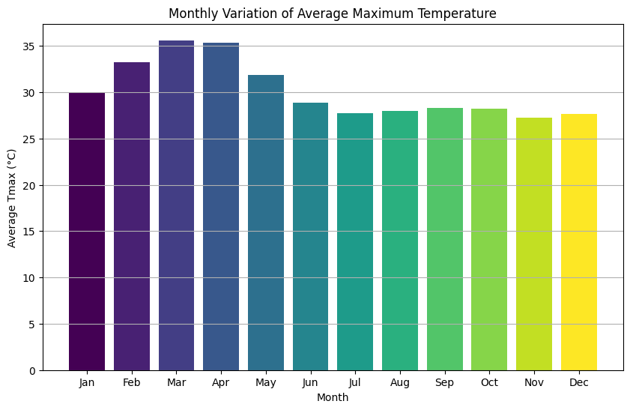

**Figure 1: Mean Monthly Maximum Temperature for the study area**

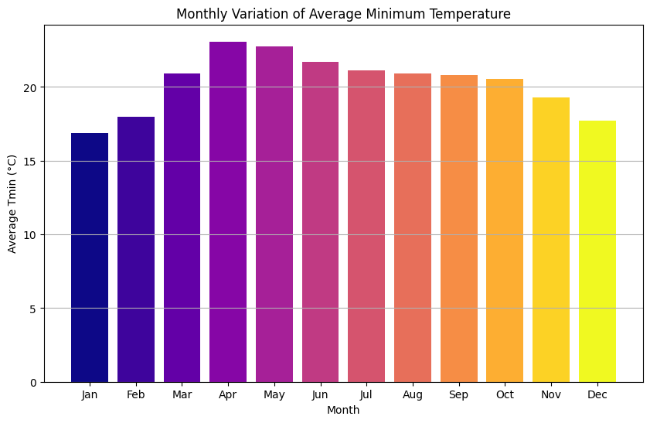

**Figure 2: Mean Monthly Minimum Temperature for the study area**

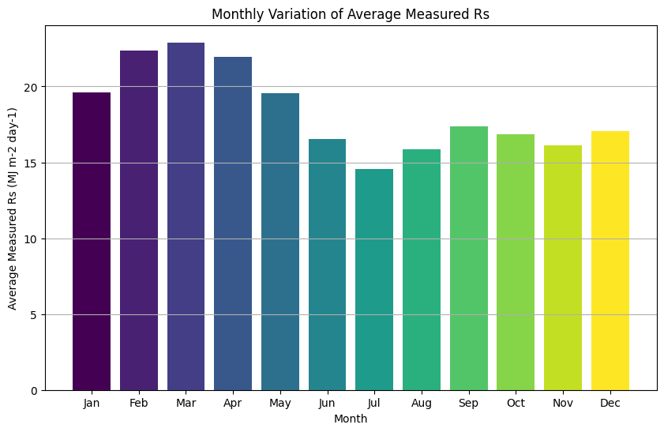

**Figure 3: Mean Monthly Solar Radiation for the study area**

**Seasonal Trends in Rs and ET₀**

**Seasonal Pattern of Measured Rs**

The seasonal trend of Rs was well-defined, with maximum average values observed during the summer months (May–July), peaking at around 20.3 MJ m⁻² day⁻¹ in July, and minimum values in winter months (December–January), with a low of approximately 4.2 MJ m⁻² day⁻¹ in December. This trend is closely associated with sun angle, day length, and atmospheric clarity. The steady increase in Rs from January to peak summer months, followed by a gradual decline, reflects typical semi-arid tropical radiation dynamics, where clear skies dominate most of the year except during the monsoon transition.

**Daily and Monthly Variation of ET₀**

The daily variation plot of FAO PM ET (Measured Rs) showed a pronounced seasonal pattern, with lower ET₀ values during the cooler months (December–January) and higher values during summer (March–May). This is primarily driven by increased Rs and air temperature, which directly influence ET demand. The monthly average bar plot confirmed this observation. The highest monthly average ET₀ occurred in April–May, consistent with the period of peak solar radiation and high vapour pressure deficit. Conversely, December and January had the lowest ET₀, coinciding with lower temperatures, solar radiation, and shorter daylight hours.

These trends affirm the critical seasonal variability in crop water demand, which must be considered while designing irrigation schedules in Coimbatore. Moreover, they validate that the simplified models (especially HS) are capable of preserving seasonal ET₀ dynamics, reinforcing their practical relevance.

The results of this study have significant practical implications. In regions like Coimbatore, where high-resolution and uninterrupted meteorological datasets are rarely available, the reliability of simplified radiation models becomes crucial. Both the HS and VAL models demonstrated high statistical fidelity in reproducing Rs and ET₀ values with minimal error. The Hargreaves–Samani model, despite its simplicity, performed remarkably well, especially under clear-sky conditions prevalent in semi-arid climates. Its use of only Tmax and Tmin makes it ideal for routine field applications and long-term historical assessments. The Valiantzas’ model, with added sensitivity to relative humidity, holds potential for slightly more humid regions or during post-monsoon periods, offering flexibility in a broader range of climatic settings. These findings support the adoption of simplified models in agro-climatic zones where access to complete meteorological data is limited. They also highlight the need for local calibration of these models to improve their predictive accuracy and reduce long-term biases.

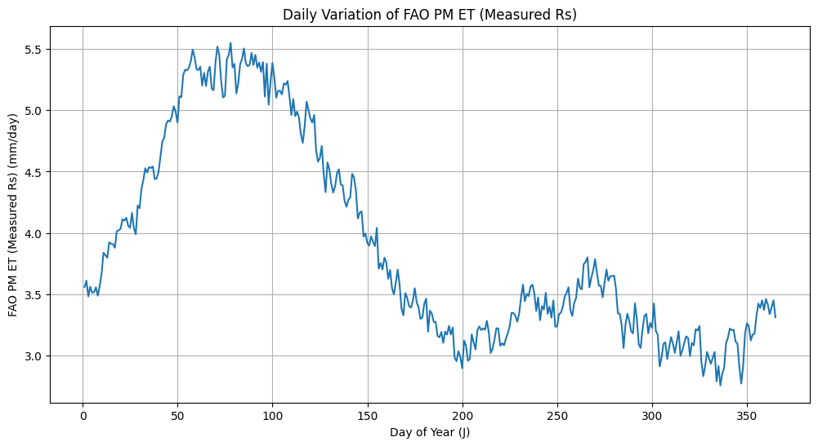

**Figure 5: FAO Reference Evapotranspiration for the study area**

**Measured Rs vs HS and VAL Rs**

The scatter plots between measured Rs and model-estimated Rs revealed a strong positive linear correlation in both cases, though the HS model showed marginally better alignment. The coefficient of determination (R²) for the HS model was 0.7866, indicating that about 79% of the variability in measured Rs could be explained by the HS model using only Tmax and Tmin. This suggests a strong dependence of Rs on air temperature differences, especially in relatively dry and sunny climates like Coimbatore, where diurnal temperature ranges are high.

On the other hand, the Valiantzas’ model, which incorporates relative humidity in addition to temperature, showed an R² of 0.7034. Although slightly lower, this still indicates a moderate to strong linear correlation. The inclusion of RH makes this model theoretically more adaptable to varying humidity conditions. However, in semi-arid zones where RH variability is limited or more stable, the additional parameter may introduce scatter, explaining the slightly lower correlation.

The Standard Error of Estimate (SEE) values further supported this trend, with HS Rs showing a SEE of 1.3014 MJ m⁻² day⁻¹ and Val Rs having a SEE of 1.5341 MJ m⁻² day⁻¹, indicating a slightly higher average deviation from the observed values in the Valiantzas’ model.

Despite these differences, the long-term average ratios (rt) for both models were almost identical, 0.9521 for HS and 0.9538 for VAL, showing that both models slightly underestimate measured Rs by about 4–5% over time. This systematic underestimation is consistent with earlier findings in similar climatic zones, suggesting that empirical models may need localized calibration to fully capture radiation dynamics under varying sky conditions.

|  |  |
| --- | --- |
| **D:\Article Publishing\Solar Radiation\Coimbatore\Results\G1.png**  **(a)** | **D:\Article Publishing\Solar Radiation\Coimbatore\Results\G2.png**  **(b)** |

**Figures 4a-4b: Comparison of daily Solar Radiation estimated by Hargreaves–Samani Model and Valiantzas’ Model versus Measured Solar Radiation**

**Effect on FAO56-PM ET₀ Estimation**

The study also aimed to evaluate how substituting the measured Rs with estimated Rs values (from HS and VAL) impacts the accuracy of reference evapotranspiration (ET₀) estimates derived using the FAO56 Penman–Monteith method.

**FAO PM ET (Measured Rs) vs HS and VAL ET**

The scatter plots between FAO PM ET using measured Rs and model-derived Rs (HS and VAL) exhibited very strong linear relationships. With an R² of 0.9477, the HS-based ET₀ estimates matched closely with those calculated using measured radiation. Similarly, the VAL-based estimates had an R² of 0.9281, still indicating an excellent correlation.

The SEE values were also low, 0.1862 for HS ET and 0.2183 for VAL ET, highlighting minimal deviation from the true ET₀ values and suggesting that both models can serve as reliable substitutes in data-scarce scenarios. The rt values (0.9676 for HS and 0.9694 for VAL) again reflected a minor long-term underestimation (~3%) compared to ET₀ calculated from actual Rs values.

These findings suggest that although there are marginal differences in the Rs estimation accuracy between the two models, both produce highly reliable ET₀ outputs. The strong correlation indicates that errors in Rs estimation do not propagate significantly when calculating ET₀, owing to the smoothing effect of multiple parameters in the FAO56-PM formulation.

|  |  |
| --- | --- |
| **D:\Article Publishing\Solar Radiation\Coimbatore\Results\G3.png**  **(a)** | **D:\Article Publishing\Solar Radiation\Coimbatore\Results\G4.png**  **(b)** |

**Figures 6a-6b: Comparison of daily FAO ETo estimated by substituting measured and Solar Radiation obtained from the Hargreaves–Samanis Model and Valiantzas’ Model**

**SUMMARY AND CONCLUSION**

This study evaluated the performance of two simplified empirical models, the Hargreaves–Samani (HS) model and the modified Valiantzas’ model, for estimating solar radiation (Rs) and their subsequent impact on reference evapotranspiration (ET₀) estimation using the FAO56 Penman–Monteith (PM) method in the semi-arid region of Coimbatore, Tamil Nadu. Utilising a 21-year daily dataset (2004–2024) from the NASA POWER database, the study provided a detailed statistical and seasonal analysis to assess the accuracy and applicability of these models under limited-data conditions. The results demonstrated that both HS and Valiantzas’ models show strong agreement with measured Rs and ET₀ values, with the HS model slightly outperforming the Valiantzas’ model in terms of correlation (R² = 0.7866 for HS vs 0.7034 for VAL) and lower error metrics. When used within the FAO56-PM framework, both models produced ET₀ estimates that closely matched those derived from measured solar radiation, with high R² values (above 0.92), low standard error of estimate (SEE < 0.22 mm day⁻¹), and minor long-term biases (rt ≈ 0.96–0.97).

Seasonal trends in Rs and ET₀ were accurately captured, further validating the models’ effectiveness in replicating agro-climatic dynamics relevant to irrigation scheduling. The HS model, requiring only maximum and minimum temperature, proves particularly advantageous in resource-constrained settings due to its simplicity, ease of implementation, and robust performance in clear-sky, semi-arid conditions. The Valiantzas’ model, incorporating relative humidity along with temperature, offers additional sensitivity in varying climatic regimes and may be more suitable for post-monsoon or humid seasons. In conclusion, both models offer reliable and practical alternatives to measured Rs in ET₀ estimation, especially where full meteorological datasets are unavailable. Their successful application in this study supports the adoption of simplified radiation models for large-scale agro-climatic planning, long-term irrigation management, and water resource optimization in semi-arid regions like Coimbatore. Future work should focus on localized calibration and validation across different agro-ecological zones to further enhance model accuracy and applicability.

**Funding acknowledgement**

No external funding was received to carry out this research.

**Ethics Statement**

There were no human participants/or animals included in this research.

**Consent for publication**

All the authors agreed to publish the content.

**Competing interest**

There is no conflict of interest in publishing this content.

**References**

Ahooghalandari, M., Khiadani, M., & Jahromi, M. E. (2016). Calibration of Valiantzas’ reference evapotranspiration equations for the Pilbara region, Western Australia. *Theoretical and Applied Climatology*, *128*(3–4), 845–856. <https://doi.org/10.1007/s00704-016-1744-7>

Allen, R. G., Pereira, L. S., Raes, D., & Smith, M. (1998). Crop evapotranspiration: Guidelines for computing crop water requirements (FAO Irrigation and Drainage Paper No. 56). FAO, Rome. [M-56_ISBN 92-5-104219-5](https://www.avwatermaster.org/filingdocs/195/70653/172618e_5xAGWAx8.pdf)

Djaman, K., Balde, A. B., Sow, A., Muller, B., Irmak, S., N’Diaye, M. K., Manneh, B., Moukoumbi, Y. D., Futakuchi, K., & Saito, K. (2015). Evaluation of sixteen reference evapotranspiration methods under sahelian conditions in the Senegal River Valley. *Journal of Hydrology: Regional Studies*, *3*, 139-159. <https://doi.org/10.1016/j.ejrh.2015.02.002>

Djaman, K., Irmak, S., Kabenge, I., & Futakuchi, K. (2016). Evaluation of the FAO-56 Penman–Monteith model with limited data and the Valiantzas’ models for estimating reference evapotranspiration in Sahelian conditions. Journal of Irrigation and Drainage Engineering, *142*(6), 04016044. <https://doi.org/10.1061/(ASCE)IR.1943-4774.0001070>

Exner-Kittridge, M. G. (2012). Closure of “Case study on the accuracy and cost/effectiveness in simulating reference evapotranspiration in West-Central Florida.” Journal of Hydrologic Engineering, *17*(2), 225–226. <https://doi.org/10.1061/(ASCE)HE.1943-5584.0000430>

Exner-Kittridge, M. G., & Rains, M. C. (2010). Case study on the accuracy and cost/effectiveness in simulating reference evapotranspiration in West-Central Florida. Journal of Hydrologic Engineering, *15*(9), 696–703. <https://doi.org/10.1061/(ASCE)HE.1943-5584.0000239>

Hargreaves, G. H., & Allen, R. G. (2003). History and evaluation of Hargreaves evapotranspiration equation. Journal of Irrigation and Drainage Engineering, *129*(1), 53–63. <https://doi.org/10.1061/(ASCE)0733-9437(2003)129:1(53)>

Hargreaves, G. H., & Samani, Z. A. (1982). Estimating potential evapotranspiration. Journal of the Irrigation and Drainage Division, *108*(3), 225–230. <https://doi.org/10.1061/JRCEA4.0001390>

Kisi, O. (2014). Comparison of different empirical methods for estimating daily reference evapotranspiration in Mediterranean climate. Journal of Irrigation and Drainage Engineering, *140*(4), 04014003. <https://doi.org/10.1061/(ASCE)IR.1943-4774.0000664>

Samani, Z. (2000). Estimating solar radiation and evapotranspiration using minimum climatological data. Journal of Irrigation and Drainage Engineering, *126*(4), 265–267. <https://doi.org/10.1061/(ASCE)0733-9437(2000)126:4(265)>

Samani, Z., Hargreaves, G., Tran, V., & Bawazir, S. (2011). Estimating solar radiation from temperature with spatial and temporal calibration. Journal of Irrigation and Drainage Engineering, *137*(10), 692–696. <https://doi.org/10.1061/(ASCE)IR.1943-4774.0000342>

Valiantzas, J. D. (2006). Simplified versions for the Penman evaporation equation using routine weather data. Journal of Hydrology, *331*(3–4), 690–702. <https://doi.org/10.1016/j.jhydrol.2006.06.006>

Valiantzas, J. D. (2012). Discussion of “Case study on the accuracy and cost/effectiveness in simulating reference evapotranspiration in West-Central Florida.” Journal of Hydrologic Engineering, *17*(2), 224–225. <https://doi.org/10.1061/(ASCE)HE.1943-5584.0000394>

Valiantzas, J. D. (2013a). Simplified reference evapotranspiration formula using an empirical impact factor for Penman’s aerodynamic term. Journal of Hydrologic Engineering, *18*(1), 108–114. <https://doi.org/10.1061/(ASCE)HE.1943-5584.0000618>

Valiantzas, J. D. (2013b). Simple ET₀ forms of Penman’s equation without wind and/or humidity data. I: Theoretical development. Journal of Irrigation and Drainage Engineering, *139*(1), 1–8. <https://doi.org/10.1061/(ASCE)IR.1943-4774.0000625>

Valiantzas, J. D. (2013c). Simple ET₀ forms of Penman’s equation without wind and/or humidity data. II: Comparisons with reduced set-FAO and other methodologies. Journal of Irrigation and Drainage Engineering, *139*(1), 9–19. <https://doi.org/10.1061/(ASCE)IR.1943-4774.0000626>

Valiantzas, J. D. (2013d). Simplified forms for the standardized FAO-56 Penman–Monteith reference evapotranspiration using limited weather data. Journal of Hydrology, *505*, 13–23. <https://doi.org/10.1016/j.jhydrol.2013.09.005>

Valiantzas, J. D. (2014a). Closure to “Simple ET₀ forms of Penman’s equation without wind and/or humidity data. I: Theoretical development.” Journal of Irrigation and Drainage Engineering, *140*(7), 07014002. <https://doi.org/10.1061/(ASCE)IR.1943-4774.0000746>

Valiantzas, J. D. (2014b). Discussion of “Comparison of different empirical methods for estimating daily reference evapotranspiration in Mediterranean climate.” Journal of Irrigation and Drainage Engineering, *141*(4), 07014001. <https://doi.org/10.1061/(ASCE)IR.1943-4774.0000816>

Valiantzas, J. D. (2015). Simplified limited data Penman’s ET₀ formulas adapted for humid locations. Journal of Hydrology, *524*, 701–707. <https://doi.org/10.1016/j.jhydrol.2015.03.003>

Valiantzas, J. D. (2017). Modification of the Hargreaves–Samani model for estimating solar radiation from temperature and humidity data. Journal of Irrigation and Drainage Engineering, *144*(1), 06017014. <https://doi.org/10.1061/(ASCE)IR.1943-4774.0001223>

Valiantzas, J. D. (2018a). Discussion of “Evaluation of Valiantzas’ simplified forms of the FAO-56 Penman–Monteith reference evapotranspiration model in a humid climate.” Journal of Irrigation and Drainage Engineering, *144*(7), 07018026. <https://doi.org/10.1061/(ASCE)IR.1943-4774.0001317>

Valiantzas, J. D. (2018b). Temperature- and humidity-based simplified Penman’s ET₀ formulae: Comparisons with temperature-based Hargreaves–Samani and other methodologies. Agricultural Water Management, *208*, 326–334. <https://doi.org/10.1016/j.agwat.2018.06.026>

Valipour, M. (2014). Investigation of Valiantzas’ evapotranspiration equation in Iran. Theoretical and Applied Climatology, *117*(1–2), 253–261. <https://doi.org/10.1007/s00704-014-1240-x>