**Assessment of Thermal and Radiation Use Efficiency of Rice (CO 47) Across Seasonal Sowing Windows in Coimbatore, Tamil Nadu**

**ABSTRACT**

Understanding seasonal energy subtleties is important for optimizing rice cultivation under changing climatic conditions. This study evaluates the thermal and radiation use efficiency of rice variety CO 47 across seven major sowing windows, Navarai, Sornavari, Kar, Kuruvai, Samba, Thaladi, and Late Thaladi, in Coimbatore district, Tamil Nadu. Using 21 years (2004–2024) of daily climatic data from NASA POWER, thermal indices such as Growing Degree Days (GDD), Photothermal Units (PTU), and Heliothermal Units (HTU) were computed alongside derived efficiencies, Heat Use Efficiency (HUE) and Radiation Use Efficiency (RUE), for vegetative, reproductive, and maturity phases. Results revealed that Sornavari and Navarai seasons exhibited the highest cumulative thermal and radiation indices, supporting robust crop development. Mid-year sowings like Kar and Kuruvai balanced thermal and radiation efficiency, while late Thaladi faced significant climatic constraints, particularly during reproductive stages. HUE peaked in early-season sowings, whereas RUE was highest in mid-year crops. These findings stress the need for season-specific agrometeorological strategies to enhance rice productivity and resilience under variable climates.

**Keywords**: Rice (CO 47); Heat Use Efficiency (HUE); Radiation Use Efficiency (RUE); Growing Degree Days (GDD); Seasonal Sowing Windows; NASA POWER; Thermal Indices; Tamil Nadu; Agrometeorology; Crop Phenology

### **INTRODUCTION**

Rice (*Oryza sativa* L.) is the principal food crop for over half the world’s population and plays a critical role in India's food security. In Tamil Nadu, rice cultivation is distributed across multiple seasons, including Navarai, Sornavari, Kar, Kuruvai, Samba, Thaladi, and Late Thaladi, each influenced by distinct combinations of temperature, day length, and solar radiation. These environmental variables exert a strong influence on crop growth, development, and yield potential. Understanding how rice responds to seasonal climatic variation is vital for optimizing sowing time, selecting suitable varieties, and maximizing productivity. Among the various agrometeorological approaches, thermal indices such as Growing Degree Days (GDD), Photothermal Units (PTU), and Heliothermal Units (HTU) have been widely used to model crop phenology and thermal energy accumulation (Dash & Hunt, 1992; Praveen et al., 2013). However, quantifying thermal input alone does not capture the full picture of crop efficiency.

To fill the gap, two derived indices, Heat Use Efficiency (HUE) and Radiation Use Efficiency (RUE), are used to evaluate how efficiently crops convert available heat and radiation into biomass and yield. HUE (expressed as g/m²/°C Day) measures the biomass accumulation per unit of thermal energy, while RUE (g/m²/MJ/day) quantifies the crop's ability to utilize intercepted solar radiation. These indices offer deeper insights into crop-environment interactions and are particularly valuable for identifying climate-resilient sowing windows and improving resource use efficiency (Rao et al., 1999; Majumdar & Roy, 2010). Studies have demonstrated significant seasonal variability in these efficiency metrics. For example, Sreekumar and Mathew (2018) reported RUE variations based on planting dates in humid tropics, and Reddy et al. (2010) linked agrometeorological indices to aerobic rice phenology and yield. Jagannathan and Balakrishnan (2000) estimated the heat unit requirements of rice varieties in Tamil Nadu, reinforcing the importance of regional and seasonal calibration.

To enable such evaluations, consistent and reliable climatic data is crucial. NASA POWER (Prediction of Worldwide Energy Resource) offers high-resolution, satellite-based agroclimatic datasets, including daily values of temperature, solar radiation, sunshine hours, and day length. Its validation for agricultural applications has been demonstrated in Indian conditions (Kumar & Sinha, 2004), and it provides an invaluable tool for long-term agrometeorological studies (NASA POWER, 2023).

Despite the known importance of thermal and radiation indices, comparative seasonal assessments of HUE and RUE for rice in Tamil Nadu’s western agro-climatic region remain limited. Therefore, this study aims to evaluate the seasonal dynamics of GDD, PTU, HTU, HUE, and RUE for the rice variety CO 47 grown in Coimbatore district, using daily climatic data from 2004 to 2024 obtained from NASA POWER. By analyzing the energy accumulation and utilization across the region’s key rice-growing seasons, the study seeks to identify the most thermally and radiatively efficient sowing windows and provide agrometeorological guidance for climate-smart rice cultivation.

By quantifying energy availability during the **vegetative, reproductive,** and **maturity** phases, this study identifies the most thermally favourable seasons for rice cultivation and highlight periods of potential climatic stress. The findings will aid in aligning sowing calendars with environmental optima, guiding varietal recommendations, and enhancing resource use efficiency in rice-based systems.

### **METHODOLOGY**

### **Study Area**

The study was conducted for the agro-climatic conditions of **Coimbatore district**, located in western Tamil Nadu, India. The region lies between **10.9°N and 11.2°N in latitude and 76.9°E and 77.2°E in longitude, at an average elevation of approximately** 411 meters above mean sea level. Coimbatore experiences a semi-arid to sub-humid tropical climate, receiving both southwest and northeast monsoonal rainfall. The district represents one of the major rice-growing belts under irrigated command areas.

### **Crop and Variety**

The rice variety selected for the study was **CO 47**, a medium-duration variety developed by Tamil Nadu Agricultural University (TNAU), with a **growth duration of 115 days**. This variety is widely adapted to Tamil Nadu and known for its erect habit, white grains, medium slender grain type, and resistance to blast disease.

### **Seasons Considered**

Seven major rice-growing seasons typical of Tamil Nadu were considered:

* **Navarai** (Jan 15)
* **Sornavari** (Mar 15)
* **Kar** (May 15)
* **Kuruvai** (Jun 1)
* **Samba** (Aug 15)
* **Thaladi** (Oct 15)
* **Late Thaladi** (Nov 15)

Each season was represented by its **first recommended sowing date**, and the crop was assumed to be grown for 115 days from that date to simulate its complete life cycle.

### **Meteorological Data**

Daily meteorological data from **January 2014 to December 2024** were retrieved from the **NASA POWER (Prediction of Worldwide Energy Resource)** database, which provides agro-climatological parameters for global locations at a spatial resolution of 0.5° × 0.5°. The following daily parameters were extracted for Coimbatore:

* Maximum temperature (°C)
* Minimum temperature (°C)
* Day length (hours)
* Actual solar radiation (MJ/m²/day)
* Sunshine hours (hours)

### **Computation of Thermal and Radiation Indices**

The phenological duration of the crop (115 days) was divided into three major growth phases based on literature and physiological development of CO 47:

* **Vegetative phase**: 0–35 Days After Sowing (DAS)
* **Reproductive phase**: 36–80 DAS
* **Maturity phase**: 81–115 DAS

For each phase and season, the following indices were computed:

Parameters Measured:

1. Growing Degree Days (GDD):

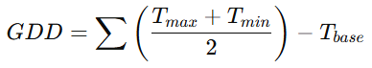

* + Tmax​: Daily maximum temperature
  + Tmin​: Daily minimum temperature
  + Tbase​: Base temperature for rice crop

1. Photo-Thermal Unit (PTU):



* + N: Maximum possible sunshine hours

1. Helio-Thermal Unit (HTU):

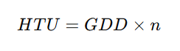

* + n: Actual sunshine hours

1. Heat Use Efficiency (HUE):

​ 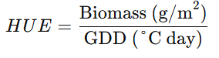

1. Radiation Use Efficiency (RUE):

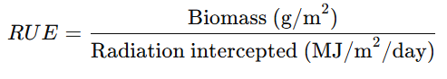​

All values were computed cumulatively for each phenological stage and each of the seven seasons.

**Data Analysis and Visualization**

The seasonal variations in GDD, PTU, and HTU across the three growth phases were analyzed using Python-based data analysis tools. Bar charts were generated to visualize the cumulative values for each phenophase and season. The data were interpreted to assess the thermal and radiation suitability of each season for CO 47 cultivation in Coimbatore.

**RESULTS AND DISCUSSION**

**Seasonal Temperature Dynamics**

The seasonal variation in daily maximum and minimum temperatures for Coimbatore, as shown in Figure 1, reveals distinct thermal regimes that influence the phenological behaviour of rice crops such as CO 47. The maximum temperature (Tmax) exhibited a pronounced increase from January (DOY ~1) to April (DOY ~110), peaking at approximately 36.5°C around day 100, indicating the pre-monsoon summer heat. This period corresponds to the Sornavari and Kar rice seasons, which experience the most thermally intense environment. Following the peak, Tmax gradually declined and stabilized around 28°C to 30°C during the southwest and northeast monsoon months (June to November).

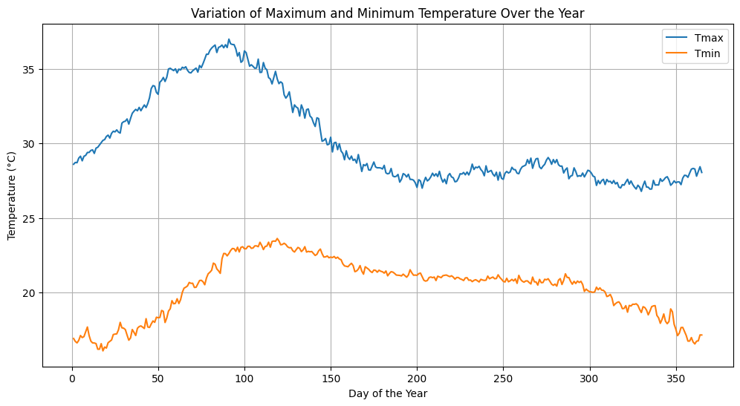

**Figure 1: Variation of maximum and minimum temperature**

In contrast, the minimum temperature (Tmin) showed a more moderate variation, with values ranging between 17°C in winter (DOY ~1 and ~360) to 23.5°C in April-May (DOY ~110–130). The Tmin curve also followed a bell-shaped pattern, although its amplitude was narrower than that of Tmax. The relatively narrow diurnal temperature range (DTR) from June to October reflects the influence of cloud cover and high humidity during the monsoon, which tends to moderate extremes in both Tmax and Tmin.

The identified thermal profiles have important implications for rice cultivation. The Navarai season (Jan–Feb sowing) starts under cooler conditions, particularly affecting vegetative growth due to lower thermal accumulation, whereas the Sornavari and Kar seasons benefit from higher GDD accumulation due to elevated Tmax and Tmin during early growth stages. However, these high temperatures may also pose heat stress risks during the reproductive phase, especially if flowering occurs in April or May.

From a phenological modelling perspective, the observed temperature trends align well with the seasonal cumulative GDD and HTU patterns presented earlier. Higher Tmax values during the early part of the year promote faster progression through growth stages, increasing thermal time accumulation. On the other hand, cooler late-year conditions (Thaladi and Late Thaladi) may prolong crop duration and reduce HUE, as biomass accumulation slows under lower temperatures.

Overall, the temperature regime of Coimbatore supports multi-seasonal rice cultivation, but requires careful sowing date selection to match sensitive growth stages with favourable thermal conditions, thereby optimizing phenology, biomass conversion, and yield potential.

**Cumulative Thermal and Radiation Indices**

The cumulative thermal and radiation indices, Growing Degree Days (GDD), Photothermal Units (PTU), and Heliothermal Units (HTU), exhibited considerable variability across seasons and crop growth stages, emphasizing the importance of temporal thermal regimes in influencing rice phenology and productivity. The phenological development of rice is closely tied to temperature accumulation and solar radiation availability, making these indices reliable indicators for assessing seasonal suitability and crop planning.

During the vegetative phase, Sornavari recorded the highest cumulative GDD (~690°C Day), reflecting optimal temperature conditions for early growth and tillering during the early summer months. This was followed by Kar, Kuruvai, and Samba, each demonstrating moderate GDD values (~520–580°C Day). In contrast, Late Thaladi recorded the lowest GDD (~470°C Day), likely due to its occurrence in the early winter months when temperature declines. This reduced thermal accumulation during the early stages may limit vegetative vigour and tiller proliferation. Navarai, although a winter crop, displayed moderately high GDD (~520°C Day), suggesting relatively favourable conditions due to residual warmth and clearer skies post-northeast monsoon.

In the reproductive phase, marked differences in GDD accumulation were evident. Navarai and Sornavari recorded the highest values (~810°C and ~790°C Day respectively), enabling proper panicle initiation, booting, and flowering under conducive thermal regimes. These seasons benefit from high solar incidence and stable thermal gradients, facilitating reproductive success and reducing the risk of spikelet sterility. On the other hand, Late Thaladi exhibited a dramatic drop in GDD accumulation (~140°C Day), suggesting a strong deviation from thermal norms necessary for reproductive progression. This could result in delayed or incomplete flowering and poor grain set. Thaladi, Kar, Kuruvai, and Samba showed intermediate values (~540–660°C Day), reflecting relatively stable but less optimal thermal support.

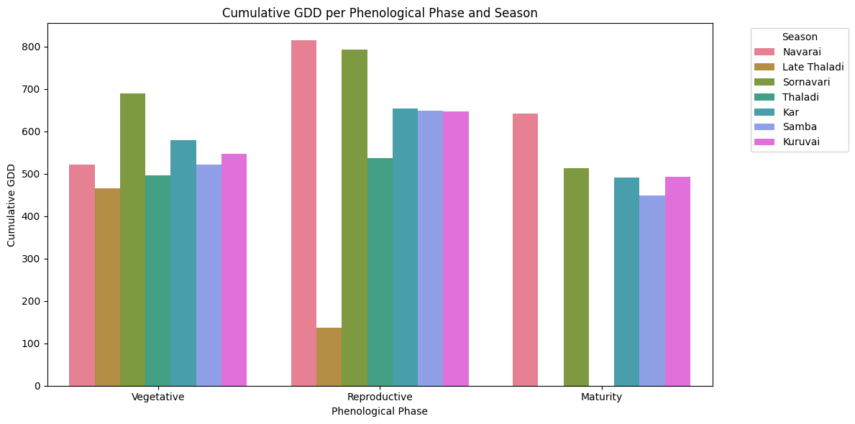

**Figure 2: Cumulative GDD per Phenological Phase and Season**

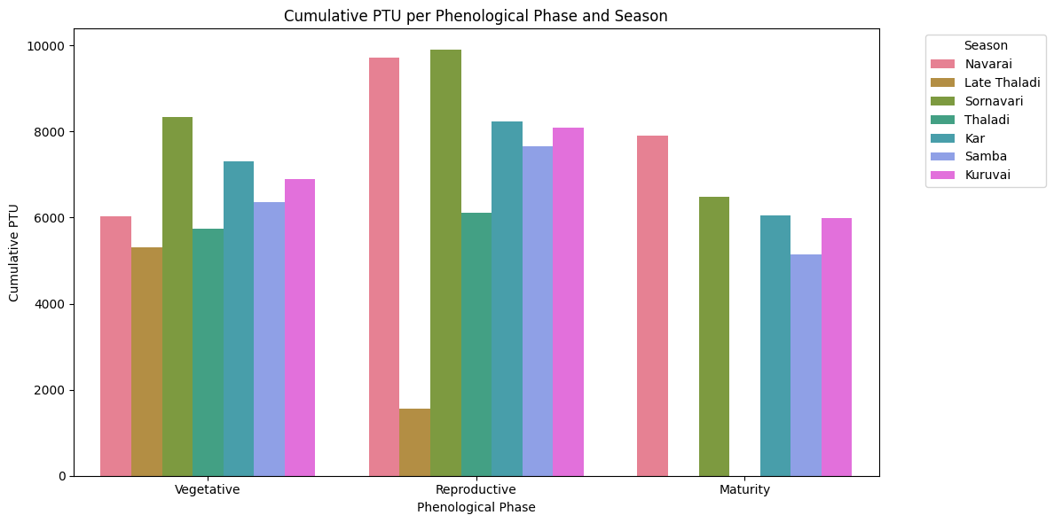

**Figure 3: Cumulative PTU per Phenological Phase and Season**

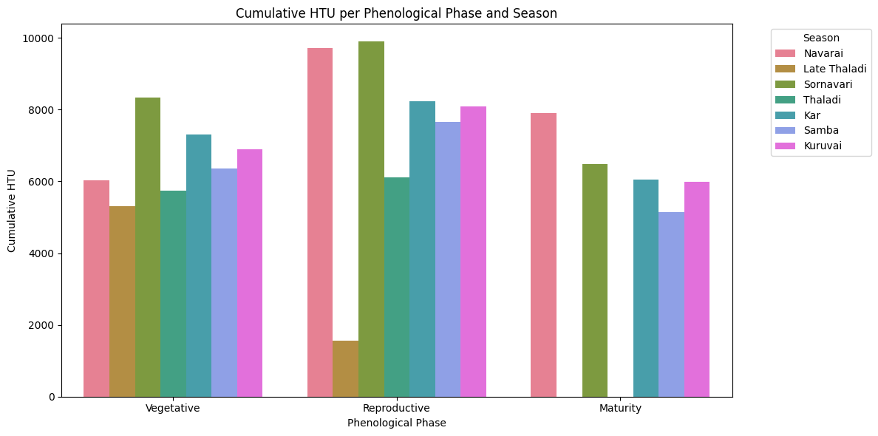

**Figure 4: Cumulative HTU per Phenological Phase and Season**

The maturity phase followed a similar seasonal pattern. Navarai maintained high GDD values (~640°C Day), indicating sustained thermal support for grain filling and physiological maturity. Sornavari and Kar followed with moderate GDDs (~510–520°C Day), ensuring gradual dry matter accumulation. Conversely, Samba and Thaladi exhibited lower GDDs (~450–490°C Day), possibly due to shortening day lengths and declining temperatures toward late monsoon and early winter, which may accelerate senescence and reduce grain weight. This again underscores the importance of aligning crop duration with expected seasonal thermal curves.

The Photothermal Units (PTU), which combine temperature and potential day length, revealed patterns similar to GDD but with amplified differences due to seasonal variation in photoperiod. Sornavari led with exceptionally high PTU values in the vegetative (~8400°C Day-hours) and reproductive (~9900°C Day-hours) phases, benefiting from high solar angles and extended daylight during the pre-monsoon period. Navarai also showed substantial PTU values (~9700°C Day-hours in reproductive phase), benefiting from stable winter sunlight and minimal cloud cover. Kuruvai and Kar followed closely, while Samba and Thaladi exhibited moderate PTU values, likely constrained by overcast conditions during the monsoon. Late Thaladi showed the lowest PTU accumulation, particularly in the reproductive stage (~1600°C Day-hours), indicating a significant restriction in both temperature and daylight duration, which could lead to suboptimal floral development and reduced yield potential.

The Heliothermal Units (HTU), integrating GDD with actual sunshine hours, further illustrated the seasonal disparity in solar radiation. Sornavari and Navarai consistently exhibited the highest HTU values across all growth stages, highlighting the synergy of temperature and solar exposure in these seasons. The vegetative phase HTU was particularly high in Sornavari (~8400°C sunshine-hours), facilitating strong biomass accumulation and tillering. The reproductive phase showed peak HTU values in Navarai and Sornavari (~9700–9900°C sunshine-hours), ensuring ideal conditions for flowering and pollination. In contrast, Late Thaladi experienced extremely low HTU (~1600°C sunshine-hours during the reproductive stage), suggesting limited solar radiation due to shorter days and possible cloud cover during winter. Such conditions are known to reduce photosynthetic efficiency and delay grain filling. Kuruvai, Kar, and Samba maintained moderate HTU values throughout, reflecting average solar input under monsoonal conditions.

The comparison of thermal and radiation indices clearly indicates that the Sornavari and Navarai seasons provide the most favourable agroclimatic environments for rice cultivation. Their consistent accumulation of thermal units and solar radiation during all phenological stages supports robust vegetative growth, successful flowering, and extended grain filling, all of which contribute to higher yield potential. These findings are in line with earlier studies that correlate increased radiation and thermal availability with improved rice productivity and radiation use efficiency.

On the contrary, the Late Thaladi season was marked by severely constrained thermal and radiative conditions, particularly during the reproductive phase. The low GDD, PTU, and HTU values observed indicate a high risk of yield reduction due to insufficient energy supply during the critical grain-setting period. This underlines the need for careful varietal selection, shorter-duration hybrids, and possibly agronomic interventions such as foliar nutrition or supplemental irrigation to mitigate stress in this season.

Kuruvai, Kar, and Samba seasons, though not as optimal as Sornavari or Navarai, demonstrated reasonably stable and moderate values for all indices, making them adaptable under standard management. Their performance may be enhanced with region-specific practices, especially in regions with assured irrigation.

The results indicate the importance of season-specific thermal and radiative profiling in aligning crop planning, sowing windows, and varietal selection to maximize yield. The quantification of GDD, PTU, and HTU offers valuable insights into phenological behaviour and helps refine agrometeorological advisories, especially in the context of climate variability.

#### **Heat Use Efficiency (HUE)**

The **Heat Use Efficiency (HUE)**, defined as the biomass produced per unit of accumulated heat (g/m²/°C Day), exhibited a steep decline over the calendar year. The plot reveals extremely high HUE values in the initial days of the year (DOY 1–10), reaching peaks above **100 g/m²/°C Day**, followed by a rapid exponential decline and stabilization near **1 g/m²/°C Day** beyond DOY 50.

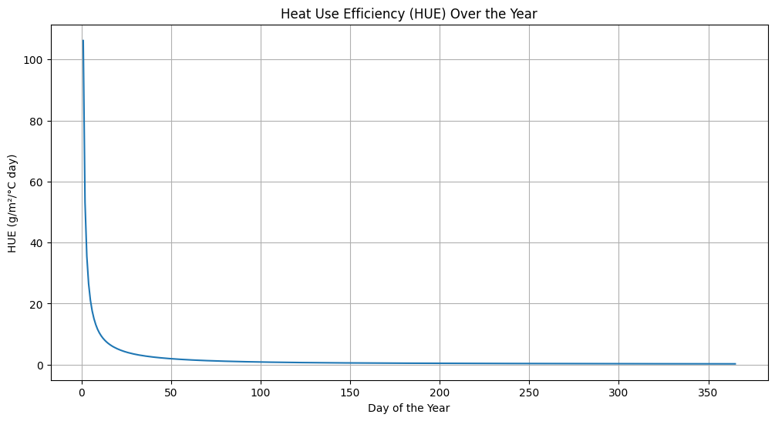

**Figure 5: Heat Use Efficiency over the Year**

This initial surge in HUE may be attributed to a **mathematical artifact** of early-season calculations when cumulative growing degree days (GDD) are still low, resulting in inflated HUE values (since HUE = Biomass / GDD). As the crop progresses and GDD increases steadily, the HUE normalizes, reflecting the **true thermal efficiency** of the crop in utilizing accumulated heat to produce biomass.

Across the rest of the year, from approximately DOY 50 onwards, HUE remains relatively constant and low, suggesting a **diminishing marginal return** of biomass production per unit heat in later sowing windows. This decline in HUE also indicates the growing influence of non-thermal factors such as photoperiod sensitivity, radiation availability, and physiological ageing on biomass accumulation during later stages. It further implies that **early-season sowing windows**, particularly in January and February (Navarai season), may offer superior thermal efficiency for CO 47 cultivation in Coimbatore.

#### **Radiation Use Efficiency (RUE)**

The **Radiation Use Efficiency (RUE)**, defined as the biomass produced per unit of radiation intercepted (g/m²/MJ/day), shows **pronounced seasonal variability** across the year. Unlike the monotonic decline in HUE, RUE fluctuates dynamically, suggesting a strong influence from radiation intensity, cloud cover, and crop radiation interception capacity.

During the early part of the year (DOY 1–60), RUE ranges between **65–75 g/m²/MJ/day**, gradually decreasing to a minimum of around **55–60** during DOY 50–90. This period coincides with the **pre-monsoon dry season**, where lower humidity but rising temperatures may slightly reduce radiation efficiency due to potential stress or vapour pressure deficit effects.

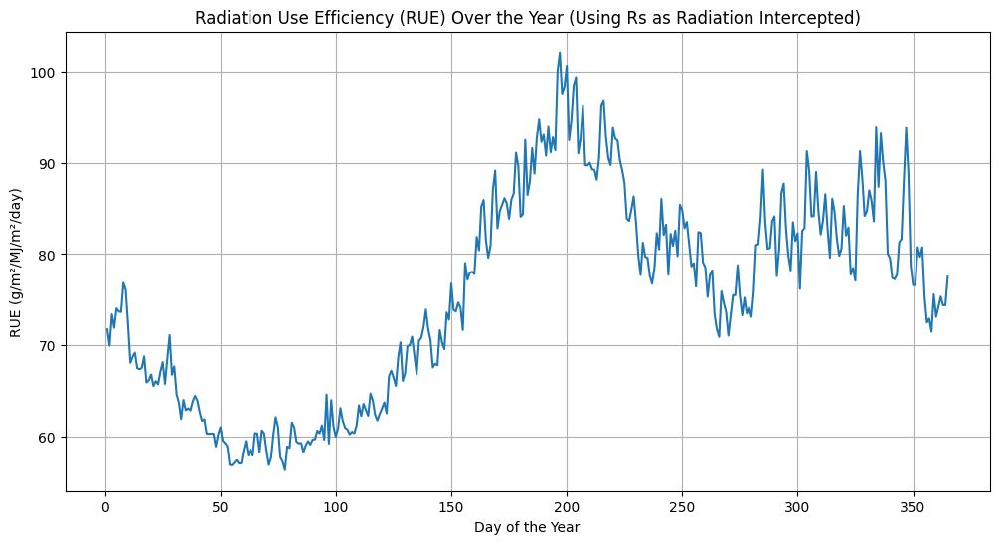

**Figure 6:** **Radiation Use Efficiency over the Year**

From DOY 100 onward, RUE exhibits a steady upward trend, reaching peaks above 100 g/m²/MJ/day around DOY 180–200, corresponding to the Kuruvai and early Samba seasons. This peak period indicates an optimal combination of high solar radiation, moderate temperatures, and favourable canopy development, resulting in efficient light utilization for biomass production. Post-DOY 200, RUE remains moderately high (~80–90) during the monsoon to early post-monsoon periods, suggesting consistent radiation utilization even during cloudier months, likely aided by diffuse radiation improving canopy light penetration.

Toward the end of the year (DOY 330–365), RUE slightly declines but remains above early-season values, reflecting sustained but slowly waning radiation efficiency in Late Thaladi season. This seasonal analysis of RUE highlights that mid-year sowing windows (Kar, Kuruvai, and Samba) align with higher radiation use efficiency, making them energetically favourable for maximizing photosynthetic productivity.

The combined analysis of HUE and RUE reveals a temporal complementarity in thermal and radiative efficiency across the year. While thermal efficiency (HUE) is highest during early-season sowing (Navarai, Sornavari), radiation efficiency (RUE) peaks during the mid-year months (Kar, Kuruvai, and Samba). This suggests that the choice of sowing window should consider whether the cropping goal is: Efficient use of temperature (favorable in January–March) and Efficient use of radiation (favorable in June–October).

From a practical standpoint, **Kar and Kuruvai seasons** strike a balance with moderately high HUE and RUE, while **Late Thaladi** suffers from both low thermal and radiation efficiencies, making it the least favourable period energetically.

Hence, it is important to align crop phenology with seasonal energy availability, especially under changing climatic conditions. Strategic timing of rice sowing in Coimbatore, based on heat and radiation use efficiency metrics, can enhance biomass accumulation, resource use efficiency, and ultimately crop yield.

The present study underscores the critical role of thermal and radiation regimes in influencing rice (CO 47) growth and productivity across seasonal sowing windows. The variation in Growing Degree Days (GDD) and Photothermal Units (PTU) among seasons highlights the crop’s sensitivity to environmental energy inputs. Similar trends were observed by Babu et al. (2023), who reported that groundnut varieties exhibited strong phenological dependence on accumulated GDD and PTU, with thermal indices explaining up to 94% of the variation in maturity timing. Likewise, Parashar et al. (2014) found that early-sown maize accumulated more GDD and showed better phenological development and yield than later sowings, which suffered from heat and moisture stress during reproductive stages. These findings affirm the value of incorporating thermal metrics into sowing calendar decisions to enhance climate-resilient crop planning across agro-climatic zones.

**CONCLUSION**

This research brings to the fore the central importance of thermal and radiation-based agrometeorological indices in directing rice cultivation plans in Coimbatore's multifaceted climatic seasons. Climatic data analysis of 20 years showed unique patterns of thermal energy acquisition and utilization during the seven rice-growing seasons. Early sowing windows like Navarai and Sornavari were thermally superior and conducive to high heat use efficiency and stable phenological development. Mid-seasons such as Kar and Kuruvai showed better radiation use efficiency and were thus optimal for maximizing biomass at favourable solar conditions. In contrast, the Late Thaladi season was the least energetically favourable because of reduced thermal and radiative input during critical developmental phases. It emphasizes the need to align sowing dates with the environmental availability of energy to enhance crop performance and resistance.

By integrating thermal and radiation indices into advisories and crop planning, agricultural stakeholders can better optimize the sowing calendars, choose the appropriate varieties, and maximize climate-smart management of rice systems in Tamil Nadu's western agro-climatic zone.

**Funding acknowledgement**

No external funding was received to carry out this research.

**Ethics Statement**

There were no human participants/or animals included in this research.

**Consent for publication**

All the authors agreed to publish the content.

**Competing interest**

There is no conflict of interest in publishing this content.

**REFERENCE**

Babu, C., Raman, K., & Selvaraju, R. (2023). Heat unit requirement of field grown groundnut varieties. Madras Agricultural Journal, 91(2), 184–189. <https://doi.org/10.29321/MAJ.10.A00087>

Dash, S. K., & Hunt, L. A. (1992). Simulation of rice phenology under different planting dates using thermal time. Agricultural and Forest Meteorology, 59(1–2), 1–17. <https://doi.org/10.1016/0168-1923(92)90002-B>

Horie, T., Yajima, M., & Nakagawa, H. (1992). Yield forecasting. In Climate Change and Rice (pp. 105–122). IRRI. <https://doi.org/10.1142/9789812813750_0006>

Jagannathan, R., & Balakrishnan, C. R. (2000). Heat unit requirement of different rice varieties. Madras Agricultural Journal, 87(1–3), 104–107. <https://doi.org/10.29321/MAJ.2000.000327>

Kumar, V., & Sinha, S. K. (2004). Climate variability and rice production in India: An assessment using NASA POWER data. Theoretical and Applied Climatology, 79(1–2), 1–9. <https://doi.org/10.1007/s00704-004-0060-6>

Majumdar, D., & Roy, A. (2010). Estimation of radiation use efficiency and its relation to crop productivity. Journal of Agrometeorology, 12(1), 75–78. <https://doi.org/10.54386/jam.v12i1.1055>

NASA POWER Data Access Viewer. (2023). Prediction of Worldwide Energy Resource (POWER). NASA Langley Research Center. <https://doi.org/10.25966/6VRY-XS34>

Parashar, A., Solanki, N. S., Nepalia, V., Shukla, K. B., Purohit, H. S., & Sumeriya, H. K. (2014). Phenology and productivity of maize (Zea mays L.) cultivars as influenced by crop weather environment. Madras Agricultural Journal, 101(7–9), 229–233. <https://doi.org/10.29321/MAJ.10.001187>

Praveen, K. V., Patel, S. R., Choudhary, J. L., & Bhelawe, S. (2013). Heat unit requirement of different rice varieties under Chhattisgarh plain zones of India. Journal of Earth Science & Climatic Change, 5(1), 165. <https://doi.org/10.4172/2157-7617.1000165>

Rao, V. U. M., Singh, D., & Singh, R. (1999). Heat use efficiency of winter crops in Haryana. Journal of Agrometeorology, 1(2), 143–148. <https://doi.org/10.54386/jam.v1i2.919>

Reddy, D. M., Sreenivas, G., & Reddy, R. D. (2010). Agrometeorological indices in relation to phenology and yield of aerobic rice. Journal of Agrometeorology, 12(2), 241–244. <https://doi.org/10.54386/jam.v12i2.1185>

Sreekumar, A., & Mathew, A. C. (2018). Seasonal variability of radiation use efficiency in wetland rice under different planting dates in humid tropics. Paddy and Water Environment, 16(3), 517–526. <https://doi.org/10.1007/s10333-018-0655-4>