**Title**: Effective Utilization of Gypsum-Enriched Water Hyacinth (*Pontederia crassipes Mart.*) Chunks as Green Manure for Groundnut Fields

**Abstract:** Water hyacinth (*Pontederia crassipes* Mart. 1843) is an invasive weed species that poses a significant threat to aquatic ecosystems due to eutrophication caused by natural or anthropogenic effects. The cost of controlling these plants is high. Despite this challenge, water hyacinth offers beneficial and economic advantages, making it a valuable resource for recovery. Due to its invasive nature, water hyacinth causes ecological, social, and economic problems in tropical and subtropical areas. It can be controlled by lowering water levels (drawdown) to "strand" and desiccate the plants on exposed shorelines; however, the time required to effectively dry large mats of the plant can be long. Additionally, drawdowns and droughts trigger seed germination, leading to rapid re-establishment water hyacinth when water levels rise. Countries like India, China, Japan, and Vietnam have addressed the problem by utilizing the beneficial aspects of water hyacinth, thus avoiding the high costs of controlling it. This paper discusses one of the beneficial uses of water hyacinth: its application as green manure enriched with gypsum for groundnut fields (Alfisols) in tropical regions. Being an organic source, water hyacinth builds up soil organic matter and enriches the soil's physical, chemical, and biological properties. This approach demonstrates a significant increase in the agronomic growth parameters of groundnut plants.

**Keywords:** Water hyacinth, eutrophication, groundnut, organic manure, and nutrient recycling

**Introduction:** *Pontederia crassipes*, formerly known as *Eichhornia crassipes* (Mart.) Solms, was introduced as an ornamental crop from South America to the botanical gardens in Bengal by 1896, during the British colonial rule (Biswas & Calder, 1954). Commonly referred to as Water Hyacinth, it belongs to the Pontederiaceae family and was once part of the polyphyletic genus Pontederia, named after the Italian botanist and botany professor Giulio Pontedera. This free-floating plant has become one of the world's most notorious aquatic weeds, causing significant problems across tropical and subtropical continents. Water Hyacinth poses various challenges; its dense growth interferes with navigation, creating barriers that impede the movement of boats and waterways. It exhibits an annual growth pattern in temperate regions and persists as a perennial weed in tropical and subtropical climates. Propagation primarily occurs vegetatively through slender horizontal runners known as stolons. Despite the considerable costs associated with its control, Water Hyacinth offers numerous economic benefits. It can be utilized as green manure, compost, feed for both ruminants and non-ruminants, fish feed, and even as a phytoremediator to mitigate heavy metal contamination. Notably, Water Hyacinth has the ability to purify wastewater by absorbing dissolved nitrogen, phosphorus, and undesirable minerals, including heavy metals.

**Materials and Methods:** In this study, Water Hyacinth is utilized as green manure and fortified with gypsum to enhance its efficacy. The research was conducted at the Agriculture College and Research Institute, Vazhavachanur, Tiruvannamalai (12.0728°N, 78.9891°E), situated in a tropical region which is characterized by Alfisols as the predominant soil class. Groundnut (VRI 10) was chosen as the target crop due to its popularity among the local farmers. As we know that Water Hyacinth is invasive aquatic weed which causing damage to water bodies and to the aquatic ecosystem. In the Moto of waste to worth and in order to protect our environment Water Hyacinth was collected from Avaniyapuram pond near Vellakal, Madurai. The collected plants were shade dried for 4-5 days, fresh Water Hyacinth contains 90% moisture and about 15-20% solid materials. After fifth day plant parts are chopped into small pieces to increase the surface area. Water Hyacinth possesses inherent nutritional value, with relatively high levels of potassium (K% 2.68-3.45) compared to other nutrients. Additionally, its incorporation into the soil enhances soil structure and water holding capacity, making it a promising organic manure to be utilized in sustainable agriculture. This research was conducted to evaluate the utilization of Water Hyacinth as a green manure and its enrichment with gypsum for improved agricultural outcomes, specifically focusing on conventional groundnut cultivation in Tamil Nadu.

**Biology:**

|  |  |
| --- | --- |
| **Rank** | **Classification** |
| **Kingdom** | Plantae |
| **Division** | Spermatophyta |
| **Subdivision** | Angiospermae |
| **Class** | Monocotyledonae |
| **Order** | Commelinales |
| **Family** | Pontederiaceae |
| **Genus** | Pontederia |
| **Species** | *P. crassipes* (Mart.) 1843 |

Pontederia, a perennial and fast-growing broad-leaved grass weed, proliferates abundantly in water bodies. It serves as a prime example of invasive and naturalized weeds, firmly establishing itself wherever it invades, such as in India. Pontederia exhibits rapid growth rates, producing approximately 100-150 tons of dry matter per hectare annually (equivalent to around 800 kg of dry matter per hectare per day) (Rao and Gupta, 1980). This growth rate surpasses even that of Napier grass (106), Eucalyptus (39-54), and lucerne (18-29). Each inflorescence of Pontederia bears around 20 flowers, with each flower capable of producing 3000-4000 seeds. These seeds sink to the bottom of water bodies and can remain viable for at least 20 years. Water Hyacinth possesses a unique type of parenchyma tissue known as aerenchyma. Aerenchyma is a spongy tissue that contains air spaces or channels, particularly in the stem of the hyacinth. This structure imparts buoyancy to the stem, enabling Water Hyacinth to float on water surface.

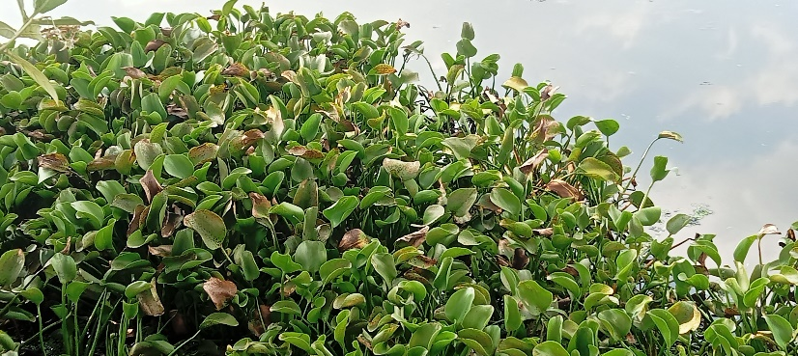

*Figure 1: Water bodies invaded by Water Hyacinth*

**Chemical Composition of Water Hyacinth**

Fresh Water Hyacinth typically contains about 90% water and 15-20% solid materials (Ndimele et al., 2011). Its nutrient composition includes nitrogen (N) at levels ranging from 1.70% to 2.15%, phosphorus (P) ranging from 0.38% to 0.56%, and potassium (K) ranging from 2.68% to 3.45%. The protein content on a dry basis is reported to be between 9.14% and 14.37%. Moreover, Water Hyacinth is recognized as a carrier of heavy metals such as iron, magnesium, and zinc, making it suitable for phytoremediation purposes (Ndimele, 2003).

**Utilizing Water Hyacinth as a Green Manure**

Water Hyacinth proliferates in water bodies due to eutrophication. It was collected from a eutrophied water body and subjected to shade drying. After drying, it was cut into small pieces, less than 3 cm in size, to increase the surface area and facilitate its effective utilization by crops. Various parts of water hyacinth were utilized for green manure, and it was applied to crops before sowing. Water Hyacinth serves as a rich source of nitrogen (N), phosphorus (P), potassium (K), and micronutrients, providing significant benefits to crops upon application. Its utilization has shown promising results, including increased soil microbial populations, and enhanced microbial activity. This, in turn, leads to the accumulation of soil organic matter and improved soil aggregation. During the decomposition process, Water Hyacinth releases gum-like materials, which aid in binding soil particles together.

Studies have indicated that the application of Water Hyacinth results in improved agronomic characteristics of plants. Additionally, it enhances the soil's water holding capacity, with treated soil showing an increase from 8.21% to 10.16% compared to untreated soil (Khan and Sarwar, 2002). However, it must be noted that if Water Hyacinth contains higher lignin compounds, it might potentially reduce the potassium content by binding it.

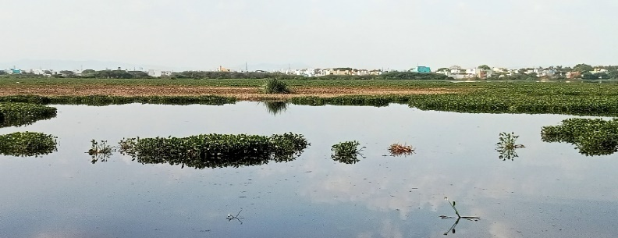

*Figure 2: Site of Collection, Avaniyapuram Pond, Vellakal, Madurai*

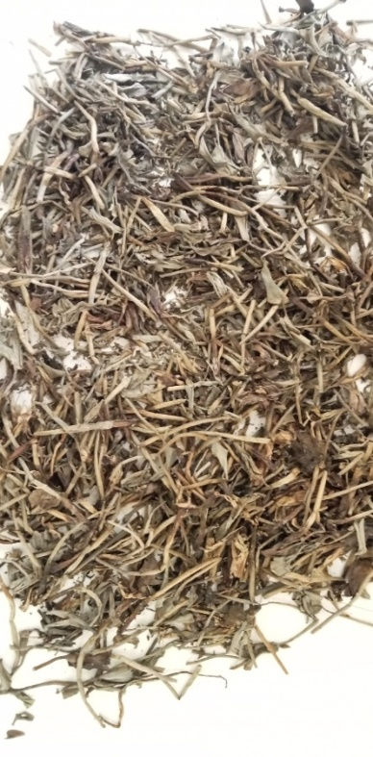

*Figure 3: Shade dried Water hyacinth*

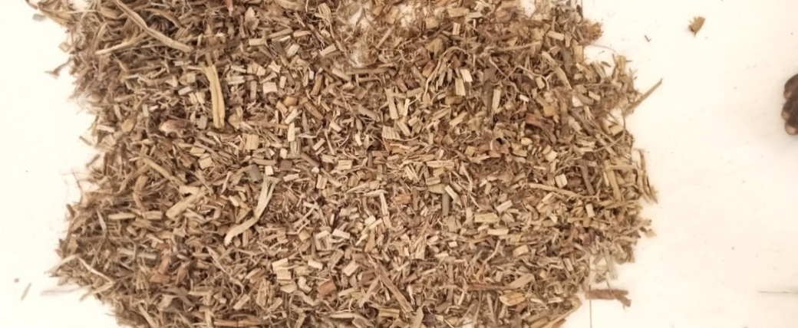

*Figure 4: Cut pieces of Water Hyacinth*

**Enrichment with Gypsum (Fortification)**

Shade-dried cut pieces (less than 3 cm) of Water Hyacinth are enriched with calcium sulfate (gypsum) at a 1:1 ratio. This enriched mixture is applied to the field before sowing and again during earthing up on the 45th day to enhance peg formation. Calcium is essential for strong shell formation and cell wall thickening (middle lamella), while sulfur is important for increasing the oil content of groundnuts. The porous nature of the small Water Hyacinth pieces helps retain the gypsum, facilitating its slow release to the plants and significantly increasing yield. This practice also enhances the soil's chelating capacity and cation exchange capacity, improving it from 22.95 to 23.78 at a depth of 0-30 cm (Khan and Sarwar, 2002; Abdalla and Elballah, 2015). Additionally, the total mineral nitrogen content before sowing the first main crop and even after harvesting was found to be twofold higher than the control (Khan and Sarwar, 2002).

Water Hyacinth wastes were collected from water bodies, shade-dried, and cut into small pieces. These pieces were then enriched with gypsum. The experiment was conducted using a Completely Randomized Design (CRD) across three trials. The treatments included: T1-Control, T2-Water hyacinth green manure and T3-Water hyacinth green manure enriched with gypsum. Agronomic growth parameters of the crop were measured at 30, 60, and 90 days, as well as at the time of harvest.

*Table 1:* *Effect on Plant Height and Width*

|  |  |  |  |  |  |  |
| --- | --- | --- | --- | --- | --- | --- |
| **PLANT HEIGHT AND WIDTH** | | | | | | |
| **Number of Days After Sowing** | **T1** | | **T2** | | **T3** | |
| **Height, (cm)** | **Width, (cm)** | **Height, (cm)** | **Width, (cm)** | **Height, (cm)** | **Width, (cm)** |
| **30 DAS** | 10 | 5 | 19 | 9 | 20 | 10 |
| **60 DAS** | 13 | 7 | 33 | 12 | 35 | 14 |
| **90 DAS** | 15 | 10 | 45 | 14 | 47 | 16 |
| **At The Time of Harvest (95 DAS)** | 15 | 10 | 46 | 16 | 49 | 18 |

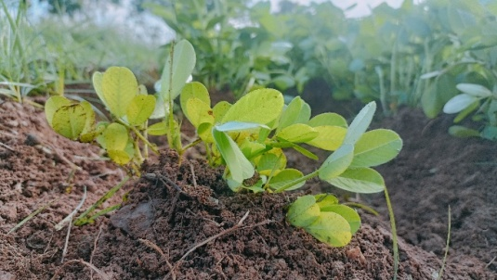

*Figure 5: Stunted growth observed in the T1*

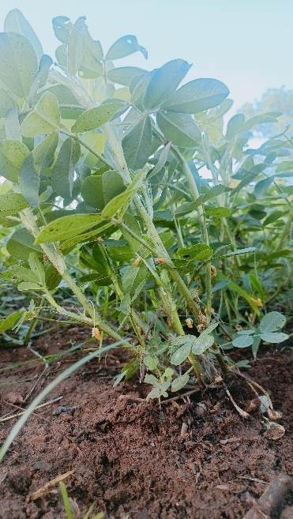

*Figure 6: Bunchy growth observed in the T2*

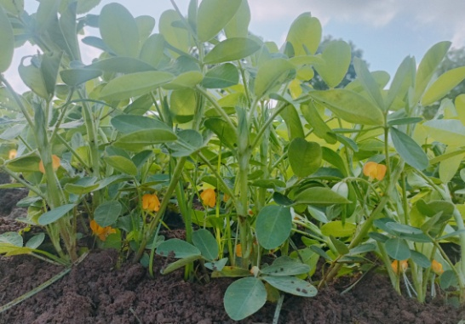

*Figure 7: Bunchy growth observed in the T3*

*Table 2: Effect on Fundamental Yield Parameters*

|  |  |  |  |  |  |  |
| --- | --- | --- | --- | --- | --- | --- |
| **NUMBER OF FILLED AND UNFILLED PODS** | | | | | | |
| **Number of Days After Sowing** | **T1** | | **T2** | | **T3** | |
| **Average Number of pods per plant** | **Average Number of filled pods/plant** | **Average Number of pods per plant** | **Average Number of filled pods/plant** | **Average Number of pods per plant** | **Average Number of filled pods/plant** |
| **30 DAS** | Flower initiation | Nil | Flower initiation | Nil | Flower initiation | Nil |
| **60 DAS** | 10 | Nil | 15 | Nil | 19 | Nil |
| **90 DAS** | 14 | 9 | 23 | 19 | 25 | 21 |
| **At the time of harvest** | 19 | 12 | 25 | 20 | 30 | 25 |

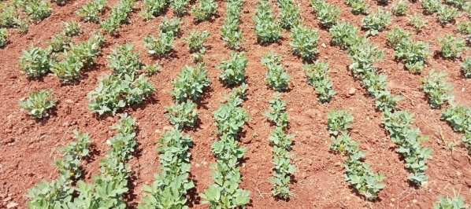

*Figure 8: Plant growth in the T1*

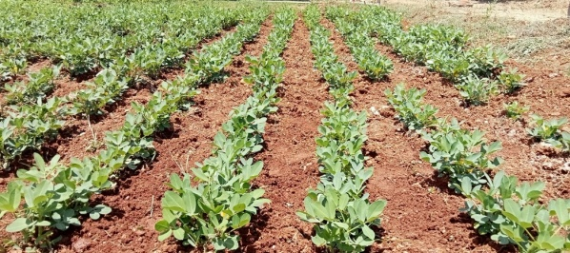

*Figure 9: Plant growth in the T2*

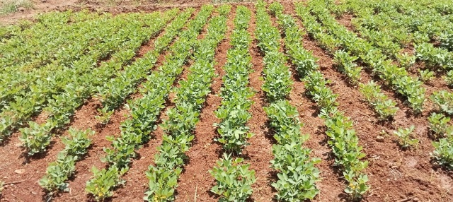

*Figure 10: Plant growth in T3*

**Discussion:** Upon observing the soil, it shows aggregation due to decomposition. Water hyacinth releases gum-like substances which aid in binding soil particles together. It also increases soil microbial activity and population, further enhancing decomposition and the release and easy absorption of minerals by roots. When observing the agronomical growth parameters.

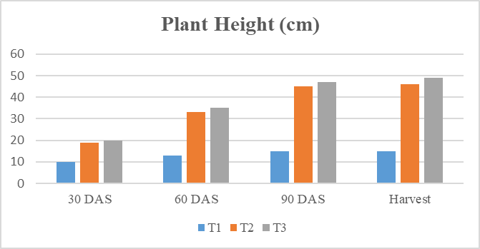

*Figure 11: Effects on Plant Height*

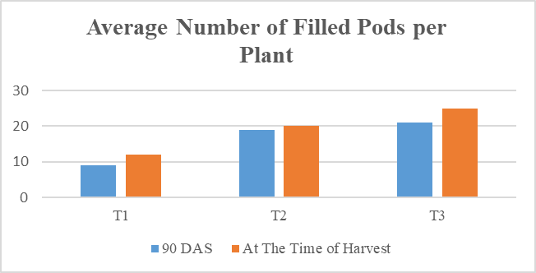

*Figure 12: Effects on Average Number of Filled Pods per Plant*

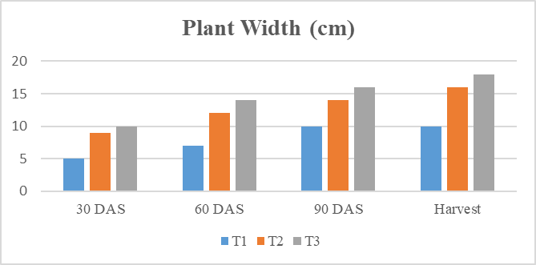

*Figure 13:* *Effects on Plant Width*

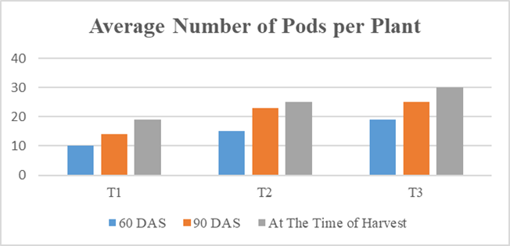

*Figure 14: Effects on Average Number of Pods per Plant*

From Table 1, agronomical growth parameters were calculated at the 30th, 60th, and 90th days and at the time of harvest. Results show that good plant height and width were achieved in T2 (Fig. 6) and T3 (Fig. 7), while stunted growth (maximum height 15 cm) was observed in the control T1 (Fig. 5). The maximum plant height of 49 cm was observed in T3, and 46 cm was observed in T2. The maximum width of 18 cm was observed in T3, and 16 cm was observed in T2. The application of water hyacinth green manure to the field on the 45th day promotes soil aggregation during the earthing-up process, which helps in more peg formation compared to the control. The application of gypsum-enriched water hyacinth green manure further promotes numerous peg formations. The presence of gypsum prevents soil compaction and loosens the soil, promoting easy peg penetration. Enrichment with water hyacinth promotes soil aggregation by releasing gummy substances, which further promotes peg formation and prevents soil erosion due to external factors. From Table 2, the number of filled and unfilled pods per plant is observed. Results show that the maximum number of good-sized filled pods (25) is achieved in T3. In T2, a maximum number of 20 filled pods is observed, while a lower number of small-sized pods is observed in the control T1.

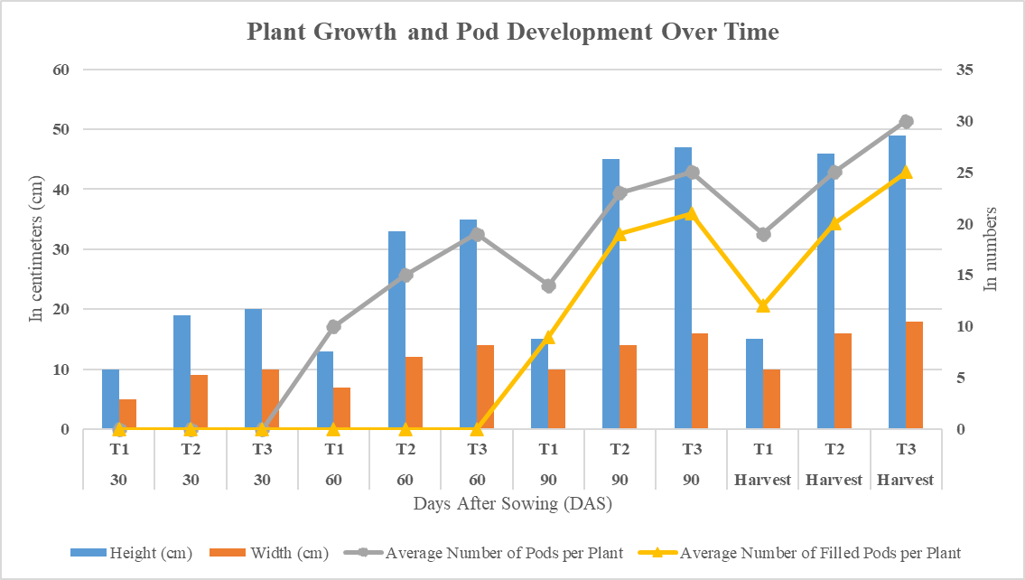

*Figure 15: Graph Depicting the Effects of Incorporating Gypsum-Enriched Water Hyacinth Chunks on the Growth and Yield Parameters of Groundnut*

**Conclusion:** The results indicate that the agronomic growth and yield parameters of the plants are significantly higher in T3 (Water Hyacinth green manure enriched with gypsum) compared to T2 (Water Hyacinth green manure) and T1 (Control). The growth and yield follow the trend: T1 < T2 < T3. Utilization of Water Hyacinth as green manure, particularly when enriched with gypsum, demonstrates significant improvements in plant growth and yield. This treatment also enhances soil structure and water-holding capacity. It promotes the aggregation of soil and prevents from soil compaction which pay way for easy peg penetration and more peg formation. Good agronomical growth parameters are achieved from the experiment. Even though no large amount of dry matter is not produced from the Water Hyacinth, Due to its invasive nature and rapid multiplication rate it can be collected large amount from water bodies. The process of making Water Hyacinth into green manure and enrichment with gypsum is not laborious and time-consuming process. It is the simplest, easiest, and not more time-consuming method comparatively to other methods of composting. It is an environment-friendly method that restores the natural balance and creates a healthy habitat for native plants and animals in our waterways by removing. Compared with other conventional methods, it is cost-effective, economical, and eco-friendly for small-scale farmers.

**ACKNOWLEDGEMENT**

We would like to express our sincere gratitude to all those who helped us complete this research successfully. First and foremost, we would like to thank our mentors, Dr. S. Babu, Associate Professor of Agronomy, and Dr. M. Yuvaraj, Teaching Assistant in SS&AC. We also extend our thanks to our college Dean, Dr. S. Manickam, Professor of Agronomy, and our Year Coordinators, Dr. K. Anandhi, Assistant Professor of Crop Physiology, and Dr. V. Arunkumar, Assistant Professor SS&AC as well as to our Ward Councillors, Dr. S. Angles, Professor of Agricultural Economics, and Dr. S. Manickam, Professor of Agronomy. We would also like to extend our sincere thanks to my beloved parents, our supportive classmates and friends.

**REFFERENCE**

Abdalla, M. A., & Elballah, M. M. A. (2015). Utilization of composted bagasse, water hyacinth and banana waste in reclamation of desert soils. *DCG Report*, No. 76.

Abdelsabour, M.F. (2010). Water hyacinth: Available and renewable resource. Electronic Journal of Environmental Agriculture and Food Chemistry. 9(11): 1746-1759.

Agbede, T.M., Ojeniyi, S.O. and Adeyemo, A.J. (2008). Effect of poultry manure on soil physical and chemical properties, growth and grain yield of sorghum in southwest, Nigeria. American-Eurasian Journal of Sustainable Agriculture. 2(1): 72-77.

Akinbile C. O. and Yusoff M. S. (2012), ‘Assessing water hyacinth (Eichhornia crassipes) and lettuce (Pistia stratiotes) effectiveness in Aquaculture wastewater treatment’, International Journal of Phytoremediation, 14(1), pp. 201-211.

Awuah E., Peprah O. M., Lubberding H.J.and Gijzen H. J. (2004), 'Comparative performance studies of water lettuce, duck weed and algal based stabilization ponds using low strength sewage’, Journal of toxicology and Environmental health,67(1), p. 1727-1739.

Azam, F., Malik, K. A., & Sajjad, M. I. (1985). Transformations in soil and availability to plants of 15N applied as inorganic fertilizer and legume residues. *Plant and Soil*, 86(1), 3-13. <https://doi.org/10.1007/BF02185020>.

Balasubramanian, D., Arunachalam, K., Arunachalam, A. and Das, A.K. (2013). Effect of water hyacinth (Eichhornia crassipes) mulch on soil microbial properties in lowland rainfed rice- based agricultural system in northeast India. Agric Res. 2(3): 246-257. DOI 10.1007/s40003-013-0073-7.

Basak, M. N. (1948). *Water hyacinth compost*. Alipore: West Bengal Govt. Press.

Bates, R. P., & Hentges, J. F. (1976). Aquatic weeds - Eradicate or cultivate? *Economic Botany*, 30(1), 39-50.

Beesigamukama, D., Tumuhairwe, J. B., Muoma, J., John, M., Maingi, J., Ombori, O., Mukaminega, D., Nakanwagi, J., & Amoding, A. (2018). Improving water hyacinth-based compost for crop production. *Journal of Agricultural Science and Food Technology*, 4(3), 52-63.

Bhattacharya A and Kumar P (2010), ‘Water hyacinth as a potential biofuel crop’, Electronic journal of Environmental, Agriculture and Food Chemistry, 9(1), pp. 112-122.

Biswas, K., & Calder, C. C. (1954). *Handbook of common water and marsh plants in India and Burma*. Health Bulletin, 24.

Burton, J., van Oosterhout, E., Ensbey, R., & Julien, M. (2010). *Water hyacinth (Pontederia crassipes): Weed of national significance*. Department of Primary Industries, NSW, Australia.

Cerveira Junior, W. R., & Carvalho, L. B. (2019). Control of water hyacinth: A short review. *Communications in Plant Sciences*, 9(1), 129-132. https://doi.org/10.26814/cps2019021.

Chang, J. I., & Chen, Y. J. (2010). Effects of bulking agents on food waste composting. *Bioresource Technology*, 101, 5917-5924. https://doi.org/10.3923/ja.2002.64.65.

Chintanwar Y. D., Batra P., Kumar V., Gour R., Chorey S., Yeole N. and Kumar R. (2016), ‘Grey water treatment and management : the potential of greywater systems to aid sustainable water management’, Journal of Research in Engineering and Applied Sciences, 1(3), pp.141-147.

Dai, L., Zhang, G., Yu, Z., Ding, H., Xu, Y., & Zhang, Z. (2019). Effect of drought stress and developmental stages on microbial community structure and diversity in peanut rhizosphere soil. *International Journal of Molecular Sciences*, 20(9), 2265.

Dhal, G. C., Singh, W. R., Khwairakpam, M., & Kalamdhad, A. S. (2012). Composting of water hyacinth using sawdust/rice straw as a bulking agent. *International Journal of Environmental Sciences*, 2(3), 1223-1238.

Dixit A., Dixit S. and Goswamy D. S. (2011), ‘Process and plants for wastewater remediation – a review’, Science reviews and chemical communication, 1(1), 71-77.

Goldhamer, D. A., Grimes, D. W., Culick, S. H., & Munk, D. S. (1994). Cover cropped enhanced water infiltration of a slowly permeable fine sandy loam. *Soil Science Society of America Journal*, 58, 310-315.

Gopal, B. (1987). *Aquatic plant studies 1: Water hyacinth*. Elsevier Publishing.

Goyal, S., Dhull, S. K., & Kapoor, K. K. (2005). Chemical and biological changes during composting of different organic wastes and assessment of compost maturity. *Bioresource Technology*, 96(14), 1584-1591.

Greenland, D. J. (1994). In *Soil science and sustainable land management in the tropics* (pp. 1-15). CAB International.

Gunnarsson, C. C., & Petersen, C. M. (2006). Water hyacinth as a resource in agriculture and energy production: A literature review. *Waste Management*, 27, 117-129.

Headley T. R. and Tanner C. C. (2012), ‘Floating treatment wetlands: an innovative option for storm water quality application’, Journal of Environmental Science and technology, 42(21), pp. 261-310.

Jiang, C., Li, X., Zou, J., Ren, J., Jin, C., Zhang, H., Yu, H., & Jin, H. (2021). Comparative transcriptome analysis of genes involved in the drought stress response of two peanut (Arachis hypogaea L.) varieties. *BMC Plant Biology*, 21(1), 64.

Khan, S. and Sarwar, K.S. (2002). Effect of water-hyacinth compost on physical, physico-chemical properties of soil and on rice yield. Journal of Agronomy. 1: 64-65. http://dx.doi.org/ 10.3923/ja.2002.64.65.

Lata, N. and Veenapani, D. (2011). Response of water hyacinth manure on growth attributes and yield in Brassica Juncea. Journal of Central European Agriculture. 12(2): 336-343.

Lekshmi, N.C.J.P. and Viveka, S. (2011). Hyacinth compost as a source of nutrient for Abelmoschus esculentus. Indian Journal of Science and Technology. 4(3): 236-239.

Li F., Wichmann K. and Otterpohl R. (2009), ‘Review of technological approaches for greywater treatment and reuse’, Science of the total environment, 407(1), pp. 3439-3449. [4.] Gupta P., Roy S. and Mahindrakar A. B. (2012),‘Treatment of Water Using Water Hyacinth, Water Lettuce and Vetiver Grass - A Review’, Resources and Environment, 2(5), pp. 202-215.

Luo, H., Guo, J., Yu, B., Chen, W., Zhang, H., Zhou, X., Chen, Y., Huang, L., Liu, N., Ren, X., et al. (2021). Construction of ddRADseq-based high-density genetic map and identification of quantitative trait loci for trans-resveratrol content in peanut seeds. *Frontiers in Plant Science*, 12, 644402.

Maine, M. A., Sune, N. L., Panigatti, M. C., & Pizarro, M. J. (1999). Relationships between water chemistry and macrophyte chemistry in lotic and lentic environments. *Archives of Hydrobiology*, 145(2), 129-145.

Majid, F. Z. (1983). *Aquatic weeds and algae: The neglected natural resources of Bangladesh* (Booklet).

Masaka, J. and Ndhlovu, S. (2007). The effect of different forms of water hyacinth (Eichchornia crassipes) organic fertilizers on leaf growth rate and yield of Rape (Brascica napus). International Journal of Agricultural Research. 2(3): 254- 260.

Muktamar, Z., Justisia B. and Setyowati, N. (2016). Quality enhancement of humid tropical soils after application of water hyacinth (Eichornia crassipes) compost. Journal of Agricultural Technology. 12(7.1): 1211-1227.

Nasrin, A., Khanom, S. and Hossain, S.A. (2019). Effects of vermicompost and compost on soil properties and growth and yield of Kalmi (Ipomoea aquatica Forsk.) in mixed soil. Dhaka University Journal of Biological Sciences. 28(1): 121-129.

Ndimele PE, Kumolu-Johnson CA and Anetekhai MA (2011). The invasive aquatic macrophyte, water hyacinth {Eichhornia crassipes (Mart.) Solm-Laubach:Pontedericeae}: problems and prospects. Research Journal of Environmental Sciences 5(6): 509–520

Ndimele PE. 2003. The Prospect of Phytoremediation Of Polluted Natural Wetlands By Inhabiting Aquatic Macrophytes (Water Hyacinth). M.Sc. Thesis, University of Ibdan, Nigeria.

Pera, A., Vallini, G., Sireno, I., Bianchin, M. L., & De Bertoldi, M. (1983). Effect of organic matter on rhizosphere microorganisms and root development of sorghum plants in two different soils. *Plant and Soil*, 74(1), 3-18.

Qin H., Zhang Z., Liu M., Liu H., Wang Y., Wen X., Zhang Y. and Yan S. (2016), ‘Site test of phytoremediation of an open pond contaminated withdomestic sewage using water hyacinth and water lettuce’, Ecological Engineering, 95(1), pp. 753-762.

Rao, K. Narayana and K. Mahadeva Gupta. 1980. From aesthetic to pest (Eichhornia crassipes (Mart) Soms.). Meeting Indian Soc. Weed Sci., Bhubaneswar, India, Abstr. no. 206

Shaikh, Sameer S. K. and Younus S. K. (2015), ‘A sustainable solution for water crisis in Pusad city Maharashtra’, International Journal on recent and innovation trends in computing and communication, 3(2), pp. 167-170.

Sivasankari B and Ravindran D. (2016), ‘A study on chemical analysis of water hyacinth (Eichornia crassipes) and water lettuce (Pistia stratiotes), International Journal of Innovative Research in Science and Technology, 5(10), pp. 17566-17570.

Steffen, R. (1979). The value of composted organic matter in building soil fertility. *Compost Science and Land Utilization*, 20, 34-37.

U.S. Environmental Protection Agency. (1988). *Design manual-constructed wetlands and aquatic systems for municipal wastewater treatment* (Report No. EPA/625/1-88/022). Office of Research and Development.

Widjajanto, D. W., Honmura, T., & Miyauchi, N. (2002). Nitrogen release from green manure of water hyacinth in rice cropping systems. *Pakistani Journal of Biological Sciences*, 5, 740-743.

Xu, Y., Zhang, D., Dai, L., Ding, H., Ci, D., Qin, F., Zhang, G., & Zhang, Z. (2020). Influence of salt stress on growth of spermosphere bacterial communities in different peanut (Arachis hypogaea L.) cultivars. *International Journal of Molecular Sciences*, 21(6), 2131.

Yang, S., Wang, F., Guo, F., Meng, J. J., Li, X. G., & Wan, S. B. (2015). Calcium contributes to photoprotection and repair of photosystem II in peanut leaves during heat and high irradiance. *Journal of Integrative Plant Biology*, 57(5), 486-495.